A combined multiscale numerical and experimental approach for the design optimization of hollow-fiber based medical devices

F. Consolo1, A. Dimasi1, R. Testa1, S. Speranza1, S. Reggiani2, G.B. Fiore1 and A. Redaelli1

1Dipartimento di Elettronica, Informazione e Bioingegneria, Politecnico di Milano, Milano, Italy. 2Sorin Group Italia, Mirandola (MO), Italy.

# Introduction

With the introduction of hollow-fiber based blood oxygenators (OXY) and heat exchangers (HE) for extracorporeal circulation (ECC), finding an optimal trade-off between different design specifications has become a refined challenge that benefits from the use of advanced numerical modelling techniques combined with innovative experimental methods. In collaboration with Sorin Group Italia (SGI), we have designed a new strategy based on multiscale computational fluid dynamics (CFD) that couples macro- and microscale flow effects to optimize the performance of integrated ECC devices, including analysis of platelet activation to characterize the device thrombotic impact.

**Materials and Methods**

A multiphysic analysis at the macroscale allowed the extraction of quantitative geometrical-dependent parameters, not derivable from empirical methods, to optimize the hemo- and thermo-dynamics performance of the HE module of an integrated hollow-fiber OXY. Afterwards, the inner core micrometric fiber bundles were modeled to capture the local flow phenomena at the fiber level. Multiscale simulations were integrated with a transient Lagrangian analysis of the mechanical load experienced by platelet-like particles, to gather data concerning the stress history experienced by cells recirculating within the device (Pelosi et *al.*, 2013). Representative shear stress loading waveforms were selected to be reproduced *in vitro* into the Hemodynamic Shearing Device (HSD, Fig. 1), in order to quantify the platelet activation state (PAS) (Bluestein et *al.*, 2013).

# Results

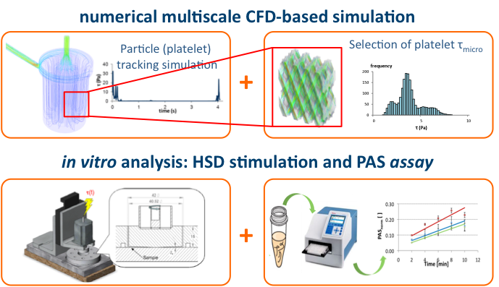A convenient design configuration of the HE was identified, characterized by *i)* uniform blood flow pattern within the fiber bundle, preventing blood flow shunting and the onset of stagnation/recirculation areas and/or high velocity pathways, inducing hemolysis and platelet activation; *ii)* enhanced blood heating efficiency; and *iii)* reduced blood pressure drop and priming volume.

Figure 1: The multiscale modeling approach combined with in vitro PAS analysis.

The microscale analysis highlighted the presence of non-negligible hemodynamic forces in the fiber bundle regions of the HE and the OXY, in particular due to the significant residence time of the platelets within the bundles, potentially eliciting platelet activation. *In vitro* PAS analysis with the HSD is ongoing, to quantify the actual thrombotic potential of the device.

# Discussion

The proposed composite numerical-experimental methodology allows the identification of suitable working conditions of blood handling medical devices, including the minimization of stress-mediated blood cells sensitization and thrombus susceptibility.

# References

Pelosi A. et *al.*, BMMB, 2013

Bluestein D et *al.*, J Biomech 2013.

***Acknowledgments****:* This work was financially supported by Fondazione Cariplo, Grant no. 2241-2011.