Errors matter: ACL injury risk and the biomechanics of unsuccessful trials
Claudia Brunetti^{1,2}*, Pietro Maver¹, Marco Tarabini^{1,2}, Filippo Bertozzi¹

¹ E4Sport Lab, Politecnico di Milano, Lecco, Italy
² Department of Mechanical Engineering, Politecnico di Milano, Milan, Italy

Mail addresses:
claudia.brunetti@polimi.it
pietro.maver@polimi.it
marco.tarabini@polimi.it
filippobertozzi23@gmail.com

ORCIDs:
Claudia Brunetti: 0000-0003-0409-8546
Marco Tarabini: 0000-0002-2640-1764
Filippo Bertozzi: 0000-0003-2240-5394

*Corresponding author’s details:
Claudia Brunetti, PhD
E4Sport Lab, Politecnico di Milano, Lecco, Italy; Department of Mechanical Engineering, Politecnico di Milano, Milan, Italy
Via G. Previati 1/c, 23900, Lecco (LC), Italy
mail: claudia.brunetti@polimi.it
phone: +39 0341 488835

Data availability statement
The data that support the findings of this study are available in the supplementary material of this article.
Funding statement
The authors declare no conflicts of interest.
Conflict of interest disclosure
No external funding was received for this study.
Ethics approval statement
The project was approved by the Institutional Ethics Committee (protocol number: 10/2022).
Patient consent statement
All participants signed informed consent before the participation in the study, containing detailed description of the experimental protocol, risks, and benefits.
Permission to reproduce material from other sources
No previously published material has been reproduced.
Clinical trial registration
Not applicable.
Disclosure
Figure 1 and parts of Figures 3 and 5 (graphical representations of cluster motor patterns) of this article were generated with the assistance of ChatGPT (OpenAI) based on the Authors’ specifications. The Authors reviewed and approved all generated content.

ABSTRACT
Landing tasks coupled with cognitive-motor demands are commonly used to assess biomechanical risk markers for anterior cruciate ligament (ACL) injury. However, most studies discard unsuccessful trials, despite these potentially better reflecting real-game injury situations, as they arise from decision-making or motor-control errors. This exploratory study investigated the biomechanics of unsuccessful trials in cognitively challenging jump-land-jump tasks using a cluster analysis approach.
Unsuccessful landings were classified as distinct mechanisms in failed (decision-making error) or bad (motor error) trials and analyzed separately, including 24 and 30 athletes, respectively. The multivariate average of successful trials were used to defined the optimal pattern, and the most abnormal failed and bad trials were identified based on their distance from the optimal pattern. Peak sagittal and frontal plane hip and knee biomechanics were extracted, and analyzed using principal component and hierarchical cluster analysis.
Failed trials revealed four distinct motor strategies (p < 0.001), in some cases characterized by greater frontal-plane misalignments, which may be considered injury risk markers. In contrast, two clusters emerged among bad trials (p < 0.001), but with low separation and relatively small principal component scores, suggesting minor adjustments rather than qualitatively different strategies. This suggests that the type of landing error (decision-making vs. motor-planning) may influence kinematics and joint-loading.
This study highlights a latent dimension of injury risk that may be overlooked when considering only successful task execution. The biomechanical analysis of unsuccessful trials may help identify cognitive-motor factors affecting neuromuscular control and motor planning, potentially complementing current ACL injury risk screening approaches.

KEYWORDS
Anterior cruciate ligament; biomechanics; invalid trials; clustering; principal component analysis

INTRODUCTION
ACL injuries are among the most debilitating injuries in sport, indeed the return-to-sport progression usually requires from 6 to 12 months, while pre-injury performance level is not guaranteed¹. Most ACL injuries occur during non-contact cutting and landing maneuvers². Despite the biomechanical differences between these two injury mechanisms, in the last decades video analyses have identified common biomechanical features that may be linked to the ligament loading and subsequent injury risk, such as the excessive knee medial displacements and the reduction of lower limb flexion, that increase shear forces at tibial proximal end and axial compressive load³. Laboratory tests that replicate injury-related sports motions (e.g., cutting and landing tasks) are commonly adopted to screen for ACL injury risk and support rehabilitation in the return-to-sport process^{4,5}. However, the overall injury rate is not decreasing, while the risk of reinjury in sports remains high⁶.
Beyond biomechanical risk markers and individual non-modifiable anatomical characteristics, such as ligament laxity, neurocognitive abilities have been recognized as potentially relevant ACL injury risk-related factors^{7–9}. Indeed, in recent years, cognitive load introduced through unanticipated protocols or dual-task conditions has been implemented in laboratory biomechanical testing, as this approach may be more ecologically valid by replicating unpredictable and cognitively challenging real-game situations and allowing for the concurrent assessment of athletes’ motor and cognitive abilities^{10–14}. The cognitive demand is often included in laboratory tests using visual stimuli that dynamically change a predetermined task requirement (e.g., jump right or left when a light turns green), which may reveal potential athletes’ deficiencies in rapidly adapting the movement and avoiding harmful motor patterns^{15,16}.
Although cognitive stimuli are believed and purposely implemented to increase cognitive-motor demands, affecting movement outcomes and, as a consequence, the number of errors or suboptimal patterns, to our knowledge, the vast majority of studies have focused exclusively on analyzing the biomechanics of what researchers usually consider “successful” or “valid” trials^{10,17}. In this case, task execution and motor patterns could be considered optimal, although invalid trials, often discarded, might provide a more representative characterization of an athlete’s exposure to injury risk, which indeed often arises from suboptimal motor planning and execution errors⁹. However, only a few studies have included a notational analysis of invalid trials^{18,19}, and very limited evidence is available regarding their biomechanics relative to valid trials²⁰.
Execution errors can arise from heterogeneous mechanisms, making the analysis of invalid trials challenging. Indeed, an invalid trial can be defined not only as a deviation from task requirements (a cognitive error as a failure of the decision-making process), but also as an incorrect movement execution (a motor error as a failure of the movement planning process, such as sliding, pivoting, or losing balance) despite the fulfillment of task requirements¹⁸. The same athlete may thus exhibit different types of errors, even within the same testing session; consequently, averaging invalid trials to compare them with valid ones may not be appropriate, as this approach may mask or compensate for the biomechanical effects of specific types of errors.
A possible solution to these challenges is to categorize the outcomes using an unsupervised exploratory approach, grouping the data based on inherent similarity rather than applying predetermined boundaries, as in cluster analysis²¹. A recent study has proposed using cluster analysis to discriminate movement patterns associated with ACL injury risk²². In a similar manner, this approach could be applied to categorize different unsuccessful biomechanical patterns, some of which may increase the athlete’s exposure to ACL injury risk. Additionally, the analysis of invalid trials should include the optimal movement patterns observed in successful trials, as comparing their kinematics and kinetics with those of unsuccessful trials may help identify potentially harmful biomechanical changes that current screening methods cannot detect, thereby providing a more comprehensive dimension of injury risk.
To our knowledge, this is the first study to explore this approach to identifying ACL injury risk markers in cognitively challenging landing tasks by analyzing the biomechanics of invalid trials. Invalid trials were selected and categorized, also considering their “deviation” from the successful motor pattern observed in valid trials, and cluster analysis was adopted to identify and group biomechanical profiles. We explored the use of cluster analysis to discriminate different motor patterns, whose error mechanisms might be associated with known ACL risk profiles, indicating greater risk markers in certain individuals.

METHODS
This cross-sectional observational study was approved by the institutional Ethic Committee (protocol No. 10/2022) and complied with the ethical standards for research involving human participants established by the Declaration of Helsinki. We approached the experimental question using an exploratory approach, as direct comparison with previous evidence is limited regarding biomechanical analysis of invalid trials²³.
Participants
Given the nature of the study and the lack of prior published evidence, the sample size was pragmatically selected for a secondary analysis as part of a broader research project examining the influence of cognitive-motor factors on injury-related biomechanics^{23,24}. Fifty participants (25 males and 25 females) were recruited for the project after signing written informed consent that included detailed protocol information, risks, and benefits. To be included, participants had to be between 18 and 35 years old, be involved in competitive ball team sports characterized by frequent unanticipated jumps and cutting movements (e.g., basketball, volleyball, soccer, rugby), report a Tegner activity score higher than 5²⁵, train at least twice per week and compete in an official match per week, have a minimum of 5 years of sport-specific experience, and hold a valid medical clearance for competitive sport participation in accordance with national regulations. Individuals were excluded if they had a history of lower limb surgery, had sustained a concussion or lower limb injury within the 6 months preceding the testing session, or reported color blindness.
Experimental protocol
The present study was part of a broader research project in which participants first completed baseline cognitive–motor tests and then performed sport-specific jump-land-jump tasks with increasing levels of cognitive demand^{26,27}. The entire experimental session was conducted on a single day and lasted approximately 3 hours, with jump testing requiring around 2 hours. Before starting with jump-land-jump tasks, participants’ height and body mass were measured using a digital stadiometer and scale (Soehnle 7831, Soehnle GmbH, Backnang, Germany), with a resolution of 0.1 cm and 0.1 kg, respectively, and the dominant limb was identified as the preferred one to kick a ball as far as possible²⁸. Participants’ characteristics are reported in Table 1.
TABLE 1 NEAR HERE
Participants performed a standardized warm-up, including squats, vertical jumps, and drop jumps, and they were allowed to familiarize themselves with the jump-land-jump tasks before initiating the protocol. They were instructed to jump from a 30-cm box placed at a distance equal to 50% of their height from two force plates, land with one foot on each plate, and immediately perform a subsequent jump at a 45° angle to the right or left²⁶. The direction of the secondary jump was indicated by two smart indicators (WittySEM, Microgate Srl, Bolzano, Italy) positioned 2 m away from the anterior edge of the force plates at a 45° angle, to stimulate peripheral vision. The jump-land-jump tasks were performed under three conditions: anticipated (ANT), unanticipated (UNA), and cognitively-challenging (COG).
In the ANT condition, one smart indicator was already turned on (green light) before the beginning of the trial, thus the participant knew a priori the direction of the secondary jump. In both UNA and COG conditions, the smart indicators were triggered by a photocell (WittyGATE, Microgate Srl, Bolzano, Italy) properly positioned between the box and the force plates to activate the visual cue during the flight phase (250-300 ms before ground contact), allowing adequate time to react^{12,15}. In the UNA condition, one of the smart indicators turned green, indicating the direction of the secondary jump. Finally, in the COG condition, the smart indicators could display three color combinations, to further increase the cognitive load: one of the smart indicators turned green indicating the direction of the secondary jump, similarly to the UNA condition (green-off); one smart indicator turned green and the other turned blue, with the blue one specifying the direction of the secondary jump (blue-green, represented in Figure 1); one indicator turned green and the other turned red, indicating that the participant was required to stop on the force plates without performing the secondary jump (red-green).
FIGURE 1 NEAR HERE
The task conditions were performed in a randomized order, and each condition ended when the participant completed at least three valid jumps per direction (in the COG condition, for each color combination). A rest of 1 minute between trials and 3 minutes between conditions (or after ten trials of the same condition) was granted to avoid the onset of fatigue^{10,15}. A trial was considered valid when the participant performed the secondary jump in the correct direction (or correctly stopped in the red-green combination) immediately after landing with one foot on each force plate without sliding, double-stepping, or losing balance. Especially in the COG condition, as expected, participants performed a considerable amount of invalid trials, that were classified as “failed” when participants selected an incorrect direction for the secondary jump (cognitive error), and as “bad” when participants initiated the second jump in the correct direction but with suboptimal execution (motor error; e.g., uncoordinated posture, loss of balance, or deviation from the intended 45° direction).
Kinematics and kinetics were collected using an 8-camera optoelectronic motion capture system (SMART-DX EVO, BTS Bioengineering, Milano, Italy) sampling at 100 Hz and two time-synchronized force plates (P-6000, BTS Bioengineering, Milan, Italy) sampling at 500 Hz. A whole-body cluster-based marker with 57 reflective markers were positioned on participants’ body: forehead and lateral sides of the head (attached to an elastic headband), 7th cervical vertebra, jugular notch, xiphoid process, 10th thoracic vertebra, and bilaterally on acromia, middle deltoids, iliac crests, posterior and anterior superior iliac spines, elbow medial and lateral epicondyles, laterally on forearms, radial and ulnar styloid processes, medial and lateral femoral condyles, tibial tuberosities, medial and lateral malleoli, calcanei, laterally on feet, 1st and 5th metatarsal heads, and four rigid 3-marker clusters fixed on shanks and thighs with elastic bands²⁶.
Data processing and statistical analysis
Visual3D (HAS-Motion, Kingston, Ontario, Canada) was used to compute biomechanical variables, using an inverse kinematics model. Marker trajectories were interpolated, and hip and knee joint angles and external moments of both dominant and non-dominant limbs were computed using a Z-X-Y Cardan rotation sequence, restricting the knee joint to t rotational degrees of freedom. Joint moments were normalized to the participants’ body weight. Signals were then filtered using a fourth-order zero-lag Butterworth low-pass filter at 10 Hz²⁶.
A customized MATLAB code (The MathWorks Inc., Natick, MA, USA) was created to further data processing and statistical analysis. Valid and invalid (failed and bad) trials of the COG condition were considered in this analysis, including both green-off and blue-green combinations toward the dominant side. Failed and bad trials were analyzed separately, given their distinct mechanisms and implications. All failed or bad trials were retained, and an equal number of valid trials were randomly selected for matched comparison for each participant. When only two invalid trials were available, three valid trials were included. Then, hip adduction, hip flexion, knee abduction, and knee flexion angles and moments of both limbs^{29,30} were extracted in a 100-ms time interval after the initial ground contact (vertical GRF > 10 N), defined as the high-risk window for ACL injuries³¹, and normalized using a z-score transformation³².
To identify potentially hazardous invalid trials, we identified abnormal invalid trials for each participant as those that deviated most from the individual optimal pattern, a biomechanical profile derived from the average time series of each variable across the selected valid trials³³. Then, for every trial included (valid and invalid), the multivariate deviation from the optimal pattern was quantified by computing the Euclidean distance over time. The instantaneous distance was integrated over the movement duration, yielding a single scalar distance value per trial. Distances from valid and invalid trials were compared using linear mixed-effects models, with trial type (valid vs. failed or bad) as a fixed effect and subject as a random effect, to account for within-subject dependency and imbalanced numbers of trials. For visual inspection, a paired t-test through statistical parametric mapping (SPM) (spm1d MATLAB package, version M.0.4.10, http://www.spm1d.org/index.html) was also performed on distance time series to illustrate when valid and invalid trials deviated from the optimal pattern throughout the entire considered movement phase. Distance time series of each condition were averaged for all participants prior to this inspection.
For each participant, invalid trials were classified as abnormal when their scalar distance from the optimal movement pattern exceeded the mean + 1 standard deviation (SD) of the distances observed in the corresponding valid trials. Peak values of the biomechanical variables were extracted from these trials, and principal component analysis (PCA) was performed for dimensionality reduction³⁴. The number of principal components (PCs) to consider was pragmatically determined based on cumulative explained variance (70-80%), the Kaiser criterion (eigenvalue > 1), and visual inspection of the scree plot (rapid change in slope of the eigenvalue curve)^{32,35}. After determining the retained components, PC scores and variable loadings were subsequently extracted.
Abnormal trials were then grouped using hierarchical clustering (Ward’s method) applied to the selected principal component scores, using Euclidean distance²². The optimal number of clusters was determined using silhouette analysis, which quantifies how well each trial is separated from neighboring clusters based on within- and between-cluster distances. The solution with the highest mean silhouette value was selected^{22,36}. Cluster separation was evaluated using non-parametric statistical tests applied to each PC, to account for potentially unbalanced cluster sizes. If the optimal number of clusters was greater than two, Kruskal–Wallis tests were performed, followed by pairwise comparisons using Mann–Whitney U tests with Holm correction. If only two clusters were identified, Mann–Whitney U tests with Benjamini–Hochberg correction were applied across all PCs. A significance level of 0.05 was adopted for all statistical analyses.

RESULTS
Complete descriptive statistics of raw biomechanical variables collected in the study are reported in the Supplementary Materials (Table S.1).
Failed trials (decision-making errors)
Twenty-four participants performed at least two failed trials and were therefore eligible for analysis, resulting in a total of 76 failed trials (12 males, 12 females; age: 22.9 ± 1.6 years; height: 174.9 ± 9.6 cm; weight: 69.0 ± 10.1 kg).
Figure 2 depicts: a) the boxplot representing the distance distribution of valid and failed trials with respect to the optimal pattern, and b) the SPM t-test to visualize differences over time.
FIGURE 2 NEAR HERE
The specific linear mixed model confirmed that valid and failed trials differed in distance from the optimal pattern (p < 0.001).
The abnormal failed trials, whose distance exceeded the mean + 1 SD of the valid-trial distance distribution, were 54 (from 21 participants). The PCA results on abnormal failed trials (Kaiser criterion, scree plot, cumulative variance) are represented in Figure 2c. Although the scree plot did not indicate a clear change in slope, four PCs (PC1_{F} - PC4_{F}) were considered adequate to describe the biomechanics of these tasks, based on the Kaiser criterion (4 PCs) and cumulative variance analysis (72%).
The silhouette analysis reported an optimal number of clusters of 4, with a mean silhouette value of 0.513 (Figure 2d). Relevant loadings of the first four PCs, the mean and SD of the scores for each cluster, and the results of the Kruskal-Wallis and post-hoc analyses are reported in Table 1.
TABLE 1 NEAR HERE
The first three PCs were significantly different among clusters (p < 0.001), thus the post-hoc analysis was not performed on PC4_{F}. Figure 3 displays the clusters from the dendrogram, along with a boxplot of the score distributions for the principal components that showed significant differences between clusters.
FIGURE 3 NEAR HERE
Bad trials (motor errors)
Thirty participants performed at least two bad trials and were therefore eligible for analysis, resulting in a total of 106 trials (12 males, 18 females; age: 23.1 ± 2.5 years; height: 173.8 ± 9.4 cm; weight: 66.9 ± 9.0 kg).
Figure 4 depicts: a) the boxplot representing the distance distribution of valid and bad trials with respect to the optimal pattern, and b) the SPM t-test to visualize differences over time.
FIGURE 4 NEAR HERE
The specific linear mixed model confirmed that valid and bad trials differed in distance from the optimal pattern (p < 0.001).
The abnormal bad trials, whose distance exceeded the mean + 1 SD of the valid trial distance distribution, were 65 (27 participants). The PCA results on abnormal bad trials (Kaiser criterion, scree plot, cumulative variance) are represented in Figure 4c. Although the scree plot did not reveal a clear change in slope, a total of five PCs (PC1_{B} – PC5_{B}) was considered adequate to describe the biomechanics of these tasks, based on the Kaiser criterion (4 PCs) and cumulative variance analysis (75%).
The silhouette analysis reported an optimal number of clusters of 2, with a mean silhouette value of 0.38 (Figure 4d). Relevant loadings of the first five PCs, the mean and SD of the scores for each cluster, and the results of Mann–Whitney U tests are reported in Table 2.

TABLE 2 NEAR HERE
The PC1_{B} was significantly different between clusters (p < 0.001). The clusters are displayed in the dendrogram in Figure 5, along with the boxplot showing the score distributions for the PC1_{B}.
FIGURE 5 NEAR HERE

DISCUSSION
The aim of this study was to explore a novel approach to identify ACL injury risk markers during unanticipated landing tasks by specifically analyzing invalid trials, categorized as failed and bad trials and related specifically to cognitive and motor errors, in relation to the successful motor pattern.
Four distinct motor patterns were identified among failed trials. This was expected, as failed trials usually result from cognitive decision-making errors that are inherently more heterogeneous. Since PC4_{F} did not contribute to cluster discrimination, the results were interpreted using PC1_{F}, PC2_{F}, and PC3_{F}. Cluster 1 appears to be primarily driven by PC3_{F}, as reflected by the markedly elevated PC3_{F} scores (mean ≈ 2.5) compared with the other clusters, while PC1_{F} and PC2_{F} show only moderate deviations from zero. Since PC3_{F} is mainly characterized by greater dominant knee abduction and reduced non-dominant knee abduction angles, this profile indicates a pronounced frontal-plane knee asymmetry, making this cluster the most frontal-plane-driven pattern observed³⁷. Only five trials from two participants were assigned to cluster 1, indicating that the pronounced frontal-plane interlimb asymmetries observed during failed trials were limited to a small number of athletes. Cluster 2 was characterized by relatively small scores across all principal components, indicating the absence of a strongly representative biomechanical pattern. This suggests that cluster 2 represents the least extreme profile and may reflect a more common, intermediate movement strategy within the sample, executed by most participants. Cluster 3 demonstrated strongly negative PC1_{F} and PC2_{F} scores (mean ≈ -3.7 and mean ≈ -2.3, respectively), with PC3_{F} values near zero. Both PC1_{F} and PC2_{F} with negative scores are characterized by an increased non-dominant knee abduction angle, which may enhance the risk of injury of the non-dominant ACL [ref]. On the sagittal plane, PC1_{F} and PC2_{F} seem to have opposite trends: decreased dominant and non-dominant hip flexion moment in PC1_{F}, which may be considered potentially harmful for ACL³⁸, while increased dominant and non-dominant hip flexion moment in PC2_{F}. Therefore, cluster 3 did not reflect a generalized reduction in hip contribution; rather, it was characterized by a redistribution of frontal-plane hip mechanics between limbs, with reduced hip adduction in the dominant limb and relatively greater hip adduction in the non-dominant limb. Additionally, the near-zero PC3_{F} indicates minimal frontal-plane knee asymmetry. While cluster 3 did not show marked asymmetry in this plane, the reduced dominant hip contribution along the primary sagittal axis suggests a relatively greater reliance on the knee joint. From a mechanistic perspective, such a knee-driven strategy has been associated with increased ACL loading in certain task conditions³⁸. However, in the absence of substantial frontal-plane knee loading, this pattern cannot be unequivocally interpreted as representing elevated ACL injury risk. Finally, cluster 4 was defined by strongly positive PC1_{F} scores, with PC2_{F} and PC3_{F} values close to zero. This configuration reflects a clear hip-dominant sagittal strategy in the dominant limb, characterized by a greater hip flexion moment contribution and reduced reliance on the knee, with no marked frontal-plane asymmetry. Among the four clusters, this pattern appears comparatively less consistent with biomechanical features typically associated with increased ACL loading. Similar to cluster 2, cluster 4 included a large number of trials, indicating that this movement strategy was frequently observed in the sample. Overall, only the two athletes classified within cluster 1 exhibited a movement pattern more consistent with biomechanical features associated with ACL injury, particularly due to the pronounced frontal-plane knee asymmetry. Moreover, the two athletes belonging to cluster 3 demonstrated a pattern only partially characterized by an ACL-related risk profile, mainly reflecting a lower sagittal hip contribution with only mild frontal-plane asymmetry. The majority of the sample was distributed across clusters 2 and 4, which appeared mechanically less indicative of ACL injury–related patterns.
Regarding the analysis of bad trials, two clusters were identified. However, the silhouette value, used to assess the clustering quality, was low, suggesting weak separation and possible overlap between them. This finding could potentially be related to the nature of bad trials: unlike failed trials, they are not the consequence of decision-making errors but rather of suboptimal motor execution of a jump performed in the correct direction. Accordingly, it seems reasonable that fewer and more homogeneous clusters of bad trials emerged. Only PC1_{B} significantly contributed to clustering, but the mean scores were small in magnitude in both clusters, with absolute values ranging between 1 and 2. Specifically, cluster 1 was primarily characterized by a positive contribution of PC1_{B}, while cluster 2 showed a negative contribution. Positive PC1_{B} scores implied reduced dominant knee abduction angle and moment, and increased dominant and non-dominant hip flexion moments. This strategy may be relatively more protective for ACL integrity, as it is characterized by reduced medial knee displacement and frontal-plane knee loading, combined with greater sagittal-plane hip contribution, which may enhance load absorption at the hip while attenuating mechanical demand at the knee^{3,38}. Consequently, the movement pattern features of cluster 2, which is characterized by negative PC1_{B} scores, could be more commonly associated with increased ACL injury risk³.
Although analyzing unsuccessful trials can already be considered a significant novel approach with respect to taking into consideration only valid trials, potentially concealing cognitive-motor deficiencies, as in the vast majority of the literature pertaining to injury-related biomechanical testing, we believe that further discriminating and comparing distinct types of error may help in expanding this potential dimension of the injury risk. Failed trials, which originate from cognitive decision-making errors under unanticipated conditions, were associated with a broader spectrum of motor strategies and, in some cases, with more pronounced frontal-plane deviations. In contrast, bad trials, reflecting suboptimal motor execution despite correct decision-making, exhibited more homogeneous and less distinctive biomechanical patterns. This distinction suggests that the underlying origin of the error (cognitive or motor) may differentially influence the resulting joint loading strategies. The analysis of invalid trials, especially those arising from decision-making errors, may provide additional insights into latent movement tendencies that remain compensated during successful task execution. Under cognitively demanding and time-constrained conditions, some athletes may be less able to maintain optimal movement coordination, thereby revealing underlying movement strategies that are not evident in anticipated or successfully completed trials²⁰. From this perspective, invalid trials may function as a form of cognitive-motor “stress test” that challenges the efficiency of neuromuscular control and motor planning. Conversely, bad trials were characterized by fewer and less clearly separated clusters, with relatively small principal component scores. This suggests that suboptimal motor performance in the absence of decision-making errors may involve less marked deviations from the optimal pattern. The limited cluster distinctiveness and lower silhouette values further indicate that these trials likely reflect minor adjustments rather than qualitatively different movement strategies.
Considering the study methodology, it is worth noting that if the aim is to analyze unsuccessful jump executions, the inclusion of unanticipated testing conditions appears necessary, as they are known to increase the likelihood of motor errors¹⁸. However, recent evidence supports the notion that increasing cognitive load by further expanding movement and cognitive options may stimulate adaptations beyond those associated with simple unplanned tasks^{11,13,39}. Indeed, the unanticipated condition alone may not be challenging enough to elicit a substantial number of errors, as should be expected in sport-related tasks. In the present study, when considering all participants and task conditions (i.e., directions and color combinations), the percentage of unsuccessful trials was approximately 0% in the ANT condition. In contrast, under the UNA condition, failed trials accounted for 3% of the total number of jumps, whereas bad trials remained close to 0%. When additional cognitive load was introduced, error rates increased markedly, with failed trials rising to 11% and bad trials to 24%. These findings suggest that although unanticipated tasks are a prerequisite for eliciting execution errors, the concurrent imposition of additional cognitive demands may be fundamental to obtaining a sufficient number of invalid trials for meaningful biomechanical analysis aimed at identifying athletes with reduced cognitive-motor control, who may consequently be at higher risk of injury.
Limitations
An inherent limitation of this exploratory study is that the number of participants included in the analysis of unsuccessful trials was constrained by the unpredictable occurrence of errors. It is important to underline that the study was not designed to induce or force errors, but to elicit natural performance under cognitively challenging conditions, without artificially increasing the likelihood of failure. Indeed, despite further increasing task difficulty, which could yield more unsuccessful trials, this approach would inevitably require more jump executions, which may promote the onset of physical fatigue, mental fatigue, and psychological stress, factors that could alter movement mechanics and act as confounding factors in the analysis^{10,40}.
In addition, analysis of the flight phase may provide a more detailed evaluation of the athlete’s decision-making and motor-planning abilities to rapidly adapt motor control following stimulus presentation. Characterizing kinematic and muscular activation adjustments before landing could provide deeper information regarding the mechanisms underlying unsuccessful trials, distinguishing between deficits in perceptual-cognitive processing and limitations in neuromuscular adaptability.

PERSPECTIVE
This study proposed a novel framework that incorporates analysis of invalid trials as a potentially latent meaningful dimension in the ACL injury risk profile. Distinct biomechanical profiles deviating from individual optimal patterns emerged, which would have remained undetected if only successful trials had been considered, as in standard methodologies. Further discrimination between error types revealed differences among unsuccessful trials, plausibly due to distinct cognitive-motor mechanisms. Since no investigations have adopted similar methodological frameworks, this limits direct comparisons with previous evidence are limited. Nevertheless, this study provided a basis for future research to replicate and confirm the present results.
REFERENCES
1. Glogovac G, Schumaier AP, Grawe BM. Return to Sport Following Revision Anterior Cruciate Ligament Reconstruction in Athletes: A Systematic Review. Arthroscopy: The Journal of Arthroscopic & Related Surgery. 2019;35(7):2222-2230. doi:10.1016/j.arthro.2019.01.045
2. Sundberg A, Högberg J, Tosarelli F, et al. Sport-Specific Injury Mechanisms and Situational Patterns of ACL Injuries: A Comprehensive Systematic Review. Sports Med. 2025;55(10):2489-2527. doi:10.1007/s40279-025-02271-w
3. Beaulieu ML, Ashton-Miller JA, Wojtys EM. Loading mechanisms of the anterior cruciate ligament. Sports biomechanics. 2023;22(1):1-29. doi:10.1080/14763141.2021.1916578
4. Calisti M, Mohr M, Riechelmann F, Werner I, Federolf P. Return-To-Sport Assessments After Anterior Cruciate Ligament Injury: Which Jump-Landing Test Is Sensitive to an ACL-Injury History Under Fatigued or NonFatigued Conditions? Eur J Sport Sci. 2025;25(6):e12317. doi:10.1002/ejsc.12317
5. Zago M, David S, Bertozzi F, et al. Fatigue Induced by Repeated Changes of Direction in Élite Female Football (Soccer) Players: Impact on Lower Limb Biomechanics and Implications for ACL Injury Prevention. Frontiers in Bioengineering and Biotechnology. 2021;9. doi:10.3389/fbioe.2021.666841
6. Ferré‐Aniorte A, Bolibar I, Cugat R, Alentorn‐Geli E. Anterior cruciate ligament injury incidence in male and female soccer players: A longitudinal study over six consecutive seasons. Knee surg sports traumatol arthrosc. 2025;33(12):4426-4434. doi:10.1002/ksa.70046
7. Bertozzi F, Fischer PD, Hutchison KA, Zago M, Sforza C, Monfort SM. Associations Between Cognitive Function and ACL Injury-Related Biomechanics: A Systematic Review. Sports Health. 2023;15(6):855-866. doi:10.1177/19417381221146557
8. Buckthorpe M, Pirli Capitani L, Olivares-Jabalera J, Olmo J, Della Villa F. Systematic video analysis of ACL injuries in professional Spanish male football (soccer): injury mechanisms, situational patterns, biomechanics and neurocognitive errors - a study on 115 consecutive cases. BMJ Open Sport Exerc Med. 2024;10(3):e002149. doi:10.1136/bmjsem-2024-002149
9. Gokeler A, Tosarelli F, Buckthorpe M, Villa FD. Neurocognitive Errors and Noncontact Anterior Cruciate Ligament Injuries in Professional Male Soccer Players. Journal of athletic training. 2024;59(3):262-269. doi:10.4085/1062-6050-0209.22
10. Bertozzi F, Fischer PD, Aflatounian F, Hutchison KA, Sforza C, Monfort SM. Influence of Fatigue on Cognitive-Motor Function During Unanticipated Landings. The American journal of sports medicine. 2023;51(10):2740-2747. doi:10.1177/03635465231180612
11. Ebner C, Granacher U, Gehring D. Effects of Anticipation and Dual-Tasking on Lower Limb Biomechanics While Performing Change-of-Direction Tasks in Physically Active Individuals: A Systematic Review with Meta-Analysis. Sports Med. 2025;55(4):857-876. doi:10.1007/s40279-025-02182-w
12. Hughes G, Dai B. The influence of decision making and divided attention on lower limb biomechanics associated with anterior cruciate ligament injury: a narrative review. Sports Biomechanics. 2023;22(1):30-45. doi:10.1080/14763141.2021.1898671
13. Knight R, Chembila Valappil A, Bruton A, Greene A. The impact of a secondary cognitive task on variables associated with ACL loading during landing: a systematic review and meta-analysis. Sports Biomechanics. Published online January 29, 2026:1-29. doi:10.1080/14763141.2025.2603396
14. Xu Y, Wang R, Yuan P, Yu S, Chen W, Liu J. Influence of unanticipated side-step cutting and landing on trunk and lower limb biomechanics: A systematic review and meta-analysis. J Biomech. 2025;190:112863. doi:10.1016/j.jbiomech.2025.112863
15. Borotikar BS, Newcomer R, Koppes R, McLean SG. Combined effects of fatigue and decision making on female lower limb landing postures: central and peripheral contributions to ACL injury risk. Clinical biomechanics (Bristol, Avon). 2008;23(1):81-92. doi:10.1016/j.clinbiomech.2007.08.008
16. Niemeyer P, Niederer D, Giesche F, et al. Unanticipated jump-landing after anterior cruciate ligament reconstruction: Does unanticipated jump-landing testing deliver additional return to sport information to traditional jump performance tests? Clinical biomechanics (Bristol, Avon). 2019;70:72-79. doi:10.1016/j.clinbiomech.2019.08.003
17. Brown TN, Palmieri-Smith RM, McLean SG. Sex and limb differences in hip and knee kinematics and kinetics during anticipated and unanticipated jump landings: implications for anterior cruciate ligament injury. British Journal of Sports Medicine. 2009;43(13):1049-1056. doi:10.1136/bjsm.2008.055954
18. Giesche F, Wilke J, Engeroff T, et al. Are biomechanical stability deficits during unplanned single-leg landings related to specific markers of cognitive function? Journal of Science and Medicine in Sport. 2020;23(1):82-88. doi:10.1016/j.jsams.2019.09.003
19. Wikstrom EA, Tillman MD, Schenker S, Borsa PA. Failed jump landing trials: deficits in neuromuscular control. Scandinavian Journal of Medicine & Science in Sports. 2008;18(1):55-61. doi:10.1111/j.1600-0838.2006.00629.x
20. Romanchuk NJ, Smale KB, Bel MJD, Benoit DL. Divergence analysis of failed and successful unanticipated single-leg landings reveals the importance of the flight phase and upper body biomechanics. Journal of biomechanics. 2020;109:109879. doi:10.1016/j.jbiomech.2020.109879
21. Frades I, Matthiesen R. Overview on Techniques in Cluster Analysis. In: Matthiesen R, ed. Bioinformatics Methods in Clinical Research. Vol 593. Methods in Molecular Biology. Humana Press; 2010:81-107. doi:10.1007/978-1-60327-194-3_5
22. Mausehund L, Patron A, Äyrämö S, Krosshaug T. Cluster analysis of cutting technique—a valuable approach for assessing anterior cruciate ligament injury risk? Front Sports Act Living. 2025;7:1463272. doi:10.3389/fspor.2025.1463272
23. Ditroilo M, Mesquida C, Abt G, Lakens D. Exploratory research in sport and exercise science: Perceptions, challenges, and recommendations. Journal of Sports Sciences. 2025;43(12):1108-1120. doi:10.1080/02640414.2025.2486871
24. Lakens D. Sample Size Justification. Ravenzwaaij DV, ed. Collabra: Psychology. 2022;8(1):33267. doi:10.1525/collabra.33267
25. Briggs KK, Steadman JR, Hay CJ, Hines SL. Lysholm Score and Tegner Activity Level in Individuals with Normal Knees. Am J Sports Med. 2009;37(5):898-901. doi:10.1177/0363546508330149
26. Bertozzi F, Brunetti C, Maver P, et al. Concurrent validity of IMU and phone-based markerless systems for lower-limb kinematics during cognitively-challenging landing tasks. Journal of Biomechanics. 2025;191:112883. doi:10.1016/j.jbiomech.2025.112883
27. Bertozzi F, Monfort SM, Di Giovanni E, et al. Development and reliability of a framework to assess cognitive-motor function in sport. J Sports Med Phys Fitness. 2025;65(9):1201-1209. doi:10.23736/S0022-4707.25.16608-5
28. Brunetti C, Rabello R, Adragna F, et al. Customized Landing Task for ACL Injury Risk Assessment: Kinematic Sex-Related Differences. Sports Health: A Multidisciplinary Approach. 2025;17(2):252-261. doi:10.1177/19417381241236893
29. Belkhelladi M, Cierson T, Martineau PA. Biomechanical Risk Factors for Increased Anterior Cruciate Ligament Loading and Injury: A Systematic Review. Orthopaedic Journal of Sports Medicine. 2025;13(2):23259671241312681. doi:10.1177/23259671241312681
30. Lepley AS, Kuenze CM. Hip and Knee Kinematics and Kinetics During Landing Tasks After Anterior Cruciate Ligament Reconstruction: A Systematic Review and Meta-Analysis. Journal of Athletic Training. 2018;53(2):144-159. doi:10.4085/1062-6050-334-16
31. Krosshaug T, Slauterbeck JR, Engebretsen L, Bahr R. Biomechanical analysis of anterior cruciate ligament injury mechanisms: three‐dimensional motion reconstruction from video sequences. Scandinavian Med Sci Sports. 2007;17(5):508-519. doi:10.1111/j.1600-0838.2006.00558.x
32. Rivadulla AR, Chen X, Cazzola D, Trewartha G, Preatoni E. Data should be made as simple as possible but not simpler: The method chosen for dimensionality reduction and its parameters can affect the clustering of runners based on their kinematics. Journal of Biomechanics. 2024;177:112433. doi:10.1016/j.jbiomech.2024.112433
33. Zago M, Esposito F, Stillavato S, Zaffagnini S, Frigo CA, Villa FD. 3-Dimensional Biomechanics of Noncontact Anterior Cruciate Ligament Injuries in Male Professional Soccer Players. The American Journal of Sports Medicine. 2024;52(7):1794-1803. doi:10.1177/03635465241248071
34. Phinyomark A, Osis S, Hettinga BA, Ferber R. Kinematic gait patterns in healthy runners: A hierarchical cluster analysis. J Biomech. 2015;48(14):3897-3904. doi:10.1016/j.jbiomech.2015.09.025
35. Jolliffe IT, Cadima J. Principal component analysis: a review and recent developments. Phil Trans R Soc A. 2016;374(2065):20150202. doi:10.1098/rsta.2015.0202
36. Rousseeuw PJ. Silhouettes: A graphical aid to the interpretation and validation of cluster analysis. Journal of Computational and Applied Mathematics. 1987;20:53-65. doi:10.1016/0377-0427(87)90125-7
37. Weir G. Anterior cruciate ligament injury prevention in sport: biomechanically informed approaches. Sports biomechanics. 2024;23(11):1867-1887. doi:10.1080/14763141.2021.2016925
38. Shimokochi Y, Yong Lee S, Shultz SJ, Schmitz RJ. The relationships among sagittal-plane lower extremity moments: implications for landing strategy in anterior cruciate ligament injury prevention. J Athl Train. 2009;44(1):33-38. doi:10.4085/1062-6050-44.1.33
39. Jiménez-Martínez J, Gutiérrez-Capote A, Alarcón-López F, Leicht A, Cárdenas-Vélez D. Relationship between Cognitive Demands and Biomechanical Indicators Associated with Anterior Cruciate Ligament Injury: A Systematic Review. Sports Med. 2025;55(1):145-165. doi:10.1007/s40279-024-02124-y
40. Zhang Z, Zheng B, Zhang Z, Kang J, Li M, Sun Y. Impact of mental fatigue on lower limb biomechanics and non-contact anterior cruciate ligament injury risk in basketball players during the stop–jump task: a self-controlled trial. J Orthop Surg Res. 2025;20(1):671. doi:10.1186/s13018-025-05905-x

TABLES
Table 1. PC loadings (absolute value ≥ 0.30), cluster-related PC scores (mean ± SD), and the results of Krustal-Wallis tests and post-hoc analyses for failed trials.
 | PC1_{F} | PC2_{F} | PC3_{F} | PC4_{F}
Variable | Loadings
HAA_{D} | 0.10 | 0.40 | -0.14 | 0.54
HFA_{D} | -0.22 | -0.38 | 0.19 | 0.04
KAbA_{D} | -0.16 | 0.12 | 0.80 | 0.26
KFA_{D} | -0.23 | 0.01 | 0.10 | -0.11
HAM_{D} | 0.11 | 0.28 | 0.08 | 0.50
HFM_{D} | 0.43 | -0.35 | 0.09 | 0.24
KAbM_{D} | -0.23 | 0.06 | 0.22 | -0.02
KFM_{D} | -0.28 | 0.24 | -0.01 | -0.03
HAA_{ND} | -0.37 | 0.02 | -0.20 | 0.16
HFA_{ND} | -0.22 | -0.35 | 0.20 | 0.04
KAbA_{ND} | -0.41 | -0.37 | -0.37 | 0.45
KFA_{ND} | -0.21 | 0.02 | 0.06 | -0.07
HAM_{ND} | -0.08 | 0.14 | 0.00 | 0.03
HFM_{ND} | 0.31 | -0.35 | 0.08 | 0.22
KAbM_{ND} | -0.07 | -0.13 | -0.02 | 0.19
KFM_{ND} | -0.19 | 0.05 | -0.08 | 0.04
Cluster (N trials) | Scores
1 (5) | -0.88 ± 0.32 | 0.85 ± 0.55 | 2.55 ± 0.30 | -0.91 ± 1.55
2 (24) | -1.13 ± 0.81 | 0.37 ± 1.29 | -0.64 ± 0.76 | -0.02 ± 0.80
3 (4) | -3.70 ± 0.84 | -2.31 ± 0.34 | 0.04 ± 0.51 | 0.63 ± 0.44
4 (21) | 2.21 ± 1.12 | -0.19 ± 1.05 | 0.12 ± 0.77 | 0.12 ± 1.22
K-W p-value | <0.001* | 0.002* | <0.001* | 0.254

HAA = hip adduction angle, HFA = hip flexion angle, KAbA = knee abduction angle, KFA = knee flexion angle, HAM = hip adduction moment, HFM = hip flexion moment, KAbM = knee abduction moment, KFM = knee flexion moment. Subscripts D and ND denote the dominant and non-dominant limbs, respectively. K-W = Kruskal-Wallis test. * represents significant results (p < 0.05).

Table 2. PC loadings (absolute value ≥ 0.30), cluster-related PC scores (mean ± SD), and the results of Mann–Whitney U tests for bad trials.
 | PC1_{B} | PC2_{B} | PC3_{B} | PC4_{B} | PC5_{B}
Variable | Loadings
HAA_{D} | -0.15 | -0.23 | -0.31 | 0.65 | -0.21
HFA_{D} | -0.22 | 0.31 | -0.27 | -0.23 | -0.17
KAbA_{D} | -0.35 | -0.26 | -0.31 | -0.13 | -0.42
KFA_{D} | -0.22 | 0.04 | -0.01 | -0.06 | 0.09
HAM_{D} | 0.02 | -0.37 | -0.02 | 0.04 | 0.03
HFM_{D} | 0.39 | 0.01 | -0.29 | -0.15 | -0.16
KAbM_{D} | -0.39 | -0.27 | -0.10 | -0.35 | 0.03
KFM_{D} | -0.27 | -0.11 | 0.14 | -0.06 | 0.23
HAA_{ND} | -0.04 | 0.04 | 0.63 | -0.26 | -0.39
HFA_{ND} | -0.21 | 0.30 | -0.27 | -0.22 | -0.18
KAbA_{ND} | -0.25 | 0.60 | 0.14 | 0.35 | -0.24
KFA_{ND} | -0.21 | 0.01 | -0.01 | -0.05 | 0.10
HAM_{ND} | -0.07 | -0.22 | 0.11 | 0.00 | -0.23
HFM_{ND} | 0.40 | 0.10 | -0.27 | -0.30 | -0.16
KAbM_{ND} | -0.12 | 0.23 | -0.21 | -0.05 | 0.54
KFM_{ND} | -0.20 | -0.05 | 0.09 | -0.14 | 0.19
Cluster (N trials) | Scores
1 (26) | 1.79 ± 1.29 | 0.35 ± 1.02 | -0.33 ± 1.12 | 0.17 ± 0.83 | -0.08 ± 0.97
2 (39) | -1.19 ± 0.89 | -0.23 ± 1.50 | 0.22 ± 1.29 | -0.11 ± 1.19 | 0.05 ± 0.95
M-W p-values | <0.001* | 0.283 | 0.154 | 0.784 | 0.552

HAA = hip adduction angle, HFA = hip flexion angle, KAbA = knee abduction angle, KFA = knee flexion angle, HAM = hip adduction moment, HFM = hip flexion moment, KAbM = knee abduction moment, KFM = knee flexion moment. Subscripts D and ND denote the dominant and non-dominant limbs, respectively. M-W = Mann-Whitney U test. * represents significant results (p < 0.05).

FIGURES
Figure 1. Representation of the blue-green COG condition.
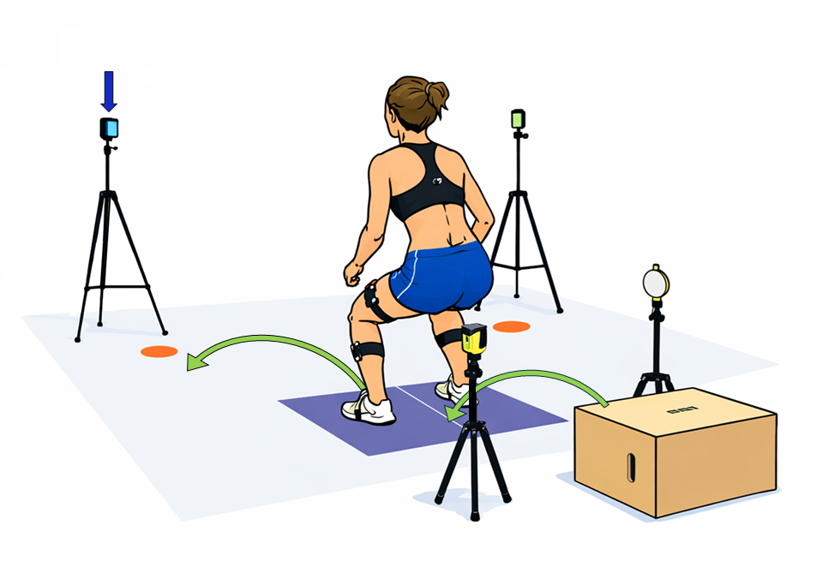

Figure 2. (a) Boxplot representing the distribution of the total multivariate Euclidean distance of valid and failed trials with respect to the optimal pattern; (b) t-test through SPM on the multivariate distance temporal series between valid and failed trials with respect to the optimal pattern; (c) scree plot and cumulative variance for PCA; (d) silhouette analysis for clustering.
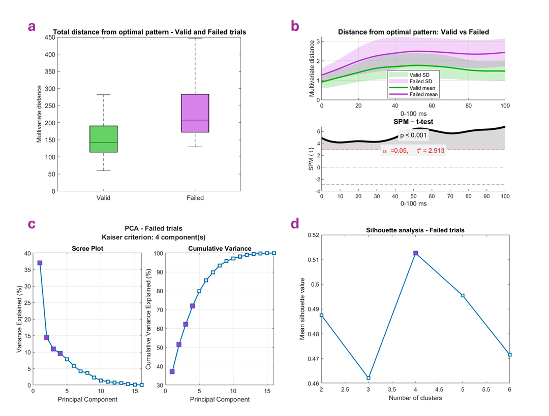

Figure 3. Dendrogram showing cluster separation for failed trials (top); boxplot of score distributions across clusters for principal components showing significant differences in the Kruskal–Wallis tests (middle); graphical representation of cluster motor patterns.
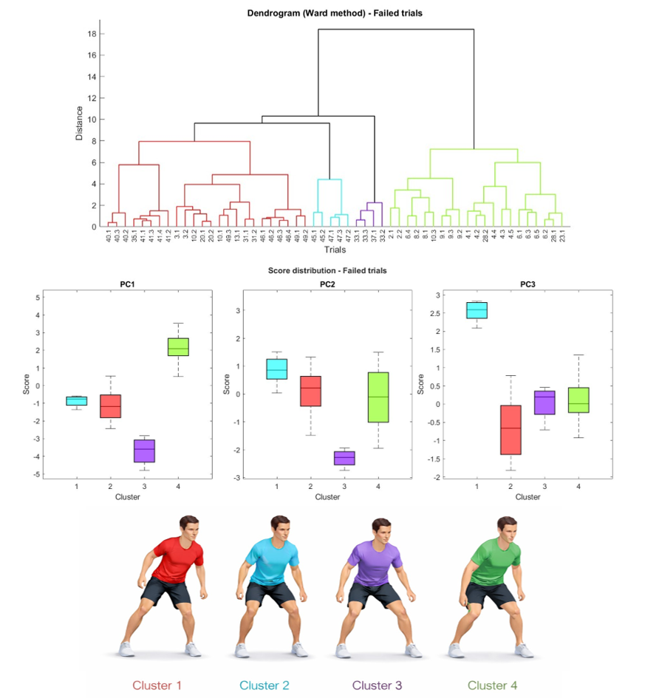

Figure 4. (a) Boxplot representing the distribution of the total multivariate Euclidean distance of valid and bad trials with respect to the optimal pattern; (b) t-test through SPM on the multivariate distance temporal series between valid and bad trials with respect to the optimal pattern; (c) scree plot and cumulative variance for PCA; (d) silhouette analysis for clustering.
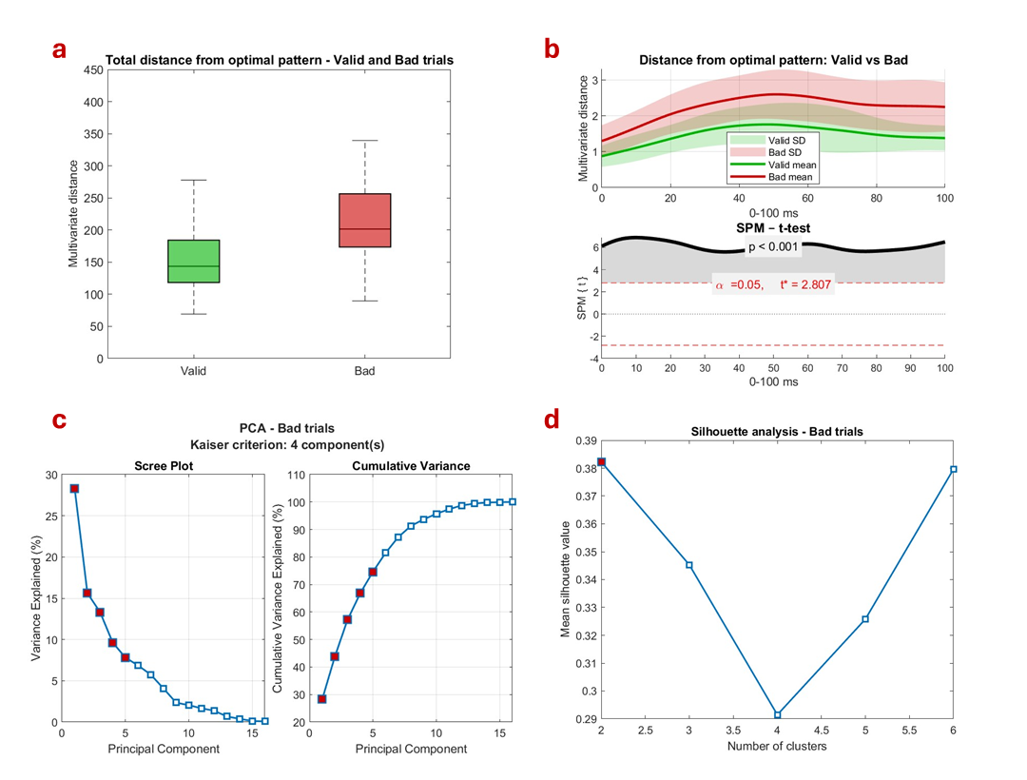

Figure 5. Dendrogram showing cluster separation for bad trials (top); boxplot of score distributions across clusters for principal components showing significant differences in the Mann–Whitney U tests (middle); graphical representation of cluster motor patterns.
