Elvira Spatolisano[1],*

Alberto R. de Angelis[2]

Laura A. Pellegrini[1]

**Middle scale hydrogen sulphide conversion and valorization technologies: a review**

The growing energy demand, together with the depletion of sweet gas reservoirs, impose the monetization of ultra-sour natural gas fields with a high H2S content. To date, in large scale facilities, H2S is removed from natural gas through amine washing and it is converted to sulphur in the Claus process. The Claus process is the leading H2S conversion technology for large scale applications. Regarding small scale plants, scavengers are the most efficient and widely spread choice. On the other hand, present middle scale options show quite high operating costs. Therefore, research efforts are devoted to developing new intermediate scale alternatives with lower costs and easier operability. When developing a new process, the study of the state-of-the-art is the first essential step. No systematic review of H2S valorization technologies is available in literature. To fill this gap, the aim of this work is to summarize the available processes considering both commercial and novel tendencies for H2S conversion. For each technology, details about process operating conditions are discussed and the typical application is provided, when possible, together with the corresponding pros and cons.

**Keywords:** H2S conversion, H2S valorization, sour and ultra-sour gases, sustainable processes

**Author affiliations**

[1] GASP - Group on Advanced Separation Processes & GAS Processing, Dipartimento di Chimica, Materiali e Ingegneria Chimica “G. Natta”, Politecnico di Milano, Piazza Leonardo da Vinci 32, 20133 Milano, Italy.

[2] Eni S.p.A. Research and Technological Innovation Department, via F. Maritano 6, I-20097 San Donato Milanese, Italy.

*Email corresponding author: elvira.spatolisano@polimi.it

**1 Introduction**

Hydrogen sulphide (H2S), also referred to as hydro sulphuric acid, is a colourless, flammable, highly toxic gas. It has a characteristic rotten-egg odour, detectable at concentrations as low as 0.5 ppb. Its normal boiling point is about -60.4°C, while its relative density with respect to air is of 1.1363. H2S is slightly soluble in water; in the aqueous phase it is highly corrosive to metals as it forms metal sulphides [1].

Hydrogen sulphide has several different sources, mainly natural or related to oil and gas or pulp and paper industries. The quantity naturally released into the atmosphere is thought to vary annually in the range 100-324×106 t, with half of this coming from volcanoes, flooded ground, or hydrogeological sources and the other half from oceans [2]. The origin of H2S in reservoirs is linked to chemical reactions. There are six processes responsible of H2S generation, each of which can produce different H2S-containing gases [3]:

1. mineral dissolution (e.g., FeS + 2H+ 🡪 H2S + Fe2+), that produces a gas stream with H2S concentration lower than 50 ppm;

2. low temperatures (< 80°C) bacterial sulphate reduction, which releases a gas with H2S content < 6%;

3. thermal cracking of organic sulphur compounds, whose discharged gas H2S concentration is < 6%;

4. thermochemical sulphate reduction at high temperature and pressure in the presence of sulphate (CH4 + SO42- 🡪 CO2 + H2S + 2OH-). In this case, gas up to 98% of H2S concentration can be produced;

5. lateral or vertical migration from deeper H2S bearing horizons. According to these kinds of processes, also, a gas with H2S concentration as high as 98% can be produced;

6. infection during field operations using contaminated fluids or gases, because of which a gas with H2S concentration as high as 98% can be released.

Industrial sources of hydrogen sulphide include petroleum and natural gas extraction and refining, pulp and paper manufacturing, rayon textile production, chemical manufacturing and waste disposal. Considering natural gas, H2S is one of the major pollutants together with CO2 and other impurities that may be present to a lower extent (e.g., nitrogen [4], aromatics [5] and mercaptans [6]).

In industrial practice, H2S is particularly undesired as a pollutant, not only for its effects on human health and natural environment, but also because it is an important poison for many widely used catalysts. For this reason, hydrogen sulphide needs to be removed from the treated gas streams. Several processes have been developed to accomplish gas purification and vary from simple once-through wash operations to complex multiple-step recycle systems. All the available technologies for H2S conversion are reported in Figure 1, as a function of the process applicability range in terms of produced sulphur rate and H2S feed content.

For small scale applications, scavengers are often used. A sulphide scavenger is a chemical that can react with one or more sulphide species to convert them to an inert form. The majority of H2S scavengers are based on a surface adsorption or ionic precipitation. On the other hand, considering large scale applications, the common practice is to absorb H2S from the acid gas using amines as chemical solvents and then convert the hydrogen sulphide to elemental sulphur in the Claus unit. The Claus process is currently the most efficient large-scale H2S valorization technique, capable of converting H2S to sulphur from highly concentrated sour gas streams. With rich acid gas (i.e., H2S content between 60% and 100% mol), the reaction heat keeps the flame temperature stable, but when the gas is leaner, the flame become unstable, its temperature falling below its critical point, and cannot be maintained [7]. This usually happens when the H2S content is below 50% mol. In this case, some modifications of the straight through Claus process are available, such as the split flow or the OxyClaus. According to the split flow configuration, approximately two-third of the acid gas flows bypasses the furnace. In this way, the flame temperature is kept above the minimum since heat is absorbed by a lower mass of gas, which is however enough to maintain the necessary 2:1 H2S to SO2 ratio. The same result is achieved through an enriched oxygen combustion: using pure oxygen instead of air can guarantee higher flame temperatures with lower H2S concentrations. When the acid gas stream contains less than 15% mol of H2S, it may be difficult to operate the facilities and achieve the necessary recovery efficiency in a modified Claus plant [8]. In such situation, the acid gas stream can be treated in an additional sweetening step with a H2S selective solvent and then routed to the Claus unit.

As an alternative to the Claus process, direct selective oxidation of hydrogen sulphide to elemental sulphur is currently being explored. For sulphur production up to approximately 5 long tons per day (LTD) of sulphur, liquid reduction-oxidation (redox) processes are quite common. In this case, the sulphur is produced as an aqueous slurry.

In this panorama, research efforts are also devoted to the development of novel H2S to valuable chemicals valorization processes. The following sections review the state of the art of middle scale H2S valorization technologies, considering both the commercial processes and the novel tendencies for H2S conversion into valuable products. For each technology, the application is reported as well as the maturity level, together with the related advantages and drawbacks.

0

10

20

30

40

50

60

70

80

90

100

**H2S in acid gas**

**[mol%]**

**Sulphur production**

**[ton/d]**

10

1

100

**Acid gas Enrichment and Claus**

**liquid redox**

**scavengers**

**Claus straight through**

**Claus and Oxygen**

**Claus with split flow and pre-heat**

**Direct oxidation**

Figure 1. Applicability range of different H2S conversion technologies, as a function of the quantity of recovered sulphur and the H2S fraction in the acid gas stream.

**2 Liquid phase H2S oxidation processes**

In liquid phase oxidation processes, H2S is absorbed from a gas stream through the contact with a redox solution in a suitable gas – liquid equipment and directly converted to sulphur in the absorbing solution. The sulphur formation which takes place in the absorber is completed in a downstream reaction vessel, that may also serve as gas – liquid separator. As a consequence of the H2S to S conversion, the solvent oxidizing agent is reduced. A subsequent regeneration step is needed to re-oxidise the absorbent to its original oxidized state. The regenerated solution is recycled to the gas – liquid contactor, while the produced sulphur, usually in the form of a froth or a slurry, is either separated by flotation or by settling, respectively, in a filter unit or in a sulphur melter. Among the all available processes for H2S to sulphur conversion, liquid phase oxidation is currently the most versatile [9]: any type of H2S containing gas stream can be treated (i.e., coke oven gas, natural gas, and synthesis gas with low H2S concentration; for Claus tail gases treatment and for very low raw gas rates handling as landfill gas), at a wide variety of operating conditions and ensuring a removal efficiencies higher than 99%, with concentrations below 1 ppm by volume in the vent gas [10]. The main process steps are shown in Figure 2.

**H2S absorption and reaction**

rich solution

regenerated solution

**H2S oxidation**

**S separation**

recovered solution

Vent gas

Air

sulphur slurry

Sulphur

make-up chemicals

Figure 2. Schematic Block Flow Diagram (BFD) of the liquid phase H2S oxidation processes (adapted from [10]).

Liquid-phase oxidation processes are suitable for the selective H2S removal versus CO2, because carbon dioxide does not react with the typical redox solution. For this reason, these processes can tolerate a high CO2/H2S ratio in the feed gas, whose treatment in a typical Claus unit can be difficult. In addition, liquid phase oxidation processes are a valid alternative for the desulphurization of Economical operation is limited to sulphur production rates less than 20 t/d due to the high utility costs.

The relatively low H2S capacities of the solutions, which can result in large liquid flow rates, is the main drawback associated to these processes, also considering that a continuous solvent make-up is required, as the solvent is usually susceptible to chemical/thermal degradation and because of its losses with the sulphur filter cake. In addition, solvent purging is required due to the accumulation of side products, often thiosulphate. Thiosulphate production can be kept below 1% of the converted H2S, if operating conditions such as temperature and solution pH are carefully managed. Other impurities in the feed stream, such as carbonyl sulphide and organic sulphur components are only partly removed in liquid oxidation processes. On the other hand, hydrogen cyanide and sulphur dioxide are almost quantitatively absorbed forming the corresponding salts in the solution. These salts accumulate in the circulating liquor and increase the required purge stream and the amount of hazardous waste by-products generated.

Typical liquid phase H2S oxidation processes are listed in Table 1, together with the corresponding licensor and the application. They can be mainly distinguished depending on the H2S oxidizing agent: thioarsenate based processes, vanadium oxide based processes, iron chelate based processes, SO2 based processes and biological processes. In addition, also novel H2S valorization technologies are provided.

**Table 1.** Typical middle scale H2S liquid redox processes [11, 12].

|  |  |  |  |  |
| --- | --- | --- | --- | --- |
| **active species** | **process name** | **developer** | **readiness level** | **H2S feed content range [mol %],**  **stream treated\*** |
| thioarsenate | Giammarco-Vetrocoke | Giammarco-Vetrocoke | industrial | < 1.5,  various |
| quinones/ vanadate | Stretford | Nicklin/British Gas | industrial | 0.5 – 25,  various |
| Takahax | Tokyo Gas Co., LTD | industrial | 0.5 – 25,  coke oven gas |
| Unisulf | Unocal Science & Technology Division | industrial | 0.5 – 25,  Claus tail gas, Rectisol or Selexol off-gas |
| Sulfolin | Weber/Linde AG | industrial | 0.5 – 25,  Rectisol off-gas |
| Hiperion | Hasebe/Ultrasystems | industrial | 0.5 – 5,  heavy gas oil |
| iron chelate | LO-CAT | Merichem | industrial | 0.5 – 25,  various |
| SulFerox | Shell/Dow Chemical | industrial | various |
| Sulfint | Integral Eng. | industrial | 0.5 – 5,  Rectisol off-gas |
| iron | Chemical-redox | Eni S.p.A. | pilot | natural gas |
| SO2  (organic phase) | UCBSRP | UCB | pilot | natural gas |
| IFP Clauspol 1500 | IFP | industrial | < 1.5,  Claus tail gas |
| Crystasulf | CrystaTech, Inc | industrial | 0.5 – 5,  natural gas |
| SO2  (aqueous phase) | AquaClaus | Stauffer Chemical Co. | pilot | 0.5 – 25,  natural gas |
| HydroClaus | Eni S.p.A. | pilot | > 50,  amine off gas |
| biological | THIOPAQTM | Shell-Paques | industrial | 0.5 – 84,  various |

*various streams treated include: refinery hydrotreater off-gas; amine off-gas; refinery process streams; coke oven gas; primary natural gas or biogas treating; associated gas (onshore and offshore).

**2.1 Thioarsenate based processes: Giammarco-Vetrocoke process**

The Giammarco-Vetrocoke (G-V) process, in the past widely spread due to its high versatility and flexibility considering the feed gas composition and operating conditions, has nowadays lost market acceptance because of the toxicity of the absorbing solution [10, 11]. Nevertheless, it is still supported by licensors in countries where the usage of an arsenic absorbent is allowed. The maximum inlet gas hydrogen sulphide concentration and sulphur removal capacity are fixed, respectively, at 1.5% and 15 t/d for the convenient process applications [13] and at a maximum of 15 t/d. The process is reported to be capable of producing purified gas containing less than 1 ppm of H2S, even when operated at absorption temperatures up to 150°C and in the presence of substantial concentrations of carbon dioxide in the gas to be treated.

The chemistry of the process is based on alkali carbonate solutions, activated by arsenic salts. The overall reaction mechanism for the absorption-regeneration cycle can be represented by the following equations:

absorption 

digestion 

acidification 

oxidation 

Due to the slow digestion reaction rate, typical operating conditions are high temperatures and high arsenate concentrations. This is a critical step because sulphur is stabilized as monothioarsenate (), thus hindering the subsequent sulphur formation through acidification. The following decomposition into elemental sulphur is favoured lowering the reaction pH, so that sulphur can be recovered in solid phase. The final step, which is the reoxidation of trivalent to pentavalent arsenic, can be achieved by simple contact with air. The process flow diagram is represented in Figure 3.

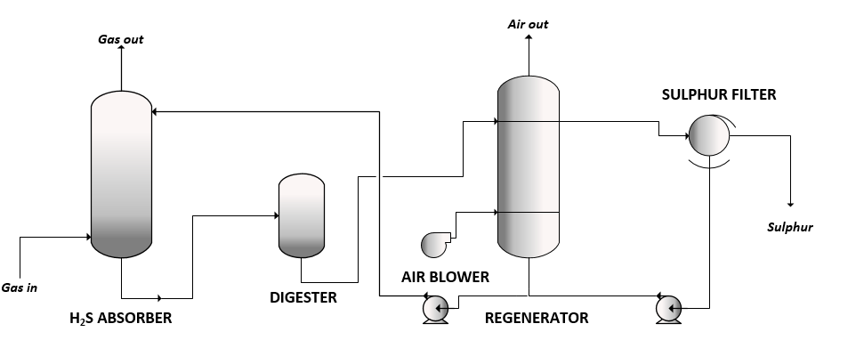

**Figure 3.** Schematic diagram of the Giammarco-Vetrocoke process [11].

Sour gases are contacted with the absorbing solution, an arsenic-activated potassium carbonate solution, into the absorbing tower. The maximum operating temperature of the absorber is of 150°C, with a typical residual H2S content in the treated gas between 0.01 and 1.0 ppm. After washing, the rich solution from the bottom of the absorber flows to a low-pressure digester, where the conversion to monothioarsenate is completed. From the digester, the spent solution is collected into an atmospheric oxidizer, that allows the recycling of the absorbing solution. In the oxidation tower, a froth that contains 90% of the solution and 10% of sulphur is generated. Sulphur is removed by flotation and further concentrated in a rotary vacuum filter of a centrifuge. The main advantage of this process is that the arsenate stabilizes the sulphur such that it is unaffected by the presence of CO2 in the feed gas.

**2.2 Quinones/vanadate based processes**

**2.2.1 Stretford by Nicklin/British Gas**

The Stretford process was the first liquid redox process, on the market since 1959. Although originally thought for the H2S removal from coke oven gas, it proved to be suitable for a variety of other gas streams. It consists in the liquid phase oxidation of H2S to produce elemental sulphur, with vanadium and anthraquinone disulphonic acid (ADA) as the primary catalyst to allow the oxygen transfer in the vanadium regeneration [14]. The overall reaction can be distinguished into three separate consecutive steps:

H2S absorption 

conversion of H2S to S 

vanadium and 

ADA reoxidation 

The H2S absorption is favoured by high pH, as the hydrogen sulphide in the gas phase is in equilibrium with the undissociated H2S in solution. On the other hand, the conversion of the liquid phase H2S to elemental sulphur becomes slow at pH values above 9.5. Therefore, the process is operated within a pH range of 8.5 to 9.5. High temperatures are also beneficial for the H2S conversion, but side reactions ( and , mainly thiosulphate formation reactions) can occur at the same time. Although the desired product is elemental sulphur, 1-5% of the inlet H2S can be converted to sulphur byproduct salts due to these reactions. For this reason, the best operating temperature is around 35°C. Also, the accumulation of sulphate, thiosulphate, and sodium ions in the solution makes necessary a periodical make-up to control the concentration of the dissolved salts.





In the reoxidation step, tetravalent vanadium is oxidized to pentavalent vanadium through the hydrogen peroxide generation of ADA. Unlike the latter, the former is largely insoluble in the Stretford liquor. This insolubility is partially overcome using chelating agents, such as sodium citrate. ADA subsequent reoxidation is rapid and is performed by the simple contact with air. A schematic flow diagram of a typical Stretford unit is presented in Figure 4.

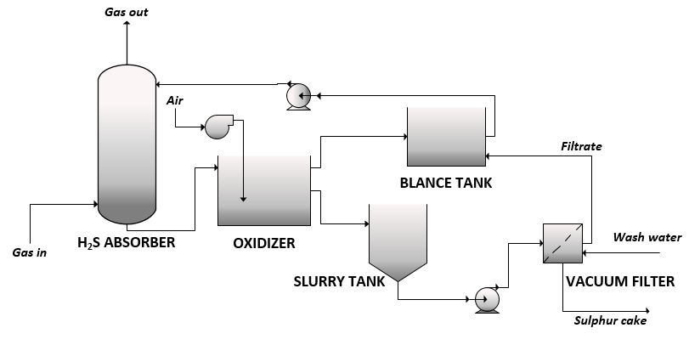

Figure 4. Schematic diagram of the Stretford process [15].

The Stretford facility consists of three major sections. In the first section, the sour gas is contacted counter-currently with the Stretford solution to remove H2S. The rich solution from the absorber flows into a delayed reaction tank, which is the major component of the second section, where the conversion to sulphur is completed. In the oxidation tank, air from the blowers contacts the liquid at the bottom and sulphur froth is floated off at the surface. Oxidized Stretford solution then goes to the circulating pump surge tank for recirculation to the absorber. The third major section of the Stretford plant is the sulphur processing section, which consists of a sulphur slurry tank, filter feed pumps, and a vacuum filter. Because of the low volume of sulphur production, sulphur is accumulated in a slurry tank and maintained in suspension with a mechanical mixer. Periodically sulphur slurry is pumped to a vacuum filter where the sulphur is removed in a semidry form and distributed for sale or disposal. The filtrate is reintroduced into the system at the circulating-pump surge tank.

Stretford has most of the experience with liquid redox processing both with respect to variety of applications and amount of operating time. There are over 120 Stretford plants in operation worldwide in western countries. One of the most important features of the Stretford Process is that it is almost entirely pollution free. Neither gaseous nor liquid pollutants are discharged in the day-to-day operation.

**2.2.2 Takahax by Tokyo Gas Co., LTD**

The Takahax process was commercialized by the Tokyo Gas Company LTD, with the aim of developing a liquid redox H2S removal process comparable to the Stretford process, eliminating the use of heavy metals to oxidize the hydrogen sulphide. The main objectives for the new process industrialization were to minimize the periodic liquid purging commonly used in liquid redox systems and to eliminate the build-up of undesirable contaminants in the scrubbing solution. The Takahax process utilizes naphthoquinone (NQ) compounds as the oxygen carrier, within a pH range of 8 to 9 [11]. The greater NQ redox potential favours a rapid H2S conversion to sulphur, avoiding the addition of vanadium. One of the major drawbacks of the Takahax process is the slow reoxidation of the reduced absorbing solution, that results in high regenerator residence times with consequently high capital costs. The process can also tolerate the CO2 presence in the feed stream: a treated gas containing less than 10 ppm of hydrogen sulphide can be obtained, even when the raw gas contains substantial quantities of carbon dioxide. The process chemistry can be described according to the reactions (11) to (17), where reaction is undesired because it leads to the build-up of ammonium sulphate within the process.

absorption 





regeneration 







Different modifications for handling the Takahax process waste solution are available:

- type A: wet oxidation to ammonium sulphate (represented in Figure 5);

- type B: incineration to sulphur dioxide;

- type C: sulphuric acid production;

- type D: sulphur production.

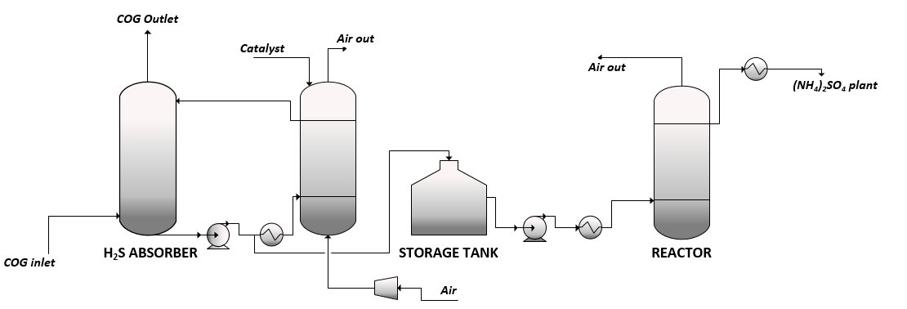

**Figure 5.** Schematic diagram of the Type A Takahax process.

According to the process shown in Figure 5, the cooled Coke Oven Gas (COG) is contacted counter-currently with the absorbing Takahax solution. In the absorber tower, H2S is oxidized to sulphur together with the redox catalyst. The spent solution exiting from the bottom of the absorber, is partially withdrawn and collected into an intermediate storage tank, to prevent the build-up of thiocyanate, elemental sulphur and sulphur salts and partially cooled and regenerated through the contact with compressed air. The redox catalyst is oxidized back and recirculating into the absorber. The spent solution from the storage tank is collected into a reactor, where all salts are converted into ammonium sulphate.

This process configuration (type A) is widely spread in the U.S. Also, type D process is largely diffused in Japan, considering that the displacement reaction between ammonium sulphate and calcium hydroxide leads to the production of ammonium hydroxide and calcium sulphate, which is largely spread in the Japanese construction industry.

**2.2.3 Unisulf by Weber/Linde AG**

The Unisulf process was intended for the clean-up of Claus tail gas, Rectisol or Selexol off-gas, capable of recovering more than 99.9% of the H2S from gas streams containing less than 10 mol % of H2S [16]. The process is quite similar to the Stretford process, but no quinone compounds are present in the Unisulf absorbing solution, since carboxylated complexing agents are used. Unisulf solution offers the same high H2S absorption efficiency as the Stretford one, with better recovery during overloading and lower thiosulfate and sulfate formation. Consequently, problems associated with the operation of Stretford plants about the severe solution disposal are significantly reduced. The typical Unisulf process flow diagram is reported in Figure 6, where all the characteristic H2S liquid redox process sections can be distinguished: the absorber, to wash the H2S containing feed gas; the oxidizer, to complete the H2S to S conversion; the finishing sulphur section, to allow the production of high purity sulphur.

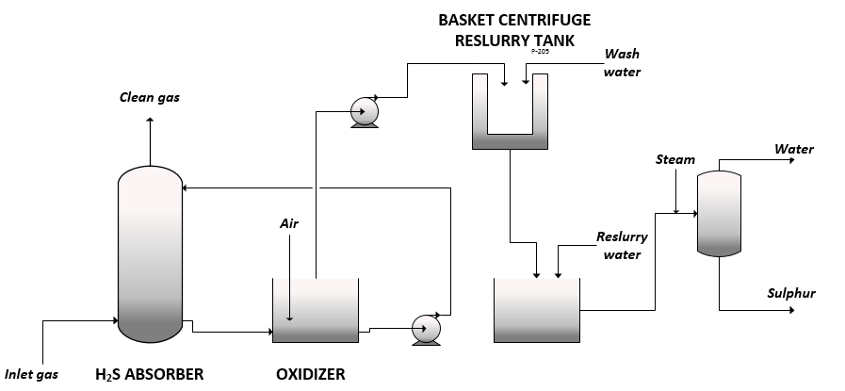

Figure 6. Schematic diagram of the Unisulf process.

**2.2.4 Sulfolin by Weber/Linde AG**

The Sulfolin process, marketed by Linde AG [17], can be interpreted as a modification of the basic vanadium chemistry of Stretford [18]. In addition to vanadium, the absorbing solution contains organic nitrogen compounds. Low by-product formation rates are claimed. The basic chemistry of the Sulfolin process is depicted in the following:

H2S absorption 

oxidation 

regeneration 

Besides elemental sulphur, soluble sulphate and thiosulphate salts can accumulate in the liquor, with a rate that is lower than that observed in the Stretford process. The process flow diagram for a typical Sulfolin plant is shown in Figure 7. The sour feed gas enters the absorber tower, where it is contacted with the washing liquor. The rich solution is then collected into a reaction tank, to complete the oxidation of hydrosulphide to elemental sulphur. Downstream the reaction tank, the oxidizer is dedicated to the absorbing solution regeneration with air. In this way, elemental sulphur particles concentrate in the top froth leaving the oxidizer vessel. The regenerated solution can be pumped back to the absorption unit, while the sulphur froth is collected to a decanter centrifuge, to allow the high purity (purity > 99.7%) sulphur production.

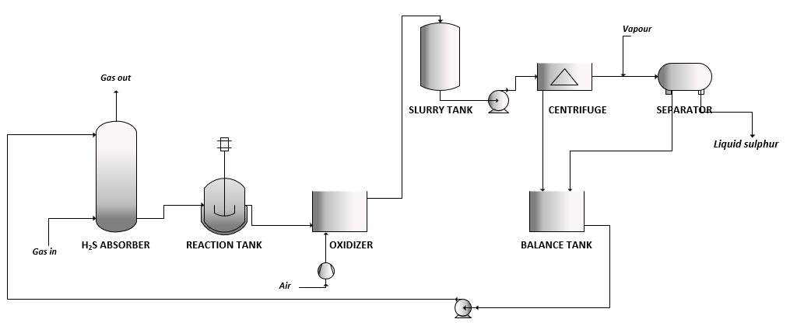

Figure 7. Schematic diagram of the Sulfolin process.

**2.2.5 Hiperion by Weber/Linde AG**

The Hiperion process is a modified version of the Takahax process, in which the active catalyst is a combination of naphthoquinone with chelated iron. This combination is responsible of reducing reoxidation recidence times requirements if compared to the Takahax process, resulting in smaller equipment sizes. The typical process flow diagram is depicted in Figure 8.

Hydrogen sulphide is first absorbed into a unique gas-liquid plate contactor, designed to be resistant to plugging. The spent catalytic mixture from the bottom is then sent to a settler, to allow the sulphur slurry separation from the absorbing solution. The sulphur slurry is periodically withdrawn and sent to a filter, to allow sulphur recovery, while the solution is oxidized with air, to be recycled at the absorption stage [11, 18].

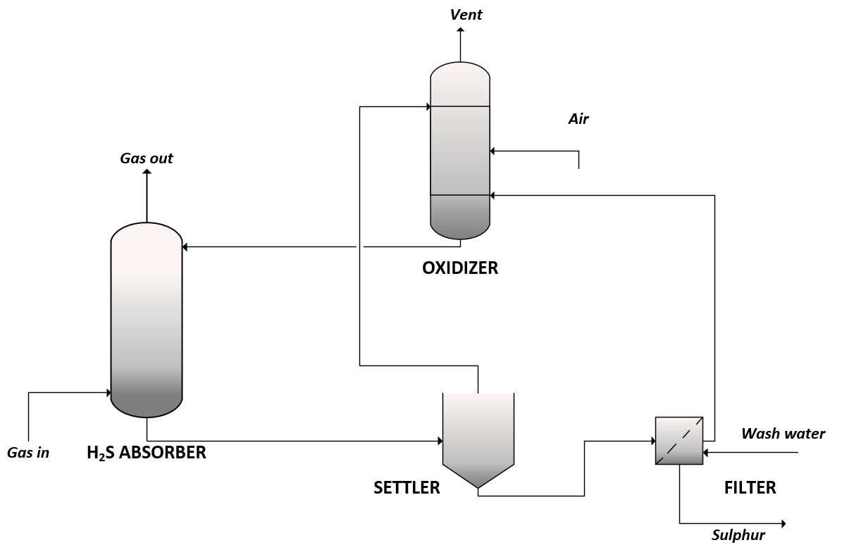

Figure 8. Schematic diagram of the Hiperion process.

**2.3 Iron-chelate based processes**

**2.3.1 LO-CAT by U.S. Filet Engineered Systems**

The LO-CAT technology was developed to provide an isothermal, low operating cost method for carrying out the modified Claus reaction. The technology has been adopted by a number of industries; starting from the oil and gas production (upstream and midstream) and oil refining (downstream), the basic process has been continually improved and modified to allow its expanded use into other industrial segments.

LO-CAT technology contains a proprietary liquid redox catalyst that converts H2S to solid elemental sulphur by carrying out the direct oxidation of H2S as follows:

H2S absorption 

oxidation 

regeneration 

Gas absorption in the liquid solution is the rate determining step of the overall process. Since iron normally precipitates in the solution, chelating agents are added to prevent precipitates formation. Thiosulphate or sulphate formation can also take place due to the oxidation of bisulphide ions, when unreacted bisulphide ion is available in the regenerator or when the lean solution fed to the absorber contains a large amount of dissolved oxygen [11].

For small scale applications, the configuration represented in Figure 9 is the preferred one. Sour gas stream is washed counter-currently to the absorber. Since solid sulphur occurs in this unit, only non-fouling devices may be used. In most cases, a single absorber device can achieve the desired H2S specification for the sweet gas. The rich solution from the absorber is collected into the oxidiser for regeneration, to allow both sulphur recovery and regenerated catalyst solution recycle [19].

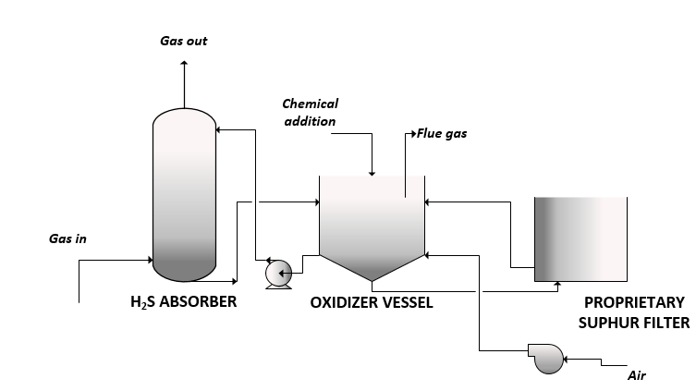

Figure 9. Schematic diagram of the LO-CAT DirectTreat process configuration [19].

**2.3.2 Sulfint by Integral Eng.**

The Sulfint process is based on the use of ethylenediaminetetraacetic acid (EDTA) as the iron chelating agent with slightly alkaline pH, normally between 7 and 9. According to the typical process configuration depicted in Figure 10, sour gas is contacted with the washing fluid in one or more Venturi scrubbers, depending on the required final treated gas purity. The liquid effluent from the scrubber flows to the oxidizer and a sedimentation chamber, to recover the washing solution, recycled back to the Venturi scrubber, and the sulphur product. In the case of high iron chelate loss in the sulphur purification stage, the washing fluid from the sulphur centrifuge can be treated in a reverse osmosis unit to separate the iron chelate from wash water and salts formed by secondary reactions [17].

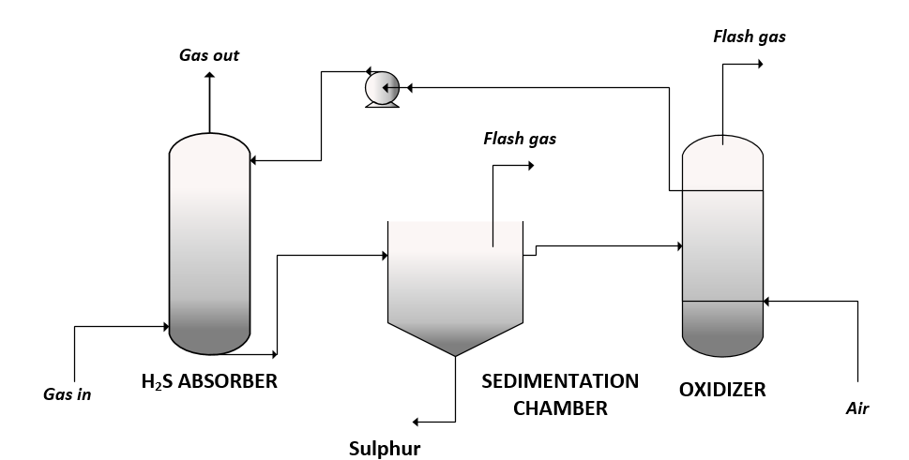

**Figure 10.** Schematic diagram of the Sulfint process.

**2.3.3 SulFerox by Shell/Dow Chemical**

The SulFerox process is a high iron concentration desulphurization process. It utilizes proprietary chemical additives plus operating condition to ensure very high H2S removal capacity as well as to reduce ligand degradation. SulFerox solution contains 2-4 wt.% iron, which results in a very high H2S removal capacity [20]. As a result, system sizes and circulation rates are relatively low. H2S conversion to sulphur is rapid. Thus, mass transfer is the rate determining step for the process. A co-current contactor was developed for the H2S absorption section to take advantage of the high solution absorption capacity and to adjust for the low circulation rates (Figure 11). Non-fouling characteristics are claimed. The sweetened gas flows into a gas-liquid separator; in this way, the sulphur-containing spent solution slurry is collected and fed to the regenerator. The regenerated liquor from the top of the regenerator flows into the settler, where the spent air is vented. Makeup chemicals are typically added to the suction of the main circulation pump to ensure adequate mixing with the process solution. Sulphur may be recovered as a cake or melted and purified, depending on the plant size and economics. The SULFEROX process is suited for handling gas streams that yield between 0.1 and 20 t of sulphur per day [21].

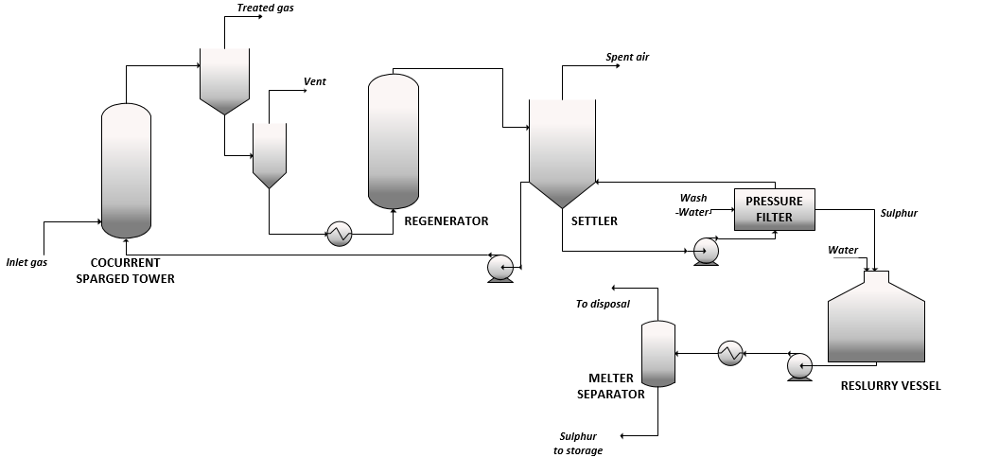

**Figure 11.** Schematic diagram of the SulFerox process.

**2.3.4 Chemical redox by Eni S.p.A.**

The Chemical redox process is a novel liquid redox H2S conversion technology which uses an acid solution containing trivalent iron in the form of nitrate [22, 23]. The process was developed to overcome the drawbacks of low sulphur purity of typical commercial liquid redox processes, such as Locat. In this kind of processes, the sulphur product is usually not Claus grade and cannot be commercialized, due to the presence of chelants in solution, necessary to avoid iron sulphide precipitation due to high pH. For this reason, Eni S.p.A. proposed an acid solution of ferric salts to allow the H2S oxidation to sulphur with the simultaneous reduction of the ferric to ferrous ions. The reaction occurs in the presence of heteropolyacids having general formula HnXVyM(12-y)O40, with n ranging from 3 to 6 and X selected from P, Si, As, B, Ge, y ranging from 1 to 3 and M consisting of Mo or W. The heteropolyacid acts as a catalyst and allows the ferrous ions reoxidation at low pH, which proceeds very slowly in normal conditions. The sulfur produced from ferric nitrate and perchlorate solutions is easily filtered, hydrophobic, and not contaminated by salts.

The proposed process flow diagram is shown in Figure 12.



**Figure 12.** Schematic diagram of the Chemical redox process.

The hydrogen sulphide rich gas enters the absorber where it is oxidized to elemental sulphur by means of the redox solution. The spent reduced solution is then routed to the filtration stage, to allow the sulphur recovery from the produced slurry, while the liquor is collected and sent to the reoxidation reactor, in which the ferrous nitrate is converted to ferric nitrate to be recycled back to the absorption stage.

Pilot tests demonstrated that the process is capable of reducing the H2S content in the off gas to 0.01 ppm, which is below the industrial limit emissions value [24].

**2.4 Sulphur dioxide based processes**

**2.4.1 UCBSRP by UCB**

The first sulphur dioxide-based process was the Townsend process, never commercialized due to mechanical and corrosion problems. After that, the University of California at Berkeley conducted extensive bench scale research on the original Townsend process, using a different physical solvent and catalyst formulation. This process was named the UCBSRP process [25-28], but it has never scaled up to the pilot-plant stage. The solvent is a polyglycol ether with variable composition according to the type of application. The preferred catalyst is 3-pyridyl-carbinol (3-PC) [28].

Figure 13 shows the UCBSRP configuration for high H2S selectivity. Sour gas enters the primary absorber where cool, H2S-free solvent absorbs H2S from the gas stream. The cold recycled solvent contains a small concentration of SO2. The top section of the column is fed with a small amount of cold, lean solvent to reabsorb any SO2 eventually stripped in the lower section. The H2S-rich solvent leaving the absorber is split into two streams: approximately 90% of the solvent flow is sent to the SO2-rich reactor, while the remaining portion flows to the H2S-rich settler. In the SO2-rich reactor, which operates as a continuous stirred tank reactor (CSTR), the precipitation of solid sulphur occurs. The sulphur slurry leaving from the bottom of the SO2-rich reactor flows to the H2S-rich settler, where is separated from the solvent and washed with water in a pusher-type centrifuge. Water and solid sulphur are separated by heating above the melting point of sulphur and decanting the molten sulphur phase from the water phase. Clarified solvent is regenerated in the solvent stripper, which is operated at near atmospheric pressure. Residual CO2 and H2S from the solvent stripper and all flash gas also are sent to the furnace. The heat of combustion is recovered in a waste-heat boiler which produces high-pressure steam.

High H2S selectivity is achieved because other absorbed gases such CO2, H2 and light hydrocarbons are not removed from this chemically regenerated solvent stream which accounts for about 90% of the solvent flow in the primary absorber. The concentrations of these gases in the solvent recycle stream reach equilibrium with their gas-phase concentrations in the sour-gas feed, so very little net absorption occurs.

If compared to the traditional technologies, the UCBSRP has fewer processing steps: equipment requirements are less than for conventional processing. The UCBSRP process is claimed to have significantly lower capital and operating costs than the combination of an ethanolamine absorber/stripper unit plus a Claus plant plus a SCOT tail gas unit [29].

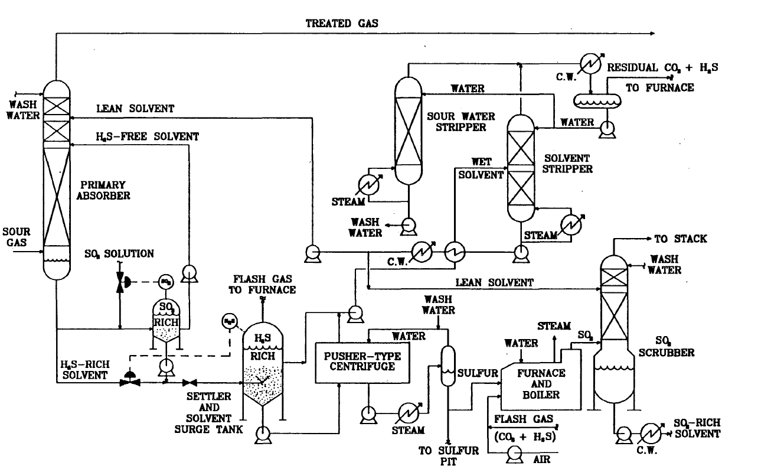

**Figure 13.** Schematic diagram of the UCBSRP process [30].

**2.4.2 IFP Clauspol 1500 by IFP**

The IFP Clauspol 1500 process was developed specifically for the H2S and SO2 removal from the Claus unit tail gases [31]. The catalytic H2S to S reaction takes place in polyethylene glycol, that acts as a common solvent for the H2S and the SO2. Polyethylene glycol was chosen because of its good thermal and chemical stability, low vapor pressure, low costs and low sulphur solubility. The process is operated at temperatures above the sulphur melting point and below the treated mixture dew point.

According to Figure 14a, tail gas enters the bottom of the reactor and flows up through a packed bed, counter-currently to the solvent. H2S and SO2 are absorbed by the solvent, which contains a proprietary catalyst, and converted to sulphur. The produced sulphur is only slightly miscible with the solvent and, owing to its higher density, is recovered as a separate liquid phase from the bottom of the reactor. Very high conversion rates are achieved if the H2S/SO2 ratio is maintained near the stoichiometric value of 2. The process reaction rate is limited primarily by the H2S mass transfer from the gas phase to the liquid. Therefore, the reactor is packed with high surface area ceramic material.

a) 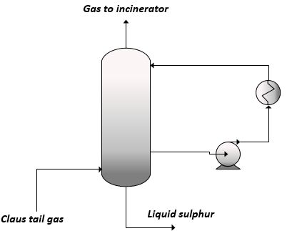 b) 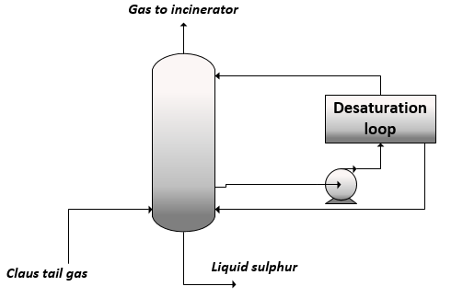

**Figure 14.** Schematic diagram of the: a) IFP Clauspol process; b) IFP Clauspol with Desaturation loop (Clauspol booster 99.9+) [32].

The other sulphur components eventually present in Claus tail gases, as COS and CS2, can be partially hydrolysed to H2S through reactions and .





To reduce the amount of sulphur in the off-gas, the Clauspol with Desaturation loop (Clauspol booster 99.9+) has been introduced (Figure 14b). Since the solubility of elemental sulphur in the solvent is low, in this configuration, the off-gases are contacted with an unsaturated solvent (containing less sulphur than the equilibrium), which comes out from the proprietary solvent desaturation loop, developed by IFP. This enables to reduce process sulphur emission in the gas phase, without modifying the basic reactor features.

The IFP Clauspol 1500 process is relatively inexpensive and easy to operate; however, the SO2 emissions (1000 ppm) are high in comparison to other competing Claus plant tail gas processes. It is now licensed all over the world, making it one of the most widespread tail gas treatment (TGT) processes.

**2.4.3 CrystaSulf by CrystaTech, Inc.**

CrystaSulf process was developed for the treatment of gases having a H2S content too high to use a scavenger system but too low to use a conventional amine/Claus approach [33]. The technology removes H2S from sour gas and converts it to elemental sulphur, through a patented non-aqueous liquid phase solvent [34, 35]. Since the solvent is capable of dissolving elemental sulphur, no solid handling related problems are observed within the plant [36]. Although it has several other applications, CrystaSulf was developed specifically to treat high-pressure sour natural gas. The process is similar to the aqueous-iron liquid redox sulphur recovery processes, but CrystaSulf controls the location where elemental sulphur particles are formed. Since it is not adversely affected by common gas contaminants, CrystaSulf is effective on gas streams containing carbon dioxide, oxygen, mercaptans and slugs of liquid hydrocarbons [37]. The solution has a very high affinity for SO2, ensuring that it is not emitted into the sweet gas. Figure 15 shows a schematic diagram of the process. Sour gases are contacted with the absorbing solution to ensure acid gas washing. Rich solution from the absorber passes to a flash step. Depending on the processing conditions, flash gases may be compressed and then returned to the inlet stream. After the flash step, the solution flows to a crystallizer where the temperature is lowered and solid elemental sulphur crystals form. The crystallizer liquor is thus recycled back to the absorption section. A heater in the lean solution return line ensures that all elemental sulphur is in a dissolved state.

For high-pressure applications, the SO2 needed for the reactions can be added two different ways. Pure SO2 can be purchased and metered into the system; this option is economical where SO2 is readily available for purchase and sulphur throughputs are small. Alternately, a portion of the product sulphur can be burned, and the resulting SO2 can be absorbed into the CrystaSulf solution via a separate small SO2 absorber.

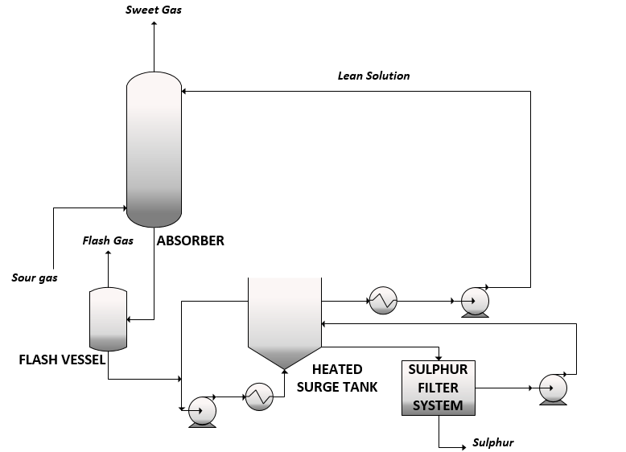

**Figure 15.** Schematic diagram of the Crystasulf process [38].

Claimed performances are low byproduct make rates (less than 0.2% of inlet sulphur) and high sulphur quality (purity > 98% on dry basis). The process shows lower capital and operating costs than the competing technologies (i.e., amine/aqueous iron liquid redox and amine/Claus/tail gas treating) and smaller plant footprint, thus being suitable to both on-shore and off-shore applications.

**2.4.4 AquaClaus by Stauffer Chemical Co.**

The AquaClaus process was originally developed in the 1980s and, after building a 28 tpd sulphur recovery pilot plant in Queen City, Texas, US, mechanical issues were detected that plagued the process, because of the carryover of colloidal droplets of molten sulphur [39].

The original process is reported in Figure 16 and consisted of a first SO2 absorption stage, which used a solution produced from phosphoric acid, sodium carbonate and water, to reduce the SO2 content of the off gas down to 10 ppm. A byproduct stream of Na2SO4·10(H2O) is also produced in this stage. The sulphate must be purged to prevent buildup in the operating solution. This is accomplished with a crystalliser. The SO2 solution is then sent to the reactor, where it is contacted with H2S to allow its conversion. The solution is below the melting point of sulphur and solid particles of sulphur form immediately. One of the unique features of the technology is that no SO2/H2S ratio control was required. The excess H2S gas and the liquid sulphur slurry produced are collected into the slurry holding tank. The liquid slurry then flows into the intercooler for preheating, to allow sulphur melting in the steam heated heat exchanger. A phase separator allow the sulphur product recovery from the absorbing solution, which is recycled back to the absorption column.

After the original process was abandoned, AquaClaus II, a development on the original technology, tries to address the problems detected. According to this process modification, a bag filter, acting as a coalescing element, was installed on the liquid inlet and discharge on the filter going to the intercoolers. Deionised water must be used for makeup solution preparation so that nickel chloride is not introduced into the system. In the new design, in order to prevent the plugging of the three intercoolers in series, two vertical Klaren BV self-cleaning heat exchangers replace the three intercoolers. A distribution system in the inlet channel provides a uniform distribution of liquid and particles into all the tubes. From the outlet channel, the particles are carried to the separator where they disengage from the liquid and are returned through the external downcomer into the control channel, and from there through a connecting line into the inlet channel. The flow of particles is activated by the control liquid flow, which is a fraction of the total liquid flow supplied to the exchanger. By changing the control liquid flow, the intensity of the cleaning action can be varied. Aquaclaus II seems a viable alternative for sulphur recovery, since the technological problems experienced in the original AquaClaus have been eliminated. Nevertheless, its feasibility at the industrial scale has still to be demonstrated.

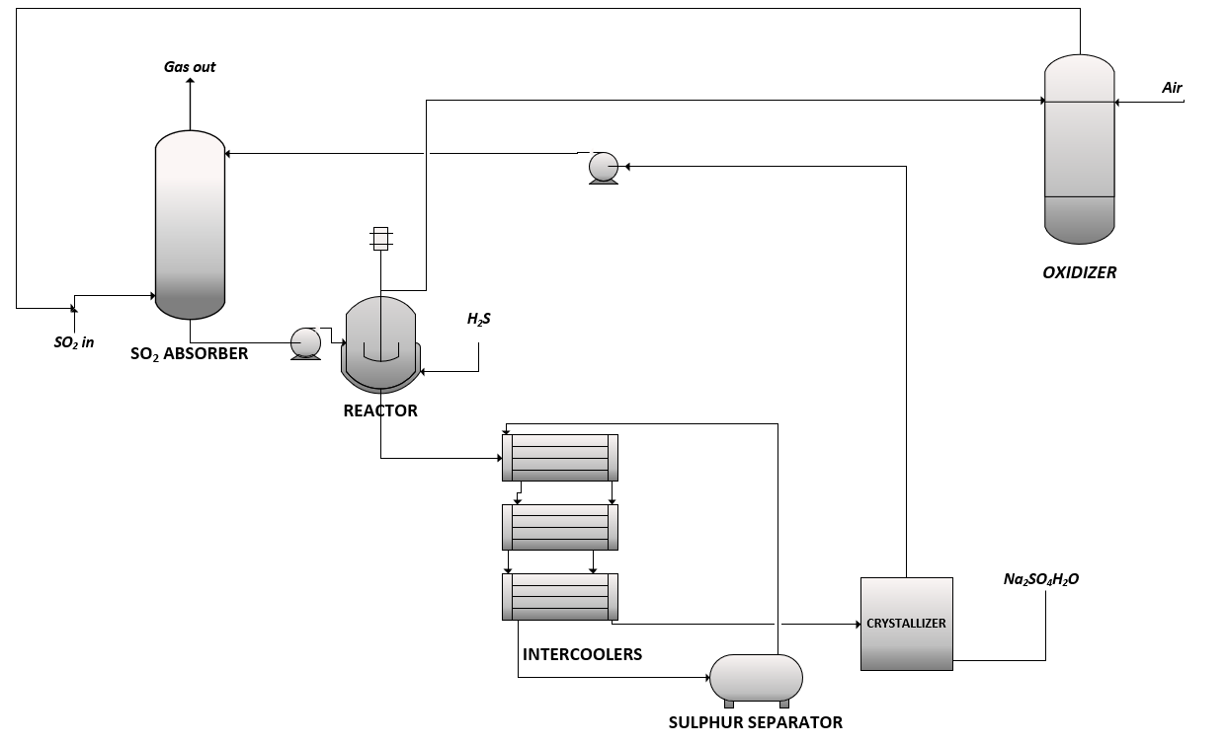

**Figure 16.** Schematic diagram of the AquaClaus process [38].

**2.4.5 HydroClaus by Eni S.p.A.**

In the liquid redox H2S technologies panorama, the HydroClaus process, patented by Eni S.p.A.[40], arises as an alternative to the traditional Claus technology. It consists in the liquid phase oxidation of H2S by SO2, forming a colloidal mixture of sulphur and sulphur rich compounds, the polythionates. The process chemistry can be described through reactions and .





This mixture is highly hydrophilic, as opposed to the traditional Claus sulphur, due to the presence of polythionate anions, which qualify for the product amphiphilic behaviour in water [41]. The product water solubility makes it particularly suitable for agricultural uses, as fertilizer and soil improver. However, polythionates can find application in several fields, due to their extreme versatility (i.e., solutions for chemical milling, lubricants or coolants for metal machining, eluting agents in gold leaching processes). This flexibility, together with their lack of abundance, make them significantly valuable products [42].

The typical HydroClaus reaction operating conditions are ambient temperature, ambient pressure and variable pH from 3 to 2. The reaction operating conditions strongly affect the nature and the distribution of polythionates produced. It was found experimentally [43] that working at pH > 1 causes the preferential formation of polythionate ions with respect to sulphur. A pH increase corresponds to a reduction in sulphur production and to an increase in polythionate ions formation whose sulphur chains become shorter and shorter, up to the formation of thiosulphate (S2O32-) only. At pH = 8 the reaction seems incomplete and proceeds slowly: a considerable portion of H2S remains unconverted. In addition to the pH, also the initial H2S/SO2 ratio can significantly influence the nature of reaction products. When a significant excess of H2S is fed to the reactor, sulphur and short chain polythionates are preferentially produced (mainly S4O62-). On the other hand, when SO2 is the most abundant reagent, SnO62-, with n ranging from 4 to 8, are essentially formed [43, 44].

Moreover, the obtained suspensions are typically constituted by particles of small dimension, which can be directly pumped into the porous matrix of suitable geologic structures, not necessarily in fractures or under conditions of hydraulic fracturing [45]. As an example, Figure 17 reports the particle size distribution (PSD) resulting of laser diffraction granulometer.

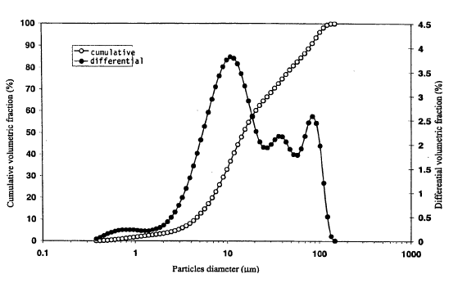

**Figure 17.** Example of sulphur Particle Size Distribution (PSD) in the HydroClaus process.

The typical process configuration, reported in Figure 18, can be distinguished into different subsections:

* combustion section, where a portion of the H2S fed to the unit battery limits is converted to SO2 by oxidation with air. At the furnace outlet, the high enthalpy content associated with the outlet stream is recovered producing high pressure steam;
* absorption section, essentially composed of the absorption tower, in which the SO2 rich gas is absorbed with water;
* reaction section, fed with the H2S rich stream and the liquid phase SO2 stream coming from the absorption unit. The outlet mixture, that is a gas-liquid-liquid mixture, is sent to a phase separator. Here, the gas phase, containing unreacted H2S and SO2, is recycled back to the combustion section. The aqueous phase is purified by air stripping in the C-101 column and the polythionate product is recovered.

In its traditional configuration, the process showed some critical issues related to fouling phenomena and process water management. For this reason, a process modification has been proposed, which is detailed elsewhere [46]. This modification introduces an amine-based species in the reaction section, such that the reaction occurs in the organic phase, that separates spontaneously from the aqueous phase, that can be recycled back to the absorption section.



Figure 18. Schematic diagram of the HydroClaus process.

**2.5 Biological processes**

**2.5.1 THIOPAQTM  by Shell-Paques**

THIOPAQ™ [47] is a biotechnological process for removing H2S from gaseous streams by absorption into a mild alkaline solution, followed by the oxidation of the absorbed sulphide to elemental sulphur by naturally occurring microorganisms [48-50]. The dissolved sulphide is oxidized into elemental sulphur in the THIOPAQ™ reactor, according to the following reactions:

absorption 

reaction 



To avoid accumulation of sulphate ions, a continuous bleed stream from the bioreactor is required and make-up water with some caustic is needed. According to the process scheme reported in Figure 19, the sour natural gas is washed in the absorber counter-currently. Treated natural gas leaves the top of the absorber and is routed to the sales gas grid via a knockout drum, while the loaded THIOPAQ™ solvent flows from the absorber into the horizontal flash vessel. The flash gas, which contains some H2S, is washed in the small column on top of the flash vessel. Flashed, loaded THIOPAQ™ solvent is then sent to the bioreactor. A blower supplies air to a distributor in the bottom section of this tank, to ensure that the content of the bioreactor is continuously mixed, also. Part of the supplied oxygen is consumed in reactions with sulphide and sulphur. The bacteria catalyse the regeneration reactions and the reaction of sulphide with oxygen to give either elemental sulphur or sulphate. The regenerated THIOPAQ™ solvent is recycled to the main absorber, the flash absorber, the solids separator and to the top of the bioreactor. The regenerated solvent leaving the bioreactor typically contains 10 kg sulphur per cubic meter. The solvent is concentrated into sulphur slurry with around 10 wt.% sulphur content in the solid separator, the clarified water phase is returned to the bioreactor. This sulphur slurry is further concentrated into a sulphur paste, with around 65 wt.% sulphur content, in a decanter-centrifuge. The sulphur paste produced can be routed to landfill.

The Shell-Paques/THIOPAQ™ process offers minimal chemical consumption, high turndown ratio and essentially 100% conversion of sulphide in the bioreactor, with 95-98% selectivity to elemental sulphur. In comparison to traditional removal processes such as the Amine/Claus process, the THIOPAQTM process claims very simple line-up, therefore little control and supervision are required and a quite high flexibility to the H2S inlet content [50].

In addition, despite THIOPAQTM is not designed to convert ammonia, approximately 35% of the ammonia present in the incoming gas streams will be converted, being incorporated into the protein structure of the microorganisms [51]. The original THIOPAQTM process for biogas applications was then extended to natural gas and syngas applications. Also, UOP and Paques adapted it for the treatment of spent caustic and LPG. All these process modifications are summarised in Table 2, together with the different applications and the corresponding developer.

**Table 2.** Names and developers of biological H2S removal processes [51].

|  |  |  |
| --- | --- | --- |
| **application** | **process name** | **developer** |
| Natural gas | Shell-Paques | Shell, Paques |
| Synthesis gas | Shell-Paques | Shell, Paques |
| Claus Tail gas | Bio-SCOT | Shell, Paques |
| Refinery gas | THIOPAQTM | Shell, UOP, Paques |
| Spent caustic | THIOPAQTM | UOP, Paques |
| Selectox Tail Gas | THIOPAQTM | UOP, Paques |
| LPG | THIOPAQTM | UOP, Paques |

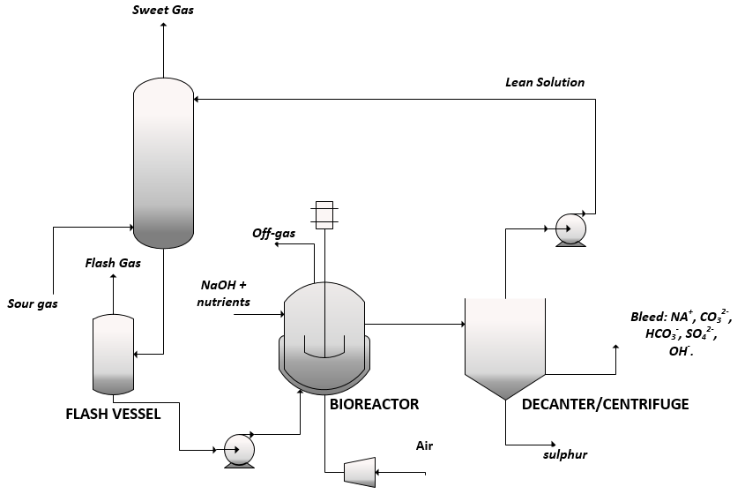

**Figure 19.** Schematic diagram of the THIOPAQTM process [50].

**3. Direct H2S oxidation processes**

According to the direct H2S oxidation process, the sour gas stream is catalytically oxidized to sulphur in gas phase. Catalysts based on metal oxides are the most widely used. These catalysts have high activity and selectivity, and allow to operate at milder conditions while ensuring a total H2S conversion of 80–100%, depending on the temperature range. A list of the most diffused direct H2S oxidation processes is reported in Table 3, together with their readiness level and the typical application.

**Table 3.** Typical middle scale H2S direct oxidation processes.

|  |  |  |  |
| --- | --- | --- | --- |
| **process name** | **developer** | **readiness level** | **H2S feed content range [mol %],**  **stream treated\*** |
| Catasulf® | BASF | industrial | 1 – 50,  various |
| Sulfatreat® DO | M-I Swaco | pilot | 3 – 4,  various |
| Selectox | Unocal | industrial | 1 – 40,  Claus tail gas, natural gas |
| MODOP | Mobil Oil Corp | industrial | 0.5 – 8,  Claus tail gas, amine offgas |
| Xergy ACT | Xergy processing Inc. | industrial | 0.5 – 35,  various |

*various streams treated include: refinery hydrotreater off-gas; amine off-gas; refinery process streams; coke oven gas; primary natural gas or biogas treating; associated gas (onshore and offshore).

The general process configuration is shown in Figure 20. H2S is directly oxidized with air or oxygen, in the presence of a suitable catalyst. After the reaction stage, sulphur is separated through condensation from the gaseous mixture. The unreacted H2S can be recycled back to the reaction section, while the remaining gases can be vented, if their composition in line with the emission limits.

**H2S oxidation**

**S condensation**

vent gas

Inlet gas

Air

Sulphur

H2S recycle

**Figure 20.** Schematic Block Flow Diagram (BFD) of direct H2S oxidation processes.

**3.1 Catasulf® by BASF**

The Catasulf process [52] is a direct catalytic oxidation of the H2S to elemental sulphur by means of oxygen-containing gases. The direct catalytic oxidation is carried out in a simple tube reactor, with indirect removal of the heat of reaction by means of a coolant, with either the catalyst in the jacket and the coolant in the tubes of the reactor or viceversa. The proprietary catalyst contains molybdenum and nickel and/or cobalt. Claimed performances are sulphur yields of more than 90% and H2S conversion in between 92 to 95%.

The sulphur formed in the tube reactor is isolated from the reaction mixture in a downstream condensation stage, with simultaneous generation of steam (see Figure 21). The condensed sulphur is removed in a cyclone separator and collected in a vessel. The gas leaving the cyclone separator has a residual sulphur content of 0.51% by volume, the sulphur compounds consisting of SO2, H2S, together with traces of CS2 and COS. In the finishing stage, all these sulphur-based compounds together with the elemental sulphur still present in the vapour phase, are hydrogenated to H2S with a Co/Mo catalyst, while the residual COS is removed by hydrolysis with the subsequent formation of CO2 and H2S. The acid gas thus obtained is routed to a sieve tray absorption column, which uses methyldiethanolamine as absorbing agent. The scrubbed carbon dioxide, which had a residual H2S content lower than the accepted emission limits can be discharged into the atmosphere, while the unconverted H2S can be returned to the inlet of the catalytic oxidation reactor.

The process is particularly economical at H2S contents from 1 to 50% by volume and can be applied to different gaseous streams: gases from partial oxidation plants, coal gasification plants, natural gas scrubbers or refineries gases, natural gases. The oxidizing agent can be either oxygen itself, enriched air with oxygen.

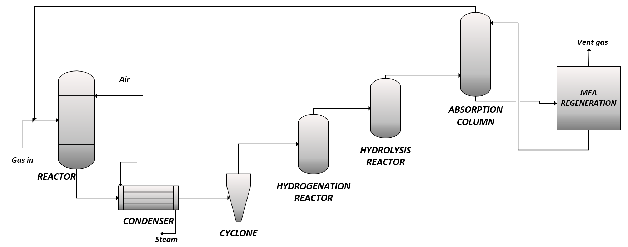

**Figure 21.** Schematic diagram of the Catasulf process.

**3.2 Sulfatreat® DO by M-I Swaco**

The Sulfatreat® DO process converts hydrogen sulphide in various gas streams into elemental sulphur and water by catalytic oxidation with air [53]. The proprietary catalyst was developed by TDA Research, Inc and is a mixed-metal-oxide based catalyst with uniform shape and size between 4 and 40 mesh. A selectivity higher than 99% for sulphur with little (< 50 ppm) SO2 formed and a conversion of about 90% of H2S is claimed [54]. The typical H2S concentration of the treated sour gas is around 3-4%.

A liquid knockout drum is located upstream of the direct oxidation reactor to minimize exposure of the catalyst to hydrocarbons. Liquids eventually present in the feed streams are removed from the bottom of this knockout drum, while the gas phase is heated and then sent to the direct oxidation reactor, usually made in carbon steel and operated adiabatically, to complete the H2S to sulphur conversion. Downstream the oxidation reactor, a sulphur condenser is responsible to the sulphur separation from the gaseous stream, which is a desulphurized gas. The sulfatreat system should be placed upstream of the dehydration step [55].

Different process modifications exist:

* the standard configuration;
* Sulfatreat HP, that can guarantee faster reaction rates in water saturated gas streams;
* Sulfatreat 410 HP, suitable for the low pressure applications and odor control;
* Sulfatreat XLP, with a bed life higher of about three times;
* SulfaTreat HC, to remove hydrogen sulphide and some light mercaptans from liquid hydrocarbons.

Once spent, the catalyst can be disposed as an environmentally non-hazardous waste.

**3.3 Selectox by Unocoal**

The Selectox process is another H2S gas phase catalytic oxidation over proprietary catalysts.

The process can be used for different H2S containing gases (i.e., Claus plant tail off gas, sour natural gas and geothermal), with a H2S content ranging from 1 to 40% by mol.

According to the typical process configuration, the acid gas stream is mixed with stoichiometric amount of air to oxidize one-third of the inlet H2S to SO2. The classic Claus reaction then occurs between the remaining H2S and the SO2 generated [12]. Several stages of catalyst beds can be used to improve the sulphur recovery. Depending on the feed gas composition, several process modifications are available [11]:

* Beavon Sulfur Recovery, which uses a proprietary catalyst to hydrogenate all the COS and CS2 to H2S before the acid gas is routed to the Selectox reactor;
* recycle Selectox, according to which part of the reactor effluent is recycled to limit the temperature rise, when the inlet concentration of the H2S is higher than 5%.

**3.4 MODOP by Mobil Oil Corp**

In the MODOP process, the H2S oxidation to elemental sulphur is carried out through TiO2 catalysts. In this process, water should be removed from the tail gas before the reaction, due to the deactivation of catalysts in the presence of water [56]. For this reason, a quench tower is placed upstream the reaction section in the traditional process scheme. After the water removal, the tail gas is first heated in a reducing gas generator and then it enter the reactor, where all the sulphur components of the tail gas are catalytically converted to hydrogen sulphide in a hydrogenation stage. The produced sulphur is separated from the gaseous stream in a condenser. About 90% of the H2S is converted to elemental sulphur but, if a higher recovery is required, additional oxidation stages may be added [11].

**3.5 Xergy ACT by Xergy Processing Inc.**

The Xergy ACT [57] (Advanced Catalytic Technology) is a dry gas phase direct oxidation of H2S to elemental sulphur and water over an activated carbon catalyst. Two process versions exist: the sub dew point and the above dew point process [58]. The sub dew point process is similar to sub dew point tail gas clean up. The above dew point process operates like a converter in the modified Claus process. A schematic flow diagram of the sub dew point process is shown in Figure 22.

According to the sub dew point process, the elemental sulphur produced is absorbed into the catalyst and builds up until the reactor is full. At this time, the reactor is switched to regeneration cycle while the reactor that has been on regeneration cycle is switched to reaction cycle. Regeneration gas is a slipstream from the front end of the process, so that sulphur is removed by heating to favour its desorption or vaporization. The sulphur is then recovered by condensation in a condenser downstream the reaction section. The vapour from the condenser is recycled back to the front end of the process. In the above dew point process, the produced sulphur is in the vapour phase and is simply recovered through a condenser downstream the reaction section.

The Xergy process is reported to be simpler and less expensive than the other sub dew point process, but conversions are approximately 10% lower. On the other hand, according to the above dew point configuration, a H2S concentration of about 5% can be treated. Nevertheless, similarly to the Selectox technology, the process is applicable up to about 35% H2S with a recycle configuration. For cases above 35% H2S in acid gas, raw gas can be treated. The Xergy ACT sulphur product is Claus quality (bright yellow) molten sulphur, easy to sell or dispose. The process is environmentally responsible and no waste streams are produced.

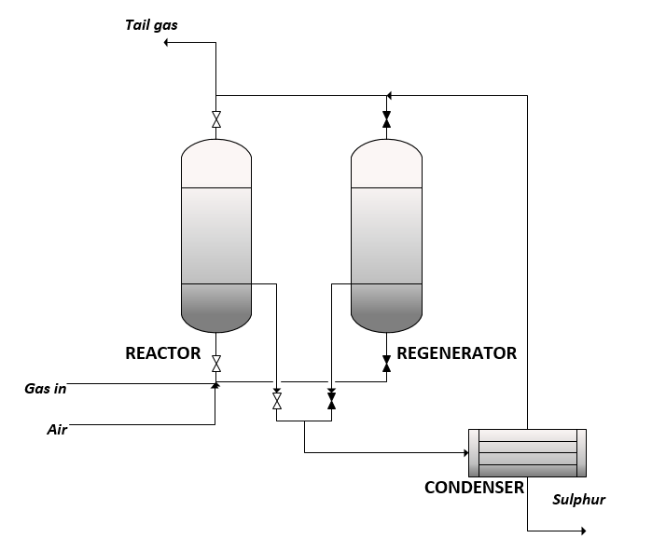

**Figure 22.** Schematic diagram of the sub dew point Xergy process.

**4. Novel H2S to H2 valorization processes**

Hydrogen sulphide can also represent a potential source of hydrogen. The recovery of hydrogen and sulphur from waste hydrogen sulphide is an interesting alternative to the manufacture of sulphur alone. In recent years, research efforts are concentrated in this respect and different processes for the H2S valorization to H2 have been proposed. A complete review of H2S to H2 valorization processes was published by De Crisci and co-workers in 2018 [59]. The main H2S to H2 conversion processes reported in literature are:

- H2S Methane Reformation (H2SMR), which is undoubtedly the most mature technology for hydrogen production from hydrogen sulphide [60, 61]. The reaction behind the process is:

 

The process is strongly endothermic: high temperatures are required to obtain a significant hydrogen yield. Working conditions such as high temperature and excess of H2S with respect to the stoichiometric are necessary to prevent the formation of carbon deposits, due to the methane pyrolysis reaction, which could hinder the reactor's operability. Compared to the traditional methane steam reforming, H2SMR has the advantage of not producing direct CO2 emissions in the reaction phase. The Technology Readiness Level (TRL) of hydrogen sulphide methane reformation is 6, so its commercialization on industrial scale looks promising.

- Direct decomposition via non-thermal (cold) plasma. Non-thermal plasma decomposition is the second most mature technology for the decomposition of H2S to H2. It is based on reaction (30) and it has the advantage of converting hydrogen sulphide at a relatively low temperature, overcoming the limit imposed by thermodynamics.

 

The TRL of the technology is 5-6. However, the unconventional equipment necessary in this case needs to be further tested, to verify its durability and scalability. Furthermore, since the reaction mechanism is not fully understood, an in-depth kinetic analysis would be required to identify the influence of operating conditions and feed composition on the process.

- Photocatalytic decomposition, that uses solar energy to convert H2S to H2. The process can be represented as follows:



Several materials can be used as photocatalysts, such as: TiO2, ZnO, MnS, In2S3, CdS, ZnS, ZnIn2S4. The process can take place both in gas and liquid phase, even if the latter is the preferred one because of the higher H2S concentrations available in the liquid phase. The main problems associated with the photocatalytic H2S decomposition are the sulphides presence in the reaction mixture, which can form yellow polysulphides that hinder the light absorption and the need of expensive UV lamps. The low TRL of this technology, which is equal to 3, makes it necessary to deepen research on a laboratory scale, before thinking to a potential commercialization of the process.

- Thermochemical decomposition through cycles of iodine, metals or sulphides. The thermochemical decomposition through iodine based cycles (reactions (32) and (33)), metals or sulphides based cycles (reactions (34) to (37)) and CO/COS based cycles (reactions (38) and (39)) presents a very complex reacting mixture, that makes its separation difficult downstream of the reaction stage. This hinders the scale-up of the technology to the industrial level. The TRL of this technology is equal to 4.

iodine based cycles 



metals or 

sulphides based cycles 





CO/COS 

based cycles 

- Thermocatalytic decomposition, that involves the use of a catalyst to reduce the reaction temperatures. The TRL of this technology is equal to 4: problems such as SO2 formation in the case of the oxidative decomposition and the catalyst deactivation currently hinder its industrial scalability.

- Decomposition by electrolysis. The process of decomposition by electrolysis presents, at present, two main problems to its industrialization: the electrodes passivation and the formation of polysulphides in the reaction environment. The TRL of this technology is 4.

All the described technologies are classified according to their TRL [62] in Figure 23. As represented in Figure 23, among the available alternatives, the Hydrogen Sulphide Methane Reformation (HSMR) is the readiest to the commercial level scale up, followed by the non-thermal plasma decomposition.



Figure 23. Available H2S to H2 valorization technologies, classified according to their TRL.

**5. Conclusion**

In this work, an overview of several middle scale H2S valorization technologies is presented. Such technologies have been grouped in different categories:

* liquid phase oxidation technologies;
* gas phase oxidation technologies;
* novel tendencies for the H2S valorization.

As a general remark, with respect to the traditional amine absorption and subsequently Claus oxidation to sulphur, these processes offer the advantage of the simultaneous gas purification and valorization. In addition, milder operating conditions are required for the reaction due to the higher catalysts activity [8]. Different commercial alternatives can be selected depending on the initial feed composition and the desired application. In this panorama, also novel approaches for the H2S valorization are under development. Considering the increasing energy demand and the current tendency to benefit from sour and ultrasour gases, the dissemination of these novel waste valorization processes can be helpful in both reducing hazardous emissions and promoting the circular economy approach. Nevertheless, still a lot of research effort is needed to scale up these technologies to the industrial level.

**References**

1. Aid, C. C. F. Souces of H2S. <https://firstaidcalgary.ca/h2s-alive-course/sources-of-h2s/>

2. Pouliquen, F., Hydrogen Sulfide. In *Ullmann's Encyclopedia of Industrial Chemistry*, Wiley-VCH Verlag GmbH & Co. KGaA, W., Ed. 2005.

3. SA, S. G. M. Assessment and mitigation, ADDS UP, SGS H2S solutions. <https://www.sgs.com/-/media/global/documents/brochures/sgs-ogc-h2s-en.pdf>

4. De Guido, G.; Messinetti, F.; Spatolisano, E., Cryogenic Nitrogen Rejection Schemes: Analysis of Their Tolerance to CO2. *Industrial & Engineering Chemistry Research* **2019,** 58, (37), 17475-17488.

5. Pellegrini, L. A.; Langè, S.; Moioli, S.; Picutti, B.; Vergani, P., Influence of gas impurities on thermodynamics of amine solutions. 1. Aromatics. *Industrial & Engineering Chemistry Research* **2013,** 52, (5), 2018-2024.

6. Langè, S.; Pellegrini, L. A.; Moioli, S.; Picutti, B.; Vergani, P., Influence of gas impurities on thermodynamics of amine solutions. 2. Mercaptans. *Industrial & Engineering Chemistry Research* **2013,** 52, (5), 2025-2031.

7. Linde Process Plants, I., Sulphur Process Technology. In <www.LPPUSA.com>.

8. Khairulin, S.; Kerzhentsev, M.; Salnikov, A.; Ismagilov, Z. R., Direct Selective Oxidation of Hydrogen Sulfide: Laboratory, Pilot and Industrial Tests. *Catalysts* **2021,** 11, (9), 1109.

9. Nagl, G. J., The State of Liquid Redox. 2014.

10. Kriebel;, M.; Schlichting, H., Gas Production. In *Ullmann's Encyclopedia of Industrial Chemistry*, Wiley-VCH Verlag GmbH & Co. KGaA, W., Ed. 2007.

11. Kohl, A. L.; Nielsen, R., *Gas purification*. Gulf Professional Publishing: Houston, TX, USA, 1997.

12. A.E. Cover; D.A. Hubbard; S.K. Jain; K.V. Shah; P.B. Koneru; Wong, E. W. *Review of selected sulfur recovery processes for SNG production*; 1985.

13. Jenett, E., Six cases throw light on the Giammarco-Vetrocoke Process. *Oil & Gas Journal* **1962,** 60, 72-77.

14. Miller, S.; Robuck, R., The Stretford Process at East Wilmington Field. *Journal of Petroleum Technology* **1972,** 24, (05), 545-548.

15. Kendrick, C.; Kenneth, E.; Darryl, L., Review of the bottle rock power stretford unit to prepare for future increases in power plant throughput. *GRC Trans* **2012,** 36, 1085-1090.

16. Fenton, D. M.; Gowdy, H. W. Method for removing hydrogen sulfide from gas streams. 1982-04-20, 1982.

17. Mackinger, H., Sulfint process. **1982**.

18. Dalrymple, D. A.; Trofe, T. W.; Evans, J. M., An overview of liquid redox sulfur recovery. **1989,** 85:3.

19. Rouleau, W.; Watson, J., LO-CAT: a flexible hydrogen sulphide removal process. *Digit. Refin* **2015**.

20. Dalrymple, D. A.; Trofe, T. W.; Evans, J. M., Liquid Redox Sulfur Recovery Options, Costs, and Environmental Considerations. *Environmental Progress* **1989,** 8, (4), 217-222.

21. Dow DOW™ IC 110 Formulated Iron Chelate Mixture. <https://www.dow.com/en-us/pdp.dow-ic-110-formulated-iron-chelate-mixture.24809z.html>

22. De Angelis, A.; Bellussi, G.; Pollesel, P.; Romano, U.; Perego, C. Process for the removal of hydrogen sulfide, by means of its oxidation in the presence of hetero polyacids. 2005.

23. Bellussi, G.; De Angelis, A.; Pollesel, P.; Milli, M. Process for the removal in continuous of hydrogen sulphide from gaseous streams. 2007.

24. de Angelis, A.; Bellussi, G.; Pollesel, P.; Perego, C., New Method for H2S Removal in Acid Solutions. *ChemSusChem* **2010,** 3, (7), 829-833.

25. Lynn, S.; Hix, R.; Neumann, D.; Sciamanna, S.; Stevens, C., Removal of H2S from Coal-Derived Gases. *APPLIED SCIENCE DIVISION* **1988**.

26. Sciamanna, S. F.; Lynn, S., An integrated process for simultaneous desulfurization, dehydration, and recovery of hydrocarbon liquids from natural gas streams. *Industrial & engineering chemistry research* **1988,** 27, (3), 500-506.

27. Neumann, D. W.; Lynn, S., Process Studies for a New Method of Removing H2S from Industrial Gas Streams. **1986**.

28. Hix, R. M.; Lynn, S., Reactive adsorption of hydrogen sulfide by a solution of sulfur dioxide in poly(glycol ether): effect of a volatile dissolved reactant on mass-transfer enhancement. *Industrial & Engineering Chemistry Research* **1991,** 30, (5), 930-939.

29. Lynn, S.; Neumann, D. W.; Sciamanna, S. F.; Vorhis, F. H., A comparison of the UCB sulfur recovery process with conventional sulfur recovery technology for treating recycle gas from a crude oil residuum hydrotreater. *Environmental Progress* **1987,** 6, (4), 257-266.

30. Hix, R. M.; Lynn, S., Reactive absorption of hydrogen sulfide by a polyglycol ether solution of sulfur dioxide. **1989**.

31. Jean-Pierre Ballaguet; Cécile Barrère-Tricca; Christian Streicher, Improvements to tailgas treatment process. *PTQ* 2003.

32. Barrere-Tricca, C.; Smith, D. H.; Margotin, J. P., Thirty Years of Operating Experience with the

Clauspol Process. *Oil & Gas Science and Technology - Revue d’IFP Energies nouvelles, Institut Français du Pétrole* **2001,** 56, (2), 199-206.

33. Dalrymple, D. *HYBRID SULFUR RECOVERY PROCESS FOR NATURAL GAS UPGRADING*; CrystaTech, Inc.(US): 2004.

34. Dalrymple, D., CrystaSulf revisited-Following the successful operation of the first commercial CrystaSulf unit at the Norsea gas terminal in Emden, northwest Germany, CrystaSulf technology has been selected as the sulphur control technology for the Clean Coal project power plant to be built at Orlando, Florida. Dennis Dalrymple of CrystaTech reports on the latest developments. *Sulphur* **2007**, (308), 36.

35. Seeger, D.; Petrinec, B.; Dávila, J., Liquid-phase Claus process medium-scale hydrogen sulphide removal technology. *Hydrocarbon World* **2011,** 6, (1), 46-49.

36. McIntush, K. E.; Petrinec, B. J.; Beitler, C. A. M., RESULTS OF PILOT TESTING THE CRYSTASULF SM PROCESS. **2000**.

37. Boschee, P., Taking on the technical challenges of sour gas processing. *Oil and Gas Facilities* **2014,** 3, (06), 21-25.

38. Seeger, D.; Petrinec, B.; Dalrymple, D.; Crysta, S. In *One-Step H2S to Sulphur Conversion for High-Pressure Natural Gas*, 84th Annual Gas Processors Association Convention, San Antonio, TX, 2005; 2005.

39. Costello, R. C., Recovering the past. *HYDROCARBON ENGINEERING* 2019.

40. de Angelis, A.; Pollesel, P. Method for adjusting the ionic features of soil and composition suitable for the purpose. 2019.

41. Steudel, R.; Göbel, T.; Holdt, G., The Molecular Nature of the Hydrophilic Sulfur Prepared from Aqueous Sulfide and Sulfite (Selmi Sulfur Sol). *Z. Naturforsch.* **1989,** 44B, 526 – 530.

42. Spatolisano, E.; Pellegrini, L. A.; Gelosa, S.; Broglia, F.; Bonoldi, L.; de Angelis, A. R.; Moscotti, D. G.; Nali, M., Polythionic acids in the Wackenroder reaction. *ACS Omega* **2021,** 6, (40), 26140-26149.

43. Barbieri, R.; Faraglia, G., Indagini sulla reazione di Wackenroder.- Nota II. Sul meccanismo di formazione dello zolfo interno degli acidi politionici. *Gazzetta Chimica Italiana* **1962,** 92, 660 – 675.

44. Barbieri, R.; Croatto, U., Il meccanismo della reazione di Wackenroder. *La ricerca scientifica, anno 34, rendiconti A* **1964,** 4, (2).

45. de Angelis, A.; Palazzina, M.; Pollesel, P.; Cobianco, S.; Lockhart, T. Process for the production of sulphur starting from the hydrogen sulfide contained in the natural gas or in the associated gas and possible disposal of the thus obtained sulfur. 2005.

46. Spatolisano, E.; De Guido, G.; Sangiorgio, V. A.; Pellegrini, L. A.; Bonoldi, L.; de Angelis, A. R.; Moscotti, D. G.; Nali, M., A novel H2S valorisation technology: experimental investigation and process assessment *Submitted to Process Safety and Environmental Protection* **2021**.

47. Klok, J.; Janssen, A.; Hendrik, A. J.; Van Heeringen, G. A process for the biological conversion of bisulphide into elemental sulphur. 2015.

48. Janssen, A. J. H. Formation and colloidal behaviour of elemental sulphur produced from the biological oxidation of hydrogensulphide. Janssen, 1996.

49. Janssen, A.; UOP, B. A.; Plaines, D.; Kijlstra, S. In *NEW DEVELOPMENTS OF THE THIOPAQ PROCESS FOR THE REMOVAL OF H2S FROM GASEOUS STREAMS*, Preprints of Sulphur Conference, 2000; 2000; pp 179-187.

50. Cline, C.; Hoksberg, A.; Abry, R.; Janssen, A. In *Biological Process for H~ 2S Removal from Gas Streams: The Shell-Paques/THIOPAQ™ Gas Desulfurization Process*, Proceedings of the Laurance Reid gas conditioning conference, 2003; 2003; pp 1-18.

51. Kijlstra, S.; Jannsen, A.; Arena, B., Biological Process for H2S Removal from (high pressure) Gas: the Shell-Paques/THIOPAQ Gas Desulfurization Process. In *51st Laurance Reid Conference*, Oklahoma City, 2001.

52. Broecker;, F. J.; Gettert;, H.; Kaempfer;, K. Desulfurization of H2S-containing gases. 1985.

53. Braga, T. G. *Sulfatreat*; 2004.

54. Srinivas, G.; Gebhard, S. c.; Peeples, E. *Test of TDA's Direct Oxidation Process for Sulfur Recovery*; 2005.

55. Jategaonkar, S.; Kay, B.; Braga, T. In *SulfaTreat-DO: Direct Oxidation for Hydrogen Sulfide Removal*, 84th Annual GPA Convention, March 13-16 2005, San Antonio, Texas, 2005; San Antonio, Texas, 2005.

56. Kim, B. K.; Hwang, B. H.; Lee, H. S.; Woo, H. C.; Park, D. W., Selective Oxidation of H2S to Ammonium Thiosulfate and Elemental Sulfur Using Mixtures of V-Bi-O and SB2O4. *Korean J. Chem. Eng* **2004,** 21, (1), 104-109.

57. Chowdlhury, A. I.; Tollefson, E. L.; Ghosh, T. K. Process for elimination of low concentrations of hydrogen sulfide in gas mixtures by catalytic oxidation. US 6,652,826 B1, 2003.

58. Monnery, W. D. In *Economic H2S Treating and Sulphur Recovery*, Canadian International Petroleum Conference, 2005; 2005.

59. De Crisci, A. G.; Moniri, A.; Xu, Y., Hydrogen from hydrogen sulfide: towards a more sustainable hydrogen economy. *Internation Journal of Hydrogen Energy* **2018,** 44, (3), 1299-1327.

60. Spatolisano, E.; De Guido, G.; Pellegrini, L. A.; Calemma, V.; de Angelis, A.; Nali, M., Process sensitivity analysis and techno-economic assessment of hydrogen sulphide to hydrogen via H2S methane reformation. *Under review, Journal of Cleaner Production* **2021**.

61. Spatolisano, E.; De Guido, G.; Pellegrini, L. A.; Calemma, V.; de Angelis, A.; Nali, M., Hydrogen sulphide to hydrogen via H2S methane reformation: thermodynamics and process scheme assessment *Under review, International Journal of Hydrogen Energy* **2021**.

62. National Aeronautics and Space (NASA), A. R. L. T. <https://www.nasa.gov/directorates/heo/scan/engineering/technology/txt_accordion1.html>

**Table and Figure captions**

**Table 1.** Typical middle scale H2S liquid redox processes [11, 12].

**Table 2.** Names and developers of biological H2S removal processes [51].

**Table 3.** Typical middle scale H2S direct oxidation processes.

**Figure 1.** Applicability range of different H2S conversion technologies, as a function of the quantity of recovered sulphur and the H2S fraction in the acid gas stream.

**Figure 2.** Schematic Block Flow Diagram (BFD) of the liquid phase H2S oxidation processes (adapted from [10]).

**Figure 3.** Schematic diagram of the Giammarco-Vetrocoke process [11].

**Figure 4.** Schematic diagram of the Stretford process [15].

**Figure 5.** Schematic diagram of the Type A Takahax process.

**Figure 6.** Schematic diagram of the Unisulf process.

**Figure 7.** Schematic diagram of the Sulfolin process.

**Figure 8.** Schematic diagram of the Hiperion process.

**Figure 9.** Schematic diagram of the LO-CAT DirectTreat process configuration [19].

**Figure 10.** Schematic diagram of the Sulfint process.

**Figure 11.** Schematic diagram of the SulFerox process.

**Figure 12.** Schematic diagram of the Chemical redox process.

**Figure 13.** Schematic diagram of the UCBSRP process [30].

**Figure 14.** Schematic diagram of the: a) IFP Clauspol process; b) IFP Clauspol with Desaturation loop (Clauspol booster 99.9+) [32].

**Figure 15.** Schematic diagram of the Crystasulf process [38].

**Figure 16.** Schematic diagram of the AquaClaus process [38].

**Figure 17.** Example of sulphur Particle Size Distribution (PSD) in the HydroClaus process.

**Figure 18.** Schematic diagram of the HydroClaus process.

**Figure 19.** Schematic diagram of the THIOPAQTM process [50].

**Figure 20.** Schematic Block Flow Diagram (BFD) of direct H2S oxidation processes.

**Figure 21.** Schematic diagram of the Catasulf process.

**Figure 22.** Schematic diagram of the sub dew point Xergy process.

**Figure 23.** Available H2S to H2 valorization technologies, classified according to their TRL.

**Table of Contents**

|  |  |  |
| --- | --- | --- |
| The increasing importance of sour natural gas reservoirs together with more stringent environmental regulations, have led to the need of novel H2S conversion strategies. Despite the large scale H2S abatement is well-assessed through the Claus process, the middle scale technologies processes panorama is variegated. This works aims at reviewing middle scale H2S conversion and valorization | **Middle scale hydrogen sulphide conversion and valorization technologies: a review**  E. Spatolisano*, A. R. de Angelis, L. A. Pellegrini  *ChemBioEng Rev.* **20XX**, *XX (X)*,  **Xxxx xxxx** | **Claus and** **its**  **modifications** |

this work

**liquid redox**

25

50

75

100

**Sulphur**

**[ton/d]**

10

1

100

**H2S in**

**[mol%]**

**Direct oxid.**