Automating fsi simulations to uncover the downstream effects of ascending aortic grafts: a prospective analysis of 20 patients

Ione Ianniruberto¹, Davide Astori¹, Davide Tondi¹, Pablo Villar Calle², Emiliano Votta¹, Jonathan W. Weinsaft², Alberto Redaelli¹
¹Department of Electronics Information and Bioengineering, Politecnico di Milano, Italy
²Department of Medicine (Cardiology), Weill Cornell College, New York, NY, United States of America
E-mail addresses: ione.ianniruberto@polimi.it (corresponding)
Replacing the ascending aorta with a synthetic graft is a well-established surgical intervention for aortic aneurysms, yet it can lead to long-term degeneration of the descending aorta[1]. Compliance mismatch between the graft and the native aorta is one of the main risk factors, as it alters the hemodynamic in the distal regions[2]. We propose a novel fully automated FSI-based approach that incorporates comprehensive patient-specific data to evaluate the biomechanical impact of graft implantation.
For each patient, MRA, 4D flow MRI, and cine-MRI scans are collected both before and after surgery and used to set two different simulations: i) real pre-operative scenario, ii) Dacron graft implantation. The vessel geometry is reconstructed from MRA and meshed with an in-house Python code. Patient-specific inlet velocity profile is derived from 4D flow MRI, while outlet boundary conditions use a three-element Windkessel tuned to in-vivo pressures. The aortic wall is modelled as an incompressible, hyperelastic, anisotropic material with regional properties for ascending aorta, arch, and descending aorta. Regional compliance values are extracted from cine-MRI, while the material parameters are determined by fitting constitutive models from literature to the measured compliance. Two preliminary simulations, a fluid simulation to compute inner pressure and a structural simulation to determine prestress, provide initial conditions for the final FSI simulation.
The workflow has been tested on 20 patients, (40 FSI simulations) each simulation requiring about two days. Significant differences in Wall Shear Stress (WSS) distributions were observed between pre- and post-operative models, with higher WSS values (~10 Pa) consistently appearing in the post-graft simulations in the isthmus region. Strain and oscillatory shear index (OSI) increased in almost all patients (~95%) post-graft implantation, in the proximal descending aorta.
This automated framework enables large-scale patient-specific FSI analyses and highlights the significant biomechanical changes induced by aortic grafts. Because WSS values rise in nearly all post-operative cases, notably in the isthmus, these findings suggest that WSS could serve as a key metric for designing next-generation compliant grafts aimed at mitigating downstream disease progression.

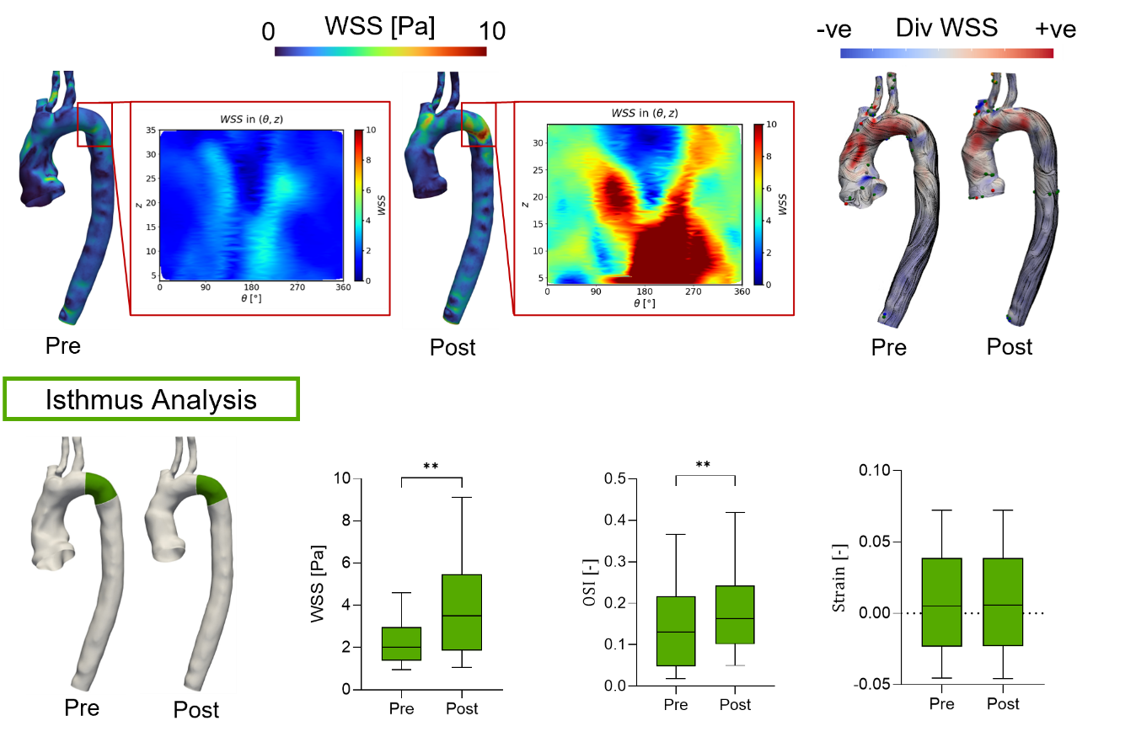
Figure 1: Result obtained for each patient of the cohort. Up: Left, comparison of the WSS map in the isthmus region pre and post-scenario; Right; WSS topological skeleton obtained for the pre and post operative scenario, -ve represent the negative values of the divergence associated with contraction regions, +ve positive values of the divergence associate with expansion regions.
Bottom: Statistical analysis of the hemodynamic quantities in the isthmus region.

[1] Palumbo MC et al, EJ of Cardiothoracic Surgery, 2022.
[2] Gaudino M et al, EJ of Cardiothoracic Surgery, 2019

