Flow Focusing Microfluidic Device for Pancreatic Islets Conformal Coating in a PEG-based Hydrogel
F. Vicinanza¹, T. Mencarini¹, F. Verderio¹, A. Tomei² and A. Redaelli¹
¹ Department of Electronics, Information and Bioengineering, Politecnico di Milano, Milan, Italy
² Diabetes Research Institute, University of Miami Miller School of Medicine, Miami, FL, USA.

Abstract— Conventional therapies for Type 1 Diabetes (T1D) aim to maintain glucose homeostasis and prevent long-term complications by administering exogenous insulin. A more promising strategy is to treat T1D with cell therapies: for this kind of treatment, islet transplantation is minimally invasive and safer than whole pancreas transplantation. However, the need of an immunosuppressive therapy severely limits its applicability. Conformal coating (CC) allows the encapsulation of single pancreatic islets in a polymeric membrane that conforms to the shape and size of the islets, resulting in a thin and uniform coating. The membrane allows exchange of small molecules, providing an immunoprotective and cell-supportive microenvironment. The present work shows how a soft lithographic microfluidic device can be utilized to obtain CC islets in a polyethylene glycol (PEG)-based hydrogel by coaxial injection of coating material and cells in an immiscible external oil phase through a built-in nozzle. The device was designed and tested to maximize coating conformality on NIT1 insulinoma cell clusters. Live/dead staining and confocal microscopy and glucose-stimulated insulin secretion were performed to assess the viability and functionality of the obtained CC clusters. In vitro results demonstrated how to obtain fully polymerized conformal capsules, having a coating thickness that allows passive diffusion of molecules that are critical for cell clusters survival and function, including oxygen, nutrients, and insulin without compromising the vitality and functionality of the encapsulated clusters.
Keywords— Microfluidics, Conformal coating, Pancreatic islets transplantation, Type 1 diabetes.

Introduction

With exogenous insulin replacement, Type 1 Diabetes (T1D) is not cured, but managed. It could be cured with allogeneic islet transplantation; however, the need for intensive immunosuppression limits the applicability of this procedure [1]. A promising strategy to avoid immunosuppressive therapy is based on immunoisolation by encapsulation in a selectively permeable membrane. Conformal coating (CC) adapts to the size and shape of pancreatic islets, resulting in 10-20 μm thick capsules [2]. It allows a better glucose-insulin diffusion kinetics and a reduction in the total graft volume (permitting grafting at more vascularized sites such as the omentum) compared to conventional microencapsulation method, which instead generates capsules of fixed diameter, larger than the maximum distance small molecules can travel by passive diffusion (~ 150 µm), regardless the size of the islets [3].
The purpose of the present work is to present a microfluidic soft lithographic device, having a flow focusing geometry, able to generate polyethylene glycol (PEG)-based conformal coatings, without affecting cell function and viability. The method relies on the flow of two immiscible phases, known as continuous (oil) and disperse (water) phase that meet at a junction and flow coaxially. Conformal coating is achieved through a combination of two phenomena: dripping-jetting transition of the water phase, by focusing the flow through physical constraints of reducing diameter, and Plateau-Rayleigh instability, that leads to the breakup of the jet into droplets of liquid polymer. The cell clusters, loaded in the water phase, are kept separate, therefore encapsulated singularly, by an elongational component of the flow. Liquid polymer capsules are finally gelled by flowing in contact with a gelling emulsion. Nit-1 cell clusters were used in the present work as they represent a suitable alternative to human pancreatic islets. Nit-1 is a pancreatic β-cell line derived from transgenic mouse insulinoma [4]. This type of cells can aggregate and form clusters with a diameter comparable to the average diameter of the human pancreatic islets.

Material and Methods

The microfluidic chip was designed using Solidworks. The desired features were milled using a CNC machine (Roland MDX-540, Roland DGA Corp, CA, USA) onto an optically transparent acrylic sheet (3.15 mm thick acrylic sheet from McMaster&Carr, Elmhurst, IL, USA). The characteristic dimensions of the CAD model are shown in Figure 1C. Polydimethylsiloxane (PDMS) at a 10:1 w/w (pre-polymer to curing agent) ratio was used to produce two identical layers from the acrylic master mould, aligned and bonded together, after a 50 sec oxygen plasma treatment. The fabrication accuracy is 7.90 ± 2,32 µm calculated as the absolute difference between the CAD model measurements and those of the silicone half-mold, across three different sections (on both thickness and width) and with N = 4 samples (mean relative error: 3.45%). Three Tygon tubes were inserted into 1.5 mm inlet ports and connected, via hypodermic needles, to three syringes loaded with the solutions (one glass Hamilton syringe for the water phase and two 3 mL disposable syringes for the oil phases) and controlled by three syringe pumps. The CC particulates were then collected in a glass Petri dish, pre-filled with gelling emulsion, through a Tygon tube placed in a 4 mm outlet port on the top PDMS layer.
Three reagents were used: as the water phase a minimally crosslinked 8-arm, 10 kDa, 75% functionalized PEG-MAL was used; the oil phase was composed of PPG and 10% Span80 surfactant; and an emulsion between the oil phase and 6% crosslinker DTT was used to induce gelation of the microcapsules. The encapsulation parameters were set as follows: the aqueous phase flow rate was 3 µL/min, the oil phase flow rate was 180 µL/min, as the one of the gelling emulsion.

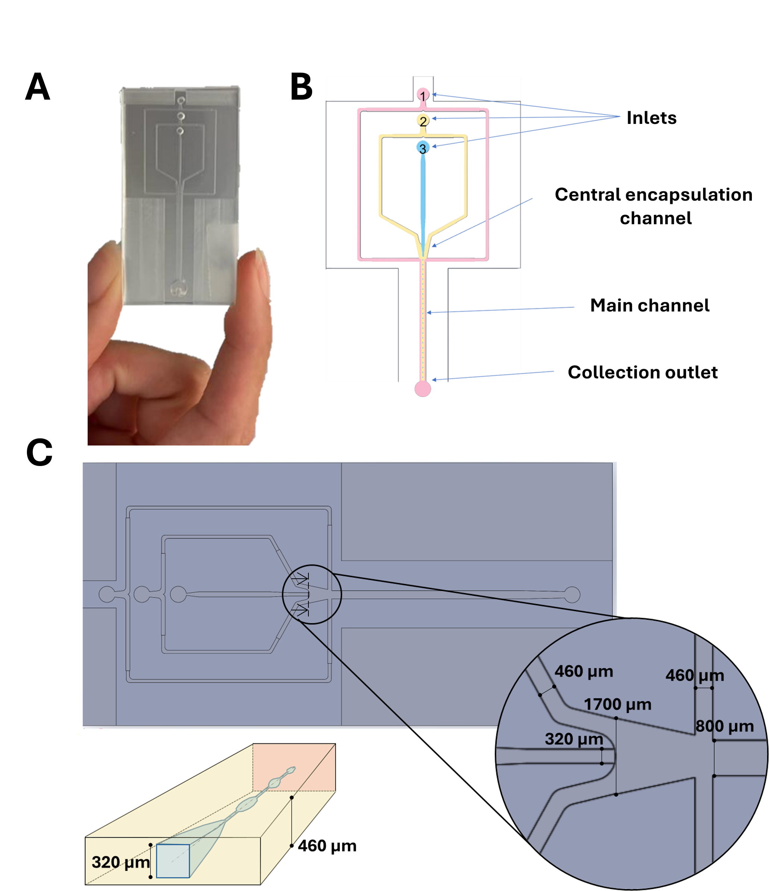

Figure 1 (A) Image of the microfluidic device, showing its structured channels (B) Representation of the chip geometry and its features; in blue the water phase, in yellow the oil phase and in pink the gelling emulsion (C) Detailed design of the microfluidic junction, with channel dimensions.

Nit-1 spheroids were cultured in a rotating spinner flask. Cells were seeded at a density of 1 million cells/mL in a 30 mL bioreactor (ReproCELL, Beltsville, MD), maintained at 37 °C in a cell culture incubator, and stirred at 70 rpm on a magnetic stirrer plate. Nit-1 clusters were suspended in the aqueous phase at a density of 160 IEQ/mL.

ImageJ was used for quantitative analysis, measuring particle and capsule diameters, and capsule thickness on three different axes for each capsule. Data were elaborated using Excel, and statistical analysis (linear regression) was performed in GraphPad Prism. Significance was set at p < 0.05.

Glucose-stimulated insulin release (GSIR) was assessed in both coated and uncoated particles to evaluate insulin secretion in response to glucose challenges. After a one-hour pre-incubation in low glucose (2 mM), clusters were sequentially transferred through different conditions: (L1) low glucose (2 mM), (H) high glucose (16.7 mM), (L2) low glucose (2 mM), and (KCl) KCl solution (30 mM), each for one hour. Eluted samples analysed by ELISA assay (Mercodia, Uppsala, Sweden)

Anti-peg staining and live (Calcein AM)/dead (ethidium) were performed on the capsules.

Results and Discussion

The conformal encapsulation of Nit-1 clusters in size-controlled PEG-based microcapsules was successfully achieved with the present microfluidic device.
Figure 2 illustrates the morphology and size distribution of encapsulated Nit-1 clusters, revealing a consistent and uniform coating with no evident structural irregularities. The polymeric membrane effectively adapted to the natural variability in cluster size and shape, demonstrating the capability of the system to generate highly reproducible microcapsules. The absence of defects or discontinuities in the coating suggests that the encapsulation process did not compromise the structural stability of the clusters.
The mean diameter of Nit-1 clusters was measured at 141.9 µm, closely resembling the average size of human pancreatic islets, reinforcing their suitability as an in vitro model [5]. The encapsulating membrane had a median thickness of 13.76 µm (IQR 10.48–19.19 µm), well below the critical diffusion threshold of 150 µm. This thin yet robust coating allows efficient passive diffusion of oxygen and essential nutrients to the encapsulated cells while facilitating the exchange of metabolic byproducts, thereby supporting long-term viability and function.

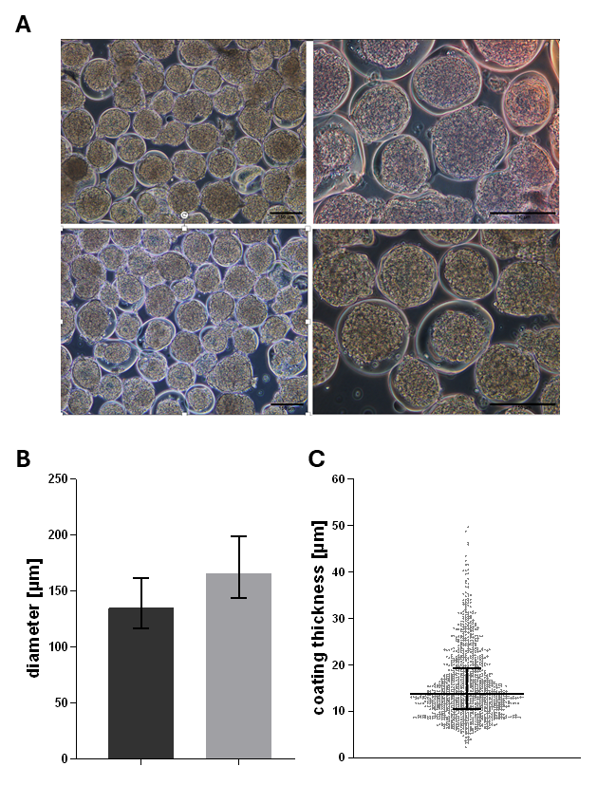

Figure 2 (A) Phase-contrast images of the coated Nit-1 clusters (scalebar: 150 μm) (B) Cluster diameter (dark gray) and capsule diameter (light gray). N = 16, with a total of n = 1135 clusters evaluated. Mean ± SD are reported on the graph (C) Coating thickness measured from the NIT-1 cluster surface to the coating exterior. Each value represents the average of three measurements taken along three different axes. N = 16, with a total of n = 1135 clusters evaluated. Data are reported as the median (13.76 µm) with the interquartile range.
Furthermore, the CC microfluidic device enabled the formation of a consistent coating thickness across all encapsulated clusters, independent of their size. In contrast, the overall capsule diameter exhibited a linear decrease as the cluster diameter decreased, as illustrated in Figure 3. Maintaining a thin and uniform encapsulation layer is advantageous, as it minimizes diffusion distance, thereby facilitating the rapid exchange of small molecules such as insulin and glucose. This enhanced permeability is critical for ensuring a timely physiological response and maintaining the metabolic functionality of the encapsulated cells. Additionally, the reduction in capsule diameter translates into a lower total graft volume, which is particularly beneficial for transplantation procedures, as it allows for a higher islet density within vascularized implantation sites.
These findings highlight the importance of preserving a fixed coating thickness rather than a constant capsule diameter to optimize diffusion kinetics while minimizing graft volume. Furthermore, anti-PEG staining confirmed that the polymeric capsules surrounding the clusters were fully cross-linked and structurally intact, ensuring the stability of the encapsulation system (data not shown).

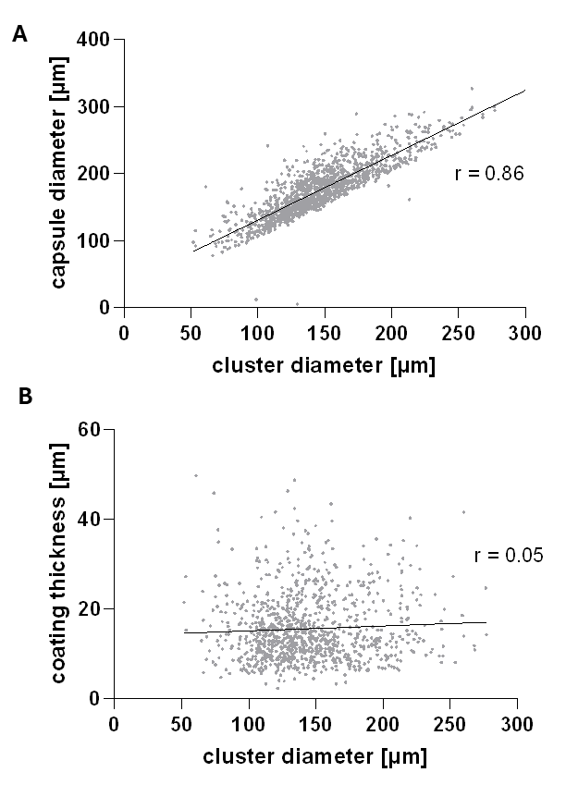

Figure 3 (A) Correlation between cluster diameter and capsule diameter. Pearson correlation coefficient: r = 0.86. Statistical significance: P < 0.0001. N = 16, with a total of n = 1135 clusters evaluated. (B) Correlation between cluster diameter and coating thickness. Spearman correlation coefficient: r = 0.05. Statistical significance: P < 0.05. N = 16, with a total of n = 1135 clusters evaluated.
Cell viability was evaluated using live/dead staining. The staining results confirmed a high viability of the encapsulated cells, with dead cells primarily observed as isolated single cells. This suggests that the encapsulation process, including the shear forces experienced by the clusters during microfluidic coating, did not have a detrimental impact on cell integrity or survival (Figure 4). The functionality of Nit-1 clusters was assessed through glucose-stimulated insulin release. CC cluster exhibited a typical GSIR profile, with a mean stimulation index, defined as the ration between the H step and the first low glucose (H/L1) in term of insulin release, of 1.98

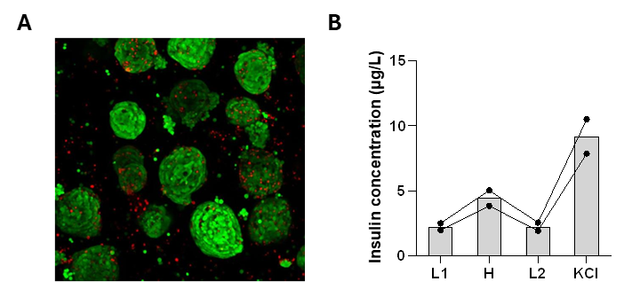

Figure 4 (A) Orthogonal projection of confocal images after live (green)/dead (red) staining of conformally coated Nit-1 clusters. (B) Histogram showing GSIR, performed on CC Nit-1 cell clusters. N=2, n=3.

Conclusions

This study demonstrates the successful development of a microfluidic flow-focusing device for the conformal encapsulation of pseudoislets in a PEG-based hydrogel. The microfluidic system achieved precise control over the formation of thin, size-controlled coatings that adapted to the natural variability in cluster dimensions.
One of the key advantages of this approach is the use of a microfluidic device, which offers significant benefits over traditional macrodevice [6]. The microfluidic platform allows for a much higher level of precision in controlling capsule size while also reducing reagent consumption, overall costs, and processing time.
Furthermore, the encapsulation process did not compromise cell viability, as confirmed by live/dead staining, and glucose-stimulated insulin release (GSIR) assays showed that encapsulated Nit-1 clusters retained their functional response to glucose variations. These results suggest that the microfluidic device not only improves encapsulation precision but also preserves the functionality of the encapsulated cells.
Overall, The findings highlight the potential of this platform as a promising tool for immunoisolation strategies in Type 1 Diabetes therapy, warranting further investigation into its applicability to primary pancreatic islets and in vivo models.

Acknowledgement
This work was funded by the National Plan for NRRP Complementary Investments (PNC, established with the decree-law 6 May 2021, n. 59, converted by law n. 101 of 2021) in the call for the funding of research initiatives for technologies and innovative trajectories in the health and care sectors (Directorial Decree n. 931 of 06-06-2022) - project n. PNC0000003 - AdvaNced Technologies for Human-centrEd Medicine (project acronym: ANTHEM). This work reflects only the authors’ views and opinions, neither the Ministry for University and Research nor the European Commission can be considered responsible for them.

References
- M. J. Shapiro, M. Pokrywczynska, and C. Ricordi, ‘Clinical pancreatic islet transplantation’, Nat. Rev. Endocrinol., vol. 13, no. 5, pp. 268–277, 2017.W.-K. Chen, Linear Networks and Systems (Book style). Belmont, CA: Wadsworth, 1993, pp. 123–135.
- T. De Toni et al., ‘Parallel Evaluation of Polyethylene Glycol Conformal Coating and Alginate Microencapsulation as Immunoisolation Strategies for Pancreatic Islet Transplantation’, Front. Bioeng. Biotechnol., vol. 10, no. May, pp. 1–16, 2022.
- A. A. Stock and A. A. Tomei, ‘Conformal coating’, Transplantation, Bioeng. Regen. Endocr. Pancreas Vol. 2, vol. 2, pp. 291–306, 2019.
- K. Hamaguchi, H. R. Gaskins, and E. H. Leiter, “NIT-1, a pancreatic beta-cell line established from a transgenic NOD/Lt mouse.,” Diabetes, vol. 40, no. 7, pp. 842–9, Jul. 1991, doi: 10.2337/diab.40.7.842.
- Gonzalez, G. C., Li, C. M., Pasolini, I., Pete, S. I., Verheyen, C., Vignolo, S. M., De Toni, T., Stock, A. A., & Tomei, A. A. (2025). High-Yield Generation of Glucose-Responsive Pseudoislets From Murine Insulinoma Cells for In Vitro Studies and Longitudinal Monitoring of Graft Survival In Vivo. Cell transplantation, 34.
- A. A. Tomei et al., ‘Device design and materials optimization of conformal coating for islets of Langerhans’, Proc. Natl. Acad. Sci. U. S. A., vol. 111, no. 29, pp. 10514–10519, 2014.

