Introduction
Paolo Rosa, Sergio Terzi and Bernd Kopacek
Abstract This chapter aims at clarifying the main research contents and presenting the main objective of the CIRC-UITS project.
P. Rosa, S. Terzi

Department of Management, Economics and Industrial Engineering, Politecnico di Milano, Piazza L. da Vinci 32, 20133 Milan, Italy
e-mail: paolo1.rosa@polimi.it
e-mail: sergio.terzi@polimi.it

B. Kopacek
SAT – Austrian Society for Systems Engineering and Automation, Konrad-Duden-Gasse 33, A-1130 Vienna, Austria
e-mail: bernd.kopacek@sat-research.at

Main context
Considering the increasing demand for data gathering, management and analysis, the global economy is becoming even more semiconductor-dependent. Several sectors are embedding within their products lots of sensors, actuators, electronic control units and telecommunication systems allowing a direct interconnection of the product with the world wide web and a real time exchange of information. Among these sectors, mass electronics and automotive [1] sectors are those that, more than others, have seen an exponential adoption of these technologies since many years. However, a strong dependency from semiconductor-based systems is presenting (especially in the last years) several weaknesses and risks that Europe must solve as soon as possible. Among them, the most important issue relates to the lack of European semiconductor companies and the full dependency from extra-EU suppliers (mainly China and Taiwan). This lack brought the European economy towards the current semiconductor crisis who is strongly influencing some of its strategic markets (e.g. automotive) [2]. Another important issue relates to the scarce ability of the European economy to recover strategic components/materials embedded in electronic equipments and exploit them to make new (high value) products. This way, high semiconductor-dependent sectors became some of the most environmental-impacting markets worldwide [3]. From this side, End-of-Life Vehicles (ELVs) [4,5,6] and e-wastes have been renown since many years like two of the most important sources of secondary raw materials. Trying to cope with all these challenges, the European Commission (EC) published (and in some cases is still working on) specific EU strategies/directives for automotive, e-waste (e.g. Digital Product Passport) and, specifically, semiconductors (e.g. European Chips Act). However, trying to make these sectors more sustainable, circular and resilient, it is mandatory to boost both EoL strategies (e.g. sorting, reuse, remanufacturing and recycling) and intra-EU production through innovations and investments. The current international scenario represents a good chance to decouple the European economy from both natural resource depletion (e.g. Critical Raw Materials - CRMs) and dependency from extra-EU supplies of strategic products. In order to better prove what the benefits of a joined circular/resilient use of secondary resources are, the automotive and mass electronics sectors have been identified as the reference for establishing a set of innovative solutions.
Main objectives
To this aim, the CIRC-UITS project demonstrates the improvement to the circularity of automotive and mass electronics sectors by recovering materials from waste products, as well as supporting the reuse & remanufacturing of electronic components into new (high value) products in these sectors.

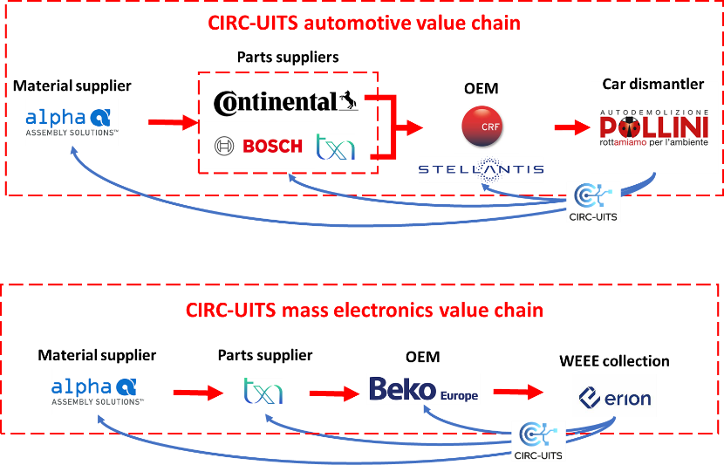
Fig. 1.1 Overall concept of the CIRC-UITS project
In this scenario the main goals of CIRC-UITS are:
- Unlock full potentials/benefits of circular practices through digital technologies. Sub-intents are: 1) Support the transition towards circular practices through the adoption of different digital technologies, 2) Identify/track/share data about critical/hazardous materials throughout their lifecycle (e.g. materials chemistry, origin, state of health and chain of custody), 3) Define a Product Environmental Footprint and enable the EU Environmental Technology Verification, 4) Link reference sectors with the EU LCA platform, 5) Decrease transaction costs and increase collection rates.
- Increase resource efficiency/independency and reducing the negative environmental footprint of electronics production processes through circular behaviours. Sub-intents are: 1) Increase resource efficiency/independency from imported materials, 2) Reduce the negative environmental footprint of current manufacturing practices, 3) Identify the best EoL scenarios in order to increase reuse, refurbish, remanufacturing and recycling.
- Improve/standardize information/data sharing/exchange among industrial leaders involved in the same and/or similar value chain. Sub-intents are: 1) Demonstrate in practice what are the real benefits coming from the adoption of circular behaviours, 2) Organize/implement dissemination, communication and education actions.
- Demonstrate the benefits coming from Digital Circular Economy through 4 pilots: P1 (Electronic Control Unit - ECU) will support the development of circular ECUs embedded in brake systems; P2 (Tyre Pressure Monitoring Sensor - TPMS) will support the development of circular tyre sensors; P3 (In-Mold Electronics - IME) will support the development of circular IME with fully embedded alternative to PCB based on printed electronics; P4 (Obsolete PCBs) will support the classification and storage of PCBs from different WEEEs.
References
[1] https://www.marketsandmarkets.com/pdfdownloadNew.asp?id=162948952
[2]https://www.kearney.com/communications-media-technology/article/?/a/europes-urgent-need-to-invest-in-a-leading-edge-semiconductor-ecosystem
[3] EU Circular Economy Action Plan (CEAP)
[4]https://appsso.eurostat.ec.europa.eu/nui/show.do?dataset=env_waselvt&lang=en
[5] Andersen, F. M., Larsen, H. V., Skovgaard, M., & Isoard, S. (2008). Projection of end-of-life vehicles. European Topic Centre on Resource and Waste Management, 3-5.
[6] M. A. Reuter, C. Hudson, A. van Schaik, K. Heiskanen, C. Meskers, and C. Hagelüken, “Metal Recycling: Opportunities, Limits, Infrastructure, A report of the Working Group on the Global Metal Flows to the International Resource Panel,” UNEP - United Nations Environment Programme, 2013.

