GALLERIE e GRANDI OPERE SOTTERRANEE
Finite Element Analyses of undrained cavity unloading
considering in-situ anisotropic state of stress
Matteo Zerbiª*, Luca Flessati^{b}, Claudio di Prisco^{c}
ªPolitecnico di Milano, Dipartimento di Architettura, Ingegneria delle Costruzioni e Ambiente Costruito, Piazza Leonardo da Vinci, 32, Milano, Italia
^{b}Delft University of Technology, Department of Civil Engineering and Geosciences, Stevinweg 1, Delft, The Netherlands
^{c}Politecnico di Milano, Dipartimento di Ingegneria Civile e Ambientale, Piazza Leonardo da Vinci, 32, Milano, Italia
Abstract
The design of tunnel linings requires the solution of a soil–structure interaction problem, simulating both excavation and construction phases. Nevertheless, the preliminary design is performed by using the convergence-confinement method, based on the equilibrium of radial stresses and compatibility at the lining–soil interface. As is well known, this approach relies on the definition of the so-called tunnel characteristic curve, putting in relation mean cavity stress and convergence. The characteristic curve is often derived from analytical solutions, typically assuming (i) infinite ground domains, (ii) infinitely long tunnel with circular cross section, (iii) absence of gravity and (iv) pre-excavation isotropic stress state. This approach allows only to assess the average axial forces on the lining, but not to predict bending moments generated by the tunnel distortion, associated with a non uniform and non isotropic initial state of stress.
In this paper finite element numerical analyses results concerning deep tunnels, considering plane strains and undrained conditions, are discussed to demonstrate that (i) the choice of the constitutive model significantly affects the system response and (ii) the anisotropy of the initial stress state leads to non-homothetic deformations.

*corresponding author
e-mail e contatti del corresponding author: matteo.zerbi@polimi.it
Parole chiave: Deep tunnel, characteristic curve, anisotropic stress, lining design

- Introduction
The design of tunnel linings is particularly complex, as it requires the solution of a soil–structure interaction problem and it should take excavation and construction methods into account. At present, the preliminary design of the lining is based on the “convergence-confinement” method (Lombardi, 1975, Gesta 1978, Brown et al., 1983, Panet 1995, Carranza-Torres and Fairhust, 2000, Panet et al., 2001, Panet and Sulem, 2022, di Prisco et al., 2022b). This standard approach is based on the definition of (i) the “tunnel characteristic curve”, putting in relation the average pressure on the tunnel wall with the average radial convergence (Kirst, 1898, Ribacchi and Riccioni, 1977), (ii) the “lining characteristic curve”, which relates the pressure on the extrados of the lining with its corresponding convergence and (iii) the curve that relates the radial stress (or convergence) with the distance of the current tunnel cross-section from the face (Panet and Guenot, 1982, Panet, 1995, Vlachopoulos e Diederichs, 2009) .
From a structural viewpoint, this approach only allows to assess the average axial force in the lining, as a function of the radial pressure, but not the bending moment. In fact, a consequence of the assumptions of the model is that the bending moment in the lining is necessarily nil.
In this paper, finite element non-linear numerical results under plane strain (two-dimensional) conditions of deep cavities unloaded under undrained conditions are discussed. In particular, the authors focus on (i) the importance of the choice of the constitutive model to obtain realistic responses, (ii) the influence of the constitutive model on the characteristic curve definition and (iii) the cavity distortion, even in case of deep tunnels, due to the anisotropy of the initial stress state.
- The characteristic curve for cylindrical cavities
As is well known, the analytical expression for the cavity characteristic curve (Ribacchi et al., 2018, di Prisco et al., 2022a) is obtained under the following hypotheses:
- infinite soil domain (infinite cover-diameter ratio $H/D$);
- homogeneous weightless and isotropic soil, characterized by an elastic-perfectly plastic mechanical behaviour with a Tresca yield criterion, behaving under undrained conditions as a one-phase material (undrained shear strength $S_{u}$);
- isotropic initial (geostatic) state of stress ($K=σ_{h0}$ $/σ_{v0}=1,$ being $σ_{v0}$ and $σ_{h0}$ the geostatic vertical and horizontal stresses, respectively);
- cylindrical cavity of infinite length with circular cross section of diameter $D$;
- plane strain geometry.
Due to these assumptions, the problem becomes axisymmetric, resulting in uniform stresses and displacements along the cavity boundary. The characteristic curve is thus obtained by progressively and monotonically nullifying the isotropic stress directly applied on the tunnel cavity boundary $σ_{c}$ from its initial value $σ_{c0}$, and calculating the radial displacement $u_{c}$. The analytical expression of the characteristic curve (CC), relating $u_{c}$ and $σ_{c}$, is the following:

$$u_{c}=\left\{\begin{matrix}\left(\frac{{σ_{c0}-σ}_{c}}{σ_{c0}}\right)u_{cr,el} σ_{c}>σ_{c0}-S_{u} \\ \frac{S_{u}}{σ_{c0}}u_{cr,el}e^{\frac{σ_{c0}-σ_{c}}{S_{u}}-1} σ_{c}>σ_{c0}-S_{u}\end{matrix}\right.$$ | (1)

where $G$ is the elastic shear modulus and $u_{cr,el}$ the residual elastic displacement associated with a nil radial stress applied to the cavity:
$$u_{cr,el}=\frac{σ_{c0}}{4G}D$$ | (2)

It is interesting to note that, according to Equation 1, cavity unloading can be completed with a finite residual displacement even in the elastic-plastic case. The stability of the system's mechanical response is ensured by the expansion of the plastified zone, due to the infinite extension of the spatial domain (di Prisco and Flessati, 2021).
To obtain an expression independent on both soil mechanical properties and tunnel diameter, the expression may be conveniently made non-dimensional as follows (Flessati, 2017, di Prisco et al., 2018, di Prisco and Flessati, 2021):

$$q_{c}=\left\{\begin{matrix}Q_{c} Q_{c}<1 \\ e^{Q_{c}-1} Q_{c}≥1\end{matrix}\right.$$ | (3)

where:

$$Q_{c}=\frac{σ_{c0}-σ_{c}}{S_{u}}$$ | (4)
$$q_{c}=\frac{u_{c}}{u_{cr,el}}\frac{σ_{c0}}{S_{u}}$$ | (5)

stand for non-dimensional radial stress and radial convergence, respectively. In this way, $Q_{c}$ is a loading variable for the system in the sense that it increases during the cavity unloading process.
In case the mechanical behaviour is assumed to be elastic, under the same hypotheses listed above, the second branch defined in Equation 3 disappears and the characteristic curve becomes a straight line passing through the origin and point (1,1).
In the light of this observation, the characteristic curve in Equation (1) may be written as:

$$q_{c}=\left\{\begin{matrix}{q_{c}^{el}=Q}_{c} Q_{c}<1 \\ q_{c}^{pl}+q_{c}^{el}=e^{Q_{c}-1}-Q_{c}+q_{c}^{el} Q_{c}≥1\end{matrix}\right.$$ | (7)

where $q_{c}^{el}$ and $q_{c}^{pl}$ stand for elastic and plastic non-dimensional generalized kinematic variables. In such a way (Figure 1), the characteristic curve becomes an upscaled generalized constitutive relationship in the framework of macro-element theory (Nova and Montrasio, 1991).

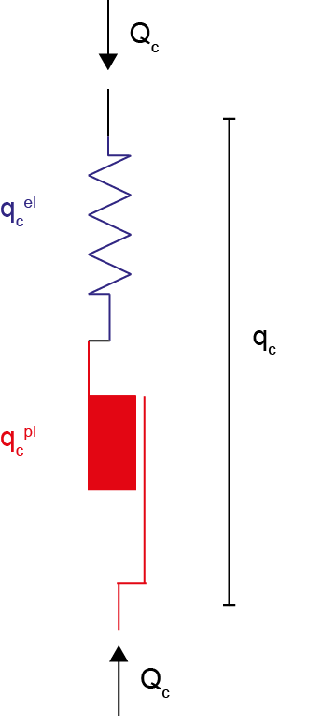
Figure 1: Interpretation of the analytical solution for the characteristic curve in the light of Macroelement theory
- Extension of the analytical solution
In case the initial state of stress is not uniform and not isotropic, the analytical solution stops being valid. From a practical perspective it is useful to test the analytical solution with finite element (FE) simulation results. Here below the results of a FE parametric study are illustrated and interpreted in the light of the non-dimensional characteristic curve previously introduced. Three different series of plane strain undrained finite element numerical analyses have been performed (Appendix), each of them characterized by a different constitutive relationship: (a) elastic, (b) elastic-perfectly plastic and (c) strain-hardening elastic-plastic. In cases (a) and (b) undrained conditions are imposed by following a simplified approach and by modelling the soil behaviour as a one phase material. On the contrary, in case (c) the constitutive law is defined in terms of effective stresses and undrained conditions are simulated by locally imposing nil volumetric strains in the whole domain.
The stress-anisotropy coefficient $K$, considered in total stress analyses, has been related to the lateral at-rest earth pressure coefficient ($k_{0}={σ'}_{h0}$ $/{σ'}_{v0}$ being ${σ'}_{v0}$ and ${σ'}_{h0}$ the initial geostatic vertical and horizontal effective stresses, respectively), by assuming the initial pore water pressure distribution to be hydrostatic, the water table coincident with the ground surface and both vertical and horizontal stresses to be principal:

$$K=\frac{k_{0} \left(γ_{sat}-γ_{w}\right)+γ_{w}}{γ_{sat}}$$ | (8)

where $γ_{sat}$ and $γ_{w}$ are soil saturated and water unit volume weights, respectively.
In the following, $K$ between $0.8$ and $1.2$ has been considered in numerical analyses, corresponding to $k_{0}=0.6-1.4$. This range derives from the values of $ϕ^{'}=20°-30°$ accounted for, since $k_{0}$ has been calculated as a function of overconsolidation ratio $OCR$ (Jaky, 1944; Brooker and Ireland, 1965):

$$k_{0}=\left(1-\sin{ϕ^{'}}\right)∙{OCR}^{0.5}$$ | (9)

In this work $OCR$ has been assumed ranging in between $1-2$
Due to the presence of both the upper boundary and gravity, the numerical model is not axisymmetric (Appendix), unlike the analytical solution. As a result, both cavity stress and displacement vary along the cavity profile. The numerical characteristic curves are thus defined considering the stress at tunnel axis $p_{c}$ (initial value $p_{c0}=\frac{1+2K}{3}γ_{sat}H$) and the average cavity displacement $u_{c}$.
  - Linear elastic FE numerical simulations
In this section, numerical results are obtained by employing a linear-elastic constitutive relationship, with $γ_{sat}=20 kN/m^{3}$, an undrained Young modulus $E_{u}=50 MPa$ (assumed to be constant with depth) and an undrained Poisson ratio $ν_{u}=0.5$. As is evident in Figure 2a, independently of the $K$ imposed value, if the characteristic curve is plotted in terms of $p_{c}$, and $u_{c}$, parallel straight lines are obtained and $u_{cr,el}$ can be still evaluated by using Equation 6, in which $σ_{c0}$ is replaced by$p_{c0}$:

$$u_{cr,el}=\frac{p_{c0}}{4G} D$$ | (10)

Once plotted in the non-dimensional plane $p_{c}/p_{c0}-u_{c}/u_{cr,el}$ (Figure 2b) (the non-dimensional variables introduced in Section 2 cannot be employed since for an elastic material the undrained strength $S_{u}$ is not defined), the curves for different $K$ superimpose.
This implies that, as long as non-dimensional kinematic and static variables are suitably defined, for deep tunnels, if the constitutive relationship is elastic, the solution for the characteristic curve (expressed in terms of average cavity stress and displacement) is not affected by $K$. Nevertheless, the solutions markedly differ in terms of cavity radial displacements $u(θ)$ (Figure 2c). As was expected, for $K=1$, the radial displacement $u(θ)$ is almost constant with $θ$, whereas for $K=0.8$ and $1.2$, the initial circular cavity tends to ovalize: with major axis along the horizontal and vertical directions for $K=0.8$ and $1.2$ , respectively.

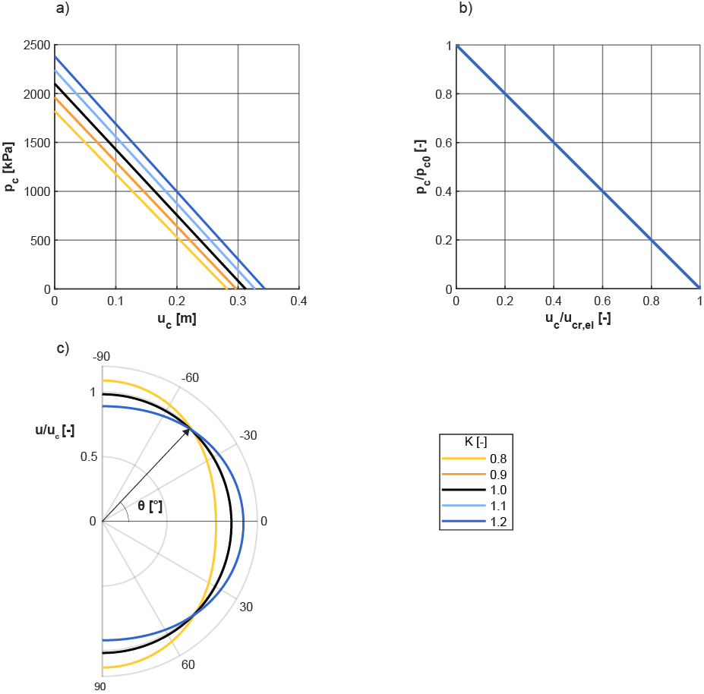

Figure 2: FE linear elastic numerical results: (a) dimensional and (b) non-dimensional characteristic curves, (c) distribution of radial convergence (normalised over the mean convergence) at 50% of cavity unloading.

The influence of $K$ is particularly evident when analyzing the displacement field in the soil domain, where the combined effects of gravity and ground level boundary make severely asymmetric the displacement field (Figure 3), justifying the non-uniform convergence due to the unloading.

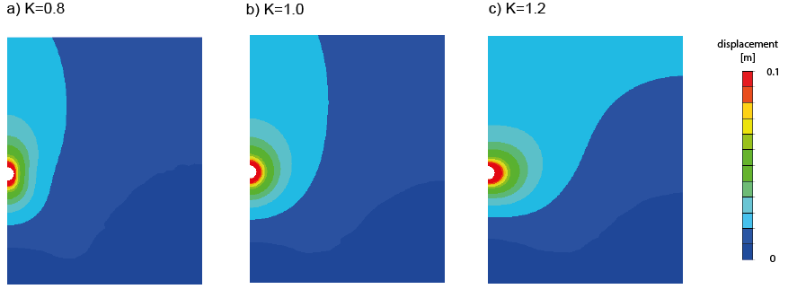
Figure 3: FE linear elastic numerical results: displacement field for different initial stress anisotropy ratio (a) $K=0.8$, (b) $K=1.0$, (c) $K=1.2$ at 50% of cavity unloading
  - Elastic-perfectly plastic FE numerical simulations
In case an elastic-perfectly plastic constitutive relationship with Tresca yield surface and associated flow rule is used, the linearity of the characteristic curve is lost and the influence of stress anisotropy more evident. In the practice, this constitutive law is very popular to model the mechanical behaviour of clays under undrained conditions, without considering hydro-mechanical coupling and adding, with respect to the elastic case, only one additional parameter, the undrained strength $S_{u}$, assumed to be constant with depth. This has been imposed equal to $S_{u}=300 kPa$, by prescribing $σ_{vc0}/S_{u}=7$ , being $σ_{vc0}$ the geostatic total vertical stress at the tunnel axis depth.
In Figure 4, non-dimensional characteristic curves are plotted and compared with the standard analytical solution reported in Section 2. In case $K≠1$, the non-dimensional variables introduced in eqs 4 and 5 modify as follows:

$$Q_{c}=\left(1-\frac{p_{c}}{p_{c0}}\right)\frac{p_{c0}}{S_{u}}$$ | (11)
$$q_{c}=\frac{u_{c}}{u_{cr,el}}\frac{p_{c0}}{S_{u}}$$ | (12)

where $u_{cr,el}$ is evaluated according to eq. 10.
For $K=1$, the numerical characteristic curve practically coincides with the analytical solution, except for very large values of​ $u_{c}/u_{cr,el}$ due to interference with the upper boundary. This confirms that (i) the geometric dimensions of the numerical model are sufficient to minimize boundary effects on numerical results, and (ii) in the case of deep tunnels, gravity has a negligible influence on the characteristic curve. Differently from the analytical curve, failure is reached before the complete unloading of the cavity (Figure 4a). This is due to the interference with the upper boundary, limiting the expansion of the plastic radius and consequently the structural hardening response (di Prisco and Flessati, 2022, Zerbi et al., 2024). However, due to the very large $H/D$ ratio, failure is reached for very large (and not realistic) convergences.
For $K≠1.0$, the numerical characteristic curves deviate from the analytical one. In particular, this deviation is more significant as the initial state of stress becomes more anisotropic (Figure 4b). A not negligible lowering of the characteristic curve is observed, justifying the caution in the use of the standard analytical solution: for fixed values of $Q_{c}$, the analytical predictions may markedly underestimate the convergences numerically assessed. This difference is justified by the convergence profile of the cavity (Figure 4c) and by both displacement and plastic strain fields (Figures 5 and 6). As for the case $K=1$, the complete unloading of the cavity cannot be realized (Figure 4a).
For $K≠1$, numerical solutions are affected by the domain lower boundary. This is due to both Tresca failure envelope shape and the choice of assuming $S_{u}$ to be constant with depth. Indeed, the initial radius of the Mohr circle is a function of both initial stress state anisotropy (the initial radius is nil only in case $K=1$) and material depth. As a consequence, yielding is more likely to occur in lower layers. This limitation may be overcome by assuming $S_{u}$​ to increase with depth.

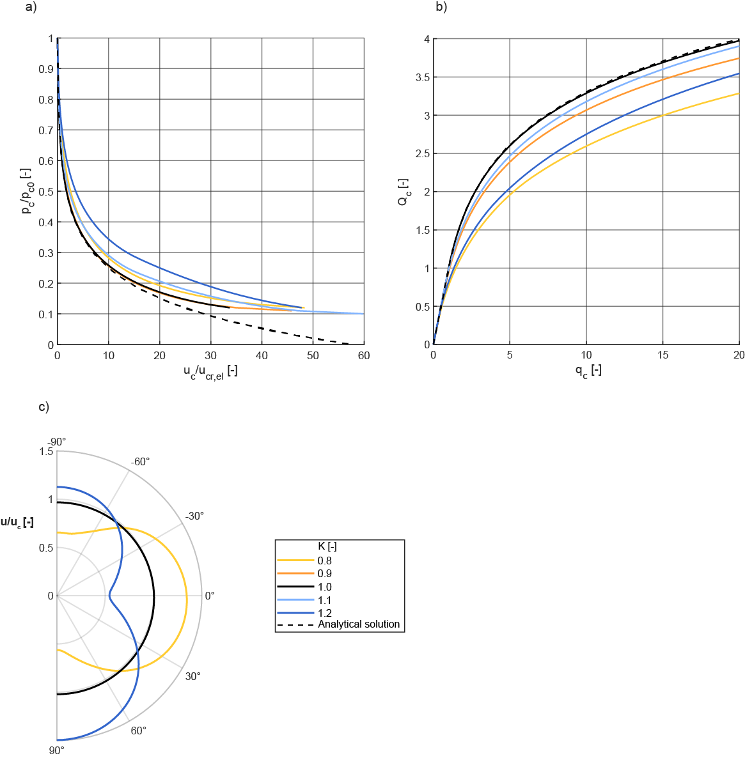

Figure 4: FE elastic-perfectly plastic numerical results: (a) (b) non-dimensional characteristic curves and (c) distribution of radial convergence (normalised over the mean convergence) at $50\%$ of cavity unloading

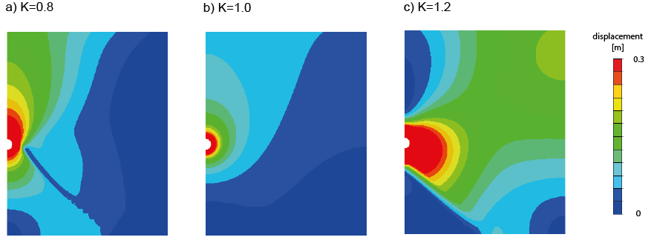
Figure 5: FE elastic-perfectly plastic numerical results: displacement field for different initial stress anisotropy ratio (a) $K=0.8$, (b) $K=1.0$, (c) $K=1.2$ at $50\%$ of cavity unloading

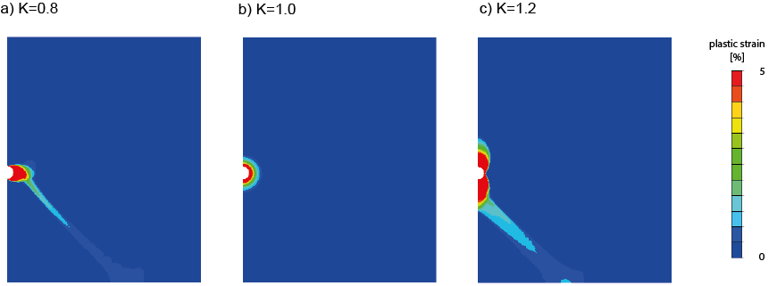

Figure 6: FE elastic-perfectly plastic numerical results: plastic strain field for different initial stress anisotropy ratio (a) $K=0.8$, (b) $K=1.0$, (c) $K=1.2$ at $50\%$ of cavity unloading

To capture the numerical results in the $Q_{c}- q_{c}$ plane, a modification of expression (3) has been thus suggested:

$$q_{c}=\left\{\begin{matrix}Q_{c} Q_{c}<a_{c} \\ {a_{c} e}^{\left[{(Q_{c}/a_{c})}^{b_{c}}-1\right]/b_{c}} Q_{c}≥a_{c}\end{matrix}\right.$$ | (11)

where $a_{c}$ determines the activation of the plastic radius expansion and, consequently, a deviation of the characteristic curve from the linear-elastic trend, whereas $b_{c}$ governs the shape of the plastic branch. It is worth mentioning that (i) for $a_{c}=b_{c}=1$ the analytical solution is recovered (eq.3) and (ii) this expression is valid for sufficiently small values of $q_{c}$ such that the plastic mechanism does not interfere with the upper boundary (i.e. the model is not capable of predicting system failure occurring for large values of convergences).
The modified expression of Equation (11) has been used to interpolate FEM results (Table 1), demonstrating the effectiveness of the proposed characteristic curve formulation in capturing the role of $K$ (Figure 7). Notably, when $K≠1$, $a_{c}<1$, indicating that the activation of plastic radius expansion occurs at a lower level of cavity unloading (Table 1).

$$K [-]$$ | $$a_{c} [-]$$ | $$b_{c} [-]$$
$$0.8$$ | $$0.38$$ | $$0.51$$
$$0.9$$ | $$0.78$$ | $$0.83$$
$$1.0$$ | $$1.0$$ | $$1.0$$
$$1.1$$ | $$0.78$$ | $$0.79$$
$$1.2$$ | $$0.38$$ | $$0.47$$
Table 1: Model parameters for the modified expression of the characteristic curve

To show the capability of the modified expression (equation (11)) in predicting FEM characteristic curves, in Figure 7, analytical standard (black dashed lines), FEM (solid lines) and modified analytical characteristic curves (circles) are compared in the non-dimensional plane The agreement is very satisfactory for any $K$ value.
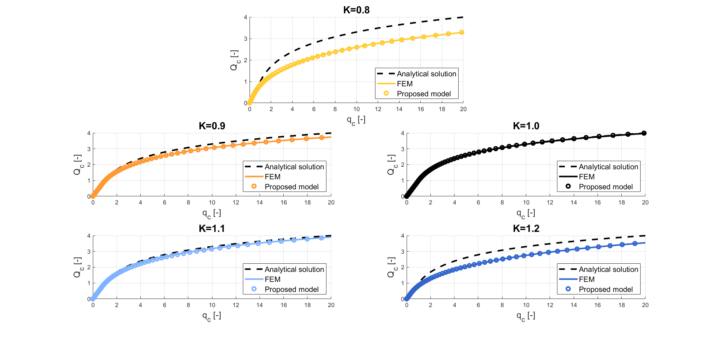
Figure 7: Comparison of standard analytical characteristic curve (black dashed line), FE numerical results (continuous lines) and modified analytical characteristic curve (circles) in the non-dimensional plane $Q_{c} -q_{c}$ for different $K$ values.

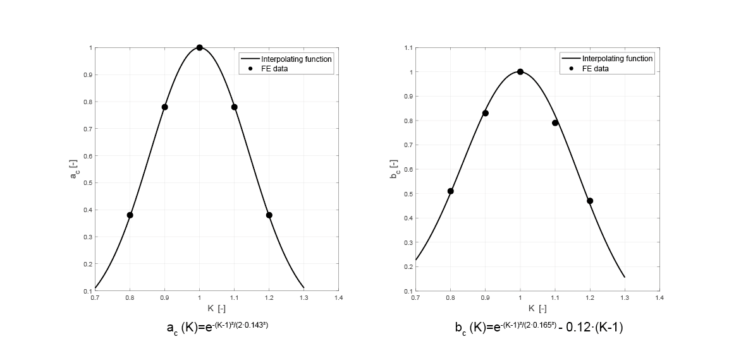
The value for parameters $a_{c}$ and $b_{c}$ as a function of $K$ reported in Table 1 have been interpolated to derive the expressions for the functions $a_{c}(K)$ and $b_{c}(K)$ (Figure 8). In particular, for $a_{c}(K)$ a gaussian function has been proposed to account for (i) the symmetry of the function around $K=1$ and (ii) for the faster decrease in $a_{c}$ as the initial stress state becomes far from the isotropic one. For function $b_{c}(K)$ a function obtained by adding a gaussian curve to a linear one has been chosen. Such an asymmetry, according to the authors, is likely to be due to a difference in the dependency of the solution on the lower boundary, effect also evident in Figure 6 where plastic strains are plotted. The comparison between provided data and interpolating functions is reported in Figure 8.
Figure 8: Interpolating functions for model parameters as function of the initial stress anisotropy ratio $K$ a) activation parameter $a_{c}$ and b) shape parameter $b_{c}$.

  - Strain-hardening elastic-plastic (Modified Cam Clay) FE numerical simulations

In the previous sections, the mechanical behaviour of the homogeneous clay stratum is simulated by disregarding the biphasic nature of the material, whereas here below the numerical problem is solved by using the effective stress principle and locally imposing undrained conditions, that is nil volumetric strains. For the soil skeleton, the strain hardening elastic-plastic Modified Cam Clay model (Schofield and Wroth, 1968, Roscoe and Burland, 1968, Wood, 1990) has been employed. As a consequence, the number of constitutive parameters (Table 2) to be assigned passes from $3$ to $4$: $λ, κ, ν^{'}$and $M$, virgin loading and unloading/reloading compression line slopes, drained Poisson ratio and critical state line slope (assumed to be not dependent on the Lode angle), respectively.
In this case, initial conditions have also to be imposed in terms of initial void ratio $e_{0}$ (constant with depth) and overconsolidation ratio OCR. This latter has been imposed to be constant with depth and ranging in between $1$ and $2$ (the strategy followed for the initialization of modified Cam Clay isotropic hardening variable $p_{0}$ is reported in Appendix). The soil saturated unit weight has been assumed equal to $20 kN/m^{3}$, whereas the values for constitutive and state parameters are reported in Table 2.

Parameter/State variable | Value
$$λ$$ | $$0.25$$
$$κ$$ | $$0.05$$
$$ν^{'}$$ | $$0.3$$
$$M$$ | $1.0$ (corrsponding to $ϕ^{'}=25°)$
$$e_{0}$$ | $$0.5$$

Table 2: Modified Cam Clay model parameters and initial state variables

Due to its formulation, Modified Cam Clay accounts for the increase in both elastic stiffness and shear strength with the effective confining pressure. To discuss the numerical results in the non-dimensional $Q_{c}-q_{c}$ plane, the authors adopted the strategy followed in Flessati et al., 2021 and Flessati and di Prisco, 2024. In particular, the $S_{u}$ reference value is calculated by analytically integrating the Modified Cam Clay constitutive equations under standard undrained triaxial compression stress paths (Cao et al., 2001)

$$S_{u}=\frac{M}{2^{2-κ/λ}}{p'}_{0} {OCR}^{1-κ/λ}$$ | (12)

Thus, different over-consolidation ratios correspond to different $k_{0}$, $K$ and $S_{u}$values (Table 3).

$$OCR [-]$$ | $$k_{0}[-]$$ | $$K [-]$$ | $$S_{u} [kPa]$$ | $$p_{c0}{/S}_{u}[-]$$
$$1$$ | $$0.577$$ | $$0.788$$ | $$217$$ | $$8.33$$
$$1.25$$ | $$0.646$$ | $$0.823$$ | $$319$$ | $$5.81$$
$$1.5$$ | $$0.707$$ | $$0.854$$ | 336 | $$5.65$$
$$1.75$$ | $$0.764$$ | $$0.882$$ | $$351$$ | $$5.50$$
$$2$$ | $$0.817$$ | $$0.909$$ | 461 | $$4.28$$
Table 3: Initial stress anisotropy ratios and undrained strength for the different OCR values

Analogously, $u_{cr,el}$ is calculated by using Equation 10 and $E_{u}$ evaluated as:

$$E_{u}=\frac{9}{2}\frac{1+e_{0}}{κ}\frac{1-2ν'}{1+ν'}{p'}_{0}$$ | (13)

This procedure is correct, since during elastic undrained cavity unloading, $p’$ is not expected to vary and consequently also material elastic stiffness.
As is evident in Figure 9a, due to the variation in $S_{u}$, numerical characteristic curves severely depend on $OCR$: for $OCR< 1.5$, the excavation cannot be completed and $u_{c}/u_{cr,el}$ goes to infinite for finite values of $p_{c}/p_{c0}$.
In $Q_{c}-q_{c}$ plane, numerical characteristic curves are more similar (Figure 9b), since normalized by employing in each case the correspondent $S_{u}$ value. The initial “elastic” branch extension depends on the $OCR$ value imposed and for $OCR=1$ it disappears.
To confirm the reliability of the strategy employed to make non-dimensional the numerical characteristic curves obtained by using the Modified Cam Clay model, the authors have performed a series of numerical analyses by changing $λ, κ, ν^{'}$and $M$ and keeping constant $S_{u}$, $E_{u}$ and $OCR$. In the $Q_{c}-q_{c}$ plane all these curves superimposed. This demonstrates that the characteristic curve in the non-dimensional plane is only governed by $OCR$.

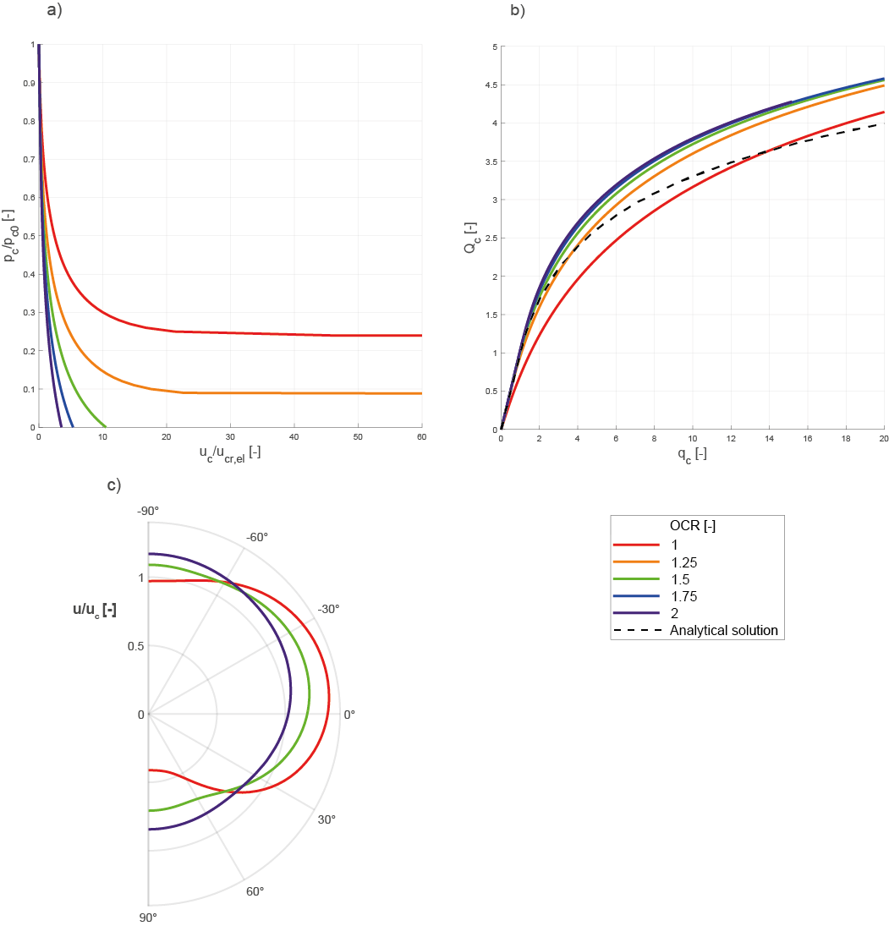

Figure 9: FE strain hardening elastic-perfectly plastic numerical results: (a) (b) non-dimensional characteristic curves and (c) distribution of radial convergence (normalised over the mean convergence) at $50\%$ of cavity unloading

The comparison of numerical curves with the standard analytical solution allows to highlight the reliability of this latter in predicting the cavity convergence: the quality of the predictions reduces for decreasing values of OCR, but predictions are on the safe-side for sufficiently large $OCR$ values ($OCR≥1.5$).
The numerical results in terms of cavity convergence (Figure 9c) and fields of soil displacements (Figure 10) and plastic strains (Figure 11) confirm that as $k_{0}$ increases, the cavity deformation tends to be axially symmetric and the most distorted is the profile relative to the normally consolidated case. Moreover, differently from what obtained in the elastic-perfectly plastic case (Section 3.1), the Modified Cam Clay model predictions are characterized by a lower (and more realistic, since lower with respect to the crown displacement) invert arch heave (Figure 9c).

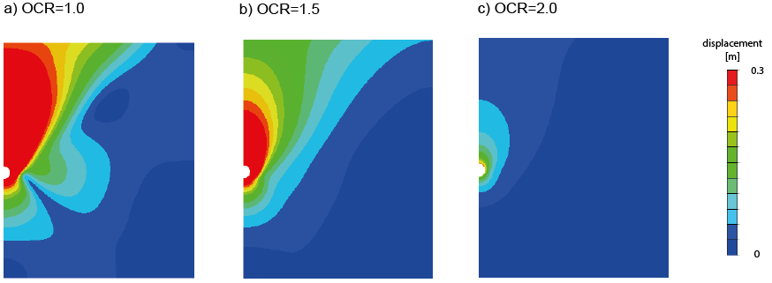
Figure 10: FE strain hardening elastic-plastic numerical results: displacement field for different initial stress anisotropy ratio (a) $OCR=1.0$, (b) $OCR=1.5$, (c) $OCR=2.0$ at $50\%$ of cavity unloading

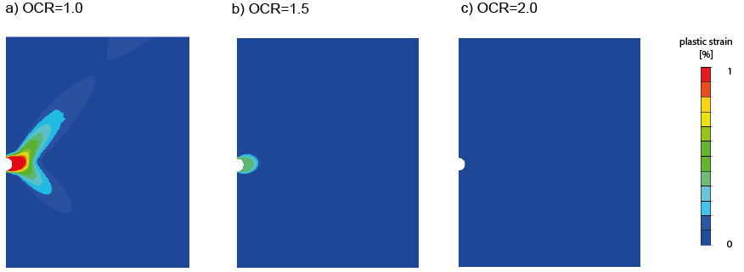
Figure 11: FE strain hardening elastic-plastic numerical results: plastic strain field for different initial stress anisotropy ratio (a) $OCR=1.0$, (b) $OCR=1.5$, (c) $OCR=2.0$ at $50\%$ of cavity unloading

Displacement and plastic strain spatial distributions (Figures 10 and 11) recall those obtained in the elastic-perfectly plastic case (Section 3.2); nevertheless, in this case, as was expected, the results are not affected by the presence of the lower boundary. The magnitude of both displacements and plastic strains significantly decrease for increasing $OCR$ and $k_{0}$ values. Indeed, for $OCR = 1$ (Figures 11a), yielding mainly develops laterally, coherently with convergence trend (green line in Figure 8); in case $OCR =1.5$, yielding, although less pronounced, takes place laterally again (Figure 11b); whereas in case $OCR =2$, yielding is negligible (Figure 11c), and displacements do not reach the upper boundary (Figure 10c).
As was already observed here above, $OCR$ rules the passage from elastic to elastic-plastic responses. For $OCR=1$, the system response is elastic-plastic from the very beginning. Such a behaviour necessarily affects also the nature of the model equations that are used to predict the system response in the $Q_{c}-q_{c}$ plane.
As was mentioned in Section 2, Equation 11 may be interpreted as elastic and elastic-plastic upscaled constitutive relationships. For $Q_{c}=a_{c}$ (yielding condition), the cavity response passes from elastic to elastic-plastic. In case, an elastic-perfectly plastic constitutive relationship is employed, such a condition takes place for finite value of $Q_{c}$. Analogously, such a threshold exists when Modified Cam Clay model is used and $OCR>1$. Conversely for $OCR=1$ such threshold nullifies, and the response of the system is elastic-plastic from the beginning. In this last case, Equation 11 cannot be used and must be substituted by the following one:

$q_{c}=$ ${c_{c} e}^{\left[{(Q_{c}/c_{c})}^{b_{c}}-1\right]/b_{c}}$ | (14)

in which $c_{c}$ governs the initial slope of the curve.
The model parameters to be used in Equations 11 and 14, are reported in Table 3 whereas the comparison between model predictions and numerical results are in Figure 12. The agreement is more than satisfactory. In case $OCR=1$, the discrepancy for $q_{c}>12$ is justified by the interference between yielded zones and the ground level.

$$OCR [-]$$ | $$a_{c} [-]$$ | $$b_{c} [-]$$ | $$c_{c} [-]$$
$$1.0$$ | $$-$$ | $$0.2$$ | $$0.15$$
$$1.25$$ | $$0.72$$ | $$0.57$$ | -
$$1.5$$ | $$1.0$$ | $$0.8$$ | -
$$1.75$$ | $$1.2$$ | $$1.0$$ | -
$$2.0$$ | $$1.4$$ | $$1.2$$ | -
Table 4: Calibrated model parameters for the modified expression of the characteristic curve

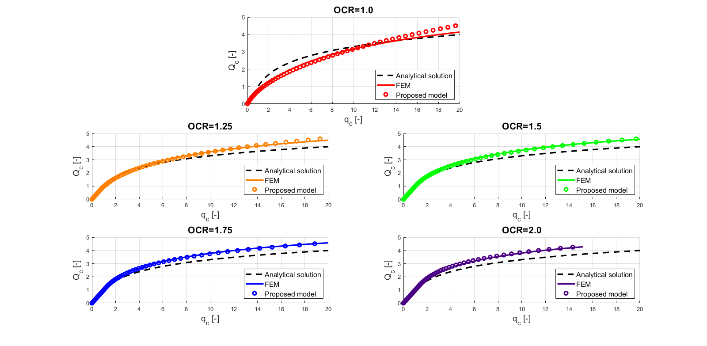
Figure 12: Comparison of analytical characteristic curves and FE numerical results in the non-dimensional plane $Q_{c} -q_{c}$ for different $OCR$ values.

The value for parameters $a_{c}$ and $b_{c}$ as a function of $OCR$ reported in Table 4 have been interpolated to derive the expressions for the functions $a_{c}(OCR)$ and $b_{c}(OCR)$, for $OCR>1$ (Figure 13).
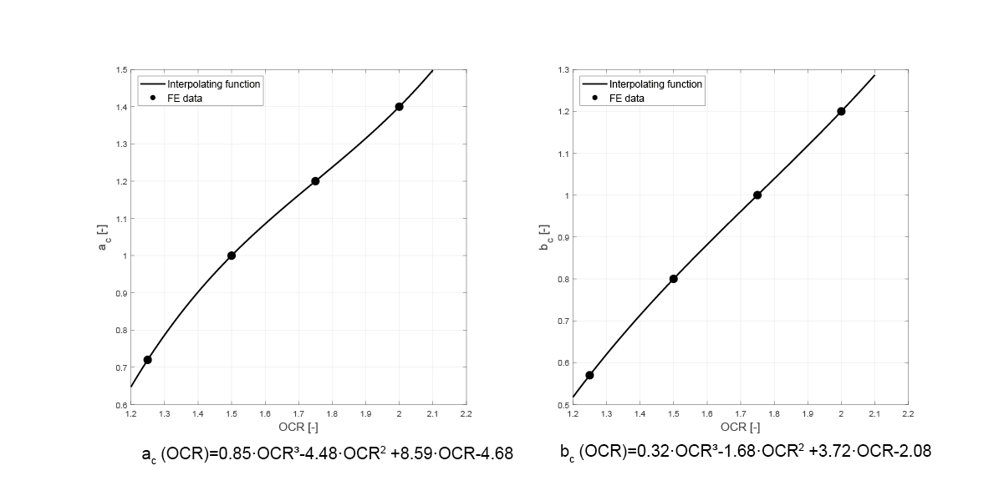
Figure 13: Interpolating functions for model parameters as function of the overconsolidation ratio $OCR$ a) activation parameter $a_{c}$ and b) shape parameter $b_{c}$ (for $OCR>1$).

Conclusions
In this paper, plane strain finite element numerical analyses results, concerning the problem of cavity unloading, are discussed. Ideal cylindrical deep tunnels, immersed in homogeneous clayey strata and behaving under undrained conditions, are taken into consideration. The numerical problem is tackled by employing three standard and popular constitutive relationships: one elastic, one elastic perfectly plastic and one strain hardening elastic-plastic.
Numerical results have been used to:
- compare the characteristic curves numerically obtained with the standard one, analytically derived under ideal conditions, not taking into account the material self-weight, the anisotropy of the in-situ state of stress, the dependence of the soil stiffness on confining pressure and the non-linearity of the stress-strain curve before reaching the ultimate condition.
- discuss the influence of initial stress anisotropy and constitutive relationships employed on the prediction of cavity distortion.
The authors have derived that, in case of deep tunnels:

- the material self-weight plays a negligible role;
- the ground level affects the solution in terms of convergence only for very large displacements;
- the anisotropy of the initial stress state severely modifies the characteristic curve;
- in case a Tresca elastic-perfectly plastic model is chosen, the reliability of the results becomes questionable, when values of $K$ far from 1 are taken into consideration;
- the anisotropy of the initial stress state is particularly important in relation to the radial convergence profile, that is almost uniform only in case of $K = 1$ and becomes strongly dependent on the angular coordinate for $K≠1.$

A modified formulation of the standard characteristic curve is thus proposed to account for the anisotropy of the initial state of stress. The modification of the standard characteristic curve definition passed through the non-dimensional definition of the relationship. This allowed to adapt it to a wide range of cases characterised by different geometries and soil mechanical properties.
In case of Modified Cam Clay model is employed, a strategy to adapt the original formulation of the characteristic curve is suggested. In this case, the characteristic curve is demonstrated to depend exclusively on the over-consolidation ratio imposed.
The capability of the modified formula of predicting FEM numerical results seems to be satisfactorily for pre-design stages, extending its applicability.

Appendix Numerical model

Numerical analyses were conducted using the finite element code MIDAS FEA NX. The geometry of the numerical model is shown in Figure 14. Plane strain conditions were imposed and, owing to the problem's symmetry, only half of the domain was simulated. The system geometry is defined by a tunnel diameter $D=10m$ and an axis depth $H=10.5D$. The lateral and lower boundaries were placed sufficiently far from the tunnel to minimise their influence on numerical results, and displacements in the normal direction were not allowed along these boundaries.
The analyses were performed in two stages:

- the initial stress field was applied throughout the entire domain. In the case of total stress analyses, the vertical stress was gradually increased to its final geostatic value while the horizontal stress was imposed based on the coefficient $K$. For effective stress analyses, the vertical stress was similarly increased to its final geostatic value, but the horizontal stresses were imposed using the coefficient $k_{0}$. In the latter case, it was necessary to initialize the water pressure, which was initially assumed to be hydrostatic, and the modified Cam Clay isotropic hardening variable $p_{0}$. This is done by evaluating the $p_{0}$ value that satisfies the yield function equation $f=0$ in each point of the soil stratum:

$f={(OCR q_{0})}^{2}-M^{2}OCR {p'}_{0}(p_{0}-OCR {p'}_{0})$=0 | (15)

where

${p'}_{0}=(1+2k_{0})γ'z$ | (16)

$q_{0}=\left|1-k_{0}\right|γ'z$ | (17)

- the unloading process of the cavity was simulated by progressively removing the soil elements within the cavity.

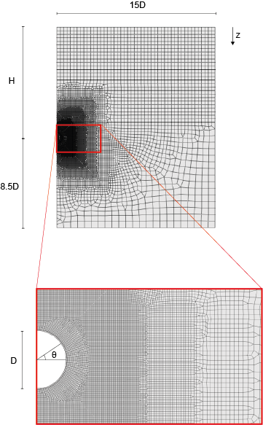

Figure 14: FEM numerical model employed.

Bibliografia
[1] Brooker, E. W., & Ireland, H. O. (1965). Earth Pressures at Rest Related to Stress History. Canadian Geotechnical Journal, 2(1), 1–15.
[2] Brown, E. T., Bray, J. W., Ladanyi, D., & Hoek, E. (1983). Ground response curves for rock tunnels. Journal of Geotechnical Engineering, 109(1), 15–39.
[3] Cao, L. F., Teh, C. I., & Chang, M. F. (2001). Undrained cavity expansion in modified Cam clay I: Theoretical analysis. Géotechnique, 51(4), 323–334.
[4] Carranza-Torres, C., & Fairhurst, C. (2000). Application of the convergence-confinement method of tunnel design to rock masses that satisfy the Hoek-Brown failure criterion. Tunnelling and Underground Space Technology, 15(2), 187–213.
[5] di Prisco, C., Boldini, D., Desideri, A., Bilotta, E., Russo, G., Callari, C., Flessati, L., Graziani, A., & Meda, A. (2022). Computational methods. In Handbook on tunnels and underground works (eds E. Bilotta, R. Casala, C. Giulio di Prisco, S. Miliziano, D. Peila, A. Pigorini and E. M. Pizzarotti), pp. 203–245. Leiden, The Netherlands: CRC Press/Balkema.
[6] di Prisco, C., & Flessati, L. (2021). A generalized constitutive relationship for undrained soil structure interaction problems. In International Conference of the International Association for Computer Methods and Advances in Geomechanics (pp. 398–405). Cham: Springer International Publishing.
[7] di Prisco, C., Callari, C., Barbero, M., Bilotta, E., Russo, G., Boldini, D., … & Sciotti, A. (2022). Assessment of excavation-related hazards and design of mitigation measures. In Handbook on tunnels and underground works (eds E. Bilotta, R. Casala, C. Giulio di Prisco, S. Miliziano, D. Peila, A. Pigorini and E. M. Pizzarotti), pp. 247–316. Leiden, The Netherlands: CRC Press/Balkema.
[8] di Prisco, C., Flessati, L., Frigerio, G., & Lunardi, P. (2018). A numerical exercise for the definition under undrained conditions of the deep tunnel front characteristic curve. Acta Geotechnica, 13, 635–649.
[9] Flessati, L. (2017). Mechanical response of reinforced deep tunnel fronts in cohesive soils: experimental and numerical analyses. PhD Thesis. Politecnico di Milano.
[10] Flessati, L., & di Prisco, C. (2024). Mechanised deep tunnel excavation in saturated clayey soils: a pre-design hydro-mechanically coupled method for the assessment of both spoil and face volume loss. Géotechnique, 1–14.
[11] Flessati, L., di Prisco, C., & Callea, F. (2021). Numerical and theoretical analyses of settlements of strip shallow foundations on normally consolidated clays under partially drained conditions. Géotechnique, 71(12), 1114–1134.
[12] Gesta, P., et al. (1978). Tunnel stability by convergence confinement method. Simposyum AFETS, Paris.
[13] Jaky, J. (1944). The coefficient of earth pressure at rest. Journal of the Society of Hungarian Architects and Engineers.
[14] Kirst, G. (1898). Die theorie der elastizität und die bedürfnisse der festigkeitslehre. Zeitschrift des Vereines Deutscher Ingenieure, 42(28), 797–807.
[15] Lombardi, G. (1973). Dimension of tunnel lining with regard to constructional procedure. Tunnels & Tunnelling International, 5(4).
[16] Nova, R., & Montrasio, L. (1991). Settlements of shallow foundations on sand. Géotechnique, 41(2), 243–256.
[17] Panet, M., & Guenot, A. (1982). Analysis of convergence behind the face of a tunnel. Tunneling ’82, Brington, 197–204.
[18] Panet, M. (1995). Le calcul des tunnels par la methode convergence-confinement. Presses ENPC.
[19] Panet, M., Bouvard, A., Dardard, B., Dubois, P., Givet, O., et al. (2001). Recommandations on the convergence-confinement method. AFTES, France.
[20] Panet, M., & Sulem, J. (2022). Convergence-confinement method for tunnel design. Cham, Switzerland: Springer.
[21] Ribacchi, R., & Riccioni, R. (1977). Stato di sforzo e deformazione intorno ad una galleria circolare. Gallerie e Grandi Opere Sotterranee, 5, 7–18.
[22] Ribacchi, R., Rotonda, T., Graziani, A., Boldini, D., Tommasi, P., & Lembo Fazio, A. (2018). Meccanica delle rocce. Teoria e applicazioni nell'Ingegneria. Libreria Efesto di A. Catalfo.
[23] Roscoe, K. H., & Burland, J. B. (1968). On the generalized stress-strain behaviour of 'wet' clay. In Engineering Plasticity, Cambridge University Press, 535–609.
[24] Schofield, A. N., & Wroth, P. (1968). Critical state soil mechanics (Vol. 310). London: McGraw-Hill.
[25] Vlachopoulos, N., & Diederichs, M. S. (2009). Improved longitudinal displacement profiles for convergence confinement analysis of deep tunnels. Rock Mechanics and Rock Engineering, 42(2), 131–146.
[26] Wood, D. M. (1990). Soil behaviour and critical state soil mechanics. Cambridge University Press.
[27] Zerbi, M., Flessati, L., & di Prisco, C. (2024). Curve caratteristiche non drenate per gallerie profonde e superficiali in assenza e in presenza di rivestimento: analisi numeriche e interpretazione teorica. In Atti dell'Incontro Annuale dei Ricercatori di Geotecnica IARG 2024.

