Parametric simulations to evaluate occupants’ behavior incidence on building energy performance – A Passive House case study

Massimiliano Manfren
Faculty of Engineering and Physical Sciences
University of Southampton
Southampton, United Kingdom
M.Manfren@soton.ac.uk
Maria Cristina Tommasino
Department of Architecture
University of Bologna
Cesena, Italy
mariacristina.tommasino@unibo.it

Lamberto Tronchin
Department of Architecture,
University of Bologna
Cesena, Italy
lamberto.tronchin@unibo.it

Abstract— The building industry's rising commitment to resource efficiency is influencing the evolution of building design and operation practices. At the same time, built environment decarbonisation is among the most important policy goals at the EU and global scale. High performance building design are emerging and their deployment in practice involves both new and existing buildings. Taking advantage of heat gains (solar and internal) to balance heat losses, as in passive design strategies, is becoming more increasingly relevant, but this must be carefully considered to reduce the risk of overheating during intermediate seasons and an increase of cooling demand during summer. In general, however, optimistic assumptions are frequently made during the design phase; semi-stationary calculation methods also are still widely used, especially for code compliance. Furthermore, the impact on performance of occupant's behaviour and comfort preferences is frequently overlooked. This study investigates the potential variability of simulated performance in a case study building constructed in Italy to the Passive House standard. The study contrasts the initial design hypothesis, which was developed using a semi-stationary model, to a larger set of data created through parametric simulations using a Design of Experiments methodology and a grey-box dynamic model. The modelling approach presented aims to detect potentially problematic assumptions early in the design process, with minimal computational effort. A detailed examination of design solutions from the early design stage can aid in the provision of more robust energy performance assessments, resulting in positive implications for techno-economic optimisation and for the credibility of high performance building design paradigms.
Keywords— building performance simulation, parametric modelling, Design of Experiments, behavioural modelling, occupant behaviour.

Introduction
The building industry's rising commitment to resource efficiency [1] is influencing the evolution of building design and operation practices. Decarbonisation of the built environment is one of the most important goals in terms of policy, considering the carbon emission impact of building stock at the EU [2] and global level. Energy efficiency paradigms (i.e. NZEB, PEB, etc.) are emerging and their deployment involves both new and existing buildings [3], with the latter being far more relevant in absolute terms [4, 5]. Taking advantage of solar and internal gains to offset heat losses due to transmission and ventilation (in heating mode), as in passive design strategies is becoming more increasingly relevant. Nonetheless, this has to be carefully considered (e.g. with an appropriate level of insulation, effective natural ventilation and solar shading) to reduce the risk of overheating during intermediate seasons and an increase of cooling demand during summer. In addition, optimistic assumptions are frequently made during the design phase. Semi-stationary simplified calculation methods also are still widely used, especially for code compliance. Furthermore, the impact on performance of occupant's behaviour and comfort preferences is frequently overlooked. The goal of this research is to provide an investigation of the prospective gap between simulated and measured performance in a real-world case study building located in Italy and constructed according to Passive House standard, which represents a high efficiency design paradigm at the state of the art.

METHODS
The study compares the original design hypothesis, derived using Passive-House Planning Package (PHPP) [6], a semi-stationary model developed for Passive-House design, to a larger set of simulated data obtained by leveraging a Design Of Experiment (DOE) approach, in the context of a parametric simulation. This technique aims to increase the robustness of energy performance assessment by detecting assumptions that can generated large discrepancies between simulated and real performance (expressed in terms of KPI) early in the design process. This robustness is crucial in light of its implications for techno-economic optimisation and the effectiveness of energy efficiency practises and policies. One of the most important aspects to consider for the successful implementation of high performance design paradigms and, subsequently, the success of policies regarding building performance is cost-optimality [7] of solutions. However, large discrepancies between simulated and real performance can be found in many cases [8], in relation in particular to the effect of occupants’ comfort settings and behaviours [9, 10] in high efficiency buildings. A smooth integration between performance modelling methods across life cycle stages has to be developed to overcome this issue, e.g., by employing simulation with a multiplicity of input conditions (design stage) and gradually calibrating models to measured data up to the energy management and control strategy (operation stage) [11, 12]. In this sense, surrogate models [13] can be used effectively in multiple stages of building performance analysis from design optimisation [14], to calibration [13], and control [15]. A dynamic reduced-order grey-box model was used in the research. Additional research should focus on developing multi-level performance analytics [16, 17] and visualisation tools to further automate and improve these applications.

CASE STUDY
The chosen case study is a Passive House residential building located in the Emilia-Romagna province of Forli-Cesena, Italy. To compare initial building design simulations to more extensive parametric simulation conditions, the Design Of Experiment method is implemented. In Design Of Experiment simulations (indicated later as DOE runs), parameters are modified relative to the baseline design (initially developed using the PHPP semi-stationary model), using a two-level factorial design [18]; parameters are the used as input to run a grey-box dynamic model. The choice of a grey-box lumped parameter model is due to two facts: it is validated according to current standards for dynamic building simulation and it can run multiple configurations in a very short amount of time thus not increasing the computational burden in design phase optimisation. The DOE method aims to mimic the potential impact of variations in building characteristics and occupants’ preferences (e.g. in terms of comfort and operation) that can create a significant difference between simulated and real performance undermining credibility (and environmental and economic effectiveness) of solutions.
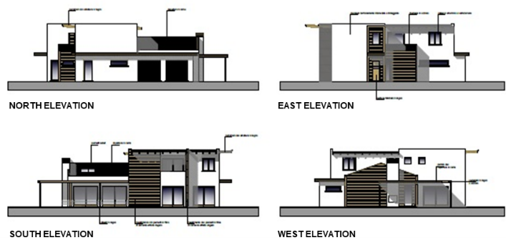
- Elevations of the building in the different orientations.
The case study building includes a highly insulated envelope, mechanical ventilation with heat recovery (MVHR), a ground-source heat pump (GSHP) system, and a photovoltaic (PV) system for on-site power generation. Heat recovery (MVHR) was considered in the parametric simulation because the system uses heat recovery in winter mode (heating) operation, but was not considered for summer mode (cooling) operation, due to the characteristics of the building. However, if we consider the trade-off between exhaust air stream’s recovered energy and auxiliaries’ electricity consumption [19], based on the mild locations’ climate conditions, the yearly energy saving provided by heat recovery is relatively modest.

RESULTS
The baseline configuration considered in the initial stage of the research is the one derived from the original building's design stage model in PHPP. The lumped parameters describing building’s characteristics in the grey-box model were calibrated to match the thermal needs computed with the original PHPP model, but the whole building energy balance has been considered in this case for the simulations’ results. Given that only four people live in the building, despite its size, the expected internal gains are much lower than average values found in typical residential buildings. Table 1 summarizes baseline simulations’ inputs.
- simulation input data - baseline
Input group | Input type | Unit | Value
Geometry | Gross volume | m³ | 1557
 | Net volume | m³ | 1231
 | Heat loss surface area | m² | 847
 | Net floor area | m² | 444
 | Surface/volume ratio | 1/m | 0.54
Construction components | U value external walls | W/(m²K) | 0.18
 | U value roof | W/(m²K) | 0.17
 | U value transparent components | W/(m²K) | 0.83
Activities | Internal gains (lighting, appliances and occupancy) | W/m² | 1
Control and operation | Heating set-point temperature | °C | 20
 | Cooling set-point temperature | °C | 26
 | Air-change rate | vol/h | 0.3
 | Operation schedules | - | 0.00-23.00

Following baseline simulation run using PHPP, a grey-box dynamic validated model was used to run annual simulations in multiple conditions. The whole building energy balance has been considered (heating, cooling, lighting, DHW, appliances). The building is all electric; electricity feeds the GSHP for heating and cooling services. Figure 2 present the electricity demand composition for the baseline configuration.
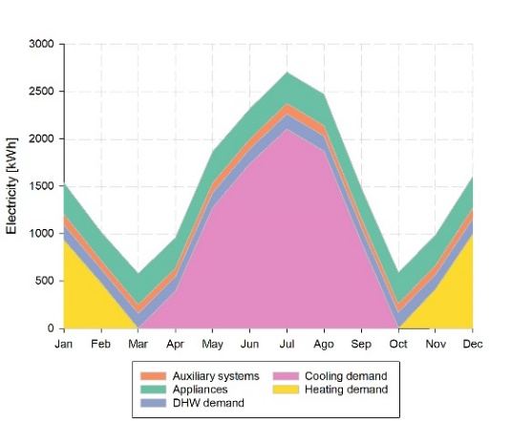
- Electricity demand total (including appliances) – Baseline.
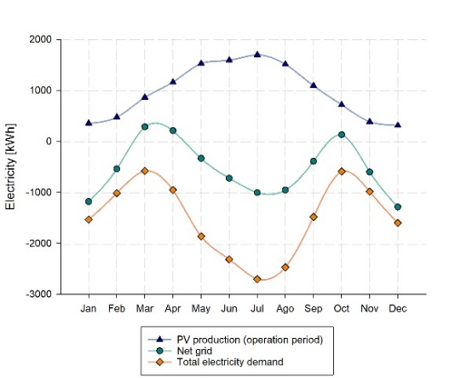
- On-site production and demand - Electricity meter balance - Baseline.
Demand and on-site production from renewables, referring to the electricity meter balance, are depicted in Figure 3 which indicates that the photovoltaic system can meet a substantial portion of the building's total electricity demand. Figure 4 instead reports the imported and exported energy components (considering again the balance at the meter level), illustrating the building-grid interaction.
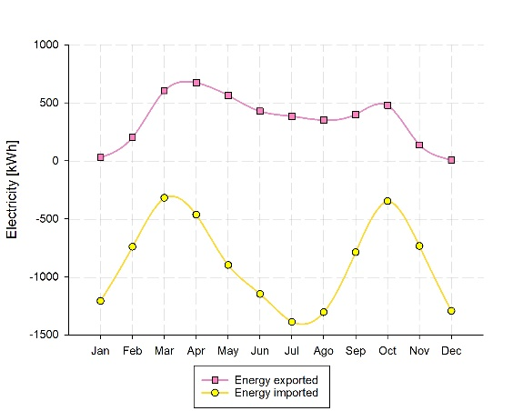
- Imported and exported energy - Electricity meter balance – Baseline.
For reasons of consistency and comparability with the original design phase simulations, the baseline model using constant operational schedules. This is clearly not accurate when studying the dynamic building energy behaviour. Therefore, more realistic simulation conditions have been included in the parametric simulation runs, which is based on a two-level Design of Experiment (DOE) full factorial set of combinations, in which model input parameters can from a (-1) minimum to (+1) maximum level. The DOE simulations are repeated with different operational patterns.
- Design Of Experiment simulation data (two-level – full factorial)
Input group | Input type | Unit | DOE levels
 |  |  | -1 | +1
Construction components | U values external walls | W/(m²K) | 0.22 | 0.27
 | U values roof | W/(m²K) | 0.20 | 0.26
 | U values transparent components | W/(m²K) | 1.03 | 1.25
Activities | Internal gains (lighting, appliances and occupancy) | W/m² | 1.0 | 1.5
Control and operation | Heating set-point temperature | °C | 20 | 22
 | Air-change rate | vol/h | 0.4 | 0.6

Three DOE simulation trials were conducted, considering the operational patterns reported in Table 3. The hours of operation indicate the hours when the building is operated with a more intense use of appliances and occupied; coherent operating schedules (heating, cooling, ventilation, lighting) have been set in the simulation.
- Behavioural operation patterns – DOE runs
Simulation | Behavioural patterns | Hours of operation
DOE run 1 | Constant | 0.00-24.00
DOE run 2 | Variable operation 1 | 7.00-22.00
DOE run 3 | Variable operation 2 | 7.00-9.00; 17.00-22.00
DOE – Run 1 (constant operation) | 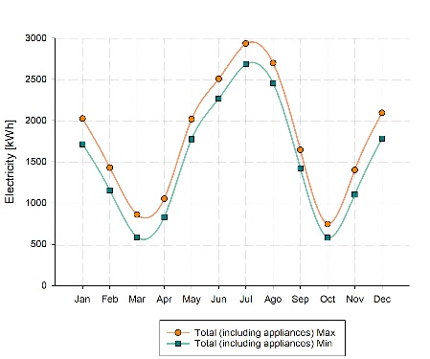
DOE – Run 2 (variable operation 1) | 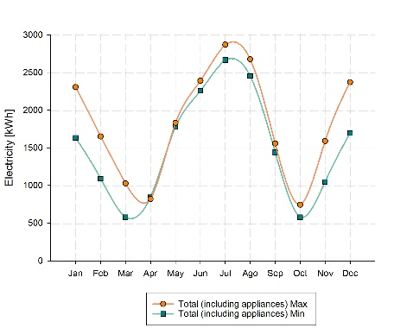
DOE – Run 3 (variable operation 2) | 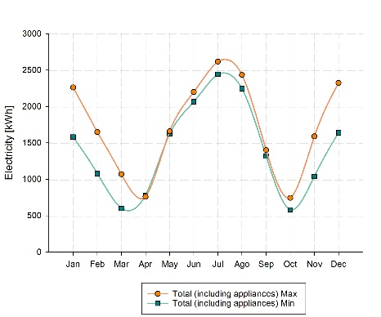
- Electricity demand total (including appliances) - DOE runs
Figures 5, 6, and 7 illustrates the outcomes of parametric simulations. In order to enable a direct comparison with the baseline simulations' results, the graphical representation are the same as in Figures 2, 3, and 4. In this case, however, the configurations corresponding respectively to the minimum and to the maximum values (of non-renewable primary energy demand) are reported, to indicate the spectrum of variability achieved in results. This performance indicator was computed in accordance with the methodology outlined in ISO 52000-1 [20]. In other fields, such as cultural heritage [21, 22] and room acoustics [23, 24, 25], performance indicators described in technical standardization have been used in conjunction with techniques for parametric simulation and digital model reconstruction to enable a better characterization of performance under variable conditions [26]. In this instance, the entire building's energy demand (including appliances, not normally considered for code compliance) has been considered, with imported and exported electricity given unequal weight. The weight considered in this research is 0.4, which is different from the one used in the Italian legislation regarding energy performance of buildings. The building has also been monitored for 3 years [27] and a more in-depth analysis of the relation between comfort preferences and settings [28] and building-grid interaction is part of further research on this case study.
DOE – Run 1 (constant operation) | 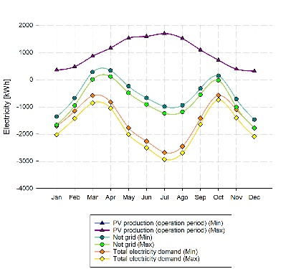
DOE – Run 2 (variable operation 1) | 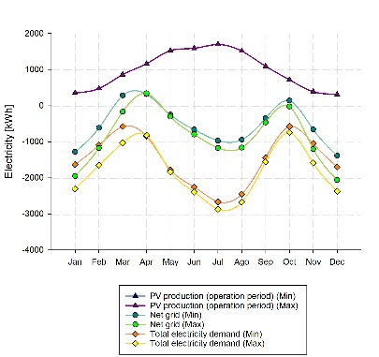
DOE – Run 3 (variable operation 2) | 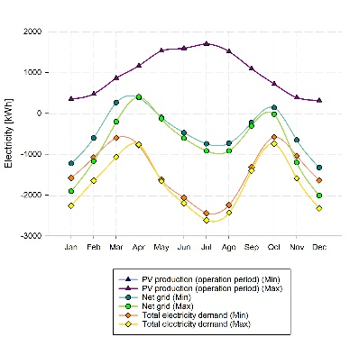
- On-site production and demand - Electricity meter balance - DOE runs.
The total electricity demand, including appliances, (shown in Figure 5) and the on-site electricity production and demand (shown in Figure 6), derived by means of parametric (DOE) simulations, vary with respect to the absolute magnitude of quantities but not with respect to their “seasonality”, exemplified by monthly patterns, given consistent input choices across the parametric runs. Conversely, Figure 7 indicates how the different schedules selected for parametric simulation affect building-grid interaction significantly. Different building-grid interaction patterns may have significant technological, economic, and environmental implications, especially concerning primary energy, and carbon emission, self-consumption and the related prosumer business model. The results were then employed to compute the KPIs (Key Performance Indicators) shown in Table 4. Additionally, the sensitivity of KPIs has been computed, reporting the percentage of variation relative to the baseline configuration (representing zero variation), defined in Table 1. Figure 8 shows that a small change in input data can have a big impact on output data and this effect is amplified when the quantities become smaller (e.g. heating demand) or in the case of self-consumption which is clearly influenced by the building-grid interaction patterns.
DOE – Run 1 (constant operation) | 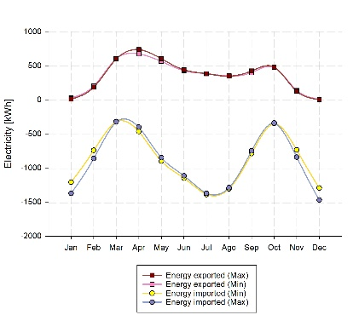
DOE – Run 2 (variable operation 1) | 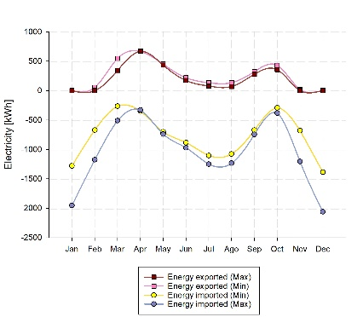
DOE – Run 3 (variable operation 2) | 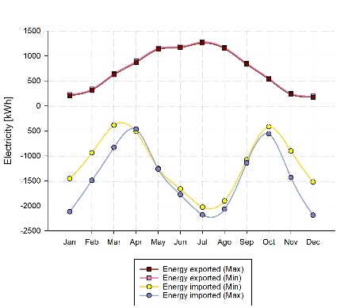
- Imported and exported energy - Electricity meter balance - DOE runs.
- Baseline – DOE runs sensitivity analysis
Simulation run | Heating demand | Cooling demand | Self- consumption | Renewable Energy Ratio | Primary Energy | CO₂ Emission
 | kWh/m² | kWh/m² | % | % | kWh/m² | kg/m²
Baseline | 20.4 | 52.3 | 63.6 | 61.7 | 39.3 | 8.7
DOE run 1 - min | 24.5 | 49.2 | 62.1 | 62.4 | 41.0 | 8.9
DOE run 1 - max | 29.2 | 51.5 | 68.4 | 59.2 | 52.4 | 11.6
DOE run 2 - min | 22.8 | 49.7 | 73.9 | 64.6 | 36.2 | 7.8
DOE run 2 - max | 37.8 | 48.0 | 78.8 | 62.1 | 51.2 | 11.1
DOE run 3 - min | 21.9 | 43.9 | 25.3 | 59.2 | 46.5 | 10.0
DOE run 3 - max | 37.3 | 41.5 | 27.6 | 57.8 | 62.1 | 13.8
Min | 20.4 | 41.5 | 25.3 | 57.8 | 36.2 | 7.8
Average | 27.7 | 48.0 | 57.1 | 61.0 | 47.0 | 10.3
Max | 37.8 | 52.3 | 78.8 | 64.6 | 62.1 | 13.8
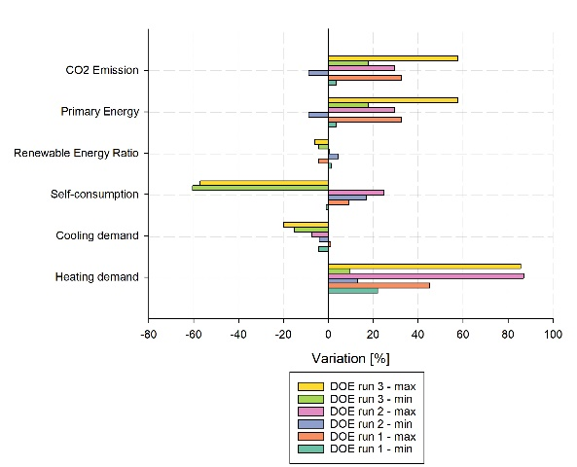
- Sensitivity of KPI, results of DOE parametric runs, variations with respect to baseline configuration.

Conclusions
The "Performance Gap" refers to the fact that the actual monitored energy consumption of buildings frequently differs substantially from the expected calculated consumption, even if the latter is obtained using advanced dynamic building energy performance simulation. Nevertheless, the building performance gap (due to multiple factors, including occupant’s behaviour) must be acknowledged, and for this reason, it is essential to provide continuity in the analytical methodologies used from design to operation and across various temporal scales of analysis. Adopting a critical perspective on building performance, we can now leverage parametric simulation to evaluate design solutions’ robustness from the very early design stage. This is necessary to guarantee the credibility of high performance paradigms and energy efficiency practises, in particular in relation to the emerging business models (such as the prosumer one) in which cost-optimization is a fundamental requirement. In addition, the preferences and behaviour of occupants are frequently overlooked during design phase simulations, despite their importance to the success of innovative building practises and policies. As the case study demonstrates, the patterns of energy imports and exports can change drastically when realistic operation profiles are utilised rather than standard assumptions. This can have significant economic and environmental consequences, as the primary energy and carbon emission factors, as well as the unitary costs, for imported and exported energy may be different. Parametric design must be gradually implemented with increasingly realistic building operation profiles and grid interaction data (primary energy and carbon emission factors, tariffs, etc.). This, in turn, could promote the co-evolution of building design practices and energy infrastructure, in particular the electric grid.

Acknowledgment
The authors would like to thank Kristian Fabbri for his assistance and feedback during the research process.

References
- N. Dodd, S. Donatello, E. Garbarino, and M. Gama-Caldas, "Identifying macro-objectives for the life cycle environmental performance and resource efficiency of EU buildings" JRC EU Commission, 2015.
- "Europe’s buildings under the microscope" Buildings Performance Institute Europe (BPIE), 2011.
- D. D'Agostino, P. Zangheri, B. Cuniberti, D. Paci, and P. Bertoldi, "Synthesis Report on the National Plans for Nearly Zero Energy Buildings (NZEBs)" JRC EU Commission, 2016.
- "Energy Efficiency – the first fuel for the EU Economy, How to drive new finance for energy efficiency investments" EEFIG, 2015.
- M. Manfren, B. Nastasi, L. Tronchin, D. Groppi, and D.A.Garcia, "Techno-economic analysis and energy modelling as a key enablers for smart energy services and technologies in buildings" Renewable and Sustainable Energy Reviews, vol. 150, article 111490, 2021.
- PHPP – the energy balance and Passive House planning tool.
- N. Aste, R. S. Adhikari, and M. Manfren, "Cost optimal analysis of heat pump technology adoption in residential reference buildings" Renewable Energy, vol. 60, pp. 615-624, 2013.
- P. de Wilde, "The gap between predicted and measured energy performance of buildings: A framework for investigation" Automation in Construction, vol. 41, pp. 40-49, 2014.
- A. C. Menezes, A. Cripps, D. Bouchlaghem, and R. Buswell, "Predicted vs. actual energy performance of non-domestic buildings: Using post-occupancy evaluation data to reduce the performance gap" Applied Energy, vol. 97, pp. 355-364, 2012.
- L. C. Tagliabue, M. Manfren, A. L. C. Ciribini, and E. De Angelis, "Probabilistic behavioural modeling in building performance simulation—The Brescia eLUX lab" Energy and Buildings, vol. 128, pp. 119-131, 2016.
- M. Manfren and B. Nastasi, “Parametric Performance Analysis and Energy Model Calibration Workflow Integration—A Scalable Approach for Buildings,” Energies , vol. 13, no. 3. 2020. doi: 10.3390/en13030621.
- M. Manfren, B. Nastasi, and L. Tronchin, “Linking Design and Operation Phase Energy Performance Analysis Through Regression-Based Approaches,” Front Energy Res, vol. 8, p. 288, 2020, doi: 10.3389/fenrg.2020.557649.
- M. Manfren, N. Aste, and R. Moshksar, "Calibration and uncertainty analysis for computer models – A meta-model based approach for integrated building energy simulation" Applied Energy, vol. 103, pp. 627-641, 2013.
- A.-T. Nguyen, S. Reiter, and P. Rigo, "A review on simulation-based optimization methods applied to building performance analysis" Applied Energy, vol. 113, pp. 1043-1058, 2014.
- Z. Yang and B. Becerik-Gerber, "A model calibration framework for simultaneous multi-level building energy simulation" Applied Energy, vol. 149, pp. 415-431, 2015.
- M. Manfren, M. Sibilla, and L. Tronchin, “Energy Modelling and Analytics in the Built Environment—A Review of Their Role for Energy Transitions in the Construction Sector,” Energies , vol. 14, no. 3. 2021. doi: 10.3390/en14030679.
- L. Tronchin, M. Manfren, and L. C. Tagliabue, "Optimization of building energy performance by means of multi-scale analysis – Lessons learned from case studies" Sustainable Cities and Society, vol. 27, pp. 296-306, 2016.
- J. Antony, Design of Experiments for Engineers and Scientists: Elsevier Science, 2014.
- L. Tronchin , K. Fabbri and C. Bertolli, "Controlled mechanical ventilation in buildings: A comparison between energy use and primary energy among twenty different devices" Energies, vol 11(8), Article 2123, 2018.
- EN ISO/DIS 52000-1:2017, Energy performance of buildings — Overarching EPB assessment – Part 1: General framework and procedures
- L. Tronchin, D.J. Knight, “Revisiting Historic Buildings through the Senses Visualising Aural and Obscured Aspects of San Vitale, Ravenna”, International Journal of Historical Archaeology, vol 20(1), pp127-145, 2016
- L. Tronchin, A. Bevilacqua "Historically informed digital reconstruction of the Roman theatre of Verona. Unveiling the acoustics of the original shape" Applied Acoustics, vol. 185, Article 108409, 2022
- L. Tronchin, F. Merli, M. Manfren "On the acoustics of the Teatro 1763 in Bologna" Applied Acoustics, vol. 172, p. 1-9, Article 107598, 2021
- L. Tronchin, F. Merli, M. Dolci "Virtual acoustic reconstruction of the Miners’ Theatre in Idrija (Slovenia)" Applied Acoustics, vol. 172, Article 107595, 2021
- L. Tronchin, A. Bevilacqua "Acoustic study of different sceneries at the São Carlos national theatre of Lisbon" Applied Acoustics, vol. 180, Article 108102, 2021
- L. Tronchin, “Variability of room acoustic parameters with thermo-hygrometric conditions” Applied Acoustics, Vol 177, article 107933, 2021.
- M. Manfren, P. AB. James, L. Tronchin “Data-driven building energy modelling – An analysis of the potential for generalisation through interpretable machine learning” Renewable and Sustainable Energy Reviews, vol. 167, article 112686, 2022
- M. Manfren, B. Nastasi, E.A. Piana and L. Tronchin. “On the link between energy performance of building and thermal comfort: An example” AIP Conference Proceedings. vol. 2123, p. 1-9, American Institute of Physics, Beirut, 10-12 April 2019, 2019

