Supplementary information

A Multifunctional Molecular Bridge for Carbon-Silver Nanohybrids Enabling Flexible Electronic and Biocidal Applications
Edoardo Testa,†¹ Simone Raciti,†¹ Davide Gentile,¹ Mattia Mondella,¹ Francesco Goto,² Gianlorenzo Bussetti, ² Nina Bono, ¹ Dario Allevi, ¹ Alberto Bottari, ¹ Gabriele Candiani, ¹ Maurizio Galimberti¹ and Vincenzina Barbera*¹

¹ Department of Chemistry, Materials and Chemical Engineering “G. Natta”, Politecnico di Milano, Via Bassini 6, 20133 Milano, Italy
² Department of Physics, Politecnico di Milano, piazza Leonardo da Vinci 32, Milan, 20133 Italy

† These authors contributed equally to this work.
*Correspondence: vincenzina.barbera@polimi.it (V.B.)
Summary of sections
S1. Preparation and characterization of CA-SP/Ag adduct 5
S2. Scalable production of HSAG-SP/Ag nanocomposites via a two-step, one-pot functionalization approach employing High Shear Mixing (HSM). 25
S3. Theoretical Calculations 26
S4. Applicability of the HSAG-SP/Ag Adduct in Composite Materials and Inks for Flexible Electronics for Antimicrobial Applications in Wearable Pressure Sensors. 35
References 35

Table S 1 . Summary of chemical and physical strategies for the decoration of carbon allotropes with silver nanoparticles (AgNPs): comparison of substrates, synthetic routes, and functional performance.
Previous works |  | Substrate | Strategy | Results | Ref
Previous works | Chemical modification | Cotton, polyester (PET), polyamide (NL) blends. | In situ generation of catechol-formaldehyde resins (CFR) to anchor AgNPs via condensation at 100°C. | Achieved 99.99% bacteriostasis after 50 laundering cycles; low cytotoxicity and zero formaldehyde residue. | [1]
Previous works | Chemical modification | Nitrogen and sulfur co-doped fluorescent carbon dots (~5 nm). | NSCDs synthesized under reflux; AgNO₃ reduced by NSCDs at room temperature to form hybrids. | Successful acetone and sulfide sensing; high catalytic activity for dye degradation and strong antimicrobial effect. | [2]
Previous works | Chemical modification | Citrate-capped AgNPs and Green Tea extract-stabilized AgNPs. | Comparison between NaBH₄ reduction (citrate-capped) and green tea extract reduction/stabilization. | Demonstrated that high aggregation (pH/electrolyte induced) reduces toxicity; green tea AgNPs were more stable than citrate ones. | [3]
Previous works | Chemical modification | Reduced graphene oxide (rGO) | The reduction of silver nitrate is conducted in water and ethanol in alkaline environment. The selected reducing agent is thiourea dioxide, which can reduce both silver and GO. | Silver nanoparticles with sizes of 6–7 nm can be detected on the surface of the graphene sheets. | [4]
Previous works | Chemical modification | Graphene oxide (GO) | A suspension of GO and AgNO₃ is prepared in water, then sodium citrate was added, and the suspension is heated to generate silver nanoparticles stabilized with sodium citrate. | The Silver-decorated GO powder shows interesting antibacterial activity. | [5]
Previous works | Chemical modification | Graphene sheets | Graphite and AgNO₃ are suspended in water, with the aid of PVA. Ultrasonication and NaBH₄ activities lead to the reduction of silver, generating nanoparticles (8.6–15.6 nm) on the surface of graphene. | By fine-tuning ultrasonication time and power, the composite’s performance was significantly enhanced, leading to its application as an advanced antibacterial finish for textile fabrics. | [6]
Previous works | Chemical modification | GO and rGO | Graphite and AgNO₃ are suspended in water and ammonia, with the aid of PVP. The reduction of silver ammoniate is achieved by deploying glucose as a reducing agent. | A metallic silver nanoparticle deposit can be obtained on the graphite surface, showing an interesting Raman scattering. | [7]
Previous works | Chemical modification | GO | GO, sodium citrate and silver nitrate are suspended in water. Microwave irradiation heating in the presence of the citrate as reducing agent lead to the formation of AgNps and rGO. | The concomitant use of citrate and efficient heating allows for the preparation of Ag-CA adducts. Ag-rGO adducts show interesting antibacterial and antiglioma activities. | [8]
Previous works | Physical modifications | Carbon onions | A plasma charge between two Ag-based electrodes lead to the creation of Ag nanoparticles. Also, the use of hydrocarbon gas, generating graphene-based onions, tightened with the NP. | Arch discharge technology allows for the preparation of those adducts. High energy helps in the pyrolysis of carbon-based gas. The prepared particles show interesting ferromagnetic properties. | [9]
Previous works | Physical modifications | GO | A suspension of GO and AgNO3 are hit by a Ti : sapphire femtosecond laser system. The high energy of laser pulsations allows the reduction of Ag¹⁺ to Ag^{0,} generating microparticles on the GO surface. | The Ag NPs/rGO nanocomposites are mainly used to protect sensors and eyes from high-intensity laser light as optical limiting materials. They can also be applied in photonic devices to control or modulate intense light. | [10]
Previous works | Physical modifications | MWCNTs | Silver nanoparticles were formed in situ during carbon nanotube growth by chemical vapor deposition (CVD), using silver nitrate vapor pulses to uniformly decorate the nanotube surfaces. | A hybrid nanostructure was successfully obtained, combining the high conductivity and strength of CNTs with the unique properties of silver nanoparticles, useful for antibacterial applications, and sensors. | [11]
This work |  | Carbon black, graphite, multi-walled carbon nanotubes | Functionalization of carbon allotropes through the pyrrole methodology; in situ AgNP nucleation mediated by Tollens’ reagent and surface aldehyde groups without exogenous reductants. | Pyrrole-grafted carbon allotropes are decorated with silver nanoparticles, enabling both bactericidal action and enhanced conductivity.  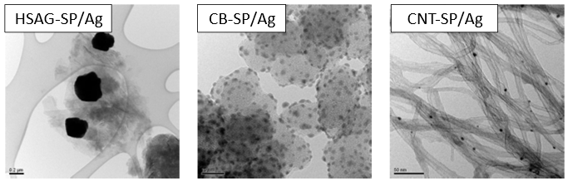

S1. Preparation and characterization of CA-SP/Ag adduct
Table S 2 Quantitative analysis of the organic fraction (SP) and inorganic residue (Ag) in CA-SP/Ag adducts, as determined by thermogravimetric analysis (TGA). Experimental values (%wt) are compared with theoretical estimates.
Sample | Organic fraction (%wt)ª | Theorical org. fraction (%wt) ^{b} | Ag (%wt)ª | Theorical Ag (%wt) ^{b}
HSAG | - | 0 | - | 0
HSAG-SP | 4.43 | 9 | - | 0
HSAG-SP/Ag | 8.01 | n.d. | 7.85 | 9
CB | - | 0 | - | 0
CB-SP | 7.98 | 9 | - | 0
CB-SP/Ag | 9.35 | n.d. | 9.5 | 9
MWCNT | - | 0 | - | 0
MWCNT-SP | 7.85 | 9 | - | 0
MWCNT-SP/Ag | 4.2 | n.d. | 13.1 | 9

ª from TGA analyses; ^{b} based on reacted material; n.d.: not determinable

Table S 3 Cumulative Mass losses (%wt) for HSAG, CB and CNT adducts. Data from raw thermograms.
 | Mass loss (%) (in N₂)
 | T<150°C | 150°C<T<900°C | T>900°C | Residue
HSAG | 0,43 | 5,01 | 93,91 | 0,65
HSAG-SP | 0,42 | 9,44 | 87,79 | 0,67
HSAG-SP/Ag | 2,41 | 13,02 | 76,03 | 8,5
CB | 0,35 | 3,16 | 95,95 | 0,54
CB-SP | 1,64 | 11,14 | 86,46 | 0,76
CB-SP/Ag | 1,46 | 12,51 | 75,99 | 10,04
MWCNT | 0,15 | 3,68 | 84,38 | 11,79
MWCNT-SP | 0,99 | 9,61 | 71,92 | 17,46
MWCNT-SP/Ag | 2,71 | 13,34 | 53,93 | 30,03

HSAG
(A)
(B)
(C)
(D)
(E)
(F)
(G)
Figure S 1 Decorated HSAG (A) IR analysis of the pristine carbon allotropes, (B) pyrrole grafted HSAG, (C) HSAG-SP – HSAG pristine overlapping, (D) silver decorated (high concentration-650) nanomaterials, (E) silver decorated (high concentration-650) overlapped with HSAG-SP, (F) silver decorated (low concentration-350) nanomaterials, (G) silver decorated (low concentration-350) overlapped with HSAG-SP.
CARBON BLACK
(A)
(B)
(C)
(D)
(E)
(F)
(G)
Figure S 2 Decorated Carbon Black (A) IR analysis of the pristine carbon allotropes, (B) pyrrole grafted CB, (C) CB-SP – CB pristine overlapping, (D) silver decorated (high concentration-650) nanomaterials, (E) silver decorated (high concentration-650) overlapped with CB-SP, (F) silver decorated (low concentration-350) nanomaterials, (G) silver decorated (low concentration-350) overlapped with CB-SP.
CARBON NANOTUBES
(A)
(B)
(C)
(D)
(E)
(F)
(G)
Figure S 3 Decorated Carbon Nanotubes (A) IR analysis of the pristine carbon allotropes, (B) pyrrole grafted CNT, (C) CNT-SP – CNT pristine overlapping, (D) silver decorated (high concentration-650) nanomaterials, (E) silver decorated (high concentration-650) overlapped with CNT-SP, (F) silver decorated (low concentration-350) nanomaterials, (G) silver decorated (low concentration-350) overlapped with CNT-SP.
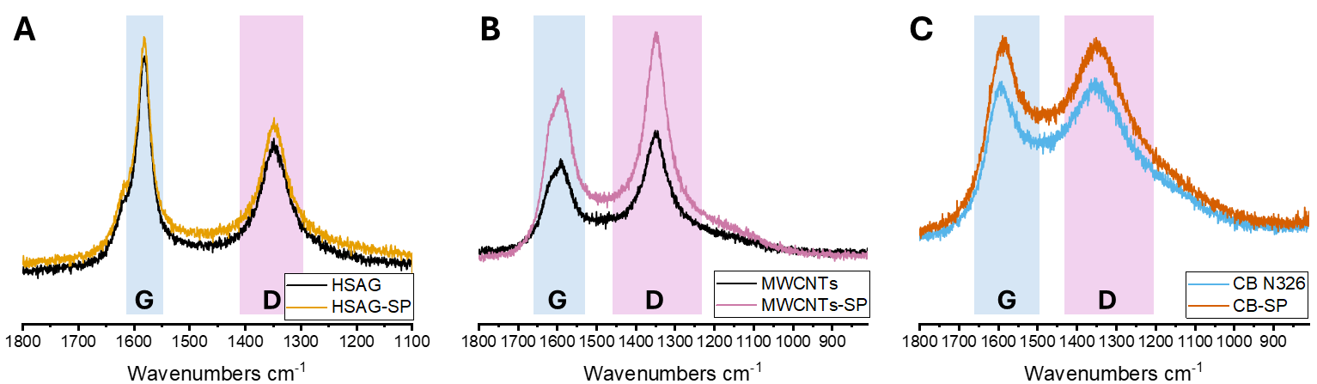
Figure S 4 Raman spectra of A Pristine and SP functionalized HSAG, B Pristine and SP functionalized CNTs, C Pristine and SP functionalized CB.
Table S 4 Structural parameters and disorder analysis of pristine and SP functionalized carbon-based materials. I_{G} = Height of G Peak, I_{D} = Height of D peak, I_{D}/I_{G} ratio of the different peaks heights, La (nm) = crystallite length, calculated from Tuinstra and Koenig equation (with a C(λ) = 19.22 nm for a 532 nm laser) La (nm) = C(λ) / (I_{D}/I_{G}).
CA | I_{G} | I_{D} | I_{D}/I_{G} | La (nm)
HSAG | 392.307 | 244.154 | 0.62 | 30.88
HSAG-SP | 405.123 | 307.053 | 0.76 | 25.36
CNT | 977.085 | 506.728 | 0.52 | 37.06
CNT-SP | 953.1883 | 565.719 | 0.59 | 32.38
CB | 917.388 | 1248.426 | 1.36 | 14.12
CB-SP | 452.109 | 675.977 | 1.50 | 12.85

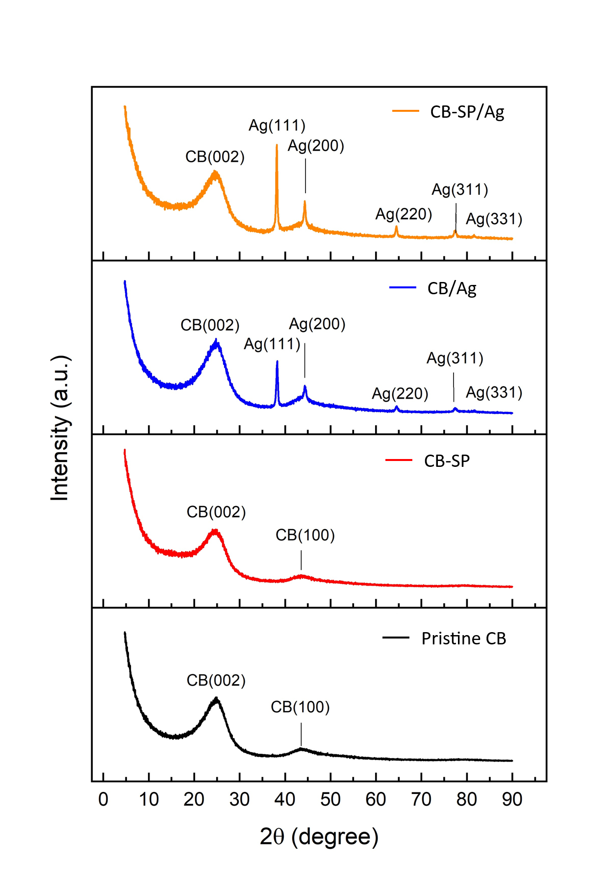
Figure S 5 XRD analysis of CB-based adduct powders.

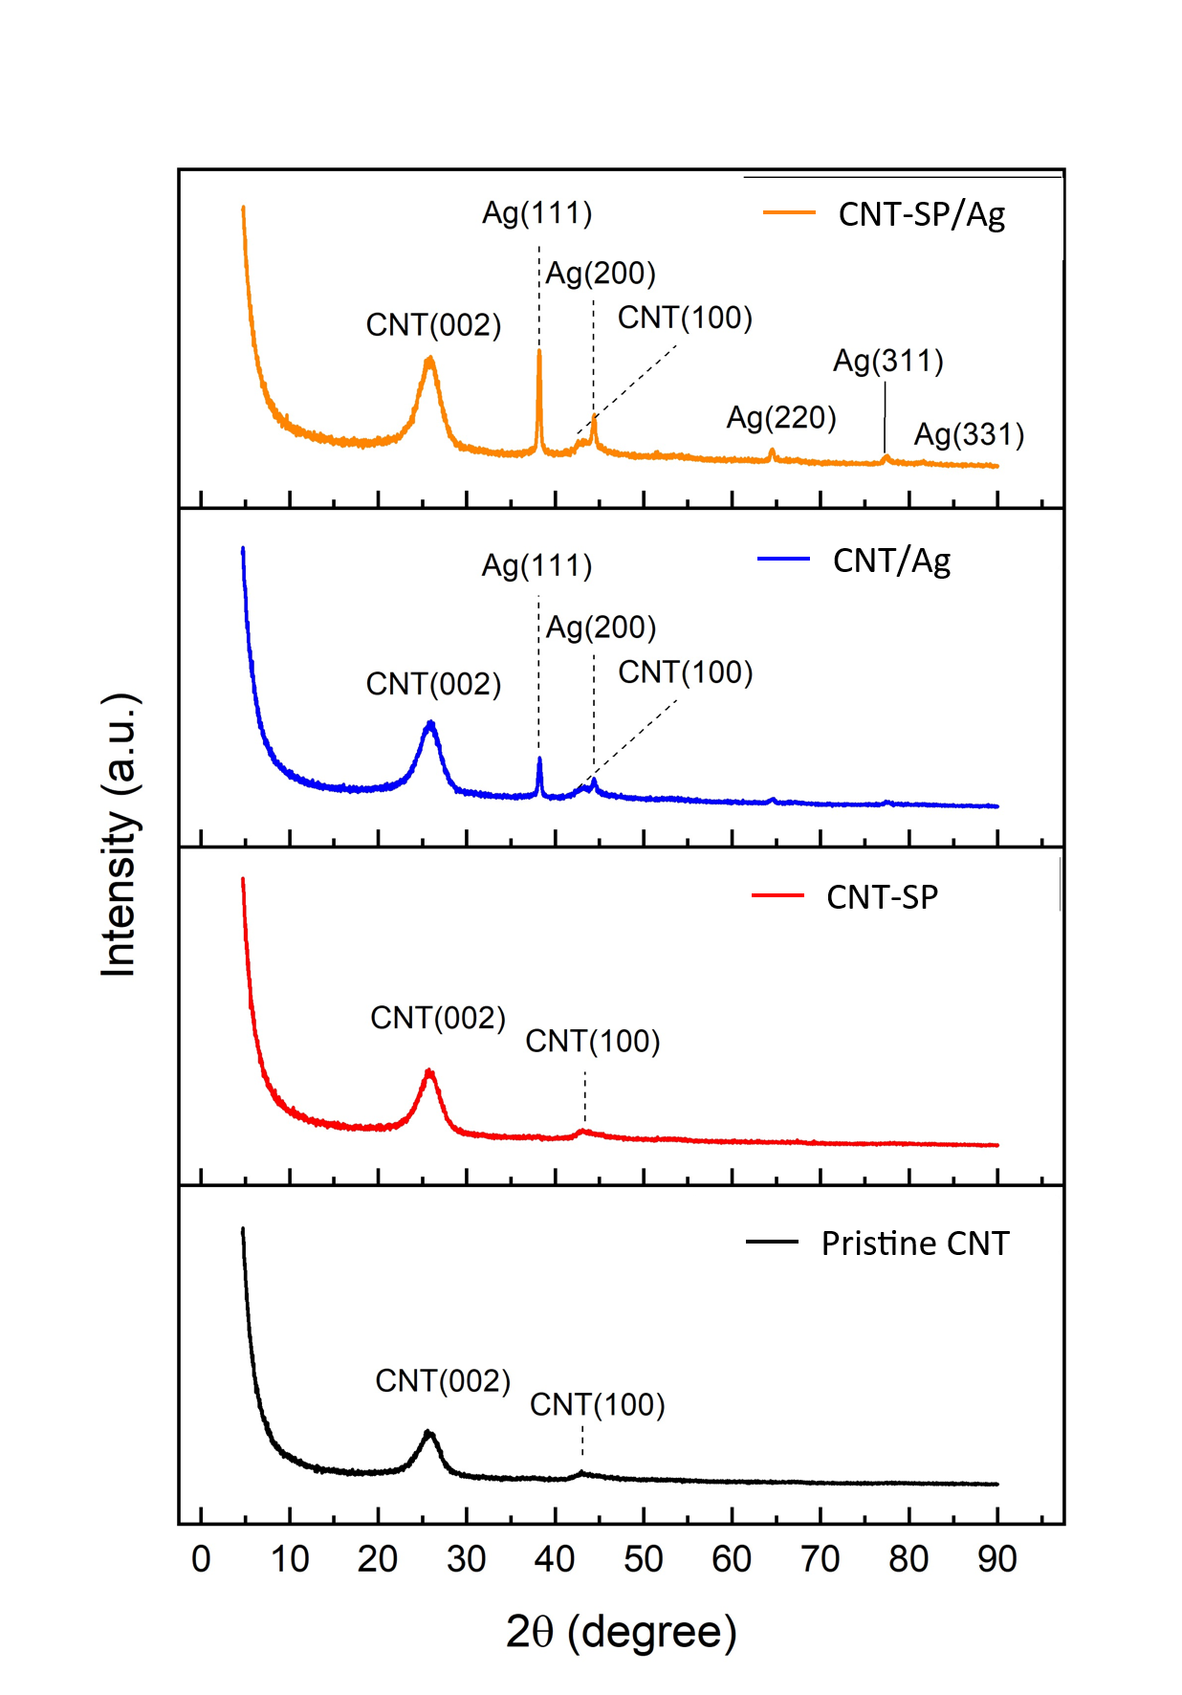
Figure S 6 XRD analysis of MWCNT-based adduct powders.
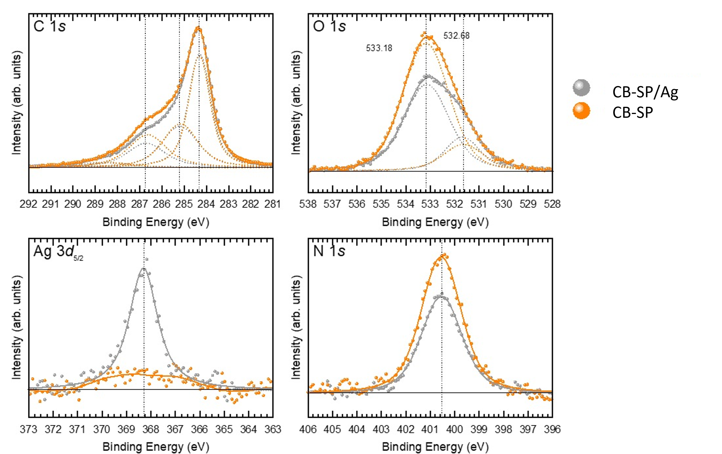

Figure S 7 XPS analysis of CB-based adduct powders.

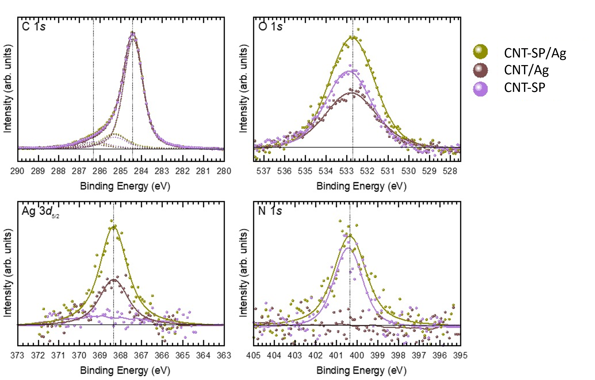

Figure S 8 XPS analysis of CNT-based adduct powder.

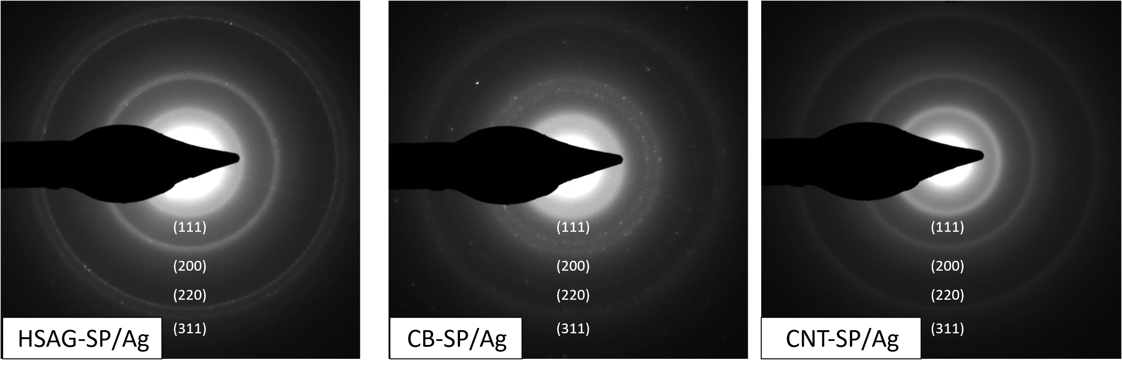
Figure S 9 SAED of CA-SP/Ag allotropes associated with pictures in Figure 2.

S2. Scalable production of HSAG-SP/Ag nanocomposites via a two-step, one-pot functionalization approach employing High Shear Mixing (HSM).
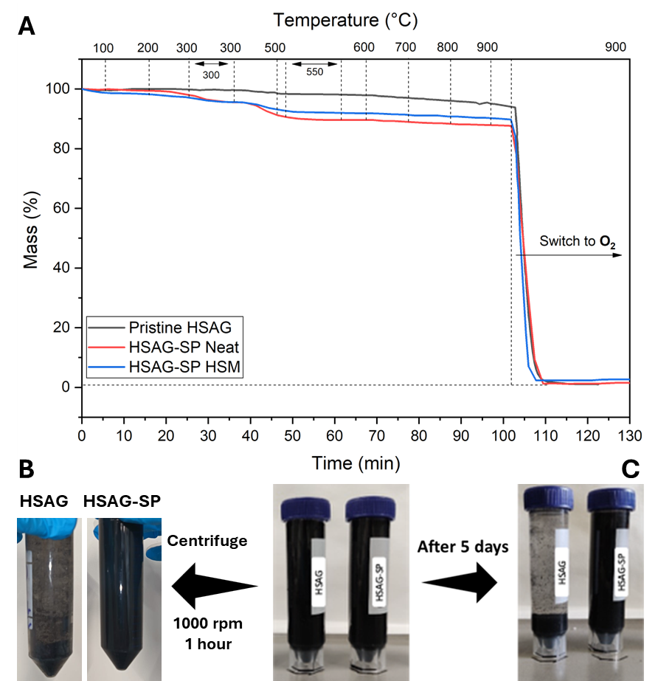
Figure S 10 A TGA analysis of HSAG decoration steps. Black: pristine, red: grafted HSAG, blue: HSM treated HSAG. B Centrifugation decantation test: 1000 RPM, 1 hour. HSM treated HSAG-SP shows a higher level of homogenization. HSM treated pristine HSAG shows a consistent deposit instead. C Decantation test in water: after 5 days, the HSM treated HSAG-SP shows a higher level of homogenization. HSM treated pristine HSAG shows a consistent deposit instead.
Table S 5 Mass losses (%wt) for HSAG-SP adducts obtained from neat and HSM processes. Data from raw thermograms.
 | T<150⁰C | 150⁰C<T<350⁰C | 350⁰C<T<550⁰C | Organic mass [%]
HSAG-SP (Neat) | 0.42 | 2.90 | 4.49 | 7.41
HSAG-SP (HSM) | 1.71 | 2.97 | 3.66 | 6.74

S3. Theoretical Calculations
In order to rationalize the selective Ag⁺ coordination/reduction and the resulting stabilization, DFT calculations were performed on two coronene–pyrrole supramolecular adducts bearing either a carboxylate (adduct 1) or an aldehyde (adduct 2) group (Fig. 1Fig. 2F). Geometry optimizations and thermal complexation energies were obtained using coronene as a model (coordinates of optimized structures in table S6). The most stable species were optimized using the B3LYP/LANL2DZ method, and NBO analyses were conducted using Gaussian 09.
It has been proven that both adducts bind Ag⁺ in a distorted tetrahedral environment involving two O donors, the pyrrolic nitrogen, and a π-interaction with the coronene platform (Fig. 1Fig. 2F). The interaction energy is markedly more favorable for the carboxylate-containing adduct than for the aldehyde derivative, consistent with stronger carboxylate donation. Upon reduction to Ag⁰, the interaction energies converge to −6.385 and −6.197 kcal/mol (with values of −143.62 and −71.97 kcal/mol, respectively), indicating that the organic scaffold/adduct core is not significantly altered by the reduction step.
Despite the presence of an identical coordination motif, the two adducts exhibit disparities in the intensity and distribution of donor interactions. In adduct 1, Ag+ displays a shorter contact with the carboxylate oxygen O32 (2.21 Å) and a relatively short interaction with the pyrrolic N29 (2.75 Å), supporting a stronger and more "anchored" binding environment. In adduct 2, the O35 donor approaches Ag⁺ more closely (2.35 Å) than the corresponding Ag-O35 contact in adduct 1 (2.49 Å), indicating a reorganisation of the coordination environment (Table S6). Overall, the carboxylate functionality is responsible for the promotion of a more stable and better-defined coordination geometry. In contrast, the aldehyde-containing adduct exhibits a weaker, more redistributed binding pattern.
Wiberg bond indices (Table S7) support an oxygen-dominated binding mode. In adduct 1, the largest covalent contribution arises from Ag–O32 (WBI = 0.1814), followed by Ag–O35 (0.0803), whereas the pyrrolic N29 (0.0355) and the π-interaction (C11, 0.0368) contribute less. In adduct 2, the Ag-O32 WBI decreases to 0.1105 while Ag-O35 increases to 0.0951, consistent with the donor-strength redistribution inferred from the optimized geometries.
Second-order NBO perturbation analysis (Table S8) likewise identifies O-lone-pair donor into Ag⁺ acceptor orbitals as the dominant stabilization terms, reaching 20.89 kcal/mol in adduct 1 but being overall weaker in adduct 2 (e.g., O32 = 9.63 kcal/mol; O35 up to 3.84 kcal/mol). In adduct 1, the most significant orbital interactions involve lone pairs on O32 and O35 with Ag⁺ acceptor orbitals LP*(6) and LP*(7), yielding stabilization energies up to 20.89 kcal/mol. Additionally, albeit weaker, interactions include those involving N29 (up to 2.78 kcal/mol), C11, and bonding orbitals from C30 and C31, indicating a multidentate coordination environment.
Adduct 2 displayed analogous trends, albeit with slightly reduced E(2) values. Key interactions again involve O32 (9.63 kcal/mol) and O35 (up to 3.84 kcal/mol), while additional contributions from N29, C11, and the C30–O32 bond remain relevant. Despite comparable orbital stabilization, adduct 1 is calculated to be ~33 kcal/mol more stable than adduct 2, suggesting that the carboxylic acid group enhances coordination through both electronic delocalization and electrostatic effects.
The F(i,j) values and ΔE trends further emphasize the predominance of oxygen-based interactions, particularly with LP*(6)Ag and LP*(7)Ag orbitals. Moreover, contributions from CR orbitals on O32 and C11 suggest minor π-backbonding, reinforcing the multidentate nature of the coordination.
Collectively, the WBI and NBO analyses substantiate that Ag⁺ binding is governed predominantly by interactions with oxygen lone pairs, with subsidiary roles played by nitrogen and aromatic π-systems. The superior thermodynamic stability of adduct 1 is attributed to the enhanced donor strength and favorable orbital alignment conferred by the carboxylic group.
Frontier-orbital analysis indicates delocalization over the aromatic core for the HOMO, whereas HOMO-1 and HOMO-2 are largely localized on the pyrrole unit. In the virtual manifold, electron density shifts toward the Ag⁺ center, most clearly in LUMO+2 (Fig. S11 - S12), consistent with acceptor character at the coordination pocket and ligand-defined Ag⁺ nucleation sites. This interpretation is consistent with XPS evidence of Ag⁺/Ag⁰ coexistence, suggesting that Ag⁺ chelation precedes in situ Ag⁰ growth while a fraction of Ag⁺ remains stabilized by the ligand environment.
Consistently, adduct 1 is calculated to be ∼33 kcal/mol more stable than adduct 2, supporting a key stabilizing role of the carboxylate functionality.

Table S 6 Selected Ag–Ligand Distances (in Å) for Adduct 1 and Adduct 2.
 | Ag–O32 | Ag–O35 | Ag–N29 | Ag–C11
Adduct 1 | 2.21 | 2.49 | 2.75 | 2.57
Adduct 2 | 2.39 | 2.35 | 2.95 | 2.51

Table S 7 Wiberg bond indices calculated between the indicated adduct atoms and Ag.
Atom | O32 | O35 | N29 | C11
Adduct 1-Ag | 0.1814 | 0.0803 | 0.0355 | 0.0368
Adduct 2-Ag | 0.1105 | 0.0951 | 0.0315 | 0.0448

Table S 8 Second-order perturbation theory analysis of Fock matrix in NBO basis. NBO Interactions (E(2) > 1.0 kcal/mol) for Adduct1 and Adduct2.
Donor Type | Donor Atom(s) | Acceptor Orbital (Ag) | E(2) [kcal/mol] | F(i,j) [a.u.] | ΔE [a.u.] | Adduct
LP | O 32 | LP*(6)Ag | 20.89 | 0.080 | 0.39 | Adduct 1
LP | O 32 | LP*(6)Ag | 8.43 | 0.064 | 0.60 | Adduct 1
LP | O 32 | LP*(7)Ag | 7.64 | 0.063 | 0.64 | Adduct 1
LP | O 35 | LP*(6)Ag | 7.55 | 0.058 | 0.54 | Adduct 1
LP | O 32 | LP*(7)Ag | 4.19 | 0.039 | 0.43 | Adduct 1
LP | O 35 | LP*(7)Ag | 4.09 | 0.044 | 0.59 | Adduct 1
LP | N 29 | LP*(6)Ag | 2.78 | 0.027 | 0.32 | Adduct 1
LP | O 35 | LP*(8)Ag | 2.62 | 0.037 | 0.64 | Adduct 1
LP | O 35 | LP*(7)Ag | 2.36 | 0.031 | 0.51 | Adduct 1
BD | C 30 - O 32 | LP*(7)Ag | 2.00 | 0.040 | 0.96 | Adduct 1
LP | N 29 | LP*(9)Ag | 1.68 | 0.022 | 0.34 | Adduct 1
BD | C 30 - O 32 | LP*(6)Ag | 1.61 | 0.035 | 0.92 | Adduct 1
BD | C 5 - C 11 | LP*(8)Ag | 1.43 | 0.031 | 0.82 | Adduct 1
BD | C 30 - C 31 | LP*(6)Ag | 1.41 | 0.028 | 0.66 | Adduct 1
BD | C 30 - C 31 | LP*(7)Ag | 1.39 | 0.028 | 0.70 | Adduct 1
BD | N 29 - C 31 | LP*(6)Ag | 1.27 | 0.029 | 0.76 | Adduct 1
CR | O 32 | LP*(7) Ag | 1.23 | 0.141 | 18.92 | Adduct 1
CR | O 32 | LP*(8) Ag | 1.17 | 0.135 | 18.97 | Adduct 1
LP | C 11 | LP*(7) Ag | 1.16 | 0.017 | 0.18 | Adduct 1
BD | N 29 - C 31 | LP*(8) Ag | 1.15 | 0.027 | 0.79 | Adduct 1
LP | LP (2) O 32 | LP*(6)Ag | 9.63 | 0.056 | 0.41 | Adduct 2
LP | LP (1) O 32 | LP*(6)Ag | 7.82 | 0.067 | 0.71 | Adduct 2
LP | LP (1) O 32 | LP*(7)Ag | 6.33 | 0.062 | 0.76 | Adduct 2
LP | LP (2) O 35 | LP*(7)Ag | 3.84 | 0.044 | 0.62 | Adduct 2
LP | LP (2) O 35 | LP*(8)Ag | 3.13 | 0.041 | 0.67 | Adduct 2
LP | LP (1) N 29 | LP*(6)Ag | 2.3 | 0.025 | 0.32 | Adduct 2
LP | LP (1) O 35 | LP*(7)Ag | 2.25 | 0.029 | 0.48 | Adduct 2
BD | BD (1) C 30 - O 32 | LP*(7)Ag | 1.28 | 0.034 | 1.1 | Adduct 2
LP | LP (1) C 11 | LP*(6)Ag | 1.22 | 0.017 | 0.18 | Adduct 2
LP | LP (1) C 11 | LP*(8)Ag | 1.22 | 0.022 | 0.27 | Adduct 2
LP | LP (1) N 29 | LP*(9)Ag | 1.09 | 0.018 | 0.36 | Adduct 2
CR | CR (1) C 11 | LP*(8)Ag | 1.06 | 0.093 | 10.21 | Adduct 2
BD | BD (1) C 30 - O 32 | LP*(6)Ag | 1.05 | 0.03 | 1.05 | Adduct 2
CR | CR (1) O 32 | LP*(6)Ag | 1.0 | 0.126 | 19.0 | Adduct 2
– means energy of hyper-conjugative interactions (stabilization energy) in kcal/mol.
E(j) – E (i) – Energy difference between donor and acceptor i and j NBO orbitals in a.u.
F(i, j) – is the Fock matrix elements between i and j NBO orbitals in a.u.

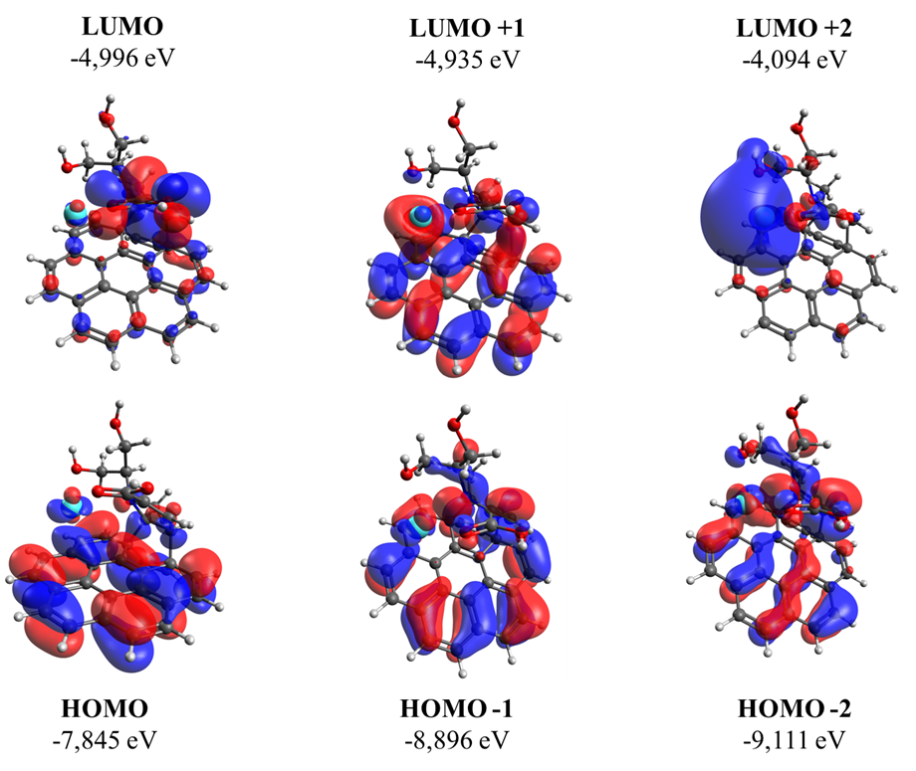
Figure S 11 Energy diagrams of adduct 1 for the first, second, and third molecular orbitals HOMO and LUMO (the red and blue colors show the negative and positive areas of the wave functions, respectively).
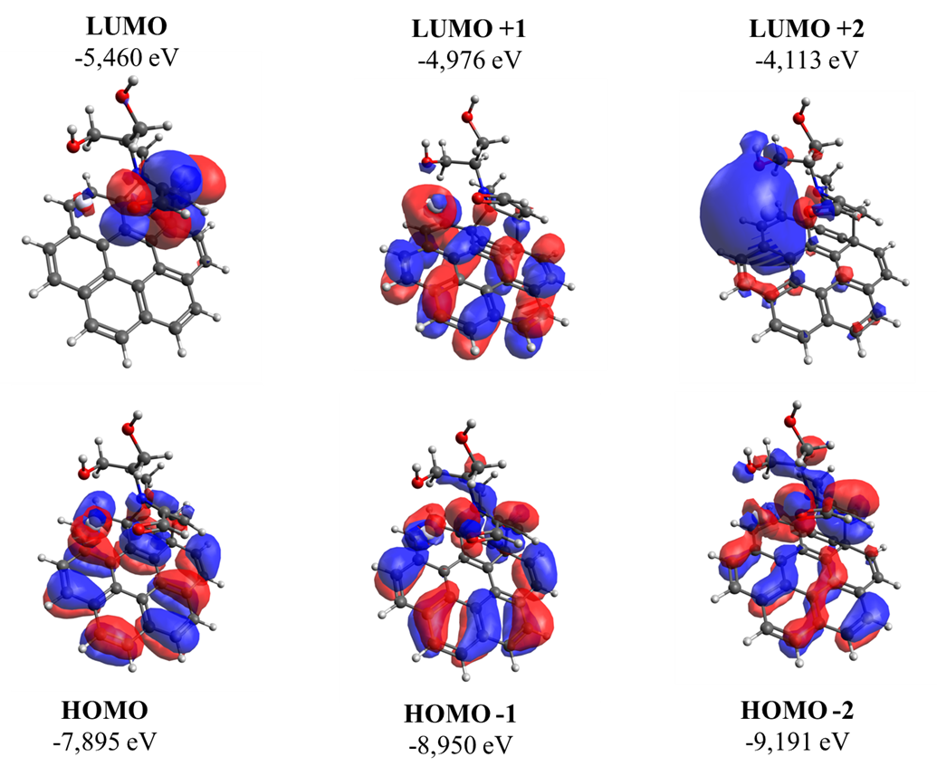
Figure S 12 Energy diagrams of adduct 2 for the first, second, and third molecular orbitals HOMO and LUMO (the red and blue colors show the negative and positive areas of the wave functions, respectively).

Table S 9 Coordinates of most stable optimized structures at b3lyp/lanl2dz
Coordinates Adduct 1
----------------------------------------------------------------------------------------------------------------
C | 1.60639 | 1.33582 | -0.65639
C | 2.74741 | 0.86436 | 0.0568
C | 0.7378 | 0.47469 | -1.27938
C | 3.0049 | -0.54005 | 0.09254
C | 0.95503 | -0.93614 | -1.23863
C | 2.107 | -1.44512 | -0.55655
C | 1.21595 | 2.7935 | -0.73433
C | 3.61563 | 1.78267 | 0.70754
C | -0.4345 | 1.1298 | -1.99014
C | 4.15378 | -1.0345 | 0.79142
C | 0.04022 | -1.82379 | -1.89072
C | 2.34995 | -2.85822 | -0.52332
C | 0.96424 | 3.1214 | -2.21258
C | 3.29656 | 3.21363 | 0.62535
C | 2.20894 | 3.69011 | -0.04005
C | 4.38029 | -2.46169 | 0.81071
C | 0.29932 | -3.22147 | -1.83644
C | -1.23292 | 0.12368 | -2.77985
C | 3.51847 | -3.3345 | 0.18107
C | -1.02932 | -1.22043 | -2.70562
C | 0.13615 | 2.27111 | -2.85013
C | 1.42802 | -3.72462 | -1.1675
C | 4.74392 | 1.27665 | 1.39184
C | 5.00904 | -0.10239 | 1.43258
C | -3.78891 | 0.45923 | 1.8045
C | -0.26514 | 2.31637 | 1.34962
C | -2.39868 | 2.7912 | -1.48472
O | -5.22072 | 0.11743 | 1.6824
N | -1.83002 | 0.97027 | 0.25082
C | -0.99659 | 0.29186 | 2.66631
C | -1.07233 | 1.2394 | 1.46586
O | -1.11794 | -1.00089 | 2.40871
C | -3.3318 | 0.83189 | 0.37571
C | -3.91708 | -0.17486 | -0.64052
O | -3.68689 | -1.57641 | -0.24725
C | -1.29861 | 1.937 | -0.81648
C | -0.26907 | 2.86708 | -0.04861
H | 3.97553 | 3.9089 | 1.11648
H | 2.02282 | 4.76316 | -0.07946
H | 1.43891 | 3.98224 | -2.67415
H | 3.70389 | -4.4058 | 0.21288
H | -0.37633 | -3.90593 | -2.34531
H | -0.14401 | 2.35628 | -3.89605
H | -1.65263 | -1.89485 | -3.29041
H | 5.2505 | -2.84138 | 1.34182
H | 5.41503 | 1.96778 | 1.89733
H | -1.99928 | 0.50889 | -3.45166
H | 1.60161 | -4.79768 | -1.1402
H | 5.88206 | -0.46734 | 1.96902
H | 0.41435 | 2.63864 | 2.12729
H | -3.14966 | 2.19411 | -2.01381
H | -3.24266 | -0.40001 | 2.19696
H | -3.43564 | -0.07418 | -1.61131
H | -4.3079 | -1.79645 | 0.48098
H | -4.99403 | -0.00584 | -0.73494
H | -2.91604 | 3.41682 | -0.74772
H | -1.93742 | 3.46505 | -2.21098
H | -3.81075 | 1.79513 | 0.15817
H | -3.65088 | 1.31032 | 2.48191
H | -5.62142 | 0.04091 | 2.57221
H | -0.56631 | 3.92218 | -0.10457
Ag | -1.26667 | -1.7192 | 0.31989
O | -0.78203 | 0.80078 | 3.80056

Coordinates Adduct 2
----------------------------------------------------------------------------------------------------------------
C | -1.67656 | 1.32734 | 0.54646
C | -2.79507 | 0.76273 | -0.13469
C | -0.73775 | 0.54359 | 1.17182
C | -2.95693 | -0.65652 | -0.12715
C | -0.8613 | -0.87846 | 1.17356
C | -1.98589 | -1.48123 | 0.52501
C | -1.379 | 2.80993 | 0.56353
C | -3.73663 | 1.60342 | -0.79009
C | 0.40923 | 1.29461 | 1.8293
C | -4.08625 | -1.24575 | -0.78354
C | 0.12321 | -1.68406 | 1.83119
C | -2.13685 | -2.90895 | 0.53469
C | -1.09494 | 3.21258 | 2.01611
C | -3.51204 | 3.05445 | -0.75374
C | -2.44044 | 3.62224 | -0.13401
C | -4.22023 | -2.68482 | -0.75645
C | -0.04319 | -3.10123 | 1.8184
C | 1.28621 | 0.36875 | 2.63714
C | -3.2879 | -3.48117 | -0.12601
C | 1.15915 | -0.98675 | 2.61941
C | -0.2029 | 2.43608 | 2.66002
C | -1.14859 | -3.69531 | 1.1823
C | -4.84466 | 1.00428 | -1.43138
C | -5.01744 | -0.39043 | -1.42664
C | 3.63511 | 0.69633 | -2.10959
C | 0.04238 | 2.30838 | -1.52652
C | 2.27352 | 3.02772 | 1.19925
O | 5.0744 | 0.41477 | -2.05186
N | 1.73583 | 1.1021 | -0.43688
C | 0.62207 | 0.16498 | -2.55135
C | 0.88542 | 1.23614 | -1.59011
O | 0.9378 | -1.04708 | -2.38146
C | 3.23682 | 1.06799 | -0.66014
C | 3.95411 | 0.12958 | 0.33467
O | 3.84333 | -1.28461 | -0.06937
C | 1.19207 | 2.09968 | 0.60869
C | 0.09201 | 2.93902 | -0.16936
H | -4.25432 | 3.69066 | -1.23206
H | -2.33383 | 4.70595 | -0.11494
H | -1.60649 | 4.06238 | 2.45671
H | -3.40785 | -4.5616 | -0.11793
H | 0.66928 | -3.72534 | 2.35375
H | 0.09804 | 2.5794 | 3.69318
H | 1.81557 | -1.5983 | 3.23612
H | -5.07926 | -3.13596 | -1.24715
H | -5.57758 | 1.63289 | -1.93161
H | 2.02935 | 0.82342 | 3.29068
H | -1.25556 | -4.77672 | 1.19655
H | -5.8811 | -0.82584 | -1.92314
H | -0.71305 | 2.55075 | -2.2663
H | 3.07214 | 2.48269 | 1.71302
H | 3.11672 | -0.19783 | -2.46213
H | 3.49949 | 0.18409 | 1.32282
H | 4.5188 | -1.47275 | -0.75668
H | 5.01242 | 0.39483 | 0.39241
H | 2.72883 | 3.66192 | 0.42953
H | 1.81096 | 3.69689 | 1.92867
H | 3.64876 | 2.06824 | -0.4879
H | 3.4245 | 1.53265 | -2.78903
H | 5.48678 | 0.45254 | -2.93875
H | 0.32232 | 4.01013 | -0.19379
H | 0.04497 | 0.44943 | -3.44338
Ag | 1.56031 | -1.83308 | -0.21519

S4. Applicability of the HSAG-SP/Ag Adduct in Composite Materials and Inks for Flexible Electronics for Antimicrobial Applications in Wearable Pressure Sensors.
Table S 10 MBC of HSAG, CB and CNT-based powder adducts.
 | MBC ª [µg/mL]
HSAG - SP/Ag350 | 10
HSAG - SP/Ag650 | 9
CB - SP/Ag350 | 180
CB - SP/Ag650 | 195
CNT - SP/Ag350 | 23
CNT - SP/Ag650 | 7
ª at 99.9% bacterial reduction.
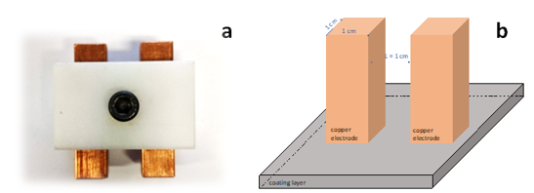
Figure S 13 A Copper electrode device to measure sheet resistance and, B representation of the geometry of the copper electrode when device positioned on a coating layer.
Table S 11 Sheet resistance of the printed inks. It is reported the sheet resistance of the cured inks printed on TPU. It is reported also the decreasing trend of the carbon content in the ink, the comparison with pure Ag flakes and the quantity of filler (w/w respect to the adhesive weight).
Sample | Sheet resistance  (kΩ/sq) | %C | %SP | %Ag | Filler concentration
CBc | 2.4 | 100 | 0 | 0 | 10%
CBc-SP | 3 | 94.2 | 5.8 | 0 | 10%
CBc-SP/Ag | 3 | 87.5 | 5 | 7.5 | 10%
Silver flakes | 0.01 | 0 | 0 | 100 | 70%

References
[1] Qu L-Y, Liu J-L, Liu Y-Y, Zhang G-Q, Xu Y-J, Zhu P, et al. Anchoring silver nanoparticles using catechol-derived resins: An efficient and versatile approach for producing durable antimicrobial fabrics. Prog Org Coat 2023;176:107397. https://doi.org/10.1016/j.porgcoat.2022.107397.
[2] Jana J, Gauri SS, Ganguly M, Dey S, Pal T. Silver nanoparticle anchored carbon dots for improved sensing, catalytic and intriguing antimicrobial activity. Dalton Transactions 2015;44:20692–707. https://doi.org/10.1039/C5DT03858H.
[3] Bélteky P, Rónavári A, Igaz N, Szerencsés B, Tóth IY, Pfeiffer I, et al. Silver nanoparticles: aggregation behavior in biorelevant conditions and its impact on biological activity. Int J Nanomedicine 2019;Volume 14:667–87. https://doi.org/10.2147/IJN.S185965.
[4] Dong LL, Ding YC, Huo WT, Zhang W, Lu JW, Jin LH, et al. A green and facile synthesis for rGO/Ag nanocomposites using one-step chemical co-reduction route at ambient temperature and combined first principles theoretical analyze. Ultrason Sonochem 2019;53:152–63. https://doi.org/10.1016/j.ultsonch.2019.01.002.
[5] de Faria AF, Martinez DST, Meira SMM, de Moraes ACM, Brandelli A, Filho AGS, et al. Anti-adhesion and antibacterial activity of silver nanoparticles supported on graphene oxide sheets. Colloids Surf B Biointerfaces 2014;113:115–24. https://doi.org/10.1016/j.colsurfb.2013.08.006.
[6] Attia NF, Eid AM, Soliman MA, Nagy M. Exfoliation and Decoration of Graphene Sheets with Silver Nanoparticles and Their Antibacterial Properties. J Polym Environ 2018;26:1072–7. https://doi.org/10.1007/s10924-017-1014-5.
[7] Tang X-Z, Li X, Cao Z, Yang J, Wang H, Pu X, et al. Synthesis of graphene decorated with silver nanoparticles by simultaneous reduction of graphene oxide and silver ions with glucose. Carbon N Y 2013;59:93–9. https://doi.org/10.1016/j.carbon.2013.02.058.
[8] Moghayedi M, Goharshadi EK, Ghazvini K, Ahmadzadeh H, Ranjbaran L, Masoudi R, et al. Kinetics and mechanism of antibacterial activity and cytotoxicity of Ag-RGO nanocomposite. Colloids Surf B Biointerfaces 2017;159:366–74. https://doi.org/10.1016/j.colsurfb.2017.08.001.
[9] Caudillo R, Gao X, Escudero R, José-Yacaman M, Goodenough JB. Ferromagnetic behavior of carbon nanospheres encapsulating silver nanoparticles. Phys Rev B 2006;74:214418. https://doi.org/10.1103/PhysRevB.74.214418.
[10] Yu Y, Yan L, Yue M, Xu H. Femtosecond laser-assisted synthesis of silver nanoparticles and reduced graphene oxide hybrid for optical limiting. R Soc Open Sci 2018;5. https://doi.org/10.1098/rsos.171436.
[11] Hoyos-Palacio LM, Cuesta Castro DP, Ortiz-Trujillo IC, Botero Palacio LE, Galeano Upegui BJ, Escobar Mora NJ, et al. Compounds of carbon nanotubes decorated with silver nanoparticles via in-situ by chemical vapor deposition (CVD). Journal of Materials Research and Technology 2019;8:5893–8. https://doi.org/10.1016/j.jmrt.2019.09.062.

