1 )AI-Driven Estimation of Patient-Specific Aortic Wall Mechanics for Improved Biomechanical Simulation
Ione Ianniruberto¹, Davide Astori¹, Jonathan W. Weinsaft², Emiliano Votta¹, Alberto Redaelli¹
¹Department of Electronics Information and Bioengineering, Politecnico di Milano, Italy
²Department of Medicine (Cardiology), Weill Cornell College, New York, NY, United States of America
E-mail addresses: ione.ianniruberto@polimi.it (corresponding)

Finite element analysis (FEA) is widely used to estimate aortic wall stress in pathological conditions, with the main goal of assessing rupture or dissection risk[1]. However, patient-specific FEA is still hindered by the lack of non-invasive measurements of aortic wall mechanical properties. Because these properties can only be obtained from excised tissue, most simulations rely on generic material parameters derived from literature data, despite pronounced inter-patient variability[2].
To address this, we introduce a new framework that estimates patient-specific material behaviour by leveraging a database of human aortic tissue mechanics and a generative AI model, a conditional variational autoencoder (CVA). Through a literature review, we assembled 100 equibiaxial tensile tests on human aortic samples processed under consistent preservation protocols. This dataset includes paired circumferential and axial stress–stretch curves categorized according to four clinical factors: i) anatomical region, ii) pathology (thoracic aneurysm, dissection, Marfan syndrome, or healthy control), iii) valve morphology, and iv) age group (young, middle, old).
For a given patient, the method first extracts the appropriate subgroup of the database based on these factors. Within this tailored subset, the curve that best matches the patient’s circumferential mechanical behaviour, estimated from systolic/diastolic pressures and aortic compliance, is selected. Once the closest circumferential curve is identified, the corresponding paired axial curve from the same tissue sample is automatically included, ensuring a consistent biaxial representation. To automate this process, we trained a CVA capable of generating stress–strain curves conditioned on patient-specific attributes.
Validation was performed using tissue samples from 10 patients for whom both clinical data and ex vivo equibiaxial tests were available. A permutation test based on the L2 norm showed no significant difference between predicted and experimental curves in 8 out of 10 cases (p < 0.001). Preliminary analysis further demonstrates that the CVA successfully learns and reproduces the statistical characteristics inherent to each clinical subgroup.
This approach offers a promising pathway toward integrating patient-specific mechanical surrogates into aortic biomechanics simulations, potentially improving risk stratification and personalized treatment planning.

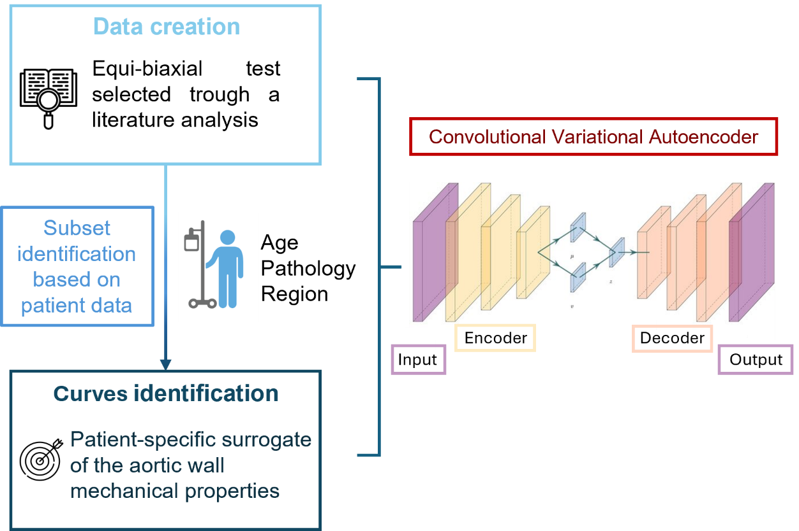
Figure 1: Left panel: schematic of the algorithm implement for the curve identification starting from the database; Right: schematic model of the neural network used for the curve selection based on patient data.

[1] Zhu, Y.et al,.Cardiovasc Eng Tech, 2025
[2] Roccabianca et al, J M B of Biomedical Materials, 2014

