Functionalizing Cryogels with the GPGKLVFF Peptide for Amyloid-ß Binding: A Comparative Study of Two Synthetic Pathways

Kaiyue HU,¹ Tommaso MECCA,² Giuseppina SABATINO,³ Cristina SATRIANO,⁴ Luigi BRAMBILLA,¹ Sandro DATTILO,⁵ Valentina GIGLIO,⁵ Giuseppe DI NATALE,³ Chiara CASTIGLIONI,¹ Francesca CUNSOLO,² Giuseppe PAPPALARDO.³
¹ Politecnico di Milano, Dipartimento di Chimica, Materiali e Ingegneria Chimica “Giulio Natta” P.zza Leonardo da Vinci, 32. I-20133 Milano.
² CNR-Istituto di Chimica Biomolecolare, Via Paolo Gaifami 18, 95126 Catania
³ CNR-Istituto di Cristallografia Via Paolo Gaifami 18, 95126 Catania
⁴ Dipartimento di Scienze Chimiche Università degli Studi di Catania, V.Le Andrea Doria 6, 95126 Catania
⁵ CNR-Istituto per i Polimeri, Compositi e Biomateriali, Via Paolo Gaifami 18, 95126 Catania

Supplementary Material
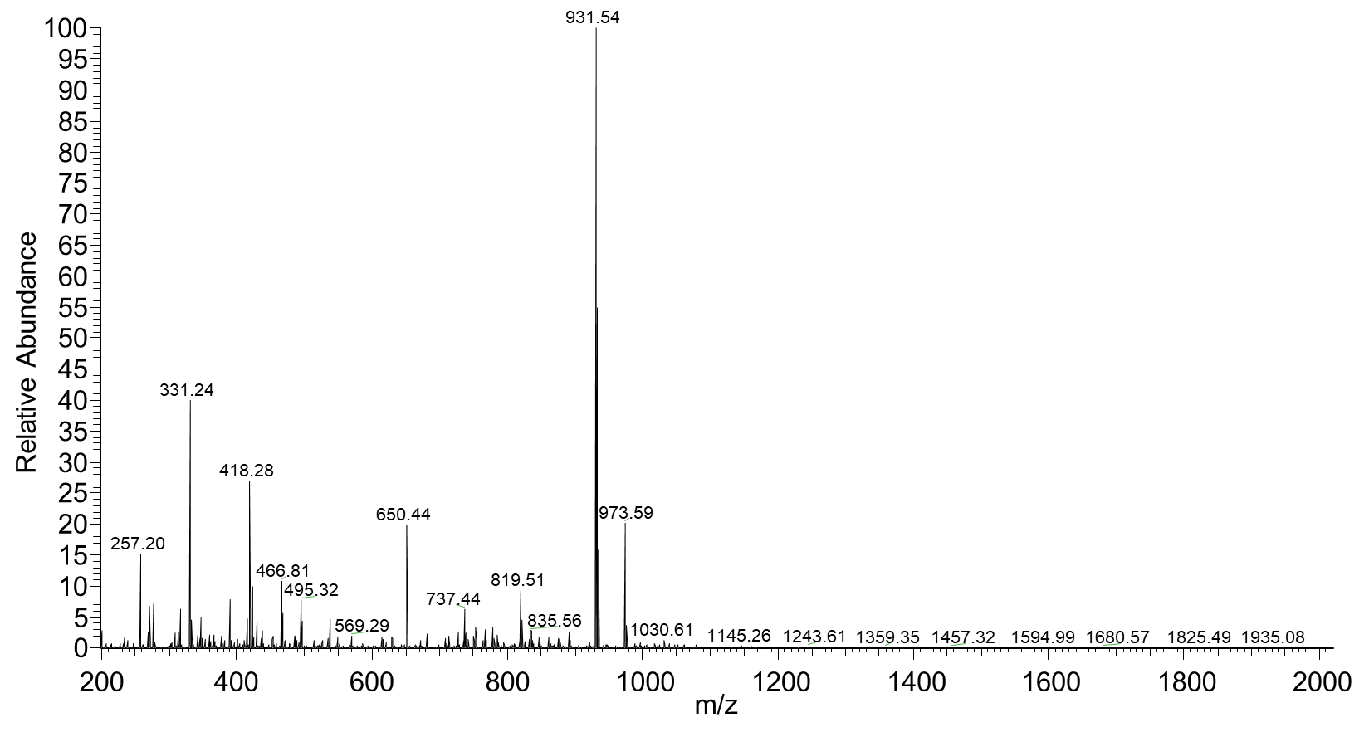

Figure S1. ESI-MS of the peptide maa-GPGKLVFF

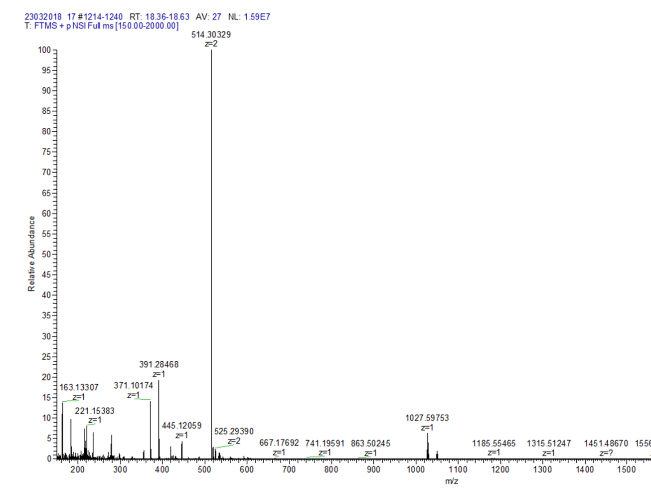

Figure S2. ESI-MS of the peptide GPGK(Dde)LVFF

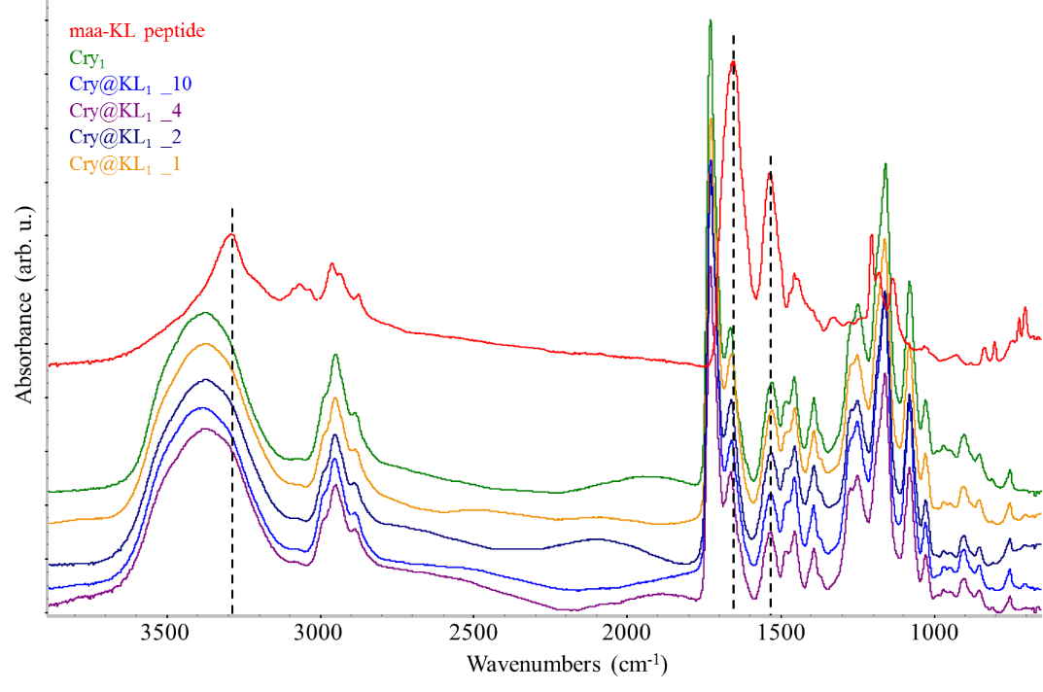
Figure S3. FTIR spectra of Cry@KL₁ samples. Numbers (1, 2, 4, 10) in the spectra labels indicate the peptide concentration (mg/ml); capital letters (A, B, C) indicate different regions of the same sample, where the laser probe has been focused. The spectrum of the unfunctionalized Cry₁ (green line) and of the pure maa-KL peptide (red line) are displayed for the sake of comparison. The dashed lines highlight the strongest bands of the pure peptide. These bands cannot be detected in the spectra of Cry@KL₁ samples, even in the case of formulation with the highest peptide concentration (10 mg/ml). The spectra are vertically stacked for clarity.

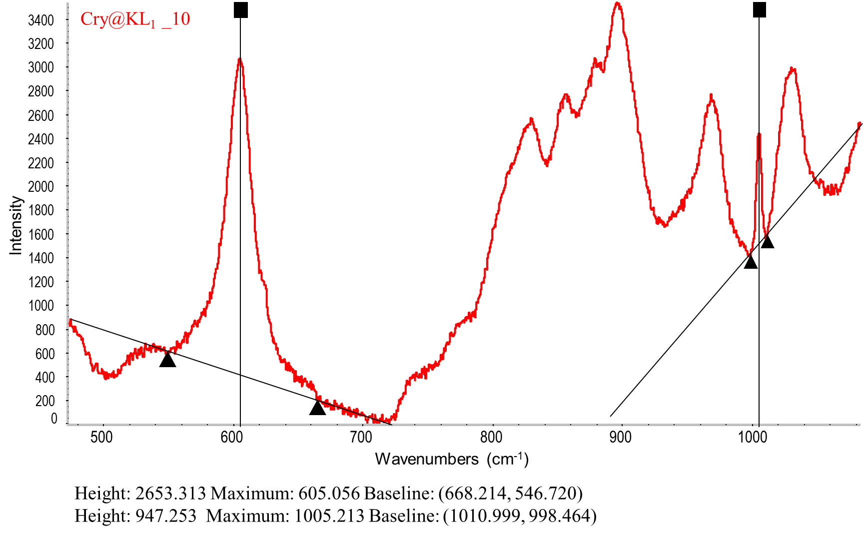
Figure S4. Raman spectrum of a Cry@KL₁ sample synthesized with the 10 mg/mL concentration of the maa-KL peptide, shown in the 480 -1080 cm⁻¹ region. The procedure used to determine the parameter R = I₁₀₀₀/I₆₀₀ is illustrated. The value of R is obtained from the peak heights after applying a linear baseline correction.The parameter provides a quantitative estimate of the degree of matrix functionalization.

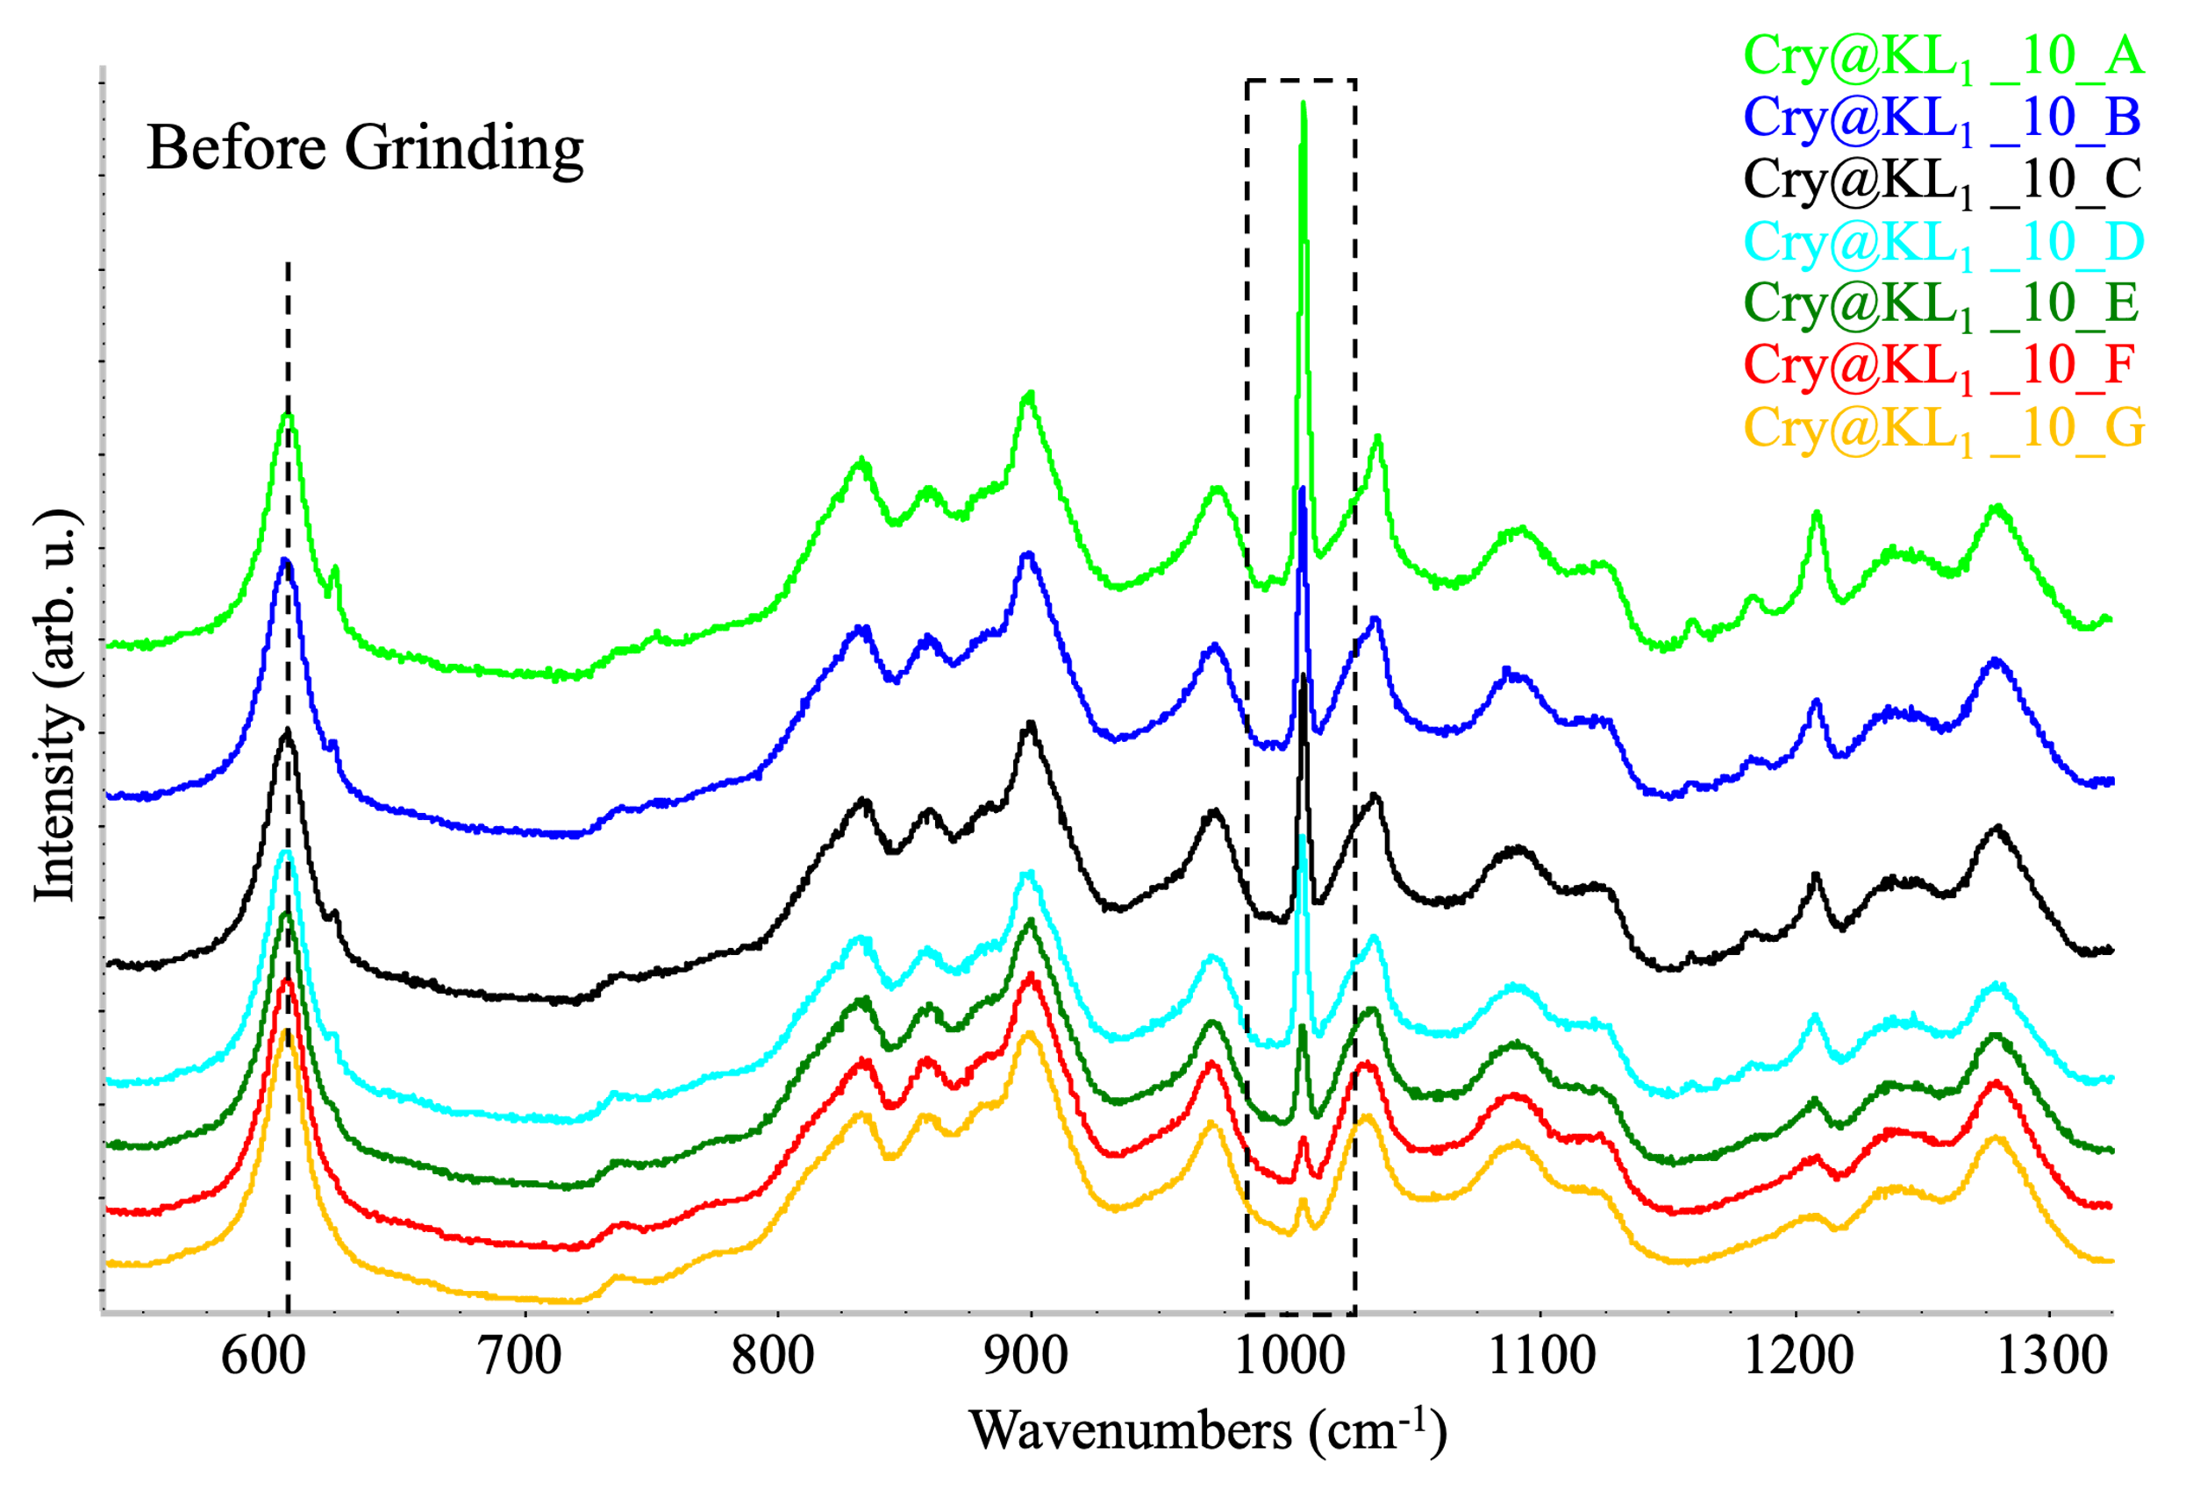 | 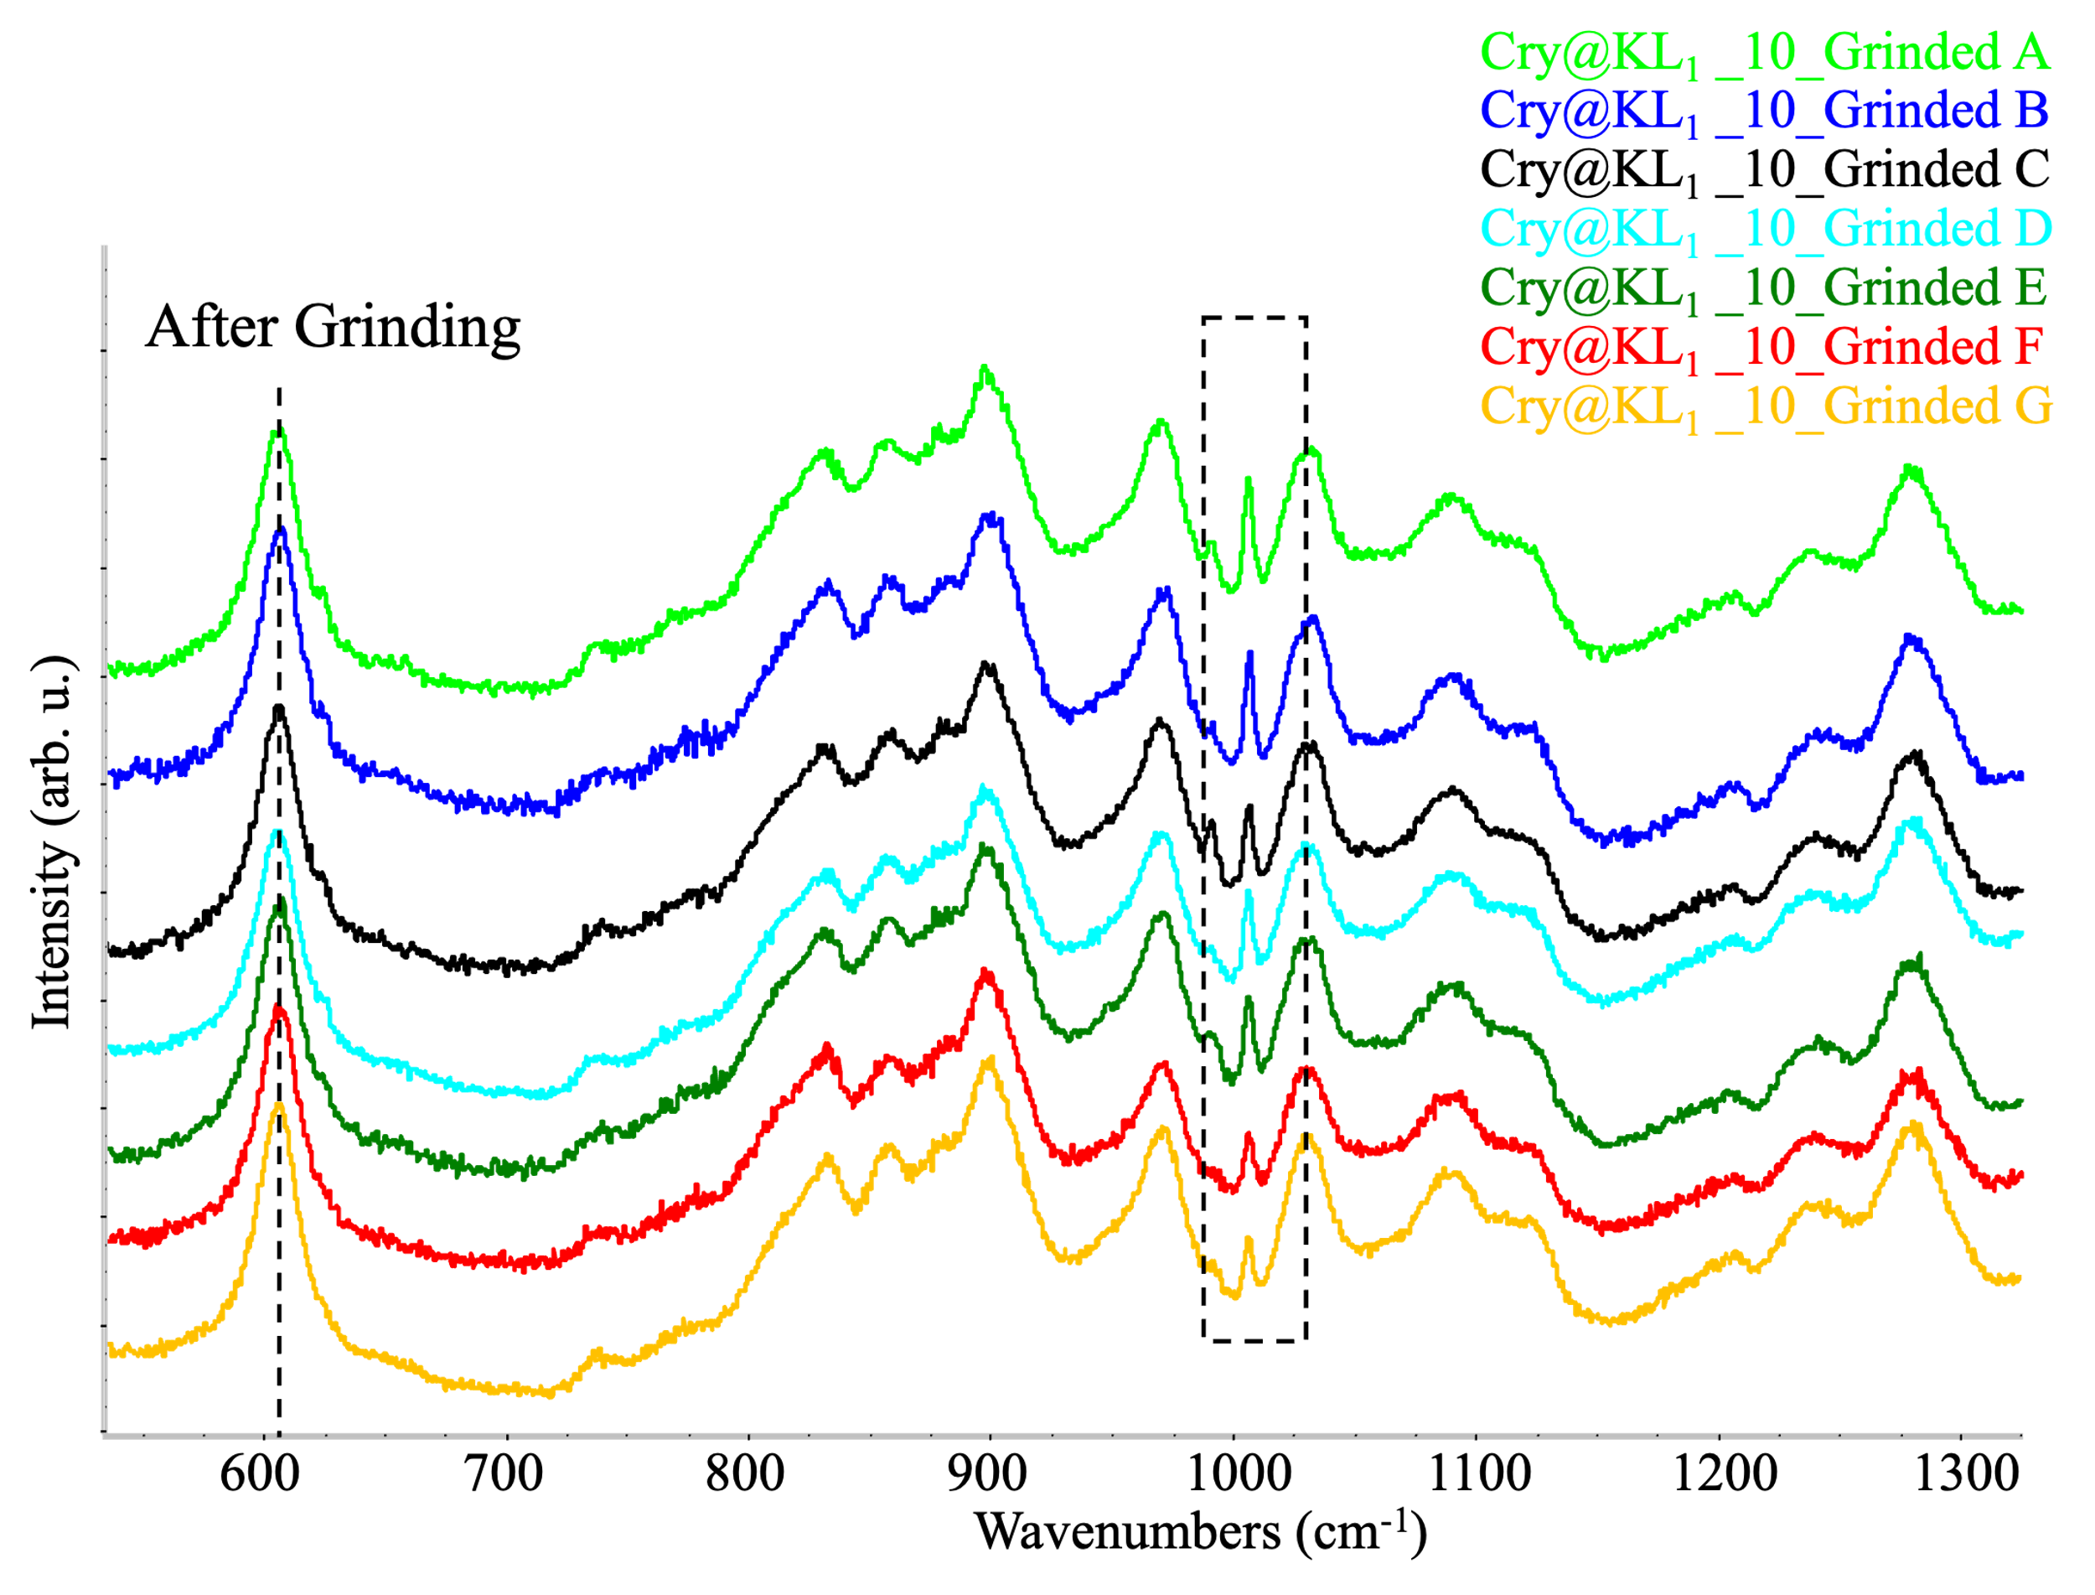
(a) | (b)

Figure S5. Raman spectra of Cry@KL₁ sample obtained with peptide concentration of 10 mg/ml in the formulation, excitation at 532 nm. Spectra are recorded focusing in seven different points (from A to G) of the specimen. (a) Cry@KL₁ before grinding. (b) Cry@KL₁ after grinding. The spectra are vertically stacked for clarity and normalized at frequency in 600 cm⁻¹.

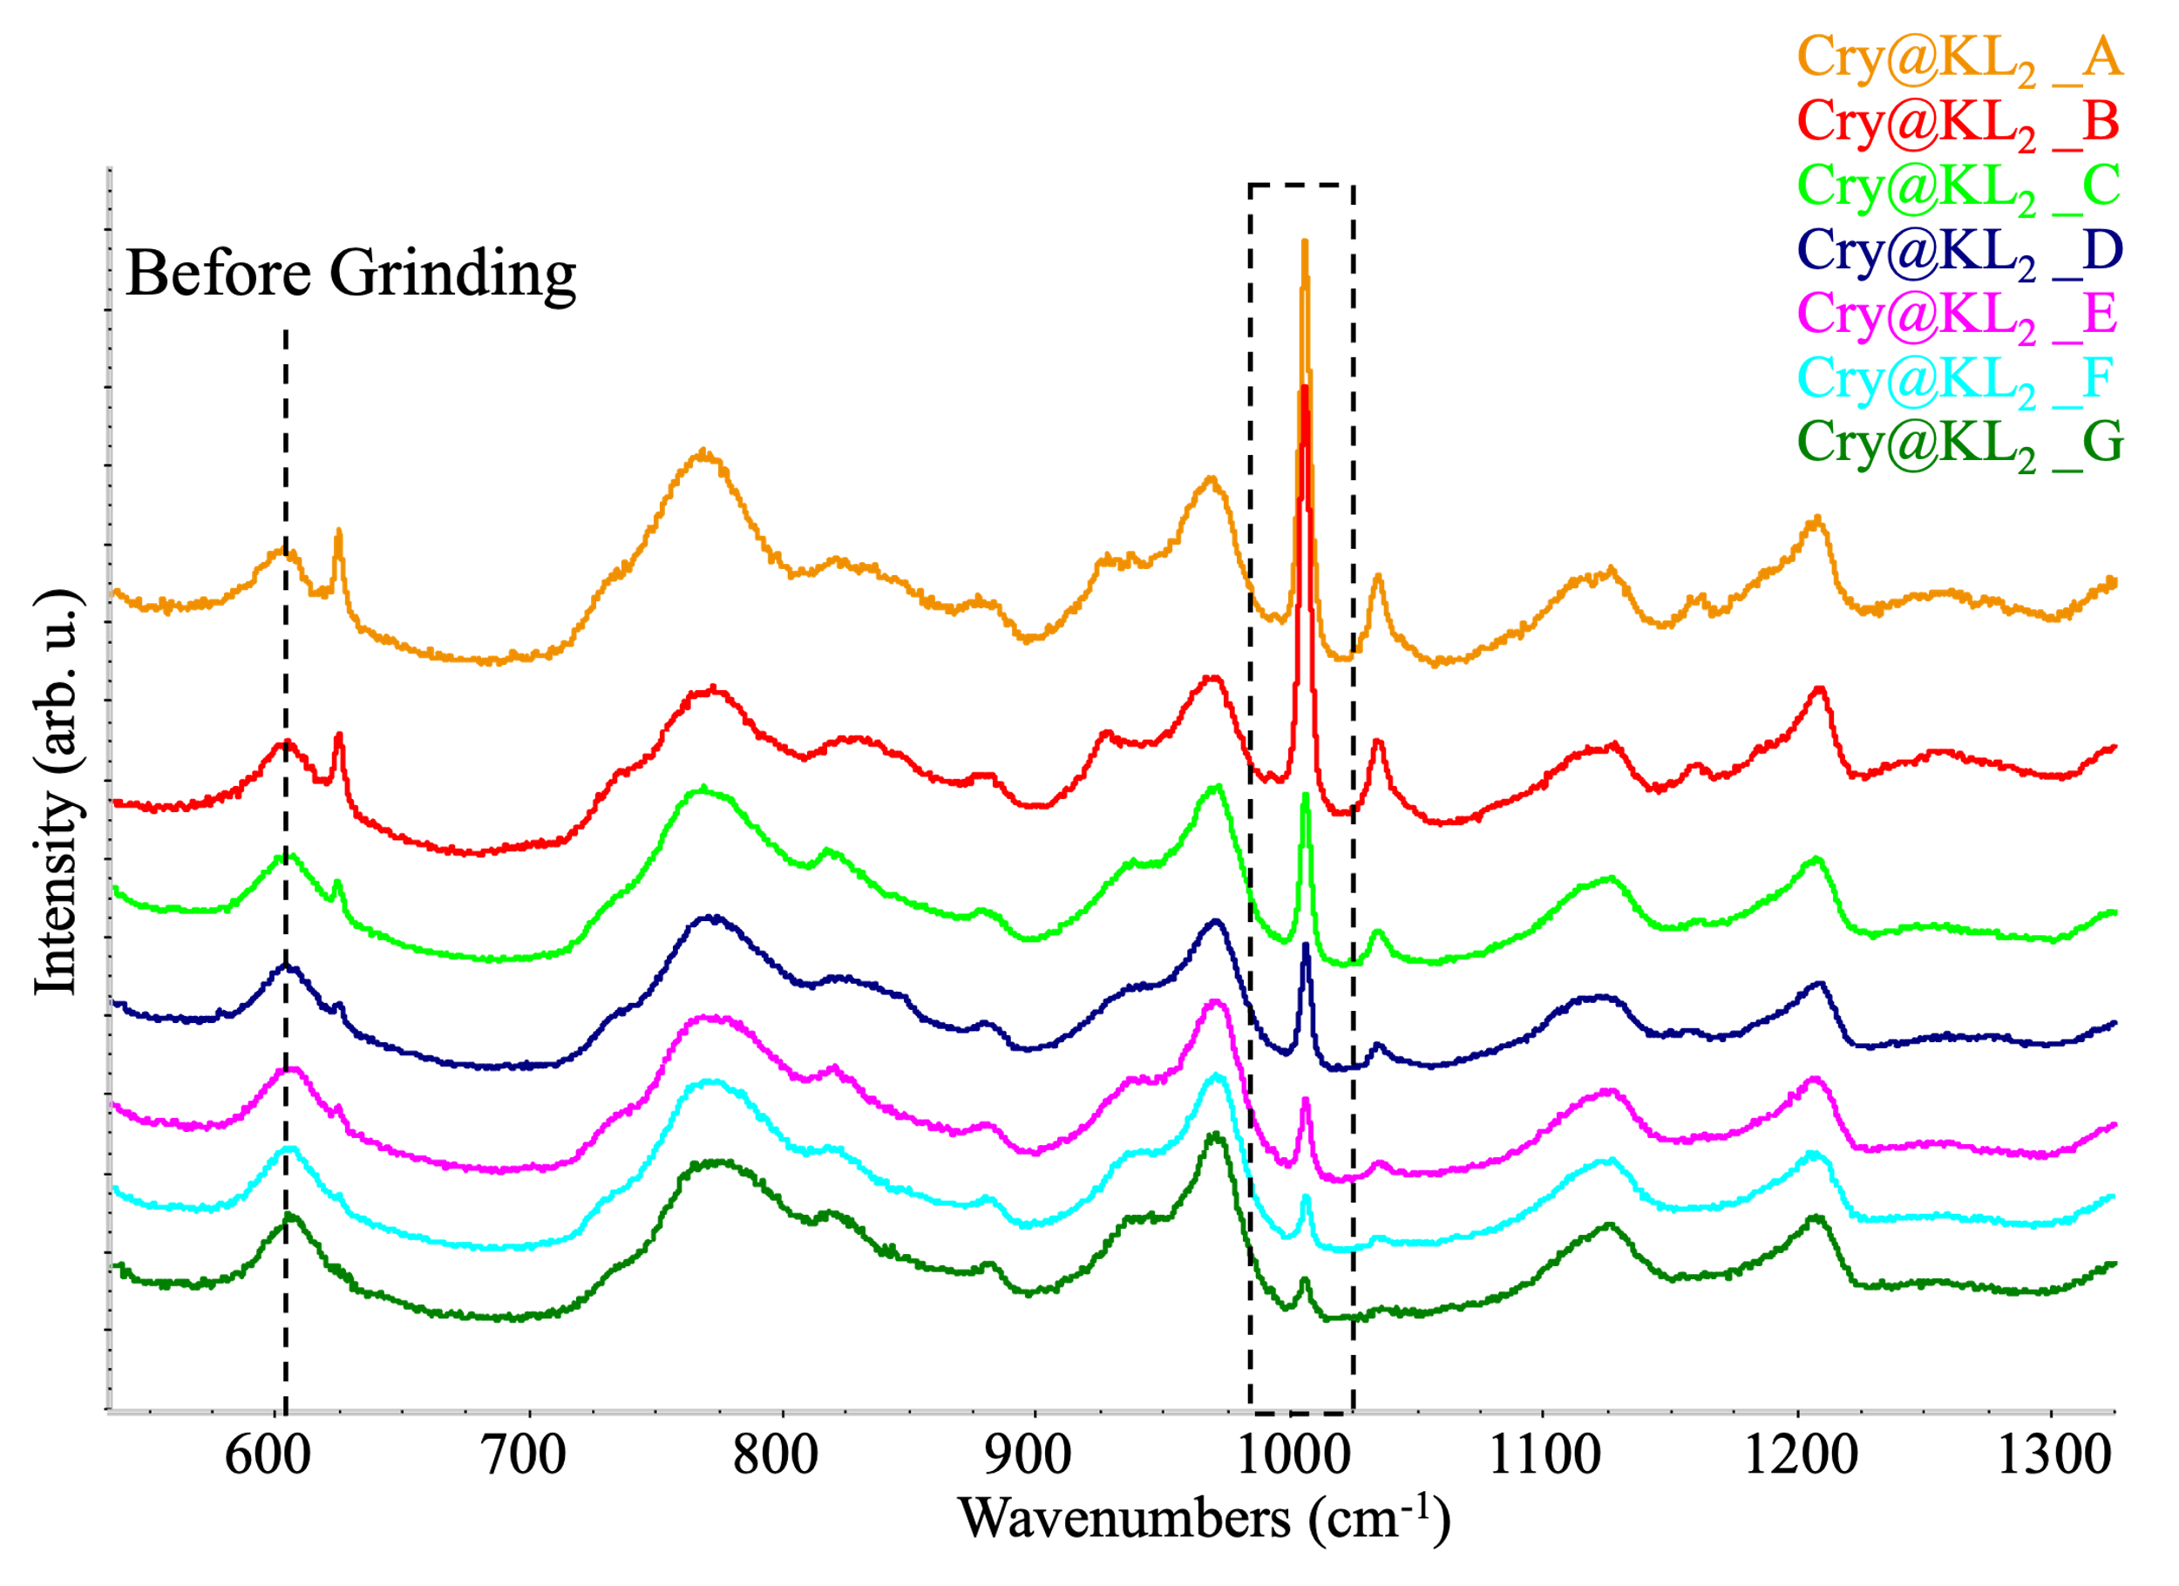 | 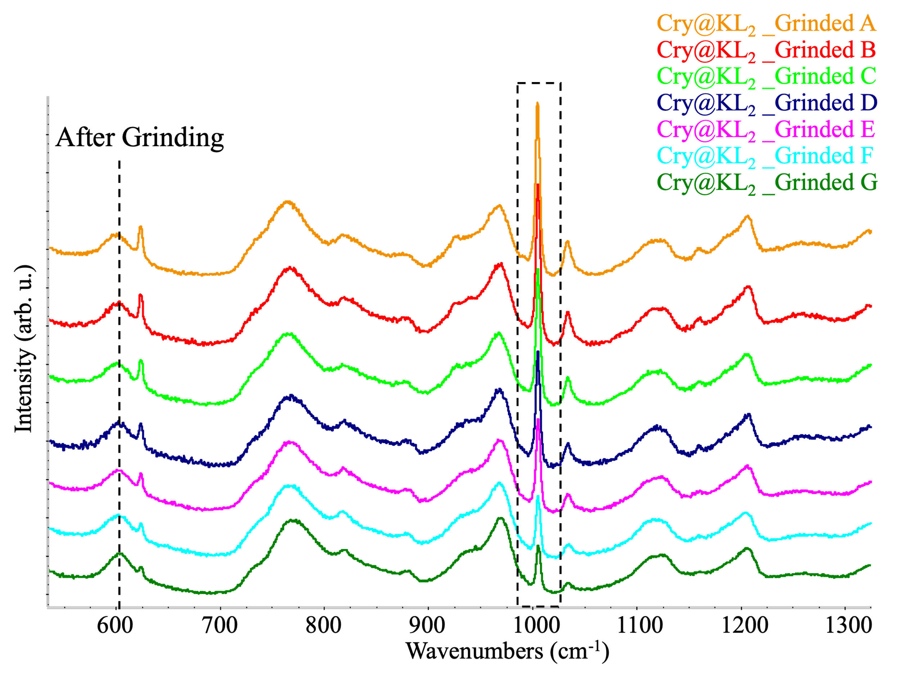
(a) | (b)

Figure S6. Cry@KL₂ sample: Raman spectra recorded focusing in seven different points (from A to G) of the specimen, excitation at 532 nm. (a) Cry@KL₂ before grinding. (b) Cry@KL₂ after grinding. The spectra are vertically stacked for clarity and normalized to the band at 600 cm⁻¹ (band characteristic of Cryogel).

Table S1. Dispersion of the intensity ratio R between the Raman band associated to the breathing mode of the phenyl ring of the peptide (1000 cm⁻¹) and the band at 600 cm⁻¹ of the Cry@KL₁ sample obtained with a peptide concentration of 10 mg/ml in the formulation. The different values correspond to Raman measurements focusing on different points of the sample. Data before and after grinding of the Cry@KL₁ specimen are reported, showing that the inhomogeneity of the datum is drastically reduced by grinding.

Cry@KL₁ (10 mg/ml) | intensity ratio R at point A | intensity ratio R at point B | intensity ratio R at point C | intensity ratio R at point D | intensity ratio R at point E | intensity ratio R at point F | intensity ratio R at point G
Before grinding | 0.84 | 1.00 | 0.16 | 0.96 | 0.38 | 1.90 | 0.17
After grinding | 0.33 | 0.28 | 0.27 | 0.19 | 0.23 | 0.21 | 0.35

Table S2. Dispersion of the intensity ratio R between the Raman band associated to the breathing mode of the phenyl ring of the peptide and the band at 600 cm⁻¹ of Cry@KL₂. The different values correspond to Raman measurements focusing on different points of the sample. Data before and after grinding of the Cry@KL₂ specimen are reported, showing that the inhomogeneity of the datum is drastically reduced by grinding.

Cry@KL₂ | intensity ratio R at point A | intensity ratio R at point B | intensity ratio R at point C | intensity ratio R at point D | intensity ratio R at point E | intensity ratio R at point F | intensity ratio R at point G
Before grinding | 5.79 | 0.33 | 4.58 | 3.44 | 0.73 | 5.57 | 1.00
After grinding | 3.79 | 5.63 | 5.75 | 3.09 | 3.45 | 5.04 | 3.79

