SUPPORTING INFORMATION
Mucosomes as next-generation drug carriers for treating mucus-resident bacterial infections and biofilms
Giuseppe Guagliano¹, Emanuela Peluso², Cosmin Stefan Butnarasu³, Elisa Restivo², Lorenzo Sardelli¹, Enrica Frasca¹, Paola Petrini⁴, Nicola Tirelli⁵, Stefania Sganga⁵, Livia Visai*^{2,6}, Sonja Visentin*¹
¹ Department of Molecular Biotechnology and Health Sciences, University of Torino, via Nizza 44bis, 10126, Turin, Italy
² Molecular Medicine Department (DMM), Centre for Health Technologies (CHT), Unità di Ricerca (UdR) INSTM, Operative Unit (OU) of the Interuniversity Center for the Promotion of the 3Rs Principles in Teaching and Research (Centro 3R), University of Pavia, 27100 Pavia, Italy
³ Institute of Pharmacy Biopharmaceuticals, SupraFAB, Freie Universität Berlin, Altensteinstr 23a, 14195, Berlin, Germany
⁴ BioAvatar Lab, Department of Chemistry, Materials, and Chemical Engineering “G. Natta”, Politecnico di Milano, Piazza L. Da Vinci 33, 20133, Milan, Italy
⁵ Laboratory of Polymers and Biomaterials, Fondazione Istituto Italiano di Tecnologia, Via Morego 30, 16163 Genova, Italy
⁶ UOR6 Nanotechnology Laboratory, Department of Prevention and Rehabilitation in Occupational Medicine and Specialty Medicine, Istituti Clinici Scientifici Maugeri IRCCS, Via Maugeri 4, 27100 Pavia, Italy
*Corresponding authors
Prof. Sonja Visentin: sonja.visentin@unito.it
Prof. Livia Visai: livia.visai@unipv.it

Table of contents

Supplementary Figure 1 (page S3): UV spectra of unloaded mucosomes, ciprofloxacin-loaded mucosomes, and free ciprofloxacin solution.

Supplementary Figure 2 (page S3): Weight distributions of the radius of gyration and of the hydrodynamic radius, and number distribution of the radius of gyration of mucosomes.

Supplementary Figure 3 (page S4): Agar diffusion tests against P. aeruginosa and S. aureus.

Supplementary Figure 4 (page S4): Dose-dependence experiment of the efficacy of mucosomes against P. aeruginosa and S. aureus planktonic cultures.

Supplementary Figure 5 (page S5): Crystal violet assay for P. aeruginosa and S. aureus biofilm formation detection.

Supplementary Figure 6 (page S6): Orthogonal projections of CLSM imaging in pre-biofilm conditions.

Supplementary Figure 7 (page S6): Orthogonal projections of CLSM imaging of cultures treated after biofilm formation.

Supplementary Figure 8 (page S7): Hemolytic activity of mucosomes.

Supplementary Figure 9 (page S8): Controls employed in the experiment to evaluate the colocalization between mucosomes and pathogens.

FIGURE S1
Figure S1 UV spectra of unloaded mucosome suspension (red), ciprofloxacin-loaded mucosomes (blue), and free ciprofloxacin solution (green) (A). The dashed line indicates the wavelength (324 nm) corresponding to the absorption peak used for quantification via calibration curve (B).

FIGURE S2

Figure S2. Weight distributions of the radius of gyration (black) and of the hydrodynamic radius (red), and number distribution of the radius of gyration (grey). Note that DLS measurements of mucosomes with FITC could be affected by potential interference between the DLS laser (532 nm) and the FITC emission (518 nm). n=3 measurements on the same sample.
FIGURE S3
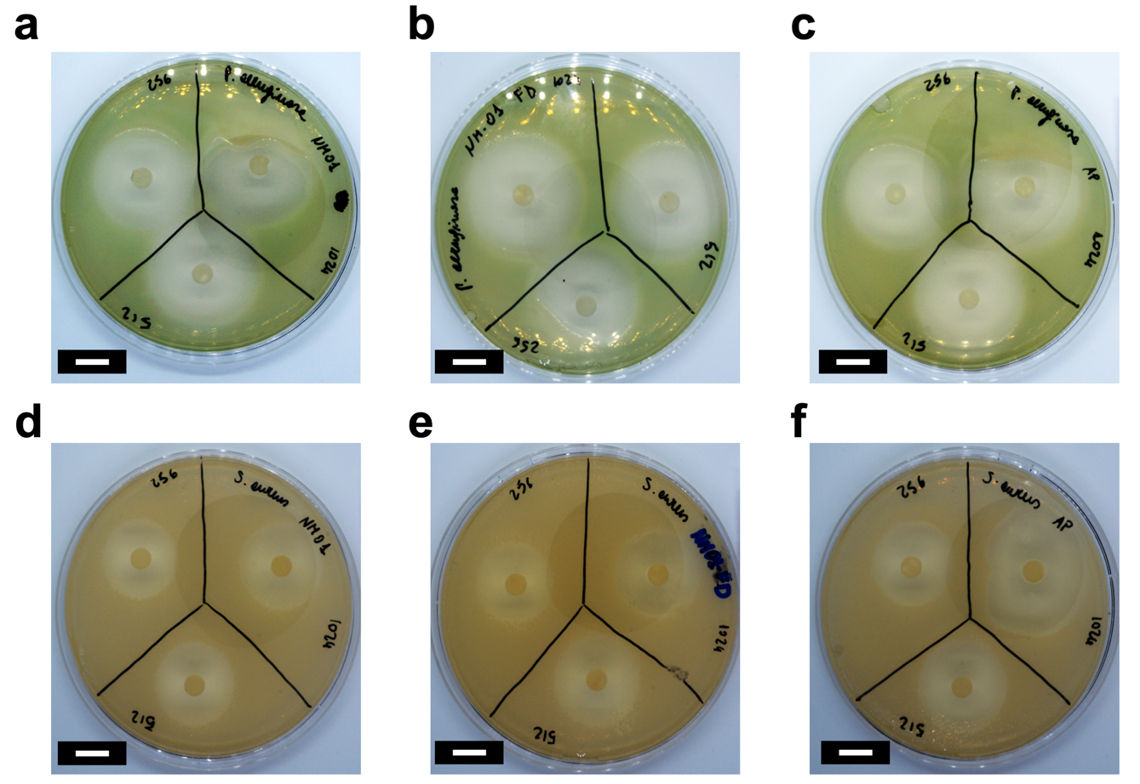
Figure S3 Agar diffusion test. The inhibition radius of ciprofloxacin-loaded mucosomes, freeze-dried and resuspended ciprofloxacin-loaded mucosomes, and free ciprofloxacin against P. aeruginosa (a), b), and c), respectively) and S. aureus (d), e), and f), respectively).

FIGURE S4

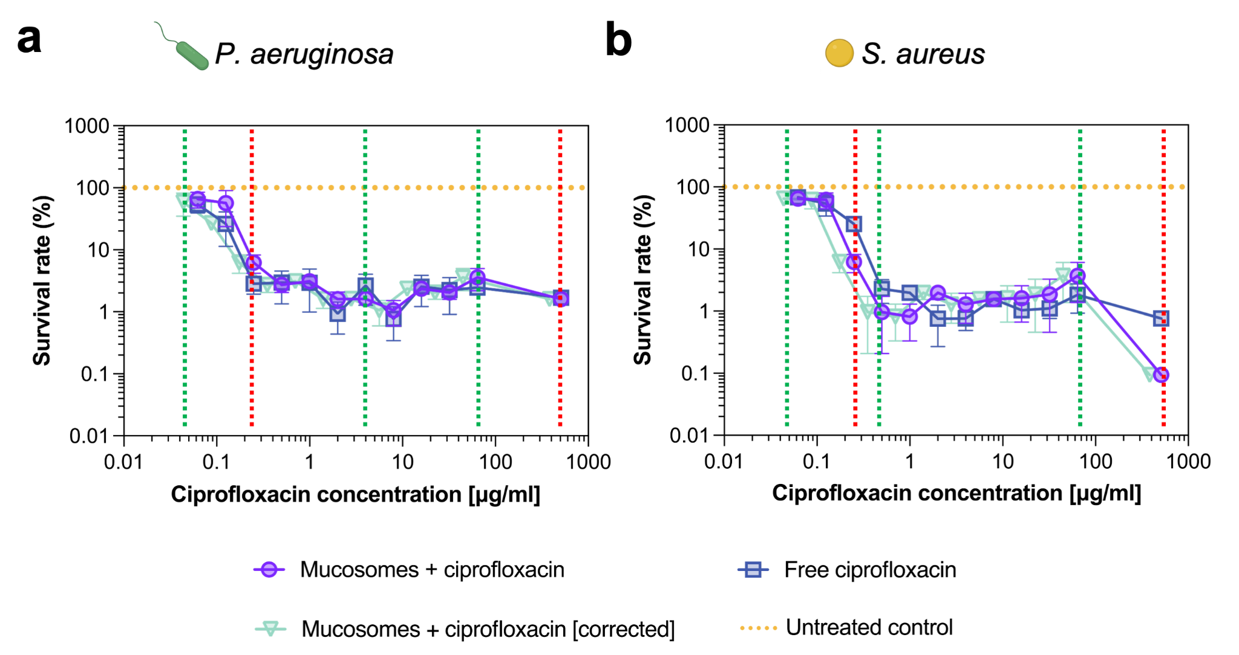
Figure S4 Dose-dependence experiment to test the efficacy against planktonic cultures of P. aeruginosa and S. aureus. a) The viability of P. aeruginosa decreases as a function of the antibiotic concentration. No significant differences in terms of efficacy were reported between the treatment with ciprofloxacin-loaded mucosomes and free ciprofloxacin. b) S. aureus viability as a function of the antibiotic concentration. The use of mucosomes enhances the activity of ciprofloxacin and allows to reduce the minimum inhibitory concentration up to 0.5 𝝁g/ml. Moreover, at a ciprofloxacin concentration equal to 512 𝝁g/ml mucosomes further enhance the activity of ciprofloxacin and reduce by 8 times the residual viability of S. aureus. In both panels the data reported as “mucosomes + ciprofloxacin [corrected]” refers to an adjustment that was made aiming to consider the actual ciprofloxacin amount to which bacteria were exposed, based on release kinetics from mucosomes. These data were obtained by multiplying the nominal concentration of ciprofloxacin for the average percentage of drugs released from mucosomes in 24 hours. In each panel, the dashed red lines highlight the treatment concentrations featured in Figure 2, while the dashed green lines highlight the treatment concentrations displayed in Figure 3.

FIGURE S5

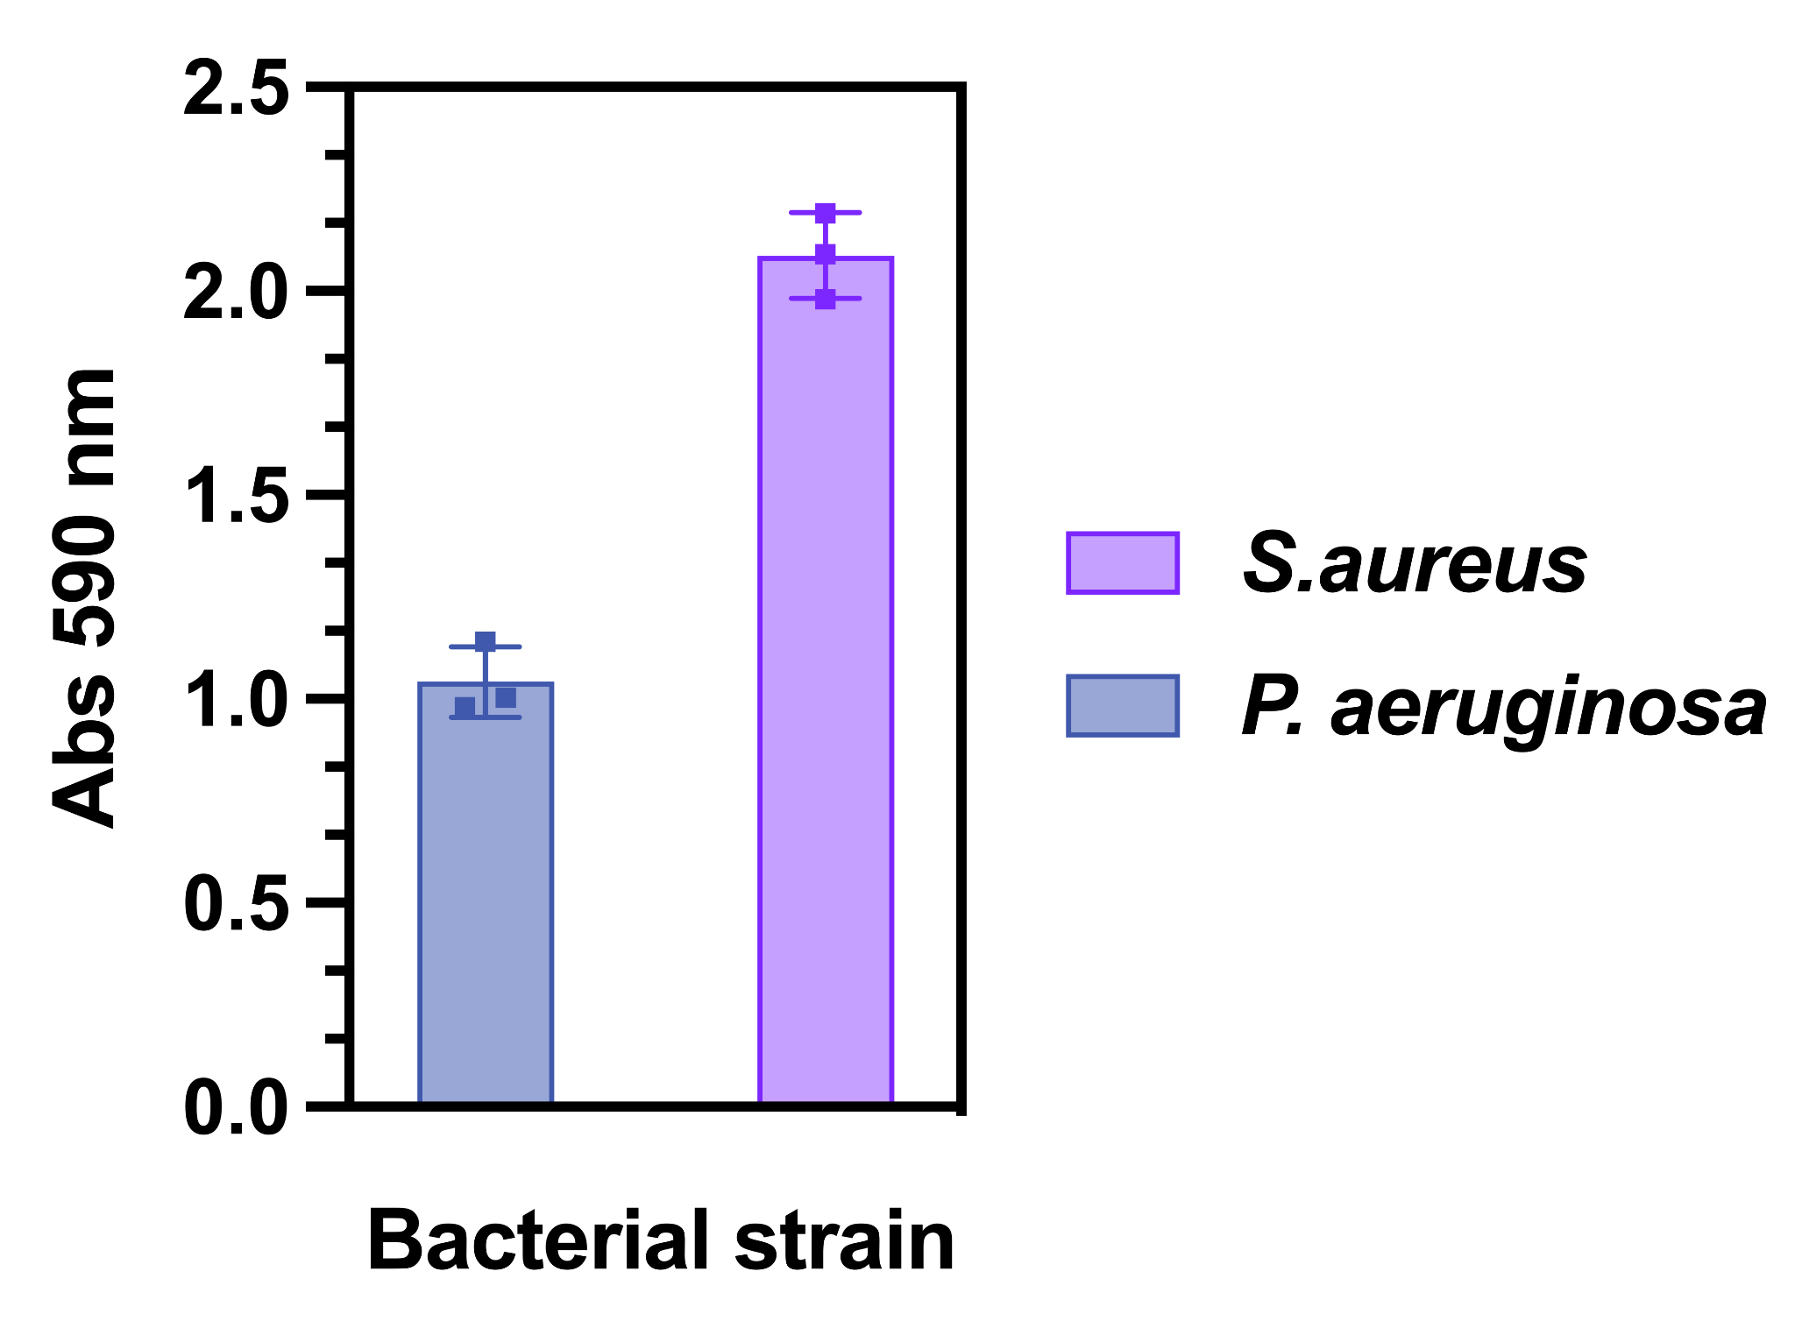

Figure S5 Crystal violet assay for biofilm formations detection. P. aeruginosa PAO1 and S. aureus ATCC25923 were seeded for 24 h at 37°C in biofilm condition. The biomass quantification has been determined through crystal violet assay, indicating that P. aeruginosa biofilm produced a lower biomass compared to S. aureus’s. Bars indicate the average of the absorbance measured at 590 nm of replicates (n = 3) ± standard deviation (SD). Statistical analysis through the unpaired t-test, indicated significant differences between the two bacterial biofilm biomasses (p < 0.05).

FIGURE S6
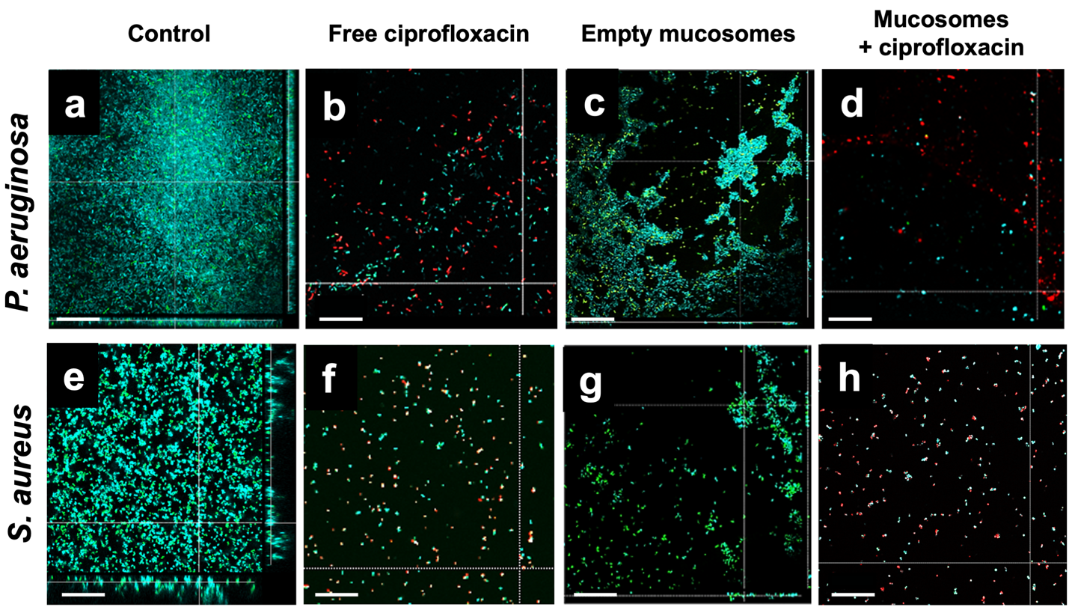
Figure S6 Confocal laser scanner microscope (CLSM) representative images of bacterial cells differently treated in pre-biofilm conditions. Orthogonal CLSM projections of P. aeruginosa PAO1 (a-d) and S. aureus ATCC 25923 (e-h) preformed biofilms upon treatment with ciprofloxacin (free and loaded in mucosomes) and with empty mucosomes. Live cells were stained in green by SYTO 9 and dead cells stained in red by propidium iodide. Images show biofilm matrix in cyan. Images acquired at 63× magnification (scale bar: 50 µm).

FIGURE S7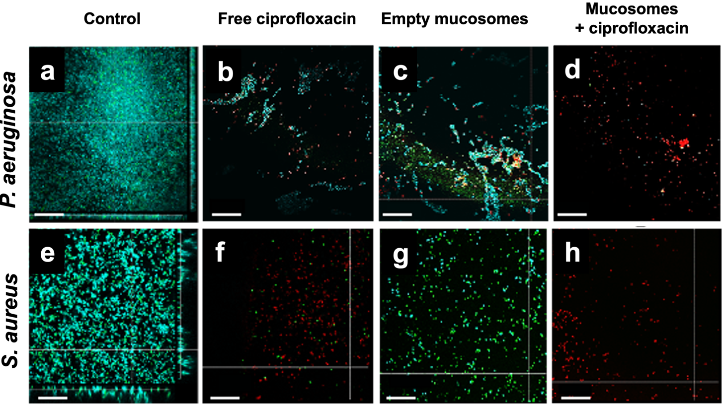
Figure S7 CLSM representative images of bacterial cells differently treated in post-biofilm conditions. Orthogonal CLSM projections of P. aeruginosa PAO1 (a-d) and S. aureus ATCC 25923 (e-h) post biofilms upon treatment with ciprofloxacin (free and loaded in mucosomes) and with empty mucosomes. Live cells were stained in green by SYTO 9 and dead cells stained in red by propidium iodide. Images show biofilm matrix in cyan. Images acquired at 63× magnification (scale bar: 50 µm).

FIGURE S8

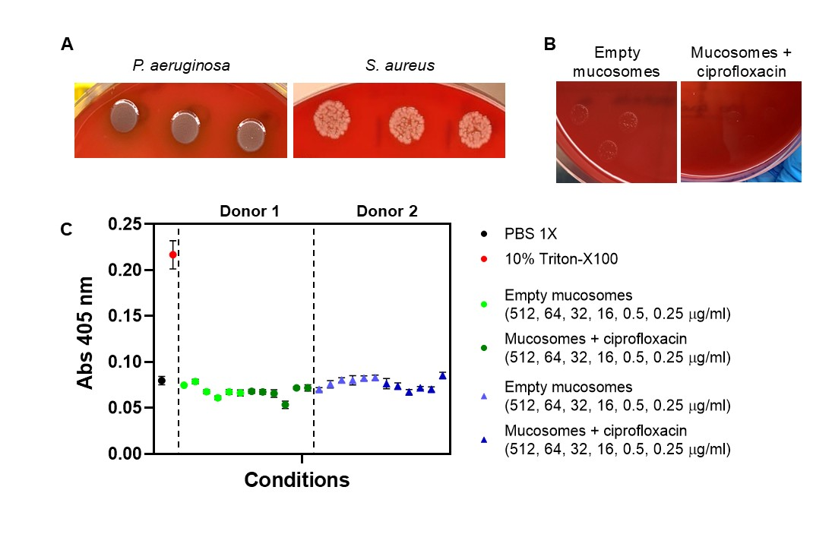

Figure S8 Hemolytic activity. Growth on blood agar of (A) P. aeruginosa PAO1 and S. aureus ATCC 25923 strains showing no hemolysis. (B) Empty mucosomes and mucosomes + ciprofloxacin were inoculated on agar blood and showed no hemolysis. (C) OD measurements at 405 nm (Y-axis) of free hemoglobin in 1% erythrocyte solution of pooled blood deriving from 2 healthy donors, incubated for 60 min at 37 °C with PBS 1X (negative control), 10% Triton X-100 (positive control), and mucosomes (empty and ciprofloxacin loaded) at different concentrations (512, 64, 32, 16, 0.5, 0.25 µg/ml). The dots indicate the average values from replicates (n =3) ± standard deviation (SD).

FIGURE S9
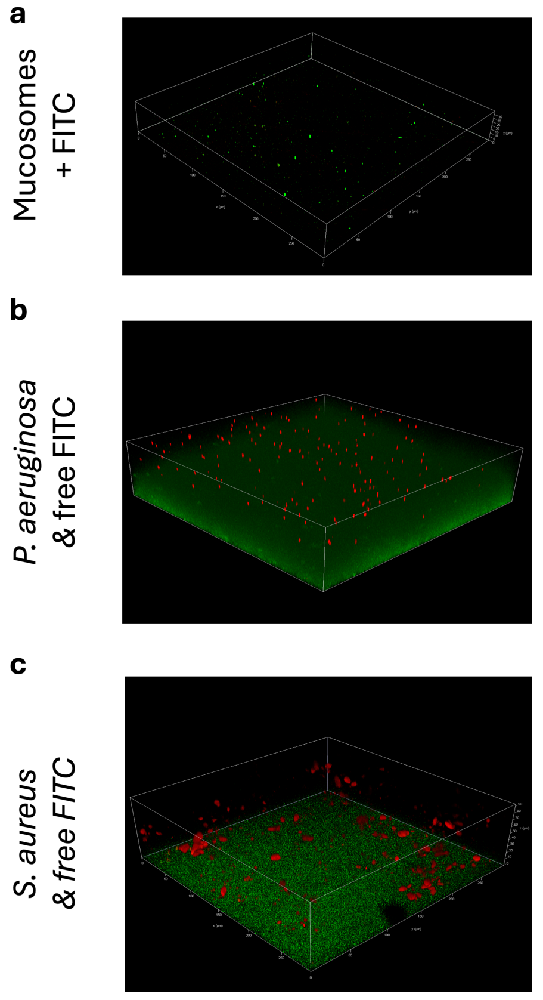

Figure S9 Controls used to evaluate the co-localization of FITC-loaded mucosomes and bacteria in a 3D model of mucosal infection. a) Image acquired for a non-infected gel that was only seeded with FITC-loaded mucosomes; no aggregation of nanoparticles is observed. In the images acquired for gels infected with b) P. aeruginosa and c) S. aureus and subsequently stained with free FITC no co-localization between the dye and the bacteria was observed.

