Active House in Mediterranean Country:
First assessment on energy needs and thermal comfort

ARIANNA BRAMBILLA¹, GRAZIANO SALVALAI¹, MARCO IMPERADORI¹

¹Department ABC, Politecnico di Milano, Milano, Italy

ABSTRACT: The last Century witnessed an increasing awareness about energy efficiency in the construction sector, seen as the only possible solution to smooth the negative effects of buildings on the environment. Therefore energy efficient design and envelope innovation have been pushed, decreasing the thermal dispersions through enclosures and minimizing flows exchange. The adiabatic concept of dwellings, however, brings to a criticism: increasing internal gains and the risk of overheating, especially in warm climate. The analysis proposed aims to understand the robustness of the design choices in the Mediterranean climate, defining the resilience associated to different architectural and technical solutions. A model of Active house is taken as case-study and different technological scenarios are created. The results are compared both on the energy needs and the indoor thermal comfort provided. The results show that, to increase the resilience of buildings in Mediterranean climates, it is important to act on the exchange flows with the outdoor, integrate a proper shading system (or closing the south façade and opening the northern one) and avoid over insulated skins, which easily bring to overheating. This work shows the importance of coupling comfort and energy consumption in buildings performances evaluation to achieve a reliable and robust design.
Keywords: active house, warm climate, overheating, energy efficiency, thermal comfort

INTRODUCTION
Environmental awareness of design choices is becoming a very important issue in the last decades. Climate change, in fact, threats the entire ecosystem balance and researches are focusing on finding a way to mitigate its effects. Greenhouse gas (GHG) emissions are the responsible of climate change and it is recognized that buildings are the principal contributor in the GHG production. It has been estimated that the construction sector alone accounts for 36% of the total emissions of the European Union (European Commission, 2016). Recent investigations categorized the European building stock based on the construction period: the heated floor in the Southern regions built before 1960 is around 37% and up to 49% was built in the period 1961-1990 (BPIE; 2011) meaning that more than 80% of the constructed environment was erected before energy and carbon emissions limitations. It is clear that there is a need of an urgent and consistent change in the sector. However, it is still possible to cease the tendency: GHG emissions could be reduced by 40% with current technologies (UNEP, 2009).

The European Union has focus its attention on fostering a measure to contract climate change, developing a new directive for buildings efficiency (EPBD recast, 2010). EPBD indicates that energy efficiency of buildings is a straightforward way to cut GHG emissions in the construction sectors, defining a new category of efficient buildings, which has a neutral energy balance, called nearly zero energy buildings (NZEB). Rooted on this definition, several interpretation of the meaning of NZEB have been collected and analysed (Voss et al., 2012 – Sartori et al., 2012 – Sesana et al., 2013)

Energy efficiency and environmental consciousness are at the basis of the new buildings visions, which focus the attention on how to limit the resources consumption. However, buildings satisfy one of the primary needs of humans: the necessity of a safe place. For this reason, occupants play an essential role in buildings performance evaluation. The final evaluation of a building’s performance is given by the degree of acceptability of the created spaces from dwellers, thus comfort, in all its declination, must be considered as important as energy efficiency.

Energy efficiency and thermal comfort, usually, influence each other in an opposite way, and the effects of the interactions must be appreciate in order to design a sustainable building that could be also liveable [Yang and Wang; 2013]. It is hard to define which parameters should be evaluated in a sustainable construction, because standards are becoming restrictive and limiting, focusing more on numbers and parameters easily measurable. However, beyond quantitative factors, as physical and technical elements, there are other qualitative ones that need to be considered, as elements related to social, psychological and cultural environment (Gylling et al.; 2011). These are more difficult to control and mitigate with technological systems but they determine the real sustainability of the buildings. What is needed is an integrated approach that could consider the several aspects of sustainability without limiting the complex system to the only final energy performance.

The Active House vision represents the next generation of sustainable buildings that take in count both energy and comfort (Active House Specification, 2011). The Active House Alliance is a non-profit organization supported by a group of partners with the same ambition: creating an independent and international vision of dwellings and define long term goals for the future buildings stock. The purpose is to spread a new balanced and holistic approach to the constructions sector, promoting sustainable design through an indexing of rules and suggestions of sustainability. Active House does not aim at being a legislative integration, but it is considered as a design compass: a useful tool for early design stage that could help in decision making towards sustainability. The analysis presented is made in the framework of a research on the adaptability of the Active House Specification to warm regions (Brambilla and Imperadori, 2013). It focuses on Mediterranean climate and aims to understand the features of a resilient design for Active House in warm climate. Sustainability means also defining a robust solution according to weather stresses and external environment inputs. Due to the global warming, in fact, overheating is becoming a main issue in some European region and it can’t be neglected any longer.

The aim of this paper is to define the main features of a resilient design for hot climates in Active House framework, using an integrate approach for decision making in the early design stage as a compass towards sustainability.

METHODOLOGY

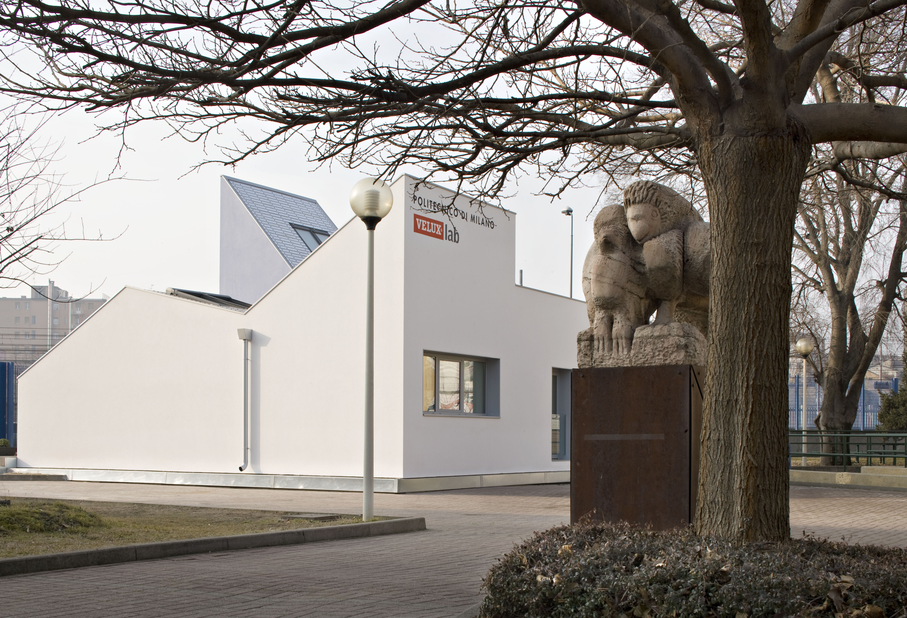
Figure 1: VELUXlab building, placed in Bovisa Campus of Politecnico di Milano (credits: Alberto Parise)

The methodology used is based on the comparison of different scenarios in relation to a reference case, defined as a model for a Mediterranean Active House. The case study is represented by VELUXlab, a very highly innovative experimental laboratory of Politecnico di Milano (Brambilla and Imperadori, 2013 – Imperadori et al., 2013).

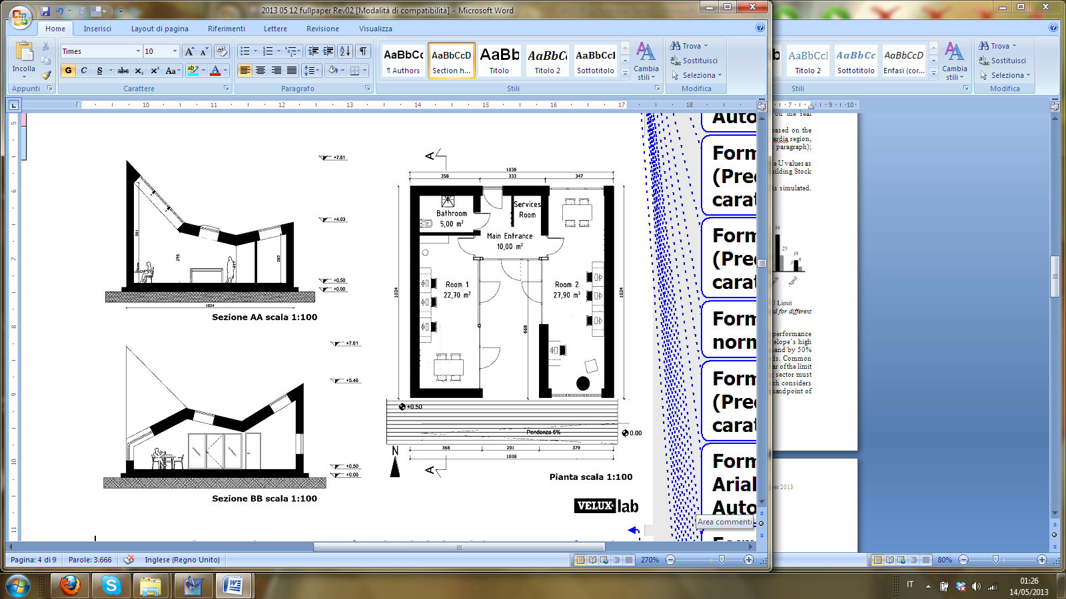
Figure 2: Plan and section of VELUXlab building (not in scale)

According to the Active House Specification (Active House), the analysis aims to evaluate both energy consumption and indoor comfort. For this reason three main parameters are considered: heating needs, cooling needs and hours of discomfort. In this way it is possible to comprehend at the same time the overall performance and the specific criticisms. The evaluation is made through the dynamic simulation of the yearly performance of the models, using the software Trnsys, an extremely flexible graphically based software used to simulate the behaviour of transient system. While heating and cooling needs (in kWh/m² y) are the direct results of the simulations, the comfort is assessed through three main indicators:
- hours with temperature above 28°C, according to the Fanger method (UNI EN ISO 7730: 2006)
- hours with temperature outside the Active House classification
- maximum temperature

Mediterranean climate identification
The Mediterranean area is representative of a wide zone, which include several different sub-climates, all defined as Mediterranean but with slight differences. It is important to have a precise boundary of this region, to understand the limits of validity of the analysis itself. Mediterranean zone is characterized by a variety of different weather conditions influenced by morphology of the land, altitude and latitude. Referring to different parameters it is possible to create different weather clusters. An easy example could be the temperature: grouping cities on the basis of the yearly average temperature or the maximum temperature can lead to different conclusions. Therefore, the climate definition is introduced as an assumption to this study.

In this presented work, three different Italian cities are used: Milano, Roma and Palermo, representative of three main sub-climate. Milano is a nearly continental climate, characterized by strong winter and warm summer; Roma presents warm winter and warm summer, while Palermo has warm winter and hot summer.
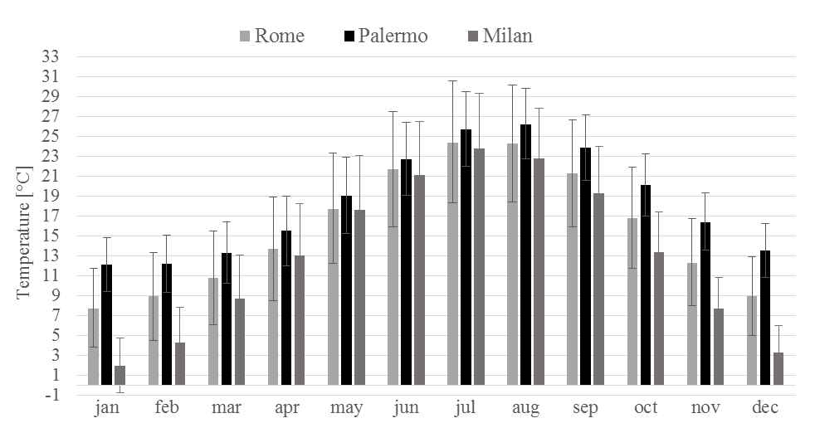

Figure 3: Main climatic features for the three reference cities.

Definition of the scenarios
Heating and cooling requirements has been considered as indicator of the model’s response to the climatic stress. To assess these, seven scenarios are defined. Four of them aim to optimize the summer comfort, investigating the effects of a good shading and ventilation system. The others, instead, maximize the thermal shield behaviour, typical of cold climate and winter energy strategies.

Worst configuration: “basis” scenario
This scenario assumes that the occupants don’t act to prevent overheating and control of building’s device. It aims to represent a situation of high vulnerability to solar radiation. A passive and un-optimized used of shading devices and natural ventilation is assumed: windows are not protected from the sun and are set as closed. In this way the building act like a greenhouse, maximizing the effects of solar radiation on façade but without the possibility to discharge the heat through ventilation.
- ventilation: windows close
- all windows: without blinds

Realistic configuration: “middle” scenario
The scenario intends to describe a realistic situation, introducing a little effort of users in preventing overheating by changing configuration of the blinds during the day. The basic assumption is that occupants usually don’t operate blinds and ventilation more than once per day, but they do according to external conditions (Mahdavi and Proglhof; 2009).
- ventilation: windows partially open, recreating a constant flow of 0,6vol/h
- windows facing North without blinds
- windows facing east/west: 30% shaded
- windows facing South: 80% shaded

MAS configuration: “domos” scenario
This scenario assumes that an automatic system can change the windows setting whenever it is needed according to external temperature (Text) and the incident solar radiation on the blind (I). The controllers work on a simple algorithm that takes in consideration indoor and outdoor conditions in order to assure comfort and prevent overheating. The configuration for this scenario is not fixed but changes thanks to a circular process of inputs control. This scenario is considered as representative of a basic automation, needed to help users in taking decisions according to an optimized behaviour of the building (Griffith et al., 2007).
- ventilation: IF: Text>22°C and Tint>Text, then open
- windows facing North: without blinds
- windows facing East/West: IF: Tint>Text, Text>24°C and I>140W/m², then 30% of the surface is shaded
- windows facing South: IF: Tint>Text, Text>24°C and I>140W/m², then 70% of the surface is shaded

Improved MAS configuration: “domos+” scenario
This scenario is the best for keeping the house cool during summer, it is based on the automation scenario domos but with improved value of ventilation and shading. It is the best tech scenario:
- ventilation: IF: Text>22°C and Tint>Text, then open
- windows facing North: without blinds
- windows facing East/west: IF: Tint>Text, Text>24°C and I>140W/m², then 50% of the surface is shaded
- windows facing South: IF: Tint>Text, Text>24°C and I>140W/m², then 90% of the surface is shaded

Improved insulating layer: “iso+” scenario
This scenario is based on the previous one, but it improves the winter behaviour. According to the lightweight construction features, it improves the thermal shield effects increasing the walls resistance through a new layer of insulation.
- added wood wool panels
- Uwall= 0,085 W/m²K
- Uroof= 0,077 W/m²K

Improved windows features: “win+” scenario
As the previous one, this scenario aims to mitigate optimize the building’s behaviour for winter. The thermal resistance of the case study is increased through the optimization of the transparent part. In this scenario the elements with an improved behaviour are the windows.
- double glass
- krypton filler
- U= 0,7 W/m²K

Improved tech: “tech+” scenario
This scenario aims to improve the building’s performances changing the active part of the building itself. It is based on the scenario iso+, but it conjugates an optimized ventilation system.
- based on iso+
- heat recovery efficiency= 2000 kJ/hK

RESULTS
The evaluation is made both on thermal comfort and energy consumption. Firstly during the results analysis the two assessment are separated, in order to clearly understand the criticisms of each scenario in the two indicators. Secondly, conclusions are made on the basis of an integrate approach, which include both comfort and energy assessments. In this way it is possible to define the assumptions that resilient design for buildings sustainability must consider to identify a robust solution.

Energy efficiency
The first feature of a sustainable building is energy efficiency: green design encourages measures to reduce the energy consumption before introducing a smart way to produce energy. Comparing cooling and heating needs help to understand the yearly performance of a scenario, however it is necessary to refer to a reference case to identify the benefits of the solutions proposed in each scenario. The basis case is used as reference.

From Figure 4 it is possible to compare the benefits induced by each scenario and to understand the sensitivity of the sub-climates to the technological variation introduced. Analysing the results it is possible to notice that the two hotter cities show the same tendency, but not the third one with warmer temperatures.

Considering the heating needs, for Palermo and Roma, characterized by warm winter, it is sufficient to improve the overall performance of the windows part to decrease the heating needs (the difference with basis case is higher). For Milano, instead, the benefits are higher when the thermal properties of the opaque envelope are higher (scenario iso+), or when a heat recovery system is introduced (tech+). This means that for climate close to the continental features, with cold winter and warm summer, it is important to improve the thermal flux control through better insulated walls and efficient ventilation system. For all the reference locations, however, the scenario middle, characterized by a manual control of shading and ventilation systems, increases the consumption underlining the importance of controlling the ventilation and the cold air from outside during the winter period.

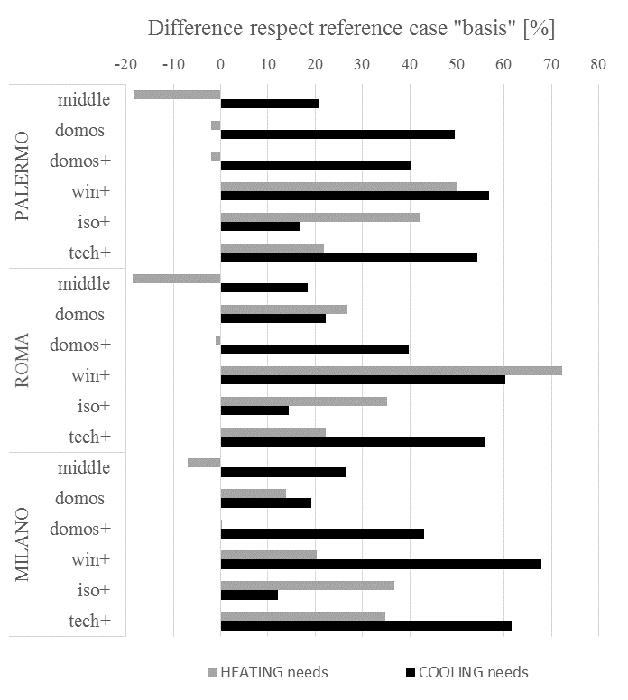
Figure 4: Heating and cooling needs of each scenario, expressed as percentage difference with the reference case (scenario: basis). The consumption of the reference cases are: PALERMO 29.9 kWh/m² heating and 27.7 kWh/m² cooling - ROMA 27.4 kWh/m² heating and 22.0 kWh/m² cooling - MILANO 80 kWh/m² heating and 14.9 kWh/m² cooling.

On the other hand, when cooling is addressed, it is possible to notice that the sensitivity to changes in Milano is higher than the other two locations. However, in all the three sub-climates, the best scenarios are the win+ and tech+, indicating that, to reduce cooling needs, it is very important to improve the ventilation system in all its components.
Considering the overall yearly performance of the building, it is possible to conclude that a more energy-efficient windows can reduce both the heating and cooling needs of a considerable part -up to 70%- according to all the three sub-climate defined for the Mediterranean region.

Comfort assessment
The second step is the comfort assessment. Since that the paper is focused on Mediterranean region where the heating system are provided, the analysis is made on the capacity of the scenario to reduce indoor summer discomfort during the cooling period. The analysis of the overheating hour’s (Tinternal higher than 28°C) helps to find which scenario is the best for enhancing heat charge/discharge cycles.
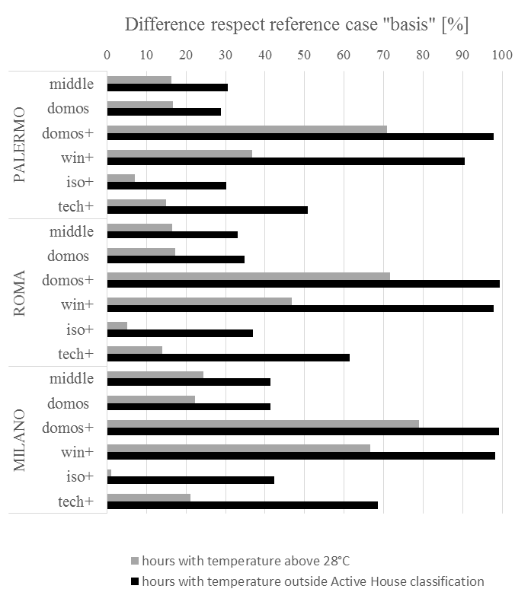

Figure 5: Hours of discomfort for each scenario expressed as percentage difference with the reference case (scenario: basis).

In Figure 5 it is represented the difference with the reference case, it means that the bars are representative of a percentage improvement respect the scenario basis. The first consideration that can be made is the difference between the two assessment methods. The Active House approach is based on the adaptive method, and it is therefore more sensitive to little change. While the static method does not change the threshold for discomfort, with the other one it is possible to accept higher temperature, depending on the outside running mean. On the results, this is reflected on a higher variability of the comfort hours.

Considering the three climate, for the comfort assessment it is possible to notice the same tendency among them and, moreover, the effects of the different scenarios have the same magnitude. Differently from the energy analysis, the best scenario is domos+ (almost completely reduce the hours outside Active House classification) and not win+, which however induces the second bigger improvement among all the scenarios. This means that, from a summer comfort point of view, it is important to introduce a shading and ventilation system which can react to the external climatic variations instantaneously with an optimized automated control.

Table 1 shows the maximum temperature achieved with each scenario, to understand the effects of the technological choices it is important to read the results of the comfort assessment on both side: discomfort hours and temperature. Adding insulation to the envelope, for example, easily bring to overheating achieving high temperatures. This change completely the results of the energy assessment, which were indicating a slightly improvement due to the added insulation. Considering also comfort results, instead, it is clear that the hours above 28°C doesn’t decrease of a significant value (less than 5%) but the maximum temperatures achieved are still outside the comfort range and above 35°C.

Table 1: Maximum indoor temperature reached in each configuration during the summer period.

SCENARIO | Palermo  T_{max} [°C] | Roma  T_{max} [°C] | Milano  T_{max} [°C]
Basis | 39.5 | 37.6 | 35.7
Middle | 37.1 | 36.1 | 34.1
Domos | 38.2 | 36.1 | 34.5
Domo+ | 34.2 | 32.5 | 31.6
Win+ | 34.9 | 33.2 | 31.4
Iso+ | 39.2 | 36.9 | 35.5
Tech+ | 38 | 35.9 | 34.4

CONCLUSION
This paper showed the application of an integrate approach that includes both energy efficiency and comfort assessment to evaluate buildings performances. The method has been applied on an innovative building placed in Bovisa Campus of Politecnico di Milano, VELUXlab. The evaluation is made according to the framework of the Mediterranean Active House research, which aims to understand the features of a sustainable building in warm climate. The results show that the ventilation control is essential to reduce cooling needs and to prevent overheating. Moreover, comfort assessment demonstrate that over-insulated envelopes in warm climate can easily bring to indoor overheating and discomfort situations. This paper underline the importance of using an integrate approach in the early design stage as decision making tool.

ACKNOWLEDGEMENTS
The authors would like to thank VELUX Italia s.p.a. and Active House Alliance for the big contribution to the research.

REFERENCES
Active House Specification, [online], Available: www.activehouse.info [18 September 2015].
Brambilla A. and M. Imperadori, (2013). Active House: new buildings for sustainable architecture. In Sustainable Built Environment for now and the future, Hanoi, VN, March 26-27.
Brambilla A. and M. Imperadori, (2013). VELUXlab: a sustainable prototype of active house for innovation. In Science and the future, Torino, IT, October 28-31.
Building Performance Insitute Europe, (2011). Europe’s buildings under the microscope, [online], Available: http://www.institutebe.com
European Commission, (2016). Buildings – Energy, [online], Available: https://ec.europa.eu/energy/en/topics/energy-efficiency/buildings [accessed 1.31.16].
European parliament, (2010). Directive 2010/31/EU of the European Parliament and the Council of 19th May 2010 on the energy performance of buildings (recast). Official Journal of European Union.
Gylling G., Knudstrup M., Heiselberg P.K., and E.K. Hansen, (2011). Holistic Evaluation of Sustainable Buildings through a Symbiosis of Quantitative and Qualitative Assessment Methods. In PLEA, Louvain-la-Neuve, BR, July 13-15.
Griffith B., Torcellini P., Judkoff F., Crawley D. and J. Ryan, (2007) Assessment of the technical potential for achieving net zero energy buildings in the commercial sector, Technical report NREL/TP-550-41957.
Imperadori M., Sauchelli M., Brambilla A., Falcone N., Zanello C. and V. Zorzi, (2013). Comfort and Energy Assessment of the First Italian Nearly Zero Energy Building in a University Campus. In PLEA, Munich, IT, September 10-12.
Yang R. and L. Wang, (2013). Multi-zone building energy management using intelligent control and optimization. Sustainable Cities and Society, 6: p. 16-21.
Mahdavi A. and C. Proglhof , (2009). User behavior and energy performance in building. In InternationalenEnergiewirtschaftstagung, Wien, AU, February 11-13.
Sartori I.,Napolitano A. And K. Voss, (2012). Net Zero Energy Buildings: A Consistent Definition Framework. Energy and Buildings, 48: p. 220–232.
Sesana M.M., Salvalai G. (2013). Overview on life cycle methodologies and economic feasibility for nZEBs. Building and Environment, 67: p 211-216.
United Nations Environmental Programme, (2009). Common carbon metric for measuring energy use & reporting grennhouse gas emission from buildings operations. Sustainable buildings & construction initiative.
UNI EN ISO 7730:2005 - Ergonomics of the thermal environment - Analytical determination and interpretation of thermal comfort using calculation of the PMV and PPD indices and local thermal comfort criteria.
UNI EN 15251:2007 -Indoor environmental input parameters for design and assessment of energy performance of buildings addressing indoor air quality, thermal environment, lighting and acoustics.
Voss K., Sartori I. and R. Lollin, (2012). Nearly-zero, Net zero and Plus Energy Buildings. How definitions & regulations affect the solutions. REHVA Journal, 6: p. 23-27.

