Title: Effect of crystalline admixtures on the self-healing capability of early-age concrete studied by means of permeability and crack closing tests
Author names and affiliations: M. Roig-Flores ª (marroifl@upv.es), F. Pirritano ^{b} (francesco.pirritano@gmail.com), P. Serna ª (pserna@cst.upv.es), L. Ferrara ^{b} (liberato.ferrara@polimi.it)
ª ICITECH-Institute of Concrete Science and Technology, Universitat Politècnica de València, Valencia, Spain
^{b} Politecnico di Milano, Milano, Italy
Corresponding author: M. Roig-Flores; marroifl@upv.es; Spain: +34 963877563 (Ext.:75631); ICITECH-Institute of Concrete Science and Technology, Universitat Politècnica de València, 4N Building, Camino de Vera s/n, 46022 Valencia, Spain
Present address: M. Roig-Flores (marroifl@upv.es) ICITECH-Institute of Concrete Science and Technology, Universitat Politècnica de València, 4N Building, Camí de Vera s/n, 46022 Valencia, Spain
Abstract: This paper analyzes the self-healing properties of early-age concretes, engineered using a crystalline admixture (4% by the weight of cement), by measuring the permeability of cracked specimens and their crack width. Two concrete classes (C30/37 and C45/55) and three healing exposure conditions have been investigated: water immersion at 15°C, at 30°C and wet/dry cycles. Specimens were pre-cracked at 2 days, to values of crack width in the range of 100-400µm. The results show almost perfect healing capability for specimens healed under water at 30°C, better than for specimens healed under water at 15°C, while insufficient for the wet/dry exposure.
Keywords: concrete, self-healing, autogenous, crystalline admixtures, permeability, durability

Introduction
Self-healing is the process through which a material is able to recover its properties, degraded after having suffered some damage, with little or no external help [1]. Some authors also differentiate between self-healing and self-sealing, depending on the recovered property [1, 2]. The self-healing process is well-known in bones and trees, which are able to repair damage and recover their strength [3]. Structures built with self-healing materials will likely feature extended service life and lower maintenance costs, furthermore benefiting from the avoidance of complicated repairs all along their service life [4]. In the case of concrete, self-healing research has focused on the closing of cracks and the related recovery of properties, either mechanical or durability-based. The property that is sought after will depend on the specific type of structure. Sometimes the structure will require both mechanical and durability-based recovery, for example, in cases where watertightness is needed for the structural stability to prevent the ingress of harmful substances that may activate or accelerate corrosion of reinforcement, thus leading to loss of load bearing capacity.
Though the popularity of self-healing concrete has strongly increased in most recent years, the mechanism has been known for years. Neville [5] already talked about the autogenous healing of concrete, and Fernández Cánovas [6] called it “cicatrization”. Moreover, it was observed in [7, 8] that concrete water reservoirs and historical lime and lime-pozzolana mortars featured self-healing capabilities due to their composition. This phenomenon benefits from tighter cracks [9], as the volume that needs to be healed is smaller and thus the process is fastened.
Self-healing in concrete is caused by the following two main mechanisms [1, 10, 11]: autogenous healing and autonomous/engineered healing. Autogenous healing of small cracks in concrete is a natural process, intrinsic to the properties and the composition of the material itself. It is mainly caused by further hydration of cement and calcium carbonate precipitation, though other processes could also enhance it [12]. Autonomous healing is an engineered healing process designed to improve the self-healing properties of a concrete element. Furthermore, autonomous/engineered healing can be further divided into 'passive' and 'active' modes [1, 11, 13]. The 'active' mode requires some human help to activate the mechanism, while the 'passive' mode requires no human intervention. One of the methods for autonomous healing is the use of self-healing admixtures, such as crystalline admixtures.
The ACI TC 212 report [14] regards crystalline admixtures (CA) as a type of permeability reducing admixtures. Specifically, crystalline admixtures are hydrophilic, i.e., they react easily with water, in contrast to water-repellent or hydrophobic products. The behavior of these products is still partially unknown: in fact, the ACI TC 212 report [14] states that the concrete compounds reacting with CA are tricalcium silicates, while other authors [15] indicate calcium hydroxide as the reactive. The general process, according to [14], follows Equation (1), where a crystalline promoter, $M_{X}R_{X}$, reacts with tricalcium silicates and water to produce modified calcium silicate hydrates and a pore-blocking precipitate, $M_{X}CaR_{X}-{\left(H_{2}O\right)}_{X}$.
$3CaO-SiO_{2}+M_{X}R_{X}+H_{2}O→{Ca}_{X}{Si}_{X}O_{X}R-{\left(H_{2}O\right)}_{X}+M_{X}CaR_{X}-{\left(H_{2}O\right)}_{X}$ (1)
There are relatively few recent publications concerning the effect of crystalline admixtures as promoters of self-healing. Jaroenratanapirom and Sahamitmongkol [16] focused on the visual observation of crack closing in mortar specimens healing under water. Their results show that CA provided the best behavior for small and early age cracks (under 0.05 mm and pre-cracked at 3 days and at 28 days), but were ineffective for larger cracks (around 0.3 mm) when compared to Ordinary Portland Cement (OPC) mortars. Similar results were obtained by Sisomphon, et al. [15], who also made reference to visual closing of cracks in mortar specimens with CA pre-cracked at the age of 28 days: only crack widths up to 150 microns were able to close completely when the samples were healed for 28 days under water. On the other hand, their water permeability tests showed rapid healing for mortars with CA during the first 5 days, but only a limited reaction for OPC mortars not containing the admixture. Afterwards, Sisomphon et al. [17] tested the recovery of mechanical properties of strain-hardening cementitious composites containing CA and reported hardly any benefit when compared with control specimens. However, the reaction for both kinds of specimens was enhanced when subjected to wet/dry cycles (immersion in tap water for 12 hours and drying in air for 12 hours) as compared to continuous water immersion. Later on, Ferrara, et al. [18] studied the effect of CA on strength recovery in normal strength concrete specimens, in their case made with concrete containing CA at a dosage of 1% by the weight of cement, under continuous water immersion and an exposure to open air and up to one year; this resulted in an improvement of the mechanical properties along the healing period.
Other studies [19, 20] focused on the development of self-healing admixtures, by using expansive agents, geo-materials and chemical agents, in order to improve the chemical stability of re-hydration products and the velocity of the reaction, which is fundamental for an effective healing.
All the aforementioned studies have anyway highlighted, once more, that presence of water is needed, even in a discontinuous way (as in the case of wet/dry cycles), to activate the healing reactions for both autogenous healing and CA-based healing. However, some discrepancies have been noticed when analyzing the autogenous healing capability of concrete: while some studies [21] showed improvement of the healing capability with increasing ambient humidity for early-age cracked specimens, others [22] concluded that exposures of high humidity levels do not activate self-healing reactions. To the knowledge of the authors, the majority of works so far have used continued water immersion as their healing exposure of choice. However, a few studies [23, 17] have shown better behavior for both autogenous healing and CA-based healing under the exposure to wet/dry cycles than for continued immersion, which motivates specific analysis on this subject.
This work compares the effect of a crystalline admixture on self-healing behavior in early-age concrete, considering two classes of concrete under three different exposure conditions, all of them featuring the presence of water. The methodology used in this research is based on permeability tests and crack width evaluations, comparing their performance to evaluate self-healing, since some studies have registered correlations between permeability and crack width measurements [24, 25, 26]. The former method is based on the standard permeability test for uncracked concrete specimens and the methods for cracked specimens used by Edvardsen [24] and Sisomphon et al. [15].

Research significance
The results from this study will allow assessing the effect of a crystalline admixture on the self-healing properties of concrete at early ages through the analysis of water permeability and crack closing as healing parameters. This work studies the self-healing behavior in two commonly used concrete classes, one typical for precast concrete elements and/or civil engineering infrastructures (C45/55) and one standard class widely used for building constructions (C30/37). The influence of the environmental exposure on self-healing is also investigated by comparing three different exposure conditions and comparing their results with those of exposures from previous research [27], in order to widen the analysis data base and strengthen the conclusions. In all cases, the examined crack widths range between 0.10 and 0.40 mm, for the purpose of verifying the limits of healing effectiveness for each combination of experimental variables. This work aims to provide new perspectives on the use of crystalline admixtures as self-healing agents in engineering applications where watertightness is a key factor.

Experimental program and methodology

Experimental program
In this work, all specimens have been evaluated by means of a permeability-based method and the crack closing. Specimens were divided into eight testing groups to analyze the effect of concrete strength class, influence of exposure condition during healing and the presence of a crystalline admixture (CA) as a self-healing “promoter.” Table 1 shows the experimental variables combination and the number of tested specimens for each of them, adding up to a total of 144 specimens tested in this study. Higher amount of specimens were tested for the “water immersion at 15ºC” groups, since they are the reference used for comparison.
Concrete quality | Self-healing admixture | Exposure conditions | Number of specimens
Precast concrete  C45/55 | - | Water immersion at 15°C | 22
Precast concrete  C45/55 | - | Water immersion at 30°C | 14
Precast concrete  C45/55 | - | Wet/dry cycles at 15ºC 100RH / 17ºC and 40% RH | 14
Precast concrete  C45/55 | CA | Water immersion at 15°C | 22
Precast concrete  C45/55 | CA | Water immersion at 30°C | 14
Precast concrete  C45/55 | CA | Wet/dry cycles at 15ºC 100RH / 17ºC and 40% RH | 14
Standard concrete  C30/37 | - | Water immersion at 15°C | 22
Standard concrete  C30/37 | CA | Water immersion at 15°C | 22
Table 1 - Number of specimens cast for each group.
The goal of the main set of these experiments is to compare the self-healing behavior of concrete with and without the crystalline admixture under three different exposure conditions: water immersion at 15°C (WI_15), water immersion at 30°C (WI_30), and wet/dry cycles (W/D). More detailed information on these conditions will be given in Section 3.3.
A second set of experiments studied the effect of concrete class and whether the crystalline admixture affects this effect. Two classes of concrete have been considered, comparing their healing only under water immersion at 15°C. The first class of concrete can be considered as a usual high-quality/performance mix for precast concrete elements, with water/cement ratio of 0.45 and a cement content of 350 kg/m³, for a target strength class C45/55. The second class features a standard composition for building constructions, with water/cement ratio of 0.60 and a cement content of 275 kg/m³ for a target strength class C30/37.

Materials
Two different concrete classes were investigated in this study, featuring different water/cement ratios and cement contents, meant as representative of a standard normal strength concrete and of a high performance one used in precast construction. These compositions were further modified by adding the crystalline admixture, in powder form, at a dosage equal to 4% by the weight of cement. Table 2 shows the composition of the four considered concrete mixes. It is worth remarking that powder content was kept constant in mixes with CA by reducing the quantity of limestone filler accordingly.
40 kg/m³ of steel fibers (0.51% by volume) were used for the purpose of controlling crack width during the pre-cracking and healing stages. Steel fibers were chosen to study just autogenous and CA-based healings and avoid the additional effects by some plastic fibers, such as those reported by Nishiwaki et al. [28]. The dosage of the superplasticizer, Sika ViscoCrete 5720, was adjusted in each different group in order to get a similar slump (around 150 mm). Standard concrete with crystalline admixture needed a dosage of superplasticizer between 0.70-1.00% by the weight of cement, and all other groups needed between 1.00-1.30%.
 | Precast concrete  C45/55 |  | Standard concrete  C30/37
Material (kg/m³) | Control | CA | Control | CA
Cement II/A-L 42.5 R | 350 | 350 | 275 | 275
Water | 157.5 | 157.5 | 165 | 165
Water / cement | 0.45 | 0.45 | 0.60 | 0.60
Gravel (4-12 mm) | 950 | 959 | 908 | 915
Natural sand | 899 | 875 | 987 | 967
Fibers, Dramix RC 65/35 BN | 40 | 40 | 40 | 40
Limestone powder | 50 | 36 | 50 | 39
Crystalline Admixture | - | 14 | - | 11
Number of batches | 4 | 4 | 2 | 4
Average Slump ± std. dev. (cm) | 13 ± 3.5 | 16 ± 1.5 | 15 ± 1 | 14 ± 2
Average Compressive Strength ± std. dev. (MPa) | 55 ± 3 | 63 ± 3 | 38 ± 3 | 41 ± 2
Table 2 - Mix design of control and CA concretes using different water/cement ratio.
All batches were characterized by their workability with slump tests as per EN 12350-2:2009 and compressive strength at 28 days as per EN 12390-3 for cylindrical specimens. These control tests were performed with the objective of verifying the homogeneity of specimens from different batches of the same mix group (control or CA, precast or standard) and in order to compare the results between the four different types of concrete. Four batches were cast for each test matrix combination except for control standard concrete.
After averaging the results of all batches for each group, it was observed that the addition of CA resulted in a higher compressive strength at 28 days for both classes of concrete: 15% higher than control concrete for precast concrete and 8% higher for standard concrete. The slump tests showed differences within acceptable tolerance limits according to the current standards.

Exposure simulation
Three environmental exposure conditions were considered in order to determine the influence of water availability and its temperature on the self-healing capability of the tested specimens, comparing reference concrete with crystalline admixture concrete (Figure 1). All specimens were left to heal for 42 days.
- WI_15 (water immersion at 15°C): continuous immersion in tap water at a temperature of 15°C, only adding water to compensate the evaporation and to maintain a constant water level;
- WI_30 (water immersion at 30°C): continuous immersion in tap water at a temperature of 30°C, including a motor that ensured a uniform temperature in the whole container, only adding water to compensate the evaporation and to maintain a constant water level;
- W/D (wet/dry cycles): immersion in tap water at a temperature of 15°C for 3.5 days and air exposure for another 3.5 days (air conditions: 17 ± 1°C and 40 ± 5% RH); this process is repeated six times.
(a)  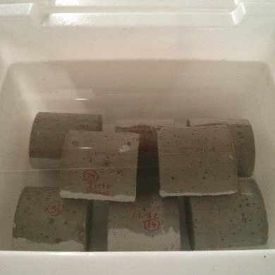 | (b)  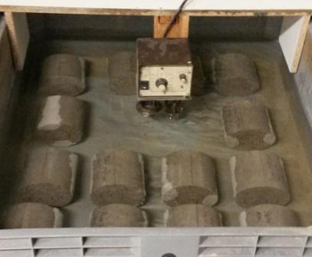 | (c)  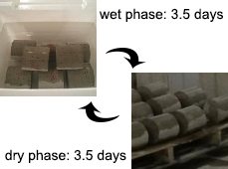
Figure 1 - Three exposure conditions: water immersion at 15°C (a), water immersion at 30°C (b) and wet/dry cycles (c).
Specimens were divided in two different water containers in order to avoid interferences between control and CA concrete, and water temperature was measured regularly. The volume of water per specimen was constant. Immersed specimens were placed ensuring a distance between the specimens of at least 5 cm between cracked surfaces and 1 cm between lateral surfaces, in order to let the water infiltrate inside the crack and act over the whole specimen. Each healing exposure has been designed with the objective of simulating real conditions (see Section 5.1). The analysis of the healing behavior under warm water serves a twofold purpose: first, to compare the effect at a different but feasible temperature of water and, second, to verify if a higher temperature accelerates the healing reactions.

Methodology for the evaluation of self-healing
The methodology followed in this work has been thoroughly explained in Roig-Flores et al. [27] and will be briefly summarized hereafter. For each class of concrete, cylindrical specimens (Φ150×150 mm) were pre-cracked at the age of 2 days, inducing controlled damage by means of a splitting test. The range of studied crack widths was 0.1-0.4 mm. Water permeability was analyzed using a test method based on the standard test to measure water depth penetration on concrete specimens (EN 12390-8), but measuring water flow instead. Water pressure was always applied in the “top surface” of specimens (see Figure 2). Permeability tests were performed one day after pre-cracking, i.e. before exposure to the different conditioning environments, and at the end of a 42 days conditioning period.
The parameters of the permeability test were water head pressure equal to 2.00 ± 0.05 bar, and testing time of 5 min. In addition, crack width was also quantified by means of an optical microscope (PCE-MM200) to support the results from permeability tests. This parameter was evaluated by estimating the average crack width (w_{avg}) by measuring its value at multiple fixed locations along the length of the crack, which is a feasible method with a short post-processing stage [27].
In detail, the average crack width (in millimeters) was calculated by averaging seven crack width measurements taken at fixed positions, three on the top surface and four on the bottom surface of the specimens, as it can be seen in Figure 2. The distance between crack width measuring positions was 25 mm on the top surface and 30 mm on the bottom surface. The optical microscope focuses the center of the image, therefore, in order to widen the focused area, two overlapping pictures were taken at each fixed position. Then, the two pictures were combined in order to create a joint picture with a wider focused area. This process was made by using the photo editing software Adobe Photoshop CS6. Each individual picture had a size of 1600×1200 pixels and covered an area of 8×6 mm, therefore 1 pixel was equivalent to 5 µm. The resolution of the images was maintained in the larger composed pictures, thus 5 µm was the limit of resolution of the measurements.
After the healing process and after a short conditioning period in lab environment (a couple of hours), all specimens were subjected to the final permeability test. Afterwards, they were left to dry at air exposure at laboratory conditions in order to obtain an unwetted crack surface prior to the visual observation of the same cracks. Intermediate measurements were not performed, in order to avoid uncontrolled effects due to the high pressure of the permeability test during the healing process and to avoid an interruption due to the drying stage needed to take high quality photos.
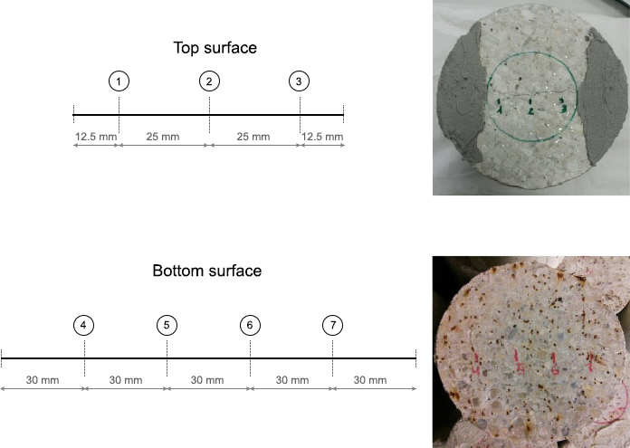 | 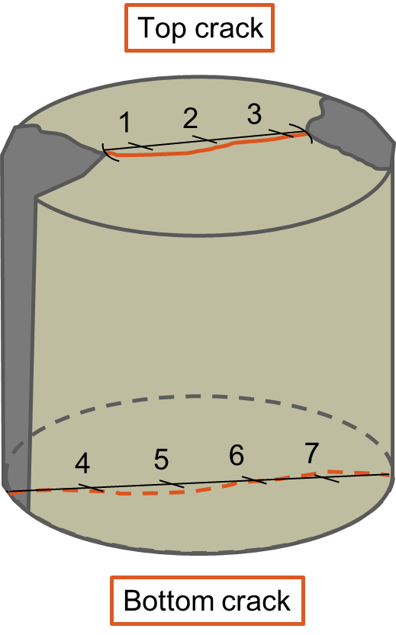
Figure 2 - Fixed positions on the top and bottom surface where crack width is measured

a) Parameters for permeability and crack width evaluation
The effect of healing on permeability was evaluated by calculating a Healing Ratio parameter as follows, equation (2):
$Healing Ratio=1-\frac{Final Flow}{Initial Flow}=1-\frac{Q_{42}}{Q_{0}}≮0$ (2)
With:
Q₀ the initial water flow [ml/5min], measured after pre-cracking
Q₄₂ the final water flow [ml/5min], measured after a healing period of 42 days
Analogously to the Healing Ratio, a Crack-Closing Ratio parameter has been defined as follows, equation (3):
$Closing Ratio=1-\frac{Final Crack Width}{Initial Crack Width}=1-\frac{ω_{42}}{ω_{0}}≮0$ (3)
With:
ω₀ the initial crack width [mm], measured after pre-cracking
ω₄₂ the final crack width [mm], measured after a healing period of 42 days
This research analyzes the use of both parameters, since the measure of crack width is fast, cheap and non-destructive, while permeability-based tests are expected to be of greater importance regarding the recovery of durability properties in concrete. This is due to the possibility that a visual closing of cracks, which can occur on the surface, might not effectively block water flow at the testing pressure. If the crack is visually closed but water can still pass through the specimen, the durability will not be improved by the closing.

b) Relation between permeability and crack width parameters
From the literature, it has been shown [24] that the relation between the water flow passing through a crack and the width of that crack is a third-order polynomial with only the cubic term. This relation could be modified by the presence of fibers, as reported by Lawler, et al. [25], in which the type and amount of fibers affected the relation between crack width and water flow due to the multicracking effect.
Figure 3 plots the values of initial water flow from the permeability test versus the corresponding initial average crack width of specimens from the present study, as well as the computed regression curves. Two robustness methods were used to minimize the influence of outliers in the regression curve, Least Absolute Residuals (LAR) and Bisquare, and compared with the regression obtained when no outlier influence-minimization method was employed. The three curves were quite similar, but with different values of the coefficient of determination (R²): 0.95 for the LAR curve, 0.77 for the Bisquare curve and 0.47 when using no robustness model. The dispersion in this correlation could be caused by different geometries of the in-depth volume of the crack. These curves were plotted considering only the initial values of water flow and crack width, since self-healing could be happening inside the specimen yet have no visible effect on the surface crack. This correlation will only be used to compare the values of healing for permeability and crack closing, rather than to find an exact relationship between both parameters.
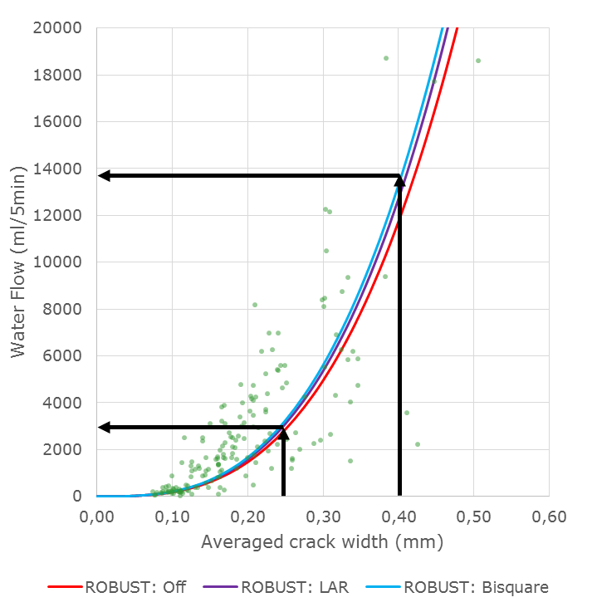
14000 ml/5min ≈ 0.40 mm
3000 ml/5min ≈ 0.25 mm
Figure 3 - Initial crack width versus initial water flow with trendline with different adjustments.
Despite the fact that the healing capacity of specimens was inverse related with damage suffered, in the literature there is no clear agreement between the limit values of initial damage in order to achieve complete healing in terms of permeability and crack closing. In this research, average crack widths up to 0.40 mm have been analyzed, which corresponded to measured water flow values around 14000 ml/5min. The effect of initial damage is explained in Section 4.2.a.

Results

Morphology of healed cracks
The first observed aspect of the crack healing phenomenon were white crack-sealing formations in control and CA specimens under water immersion for 42 days, which can be clearly seen in Figure 4 for initial cracks between 0.20 and 0.30 mm. It can be furthermore observed that specimens subjected to the WI_15 and WI_30 exposures have a higher healing ability, closing cracks almost completely, especially for specimens in warm water. Crack closing was also observed in specimens subjected to wet and dry cycles, though to a lower extent. These results confirm the important role of the presence of water and its temperature in the healing process, as well as the time under water.
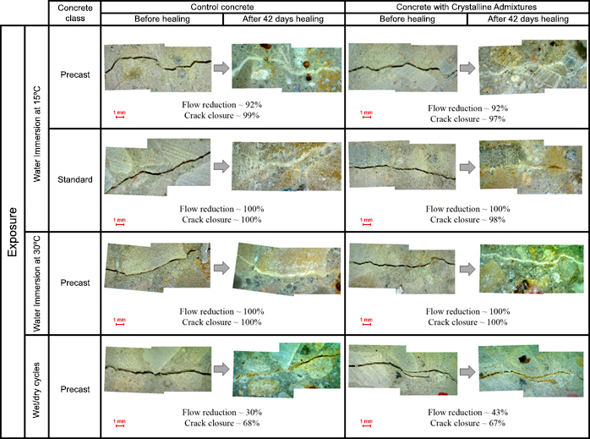
Figure 4 - Crack before and after healing, for control and CA specimens, for the two qualities of concrete and exposed to the three exposure conditions: water immersion at 15°C, water immersion at 30°C and wet/dry cycles.
A qualitative evaluation of the composition of crystals leaching out of the crack was performed for both control specimens and for specimens with the crystalline admixture. The purpose of this evaluation was to discern whether those products mainly consisted of carbonate ions (${\text{CO}}_{\text{3}}^{\text{=}}$). Chlorhydric acid (HCl) was used for this purpose, due to its reactivity with carbonates, which produces clear effervescence due to the release of carbon dioxide (CO₂). The reaction for the specific case of calcium carbonate (CaCO₃), which is the most feasible carbonate in this context, is:
$2HCl + Ca{CO}_{3}→Ca{Cl}_{2}+{CO}_{2}+H_{2}O$ (4)
The effervescences that were obtained with this test indicated that the crystal products formed in the surface crack were mostly carbonates. The presence of calcium silicate hydrates (C-S-H) has not been investigated.

Self-healing results: permeability and crack width

a) Effect of initial damage on healing for specimens under water immersion at 15°C
The main analysis on the effect of initial damage was performed on specimens stored under water at 15°C, for both mix designs, as they are the groups with the highest amount of specimens in this study and this exposure condition is the most studied in the literature.
Figure 5 shows the results of Healing Ratio versus initial damage (i.e., initial water flow) for specimens under water immersion at 15°C for the two considered classes. As explained in the literature [9], larger cracks are more difficult to seal; as a matter of fact, in this work a decrease in healing ability was observed in all exposure conditions when increasing initial water flow. Specimens with damage corresponding to an initial water flow higher than 5000 ml/5min were unlikely to heal completely within 42 days of healing time under water immersion at 15°C.
Figure 6 shows the Closing Ratio results versus average initial crack width. The closing capability for cracks between 0.15 and 0.40 mm decreased for larger crack widths. According to the Closing Ratio results, initial crack widths larger than 0.30 mm were unlikely to be healed completely within 42 days under the WI_15 exposure. The limits considering the two parameters are consistent with the regression curves shown in Figure 3.
In both cases, specimens with very little damage showed high dispersion: this could be due to a damage threshold that should be overcome in order to get significant measurements from the employed method and/or to the precision limit of the method itself, which could be less efficacious for cases with similar small initial and final values of the parameter. This damage threshold is marked as a black vertical line at the value of initial water flow of 500 ml/5min in Figure 5 and initial crack width of 0.11 in Figure 6.

b) Effect of concrete quality and crystalline admixture on healing for specimens under water immersion at 15°C
The self-healing behavior obtained from permeability measurements of control specimens (Figure 5) was similar for the two concrete compositions (with different w/c ratio). Control concrete specimens achieved Healing Ratios between 0.70 and 1.00 for most specimens, but showing high dispersion. CA concrete had less scattering for both concrete mixes, with Healing Ratios between 0.80 and 1. Even though control specimens were also capable of achieving high values, specimens containing the crystalline admixture featured higher minimum healing values.
Threshold (500 ml/5min)
Figure 5 - Healing Ratio by permeability of specimens stored WI_15 with w/c of 0.45 and 0.60.
Comparing the visual closing of the crack (Figure 6), the two concrete classes and the presence of CA showed no discernible difference.
Threshold (0.11 mm)
Figure 6 - Closing Ratio by crack closing of specimens stored WI_15 with w/c of 0.45 and 0.60.
Figure 7 shows the average Healing and Closing Ratios for these four types of concrete, excluding those values of the samples with initial damage under the aforementioned thresholds. The results show little improvement when using the crystalline admixture: around 2% for precast quality concrete, while the differences are hardly noticeable for standard concrete. In contrast, the standard deviation was notably reduced when adding the crystalline admixture, with a reduction of 32% and 40% in the case of precast quality concrete for the Healing and Closing Ratios respectively, and a reduction of 20% and 37% in the case of standard concrete for the Healing and Closing Ratios.
Figure 7 – Average and standard deviation values for Healing (left) and Closing Ratios (right) for specimens of the types of concrete healed under water immersion at 15°C.

c) Effect of water temperature and wet/dry cycles on healing for precast concrete
The effect of warm water and discontinuity in the presence of water were considered on the healing exposures of water immersion at 30°C (WI_30) and wet/dry cycles, respectively. Both cases were analyzed for precast concrete only.
Figure 8 shows that specimens healed in warm water featured Healing Ratios between 0.90 and 1 for the control group, while specimens with the crystalline admixture always obtained results higher than 0.96, even for larger initial crack widths. However, as only a few specimens were tested with the highest values of initial crack width, the limit crack width for self-healing could not be clearly discerned for this group. One anomalous response was obtained in this group for control concrete, with a Healing Ratio of 0.20, which was under the aforementioned threshold of 500 ml/5min. The healing exposure of water immersion at 30°C resulted the best healing condition among the ones herein investigated, especially when using the crystalline admixture.
The results obtained for specimens subjected to wet/dry cycles (Figure 8) showed a high dispersion in the results for control concrete and concrete with the crystalline admixture, which hindered the search for clear patterns. Most of the Healing Ratios obtained for this exposure were located around 0.30-0.50.
Figure 8 – Healing Ratio for control concrete (left) and CA concrete (right) for three different healing exposures.

d) Effect of crystalline admixtures on the dispersion of the results
As stated before, CA specimens yielded Healing and Closing Ratios that were more consistent (i.e., presented lower standard deviation) than those for control specimens. The statistical significance of these differences was analyzed using Levene's test. This test compares the standard deviation of two sets of data against the null hypothesis that both tests come from distributions with equal variance. Thus, a p-value under the significance level (0.05 in this work) means that the variances can be considered significantly different. This analysis was performed by comparing the Healing and Closing Ratios of CA and control specimens under all exposures, in order to evaluate the effectiveness of CA.
The results obtained for the Healing Ratio of precast concrete show that CA specimens achieved smaller variance than control specimens in all groups. Specifically, specimens healed under water immersion at 15ºC yielded a p-value of 0.057, whereas those healed under water immersion at 30ºC yielded 0.042. This means that CA reduced the variance in both groups, being statistically significant for latter and almost significant for the former. In contrast, specimens healed under the wet/dry cycles exposure showed no significant difference between the variances of CA and control specimens (p-value of 0.140). The same analysis for standard concrete (healed under water immersion at 15ºC) show that there was no significant difference between the variances (p-value of 0.55).
The results obtained for the Closing Ratio values showed no significant differences between CA and control specimens in any group.

Comparison with previous research and discussion

Effect of healing exposure for cracks up to 0.40 mm
In this study, the healing properties of specimens with w/c ratio of 0.45 have been analyzed under three exposure conditions. Previous tests [27] were performed for the same composition of precast concrete, for smaller ranges of crack widths (up to 0.20 mm), under four exposure conditions (one of which was also investigated in this study), and for the same duration of the healing period. So, six different exposure conditions have been analyzed in total. Each type of exposure condition was designed with the objective of simulating a different set of real conditions, as indicated in Table 3.
Campaign | Code | Exposure | Conditions | Simulates | Examples
Present campaign | WI_30 | Water immersion at 30°C | Continuous immersion in tap water at laboratory conditions only adding water to compensate for evaporation (temp. of water, 30°C). | Under water concrete elements with warm water or an accelerated version of WI_15. | Similar to WI_15 but for warm climates and specific zones.
Present campaign | W/D | Wet/Dry Cycles | Water immersion in tap water at the temperature of 15°C for 3.5 days and air exposure for others 3.5 days (air conditions: 17 ± 1°C and 40 ± 5% RH). | Concrete elements with wet/dried periods. | Partially immersed piles of bridges, dams, water-reservoirs.
Common in both campaigns | WI_15 | Water immersion at 15°C | Continuous immersion in tap water at laboratory conditions only adding water to compensate for evaporation (temp. of water, 15°C). | Under water concrete elements. | Completely immersed water-reservoirs, irrigation canals.
Previous campaign | WC | Water contact | A layer of water of 2 cm on one surface. Stored in humidity chamber at 20°C, 95±5% RH. Additional water was supplied to maintain the water layer. | Situations with a face directly exposed to water with a very low pressure and the other not exposed to it. | Buried walls under the water table.
Previous campaign | HC | Humidity chamber | Storage inside a standard humidity chamber at 20°C, 95±5% RH. | Concrete elements in a high humidity environment. | Bridges, buildings, etc. in humid locations.
Previous campaign | AE | Air Exposure | Storage of the specimens in normal laboratory conditions inside a room without exterior influences on air conditions, at 17 ± 1°C, 40 ± 5% RH. | Concrete elements in an average humidity environment. | Bridges, buildings, etc. in dry locations.
Table 3 - Healing exposure conditions.
Figure 9 shows the individual values of Healing Ratio for specimens with initial water flows up to 1500 ml/min (approx. crack widths of 0.20 mm) from the current study and from [27], since the previous study focused only on small crack widths. The graph shows high scattering of results, as could be expected due to the presence of specimens with values of initial damage under the threshold. The results can be gathered in two groups: those in direct contact with water during the healing period (WI_15, WI_30, W/D and WC), and those exposed to different humidity values (HC and AE). Negative values of the Healing Ratio and Crack-Closing Ratio were occasionally seen when samples were exposed to low humidity conditions and have been plotted as zeros in the graphs. Figure 9 shows that the crystalline admixture improved self-healing only for specimens healed under the two water immersion exposures.
Figure 9 – Individual values of Healing Ratio for specimens with initial water flow up to 1500 ml/5min.
Since the present study focuses on specimens with initial crack widths between 0.10 and 0.40 mm and the results suggested the presence of a threshold, it has been considered of interest to evaluate separately the response (Healing and Closing Ratios) obtained for specimens with initial damage values above the threshold and strictly under 0.40 mm (or 14000 ml/5min).
Figure 10 shows Healing Ratios of specimens with initial water flow between the threshold of 500 ml/5min and 14000 ml/5min, altogether with values in the same range from [27]. In the case of the specimens of the present study (WI_15, WI_30 and W/D), the average value and standard deviation are represented; for the rest of exposure conditions, only the individual values are plotted, since the amount of tested specimens was smaller. Figure 11 is the analogous graph but corresponding to the Closing Ratio.
Analyzing both the Healing Ratio and the Crack Closing Ratio, the exposures with the better healing behavior are the two corresponding to water immersion, with better response for specimens healed under warm water. In both cases, the presence of the crystalline admixture not only improved the average value of the Healing Ratio, but also decreased significantly the scattering of the response, which indicates a more reliable and predictable self-healing behavior of CA concrete. In fact, specimens with CA healed under water at 30°C achieved an average Healing Ratio equal to 0.99 with a standard deviation of 0.01 and an average Closing Ratio of 0.98 with a standard deviation of 0.04. In contrast, control specimens healed under that exposure achieved an average Healing Ratio equal to 0.97 with a standard deviation of 0.08 and an average Closing Ratio of 0.93 with a standard deviation of 0.04.
In the case of specimens healed under water at 15°C, this trend is maintained but with slightly lower values: specimens with CA achieved an average Healing Ratio equal to 0.92 with a standard deviation of 0.08 and an average Closing Ratio of 0.93 with a standard deviation of 0.08, while control specimens achieved an average Healing Ratio equal to 0.90 with a standard deviation of 0.12 and an average Closing Ratio of 0.91 with a standard deviation of 0.07.
For the wet/dry cycles exposure, with intermittent contact with water, the response showed high dispersion, and thus the average values should be handled with care as far as their reliability and representativeness are concerned. The values are around 0.50, which suggests that structures under cycling regimes (i.e., periods under water immersion followed by drying periods) will not be healed effectively within 42 days.
Figure 10 shows that specimens under the humidity exposures (AE and HC) had significantly low Healing Ratios. Some of the specimens stored under air exposure (AE) had negative Healing Ratios, set as equal to zero in the graph as already specified above (see 3.4.a). Such negative values of the Healing Ratios were more frequent in control specimens, and were also present under the humidity chamber exposure. This could possibly be caused by shrinkage compensation due to the presence of CA. In any case, as these two exposures were only tested for a small range of crack widths, it would be interesting to test them focusing on the range of 0.20-0.40 mm for future tests.
Figure 11 shows that Closing Ratio differs from the Healing Ratio results for specimens under the water contact and wet/dry cycles exposures (WC and W/D). For the water contact exposure, the average Closing Ratio had to be smaller than the Healing Ratio, as only one crack was in direct contact with water and, therefore, only one crack was able to heal, explaining the relatively high values of Healing Ratio that accompany the low values of Closing Ratio. In the case of wet/dry cycles, an evaluation of the visual closing may overestimate the healing capability in comparison to the recovery in permeability terms.

Figure 10 - Healing Ratio for initial water flows between 500 and 14000 ml/5min.

Figure 11 - Closing Ratio for initial crack widths between 0.11 and 0.40 mm.
These results show that an evaluation of the visual closing may not be as reliable as permeability tests to evaluate the healing capability when specimens are subjected to discontinuous immersion. The results of specimens healed under the wet/dry exposure contrast with the conclusions from other authors [17, 23] that experienced better behavior for wet/dry cycles than for continued immersion. The study of Yang et al. [23] compared autogenous healing for Engineered Cementitious Composites (precracked at an early age) under different environments, but they focused on tight crack widths (around 0.050 mm). Their results show that specimens were more likely to recover stiffness under two different wet/dry regimes than when healed under water. Similar results were achieved by Sisomphon et al. [17], also for CA-based healing. The contradiction with the conclusions from this work could be caused by the differences on the materials and methods, such as the use of different basis material (including different CA), the differences on crack width ranges, the use of high contents of PVA fibers (which enhance healing [28]) and high contents of cement and fly ash (thus having high potential for delayed reactions), but also by the focus on the evaluation of different properties.

Comparison between Healing Ratio and Closing Ratio
The differences between Healing and Closing Ratios are of major importance, as many studies only compare the visual closing of cracks, while the study of permeability properties could provide more information on the durability properties of cracked concrete structures and their self-healing possibilities.
Figure 12 shows the Healing Ratio and Closing Ratio parameters for the water immersion at 15°C and wet/dry cycles exposures. Values corresponding to water immersion at 30°C are omitted for clarity, as they were all close to 1, with little to no differences between both parameters. The results show that specimens under water immersion at 15°C achieved higher Healing and Closing Ratios, but control specimens were more likely to feature higher Closing Ratios that did not correspond to higher Healing Ratios. This effect was especially noticeable for the wet/dry cycles exposure, for which specimens achieved notably worse Healing Ratios than Closing Ratios. This can be due to physical closing of cracks that had not influence on actual permeability. Consequently, visual evaluation of crack closing may overestimate healing, leading to misconceptions of the recovery of durability properties.

Figure 12 - Healing Ratio vs Closing Ratio for control and CA specimens with w/c ratio of 0.45 exposed to water immersion at 15°C and exposed to wet/dry cycles.
This is an important issue for engineers involved in evaluating self-healing cement-based materials for the construction of new or retrofitting of existing structures, since, as indicated by the results of this work, the healing effectiveness of a technique or product should always be evaluated by at least two parameters, one concerning the visual aspect of the crack (crack width) and another referring to a physical or mechanical parameter.

Conclusions
This paper has presented the results of a study on the self-healing capacity of early-age fiber-reinforced concrete and the effectiveness of a crystalline admixture as self-healing agent. Two different concrete compositions, corresponding to two different strength classes and potential uses, were evaluated in three different environmental exposures: water immersion at 15°C and 30°C and wet/dry cycles. These results were also compared with those in the literature. The following conclusions can be drawn:
- Specimens with crystalline admixtures yielded Healing Ratios with lower standard deviation than those for control specimens, reducing the scattering and thus increasing the reliability of healing, when specimens were healed under water at 15ºC, and specially when healed at 30ºC.
- Specimens under the wet/dry cycles exposure have lower healing and closing capabilities, even for specimens with CA; anyway, the high-scattered results have not allowed to identify a clear trend.
- The best healing exposure condition among the ones herein investigated is water immersion at 30°C with the crystalline admixture. Under this exposure, specimens achieved an average Healing Ratio equal to 0.99 with the smallest standard deviation, and average Closing Ratio of 0.98, for cracks up to 0.40 mm after 42 days of healing.
- The two investigated concrete classes showed similar self-healing behavior, even when using the crystalline admixture. The results were slightly better when using CA in the high performance concrete, mainly due to the lower scattering of the results.
- Crack Closing Ratio featured similar trends compared with the Healing Ratio, but it may overestimate the phenomenon when the elements are exposed to wet/dry cycles, thus it is recommended that the Closing Ratio is always assisted by a second parameter or technique for a proper evaluation of self-healing.

Acknowledgements
The authors would like to thank Sika AG, Elite Cementos S.L. and Bekaert S.A. for the material donations for the study.

References

[1] | M. De Rooij, K. Van Tittelboom, N. De Belie and E. Schlangen, Self-healing phenomena in cement-based materials., RILEM State-of-the-Art Reports, 2011.
[2] | N. Hearn, "Self-sealing, autogenous healing and continued hydration: What is the difference?," Materials and Structures/Matériaux et Constructions, vol. 31, pp. 563-567, 1998.
[3] | O. Speck, M. Schlechtendahl, F. Schmich and T. Speck, "Self-healing processes in plants – a treasure trove for biomimetic self-repairing materials," International Conference on Self-Healing Materials, 2013.
[4] | S. Van der Zwaag, "An Introduction to Material Design Principles: Damage Prevention versus Damage Management," in Self Healing Materials. An Alternative Approach to 20 Centuries of Materials Science, Dordrecht, The Netherlands, Springer, 2007, pp. 1-18.
[5] | A. M. Neville, Properties of Concrete, First ed., Longman, 1986.
[6] | M. Fernández Cánovas, Patología y terapéutica del hormigón armado, ETS de Ingenieros de Caminos, Canales y Puertos de Madrid, 1994.
[7] | N. Ter Heide, Crack healing in hydrating concrete, Delft: Delft University of Technology, Faculty of Civil Engineering and Geosciences, 2005.
[8] | T. G. Nijland, J. A. Larbi, R. P. van Hees, B. Lubelli and M. de Rooij, "Self healing phenomena in concretes and masonry mortars: a microscopic study," International Conference on Self Healing Materials, 2007.
[9] | H.-W. Reinhardt and M. Jooss, "Permeability and self-healing of cracked concrete as a function of temperature and crack width," Cement and Concrete Research, vol. 33, p. 981–985, 2003.
[10] | C. Joseph, A. D. Jefferson, B. Isaacs, R. Lark and D. Gardner, "Experimental investigation of adhesive-based self-healing of cementitious materials," Magazine of Concrete Research, vol. 62, no. 11, pp. 831-843, 2010.
[11] | H. Mihashi and T. Nishiwaki, "Development of engineered self-healing and self-repairing concrete-state-of-the-art report.," Journal of Advanced Concrete Technology, vol. 10, no. 5, pp. 170-184, 2012.
[12] | K. Van Tittelboom, D. Snoeck, J. Wang and N. De Belie, "Most recent advances in the field of self-healing cementitious materials," International Conference on Self-Healing Materials, 2013, pp. 406-413.
[13] | C. M. Dry, "Three designs for the internal release of sealants, adhesives, and waterproofing chemicals into concrete to reduce permeability," Cement and Concrete Research, vol. 30, pp. 1969-1977, 2000.
[14] | ACI Committee 212, "Report on chemical admixtures for concrete," American Concrete Institute (ACI), vol. Chapter 15, no. Report ACI 212-3R-10, pp. 46-50, 2010.
[15] | K. Sisomphon, O. Copuroglu and E. A. B. Koenders, "Self-healing of surface cracks in mortars with expansive additive and crystalline additive," Cement & Concrete Composites, no. 34, p. 566–574, 2012.
[16] | D. Jaroenratanapirom and R. Sahamitmongkol, "Effects of Different Mineral Additives and Cracking Ages on Self-Healing Performance of Mortar," Annual Concrete Conference 6, 2011.
[17] | K. Sisomphon, O. Copuroglu and E. Koenders, "Effect of exposure conditions on self healing behavior of strain hardening cementitious composites incorporating various cementitious materials," Construction and Building Materials, vol. 42, p. 217–224, 2013.
[18] | L. Ferrara, V. Krelani and M. Carsana, "A ‘‘fracture testing’’ based approach to assess crack healing of concrete with and without crystalline admixtures," Construction and Building Materials, no. 68, p. 535–551, 2014.
[19] | T.-H. Ahn and T. Kishi, "Crack Self-healing Behavior of Cementitious Composites Incorporating Various Mineral Admixtures," Journal of Advanced Concrete Technology, vol. 8, no. 2, pp. 171-186, 2010.
[20] | A. Hosoda, S. Komasu, T. Ahn, T. Kishi, S. Ikeno and K. Kobayashi, "Self healing properties with various crack widths under continuous water leakage," in Concrete Repair, Rehabilitation and Retrofitting II, London, Taylor & Francis Group, 2009, pp. 221-227.
[21] | H. Ma, S. Qian and Z. Zhang, "Effect of self-healing on water permeability and mechanical property of Medium-Early-Strength Engineered Cementitious Composites," Construction and Building Materials, vol. 68, p. 92–101, 2014.
[22] | E. Schlangen, N. ter Heide and K. van Breugel, "Crack Healing of early age cracks in concrete," in Measuring, Monitoring and Modeling Concrete Properties, M. Konsta-Gdoutos, Ed., Springer, 2006, p. 273–284.
[23] | Y. Yingzi, E.-H. Yang and V. C. Li, "Autogenous healing of engineered cementitious composites at early age," Cement and Concrete Research, no. 41, p. 176–183, 2011.
[24] | C. Edvardsen, "Water Permeability and Autogenous Healing of Cracks in Concrete," ACI Materials Journal, no. 96-M56, 1999.
[25] | J. S. Lawler, T. Wilhelm, D. Zampini and S. P. Shah, "Fracture processes of hybrid fiber-reinforced mortar," Materials and Structures / Matériaux et Constructions, vol. 36, pp. 197-208, 2003.
[26] | H. Mihashi, S. F. U. Ahmed, T. Mizukami and T. Nishiwaki, "Quantification of Crack Formation Using Image Analysis and its Relationship with Permeability," Restoration of Buildings and Monuments. Bauinstandsetzen und Baudenkmalpflege, vol. 12, no. 4, pp. 335-348, 2006.
[27] | M. Roig-Flores, S. Moscato, P. Serna and L. Ferrara, "Self-healing capability of concrete with crystalline admixtures in different environments," Construction and Building Materials, no. 86, pp. 1-11, 2015.
[28] | T. Nishiwaki, S. Kwon, D. Homma, M. Yamada and H. Mihashi, "Self-Healing Capability of Fiber-Reinforced Cementitious Composites for Recovery of Watertightness and Mechanical Properties," Materials, no. 7, pp. 2141-2154, 2014.

