Zero Waste PCBs: a new integrated solution for key-metals recovery from PCBs
M. COLLEDANI*/**, G. COPANI**, P. ROSA**
* Politecnico di Milano, Department of Mechanical Engineering, Milan, Italy
** ITIA-CNR, Institute of Industrial Technologies and Automation-National Research Council, Milan, Italy
SUMMARY: Printed Circuit Boards (PCBs) recycling is a very challenging task that has not been solved yet from a technological and business model sustainability point of view. Most of the current PCB recycling approaches are based on the combination of thermal and chemical processes, thus being high energy-demanding processes that raise environmental concerns. Due to their costs, these processes are usually implemented in large-scale plants that are not accessible to Small Medium Enterprises. Moreover, currently many critical raw materials found in small concentrations in PCBs but in considerable concentrations in specific components are not recovered and usually end-up in the fraction going to landfill. To overcome these limitations the “Zero Waste PCBs” project aims at developing a systemic solution integrating technological and business model innovations to achieve a more sustainable end-of-life treatment of this key-metal rich waste flow. In particular, automatic component disassembly and intelligent mechanical shredding and separation
processes are integrated to achieve a high purity mixture of metal and non-metal fractions to be further treated by chemical recovery processes. Moreover, methods to re-use the non-metal fractions are investigated, under a zero-waste view. This paper reports the major intermediate results of the project and highlights the application potentials of the methodological and technological innovations.

1. INTRODUCTION
The key metals demand for the production of high-tech products is constantly growing in Europe thus leading to relevant problems both in terms of supply risks and economical issues. According to the data shown in “Critical Raw Materials for the EU ‐ Report of the Ad‐hoc Working Group on defining critical raw materials, 2010”, 14 critical metals have been identified. Their high supply risk is mainly due to the fact that a high share of the worldwide production comes from China, Russia, the Democratic Republic of Congo and Brazil. This production concentration, in many cases, is compounded by low substitutability and low recycling rates. Another consequence of this situation is the extremely high variability of the values of these materials on the international markets.
Waste from post-consumer Electric and Electronic Equipment (WEEE) is the fastest growing waste stream in EU, with a growth rate of 3-5% per year. In Italy, this growing trend is even more significant: in 2010 about 245.000 tons of WEEE have been collected with a significant increment of 30% with respect to the previous year. Electronic waste can represent a very important source of key-metals for advanced technological products. Printed Circuit Boards (PCBs), which are contained in the totality of these end-of-life products, are called “urban mineral resources” since 25-35% in weight of their composition is made of valuable metals such as copper, tin, nickel, gold, silver, ruthenium, gallium, and tantalum. Therefore, developing sustainable solutions for PCB key metals recovery is of fundamental importance for the European recycling and high-tech manufacturing sectors.
Because of their complexity, PCBs recycling is a very challenging task that has not been yet solved from a technological and business model sustainability point of view. Most of the current PCB recycling approaches are based on the combination of thermal and chemical processes, thus being high energy-consuming processes with severe environmental impacts (both in terms of water, air and ground pollution). The great amount of the PCBs contents, also including poorly concentrated key-metals (such as tantalum and gallium) or rare earths elements, cannot yet be recycled and recovered in an economic way, ending in landfills. According to recent studies, the major causes for losses of key metals in PCBs is due to mechanical pre‐treatments (from 40% to 100% depending on the material), while only marginal losses are due to the collection and to the downstream chemical end‐processes (Buchert et al., 2012).
The main complexity of the pre-treatment process is due to the fact that post-consumer PCBs are a very inhomogeneous class of products in terms of size, shape, and materials composition. A very limited knowledge is available about the elemental composition of PCBs mounted components and their concentrations of key metals. Flexible automation could contribute to cope with challenge; however it is, in general, not adopted by recyclers and the recycling process control is still poorly deployed in industrial practices. Finally, at reverse logistics level, there are few links among different PCBs recycling processes, that are usually carried out by independent companies. Finally, the lack of proven successful business models from an economical and environmental point of view does not encourage the implementation of new methods.
To overcome these barriers the Italian national programme “Progetto Bandiera - La Fabbrica del Futuro” funded the “Zero Waste PCBs” project. This project aims at developing a new systemic approach for the sustainable recovery of both key metals and the non-metallic fraction of PCBs in a zero-waste logic. In Figure 1 the main differences between the traditional PCB recycling process chain and the “Zero Waste PCBs” proposed solution are represented. Currently, Italian electronic waste treatment centers, but the situation is similar also at European level, perform the manual disassembly of the PCB from the electronic product in which it is integrated and classify the PCBs with respect to their grade into three quality classes, namely low, medium and high grade. These PCBs are then collected in big bags and sold to the market, typically involving large European multi-national companies or the Chinese market. The price for a ton of low grade PCBs is usually around 200 Euro/ton, while the price for high grade PCBs can reach 6000-7000 Euro/ton. Upon arrival at the recovery plant, these PCBs are analyzed, the hazardous components (capacitors, batteries, etc.) are manually disassembled and the recovery process takes place. This process typically involves a first pyro-metallurgical treatment, smelting, that eliminates the organic fraction, and a subsequent hydro-metallurgical treatment to recover precious metals up to very high-grade levels. For example, Umicore, recovers 14 valuable and strategic metals in its recovery plant.
The main technical limitations of this process, related to material recovery performance, is that other critical raw materials that are poorly concentrated in the overall PCB but highly concentrated in specific components (i.e. tantalum reaches a 30% concentration in certain capacitors) are lost and currently not-recovered. Moreover, the non-metal fraction is not recovered and used as a fuel for combustion during smelting or is sent to landfill.
The innovative process-chain proposed by the “Zero Waste PCB” project relies on a tight coupling between mechanical pre-treatments and chemical recovery processes, to enhance improved ability to recover key-metals and re-use non-metal fractions. The key difference of the new process chain under development is the integration of an automatic component disassembly process, able to separate components from the PCB before the mechanical treatment. Then, an intelligent size reduction and separation mechanical process chain is dedicated to the separation of the metal from the non-metal organic fraction, to obtain a highly pre-concentrated metallic mixture to be treated by downstream chemical recovery processes. This process will thus allow substituting energy demanding thermal processes with advanced mechanical processes and recoverying also the non-metallic fraction for re-use in different applications, for example as filler for new compounds that found application in civil and building engineering.

To support this significant transition, a series of methodological/technological solutions and new business models have to be designed and developed to allow an easier and effective implementation of this new PCB recovery practice in industry, mainly Small Medium Enterprises - SMEs, which account for the 85% of the industries in this sector. Such an approach leverages on the introduction of smart mechanical pre-treatments that, coupled with chemical recovery processes, will represent an ideal technique for addressing the recovery of materials from PCBs (metals and non-metals), limiting the overall environmental impact, energy consumption and production of hazardous by-products simultaneously.
In this paper, the main rationale and phases of the project are discussed and the most significant intermediate project results are presented with reference to the treatment of a specific set of PCBs acquired from the automotive and white goods sectors. The paper is organized as follows. Section 2 revises the state of the art on advanced recycling of PCBs and points out the major limitations of available technologies. Section 3 is dedicated to the detailed analysis of the innovative mechanical pre-treatment proposed by the “Zero Waste PCB” project and the developed enabling technologies. Section 4 provides promising proposals for the treatment of the non-metal fraction separated by the mechanical pre-treatment. Section 5 highlights the need for a new business model enabled by the availability of these technologies and Section 6 draws conclusions and hightlights directions for future research.

Figure 1. The traditional PCBs recycling chain versus the innovative “Zero Waste PCBs” chain.
2. STATE OF THE ART PCB RECYCLING PROCESSES
State of the art PCB recycling processes involve disassembly, pre-treatment and recovery stages. A first disassembly operation is always required to remove dangerous components such as batteries and condensers from PCBs. Manual dismantling is still in operation despite the attempts to proceed by automatic procedures which however need more progress to be really effective. Moreover, disassembly operations are nowadays poorly integrated with the downstream recovery treatments, thus making selective disassembly of highly concentrated components far from being achieved. As a result, most of the recycle plants utilize manual dismantling. The main reason for the spread use of manual disassembly methods is the high degree of variability encountered in a post-consumer PCbs. This causes a demand on higher flexibility in disassembly systems with respect to assembly systems (Kim et al., 2007). Modular disassembly devices can in principle meet the requirements of continuously changing disassembly operations. Moreover, integrating systems of manual and automated workstations (hybrid disassembly systems) can represent another viable solution (Willems and Duflou, 2007). Research effort have been recently oriented to the design and implementation of such automatic or semi-automatic solutions for electronic products de-assembly (Kara et al, 2006). In particular, a first semi-automatic PCB disassembly case study have been investigated in (Kopacek and Kopacek, 2002), integrating a visual inspection system, a laser de-soldering system, a robot component removal station and an infrared heating removal station. Nonetheless, an integrated automation solution, capable of processing heterogeneous complex products such as PCBs is still undeveloped.

State of the art practices for the recovery of materials from PCBs include thermal, chemical and physical processes. Pyrolysis (Zhou et al., 2010) allows obtaining friable solid residue from printed circuit boards that includes organic, glass fibre and metallic fractions that can be easily separated (Hall and Williams, 2007). The ashes in the residues mainly contain copper, iron, nickel and aluminum that can be further treated by electrolysis and pyrometallurgical processes (Cui and Zhang, 2008). Despite differences in the plants, general electronic scraps are treated together with other metal scraps by pyrometallurgical processes in the Noranda process at Quebec, Canada, at the Boliden Ltd. Rönnskår Smelter, Sweden, and at Umicore at Hoboken, Belgium (Hageluken, 2006). However, these processes are high energy-demanding processes and are subject to unsustainability drawbacks.
The methods currently in use for Key and Noble Metals recovery from PCBs often involve oxidation processes based on energy-intensive and/or unattractive agents for the environment and operators. In particular the well-known chemical methods are based on the use of reagents such as boiling aqua-regia for the Au, Pd and Pt dissolution or such as cyanides widely employed also in the gold-mine extraction processes. These methods exploit the presence of a complexing agent (Cl⁻ and CN⁻ respectively), which lowers metals high oxidation potential and makes them easier to be oxidised (by NO₃⁻ and O₂, respectively). With the goal of limiting the use of these unsafe reagents in the next future many efforts have been devoted to find new reagents safer for operators, non polluting and easy to handle. On these bases, other complexing/oxidating systems, generally containing a donor which shows a great affinity to Key Metals, in the presence of an oxidating reagent, have been proposed (i.e. thiourea or thiosulfate (Serpe et al., 2005) leaching) but seem not suitable for a safe industrial application. A further effort in this area is required with the view to design effective and safe methods to recover other kind of critical minerals such as the so-called rare earth elements (REE) or metals as ittrium, tantalium, gallium, indium, germanium, etc. These elements are not recovered from PCBs or recovered in low yield and only from few kind of WEEE (i.e. lamps, CRT, LCD, batteries) by hydrometallurgical methods mainly based on the use of unselective strong oxidizing acids, such as sulfuric acid, followed by a selective precipitation process (HydroWEEE, 2011).
Physical treatment is a promising recycling pre-treatment method without environmental pollution and with reasonable equipment investments, low energy cost and diversified potential applications of products. Physical processes mainly consist in mechanical separation and size-reduction stages for obtaining highly concentrated mixture of metallic and non-metallic fractions. Specific technologies that have been investigated for PCB mechanical separation treatments involve corona electrostatic separation (Li et al., 2007), eddy current separation and air classifier. However, due to technological limitations, metals’ recovery rate is still limited and a consistent fraction of precious metals is lost during shredding and separation operations (Li and Xu, 2010). Therefore, separation between the metallic and non-metallic fraction from waste PCBs still has to be enhanced. The alternative to these relatively complex processes is still manual re-usable component disassembly and incineration of the remaining PCB matrix; as a matter of fact nearly 80% of the PCBs collected in the world are processed in China with very poor ergonomic and safety conditions (Huang and Xu, 2009).

The aforementioned limitations constitute a barrier towards the wide industrial diffusion of PCB recycling, especially among SMEs. As a matter of fact, the treatment of PCBs is still considered as uneconomical at the current WEEE collection levels and the WEEE treatment centers do not usually process them. As a consequence, the value of materials and of integer components embedded in the PCBs is not exploited, with untapped economic potential on the one hand and with serious negative environmental impacts on the other hand. A successful recycling approach of PCB should take into consideration the valorization of the recycled components to compensate for recycling costs.
3. INTELLIGENT MECHANICAL PRE-TREATMENTS
According to the overall “Zero-Waste PCB” project ideas, the designed pre-treatment process chain involves the integrated implementation of new selective component disassembly technologies and intelligent size-reduction and separation technologies. The main techological features of these innovations are reported in the next paragraphs.

3.1 Component disassembly technology
Selective component disassembly before mechanical shredding and separation processes can be a suitable solution to:
- Preserve the value of functioning components that could be re-used;
- Automatically separate the components containing hazardous materials before the mechanical treatment;
- Preliminarily isolate the components that are rich of key-metals to pre-concentrate the flow for a differentiated mechanical disruptive process.
However, inherent complexity of the disassembly process is found, mainly due to the positioning of the high-variant PCB geometries, to the identification of the components to be disassembled and to the control of the heat flow to perform the disassembly operations.
Within the “Zero Waste PCB” project a prototype machine has been designed and installed within the “De-manufacturing” pilot plant at ITIA-CNR for the automatic disassembly of the components, selected according to the three criteria previously identified. The main features of the machine are described in the following. A linear motor based gantry architecture has been adopted to guarantee tools positioning accuracy as well as proper dynamic capabilities. Moreover, a force control table has been integrated in order to properly control the contact force impressed by the PCB components disassembly tools onto the PCB during operation so to avoid reusable chips damage. In fact, the robot is moved under position control during normal operation. The force control loop is activated when the tool is in proximity of the PCB to be operated (about 5 millimeters far from the PCB surface). To guarantee machine flexibility in processing different electronic chip case shapes, an automatic tool exchange system have been integrated within the machine architecture. Furthermore, a system for automatic load and unload of the PCB pallet within the machine operation area has been included. The disassembly station is equipped with linear motor drives and linear encoders, which allow precise movements. In order to properly support the on-line automatic recognition of the components to be removed, an automatic vision system has been included in the disassembly station. Such system is capable of identifying the component to be removed and can automatically adapt the target coordinates in the operation plane. Such coordinates are then delivered to the station controller in order to automatically reconfigure the operation point.
A structured control solution has been implemented in order to coordinate the machine actuators (hot air nozzle and bottom heater) in terms on heating power. To this aim, two coordinated control loops have been implemented. To guarantee proper temperature level control, so to avoid thermal shock onto PCB and chip or under-heating, thermocouples have been installed and connected in both control loops. A Modbus/TCP interface has been also included to support the information exchange to/from the process supervision, i.e. the list of disassembly operations to be performed and the related parameters.
Views of the developed station are reported in Figure 2. The key open challenge is to reduce the cycle time of this machine in order to allow in-line implementation within a recycling flow, at least for the high grade PCB class.
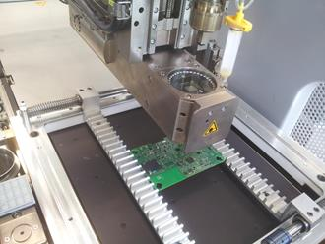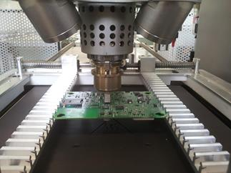
Figure 2. Automatic PCB component disassembly station installed at ITIA-CNR.

3.2 Intelligent size-reduction processes
Size-reduction processes are core processes in the mechanical pre-treatment chain; in fact they are functional to all subsequent mechanical separations but they are also key steps enabling the optimization of the downstream chemical processes for precious metals recovery. The main goal of size-reduction processes is to produce a homogeneous mixture of highly liberated particles for improved recovery performance of the separation processes. For achieving these results in highly complex matrices such as PCBs it is of paramount importance to correctly set the characteristic parameters of size-reduction processes, including both the first gentle shredding stage (performed at very low rotor speed, i.e. 25 rpm) and the second stage shredding, also named pulverizing stage, releasing particles of size that is far below 1 mm by using a multi-inserts tool rotating at very high speed (between 900 and 3500 rpm). For example the chamber volume, V_{chamber}, the size of the grate holes d_{g} and the cutting rotor speed  are among the most important parameters to be set. To this purpose, advanced dynamic size-reduction process models have to be developed.
In the literature, size-reduction modelling for recycling has attracted limited attention in the past. The available contributions are mainly related to the size reduction processes implemented in the mining industry. However, comminution processes used in recycling substantially differ from those adopted in mining for the following reasons. Firstly, in recycling systems size reduction processes are continuous processes, with a grate of a specified size which regulates the output flow rate and size, while in mining they typically behave as batch processes with closed chamber. Secondly, the material mixtures found in recycling are more complex, as different joint and welded parts are found. These differences make traditional size reduction process models not suitable for recycling (or at least there is no contribution in the literature proving by experimental validation that they can be suitably applied to recycling technologies). The model developed in the project overcomes these limitations.
Promising approaches that attempt to model the evolution of the particle population distribution inside the size-reduction chamber are named Population Balance Models (PBM) (Bilgili and Capece, 2011). A particle type is considered to be characterized by three attributes, i.e. the particle liberation class (l=1,..,L), the particle size class (d=1,..,D), and the particle shape class (s=1,..,S). In total, V=L*D*S particle types are present. The transitions between classes are regulated by breakage and selection functions. Selection functions express the rate at which particles of a certain class (l,d,s), where undergo breakage. The breakage function gives the proportion of particles of a certain class (l,d,s) that generate particles of another class (l’,d’,s’), given that they are broken. When a particle reaches a size class that is below the comminution grate size d_{g}, it can leave the comminution chamber according to a probabilistic discharge function, D(l,d,s). In this case, it composes the output flow. Selection, breakage and discharge functions need to be estimated by experimental analysis. These parameters are collected in a transition matrix T. The core of the PBM stochastic dynamics of the proposed comminution process model for recycling is a discrete time Markovian model which is based on the assumptions of:
- Homogeneity: the transition matrix T does not depend on time.
- Multiplication: within a certain rpm range, after a number k of breakage intervals the output size distribution depends only on the number of breakage intervals and not on the rotational speed of the tools.
Under these assumptions, the stochastic evolution of the underlying discrete Markov chain is regulated by m(t+Δ)=Tm(t), where m is the vector of the masses of the particles in each of the V classes and Δ is a small time interval equal to the minimum interval between two consecutive breakages. The initial mass distribution m(0) is an input parameter of the model and can be characterized by analytic sieve or laser/vision based particle characterization techniques.
The applicability of this model has been tested by an experimental campaign carried out at the De-manufacturing Lab at ITIA-CNR. The shredded product is the wire wound SMD power inductor, commonly used in high value printed circuit boards, typically found in WEEE streams recycling. It is made of a coil of conducting material, i.e. copper, wrapped around a core of ferromagnetic material. The composition of the SMD power inductor includes copper (23%), Fe203/NiO/ZnO (62%), CuSn6 (3%), phenolic resin (9.5%) and minor elements (2.5%).
The size-reduction machine is a Retsch SM300 with variable rotating speed. The available grate sizes are 1, 1.5, 2 and 4mm. 24 components has been shredded for t=30s at three speed levels, i.e. 1000, 1900, and 2800rpm. After each experiment, the material inside the chamber and in the output bin has been clustered in 5 size classes by an analytic sieve (liberation and shape classes are not considered). Then, the transition matrix T has been obtained by statistical methods. For =1900 rpm the matrix T is reported in Table 1. Matrices are upper triangular since transitions are only possible to smaller size classes.
Table 1. Transition matrix T for the comminution model at rotational speed =1900rpm.
mm | >1.4 | [1-1.4] | [0.71-1] | [0.4-0.7] | <0.4
>1.4 | -0.172 | 0.086 | 0.052 | 0.034 | 0
[1-1.4] | 0 | -0.139 | 0.120 | 0.019 | 0
[0.71-1] | 0 | 0 | -0.125 | 0.075 | 0.050
[0.4-0.7] | 0 | 0 | 0 | -0.087 | 0.087
<0.4 | 0 | 0 | 0 | 0 | 0

A second set of experiments has been carried out for estimating the discharge function. The entire output from the first experiment, in size classes 1,2, and 3 (Figure 3), has been re-shredded at =1900rpm and d_{g}=1mm and the output samples are collected at times t=20, 40 seconds. After each experiment, all the samples as well as the material inside the chamber have been classified in the 5 size classes by sieve. The discharge function has been statistically estimated. The obtained values of D for the different classes are D=[0,0,0.02,0.08,0.41]. The matrix T and the function D are used to run the markovian model to predict the output at time t=60s. The result is then compared with a new experiment where material is collected at t=60s. Results are reported in Figure 4, for the mixture distribution inside and outside the chamber. The model well fits the output density function of particle classes (SSR=0.014), except for small classes, where several particles below the grate size remain stacked inside the chamber, probably for electrostatic effects that are not modeled in the PBM. The model predicts that at t=60s, 71% of the input mass leaves the chamber, a value that is very close to the experimental value (69%).
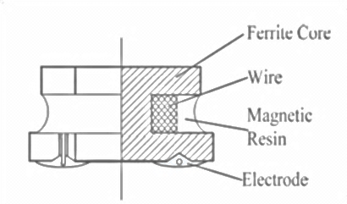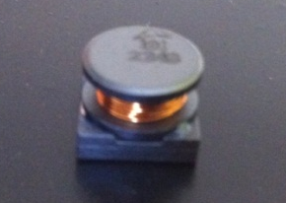
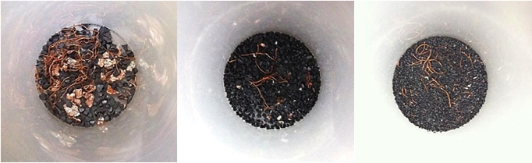
Figure 3. Samples of particles above 1.4 mm – class 1 (left), 1-1.4 mm – class 2 (centre), 0.7-1 mm – class 3 (right).
Figure 4. Particle size distribution by experimental results and the developed Markovian PBM.
3.3 Advanced mechanical separation processes
In the new concept of recycling process chain designed within the project, mechanical separation processes have the goal of processing the shredded mixture in order to separate the metal-rich fraction from the non-metal fraction. The objective is to provide to the downstream chemical recovery treatment a pre-concentrated key-metal rich mixture, thus enabling to reduce the number of stages required by the treatment and to improve the separation performance, under a systemic view. The most promising technology for separating metal and non-metal particles from fine particle mixtures is Corona Electrostatic Separation (CES). CES is a separation process that uses particle conductivity as physical property for the separation. The mixture is brought by a vibrating feeder to a high potential electrostatic field (35 kV) generated between a corona electrode and a grounded rotor. Both conductive and non-conductive particles are charged by the electrostatic field. However, conductive particles loose the charge during their trajectory within the field and are deflected by an additional plate. Two splitters are used to generate three output flows, namely conductive, non-conductive and middlings flows. The middling flow include particles that are either non liberated or not correctly classified. Therefore the middling flow needs reprocessing with different process parameters.
Since in the “Zero-Waste PCB” process chain, the separation process will treat both mixtures of shredded key-metal rich components and mixtures of shredded unpopulated PCBs, it is of paramount importance to properly select the parameters of the CES process according to the specific mixture under treatment. Indeed, the quality of the separation process is strongly dependent on the characteristic parameters of the process, including the electrostatic field intensity, the rotor speed, and the splitter positions. Therefore, separation process modeling and control become fundamental activities to enable the implementation of the innovative process chain.
Separation stage modeling has attracted interest from researchers, especially in the mineral technology area. Models for particle trajectories in corona electrostatic separation (Li et al., 2007) have been developed. However, these models always focus on single particle trajectories and fail to model two major causes for loss of efficiency in the separation process, i.e. (i) particle interactions and impacts, and (ii) the presence of unliberated particles in the material flow. Discrete granular material flow models could handle these issues. With the objective to support optimal parameter selection, an advanced multi-body granular-flow simulation model of the CES process was developed within the “Zero-waste PCB” project. A screen-shot of the developed simulation model together with the schematic view of the machine installed in the de-manufacturing plant at ITIA-CNR is reported in Figure 5. The validation of the developed model has been carried out by comparison with experimental results on a set of test samples. Details of the validation and the model are reported in (Colledani et al, 2014).
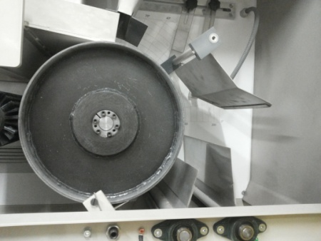 | 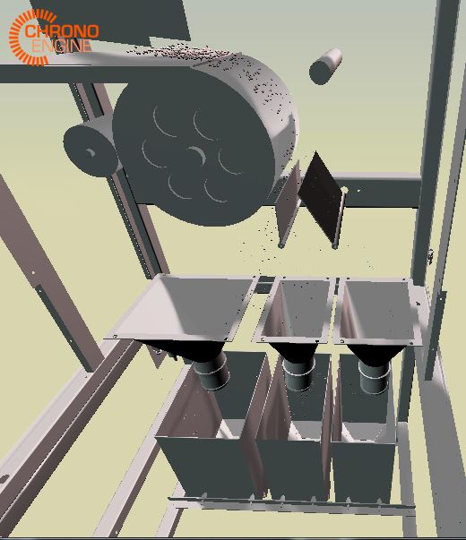
Figure 5. CES machine installed at ITIA-CNR (left) and developed simulation model (right).
The potentials of the proposed approach are highlighted through a preliminary set of experimental results. Two sets of sample PCBs have been considered, respectively coming from the automotive and the white good sectors. They have been provided by the industrial partners of the project. The concentration of valuable and key-metals in these samples is reported in Table 2, together with an estimate of the potential market value of the recovered materials. Other metals that are easier to recover, such as copper and aluminum, are not reported in this list, as they are not usually classified as key-metals.
Table 2. Fraction of key-metals in the analysed PCBs, obtained by shredding and ICP-MS.
Picture | Type of PCB | Element | Fraction [mg/Kg] | Market value - July 2013 [€/Kg] | Potential value [€/tons]
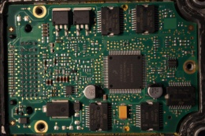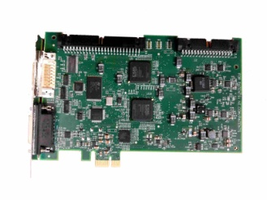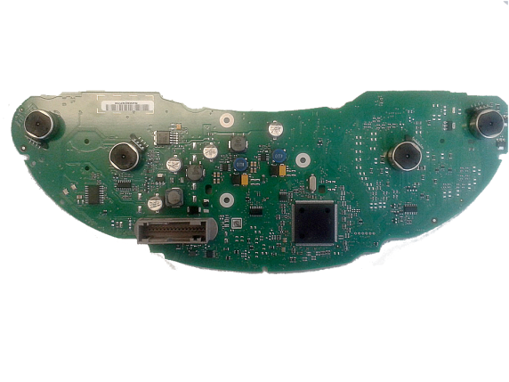 | Automotive PCB sample –  Weight = 300.9 mg | Au | 109.67 | 30630 | 3359
 | Automotive PCB sample –  Weight = 300.9 mg | Pd | 6.60 | 17010 | 113
 | Automotive PCB sample –  Weight = 300.9 mg | Rh | 1.26 | 24994 | 32
 | Automotive PCB sample –  Weight = 300.9 mg | Ce | 3.66 | 12.4 | 0.05
 | Automotive PCB sample –  Weight = 300.9 mg | La | 1.23 | 10.9 | 0.01
 | Automotive PCB sample –  Weight = 300.9 mg | Y | 9.07 | 43.7 | 0.39
 | Automotive PCB sample –  Weight = 300.9 mg | Dy | 3.12 | 456 | 1.42
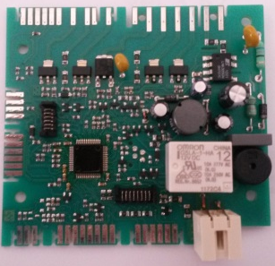 | White goods PCB sample –  Weight=296.1 mg | Au | 62.14 | 30630 | 1903
 | White goods PCB sample –  Weight=296.1 mg | Pd | 1.89 | 17010 | 33
 | White goods PCB sample –  Weight=296.1 mg | Ce | 2.16 | 12.4 | 0.03
 | White goods PCB sample –  Weight=296.1 mg | La | 1.11 | 10.9 | 0.01
 | White goods PCB sample –  Weight=296.1 mg | Nd | 0.95 | 78 | 0.07
 | White goods PCB sample –  Weight=296.1 mg | Y | 4.05 | 43.7 | 0.18

These sample PCBs have been processed by the first stage single shaft shredder with a grate size of 8 mm and then processed by the second fine shredding stage at two different grate sizes, i.e. 2 mm and 1 mm. Then, both samples have been separated by Corona Eletrostatic Separation with the following procedure. In a first pass, very conservative splitting parameters have been adopted. In a second pass, the middlings have been re-processed in the system, under less conservative splitting parameters. In both cases the developed CES multi-body model was not used to optimize the process parameters. Therefore, the adopted parameters are not optimized. This case would then represent a worst case scenario, that could be largely improved by future process optimization. The obtained non-conductive and middlings fractions are shown in Figure 6.
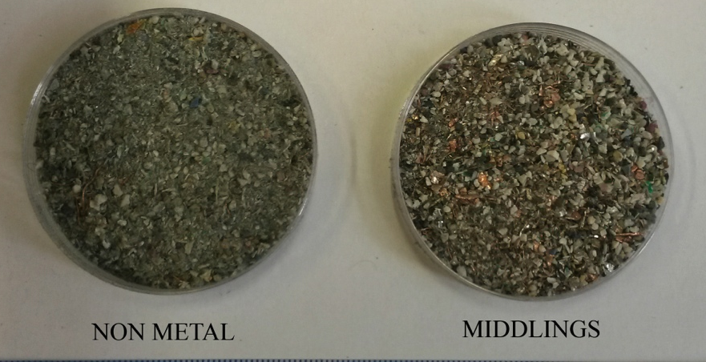
Figure 6. Mixtures obtained in output from the CES process.
Analyzing the fractions after the two passes of the material through the machine, as explained above, the following results have been obtained. For the first sample, shredded at 2 mm, a purity of 73% of the metallic fraction and of 89% of the non-metallic fraction was found. The recovery of metals in the metal-rich bin was 65% while the recovery of non-metals in the non-metal rich bin was 87.5%. However, around 30% of the strategic metals were found in the non-metal bin. As concerns the second sample, shredded at 1 mm grate size, the results are as follows. The grade of the metal-rich fraction increased to the 85.5% and the grade of the non-metal rich fraction dropped to the 84%. However, the recovery of the metals in the metal-rich bin increased to the 74% and the recovery of the non-metal fraction in the non-metal rich bin increased to the 94%. Unfortunately, a non-negligible fraction of very fine key-metals was found in the middlings, highlighting the need for future improvements of the process by knowledge-based optimization approaches.
All in all, these preliminary results represent a promising starting point for the future research. The objective of a very pure non-metal fraction for possible non-metals re-use seems to be easily achievable, since a purity of around 90% was already reached. Moreover, the objective of a high-grade metal-rich fraction also seems achievable, as the current starting point is 85%. However, a target of 99% should be achieved in order to substitute the thermal processes that are used to remove the organic fractions. Also from the point of view of the mass balance, the process seems to be sustainable. Only the 0.05% of the material is lost in the shredding residue when the grate size is 2mm; this fraction grows to the 1% when the grate size is set to 1 mm. The most challenging objective seems to be the achievement of a suitable key-metals recovery rate. Working with smaller particles increases the separation performance overall but decreases the recovery rate of key-metals. A selection of the splitting points that is less conservative seems to be a promising way to improve the performance of the overall separation process.
4. NON-METAL FRACTION RE-USE STRATEGIES
The Non-Metal fraction (NM) of PCBs is usually a mixture of woven glass fiber or cellulose paper, reinforced with various thermosetting resins (epoxy, unsaturated polyester, phenolic, etc.) (Gou et al. 2009). To prevent the risk of ignition during soldering with electric current, the matrix is often bromine containing. The physical and chemical characteristics of the NM fraction make it difficult to recycle. In order to avoid landfilling the NM fraction obtained from previous mechanical pre-treatment two possible re-use/recovery strategies have been identified and are currently under investigation within the “Zero Waste PCBs” project. The first strategy entails the control of the chemical decomposition of the organic fraction of PCBs in order to obtain intermediate products suitable for further polymerization reaction. The second strategy regards
the re-use of the PCB-NM powder, mixed with tire scrap and packaging scrap, to obtain a derived polymer to be adopted in constructions and buildings.
As regards the first strategy, the depolymerization reaction is usually not easily achieved, due to the chemical nature of the matrix used: thermosetting resins (crosslinked and thermo-mechanically stable). Most of the depolymerization reactions require relatively harsh reaction conditions, such as high temperatures in the presence of strong acids or bases, and these conditions tend to cause unnecessary side reactions that often produce a complex mixture. As a result, the formation of rebuilt plastic from the recovered monomeric material requires further purification procedures that are usually difficult and laborious. In “Zero Waste PCBs” the use of supercritical/subcritical solvents and microwave reactors to this purpose are under investigation. Preliminary results on the use of microwave reactors show that the microwave irradiation is very effective, not only for quick heating, but also for the acceleration of depolymerization and of solubilization of the polymer. More experiments are need to compare the processes and promote an industrial implementation of this kind of recovery technique.
Concerning the second strategy, the disposal of ground rubber tires represents a worldwide problem. Every year about 3.3 million tonnes of used tires are generated in Europe, of which 2.6 million tonnes are either recycled or recovered. Moreover, EPS is widely available as result of its use as loose fill packaging for fragile goods. Its lightness (30 kg per cubic meter, on average) makes its disposal highly difficult. The price of the raw EPS is about 1 - 1.20 €/Kg. Therefore, these materials seem to guarantee the suitable availability for the purpose of the new treatment. In detail, the NM fraction of the PCBs powders from the samples in Table 2 has been emulsified in recycled EPS in order to obtain new compounds. Moreover, in a different preparation, a mixture of grinded rubber tires has been added. Emulsification has been carried out in low boiling solvent at room temperature using a patented process. Good performances have been obtained on the basis of the effective incorporation of grinded PCB-NM and rubber tire powder into the EPS gel. In fact, emulsified EPS is able to combine a fluid state with the elasticity of the physical network. This gel is a kind of cage, in which the filler particles can accommodate in high amounts without loss of continuity. When the gel is condensed in dry state, the plastic cage shrinks around the particles, firmly entrapping them in a 3-dimensional network. In terms of mechanical properties of the compound, the first preparation only including the NM fraction of the PCB and EPS showed better Young modulus and stress at brake values (respectively 26 Mpa and 27 Mpa) with respect to the compound that also includes rubber for tires. The inclusion of rubber tires, however, improves the resilience of the compound. After these preliminary results and tests, a prototypal process, also including compound compression moulding will be set up and validated at pilot scale and the process will be controlled to target the preparation of the compound to the operational specifications of the material, depending on the specific application.

5. A NEW PCBs RECYCLING BUSINESS MODELS
5.1 The current PCBs recycling business
Literature reports several studies about the recycling chain and system in different countries. Even if the structure of the recycling system can vary in different nations, it is possible to propose a general scheme of the value chain currently diffused in industry by integrating different authors’ contributions. The first step is the collection of cores, which can derive from consumer or industrial sources. The national collection system is the system of companies responsible for the collection of WEEEs and for sorting it to companies that have the capabilities and technologies to treat them properly. It has a national coordination and monitoring role of WEEE flows and it is the intermediate actor between WEEEs producers (private and industrial consumers) and the Authorized Treatment Centers (ATFs), which are the organizations authorized to receive WEEEs from the collection centers in order to start the recycling process. Depending on the type of products, ATFs act buying cores from the collection centers or are paid by companies on a private basis to treat specific products. ATFs disassemble hazardous parts (PCBs, batteries and dangerous gases), generally recover re-usable components and shred the remaining parts (e.g. external WEEEs cases) to collect base metals (e.g. copper, aluminum, stainless steel, iron, etc.) and non-metals (e.g. glass, plastics, wood, concrete, etc.). Some ATFs performs a coarse shredding of PCBs.
Disassembled (or shredded) PCBs are the input for the Authorized Recovery Centers (ARCs). These centers buy materials directly from ATFs (common in the EU) or by specialized PCBs traders (common in the US). ARCs can also treat WEEEs without the need of previous disassembly procedures. The main role of an ARC is the recovery of pure metals embedded in the input material. The most diffused process they implement is pyrolysis followed by chemical recovery. While ATFs are focused on disassembly and mechanical processes, ARCs deal with thermal and chemical processes, making the two type of actors very different in terms of technologies and competence. Figure 7 schematizes the currently diffused recycling chain and its main actors.

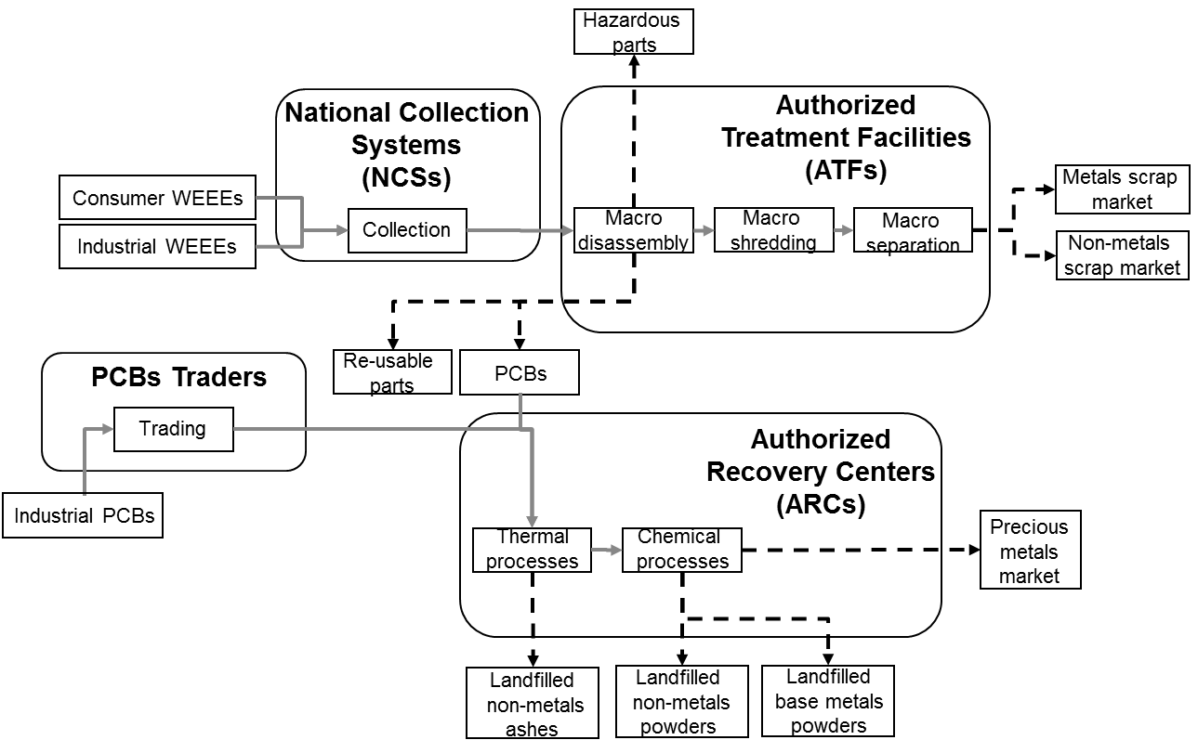

Figure 7. Current PCBs recycling value chain and players

5.2.
Hypothesis of new PCBs recycling business models
The innovation of the process chain through the introduction of advanced mechanical pre-treatments, as well as the hypothesis for new market applications of recovered materials, requires recycling organizations to innovate their business model by introducing new activities that are not currently performed. Different business model can be hypothesised depending on the allocation of responsibility for the new operations (selective disassembly, micro-shredding and separation) in the value chain. Three new business models were preliminarly proposed in the project, named “Independent Demanufacturing Centre”, Multi-Treatment Faciclity and “Integrated Recovery Centre” (Figure 8).

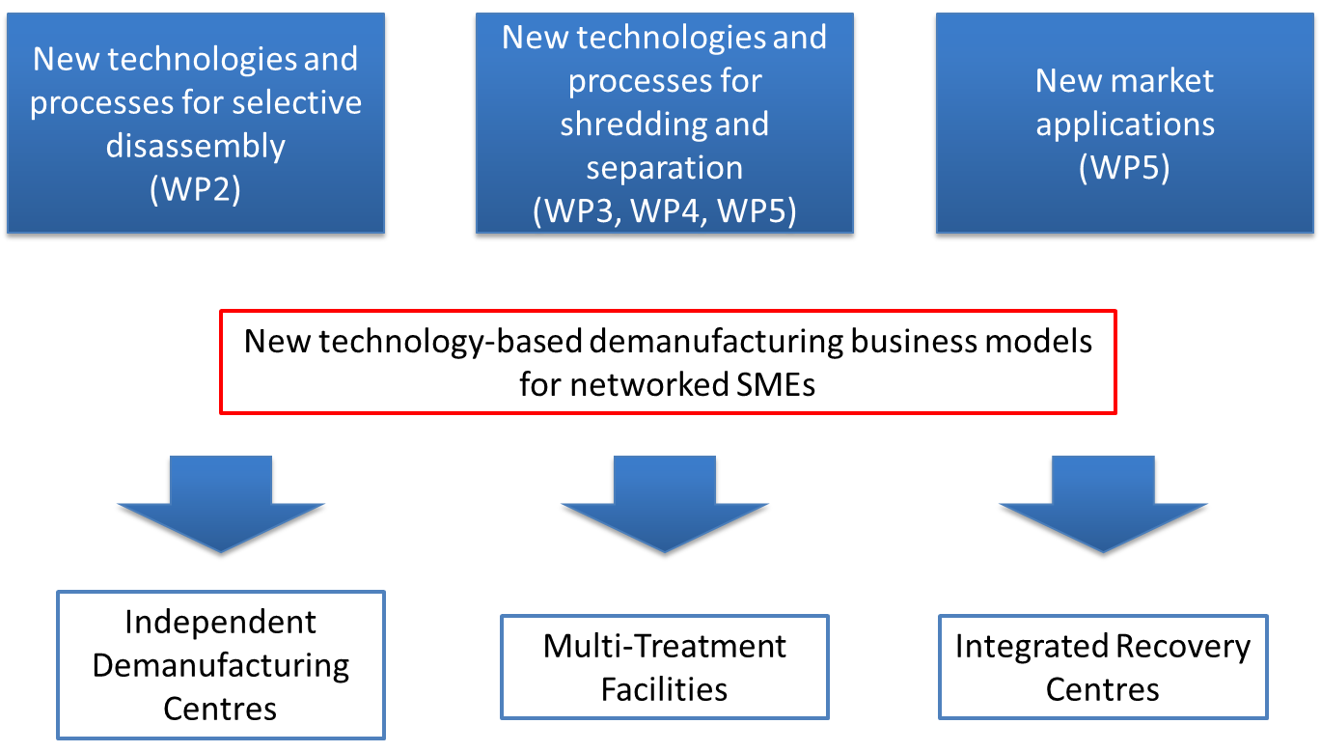

Figure 8 – Hypotheses of new PCBs recycling business models

The “Independent Demanufacturing Center” business model foresees the establishment of a new business actor in the value chain, who is specialized in smart mechamical pre-treatments. His activities will deal with selective disassembly, micro-shredding and separation. By processing high volumes of products, he will develop specific competences on smart mechanical pre-treatments and continuously improve technology that will allow him to provide additional value in the supply chain. He will be able to improve the output quality materials of the ATFs and will realize an input material for ARCs that will increase their process performance, since it will be more pre-concetrated. Thanks to the added value, he will buy materials from ATFs and sell pre-concentrated powders to ARCs at a higher price compared to the one the latter currently pay to ATFs. The advantage of such a business model would be the possibility to fast introduce the new processes in the value chain through new entrepreneurship, thus avoiding change management processes of companies operating in the field since a long time. Additionally, another advantage would be the possibility to continue developing high-level capabilities and competences in the new advanced mechanical pre-treatments, thus achieving continuous improvement, due to the high specialization of business activity.
The “Multi Treatment Faciclity” model implies that ATFs introduce new mechanical pre-treatments at the end of their process line, being able in this way to deliver a material of higher quality to ARCs compared to the one they currently prodiuce through coarse shredding. This will allow them to increase the price of materials they sell, thus to obtain a financial benefit and a market benefit too, since the higher quality can allow market increase. Since ATFs generally perfom coarse shredding process, they already have mechanical competences that would enable the introduction and management of the new smart mechanical pre-treatments withour significant cultural barriers. Thus, it can be imagined that ATFs will be motivated in this type of business model innovation and that process chain innovation will not require particular effort and time.
Finally, the “Integrated Recovery Centre” business model foresess that ARCs will acquire the technologies and competences for mechanical pre-treatments. In this way, they will introduce a new process preliminary to the ones they currently manage with the scope to improve tha quality of the material entering the chemical recovery process. However, due to their traditional business, ARCs generally have good chemical competence and are quite distant from the mechanical issues of pre-treatments. Thus, from a cultural point of view, the acquisition of the new processes might be not immediate. In addition, there might also be the possibility of a conservative approach due to the need of saturation of the existing infrastructures (such as furnaces), whose utilization migh decrease if mechanical pre-treatments are introduced in the chain. Thus, this option appears the less promising among the three.
The pros and cons of the three hypotheses of business models are currently under investigations in the project, together with the barriers to their implementations. For all business model, a critical activity is the quantification of the potential economic impact of the introduction of the new technologies. The decision on the business model, in fact, will depend significantly on the costs and benefits that each actor (the new “Independent Demanufacturing Center”, ATFs and ARCs) will experience. Under this light, due to the current fragmentation of available literature benchmarks (Wang et al. 2014, Wang and Gaustad 2013, Xueping et al. 2007), a systematic activity of process and cost modelling is ongoing in the project, recurring to structured investmed decision models and techniques (Life Cycle Costing, sensitivity analysis and scenario analysis). Data on new processes and technologies are being estimated with the support of experiments carried out in the ITIA-CNR pilot plant.

5. CONCLUSIONS
This paper has presented the hypotheses and the characteristics of a new technology-oriented business approach towards the recycling of Printed Circuit Boards, as high value electronic waste. The preliminary results show potential benefits of the new solution in terms of substitution of currently adopted energy demanding processes as well as in terms of ability to recover currently unrecovered materials. Moreover, the suggested new business models ground on the key idea of implementing these technological solutions at SME level, thus increasing the competitiveness of the Italian and European recycling industry as a whole, composed for the 85% of SMEs. A first important step towards more affordable and local recycling strategies is represented by these new business models. Future research will be devoted to the further tuning of the methods, models and technologies proposed in the “Zero Waste PCBs” project and summarized in this paper. Moreover, more extensive testing of the methods on a wider set of PCBs coming from different industries and sectors will enable to validate the robustness and flexibility of the developed solution.

AKNOWLEDGEMENTS
This research was partially funded by MIUR-Ministry for Education, University and Research of Italy through the project “Zero Waste PCBs - Integrated Technological Solutions for Zero Waste Recycling of Printed Circuit Boards (PCBs)” (FdF‐SP1‐T4.2). The authors acknowledge the Ministry for its support and Zero Waste PCBs project partners for their contribution during the development of various ideas and concepts here presented.
REFERENCES
Serpe A., Bigoli F., Cabras M. C., Deplano P., Fornasiero P., Graziani M., Mercuri M. L., Montini T., Pilia L., Trogu E. F. (2005). European patent n. EP1743044B1 (2005), property of 3R Metals ltd.
Bilgili, E., Capece, M., (2011), Quantitative Analysis of Multi-particle Interactions During Particle Breakage: A Discrete Non-linear Population Balance Framework, Powder Technology, 213/13: 162-173.
Buchert M., Manhart A., Bleher D., Pingel D. (2012). Recycling critical raw materials from waste electronic equipment, Oko-Institut e.V. report.
Cui J., and Zhang L. (2008). Metallurgical recovery of metals from electronic waste: A review. J Hazard. Mater., vol. 158, n. 2/3, 228‐256.
Guo J., Guo J., Xu Z., (2009). Recycling of non-metallic fractions from waste printed circuit boards: a review. Journal of Hazardous Materials 168: 567-590.
H. Kim, R. Harms, and G. Seliger, (2007) Automatic Control Sequence Generation for a Hybrid Disassembly System IEEE Transactions on Automation Science and Engineering, VOL. 4, NO. 2.
Hageluken, C. (2006). Recycling of electronic scrap at Umicore's integrated metals smelter and refinery. World of Metallurgy – ERZMETALL , Vol. 59, N° 3, pp. 152–161.
Hall W.J. and Williams, P.T. (2007). Processing waste printed circuit boards for material recovery. J Circuit world, vol. 33, n. 4, 43‐50.
Huang K. and Xu J.G.Z. (2009). Recycling of waste printed circuit boards: A review of current technologies and treatment status in China. J Hazard. Mater. vol 164, 399-408.
Kara S, Pornprasitpol P, Kaebernick H. (2006). Selective Disassembly Sequencing: A Methodology for the End-of-Life Products. Annals of the CIRP 55(1): 37–40.
Kara S., Pornprasitpol P., Kaebernick H. (2006). Selective Disassembly Sequencing: A Methodology for the End‐of‐Life Products. CIRP Annals vol. 55, n. 1, 37-40.
Kopacek B., Kopacek, P. (2002). A semi-automatised disassembly cell for printed circuit boards. Problems on Engineering Cybernatics and Robotics 53, 10-15.
Li, J., Hongzhou L., Shushu L., Z. Xu. (2007). Optimizing the operating parameters of corona electrostatic separation for recycling waste scrapped printed circuit boards by computer simulation of electric field. Journal of Hazardous Materials, 153, 269-275.
Li, J. and Xu Z. (2010). Environmentally friendly automatic line for recovering metal from waste printed circuit boards. Journal of Environmental Science Technology vol. 44, 1418‐1423.
Li, J., Xu Z., Zhou Y. (2007). Application of corona discharge and electrostatic force to separate metals and non-metals from crushed particles of waste printed circuit boards. Journal Electrostatics vol. 65, 233‐238.
Ongondo F.O., Williams I.D. and Cherrett T.J. (2011). How are WEEE doing? A global review of management of electrical and electronic wastes. J Waste Manag. vol. 31, 714‐730.
Report of the European Project “HydroWEEE” (2011). Proceedings of the Green Electronics 2011 conference.
Wang, X., Gaustad, G. (2013). Prioritizing material recovery for end-of-life printed circuit boards. J. Waste Management, Vol. 32 pp. 1903-1913.
Wang, X., Gaustad, G., Babbitt, C. W., & Richa, K. (2014). Economies of scale for future lithium-ion battery recycling infrastructure. Resources, Conservation and Recycling, 83, 53-62.
Willems B, Duflou J (2007). Shredding Versus Disassembly. Proceedings of the International Conference on Competitive Manufacturing, 289–394.
Xueping, Q., Dong, L., Duan, X. (2007). The Recycle Model of Printed Circuit Board and Its Economy Evaluation. Proceedings of the 2007 IEEE conference, pp. 106-111.
Zhou, Y.; Wu, W. & Quj, K. (2010). Recovery of materials from waste printed circuit boards by vacuum pyrolysis and centrifugal separation, Waste management, Vol. 30, pp. 2299-2304.

