ALESSANDRO MAZZUCOTELLI:
AN ARTISTIC AND EDUCATIONAL PROJECT

MAGNAGHI-DELFINO Paola, (I), NORANDO Tullia, (I)

Abstract. Look away, see close. The title of the book of a famous art critic can represent the significance of this work. We proposed to students of the high school of Busto Arsizio (VA, I) a work that combined math and art. We chose a “minor” art and an artist, Alessandro Mazzucotelli, whose wrought iron’s works they could see in Busto Arsizio or in Milan. We kept some lessons in geometric transformations to the whole class at Politecnico di Milano. Then they analysed the Mazzucotelli’s works from the mathematical and artistic point of view and they produced some fine art prints.

Key words. Art Nouveau, Geometry, Plane Transformations, Education, Alessandro Mazzucotelli, Wrought Iron

Mathematics Subject Classification: AMS_97M80

He who loves practice without theory is like the sailor who boards ship
without a rudder and compass and never knows where he may cast.
Leonardo da Vinci

Introduction

The authors of the present paper are engaged in interdisciplinary research initiatives of the FDS Laboratory of the Politecnico di Milano (Formation, Didactics, Science Communication) and, in particular, they are interested to “contamination” projects between scientific thoughts and artistic insights. The mathematical knowledge is applied in drawings with the use of symmetry or the choice of lines and shapes. It is well known that Mathematics plays a very important role from a cultural point of view in the modern world and the students realize that Mathematics is also a powerful tool, rather than being a closed discipline. Mathematical concepts connect new ideas to other ideas learned previously or in other educational experiences, helping to learn concepts used in other disciplines. Within the study of such a context, arises our educational project as collaboration between the FDS Laboratory and the teachers of the secondary school “Daniele Crespi” - Busto Arsizio (Lombardy) and the artist and mathematician Adriana Contarini.
The project here presented was meant as an opportunity for the students of the next to last year of “Daniele Crespi”, focusing on Humanities or Languages, to investigate the relationship between geometric representation and artistic interpretation. It is the first project we proposed in the study of plane isometries. We proposed an original topic in relation to projects usually offered to high school students, both as regards the kind of application of symmetries both as regards the artist chose. We established to study the artworks of Alessandro Mazzucotelli (1865-1938), which produced many significant works in Lombardy and, in particular, in Milan and Busto Arsizio. Therefore, the students could find Mazzucotelli’s artworks in their town and we learned to see it from a different point of view and discover a new approach to the mathematical topics.

The students were introduced to the study of geometric transformations and, in particular, of plane symmetries, through lessons that we kept to the whole class at Politecnico di Milano.
Students involved in the project shared the general thrust of the work, and then they were divided into three groups. The first group dedicated to the search of bibliographic sources and documents and created a poster design in Art Nouveau Style, inspired to artworks of Mucha; the second group organized visits to the artworks in Busto Arsizio and in Milan and created a rose window’s design in Art Nouveau Style, inspired to the unique similar artwork of Mazzucotelli. The third group planned and performed a print artwork, inspired by the Mazzucotelli’s, at the atelier of Adriana Contarini. The drawing was based on floral style and realized using an etching press; the lines and shape was studied using geometrical transformations and colouring techniques made possible by the etching press. In this paper we remember the artistic background in which Alessandro Mazzucotelli worked the characteristics of technique and style of his works. Then we summarize the mathematical path followed by the students and finally we describe the main aspects of the laboratory activities, which took place in the studio of Adriana Contarini.

Index

- Art Nouveau: the name of the artistic style
  - Art Nouveau: total art style
  - Art Nouveau in Italy
- The art of wrought iron
- Alessandro Mazzucotelli: Italian artist of wrought iron
  - Mazzucotelli’s artistic life
  - Mazzucotelli’s drawings and subjects
  - Mazzucotelli in Milan
- Mathematical laboratory
  - Basics on Mathematical symmetry
  - Scaling in the Euclidean plane
  - Importance of symmetries and scaling in artworks
- The Artistic laboratory
  - Design in classroom
  - Print in art studio
Conclusions
Appendix A
References

1 Art Nouveau: the name of the artistic style

Art Nouveau (New Art) is an international philosophy and style of art, architecture and applied art, especially the decorative arts, that was most popular during the period 1890–1910.
At its beginning, neither Art Nouveau nor Jugendstil was the common name of the style but was known as this in some locations and the style had different names. Those two names came respectively from Siegfried Bing's gallery Maison de l'Art Nouveau in Paris and from the magazine Jugend in Munich, both of which promoted and popularized the style.
English uses the French name Art Nouveau ("New Art") or Modern Style o Studio Style, it was spread as Jugendstil in Deutschland, Nieuwe Kunst in Nederland, Secesja in Poland, Style sapin or Jugendstil in Switzerland, Secesija in Serbia and Croatia, Modern in Russia, Arte modernista or Modernismo Catalano in Spain and is called Stile Liberty (Liberty Style) in Italy from London’s Arthur Liberty & Co department store, which introduced the new art’s designs in.
In other cases, well-known artists and associated locations influenced the names. For example, Hector Guimard's Paris Métro entrances provided the term Style Métro; in the United States, it became known as the Tiffany style due to its association with Louis Comfort Tiffany. In Austria, artists of the Vienna Secession practised a localized form of Art Nouveau, and so it is known as the Sezessionstil (Secession style). As a stand-alone term, Secession is used frequently to describe the general characteristics of Art Nouveau style outside Vienna, but mostly in areas of Austria-Hungary at the beginning of the 20th century. In the United Kingdom, it is associated with the activities of Charles Rennie Mackintosh in Glasgow and is often known as the Glasgow style.

1.1 Art Nouveau: total art style

The Art Nouveau movement was a reaction to academic art of the 19th century; its origins are found in Arthur Mackmurdo’s book-cover for Wren's City Churches (1883), with its rhythmic floral patterns, and in Hermann Obrist’s Cyclamen (1894), also known as The Whiplash because of its writhing curves, described it as "sudden violent curves generated by the crack of a whip". [17]
Art Nouveau is considered a total art style, embracing architecture, graphic art, interior design, and most of the decorative arts including jewellery, furniture, textiles, household silver and other utensils and lighting, as well as the fine arts. According to the philosophy of the style, art should be a way of life. For many well-off Europeans, it was possible to live in an art nouveau-inspired house with art nouveau furniture, silverware, fabrics, ceramics including tableware, jewellery, cigarette cases. Artists desired to combine the fine arts and applied arts, even for utilitarian objects. [12]-[14]
Architects tried to harmonize with the natural environment. In architecture, ellipses, hyperbolas and parabolas in windows, arches, and doors were common and decorative mouldings 'grow' into plant-derived forms. Unlike the artisan-oriented Arts and Crafts Movement, Art Nouveau artists readily used new materials, machined surfaces, and abstraction in the service of pure design. Art Nouveau did not eschew the use of machines, as the Arts and Crafts Movement did. For sculpture, the principal materials employed were glass and wrought iron, resulting in sculptural qualities even in architecture. By the start of World War I, however, the stylized nature of Art Nouveau design, which was expensive to produce, began to be disused in favour of more streamlined, rectilinear modernism, which was cheaper and thought to be more faithful to the plainer industrial aesthetic that became Art Deco. Part of the evolution of Art Nouveau was several international fairs which presented buildings and products designed in the new style. The 1888 Barcelona Universal Exposition marked the beginning of the Modernism, the Exposition Universelle of 1900 in Paris presented an overview of the modern style in every medium. It achieved further recognition at the Esposizione Internazionale d’Arte Decorativa Moderna of 1902 in Torino where designers exhibited from almost every European country where Art Nouveau was practiced.[www.artliberty.it]
Art Nouveau tendencies were also absorbed into local styles. The style was the first major artistic stylistic movement in which mass-produced graphics (as opposed to traditional forms of printmaking) played a key role, often techniques of colour printing developed relatively recently. A key influence was the Paris-based Czech artist Alphonse Mucha, who produced a lithographed poster, which appeared on 1 January 1895 in the streets of Paris as an advertisement for the play Gismonda by Victorien Sardou, featuring Sarah Bernhardt.[6]-[17]
The development of high temperature (grand feu) porcelain with crystallised and matte glazes, with or without other decoration, was typical of these works. It was a period where lost techniques were rediscovered, such as the oxblood glaze, and entirely new methods were developed. In 1893, Vilmos Zsolnay introduced porcelain pieces made of eosin. Eosin, by Eos goddess of dawn, was a ruby red metallic glazing, invented by Vinsce Wartha, which became a manufacturing characteristic of Zsolnay’s factory.[wiki/Zsolnay]

1.2 Art Nouveau in Italy

The Art Nouveau European Route provides details of the heritage in Europe and worldwide of the Art Nouveau style featuring considerable information about Italy's Stile Liberty. This represented the modern designs from the Liberty & Co store of London, indicating both Art Nouveau's commercial aspect and the 'imported' character that it retained in some parts of Italy, though not in Palermo, isolated from developments in the north and evolving an independent character due largely to designers such as architect Ernesto Basile and Vittorio Ducrot, who specialized as a cabinetmaker. Important Italian Liberty cities or sites are Salsomaggiore Terme and San Pellegrino Terme as well as Cernobbio on Lake Como. Some large cities have a considerable number of Liberty-style decorations and buildings, especially Torino, Milano, Napoli, Firenze, Genova and large sections of the seaside town of Viareggio.[13]

2 The art of wrought iron

“Dum vulnerat format” While injures form – from Mazzucotelli’s house gate

Ironwork is any weapon, artwork, utensil or architectural feature made of iron especially used for decoration. There are two main types of ironwork: wrought iron and cast iron.

Wrought ironwork is forged by a blacksmith using an anvil. Its use was primarily utilitarian for weapons and tools before the middle Ages, but due to rusting, very little remains of early ironworks. From the beginning of the 19th century, wrought iron was being replaced by cast iron. The basic distinction between the two terms, wrought iron and cast iron, is simple: wrought iron is iron that has been heated and then worked with tools to produce its shape and form; cast iron is iron that has been melted and poured into a mold to give a desired look. The production’s process makes wrought iron easier to handwork into shapes. Wrought iron is tough, malleable, ductile, corrosion-resistant and easily welded. Although cast iron is less pure than true wrought iron, because the metal is poured into precision-made molds, resulting cast iron designs are more detailed and accurate. Cast iron replaced wrought iron is due to the lower cost and the suitability for mass production. The demand for wrought iron reached its peak in the 1860s with the adaptation of ironclad warships and railways, but then declined as mild steel quality problems such as brittleness were solved and it became inexpensive and widely available. The fashion of Liberty made re-evaluate the ancient art of wrought iron thanks to technical advances as steam engines and welding oxygen tanks. New technologies allowed artisans and blacksmiths to develop all their mastery: gates, railings and balconies, divided into spaces and rich in plant and animal nature inspired soft lines. This encouraged a high collaboration between artists from various fields, from the architect to the interior decorator, to factories of cabinetmaking, chandeliers and home decor.[wiki/wrought iron]

3 Alessandro Mazzucotelli: Italian artist of wrought iron

“For the material from which a piece of art is formed is not a set feature, established for all time. From its inception, it can become transformed and renewed, as artistic creation is like a chemical process: it elaborates matter while continuing to achieve metamorphosis”. (H. Focillon)
Alessandro Mazzucotelli, with Alberto Calligaris (Udine 1880-1960), was placed at the top of the wrought iron art in Europe. Other important iron artists of the Liberty period were Sante Mingazzi (Ravenna 1867-Bologna 1922), Carlo Rizzarda (Feltre 1883-1931) pupil of Mazzucotelli, Umberto
Bellotto (Venezia 1882 – 1940) and the Matteucci’s family (Faenza 1850- 1940).

3.1 Mazzucotelli’s artistic life

Alessandro Mazzucotelli was born in Lodi in 1865. As a youth, he dreamed of being a painter or a sculptor, but his parents could not afford to put him through school and he was forced to work for a living. At the age of 18, he joined the workshop of the Milanese blacksmith Defendente Oriani and learned all the tricks of the trade from him. In this time, Milan was the city that rises in the words of Boccioni, a capital of business and industry. In 1891, Mazzucotelli took over the workshop. Mazzucotelli's initiation took place thanks to his mingling with artists in the evening schools of the Società Patriottica and especially his relationship with the painter Giovanni Beltrami who, roused by modernist doctrines, abandoned easel painting and founded the largest Art Nouveau glassworks factory in Milan. Mazzucotelli drew the attention of critics as the only Italian master blacksmith to exhibit modern works at the 1900 World Fair in Paris. The first decade of the 20th century, which in Italy coincided with the rise, triumph, and decline of Art Nouveau, was for Mazzucotelli a period of explosive creativity, achievement, and success. At the 1902 Turin Fair - the first international exhibition dedicated exclusively to modern decorative arts, with the participation of Mackintosh, Tiffany, and Behrens – Mazzucotelli obtained the highest praise for his stand, which his friend Bugatti had decorated. After this event, the board of the newly established Società Umanitaria appointed Mazzucotelli as a director of one of its first two schools of applied arts, whose educational principle was to achieve practical utility through the simplicity of decorations; obtaining a style that defines our era through painstaking, perfect execution.
While he had been absorbed by very demanding client orders in Italy and abroad, a rapid shift took place over the course of a few years from a floral, soft, and naturalistic Art Nouveau style to more rigid forms, with a focus on geometry, influenced by the rigor of the secessionist movement. This gradual evolution is evident both in their final works and in preparatory sketches. These drawings are held in the Bertarelli Civic Collection of Prints at the Sforza Castle in Milan. Mazzucotelli collaborated with the most renowned architects in Lombardy, most notably Giuseppe Sommaruga, Alfredo Campanini and Luigi Conconi, producing the decorative wrought iron elements on their buildings. The close relationship between iron and architecture only becomes evident later, when Mazzucotelli gave his work an architectural dimension. This is the case with the emblematic street lamps in Milan’s Piazza Duomo, designed to create a close link with the urban landscape and the church belt tower.
For further information and more details about the Mazzucotelli’s artworks we suggest [7]-[8].

3.2 Mazzucotelli’s drawings and subjects

The Mazzucotelli's drawings are very different in style of the others contemporary artists. His charcoal lines are thick and well-marked his depictions dynamic with the immediacy of a sketch. His drawings are the first step in his working process. Based on the field observation of flowers, leaves, insects, and small animals, the blacksmith made a quick initial sketch; later, in the studio, he would use it to prepare a more accurate, analytical drawing. The next step was a life-size drawing on a pierced cardboard cut-out. In some cases, prior to forging the final work, Mazzucotelli made a clay or putty model of it. The dragonfly, a topic of international Art Nouveau, was a challenge: an icon of lightness and fragility wrought out of iron seemed to be a contradiction in terms. Mazzucotelli applied eyes to the dragonfly's body, fashioned wings out of iron leaf, and moulded the legs from a small square iron wire. Thanks to his exceptional manual dexterity, he was able to portray (in the words of Rossana Bossaglia, the first great scholar of Italian Art Nouveau) the life breath of the animal. The bolts necessary to keep the works together were highlighted to become decorative elements. The lamp displayed at the Sempione exhibition was imitated for years by blacksmiths all over Italy. The snake was a typical Art Nouveau decoration motif due to its natural sinuosity. Mazzucotelli adopted it as a subject for decorative sculpture and used it as iron decorations a support for his lamps. The first time he displayed one of his serpent sculptures was at the Sempione exhibition, but over the years, he would create numerous versions of it with one or more animals. In 1906, he built the gate for a villa at Crocetta del Montello. Iron wraps itself around stone as if it were a soft, full-bodied, limber ribbon unfolding in soft, eccentric curves. Mazzucotelli was responsible for all iron works at the Kursaal Casino in San Pellegrino Terme, including the two large wall-mounted lamps at the sides of the entrance. The preparatory sketches emphasize static issues and the balance of the composition. The palm leaf decorations, only hinted at in the drawing, are actually lavish and lush. This proved to be one of his last naturalistic depictions: although plants and animals would continue to be a part of his decorations, from then on Mazzucotelli would depict them in a highly stylized manner. For him the floral Art Nouveau era was over, as evidenced by the pennant that crowned the Kursaal. The style of other wrought iron artists of the Art Nouveau period is profoundly different from Mazzucotelli’s style. Alberto Calligaris was the ingenious forger of a personal and heroic style, perhaps closer to neo-Louis XVI, more cultured and aristocratic style, lightened with white colour. His style was called ironically "Garland style" for the massive use he made it. Sante Mingazzi distinguished himself in the production of fine glass and wrought iron canopies and, following the example of the Arts and Crafts Movement of William Morris, produced daily items (lace, furniture, jewellery, typography) of refined execution. Umberto Bellotto, together the architect Cesare Aurienti, in 1910 invented and patented a technique for "blend of iron and glass".

3.3 Mazzucotelli in Milan

“El fer l’ha da vess trattaa come una sciora”
The iron should be treated like a lady
The Liberty in Milan was the artistic experience that had its maximum splendour from the early 1900s until the outbreak of World War I; the experience ranged from Floral Liberty to the influences of Viennese Secession, influenced by Art Nouveau magazines as Ver Sacrum (1898-1903), to conclude in a convergence towards eclecticism. The new Milanese bourgeoisie wanted to purchase economic and social power and so the areas of the city most affected by this architectural change are the areas between Corso Venezia and Corso Monforte, and between Corso Magenta and Sempione Park, plus some sporadic works in the town and in outlying areas.
With skill and exceptional creativity, capable of conferring to iron that lithe appearance and "bloomed" which constituted the dominant character of Liberty, Mazzucotelli soon became a required contributor to renowned architects such as Giuseppe Sommaruga, Gaetano Moretti, Ernesto Pirovano, Franco Oliva and Ulisse Stacchini.
The students of our project visited some of the most important and best-preserved Mazzucotelli’s works in Milan. The map of sites can be found in Appendix A.[1]

- Villa Romeo, now Columbus Hospital, via Buonarroti 46.
The house was built in 1912-14. The villa is considered one of the masterpieces of Giuseppe Sommaruga: Mazzucotelli’s part in the series of splendid wrought ironworks is not documented but it is proven by certain pieces, which show the imprint of his style. All the zoomorphic motifs fit well into Mazzucotelli’s specific repertory.
- Castelli’s House, via Revere 15.
The house was built by Dino Castelli in 1907. In the balconies, we can see floral patterns in concrete alternate ones made of wrought iron by Alessandro Mazzucotelli.
- Laugieri’s House, corso Magenta 96.
Antonio Tagliaferri built this house in 1906 and it is complete with the ironwork by the firm of Mazzucotelli- Engglemann.
- Moneta’s House, via Ausonio 3.
The architect Giuseppe Borioli built the house in 1904. The intervention of Mazzucotelli regards the hallway with large gate decorated with motifs of butterflies and hazel branches and the frame of the window. Butterflies are made with the technique of modelling hot animal's body and performing a clipping of the wings, as in the lamp of dragonflies.
- Donzelli’s House, via Revere 7.
Ulisse Stacchini built the house in 1909. Donzelli’s House is a beautiful Art Nouveau building in Milan. A depressed arch, on which is placed a bust of Torquato Tasso, serves as a symbol for the entrance. Windows and bow windows are placed at the ends of the facade.
The wrought iron of Mazzucotelli follows the intentions of the architect according to a formula calm and discarding the floral repertoire.
- Ferrario’s House, via Spadari 3/5.
Ernesto Pirovano built the house in 1904. It is one of the many art nouveau houses in Milan; the outside is beautiful, featuring balconies with wrought-iron railings, exquisite craftwork.
The original design included the realization of simple railings, but later opted for the realization of continuous balconies on three floors of the house. They are governed by brackets set of griffins, which are connected vertically by means of auctions and strong attacks that constitute the joint between iron and cement. Mazzucotelli created three floors of continuous balconies, supported by figurate consoles and connected vertically by means of shafts and robust attachments formed by junctures between the iron and the cement, the whole decorated with plants and sprays of leaves, snails and butterflies. The balconies are also covered with rich clumps of flowers and leaves, snails and butterflies, all in the repertoire of Mazzucotelli frequent motifs in his creative seasons, with a meaning rigorous and concise.
- Cusini’s industrial building, via dell’Orso 11.
This building was built by Cesare e Luigi Mazzocchi 1908/10.
The elegant facade liberty road characterizes the house. The three-storey building above ground was uneven and plant on his forehead three main different series of openings, separated between a plan and the other by floral motifs. The lining material is on the ground floor from rustic, machined plates on the upper floors to whitewash such as wood, interrupted by three bands that run along the facade at the height of the covers on the top floor. Remarkable are the wrought iron railings and underground of the balconies on the second floor. The wrought iron was made by Mazzucotelli.

- Teatro Filodrammatici, piazza Ferrari.
The theatre was rebuilt between 1904 and 1906. The attribution of the marquee to Mazzucotelli is traditional and fully confirmed by the style.
- Bar Camparino, galleria Vittorio Emanuele.
The Bar Camparino was opened in 1915. We can see the elegant perforated wall lamps made by Alessandro Mazzucotelli, models of which remain in the master’s archives. The style of these pieces is in line with Mazzucotelli’s other work of the period.
- Guazzoni’s House, via Malpighi 12.
The architect Giovanni Battista Bossi (1864-1924) designed it in 1904-1906 on behalf of CAV. Giacomo Guazzoni. The driveway has a fine wrought iron gate and frescoes with putti and flowers found in restoration of 1997, probably of the water-colourist Paul Sala. The wrought iron is probably of Alessandro Mazzucotelli.
- Palazzo Castiglioni, corso Venezia 47/49.
The building was inaugurated in 1903 and it is the masterpiece of the architect Giuseppe Sommaruga, with wrought iron of Alessandro Mazzucotelli. Famous for its rich facade of cherubs above the windows and plant decoration of the portal, the Palace also features a mock stone basement which still gives a darker tone and dramatic to the façade. The back gate, the grand staircase, chandeliers and large bees that decorate the upper end of the building, are all works of Lodi. Not surprising choice to decorate a building with insect iron, the Liberty style is inspired by nature, by representing not descriptively, but evocative, through soft, thin lines.
- Campanini’s house, via Vincenzo Bellini 11.
The house was built in 1903. Immediate impacts are the caryatids at the entrance to concrete, made by the sculptor Michele Vedani: although they represent a clear homage to the caryatids originally placed at the entrance to Palazzo Castiglioni of Sommaruga but there are less austere and monumental. The entrance gate in wrought iron, designed by Campanini and realized by Mazzucotelli, portrays the typical floral motifs of Art Nouveau sculpture; these textures can be found also in wrought iron inside the building and the elevator cage. The building altogether, than the more monumental Palazzo Castiglioni, assume forms less majestic but more attentive to daily life Noteworthy is the ceiling of the portico of the courtyard, where the floral theme of liberty is interpreted through art by Cherry Red bouquets, and the chandelier in wrought iron.
- Street lamps, piazza del Duomo.
The street lamps were built between 1927 and 1928, on the recommendation of the architect Gaetano Moretti, although the executive idea belongs entirely to Mazzucotelli, as shown by the original sketches dating back to 1927 still visible to the archive of Rota Imagna. The structure of the street lamps was carefully studied in order to maintain a large formal harmony in the square according to a principle of analogy physiognomy with marble spires of the Cathedral. Significant is the fact that Mazzucotelli previously collaborated with Moretti for the gates to the palace of the Museum of Lima, Peru.

4 Mathematical laboratory

The students followed lessons that we kept at Politecnico about the mathematical aspects of the topic, in particular the concept of mathematical symmetry and similarity in order to render mathematically the design’s bases of the Mazzucotelli’s works, they selected. In the following sections we summarized the arguments covered in the lectures.
4.1 Basics on Mathematical symmetry

The class of transformations that govern rigid-body motions and reflections in a mirror are called isometries. Mathematically the isometries are defined to be transformations that preserve distances between points. Because of preserving distance, the size and shape of the object are also preserved. [15, definition 11.1] There are four types of Euclidean plane isometries: translations, rotations, reflections, and glide reflections. It is useful to subdivide isometries into two categories: proper isometries, which transform geometric figures by rigid-body motions entirely within the plane and improper isometries, which can be only carried out by rigid-body movements that remove the figure from the plane. Translations and rotations are proper isometries while reflections and glide reflections are improper.
The translation is denoted by T_{v}, where v is a vector in R². A translation has the effect of shifting the plane in the direction of v; that is, for any point P in the plane represented by the vector p, the transformed point is represented by the vector
$$T_{v}\left(p\right)=p+v$$

or in terms of (x, y) coordinates
$$T_{v}\left(p\right)=\left[\begin{matrix}p_{x}+v_{x} \\ p_{y}+v_{y}\end{matrix}\right]$$
Every point moves the same amount and in the same direction. No points are left fixed

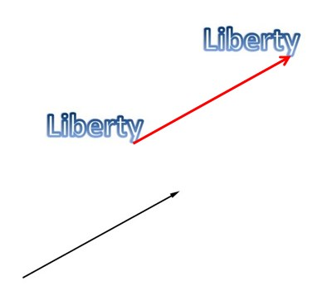 | 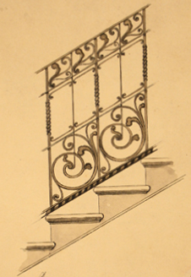
Fig.1 Mathematical sketch Civica Raccolta Bertarelli 2-12

In Art, geometric pattern or motif and its translations often appear in freezes.
We can find translations in many Mazzucotelli’s drawings, for example drawings of gates or railings.
The rotation is denoted by R_{c,θ}, where c is a point in the plane (the centre of rotation), and θ is the angle of rotation. In terms of coordinates, rotations are expressed by breaking them up into two operations. First, a rotation around the origin is given by an orthogonal matrix
$$R_{0,θ}\left(p\right)=\left[\begin{matrix}cosθ & -sinθ \\ sinθ & cosθ\end{matrix}\right]\left[\begin{matrix}p_{x} \\ p_{y}\end{matrix}\right]$$

followed by a translation:
$$R_{c,θ}\left(p\right)=R_{0,θ}\left(p\right)+v$$

A rotation around c can be accomplished by first translating c to the origin, then performing the rotation around the origin and finally translating the origin back to c. That is,
$$R_{c,θ}\left(p\right)=T_{c} {∙R}_{0,θ}\left(p\right)∙T_{-c}$$
or in other words
$$R_{c,θ}\left(p\right)=c+R_{0,θ}\left(p-c\right)$$

The set of translations and rotations together form the rigid motions or displacements. This set forms a group under composition, the group of rigid motions, and a subgroup of the full group of Euclidean isometries. All points rotate around the same fixed point with the same angle.
In Art, geometric patterns or motif are often transformed by a sequence of rotations, as in rose windows. We can find rotations in some Mazzucotelli’s drawings, mainly drawings of chandeliers or street lamps.
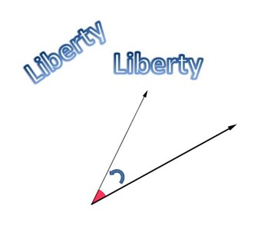 | 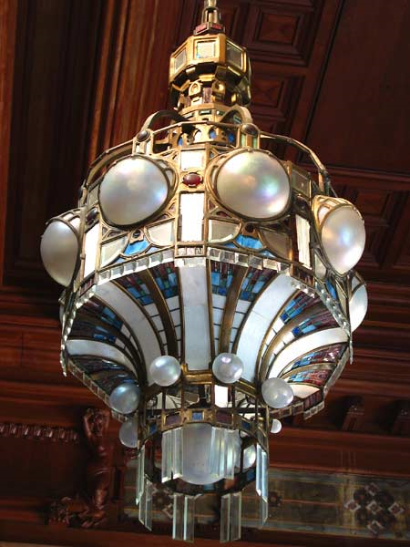
Fig. 2 Mathematical sketch San Pellegrino’s Kursaal chandelier
(photo of Piero Gritti www.pieroweb.com)
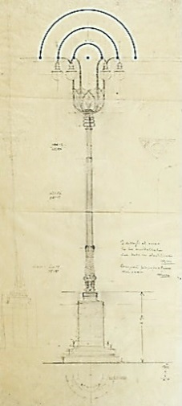 | 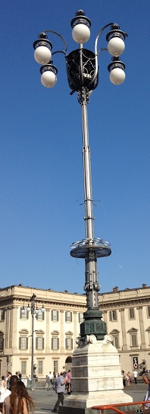
Fig. 3 Civica Raccolta Bertarelli 3-g15bisb Duomo of Milan Street Lamp

The reflection, or mirror isometry is denoted by F_{c, v}, where c is a point in the plane and v is a unit vector in R². A reflection has the effect of reflecting the point p in the line L that is perpendicular to v and that passes through c. The line L is called the reflection axis or the associated mirror. To find a formula for F_{c,v} , we first use the dot product to find the component t of p − c in the v direction,
$$t=\left(p-c\right)∙v=\left(p_{x}-c_{x}\right)v_{x}+\left(p_{y}-c_{y}\right)v_{y}$$
and then we obtain the reflection of p by subtraction,
$$F_{c,v}=p-2tv$$
The combination of rotations about the origin and reflections about a line through the origin is obtained with all orthogonal matrices forming orthogonal group O (2). In the case of a determinant of equal to −1, we have:
$$R_{0,θ}\left(p\right)=\left[\begin{matrix}cosθ & sinθ \\ sinθ & -cosθ\end{matrix}\right]\left[\begin{matrix}p_{x} \\ p_{y}\end{matrix}\right]$$
which is a reflection in the x-axis followed by a rotation by an angle θ, or equivalently, a reflection in a line making an angle of θ/2 with the x-axis. Reflection in a parallel line corresponds to adding a vector perpendicular to it. As Alice found through the looking glass, a single mirror causes left and right hands to switch. (In formal terms, topological orientation is reversed). Points on the mirror are left fixed. Each mirror has a unique effect. Many Mazzucotelli’s design projects are based on mirror symmetry, for example gates or doors.
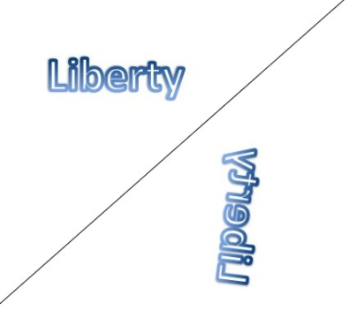 | 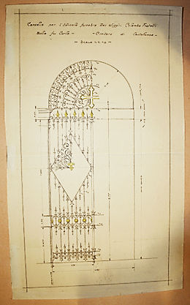
Fig. 4 Mathematical sketch Civica Raccolta Bertarelli 1-109

The glide reflection is denoted by G_{c, v, w,} where c is a point in the plane, v is a unit vector in R², and w is non-null a vector perpendicular to v. A glide reflection is a combination of a reflection in the line described by c and v, followed by a translation along w; that is
$$G_{c,v,w}=T_{w}∙F_{c,v}$$
or in other words,
$$G_{c,v,w}=w+F_{c,v} (p)$$
It is also true that
$$G_{c,v,w}(p)=F_{c,v}(p+w)$$
that is, we obtain the same result if we do the translation and the reflection in the opposite order.
Alternatively we multiply by an orthogonal matrix with determinant equal to −1 (corresponding to a reflection in a line through the origin), followed by a translation. This is a glide reflection except in the special case that the translation is perpendicular to the line of reflection, in which case the combination is itself just a reflection in a parallel line. The effect is a reflection combined with a translation parallel to the mirror. No points are left fixed. In Mazzucotelli’s artwork we can find an example of glide reflection in the freeze for a mirror.
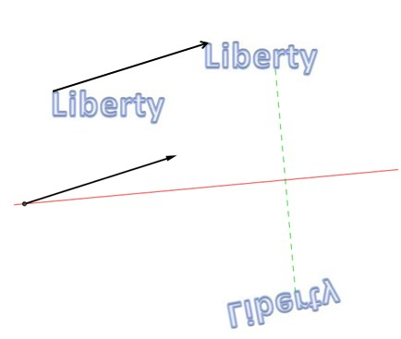 | 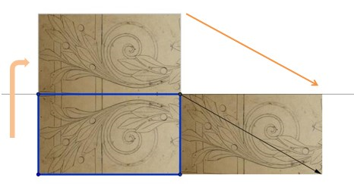
Fig. 5 Mathematical sketch Civica Raccolta Bertarelli 1-27
In all cases we multiply the position vector by an orthogonal matrix and add a vector; if the determinant is 1, we have a rotation, a translation, or the identity, and if it is equal to −1, we have a glide reflection or a reflection. Reflections, or mirror isometries, can be combined to produce any isometry. Thus isometries are an example of a reflection group. The set of Euclidean plane isometries forms a group under composition: the Euclidean group in two dimensions. It is generated by reflections in lines and every element of the Euclidean group is the composite of at most three distinct reflections. The identity isometry, defined by I (p) = p for all points p, is a special case of a translation and a special case of rotation. It is the only isometry, which belongs to more than one of the types described above. Two reflections in the same mirror restore each point to its original position. All points are left fixed. In all cases we multiply the position vector by an orthogonal matrix and add a vector; if the determinant is 1, we have a rotation, a translation, or the identity, and if it is equal to −1, we have a glide reflection or a reflection. Reflections, or mirror isometries, can be combined to produce any isometry. Thus, isometries are an example of a reflection group.
We can recognize which of these isometries preserves hands or swaps them and whether it has at least one fixed point or not, as shown in the following table (omitting the identity)
 | Preserve hands?
 |  | Yes | No
Fixed points? | Yes | Rotation | Reflection
Fixed points? | No | Translation | Glide Reflection
Isometries requiring an odd number of mirrors — reflection and glide reflection — always reverse left and right. The even isometries — identity, rotation, and translation — never do; they correspond to rigid motions, and form a normal subgroup of the full Euclidean group of isometries. Neither the full group nor the even subgroup is abelian; for example, reversing the order of composition of two parallel mirrors reverses the direction of the translation they produce.
4.2 Scaling in the Euclidean plane

In Euclidean geometry, uniform scaling is a linear transformation that enlarges (increases) or shrinks (diminishes) objects by a scale factor that is the same in all directions. The result of uniform scaling is similar (in the geometric sense) to the original. Uniform scaling happens, for example, when enlarging or reducing a photograph, or when creating a scale model of a building.
More general is scaling with a separate scale factor for each axis direction. Non-uniform scaling is obtained when at least one of the scaling factors is different from the others; a special case is directional scaling or stretching in one direction. Non-uniform scaling changes the shape of the object; e.g., a square may change into a rectangle or into a parallelogram if the sides of the square are not parallel to the scaling axes. A scaling in the plane can be represented by a scaling matrix. To scale an object by a vector v = (v_{x},v_{y}), each point p = (p_{x}, p_{y}) would need to be multiplied with this scaling matrix:
$$S_{v}=\left[\begin{matrix}v_{x} & 0 \\ 0 & v_{y}\end{matrix}\right]$$
The multiplication will give the expected result: $S_{v}p=\left[\begin{matrix}v_{x}p_{x} \\ v_{y}p_{y}\end{matrix}\right]$
Such a scaling changes the diameter of an object by a factor between the scale factors and changes the area by a factor between the smallest and the largest product of two scale factors.
 | 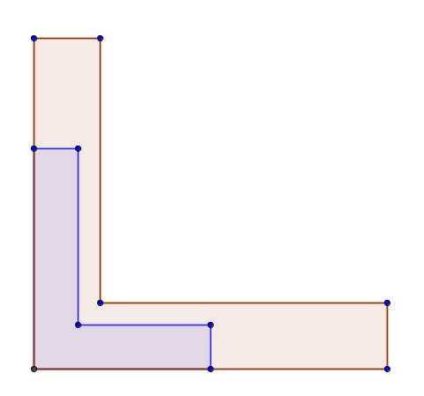
Uniform Scaling | Non-uniform scaling

4.3 Importance of symmetries and scaling in artworks

Symmetry creates balance, and balance in design creates harmony, order, and aesthetically pleasing results. Reflection symmetry that is also known as bilateral symmetry or “mirror” effect is the most common type of symmetry we see in nature. For instance, we see reflection in a butterfly, in the human body, with the central axis being vertical. Rotational symmetry in nature is found from the petals of a flower to the topside view of a jellyfish. In art and design, rotational symmetry can be used to portray motion or speed. Even on a static medium, rotational symmetry can convey action. Translational symmetry is when an object is relocated to another position while maintaining its general or exact orientation. Translational symmetry can be used to create patterns, such as in the case of repeating design elements. It can also be used strategically and more profoundly to create the feeling of motion and speed just like rotational symmetry. Sometimes artists use the translation and scaling at the same time. They move one object several times at even intervals. These intervals do not have to be equal in order to maintain translational symmetry; they just need to be proportional. Strategic use of symmetry is a powerful design tool. Designs that need more stability, a strong organizational structure, and a classic and trusting message, tend to use more symmetry in the design.

5 The Artistic laboratory

5.1 Design in classroom

At the end of their experience, the students that worked in Contarini’s atelier shared with their school friends the mathematical aspects of their work, so other students decided to drawing or painting some artwork in Art Nouveau style. Some of them created a poster design in Art Nouveau Style, inspired to artworks of Mucha, others design a rose window’s project informed to the unique Mazzucotelli’s artwork.

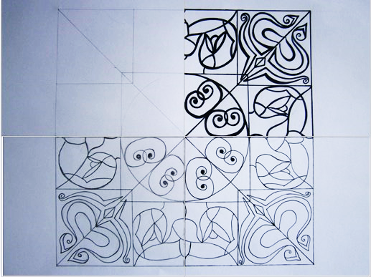 | 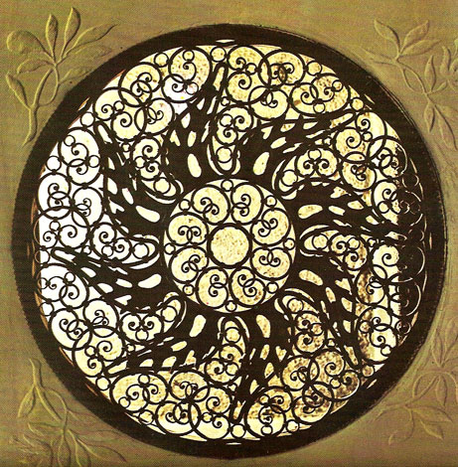
Fig. 6 Students’ rose window project Mazzucotelli’s rose window
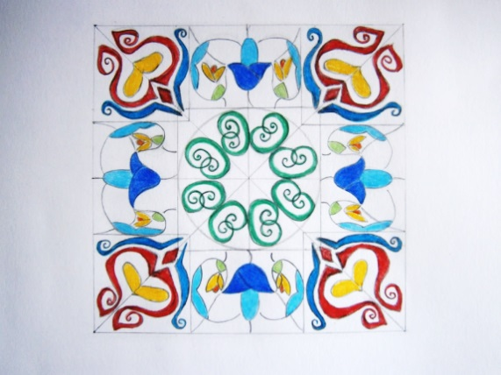 | 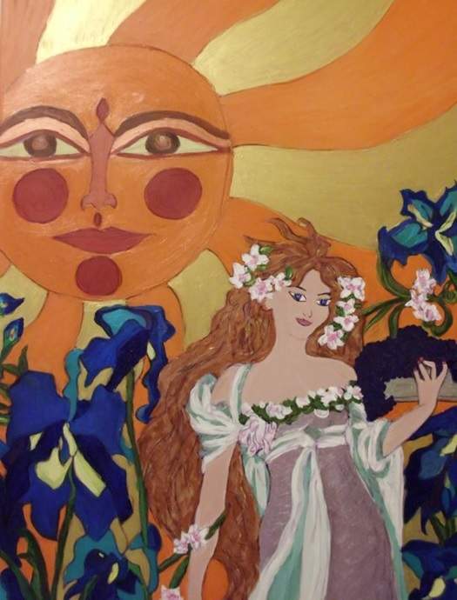
Fig. 7 Students’ rose window Students’ painting

5.2 Print in art studio

There is a kind of emotion that is of painting and nothing in literature can give the idea: an impression that results from a certain arrangement of colours, lights, shadows, etc., which might be called music. (Journal of Eugène Delacroix, 1855)
The students of the third group, with the support of Adriana Contarini, had a very interesting experience about symmetry: their aim was to recreate an artwork on paper in the style of the works of Mazzucotelli on iron. Adriana Contarini, artist and mathematician, has an atelier in Milan, in which she uses the printmaking’s techniques. The printmaking is the process of making artworks by printing, normally on paper, using an etching press (torchio calcografico). The process is capable of producing multiples of a same piece, which is called a print. Each print produced is not considered a "copy" but rather is considered an "original". This is because typically each print varies to an extent due to variables intrinsic to the printmaking process and also because the imagery of a print is typically not simply a reproduction of another work but rather is often a unique image designed from the start to be expressed in a particular printmaking technique. A print may be known as an impression. Printmaking was chosen for the unique qualities that each of the printmaking processes lends itself to. Prints are created by transferring ink from the matrix to the sheet of paper.

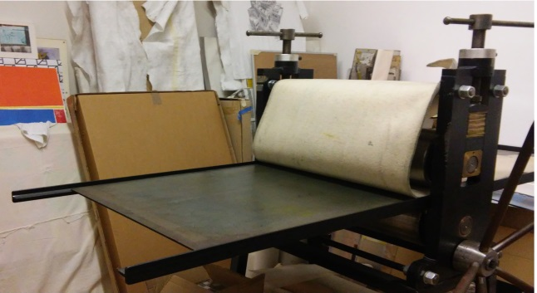
Fig. 8 The etching press into Contarini’s atelier
The first step of the students’ work was the choice of the pattern; the students chose a floral pattern with spirals similar to the Mazzucotelli’s design “the fence detail with curled lines and stylized leaves”.

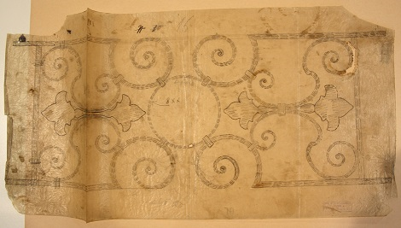 | 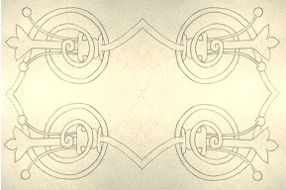
Fig. 9 Civica Raccolta Bertarelli 1-29 Students’ design project

The students’ choice was justified by the Mazzucotelli’s research of new formal solutions during the period 1902 – 1908. In this years, Mazzucotelli combined floral and zoomorphic elements with abstract structures. He drew large and small masterpieces, deepening the themes to represent the iron with a series of studies from life: sketches, projects, drawings and writings, many of which are preserved in the Civica Raccolta Bertarelli, Milan. The forms drawn from direct observation of nature, that characterize his work, became themes for railings, gates, balconies, lamps and other furnishings in the building, for example in villa Ottolini of Busto Arsizio (1903-1904) and the Kursaal in San Pellegrino Terme (1908).
In the second step, after the choice of the design project, the students created the matrix or better the module-matrix in plastic material.
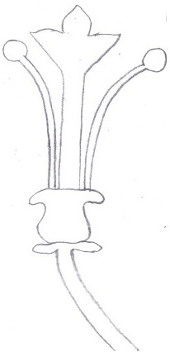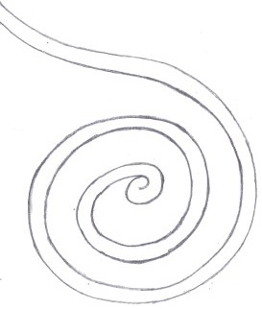 | 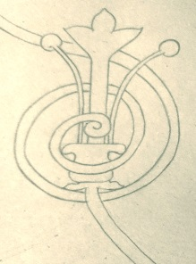
Fig. 10 Two parts of the module and the Module-Matrix
The students composed the module-matrix, using the two parts together but in different positions related the place occupied in the design project. The colouring was the most important moment and required greater attention to design project. When they colorized the module-matrix, they must always remember that the matrix and the work on paper are like a mirror, so was necessary prepare and colorize the side of the surface that in the mirror symmetry appeared.
They colourized the flower (yellow or blue) and the spiral (blue or red) separately using acrylic colours and then they interlaced the two parts.
Sketches for explications
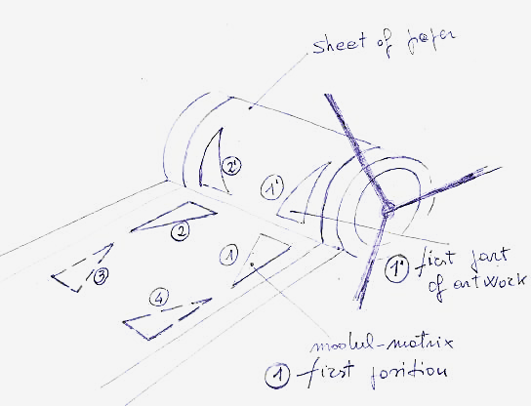 | 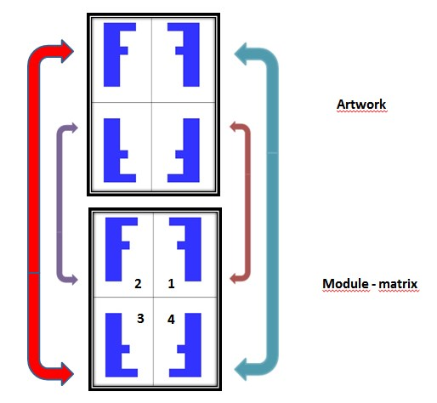
Fig. 11 Etching press simulation Mathematical sketch
We remark some aspects about colouring procedure. The students used little rollers in drawing the colours. The yellow, red, and blue are off-set colours: with this kind of colours it’s possible to have a very slim film of colour on each of the two module-matrix’s parts before using these together.
Moreover it’s important to work with wetted engraving paper to obtain a good result.

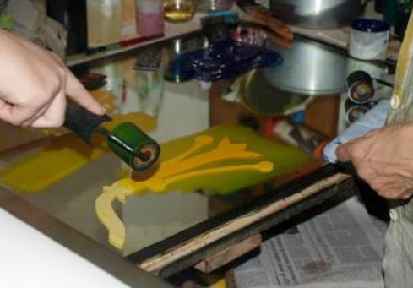 | 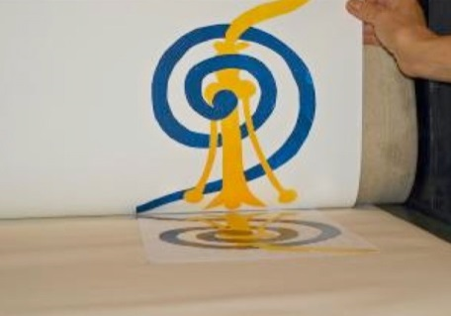
Fig. 12 Coloration of the flower Module-matrix and corresponding impression

To get the final artwork, the students used the module-matrix four times in four different positions but during the work the sheet of paper was stopped by the roll of the etching press.
Obviously the students could change the module-matrix in realizing other artworks and indeed they obtained two different final results.

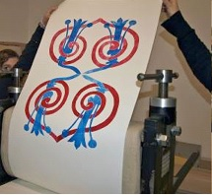 | 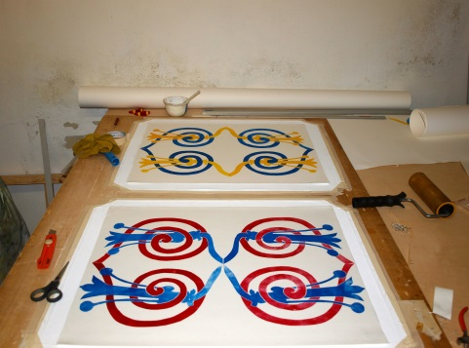 | 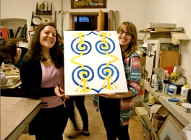
Fig 13
After some initial uncertainties, the students have performed the steps correctly acquiring the "rhythm" of the artwork and the end after a hard, logic and geometrical work, the students were very happy for their art-mathematic-Mazzucotelli masterpiece.

Conclusions

We proposed the Mazzucotelli’s project to a whole class of the “Liceo Daniele Crespi” of the town of Busto Arsizio. We chose this specific argument because the students could find Mazzucotelli’s artworks in their town and we learned to see it from a different point of view and discover a new approach to the mathematical topics. The implementation of our proposal required to the students and the two teachers of mathematics and art make an effort from many points of view. For the subscription of the students in the three groups we divided, we considered their aptitudes and preferences. The documental research, in particular that concern the Mazzucotelli’s activity in ISIA, and the organization of the visit in Milan required abilities not usually employed in our schools.
All students learned the artistic use of the mathematical transformation by observation of the Mazzucotelli’s artworks. The group that created artworks in Contarini’s atelier never used etching
press and worked for the love of it. Each group worked very well and at the end of the project they shared with all the students of their high school their experience in an exhibition in “Liceo Daniele Crespi”.

Appendix A

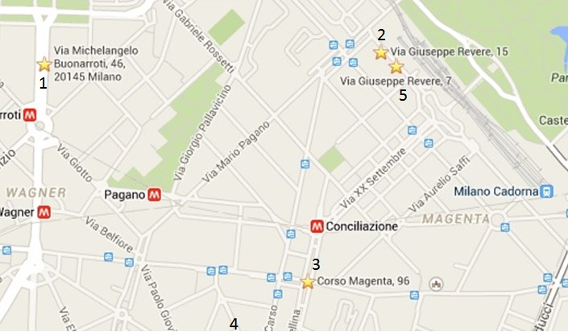 | 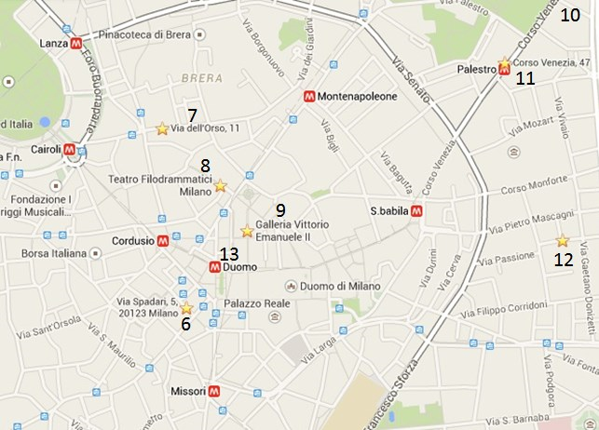

Acknowledgements
The authors thank
Adriana Contarini, mathematician and artist, who was able to teach High School students technical rigor and taste for beauty, always with the smile. Adriana collaborated to write the paragraph 5.2.
Civica Raccolta Bertarelli for permission to reproduce the images of Mazzucotelli’s works.
Piero Gritti for permission to reproduce his photo of Mazzucotelli’s chandelier.
prof. Giulio Magli, Politecnico di Milano, for encouragement.

References
[1] AA.VV. Venticinque secoli milanesi. Itinerario 8. A cura di Bossaglia, R. Ente Provinciale per il Turismo, Milano, 1972.
[2] AA.VV. L’ISIA a Monza. Una scuola d’arte europea. A cura di Bossaglia, R. Associazione Pro Monza, Monza, 1986. (Italian-English Edition)
[3] AA.VV. Simmetria: una scoperta matematica. A cura di Betti, R, Marchetti, E, Rossi Costa, L. Polipress, Milano, 2007.
[4] AA.VV. A Strange world: hybridisation in Art Nouveau and Symbolism. Ministry of the Brussels Capital Region, Brussels, 2014.
[5] ANDREINI,M, MANARA, R, PRESTIPINO, F, SAPORITI, I. Pensare e fare matematica. RCS Libri, Milano, 2012
[6] BADE, P, CHARLES, V. Alphonse Mucha. Parkstone Press Ltd., 2015 (ebook)
[7] BOSSAGLIA, R, HAMMACHER, A. Mazzucotelli: l’artista italiano del ferro battuto liberty. Il Polifilo, Milano, 1971. (Italian-English-German Edition)
[8] BOSSAGLIA, R, TERRAROLI, V. Il Liberty a Milano. Catalogo della mostra Spazio Oberdan, Skira, Milano, 2003.
[9] de GUTTRY, I. Eugenio Quarti and Alessandro Mazzucotelli, Two Protean Figures: Artists, Artisans, Industrialists, Teachers. ICIMSS, Poland, 2010.
http://uncommonculture.org/ojs/index.php/UC/article/view/5332/4063
[10] DELACROIX, E. Journal, nouvelle edition par Hannoosh M. Corti, Paris, 2009.
[11] DELACROIX, E. The Journal of Eugène Delacroix (translation by Norton, L.). Hubert Wellington edition, Edinburgh, 1980
[12] FAHR-BECKER, G. Art Nouveau. Konemann, Köln, 2007
[13] GIAMBRUNO, M, PISTIDDA, S. Milano: Liberty e città borghese (in collaboration with Silva, B, Vigotti, F, Gabaglio, R). Altralinea Edizioni, Firenze, 2015.
[14] HOWARD, J. Art Nouveau: International and National Styles in Europe (Critical Introduction to Art). Manchester University Press, New York, 1996.
[15] KAPPRAFF, J. Connections. The Geometric bridge between Art and Science. Series on Knots and Everything,vol. 25, Singapore, 1992.
[16] MARTIN, G. E. Transformations Geometry: An Introduction to Symmetry. Springer-Verlag, New York, 1982.
[17] MASINI, L.V. Il Liberty Art Nouveau. Giunti, Firenze, 1976.

Current address

Paola MAGNAGHI-DELFINO, Researcher
Dipartimento di Matematica, Politecnico di Milano, piazza Leonardo da Vinci 32, 20133 Milano (MI), Italy – tel. +390223994515 - paola.magnaghi@polimi.it

Tullia NORANDO, Assistant Professor
Dipartimento di Matematica, Politecnico di Milano, piazza Leonardo da Vinci 32, 20133 Milano (MI), Italy – tel. +390223994533 - tullia.norando@polimi.it

In the period 1850-1915 many school as the Patriotic Society of Milan were founded to promote the cultural development of the artisans.
The Società Umanitaria, an extraordinary charity institution, was established thanks to a bequest by the philanthropist Prospero Moisé Loria to the Municipality of Milan for putting the deprived, with no distinction, in a position to help themselves by providing them with jobs, assistance, and education.

