Digitalizing Circular Economy through Blockchains: The Blockchain Circular Economy Index

Davide Basile¹, Idiano D’Adamo^{2,*}, Valerio Goretti¹ and Paolo Rosa³

¹ Sapienza University of Rome, Italy
² Department of Computer, Control and Management Engineering, Sapienza University of
Rome, Via Ariosto 25, 00185, Rome, Italy
³ Department of Management, Economics and Industrial Engineering, Politecnico di Milano,
Piazza L. Da Vinci 32, 20133 Milano, Italy
basile.1810355@studenti.uniroma1.it; idiano.dadamo@uniroma1.it; goretti.1811110@studenti.uniroma1.it; paolo1.rosa@polimi.it
* Corresponding author

Abstract

The integration of circular economy (CE) models into everyday contexts generates huge amount of data involved in goods tracking and tokenization procedures. The sector of blockchain platforms is extremely varied, and the choice of the proper technology is not easy. It is important that the selection is conducted consistently with respect to the CE models. With this study, we present a performance indicator named Blockchain Circular Economy Index (BCEI). BCEI, obtained through Multicriteria Decision Analysis and Analytic Hierarchy Process, aims to measure the suitability of blockchain platforms to the needs highlighted by a CE scenario. The present study is contextualized by comparing six blockchain platforms, for each of which, the related BCEI is calculated. The results of the analysis show that transaction fee and energy consumption are the two most critical parameters.

Keywords: Blockchain, Circular Economy, Digitalization, Multicriteria Decision Analysis, Technological Sustainability

Graphical abstract

1. Introduction

In recent years, the shortage of raw materials has highlighted the need for the adoption of sustainable policies, aimed to reduce waste and maximize reuse. Circular Economy (CE) provides an economic model involving the generation of value from already used products, by reducing waste and consumption of raw materials ^{[1, 2]}. The European Commission adopted legislative proposals to increase recycling initiatives and move towards a zero-waste future.

Several CE realities have emerged, and numerous organizations are investing into more sustainable models ^{[3, 4]}. IT systems have proved to be essential in the transition process, supporting innovation and competitive advantage ^{[5]} and allowing the identification of alternative businesses ^{[6]}. CE involve the acquisition and management of large amounts of data. The integration of the proper technology becomes a crucial aspect of the design process. Big data, internet of things, artificial intelligence and data storage play an important role in this regard ^{[7][8][9]}. Among emerging technologies, Blockchain platforms highly fit the CE needs ^{[10, 11]} and generally find greater attention within the literature ^{[12, 13]}. However, the relationship between circular economy and blockchain needs further studies to evaluate best practices and maximize benefits ^{[14–16]}.

To this aim, the present work wants to propose a new reference index (called Blockchain Circular Economy Index - BCEI) supporting decision makers during the selection of a proper blockchain within a CE scenario. BCEI will allow the comparison of existing blockchain technologies basing on their compatibility with CE principles and, starting from it, the identification of the most suitable platform to adopt. Hence, the main objective of the paper is demonstrating the validity of BCEI trough its direct application on existing blockchain platforms. To this aim, six of the most famous blockchain platforms will be compared in terms of BCEI values and the obtained results will be discussed accordingly.

The paper is structured as follows. Section 2 presents a literature review on blockchains. Section 3 describes the adopted methodology. Section 4 presents the results of the analysis. Section 5 discusses about results. Section 6 concludes the paper with some remarkable elements and future trends.

2. Literature review
2.1 Circular economy and blockchains (pros and cons)
2.2 Existing indexes on blockchain in circular economy (and their limits)

Blockchains are Distributed Ledger Technologies (DLT) adopted to record and track transactions ^{[14]}. Then, transactions are stored into encrypted blocks and validated through a consensus mechanism. Blockchains are based on a decentralized shared database

providing transparency and immutability of transaction records. Originally implemented by the well-known cryptocurrency Bitcoin^{[17]}, they evolved to offer a trust-free platform for execution of arbitrary business logic through many alternative blockchain platforms (e.g. Ethereum^{[18]} and Hyperledger Fabric^{[19]}). Given the continuous evolution of blockchain technologies, they are becoming fundamental in several sectors^{[20]}.

Decentralization, encryption and distribution make blockchains highly robust and secure data structures for storing confidential information ^{[21]}. Blockchains are widely used in supply chain scenarios, improving the transparency and traceability of the production process ^{[22–25]}. To avoid counterfeiting and falsification during the production flow, blockchains enable the exchange of digital tokens associated to physical objects, allowing end users to analyse the history of products, from its origin to the purchase ^{[26][27]} ^{[28][29]}. The needs for tokenization and transparency are manifested also in CE scenarios. The collection, recycling and the reuse of materials should be tracked and quantified. Blockchains allows to store the processing materials undergo. Users and machines are allowed to access data anytime and observe the recycling process ^{[30]}. The world of blockchains is extremely varied and platforms differ from each other in numerous aspects. Blockchains can be public, private or hybrid ^{[31, 32]}, they can use different cryptocurrencies, consensus mechanisms or fees, and each of them determine different costs, consumption, and performances ^{[33]}. Analysing the scenario from a managerial perspective, the appropriate choice of the specific technology can be complicated in a sustainable context ^{[34]}.

3. Methods
3.1 Industrial background

Through the contribution of recycled materials to raw materials demand indicator, Eurostat measures the quantity of reinjected material into the European countries’ economy. According to Figure 1, the first European country is Netherland, with a circularity rate slightly below 30 %. Belgium, France and Italy follow with rates between 20% and 25%. Furthermore, a comparison among European countries proposes a circularity performance in which the situation of Europe is significantly different based on a Multicriteria decision analysis (MCDA) - ^{[35]}.

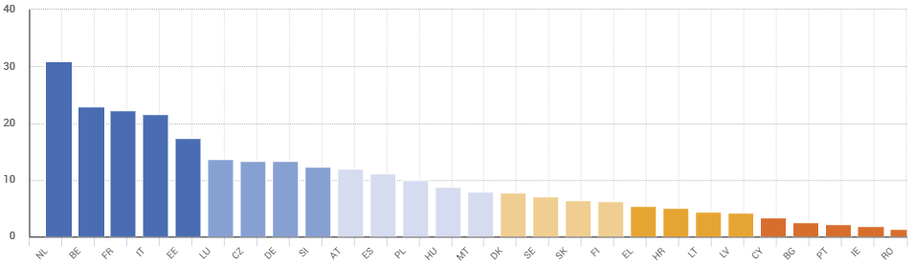
Figure 1. Circularity rate for European countries

3.2 Existing methods (and lacks)
3.3 AHP

In this section, we broaden our discussion on the research methodologies and the related data sources, in order to clarify the steps that characterize the conducted work. MCDA is introduced to define an indicator, called BCEI, which makes the blockchain platform comparison possible. The reliability of this methodology is profoundly influenced by the criteria selection, weights assignment, and value assessment processes. Thanks to this procedure the comparison criteria are chosen, and their relevance weights and values are assigned. In the following paragraphs we will go into detail about each of the referenced procedures. MCDA is an analytical methodology used to compare different conflictual alternatives and to perform choices ^{[36]}. The effectiveness of this benchmarking tool for decision making processes is showed by several studies, in which the usage scenarios are numerous and very different from each other ^{[37, 38]}. According to the work of Öztürk and Yildizbaşi ^{[39]}, MCDA is useful to identify the most relevant barriers to the integration of blockchains into supply chain management. Differently, some authors ideated a multicriteria based approach to support decision making for the design of blockchain applications ^{[40]}. Our research proposes a method to identify and analyse multiple criteria and compare different blockchain platforms, defining an adaptability indicator. The goal of the BCEI is to highlight the alternatives that are most likely to be used in a circular economy project. The process by which we have pursued the target is composed of several steps – Figure 2.

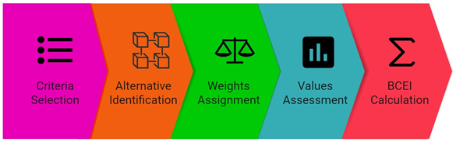
Figure 2. Main phases of the BCEI calculation

Initially, the set of criteria is selected. Next, all the blockchain alternatives are identified and a numerical weight is assigned to each criterion. Afterwards, attribute values corresponding to the blockchain alternatives are determined for all the criteria. Finally, the performance indicators are calculated for each alternative, according to the assigned weights and values. The final indicators are used to carry out a comparison of the blockchain platforms.

3.4 Criteria selection process
The success of MCDA crucially depends on the way in which the comparison criteria are selected ^{[41]}. It is important that they provide different points of view on the alternatives, with respect to the problem we are trying to solve. At this stage, our work aims to identify the main blockchain’s descriptive features, and to use them as distinctive elements, regarding the theme of the circular economy. A selection process which only considers the opinion of our research team, may provide a biased viewpoint. Blockchains are extremely composed technologies, and their classification criteria are multiple. According to this, our research proposes a literature-based approach thanks to which the initial set of criteria is identified. The research team has identified and reviewed five scientific works, which discuss the theme of blockchain taxonomy ^{[40, 42–45]}. This choice was motivated by recently published work with high scientific impact and published in leading journals. The five-way screening was done in order to identify papers that covered a significant number of criteria. A set of thirty-six classification criteria have been identified because of this process. Once the criteria have been defined, they have been filtered according to their occurrence in the five documents, as showed in Table 1. A criterion is selected if it appears in at least the 60% of the viewed works (three out of five). The criteria which passed the selection process are Security, Network Type, Access Control, Consensus Mechanism, Transaction Fee, Energy Consumption, Cryptocurrency, Smart Contract Language, and Transaction Throughput.

Table 1. Table for the criteria selection process
Criteria | ^{[40]} | ^{[42]} | ^{[43]} | ^{[44]} | ^{[45]} | Total occurrences
Network Type | x |  | x | x | x | 4
Transparency | x |  |  |  |  | 1
Centralization | x |  |  |  | x | 2
Auditability | x |  |  |  |  | 1
Transaction volume | x |  |  |  |  | 1
Privacy | x |  |  |  |  | 1
Security | x | x |  |  | x | 3
Scalability | x |  |  |  |  | 1
Transaction throughput | x | x |  | x |  | 3
Block Time | x | x |  |  |  | 2
Consensus mechanism | x | x | x | x | x | 5
Smart contract language | x | x | x | x | x | 5
Cryptocurrency | x | x | x |  | x | 4
Transaction fee | x | x |  |  | x | 3
Simplicity |  | x |  |  |  | 1
Size of the community |  | x |  |  |  | 1
Ease of use |  | x |  |  |  | 1
Ease of learning |  | x |  |  |  | 1
Level of support |  | x |  |  |  | 1
Authentication |  | x | x | x |  | 3
Aviability of training and learning material |  | x |  |  |  | 1
Energy consumption | x | x |  | x |  | 3
Reputation |  | x |  | x | x | 3
History |  | x |  |  |  | 1
Updatetes and release of version |  | x |  |  |  | 1
Advanced features |  | x |  |  |  | 1
Support for web apps and mobile development |  | x |  |  |  | 1
Purpose |  |  | x |  |  | 1
Layers |  |  |  | x |  | 1
Presence of smart contract |  |  |  | x |  | 1
Presence of virtual machine |  |  |  | x |  | 1
Innovation |  |  |  | x |  | 1
Blockchain platform maturity |  |  |  | x |  | 1
Gossiping |  |  |  |  | x | 1
Block Header Data Structure |  |  |  |  | x | 1
Block Storage |  |  |  |  | x | 1

3.5 Alternatives identification

MCDA provides a metric-based approach to analyse different alternatives and carry out a comparison. The main goals of our work are the design of a rigorous analysis methodology and the demonstration of its implementation by evaluating famous blockchain platforms, in a circular economy’s perspective. Different blockchains have been selected to produce a set of alternatives. At the end of the process, 6 blockchains have been selected. Bitcoin and Ethereum are popular public blockchain platforms, whose digital assets have reached considerable peaks. Corda and Hyperledger are private platforms widely used in industry. XDC Network is a hybrid blockchain, which combines the features of both private and public blockchains. Finally, Eos is a public blockchain platform that enables the development of app with high scalability.

3.6 Weights assignment through Analytic Hierarchy Analysis

MCDA methodology involves weighting processes thanks to which criteria relevance are defined. The proposed weight assignment process is based on the Analytic Hierarchy Process (AHP) method. It is an eigenvalue model, that derives a priority scale through experts’ evaluations ^{[46]}. Also this method is widely used to evaluate circularity performance ^{[47]}. The identification of the experts committee represents a key role for the success of the whole procedure. The selection process was guided by the need for contextual knowledge. According to this, ten academics from five different countries (Italy, Austria, Brazil, England and Germany) have been selected, with experienced specializations in the fields of blockchain technologies, circular economy and project management. A list of authors with these keywords was selected on Scopus, and only researchers with at least 10 years of experience were chosen. An invitation email was sent, specifying the purpose and mode of the study, indicating that only the first ten accessions would be chosen. The analysis was conducted between April and May 2022. Experts were asked to compile a questionnaire and to elaborate a list of priorities through criteria pairwise comparisons. For each expert, a comparison matrix has been produced, in which a single cell expresses the numerical result of the confrontation between two criteria according to the Saaty 9-points scale ^{[46]}. Specifically, scores ranged from 1 to 9, where: 1 = equal preference; 2 = equal to moderate preference; 3 = moderate preference; 4 = moderate to strong preference; 5 = strong preference; 6 = strong to very strong preference; 7 = very strong preference; 8 = very to extremely strong preference; and 9 = extremely strong preference. All the cells of the matrix are normalized, and for each criteria the considered weight is the average of the scores related to the comparison with the other criteria of the table. The thrust worthiness of the matrices is monitored through the calculation of the consistency ratio. In all the cases, experts have provided comparison matrix whose consistency ratio is equal or below 0.10, a score which ensures the reliability of the evaluations ^{[46]}. As result of the questionnaires session, ten weight vectors (one for expert) were produced. Finally, the criteria weights considered for the MCDA are collected in the mean vector of the 10 expert’s vectors.

3.7 Values assignment

In order to successfully complete the MCDA process, values should be assigned to each blockchain for all the nine criteria. Features related to each criterion are retrieved from official blockchain channels, websites, white papers and articles. Many of the selected criteria involves qualitative values, which does not enable an objective evaluation. In order to correlate each feature to a numerical value, another questionnaire session was necessary. Different expert evaluations are used to turn qualitative features into numerical values. Experts were contacted through LinkedIn and selected according to the technical knowledge of blockchain platforms and their experience (at least ten years). In this case they consider the more technical profile of the experts, a number of five was chosen and again several invitations were sent specifying the purpose and mode of the study. It was, moreover, specified that only the first five accessions would be chosen. The analysis was conducted between April and May 2022. Each expert was asked to rate each criterion feature of all the alternative, with a range value from 1 (the lowest preference) to 10 (the highest preference). Once all the experts have assigned their scores, a value matrix has been generated, in which the two dimensions are blockchain alternatives and criteria. Each cell of the matrix expresses the mean value among all the experts’ assignments for the blockchain alternative, regarding the respective criteria.

3.8 Performance Indicator calculation

Once weighted the criteria and assigned the values, it has been possible to calculate the performance indicator for all the alternatives. The following formula represent the calculation of the Blockchain Circular Economy Index (BCEI):
$${BCEI}_{\left(BlockchainAlternative\right)}=\sum_{i=1}^{N}{{RV}_{(i)}×CV_{\left(BlockchainAlternative\right)\left(i\right)}}$$

The two main component for the final calculation are the row vector (RV) and column vector (CV), obtained through the weighting process and the values assignment. N represents the total number of criteria, while i is related to the specific criteria index. The column vector expresses for each blockchain-criteria pair a numerical value. The row vector contains the weight of each criterion. The final score for a blockchain alternative is given by the summation of each criteria value, to each of which the related criteria weight is applied.

4. Results
After the values and weights aggregation, all the components for the BCEI calculation are available. The main goal of this section is to show and analyse the results coming from experts’ consultations, and finally compare the blockchain platforms through the BCEI of each alternative.

4.1 Assessment of weights
The first expert consultation session produced ten 9x9 matrices, in which normalized pairwise are aggregated. At the end of the process, the opinion of each expert is represented as a numeric value between 0 and 1, which expresses the percentage of relevance of the criteria. For example, expert ten’s matrix assigns 0.28 to Energy Consumption, 0.20 to Transaction Fee, 0.21 to Consensus Mechanism, 0.10 to Access Control, 0.05 to Network Type, 0.05 to Transaction Throughput, 0.04 to Smart Contract Language, 0.06 to Security and 0.02 to Cryptocurrency. The opinion of each expert is equally weighted for the final average calculation. The results are proposed in graphical representation in Figures 3-4.

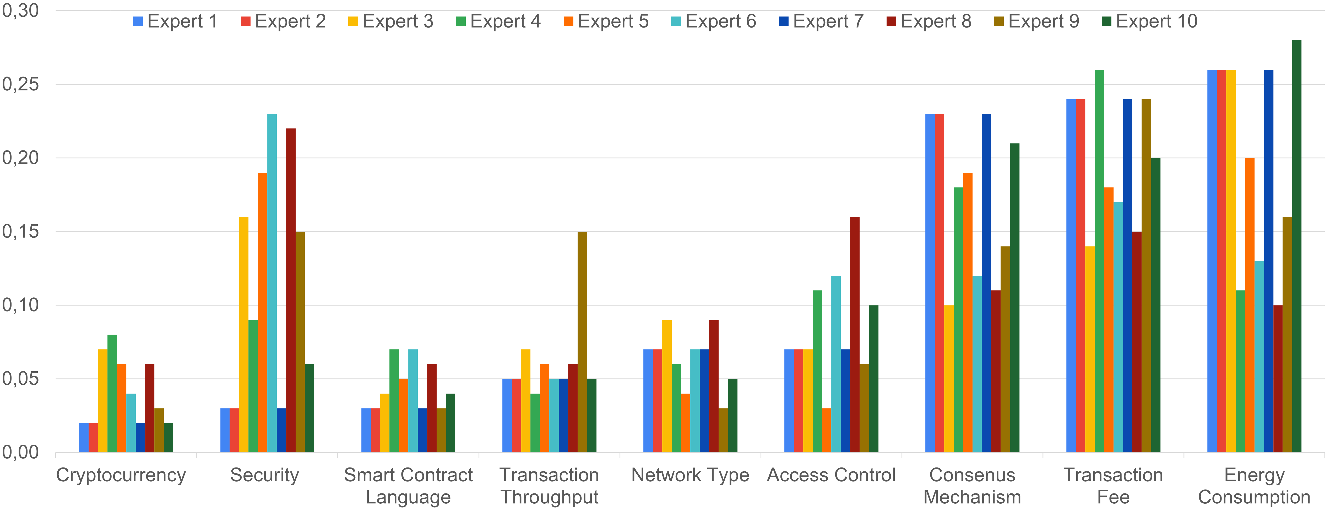
Figure 3. Weights results for blockchain features

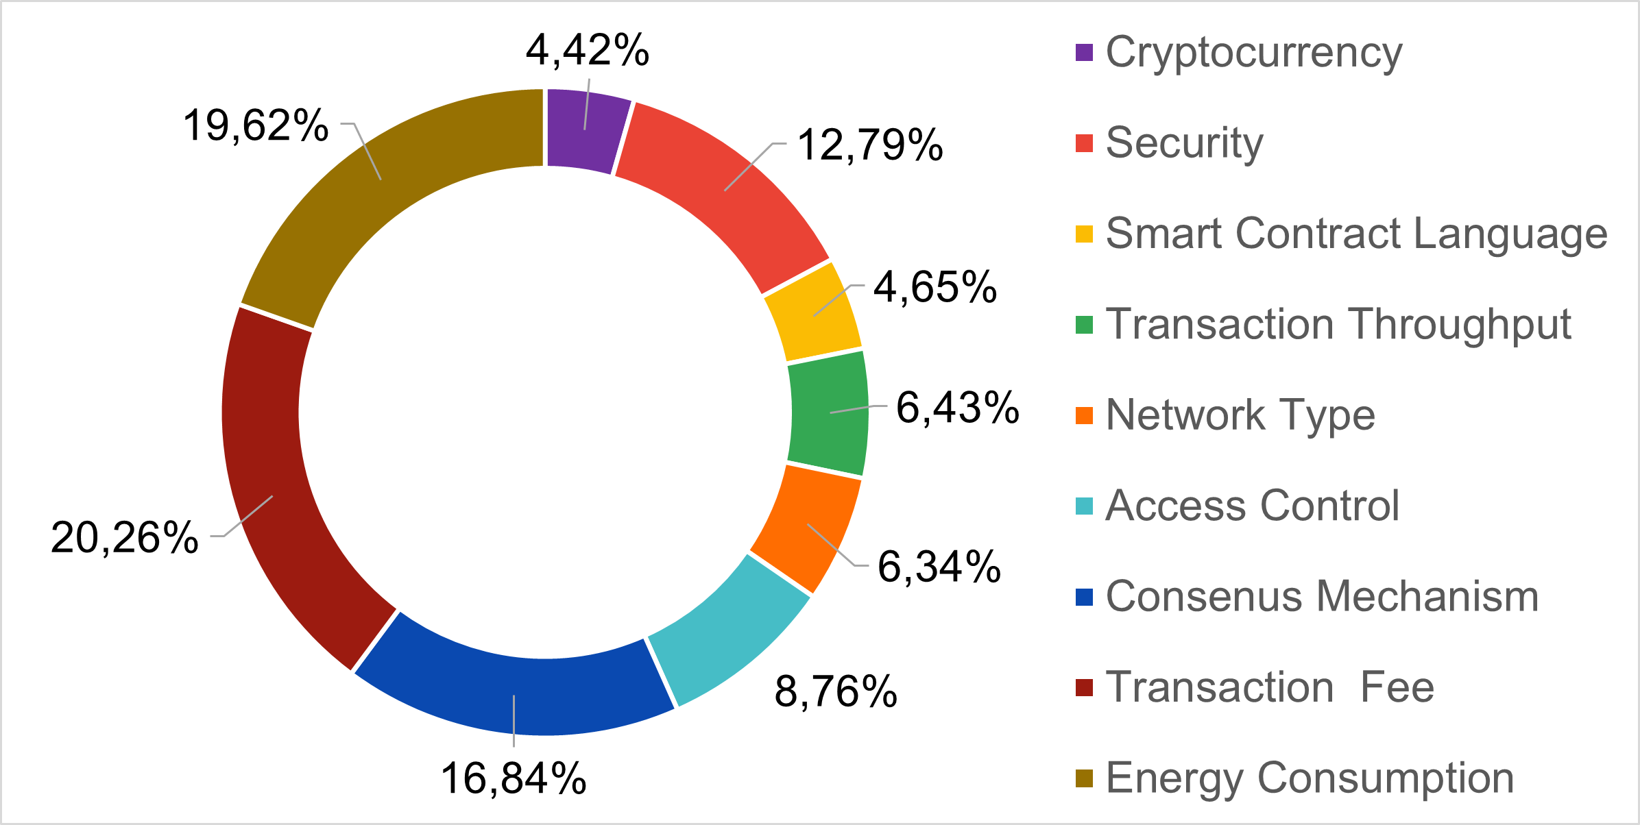
Figure 4. Weights distribution

Transaction Fee is considered the most relevant criteria, with a mean value of 21% (0.21). It refers to the cost that is charged to users/organizations to add new data to the blockchain. The onerousness of the amount varies according to a multiplicity of factors related to the specific blockchain environment ^{[48]}. In a circular economy perspective, a blockchain based project can result in an extremely high number of transactions per second. The majority of the already proposed circular economy models expect to affect citizen behaviour in their daily lives. Traceability and tokenization procedures, typical of a circular economy project, involves the generation of considerable volumes of data, to be frequently recorded. This explains the expert opinions, which considers the cost of recording a crucial factor for the platform selection. Energy Consumption is the second most relevant criteria, with a mean weight of 20% (0.20). The criteria relate to the amount of energy consumed to maintain the blockchain infrastructure. In many cases, blockchain has proved to be particularly costly technologies in terms of consumed energy ^{[49]}. Unsurprisingly, experts have strongly weighted this feature. The circular economy model bases its principle on reuse and waste reduction ^{[50]}, and a blockchain platform selection process should guarantee consistency with this regard. Consensus Mechanisms are blockchain algorithms which ensures data validity and consistency, in a distributed environment ^{[51]}. This feature may affect different aspects of a circular economy project, like efficiency, costs and consumption. The experts strongly evaluated this feature, assigning relevance percentages between 10-23%. Its average value (17%) is lower only than the first two mentioned criteria. Following the relevance order, a lower value is assigned to the Security criteria (10%). Blockchain technologies spread data across multiple independent nodes. In a circular economy perspective, sensible data of organizations (i.e. production details) or individuals (i.e. purchasing information) are exposed. However, the vast majority of blockchain platforms already guarantee a high degree of confidentiality, integrability and availability for the stored information, through cryptographic methodologies. According to experts, the Security criteria is an important factor to consider in the selection process, but not distinctive enough to make the final decision. More technical blockchain features such as Access Control, Network Type, Transaction Throughput and Smart Contract Language achieves lower weights. Their average relevance percentages are respectively 9%, 6%, 6% and 5%. These results are surprising, since experts in the technical field were consulted too. The lowest relevance is assigned to Cryptocurrency, whose mean value is 4% (0.04). The monetary value of blockchains’ digital assets strongly suffers from rapid market fluctuations. Tokenization processes for circular economy models should not be excessively related to this issue. According to experts’ opinion, this criterion must not be overly considered for the final decision.

4.2 Assessment of values

In the second round of interviews, five blockchain experts have been surveyed in order to assign values to the six blockchain alternatives. The selected platforms are open source blockchains and each criteria information is publicly available. However, most of the identified criteria (Cryptocurrency, Security, Smart Contract Language, Network Type, Access Control, Consensus Mechanism) expect qualitative information that do not enable an objective evaluation. For all the collected characteristics, experts’ know-how has provided quantitative values, translating each feature to a value between 1 and 10. For example, considering the Smart Contract Language criteria, expert five assigns 3 to XDC Network, 3 to Hyperledger, 2 to Corda, 3 to Ethereum and 2 to Bitcoin. After the opinions collection, each of them is equally considered for the average value calculation. Due to space constraints, we are not able to show all the 270 values. We present the average values coming from experts’ assessments in Table 2. The analysis of the values’ distribution underlines uniform judgments, with peeks for values 7 and 3. Precisely, the following percentage distribution was determined: 1 = 7.8%, 2 =10.0%, 3 = 14.1%, 4 = 8.1%, 5 = 6.7%, 6 = 10.7%, 7=17.4%, 8=10.0%, 9=7.8%, 10=7.4%.

Table 2. Average values for blockchain alternatives
 | XDC Network | Hyperledger Fabric | Eosio | Corda | Ethereum | Bitcoin
Cryptocurrency | 6 | 5 | 5.2 | 4.6 | 5.6 | 4.4
Security | 4.4 | 2.6 | 2.6 | 2.2 | 6.4 | 6.2
Smart Contract Language | 6.6 | 7.2 | 6.4 | 6.6 | 6.8 | 3
Transaction Throughput | 6.2 | 7.8 | 5.6 | 3.6 | 2.2 | 1.4
Network Type | 6.6 | 5 | 6.6 | 4.8 | 6 | 5.8
Access Control | 6 | 5.6 | 5.2 | 5.4 | 5.8 | 5.4
Consensus Mechanism | 6.6 | 6.8 | 6.8 | 5.8 | 5.8 | 3.2
Transaction Fee | 7.8 | 8.4 | 8.4 | 6.8 | 3 | 2.6
Energy Consumption | 7 | 7.8 | 5.6 | 7.6 | 2.8 | 1.4

Regarding Energy Consumption, experts show their preference towards Hyperledger Fabric (average value 7.8). The platform is known for its low consumption, with average by 1.0*10⁻⁸ TWh. Hyper- ledger Fabric achieved the best average score also for Transaction Fee (average value 8.4), Consensus Mechanism (average value 6.8) and Transaction Throughput (average value 7.8). In the field of Smart Contract Languages, assignments highlight a higher preference for the JavaScript/Java/Go combination rather than Solidity. The less valued language is Bitcoin Script. Another important aspect emerged from the analysis concerns the technology network type. Experts tend to devalue private technologies against hybrid and public network types. Unsurprisingly, technologies with lower Transaction Fee and Transaction Throughput are more valuable than platforms with higher costs and latencies. Regarding Consensus Mechanisms, the proposed algorithms achieve similar assessments with average values between 6.8 and 5.8, except the Proof of Work. The latter has received low ratings, with an average value of 3.2. Generally, interviews revealed strong scepticism towards the Bitcoin platform, which achieves the lowest average value for the 67% of criteria. The analysis shows that the latest technologies, XDC Network and EOSIO, are positively considered. XDC Network gets the best average score for the 33.3% of criteria, with values higher than 6 in 66.67 % of cases. EOSIO determine similar performances, with positive values (6 or higher) in 64.09% of assignments.

4.3 BCEI for blockchains

The BCEI has been obtained through the product of two variables: the row vector and the column vector. The BCEI is determined for each proposed alternative. Its numerical value expresses the suitability of the blockchain platform with the respect to the appropriateness to a circular economy project. The BCEI enables an objective comparison of the proposed alternatives. The results are represented in Figure 5.

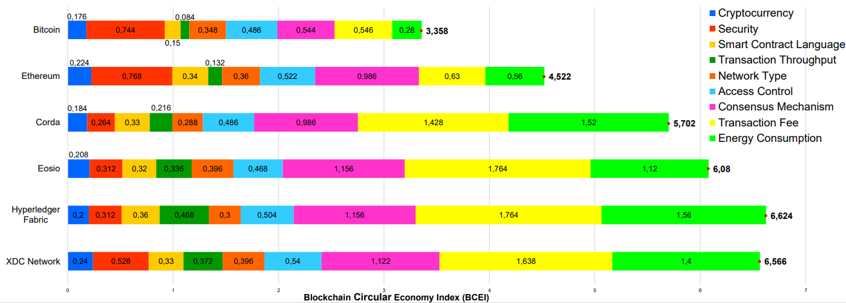
Figure 5. BCEI results

The analysis of the results has underlined clear trends that are shared by various assessments. The crucial factors that affect the index most are Consensus Mechanism, Energy Consumption and Transaction Fee. These elements are the features that a Circular Economy implementation should consider most. Differently, blockchain technical features are individually considered less relevant. This aspect highlights a degree of adaptability of circular economy principles to such fields. Results showed high incompatibility between circular economy and Bitcoin (BCEI = 3.358). Despite the monetary value of its native cryptocurrency, the platform raises many doubts about its sustainability. Its consensus mechanism used for block validation, the Proof of Work, is a very onerous algorithm. It is estimated that Bitcoin consumes annually 1.47 * 10⁵ GWh, a value higher than the consumption of the whole of Sweden in 2020 ^{[52]}. The platform determines also a considerable average transaction fee, about 2 USD/tx, and reduced versatility in smart contract writing. Similar results are achieved by Ethereum (BCEI = 4.522), also considered insufficient in a circular economy perspective. The platform is slightly better seen than the previous one, in Consensus Mechanism, recently mutated from the Proof of Work to the more sustainable Proof of Sake, and Transaction Fee. Another similar aspect that the two platforms’ shares is the Security evaluation, which is the only feature with higher values than the other alternatives. The large-scale use of both the technologies, resulted in greater reliability during the value assessment process. The analysis of the results shows that none of the other alternatives distinctly prevails over the others. Their BCEI range is grouped between 5.7 and 6.6. The blockchain platform which gets the best result is Hyperledger Fabric (BCEI = 6.624). The platform is well known for its low consumption. Moreover, the absence of transaction fees and the higher transaction throughput (10000 Transaction per second) make Hyperledger Fabric a good candidate for the implementation of a circular economy project. A very similar result is achieved by XDC Network, with BCEI = 6.566. The platform is a relatively new technology that combines features of both public and private blockchains. Its consensus mechanism, called Delegated Proof of Stake, is a more efficient version of the classical Proof of Stake, involving a voting mechanism for the validator’s election. The same protocol is implemented by EOSIO, which achieves a BCEI = 6.08. The Corda alternative (BCEI = 5.702) turns out to be slightly penalized by its adaptive transaction fee system, that varies the cost according to the total number of transactions of the network.

In order to present a more robust result analysis, an additional index calculation has been carried out, in which all the criteria have the same weights (equal to 1/9). These alternative results are compared with the weighted BCEI scores. The unweighted results are XDC Network = 6.86, Hyperledger Fabric = 6.24, EOSIO = 5.82, Corda = 5.27, Ethereum = 4.93 and Bitcoin = 3.71. The only rating difference involves the first position, which is occupied by XDC Network, rather than Hyperledger Fabric. The consistency of the unweighted calculation with the BCEI results, shows that the proposed assessment goes beyond the circular economy perspective, and the evaluations can be generally extended to more contexts.

5. Discussions
The results obtained in this work thus allowed a comparison of different technologies, where they were not applied to a specific context (a limitation of our work). However, the goal was to apply an established methodology to a growing context in which digitization and sustainability are changing the economic system. Thus, they have the potential to be enablers for businesses, for public agencies as they allow for advantages within the time, quality and cost mix. However, quantitative approaches are geared toward providing answers to current problems. Comparing different technologies is a decision-making process in several contexts, and MCDA finds use in multiple contexts. Where values and weights are obtained from business data, objectivity is much more meaningful and adherence to reality is greater. However, when these data are not available, reference should be made to expert knowledge. Our results are valid for the proposed criteria and refer to the chosen panel of experts. Clearly, a change in either of these aspects could lead to different results. Nevertheless, the values recorded suggest to us some indications: i) the low propensity for sustainability of some of the technologies considered and ii) the not high performance of even the top ranked ones, clearly determines some aspects to be improved. So comparing the alternatives not only allows us to rank them but also to identify theoretical and practical considerations. By analysing the two criteria that have been given greater prominence, some corrective actions turn out to be possible: transaction fee should provide discounted packages for those who make great use of it in order to find a proper mix between processed data and resource use, while energy consumption can reduce its effect through renewable energy. Digital technologies make it possible to reduce physical travel, improve manufacturing processes and dematerialize many activities. However, their use should be modulated on the effects needs in light of reflecting sustainability goals as well.

5.1 Theoretical implications

5.2 Managerial & practical implications

6. Conclusions
The present study underlines theoretical and practical considerations. The theoretical point of view proposes a methodological approach that enables a quantitative comparison of the technologies. The considered evaluations embed several aspects of the blockchain selection, which are mathematically expressed through criteria and weights. The criteria multiplicity highlights the multidimensionality of the issue, which needs an analysis based on several themes. The approach can easily be transposed in other contexts, without the need to distort its foundation. One of the main goals of the work was to examine an evaluation methodology that is as objective as possible, and to provide theoretical tools to compare blockchain technologies in different scenario. The proper application of MCDA and AHP is crucial in this regard. In order to provide results that consider the issue in its entirety, experts’ competencies should be properly mixed. In our case, it was essential to equally consider the technical view, related to the blockchain area, as much as the managerial and economic ones. Experts’ reliability has been measured through their scientific impact in the field of blockchain technologies and circular economy. The practical perspective of the study regards the analysis of the BCEI results. The application of the BCEI is potentially interesting for both private and public initiatives. Numerous local government agencies and corporate businesses are undertaking sustainable economic models. Blockchain technologies can improve the management of circular economy projects. However, the world of blockchains is extremely composed and the BCEI can be used as guideline for the selection process. The BCEI measures the platform performances considering both technical and sustainability features. However, transaction fee and energy consumption represent highly relevant factors for the evaluation process. The study considers six of the most popular blockchain platforms. Excepting Bitcoin and Ethereum, whose BCEIs underline high incompatibility with circular economy, the results for the other alternatives are decent but not exciting. A slight advantage is achieved by Hyperledger Fabric. Moreover, BCEI results determine another managerial consideration. The similarity of the obtained results highlights the lack of an industry leading technology in the circular economy sector. The presence of industry entry space and the growing demand determine good chance of success for investments in blockchain technologies, specializing in the management of circular economy processes. However, our study does not provide the whole picture of the market, but just a fragment with the most famous technologies. Part of our future works involves the extension of the present study, by applying the BCEI methodology to a wider selection of blockchain alternatives. In addition, other expert figures may be involved, increased the number of criteria considered (through the local-global priority approach). However, this study confirms the need for quantitative studies that monitor the impact of technology in the combination of digitization and sustainability.

References
[1] D’Adamo, I.; Mazzanti, M.; Morone, P.; Rosa, P. Assessing the Relation between Waste Management Policies and Circular Economy Goals. Waste Manag., 2022, 154, 27–35. https://doi.org/10.1016/j.wasman.2022.09.031.
[2] Urbinati, A.; Rosa, P.; Sassanelli, C.; Chiaroni, D.; Terzi, S. Circular Business Models in the European Manufacturing Industry: A Multiple Case Study Analysis. J. Clean. Prod., 2020, 274 (122964), 1–11. https://doi.org/10.1016/j.jclepro.2020.122964.
[3] Zamfir, A. M.; Mocanu, C.; Grigorescu, A. Circular Economy and Decision Models among European SMEs. Sustain., 2017, 9 (9). https://doi.org/10.3390/su9091507.
[4] Taddei, E.; Sassanelli, C.; Rosa, P.; Terzi, S. Circular Supply Chains in the Era of Industry 4.0: A Systematic Literature Review. Comput. Ind. Eng., 2022, 108268. https://doi.org/10.1016/J.CIE.2022.108268.
[5] Leong, L.-Y.; Hew, T.-S.; Ooi, K.-B.; Lin, B. A Meta-Analysis of Consumer Innovation Resistance: Is There a Cultural Invariance? Ind. Manag. Data Syst., 2021, 121 (8), 1784–1823. https://doi.org/10.1108/IMDS-12-2020-0741.
[6] Liu, Z.; Liu, J.; Osmani, M. Integration of Digital Economy and Circular Economy: Current Status and Future Directions. Sustain., 2021, 13 (7217). https://doi.org/10.3390/su13137217.
[7] Demestichas, K.; Daskalakis, E. Information and Communication Technology Solutions for the Circular Economy. Sustain., 2020, 12 (18), 1–19. https://doi.org/10.3390/su12187272.
[8] City Loops. City Loops https://cityloops.eu (accessed May 23, 2022).
[9] PlastiCircle. PlastiCircle https://plasticircle.eu/home/ (accessed May 23, 2022).
[10] Tang, Y. M.; Chau, K. Y.; Fatima, A.; Waqas, M. Industry 4.0 Technology and Circular Economy Practices: Business Management Strategies for Environmental Sustainability. Environ. Sci. Pollut. Res., 2022. https://doi.org/10.1007/s11356-022-19081-6.
[11] Govindan, K. Tunneling the Barriers of Blockchain Technology in Remanufacturing for Achieving Sustainable Development Goals: A Circular Manufacturing Perspective. Bus. Strateg. Environ., 2022. https://doi.org/10.1002/bse.3031.
[12] Lim, M. K.; Li, Y.; Wang, C.; Tseng, M.-L. A Literature Review of Blockchain Technology Applications in Supply Chains: A Comprehensive Analysis of Themes, Methodologies and Industries. Comput. Ind. Eng., 2021, 154 (107133). https://doi.org/10.1016/j.cie.2021.107133.
[13] Tseng, M.-L.; Tran, T. P. T.; Ha, H. M.; Bui, T. D.; Lim, M. K. Sustainable Industrial and Operation Engineering Trends and Challenges Toward Industry 4.0: A Data Driven Analysis. J. Ind. Prod. Eng., 2021, 38 (8), 581–598. https://doi.org/10.1080/21681015.2021.1950227.
[14] Upadhyay, A.; Mukhuty, S.; Kumar, V.; Kazancoglu, Y. Blockchain Technology and the Circular Economy: Implications for Sustainability and Social Responsibility. J. Clean. Prod., 2021, 293 (126130). https://doi.org/10.1016/j.jclepro.2021.126130.
[15] Nandi, S.; Sarkis, J.; Hervani, A. A.; Helms, M. M. Redesigning Supply Chains Using Blockchain-Enabled Circular Economy and COVID-19 Experiences. Sustain. Prod. Consum., 2021, 27, 10–22. https://doi.org/10.1016/j.spc.2020.10.019.
[16] Böckel, A.; Nuzum, A.-K.; Weissbrod, I. Blockchain for the Circular Economy: Analysis of the Research-Practice Gap. Sustain. Prod. Consum., 2021, 25, 525–539. https://doi.org/10.1016/j.spc.2020.12.006.
[17] Nakamoto, S. Bitcoin: A Peer-to-Peer Electronic Cash System; 2008. https://doi.org/10.1162/ARTL_a_00247.
[18] Buterin, V. A Next-Generation Smart Contract and Decentralized Application Platform; 2014.
[19] Hyperledger. Hyperledger Fabric https://www.hyperledger.org/projects/fabric.
[20] Rodrigues, B.; Bocek, T.; Stiller, B. The Use of Blockchains: Application-Driven Analysis of Applicability. In Advances in Computers; Elsevier, 2018.
[21] Zhang, R.; Xue, R.; Liu, L. Security and Privacy on Blockchain. ACM Comput. Surv., 2019, 52 (3), 1–34. https://doi.org/10.1145/3316481.
[22] Tseng, M.-L.; Lim, M. K.; Ali, M. H.; Christianti, G.; Juladachah, P. Assessing the Sustainable Food System in Thailand under Uncertainties: Governance, Distribution and Storage Drive Technological Innovation. J. Ind. Prod. Eng., 2022, 39 (1), 1–18. https://doi.org/10.1080/21681015.2021.1951858.
[23] Fernando, Y.; Tseng, M.-L.; Wahyuni-Td, I. S.; Lopes de Sousa Jabbour, A. B.; Chiappetta Jabbour, C. J.; Foropon, C. Cyber Supply Chain Risk Management and Performance in Industry 4.0 Era: Information System Security Practices in Malaysia. J. Ind. Prod. Eng., 2022, 1–15.
[24] Poursoltan, L.; Seyedhosseini, S. M.; Jabbarzadeh, A. A Two-Level Closed-Loop Supply Chain under the Constract of Vendor Managed Inventory with Learning: A Novel Hybrid Algorithm. J. Ind. Prod. Eng., 2021, 38 (4), 254–270.
[25] Zhu, C.; Guo, X.; Zou, S. Impact of Information and Communications Technology Alignment on Supply Chain Performance in the Industry 4.0 Era: Mediation Effect of Supply Chain Integration. J. Ind. Prod. Eng., 2022, 1–16.
[26] Francisco, K.; Swanson, D. The Supply Chain Has No Clothes: Technology Adoption of Blockchain for Supply Chain Transparency. Logistics, 2018, 2 (1), 2. https://doi.org/10.3390/logistics2010002.
[27] Golden State Food. Golden State Food https://goldenstatefoods.com/ (accessed May 23, 2022).
[28] Tseng, M.-L.; Ha, H. M.; Tran, T. P. T.; Bui, T.-D.; Lim, M. K.; Lin, C.-W.; Ali, M. H. Data-Driven on Sustainable Food Supply Chain: A Comparison on Halal and Non-Halal Food System. J. Ind. Prod. Eng., 2022, 1–28.
[29] Brilliant Earth. Brilliant Earth https://www.brilliantearth.com/blockchain-diamonds-search/ (accessed May 23, 2022).
[30] Longo, F.; Nicoletti, L.; Padovano, A.; d’Atri, G.; Forte, M. Blockchain-Enabled Supply Chain: An Experimental Study. Comput. Ind. Eng., 2019, 136 (July), 57–69. https://doi.org/10.1016/j.cie.2019.07.026.
[31] Guegan, D. Public Blockchain versus Private Blockchain; 2017.
[32] Li Shen, Z.; Wu, H.; King, B.; Ben Miled, Z.; Wassick, J.; Tazelaar, J. A Hybrid Blockchain Ledger for Supply Chain Visibility. In ISPDC 2018 - Proceedings of the 17th International Symposium on Parallel and Distributed Computing; IEEE, 2018; pp 118–125. https://doi.org/10.1109/ISPDC2018.2018.00025.
[33] Zheng, Z.; Xie, S.; Dai, H.; Chen, X.; Wang, H. An Overview of Blockchain Technology: Architecture, Consensus, and Future Trends. In Big Data 2017 - 6th IEEE International Congress on Big Data; 2017; pp 557–564. https://doi.org/10.1109/BigDataCongress.2017.85.
[34] Vacchi, M.; Siligardi, C.; Demaria, F.; Cedillo-González, E. I.; González-Sánchez, R.; Settembre-Blundo, D. Technological Sustainability or Sustainable Technology? A Multidimensional Vision of Sustainability in Manufacturing. Sustain., 2021, 13 (9942). https://doi.org/10.3390/su13179942.
[35] Colasante, A.; D’Adamo, I.; Morone, P.; Rosa, P. Assessing the Circularity Performance in a European Cross-Country Comparison. Environ. Impact Assess. Rev., 2022, 93 (106730), 1–13. https://doi.org/10.1016/j.eiar.2021.106730.
[36] D’Adamo, I.; Gastaldi, M. Sustainable Development Goals: A Regional Overview Based on Multi-Criteria Decision Analysis. Sustain., 2022, 14 (15), 9779. https://doi.org/10.3390/su14159779.
[37] Wahlster, P.; Goetghebeur, M.; Kriza, C.; Niederländer, C.; Kolominsky-Rabas, P. Balancing Costs and Benefits at Different Stages of Medical Innovation: A Systematic Review of Multi-Criteria Decision Analysis (MCDA). BMC Health Serv. Res., 2015, 15 (1), 1–12. https://doi.org/10.1186/s12913-015-0930-0.
[38] Appolloni, A.; Chiappetta Jabbour, C. J.; D’Adamo, I.; Gastaldi, M.; Settembre-Blundo, D. Green Recovery in the Mature Manufacturing Industry: The Role of the Green-Circular Premium and Sustainability Certification in Innovative Efforts. Ecol. Econ., 2022, 193 (107311), 1–9. https://doi.org/10.1016/j.ecolecon.2021.107311.
[39] Öztürk, C.; Yildizbaşi, A. Barriers to Implementation of Blockchain into Supply Chain Management Using an Integrated Multi-Criteria Decision-Making Method: A Numerical Example. Soft Comput., 2020, 24 (19), 14771–14789. https://doi.org/10.1007/s00500-020-04831-w.
[40] Lu, W.; Wu, L.; Xue, F. Blockchain Technology for Projects: A Multicriteria Decision Matrix. Proj. Manag. J., 2022, 53 (1), 84–99. https://doi.org/10.1177/87569728211061780.
[41] Voukkali, I.; Zorpas, A. A. Evaluation of Urban Metabolism Assessment Methods through SWOT Analysis and Analytical Hierocracy Process. Sci. Total Environ., 2021, No. 150700. https://doi.org/10.1016/j.scitotenv.2021.150700.
[42] Nanayakkara, S.; Rodrigo, M. N. N.; Perera, S.; Weerasuriya, G. T.; Hijazi, A. A. A Methodology for Selection of a Blockchain Platform to Develop an Enterprise System. J. Ind. Inf. Integr., 2021, 23 (100215). https://doi.org/10.1016/j.jii.2021.100215.
[43] Ilieva, G.; Yankova, T.; Radeva, I.; Popchev, I. Blockchain Software Selection as a Fuzzy Multi-Criteria Problem. Computers. 2021, p 120. https://doi.org/10.3390/computers10100120.
[44] Farshidi, S.; Jansen, S.; España, S.; Verkleij, J. Decision Support for Blockchain Platform Selection: Three Industry Case Studies. IEEE Trans. Eng. Manag., 2020, 67 (4), 1109–1128. https://doi.org/10.1109/TEM.2019.2956897.
[45] Tasca, P.; Tessone, C. J. A Taxonomy of Blockchain Technologies: Principles of Identification and Classification. LEDGER, 2019, 4, 1–39. https://doi.org/10.5195/LEDGER.2019.140.
[46] Saaty, T. L. Decision Making with the Analytic Hierarchy Process. Int. J. Serv. Sci., 2008, 1 (1), 83–98.
[47] Singh, A. S. Integrated Approach for Finding the Causal Effect of Waste Management over Sustainability in the Organization. Benchmarking An Int. J., 2021. https://doi.org/10.1108/BIJ-08-2020-0419.
[48] He, J.; Zhang, G.; Zhang, J.; Zhang, R. Q. An Economic Model of Blockchain: The Interplay between Transaction Fees and Security. SSRN Electron. J., 2020, No. April, 1–41. https://doi.org/10.2139/ssrn.3616869.
[49] de Vries, A. Bitcoin’s Growing Energy Problem. Joule, 2018, 2 (5), 801–805. https://doi.org/10.1016/j.joule.2018.04.016.
[50] Reh, L. Process Engineering in Circular Economy. Particuology, 2013, 11 (2), 119–133. https://doi.org/10.1016/j.partic.2012.11.001.
[51] Wang, W.; Hoang, D. T.; Hu, P.; Xiong, Z.; Niyato, D.; Wang, P.; Wen, Y.; Kim, D. I. A Survey on Consensus Mechanisms and Mining Strategy Management in Blockchain Networks. IEEE Access, 2019, 7, 22328–22370. https://doi.org/10.1109/ACCESS.2019.2896108.
[52] Cambridge Bitcoin Electricity Consumption Index. Cambridge Bitcoin Electricity Consumption Index https://ccaf.io/cbeci/index (accessed May 11, 2022).

https://ec.europa.eu/eurostat/databrowser/view/ceisrm030/def ault/line?lang = en

