Influence of stoichiometry on the corrosion response of titanium oxide coatings produced by plasma electrolytic oxidation
L. Casanova†*, Mattia Arosio†, Mohammad Taghi Hashemi††, M. Pedeferri†, G.A. Botton††, M. Ormellese†

† Dept. Chemistry, Materials and Chemical Engineering “G. Natta”, Politecnico di Milano, Via Mancinelli 7, 20131 Milano, Italy
†† Department of Materials Science and Engineering McMaster University, 1280 Main Street West Hamilton, Ontario L8S 4L7, Canada
*Corresponding author:
Luca Casanova
E-mail: luca.casanova@polimi.it
Phone: +39 02 2399 3324

Abstract:
In this study the corrosion mechanism leading to coating debonding in low pH environments, produced by plasma electrolytic oxidation (PEO) on Ti, is investigated through the conjunction of electrochemical impedance spectroscopy (EIS), potential step chronometric, and a detailed structural characterization according to the use of electron energy loss spectroscopy (EELS). It will be demonstrated that a slightly reduced oxide will enhance proton adsorption and percolation leading to oxide debonding, while the synthesis of a barrier layer mainly composed by Ti⁴⁺ oxide bearing phases and low S content will retard H⁺ permeation enhancing H₂ evolution in correspondence of the oxide surface.

Keywords: titanium; EIS; TEM; acid corrosion; anodic films; hydrogen absorption

1. Introduction
When hydrogen makes its way into titanium, and the concentration eventually approaches the solubility limit of the material, weaknesses may arise from hydrides formation inducing loss in ductility and failure of the component [1]. This is particularly true when the metal is employed in cathodically protected structures like heat exchangers of desalination plants where the formation of scales, like Mg(OH)₂ and CaCO₃, onto the metal surface, affects the heat transfer coefficient decreasing the overall rated capacity of the plant. As a matter of fact, frequent descaling operations are generally carried out with the use of sulfuric acid [2,3] to restore design and in-service conditions. Several reports [3–6] demonstrated the high susceptibility of unalloyed Ti to low pH environments containing sulfates even manifesting corrosion rates of the order of ~ 8 mm·year⁻¹ [5] for pristine grade 2 Ti immersed in 10 %v/v H₂SO₄ at 60 °C. The phenomenon of Ti corrosion in sulfuric acid has been well documented in literature where, according to coulometric weight-loss and polarographic analyses [7], it was established that the metal generally goes in solution as Ti³⁺ in case of electrode activity (i.e. corrosion potential E_{corr} < ~ 620 mV/SSC_{sat.} for Ti in 2 M H₂SO₄). On the other hand, as E_{corr} rises ~ 100 ÷ 130 mV above a certain threshold, identified as the critical potential (E_{crit}) falling around -477 mV/SSC_{sat.} (for Ti in 2 M H₂SO₄) [7,8] Ti⁴⁺ are released in solution. It is well-recognized that, provided E_{corr} is sufficiently negative in a low pH environment (pH < 2), H⁺ can not only be adsorbed, contributing to charge accumulation in the electrical double layer established at the oxide-solution interface, but also intercalate within TiO₂ according to the reduction process described by Eq. (1) [9–11]:
${Ti}^{4+}O_{2}+{H_{3}O}^{+}+e^{-}↔{Ti}^{3+}(O)(OH)+H_{2}O$ (1)
becoming feasible for E_{corr} < 197 mV_{SSC} [4] considering present conditions. Such a reduction process, assisted by proton intercalation, can be thought as a local charge compensation mechanism in correspondence of the formation of Ti³⁺ centers. Apart from electrochemical reduction chemical dissolution is also significant. Blackwood et al. [12,13], for example, hypothesized the presence of a first order reaction proportional to proton concentration. This is of direct relevance for the decrease of the electrode E_{corr} until values required for electrochemical oxide reduction to be feasible. It should also be emphasized that this will cause the inevitable increase of the material conductivity making the coating an inefficient barrier against diffusion of charges. A rather recent technique, with important applications in industry and research field found to be effective against many forms of corrosion, like uniform attack in strong reducing acids or localized dissolution in halides rich environment, is plasma electrolytic oxidation (PEO) [14–16]. Typical PEO oxides present a morphology characterized by a porous outer layer, imparting to the coating a rather high thickness, whose features are generally affected by the plasma developed during the treatment, and a barrier layer immediately in contact with the metallic substrate responsible for corrosion protection. Even if a high pH environment is generally optimal for PEO applied on valve metals like Al and Mg, several attempts [4,17–19] are present for PEO applied on Ti surfaces in acidic solutions. Sulfuric acid, in particular, has the ability to favour the formation of rutile [18] demonstrated to be more resistant towards leaching in H₂SO₄ with respect to other TiO₂ polymorph like anatase [20]. Until now, some publications have reported on the morphology [21,22] and microstructure [19,23] of Ti PEO oxides without providing, however, detailed stoichiometric information and its influence on the corrosion response of the material.
It is expected, in fact, that stoichiometry is an important actor controlling the mechanism leading to corrosion of electrodes immersed in low pH environments. This has been largely because proton transport in oxides generally requires low activation energy owing to the combination of small dimension and the absence of an electron cloud. At low temperatures proton conduction, in nanometric oxides, can be in principle described by four different mechanisms [24]: 1) diffusion through the crystal lattice, 2) within an adsorbed H₂O layer, 3) within grain boundaries and 4) beneath the space charge region formed at the water/oxide interface. Stoichiometric inhomogeneity expressed in the form of oxygen vacancies is particularly advantageous in proton conduction enhancement particularly in perovskites [25] where water molecules can find an easy path to dissociate into OH⁻ and H⁺, the former being incorporated inside the oxygen vacancy while the latter forming a bond with a lattice oxygen atom [26]. Considering the present electrochemical investigation being limited to almost compact barrier regions, it is reasonable to hypothesize mass transport to occur in the bulk. As a consequence, after H⁺ adsorption, solid-state diffusion involves 1) a fast rotation around the host oxygen ion followed by 2) transfer to another oxygen ion through an hopping process [27].
Some of these outcomes may have important implications on the corrosion response of the electrode, because of this here we provide a detailed stoichiometric investigation exploiting the outstanding lateral resolution of high-resolution electron energy loss spectroscopy (EELS) applied on Ti oxide coatings synthesized by PEO in direct current and pulsed regime. We demonstrate how the use of a pulsed regime supports the growth of a barrier layer mainly constituted by Ti⁴⁺ bearing oxide phases including a low level of S impurity. Our approach of designing a highly stoichiometric (Ti⁴⁺) and S deficient barrier layer results in enhanced protection of the metallic substrate, limiting H recombination at the oxide-metal interface. This process delayed the coating debonding thus preserving Ti from 24 h immersion in 10 %v/v sulfuric acid at 60 °C, a common environment adopted during metal pickling procedures [28].

2. Materials and methods

2.1 PEO treatments
Anodization treatments were performed in a water-based solution (0.5 M H₂SO₄) in a 1 L Pyrex beaker over 10 × 10 × 1.6 mm³ grade 2 Ti (UNS R50400) samples cut by metal shearing. Samples were incorporated into epoxy resin and mechanically polished with silicon carbide papers according to the sequence 100, 320, 600, 800, 1200, 2400/4000 mesh, and alumina particles to obtain a mirror like surface with roughness down to ~ 0.8 µm. After polishing, the specimens were sonicated in ethanol for 5 min and washed in deionized water. A cylindrical counter electrode based on activated titanium net (radius 50 mm) was placed around the titanium coupon while the solution was stirred, using a magnetic anchor rotating at 1500 rpm, in order to avoid mass transfer limitations. The anodization signal was designed according to the fully programmable California Instruments Asterion 751 series AC/DC power source. Two treatments were analyzed in this study: a DC process, further on referred as “PEO-DC”, and a pulsed signal with a hybrid duty cycle: 25A%-25C%-50R%-5CP% repeated at 1000 Hz called “PEO-H-25” where “A” and “C” stands for anodic and cathodic polarization while “R” indicates the % of rest time, i.e. no polarization applied at all. CP indicates the % of cathodic polarization applied with respect to the anodic one. Both conversion treatments were performed under potential-controlled regime considering a forming voltage of 160 V reached through a constant ramp of 0.5 V·s⁻¹ leading to a total treatment time of 320 s.
  - FIB preparation and TEM analysis
A Focused Ion Beam (FIB)/Scanning Electron Microscope (SEM) Zeiss NVision 40 was used to mill and extract an electron transparent sample, from PEO oxides (∼ 100 nm thickness), for transmission electron microscopy (TEM) analysis. Given the sample preparation with a protective top layer on the coating, with final thinning at low energies carried out, we expect the damage, induced by FIB operations, to be minimal to few nm and uniform across the section. As a consequence, gradients through the thickness of the coating as seen with EELS are not expected. The sample was positioned onto a supporting grid and attached via electron beam deposition of a precursor gas, then stored into a double membrane layer. The phase distribution was investigated with EELS using a FEI Titan 80–300 TEM, operated at 300 keV with a field emission electron source equipped with an electron monochromator, allowing to improve the energy resolution down to around 0.11 eV. EELS spectra were extracted using a home-made script developed in Python environment, with the help of Hyperspy, an open source data processing software ​[29]. According to a rigorous investigation of the titanium oxide related EELS spectra, comparing them with reference data presence in literature, a component map (each component identified with a color code) based on automatic structural discrimination was obtained for all the coatings. Details about the script and its operation principles can be found elsewhere [30].

2.3 Electrochemical tests
All the electrochemical tests were performed using a Metrohm Autolab PGSTAT equipped with a FRA32M module for EIS using a standard 3 electrode cell (ASTM G5 [31]) with a KCl saturated silver/silver chloride (SSC_{sat.}) reference electrode and an Amel Pt counter electrode. All the tests were repeated three times in 1 L solution. EIS and E_{corr} evolution upon immersion were studied in a solution of 10 %v/v H₂SO₄ with temperature set to 60 °C using a Velp Scientifica Arex with VTF digital thermoregulator system. The impedance was evaluated cyclically at E_{corr}, after 30 min of stabilization, until complete electrode activation in a frequency window between 10⁻² to 10⁵ Hz collecting 10 points per decade with a voltage amplitude, of the sinusoidal perturbation, of 10 mV_{rms}. A salt bridge, composed by Agar-Agar and KCl, was used to not expose the reference electrode directly to the aggressive solution. EIS spectra were analyzed using to the Nova 2.1 software. Potential step chronometric responses were evaluated, in the above solution, holding a polarization of -1 V/SSC_{sat.} for different times: 30, 45 and 90 s respectively monitoring the resulting current transient.

2.4 Weight-loss tests
According to standard ASTM G-31 [32], Eq. (2) was used to evaluate the minimum test time required, where “mpy” stands for the corrosion rate expressed in mils per year:
$hours=\frac{2000}{mpy}$ (2)
Using the above equation, considering an average corrosion rate, for untreated grade 2 Ti, equal to 8.1 mm·year⁻¹, evaluated during preliminary measurements in similar conditions, a minimum time of 6.3 h was found. However, to increase the magnitude of the mass loss value and decrease uncertainty, the test was run for 24 h. Corrosion rates were evaluated upon weight loss measurements performed with a Mettler-Toledo MS105 balance with a resolution of 10⁻⁵ g. Then according to ASTM G-31 weight-losses were converted into corrosion rates.
2.5 GD-OES analysis
Glow discharge optical emission spectroscopy was carried according to a SpectrumA ANALYTIK GDA 750 HR analyzer considering an anode diameter of 2.5 mm, an operating voltage of 700 V with internal Ar pressure of 2.3 hPa in RF regime.

3. Results

3.1 Morphology and structure:
Acquisition of SEM images allowed to distinguish relevant features imparted to the oxide surface depending on the technological parameters adopted. In particular, the surface of PEO-DC (Fig. 1 a) and c)) appeared flatter and with well-developed surface porosity typical of a Ti PEO coating in sulfuric acid.
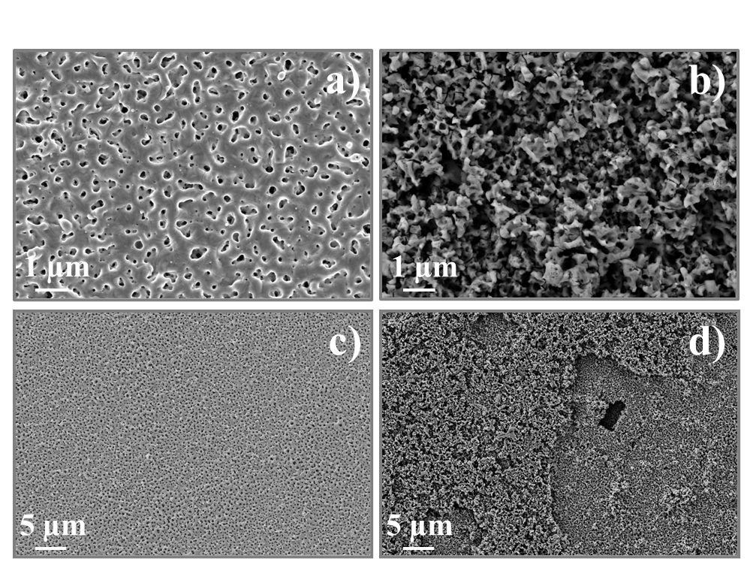
Fig. 1. SEM surface overview of a) and c) PEO-DC and b) and d) PEO-H-25.
Switching to pulsed anodizing, an apparently less homogeneous surface is observed, an indication that oxide synthesis occurred concurrently with fast gas delivery inducing the formation of a rough architecture. In particular, in Fig. 1 d), large holes were formed following the intense plasma developed according to the selected parameters used. These emissions were characterized, in our previous paper [30] to be type-B in nature and promoted according to the combination of high anodization frequency (1000 Hz) and the use of an hybrid duty cycle. It is reasonable to assign to those morphological depressions the role of weak points characterizing the electrochemical response of the coating. Accordingly, a TEM lamella was prepared trough by FIB operations and displayed in Fig. 2 b) where also the cross-section of sample PEO-DC is shown. The high porosity previously observed seems to be transmitted to the entire coating thickness with presence of large holes separating the barrier layer, in contact with the metallic substrate, to the porous outer layer. Concerning thicknesses bipolar PEO favored growth, leading to a thickness of ~ 3.2 µm compared to ~ 1.3 µm for PEO-DC.
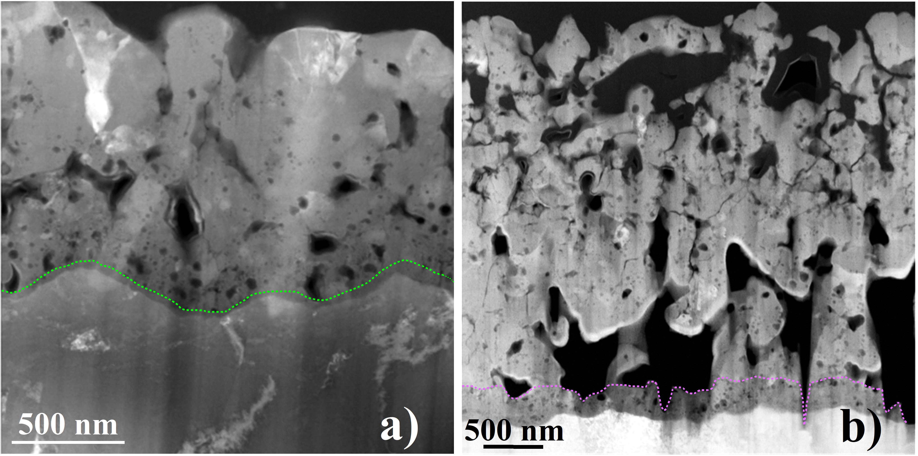
Fig. 2. TEM overview of a) PEO-DC and b) PEO-H-25 cross sections.
Focusing on barrier layer properties, EELS was used to obtain a detailed characterization of the oxide stoichiometry of the layers immediately in contact with Ti. EELS spectra extracted from the present analysis are collected in Fig. 3, with Ti⁴⁺ bearing phases in a) and titanium sub-oxides in b). Spin orbit coupling is responsible for the formation of a doublet in all the spectra, manifested as the appearance of L₃ and L₂ edge components. Then, in case of Ti⁴⁺ valence crystal field effects determine a further splitting into four features labelled as: L₃ t_{2g}-e_{g} and L₂ t_{2g}-e_{g} listed according to increasing electron energy losses. Particularly useful, for structural discrimination, is the L₃-e_{g} component being very sensitive to the bonding environment surrounding the cation as the e_{g} orbital points directly towards the ligand. The latter feature appears particularly modified in case of TiO₂-D (“defected TiO₂” displayed in blue) revealing the presence of a broad peak postulated to be related to crystal lattice modifications induced by retention of foreign elements like S [30].
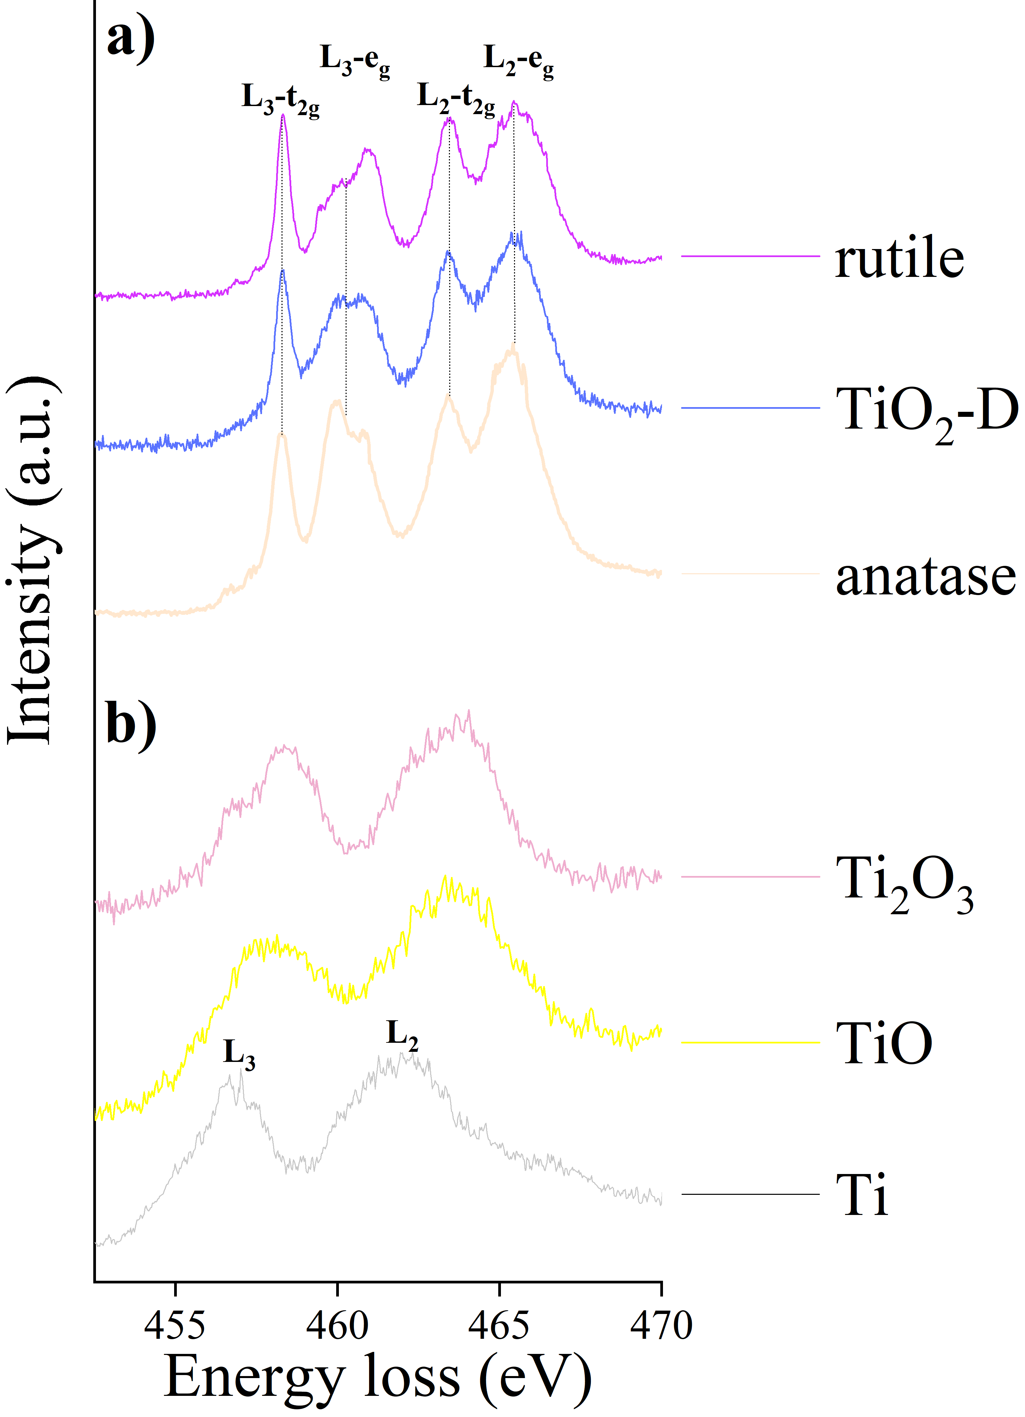
Fig. 3. EELS spectra of a) Ti⁴⁺ oxide bearing phases and b) Ti suboxides
For sake of representation, component maps (each component identified with a color code) based on automatic structural discrimination, of previous spectra collected in Fig. 3, were drawn for the barrier layers of both coatings, as shown in Fig. 4 and 5. It may be observed that upon the use of a DC regime, the stoichiometry regularly distinguished in naturally grown Ti oxide [33,34] is preserved, manifesting a characteristic three-layer structure: a first layer of TiO ~ 12 nm thick (Ti²⁺ in yellow) in contact with the metal followed by ~ 47 nm of Ti₂O₃ (in pink), and ~ 131 nm of titanium oxide with a strong Ti³⁺ fingerprint (in green). Then, outside the barrier region, the structure evolved towards an oxide phase characterized by a strong Ti⁴⁺ character before saturating towards anatase (not shown) in the upper portion of the porous layer.
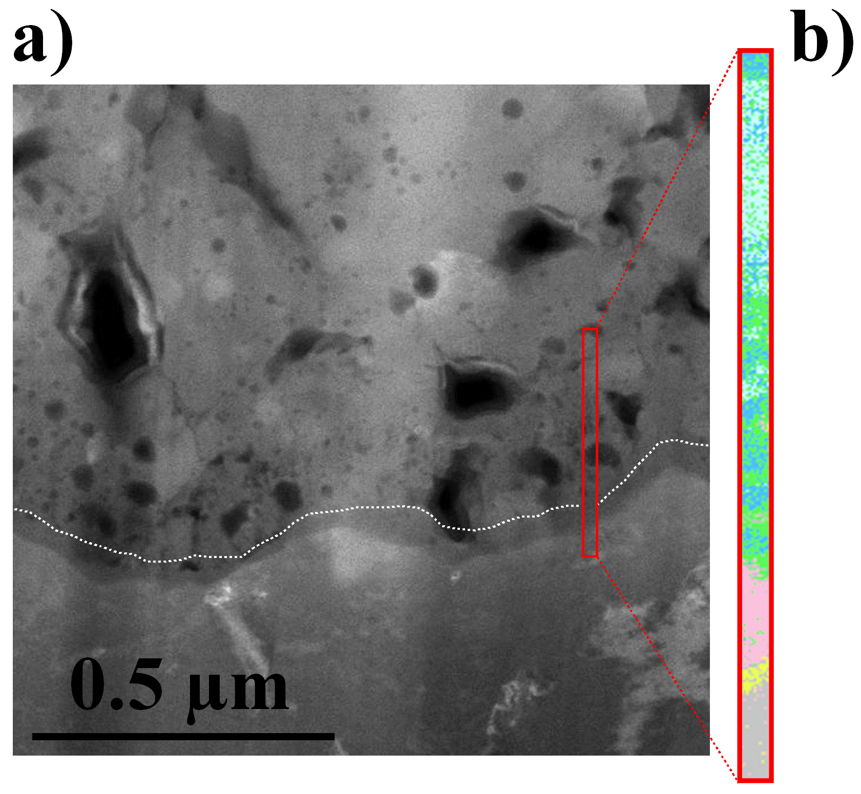
Fig. 4. EELS component map based on the spectra identified with a color in Fig. 3 for PEO-DC barrier region where gray corresponds to metallic Ti, green to mix-Ti³⁺, light blue to mix-Ti⁴⁺, pink to Ti₂O₃ and yellow to TiO.
Things are different when looking at sample PEO-H-25: pulsed anodizing comprising cathodic polarization favored the oxidation of the first 62 nm in contact with Ti, denoting a prevalent Ti⁴⁺ character. After that, 258 nm of defected TiO₂ developed followed by the establishment of the prevalent TiO₂ polymorph present in this coating, i.e., rutile (in purple).
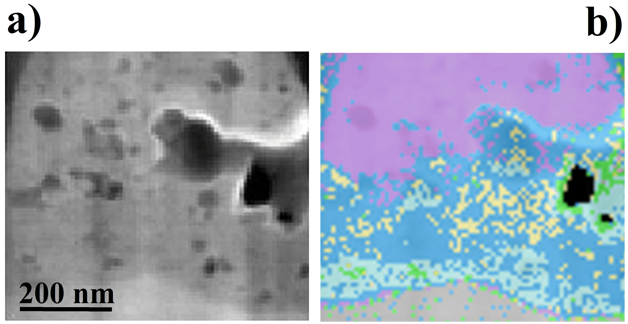
Fig. 5. EELS component map based on the spectra identified with a color in Fig. 3 for PEO-H-25 barrier region where gray corresponds to metallic Ti, green to mix-Ti³⁺, light blue to mix-Ti⁴⁺, blue to TiO₂-D, light orange to anatase and purple to rutile.
Sulfur accumulation in correspondence of the barrier region, and its effect in altering the crystal structure of the material, can be used as a further criterion to separate barrier from porous layer and its presence easily distinguished upon modification of the fine structures observed in EELS spectra. Following this idea, but also referring to TEM images, in section 3.3 GD-OES will be used to control the elemental distribution along coating depth and to sputter, according to the use of an argon plasma, all the porous layer leaving the barrier layer only. This allowed to isolate the barrier region contribution and to effectively assess the role of the oxide stoichiometry on the corrosion response of the material.
3.2 E_{corr} evolution and weight-loss measurements
As a preliminary step samples were immersed 24 h in 10 %v/v H₂SO₄ and investigated for weight-losses and E_{corr} evolution displayed in Fig. 6.
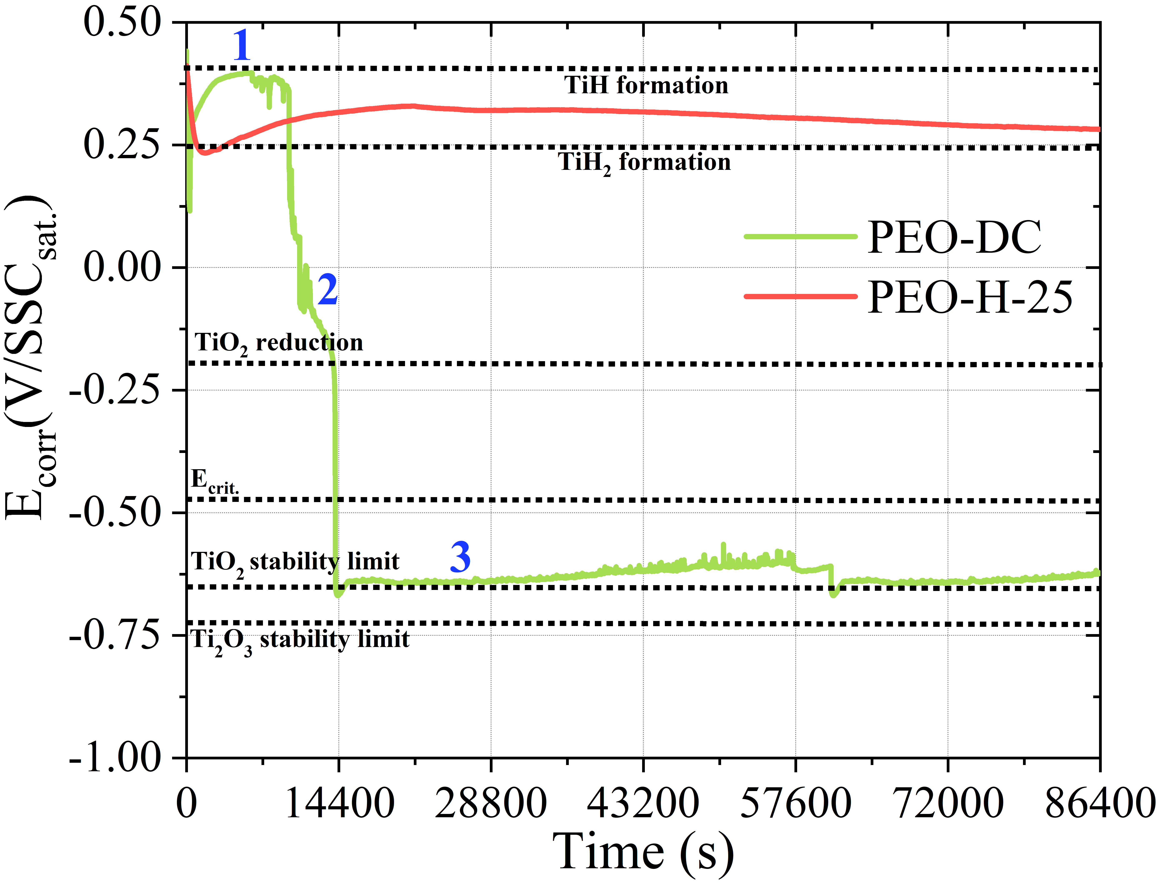
Fig. 6. E_{corr} evolution in time for PEO-DC (in green) and PEO-H-25 (in red).
A corrosion rate of 6.2 mm·year⁻¹was verified on coating PEO-DC while PEO-H-25 demonstrated to be very resistant towards the aggressive solution with only 0.03 mm·year⁻¹. Evolution of E_{corr} in time indicates that PEO-DC underwent debonding after few hours of immersion, passing from a passive condition (region 1) to an active state (region 3). The region in correspondence of the potential drop (region 2) is an active-passive transition zone comprising the main processes resulting in the detachment of the oxide layer. For sake of clarity, some relevant redox reactions are indicated by dashed horizontal lines, whose thermodynamic threshold was corrected according to the present experimental conditions.
3.3 Barrier layer analysis
A first GD-OES analysis was done, on both samples, to understand the total thickness and the elemental quantification, allowing to plot results as in Fig. 7:
Fig. 7. GD-OES elemental profiles for a) PEO-DC and b) PEO-H-25.
thickness values agree very well with data extracted from TEM analysis denoting the presence of a high accumulation of S in correspondence of the barrier layer [35] (denote as “B”). According to that, a second run was performed removing only the porous layer (“P”), leaving metallic Ti and a residual thickness corresponding to the barrier region (according to TEM ~ 190 nm for PEO-DC and 320 nm for PEO-H-25). Ar etching parameters, listed in section 2.5, were optimized to limit as much as possible roughness and indentations resulting in homogeneous crater shapes (see Fig. S1 in Supplementary material). Arithmetical roughness (R_{a}) was evaluated for both craters (~ 93 nm and ~ 138 nm for PEO-DC and PEO-H-25) and the value used as a “safety” tolerance to anticipate the shut-down of the sputtering procedure. In this way, the region of interest can be assumed to be almost preserved from indentations and residual stoichiometric alterations (if any considering the robust nature of titanium oxides) imparted by impacts with the energetic particles.
EIS results carried out on PEO-DC sample are presented in Fig. 8 in the form of Nyquist and Bode representation. For sake of brevity, spectra regarding PEO-H-25 were avoided as the trend was qualitatively comparable.
Fig. 8. Nyquist representation and related Bode diagram of EIS tests carried out on PEO-DC.
It is possible to see how the residual barrier layer held passivity for the first few minutes of immersion in perfect agreement according to E_{corr} evolution measured on the complete oxide. This demonstrates the relevant role covered by the barrier region in determining the corrosion response of the electrode. A single depressed semicircle in the Nyquist representation, typical of almost passive materials, manifests a distribution of time constants becoming more evident at progressively increasing immersion time: the depression in – phase angle, evidenced around 10 Hz, determined the appearance of two peaks as the immersion time and the electrode degradation advanced. To get insight about the time scale governing the electrochemical process, by-passing the contribution of the solution resistance, the imaginary impedance is plotted in Fig. 9 for the most relevant processes verified during immersion of both electrodes:
Fig. 9. Imaginary impedance plot for a) PEO-DC and b) PEO-H-25.
initially as the electrode held passivity, a single peak in -Z'' established around 0.025 Hz for sample PEO-DC, indicating a corrosion mechanism prevalently controlled by diffusion. At progressively increasing immersion time charged species diffuse through the compact oxide lattice in a semi-∞ manner as it is demonstrated by the low frequency straight line (slope = 1) of Fig 8 c) and corresponding phase angle approaching 45 °. A change of slope of the imaginary impedance component in correspondence of 0.25 Hz (for PEO-DC) and 0.32 Hz (for PEO-H-25) denotes the presence of concomitant reactions with different time scales, as in case of processes in mixed diffusion-charge transfer control. Interestingly the same relaxation frequency (0.25 Hz or 0.32 Hz) is observed for the electrode in the active state where such a peak is generally attributed to electrochemical desorption of H⁺ (Heyrovsky step) [4,36,37]. Electrode activation also favors the observation of the middle frequency time constant (158 Hz for PEO-DC and 89 Hz for PEO-H-25) describing H⁺ discharge reaction (Volmer step) previously hindered by the capacitive reactance of the protecting film. Similar conclusions can be drawn for sample PEO-H-25 apart from the absence of the low frequency diffusion related time constant observed for PEO-DC in case of electrode passivity. This outcome relates to the slower mass transport occurring inside PEO-H-25, according to the lower diffusion coefficient (and even the slightly larger thickness) resulting from the analysis present in section 4. It is certainly evident that this can cause incompatibility between the time scale of the phenomenon under investigation and the experimental frequency window (not detected even in case of lower bound decreased to 5 mHz). To gain deeper insight on the corrosion mechanism, the first derivative of -Z'' was plotted in Fig. 10 considering a regime of semi-∞ diffusion:
Fig. 10. First derivative of the imaginary impedance of sample a) PEO-DC and b) PEO-H-25
despite the similar E_{corr} (~ -160 mV/SSC_{sat.}) it is evident the pronounced high frequency shoulder, manifesting in between 10² ÷ 10³ Hz, related to a potential dependent relaxation process (HER).
A significant transition between semi-∞ to finite diffusion takes place as charges approach a reflecting boundary or even charge saturation of the material is reached. This can be seen according to the raise of the imaginary impedance in the low frequency region of the Nyquist representation where the slope of the low frequency Nyquist tail passed from 1 (- phase angle = 45 °) to almost ∞ (- phase = 90 °). Fig. 11 offers a perspective of the above-mentioned shift, where a transition frequency (ω_{trans} = 39.1 mHz for PEO-DC), between semi-∞ to finite diffusion can be extracted. As the process proceeds, the latter parameter shifted towards higher values passing from 0.025 Hz, after 102 min of immersion, to 0.1 Hz in case of a prolonged immersion time (180 min). Considering Eq. 3 it is fairly clear that ω_{trans} variation can be related to modification of the finite diffusion layer (which can be reduced by material dissolution) or variation of the diffusion coefficient due to a different state of charge of the electrode.
$ω_{trans}∝\frac{D^{H^{+}}}{l^{2}}$ (3)
After the blocking condition is approached, barrier layer dissolution and consequent coating debonding occurred. This can be visualized in Fig. 11 according to the formation of a low frequency capacitive loop with negative real impedance describing the release of charge accumulated in the redox capacitance of the material during immersion in the acidic solution.
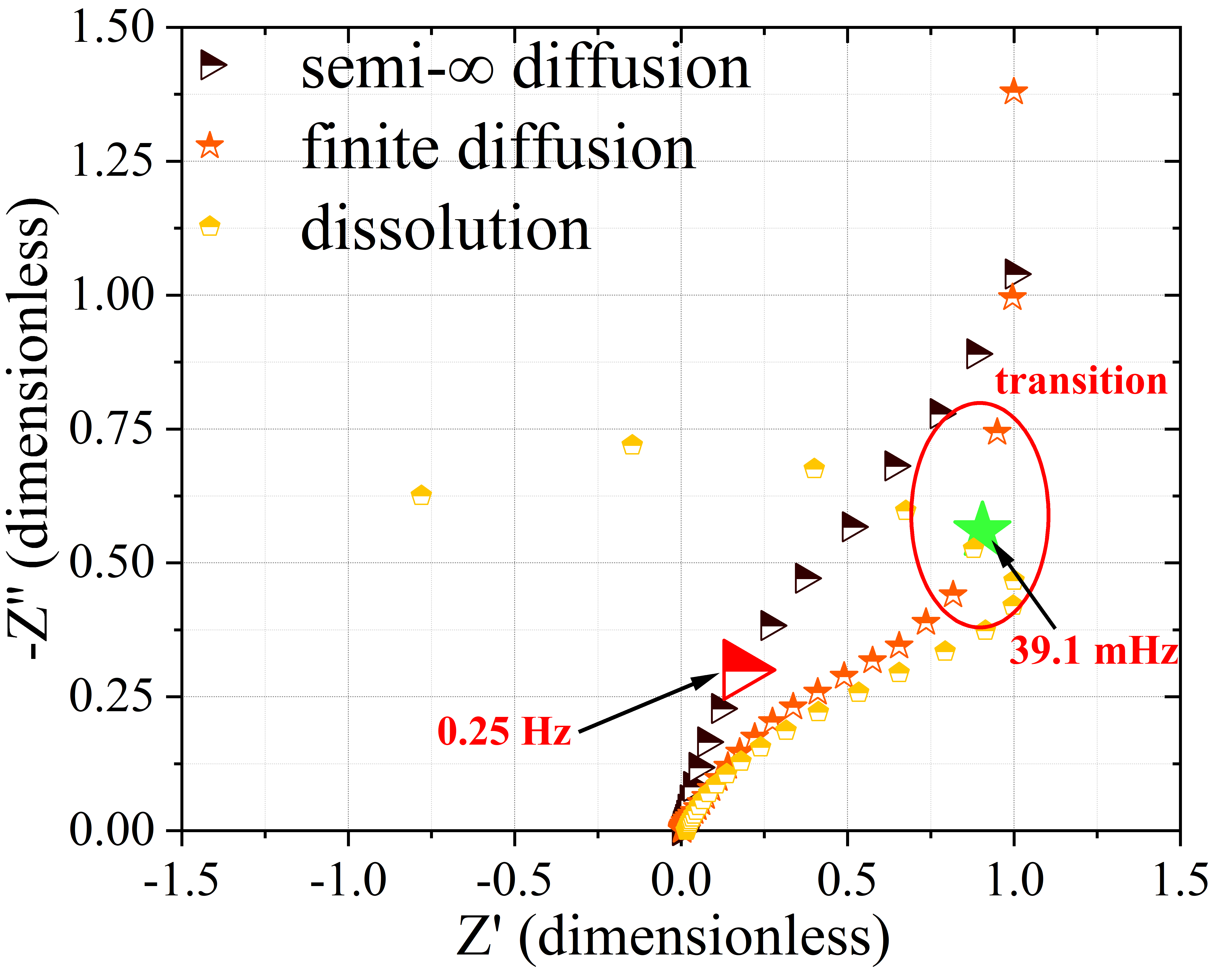
Fig. 11. Normalized Nyquist representation to focus on the diffusion transition and dissolution.
This occurred as E_{corr} became cathodic with respect to the conduction band edge of TiO₂ found to be ~ - 166 mV/SSC_{sat.} [38,39] as a result of its Nernstian dependence on pH. After that the electrode can be considered as almost proton transparent thus losing its barrier effect.
4. Discussion
During immersion in the aggressive solution a strong concentration gradient favored proton diffusion inside the porosity of the oxide filling all the active surface in contact with the acidic electrolyte. The presence of donor defects, like oxygen vacancies, generates almost free electrons necessary for proton reduction at the oxide-solution interface enhancing surface adsorption and consequent oxide reduction according to Eq. 1. As the E_{corr} potential, in the first period of immersion, was very anodic no concurrent HER is observed concomitantly to H⁺ intercalation, thus only a low frequency relaxation (0.025 Hz) was detected and attributed to diffusional phenomena. Once HER became thermodynamically feasible a time constant coincident with the relaxation of the Heyrovsky step, generally well discernable on active Ti, appeared around 0.25 Hz. Volmer discharge reaction remained hindered by the capacitive reactance of the still present oxide coating until the metallic substrate was exposed to the aggressive solution. As the immersion time goes on, the semi-∞ diffusion process shifted towards finite diffusion due to charge saturation of the oxide layer. According to previous observations, indicating slightly different electrochemical reaction and a marked mismatch between the corrosion response of both coatings a procedure, based on EIS [40,41], will be adopted to extract mass transport parameters. According to that it is possible to evaluate the oxide redox capacitance (C_{redox}) by fitting the low frequency tail of the Nyquist plot in Fig. 12 using the definition of capacitive reactance:
$Z^{''}=\frac{1}{2πCω}$ (x)
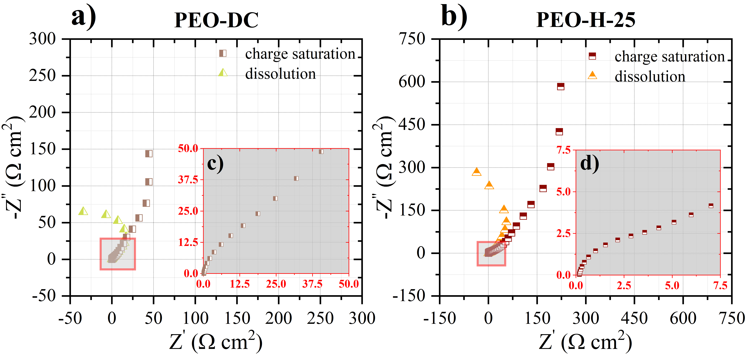
Fig. 12. Nyquist representation of a) PEO-DC and b) PEO-H-25 in correspondence of charge saturation and coating debonding.
where the slope extrapolated by linear regression, of data shown in Fig. 13, permits the estimation of the low frequency C_{redox} arising from electron coupled proton intercalation.
Fig. 13. Graphical procedure for extrapolation of C_{redox} of sample a) PEO-DC and b) PEO-H-25
Graphical extrapolation of the low frequency resistance (R), determined as the intersection between a virtual vertical line fitting data in the charge saturation regime and the real impedance axis, inserted in Eq. 4 is used to evaluate H⁺ diffusion coefficient inside the barrier layer of length “l”:
$D^{H^{+}}=\frac{l^{2}}{3C_{redox}R}$ (4)
providing slightly different values for both electrodes:
- $D_{PEO-DC}^{EIS}=2.61±0.31∙{10}^{-11} {cm}^{2}∙s^{-1}$
- $D_{PEO-H-25}^{EIS}=8.51±0.87∙{10}^{-12} {cm}^{2}∙s^{-1}$
Diffusion coefficient extraction was done considering EIS tests performed in correspondence of the active-passive transition region highlighted in Fig. 6 where effective proton intercalation was thermodynamically feasible. To confirm the solid-state nature of the diffusion process the procedure was repeated considering solution stirring and deviations inside the experimental error were obtained.
The value of C_{redox} extracted according to previous method, applied on data collected immediately before oxide debonding, can be used to evaluate the number of charges accumulated during the overall oxide reduction process. Considering an excitation potential, used during EIS, of 10 mV_{rms} 1.66·10¹⁵ and 3.412·10¹⁶ H⁺ intercalated inside PEO-DC and PEO-H-25. With the aim of evaluating the number of Ti⁴⁺ reduced during immersion in the acid it is possible to roughly consider (see calculations in Supplementary material) the total number of Ti⁴⁺ centers assuming PEO-H-25 barrier region to have similar crystal cell parameters as rutile. This allowed to verify a total of 4.62·10¹⁶ Ti⁴⁺ concluding that oxide debonding occurred after the reduction of ~ 85 % ± 9 % of Ti⁴⁺ sites after an immersion period of 28 h ± 2 h. Considering the low content of Ti⁴⁺ present in PEO-DC (no chance to quantify according to structure highlighted in section 3.1) the smaller number of charges involved in the diffusion process, until the occurrence of debonding, correlates with the lowest amount of Ti⁴⁺ centers and time required to lose the oxide protectiveness (< 3 h).
To confirm previous results, potential steps were applied monitoring current transient after the application of -1 V/SSC_{sat.} for 30, 45 and 90 s. Such potential was sufficiently cathodic to determine proton intercalation, while the polarization times sufficiently small to assume semi-∞ diffusion of H⁺ thus justifying the adoption of the Cottrell equation (Eq. 5) to extract $D^{H^{+}}$
$i=\frac{D^{\frac{1}{2}}∆Q}{π^{\frac{1}{2}}l}∙\frac{1}{t^{\frac{1}{2}}}$ (5)
from the fitting of the linear portion of the i - $t^{\frac{1}{2}}$ trend. From Table 1, it appears evident that the decrease in the diffusion coefficient, by increasing the polarization time to 90 s, approaches numbers found in saturation regime: 8.6 $± 0.23$ $∙$ 10⁻¹¹ and 7.51 $± 0.41$ $∙$ 10⁻¹² cm²·s⁻¹ for PEO-DC and PEO-H-25 respectively. Furthermore, the experimental values of H diffusion in PEO-H-25 correlated well with the one extracted according to the use of Eq. 6 applied by Hupfer et al. [42] for H⁺ diffusion in rutile along the c-axis.
$D^{H^{+}}=9.4∙{10}^{-4}\exp\left(\frac{-0.541}{k_{b}T}\right)=6.15∙{10}^{-12} {cm}^{2}·s^{-1}$ (6)
However, with both electrochemical techniques, a slightly lower H⁺ diffusion coefficient was verified for the oxygen rich PEO-H-25 barrier layer, indicating a slower transport with respect to the interfacial region of PEO-DC constituted by oxygen deficient material made up of TiO (12 nm) and Ti₂O₃ (47 nm). This was also highlighted by Yen et al. [43], emphasizing the importance of oxygen content with respect to oxide thickness. The role of oxygen vacancies, in fact, can be related to H_{ads} enhancement, a property also observed in other oxide systems like WO₃ [44]. This can lead to substantial modifications of the corrosion mechanism particularly on HER occurring on the electrode surface.
To shed light on the role of the oxide structure on the electrochemistry occurring on the electrodes, current transients were further fitted considering a model (which can be found elsewhere [45]) allowing separation of the three main contributions, according to the use of Eq. 7, arising from: double-layer response, diffusional current and ongoing faradaic reactions
$i_{T}=\frac{V}{R}\exp\left(-\frac{t}{RC_{edl}}\right)+\frac{B}{t^{\frac{1}{2}}}+F$ (7)
where V is the applied polarization, C_{edl}, R, B and F are fitting parameters, evaluated according to non-linear least square regression performed thanks to SciPy [46]. R is a series resistance attributed to electrolyte, electrodes, and cables, C_{edl} is the double layer capacitance, B is a mass transport index containing parameters of the Cottrell equation while F relates to the presence of current arising from residual faradaic reactions (mainly HER). Results, in terms of cathodic current density Vs time, are plotted in Fig. 14 in case of cathodic polarization held for 45 s for both materials.
Fig. 14. Experimental data and fitting of the current transient of sample a) PEO-DC and b) PEO-H-25 arising from application of a potential step of -1 V/SSC_{sat.} held for 45 s.
A slight deviation from the theoretical model is observed for PEO-H-25, caused by the higher residual current due to HER, continuously increasing along all the selected time windows. Fitting parameters are collected in Table 1:
Table 1. Electrochemical parameters extracted according to fitting of the current transient response highlighted in Fig. 14.
 | 30 s |  | 45 s |  | 90 s
Parameters | DC | 25 | DC | 25 | DC | 25
R_{s} (Ω·cm²) | 1.62$±$0.1 | 1.73$±$0.1 | 1.55$±$0.1 | 1.63$±$0.2 | 1.75$±$0.14 | 2.06$±$0.11
C_{edl} (F·cm⁻² $∙$10⁻⁴) | 2.77$±$0.2 | 1.38$±$0.1 | 2.78$±$0.1 | 2.00$±$0.1 | 2.92$±$0.31 | 2.49$±$0.27
B (10⁻³) | 16.3$±$1.8 | 39.1$±$2.7 | 11.9$±$0.9 | 5.76$±$0.7 | 1.85$±$0.08 | 0.58$±$0.42
F (A·cm⁻² $∙$10⁻²) | 1.67$±$0.1 | 0.88$±$0.0 | 1.60$±$0.1 | 2.25$±$0.1 | 1.43$±$0.06 | 3.79$±$0.12
D^{H+} (cm²·s⁻¹ $∙$10⁻⁹) | 3.86$±$0.2 | 5.00$±$0.3 | 2.07$±$0.1 | 0.47$±$0.03 | 0.086$±$0.004 | 0.0075$±$0.00026
It is possible to see that, generally, the PEO-DC condition was characterized by higher C_{edl} increasing with polarization time due to charge accumulation in the electrical double layer according to abundant H_{ads}. The parameter B, related to mass transport, was high during the initial 30 s of polarization (D^{H+} ~ 10⁻⁹ cm²·s⁻¹) indicating prevalence of liquid phase diffusion. In case of longer cathodic polarization times D^{H+} saturated towards values associated to solid state-diffusion according to previous analysis. Apart from mass transport phenomena a higher residual current for sample PEO-H-25 indicates faster kinetics of HER occurring on the oxide surface which is beneficial to retard oxide debonding. In fact, this allowed to decrease protons percolation through the oxide layer leading to reduction and eventual recombination at the metal-oxide interface. The lower HER kinetics in case of PEO-DC was due to the high content of S left by the continuous anodic field applied during oxide synthesis verified according to previous GD-OES profiles. This happens when cathodic poisoners, like S containing species, inhibit molecular hydrogen formation, resulting in accumulation of H in contact with the metal where it can eventually recombine leading to oxide debonding. One can argue that HER is generally favored by the presence of oxygen vacancies, particularly for structures like Ti₂O₃ (with band gap ~ 0.1 eV [47]) or even better TiO [48] which thanks to vast structural vacancies manifests a d-like metal conductivity. However, it is worth noting that the third layer composing PEO-DC barrier region, surmounting the previous structures (~ 12 nm of TiO and ~ 47 nm of Ti₂O₃), corresponds to an oxide phase (~ 131 nm thick) with mixed Ti³⁺/Ti⁴⁺ character (EELS spectrum shown in Fig. 15 in green) whose catalytic property towards HER cannot be considered as advantageous as the one verified on more conductive structure like Ti₂O₃ or TiO [48]. From a structural point of view, the transition between a “pure” Ti³⁺ bearing oxide like Ti₂O₃ (in pink) and other phases characterized by a more or less abundant presence of Ti⁴⁺ centers (higher in case of spectrum in light blue denoted as “mix Ti⁴⁺”) can be distinguished by looking at the so called “oxidation parameter”, which increases with the Ti⁴⁺ content, defined as the intensity difference between the L₃-t_{2g} peak and the following valley (null in case of corundum Ti₂O₃) or even at the ∆L₃ splitting arising from crystal field interaction. Having demonstrated the inhomogeneity and the lower oxidation state of the cation, it is reasonable to hypothesize that the concurrent presence of oxygen vacancies and consequent presence of Ti³⁺ centers can lead to strong H_{ads} making the desorption an unlikely step required for gas evolution.
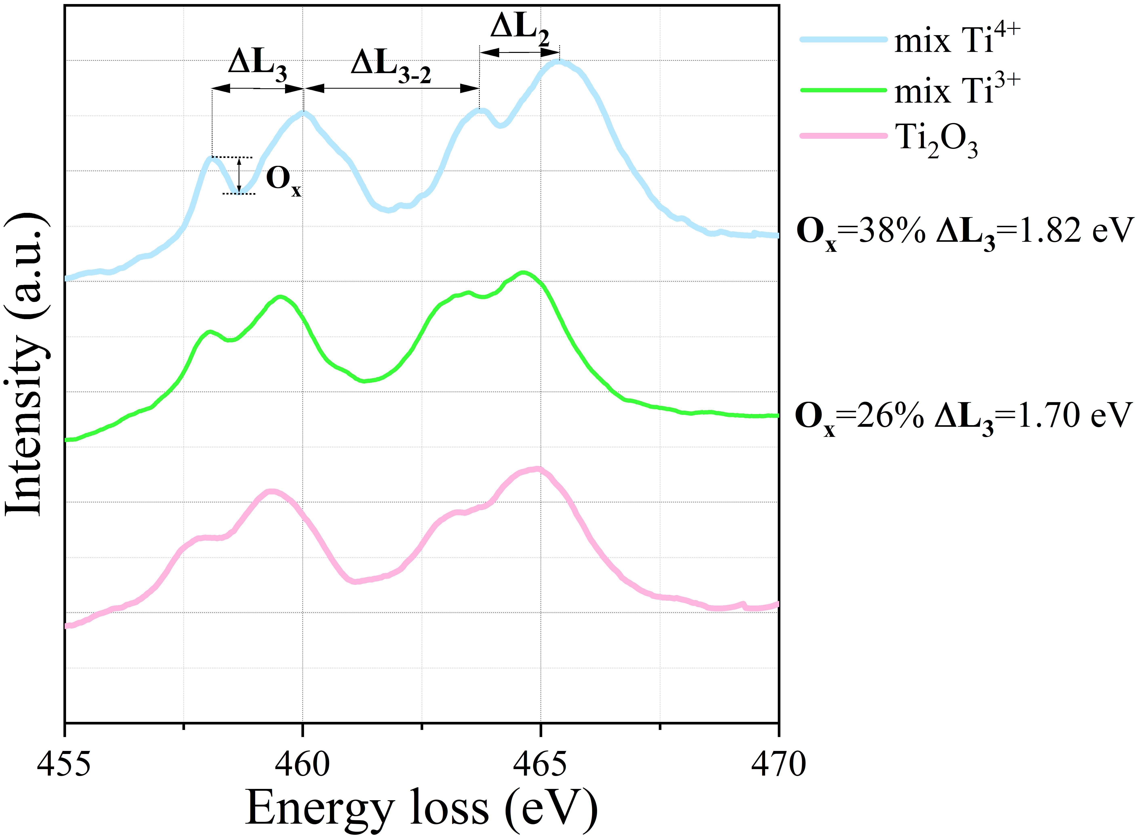
Fig. 15. EELS spectra and fine structure related parameters indicating different oxidation levels.
The same kinetic conclusions can be drawn even from EIS: considering Fig. 12 c) and d) the charge transfer resistance R_{ct} was extracted graphically from the diameter of the high frequency semicircle thus obtaining: 24.1 and 5.5 Ω·cm² for PEO-DC and PEO-H-25 respectively. Upon evaluation of the characteristic frequency (ω_{max}), corresponding to the value in proximity of the maximum of -Z'' in the Bode representation, it is possible to calculate the double layer capacitance using Eq. 8:
$C_{edl}=\frac{1}{R_{ct}ω_{max}}$ (8) values of 2.97$∙$10⁻³ and 3.07$∙$10⁻⁴ F·cm⁻² were obtained, thus denoting a good correlation with parameters extracted from previous step potential measurements. Such high values demonstrate that the capacitances did not merely arise from charge separation but also accumulation in the EDL. The faster kinetics of HER on PEO-H-25, expressed by the lower R_{ct} and the lower C_{edl}, can support the increase of the near-surface pH of the electrode thus altering chemical and electrochemical processes responsible for the corrosion response of the material for example by favoring oxide stability. Furthermore, TiO₂ surfaces are generally covered predominantly by molecular water thus decreasing the number of OH⁻ terminations responsible for H⁺ conduction [49]. However in presence of oxygen vacancies adsorbed water dissociates leaving the surface mainly covered by hydroxyls raising proton conductivity [50].
Apart from kinetics and mass transport phenomena, responsible to the increase of C_{redox} of the material until charge saturation occurred, oxide debonding was always anticipated by the formation of a growing bubble (see the red arrow in Fig. 16 a)) developed at the metal-oxide interface.
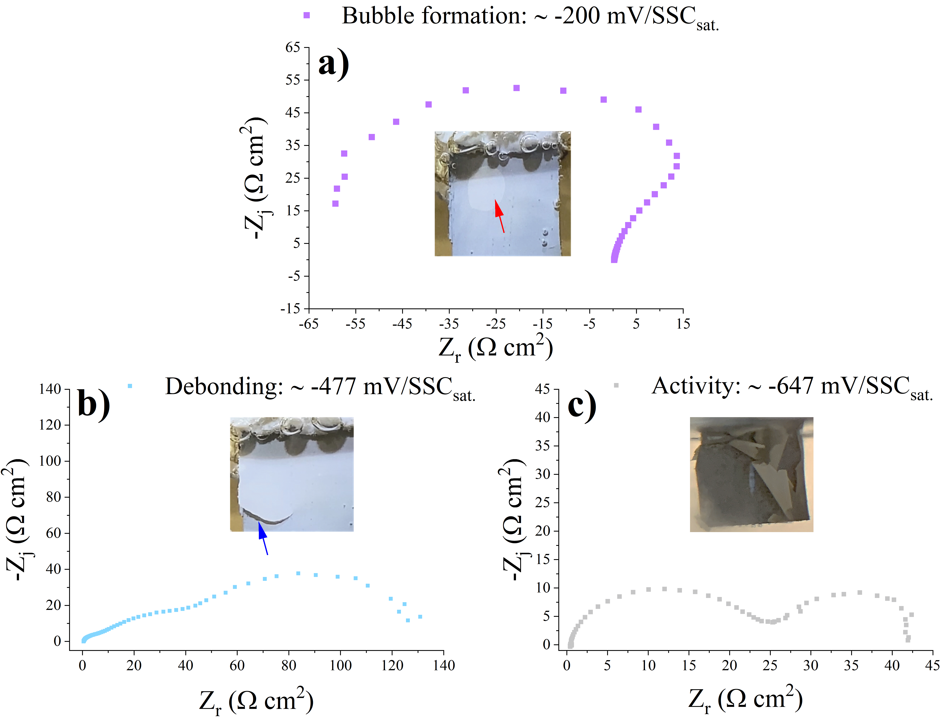
Fig. 16. Nyquist representation of PEO-DC and in-situ images collected during process evolution.
Once the bubble reached a critical thickness, mechanical lift up of the coating took place as in the insert of Fig. 16 b) highlighted by the blue arrow. In correspondence of bubble formation a capacitive low frequency loop with negative real impedances always manifested. Linear polarization resistance test (LPR) (displayed in Fig. S2 of Supplementary material), performed immediately after EIS, confirms the presence of a negative differential resistance as a consequence of the negative slope of the potential-current plot in the anodic overpotential region. The only presence of anodic current, during LPR test, is indicative of the natural tendency of the electrode to shift cathodically as the result of oxide debonding while the progressively decreasing anodic current verified for higher anodic overvoltages (responsible for the negative differential resistance) is due to the abundant release of charges accumulated inside C_{redox} during the oxide immersion.
A similar behavior was already observed in different scientific fields: for example researchers working on capacitors [51] verified it after complete charging of the device due to the occurrence of voltage relaxation phenomena inducing charge release back to the system. Even in the corrosion field this trend is not new: in fact, Boukamp et al. [52,53] obtained such a negative impedance loop in case of corroding Cr electrodes immersed in sulfuric acid attributing the observation to surface coverage variations during the active-passive transition. After oxide debonding occurred three capacitive loops are generally observed before saturating towards the two typical relaxations referring to hydrogen evolution on an active metal [36,54,55].
Fig. 17. Imaginary impedance versus frequency showing a) three and b) two time constants for active Ti electrode.
Considering actual experimental conditions (pH ~ -2 at 60 °C) it is reasonable to assume the critical solubility of H in Ti for hydride formation (~ 0.002 ÷ 0.004 in H:Ti atomic ratio) to be reached acting, similarly to the first monolayers of oxide/hydroxides always present on the metal when immersed in an aqueous solution, as a diffusion barrier towards H absorption. This made possible the appearance of the third middle frequency time constant attributed by Lasia et al. [54] to H absorption phenomena, whose relaxation frequency (4 Hz) can be easily extracted from Fig. 17a. However, as E_{corr} moved below ~ - 620 mV/SSC_{sat.} (near the TiO₂ stability limit as highlighted in Fig. 6) H absorption became so fast to make the middle-frequency time constant no more easily discernable, a result coming from the loss of protectiveness of even the few layers of oxide/hydroxide (the thermodynamic stability limit of TiO₂ is reached) always present when Ti is in contact with an aqueous solution.
5. Summary and conclusions
The synthesis of titanium oxides characterized by different stoichiometry, using plasma electrolytic oxidation (PEO), allowed to conclude an important effect of crystal structure on the corrosion response of titanium oxide electrodes immersed in hot concentrated sulfuric acid. Once the technological choices allow the formation of an oxide barrier layer composed by a homogeneous stoichiometry, comprising mainly Ti oxidized as 4+ and a relatively low level of S, oxide debonding was largely retarded (not observed for 24 h electrode immersion in 10 %v/v H₂SO₄ at 60 °C) as the result of decreased H⁺ diffusion coefficient, evaluated electrochemically to be ~ 10⁻¹² cm²·s⁻¹, and enhanced hydrogen evolution reaction (HER) at the oxide-electrolyte interface. On the other hand, using PEO with a DC voltage preserves the natural three-layer structure of the oxide layer, growing on Ti in common oxidizing environments, resulting in the following relevant features for oxide debonding and consequence high corrosion rate ~ 6.2 mm·year⁻¹:
1) The abundant presence of oxygen vacancies enhances H_{ads} and favors H⁺ diffusion ($D^{H^{+}}$~ 10⁻¹¹ cm²·s⁻¹).
2) Sulfur species act as cathodic poisoners, limiting hydrogen recombination and increasing dramatically H accumulation in correspondence of the metal-oxide interface.
3) Oxide debonding incubation time scaled substantially with the content of Ti⁴⁺: after the reduction of ~ 85 % ± 9 % of Ti⁴⁺ cations coating debonding occurred.
4) Debonding was found to result according to the mechanical action of H₂ bubbles grown over the metal surface after charge saturation of the material. The present research demonstrates with success the opportunity to detect the occurrence of oxide debonding according to the formation of a low frequency capacitive loop with negative real impedance in the Nyquist representation.
Acknowledgements
Surface treatments were performed at the Pietro Pedeferri Corrosion Laboratory “PoliLapp”. The EELS work was carried out at the Canadian Centre for Electron Microscopy, a facility supported by the Canada Foundation for Innovation under the Major Science Initiatives program, NSERC and McMaster University. GAB is grateful to NSERC for supporting this work under the Discovery Grants program.
References
[1] C.L. Briant, Z.F. Wang, N. Chollocoop, Hydrogen embrittlement of commercial purity titanium, Corros. Sci. 44 (2002) 1875–1888. https://doi.org/10.1016/S0010-938X(01)00159-7.
[2] I.N. Andijani, S. Ahmad, A.U. Malik, Corrosion behavior of titanium metal in the presence of inhibited sulfuric acid at 50°C, Desalination. 129 (2000) 45–51. https://doi.org/10.1016/S0011-9164(00)00050-3.
[3] D. Prando, A. Brenna, M.. V. Diamanti, S. Beretta, F. Bolzoni, M. Ormellese, M. Pedeferri, Corrosion of titanium: Part 1: aggressive environments and main forms of degradation, J. Appl. Biomater. Funct. Mater. 15 (2017). https://doi.org/10.5301/jabfm.5000387.
[4] L. Casanova, M. La Padula, M. Pedeferri, M.V. Diamanti, M. Ormellese, An insight into the evolution of corrosion resistant coatings on titanium during bipolar plasma electrolytic oxidation in sulfuric acid, Electrochim. Acta. 379 (2021) 138190. https://doi.org/10.1016/j.electacta.2021.138190.
[5] L. Casanova, L. Vicentini, M. Pedeferri, M. Ormellese, Unipolar plasma electrolytic oxidation: Waveform optimisation for corrosion resistance of commercially pure titanium, Mater. Corros. (2020). https://doi.org/10.1002/maco.202012198.
[6] L. Casanova, M. Gruarin, M.P. Pedeferri, M. Ormellese, A comparison between corrosion performances of titanium grade 2 and 7 in strong reducing acids, Mater. Corros. (2021). https://doi.org/10.1002/maco.202112392.
[7] E.. J. Kelly, Electrochemical Behaviour of Titanium, in: Mod. Asp. Electrochem., 1982: pp. 557–639. https://doi.org/https://doi.org/10.1007/978-1-4615-7458-3_5.
[8] Y. Liu, R.F. Schaller, E. Asselin, Effect of Fe(III) and Cu(II) on the Passivation of Ti-2 in Acidic Chloride Solutions, J. Electrochem. Soc. 166 (2019) C76–C82. https://doi.org/10.1149/2.1021902jes.
[9] T. Ohtsuka, Cathodic Reduction of Anodic Oxide Films Formed on Titanium, J. Electrochem. Soc. 134 (1987) 2406. https://doi.org/10.1149/1.2100212.
[10] S.M.A. Hosseini, V.B. Singh, Active-passive behaviour of titanium and titanium alloy (VT-9) in sulphuric acid solution, Mater. Chem. Phys. 33 (1993) 63–69. https://doi.org/10.1016/0254-0584(93)90091-Y.
[11] D. Devilliers, M.T. Dinh, E. Mahé, D. Krulic, N. Larabi, N. Fatouros, Behaviour of titanium in sulphuric acid - Application to DSAs, J. New Mater. Electrochem. Syst. 9 (2006) 221–232.
[12] D.J. Blackwood, L.M. Peter, D.E. Williams, Stability and open circuit breakdown of the passive oxide film on titanium, Electrochim. Acta. 33 (1988) 1143–1149. https://doi.org/10.1016/0013-4686(88)80206-8.
[13] D.J. Blackwood, S.K.M. Chooi, Stability of protective oxide films formed on a porous titanium, Corros. Sci. 44 (2002) 395–405. https://doi.org/10.1016/S0010-938X(01)00080-4.
[14] A. Hakimizad, K. Raeissi, M.A. Golozar, X. Lu, C. Blawert, M.L. Zheludkevich, Influence of cathodic duty cycle on the properties of tungsten containing Al2O3/TiO2 PEO nano-composite coatings, Surf. Coatings Technol. 340 (2018) 210–221. https://doi.org/10.1016/j.surfcoat.2018.02.042.
[15] B.L. Jiang, Y.M. Wang, Plasma electrolytic oxidation treatment of aluminium and titanium alloys, Surf. Eng. Light Alloy. Alum. Magnes. Titan. Alloy. (2010) 110–154. https://doi.org/10.1533/9781845699451.2.110.
[16] M. Shokouhfar, C. Dehghanian, M. Montazeri, A. Baradaran, Preparation of ceramic coating on Ti substrate by plasma electrolytic oxidation in different electrolytes and evaluation of its corrosion resistance: Part II, Appl. Surf. Sci. 258 (2012) 2416–2423. https://doi.org/10.1016/j.apsusc.2011.10.064.
[17] S. Stojadinović, R. Vasilić, M. Petković, L. Zeković, Plasma electrolytic oxidation of titanium in heteropolytungstate acids, Surf. Coatings Technol. (2011). https://doi.org/10.1016/j.surfcoat.2011.07.090.
[18] B. Engelkamp, B. Fischer, K. Schierbaum, Plasma electrolytic oxidation of titanium in H2SO4-H3PO4 Mixtures, Coatings. 10 (2020) 1–11. https://doi.org/10.3390/coatings10020116.
[19] A.E.R. Friedemann, T.M. Gesing, P. Plagemann, Electrochemical rutile and anatase formation on PEO surfaces, Surf. Coatings Technol. 315 (2017) 139–149. https://doi.org/10.1016/j.surfcoat.2017.01.042.
[20] A.. V. Dubenko, M.. V. Nikolenko, E.. V. Aksenenko, A. Kostyniuk, B. Likozar, Mechanism, thermodynamics and kinetics of rutile leaching process by sulfuric acid reactions, Processes. 8 (2020). https://doi.org/10.3390/pr8060640.
[21] H.F. Nabavi, M. Aliofkhazraei, A.S. Rouhaghdam, Electrical characteristics and discharge properties of hybrid plasma electrolytic oxidation on titanium, J. Alloys Compd. 728 (2017) 464–475. https://doi.org/10.1016/j.jallcom.2017.09.028.
[22] E. Erfanifar, M. Aliofkhazraei, H.F. Nabavi, A.S. Rouhaghdam, Growth kinetics and morphology of microarc oxidation coating on titanium, Surf. Coatings Technol. 315 (2017) 567–576. https://doi.org/10.1016/j.surfcoat.2017.03.002.
[23] E. Matykina, R. Arrabal, P. Skeldon, G.E. Thompson, Transmission electron microscopy of coatings formed by plasma electrolytic oxidation of titanium, Acta Biomater. 5 (2009) 1356–1366. https://doi.org/10.1016/j.actbio.2008.10.007.
[24] I.G. Tredici, F. Maglia, C. Ferrara, P. Mustarelli, U. Anselmi-tamburini, Mechanism of Low-Temperature Protonic Conductivity in Bulk , High-Density , Nanometric Titanium Oxide, (2014) 5137–5146. https://doi.org/10.1002/adfm.201400420.
[25] R. Ren, Z. Wang, X. Meng, X. Wang, C. Xu, J. Qiao, W. Sun, K. Sun, Tailoring the Oxygen Vacancy to Achieve Fast Intrinsic Proton Transport in a Perovskite Cathode for Protonic Ceramic Fuel Cells, (2020). https://doi.org/10.1021/acsaem.0c00486.
[26] Z. Lin, S. Lin, Y. Tian, A. Van Bokkelen, M. Valerio, M.A. Gomez, Oxygen Vacancies Altering the Trapping in the Proton Conduction Landscape of Doped Barium Zirconate, (2020). https://doi.org/10.1021/acs.jpcc.0c09461.
[27] Y. Meng, J. Gao, Z. Zhao, J. Amoroso, J. Tong, K.S. Brinkman, Review : recent progress in low-temperature proton-conducting ceramics, J. Mater. Sci. 54 (2019) 9291–9312. https://doi.org/10.1007/s10853-019-03559-9.
[28] V.S. Sastri, Green Corrosion Inhibitors: Theory and Practice, Wiley, Singapore, 2011. https://doi.org/10.1002/9781118015438.
[29] F. de la Peña, E. Prestat, V.T. Fauske, hyperspy/hyperspy: Release v1.6.2, (2021). https://doi.org/10.5281/ZENODO.4683076.
[30] L. Casanova, M. Arosio, M. Taghi Hashemi, M. Pedeferri, G.A. Botton, M. Ormellese, A nanoscale investigation on the influence of anodization parameters during plasma electrolytic oxidation of titanium by high-resolution electron energy loss spectroscopy, Appl. Surf. Sci. 570 (2021) 151133. https://doi.org/10.1016/j.apsusc.2021.151133.
[31] ASTM G5 Standard Reference Test Method for Making Potentiodynamic Anodic Polarization Measurements, Annu. B. ASTM Stand. (2014). https://doi.org/10.1520/G0005-13E02.2.
[32] ASTM Standards: G31-72, Annu. B. ASTM Stand. 72 (2012) 1–8. https://doi.org/10.1520/G0031-72R04.2.
[33] E. McCafferty, J.P. Wightman, X-ray photoelectron spectroscopy sputter profile study of the native air-formed oxide film on titanium, Appl. Surf. Sci. 143 (1999) 92–100. https://doi.org/10.1016/S0169-4332(98)00927-1.
[34] S.A. Fadl-allah, Q. Mohsen, Characterization of native and anodic oxide films formed on commercial pure titanium using electrochemical properties and morphology techniques, Appl. Surf. Sci. 256 (2010) 5849–5855. https://doi.org/10.1016/j.apsusc.2010.03.058.
[35] D. Elabar, A. Němcová, T. Hashimoto, P. Skeldon, G.E. Thompson, Effect of sulphate impurity in chromic acid anodizing of aluminium, Corros. Sci. 100 (2015) 377–385. https://doi.org/10.1016/j.corsci.2015.08.019.
[36] B.. E. Conway, R.. E. White, K. Plenum, N. York, A. Lasia, “Applications of the Electrochemical Impedance Spectroscopy to Hydrogen Adsorption, Evolution and Absorption into Metals ,” 2002. https://doi.org/10.1007/0-306-47604-5.
[37] N.. T. Thomas, K. Nobe, Kinetics of the Hydrogen Evolution Reaction on Titanium, J. Electrochem. Soc. 117 (1970) 622–626. https://doi.org/10.1149/1.2407590.
[38] N. Makivić, J.Y. Cho, K.D. Harris, J.M. Tarascon, B. Limoges, V. Balland, Evidence of Bulk Proton Insertion in Nanostructured Anatase and Amorphous TiO2Electrodes, Chem. Mater. 33 (2021) 3436–3448. https://doi.org/10.1021/acs.chemmater.1c00840.
[39] Y.S. Kim, S. Kriegel, K.D. Harris, C. Costentin, B. Limoges, V. Balland, Evidencing Fast, Massive, and Reversible H+ Insertion in Nanostructured TiO2 Electrodes at Neutral pH. Where Do Protons Come From?, J. Phys. Chem. C. 121 (2017) 10325–10335. https://doi.org/10.1021/acs.jpcc.7b02395.
[40] Y. Zeng, J.J. Noël, P.R. Norton, D.W. Shoesmith, Hydrogen transport through thin titanium oxides, J. Electroanal. Chem. 649 (2010) 277–285. https://doi.org/10.1016/j.jelechem.2010.06.022.
[41] S. Motupally, C.C. Streinz, J.W. Weidner, Proton Diffusion in Nickel Hydroxide Films: Measurement of the Diffusion Coefficient as a Function of State of Charge, J. Electrochem. Soc. 142 (1995) 1401–1408. https://doi.org/10.1149/1.2048589.
[42] A.J. Hupfer, E. V Monakhov, B.G. Svensson, I. Chaplygin, E. V Lavrov, Hydrogen motion in rutile TiO 2, Sci. Rep. (2017) 1–10. https://doi.org/10.1038/s41598-017-16660-3.
[43] S.K. Yen, Retardation effects of thermally grown oxide films on the hydrogen embrittlement of commercial pure titanium, Corros. Sci. 41 (1999) 2031–2051. https://doi.org/10.1016/S0010-938X(99)00022-0.
[44] H. Tian, X. Cui, L. Zeng, L. Su, Y. Song, J. Shi, Oxygen vacancy-assisted hydrogen evolution reaction of the Pt/WO3 electrocatalyst, J. Mater. Chem. A. 7 (2019) 6285–6293. https://doi.org/10.1039/c8ta12219a.
[45] M.F. Dupont, S.W. Donne, A Step Potential Electrochemical Spectroscopy Analysis of Electrochemical Capacitor Electrode Performance, Electrochim. Acta. 167 (2015) 268–277. https://doi.org/10.1016/j.electacta.2015.03.137.
[46] C. Hill, SciPy, in: Learn. Sci. Program. with Python, 2020. https://doi.org/10.1017/9781108778039.009.
[47] Y. Li, Z.G. Yu, L. Wang, Y. Weng, C.S. Tang, X. Yin, K. Han, H. Wu, X. Yu, L.M. Wong, D. Wan, X.R. Wang, J. Chai, Y.W. Zhang, S. Wang, J. Wang, A.T.S. Wee, M.B.H. Breese, S.J. Pennycook, T. Venkatesan, S. Dong, J.M. Xue, J. Chen, Electronic-reconstruction-enhanced hydrogen evolution catalysis in oxide polymorphs, Nat. Commun. 10 (2019). https://doi.org/10.1038/s41467-019-11124-w.
[48] J. Swaminathan, R. Subbiah, V. Singaram, Defect-Rich Metallic Titania (TiO1.23) - An Efficient Hydrogen Evolution Catalyst for Electrochemical Water Splitting, ACS Catal. 6 (2016) 2222–2229. https://doi.org/10.1021/acscatal.5b02614.
[49] A. Ignatchenko, D.G. Nealon, R. Dushane, K. Humphries, Interaction of water with titania and zirconia surfaces, 256 (2006) 57–74. https://doi.org/10.1016/j.molcata.2006.04.031.
[50] E. Celik, R.S. Negi, M. Bastianello, D. Boll, Tailoring the protonic conductivity of porous yttria-stabilized zirconia thin films by surface modification, (2020) 11519–11528. https://doi.org/10.1039/d0cp01619e.
[51] V. Martynyuk, M. Ortigueira, M. Fedula, O. Savenko, Fractional model of the electrochemical capacitor relaxation phenomenon, Bull. Polish Acad. Sci. Tech. Sci. 66 (2018) 441–448. https://doi.org/10.24425/124260.
[52] M.W. Losey, J.J. Kelly, Electrodeposition, 2007. https://doi.org/10.1016/B978-044452190-3.00010-0.
[53] B.A. Boukamp, A Linear Kronig‐Kramers Transform Test for Immittance Data Validation, J. Electrochem. Soc. 142 (1995) 1885–1894. https://doi.org/10.1149/1.2044210.
[54] A. Lasia, Applications of Electrochemical Impedance Spectroscopy to Hydrogen Adsorption, Evolution and Absorption into Metals, in: Mod. Asp. Electrochem., 2005. https://doi.org/10.1007/0-306-47604-5_1.
[55] A. Lasia, Electrochemical impedance spectroscopy and its applications, 2014. https://doi.org/10.1007/978-1-4614-8933-7.

