1 Introduction
Paolo Rosa, Sergio Terzi and Bernd Kopacek
Abstract This chapter aims at clarifying the main research contents and presenting the main objective of the FENIX project. we briefly describe some fundamental concepts, like Circular Economy (CE), Industry 4.0 (I4.0) and Product-Service Systems (PSSs). All these contents are strictly connected in FENIX, since the project aims at demonstrating the benefits coming from the adoption of CE-related practices through a set of PSS-based business models supported by I4.0-based technologies.
P. Rosa, S. Terzi

Department of Management, Economics and Industrial Engineering, Politecnico di Milano, Piazza L. da Vinci 32, 20133 Milan, Italy
e-mail: paolo1.rosa@polimi.it; e-mail: sergio.terzi@polimi.it

B. Kopacek
SAT – Austrian Society for Systems Engineering and Automation, Beckmanngasse 51/28, A-1140 Vienna, Austria
e-mail: bernd.kopacek@sat-research.at

1.1 Circular Economy
Commonly agreed definitions of CE are those proposed by [1] and [2]. First, the CE is defined as a global economic model to minimize the consumption of finite resources, by focusing on intelligent design of materials, products, and systems. Second, the CE aims at overcoming the dominant linear (e.g., take, make, and dispose) economy model (i.e., a traditional open-ended economy model developed with no built-in tendency to recycle; [3], [4]). However, only in the last few years has the relevance of the CE been amplified worldwide [5]. Before the CE was introduced, a traditional (linear) lifecycle was the only process followed during the conceptualization, design, development, use, and disposal of products [2]. Progressively, closed-loop patterns—completely focused on balancing economic, environmental, and societal impacts—have substituted old industrial practices.
1.2 Industry 4.0
Differently from CE, there is no consensus among experts about which technologies can be classified under the I4.0 umbrella. Thus, we decided to follow an alternative strategy during the implementation of this work. Initially, they adopted the nine pillars described by [6] as keywords to exploit during the literature assessment. Basing on the resulting literature gathered from the web, only five of the nine pillars were further assessed. This way, cyber-physical systems (CPSs), the IoT, big data and analytics (BDA), additive manufacturing (AM), and simulation were identified as the main I4.0-based technologies related to the CE. For clarification, brief descriptions of these four technologies are provided. First, CPSs are an integration of computation and physical processes. Embedded computers and networks monitor and control the physical process, usually with feedback loops, where physical processes affect computations, and vice versa [7]. Second, the IoT are technologies that allow interaction and cooperation among people, devices, things, or objects through the use of modern wireless telecommunications, such as radio frequency identification (RFID), sensors, tags, actuators, and mobile phones [8]. Third, BDA is the application of advanced data analysis techniques for managing big datasets [9]. Fourth, AM describes a suite of technologies that allow the production of a growing spectrum of goods via the layering or 3D printing of materials [10]. Finally, simulations consider a wide range of mathematical programming techniques to achieve purposes related to CE and I4.0 paradigms. What is rarely assessed by the literature is the relation between I4.0 and the CE, and their reciprocal effect on the overall performance of a company.
1.3 Product-Service Systems
The adoption of the service business by manufacturing companies is a common trend in many industrial sectors, especially those offering durable goods. This shift, referred to in literature as servitization process, is defined as “[…] the increased offering of fuller market packages or ‘bundles’ of customer focused combinations of goods, services, support, self-service and knowledge in order to add value to core product offerings” [6]. Servitization supports companies to strengthen their competitive position thanks to the financial, marketing and strategic benefits led by the integration of services in the companies’ offer [2], [3], [6], [9]. Differentiation against competitors, hindering competitors to offer similar product-service bundles and the increasing of customer loyalty are the main benefits of servitization. Today, more than ever, servitization is customer driven [1]. A research field that is often associated to the servitization process is the one related to the Product Service-Systems (PSS) [11]. The first definition of a PSS was given in 1999: “A product service-system is a system of products, services, networks of players and supporting infrastructure that continuously strives to be competitive, satisfy customer needs and have a lower environmental impact than traditional business models” [12]. Manzini points out that PSS is an innovation strategy that allows fulfilling specific customer needs [13]. Tukker observes that PSS is capable to enhance customer loyalty and build unique relationships since it follows customer needs better [14]. Another important contribution comes from Sakao and Shimomura that see PSS as a social system that enhances social and economic values for stakeholders [15]. The move towards the PSS entails an organizational change that makes a company shift from a product-oriented culture to a service-oriented one. The transition is quite a complex process that requires several changes and that usually happens in subsequent steps. Martinez et al. identify the five categories of challenges a company must deal with when moving along the servitization process, namely embedded product-service culture, delivery of integrated offering, internal processes and capabilities, strategic alignment and supplier relationships [16]. PSS often include value adding services based on ICT contributions, both in terms of enhanced information and knowledge generation/sharing, as well as of additional functionalities [17], [18]. PSS providers need to establish collaboration among specialized companies. Fisher et al. discussed approaches for service business development on a global scale. They consider organizational elements, such as customer proximity or behavioural orientation [19]. The closer affiliation of customers and manufacturers/service providers offer potential to generate revenue throughout the entire lifecycle [17], [18], [20]. Moreover, as stated by Baines et al., “… integrated product-service offerings are distinctive, long-lived, and easier to defend from competition based in lower cost economies …” [18]. The potential extension of the lifetime of tangible components of PSS, due to their integration with adding value services, opens interesting perspectives also about environmental sustainability improvements. The advantages coming from PSS have been demonstrated in literature, yet for many companies efficiently managing the service operations is still a challenge. Best practices and empirical analysis are mainly carried out with a focus on larger companies. Nonetheless, the PSS topic is more and more recognized by SMEs that are looking for innovative business solutions to improve their competitive advantages.
1.4 The FENIX project
Since the advent of globalization, the European manufacturing sector is coping with both an increasing lack of stability in the market and a need for quicker responses to customers’ demands. With time, these two elements disincentivated long-term investments of companies in tangible fixed assets, by shifting their attention in high-value markets characterized by lower volumes than mass production. Subsequently, plant’s capacity use rates have felt down quickly since the production was moved abroad. This negative scenario has affected the overall performances of SMEs. In parallel, in Europe there has been an increasing awareness about the environmental impact of products and processes and the importance of the sustainable use of resources. In this context, the circular economy paradigm is getting more and more success.
The main aim of FENIX is the development of new business models and industrial strategies for three novel supply chains to enable value-added product-services:
- A modular, multi-material and reconfigurable pilot plant producing 3D printing metal powders. This pilot plant will allow the production of high-quality metal and CerMet powders to be used in the production of mechanical components through manufacturing processes like additive manufacturing (SLM, LMD) thermal spraying and sintering. The peculiarity of this use case is that the metallic material entering the manufacturing process will be recovered from different kinds of wastes coming from the mass electronics sector. These wastes, once disassembled to recover hazardous components, will be reduced in powders. Subsequently, powders will be separated in metal and non-metal ones. In this case, only some specific metals (e.g. Sn, Ni, Cu, Co and Al) present in powders will be refined completely through bio-hydrometallurgical processes, processed by High Energy Ball Milling and optimized by classification and jet-mills to be used in industrial 3D printing, thermal spraying or sintering processes.
- A modular, multi-material and reconfigurable pilot plant producing customized jewels. This pilot plant will allow the production of customized jewels through additive manufacturing processes. The peculiarity of this use case is that precious metals entering the additive manufacturing process will be recovered from different kinds of waste coming from the mass electronics sectors. These wastes, once disassembled to recover hazardous components, will be reduced in powders. Subsequently, powders will be separated in metal and non-metal ones. In this case, only precious metals (e.g. Au, Ag, Pt and Pd) present in powders will be refined completely through bio-hydrometallurgical processes and directly used as basic material in dedicated 3D printing processes.
- A modular, multi-material and reconfigurable pilot plant producing 3D printing advanced filaments. This pilot plant will allow the production of advanced filaments through additive manufacturing processes. The peculiarity of this use case is that both metals (e.g. Cu and Al) and non-metal resins entering the additive manufacturing process will be recovered from different kinds of waste coming from the mass electronics sectors. These wastes, once disassembled to recover hazardous components, will be reduced in powders. Subsequently, powders will be separated in metal and non-metal ones. In this case, only Cu, Al and a specific set of non-metal materials (e.g. ABS and epoxy resins) present in powders will be refined completely through bio-hydrometallurgical processes and directly used as basic material in dedicated 3D printing processes.
All the three pilot plants will share the same structure. They will be designed also to host and fully exploit industry 4.0 solutions represented by smart sensors able to send real-time data to the online marketplace developed in FENIX. This will enhance the sharing of overcapacity among different supply chains from very different sectors, the involvement of private end users in industrial processes as well as the provision of new services to companies, for the monitoring and control of the pilot plant.
The second aim of FENIX is the representation of a set of success stories coming from the application of circular economy principles in different industrial sectors. FENIX will demonstrate how the adoption of circular economy principles can enable more sustainable supply chains, by increasing quality, market value and alternative exploitation of secondary materials. FENIX will enable a concrete sharing of capacity among different industrial contexts and the active participation of local communities in industrial processes. This will enable a long-lasting European leadership in innovative manufacturing plants engineering.
The design and engineering needed for the three pilot plants will follow a similar logic. All the pilot plants must be modular, focused on multi-materials and easily reconfigurable. These three features are the basic enablers for the adoption of the same pilot in different industrial contexts. From one side, modularity will allow: (a) the selection of the only set of modules constituting the overall FENIX pilot needed by end users and (b) the parallel use of each FENIX pilot plant’s module for different purposes. For example, a user interested only in recovering materials from wastes will decide to exploit the only assembly/disassembly and materials recovery modules, without considering the additive manufacturing one. From another side, the focus on multi-materials could guarantee a wider exploitation of the FENIX pilot – or better its materials recovery module – for treating several kinds of wastes, even different from the ones selected during the project. From the last side, the easiness of reconfiguration could allow a shorter setup time for adequating the FENIX pilot to different recovery/production processes.
All the FENIX pilot plant’s modules are based on already existing pilot plants:
- Industry 4.0 Lab: POLIMI is going to implement within its Department of Management, Economics and Industrial Engineering a pilot plant dedicated to assembly/disassembly activities. This demonstrative, lab-scaled, manufacturing process will be adequately reconfigured to manage the selected kind of obsolete products that could be the source of materials to be recovered during FENIX.
- HydroWEEE/Demo pilot plant: UNIVAQ, together with SAT and GREEN, has already implemented a mobile pilot plant dedicated to the recovery of materials from electronic wastes. This chemical process will be adequately reconfigured to manage different kinds of materials in a more sustainable way.
- High Energy Ball Milling pilot plant: MBN has already developed a pilot plant for High Energy Ball Milling of metal and ceramic materials producing powders for additive manufacturing and thermal spraying purposes. This pilot plant will be adequately reconfigured basing on the new requirements of the FENIX project.
The third aim of FENIX is the integration of Key Enabling Technologies (KETs) for the efficient recovery of secondary resources. FENIX will support the integration of different KETs within a unique industrial plant. Industry 4.0 and circular economy principles will be considered in the project, in order to enhance the development of innovative business models and supply chains based on new kinds of product-service concepts. Essentially, two types of KETs will be considered by FENIX:
- Advanced manufacturing systems: a wide number of sensors will be embedded within each module constituting the FENIX pilot plant. These components will have a double role. From one side, they will allow a real-time control and optimization of operational procedures. From another side, they will allow the real-time sharing of information with the society. At the same time, the integration of automated assembly/disassembly procedures, advanced materials recovery techniques, additive manufacturing technologies and the digital world will put together sustainable processes and local societies.
- Industrial biotechnology: since the initial steps, FENIX considered the exploitation of biometallurgy for the sustainable recovery of materials from different kinds of wastes. The final aim is demonstrating not only the environmental and social sustainability related to this type of processes, but especially their economic relevance
- Nanotechnology: this kind of material technologies enables an improvement of mechanical properties of materials, as well as thermal and electrical conductivity and functional properties. These technologies open the market to new materials able to substitute the most critical ones used today and seek more lightweight solutions than current materials. The High Energy Ball Milling process will induce a nano-structurization in materials that will be retained in the manufacturing process by additive laser sintering, thermal spraying and fast sintering.
These three aims are represented all together in the following Fig. 1.1, which represents how circular economy principles and digital tools will be used in the project to implement and test the three different modules constituting the FENIX pilot plant, using an iterative flow of data and knowledge between different actors involved in the supply chain. FENIX will allow closing the material’s loop between original production, usage and final recovery, providing IT tools supporting a continuous cooperation between industrial and private contexts, from one side, and different industrial sectors from the other side. This approach will help advanced materials recovery techniques to reach better new market requirements, sharing overcapacity and better linking industrial plants with local communities, by also increasing the European manufacturing sector competitiveness worldwide. FENIX, through a wide usage of sensors and social media, will collect information from the plant and will share them with different end users, supporting them in several daily operational aspects.

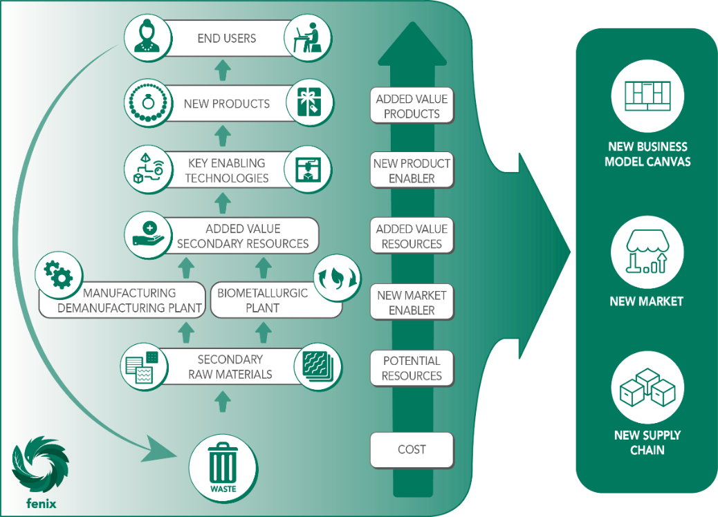
Fig. 1.1 Overall concept of the FENIX project

When products will reach their end-of-life, becoming waste, they will be collected and sent to the FENIX pilot plant. Here, the manufacturing/demanufacturing module will disassemble them, by extracting only the most relevant components (basing on materials contents). These components will be shredded and reduced into powders. Once separated basing on their physical characteristics, the biometallurgical module will recover and refine metals. The additive manufacturing module, for producing value-added products, will exploit these metals (see use case description for details). In case of complex products being produced, the manufacturing/demanufacturing module will be reconfigured for managing and automate the final assembly process.
References
[1] The Ellen MacArthur Foundation, “Towards a Circular Economy: Business Rationale for an Accelerated Transition,” 2015. doi: 2012-04-03.
[2] B. Su, A. Heshmati, Y. Geng, and X. Yu, “A review of the circular economy in China: Moving from rhetoric to implementation,” J. Clean. Prod., vol. 42, pp. 215–227, 2013, doi: 10.1016/j.jclepro.2012.11.020.
[3] W. R. Stahel and G. Reday-Mulvey, Jobs for tomorrow: the potential for substituting manpower for energy, 1st ed. New York: Vantage Press, 1981.
[4] D. W. Pearce and R. K. Turner, “Economics of natural resources and the environment,” Land Econ., vol. 67, no. 2, pp. 272–276, 1991, doi: 10.1016/0308-521X(91)90051-B.
[5] M. A. Reuter, C. Hudson, A. van Schaik, K. Heiskanen, C. Meskers, and C. Hagelüken, “Metal Recycling: Opportunities, Limits, Infrastructure, A report of the Working Group on the Global Metal Flows to the International Resource Panel,” UNEP - United Nations Environment Programme, 2013.
[6] M. Rüßmann et al., “Industry 4.0 - The Future of Productivity and Growth in Manufacturing Industries,” 2015. doi: 10.1007/s12599-014-0334-4.
[7] J. Lee, B. Bagheri, and H.-A. Kao, “A Cyber-Physical Systems architecture for Industry 4.0-based manufacturing systems,” Manuf. Lett., vol. 3, pp. 18–23, 2015, doi: 10.1109/ISORC.2008.25.
[8] M. Nasiri, N. Tura, and V. Ojanen, “Developing disruptive innovations for sustainability: A review on Impact of Internet of Things (IOT),” in PICMET ’17 - Portland International Conference on Management of Engineering and Technology, 2017, pp. 1–10, doi: 10.23919/PICMET.2017.8125369.
[9] A. Soroka, Y. Liu, L. Han, and M. S. Haleem, “Big Data Driven Customer Insights for SMEs in Redistributed Manufacturing,” Procedia CIRP, vol. 63, pp. 692–697, 2017, doi: 10.1016/j.procir.2017.03.319.
[10] D. Dutta, F. B. Prinz, D. Rosen, and L. Weiss, “Layered Manufacturing: Current Status and Future Trends,” J. Comput. Inf. Sci. Eng., vol. 1, pp. 60–71, 2001, doi: 10.1115/1.1355029.
[11] R. Roy, “Sustainable Product-Service Systems,” Futures, vol. 32, pp. 289–299, 2000, doi: 10.1007/978-3-319-70223-0_3.
[12] M. J. Goedkoop, C. J. G. van Halen, H. R. M. te Riele, and P. J. M. Rommens, “Product service systems, ecological and economic basics,” 1999.
[13] E. Manzini and C. Vezzoli, “A strategic design approach to develop sustainable product service systems: examples taken from the ‘environmentally friendly innovation’ Italian prize,” J. Clean. Prod., vol. 11, pp. 851–857, 2003, doi: 10.1016/S0959-6526(02)00153-1.
[14] A. Tukker and U. Tischner, “Product-services as a research field: past, present and future. Reflections from a decade of research,” J. Clean. Prod., vol. 14, no. 17, pp. 1552–1556, Jan. 2006, doi: 10.1016/j.jclepro.2006.01.022.
[15] T. Sakao and Y. Shimomura, “Service Engineering: a novel engineering discipline for producers to increase value combining service and product,” J. Clean. Prod., vol. 15, no. 6, pp. 590–604, 2007, doi: 10.1016/j.jclepro.2006.05.015.
[16] S. Pérez-Martínez, J. Giro-Paloma, A. Maldonado-Alameda, J. Formosa, I. Queralt, and J. M. Chimenos, “Characterisation and partition of valuable metals from WEEE in weathered municipal solid waste incineration bottom ash, with a view to recovering,” J. Clean. Prod., vol. 218, pp. 61–68, 2019, doi: 10.1016/j.jclepro.2019.01.313.
[17] M. Garetti, P. Rosa, and S. Terzi, “Life Cycle Simulation for the design of Product-Service Systems,” Comput. Ind., vol. 63, pp. 361–369, 2012, doi: 10.1016/j.compind.2012.02.007.
[18] T. S. Baines et al., “State-of-the-art in product-service systems,” Proc. Inst. Mech. Eng. Part B J. Eng. Manuf., vol. 221, no. 10, pp. 1543–1552, 2007, doi: 10.1243/09544054JEM858.
[19] O. Fisher, N. Watson, L. Porcu, D. Bacon, M. Rigley, and R. L. Gomes, “Cloud manufacturing as a sustainable process manufacturing route,” J. Manuf. Syst., vol. 47, pp. 53–68, 2018, doi: 10.1016/j.jmsy.2018.03.005.
[20] A. Ericson, P. Müller, T. C. Larsson, and R. Stark, “Product-service systems–from customer needs to requirements in early development phases,” in IPS2 - 1st CIRP Industrial Product-Service Systems Conference, 2009, pp. 1–6, [Online]. Available: http://dspace.lib.cranfield.ac.uk/handle/1826/3612.

