4 Semi-automated PCB disassembly station
Simone Galparoli, Andrea Caielli, Paolo Rosa, Sergio Terzi
Department of Management, Economics and Industrial Engineering, Politecnico di Milano,
Piazza L. da Vinci 32, 20133 Milan, Italy
Abstract The main aim of the FENIX project is the development of new business models and industrial strategies for three novel supply chains in order to enable value-added product-services. Through a set of success stories coming from the application of circular economy principles in different industrial sectors, FENIX wants to demonstrate in practice the real benefits coming from its adoption. In addition, Key Enabling Technologies (KETs) will be integrated within the selected processes to improve the efficient recovery of secondary resources. In this sense, among the available KETs, the adoption of digital and advanced automated solutions allows companies to re-thinking their business strategies, trying to cope with even more severe environmental requirements. Among these technological solutions, the paradigm of Industry 4.0 (I4.0) is the most popular. I4.0 entails the development of a new concept of economic policy based on high-tech strategies and internet-connected technologies allowing the creation of added-value for organizations and society. Unlike the activities developed in T3.1, related to the development and implementation of simulation tools and models for the smartphones’ disassembly process optimization, here the attention has been spent in managing and optimizing a new semi-automated PCBs disassembly station. The disassembly of products is a key process in the treatment of Waste Electrical and Electronic Equipment. When performed efficiently, it enables the maximization of resources re-usage and a minimization of pollution. Within the I4.0 paradigm, collaborative robots (co-bots in short) can safely interact with humans and learn from them. This ﬂexibility makes them suitable for supporting current CE practices, especially during disassembly and remanufacturing operations. D3.2 focuses on describing the semi-automated PCB disassembly process implemented at the POLIMI’s Industry 4.0 Lab, aiming to demonstrate in practice the benefits of exploiting I4.0 technologies in PCB disassembly processes. Results highlight how a semi-automated cell where operators and cobots works together can allow a better management of both repetitive and specific activities, the safe interaction of cobots with operators and the simple management of the high variability related with different kinds of PCBs.
4.1 State of the art on WEEE disassembly processes
This section presents a brief literature analysis related to relevant studies describing the relation between I4.0 and disassembly processes. The attention was placed on the role of digital technologies and techniques (specifically of autonomous robots) in supporting human operators during the disassembly process. A summary of the main contributions analysed is reported in the following sub-sections.
4.1.1 Cobots and disassembly processes
Since many decades, robots are exploited by manufacturers for managing complex assignments. However, common robots do not allow the direct interaction with human operators. Recently, a new generation of robots have been equipped with lots of sensors able to check the presence of humans and react accordingly during operation processes. This innovation made them more autonomous, ﬂexible and cooperative. Under an I4.0 vision, they can interact and work safely side by side with humans and learn from them. Their ﬂexibility enables their exploitation also for disassembly processes. Here, (van den Beukel, 2017) describes as advances in robotics allow manufacturers to employ robots in an increasing number of applications, by increasing yield and reducing waste, as well as extending product lifecycles. Some tentative applications in industry have been described in literature. (Axelsson, 2019) examined how to facilitate the design of a collaborative disassembly workstation in the automotive industry by means of simulation. (Huang et al., 2019) evidenced as human–robot collaborative disassembly is an approach: i) designed to mitigate the effects of uncertainties associated with the condition of end-of-life products returned for remanufacturing, ii) able to handle unpredictability in the frequency and numbers of such returns and iii) able to manage the variance in the remanufacturing process. Here, the authors presented a new method for disassembling press-fitted components in the automotive sector by exploiting human–robot collaboration based on the active compliance provided by a cobot. (Cheng et al., 2017) focused on the assessment and optimization for manufacturing capability of human-robot collaborative disassembly to realize the aggregation and optimization of disassembly services. Here, historical data and real-time data have been fused through manifold algorithm (combining PCA, Grey correlation degree method and AHP) to get more accurate results. (Liu et al., 2019) described a human-robot collaborative disassembly (HRCD) process exploiting Cyber-Physical Systems (CPSs) and Artificial Intelligence (AI), by evidencing the high feasibility and effectiveness of the cobot-based system in interacting with human operators. (Wegener et al., 2014, 2015) described a cobot-assisted disassembly process dedicated to Electric Vehicle (EV) batteries. Here, humans perform complex tasks and cobots perform simple (repetitive) tasks (e.g. removing bolts and screws).
4.1.2 Cobots and WEEE disassembly processes
In terms of cobot-assisted WEEE disassembly processes, there are very few contributions from the literature. From one side, (Bogue, 2019) evidenced as robotic systems exploiting artificial intelligence combined with various sensing and machine vision technologies are playing a growing role in the sorting of e- wastes, prior to recycling. To this aim, the author describes two systems for the disassembly of electronic products based on both robots and cobots, by evidencing how significant technological challenges are limiting the number of systems developed for product disassembly. From another side, (Papadopoulos et al., 2019) proposed a new hybrid human-robot WEEE recycling plant. Here, automatic (robotic based) systems have been exploited to categorize, disassemble, and sort products and components. What emerges from these studies is that, given the high variability of WEEEs to be disassembled, hard automated systems cannot be adopted in this context.
4.1.3 Cobots and PCB disassembly processes
Another important context where cobots could support human operators is in PCB disassembly and desoldering processes. However, no articles have been found in literature assessing this issue.
4.2 The semi-automated PCB disassembly station at POLIMI’s Industry 4.0 Lab
This section introduces the semi-automated PCB disassembly station implemented at POLIMI’s Industry 4.0 Lab, a laboratory of the Manufacturing Group of POLIMI’s Department of Management, Economics and Industrial Engineering completely dedicated to Industry 4.0 technologies and research. Considering existing gaps in literature, the intent of POLIMI within the FENIX project has been to exploit cobots during a PCB disassembly process in order to desolder both hazardous and valuable components from the board. This way, material recovery performances related to the subsequent hydrometallurgical recycling process could be increased, together with the overall profitability of the pilot plant. Within this section, a first overview of the developed PCB disassembly process will be presented. Then, some more details will be discussed about the operational process (and related software). Subsequently, two human-cobot collaborative interfaces developed within the FENIX project will be described. Finally, some details about the data gathering process (and the connection with Chapter 10) will be presented.
4.2.1 Structure of the PCB disassembly station
The semi-automated PCB disassembly station at I4.0Lab is constituted by a small amount of equipments, as: i) a table supporting the full process, ii) a cobot, iii) a frame supporting PCBs during the disassembly process, iv) a heating equipment needed to desolder components from the board, v) a keyboard allowing the direct interaction of the human operator with the cobot, vi) a desktop PC for the configuration of the disassembly process and vii) an extractor hood intercepting (eventually) hazardous fumes. The following Figure 1 shows all the equipments exploited by POLIMI to implement the disassembly station within its I4.0Lab and the real configuration of the disassembly station.

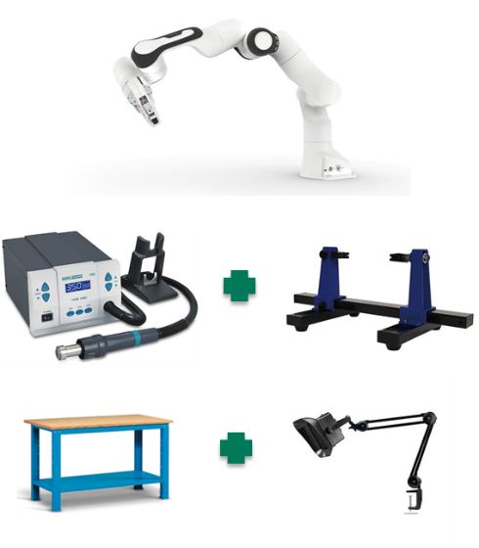 | 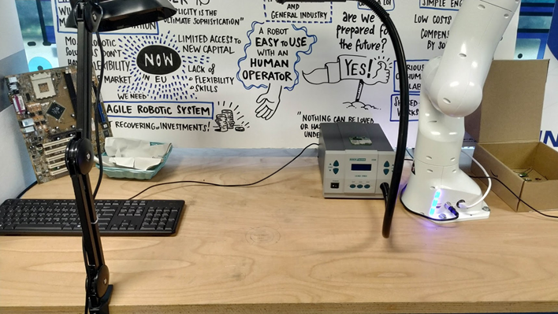
(a) | (b)

Fig. 4.1 The semi-automated PCB disassembly station – (a) main equipments, (b) real configuration
4.2.2 The PCB disassembly process in detail
The semi-automated PCB disassembly process starts from a clean worktop, where all the tools needed for operating have been previously positioned (see Figure 2). Before proceeding with the process, the operator dresses all the personal protection devices required by safety regulations.
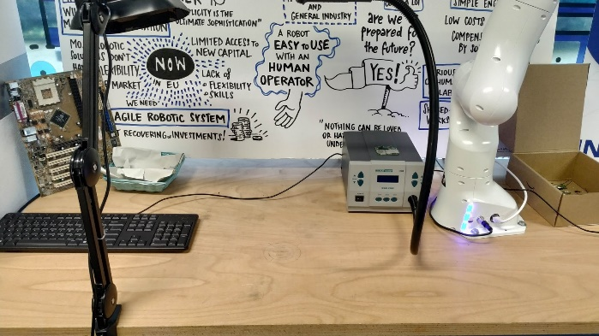 | 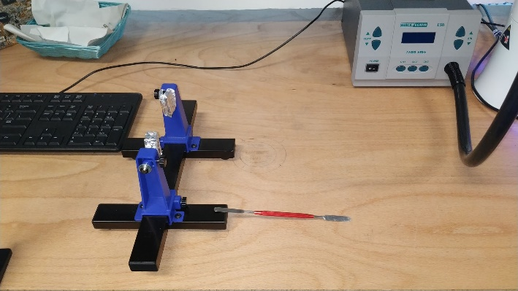
(a) |  | (b)
Fig. 4.2 Workplace setup – (a) clean worktop, (b) tools positioning
Once the workplace is ready to operate, the operator selects the PCB to be disassembled and the disassembly process can start.
4.2.3 Front/back PCB disassembly process setup
Subsequently, the selected PCB is mounted on the frame in order to avoid any involuntary movement during the disassembly process. The PCB is mounted with the front side directed to the cobot. Then, the cobot arm is put in the starting position in front of the PCB (see Figure 3). The distance between the PCB and the cobot arm depends from: i) the type of PCB to be disassembled, ii) the type of component to be desoldered, iii) the air temperature and iv) the airflow. Finally, the operator turns on the desoldering tool and the PCB disassembly process can start.
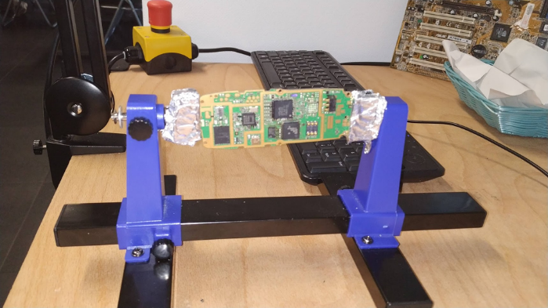 | 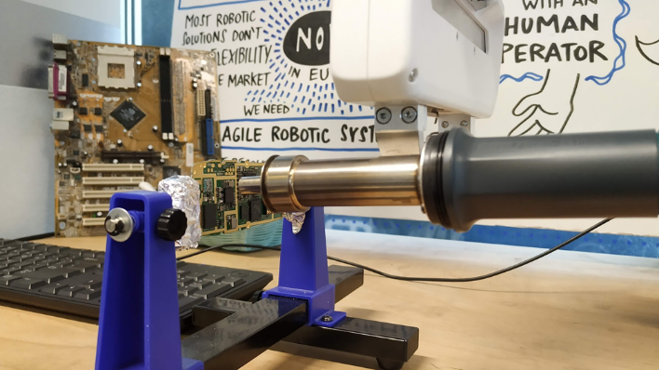
(a) |  | (b)

Fig. 4.3 Front setup – (a) PCB positioning, (b) cobot arm positioning
4.2.4 Front/back PCB desoldering process
After the setup of the disassembly process, the operator can start working on the PCB. First, the hot airflow coming from the heating equipment is directed (through the cobot arm) to the component to be desoldered. Then, the operator (through a metal spatula) can remove all the chipsets whose pins have been already loosened by the desoldering process (see Figure 4). In order to proceed with the back desoldering, the PCB is reversed on the frame and the cobot arm is reset to the starting position.
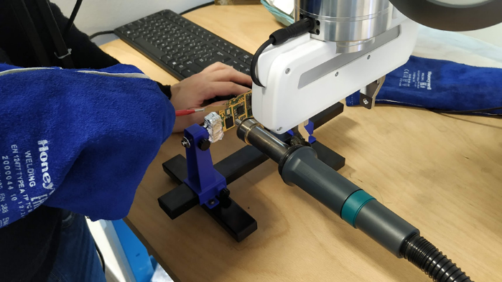 | 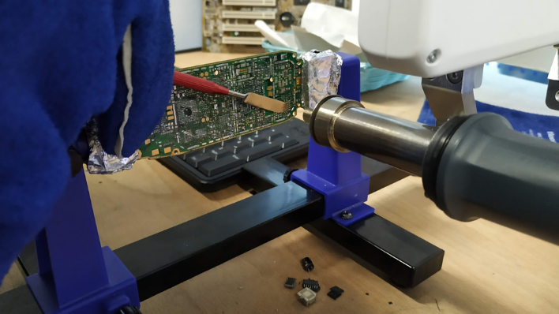
(a) | (b)
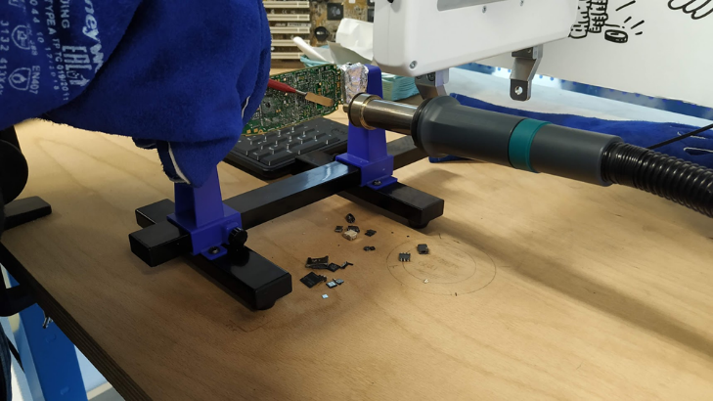 | 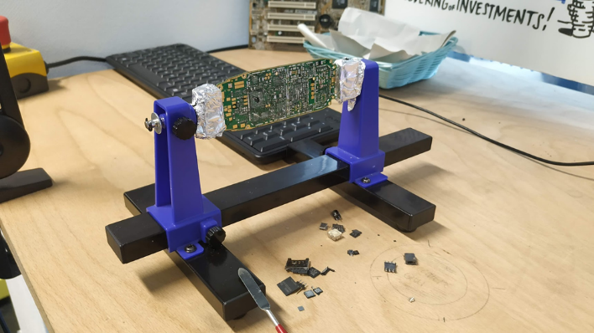
(c) | (d)

Fig. 4.4 Front desoldering – (a) initialization, (b) desoldering 1, (c) desoldering 2, (d) finalization
At the end of the PCB disassembly process (see Figure 5), all components are desoldered from the board and both components and board can be sent to UNIVAQ’s hydrometallurgical recycling process for material recovery.
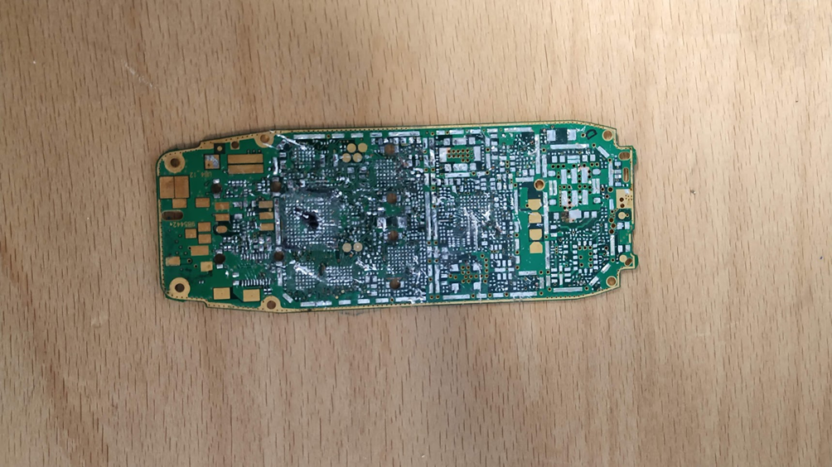
Fig. 4.5 Final PCB desoldering process result

4.3 ROS-based control architecture setup
The robot controller can be divided into two levels. The low-level control and the high-level control. The whole control application is built using ROS (Robot Operating System) to grant a standardized open architecture with the possibility of adding new component interacting with the existing ones in an easy and open way.
The setup is composed of several modules. Each of them takes care of a specific functionality using the ROS topic-based communication architecture to share services and information with other modules. Together with ROS_Kinetic as core element, other third-party essential modules and libraries are included, like:
- LibFranka Is a C++ library developed by Franka® Emika, the cobot producers
- FrankaRos Is a collection of ROS packages developed from Franka® Emika
- Moveit is a ROS motion planning framework

The main nodes developed for the control architecture are:
- Fenix main: Manages all the Moveit entities and provides services for moving the cobot
- Fenix manager: Manages the logic states of the cobot, tracks the actual state and defines the target pose
- Keyboard interface: Provides a simple interface to command the cobot from keyboard keys
4.3.1 Low-level real time controller
The low-level real time controller is based mainly on three parts.
The first one is the ROS controller that takes as input a trajectory, compute, and communicate the required joint speed to the Franka® Control Interface (FCI). The communication takes place over ethernet and ensures 1 KHZ control loop between the control software and the cobot Hardware.
The Franka® Control Interface inside the cobot is responsible of the actuation of the command received from the control unit and of all the safety check described below.
The Loop is closed from the FCI with a constant flow of information on the kinematical and dynamical parameters of the cobot itself forwarded to the ROS controlled and available inside the ROS High-level architecture.
The low-level safety measures are based on torque sensors present on each joint of the cobot. The sensors allow the FCI to monitor the force that each link is applying at every time instant. To operate the cobot needs as information the weight of the loads attached to the end effector. With this parameter it can calculate the theoretical torque each joint need to produce in order to grant the required kinematic and dynamic state. If the measured values differ from the estimated ones more than the specified tolerance the cobot has detected an undesired contact and, in the actual configuration, interrupt its operation instantaneously waiting for a feedback from the operator in order to resume the work.
Other strategies that can be implemented are based on a dynamic response to unwanted interaction such as elastic behaviour or dynamic trajectory re-planning.
4.3.2 High-level task and safety management controller
The high-level control is in charge to define, based on a set of input, the desired position for the cobot end effector, and the desoldering tool. In the actual configuration the input is keyboard based and is represented by a couple of direction and distance representing a vector in 3D space but aligned with one of the three axes. The Control unit sums this vector with the actual position and determines the next desired position. The orientation for the desired pose is considered fixed and with the desoldering tool pointing directly to the PCB. This is the most efficient working position and, has been tested, the easiest way for an operator to clearly visualize and instruct the robot on where to place itself.
From the safety aspect together with the automatic collision detection system discussed above some additional safety measures are included.
From a physical point of view, the operator can use three different emergencies stop procedures.
The first one is associated to a key on the keyboard that tells the robot management system to send the command to stop the cobot. This procedure allows the cobot to immediately restart working by pressing another key and is the lightest emergency stop mode.
The second is a physical separated button that tells directly to the FCI to stop the cobot in case of high-level control failure. After this procedure, the cobot should be re-initialized to start operating again.
The third is a power cut-off button that physically interrupt the power supply to all the motor and stops them. With the power cut off the cobot will collapse since is maintained in it is position by the motors. For this reason, each joint possesses a pneumatic emergency stopper. During the normal operation, the pneumatic systems keeps the stoppers open and the cobot can move but when the power is off the stoppers closed and the arm is fixed in position preventing further movement, operator injures and instrumentation damages.
The last safety measure is the decision to keep the maximal movement speed for the end effector very low (below 10cm/s) in order to test the interaction between Human operator and cobot in the safest condition as possible, even if, it’s clear that this is a limit in the actual performances.
4.3.3 Cobot state and trajectory planning real time visualization tool
The cobot calculate the desired pose from a direct operator input but the way to reach the desired pose perform some more sophisticated calculation. The first aspect to underline is that the cobot possess a knowledge of the 3D spaces around itself, given on startup and therefore its operative space is restricted to avoid collision and injures. The trajectory is calculated in order online for each movement with the OMPL planner using RRT* algorithm.
The trajectory planning wants to minimize:
- The deviation of the tool from the predetermined work plane to increase the performance of the operation.
- The deviation from the operator’s expected trajectory to help the human operator understanding the cobot behaviour.
Together with the trajectory plan the operational space and the planned trajectory are visualized in RViz (Figure 6) in order to allows the operators an even better understanding of the cobot actual state and give a clear feedback.
The 3D real time robot visualizations allow also to disconnect the robot controller and connect the trajectory planner only to the RViz simulation. This is useful in case of test or operators training, since the input are executed in the virtual operating space from the virtual cobot based on the same logic that in a real situation but in a safer environment, providing a clear real time feedback.

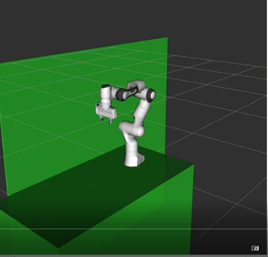
Fig. 4.6 The RViz Real time cobot Visualization
4.3.4 Operator-oriented manual control interface
The manual control interface has been developed to give the operator a way to operate the cobot that is easy and intuitive to allows him to focus on the desoldering operation. Since the orientation of the end effector is decided from the cobot autonomously (and in the first setup is fixed) the operator needs only to input the desired movement of the end effector within respect with the current position.
This can be easily done by an arrow key-based interface. The operator can choose with two keys (“+” and “–“) the amount of cm (in step of 5mm) he wants the cobot to move and with 6 keys (2 for each axes) the direction of the movement.
4.3.4 Real time process data gathering tool
The last aspect implemented is a node used to save the data related to the cobot and desolder tool’s state together with the current state of the desoldering operation.
Each second the following data are saved:
- Time
- Sample ID
- Operational state
- Energy Consumption
- Cobot Joint position
- Cobot Joint Acceleration
The data are used to perform an energetic analysis of the operation together with a performance analysis to guide the future improvement of the Setup.
4.3.5 Desk web interface
Panda Desk is a web interface published by the cobot’s producer.
Panda offers the easiest and fastest workflow-based user experience. Using Desk – Franka® Emika’s browser-based interface – apps can be arranged to create entire tasks in no time. These tasks can quickly be adapted, reused, or deployed on multiple robots to remarkably reduce setup costs. Robot apps incorporate the entire complexity of the system and represent modular building blocks of a production process such as grasping, plugging, insertion and screwing. Individual apps can be parameterized by means of showing Panda poses by demonstration, or adding context relevant parameters such as speed, duration, forces, and triggering actions.
4.3.6 FRANKA® control interface
The Franka® Control Interface (FCI) allows a fast and direct low-level bidirectional connection to the Arm and Hand. By using libfranka, an open source C++ interface, you can send real-time control values at 1 kHz. In addition, rankaROS connects Franka® Emika research robots with the entire ROS ecosystem. It integrates libfranka into ROS Control. Additionally, it includes URDF models and detailed 3D meshes of the robots and end effectors, which allows visualization (e.g. RViz) and kinematic simulations. MoveIt! integration allows pose and trajectory plan and execution.
4.4 Application and results
4.4.1 Manual desoldering tests
The first tests conducted without the usage of the cobot aims to confront the results of the Literature research related to the desoldering operations with a real operation in a real environment and with a real equipment.
The tests conducted have allowed us to define operation parameter for the cobot-assisted procedure. The main involved parameters are 4:
- Temperature of hot air
- Flow power of hot air
- Time to desoldering different components
- Distance of the tools from the components
Together with the parameter the tests aim to test the safety equipment provided to the operator to grant his safety.
4.4.2 Cobot-assisted desoldering tests
The tests have been conducted on two sets of smartphone’s PCBs with similar characteristics. The differences present in the test set represent the real industrial condition since smartphones PCB are an extremely variable product.
The first set of PCBs has been used to perform some qualitative tests to detect problem in the setup and gather feedback from the operators. For this reason, half of the PCBs have been processed by one of the developers of the application and the other half by a new operator trained during the process from the expert one.
The feedback gathered helped in the development of the keyboard interface, of the data acquisition module and in the definition of the rues for the trajectory planning in order to give the correct feedback to the operator in terms of response time and expected behaviour.
The second set of 50 PCBs has been disassembled to test the performance of the setup following the steps here described:
- The PCB is weighted
- The PCB is disassembled, and the process data are gathered automatically
- The PCB is weighted again to detect the removed components’ weight
- The operator reports any problem during the operation.
The data obtained from this set of tests are the ones used to produce the reports of the experiments.
4.4.3 Data gathering from cobot-assisted desoldering tests
The data gathering infrastructure described above presents one main critical aspect. The electrical consumptions for the cobot and for the desoldering tool are estimated based on the state of the equipment and on the nominal consumption data provided from the producer. This limits the real analysis capability and is, therefore, one of the aspects we aim to improve in the next activities with the cobot, even if not as part of the FENIX project.
The solution for this problem is clearly the installation of a smart power measurement system capable of automatically deliver the measured data to ROS in order to be integrated in the data generated ad described in Chapter 10.
The sensors will directly monitor the power consumption from the electrical network to generate data with a frequency of 2HZ. Each data is an average of the consumption in the past 0.5 second.
The data are published through MQTT or can be obtained by issuing a rest call to the device itself.
The Presence of two sensors one for each of the two power-consuming assets will give us a clear understanding of where the most critical power consumption is and clues on how to reduce the energetic impact of the operation.
4.5 Conclusions
Chapter 4 described the implementation a semi-automated PCB disassembly process carried out at the POLIMI’s Industry 4.0 Lab. Considering the results, the cobot-assisted desoldering process allows to completely and easily desolder components from PCBs in about 9 minutes/unit. However, after some preliminary estimates, the full operation time could be furtherly reduced in about 4 minutes/unit. As already discussed in other sections, this experiment allowed to demonstrate in practice what should be the benefits and performances reachable through the introduction of I4.0 technologies in current WEEE management processes. Here, the role of a human operator is essential for two reasons: i) the fast identification of valuable components to be removed and ii) the fast decision-making and problem solving during too complex activities for the cobot.
References
Axelsson, J. (2019). Using IPS software for decision making when developing a collaborative work station - A simulation-based case study in the remanufacturing industry. Malardalen University Sweden.
Bogue, R. (2019). Robots in recycling and disassembly. Industrial Robot, 46(4), 461–466. https://doi.org/10.1108/IR-03-2019-0053
Cheng, H., Xu, W., Ai, Q., Liu, Q., Zhou, Z., & Pham, D. T. (2017). Manufacturing Capability Assessment for Human-Robot Collaborative Disassembly Based on Multi-Data Fusion. Procedia Manufacturing, 10, 26–36. https://doi.org/10.1016/j.promfg.2017.07.008
Huang, J., Pham, D. T., Wang, Y., Qu, M., Ji, C., Su, S., Xu, W., Liu, Q., & Zhou, Z. (2019). A case study in human–robot collaboration in the disassembly of press-fitted components. Proceedings of the Institution of Mechanical Engineers, Part B: Journal of Engineering Manufacture, 1–11. https://doi.org/10.1177/0954405419883060
Liu, Q., Liu, Z., Xu, W., Tang, Q., Zhou, Z., & Pham, D. T. (2019). Human-robot collaboration in disassembly for sustainable manufacturing. International Journal of Production Research, 57(12), 4027–4044. https://doi.org/10.1080/00207543.2019.1578906
Papadopoulos, G. T., Axenopoulos, A., Giakoumis, D., Kostavelis, I., Papadimitriou, A., Wollherr, D., Sillaurren, S., Bastida, L., Oguz, O. S., Wollherr, D., Garnica, E., Vouloutsi, V., Verschure, P. F. M. J., Tzovaras, D., & Daras, P. (2019). A hybrid human-robot collaborative environment for recycling electrical and electronic equipment. SmartWorld 2019 - Ubiquitous Intelligence & Computing, Advanced & Trusted Computing, Scalable Computing & Communications, Cloud & Big Data Computing, Internet of People and Smart City Innovation (SmartWorld/SCALCOM/UIC/ATC/CBDCom/IOP/SCI), 1754–1759. https://doi.org/10.1109/SmartWorld-UIC-ATC-SCALCOM-IOP-SCI.2019.00312
van den Beukel, J.-W. (2017). Industry 4.0 as an enabler of the Circular Economy: preventing the waste of value and permitting the recovery of value from waste. PWC Sustainability and Climate Change Blog. https://pwc.blogs.com/sustainability/2017/06/industry-40-as-an-enabler-of-the-circular-economy.html
Wegener, K., Andrew, S., Raatz, A., Dröder, K., & Herrmann, C. (2014). Disassembly of electric vehicle batteries using the example of the Audi Q5 hybrid system. Procedia CIRP, 23, 155–160. https://doi.org/10.1016/j.procir.2014.10.098
Wegener, K., Chen, W. H., Dietrich, F., Dröder, K., & Kara, S. (2015). Robot assisted disassembly for the recycling of electric vehicle batteries. Procedia CIRP, 29, 716–721. https://doi.org/10.1016/j.procir.2015.02.051

