Circular Economy-oriented simulation: a literature review grounded on empirical cases

Claudio Sassanelli §, Paolo Rosa, Sergio Terzi

Department of Management, Economics and Industrial Engineering,
Politecnico di Milano, Piazza Leonardo da Vinci 32, 20133 Milan - Italy
§ Corresponding author: claudio.sassanelli@polimi.it, https://orcid.org/0000-0003-3603-9735

Abstract
Nowadays, manufacturers are even more impelled in adopting Circular Economy (CE) strategies and consistently adequating their business models to more environment-oriented practices. However, several barriers can be encountered during the transition from linear to circular behaviours. Here, simulation methods can play a strategic role in supporting companies during the assessment of potential solutions to make their products’ lifecycle circular. To this aim, simulation (as part of Industry 4.0 (I4.0) technologies), have been detected through a literature review as one of the main technologies supporting CE. Basing on results, the End-of-Life (EoL) stage seems to play a strategic role within CE practices, with disassembly processes as the enabler for most of these circular strategies (e.g. reuse, reman, recycle, etc.). Moreover, a big focus is on how to foster CE through the improvement of disassembly processes of Waste from Electrical and Electronic Equipments (WEEEs) and Printed Circuit Boards (PCBs). Hence, a deeper analysis of how simulation approaches can contribute to enhance these processes is presented, by defining those technologies needed to improve specific product lifecycle stages.

Keywords: Circular Economy; Simulation; Disassembly; Industry 4.0; Systematic literature review

1. Introduction
Circular Economy (CE) has been increasingly considered during the last decade by manufacturers. In order to turn both portfolios and plants under a circular perspective, (André et al., 2019; The Ellen MacArthur Foundation, 2015) several strategies have been identified in literature (e.g. reuse, remanufacturing, recycling). In parallel, specific business models have also been suggested (Rosa et al., 2019a) in order to apply CE practices and gather real benefits (Rosa et al., 2019b). Here, simulation methods can play a strategic role in supporting companies during the assessment of potential solutions to make their products’ lifecycle circular. Considering the increasing importance of managing EoL stages and the increasing amount of wastes to be disposed of (e.g. in terms of WEEEs and PCBs), the paper investigates how simulation (as part of Industry 4.0 (I4.0) technologies) has been used to support a real transition towards CE. A literature review has been conducted to identify the main role of simulation in terms of CE and Industry 4.0 (I4.0) research contexts. The paper is structured as follows. Section 2 provides the research context. Section 3 explains the research methodology used to conduct the literature review. Section 4 presents results from the literature analysis. Section 5 discusses about results and makes some concluding remarks.

2. Research context
2.1 Circular Economy
The CE paradigm is a new economic model taking over - especially in the last few years - at global level (Reuter et al., 2013). CE aims at shrinking finite resources consumption, by focusing on intelligent design of materials, products and systems, in order to move from traditional economic models (based on a linear process → take, make, dispose) – and conceived without any built-in inclination to recycle (Su et al., 2013; The Ellen MacArthur Foundation, 2015) – towards new (closed loop) patterns balancing economic, environmental and societal impacts.
2.2 Simulation
Simulation approaches aim at managing change, reproducing or projecting the behaviour of a modelled system in order to bring clarity to the reasons for change (Barnett, 2003). Equations, state machines, flowcharts, cellular automata represent different types of rules that, once coupled with an experimental design (Harrison et al., 2007), can allow to define the future behaviour of a modelled system starting from its present state (Borshchev and Filippov, 2004). The most common simulation approaches are:
- System Dynamics (SD) – used for strategic (high-level) decision-making and qualitative analysis (e.g. knowledge management)
- Discrete Event (DE) – used for tactical and operational (medium/low-level) decision-making. It is based on the concept of entities, resources and block charts to describe entity flows and resource sharing
- Agent-Based (AB) – is used for modelling the behaviour of an entire system, by neglecting the behaviour of actors within the system
In particular, SD considers continuous timeframes, while DE and AB consider discrete timeframes (Borshchev and Filippov, 2004).
3. Research method

In order to identify relevant studies describing both the relation between simulation and CE and its practical adoption in lab-scaled and industrial contexts, a literature analysis has been conducted in both Scopus® and Science Direct®. Looking at titles, abstracts and keywords, the terms “Circular Economy” and “Simulation” have been coupled with other terms like “application”, “industrial” or “laboratory”, by gathering 153 documents. In addition, no constraints on the publication year have been considered and only papers written in English have been evaluated. The review process has been carried out in three steps (collection, evaluation and analysis). Firstly, the assessment of abstracts reduced the initial set to 21 documents. Secondly, a full reading of these manuscripts allowed to consider a final set of 19 documents assessing the role of both digital technologies and simulation tools in supporting CE practices. Table 1 reports the three strings used to carry out the searches on Scopus® and Science Direct® databases, leading to 153 results, becoming 149 after redundancies removal among results.
Table 1 Searches by keywords and documents selection
Searches by keywords | Results
Searches by keywords | Scopus | Science Direct
“Circular Economy” AND “Industry 4.0” | 30 | 4
“Circular Economy” AND “Simulation” | 111 | 14
“Circular Economy” AND “Simulation” AND  (“application” OR “industrial” OR “laboratory”) | 33 | 14
Total per database | 174 | 32
Total per database discarding redundancies among searches | 135 | 18
Total discarding redundancies among databases | 135+18-4= 149

Figure 1 shows the research strategy used in the systematic literature review (Sassanelli, Rosa, et al., 2019; Sassanelli, Rossi, et al., 2019; Smart et al., 2017). 3 documents were taken in consideration through cross-referencing processes and 2 through hand search. Finally, 7 more documents were suggested by experts to be added to the list. Applying the three criteria, the set of documents found was reduced to 19 articles to be fully analysed. The selection and examination of documents was conducted by two authors, carrying it out autonomously to avoid bias of analysis along the review. Finally, their results were compared and made consistent to each other, leading to the research presented in this article. The selection was based on the relevance of documents, by considering only those contributions proposing simulation approaches and tools fostering the adoption of CE practices.

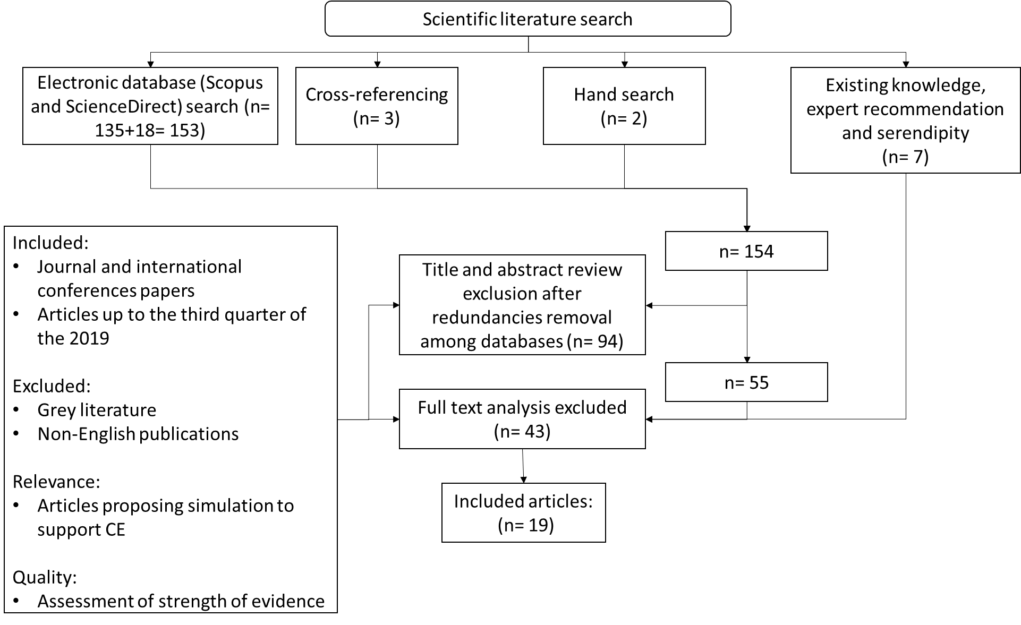
Figure 1 Research strategy (adapted by Smart et al. (2017))

As shown in the next section, all the contributions have been analysed and grouped basing on the purpose of exploiting simulation to support the adoption of CE.

4. Results
The set of 19 documents selected have been analysed through the SLIP (Sort-Label-Integrate-Prioritize) method (Maeda, 2006). At the end, six main groups have been detected: a) design alternatives selection, b) decision-support tools, c) online platforms and monitoring for Industrial Symbiosis (IS), d) recycling performance and Key Performance Indicators (KPIs), e) material and technological properties and f) benefits and business impacts. All contributions were focused on exploring the role of simulation (as part of Industry 4.0 technologies) in supporting the adoption of CE. Most of them (5) were aimed at strengthening and highlighting benefits and business impacts deriving from the adoption of CE. Others (4) considered simulation as a mean to provide recycling performances and KPIs metrics and evaluations. Others, considered simulation as a mean to support decision-making processes (3), selection of different design alternatives (2), evaluation of material and technological properties (2) and adoption of online platforms and monitoring tools at all Industrial Symbiosis levels (2). Table 2 reports some details about the final set of 19 papers.
Table 2 The six roles of simulation and digital technologies to foster circularity adoption
 | Simulation roles in supporting CE
 |  | Design alternatives selection | Decision-support tools | Online platforms and monitoring for Industrial Symbiosis (IS) | Recycling performance and Key Performance Indicators (KPIs) | Material and technological properties | Benefits and business impact
Total |  | 2 | 3 | 2 | 4 | 2 | 5

All the detected roles played by simulation under a circular perspective (see Figure 7 below), have been analysed in the following sub-sections.

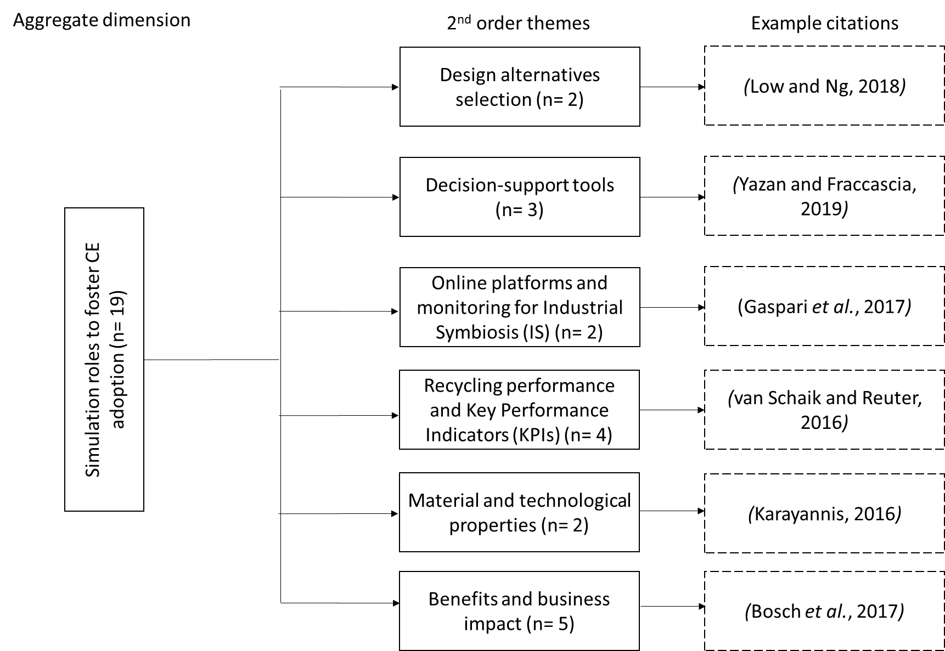
Figure 2 Scheme of Simulation roles fostering CE adoption

3.1.1 Design alternatives selection

Low and Ng (2018) built a methodological framework supporting flexible design of remanufacturing systems. Through an application case study based on remanufacturing of laptop computers for the Cambodian market, they also demonstrated as Monte Carlo simulation can be adopted to gauge the efficacy of different flexible design strategies in managing uncertainties. To support both design alternatives selection and End-of-Life (EoL) options evaluation, Ameli, Mansour and Ahmadi-Javid (2019) developed a simulation-optimization model and applied it on a real-world case. The proposed model is useful to producers for evaluating EoL performances of their products and to policymakers for foreseeing reactions of producers against a defined set of CE strategies.

3.1.2 Decision-support tools

Matino, Colla and Baragiola (2017) quantified the electric energy consumption and environmental impact of unconventional electric steelmaking scenarios, by concurrently monitoring steel composition. Through a Decision Support Tool (DST) they highlighted as the scrap quality strongly affects the monitored energy and environmental KPIs. Moreover, simulations highlighted a slag reduction and yield improvement, by conserving steel quality and marginally improving electric energy consumption. Yazan and Fraccascia (2019) adopted an enterprise input-output model providing a cost–benefit analysis of IS integrated with an Agent-Based (AB) model for simulating how companies share the total economic benefits deriving from IS. The proposed model, under the form of a DSS, allowed to explore the space of cooperation, by enabling users to evaluate if the IS relationship is enacted and define the cost-sharing policy. Pfaff et al. (2018) paired a macroeconomic simulation model and a substance flow model to define both sectoral copper demand and availability of secondary copper. They modelled and simulated several scenarios, aiming at diminishing primary copper demand and rising the supply of secondary copper.
3.1.3 Online platforms and monitoring for Industrial Symbiosis (IS)

Fraccascia and Yazan (2018) designed an AB model to simulate the emergence and operations of self-organized IS networks. Three platform-oriented scenarios (no information-sharing, information sharing of geographical location of wastes and information sharing of sensitive data about IS operating costs) were simulated in two businesses (marble residuals reused in concrete production and alcohol slops reused in fertilizers production). Simulations were useful to demonstrate how online platforms could improve the economic and environmental performance of IS networks. Gaspari et al. (2017) proposed a remanufacturing-oriented simulation model based on a modular framework enabling users in managing process settings and production control policies (e.g. token-based policies). The model allowed the assessment of logistics performances, by enabling the selection of optimal production policies in specific businesses. In addition, an application case in a real remanufacturing environment was proposed.

3.1.4 Recycling performance and Key Performance Indicators (KPIs)

(van Schaik and Reuter, 2016) developed a Recycling Index (RI) (embedding a new material-RI) based on minerals and metallurgical processing simulation models, aimed at measuring recycling performances of a product and its embedded materials. (Wiedenhofer et al., 2019) extended the Economy-Wide Material Flow Analysis (EW-MFA) framework jointly addressing material flows, in-use stocks of manufactured capital and waste. Through a fully consistent Material Inputs, Stocks and Outputs (MISO) model, they enabled a dynamic and complete appraisal of resources, stocks and wastes in a socio-economic metabolism. (Innocenzi et al., 2018) simulated a solvent extraction process to determine the mass and energy balance of the whole recycling treatment of spent lamps. The process consisted in the recovery of rare earth elements from sulfuric leaching solutions achieved by a dissolution of fluorescent powders of lamps. (Wakiru et al., 2018) adopted a Discrete Event Simulation (DES) model to analyse the effect of two CE strategies (remanufacturing and maintenance) on power plants availability and maintenance time. A thermal power plant located in a remote region was considered as a demonstration case.
3.1.5 Material and technological properties
(Karayannis, 2016) studied the development of building bricks through a pilot-plant simulation of industrial processes for red bricks manufacturing. They found that extruded and fired bricks produced with up to 15 wt% recycled steel industry by-products is feasible without compromising their technological properties. (Odenbreit and Kozma, 2019) performed 15 large scale push-out tests, two large scale composite beam tests and several finite element simulations for demountable flooring and beam systems. These applications were useful to determine the suitability of dis-/re-assembly processes and some inner material characteristics.
3.1.6 Benefits and business impacts

(Bosch et al., 2017) used a dynamic business model simulation for estimating CE business impacts. (Dong et al., 2017) conducted a System Dynamics (SD)-based simulation, whose results stated that manufacturing transition towards CE can foster coal power and cement companies to decrease waste emission and improve economic profits. (Reuter, 2016) focused on the metallurgical industry. Given that: i) all metals have strong intrinsic recycling potentials and ii) a digital integration of metallurgical reactor technologies and systems can support dynamic feedback control loops, they used modelling, simulation, and optimization tools to perform real-time measurement of ore and scrap properties in intelligent plant structures, by enabling CE-oriented big data analysis and process control of industrial metallurgical systems. Results were used to elaborate the resource efficiency of CE systems. (Hao et al., 2012) proposed a similar SD model and applied it on coal-dependent systems with a full lifecycle perspective. Thirteen development projects divided in two types of scenarios were run on the model. Simulation results were analysed through the efficacy coefficient method in order to determine the best project and demonstrate benefits coming from CE adoption. (Teekasap, 2018) used SD models to enlighten benefits deriving from CE in countries without resource shortage issues. Simulation demonstrated as, despite investment costs, countries can obtain economic benefits through a lower raw material cost in a long run.

5. Discussion and conclusions
This research consisted in a systematic literature assessment aiming at understanding the real contribution of simulation methods and tools to foster the adoption of CE. The purpose of exploiting simulation to support CE practices has been split in six groups: a) design alternatives selection, b) decision-support tools development, c) online platforms and monitoring tools development for Industrial Symbiosis (IS), d) recycling performance and Key Performance Indicators (KPIs) quantification, e) material and technological properties evaluation, f) benefits and business impacts assessment. Benefits and business impact assessment and recycling performance and KPIs quantification are the two most explored simulation roles to foster CE practices. Moreover, results show that disassembly processes (among other EoL practices) are becoming the enabler for great part of circular strategies detected, raising the need for automated solutions. So far, only scattered attempts have been done in this direction, by exploiting simulation as reference approach (Ameli et al., 2019; Kobayashi and Kumazawa, 2005; Wang and Wang, 2019). In addition, new actions must be focused on the improvement of disassembly processes in the WEEE sector (Ongondo et al., 2011). About this last issue, a recent work (Rocca et al., 2020) presented a lab-scaled case were different I4.0-based technologies have been exploited to support CE practices. Here, a virtual testing of a WEEE disassembly plant configuration was implemented through a set of dedicated simulation tools. They highlighted as service-oriented (event-driven) processing and information models can support the integration of smart and digital solutions in current CE practices at the factory level. Limitations/main issues of the literature assessment presented in this work can be considered the limited amounts of scientific databases considered, the limited number of works classified and the absence of a classification in terms of automation processes exploiting traditional simulation approaches that could support also CE practices. This would push CE to an even stronger integration with I4.0 technologies (Rosa et al., 2020). Future researches could assess how the previously detected simulation purposes should be extended and analysed in terms of:
- Adopted means (e.g. methods, tools, algorithms, rules, virtual environments, system architectures) supporting circularity issues
- Improved lifecycle phases
- Involved technologies
- Selected simulation types (e.g. physics-based modelling or virtual/augmented reality)
- Improved human-machine interactions
- Optimized variables
- Addressed issues along systems’ lifecycle.

Acknowledgements
This work has received funding from the European Union’s Horizon 2020 research and innovation programme under grant agreement No 760792. In any case, the present work cannot be considered as an official position of the supporting organization, but it reports just the point of view of the authors.

References
Ameli, M., Mansour, S. and Ahmadi-Javid, A. (2019), “A simulation-optimization model for sustainable product design and efficient end-of-life management based on individual producer responsibility”, Resources, Conservation and Recycling, Elsevier, Vol. 140, pp. 246–258.
André, H., Ljunggren Söderman, M. and Nordelöf, A. (2019), “Resource and environmental impacts of using second-hand laptop computers: A case study of commercial reuse”, Waste Management, Vol. 88, pp. 268–279.
Barnett, M.W. (2003), Modeling & Simulation in Business Process Management.
Borshchev, A. and Filippov, A. (2004), “From System Dynamics and Discrete Event to Practical Agent Based Modeling: Reasons, Techniques, Tools”, SDS 2004 - 22nd International Conference of the System Dynamics Society, Oxford (UK), pp. 1–23.
Bosch, T., Verploegen, K., Grösser, S.N. and van Rhijn, G. (2017), “Sustainable Furniture that Grows with End-Users”, Dynamics of Long-Life Assets - From Technology Adaptation to Upgrading the Business Model, Springer International Publishing, Cham, pp. 303–326.
Dong, S., Wang, Z., Li, Y., Li, F., Li, Z., Chen, F. and Cheng, H. (2017), “Assessment of comprehensive effects and optimization of a circular economy system of coal power and cement in Kongtong District, Pingliang City, Gansu Province, China”, Sustainability, Vol. 9 No. 5, pp. 1–16.
Fraccascia, L. and Yazan, D.M. (2018), “The role of online information-sharing platforms on the performance of industrial symbiosis networks”, Resources, Conservation and Recycling, Elsevier, Vol. 136, pp. 473–485.
Gaspari, L., Colucci, L., Butzer, S., Colledani, M. and Steinhilper, R. (2017), “Modularization in material flow simulation for managing production releases in remanufacturing”, Journal of Remanufacturing, Springer Netherlands, Vol. 7 No. 2–3, pp. 139–157.
Hao, Y.H., Wang, L.M. and Qiu, L.X. (2012), “System Dynamics Simulation and Adjustment on Coal Resource Utilization Based on Circular Economy”, Advanced Materials Research, Trans Tech Publications Ltd, Vol. 524–527, pp. 3190–3201.
Harrison, J.R., Lin, Z., Carroll, G.R. and Carley, K.M. (2007), “Simulation modeling in organizational and management research”, Academy of Management Review, Vol. 32 No. 4, pp. 1229–1245.
Innocenzi, V., Ippolito, N.M., Pietrelli, L., Centofanti, M., Piga, L. and Vegliò, F. (2018), “Application of solvent extraction operation to recover rare earths from fluorescent lamps”, Journal of Cleaner Production, Vol. 172, pp. 2840–2852.
Karayannis, V.G. (2016), “Development of extruded and fired bricks with steel industry byproduct towards circular economy”, Journal of Building Engineering, Elsevier, Vol. 7, pp. 382–387.
Kobayashi, H. and Kumazawa, T. (2005), “A Simulation-based Decision Support Methodology for Reuse Business”, ECODIM ’05 - 6th IEEE International Symposium on Environmentally Conscious Design and Inverse Manufacturing, pp. 598–605.
Low Sze Choong, J. and Ng, Y.T. (2018), “Improving the Economic Performance of Remanufacturing Systems through Flexible Design Strategies: A Case Study Based on Remanufacturing Laptop Computers for the Cambodian Market”, Business Strategy and the Environment, Vol. 27, pp. 503–527.
Maeda, J. (2006), The Laws of Simplicity: Design, Technology, Business, Life, MIT Press.
Matino, I., Colla, V. and Baragiola, S. (2017), “Quantification of energy and environmental impacts in uncommon electric steelmaking scenarios to improve process sustainability”, Applied Energy, Elsevier, Vol. 207, pp. 543–552.
Odenbreit, C. and Kozma, A. (2019), “Dismountable Flooring Systems for Multiple Use”, IOP Conference Series: Earth and Environmental Science, Vol. 225, pp. 1–8.
Ongondo, F.O., Williams, I.D. and Cherrett, T.J. (2011), “How are WEEE doing? A global review of the management of electrical and electronic wastes”, Waste Management, Elsevier Ltd, Vol. 31 No. 4, pp. 714–730.
Pfaff, M., Glöser-Chahoud, S., Chrubasik, L. and Walz, R. (2018), “Resource efficiency in the German copper cycle: Analysis of stock and flow dynamics resulting from different efficiency measures”, Resources, Conservation and Recycling, Elsevier, Vol. 139, pp. 205–218.
Reuter, M.A. (2016), “Digitalizing the Circular Economy: Circular Economy Engineering Defined by the Metallurgical Internet of Things”, Metallurgical and Materials Transactions B: Process Metallurgy and Materials Processing Science, Springer US, Vol. 47 No. 6, pp. 3194–3220.
Reuter, M.A., Hudson, C., van Schaik, A., Heiskanen, K., Meskers, C. and Hagelüken, C. (2013), Metal Recycling: Opportunities, Limits, Infrastructure, A Report of the Working Group on the Global Metal Flows to the International Resource Panel, UNEP - United Nations Environment Programme.
Rocca, R., Rosa, P., Sassanelli, C., Fumagalli, L. and Terzi, S. (2020), “Integrating Virtual Reality and Digital Twin in Circular Economy Practices: A Laboratory Application Case”, Sustainability, Vol. 12 No. 2286, pp. 1–27.
Rosa, P., Sassanelli, C. and Terzi, S. (2019a), “Towards Circular Business Models: A systematic literature review on classification frameworks and archetypes”, Journal of Cleaner Production, Vol. 236 No. 117696, pp. 1–17.
Rosa, P., Sassanelli, C. and Terzi, S. (2019b), “Circular Business Models versus Circular Benefits: An Assessment in the Waste from Electrical and Electronic Equipments Sector”, Journal of Cleaner Production, Elsevier B.V., Vol. 231, pp. 940–952.
Rosa, P., Sassanelli, C., Urbinati, A., Chiaroni, D. and Terzi, S. (2020), “Assessing relations between Circular Economy and Industry 4.0: a systematic literature review”, International Journal of Production Research, Taylor & Francis, Vol. 58 No. 6, pp. 1662–1687.
Sassanelli, C., Rosa, P., Rocca, R. and Terzi, S. (2019), “Circular Economy performance assessment methods: a systematic literature review”, Journal of Cleaner Production, Elsevier B.V., Vol. 229, pp. 440–453.
Sassanelli, C., Rossi, M., Pezzotta, G., de Jesus Pacheco, D.A. and Terzi, S. (2019), “Defining lean product service systems features and research trends through a systematic literature review”, International Journal of Product Lifecycle Management, Vol. 12 No. 1, pp. 37–61.
van Schaik, A. and Reuter, M.A. (2016), “Recycling Indices Visualizing the Performance of the Circular Economy”, World of Metallurgy - ERZMETALL, Vol. 69 No. 4, pp. 5–20.
Smart, P., Hemel, S., Lettice, F., Adams, R. and Evans, S. (2017), “Pre-paradigmatic status of industrial sustainability: a systematic review”, International Journal of Operations & Production Management, Vol. 37 No. 10, pp. 1425–1450.
Su, B., Heshmati, A., Geng, Y. and Yu, X. (2013), “A review of the circular economy in China: Moving from rhetoric to implementation”, Journal of Cleaner Production, Elsevier Ltd, Vol. 42, pp. 215–227.
Teekasap, P. (2018), “National economic benefits of circular economy policy”, ICBIR 2018 - 5th IEEE International Conference on Business and Industrial Research, IEEE, pp. 486–490.
The Ellen MacArthur Foundation. (2015), Towards a Circular Economy: Business Rationale for an Accelerated Transition, available at:https://doi.org/2012-04-03.
Wakiru, J., Pintelon, L., Muchiri, P.N. and Chemweno, P. (2018), “Maintenance Optimization: Application of Remanufacturing and Repair Strategies”, Procedia CIRP, Elsevier, Vol. 69, pp. 899–904.
Wang, X.V. and Wang, L. (2019), “Digital twin-based WEEE recycling, recovery and remanufacturing in the background of Industry 4.0”, International Journal of Production Research, Taylor & Francis, Vol. 57 No. 12, pp. 3892–3902.
Wiedenhofer, D., Fishman, T., Lauk, C., Haas, W. and Krausmann, F. (2019), “Integrating Material Stock Dynamics Into Economy-Wide Material Flow Accounting: Concepts, Modelling, and Global Application for 1900–2050”, Ecological Economics, Elsevier, Vol. 156, pp. 121–133.
Yazan, D.M. and Fraccascia, L. (2020), “Sustainable operations of industrial symbiosis: an enterprise input-output model integrated by agent-based simulation”, International Journal of Production Research, Vol. 58 No. 2, pp. 392–414.

