Synthesis and Application of Hydrophilic Polymer Nanoparticles for Water Shut-Off

Arianna Zanoni1, Ruggiero M. Pesce1, Mattia Sponchioni,1, Lucilla Del Gaudio2, Roberto Lorefice2, Paola Albonico2, Alessandra Belloni2, Alberto Cesana1, Massimo Morbidelli1 and Davide Moscatelli1,*

1Department of Chemistry, Materials and Chemical Engineering “Giulio Natta”, Politecnico di Milano, Via

Mancinelli 7 - 20131 Milano, Italy.

²ENI SPA, Via Felice Maritano 26 – 20097 San Donato Milanese, Italy.

- Corresponding author: Davide Moscatelli; E-mail: davide.moscatelli@polimi.it

Abstract: During the last years, much effort has been done by oil companies to decrease the amount of water that is pumped up with oil, especially from mature reservoirs, where the water production is huge. Besides reducing the profit margin, the water extracted from an oil field is polluted by different organic and inorganic compounds and must be properly treated before being discharged or re-injected. Alternatively it must be disposed with high treatment and / or disposal costs.
To overcome costs associated to water treatment/disposal, mechanical and chemical strategies devoted to the reduction of the amount of extracted water (i.e. water shut-off) are applied. Among them, hydrophilic polymer micro- and nanogels are promising materials that are gaining increasing interest. They are three-dimensional networks able to retain water by increasing in size and thus creating a physical barrier to the water flowing. In this work, nano- and micro- absorbent particles made up of crosslinked poly(methacrylic acid-co-oligo(ethylene glycol) methyl ether methacrylate) p(MAA-co-OEGMA) were synthetized via inverse suspension polymerization in Lamix, an aromatic-free hydrocarbon blend. The formulation was optimized in terms of OEGMA mole fraction in order to grant a high swelling in seawater, and hence high efficacy in the water shut-off. Finally, the suspension was revised to be produced on a ton-scale and injected in an open-hole, partially depleted oil reservoir for a first pilot field test. A one-year monitoring was conducted by evaluating the oil productivity as well as the water fraction (i.e. water cut) under conventional extraction procedures. This trial assessed a decrease in the water cut, which is reduced of 30% as well as an increase in the oil production from 5 m3/d to 30 m3/d¹. This confirmed the developed microgels as a promising tool for water shut-off.

Keywords: Water shut-off; Hydrophilic Polymers; Nanogels; Microgels; Field test; Water cut

  - Introduction
At the end of its lifetime, a typical oil reservoir can reach the production of three barrels of water each barrel of oil.² However, water production affects every stage of the oilfield life, from the exploitation to the abandonment. During the first years of production, water usually comes from an aquifer placed right under the reservoir through high permeability zones or fractures as well as a consequence of the water coning phenomenon.³ In mature oilfields, the extracted water may be also anthropogenic. Indeed, water is pumped in the reservoir to displace the residual oil (i.e. water flooding)⁴ or to case leaks.⁵ The presence of water leads to a rapid reduction in the productivity and considerable increases in production costs, mainly connected to its management. In fact, organic and inorganic pollutants contaminate the produced water, bringing about serious ecological concerns, among which the contamination of surface and underground water and soil. This makes careful wastewater treatment compulsory before the final disposal.⁶ Since water treatment plants are usually centralized and far from the reservoir, the costs for transportation significantly affect the overall process economy.⁶ These water management costs may be so important to lead to the closure of a reservoir well before all of the available oil is run out.⁷,8 Besides limiting the productive life of a reservoir, water causes corrosion of piping, fines migration and hydrostatic loading.⁹ This picture gives a clear idea of the urgency for an efficient and cost-effective water shut-off strategy.
Historically, mechanical and chemical techniques have been implemented to reduce the water production during the reservoir exploitation. The former, based on plugs, patches and packers, are effective only when the water and the oil production intervals are well defined and separated.¹⁰ However, they are useless when water and oil are produced together or when the water comes from the in-depth formation.¹¹ Chemical water shut-off methods are more feasible and practical.¹¹ One of the first attempt consisted in the injection of a permeability modifier close to the fracture. The difficulty in this case relies in the precise localization of the specific water production zone.³ Nowadays, crosslinked polymeric gels are the most studied chemical treatments to reduce the water-cut from nearly depleted oil fields. This is due to their low-cost and effectiveness in reducing the water production from the reservoir.¹² In particular, hydrogels are three-dimensional polymer networks able to swell and retain a large amount of water, increasing in size and weight. The ability of entrapping water and changing conformation has been exploited in various fields, in addition to oil and gas applications, such as drug delivery¹³, tissue engineering¹⁴ and actuators for optics and fluidics.¹⁵ So far, partially hydrolyzed polyacrylamides (HPAM)-based hydrogels have been deeply studied and tested in water shut-off applications. When polyacrylamide is mixed with an alkaline solution, some of the amide groups convert into negatively charged carboxylate groups, and the polymer becomes susceptible to ionic cross-linking. Cr3+ is often used as crosslinker.¹⁶,11,8 However the ionic bonds are unstable from 70 °C on up.¹⁷ For this reason, some studies focused on creating PAM-based hydrogels with covalent bonding, such as a hydroquinone/hexamethylene tetramine crosslinked polyacrylamide gelling system.¹⁸ Even with this improvement, an additional problem is that PAM degrades at temperatures greater than 80 °C.16 Phenol- formaldehyde bulk gelation systems seem to

withstand high temperatures¹⁹, but the two monomers are known to be toxic.10 Polyethylene imine (PEI) is another monomer quite used in water shut-off applications10, alone or in combination with HPAM²⁰,²¹ or reinforced with coal or fly ashes.²² Lately, blends of polyvinyl alcohol (PVA)-polyvinyl pyrrolidone (PVP) were studied as gelling materials²³, with the crosslinking reaction starting when the formulation is placed at high temperatures. These formulations, however, are more used in fractured reservoirs²⁴ due to their difficulty in entering selectively in the water channels.¹⁶
Despite many examples of water shut-off materials have been proposed in the literature, most of them are still on a laboratory investigation stage. Very few examples of a scaled-up production followed by injection of the formulation in a real oil reservoir are available. Al-Muntasheri et al, for example, injected a thermally stable water-soluble polymer with an organic crosslinker in different fields in Venezuela to form a hydrogel in situ.3 Similar polyacrylamide- tert Butyl Acrylate crosslinked with Polyethyleneimine hydrogels were also applied in two oilfields, obtaining a water cut reduction from 63% to 25% and an increase in the oil production in the first oilfield. However, in the second one the treatment proved to be unsuccessful. The huge problem of these systems is that they do not differentiate oil and gas zones from those producing water and are effective in near wellbore regions.²⁵ For an improved modification of water profiles, microgels turned out to be more appropriate,²⁶ since are able to penetrate deeper in the reservoir. ²⁷ Microgels are preformed crosslinked particles with size ranging from 10 to 30 μm that are injected in the reservoir in the form of a liquid suspension. In the work of El-Karsani et al, acrylamide-based microgels were injected as a water suspension in three reservoirs in China and proved to efficiently obstruct the fractures, mainly because of their elasticity, which allows them to deform and recover their shape when passing through the pore throats. Following the treatment, the water cut decreased from 55% to 26%.22 However, also in this case, a poor selectivity is obtained, with the microspheres obstructing indifferently the flowing of water as well as of the oil, thus leading to a reduced productivity. Therefore, a selective material, able to prevent the water flowing but keeping unaltered the pumpability of the hydrocarbon phase is urgently looked for by the oil companies.
In this work, hydrophilic absorbent micro- and nanogels were synthetized in a hydrocarbon phase. The procedure described in this paper has been patented previously1. This enabled their injection in a real oil reservoir, through the production well, using the same reaction medium. In this way, there is no need to introduce further water in the well. In addition, and more importantly, the particles preserve a shrinked size until they get into contact with water. This avoids undesired obstructions to the flow of oil, whose production is kept unaltered. On the other side, the swelling occurring in the presence of water determines an increase in the size of the particles and hence a selective insulation of the water-rich zones. More in details, the polymeric particles made of crosslinked methacrylic acid-co-oligo(ethylene glycol) methyl ether methacrylate (OEGMA) copolymers were synthetized via inverse suspension polymerization in an aromatic- free hydrocarbon blend (Lamix30, C11-C14). The particle behavior was first studied on a laboratory scale, to investigate their swelling ability as well as how polymer design parameters such as the composition of the surfactant mixture and the OEGMA feed affect the amount of absorbed water and particle migration in the aqueous phase. Due to the different types of reservoir (sandy, rocky, with canal of different size), polymer particles with two different size distributions but same composition were synthetized, one ranging from 100 to 200 nm and the other one of about 20 µm.
The micro-gel particles were finally produced on a ton-scale and injected in a mature oil reservoir. The efficiency of the particles in reducing the water cut was therefore evaluated in a real case test, consisting in the monitoring of the reservoir productivity under typical oil well conditions for one year. The results were great, with a water cut reduction and an increase in the oil recovery from 5 m3/d to 30 m3/d.

Experimental Section

Materials
Oligo(ethylen glycol) methyl ether methacrylate (OEGMA 95%, Mn 2000 Da), methacrylic acid (MAA, 99%), polysorbate 80 (SPAN 80), sorbitan monooleate 80 (TWEEN 80), ammonium persulfate (APS, ≥ 98%), sodium metabisulfite (SMBS, ≥ 99%), sodium dodecyl sulphate (SDS, ≥ 99%), N,N’- methylenebis(acrylamide) (MBA, 99%) were purchased from Sigma Aldrich and used without further treatment. Lamix was supplied by ENI s.p.a.

Nanoparticle Synthesis
Nanoparticles (NPs) of poly(MAA-co-OEGMA) were produced via inverse suspension polymerization at 0
°C using a probe sonicator (Hielscher UP200S) to allow the formation of a nano-suspension. Two different phases were initially produced: the oily continuous phase was prepared in a three-necked flask by loading 64 g of Lamix and 1.44 g of a mixture of TWEEN 80 and SPAN 80. The weight percentage of the two surfactants was selected based on the desired hydrophilic to lipophilic balance (HLB). In two cases (i.e. samples LS5 and LS6 in Table 1), 0.014 and 0.028 g of SDS were added to the mixture, while the total amount of surfactant was kept constant. The discontinuous aqueous phase was prepared into a vial by mixing 6.97 g of distilled water, 5 g of MAA, 5.77 of a solution of NaOH 30% w/w, 1 g of a 50% w/w aqueous solution of OEGMA, 0,056 g of MBA and 0.239 g of APS. While the continuous phase was sonicated, the discontinuous phase was added drop by drop. For the whole reaction period, the mixture was maintained at 0-5 °C through an ice-bath. After 20 minutes of sonication, 0.2 g of SMBS dissolved in 0.5 g of distilled water were added. The reaction was allowed to continue for further 30 minutes.

Microparticle Synthesis
To synthesize the microgels, the same relative amount of surfactants as LS6 sample was used. On the other hand, OEGMA/MAA ratio was varied to find the best swelling performance. The continuous phase was prepared in a three-necked reactor by loading 404 g of Lamix, 5.74 g of TWEEN 80, 5.03 g of SPAN 80 and
0.11 g of SDS. The system was heated up to the reaction temperature of 70 °C. The discontinuous phase was separately prepared in a beaker, mixing 37.87 g of MAA and 43.75 g of a 30% w/w NaOH solution. The neutralization was carried out in an ice bath. The OEGMA amount was varied between 5% and 12.5% w/w with respect to MAA to find the best swelling performance and was added with 0.379 g of MBA and 0.253 g

of APS to the beaker as well. The discontinuous phase was injected in the reactor after it was subjected to nitrogen purging and after 70 °C were reached. The reaction lasted 3 hours.

Suspension Characterization
To characterize the NPs in terms of particle size distribution, dynamic light scattering (DLS) measurements were performed with a Malvern Zetasizer Nano ZS at a scattering angle of 173° (backscatter). The sample was diluted to a concentration of 0.5% w/w before the measurement. Three independent analyses were performed, and the results shown are the average of the three. The particle diameter was then measured in water by diluting the NP latex in a 20 fold excess of water and letting the NPs to equilibrate overnight.
The amount of NPs that passed from the suspension to the water phase was assessed with the use of a thermogravimetric balance (Fisher Scientific OHAUS MB 35). 1 g of NP suspension was weighted before and after the contact with water, and the weight after all Lamix and water were evaporated was registered. The difference in weight before and after the contact with water gave the amount of particles that migrated in the aqueous phase. In particular, the suspension was added to a water phase with a volume ratio of 1:3. After one week of contact in static conditions, the upper oily phase was withdrawn and subjected to thermogravimetric analysis.
The micro-particle size was measured via laser diffraction spectroscopy through a Malvern Mastersizer 3000 and confirmed with the use of Leica Compound Microscope DM LM 020-520-718. The size measurements were performed by diluting the sample to a concentration of 1% w/w. To confirm the obtained results, a droplet of the solution was deposited on a microscope slide and a picture of the image obtained with the microscope was analyzed with the software Leica LAS Live Image Builder. The particle size was determined, and the final diameter was taken as the average of about 50 measures. As for the NPs, the measure was taken first in Lamix and then after the latex was diluted in water and let equilibrate overnight.
Finally, in both cases, the swelling percentage was calculated as the percentage of volume variation over the initial volume, according to equation 1.
$$Swelling \left[\%\right]=\frac{V_{f}-V_{i}}{V_{i}}×100$$ | (1)

Where Vf and Vi are the particle volumes in Lamix and after equilibration in water, respectively. The NP
swelling was evaluated in distilled water and in two synthetic sea waters with increasing ionic strength: “water 1” (concentration of Na+ ions 9 g/L, Ca2+ ions 0.53 g/L, Mg2+ ions 5.8 g/L) and “water 2” (concentration of Na+ ions 34 g/L, Ca2+ ions 5.8 g/L, Mg2+ ions 0.6 g/L).

Results and Discussion

Nanoparticle Synthesis and Characterization
Crosslinked polymer particles in the nanometer size range (i.e. nanogels) were obtained via free-radical polymerization in Lamix through low temperature and high-energy mixing conditions. To enhance the hydrophilicity of the particles, methacrylic acid was fully neutralized with sodium hydroxide and polymerized in its anionic form. Even if charged particles possess a higher hydrophilicity, their swelling capacity sharply decreases when they are put in contact with water with a high ionic strength. This is due to the screening effect operated by the water ions that enter the particles and attach to the negative charges of the polymer, keeping the system electrically neutral. Therefore, the nanoparticles become much less hydrophilic, decreasing the swelling ability. To counter-balance this effect and ensure high swelling efficiency in seawater, OEGMA was co-polymerized with methacrylic acid (Figure 1).

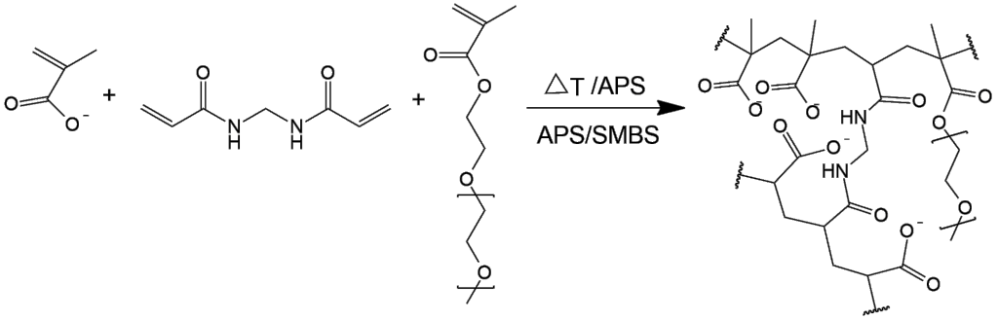

Figure 1. Crosslinked methacrylic acid-ethylene glycol methyl ether acrylate copolymer.

OEGMA is a hydrophilic but uncharged monomer, whose ability to form hydrogen bonds with water is therefore only poorly affected by the presence of low molar mass electrolytes. This makes OEGMA-based polymers very suitable in the synthesis of hydrogels, especially for biomedical applications, both as homopolymer²⁸ and copolymer, to stabilize hydrophobic monomers forming amphiphilic structures.²⁹
Firstly, the diameter and polydispersity index (PDI) for the produced nanogels were evaluated through DLS analysis and correlated to the HLB of the mixture of surfactant, at a given OEGMA/MAA ratio (i.e. 0.9 w/w). Different HLBs were obtained by varying the relative amount of SPAN 80 (HLB = 4.3) and TWEEN 80 (HLB
=15). The amount of the two surfactants was calculated according to the following Equation 2:
𝐻𝐿𝐵T𝑂T = 𝑋T𝐻𝐿𝐵T + 𝑋S𝐻𝐿𝐵S (2)
where 𝑋𝑖 is the mass fraction of the component i, while T and S indicate the TWEEN 80 and SPAN 80,
respectively. As shown in Table 1, the obtained NPs have a diameter ranging from 100 to 200 nm, and the
diameter increases with the HLB. Increasing values of HBL mean increasing amount of TWEEN 80 over SPAN 80. Since TWEEN 80 is much more hydrophilic than SPAN 80, the hydrophilic portion of surfactant that stays in the water phase inside the NPs is bigger, thus leading to an overall increase in the diameter, from 100 to 200 nm. As said previously, SDS was added to the surfactant mixture to increase the swelling performance (LS5 and LS6 samples).

Table 1. NPs size variation with the HLB values and effect of adding SDS as an additional surfactant.

sample | HLB (-) | average diameter (nm) | PDI (-)
LS1 | 4.3 | 106 | 0.1
LS2 | 6 | 154 | 0.12
LS3 | 8 | 164 | 0.14
LS4 | 10 | 205 | 0.12
LS5 | n.a. | 198 | 0.11
LS6 | n.a. | 208 | 0.13

Even though the HLB influences the particle size, the NPs did not aggregate for all the HLB values from 4.3 to 10. All the suspensions remained stable for at least three months, as confirmed by DLS and since visually no separation of the two phases was noticed.
To evaluate the influence of the SDS on the swelling performances, given a similar size, the samples LS4, LS5 and LS6 were selected for further studies. These samples have an increasing content of SDS and same TWEEN 80/SPAN 80 ratio, while the total amount of surfactant was fixed. Since SDS is an anionic surfactant, its addition is expected to promote the NP migration from the oily phase to water and hence a more pronounced swelling. In particular, both the swelling behavior in different ionic strength conditions as well as the ability of the NPs to migrate in the aqueous phase were studied.
This was done by contacting the hydrocarbon NP suspension with a 20-fold excess of water. At the beginning, at the water-oil interface a whitish layer having viscous consistency was observed, due to the swelling of the

particles in contact with water. In addition, the watercolor changed from transparent to opaque when the NPs started to swell.
It can be noticed from Figure 3 Reference source not found. that the particle swelling in distilled water increases with SDS addition, going from 759% (LS4 sample, with no SDS) to 960% and finally to 981% (LS6, the sample with the higher amount of SDS in the formulation). In fact, the addition of an anionic surfactant makes the particle more hydrophilic and likely to absorb water. The test was then repeated using water with different salt content. In particular, “water 1” and “water 2” were used. As shown in Figure 2, the water turbidity decreases with the water salinity, meaning that the particles are less prone to swell and migrate in the water phase.

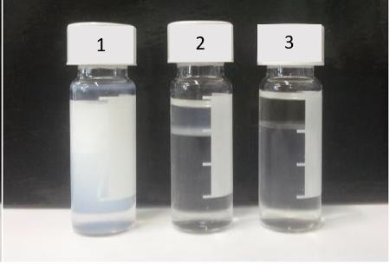

Figure 2. NP suspension LS4 in distilled water (1), water 1(2) and water 2(3) after 24 h contact.

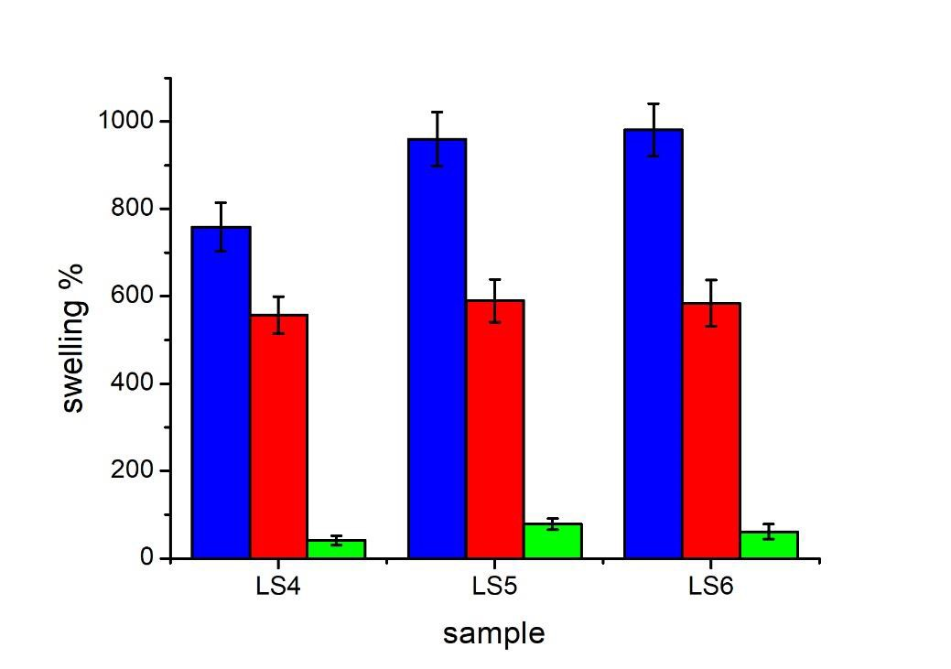

Figure 3. Swelling ability for the samples LS4, LS5, LS6 after being mixed with a 20 fold excess of water with different salinity for 24 h. The swelling percentage was calculated according to Equation 1 in the case of distilled water (blue bars), water 1 (red bars) and water 2 (green bars).

For the three samples, the difference in swelling percentage between the distilled water and the “water 2” is large. As explained previously, the presence of salts leads to a smaller water absorption and to the downward trend in swelling ability. The presence of SDS seems to increase the swelling especially in distilled water, but a slight improvement in swelling ability is noticeable even in salty water.
After having evaluated the NP swelling, their ability to migrate from the hydrocarbon to the water phase was studied. In particular, from Figure 4, the great effect given by the presence of SDS in promoting the NP migration from the hydrocarbon to the water phase is evident. Its hydrophilic character makes the particle more likely to stay in the water phase than oily one.

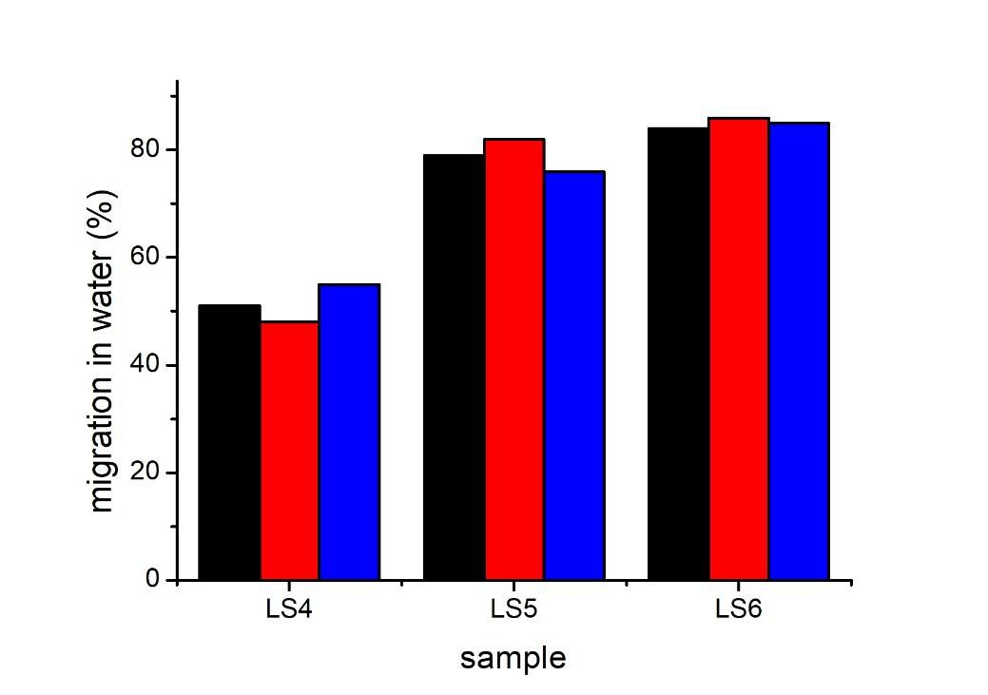

Figure 4. Particle migration in water. The particle migration was assumed to be 100-(particle percentage in the hydrocarbon phase) and evaluated via thermogravimetric analysis. The study was performed in the case of distilled water (black bars), water 1 (red bars) and water 2 (blue bars).

While without SDS (LS4 sample) only the 50% of NPs actually migrated in water, its addition made possible to promote the particle migration up to the 80 - 85% (LS5 and LS6 samples, respectively) of the total population, as it is clearly visible in Figure 4. A remarkable observation is that SDS improves the particle diffusion in distilled water as well as in salty water, with no much difference between distilled, water 1 and water 2 solutions.

Microparticle Characterization
The aim of this work is the application of the developed water shut-off formulation in a real nearly-depleted oilfield to evaluate the possibility of increasing the oil productivity and reducing the water-cut. In particular, the selected reservoir in Gela, Italy, comprises a fractured rock formation, with pore size in the micrometer range. Therefore, we changed the FRP conditions in order to obtain microgels with average size in the order of 10-20 μm. This seize range is indeed more effective in obstructing such kind of channels. Due to the micrometric size, these particles undergo gravimetrical sedimentation in few hours. Since the suspension must be stored for days before the application, the possibility of re-dispersing the particles is crucial. In this specific case, the microgels prepared using the same surfactant mixture as the LS6 nanogels could be easily resuspended in Lamix with a mild mechanical stirring after three months from the synthesis. This testifies the stability of the suspension as well as its long shelf life.
To maximize the swelling for these microgels, the OEGMA/MAA ratio was systematically varied. The particle shape and size were studied using both laser diffraction and an optical microscope, before and after the contact with distilled water, water 1 and water 2. A-C in Figure 5 represent the optical microscope images in Lamix, water 1 and water 2, respectively for the sample with 12.5% w/w OEGMA (i.e. sample M3 in Table 2).

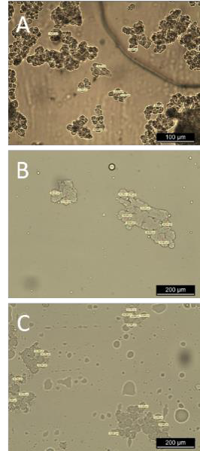

Figure 5. Micro-particles M3 optical microscope images in (A) Lamix, (B) water 1 and (C) water 2 .

The optical images were further analyzed with Leica LAS Live Image Builder software and the average size was calculated. Laser diffraction analysis confirmed the optical microscope results. As expected, the obtained particles are much bigger, with a diameter of about 20 μm in Lamix and reaching 50 μm when contacted with distilled water.

Table 2. Particle diameters in Lamix as a function of the OEGMA percentage.

 | OEGMA (%) | Average diameter (µm) | Std. Dev. (µm)
M1 | 5 | 19 | 1.2
M2 | 10 | 20 | 1.2
M3 | 12.5 | 23 | 1.4

From Figure 6, it is possible to observe that in distilled water an increasing amount of OEGMA in the copolymer led to a reduction in the swelling capacity. However, as expected in synthetic seawaters, the presence of OEGMA is useful to enhance the amount of adsorbed water and in turn the size increase.

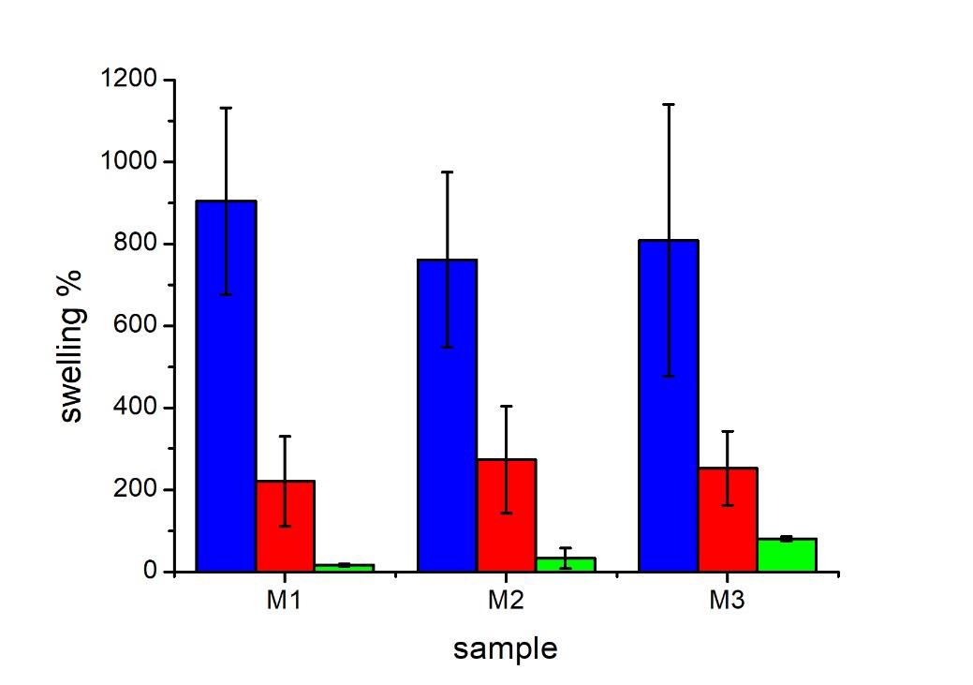

Figure 6. Microgel swelling in water with different ionic strength, namely distilled water (blue bars), water 1 (red bars) and water 2 (green bars).

As explained previously, OEGMA presence dampens the salt effect, thus promoting the water absorption even in the case of high ionic strengths. However, a further increase in the OEGMA content (i.e. > 12.5% w/w) led to an unstable system, with irreversible aggregation of the latex. Consequently, 12.5% w/w OEGMA/MAA was assumed as the best ratio between the two monomers to avoid precipitation and to make possible a great swelling both in distilled and salty water, covering a broad range of applications.

Since the obtained microparticles are much bigger than the produced nanogels, when put in water they do not only increased the turbidity of the aqueous phase but they created a dense whitish cream that makes the water impossible to flow, thus confirming the suitability of the formulation for water shut-off applications (Figure 7).

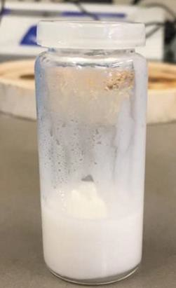

Figure 7. M3 in distilled water.

Oil-Phase Crossing Test
Some channels in the reservoir contains both water and oil, with water immediately below an oil layer. Therefore, the polymeric particles inside the suspension must be able to migrate from the oily to the water phase not only if they come in direct contact with water but even in static conditions.
The ability to pass from a dispersion in organic solvent to a hydrocarbon oily phase and from that to reach the aqueous phase was assessed.
In particular, water with “water 2” composition, hydrocarbon oil, and the polymeric suspension were introduced in a vial with the following order, from the top to the bottom: suspension/oil/water, with a volume ratio of 1:1:1. The test was carried out both at room temperature and at 90 °C in static conditions, to mimic the reservoir environment.

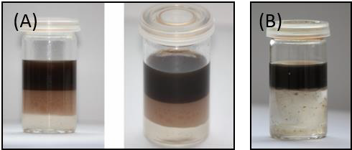

Figure 8. (A)Oil-phase crossing test after 30 minutes and (B) after two weeks at 90 °C.

The microgels in the suspension were found to cross the oily phase without significantly alter its viscosity, which is a prior aim for the practical application. In fact, this means that the addition of the microparticle formulation do not affect the possibility to extract oil from the reservoir. The brownish layer in Figure 8 (A)

is given by the micro-particles suspension that crossed the oil phase. At room temperature, the particles settled through the oil and came in contact with water within about 5 hours. At 90 °C, the time necessary to reach the water phase was only 30 minutes, compatible with the lower density of the medium at that temperature that promotes a faster gravimetrical sedimentation.
After two weeks of contact with water, the brownish layer disappeared (Figure 8 (B); the suspension mixed with the water phase and the particle swelled creating a much denser solution.

Reversibility of Water Absorbing Effect
To avoid the reservoirs to be irreversibly compromised, one important feature of the suspension to be investigated was the reversibility of the blocking effect. To check it, the microparticles were put in contact with “water 2” in a vial. Once the hydrogel was formed, hydrochloric acid or formic acid was introduced until reaching pH=2. In both cases, a reduction of the viscosity was observed, due to the re-protonation of the MAA charges and the consequent decrease in the polymer hydrophilicity. In particular, in Figure 9 the viscosity change between the two vials is clearly visible. The second vial from the top contains the suspension swollen in water. Due to the high viscosity, the mixture remains stitched to the bottom. On the other hand, with HCl addition (first vial from the top) the consistency changes and the mixture become more liquid-like, thus confirming the possibility of reverting the swelling by acting on the solution pH. This important feature grants the reservoir not to be irreversibly damaged after the treatment.

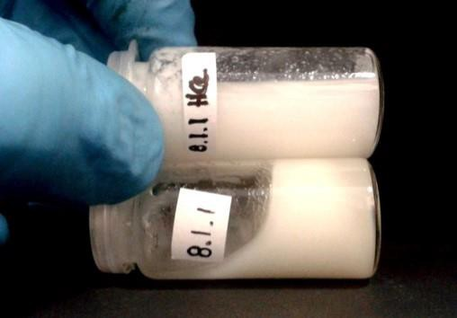

Figure 9. Reduction of viscosity due to an acid addition. The second vial from the top contains the hydrogel before HCl addition, while in the first vial from the top HCl was added.

Fractured Rock Simulation
To simulate the behavior of the microgels into a fractured rock formation, a capillary tube was used. More in details, a vial was filled with a sample of “water 2” and heated up to 90 °C. The capillary tube was inserted in vertical direction in the vial, thus immerging one end under the water surface. Then, M3 micro-gel dispersion was placed into the capillary tube with a syringe. After 24 hours, at the end of the tube a highly viscous phase

was observed, as shown in Figure 10. This viscous part behaved as a plug with such adherence that the injection of a second portion of dispersion or water required to apply a certain pressure. The effect could be annulled injecting formic acid/HCl from the top.

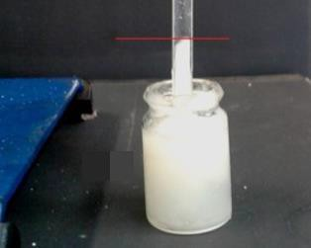

Figure 10. Capillary tube test.

Field Test
After the laboratory validation of the particle swelling behavior, the ability of the suspension to decrease the water cut from a real well-bore was assessed. The M3 sample formulation was properly revised to be produced on a ton-scale thus demonstrating the scale-up ability of the formulation. Afterwards, the microgel particles were injected in a fractured reservoir.
M3 sample was selected as the best option for a fractured reservoir due to the micro-dimension and the best swelling ability obtained in synthetic seawater.
The in situ suspension ability to reduce the water production was tested in the treatment of a fractured reservoir with well depth of about 3000 m, total volume of 19 m³ and well bottom temperature of 95-100 °C. The well was equipped with an artificial lift pumping system Thomassen 5 holes.
In particular, 20 m³ of microgel suspension with same composition and concentration as M3 sample were prepared on a discontinuous pilot scale reactor. Then, the well production was stopped and 10 m³ of dry light gasoil was pumped inside the reservoir to displace water, followed by the polymer suspension. Finally, 20 m³ of dry light gas oil was pumped again to make the polymer micro-particles penetrate deeper into the reservoir.
The reservoir was then maintained in shut-in for 50 hours before starting again the extraction, to let the particles get in contact with water and swell.
In particular, the average production conditions before the treatment were 5 m3/d of oil and 20 m3/d of water.
After about 20 days from the suspension injection the well production stabilized to a production rate of 60 m3/d and a 30% decrease in the water cut with respect to the initial conditions.1 The overall average oil production increased to 30 m3/d, and same production characteristics could be maintained over one year.1
Overall, the real-field test demonstrated the effectiveness of hydrophilic polymeric microgels in reducing the water production from a mature oil reservoir, and in increasing the amount of extracted oil.

Conclusion
Poly(MAA-co-OEGMA) copolymer NPs were synthetized via inverse suspension polymerization in the aromatic-free hydrocarbon mixture Lamix 30, supplied by eni s.p.a. To obtain particles with different size, the monomer suspension was polymerized with two mixing conditions. These led to particles in the range of both nanometers and micrometers. The HLB was settled to have particles with the desired size and that can be easily resuspended in the hydrocarbon phase after gravimetrical sedimentation. The addition of an anionic surfactant was found to improve the migration of the particles in the water phase and SDS was included in the mixture. To assess the swelling ability of the particles, they have been contacted with water with an increasing content of salt. Swelling was noticed in any kind of water with a greater increase of dimension in distilled water, as expected.
On microgel suspensions, the effect of the addition of OEGMA as co-monomer was investigated. The results show that an increase in the OEGMA content decreases the swelling in distilled water but increases it in synthetic seawater. In addition, the microgels were found to be able to create a dense cream when put in water. Aging tests at high temperatures were performed on this suspension. The reversibility of the water-blocking behavior was studied as well, and the viscosity decreased with the addition of an acidic solution.
The greatest results were obtained when the suspension was injected in a real fractured oil reservoir, confirming the huge advantages that oil and gas industries could obtain using this technology for water shut off applications. In fact, the oil production increased from 5 to 30 m³/d for over a year after the suspension injection and a 30% decrease in the water cut was achieved¹.

Conflict of Interest: The authors declare no competing interest.

References

(1) DEL GAUDIO, L.; LOREFICE, R.; MORBIDELLI, M. S.; MOSCATELLI, D. Method for Inhibiting the Permeation of Water in an Extraction Well of an Hydrocarbon Fluid from an Underground Reservoir. WO/2016/166672, 2016.

(2) Crabtree, M.; Romano, C. The Challenge of Water Control. Oilf. Rev. 2000, No. January 2000, 30–51.

(3) Al-Muntasheri; Sierra, L.; Garzon, F. O.; Lynn, J. D.; Izquierdo, G. Water Shut-off With Polymer Gels in a High Temperature Horizontal Gas Well: A Success Story. SPE Improv. Oil Recover. Symp. held Tulsa, USA 2010, No. 2007, 1–24. https://doi.org/10.2118/129848-MS.

(4) Nasralla, R. A.; Alotaibi, M. B.; Nasr-El-Din, H. A. Efficiency of Oil Recovery by Low Salinity Water Flooding in Sandstone Reservoirs. SPE West. North Am. Reg. Meet. 2011, No. 1967. https://doi.org/10.2118/144602-MS.

(5) Pendashteh, A.; Abdullah, L. C.; Biak, D. R. A.; Abidin, Z. Z.; Madaeni, S. S.; Fakhru’l-Razi, A. Review of Technologies for Oil and Gas Produced Water Treatment. J. Hazard. Mater. 2009, 170 (2–3), 530–551. https://doi.org/10.1016/j.jhazmat.2009.05.044.

(6) Veil, J A, Puder, M G, Elcock, D, and Redweik, R. J., J. A White Paper Describing Produced Water from Production of Crude Oil, Natural Gas, and Coal Bed Methane. United States N. p. 2004, No. January. https://doi.org/10.2172/821666.

(7) Simjoo, M.; Koohi, A. D.; Seftie, M. V.; Zitha, P. L. J. Water Shut-Off in a Fractured System Using a Robust Polymer Gel. 8th Eur. Form. Damage Conf. 2009, 1–8. https://doi.org/10.2118/122280-MS.

(8) Tongwa, P.; Nygaard, R.; Bai, B. Evaluation of a Nanocomposite Hydrogel for Water Shut-off in Enhanced Oil Recovery Applications: Design, Synthesis, and Characterization. J. Appl. Polym. Sci. 2013, 128 (1), 787–794. https://doi.org/10.1002/app.38258.

(9) Chris, S. Downhole Separation as a Strategic Water and Environmental Management Tool. Pap. Present. SPE Int. Conf. Heal. Saf. Environ. Oil Gas Explor. Prod. 2007. https://doi.org/10.2523/61186-ms.

(10) Taha, A.; Amani, M. Overview of Water Shutoff Operations in Oil and Gas Wells; Chemical and Mechanical Solutions. ChemEngineering 2019, 3 (2), 1–11. https://doi.org/10.3390/chemengineering3020051.

(11) Bai, Y.; Xiong, C.; Wei, F.; Li, J.; Shu, Y.; Liu, D. Gelation Study on a Hydrophobically Associating Polymer/Polyethylenimine Gel System for Water Shut-off Treatment. Energy and Fuels 2015, 29 (2), 447–458. https://doi.org/10.1021/ef502505k.

(12) Bai, Y.; Wei, F.; Xiong, C.; Li, J.; Jiang, R.; Xu, H.; Shu, Y. Effects of Fracture and Matrix on Propagation Behavior and Water Shut-off Performance of a Polymer Gel. Energy and Fuels 2015, 29 (9), 5534–5543. https://doi.org/10.1021/acs.energyfuels.5b01381.

(13) Basu, A.; Kunduru, K. R.; Doppalapudi, S.; Domb, A. J.; Khan, W. Poly(Lactic Acid) Based Hydrogels. Adv. Drug Deliv. Rev. 2016, 107, 192–205. https://doi.org/10.1016/j.addr.2016.07.004.

(14) Buwalda, S. J.; Boere, K. W. M.; Dijkstra, P. J.; Feijen, J.; Vermonden, T.; Hennink, W. E. Hydrogels in a Historical Perspective: From Simple Networks to Smart Materials. J. Control. Release 2014, 190, 254–273. https://doi.org/10.1016/j.jconrel.2014.03.052.

(15) Dong, L.; Agarwal, A. K.; Beebe, D. J.; Jiang, H. Adaptive Liquid Microlenses Activated by Stimuli-Responsive Hydrogels. Nature 2006, 442 (7102), 551–554. https://doi.org/10.1038/nature05024.

(16) Kabir, a H. SPE 72119 Chemical Water & Gas Shutoff Technology - An Overview. Soc. Pet. Eng. 2001. https://doi.org/10.2118/72119-MS.

(17) Al-Muntasheri, G. A.; Nasr-El-Din, H. A.; Hussein, I. A. A Rheological Investigation of a High Temperature Organic Gel Used for Water Shut-off Treatments. J. Pet. Sci. Eng. 2007, 59 (1–2), 73–83. https://doi.org/10.1016/j.petrol.2007.02.010.

(18) Sengupta, B.; Sharma, V. P.; Udayabhanu, G. In-Situ Gelation Studies of an Eco-Friendly Cross-Linked Polymer System for Water Shut-off at High Temperatures. Energy Sources, Part A Recover. Util. Environ. Eff. 2014, 36 (13), 1445–1467. https://doi.org/10.1080/15567036.2011.553661.

(19) Banerjee, R.; Ghosh, B.; Khilar, K.; Boukadi, F.; Bemani, A. Field Application of Phenol Formaldehyde Gel in Oil Reservoir Matrix for Water Shut-off Purposes. Energy Sources, Part A Recover. Util. Environ. Eff. 2008, 30 (19), 1779–1787. https://doi.org/10.1080/15567030701268476.

(20) Zhao, J. Z.; Jia, H.; Pu, W. F.; Liao, R. Influences of Fracture Aperture on the Water-Shutoff Performance of Polyethyleneimine Cross-Linking Partially Hydrolyzed Polyacrylamide Gels in Hydraulic Fractured Reservoirs. Energy and Fuels 2011, 25 (6), 2616–2624. https://doi.org/10.1021/ef200461m.

(21) Jia, H.; Pu, W. F.; Zhao, J. Z.; Jin, F. Y. Research on the Gelation Performance of Low Toxic PEI Cross-Linking PHPAM Gel Systems as Water Shutoff Agents in Low Temperature Reservoirs. Ind. Eng. Chem. Res. 2010, 49 (20), 9618–9624. https://doi.org/10.1021/ie100888q.

(22) Adewunmi, A. A.; Ismail, S.; Sultan, A. S. Study on Strength and Gelation Time of Polyacrylamide/Polyethyleneimine Composite Gels Reinforced with Coal Fly Ash for Water Shut-off Treatment. J. Appl. Polym. Sci. 2015, 132 (5), 1–8. https://doi.org/10.1002/app.41392.

(23) Reena; Kumar, A.; Mahto, V.; Choubey, A. K. Synthesis and Characterization of Cross-Linked Hydrogels Using Polyvinyl Alcohol and Polyvinyl Pyrrolidone and Their Blend for Water Shut-off Treatments. J. Mol. Liq. 2020, 301, 112472. https://doi.org/10.1016/j.molliq.2020.112472.

(24) Bai, Y.; Wei, F.; Xiong, C.; Li, J.; Jiang, R.; Xu, H.; Shu, Y. Effects of Fracture and Matrix on Propagation Behavior and Water Shut-off Performance of a Polymer Gel. Energy and Fuels 2015, 29 (9), 5534–5543. https://doi.org/10.1021/acs.energyfuels.5b01381.

(25) El-karsani, K. S. M.; Al-Muntasheri, G. A.; Hussein, I. A. Polymer Systems for Water Shutoff and Profile Modification: A Review Over the Last Decade. SPE J. 2013, 19 (01), 135–149. https://doi.org/10.2118/163100-pa.

(26) Kumar, A.; Mahto, V.; Sharma, V. P. Reinforced Preformed Particle Gel: Synthesis, Characterization and Performance Evaluation for Water Shut-off Jobs in Heterogeneous Reservoir. J. Pet. Sci. Eng. 2020, 193 (January), 107408. https://doi.org/10.1016/j.petrol.2020.107408.

(27) Paprouschi, A.; Fatemi, M.; Ghazanfari, M. H. Effect of Silicate Sodium and Graphene Nanoplatelets on Morphology and Rheology Characteristics of New Synthesized Preformed Particle Gel (PPG) for Water Shut-off Treatment. J. Pet. Sci. Eng. 2021, 204 (October 2020), 108736. https://doi.org/10.1016/j.petrol.2021.108736.

(28) Lutz, J. F. Polymerization of Oligo(Ethylene Glycol) (Meth)Acrylates: Toward New Generations of Smart Biocompatible Materials. J. Polym. Sci. Part A Polym. Chem. 2008, 46 (11), 3459–3470. https://doi.org/10.1002/pola.22706.

(29) Serra, L.; Doménech, J.; Peppas, N. A. Drug Transport Mechanisms and Release Kinetics from Molecularly Designed Poly(Acrylic Acid-g-Ethylene Glycol) Hydrogels. Biomaterials 2006, 27 (31), 5440–5451. https://doi.org/10.1016/j.biomaterials.2006.06.011.

For Table of Contents Only

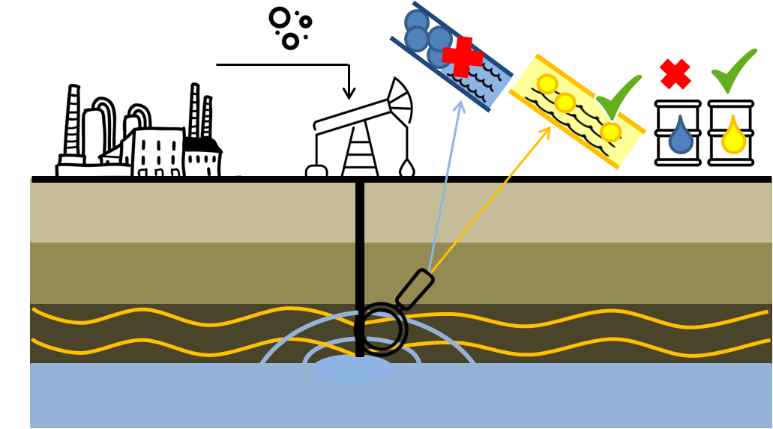

Hydrophilic nano- and microparticles able to absorb water were produced on a multi-ton scale and tested as water shut-off systems in a fractured reservoir

