JIT implementation in manufacturing: The case of Giacomini SPA
Bassel Kassem¹, Federica Costa², Alberto Portioli Staudacher³
Politecnico di Milano, Dipartimento di Ingegneria Gestionale,
Via lambruschini 4, 20156, Milano, Itlay
bassel.kassem@polimi.it, federica.costa@polimi.it, alberto.portioli@polimi.it
Abstract. Purpose: The paper aims at exploring a JIT implementation framework integrating the hard and the soft pillars of Lean Production in a manufacturing company. Design/methodology/approach: A JIT cell creation project is analyzed in Giacomini using a Learn, Use, Teach and Inspect, LUTI JIT framework. Findings: Any continuous improvement project should embrace its actors in a lean culture for it to succeed, that is grasping the “who” and the “why” aspect. Practical implications: The main contribution of the article is showing empirically, the importance of the “who” and the “why” aspect in successfully transforming a batch-and-queue production system into a Just-In-Time system. Limitations: The framework is applied in one company and one sector which may hinder generalizability issues.
Keywords. Lean Production, Lean Culture, Lean Education, JIT, LUTI.
- Introduction
In 1950, Toyota Chief Engineer Taiichi Ohno was entrusted to improve the Toyota production system to reach the same productivity level of American competitors, such as Ford. Ohno overcame the expectations through the creation of Toyota Production System (TPS) otherwise known as “Lean Production” (LP) [8]. LP has two main pillars: “Respect for people” and “Continuous improvement”. The former pillar was less emphasized by managers until the publication of “The Toyota way” by Toyota corporation in 2004 [7] that showcased that the first pillar intrinsically enables the second one [3]. “Respect for people” advocates people’s engagement and active participation in value creation through a culture of learning and embracing change. The role of management in instilling trust between the different actors of the organization is crucial for continuously improving company’s operations, hence the second LP pillar [7].
Just in Time JIT is one of LP hard practices. It is focused on having the right product at the right time in the right quantity to the right customer [8],[9] and requires people’s involvement in its implementation. The literature review presents frameworks that deal with Lean transformation, when it comes to JIT implementation frameworks, those are not JIT specific but rather of generalized nature that authors tend to apply it to JIT. The main contribution of the article is the creation of an adhoc framework for transforming a batch-and-queue production system into a Just-In-Time system, by coupling LP’s two pillars in a Lean project at Giacomini SPA. The “LUTI JIT framework” is a JIT-specific framework, where LUTI stands for Learn, Use, Teach and Inspect, an acronym which explains that the model comes from the experience of a Lean expert and then it is turned into a standardized, replicable model.
This paper is structured as follows: after the introduction, section 2 discusses the literature regarding the JIT implementation frameworks followed by section 3 that introduces the project at Giacomini and its results using the framework suggested. The article concludes with important considerations and implications.
- Literature review
This section highlights the most relevant articles in the literature discussing JIT implementation frameworks found in Scopus that are available to download and their access is not restricted by their authors.
[6] proposed eight implementation phases for JIT: (1) establish a focused factory; (2) streamline the order flow; (3) adopt good manufacturing techniques; (4) improve material availability; (5) plant-adopted standards, including information, design, process, and equipment standards; (6) concern with the quality improvement; (7) attention focused on improving skills and awareness, and upgrading the responsibilities of the employees, and (8) moving closer to customers. However, it is done with no explanation of these steps in an exhaustive way but rather describes them in generic terms.
[4] believes that project management is a suitable tool to properly implement JIT: planning, controlling and monitoring can be also applied for JIT as shown in Figure 1.
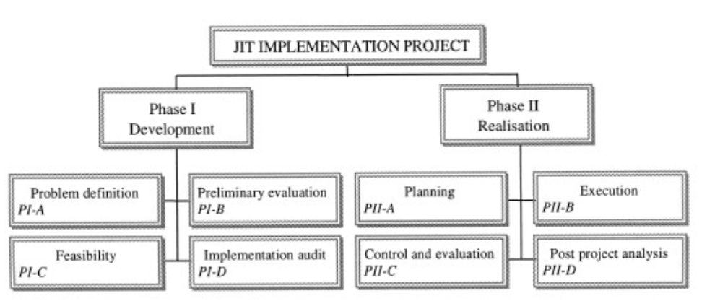
Figure 1: Project management framework for JIT implementation
The framework constitutes of development and realization. Development starts by defining the problem, followed by evaluating the situation and possible solution to the problem. Then feasibility is performed, an evaluation of physical, managerial and financial constraints followed by the implementation audit. It enables the verification of the company’s position according to the drivers required for a successful JIT implementation. The result of this step is the description of the strengths and weaknesses of the company according to a list of managerial and operational key factors. The realization phase, on the other hand, deals mainly with the planning and the execution. The planning part defines the activities to be implemented, their sequence, and the related resources needed – both financial and human. Then, after the execution of the planned activities, a control and evaluation of the ongoing activities is done. Finally, a post project analysis is performed. This project management is advantageous; it forces a deep, structured analysis about the prerequisites of each phase and defines the operations sequence in a systematic way, without losing energy and time in unnecessary activities.
[11] developed a model for designing, managing and improving Kaizen event programs. This differs from the former, in the sense that it is a cycle rather than a process and can be used for any kind of LP activity according to the steps to follow:
- Plan: identification of the stakeholders involved, the selection of the Kaizen event to be improved and the definition of the project charter.
- Implement: event preparation and execution in addition to follow-up after event and full-scale deployment.
- Sustain: reviewing the results and share them, through a standardization of the best practices.
- Support: education and motivation of employees as they are critical activities which should be done alongside the whole project.
[13] instead, creates a very comprehensive model which, starting from the 5 principles of Lean mentioned in [12], defines three action areas (Think Lean, Act Lean and Human) which leads to the implementation of Lean into the whole company. The most relevant paper is that of [2]. The paper discusses four main variables: the “what” (e.g. what are the techniques to be used), the “how” (e.g. how to implement them), the “who” (e.g. who is going to perform a specific task) and the “why” (e.g. the reason beyond a specific activity). These four elements are discarded by the surveyed papers described previously, but they shall be relied upon for the project conducted in Giacomini SPA.
- Methodology
The importance of the “who” and “why” part in any JIT implementation process is evident in a project conducted at Giacomini. This section introduces the company and the project conducted on its site applying LUTI JIT framework comparing it with the works of [2].
Giacomini S.p.A. is a world leader in the production of components and systems that use water to produce comfort, to manage water usage "in situ" and to extinguish fire. The Group has a well-established international presence, with new subsidiaries and sales offices opening around the world. Brazil, Thailand, Canada, India and Turkey are the most recent examples. Giving a few numbers, about 200 million in revenue, more than 80% of it coming from foreign markets, with 3 Italian production facilities, 18 international subsidiaries, 900 employees and 70 tons of brass processed each day. The company implemented Lean as both a need and a vision [5]. On one side, they pursue efficiency to get costs reduction. On the other, they believed that Lean could be more than a simple set of rules: a source of competitive advantage and a source of innovation that led Giacomini towards a next step in its evolutionary process. The company created for itself a “house” (see figure below) embodying everything that they stand for: Safety, People and Environment, with “Continuous improvement” as its essence and customer satisfaction as its objective.
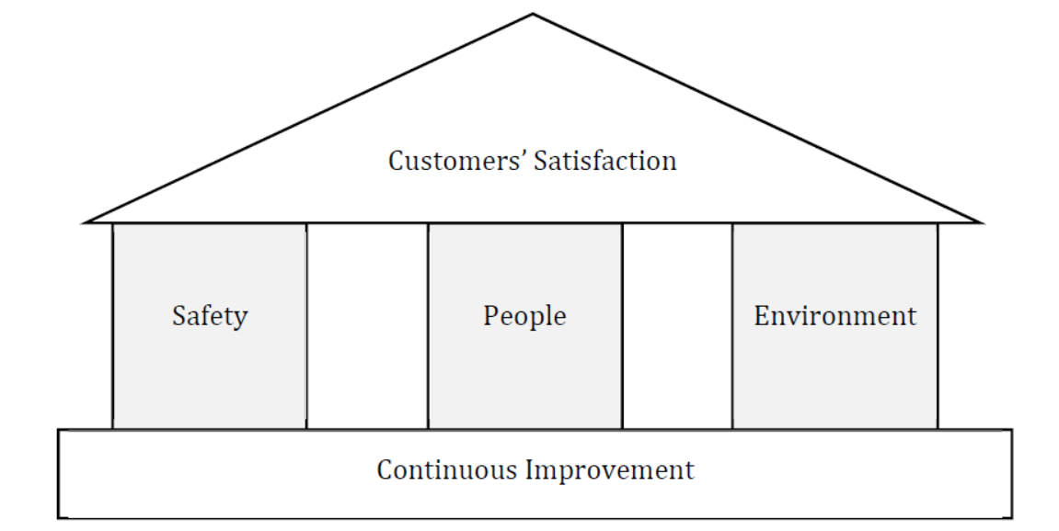
Figure 3: Giacomini House of Lean
One of the crucial steps adopted by the company in the Lean implementation is the communication between top management and workers. Communicating means creating a better sense of belonging. Another tool used to improve the relationship among management and workers is the “Plant of ideas” or as it is called in Italian “Fabbrica delle idee”, a document which can be filled by the operators with suggestions, ideas and comments about their job. The proposal of interesting ideas will be rewarded with a certain amount of points. The points collected can be spent in recreational activities.
Students of Polimi participated in the project conducted by Giacomini with the support of Lean Excellence Center of Polimi by creating JIT cells using “LUTI JIT framework”, one of the pillars of World Class Manufacturing WCM [10].
The company with the students decided to adopt a new model based on the context of Giacomini, what the literature says and the experience the workers have as well. The LUTI framework, which is JIT specific, follows seven main steps (see figure below) preceded by a preliminary phase, indicated as Step 0. This phase is the preparation of the activities, which includes: (i) the selection of the project, based on the Gantt diagram listing all the improvement projects forecasted for the year, (ii) the analysis of the product codes involved and their volumes and (iii) the preparation of the module for the time registering.
Step 1 is the Teamwork selection. According to the typology of project and the related skills level required, a team is created. Indeed, the lean specialist should not work alone. He will require the support of the maintenance technician, the programmer, the line responsible, the department responsible and the operators.
Step 2 is the as-is mapping and a detailed definition of the process map, registering all the transformation phases of the products. In this step, it is fundamental working directly on the shop floor, in Gemba.
The data to record are the production volumes, the characteristics of each working stations (C/T, C/O, machine availability, OEE, process phase description), human resources per machine and the product travel distance.
Step 3 consists of creating laminar flows for each product family, laminar in the sense that the flow is smooth just like particles. This is a theoretical step: what will be the ideal flow of the products with totally dedicated and independent resources?
Step 4: the laminar flows created in the Step 3 should be grouped together in a single laminar flow, which include all the families’ products. Then, the model requires to account the Takt Time and to compare it with the C/T of the new line.
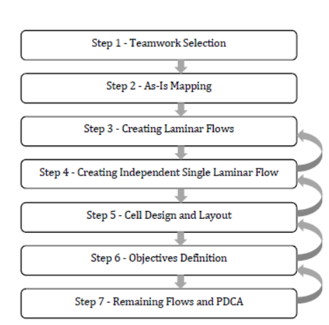
Figure 2: LUTI JIT framework
Step 5 is the cell design and layout. It is composed by six sections: (i) collection of the scaled layout of the department, (ii) realization of the shapes for machines and equipment, (iii) creation of a possible layout per person considering physical (e.g. presence of pillars), ergonomic (e.g. considering the golden zone rule in the working stations) and technical (e.g. feasibility of the electric current provisioning) , (iv) comparison of the layouts and selection of the best alternative, (v) share of the final layout with the whole teamwork and (vi) testing the layout in a simulated environment.
The Step 6 where a list of objectives should be prepared to assess the main differences: lead time, WIPs, travel distance, number of resources, and economic evaluation.
Step 7 is related to the remaining flows – the ones have been removed from the JIT cell due to low production volumes – and how to treat them. An ad hoc solution may be necessary. After this activity, the project can be presented to the top management. Once the approval is received, the team should prepare a detailed PDCA for the cell realization and kick off the project. The process is shown above.
Most of the frameworks seen, focus only on the “what” (e.g. the techniques of TPS).
1) The majority of the analyzed frameworks do not describe the sequences and the phases to transform a company in a Lean organization [1], [2].
2) Most of the models do not indicate the “who” of a specific step, the specific internal stakeholders to which assign a task [1], [2].
[1] tackled the “how” as well. They deeply explain what to do and how to do it, describing the specific steps to follow. [2] build on their work, adding another dimension of analysis, which is missing in [1]: the “why” factor. They review 30 frameworks in the literature and believe that blindly following certain steps does not mean transforming a company into a Lean enterprise. Otherwise, every company could do it perfectly. Since each company has specific external and internal contexts, the main point is to understand the reasons of a certain technique and model, before implementing it.
The last consideration taken from [2] is related to the bottom-up versus top-down approach. All frameworks starting from a management input increase the risk of fail due to the poor workers’ participation.

The first aspect emerged by the LUTI JIT framework implementation is the presence of a strong iterative component. However, the implementation on the ground reveals the need to go back to the previous steps, according to the discovery of a specific constraint. In particular, the final steps require to consider physical, economical and managerial limitations, that could require moving back to the previous phases.
A main issue is highlighted: the LUTI JIT framework theoretically does not explain the “why”. Comparing the LUTI JIT model with the considerations done by [1] and [2], the framework can be analyzed according to four main variables: the “what” (e.g. what are the techniques to be used), the “how” (e.g. how to implement them), the “who” (e.g. who is going to perform a specific task) and the “why” (e.g. what the reason beyond a specific activity). The LUTI model deeply defines the techniques, their implementation and describes the tasks’ responsibilities throughout its steps as well as in the PDCA procedure used in the Step 7. However, it shows a lack of “why”. Of course, this missing element is not present in the top management. They are perfectly aware of the reasons, advantages and limitations of a JIT production system. The workers may see the framework as a simple change in the operations and in their sequence. Their involvement is mainly in the layout phase, not in the conceptual one. They may understand the idea of the cell manufacturing but will miss the connection with the comprehensive picture: Why a JIT system is needed, why Lean improves the AS-IS situation and, most importantly, why working in a JIT line improves their working conditions. The main reason is the instillation of the Lean culture. If Lean was a simple set of rules to be blindly followed, all the companies could reach the objectives of costs reduction, higher quality and shortest lead times. Instead, there is more. The main difficulty is inside the company culture. Obtaining the proper mind-set, both in the management and in the workers, is harder than instructing an operator about a specific task. The Lean methodology requires a complete mentality change.
In Giacomini, this cultural evolution started few years ago, and, as every long-term process, it started producing some results, despite the presence of some constraints. Another consideration to have in mind in comparison with the work of [2] is the “who” aspect. This driver of analysis examines who is going to perform a specific task. Two main opposite approaches can be found among the possible ways to assign tasks to the workers. The first is the “top-down” approach: the assignment of tasks to each person is driven by the top management. Thus, the operative workers simply receive the instructions about the new operating standards, without being active actors in the transformation process. They receive orders from the managers, without having a clear idea about the context where they are working. On the other side, the “bottom-up” approach relies on the operative workers from the initial phases of a transformation process. Sometimes, they could be the initiator of the project itself. The managers’ role is to coordinate the project with a high degree of delegation to the workers.
The LUTI JIT framework shows a good trade-off between a top-down and a bottom up approach. The model initially receives a strong input from the management. Indeed, the first four phases do not involve so much the operators while Step 5 is almost centered on the workers’ participation.
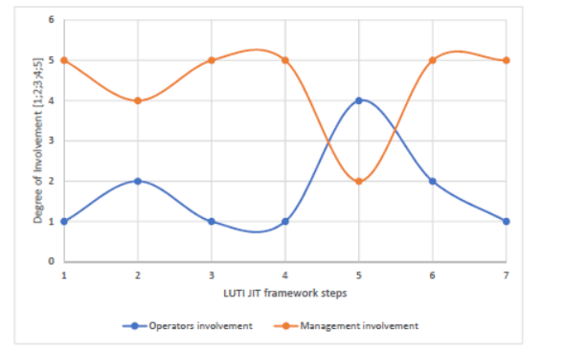
Figure 4: Distribution of workload for the project
The Figure above shows the qualitative involvement of the operators against the managerial support (accounted dividing the number of hours dedicated by the people involved in each step of the framework). The communication among management and operators follows a similar path, increasing in the fifth step. Some possible suggestions about how to improve the operative workers’ involvement are: increasing the communication between the two categories since the initial phases (e.g. weekly meeting could be useful for this scope); increasing the communication among the whole company’s workforce (e.g. company journals address this point) and constantly providing training to the operative workers about the Lean techniques and principles, with a specific focus to the models and tools used in Giacomini. The proportion among the two typologies of workers is 60 hours spent by a manager against 300 hours spent by the operative workers, meaning less than one third of the time spent.
Since the nature of the LUTI is to be improved and adjusted every time it is applied, the previous analysis about the “who” driver leads to the following elaboration. The Giacomini application suggests dividing the “who” driver into two parties: the manager, who is leading the process, and the operative workers, who are effectively implementing the transformation tasks. In particular, in the PDCA documents the distinction between these two typologies of workers should be evident. The main benefit of this improvement is the time saving achieved by the manager, who can dedicate time to other projects as well as the improvement of workers’ performances and motivation.
Finally, among the variables analyzed by the paper of [2], the time dimension was not considered. The reason is related to the characteristics of each project: the complexity of the process directly affects the timeline. However, some considerations about the Giacomini case can be done. The financial savings brought by the JIT cells months has surpassed the expectations. Apart from the financial side, the operational advantages of the lines included: reduction of lead time, reduction of WIP along the line, reduction of the human resources and improving of material handling. In only 2 months, the Lean Manager was able to achieve incredible results. The main reason of this success is having a well-working model to reach the objectives is a facilitator element.

4 Conclusion
The presence of a fixed schema to follow, with a very high level of specificity and details, enables the Lean Manager to delegate to the Lean Assistants the less strategic activities, without anyway losing the control on the project development. The LUTI JIT framework proves how the usage of models is fundamental in the realization of a Lean transformation with the necessary involvement of both white and blue collars in all phases of the project. The Giacomini Group took the right way, which is the creation of ad-hoc transformation structure, perfectly suitable for the company organization.
This article is a testimony of the importance of including both the hard and the soft part of Lean whenever a project of continuous improvement is to be held in a manufacturing context. On the one hand it is essential to have a lean culture instilled in the company and on the other hand people are the core of LP. Their contribution would bring success when involved actively in the processes and the contribution of the workers have been increasing ever since in Giacomini leading to greater results.
The main limitation of the research is that it is based on one case study, but the team of LEC is continuously performing improvement projects in various Italian companies and there is the possibility of generalizing the findings with other projects that are ongoing as well.

Acknowledgments. We would like to thank Giacomini SPA represented by Mr. Emanuele Peraldi along with their management and their operators for their support of this project. The authors would like also to thank the Lean Excellence Center team and the students of Politecnico.

References

1. Anand, G., Kodali, R.: Analysis of lean manufacturing frameworks. In: Journal of Advanced Manufacturing Systems, 9 (1), pp. 1-30 (2010)
2. Chay, T., Xy,Y., Tiwari, A., Chay, F.:Towards lean transformation: the analysis of lean implmentation frameworks, Journal of Manufacturing Technology Management, Vol. 26 Issue: 7, pp. 1031-1052. (2015)
3. Emiliani, M.L., Stec, D.J.: Leaders lost in transformation. In: Leadership and Organization Development Journal, 26 (5), pp. 370-387 (2005)
4. Gélinas, R.: The Just-In-Time implementation project, International Journal of Project Management, Vol. 17, No. 3, pp. 171-179. (1999)
5. Giacomini SPA, https://it.giacomini.com/ (visited on 10/06/2019)
6. Harvey, R. E.: How to deliver Just-in-Time. In: Manufacturing Management, 229(18), 36-40 (1986).
7. Liker, J.K.: The Toyota Way: 14 Management Principles from the World’s Greatest Manufacturer, McGraw-Hill. (2004)
8. Shah, R. & Ward, P. T.: Lean manufacturing: context, practice bundles, and performance. In: Journal of Management Operations, pp. 129-149. (2003)
9. Shah, R. & Ward, P. T.: Defining and developing measures of lean production. In: Journal of Operational Management, pp. 785-805. (2007)
10. Sukarma, L., Azmi, H., Abdullah, N.L.: The impact of world class manufacturing practices on company performance: A critical review. In: Applied Mechanics and Materials, 564, pp. 727-732 (2014)
11. Van Aken, E. M., Farris, J. A., Glover W. J., Letens G.: A framework for designing, managing, and improving Kaizen event programs. In: International Journal of Productivity and Performance Management, Vol. 59 Issue: 7, pp.641-667. (2010)
12. Womack, J., Jones, D.: Lean thinking. Banish waste and create wealth in your corporation. New York, NY: Free Press, Simon & Schuster, Inc. (1996)
13.Wong YC, Wong KY, Ali A.: A Study on Lean Manufacturing Implementation in the Malaysian Electrical and Electronics Industry. European Journal of Scientific Research 2009; 38/4:521-535 (2010)

