One-pot Biocatalytic Cascade Reduction of Cyclic Enimines for the Preparation of Diastereomerically Enriched N-Heterocycles
Thomas W. Thorpe,† Scott P. France,†,‡ Shahed Hussain,† James R. Marshall,† Wojciech Zawodny,† Juan Mangas-Sanchez,† Sarah L. Montgomery,† Roger M. Howard,‡ David S. B. Daniels,¶ Rajesh Kumar,¶ Fabio Parmeggiani,†* Nicholas J. Turner†*
† School of Chemistry, University of Manchester, Manchester Institute of Biotechnology, 131 Princess Street, Manchester, M1 7DN (UK).
‡ Pfizer Worldwide Research and Development, 445 Eastern Point Road, Groton, CT 06340 (USA).
¶ Pfizer Worldwide Research and Development Discovery Park, Sandwich, Kent, CT13 9NJ (UK).

Supporting Information Placeholder
ABSTRACT: Ene-reductases (EREDs) catalyse the reduction of electron-deficient C=C bonds. Herein, we report the first example of ERED-catalysed net reduction of C=C bonds of enimines (α,β-unsaturated imines). Preliminary studies suggest their hydrolysed ring-open ω-amino enones are the likely substrates for this step. When combined with imine reductase (IRED)-mediated C=N reduction, the result is an efficient telescoped sequence for the preparation of diastereomerically enriched 2-substituted saturated amine heterocycles.
Stereochemically enriched amines, and particularly their heterocyclic derivatives, are commonly found in a variety of alkaloid natural products and key motifs of APIs.¹ Biocatalysis has emerged as a proficient technology for the preparation of these species due to the intrinsic regio-, chemo-, and stereoselectivity as well as the green credentials exhibited by enzymes.² Pictet-Spenglerases,³ amine oxidases,⁴ transaminases⁵ and more recently imine reductases (IREDs)^{6–8} have all been utilised for the preparation of enantioenriched amine heterocycles containing a single stereocentre. However, valuable compounds often have multiple stereocenters and their stereoselective preparation has proved more challenging, as few enzymes are able to set two stereogenic centres simultaneously and remote selectivity is often substrate-restricted. In order to address this challenge, multi-enzyme cascades and telescopic reactions have been developed which allow for the stereocontrolled formation of multiple asymmetric centres in a single pot.^{9–11}
Chemoselective biocatalytic reduction of the C=N bond of cyclic enimines (α,β-unsaturated imines) in the presence of a conjugated C=C bond (Scheme 1), has been reported using IREDs, allowing for the preparation of pharmaceutically important bioactive piperidines¹² and morphinans.¹³ The complementary process, namely selective reduction of the C=C bonds of an enimine without concomitant C=N bond reduction has not been reported, although it has been postulated as the activity of the reductase genes (ArpDHs) involved in the metabolic pathway that converts nigrifactin to the argimycins (Scheme 1).¹⁴ Such a chemoselective activity would allow the conversion of cyclic enimines to chiral cyclic imines which might be followed by IRED-mediated C=N
Scheme 1. Biocatalytic reduction of enimines and examples of target molecules.

reduction to yield the corresponding diastereomeric saturated amine heterocycles. These are important moieties commonly found in natural products, bioactive molecules and their intermediates and analogues (Scheme 1).^{15–17}
To explore this possibility, we focussed on the use of ene-reductases (EREDs) to reduce enimines. These biocatalysts are well established for the reduction of electronically deficient C=C bonds asymmetrically.^{18–21} EREDs catalyse the reduction of α,β-unsaturated aldehydes, ketones and nitro compounds, as well as C=C bonds activated by less electron-withdrawing functional groups (nitriles, amides, esters, carboxylic acids).^{22–24}

Scheme 2. Synthesis of cyclic enimine substrates 4-6a-d and of analytical cyclic imine and amine reference standards 13-18a-d.
_______________________________________________________________________________________________________________

To identify and characterise EREDs able to catalyse the reduction of cyclic enimines, a panel of 12 substrates was prepared by adaptation of a previously reported method (Scheme 2).²⁵ Substituted vinyl Grignard nucleophiles were used to ring open N-Boc lactams before subsequent TFA-mediated amine deprotection and spontaneous cyclisation affording the corresponding enimines 4-6a-d. Cyclic enimines 4-6a-d proved to be less stable than their saturated imine counterparts 13-15a-d, often dimerising. However when isolated as the corresponding TFA salts they could be stored for several weeks. To monitor the biocatalytic reduction of the enimine substrates, analytical standards of the expected products were prepared from N-Boc ω-amino enones 1-3a-d (Scheme 2) via hydrogenation and deprotection affording the corresponding cyclic imines 13-15a-d. Finally, NaBH₄ reduction yielded the 2-substituted cyclic amines 16-18a-d. The panel of 5-, 6-, and 7-membered enimines 4-6a-d was then tested against a

Table 1. Screening of ERED-catalysed C=C reduction of cyclic enimines 4-6a-d.
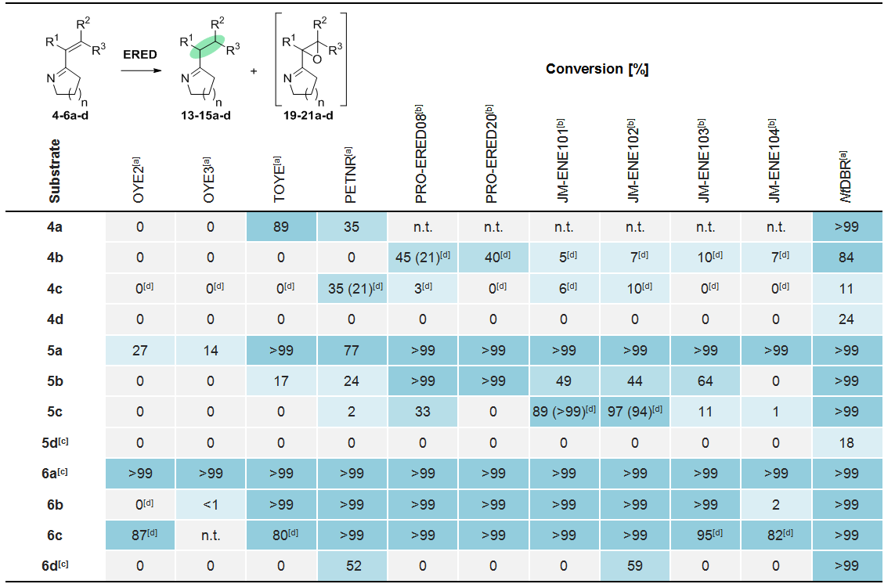
Conversion was determined by GC analysis after 24 h. n.t. = not tested. Reaction conditions: 5 mM enimine, [a] 2 mg·mL^{–1} purified ERED or [b] 5 mg·mL^{–1} ERED CFE, 0.1 mg·mL^{–1} GDH, 0.1 mM NADP⁺, 50 mM glucose, 5% v/v DMSO, 100 mM potassium phosphate buffer pH 7.0. [c] Product determined by analogy based on the GC-MS spectrum. [d] α,β-epoxy imine observed, reported conversion in brackets refer to the addition of 0.1 mg·mL^{–1} catalase.

broad selection of EREDs, either produced in-house as His-tagged purified enzymes or obtained from commercial sources (see Supporting Information).
Biotransformations were performed using glucose dehydrogenase (GDH) and glucose to recycle the NADPH. Control reactions omitting the ERED were run in parallel to ensure that activity was due to the biocatalyst and that substrate degradation was minimal during the reaction. A selection of ERED biotransformation results is presented in Table 1 (see the Supporting Information Table S1 for the full data set). All of the EREDs were shown to catalyse the reduction of the C=C bond of at least two of the substrates, the highest conversions being observed for cyclic enimines that contained terminally unsubstituted alkenes (4-6a). As expected, the enzymes were completely chemoselective for C=C reduction, with no C=N reduction detected. Traditional ERED biocatalysts belonging to the Old Yellow Enzyme (OYE) subfamily, such as TOYE and PETNR, only afforded high conversions with sterically unhindered and 7-membered enimines (4a, 5a, 6a-c). Certain OYE homologues (PRO-ERED08 and JM-ENE101) were able to catalyse the reduction of specific substituted substrates (5b and 5c) with excellent conversion. However, the best results overall were obtained with the flavin-independent dehydrogenase NtDBR, which was able to reduce the entire panel of enimine substrates.
Interestingly, for some substrates (4b, 6b, 4-6c), the formation of the α,β-epoxy imine (19b, 21b, 19-21c respectively) was indicated (see Supporting Information). The synthesis of this by-product could be tentatively ascribed to the ERED-catalysed reduction of O₂ to H₂O₂ and subsequent chemo-epoxidation, in a similar fashion to other activated alkenes.²⁶ The addition of catalase to the reaction, designed to reduce the latent H₂O₂ concentration, mitigated the formation of the by-product and supported its identification as the α,β-epoxy imine (Table 1, brackets).

Figure 1. Potential mechanisms and relative rates of ERED-catalysed enimine reduction.
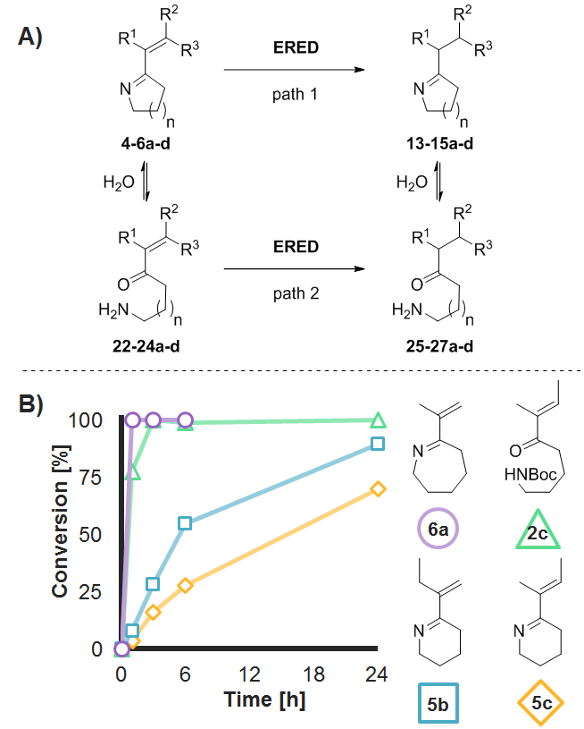
Table 2. Screening of IRED-catalysed C=N reduction of rac-14b.
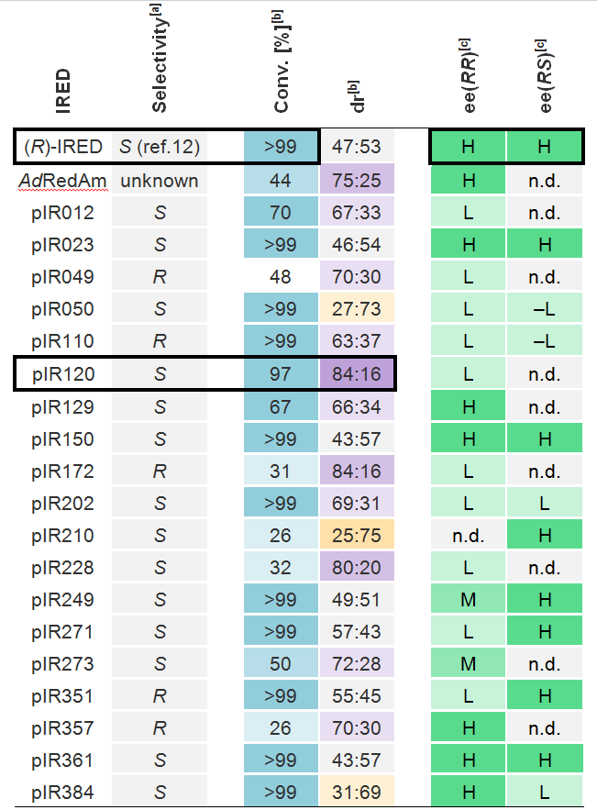
Reaction conditions: 5 mM rac-14b, 4 mg·mL^{–1} IRED CFE, 0.1 mg·mL^{–1} GDH, 0.1 mM NADP⁺, 10 mM glucose, 5% v/v DMSO, 100 mM potassium phosphate buffer pH 7.0. [a] Selectivity toward 6-phenyl-2,3,4,5-tetrahydropyridine as provided by the supplier, unless stated. [b] Conversion and dr were determined after 24 h by GC-MS. [c] Enantioselectivity estimated by GC, H = high (>90% ee), M = medium (75-90% ee), L = low (<75% ee), – = opposite enantiomer, n.d. = not determined.

From the outset we were mindful that two possible pathways might be operating during the reduction process. Firstly, the enimine substrate could undergo direct reduction of the C=C bond (Figure 1A, path 1). Alternatively, the substrate might undergo hydrolysis in situ to generate the enone 22-24a-d which would then be reduced by the ERED, followed by ring closure to give the product (Figure 1A, path 2). Recently we have shown that for simple cyclic imines the equilibrium position between the open and closed form in the biotransformation medium is highly dependent upon ring size.²⁷ Similarly, the 7-membered cyclic enimine 6a was found to exist predominantly in the ring-open form 24a whilst the 6-membered 5c was observed only slightly as the ring-open form 23c by ¹H NMR. To gain insight into the nature of the ERED-catalysed enimine reduction we carried out a time course study of three different ring sized substrates (Figure 1B). The conversion of N-Boc-protected amino enone 2c (43:57 E/Z) was also monitored for comparison, to mimic the ring-open 6-membered cyclic enimines.
The rate of NtDBR-catalysed reduction for both ring-open 2c and 6a was far higher compared to the predominantly ring-closed enimines 5b and 5c. This experiment confirms that the ERED can accept the ring-open enone 2c and that its reduction is fast compared with the analogous ring-closed form 5c. To further investigate the reduction mechanism, computational calculations were performed to assess the relative electrophilicity of the β-carbon of each unsaturated system (see Supporting Information). The calculated ranking parallels the order of the experimental rates of enimine reduction (Figure 1B), in particular when calculated based on the ring open major form of 6a. Both these pieces of evidence suggest that C=C reduction progresses via the enone. However, these data do not rule out the possibility of the reduction progressing at least partially via path 1. It is feasible that the lower alkene activation of the imine group relative to the ketone, or the steric hindrance or stereoelectronic properties of the cyclic imine functionality hamper substrate binding or reduce turnover.
To demonstrate the synthetic utility of the ERED-catalysed reduction of enimines, an ERED-IRED cascade was envisaged to prepare cyclic amine diastereomers. For this purpose, it was important to identify IREDs with complementary stereoselectivity toward α-chiral imines. A selection of 29 IREDs either produced in-house or obtained from commercial sources was screened against the racemic α-chiral imine 14b (Table 2 and Supporting Information Table S2). The majority of IREDs favoured formation of the (RR)-enantiomer but differences in both enantio- and diastereoselectivity were observed within the panel, including excellent conversion to differently enriched mixtures of three out of the four possible stereoisomers of 17b. Interestingly, pIR120 and pIR202 exhibited simultaneously high diastereoselectivity and high conversion toward the imine rac-14b. Dynamic kinetic resolution-mediated reduction of the chiral imine was ruled out through a ¹H NMR study which showed that, whilst racemisation occurred, it was at an insufficient rate to allow interconversion of the two enantiomers during the reaction (see Supporting Information). This suggests that both these biocatalysts deliver the hydride from opposite directions depending on the pre-existing stereochemistry of the imine substrate. These two observations demonstrate the propensity for substrate-controlled diastereoselectivity exhibited by IREDs.¹¹
Initial attempts to combine ERED and IRED steps in a one-pot cascade double reduction of enimines were unsuccessful. The rate of IRED-catalysed reduction of the C=N bond was much faster than the ERED-catalysed C=C bond reduction and ultimately led to the formation of considerable quantities of the corresponding allylic amines 7-9a-d (data not shown), which are not substrates for EREDs due to the lack of C=C activation. To overcome this limitation, a two-step telescopic procedure was employed, in which a stereocomplementary IRED was charged after ERED-catalysed C=C reduction of the enimine. Cyclic stereoenriched amines could be prepared with good to complete conversion and moderate to excellent stereoselectivity. Whilst NtDBR displayed good activity towards all the substrates, it appeared to reduce all tested enimines unselectively and so diastereomers prepared using this biocatalyst were stereoenriched by the IRED only (see Supporting Information, Scheme S2).
As an initial example, chiral piperidine 17a was formed with excellent conversion and enantioselectivity after 4 h (Scheme 3). Remarkably, by selecting suitably complementary ERED-IRED pairs and using structurally convergent substrates 5b and 5c (which are both reduced to the same imine intermediate 14b=14c), 3 of the 4 possible stereoisomers of amine 17b=17c could be formed with excellent conversion and moderate to excellent dr, ee and analytical yield, demonstrating the utility of this methodology.
Scheme 3. Representative examples of ERED-IRED telescopic synthesis of saturated N-heterocycles.
Reaction conditions: 20 mM enimine, 16 mg·mL^{–1} ERED and IRED CFE, 0.1 mg·mL^{–1} catalase, 1 mg·mL^{–1} GDH, 0.1 mM NADP⁺, 100 mM glucose, 5% v/v DMSO, 100 mM potassium phosphate buffer pH 7.0. Conversion was determined by GC-MS analysis. Analytical yields were determined via comparison to external calibration. Stereoselectivity was determined by chiral GC following derivatisation (absolute configuration of 18b was assigned by analogy with 17b²²).

The discrepancy between analytical yields (determined via an external calibration curve) and conversion could be ascribed to substrate degradation and/or product loss during the workup procedure. To the best of our knowledge, this telescoped biocatalytic procedure is superior in terms of yield and diastereoselectivity to known methods for synthesising 17b,¹⁵ and importantly also allows access to a greater range of diastereomers. Enzyme engineering and/or optimisation of the reaction and isolation conditions could potentially reduce catalyst loadings and enhance yields or selectivity of the process even further.
The same telescopic system applied to 5-membered substrates 4b and 4c gave the same diastereoisomer of 16b in moderate selectivity, but produced significant amounts of the allylic amines 7b and 7c. In contrast, 7-membered substrates 6b and 6c afforded complementary diastereoisomers of 18b in much higher selectivities, albeit in moderate conversions due to a less efficient IRED-mediated reduction. Additional examples of successful telescopic reactions are provided in the Supporting Information. Overall, the best compromise between selectivity and yield was obtained with the 6-membered compounds. Therefore, in order to demonstrate the preparative utility of the telescopic ERED-IRED enimine reduction protocol, preparative syntheses of the chiral amines (S)-17a and (RS)-17b were performed, yielding the hydrochloride salts with excellent enantioselectivity (>99% ee) and in 40% and 57% isolated yield respectively, comparing well with the corresponding analytical yield.
In summary, a new class of activated alkenes has been shown to undergo ERED-mediated C=C bond reduction. The mechanism by which these substrates are converted has been probed via a time course study and computational electrophilicity calculations in order to gain evidence for the presence of ring-open linear enones as intermediaries. Finally, synthetic applicability has been demonstrated through the development of a new ERED-IRED cascade enabling the preparative scale synthesis of a range of diastereomerically enriched amine heterocycles, which are known to be difficult to access via traditional chemical synthesis, despite their value as intermediates for APIs and bioactive natural product analogues with multiple stereocentres.
ASSOCIATED CONTENT
Supporting Information
The Supporting Information is available free of charge on the ACS Publications website.
Experimental section, extended data sets, substrate and product characterisation, copies of NMR, GC and GC-MS traces (PDF).
AUTHOR INFORMATION
Corresponding Author-
E-mail: fabio.parmeggiani@manchester.ac.uk,
nicholas.turner@manchester.ac.uk
Website: https://www.turner-biocatalysis.com/
Notes
The authors declare no competing financial interests.
ACKNOWLEDGMENT
N.J.T. is grateful to the ERC for the award of an Advanced Grant (BIO-H-BORROW, grant number 742987). T.W.T. acknowledges a CASE award from the UK Biotechnology and Biological Sciences Research Council (BBSRC) and Pfizer (BB/M011208/1). J.R.M. acknowledges a CASE award from the Industrial Biotechnology Innovation Centre (IBioIC), BBSRC and Prozomix Ltd. The authors would also like to thank Yuriy Abramov, Jason Mustakis, Shu Yu, Jacquelyn Klug-McLeod and Hahdi Perfect for their computational calculation support.

REFERENCES
(1) Jarvis, L. M. The Year in New Drugs. Chem. Eng. News 2018, 96 (4), 26–30.
(2) Schrittwieser, J. H.; Resch, V. The Role of Biocatalysis in the Asymmetric Synthesis of Alkaloids. RSC Advances. The Royal Society of Chemistry September 17, 2013, pp 17602–17632. https://doi.org/10.1039/c3ra42123f.
(3) Lichman, B. R.; Zhao, J.; Hailes, H. C.; Ward, J. M. Enzyme Catalysed Pictet-Spengler Formation of Chiral 1,1’-Disubstituted- A Nd Spiro-Tetrahydroisoquinolines. Nat. Commun. 2017, 8 (1), 14883. https://doi.org/10.1038/ncomms14883.
(4) Heath, R. S.; Pontini, M.; Bechi, B.; Turner, N. J. Development of an R-Selective Amine Oxidase with Broad Substrate Specificity and High Enantioselectivity. ChemCatChem 2014, 6 (4), 996–1002. https://doi.org/10.1002/cctc.201301008.
(5) Ryan, J.; Šiaučiulis, M.; Gomm, A.; Maciá, B.; O’Reilly, E.; Caprio, V. Transaminase Triggered Aza-Michael Approach for the Enantioselective Synthesis of Piperidine Scaffolds. J. Am. Chem. Soc. 2016, 138 (49), 15798–15800. https://doi.org/10.1021/jacs.6b07024.
(6) Zumbrägel, N.; Merten, C.; Huber, S. M.; Gröger, H. Enantioselective Reduction of Sulfur-Containing Cyclic Imines through Biocatalysis. Nat. Commun. 2018, 9 (1). https://doi.org/10.1038/s41467-018-03841-5.
(7) Leipold, F.; Hussain, S.; Ghislieri, D.; Turner, N. J. Asymmetric Reduction of Cyclic Imines Catalyzed by a Whole-Cell Biocatalyst Containing an (S)-Imine Reductase. ChemCatChem 2013, 5 (12), 3505–3508. https://doi.org/10.1002/cctc.201300539.
(8) France, S. P.; Aleku, G. A.; Sharma, M.; Mangas-Sanchez, J.; Howard, R. M.; Steflik, J.; Kumar, R.; Adams, R. W.; Slabu, I.; Crook, R.; Grogan, G.; Wallace, T., W.; Turner, N., J. Biocatalytic Routes to Enantiomerically Enriched Dibenz[c,e]Azepines. Angew. Chem. Int. Ed. 2017, 56 (49), 15589–15593. https://doi.org/10.1002/anie.201708453.
(9) O’Reilly, E.; Iglesias, C.; Ghislieri, D.; Hopwood, J.; Galman, J. L.; Lloyd, R. C.; Turner, N. J. A Regio- and Stereoselective ω-Transaminase/Monoamine Oxidase Cascade for the Synthesis of Chiral 2,5-Disubstituted Pyrrolidines. Angew. Chem. Int. Ed. 2014, 53 (9), 2447–2450. https://doi.org/10.1002/anie.201309208.
(10) Costa, B. Z.; Galman, J. L.; Slabu, I.; France, S. P.; Marsaioli, A. J.; Turner, N. J. Synthesis of 2,5-Disubstituted Pyrrolidine Alkaloids via A One-Pot Cascade Using Transaminase and Reductive Aminase Biocatalysts. ChemCatChem 2018, 10 (20), 4733–4738. https://doi.org/10.1002/cctc.201801166.
(11) France, S. P.; Hussain, S.; Hill, A. M.; Hepworth, L. J.; Howard, R. M.; Mulholland, K. R.; Flitsch, S. L.; Turner, N. J. One Pot Cascade Synthesis of Mono- and Di-Substituted Piperidines and Pyrrolidines Using Carboxylic Acid Reductase (CAR), ω-Transaminase (ω-TA) and Imine Reductase (IRED) Biocatalysts. ACS Catal. 2016, 6 (6), 3753–3759. https://doi.org/10.1021/acscatal.6b00855.
(12) Hussain, S.; Leipold, F.; Man, H.; Wells, E.; France, S. P.; Mulholland, K. R.; Grogan, G.; Turner, N. J. An (R)-Imine Reductase Biocatalyst for the Asymmetric Reduction of Cyclic Imines. ChemCatChem 2015, 7 (4), 579–583. https://doi.org/10.1002/cctc.201402797.
(13) Yao, P.; Xu, Z.; Yu, S.; Wu, Q.; Zhu, D. Imine Reductase-Catalyzed Enantioselective Reduction of Bulky α,β-Unsaturated Imines En Route to a Pharmaceutically Important Morphinan Skeleton. Adv. Synth. Catal. 2019, 361 (3), 556–561. https://doi.org/10.1002/adsc.201801326.
(14) Ye, S.; Braña, A. F.; González-Sabín, J.; Morís, F.; Olano, C.; Salas, J. A.; Méndez, C. New Insights into the Biosynthesis Pathway of Polyketide Alkaloid Argimycins P in Streptomyces Argillaceus. Front. Microbiol. 2018, 9 (FEB). https://doi.org/10.3389/fmicb.2018.00252.
(15) Adriaenssens, L. V.; Austin, C. A.; Gibson, M.; Smith, D.; Hartley, R. C. Stereodivergent Diversity Oriented Synthesis of Piperidine Alkaloids. European J. Org. Chem. 2006, 2006 (22), 4998–5001. https://doi.org/10.1002/ejoc.200600744.
(16) Guerlet, G.; Spangenberg, T.; Mann, A.; Faure, H.; Ruat, M. Synthesis and Biological Evaluation of Desmethylveramiline, a Micromolar Hedgehog Inhibitor. Bioorganic Med. Chem. Lett. 2011, 21 (12), 3608–3612. https://doi.org/10.1016/j.bmcl.2011.04.103.
(17) Fellah, M.; Santarem, M.; Lhommet, G.; Mouriès-Mansuy, V. Total Synthesis of Quinolizidine (-)-217A. J. Org. Chem. 2010, 75 (22), 7803–7808. https://doi.org/10.1021/jo101668k.
(18) Stuermer, R.; Hauer, B.; Hall, M.; Faber, K. Asymmetric Bioreduction of Activated C=C Bonds Using Enoate Reductases from the Old Yellow Enzyme Family. Current Opinion in Chemical Biology. Elsevier Current Trends April 1, 2007, pp 203–213. https://doi.org/10.1016/j.cbpa.2007.02.025.
(19) Toogood, H. S.; Scrutton, N. S. Discovery, Characterization, Engineering, and Applications of Ene-Reductases for Industrial Biocatalysis. ACS Catal. 2018, 8 (4), 3532–3549. https://doi.org/10.1021/acscatal.8b00624.
(20) Yanto, Y.; Winkler, C. K.; Lohr, S.; Hall, M.; Faber, K.; Bommarius, A. S. Asymmetric Bioreduction of Alkenes Using Ene-Reductases YersER and KYE1 and Effects of Organic Solvents. Org. Lett. 2011, 13 (10), 2540–2543. https://doi.org/10.1021/ol200394p.
(21) Padhi, S. K.; Bougioukou, D. J.; Stewart, J. D. Site-Saturation Mutagenesis of Tryptophan 116 of Saccharomyces Pastorianus Old Yellow Enzyme Uncovers Stereocomplementary Variants. J. Am. Chem. Soc. 2009, 131 (9), 3271–3280. https://doi.org/10.1021/ja8081389.
(22) Mueller, N. J.; Stueckler, C.; Hauer, B.; Baudendistel, N.; Housden, H.; Bruce, N. C.; Faber, K. The Substrate Spectra of Pentaerythritol Tetranitrate Reductase, Morphinone Reductase, N-Ethylmaleimide Reductase and Estrogen-Binding Protein in the Asymmetric Bioreduction of Activated Alkenes. Adv. Synth. Catal. 2010, 352 (2–3), 387–394. https://doi.org/10.1002/adsc.200900832.
(23) Brenna, E.; Crotti, M.; Gatti, F. G.; Manfredi, A.; Monti, D.; Parmeggiani, F.; Santangelo, S.; Zampieri, D. Enantioselective Synthesis of (R)-2-Arylpropanenitriles Catalysed by Ene-Reductases in Aqueous Media and in Biphasic Ionic Liquid-Water Systems. ChemCatChem 2014, 6 (8), 2425–2431. https://doi.org/10.1002/cctc.201402205.
(24) Brenna, E.; Gatti, F. G.; Manfredi, A.; Monti, D.; Parmeggiani, F. Old Yellow Enzyme-Mediated Reduction of β-Cyano-α,β- Unsaturated Esters for the Synthesis of Chiral Building Blocks: Stereochemical Analysis of the Reaction. Catal. Sci. Technol. 2013, 3 (4), 1136–1146. https://doi.org/10.1039/c3cy20804d.
(25) Williams, G. D.; Pike, R. A.; Wade, C. E.; Wills, M. A One-Pot Process for the Enantioselective Synthesis of Amines via Reductive Amination under Transfer Hydrogenation Conditions. Org. Lett. 2003, 5 (22), 4227–4230. https://doi.org/10.1021/ol035746r.
(26) Durchschein, K.; Hall, M.; Faber, K. Unusual Reactions Mediated by FMN-Dependent Ene- and Nitro-Reductases. Green Chem. 2013, 15 (7), 1764. https://doi.org/10.1039/c3gc40588e.
(27) Zawodny, W.; Montgomery, S. L.; Marshall, J. R.; Finnigan, J. D.; Turner, N. J.; Clayden, J. Chemoenzymatic Synthesis of Substituted Azepanes by Sequential Biocatalytic Reduction and Organolithium-Mediated Rearrangement. J. Am. Chem. Soc. 2018, 140 (51), 17872–17877. https://doi.org/10.1021/jacs.8b11891.

TOC GRAPHIC
