Towards Circular Business Models: A systematic literature review on classification frameworks and archetypes
Paolo Rosa §, Claudio Sassanelli, Sergio Terzi

Department of Management, Economics and Industrial Engineering,
Politecnico di Milano, Piazza Leonardo da Vinci 32, 20133 Milan - Italy
§ Corresponding author: paolo1.rosa@polimi.it

Abstract
Since many years, companies are trying to cope with impressive technological growth rates, severe environmental issues and even more restrictive national and international directives. However, innovative Business Models (BMs) and industrial strategies adequate to this new context are still either under development or implementation. To this aim, the article proposes a systematic literature review on existing Circular Business Models (CBMs) and their classification methods, by selecting the most promising ones. A total amount of 283 articles related with CBMs has been assessed into detail, by identifying: 5 archetypes, 9 classification methods, 5 adoption-oriented challenges, 4 decision-support tools and 3 additional research areas. Key findings demonstrate that: i) Product-Service Systems (PSSs)-oriented and Reuse, Remanufacturing and Recycling (3R)-based CBMs are the most common archetypes, ii) Business Model Canvas is the most diffused classification framework, iii) sustainability and company-based challenges are the most discussed by the experts and iv) sustainability check-oriented is the most common type of decision-support tools. These (and others) results could support both companies, researchers and governments in updating the current knowledge on CBMs and make them adoptable for practitioners from different industrial contexts.

Keywords: Circular Economy; Circular Business Models; Classification Frameworks; Archetypes; Literature Review.

Acronyms
3R | Reuse, Remanufacturing, Recycling | GBM | Green Business Model
AM | Additive Manufacturing | ICT | Information and Communication Technology
BM | Business Model | IoT | Internet of Things
BMC | Business Model Canvas | KET | Key Enabling Technology
BoL | Beginning of Life | MoL | Middle of Life
CBM | Circular Business Model | P2P | Peer-to-Peer
CE | Circular Economy | PSS | Product-Service System
CEBM | Circular Economy Business Model | SBM | Sustainable Business Model
DfX | Design for X | SME | Small and Medium Enterprise
EoL | End of Life

1. Introduction
Since many years, companies are trying to cope with the fast technological growth rates, severe environmental issues (Murray et al., 2017; WCED, 1987) and even more restrictive national and international directives (European Commission, 2017, 2011; Mathews and Tan, 2016, 2011). However, innovative Business Models (BMs) and industrial strategies adequate to this new context are still either under development or implementation (Ghezzi and Cavallo, 2019). The need of rethinking and reshaping current production and consumption behaviours emerged from several works (Bocken et al., 2016a; Merli et al., 2018; Pardo, 2018), claiming for further researches on CE-oriented innovative practices, such as sharing economy, product-service systems, dematerialization, remanufacturing and product lifecycles. Considering all these elements, the paper wants to analyse the Circular Business Model (CBM) research context in all its dimensions and make companies aware about them during their shift towards CE. To this aim, a systematic literature review has been conducted. Firstly, a state-of-the-art analysis allowed the identification of macro-areas composing the CBM research context and the most common types of CBMs. Secondly, an in-depth analysis of these macro-areas allowed the understanding of their classification into archetypes. The paper is structured as follows. Section 2 defines the research context and its objectives. Section 3 analyses the adopted research methodology to perform the systematic literature review. Section 4 presents and discusses results coming from the literature analysis. Finally, Section 5 provides some concluding remarks and proposes future research areas.
2. Research context
The entire work is based on two main concepts, as CE and CBMs. This section presents them and tries to clarify their definition.
2.1 Circular Economy
CE is often framed in the wider concept of sustainability (Merli et al., 2018). Considering the report of The Ellen MacArthur Foundation (2015), CE is defined as a global economic model minimizing the negative effects of finite resources consumption, by focusing on intelligent design of materials, products and systems. Inspired by the concept of closed-loop economy, the CE paradigm was introduced at the end of the ‘80s (Pearce and Turner, 1991; Stahel and Reday-Mulvey, 1981) to minimise emissions, resource use, pollution and waste, and maximise the resource efficiency of material assets. However, only in the last years its relevance was amplified worldwide, by an increasing interest of people in environmental impacts of products and processes and the sustainable use of natural resources (Reuter et al., 2013). Before the introduction of CE, a traditional linear (open-ended) economy was the only existing paradigm, treating the environment as a waste reservoir (Su et al., 2013). Products followed a linear lifecycle that, starting from conceptualization and design, went through development, in-service and finished with disposal. Progressively, these old production and consumption patterns have been substituted by closed-loop ones – completely focused on resource efficiency and waste reduction – able to better balance and harmonize economy, environment and societal needs. However, this paradigm shift is not immune from criticalities (Murray et al., 2017). CE is an active research area evolved primarily as research on waste generation, resource use and environmental impact, while neglecting business and economic perspectives. This way, its implementation at industrial level has been inhibited, since advantages for industries are still not explicit (Lieder and Rashid, 2016). To this aim, a real transition towards CE requires relevant changes along the value chain, also in the terms of adopted market strategies and BMs.
2.2 Circular Business Models
BMs describe the rationale of how an organization creates, delivers, and captures value (Osterwalder and Pigneur, 2010). The literature studied along the time their role as a mean for driving competitiveness and set up a company’s market strategy (Wünderlich et al., 2015). CBMs are a new kind of BMs, where the value creation is grounded on keeping the economic value embedded into products after their use and exploit it for new types of market offerings. This action requires a set of return flows (from end users to producers), eventually through intermediaries (Linder and Williander, 2017). The economic value of a product can be maintained through a series of activities, like: i) lowering the dependence from virgin materials, ii) shifting from non-renewable to renewable energy systems, iii) adopting more sustainable production practices and iv) greening the entire value chain. Depending on the reference literature, CBMs (also named Circular Economy Business Models – CEBMs) can be grouped under the wider umbrella of either Green Business Models (GBMs) and/or Sustainable Business Models (SBMs). Among the several types of CBMs available in literature, Product-Service System (PSS)-based CBMs are considered by several authors as one of the most simple innovation strategy towards CE (Manzini and Vezzoli, 2003; Tukker and Tischner, 2006; Wong, 2004). They are declined in three main categories (product-, use- and result-oriented PSSs) and differentiated in eight archetypes (Tukker, 2004).
3. Research methodology
A systematic literature review has been conducted by following the five steps defined by Denyer and Tranfield (2009). Firstly, the research scope was defined, grabbing valuable knowledge from papers related to both the effects of CE on traditional BMs and methods to classify CBMs. This approach led to the following research questions:
- RQ1: Which existing BMs can be identified as CBMs?
- RQ2: What is the most common framework for classifying CBMs?
Trying to improve the searching efficiency, scientific articles published from 2000 up to the first quarter of 2018 and gathered from the most popular academic search engines (i.e. Scopus and Science Direct) has been assessed. Without considering any document type and field content limitation, a total amount of three searches have been performed. The set of queries selected for conducting the searching process on title, abstract and keywords has been reported in the following Table 1, leading to 1703 results.
Table 1. Searches by keywords
Queries | Search engine
Queries | Scopus | Science Direct
“Circular Economy” AND “Business Model” | 728 | 661
“Circular Business Model” | 125 | 95
“Circular Economy Business Model” | 59 | 35
Total | 912 | 791

Figure 1 shows the adopted research strategy. The initial set of 1703 articles has been improved with 58 documents added through cross-referencing, 8 through hand-searching and 23 recommended by the experts. After having detected and removed redundancies among documents, a first selection by title, abstract and keywords was performed. A second screening was done by assessing full text.
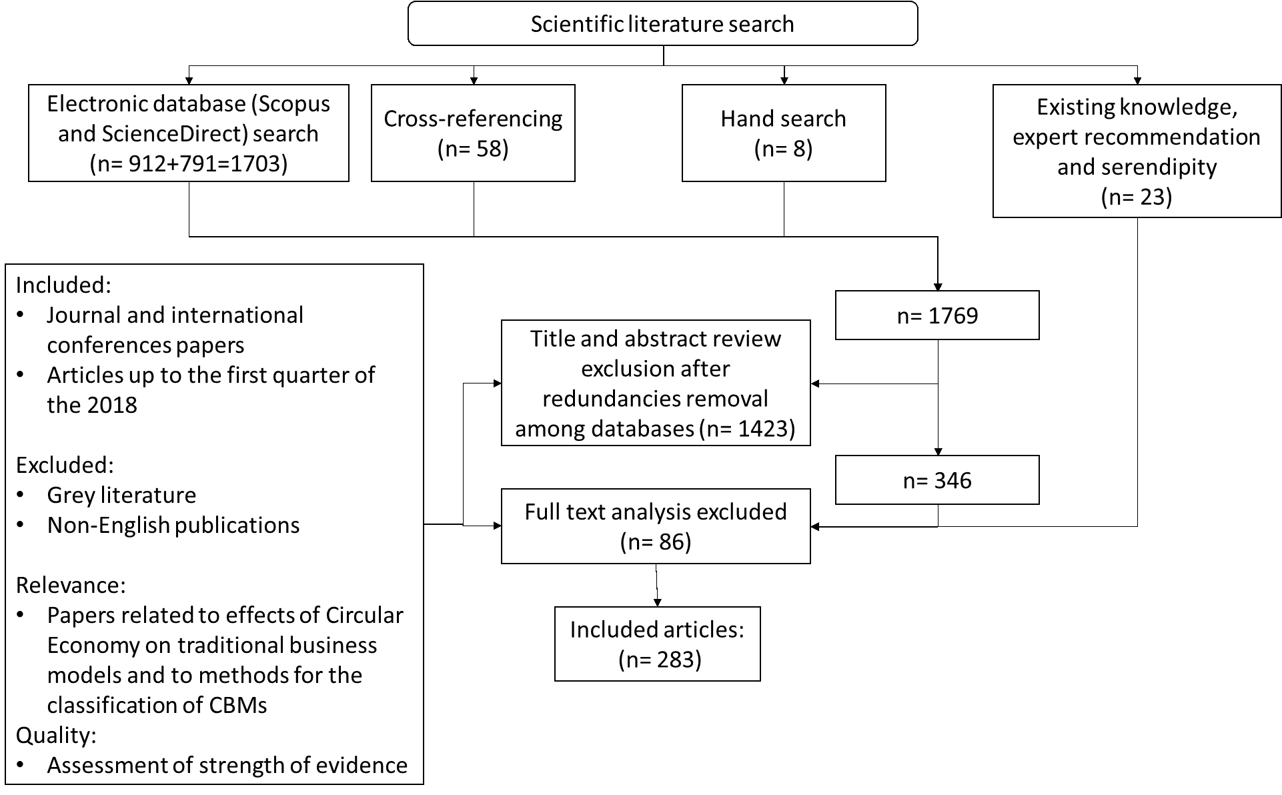
Figure 1. Systematic review approach adapted by (Smart et al., 2017)

By applying some refining criteria, a final amount of 283 documents was considered as reference literature and assessed into detail (see Section 4). Two experts analysed the documents to avoid biases and obtaining a full interpretation of the assessed contributions. Results were compared and, then, made consistent to each other. Documents have been classified by year, type of publication, nationality of the first author and type of research. Furthermore, documents have been clustered into 8 macro topics (e.g. CBM design, industrial strategies, governmental policies, environmental impact, circular design, theoretical analysis, societal impact, new technologies) detected through a keywords analysis (i.e. progressively gathering and grouping articles by keywords) and furtherly declined in 35 detailed topics.
3.1 Descriptive characterization of the sample
Results reported in Table 1 unveiled that the attractiveness of CBMs increased from 2015 onwards. The first round included "Circular Economy" AND "Business Model", providing 661 results constantly growing along the period (see Figure 2). This highlights the relevance of the topic in literature. Due to the high number of contributions, a second search has been conducted, using "Circular Business Model” as keyword, providing 95 results. A further search was implemented inserting “Circular Economy Business Model” as keyword, but very few contributions were gathered from it. These numbers reveal not only the interest raised by academics in this research context, but also the need for further investigation on these topics. Furthermore, the same trends can be found through word searches conducted with other search engines.
Figure 2 displays results of the searching process, in terms of number of articles per year and publications trend. The total amount of 283 articles reveals the relevant attention devoted to this topic (from 2000 up to 2018-first quarter) by the experts, especially in 2016 and 2017. An inflection point occurs around 2015, after which annual publication rates accelerate. A total of 158 articles were published in scientific journals with impact factor, 26 in scientific journals without impact factor, 64 in proceedings of scientific conferences, 24 scientific reports, 8 book chapters and 2 industrial reports.
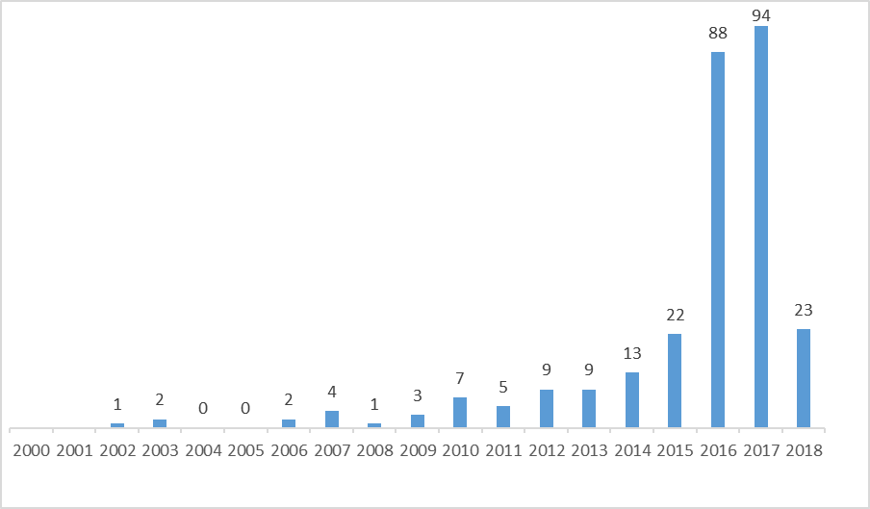
Figure 2. Historical series of published articles
As shown in Figure 3, 32,5% of the articles (92 out of 283) have been published in five top scientific journals, and the most popular one is Journal of Cleaner Production.
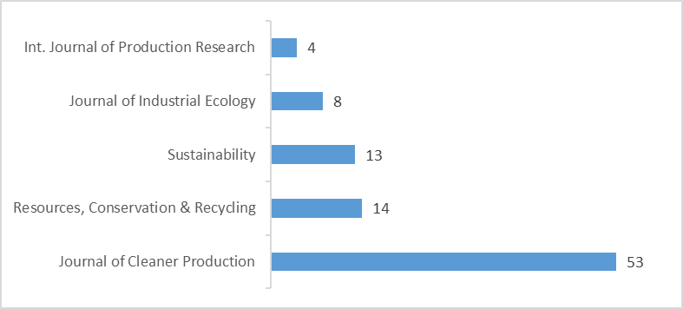
Figure 3. Top five journals

In general terms, the literature assesses CBMs considering either a theoretical/analytical or a practical view. In the first case, the intent is presenting the main concepts of CE and CBMs to a general public, in terms of strengths and weaknesses (112 articles) or analytical assessments (95 articles). In the second case, the final aim is describing best practices through case studies (58 articles) or surveys (18 articles). This extract shows that studies not involving companies, both theoretical (presenting a qualitative assessment of the common knowledge) and analytical ones (performing a quantitative analysis through mathematical models), constitute 73.1% of the overall literature on CE and CBMs.
Considering the nationality of the authors, the highest number of contributions come from northern European countries, followed by China and Italy. More into detail, United Kingdom is the major contributor, with 36 articles (19.6%), followed by Sweden (10.2%), The Netherlands (8.1%), China (6.0%) and Italy (4.9%) (see Figure 4).
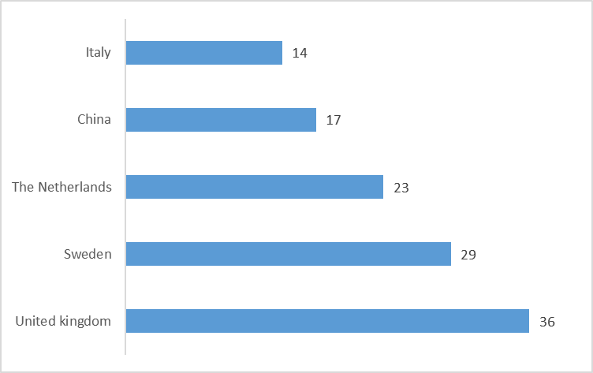
Figure 4. Top five publishing countries

Following a bottom-up procedure about the typology of literature assessed, there are several perspectives from which CE and CBMs were approached by the experts. Works have been gathered basing on micro topics (i.e. considering title, abstract and keywords). Best practices are the most discussed topic in literature (10.2%), followed by opportunities and challenges related with CE (9.2%), conceptualization of CE (7.8%), BM innovation frameworks (7.4%), BM challenges and BM decision-support tools (6.0% each), Chinese CE policies, design decision-support tools and future trends (5.7% each). The sum of the mentioned topics represents about 50% of the available literature. Then, a lot of other topics have been discussed (see Figure 5).
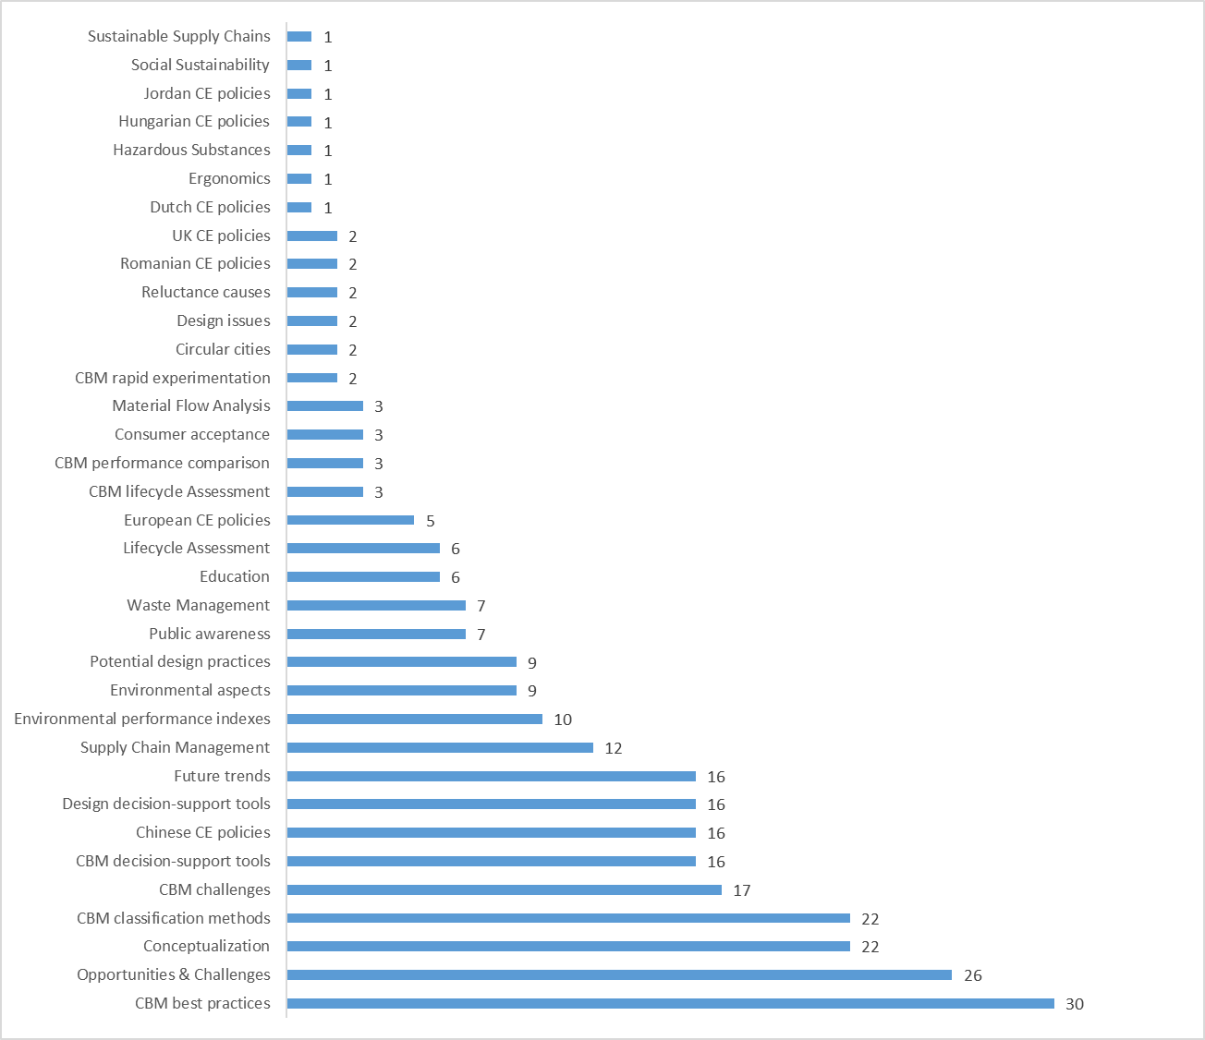
Figure 5. CE and CBM micro topics

Trying to streamline the analysis, micro topics have been grouped in macro categories basing on their mutual consistency. This way, business model design is the most discussed macro topic in literature (23.3%), followed by industrial strategies (20.1%), governmental policies (19.1%), environmental impact (11.7%), circular design of products (9.5% each), theoretical analyses (8.5%), societal impact (5.3%) and new technologies (2.5%) (Figure 6).
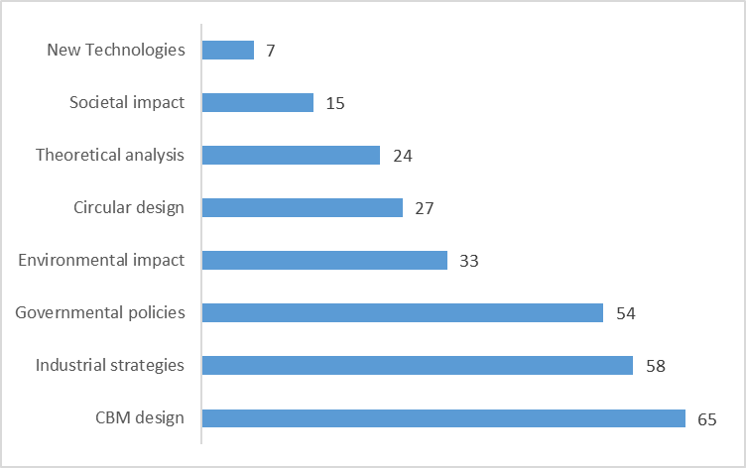
Figure 6. CE and CBM macro topics

Concerning the mentioned topics appearing in Figure 5 and Figure 6, only topics strictly related with CBMs will be described into detail in the following Section 4. In particular, the micro topics named CBM rapid experimentation, CBM performance comparison, CBM lifecycle assessment, CBM decision-support tools, CBM challenges, CBM classification methods and CBM best practices have been grouped in the macro topic named CBM design, consisting in 65 articles (see Figure 7).
4. Thematic analysis
After having identified the limited group of documents that, more than others, can allow to get information about the research questions identified in Section 2, the present section is focused on the thematic analysis of detailed topics listed at the end of the previous section. The aggregate dimension of analysis, named CBM design, is split into seven 2nd order themes (see Figure 7) and each of them will be described into detail and furtherly divided in 3rd order themes. Subsequently, the focus shifts on CBM classification methods and the, so called, “archetypes”.
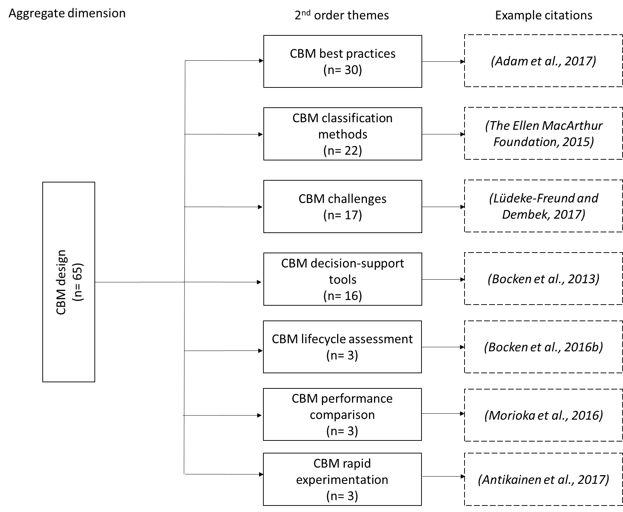
Figure 7. CBM design dimension scheme (adapted from (Smart et al., 2017))

4.1 CBM best practices
The first, and most discussed, topic is related with CBM best practices, or practical implementation of CBMs. From this perspective, the authors follow different strategies. Some experts present CBMs by directly referring to existing examples, usually calling them with emblematic names, like repair cafés (Adam et al. 2017), gap exploiters (Whalen et al. 2017) and gatekeepers (Prendeville et al. 2017b), trying to interpret what already proposed by The Ellen MacArthur Foundation (2015). Other experts are focused on specific services and their role in reaching an efficient and sustainable growth (Piciu 2016). Again, other experts are focused on a specific product, mainly on washing machines (Bocken et al., 2017; Bressanelli et al., 2017; Gnoni et al., 2017). However, great part of the literature focuses on a particular sector, like metallurgy (Hindley, 2016; Kim et al., 2016; Ma et al., 2014), electric components (Laubscher et al. 2014), ICT (McIntyre and Ortiz 2015), apparels (Rattalino, 2017; Stål and Corvellec, 2018), mobility (Sarasini et al. 2016), solar energy (Svatikova et al. 2015), biomass/aquaculture/hydroponics (Jagger, 2016; Yazan et al., 2015) and large white goods (Sousa-Zomer et al., 2018, 2017). Finally, other authors prefer to maintain a more generic perspective, by proposing common patterns for: i) leading companies in reinventing their BMs (Beulque and Aggeri 2016), ii) identifying different types of product-people interactions (Dewberry et al. 2016), iii) describing 3R-based generic guidelines for adopting CE (Goyal et al., 2016; Guldmann, 2016), iv) presenting CE-related competitive advantages (Morioka et al. 2017), v) implementing innovators practices for closing materials loops (Regenfelder et al. 2016), vi) describing SME-oriented methods for adopting reuse principles (Venselaar and Kelft 2014) and vii) presenting wealth creation frameworks for developing countries (Scheel 2016).
Table 2. CBM best practice classification
Author | CBM best practice classification
Author | Paradigm-based | Service-based | Product-based | Sector-based | Pattern-based
(Adam et al. 2017) | x
(Beulque and Aggeri 2016) |  |  |  |  | x
(Bocken et al. (2017) |  |  | x
(Bressanelli et al. (2017) |  |  | x
(Dewberry et al. 2016) |  |  |  |  | x
(Gnoni et al. 2017) |  |  | x
(Goyal et al. 2016) |  |  |  |  | x
(Guldmann 2016) |  |  |  |  | x
(Hindley 2016) |  |  |  | x
(Jagger 2016) |  |  |  | x
(Kim et al. 2016) |  |  |  | x
(Laubscher et al. 2014) |  |  |  | x
(Ma et al. 2014) |  |  |  | x
(McIntyre and Ortiz 2015) |  |  |  | x
(Morioka et al. 2017) |  |  |  |  | x
(Piciu 2016) |  | x
(Prendeville et al. 2017b) | x
(Rattalino 2017) |  |  |  | x
(Regenfelder et al. 2016) |  |  |  |  | x
(Sarasini et al. 2016) |  |  |  | x
(Scheel 2016) |  |  |  |  | x
(Sousa-Zomer et al. 2017a) |  |  |  | x
(Sousa-Zomer et al. 2017b) |  |  |  | x
(Stål and Corvellec 2018) |  |  |  | x
(Svatikova et al. 2015) |  |  |  | x
(Venselaar and Kelft 2014) |  |  |  |  | x
(Whalen et al. 2017) | x
(Yazan et al. 2015) |  |  |  | x
Total | 3 | 1 | 3 | 13 | 8

Summing-up the results from Table 2, five sub-categories can be assigned to CBM best practice: paradigm-based, service-based, product-based, sector-based, pattern-based. Among them, the most recurrent are the last two, i.e. those aimed at guiding companies belonging to specific industries (mainly electric and electronic equipment) and those aimed at indicating general and innovative patterns helping companies in addressing CE in a more effective way, independently by the referring industry. Furthermore, there is a research gap in terms of consolidated circular practices guiding companies in improving the circularity of either product or services.
4.2 CBM classification methods
The second research area about CBMs is related with classification methods. In general terms, it is possible to distinguish these works in three macro segments: 1) papers referring to the ReSOLVE framework proposed by The Ellen MacArthur Foundation (2015), 2) papers focusing on the Business Model Canvas (BMC) methodology proposed by Osterwalder and Pigneur (2010) and 3) papers proposing hybrid models, exploiting both the previous ideas – see Table 3 for details.
Table 3. CBM classification methods
Author | CBM classification methods
Author | ReSOLVE | BMC | SI | PPP | OS | CD | BSC | VEM | MM
(Antikainen and Valkokari, 2016) |  | x
(Bocken et al., 2014) |  |  |  |  |  | x
(Bocken et al., 2016a) |  |  |  |  |  | x
(Charter, 2016) | x
(Chiappetta Jabbour et al., 2017) | x
(Chiaroni et al., 2016) |  | x
(Haanstra et al., 2017) |  |  |  |  |  |  |  |  | x
(Heyes et al., 2018) | x | x
(Janssen and Stel, 2017) |  |  |  |  |  |  | x
(Lewandowski, 2016) |  | x
(Lozano et al., 2016) |  |  |  | x
(Manninen et al., 2018) | x
(Mendoza et al., 2017) | x
(Morioka et al., 2018) |  |  |  |  |  |  |  | x
(Nerurkar, 2017) |  |  | x
(Nußholz, 2017a) |  | x
(Nußholz, 2017b) |  | x
(Prendeville and Bocken, 2016) |  |  |  |  |  | x
(Stratan, 2017) |  | x
(Tolio et al., 2017) |  |  |  |  | x
(Urbinati et al., 2017) |  | x
(Witjes and Lozano, 2016) |  |  |  | x
Total | 5 | 8 | 1 | 2 | 1 | 3 | 1 | 1 | 1
BMC= Business Model Canvas; SI= Sustainability Impact; PPP= Public-Private Partnership; OS= Operation Strategy; CD= Circular Design; BSC= Balanced Score Card; VEM= Value Exchange Matrix; MM= Morphological Matrix

The ReSOLVE framework is a set of principles defined by The Ellen MacArthur Foundation (2015) focused on supporting companies and governments during the definition of CE policies. This framework identifies six different ways to be circular:
- Regenerate – or actions focused on: i) shifting on renewable energy and secondary materials, ii) reclaiming/retaining/restoring health of the ecosystem or iii) returning recovered biological resources to the biosphere;
- Share – or actions focused on: i) sharing assets, ii) reuse/second hand or iii) prolonging product lifetime through maintenance/DfX rules;
- Optimize – or actions focused on: i) increasing performance/efficiency of products, ii) removing waste in production and supply chains or iii) leveraging big data, automation, remote sensing and steering;
- Loop – or actions focused on: i) remanufacturing of products/components, ii) recycling of materials, iii) anaerobic digestion of wastes or iv) extraction of biochemicals from organic wastes;
- Virtualize – or actions focused on direct/indirect dematerialization of products;
- Exchange – or actions focused on: i) replacing old materials with advanced non-renewable ones, ii) applying new technologies in traditional processes or iii) transforming products/services.
Even if the ReSOLVE framework cannot be referred to as a real classification method, many experts started from it for developing their own classification methods. For example, Charter (2016) tried to translate in practical terms what theoretically defined by the ReSOLVE framework, by categorising CBMs into two macro classes and six sub-segments. Manninen et al. (2018) exploited the ReSOLVE framework to develop an Environmental Value Proposition Table (EVPT) for embedding the environmental side on the value proposition of CBMs. Mendoza et al. (2017) added to the original ReSOLVE framework the “Implement” level, trying to reduce the gap between theoretical principles presented and their practical adoption. Finally, Chiappetta Jabbour et al. (2017) started from the ReSOLVE framework to map the relation between CBMs and big data analysis.
Considering the BMC-based classification methods, papers try to modify the original BMC for making it able to map CBMs, not only linear ones. For example, Antikainen and Valkokari (2016) added two evaluation levels to the original BMC, with the intent of better mapping the existing links between a reference company and all the actors involved in its supply chain. Nussholz (2017a, 2017b) embedded in the original BMC a method for assessing the added value coming from a cyclical exploitation of resources. Lewandowski (2016) added to the original BMC two dimensions, trying to map CBMs with the same model. Stratan (2017) followed a similar logic but focusing on the social entrepreneurship side in order to assess not-for-profit businesses. Finally, Chiaroni et al. (2016) and Urbinati et al. (2017) focused on value proposition and relations with suppliers, defined as the most important KPIs to control when a CE strategy must be implemented.
Considering papers proposing hybrid models, some interesting perspectives are presented by the authors. Nerurkar (2017) classified sustainability impacts related with CBMs in four classes. Bocken et al. (2014) proposed a set of CBM archetypes starting from circular product design principles. Lozano et al. (2016) and Witjes and Lozano (2016) identified the relation between public and private sectors for developing CE strategies. Tolio et al. (2017) focused on the operational issues related with CBM implementation strategies and information exchange among actors involved in circular value chains. Heyes et al. (2018) put together BMC and ReSOLVE trying to map service-oriented companies. Morioka et al. (2018) did a similar thing, but for assessing an entire BM through a Sustainable Value Exchange Matrix (SVEM). Janssen and Stel (2017) mapped the sustainability of the value proposition through a redefinition of the Balanced Score Card (BSC) concept. Bocken et al. (2016a) tried to classify CBMs basing on the concept of resource flows and classifying them into three groups. Haanstra et al. (2017) proposed a morphological matrix linking product lifecycle stages with organizational procedures. Finally, Prendeville and Bocken (2016) proposed service design like a fundamental element supporting CE practices.
4.3 CBM challenges
The third research area about CBMs focuses on challenges related with the adoption of the CE paradigm. Here, some authors speak about CBM challenges from a general perspective on sustainability, without considering any specific sector or issue. For example, Lüdeke-Freund and Dembek (2017) reflected on the current state of sustainable business models (SBMs). Roos (2014) discussed about the origins and meaning of different “green” concepts relevant for CE, concluding with a high-level definition. Sannö et al. (2014) identified challenges and perspectives to be included in the development of environmental sustainability frameworks, grouped in four categories. Smith-Gillespie (2017) defined the concept of CBM, trying to balance the CE theory with BM design practices. Morlat and Pinto-Silva (2014) described market instruments for energy transition and their relations with CE.
Some authors describe CBM challenges from a macroscopic level, by referring to supply chains. For example, Chertow and Ehrenfeld (2012) presented a model involving numerous actors engaged in material and energy exchanges, trying to map network benefits and institutionalize beliefs and norms enabling successful collaborative behaviours.
Other authors describe CBM challenges from a microscopic level, by considering company’s boundaries. For example, de Lange and Rodić (2006) explored implications of a transition towards CE for solid waste management companies, by defining five new waste management roles. Franco (2017) identified a set of factors along a textile value chain considered crucial in expediting or delaying the development of circular products. Guldmann and Jensen (2015) analysed challenges and overcoming strategies for companies interested in CE. Rizos et al. (2015) and Rizos et al. (2016) tried to understand barriers and enablers for SMEs in implementing CBMs.
Other authors focus on the role of ICT in enabling CE. For example, Howell et al. (2017) examined the role of ICT advancements in frugal innovation and in influencing new BMs. Pagoropoulos et al. (2017) identified how digital technologies can support the transition towards CE. Planing (2017) assessed the existing relation among digital transformation of product-services, BMs and CE.
Finally, other authors consider the relation of lean thinking with CE. For example, Kurilova-Palisaitiene et al. (2018) studied how lean production could be used to tackle remanufacturing process challenges and contribute to shorter lead times. Again, Romero and Rossi (2017) demonstrated the compatibility of CE and lean principles in the context of PSSs, by reducing resources consumption and enhancing value-added for end users.
Table 4. CBM challenges classification
Author | CBM challenges classification
Author | Sustainability-based | Supply chain-based | Company-based | ICT-based | Lean-based
(Chertow and Ehrenfeld, 2012) |  | x
(de Lange and Rodić 2006) |  |  | x
(Franco 2017) |  |  | x
(Guldmann and Jensen 2015) |  |  | x
(Howell et al. 2017) |  |  |  | x
(Kurilova-Palisaitiene et al. 2018) |  |  |  | x
(Lüdeke-Freund and Dembek 2017) | x
(Morlat and Pinto-Silva 2014) | x
(Pagoropoulos et al. 2017) |  |  |  | x
(Planing 2017) |  |  |  | x
(Rizos et al. 2015) |  |  | x
(Rizos et al. 2016) |  |  | x
(Romero and Rossi 2017) |  |  |  |  | x
(Roos 2014) | x
(Sannö et al. 2014) | x
(Smith-Gillespie 2017) | x
Total | 5 | 1 | 5 | 4 | 1

Concerning challenges faced by companies willing to implement CBMs, contributions deal with five main categories: Sustainability-, supply chain-, Company-, ICT- and Lean-based ones (Table 4). Among them, supply chain and lean dimensions appear to be still neglected, while the majority of the experts dedicated their attention to challenges that companies have to face at micro-level while approaching circularity, either adopting the general lens of sustainability or focusing on the ICT dimension, considered as an enabler of CE.
4.4 CBM decision-support tools
The fourth research area about CBMs focuses on decision-support tools. Their classification can be logically deducted from the final intent of the tool. This way, four types of decision-support tools can be described in literature.
Some authors propose decision-support tools for checking the sustainability level of companies and make the transition towards CE easier. For example, Bocken et al. (2013) developed a value mapping tool for helping firms in creating value propositions better suited for sustainability. Broman and Robèrt (2017) followed a similar logic, but giving a more comprehensive and cohesive description. Cong et al. (2017) presented an approach for finding a profitable dismantling sequence for components/parts. Dolinsky and Maier (2015) exploited a game theory tool for supporting the development of CBMs focused on society and social issues. Inigo et al. (2017) examined organisational and managerial capabilities for a sustainable BM innovation and transformation. Xu et al. (2009) developed a system dynamics and multi-objective programming model for planning regional CE strategies through a sensitivity analysis. Zhao et al. (2017) proposed a hybrid framework for evaluating the comprehensive benefit of eco-industrial parks.
Other authors develop decision-support tools able to solve a dedicated issue related with CE. For example, Leising et al. (2018) developed a collaboration tool for managing circular buildings and related supply chain collaborations. Lieder et al. (2017b) provided reliable decision support at the intersection of multiple lifecycle design and BMs for identifying effects on cost and CO₂ emissions. Panarotto et al. (2017) presented a simulation framework for circular design of PSSs, by comparing functional and non-functional performances and their life cycle contributions.
Other authors focus on scenario analysis. For example, Gharfalkar et al. (2016) tried to understand inconsistencies and/or lack of clarity existing in definitions or descriptions of reuse options, by proposing different reuse-based BMs. Marconi et al. (2017) proposed a web-based platform for implementing reuse scenarios for electronic components.
Finally, other authors compare CE-related behaviours/tools and linear ones. For example, Reigado et al. (2017) analysed existing CE toolkits and PSSs, trying to characterize existing relations. van Loon et al. (2017) explored the role of the second-hand markets, by comparing the total cost of ownership for consumers and profitability for manufacturers in circular and linear business cases. Subsequently, van Loon and Van Wassenhove (2017) developed a simple tool for comparing remanufacturing and production in terms of economic and environmental attractiveness.
Table 5. CBM decision-support tools classification
Author | CBM decision-support tools classification
Author | Sustainability check | Problem-solving | Scenario analysis | Linear/circular comparison
(Bocken et al. 2013) | x
(Broman and Robèrt 2017) | x
(Cong et al. 2017) | x
(Dolinsky and Maier 2015) | x
(Gharfalkar et al. 2016) |  |  | x
(Inigo et al. 2017) | x
(Leising et al. 2018) |  | x
(Lieder et al. 2017b) |  | x
(Marconi et al. 2017) |  |  | x
(Panarotto et al. 2017) |  | x
(Reigado et al. 2017) |  |  |  | x
(van Loon et al. 2017) |  |  |  | x
(van Loon and Van Wassenhove 2017) |  |  |  | x
(Xu et al. 2009) | x
(Zhao et al. 2017) | x
Total | 7 | 3 | 2 | 3

Thanks to this analysis, four main types of CBM decision-support tools have been detected: Sustainability check, Problem-solving, scenario analysis, linear/circular comparison (Table 5). The most used tool supporting decision-making processes under a circularity perspective is the sustainability check. It seems to be a simple mean for companies to verify that circularity is applied in a correct way, by focusing on different aspects. Instead, problem solving, comparison between linear and circular configurations and scenario analysis are still not very popular. It could be ascribed to the bigger effort required by these tools to be adopted into practice.
4.5 Other CBM research areas
Other research areas related with CBMs that can be found in literature are those focused on CBM lifecycle assessment, CBM performance comparison and CBM rapid experimentation. Unfortunately, all these topics are considered by very few authors. This way, it is impossible to have a general picture of these research areas.
In the first case, CBM lifecycle assessment is proposed by just three authors and in three completely different ways. For example, Bocken et al. (2016b) proposed a list of guiding principles for assessing the impact of new CBMs, organised according to different high-level strategies. Pal and Gander (2018) examined and categorized different sustainability activities of firms in the fashion industry in terms of emerging ways of producing and distributing fashion garments. Finally, Popa and Popa (2017) developed a new conceptual framework for business process modelling and analysis using CE innovative theory as a source for business knowledge management.
The comparison of CBM performances follows a similar logic. Morioka et al. (2016) discussed the sustainability performance of CBMs from a value-based perspective, needed to implement it at organisational level. Piscicelli et al. (2018) examined the peer-to-peer (P2P) sharing of underutilised assets facilitated by digital platforms. Finally, Vogtlander et al. (2017) proposed an eco-efficient value creation method for analysing innovative product-service design together with circular business strategies.
In the third case, CBM rapid experimentation is described uniformly by all the authors. For example, Antikainen et al. (2017) tried to understand how to design CBMs experimentation by taking into account both the companies’ and the research organizations’ needs. Finally, Bocken et al. (2018) presented an in-depth case study of a large international clothing retailer willing to experiment CE.
Table 6. Other CBM research areas
Author | Other CBM research areas
Author | Lifecycle assessment | Performance comparison | Rapid experimentation
Antikainen et al. (2017) |  |  | x
Bocken et al. (2016b) | x
Bocken et al. (2018) |  |  | x
Morioka et al. (2016) |  | x
Pal and Gander (2018) | x
Piscicelli et al. (2018) |  | x
Popa and Popa (2017) | x
Vogtlander et al. (2017) |  | x
Total | 3 | 3 | 2

Finally, the other CBM research areas can be differentiated in lifecycle assessment, performance comparison and rapid experimentation (Table 6). They confirm that a lifecycle perspective is fundamental for evaluating CBMs, but also that digital technologies are effective for supporting circular performance assessments.
4.6 CBM archetypes
The assessment of the available literature on CBMs and CE produced the results depicted from Table 7 to Table 11. Contributions have been classified basing on both a macroscopic and microscopic logic. The reference macro classification is the ReSOLVE framework (The Ellen MacArthur Foundation, 2015) described in Section 4.2, composed by six classes. Instead, the reference micro classification has been adapted from the OECD report on CBMs (OECD, 2017), composed by fourteen classes.
Looking at the results reported in the following tables – and grouped together in Table 12 (see the “Supporting material”) – some considerations about the current focus of the CBM literature and the related existing gaps can be done. Just by numbering the articles basing on the reference CBM class, it is possible to see that some types of CBMs are more frequent than others and which actions are preferred to others, also within a specified CBM macro category. Starting with actions belonging to the “Regenerate” macro category (Table 7), aimed at maintaining and enhancing the earth’s bio-capacity, the use of bio-/secondary materials has been more assessed than renewable energies.
Table 7. Circular business models: regenerate actions (adapted from (OECD, 2017; The Ellen MacArthur Foundation, 2015))

Author | Regenerate actions
Author | Renewable energies | Bio- / Secondary materials
(Bradley et al., 2016)  (Braungart et al., 2007)  (de Lange and Rodić, 2013)  (Favi et al., 2017)  (Hu et al., 2011)  (Jagger, 2016)  (Jawahir and Bradley, 2016)  (Li et al., 2010)  (Liguori and Faraco, 2016)  (Malinauskaite et al., 2017)  (Molina-Moreno et al., 2016)  (Mosquera-Losada et al., 2017)  (Pan et al., 2015)  (Rattalino, 2017)  (Sahu et al., 2016)  (Scheel, 2016)  (Sheldon, 2016)  (Smol et al., 2015)  (Virtanen et al., 2017)  (Yazan et al., 2015) | x  x  x  x  x  x  x | x  x  x  x  x  x  x  x  x  x  x  x  x  x  x  x  x
Total | 7 | 17

Considering the “Share” macro category (Table 8), aimed at sharing the full use of goods and eliminate waste and duplication, use-oriented PSSs are the most common CBM, followed by reuse. Instead, the simple co-ownership and co-access deserved less attention among researchers, probably since these actions were considered as two sub-options of the use-oriented PSSs, constituting a more generic and structured concept. Also repair, aimed at slowing down the speed of products’ lifecycles, were not analysed exhaustively in literature.
Table 8. Circular business models: share actions (adapted from (OECD, 2017; The Ellen MacArthur Foundation, 2015))

Author | Share actions
Author | Co-ownership | Co-access | Use-oriented PSSs | Reuse | Repair
(Adam et al., 2017)  (Bocken et al., 2017)  (Bressanelli et al., 2017)  (Dalhammar and Milios, 2016)  (De los Rios and Charnley, 2017)  (Dewberry et al., 2016)  (Dolinsky and Maier, 2015)  (Frenken, 2017)  (Gharfalkar et al., 2016)  (Ghisellini et al., 2016)  (Gnoni et al., 2017)  (Goyal et al., 2016)  (Guldmann, 2016)  (Landaburu-Aguirre et al., 2016)  (Leslie et al., 2016)  (Lieder et al., 2017a)  (Lieder et al., 2017b)  (Linder and Williander, 2017)  (Lindström, 2016)  (Marconi et al., 2017)  (Maxwell et al., 2006)  (Mendoza et al., 2017)  (Milios, 2017)  (Nystrom et al., 2017)  (Pagoropoulos et al., 2017)  (Panarotto et al., 2017)  (Piciu, 2016)  (Piscicelli et al., 2018)  (Prendeville et al., 2018)  (Prendeville et al., 2017)  (Prendeville and Bocken, 2016)  (Reigado Rodrigues et al., 2017)  (Romero and Rossi, 2017)  (Sousa-Zomer et al., 2018)  (Sousa-Zomer et al., 2017)  (Spring and Araujo, 2017)  (Stål and Corvellec, 2018)  (Svatikova et al., 2015)  (Tyl et al., 2006)  (van Loon et al., 2017)  (Venselaar and van de Kelft, 2014)  (Vogtländer et al., 2017)  (Whalen et al., 2017)  (Zuidema, 2015) | x  x  x  x  x | x  x  x  x  x | x  x  x  x  x  x  x  x  x  x  x  x  x  x  x  x  x  x  x  x  x  x  x | x  x  x  x  x  x  x  x  x  x  x  x  x  x  x  x  x | x  x  x  x
Total | 5 | 5 | 23 | 17 | 4

Actions referring to the “Optimize” macro category (Table 9) received a quite relevant attention among researchers. The addition of basic services to traditional products (product-oriented PSSs) and the creation of different organization networks fostering eco-innovation (industrial symbiosis) have been considered quite often as means for better addressing the removal of waste, energy and materials in manufacturing and using goods.
Table 9. Circular business models: optimize actions (adapted from (OECD, 2017; The Ellen MacArthur Foundation, 2015))

Author | Optimize actions
Author | Industrial Symbiosis | Product-oriented PSSs
(Braungart et al., 2007)  (Chertow and Ehrenfeld, 2012)  (De los Rios and Charnley, 2017)  (Frone and Frone, 2017a)  (Frone and Frone, 2017b)  (Jagger, 2016)  (Li et al., 2010)  (Linder and Williander, 2017)  (Lindström, 2016)  (Mathews and Tan, 2011)  (Maxwell et al., 2006)  (Mendoza et al., 2017)  (Nystrom et al., 2017)  (Pagoropoulos et al., 2017)  (Pan et al., 2015)  (Panarotto et al., 2017)  (Prendeville and Bocken, 2016)  (Reigado Rodrigues et al., 2017)  (Ribeiro de Oliveira et al., 2018)  (Romero and Molina, 2012)  (Romero and Rossi, 2017)  (Roos, 2014)  (Spring and Araujo, 2017)  (Vogtländer et al., 2017)  (Wen and Meng, 2015)  (Yazan et al., 2015)  (Zeng et al., 2017)  (Zhao et al., 2017) | x  x  x  x  x  x  x  x  x  x  x  x  x  x  x | x  x  x  x  x  x  x  x  x  x  x  x  x
Total | 15 | 13

Recycling practices belong to the “Loop” macro category (Table 10). They attempt to reuse inorganic/technical materials processed and put them back into the economy. Recycling actions result to be the most suitable solution to pursue CE, considering the literature. However, also refurbishing and remanufacturing were indicated in several articles as a right move to pursue CE.
Table 10. Circular business models: loop actions (adapted from (OECD, 2017; The Ellen MacArthur Foundation, 2015))

Author | Loop actions
Author | Refurbish / Remanufacture | Recycling
(Beulque and Aggeri, 2016)  (Bradley et al., 2016)  (Braungart et al., 2007)  (Broadbent, 2016)  (Buil et al., 2017)  (Cong et al., 2017)  (Dalhammar and Milios, 2016)  (de Lange and Rodić, 2013)  (Di Maio and Rem, 2015)  (Dolinsky and Maier, 2015)  (Favi et al., 2017)  (Geng and Doberstein, 2008)  (Ghisellini et al., 2016)  (Giurco et al., 2014)  (Goyal et al., 2016)  (Guldmann, 2016)  (Hagelüken et al., 2016)  (Hartwell and Marco, 2016)  (Jawahir and Bradley, 2016)  (Kurilova-Palisaitiene et al., 2018)  (Landaburu-Aguirre et al., 2016)  (Leslie et al., 2016)  (Lieder et al., 2017b)  (Linder and Williander, 2017)  (Lofthouse et al., 2017)  (Milios, 2017)  (Morioka et al., 2016)  (Mugge et al., 2017)  (O’Connor et al., 2016)  (Rashid et al., 2013)  (Regenfelder et al., 2016)  (Ripanti et al., 2016)  (Sarkis et al., 2010)  (Schroeder et al., 2018)  (Testa et al., 2017)  (Tolio et al., 2017)  (van Loon and Van Wassenhove, 2017)  (Virtanen et al., 2017)  (Zvarych, 2017) | x  x  x  x  x  x  x  x  x  x  x  x  x  x  x | x  x  x  x  x  x  x  x  x  x  x  x  x  x  x  x  x  x  x  x  x  x  x  x  x  x  x  x  x
Total | 15 | 29

The fifth macro category, named “Virtualize” (Table 11), involves all those solutions directly or indirectly dematerializing a system or delivering it virtually. Result-oriented PSSs are strongly dominant in this area, while de-materialize actions are rarely reported in literature as effective solution fostering CE (Copani and Rosa, 2014).
Table 11. Circular business models: virtualize actions (adapted from (OECD, 2017; The Ellen MacArthur Foundation, 2015))

Author | Virtualize actions
Author | Result-oriented PSSs | De-materialize
(Copani and Rosa, 2014)  (De los Rios and Charnley, 2017)  (Heyes et al., 2018)  (Linder and Williander, 2017)  (Lindström, 2016)  (Maxwell et al., 2006)  (Mendoza et al., 2017)  (Nystrom et al., 2017)  (Pagoropoulos et al., 2017)  (Panarotto et al., 2017)  (Prendeville and Bocken, 2016)  (Reigado Rodrigues et al., 2017)  (Romero and Rossi, 2017)  (Sarasini et al., 2016)  (Scheepens et al., 2016)  (Spring and Araujo, 2017)  (Vogtländer et al., 2017) | x  x  x  x  x  x  x  x  x  x  x  x  x  x  x  x | x
Total | 16 | 1

Finally, the “Exchange” macro category, using new technologies to upgrade or replace old ways of doing things, deserved so far very low attention in literature. Only Giurco et al. (2014) discuss about responsible minerals supply chains and additive manufacturing as enabling elements for CE. This could be likely explained by the fact that both Circular Economy and Industry 4.0 research streams are quite recent.
5. Discussion
Wrapping up the results of this research, authors divided CBM research topics in seven dimensions. The starting point of this analysis deals with methods used to classify CBMs, mainly referring to the ReSOLVE framework, the BMC or a mix of them. Other six dimensions offer to both academics and practitioners’ suggestions about: i) best practices and tools supporting the adoption of CBMs, ii) challenges to be faced to enact them and iii) innovative lifecycle assessment and circularity performance measurements. This way, aspects claiming further investigation in terms of a more effective transition from linear to CBMs have been defined, in particular:
- Best practices have been provided for guiding companies from specific industries and for helping manufacturers in successfully address CE. However, guidelines practically driving them towards a real adoption of CE in either products or services is still not fully provided;
- Challenges hindering circularity adoption represent another strategic topic, often analysed through a wider perspective of sustainability, not forgetting the role of ICT for triggering and enabling the adoption of innovative CBMs. Here, supply chain and lean concepts are still under-investigated;
- Innovative lifecycle and circularity performance assessment tools supporting decision-making processes are either too simple or completely missing (Sassanelli et al., 2019) and digital technologies are not yet exploited in the correct way.
Within this complex scenario, the most common BMs described in literature when speaking about CE are represented by recycling practices and use-oriented PSSs. However, there are other BMs widely considered like a real application of CE. They are focused on bio-based/secondary materials exploitation, reuse and refurbishing/remanufacturing practices, result-oriented and product-oriented PSSs and industrial symbiosis. Finally, there are other CBMs not so commonly described in literature. These are focused on renewable energies, co-ownership and co-access, repair practices, product dematerialization and new technologies. What is evident from the presented literature is that there is a big research gap in terms of new ideas on how to practically transform a linear BM into a circular one. Just in very few cases experts presented innovative ideas and implemented them into practice. From one side, theoretical concepts are given usually like a suggestion to companies and politicians, without explaining the logical procedure to follow for their implementation. From another side, best practices are described like a complex mix of mechanisms not always comprehensible and adoptable by SMEs. Again, the involvement of common people in current industrial CBMs is almost absent from the reference literature. It has also to be highlighted the attention deserved to PSSs. Indeed, 25 authors out of 65 reported PSSs as suggested practices to move towards CE. More in detail, 12 papers proposed only one type of PSS. Probably, this trend can be explained since PSSs can be related with eight different archetypes (Tukker, 2004) and several types of product-related services (Gaiardelli et al., 2014). However, only in 3 cases out of 25 authors considered together actions as co-access, co-ownership, repair and refurbish/remanufacture. The final inference is that the idea of PSS among researchers is quite clear and widespread. Hence, it can be considered as a new, more structured, way for referring to different business practices coming from the past in a blurry and fuzzy mode. Moreover, PSSs are considered a key solution for involving users in CE (Romero and Rossi, 2017) through the direct utilization of new enabling technologies belonging to the Industry 4.0 domain, like IoT (Hatzivasilis et al., 2018; Nasiri et al., 2017) and additive manufacturing (Clemon and Zohdi, 2018; Sauerwein and Doubrovski, 2018; Unruh, 2018), so contributing in pursuing the unexplored exchange dimension and reducing the customer involvement issue in moving towards CE. To this aim, Tukker (2015) analysed to what extent sustainable PSS can contribute in terms of resource efficiency and CE. Results demonstrated as product-oriented PSSs do not mutate the will to maximize product sales. Furthermore, use-oriented PSSs potentially enhance and improve the use of material products, by cutting down the need for materials. However, a less careful use could lead to a quicker need to product substitution. Finally, result-oriented PSSs seem to have the greatest potential, since they boost the reduction of material costs, but asking for the most drastic changes in terms of BMs. This hampers in the industrial context both their widespread implementation and the provision of their benefits to resource efficiency and circularity. A further research, actively involving industrials, should be done for verifying and better understanding which kind of PSSs, or CBM archetypes, could better contribute in adopting and achieving CE and which benefits could be gathered by companies.
6. Conclusions
The present paper conducted a systematic literature review to both explore the CBM research context, define the most common types of CBMs and their classification methods. The analysis states that most common CBMs are recycling practices and use-oriented PSSs, but also product- and result- oriented PSSs unveil strategic potentialities towards CE. What is evident from the literature is the big research gap in terms of how to practically transform a linear BM into a circular one, with very few cases implementing CE into practice. Indeed, a clear line of action to practically support a BM change from linear to circular is still missing. From one side, theoretical concepts are given only as suggestions to companies and politicians. From another side, best practices are too complex to be adoptable by SMEs. Moreover, the involvement of common people in current industrial CBMs is almost absent from the reference literature. Considering all these issues, this research tried in proposing a practical way to overcome some of these limits, by providing a set of innovative CBMs. Indeed, the analysis conducted contributes to the research domain, by providing a declination of possible strategies for approaching CE, also ranked according to their frequency of adoption in the extant literature. From an industrial perspective, this categorization could represent a starting point to better understand which is the preferable CBM to be adopted – depending on internal strategies to be pursued – by uncovering challenges and opportunities. From a governmental perspective, detected CBM archetypes could guide politicians in drawing up circular-based plans and subsidies. From an academic perspective, they open new research opportunities. Firstly, they could be useful for understanding which CBM archetypes can be considered the most suitable to practically enable CE in specific sectors. To this aim, the involvement of both academic and industrial experts could enable both the detection of specific CBMs and related benefits in specific domains (Rosa et al., 2019). Secondly, a theoretical taxonomy for CBMs could be proposed, in order to provide managerial practices for design and implementation of CBMs focusing on value proposition, customer involvement and supply chain management. Thirdly, in order to better pursue the “Exchange” archetype, the chance to integrate CE and Industry 4.0 must be assessed. Finally, a methodology for conducting a CE performance assessment of CBMs needs to be developed (Sassanelli et al., 2019), in order to provide practitioners with an assessment tool quantifying benefits deriving from CE.
Acknowledgements
This work has received funding from the European Union’s Horizon 2020 research and innovation programme under grant agreement No 760792. In any case, the present work cannot be considered as an official position of the supporting organization, but it reports just the point of view of the authors.
References
Adam, S., Bücker, C., Desguin, S., Madsen, N., Saebi, T., 2017. Taking part in the circular economy: four ways to designing circular business models. SSRN Electron. J. 1–21. https://doi.org/http://dx.doi.org/10.2139/ssrn.2908107
Antikainen, M., Aminoff, A., Paloheimo, H., Kettunen, O., 2017. Designing circular business model experimentation - Case study, in: ISPIM Innovation Forum. Toronto, pp. 1–14.
Antikainen, M., Valkokari, K., 2016. A Framework for Sustainable Circular Business Model Innovation. Technol. Innov. Manag. Rev. 5, 1–8. https://doi.org/http://timreview.ca/article/1000
Beulque, R., Aggeri, F., 2016. Circular Business Model Innovation: Key Patterns and Challenges to unleash recycling value creation potential, in: Egos Confernce. Naples, pp. 1–29.
Bocken, N.M.P., Bom, C.A., Lemstra, H.J., 2017. Business experiments as an approach to drive sustainable consumption: the case of HOMIE, in: PLATE 2017 - Product Lifetimes And The Environment Conference. TU Delft, Delft, pp. 1–7. https://doi.org/10.3233/978-1-61499-820-4-41
Bocken, N.M.P., de Pauw, I., Bakker, C.A., van der Grinten, B., 2016a. Product design and business model strategies for a circular economy. J. Ind. Prod. Eng. 33, 308–320. https://doi.org/10.1080/21681015.2016.1172124
Bocken, N.M.P., Miller, K., Evans, S., 2016b. Assessing the environmental impact of new Circular business models, in: New Business Models - Exploring a Changing View on Organizing Value Creation. Toulouse, France, pp. 1–15.
Bocken, N.M.P., Miller, K., Weissbrod, I., Holgado, M., Evans, S., 2018. Business Model Experimentation for Circularity: Driving sustainability in a large international clothing retailer. Econ. Policy Energy Environ. (EPEE). Spec. Issue Circ. Econ. 1–38.
Bocken, N.M.P., Short, S.W., Rana, P., Evans, S., 2014. A literature and practice review to develop sustainable business model archetypes. J. Clean. Prod. 65, 42–56. https://doi.org/10.1016/j.jclepro.2013.11.039
Bocken, N.M.P., Short, S.W., Rana, P., Evans, S., 2013. A value mapping tool for sustainable business modelling. Corp. Gov. 13, 482–497. https://doi.org/10.1108/CG-06-2013-0078
Bradley, R., Jawahir, I.S., Badurdeen, F., Rouch, K., 2016. A Framework for Material Selection in Multi-Generational Components: Sustainable Value Creation for a Circular Economy. Procedia CIRP 48, 370–375. https://doi.org/10.1016/j.procir.2016.03.247
Braungart, M., McDonough, W., Bollinger, A., 2007. Cradle-to-cradle design: creating healthy emissions - a strategy for eco-effective product and system design. J. Clean. Prod. 15, 1337–1348. https://doi.org/10.1016/j.jclepro.2006.08.003
Bressanelli, G., Perona, M., Saccani, N., 2017. Reshaping the Washing Machine Industry through Circular Economy and Product-Service System Business Models. Procedia CIRP 64, 43–48. https://doi.org/10.1016/j.procir.2017.03.065
Broadbent, C., 2016. Steel’s recyclability: demonstrating the benefits of recycling steel to achieve a circular economy. Int. J. Life Cycle Assess. 21, 1658–1665. https://doi.org/10.1007/s11367-016-1081-1
Broman, G.I., Robèrt, K.H., 2017. A framework for strategic sustainable development. J. Clean. Prod. 140, 17–31. https://doi.org/10.1016/j.jclepro.2015.10.121
Buil, P., Roger-Loppacher, O., Selvam, R.M., Prieto-Sandoval, V., 2017. The involvement of future generations in the circular economy paradigm: An empirical analysis on aluminium packaging recycling in spain. Sustain. 9, 1–13. https://doi.org/10.3390/su9122345
Charter, M., 2016. Circular Economy Business Models, in: Sustainable Innovation 2016. pp. 64–69.
Chertow, M., Ehrenfeld, J., 2012. Organizing Self-Organizing Systems: Toward a Theory of Industrial Symbiosis. J. Ind. Ecol. 16, 13–27. https://doi.org/10.1111/j.1530-9290.2011.00450.x
Chiappetta Jabbour, C.J., Lopes de Sousa Jabbour, A.B., Sarkis, J., Godinho Filho, M., 2017. Unlocking the circular economy through new business models based on large-scale data: An integrative framework and research agenda. Technol. Forecast. Soc. Chang. https://doi.org/10.1016/j.techfore.2017.09.010
Chiaroni, D., Urbinati, A., Chiesa, V., 2016. Circular Economy Business Models: towards a new taxonomy of the degree of circularity, in: The XXVII Edition of the Annual Scientific Meeting of the Italian Association of Management Engineering (AiIG), Higher Education and Socio-Economic Development. AIIG, Bergamo, Italy, pp. 1–27. https://doi.org/10.1016/j.jclepro.2017.09.047
Clemon, L.M., Zohdi, T.I., 2018. On the tolerable limits of granulated recycled material additives to maintain structural integrity. Constr. Build. Mater. 167, 846–852. https://doi.org/10.1016/j.conbuildmat.2018.02.099
Cong, L., Zhao, F., Sutherland, J.W., 2017. Integration of dismantling operations into a value recovery plan for circular economy. J. Clean. Prod. 149, 378–386. https://doi.org/10.1016/j.jclepro.2017.02.115
Copani, G., Rosa, P., 2014. DEMAT: Sustainability assessment of new flexibility-oriented business models in the machine tools industry. Int. J. Comput. Integr. Manuf. 28, 1–10. https://doi.org/10.1080/0951192X.2014.924160
Dalhammar, C., Milios, L., 2016. Policies to support reconditioning and reuse of ICT, in: EGG 2016 - Electronics Goes Green 2016+. pp. 1–9. https://doi.org/10.1109/EGG.2016.7829845
de Lange, J., Rodić, L., 2013. From Waste Handler to Resource Manager : New Roles for Solid Waste Management Companies in a Circular Economy.
De los Rios, I.C., Charnley, F.J.S., 2017. Skills and capabilities for a sustainable and circular economy: The changing role of design. J. Clean. Prod. 160, 109–122. https://doi.org/10.1016/j.jclepro.2016.10.130
Denyer, D., Tranfield, D., 2009. Producing a Systematic Review, in: Buchanan, D.A., Bryman, A. (Eds.), The SAGE Handbook of Organizational Research Methods. SAGE London, pp. 671–689.
Dewberry, E., Saca, L., Moreno, M., Sheldrick, L., Sinclair, M.A., 2016. A Landscape of Repair, in: Sustainable Innovation 2016. pp. 76–85.
Di Maio, F., Rem, P.C., 2015. A Robust Indicator for Promoting Circular Economy through Recycling. J. Environ. Prot. (Irvine,. Calif). 6, 1095–1104. https://doi.org/10.1680/warm.2008.161.1.3
Dolinsky, M., Maier, S., 2015. Market-based Approach in Shift from Linear Economy Towards Circular Economy Supported by Game Theory Analysis. Creat. Knowl. Soc. 5, 1–10. https://doi.org/10.1515/cks-2015-0009
European Commission, 2017. Report on the implementation of the Circular Economy Action Plan.
European Commission, 2011. Roadmap to a resource efficient Europe.
Favi, C., Germani, M., Luzi, A., Mandolini, M., Marconi, M., 2017. A design for EoL approach and metrics to favour closed-loop scenarios for products. Int. J. Sustain. Eng. 10, 136–146. https://doi.org/10.1080/19397038.2016.1270369
Franco, M.A., 2017. Circular economy at the micro level: A dynamic view of incumbents’ struggles and challenges in the textile industry. J. Clean. Prod. 168, 833–845. https://doi.org/10.1016/j.jclepro.2017.09.056
Frenken, K., 2017. Political economies and environmental futures for the sharing economy. Philos. Trans. R. Soc. A Math. Phys. Eng. Sci. 375, 1–15. https://doi.org/10.1098/rsta.2016.0367
Frone, D.F., Frone, S., 2017a. Circular Economy in Romania: an Industrial Synergy in the Agri-Food Sector. Sci. Pap. Manag. Econ. Eng. Agric. Rural Dev. 17, 103–109.
Frone, D.F., Frone, S., 2017b. Eco-Innovation Park Promoting the Green Economy in Romania. Sci. Pap. Manag. Econ. Eng. Agric. Rural Dev. 17, 111–119.
Gaiardelli, P., Resta, B., Martinez, V., Pinto, R., Albores, P., 2014. A Classification Model for Product-Service Offerings. J. Clean. Prod. 66, 507–519. https://doi.org/10.1016/j.jclepro.2013.11.032
Geng, Y., Doberstein, B., 2008. Developing the circular economy in China: Challenges and opportunities for achieving’leapfrog development’. Int. J. Sustain. Dev. World Ecol. 15, 231–239. https://doi.org/10.3843/SusDev.15.3
Gharfalkar, M., Ali, Z., Hillier, G., 2016. Clarifying the disagreements on various reuse options: Repair, recondition, refurbish and remanufacture. Waste Manag. Res. 34, 995–1005. https://doi.org/10.1177/0734242X16628981
Ghezzi, A., Cavallo, A., 2019. Agile Business Model Innovation in Digital Entrepreneurship: Lean Startup Approaches. J. Bus. Res. https://doi.org/10.1016/j.jbusres.2018.06.013
Ghisellini, P., Cialani, C., Ulgiati, S., 2016. A review on circular economy: The expected transition to a balanced interplay of environmental and economic systems. J. Clean. Prod. 114, 11–32. https://doi.org/10.1016/j.jclepro.2015.09.007
Giurco, D., Littleboy, A., Boyle, T., Fyfe, J., White, S., 2014. Circular Economy: Questions for Responsible Minerals, Additive Manufacturing and Recycling of Metals. Resources 3, 432–453. https://doi.org/10.3390/resources3020432
Gnoni, M.G., Mossa, G., Mummolo, G., Tornese, F., Verriello, R., 2017. Supporting Circular Economy through Use-Based Business Models: The Washing Machines Case. Procedia CIRP 64, 49–54. https://doi.org/10.1016/j.procir.2017.03.018
Goyal, S., Esposito, M., Kapoor, A., 2016. Circular Economy Business Models in Developing Economies: Lessons from India on Reduce, Recycle, and Reuse Paradigms. Thunderbird Int. Bus. Rev. 1–15. https://doi.org/10.1002/tie
Guldmann, E., 2016. Best Practice Examples of Circular Business Models.
Guldmann, E., Jensen, J.P., 2015. Implementation of circular economy in Danish companies, in: Global Cleaner Production and Sustainable Consumption Conference 2015. Barcelona, Spain, pp. 1–2.
Haanstra, W., Toxopeus, M.E., van Gerrevink, M.R., 2017. Product Life Cycle Planning for Sustainable Manufacturing: Translating Theory into Business Opportunities. Procedia CIRP 61, 46–51. https://doi.org/10.1016/j.procir.2016.12.005
Hagelüken, C., Lee-Shin, J., Carpentier, A., Heron, C., 2016. The EU Circular Economy and Its Relevance to Metal Recycling. Recycling 1, 242–253. https://doi.org/10.3390/recycling1020242
Hartwell, I., Marco, J., 2016. Management of intellectual property uncertainty in a remanufacturing strategy for automotive energy storage systems. J. Remanufacturing 6, 1–19. https://doi.org/10.1186/s13243-016-0025-z
Hatzivasilis, G., Fysarakis, K., Soultatos, O., Askoxylakis, I., Papaefstathiou, I., Demetriou, G., 2018. The Industrial Internet of Things as an enabler for a Circular Economy Hy-LP: A novel IIoT protocol, evaluated on a wind park’s SDN/NFV-enabled 5G industrial network. Comput. Commun. 119, 127–137. https://doi.org/10.1016/j.comcom.2018.02.007
Heyes, G., Sharmina, M., Mendoza, J.M.F., Gallego-Schmid, A., Azapagic, A., 2018. Developing and implementing circular economy business models in service-oriented technology companies. J. Clean. Prod. 177, 621–632. https://doi.org/10.1016/j.jclepro.2017.12.168
Hindley, R., 2016. Putting the Circular Economy in Motion. Alum. Int. Today 1–4.
Howell, R., van Beers, C., Doorn, N., 2018. Value capture and value creation: The role of information technology in business models for frugal innovations in Africa. Technol. Forecast. Soc. Chang. 131, 227–239. https://doi.org/10.1016/j.techfore.2017.09.030
Hu, J., Xiao, Z., Zhou, R., Deng, W., Wang, M., Ma, S., 2011. Ecological utilization of leather tannery waste with circular economy model. J. Clean. Prod. 19, 221–228. https://doi.org/10.1016/j.jclepro.2010.09.018
Inigo, E.A., Albareda, L., Ritala, P., 2017. Business model innovation for sustainability: exploring evolutionary and radical approaches through dynamic capabilities. Ind. Innov. 24, 515–542. https://doi.org/10.1080/13662716.2017.1310034
Jagger, A., 2016. A circular economy: combined food and power projects. Biofuels, Bioprod. Biorefining 10, 202–203. https://doi.org/10.1002/bbb
Janssen, K.L., Stel, F., 2017. Orchestrating partnerships in a circular economy - a working method for SMEs, in: The XXVIII ISPIM Innovation Conference. Vienna, pp. 1–17.
Jawahir, I.S., Bradley, R., 2016. Technological Elements of Circular Economy and the Principles of 6R-Based Closed-loop Material Flow in Sustainable Manufacturing. Procedia CIRP 40, 103–108. https://doi.org/10.1016/j.procir.2016.01.067
Kim, J., Ahn, Y., Roh, T., 2016. Low-carbon Management of POSCO in Circular Economy: Current Status and Limitations, Towards a Circular Economy: Corporate Management and Policy Pathways. ERIA Research Project Report 2014-44.
Kurilova-Palisaitiene, J., Sundin, E., Poksinska, B., 2018. Remanufacturing challenges and possible lean improvements. J. Clean. Prod. 172, 3225–3236. https://doi.org/10.1016/j.jclepro.2017.11.023
Landaburu-Aguirre, J., García-Pacheco, R., Molina, S., Rodríguez-Sáez, L., Rabadán, J., García-Calvo, E., 2016. Fouling prevention, preparing for re-use and membrane recycling. Towards circular economy in RO desalination. Desalination 393, 16–30. https://doi.org/10.1016/j.desal.2016.04.002
Laubscher, M., Marinelli, T., 2014. Integration of Circular Economy in Business, in: Going Green - Care Innovation 2014. pp. 1–6.
Leising, E., Quist, J., Bocken, N.M.P., 2018. Circular Economy in the building sector: Three cases and a collaboration tool. J. Clean. Prod. 176, 976–989. https://doi.org/10.1016/j.jclepro.2017.12.010
Leslie, H.A., Leonards, P.E.G., Brandsma, S.H., de Boer, J., Jonkers, N., 2016. Propelling plastics into the circular economy - weeding out the toxics first. Environ. Int. 94, 230–234. https://doi.org/10.1016/j.envint.2016.05.012
Lewandowski, M., 2016. Designing the business models for circular economy-towards the conceptual framework. Sustain. 8, 1–28. https://doi.org/10.3390/su8010043
Li, H., Bao, W., Xiu, C., Zhang, Y., Xu, H., 2010. Energy conservation and circular economy in China’s process industries. Energy 35, 4273–4281. https://doi.org/10.1016/j.energy.2009.04.021
Lieder, M., Asif, F.M.A., Rashid, A., 2017a. Towards Circular Economy implementation: an agent-based simulation approach for business model changes. Auton. Agent. Multi. Agent. Syst. 1–26. https://doi.org/10.1007/s10458-017-9365-9
Lieder, M., Asif, F.M.A., Rashid, A., Mihelič, A., Kotnik, S., 2017b. Towards circular economy implementation in manufacturing systems using a multi-method simulation approach to link design and business strategy. Int. J. Adv. Manuf. Technol. 93, 1953–1970. https://doi.org/10.1007/s00170-017-0610-9
Lieder, M., Rashid, A., 2016. Towards circular economy implementation: A comprehensive review in context of manufacturing industry. J. Clean. Prod. 115, 36–51. https://doi.org/10.1016/j.jclepro.2015.12.042
Liguori, R., Faraco, V., 2016. Biological processes for advancing lignocellulosic waste biorefinery by advocating circular economy. Bioresour. Technol. 215, 13–20. https://doi.org/10.1016/j.biortech.2016.04.054
Linder, M., Williander, M., 2017. Circular Business Model Innovation: Inherent Uncertainties. Bus. Strateg. Environ. 26, 182–196. https://doi.org/10.1002/bse.1906
Lindström, J., 2016. When Moving from Products and Services towards Functional Products: Which Sustainability-oriented Customer Values are of Interest? Procedia CIRP 48, 16–21. https://doi.org/10.1016/j.procir.2016.03.027
Lofthouse, V., Trimingham, R., Bhamra, T., 2017. Reinventing refills: guidelines for design. Packag. Technol. Sci. 30, 809–818. https://doi.org/10.1002/pts.2337
Lozano, R., Witjes, S., van Geet, C., Willems, M., 2016. Collaboration for Circular Economy : Linking sustainable public procurement and business models. https://doi.org/10.13140/RG.2.2.36081.68969
Lüdeke-Freund, F., Dembek, K., 2017. Sustainable business model research and practice: Emerging field or passing fancy? J. Clean. Prod. 168, 1668–1678. https://doi.org/10.1016/j.jclepro.2017.08.093
Ma, S., Wen, Zong-guo, Chen, J., Wen, Zhi-chao, 2014. Mode of circular economy in China’s iron and steel industry: A case study in Wu’an city. J. Clean. Prod. 64, 505–512. https://doi.org/10.1016/j.jclepro.2013.10.008
Malinauskaite, J., Jouhara, H., Czajczyńska, D., Stanchev, P., Katsou, E., Rostkowski, P., Thorne, R.J., Colón, J., Ponsá, S., Al-Mansour, F., Anguilano, L., Krzyżyńska, R., López, I.C., Vlasopoulos, A., Spencer, N., 2017. Municipal solid waste management and waste-to-energy in the context of a circular economy and energy recycling in Europe. Energy 141, 2013–2044. https://doi.org/10.1016/j.energy.2017.11.128
Manninen, K., Koskela, S., Antikainen, R., Bocken, N.M.P., Dahlbo, H., Aminoff, A., 2018. Do circular economy business models capture intended environmental value propositions? J. Clean. Prod. 171, 413–422. https://doi.org/10.1016/j.jclepro.2017.10.003
Manzini, E., Vezzoli, C., 2003. A strategic design approach to develop sustainable product service systems: examples taken from the ‘environmentally friendly innovation’ Italian prize. J. Clean. Prod. 11, 851–857. https://doi.org/10.1016/S0959-6526(02)00153-1
Marconi, M., Favi, C., Germani, M., Mandolini, M., Mengarelli, M., 2017. A Collaborative End of Life platform to Favour the Reuse of Electronic Components. Procedia CIRP 61, 166–171. https://doi.org/10.1016/j.procir.2016.11.169
Mathews, J.A., Tan, H., 2016. Circular economy: Lessons from China. Nature 531, 440–442. https://doi.org/10.1038/531440a
Mathews, J.A., Tan, H., 2011. Progress toward a circular economy in China: The drivers (and inhibitors) of eco-industrial initiative. J. Ind. Ecol. 15, 435–457. https://doi.org/10.1111/j.1530-9290.2011.00332.x
Maxwell, D., Sheate, W., van der Vorst, R., 2006. Functional and systems aspects of the sustainable product and service development approach for industry. J. Clean. Prod. 14, 1466–1479. https://doi.org/10.1016/j.jclepro.2006.01.028
McIntyre, K., Ortiz, J.A., 2015. Multinational Corporations and the Circular Economy: How Hewlett Packard Scales Innovation and Technology in Its Global Supply Chain, in: Taking Stock of Industrial Ecology. pp. 317–330. https://doi.org/10.1007/978-3-319-20571-7
Mendoza, J.M.F., Sharmina, M., Gallego-Schmid, A., Heyes, G., Azapagic, A., 2017. Integrating Backcasting and Eco-Design for the Circular Economy: The BECE Framework. J. Ind. Ecol. 21, 526–544. https://doi.org/10.1111/jiec.12590
Merli, R., Preziosi, M., Acampora, A., 2018. How do scholars approach the circular economy? A systematic literature review. J. Clean. Prod. 178, 703–722. https://doi.org/10.1016/j.jclepro.2017.12.112
Milios, L., 2017. The “circular” building materials challenge : a case-based policy approach policy approach, in: ERSCP 2017 - 18th European Roundtable on Sustainable Consumption and Production Conference. pp. 1–11.
Molina-Moreno, V., Leyva-Díaz, J., Sánchez-Molina, J., 2016. Pellet as a Technological Nutrient within the Circular Economy Model: Comparative Analysis of Combustion Efficiency and CO and NOx Emissions for Pellets from Olive and Almond Trees. Energies (Switzerland) 9, 1–16. https://doi.org/10.3390/en9100777
Morioka, S.N., Bolis, I., Evans, S., Monteiro de Carvalho, M., 2017. Transforming sustainability challenges into competitive advantage: Multiple case studies kaleidoscope converging into sustainable business models. J. Clean. Prod. 167, 723–738. https://doi.org/10.1016/j.jclepro.2017.08.118
Morioka, S.N., Bolis, I., Monteiro de Carvalho, M., 2018. From an ideal dream towards reality analysis: Proposing Sustainable Value Exchange Matrix (SVEM) from systematic literature review on sustainable business models and face validation. J. Clean. Prod. 178, 76–88. https://doi.org/10.1016/j.jclepro.2017.12.078
Morioka, S.N., Geissdoerfer, M., Evans, S., 2016. A combined discussion on sustainable development and circular economy business models, in: EurOMA 2016 - 23rd European Operations Management Association Conference. Trondheim, pp. 1–10.
Morlat, C., Pinto-Silva, K., 2014. Dynamic modelling of cost systems applied to energy efficiency, in: IAEE 2014 - 14th European Energy Conference - Sustainable Energy Policy and Strategies for Europe. Rome, Italy, pp. 1–2.
Mosquera-Losada, R., Amador-García, A., Muñóz-Ferreiro, N., Santiago-Freijanes, J.J., Ferreiro-Domínguez, N., Romero-Franco, R., Rigueiro-Rodríguez, A., 2017. Sustainable use of sewage sludge in acid soils within a circular economy perspective. Catena 149, 341–348. https://doi.org/10.1016/j.catena.2016.10.007
Mugge, R., Jockin, B., Bocken, N.M.P., 2017. How to sell refurbished smartphones? An investigation of different customer groups and appropriate incentives. J. Clean. Prod. 147, 284–296. https://doi.org/10.1016/j.jclepro.2017.01.111
Murray, A., Skene, K., Haynes, K., 2017. The Circular Economy: An Interdisciplinary Exploration of the Concept and Application in a Global Context. J. Bus. Ethics 140, 369–380. https://doi.org/10.1007/s10551-015-2693-2
Nasiri, M., Tura, N., Ojanen, V., 2017. Developing disruptive innovations for sustainability: A review on Impact of Internet of Things (IOT), in: PICMET ’17 - Portland International Conference on Management of Engineering and Technology. pp. 1–10. https://doi.org/10.23919/PICMET.2017.8125369
Nerurkar, O., 2017. A framework of sustainable business models. Indian J. Econ. Dev. 5, 1–6.
Nußholz, J.L.K., 2017a. Circular Business Model Framework : Mapping value creation architectures along the product lifecycle, in: PLATE 2017 - Product Lifetimes And The Environment Conference. TU Delft, Delft, pp. 1–8.
Nußholz, J.L.K., 2017b. Circular business models: Defining a concept and framing an emerging research field. Sustain. 9, 1–16. https://doi.org/10.3390/su9101810
Nystrom, T., Svengren Holm, L., Van Loon, P., 2017. Future-Adaptability for energy and resource efficient vehicles, in: ICED’17- 21th International Conference on Engineering Design. University of British Columbia, Vancouver, pp. 269–277.
O’Connor, M.P., Zimmerman, J.B., Anastas, P.T., Plata, D.L., 2016. A strategy for material supply chain sustainability: Enabling a circular economy in the electronics industry through green engineering. ACS Sustain. Chem. Eng. 4, 5879–5888. https://doi.org/10.1021/acssuschemeng.6b01954
OECD, 2017. New Business Models for the Circular Economy - Opportunities and Challenges from a Policy Perspective.
Osterwalder, A., Pigneur, Y., 2010. Business Model Generation. John Wiley & Sons, Inc., Hoboken, New Jersey, USA. https://doi.org/10.1017/CBO9781107415324.004
Pagoropoulos, A., Pigosso, D.C.A., McAloone, T.C., 2017. The Emergent Role of Digital Technologies in the Circular Economy: A Review. Procedia CIRP 64, 19–24. https://doi.org/10.1016/j.procir.2017.02.047
Pal, R., Gander, J., 2018. Modelling environmental value: an examination of sustainable business models within the fashion industry. J. Clean. Prod. 184, 251–263. https://doi.org/10.1016/j.jclepro.2018.02.001
Pan, S.-Y., Du, M.A., Huang, I.-T., Liu, I.-H., Chang, E.-E., Chiang, P.-C., 2015. Strategies on implementation of waste-to-energy (WTE) supply chain for circular economy system: A review. J. Clean. Prod. 108, 409–421. https://doi.org/10.1016/j.jclepro.2015.06.124
Panarotto, M., Wall, J., Larsson, T.C., 2017. Simulation-driven Design for Assessing Strategic Decisions in the Conceptual Design of Circular PSS Business Models. Procedia CIRP 64, 25–30. https://doi.org/10.1016/j.procir.2017.03.026
Pardo, R., 2018. How the Circular Economy can benefit from the Digital Revolution.
Pearce, D.W., Turner, R.., 1991. Economics of natural resources and the environment. Agric. Syst. 37, 100–101. https://doi.org/10.1016/0308-521X(91)90051-B
Piciu, G.C., 2016. Business Models of Circular Economy. J. Contemp. Econ. 1, 85–117.
Piscicelli, L., Ludden, G.D.S., Cooper, T., 2018. What makes a sustainable business model successful? An empirical comparison of two peer-to-peer goods-sharing platforms. J. Clean. Prod. 172, 4580–4591. https://doi.org/10.1016/j.jclepro.2017.08.170
Planing, P., 2017. Will digital boost circular ? Evaluating the impact of the digital transformation on the shift towards a circular economy. Int. J. Manag. Cases 22–31.
Popa, V., Popa, L., 2017. Applying circular economy innovation theory in business process modeling and analysis. IOP Conf. Ser. Mater. Sci. Eng. 227, 1–9. https://doi.org/10.1088/1757-899X/227/1/012098
Prendeville, S., Bocken, N.M.P., 2016. Sustainable Business Models through Service Design, in: GCSM 2016 - 14th Global Conference on Sustainable Manufacturing. Elsevier, Stellenbosch, South Africa, pp. 292–299. https://doi.org/10.1016/j.promfg.2017.02.037
Prendeville, S., Cherim, E., Bocken, N.M.P., 2018. Circular Cities: Mapping Six Cities in Transition. Environ. Innov. Soc. Transitions 26, 171–194. https://doi.org/10.1016/j.eist.2017.03.002
Prendeville, S., Hartung, G., Brass, C., Purvis, E., Hall, A., 2017. Circular Makerspaces: the founder’s view. Int. J. Sustain. Eng. 10, 272–288. https://doi.org/10.1080/19397038.2017.1317876
Rashid, A., Asif, F.M.A., Krajnik, P., Nicolescu, C.M., 2013. Resource conservative manufacturing: An essential change in business and technology paradigm for sustainable manufacturing. J. Clean. Prod. 57, 166–177. https://doi.org/10.1016/j.jclepro.2013.06.012
Rattalino, F., 2017. Circular advantage anyone? Sustainability-driven innovation and circularity at Patagonia, Inc. Thunderbird Int. Bus. Rev. 1–9. https://doi.org/10.1002/tie.21917
Regenfelder, M., Slowak, A.P., Santacreu, A., 2016. Closed-Loop Innovation for Mobile Electronics – the Business Model Innovation Approach of the sustainablySMART Project, in: EGG 2016 - Electronics Goes Green 2016+. Berlin, Germany, pp. 1–6. https://doi.org/10.1109/EGG.2016.7829847
Reigado Rodrigues, C., da Costa Fernandes, S., Barrera Saavedra, Y.M., Ometto, A.R., Hornos da Costa, J.M., 2017. A Circular Economy Toolkit as an Alternative to Improve the Application of PSS Methodologies. Procedia CIRP 64, 37–42. https://doi.org/10.1016/j.procir.2017.03.034
Reuter, M.A., Hudson, C., van Schaik, A., Heiskanen, K., Meskers, C., Hagelüken, C., 2013. Metal Recycling: Opportunities, Limits, Infrastructure, A report of the Working Group on the Global Metal Flows to the International Resource Panel. UNEP.
Ribeiro de Oliveira, F., Braga França, S.L., Duncan Rangel, L.A., 2018. Challenges and opportunities in a circular economy for a local productive arrangement of furniture in Brazil. Resour. Conserv. Recycl. 135, 202–209. https://doi.org/10.1016/j.resconrec.2017.10.031
Ripanti, E.F., Tjahjono, B., Fan, I., 2016. Circular economy in reverse logistics : formulation and potential design in product refurbish, in: Production and Operations Management Society 27th Annual Conference. Orlando FL, USA, pp. 1–11.
Rizos, V., Behrens, A., Kafyeke, T., Hirschnitz-Garbers, M., Ioannou, A., 2015. The Circular Economy: Barriers and Opportunities for SMEs.
Rizos, V., Behrens, A., van der Gaast, W., Hofman, E., Ioannou, A., Kafyeke, T., Flamos, A., Rinaldi, R., Papadelis, S., Hirschnitz-Garbers, M., Topi, C., 2016. Implementation of circular economy business models by small and medium-sized enterprises (SMEs): Barriers and enablers. Sustain. 8, 1–18. https://doi.org/10.3390/su8111212
Romero, D., Molina, A., 2012. Green Virtual Enterprise Breeding Environments: A Sustainable Industrial Development Model for a Circular Economy, in: Camarinha-Matos, L.M., Xu, L., Afsarmanesh, H. (Eds.), Collaborative Networks in the Internet of Services - 13th IFIP WG 3.5 Working Conference on Virtual Enterprises, PRO-VE 2012. IFIP International Federation for Information Processing 2012, Bournemouth, UK, pp. 427–436. https://doi.org/10.1007/978-3-642-16327-2
Romero, D., Rossi, M., 2017. Towards Circular Lean Product-Service Systems. Procedia CIRP 64, 13–18. https://doi.org/10.1016/j.procir.2017.03.133
Roos, G., 2014. Business Model Innovation to Create and Capture Resource Value in Future Circular Material Chains. Resources 3, 248–274. https://doi.org/10.3390/resources3010248
Rosa, P., Sassanelli, C., Terzi, S., 2019. Circular Business Models versus Circular Benefits: An Assessment in the Waste from Electrical and Electronic Equipments Sector. J. Clean. Prod. https://doi.org/10.1016/j.jclepro.2019.05.310
Sahu, B.B., Barik, N.K., Paikaray, A., Agnibesh, A., Mohapatra, S., Jayasankar, P., 2016. Fish Waste Bio-Refinery Products : Its application in Organic Farming. Int. J. Environ. Agric. Biotechnol. 1, 837–843.
Sannö, A., Wallin, P., Fundin, A., 2014. Developing a research framework for environmental sustainability within a global automotive business, in: EurOMA 2014 - 21st International Sustainable Operations and Supply Chains Forum. Groningen, Netherlands, pp. 1–11.
Sarasini, S., Linder, M., Langeland, O., Julsrud, T.-E., 2016. Integrating a business model perspective into sustainability transitions: A research agenda based on servitised mobility, in: IST Conference 2016. pp. 1–28.
Sarkis, J., Helms, M.M., Hervani, A.A., 2010. Reverse logistics and social sustainability. Corp. Soc. Responsib. Environ. Manag. 17, 337–354. https://doi.org/10.1002/csr.220
Sassanelli, C., Rosa, P., Rocca, R., Terzi, S., 2019. Circular Economy performance assessment methods: a systematic literature review. J. Clean. Prod. 229, 440–453. https://doi.org/10.1016/j.jclepro.2019.05.019
Sauerwein, M., Doubrovski, E.L., 2018. Local and recyclable materials for additive manufacturing: 3D printing with mussel shells. Mater. Today Commun. 15, 214–217. https://doi.org/10.1016/j.mtcomm.2018.02.028
Scheel, C., 2016. Beyond sustainability. Transforming industrial zero-valued residues into increasing economic returns. J. Clean. Prod. 131, 376–386. https://doi.org/10.1016/j.jclepro.2016.05.018
Scheepens, A.E., Vogtländer, J.G., Brezet, J.C., 2016. Two life cycle assessment (LCA) based methods to analyse and design complex (regional) circular economy systems. Case: Making water tourism more sustainable. J. Clean. Prod. 114, 257–268. https://doi.org/10.1016/j.jclepro.2015.05.075
Schroeder, P., Anggraeni, K., Weber, U., 2018. The Relevance of Circular Economy Practices to the Sustainable Development Goals. J. Ind. Ecol. 23, 77–95. https://doi.org/10.1111/jiec.12732
Sheldon, R.A., 2016. Green chemistry and resource efficiency: towards a green economy. Green Chem. 18, 3180–3183. https://doi.org/10.1039/C6GC90040B
Smart, P., Hemel, S., Lettice, F., Adams, R., Evans, S., 2017. Pre-paradigmatic status of industrial sustainability: a systematic review. Int. J. Oper. Prod. Manag. 37, 1425–1450.
Smith-Gillespie, A., 2017. Defining the Concept of Circular Economy Business Model.
Smol, M., Kulczycka, J., Henclik, A., Gorazda, K., Wzorek, Z., 2015. The possible use of sewage sludge ash (SSA) in the construction industry as a way towards a circular economy. J. Clean. Prod. 95, 45–54. https://doi.org/10.1016/j.jclepro.2015.02.051
Sousa-Zomer, T.T., Magalhães, L., Zancul, E., Cauchick-Miguel, P.A., 2018. Exploring the challenges for circular business implementation in manufacturing companies: An empirical investigation of a pay-per-use service provider. Resour. Conserv. Recycl. 135, 3–13. https://doi.org/10.1016/j.resconrec.2017.10.033
Sousa-Zomer, T.T., Magalhães, L., Zancul, E., Cauchick-Miguel, P.A., 2017. Lifecycle Management of Product-service Systems: A Preliminary Investigation of a White Goods Manufacturer. Procedia CIRP 64, 31–36. https://doi.org/10.1016/j.procir.2017.03.041
Spring, M., Araujo, L., 2017. Product biographies in servitization and the circular economy. Ind. Mark. Manag. 60, 126–137. https://doi.org/10.1016/j.indmarman.2016.07.001
Stahel, W.R., Reday-Mulvey, G. eve, 1981. Jobs for tomorrow : the potential for substituting manpower for energy, 1st ed. Vantage Press, New York.
Stål, H.I., Corvellec, H., 2018. A decoupling perspective on circular business model implementation: Illustrations from Swedish apparel. J. Clean. Prod. 171, 630–643. https://doi.org/10.1016/j.jclepro.2017.09.249
Stratan, D., 2017. Success Factors of Sustainable Social Enterprises Through Circular Economy Perspective. Visegr. J. Bioeconomy Sustain. Dev. 6, 17–23. https://doi.org/10.1515/vjbsd-2017-0003
Su, B., Heshmati, A., Geng, Y., Yu, X., 2013. A review of the circular economy in China: Moving from rhetoric to implementation. J. Clean. Prod. 42, 215–227. https://doi.org/10.1016/j.jclepro.2012.11.020
Svatikova, K., Artola, I., Slingerland, S., Fischer, S., 2015. Selling Solar Services as a Contribution to a Circular Economy.
Testa, M., Malandrino, O., Sessa, M.R., Supino, S., Sica, D., 2017. Long-term sustainability from the perspective of cullet recycling in the container glass industry: Evidence from Italy. Sustain. 9, 1–19. https://doi.org/10.3390/su9101752
The Ellen MacArthur Foundation, 2015. Towards a Circular Economy: Business Rationale for an Accelerated Transition. https://doi.org/2012-04-03
Tolio, T., Bernard, A., Colledani, M., Kara, S., Seliger, G., Duflou, J.R., Battaia, O., Takata, S., 2017. Design, management and control of demanufacturing and remanufacturing systems. CIRP Ann. - Manuf. Technol. 66, 585–609. https://doi.org/10.1016/j.cirp.2017.05.001
Tukker, A., 2015. Product services for a resource-efficient and circular economy - A review. J. Clean. Prod. 97, 76–91. https://doi.org/10.1016/j.jclepro.2013.11.049
Tukker, A., 2004. Eight types of product-service system: Eight ways to sustainability? Experiences from suspronet. Bus. Strateg. Environ. 13, 246–260. https://doi.org/10.1002/bse.414
Tukker, A., Tischner, U., 2006. Product-services as a research field: past, present and future. Reflections from a decade of research. J. Clean. Prod. 14, 1552–1556. https://doi.org/10.1016/j.jclepro.2006.01.022
Tyl, B., Allais, R., Gobert, J., Bocken, N.M.P., Prendeville, S., Pichler, P.-P., Lüdeke-Freund, F., Alvarès, D.L., Len, M., Fernani, V., Gheorghica, A., Masson, G., Kubbinga, B., Baldacchino, C., Hamwi, M., Brass, C., Berlingen, F., Kruk, K., Whalen, K.A., 2006. Towards synergies between local repairers, citizens, designers, and public actors: the REVALUE project.
Unruh, G., 2018. Circular Economy, 3D Printing, and the Biosphere Rules. Calif. Manage. Rev. 60, 95–111. https://doi.org/10.1177/0008125618759684
Urbinati, A., Chiaroni, D., Chiesa, V., 2017. Towards a new taxonomy of circular economy business models. J. Clean. Prod. 168, 487–498. https://doi.org/10.1016/j.jclepro.2017.09.047
van Loon, P., Delagarde, C., Van Wassenhove, L.N., 2017. The role of second-hand markets in circular business: a simple model for leasing versus selling consumer products. Int. J. Prod. Res. 7543, 1–14. https://doi.org/10.1080/00207543.2017.1398429
van Loon, P., Van Wassenhove, L.N., 2017. Assessing the economic and environmental impact of remanufacturing: a decision support tool for OEM suppliers. Int. J. Prod. Res. 7543, 1–13. https://doi.org/10.1080/00207543.2017.1367107
Venselaar, J., van de Kelft, D., 2014. A practice based approach to further high level reuse in equipment manufacturing offering business opportunities in a circular economy, in: TII 2014 - Technology, Innovation, International Annual Conference. Utrecht, pp. 1–4.
Virtanen, M., Manskinen, K., Eerola, S., 2017. Circular Material Library. An Innovative Tool to Design Circular Economy. Des. J. 20, S1611–S1619. https://doi.org/10.1080/14606925.2017.1352685
Vogtländer, J.G., Scheepens, A.E., Bocken, N.M.P., Peck, D., 2017. Combined analyses of costs, market value and eco-costs in circular business models: eco-efficient value creation in remanufacturing. J. Remanufacturing 7, 1–17. https://doi.org/10.1007/s13243-017-0031-9
WCED, 1987. Our Common Future: Report of the World Commission on Environment and Development.
Wen, Z., Meng, X., 2015. Quantitative assessment of industrial symbiosis for the promotion of circular economy: A case study of the printed circuit boards industry in China’s Suzhou New District. J. Clean. Prod. 90, 211–219. https://doi.org/10.1016/j.jclepro.2014.03.041
Whalen, K.A., Milios, L., Nußholz, J.L.K., 2017. Bridging the gap: Barriers and potential for scaling reuse practices in the Swedish ICT sector. Resour. Conserv. Recycl. 135, 123–131. https://doi.org/10.1016/j.resconrec.2017.07.029
Witjes, S., Lozano, R., 2016. Towards a more Circular Economy: Proposing a framework linking sustainable public procurement and sustainable business models. Resour. Conserv. Recycl. 112, 37–44. https://doi.org/10.1016/j.resconrec.2016.04.015
Wong, M., 2004. Implementation of innovative product service-systems in the consumer goods industry.
Wünderlich, N. V., Heinonen, K., Ostrom, A.L., Patricio, L., Sousa, R., Voss, C., Lemmink, J.G.A.M., 2015. “Futurizing” smart service: implications for service researchers and managers. J. Serv. Mark. 29, 442–447. https://doi.org/10.1108/JSM-01-2015-0040
Xu, J., Li, X., Wu, D.D., 2009. Optimizing circular economy planning and risk analysis using system dynamics. Hum. Ecol. Risk Assess. An Int. J. 15, 316–331. https://doi.org/10.1080/10807030902761361
Yazan, D.M., Cafagna, D., Mes, M., Fraccascia, L., Pontrandolfo, P., Zijm, H., 2015. Economic sustainability of biogas production from animal manure: A regional circular economy model, in: 4th GIN Conference 2015. pp. 1–24.
Zeng, H., Chen, X., Xiao, X., Zhou, Z., 2017. Institutional pressures, sustainable supply chain management, and circular economy capability: Empirical evidence from Chinese eco-industrial park firms. J. Clean. Prod. 155, 54–65. https://doi.org/10.1016/j.jclepro.2016.10.093
Zhao, Haoran, Zhao, Huiru, Guo, S., 2017. Evaluating the comprehensive benefit of eco-industrial parks by employing multi-criteria decision making approach for circular economy. J. Clean. Prod. 142, 2262–2276. https://doi.org/10.1016/j.jclepro.2016.11.041
Zuidema, R.H., 2015. Open Building as the basis for Circular Economy Buildings, in: Future of Open Building Conference. Zurich (SWI), pp. 1–12.
Zvarych, I., 2017. Circular Economy and Globalized Waste Management. J. Eur. Econ. 16, 38–53.

