Two-stage granular sludge partial nitritation/anammox process for the treatment of digestate from the anaerobic digestion of the organic fraction of municipal solid waste
Tommaso Lotti ^{a,*}, Ottavia Burzi^{a,*}, Davide Scaglioneª, Carlos Antonio Ramos^{b}, Elena Ficaraª, Julio Pérez^{b}, Julián Carrera^{b}

ª Politecnico di Milano, Department of Civil and Environmental Engineering (DICA), P.zza L. da Vinci, 32, 20133 Milano, Italy
^{b} Department of Chemical, Biological and Environmental Engineering, School of Engineering, Universitat Autònoma de Barcelona, Ed. Q-Campus UAB, 08193 Bellaterra, Barcelona, Spain
* Both authors contributed equally to this study
Declarations of interest: none.

Abstract
The increasing amount of source separated organic fraction of municipal solid wastes (OFMSW) treated by anaerobic digestion for energy recovery requires the implementation of cost-efficient processes for the treatment of the produced digestate, especially in terms of nitrogen removal. The autotrophic nitrogen removal process, based on the coupling of two biological processes, partial nitritation (PN) and anammox (A), appears as a suitable solution due to important savings in operational costs compared to conventional treatment processes. However, its application could be hampered by the high salinity and inhibitory potential of this kind of digestate. In this contribution, two lab-scale granular sludge reactors performing the PN and anammox processes, respectively, were used to treat (opportunely diluted) real OFMSW digestate originating from full-scale biogas plants with the aim of assessing their treatment feasibility in a two-stage PN/A configuration. The PN process was implemented in an air-lift granular sludge reactor and was able to treat a nitrogen loading rate of about 1g N L⁻¹ d⁻¹ at 30 ± 0.5 ºC; moreover, its effluent was suitable for the subsequent anammox treatment, with an appropriate effluent NO₂⁻/NH₄⁺ ratio and marginal inhibiting effects. In the anammox granular sludge reactor, the anammox activity was affected by high salinity levels, nonetheless a stable reactor performance at a nitrogen removing rate of 0.83 ± 0.20 and 0.31± 0.04 g N L⁻¹ d⁻¹ at 35 ± 0.5 °C, were achieved when treating 50% and 30% diluted real wastewaters at a conductivity in the reactor of 9.1 and 11.2 mS cm⁻¹, respectively.

Keywords: partial nitritation-anammox; conductivity; organic fraction municipal solid waste; anaerobic digestion; autotrophic nitrogen removal; granular sludge.

1. INTRODUCTION
The anaerobic digestion (AD) treatment of the organic fraction of municipal solid wastes (OFMSW) is gaining increasing interest and its full-scale application is spreading all over the world (Morales-Polo et al., 2018; Cecchi and Cavinato, 2019). This technical solution is particularly well established in Europe where anaerobic digestion and/or composting are largely applied to treat the OFMSW, in accordance with the Council Directive 1991/31/EC (“Landfill Directive”). For instance, 4,865 and 3,446 thousand tons are yearly treated in Italy and Spain, respectively (Eurostat data, 2014). In 2014, 244 anaerobic digesters were in operation in Europe treating a total of 7.75 Mt/y of OFMSW, i.e. around 10% of the biodegradable waste produced suggesting a large potential for a further spreading of this technology. Among them, 49 and 24 AD plants are located in Italy and Spain, treating more than 1 Mt/y and 1.4 Mt/y of OFMSW, respectively (ISPRA, 2015; Vinot, 2011). About 40% of the AD plants treating OFMSW are operated under wet conditions while 60% operates in dry conditions (De Baere and Mattheeuw, 2010).
The increasing amount of sort-collected organic fraction of municipal solid wastes along with the spreading of AD of sort-collected OFMSW is a key factor for “closing the loop” (COM/2015/0614 -“An EU action plan for circular economy”). This means creating a cycle from production and consumption through waste management and eventually a market for secondary raw materials – e.g. by producing both renewable energy (i.e. biogas or biomethane) and a nutrient-rich digestate. The effluent of the anaerobic digester, the so-called digestate, is commonly undergoing a solid/liquid separation step (e.g. centrifugation) in order to treat separately the two different fractions. The solid fraction can be valorized in agriculture (after composting), while the liquid fraction (hereafter referred to as supernatant) is typically treated by conventional biological processes (nitrification /- denitrification, N/DN) to reduce the nitrogen and organic content before discharge into the public sewage, or it is sent to complex wastewater treatment plants before discharging to a receiving water body. Supernatant treatment costs are recognized as a major bottleneck in the spreading of AD technology. Therefore, low cost alternatives are to be established to boost biogas production and resource recovery from OFMSW. The partial nitritation/anammox (PN/A) process is widely known as a more cost effective alternative than conventional nitrification / denitrification (N/DN) to treat N -high loaded streams. Indeed, the process is fully autotrophic, thus it does not require any external carbon source, and it reduces significantly the costs for aeration and for sludge disposal (Mulder, 2003; Siegrist et al., 2008; Van Loosdrecht and Salem, 2006). Overall, van Dongen et al. (2001) calculated that 1 – 3 € per kg of nitrogen removed can be saved through PN/A. Siegrist et al. (2008) and van Dongen et al. (2001) estimated that the application of PN/A for treating reject water could save about 85% of the operational costs in comparison with N/DN. In this context, the PN/A process can guarantee an effective solution for the treatment of the AD supernatant. However, the treatability of this type of wastewater has to be proven feasible, taking into account its complex chemical composition (high content in ammonium, metals, solids, along with a low presence of readily biodegradable and recalcitrant organics) which varies in function of the AD design parameters (Scaglione et al., 2017). Ammonia concentration in the supernatant is reported in literature in the range 500-5600 mg N L⁻¹ with conductivity in the range 17-35 mS cm⁻¹ (Malamis et al. 2014). Lab-scale tests have been previously performed, proving the short-term treatability by anammox bacteria of AD supernatant coming from AD treating the OFMSW as the sole substrate or in co-digestion with waste sludge (Scaglione et al., 2017). In this same experimentation, high salinity was found to be strongly correlated to the inhibition of the anammox activity.
A two-stage PN/A was previously applied to a real wastewater characterized by high salinity and toxic compounds (Ganiguè et al., 2009; Ruscalleda et al. 2010). Those authors treated urban leachate in a PN sequencing batch reactor (SBR) with a nitrogen loading rate (NLR) of 1.5 g N L ⁻¹ d⁻¹ at 36 ± 1 °C. The effluent was fed to an anammox SBR that could successfully cope with 0.24 g N L ⁻¹ d⁻¹ at 36.5 ± 0.3 °C. Also, Mosquera Corral et al. (2005) applied PN process for the treatment of an anaerobic digestion effluent from the fish-canning industry in a SHARON (Single reactor system for High activity Ammonia Removal Over Nitrite) reactor, reaching an ammonium oxidation rate of 1.0 g N L ⁻¹ d⁻¹ at 35 °C.
In this study, the feasibility of the treatment of the liquid fraction of digestates from the anaerobic digestion of the OFMSW through PN/A was tested in a two-stage system. To the authors’ best knowledge it is the first time that such an influent is treated by the two-stage PN/A process in a long-term continuous experimentation.

2. MATERIALS AND METHODS
The experimentation has been organized into two main phases; the first one was devoted to partial nitritation (PN), the second one to the anammox (AMX) process. In the following paragraphs, details (inoculum, wastewater, reactor set-up and operation, analytical methods) related to each phase are described. Both phases involved the use of granular sludge, the PN process was performed in a continuous air-lift reactor, while the AMX process in a sequencing batch reactor.

2.1 Partial nitritation (PN) reactor
2.1.1 Inoculum. The aerobic granular sludge came from a continuous airlift reactor previously performing simultaneous nitritation and biodegradation of aromatic compounds from a synthetic wastewater. The dominant bacteria belonged to the genera Comamonas and Nitrosomonas (Ramos et al., 2016). This reactor exhibited successful partial nitritation and complete biodegradation of the aromatic compounds at nitrogen and organic loading rates of 0.67 g N L⁻¹ d⁻¹ and 0.65 g COD L⁻¹ d⁻¹, respectively, operating at 30 ± 0.5 °C. Stable operation and granulation were obtained throughout long term-operation (more than 350 days). The granular sludge used as inoculum had an average granule size of 0.95 ± 0.03 mm, sludge volumetric index (SVI) at 5 min of 15 ± 5 mL g⁻¹ and a ratio between the SVI after 30 and 5 min (SVI₃₀/SVI₅) of one (Ramos et al., 2016).

2.1.2 Wastewater. During the first 20 days of operation (start-up period), a synthetic medium, prepared according to Ramos et al. (2016), with a conductivity of 15 mS cm⁻¹ and a Total Ammonia Nitrogen (TAN) concentration of 1.0 ± 0.1 g N L⁻¹ was used.
Later on, the wastewater fed to the PN reactor was prepared by using liquid fraction of digestate sampled from a full-scale AD plant located in NE Spain, treating 100.000 tons of OFMSW per year and producing 23 GWh/year of electrical energy. Specifically, the AD plant implemented a mesophilic-dry AD process and the digestate solid-liquid separation was performed in two sequential steps through a screw press and a centrifuge.
The liquid fraction of digestate had a TAN concentration of 4.2 ± 0.3 g N L⁻¹, a conductivity of 29 ± 2 mS cm⁻¹ (25°C), a total solids (TS) concentration of 36.4 ± 3.7 g L⁻¹ and a volatile solids (VS) concentration of 16.1 ± 4.1 g L⁻¹. Chemical Oxygen Demand (COD), sulphate, phosphate, and metals concentrations (Cl, Al, As, Ag, Ca, Cd, Co, Cr, Cu, Fe, Hg, K, Mg, Mo, Mn, Na, Ni, Pb, Se, V, Zn) are reported in Table S1 in Supporting Information.
The wastewater fed to the PN-reactor (later on referred to as 'PN-influent') was prepared by diluting 1:6 (v/v) the liquid fraction of digestate with tap-water in order to reach a better regulation of the applied NLR and to achieve a conductivity and TS concentration similar to the one that was applied to the anammox reactor (see section 2.2 for details). Due to technical reasons relative to pumps clogging, the liquid fraction of the digestate was treated by gross paper filtration before dilution with tap water (days 76-102).

2.1.3 Reactor set-up and experimental plan. An airlift reactor made of glass (2.6 L of working volume) was operated in continuous mode for the partial nitritation process. The detailed description of the reactor setup is reported in Supporting Information (Figure S1 and section S.1). The main operational parameters of this reactor are listed in Table 1.

Table 1. Main operational parameters of the PN-reactor
 | PN-Phase 1 | PN-Phase 2
Operational days | 1-20 | 21-102
Influent | Synthetic | Digestate  (diluted 1:6 v/v)
HRT [d] | 1.1 ± 0.1 | 1.7 ± 1.4
TAN concentration in the influent [mg N L⁻¹] | 1040 ± 100 | 770 ± 101
NLR [g N L⁻¹ d⁻¹] | 1.0 ± 0.1 | 0.6 ± 0.3
Conductivity [mS cm⁻¹] | 15 | 8.1

Samples were regularly withdrawn (3 to 6 samples per week) from the influent and effluent to determine TAN, nitrite, nitrate and total organic carbon (TOC) concentrations. SVI₅, SVI₃₀ and settling velocity determinations were performed twice during the course of the experimentation, at the beginning and at the end of the experimental period (days 6 and 91). Average granule size was frequently measured (ca. every 10 days). Nitrous oxide emissions were assessed on day 98. The same day, a preliminary characterization of the bacterial populations in the granular sludge was obtained through Fluorescence In Situ Hybridization (FISH) coupled to confocal laser scanning microscopy (CLSM, see next section for further details).

2.1.4 Analytical methods. TAN concentration was measured by a continuous flow analyzer (AMTAX sc, Hach Lange) based on a potentiometric determination. Nitrite and nitrate concentrations were measured by ionic chromatography (ICS-2000 Integrated Reagent-Free IC System, DIONEX). Total organic carbon was measured with an OI Analytical TOC Analyzer (Model 1020A) equipped with a non-dispersive infrared (NDIR) detector and with a furnace maintained at 680°C. To perform the aforementioned analysis, all these samples were previously filtered (syringe-driven filtration on a hydrophilic Durapore® membrane, 0.45 µm). Total and Volatile Suspended solids (TSS and VSS respectively) were measured according to Standards Methods (APHA et al. 2005). Conductivity was measured with CRISON conductivity device (micro CM2100) with independent temperature probe and conductivity cell and data was expressed at 25 ºC according to Standard Methods (APHA, 2005). Total metals concentrations were measured by Inductively Coupled Plasma–Mass Spectrometry (ICP-MS) with a ICP-MS model 7700X (Agilent Technologies, USA) according to the US-EPA method 200.8 EMMC version revision 5.4 (1994).
The SVI was determined using the 2710 D procedure described in Standard Methods (APHA et al. 2005). The settling velocity was determined by placing individual granules in a column containing the described synthetic wastewater/influent and measuring the time spent to drop a height of 40 cm (Bartrolí et al., 2010). The size of the granular sludge was characterized by a laser particle size analysis system (Mastersizer 2000, Malvern instruments).
Fluorescence in-situ hybridization (FISH) coupled with Confocal Laser Scanning Microscopy (CLSM) was used to identify Betaproteobacterial ammonia oxidizing (β-AOB) and nitrite oxidizing bacteria (NOB). For NOB population, only a probe for Nitrobacter genus was chosen (NIT3) since this is the main NOB genus found in reactors with high accumulation of nitrite concentrations (Isanta et al., 2015). The cells were hybridized with the following ﬂuorescently-labeled oligonucleotide probes: EUB-338-mix (mix of oligonucleotides EUB-338, EUB-338 II and EUB-338 III), Nso190 and NIT3. Details on the target organisms and the sequences can be found in Table S2 in Supporting Information. FISH protocol was adapted from Suárez-Ojeda et al. (2011). A Leica TCS-SP5 AOBS CLSM (Leica Microsystems Heidelberg GmbH, Mannheim, Germany) was used to record the images. The confocal microscope was equipped with a HC PL APO CS 63x1.25 oil objective, several lasers for emission from 405 nm to 990 nm and a hybrid detector. 30-40 microscopic fields were analyzed and a single z-position was selected based on highest intensity for each sample. Labelled specific probe cells were quantified as a percentage of the total bacteria probe using the method stated by Jubany et al. (2009).
Off-gas was collected (at 0.5 L min⁻¹) from the reactor headspace which was covered with a plastic bag connected via a gas tube to a gas conditioning unit (series CSS, M&C Tech group). The gas outlet from the conditioning unit was connected to the multicomponent gas analyzer (VA-3000, Horiba, Japan) to measure the N₂O concentration from the gas flow. The N₂O determination was conducted in triplicate. Calculations implemented to compute the fraction of nitrogen that was emitted as N₂O are reported in Supporting Information (section S.2 in Supporting Information).

2.2 Anammox (AMX) reactor
2.2.1 Inoculum. The inoculum consisted of anammox granular sludge from the full-scale anammox reactor of Dokhaven-Sluisjesdijk municipal WWTP, Rotterdam (Van der Star et al., 2007). The dominant anammox bacteria belonged to the genus Candidatus Brocadia fulgida (Lotti et al., 2014). Prior to being used as inoculum the anammox granular sludge was stored for one month at room temperature in a plastic tank in a mineral medium with a conductivity of 4 mS cm⁻¹. Upon inoculation the specific anammox activity was in the range 0.5–0.6 g N₂-N g⁻¹ VSS d⁻¹ and the VSS/TSS content of the granular sludge was 75%. Later, the conductivity of the mineral medium of the remaining anammox granular sludge in stock was increased during 4 months up to 11 mS cm⁻¹ due to the dosage of KNO₃ used to maintain anoxic conditions and thus avoiding sulphide formation.

2.2.2 Wastewater. The wastewater fed to the AMX-reactor was prepared by using digestate sampled from a full-scale AD plant located in Lombardy (Italy) treating 369.000 tons of OFMSW per year, and producing 78 GWh/year of electrical energy. Specifically, the AD plant applied a thermophilic-wet process preceded by a pulping step in which well-water was added to achieve the required dilution. The final digestate solid-liquid separation was performed in two steps through centrifugation and floatation. The liquid fraction of digestate had a TAN concentration of 2.2 ± 0.2 g N L⁻¹, a conductivity at 25°C of 12 ± 2 mS cm⁻¹, a TS content of 5.9 ± 1.5 g L⁻¹, and a VS content of 5.6 ± 1.2 g L⁻¹. COD, sulphate, phosphate, and metals concentrations (Cl, Al, As, Ag, Ca, Cd, Co, Cr, Cu, Fe, Hg, K, Mg, Mo, Mn, Na, Ni, Pb, Se, V, Zn) are reported in Table S1 in Supporting Information. If compared to the Spanish plant, the supernatant from the Italian AD plant was less concentrated in all relevant pollutants due to the diluting with fresh water in the pulper. Wastewater samples used to feed the AMX-reactor were collected after the nitrification/denitrification section of the industrial wastewater treatment plant treating the digestate supernatant. Compared to the original supernatant, this stream had a similar saline composition; however, fluctuations in solid concentrations caused by frequent failures in the centrifugation step were minimized. Moreover, dissolved nitrogen compounds concentrations were close to zero and could be therefore easily adjusted to mimic the effluent of a PN-reactor. The final conductivity of the feed of the AMX-reactor remained within 14-16.5 mS cm⁻¹. During start-up or transient phases, a mineral medium was fed to the AMX-reactor. The composition of the mineral medium was selected to mimic the conductivity of the digestate supernatant, as follows: KCl 1.088 g L⁻¹; NaCl 3.232 g L⁻¹; NaHCO₃ 1.932 g L⁻¹; KHCO₃ 1.069 g L⁻¹; K₂HPO₄ 0.042 g L⁻¹. As for Ca²⁺, Mg²⁺, Fe²⁺ and trace elements the concentrations are the one of mineral medium reported by Lotti et al (2012). The overall conductivity was 12 mS cm⁻¹ before adding the nitrogen forms. When needed, the conductivity of the mineral medium was reduced by dilution with deionized water.

2.2.3 Reactor set-up and experimental plan. The AMX-reactor was made of a glass cylinder equipped with a double wall for temperature control (Figure S2 in Supporting Information). The inner diameter was 130 mm, the maximum operational water depth was 220 mm. The applied working volume was 2 L. Mixing was provided with a rotating shelf with three impellers. The reactor was equipped with a gas tight stainless still cover provided with housing for sampling/feeding tubes and for temperature, DO (Hamilton EasyFerm Bio) and pH (Hamilton VisiFerm) probes, along with a manometer to measure the head-space pressure. The pH value was 7.5 ± 0.2 without control. A solenoid valve connected to a gas bottle (95% N₂ and 5% CO₂) allowed for headspace flushing (5 minutes each 12 hours). Two peristaltic pumps for feeding and discharge were automatically operated by a PLC. A data logging unit allowed for data collection.
This reactor was operated as a SBR. Each cycle lasted 6 hours and included the following phases: 330 min of feeding and reaction, 10-15 min of settling, 5 min of discharging, 5-10 min of idle. An extended feeding time was adopted in order to limit nitrite built-up during the feeding and reaction phase. Temperature was controlled to 35 ± 0.5 °C. The reactor was sealed and in overpressure (1.05 bar) in order to guarantee the anoxic environment required by the anammox process. The operation plan consisted in two phases, whose main operational parameters are summarized in Table 2.

Table 2. Main operational parameters of the AMX-reactor
 | AMX-Phase 1 | AMX-Phase 2
 |  | 50% real WW |  | 70% real WW
Operational days | 1-57 | 93-120 |  | 121-190
HRT [d] | 0.5-3.7 | 0.8-1.8 |  | 1.0-2.6
TAN concentration in the influent [mg N L⁻¹] | 300-613 |  | 400-520 | 520
NLR [g N L⁻¹ d⁻¹] | 0.3-1.2 | 0.5-1.2 |  | 0.4-1.1
Conductivity [mS cm⁻¹] | 4.7-17 | 8.8-9.2 |  | 10.9-12.2

During AMX-Phase 1, the influent wastewater was initially made of the mineral medium described in section 2.2.2 whose conductivity was gradually increased from 4.7 to 17 mS cm⁻¹ and was then substituted by the real wastewater without any dilution. The reactor was then switched off for 26 days (days 58 to 84) and the biomass was stored at 4°C. Before re-starting, the AMX-reactor was opened and the biomass concentration was found to be 8.3 g VSS L⁻¹. Anammox granules (10.2 g VSS) previously stored at 11 mS cm⁻¹ were added into the AMX-reactor (later on referred to as ‘bioaugmentation’; see also section 2.2.1) and AMX-Phase 2 was then started. Again, during the first week the mineral medium with a conductivity of 11 mS cm⁻¹ was used (days 85 to 92). Then, the feed was changed (days 93 to 120) to a blend of mineral medium (50%) and wastewater (50%) with an average conductivity measured in the AMX-reactor of 9.1 mS cm⁻¹. Finally, from day 121 to 190 the percentage of wastewater in the influent blend was increased to 70% which resulted in an average conductivity in the reactor of 11.2 mS cm⁻¹.
As for the monitoring plan, pH, conductivity, TAN, nitrite and nitrate were regularly measured (2 to 4 samples per week) from the influent and effluent. The maximum anammox activity was determined once a week as described in the following section.

2.2.4 Analytical methods and experimental procedures. Commercial photochemical test kits (Hach Lange GmbH, Dusseldorf, Germany, Test) were used for TAN, nitrite, nitrate and COD measurements on 0.45 µm filtered samples. TKN, TSS, VSS, BOD, alkalinity (by the potentiometric method) were measured according to Standard Methods (APHA et al. 2005). Conductivity was measured with multimeter dual 3420 (WTW, DE) giving the output value automatically adjusted to 25 °C. Total metals concentrations were measured by Inductively Coupled Plasma–Mass Spectrometry (ICP-MS) with a ICP-MS model 7700X (Agilent Technologies, USA) according to the US-EPA method 200.8 EMMC version revision 5.4 (1994). Nitrogen, TAN and nitrite removal rates, as well as nitrate production rate, were calculated according to mass balance as described in Supporting Information (section S.3). The size distribution and biomass size was measured by a laser particle size analysis system (Mastersizer 2000, Malvern instruments).
In-situ anammox activity tests: the AMX-reactor was equipped with a pressure transducer that was used to assess the maximum nitrogen removal rate (NRR_{max}) according to the manometric procedure proposed by Caffaz et al. (2008). To perform these tests, the reactor inlet/outlet were closed in order to operate in batch mode; then, substrates were injected through a pierceable septum placed on the reactor lead in order to achieve a concentration of 70 mg N L⁻¹ for both TAN and nitrite. The pressure increase was monitored in time via the online pressure transducer. At the beginning and at the end of the test, samples were taken in order to perform mass balances for consistency check.
Fluorescence in situ hybridization (FISH): Samples were fixed for FISH as described by Pernthaler et al. (2001). Brieﬂy, cells were washed in phosphate buffer, ﬁxed in paraformaldehyde and spotted onto Teﬂon-coated multi-well slides. After dehydration by immersion into ethanol solutions (50, 80, 98%), the cells were hybridized with the following ﬂuorescently-labeled oligonucleotide probes: EUB-338-mix (mix of oligonucleotides EUB-338, EUB-338 II and EUB-338 III), Amx-820, Kst-157, Bfu-613. Details on the target organisms and the sequences can be found in Table S2 in Supporting Information. Probe and hybridization details are available at Probebase (Loy et al., 2003). Microscopic observations were performed with a Zeiss Axioplan epiﬂuorescence microscope (Zeiss, Stuttgart, Germany). Fixation took place on the first and last days of operations of the anammox SBR taking mixed liquor samples.

3. RESULTS AND DISCUSSION
3.1 First stage: partial nitritation process
3.1.1. Performance of the PN-reactor
The performance of the PN reactor is shown in Figure 1.

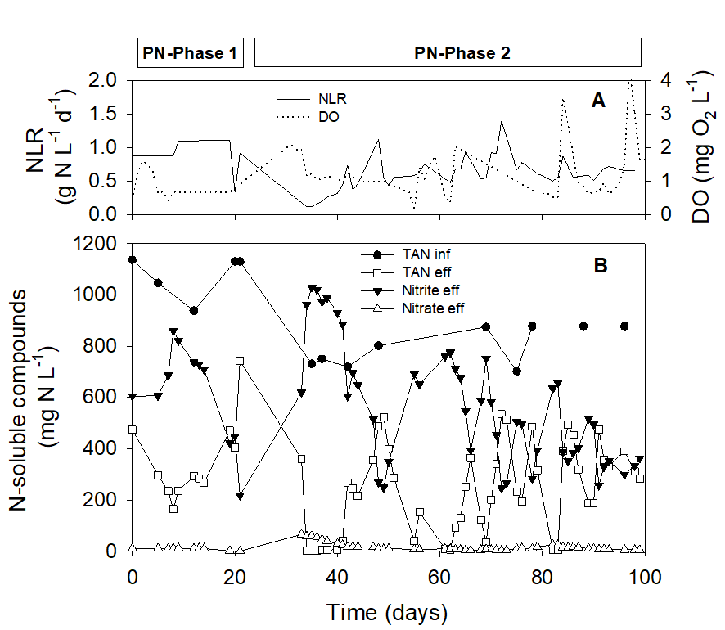
Figure 1. Performance of the PN-reactor. A) Applied Nitrogen Loading Rate (NLR) and Dissolved Oxygen (DO) concentration. B) Concentrations of N-soluble compounds throughout the study (TAN, nitrite and nitrate) in the influent and the effluent of the PN-reactor. Vertical line indicates the change of the influent from synthetic wastewater (PN-Phase 1) to real (diluted) supernatant from a full-scale anaerobic digester (PN-Phase 2).

During PN-Phase 1, a synthetic medium was used to adapt the biomass to a high conductivity influent. The PN-process was successfully achieved at a NLR of 1.0 ± 0.1 g N L⁻¹ d⁻¹ instead of the high conductivity applied (15 mS cm⁻¹). Nitrate was not detected in the PN-reactor throughout the Phase 1. Initially, the desired TAN conversion to nitrite (around 50%) was not achieved because the fraction of TAN oxidized to nitrite was too high, probably due to an excess of airflow. By reducing the airflow a TAN conversion to nitrite of 50% was achieved (day 19).
In Phase 2 the synthetic wastewater was replaced by diluted supernatant from an AD process with TAN concentration at 770 ± 70 mg N L⁻¹ . Moreover, the applied NLR was reduced to 0.6 ± 0.3 g N L⁻¹ d⁻¹. During the first 80 days of Phase 2, operational issues had to be addressed and corrected. Specifically, the high amount of solids in the influent caused frequent failures of the influent peristaltic pump due to clogging, which in turn prevented a proper control of the HRT and therefore, of the NLR. Consequently, when the NLR was lower than desired, TAN conversions increased (well above the 50% targeted) resulting in too high nitrite concentrations in the effluent. Specifically, the average conversion of TAN to nitrite during this period was 77 ± 31 % and average TAN and nitrite concentrations in the effluent were 228 ± 190 mg N L⁻¹ and 606 ± 235 mg N L⁻¹, respectively. Additionally, hydrolysis of the proteinaceous organic matter was also observed from day 33 to 47, as demonstrated by the higher effluent total nitrogen concentration higher than the influent shown in Figure 1 (more details can be found in Figure S3 in Supporting Information).
From day 80 onwards (PN-Phase 2), a gross filtration of the influent was implemented to facilitate pumping operations thus avoiding sudden technical failures due to clogging. This simple pre-treatment allowed for a proper control of the influent discharge resulting in a constant operational HRT and thus of the applied NLR.
Once the reactor stability was reached (days 85 onwards), the average TAN, nitrite and nitrate concentrations were 324 ± 111 mg N L⁻¹, 390 ± 82 mg N L⁻¹ and 10 ± 4 mg N L⁻¹ respectively. During this period of stable operation the nitrite production rate (NPR) was on average 319 ± 55 mg N L⁻¹. Such NPR is in line with recent studies reporting flocculent sludge PN system treating different wastewaters such as agro-digestate supernatant (Scaglione te al., 2015) and municipal sludge digester supernatant (Connan et al., 2018).
As for the nitrite/TAN molar ratio, an average value of 1.2 ± 0.7 was obtained, which is a suitable average value for a subsequent anammox reactor considering anammox stoichiometry (i.e. 1.225 mol-nitrite/mol-ammonium, Lotti et al., 2014). It is worth noting that the nitrate effluent concentration remained irrelevant throughout the PN-Phase 2. Indeed, the overall average conversion of ammonium to nitrate during PN-Phase 2 was 1.8 ± 1.5 % of the TAN removed. This finding evidences that very low NOB activity was observed. The reason for low nitratation activity was NOB suppression (likely due to competition for oxygen with AOB) and intensive washout, as suggested by FISH analysis (Figure 2).
Influent soluble TOC concentrations were 832 ± 49 and 1032 ± 201 mg C L⁻¹ for PN-Phase 1 and PN-Phase 2, while the removal efficiencies were 62 ± 10 % and 43 ± 16 %, respectively.
The key operational variable to be maintained to assure that TAN in converted only to nitrite in a biofilm reactor is the ratio between DO and TAN concentrations in the bulk liquid (DO/TAN [g/g], Bartrolí et al., 2010). The control of this operational parameter was found crucial for achieving and maintaining a stable nitritation even at high DO concentration, as demonstrated with long term experiments (Bartrolí et al., 2010). In that study, it was determined that full nitritation was only achieved for DO/ TAN lower than 0.25 in a granular airlift reactor.
The DO/ TAN ratio was not specifically controlled in this study because the TAN and DO concentrations in the bulk liquid were not constant (Figure 1). Therefore, the DO/TAN ratio in the PN-reactor was a consequence of the operational conditions. The average value of the DO/TAN ratio was lower than 0.01 throughout the PN-reactor operation (Figure 1) which ensured the effective repression of NOB activity (i.e. nitrate formation) in the PN-reactor. The exception was the period comprises between days 30 and 40 when the TAN concentration decreased close to 0 and the value of the DO/TAN ratio increased up to 1. This value is higher than the threshold value (0.25) reported by Bartrolí et al. (2010) to achieve a stable nitritation and hence, nitrate was formed in the PN-reactor during this period (Figure 1). However, when the TAN concentration in the PN-reactor was again re-established around 200 mg N L⁻¹ and consequently the DO/TAN ratio decreased far below 0.25, the NOB activity was again effectively repressed.
The effect of applying such operating conditions (low values of the DO/TAN concentrations ratio) is thought to be the enhancement of the stratification of the nitrifier guilds in the granular sludge, with AOB occupying the external shell (Poot et al., 2016; Picioreanu et al., 2016). If these conditions are kept in the long term, the NOB washout from the granular sludge could be achieved (as demonstrated by Isanta et al., 2015). The results from FISH analysis of the granular sludge performed at the end of the experimental period (day 98) allowed to confirm that NOB were outcompeted by AOB in the granules due to the imposed DO/TAN concentrations ratio. As can be observed in Figure 2, NOB could hardly be observed in the granular biomass (there is negligible signal for NIT3 probe, Fig. 2B) and the only nitrifier population observed in large amount were AOB (Fig. 2C). However, comparing Figures 2A and 2C, it can be inferred the presence of a significant heterotrophic bacterial population in the granules because the area colored in green (all bacteria) is higher than the area colored in blue (AOB).

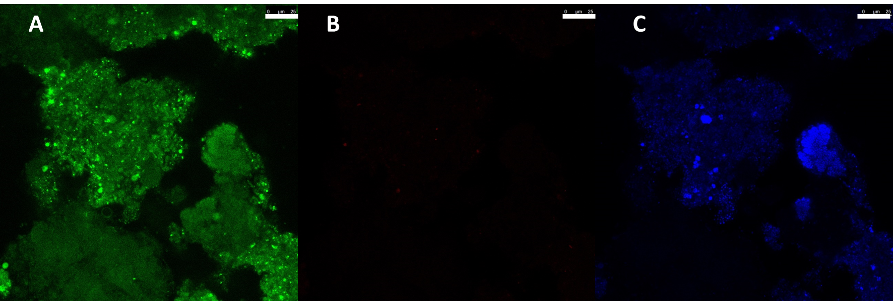
Figure 2. FISH analysis: A) EUB-338-mix (Fluos, green), B) NIT3 (Cy3, red), C) Nso190 (Cy5, blue) specific probe signals. Bars correspond to 25 µm.

3.1.3. Physical characteristics of the PN-granular biomass
Throughout the PN-reactor operation, the granular biomass was characterized by measuring the morphological characteristics, the biomass concentration and the settling properties (SVI and settling velocity). Results are summarized in Table 3.

Table 3. Summary of the aerobic granules characteristics during PN-reactor operation. D > 0.2 mm [%] is the percentage of particles with a mean size higher than 0.2 mm and therefore, it is consider the percentage of granular sludge in the reactor and in the effluent.
Experimental phase | PN-Phase 1 | PN-Phase 2
In reactor particle size [µm] – mean size | 860 ± 53 | 745 ± 48
In reactor D > 0.2 mm [%] | 96 ± 1 | 83 ± 3
Effluent particle size [µm] – mean size | - | 100 ± 58
Effluent D > 0.2 mm [%] | - | 17 ± 11
Biomass Concentration [g VSS L⁻¹] | 3.5 ± 0.2 | 3.4 ± 0.1
g VSS g⁻¹ TSS [%] | 31± 4 | 48± 7
Settling velocity [m h⁻¹] | 89 ± 6 | 100 ± 4
Sludge volumetric index [SVI₅] [mL g⁻¹ TSS] | 11.9 ± 1.6 | 6.6 ± 0.1
Ratio SVI₅/SVI₃₀ | 1 | 1

The average diameter of the particles remained above the size of 200 µm throughout the whole PN-reactor operation, which is conventional used to discriminate granular from flocculent biomass (de Kreuk et al., 2007). At the end of PN-Phase 2, the granule size was measured also in the effluent to assess whether the PN-reactor was experiencing granules wash out. The average size of the particles in the effluent (100 µm) shows that the granular biomass was efficiently retained in the PN-reactor and only flocculent biomass was wash out. As for the settling properties, throughout the reactor operation, SVI₅ and SVI₃₀ showed the same value that slightly decreased in time (from 11.9 ± 1.6 to 6.6 ± 0.1 mL g⁻¹ TSS). The resulting SVI₅ to SVI₃₀ ratio constantly equal to the unit as well as SVI₅ and SVI₃₀ values below 50 mL g⁻¹ TSS, are also consistent with the granular nature of the PN sludge. The high settling velocity is a further confirmation of the granular nature of the sludge; the values are coherent with what reported in literature for PN granules (Zheng et al. 2005, Ramos et al. 2016). The biomass concentration did not vary significantly throughout the experimental period. Overall, these results suggest that the type of wastewater (real diluted AD supernatant) does not negatively influence the granular sludge morphology and settling properties (Table 3), granting the good performance of the selected two-stage configuration for this application.

3.1.4. N₂O emission
The N₂O specific emission rate (details on calculations are reported in Supporting Information, section S.2) was 14.6 mg N L⁻¹ d⁻¹. This emission rate was calculated from data obtained during a measuring campaign on day 98 with a DO of 3 mg O₂ L⁻¹. That is the 2.2 % of the applied NLR or the 5.2% of the amount of oxidized TAN in that specific experimental day (650 mg N L⁻¹ d⁻¹). Therefore, the modest N₂O emissions of the PN process assures its low carbon footprint. Pijuan et al. (2014) with the same experimental setup (granular sludge PN-reactor) assessed that the average N₂O emissions (referred to the NLR) ranged from 6 % at low DO concentrations (1-2 mg O₂ L⁻¹) to 2.2 % at high DO concentrations (4-7 mg O₂ L⁻¹). De Graaf et al. (2010) measured a 3.2 % with a DO of 4.1 mg O₂ L⁻¹ in a lab-scale PN-reactor with flocculent sludge while Kampschreur et al. (2009) a 2.5 % at a DO of 5.0 mg O₂ L⁻¹ in a CANON reactor at full scale. Connan et al. (2018) reported about a suspended PN-reactor with N₂O emissions between 0.6 and 1.4% of the NLR and between 1.3 and 2.4% of the converted nitrogen, respectively, at a nitrite production rate ranging from 0.23 to 0.61 g N L⁻¹ d⁻¹, with the lower N₂O emissions reported for the higher NPR. With the exception of the study by Connan et al. (2018) reporting lower N₂O emissions (unfortunately without info about the DO maintained), those values are highly coherent with each other and with the value found in this study.

3.2 Second stage: anammox process
3.2.1. Performance of the AMX-reactor
The performance of the AMX-reactor is reported in Figure 3, while in Table 4 the main operational parameters are summarized. Anammox granular sludge was used for reactor inoculation (see section 2.2.1). During the first week of the first experimental phase (AMX-Phase 1), the AMX-reactor was fed on the synthetic medium previously described. In this short period, the effluent TAN and nitrite concentrations remained below 50 mg N L⁻¹ with a NRR of 0.69 ± 0.02 g N L⁻¹ d⁻¹. From day 7 onwards, the real influent was fed and the NLR was progressively reduced to 0.27 g N L⁻¹ d⁻¹ to prevent nitrite accumulation. However, few days after the change in the reactor feeding, AMX-reactor performance was deteriorated and the NRR sharply decreased to 0.17 g N L⁻¹ d⁻¹, during the last ten days of AMX-Phase 1. In this phase, the NRR_{max} decreased from 5.7 to 0.18 g N L⁻¹ d⁻¹, corresponding to a potential inhibition of 97% when treating the real wastewater with conductivity of 14.9 mS cm⁻¹.
On day 85 (beginning of AMX-Phase 2) a bioaugmentation procedure was performed by adding anammox granules previously socked in a high conductivity mineral medium. The biomass concentration was increased from 8.3 up to 13.8 g VSS L⁻¹. The reactor was fed for one week with the synthetic medium to favor the restoring of the NRR of the AMX-reactor.
Once stable reactor performance had been reached, the feed was prepared (by blending tap water) firstly with 50% (days 93-120) and later with 70% (from day 121 onward) of real wastewater. While working at 50% dilution, the conductivity measured in the reactor was on average 9.1 mS cm⁻¹. However, the NRR progressively decreased until stability was achieved with an average NRR of 0.8 ± 0.2 g N L⁻¹ d⁻¹. When the feed contained 70% of real wastewater (conductivity in the reactor of 11.2 mS cm⁻¹) the NRR stabilized around of 0.31 ± 0.04 mg N L⁻¹ d⁻¹. Indeed, during the last 40 days of the AMX-Phase 2 the NRR remained stable as well as the NRR_{max}, suggesting that the residual anammox activity was sufficient to cope with the applied NLR and confirming the treatability of the wastewater in the long term.

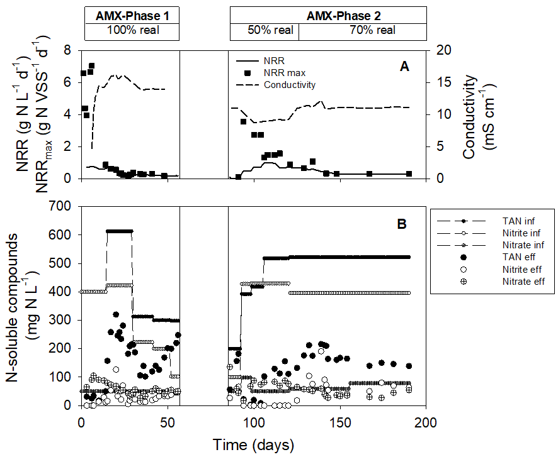
Figure 3. Performance of the AMX-reactor. A) Average Nitrogen Removal Rate (NRR), maximum Nitrogen Removal Rate (NRR_{max}) and conductivity. B) Concentrations of N-soluble compounds throughout the study (TAN, nitrite and nitrate) in the influent and the effluent of the AMX-reactor. Vertical lines indicate the temporary suspension of reactor operations occurred between the operational periods characterized by the use of undiluted real wastewater (AMX-Phase 1) and by the step-wise increase of the fraction of the real wastewater in the influent fed to the AMX-reactor (AMX-Phase 2). The % of real wastewater in the influent is also reported in boxes.

Table 4. Main operational data of the granular AMX-reactor.
 | AMX-Phase 1 | AMX-Phase 2
 | 100% real WW | 50 % real WW | 70 % real WW
NRR [g N L⁻¹ d⁻¹] | 0.17 ± 0.02 | 0.8±0.2 | 0.31 ± 0.04
Nitrite removal efficiency [%] | 85 ± 13 | 100 ± 0 | 83 ± 10
Stoichiometric NO₂⁻/TAN molar ratio | 1.03 ± 0.11 | 1.06 ± 0.14 | 1.04 ± 0.09
Stoichiometric NO₃⁻/TAN molar ratio | -0.02 ± 0.08 | -0.04 ± 0.09 | -0.05 ± 0.05

The average nitrite removal efficiencies were 100% and 83 ± 10% while the total nitrogen removal efficiencies were 85 ± 7% and 71 ± 7%, for the feed composed by 50% and 70% v/v of real wastewater, respectively. Moreover, the average nitrite to ammonium molar removal ratios (NO₂⁻/TAN) were 1.06 ± 0.14 and 1.04 ± 0.09 while the nitrate production to ammonium removal molar ratios (NO₃⁻/TAN) were -0.04 ±0.09 and 0.05 ± 0.05, respectively. The observed deviation from the anammox stoichiometry reported in literature (Lotti et al., 2014) (i.e. lower NO₂⁻/TAN and NO₃⁻/TAN ratios) could be explained with the simultaneous occurrence of heterotrophic denitrification activity reducing part of the nitrate to nitrite (denitratation); this topic was examined in depth in the work of Kumar and Lin (2010). In order to evaluate the occurrence of simultaneous heterotrophic denitratation, a COD balance was performed (see Table S3 in Supporting Information). The contribution of heterotrophic denitratation, as assessed from the observed COD removal (222 ± 45 mg COD L⁻¹ d⁻¹), could explain the deviation from the conventional anammox stoichiometry, thus suggesting that the anammox metabolism could have behaved regularly during the experimentation (Table S3 in Supporting Information).
In Figure 3, the maximum nitrogen removal capacity (NRR_{max}) of the reactor measured by manometric batch tests is reported and compared with the in-reactor conductivity. It can be observed that conductivity negatively affected the NRR_{max}. This is especially evidenced during transient increases in conductivity (days 7 to 18 in AMX-Phase 1, and 93 to 140 in AMX-Phase 2). As a matter of fact, when the conductivity was lower (approximately 8-9 mS cm⁻¹) the NRR_{max} was higher than the NRR measured in the AMX-reactor by mass-balance, indicating that surplus treatment capacity was available. Under those conditions, the limiting substrate (i.e. nitrite) was fully consumed. On the contrary, when the conductivity in the reactor increased, the NRR_{max} sharply decreased and nitrite concentration built-up.
During the stationary behavior of each phase the average reduction of the NRR_{max} was calculated. When working with a feed containing 50% of real wastewater (conductivity in the reactor of 9.1 mS cm⁻¹) a reduction of about 50% was obtained while reduction of about 90 % was measured when the feed contained 70% of real wastewater (11.2 mS cm⁻¹) and to 96% when feeding undiluted real wastewater (14.9 mS cm⁻¹).
In literature, several studies on the effect of salinity on the anammox biomass have already been conducted highlighting that salinity is one of the major inhibitors of anammox activity. However, adaption during long-term experimentations has been reported, indicating that the treatment of wastewaters with high salinity might be feasible (Kartal et al., 2006; Liu et al., 2009; Dapena-Mora et al., 2010; Ruscalleda et al., 2010; Jin et al., 2011). Results of this study (Figure 3) confirm that salinity (here expressed as conductivity) may be a suitable aggregated parameter to predict inhibition of the anammox biomass from wastewaters from biowaste or food processing treatment plants. However, inhibition was experienced at lower salinity levels than those reported in literature for synthetic saline wastewaters. This is likely due to the fact that the real wastewater used in this study could contain other inhibitors such as heavy metals (Table S1) and potentially inhibitory organics. Moreover, the anammox inoculum was sampled from a full-scale installation operating at a very low average conductivity (0.7 mS cm⁻¹) which might have contributed to strengthen the negative effect of the high conductivity. Finally, the dominant genus in the inoculum was Candidatus Brocadia, which was previously reported as very sensitive to saline environments (Carvajal-Arroyo et al., 2013, Malovanyy et al., 2015). Indeed, Scaglione et al. (2017), working with similar wastewaters, estimated a non-competitive short-term inhibition model on non-acclimated anammox granules; according to this model, a 73-77% of inhibition would be expected at 11 mS cm⁻¹ (IC₅₀=4.6-6.1 mS cm⁻¹), which is comparable with the results obtained in this study.
As for the average NRR measured at the end of AMX-Phase 2, a quite low value was obtained (0.31 ± 0.04 g N L⁻¹ d⁻¹). Although NRR values reported in the literature when treating sludge digester centrate range from 0.20 to 0.65 g N L⁻¹ d⁻¹ for SBR technology and from 1.0 to 2.3 gN L⁻¹ d⁻¹ for granular sludge reactors (Lackner et al., 2014), the NRR measured in this study was similar to that obtained with other saline wastewaters, such as landfill leachate (0.24 g N L⁻¹ d⁻¹, Ruscalleda et al., 2010). To ascertain that this NRR value could be stably maintained, or either increased, in the long term, anammox bacteria should be able to grow under these high saline and inhibiting conditions. Available data do not allow to compute a reliable mass balance to quantify biomass growth due to uncertainties in representative sampling when working with granules and to the complex feed characteristics (as for solids and organics content). Nonetheless, the observed ammonium removal rate observed under anaerobic conditions during both AMX-Phase 1 and 2, is an unequivocal sign of anammox activity and therefore growth of anammox bacteria should have taken place during reactor operation. The anammox sludge maintained its granular state throughout the experimentation, with an average diameter of 320 µm on the last day of operations (Figure S4 in Supporting Information). The results from FISH analysis of the granular biomass performed at the beginning and the end of the AMX-reactor operation allowed to confirm that the dominant anammox genus remained Candidatus Brocadia fulgida throughout the reactor operation (Figure 4).

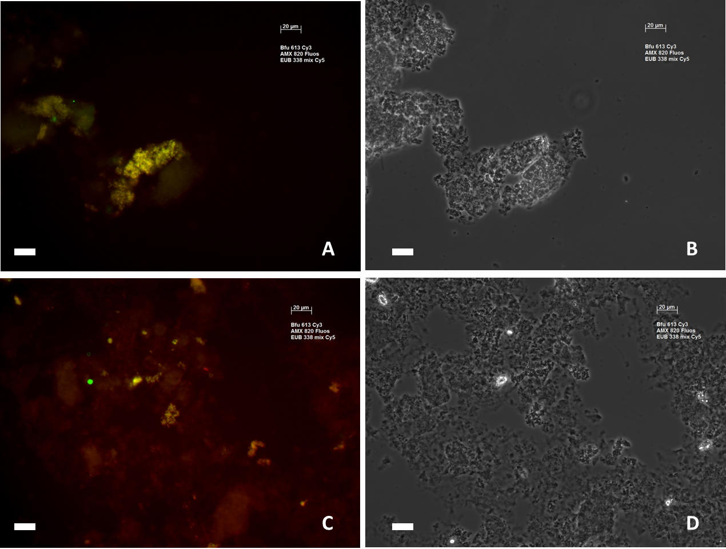
Figure 4. FISH analysis: Bfu613 (Cy3, red) and Amx-820 (Fluos, green) specific probe signal (A, C) as well as phase contrast images (B, D) for granular anammox biomass samples originating from the inoculum (A, B) and sampled from the SBR on last day of operations (C, D). Bars correspond to 20 µm.

4. CONCLUSIONS
The feasibility to treat the liquid fraction of OFMSW-digestate with a TAN concentration of 700-1000 mg L⁻¹ and a with conductivity of 9-11 mS cm⁻¹ with the PN-anammox process was successfully demonstrated. The air-lift granular sludge reactor achieved a stable PN process at a NLR of about 1g N L⁻¹ d⁻¹, while the anammox reactor achieved a stable reactor performance at NRR of 0.8±0.2 and 0.31±0.04 g N L⁻¹ d⁻¹ and conductivities of 9 and 11 mS cm⁻¹. While the PN process seems to withstand highly saline wastewater, partial dilution of digestate produced in wet and especially dry biogas plants could be considered to limit anammox inhibition by high conductivity levels.

E-supplementary data of this work can be found in online version of the paper

Acknowledgements
This research did not receive any specific grant from funding agencies in the public, commercial, or not-for-profit sectors.

References
APHA, AWWA and WEF, 2005. Standard Methods for the Examination of Water and Wastewater 2005 21st edn, American Public Health Association/American Water Works Association/Water Environment Federation, Washington DC, USA
Bartrolí, A., Pérez, J., Carrera, J., 2010. Applying ratio control in a continuous granular reactor to achieve full nitritation under stable operating conditions. Environ. sci. technol., 44(23), 8930-8935.
Carvajal-Arroyo, J. M., Sun, W., Sierra-Alvarez, R., Field, J. A., 2013. Inhibition of anaerobic ammonium oxidizing (anammox) enrichment cultures by substrates, metabolites and common wastewater constituents. Chemosphere, 91(1), 22-27.
Cecchi, F. and Cavinato, C., 2019. Smart Approaches to Food Waste Final Disposal. Int. J. Environ. Res. Public Health, 16(16), 2860.
Connan, R., Dabert, P., Moya-Espinosa, M., Bridoux, G., Béline, F., Magrí, A., 2018. Coupling of partial nitritation and anammox in two- and one-stage systems: Process operation, N₂O emission and microbial community. J. Clean. Prod., 203, 559-573.
Dapena-Mora, A., Vázquez-Padín, J. R., Campos, J. L., Mosquera-Corral, A., Jetten, M. S. M., Méndez, R., 2010. Monitoring the stability of an Anammox reactor under high salinity conditions. Biochem. Eng. J., 51(3), 167-171.
De Baere, L. D. and Mattheeuws, B., 2010. Anaerobic digestion of MSW in Europe. BioCycle, 51(2), 24-26.
De Graaff, M. S., Zeeman, G., Temmink, H., van Loosdrecht, M. C. M., Buisman, C. J. N., 2010. Long term partial nitritation of anaerobically treated black water and the emission of nitrous oxide. Water Res., 44(7), 2171-2178.
De Kreuk, M. K., Kishida, N., Van Loosdrecht, M. C. M., 2007. Aerobic granular sludge–state of the art. Water Sci. Technol., 55(8-9), 75-81.
Eurostat, 2014. Municipal waste generation and treatment, by type of treatment method. Retrieved April 20, 2014, from http://ec.europa.eu/eurostat/web/products-datasets/-/tsdpc240
Ganigué, R., Gabarró, J., Sànchez-Melsió, A., Ruscalleda, M., López, H., Vila, X., Balaguer, M. D., 2009. Long-term operation of a partial nitritation pilot plant treating leachate with extremely high ammonium concentration prior to an anammox process. Bioresource Technol., 100(23), 5624-5632.
Isanta, E., Reino, C., Carrera, J., Pérez, J., 2015. Stable partial nitritation for low-strength wastewater at low temperature in an aerobic granular reactor. Water Res., 80, 149-158.
ISPRA (Italian National Agency for Environmental Protection). Annual Report on Waste 230/2015. ISBN 978-88-448-0740-5.
Jin, R. C., Ma, C., Mahmood, Q., Yang, G. F., Zheng, P., 2011. Anammox in a UASB reactor treating saline wastewater. Process Saf. Environ., 89(5), 342-348.
Jubany, I., Lafuente, J., Carrera, J., Baeza, J.A., 2009. Automated thresholding method (ATM) for biomass fraction determination using FISH and confocal microscopy. J. Chem. Technol. Biot., 84, 140–1145.
Kampschreur, M. J., Temmink, H., Kleerebezem, R., Jetten, M. S., van Loosdrecht, M. C., 2009. Nitrous oxide emission during wastewater treatment. Water Res., 43(17), 4093-4103.
Kartal, B., Koleva, M., Arsov, R., van der Star, W., Jetten, M. S., Strous, M., 2006. Adaptation of a freshwater anammox population to high salinity wastewater. J. Biotechnol., 126(4), 546-553.
Kumar, M. and Lin, J. G., 2010. Co-existence of anammox and denitrification for simultaneous nitrogen and carbon removal—strategies and issues. Journal of Hazardous Materials, 178(1), 1-9.
Lackner, S., Gilbert, E. M., Vlaeminck, S. E., Joss, A., Horn, H., van Loosdrecht, M. C., 2014. Full-scale partial nitritation/anammox experiences–an application survey. Water Res., 55, 292-303.
Liu, C., Yamamoto, T., Nishiyama, T., Fujii, T., Furukawa, K., 2009. Effect of salt concentration in anammox treatment using non woven biomass carrier. J. Biosci. Bioeng., 107(5), 519-523.
Lotti, T., Kleerebezem, R., Lubello, C., van Loosdrecht, M.C.M., 2014. Physiological and kinetic characterization of a suspended cell anammox culture. Water Res. 60, 1-14.
Lotti, T., Van der Star, W. R. L., Kleerebezem, R., Lubello, C., Van Loosdrecht, M. C. M., 2012. The effect of nitrite inhibition on the anammox process. Water Res., 46(8), 2559-2569.
Loy, A., Horn, M., Wagner, M., 2003. probeBase: an online resource for rRNA-targeted oligonucleotide probes. Nucleic Acids Res., 31(1), 514-516.
Malamis, S., Katsou, E., Di Fabio, S., Bolzonella, D., Fatone, F., 2014. Biological nutrients removal from the supernatant originating from the anaerobic digestion of the organic fraction of municipal solid waste. Crit. Rev. Biotechnol., 34(3), 244-257.
Malovanyy, A., Plaza, E., Trela, J., Malovanyy, M., 2015. Ammonium removal by partial nitritation and Anammox processes from wastewater with increased salinity. Environ. Technol., 36(5), 595-604.
Morales-Polo, C., Cledera-Castro, M.d.M., Moratilla Soria, B.Y., 2018. Reviewing the Anaerobic Digestion of Food Waste: From Waste Generation and Anaerobic Process to Its Perspectives. Appl. Sci., 8, 1804.
Mosquera-Corral, A., Gonzalez, F., Campos, J. L., Méndez, R., 2005. Partial nitrification in a SHARON reactor in the presence of salts and organic carbon compounds. Process Biochem., 40(9), 3109-3118.
Mulder, A., 2003. The quest for sustainable nitrogen removal technologies. Water Sci. Technol., 48(1), 67-75.
Pernthaler, J., Glöckner, F. O., Schönhuber, W., Amann, R., 2001. Fluorescence in situ hybridization (FISH) with rRNA-targeted oligonucleotide probes. Method. Microbiol., 30, 207-226.
Pijuan, M., Torà, J., Rodríguez-Caballero, A., César, E., Carrera, J., Pérez, J., 2014. Effect of process parameters and operational mode on nitrous oxide emissions from a nitritation reactor treating reject wastewater. Water Res., 49, 23-33.
Ramos, C., Suárez-Ojeda, M. E., Carrera, J., 2016. Biodegradation of a high-strength wastewater containing a mixture of ammonium, aromatic compounds and salts with simultaneous nitritation in an aerobic granular reactor. Process Biochem., 51(3), 399-407.
Ruscalleda, M., Puig, S., Mora, X., Lopez, H., Ganigue, R., Balaguer, M. D., Colprim, J., 2010. The effect of urban landfill leachate characteristics on the coexistence of anammox bacteria and heterotrophic denitrifiers. Water Sci. Technol., 61(4), 1065-1071.
Scaglione, D., Ficara, E., Corbellini, V., Tornotti, G., Teli, A., Canziani, R., Malpei, F., 2015. Autotrophic nitrogen removal by a two-step SBR process applied to mixed agro-digestate. Bioresour. Technol., 176, 98-105.
Scaglione, D., Lotti, T., Ficara, E., Malpei, F., 2017. Inhibition on anammox bacteria upon exposure to digestates from biogas plants treating the organic fraction of municipal solid waste and the role of conductivity. Waste Manage., 61, 213- 219.
Siegrist H., Salzgeber D., Eugster J., Joss A., 2008. Anammox brings WWTP closer to energy autarky due to increased biogas production and reduced aeration energy for N-removal. Water Sci. Technol., 57, 383–388
Suárez-Ojeda M.E., Montón H., Roldán M., Martín-Hernández M., Pérez J., Carrera J., 2011. Characterization of a p-nitrophenol-degrading mixed culture with an improved methodology of fluorescence in situ hybridization and confocal laser scanning microscopy. J. Chem. Technol. Biot., 86(11), 1097-4660.
Van der Star, W. R., Abma, W. R., Blommers, D., Mulder, J. W., Tokutomi, T., Strous, M., ... & van Loosdrecht, M. C., 2007. Startup of reactors for anoxic ammonium oxidation: experiences from the first full-scale anammox reactor in Rotterdam. Water Res., 41(18), 4149-4163.
Van Dongen, U. G. J. M., Jetten, M. S., Van Loosdrecht, M. C. M., 2001. The SHARON®-Anammox® process for treatment of ammonium rich wastewater. Water Sci. Technol., 44(1), 153-160.
Van Loosdrecht, M. C. M. and Salem, S., 2006. Biological treatment of sludge digester liquids. Water Sci. Technol., 53(12), 11-20.
Vinot, M., 2011. Evolution of anaerobic digestion in Spain (in Spanish). InfoEnviro, March 2011
Zheng, Y. M., Yu, H. Q., Sheng, G. P., 2005. Physical and chemical characteristics of granular activated sludge from a sequencing batch airlift reactor. Process Biochem., 40(2), 645-650.

