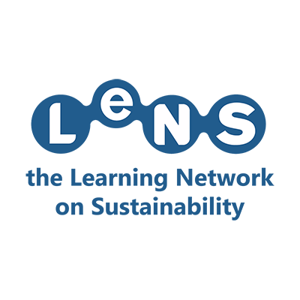
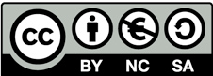
This work is licensed under a Creative Commons Attribution-NonCommercial-ShareAlike 4.0 International License.

Misleading Identities: do perceptual attributes of materials drive the disposal of single-use packaging in the correct waste stream?
Romina Santi
Department of Design, Politecnico di Milano, Milan, Italy, romina.santi@polimi.it
Agnese Piselli
Department of Chemistry, Materials and Chemical Engineering, Politecnico di Milano, Milan, Italy. agnese.piselli@polimi.it
Graziano Elegir
Innovhub-SSI, Area Carta, Milano, Italy. graziano.elegir@mi.camcom.it
Barbara Del Curto
Department of Chemistry, Materials and Chemical Engineering, Politecnico di Milano, Milan, Italy. barbara.delcurto@polimi.it

ABSTRACT
In recent years, bioplastics have been massively introduced in the food-packaging field. However, users erroneously dispose them, causing the contamination of recycling chains. From this, emerged the need for a user centred research investigating: the gestures and senses involved in packaging exploration before disposal, the perceptual attributes of different packaging materials, the possible correlation between such attributes and waste streams. This research aims at expanding current knowledge of compostable materials perceptual attributes and suggest design hints to encourage sustainable behaviour practices. The understandings led to a design that induces a sustainable allocation of waste of single-use products. Avoiding waste stream errors by recognisability of the packaging material and make the compostable packaging distinguishable for users through the perception of them can contribute to reduce the overall impact of single-use products.
Key Words: Single-Use Products (SUPs), compostable packaging, materials perception, users’ behaviour

1. INTRODUCTION
In the last XX years, a great concern arouse around the topic of plastic materials derived from fossils (Lithner, Larsson, & Dave, 2011; Thompson, Swan, Moore, & Vom Saal, 2009). One of the major macro phenomena studied by the scientific community is the one of marine litter (Bergmann, 2015; Depledge et al., 2013; Derraik, 2002; Wright, Thompson, & Galloway, 2013). In May 2018, the European Commission put forward a legislative proposal seeking to address the issue of plastic marine litter (ICF & Eunomia Research & Consulting, 2018). Single Use Plastics (SUPs) products are a broad category, encompassing a wide variety of packaging and non-packaging items used and prevalence in everyday life varies significantly. The European Commission's Joint Research Centre (JRC) Technical Report, Top Marine Beach Litter Items in Europe (JRC108181) lists marine litter items collected in the year 2016 from 276 beaches across 17 EU Member States, covering 4 Regional Seas. These data have been used by ICF & Eunomia Research & Consulting, 2018 to highlight the top ten SUP items: as drinks bottles, caps and lids, food containers, cutlery, straws and stirrers, crisps packets/sweet wrappers, plastic bags (packaging) but also non-packaging items like: wet wipes, cigarette filters, cotton bud sticks, balloons and balloon sticks, sanitary applications. This have been recognized as the most abounding products that causes plastic marine litter. EU set a series of measures to reduce the environmental issue of SUPs like: reduce the consumption, provide market restriction, product eco-design requirements, extended producer responsibility, separate collection objective and awareness raising measures. The EU Plastics Strategy (ICF & Eunomia Research & Consulting, 2018) aims to find alternative materials in substitution to fossil-based towards an effective Circular Economy approach/practice. SUPs, for example food packaging, are progressively being replaced on the market with products in bioplastic materials. According to European Bioplastics definition, a plastic material is defined as a bioplastic if it is either bio-based, biodegradable, or features both properties. Bioplastics are driving the evolution of plastics, entering with their properties and peculiarities for their replacement. There are two main advantages of bioplastic products compared to their conventional versions: the use of biomass instead of fossil resources and the possible biodegradability, which is an additional property of some types of bioplastic (European bioplastics, 2017). Compostability is a further level, in fact it exploits the biodegradability of starting materials to turn them into a final product that takes the name of compost. Not all biodegradable biopolymers are also compostable and they must pass the tests are performed according to the UNI EN 13432 to be certified.
The introduction of a new material into consumer products represents a critical issue for both producers and consumers. The manufacturer aims at establishing a market and refine the technical feasibility, while the material is faced with the public assessment for the first time (Bahrudin & Aurisicchio, 2018).
Consumers can be perceived new materials in different ways: appreciate them or feel them unattractive also through their previous perceptual knowledge. Think about how difficult now is to recognise leather by fake leather or a pure cotton t-shirt by a synthetic textile made one? In recent years, several studies investigated how consumers perceive products by exploring the expressive-sensorial characteristics of the material they are made of (Labbe, Pineau, & Martin, 2013; Magnier, Schoormans, & Mugge, 2016; Schifferstein, 2009; Spence & Wan, 2015; Steenis, van Herpen, van der Lans, Ligthart, & van Trijp, 2017; Thackston, 2013). Expressive-sensorial properties of materials (Piselli, Baxter, Simonato, Del Curto, & Aurisicchio, 2018) are not only relevant in purchasing products by driving particular meaning, perceptions and associations. The expressive-sensorial characteristics, for instance, can drive consumers to sustainable or unsustainable behaviours in the last phase of products use. In particular, the bioplastics material expressiveness has been recently studied from different perspectives (meaning creation, sustainability and ethical consumption association (Bahrudin & Aurisicchio, 2018; Bahrudin, Aurisicchio, & Baxter, 2017; Herbes, Beuthner, & Ramme, 2018; Kale et al., 2007; Karana, 2012; Klaiman, Ortega, & Garnache, 2016). Furthermore, recognizing bioplastics as different from fossil-based materials represent a key factor in the food-packaging field. Bioplastics, indeed, are generally used in packaging if compostable and because of this disposed in the “organic fraction” of waste collection. Although there is no evidence in literature regarding the possible correlation of materials attributes in driving food packaging disposal to the correct waste stream. However, new bioplastics SUPs are often indistinguishable from traditional ones. A critical issue in this context is that bioplastics SUPs (in particular food packaging) are not recognized and are therefore erroneously conferred causing the contamination of traditional recycling chains and not increasing organic recovery.
In the case of this work, the reference context is Italy's collection and differentiation system, in which compostable products have to be given to the “organic fraction collection”. CONAI, the National Packaging Consortium shows us that the maximum quota of compostable bioplastics sustainable by the Italian plastic system is estimated at 10% of the total volume of treated plastic packaging. At the end of 2018, new supply chain consortium born in Italy: Biorepack (ongoing project) for the end-of-life management of biodegradable and compostable packaging collected with the organic waste fraction and transformed, with specific industrial treatment, into compost or biogas. Therefore, it becomes more and more important to understand if bioplastic packaging are recognized by users in order to achieve sustainability of their life cycle.

2. THEORETICAL BACKGROUND
To design increasingly sustainable products, it is essential to study and understand the dynamics of user interaction with products. In designing sustainable products, the designer has the fundamental role of combining the shape, the material and the communication of the product in order to "design" even the user's behaviour. Related to this, a discipline of product design has recently born: Design for Sustainable Behaviour (DfSB). DfSB aims specifically on reducing the environmental impact caused by the way people interact with products (Boks, Lilley, & Pettersen, 2017; Lockton, Harrison, & Stanton, 2010). Strategies have been developed on how to induce purchasing choices of sustainable products, reduce food waste, life-time extension, reduction of energy use, and littering behaviour (Baxter, Aurisicchio, & Childs, 2016; R. Wever & * L. van Onselen, 2017; Williams, Venkatesh, & Wikstr, 2016; Zafarmand et al., 2016). In the field of sustainable packaging, much has already been explored, because packaging is a "fast" product, which has the particularity of making its content preferable over an analysis that is first sensorial and qualitative. With the same speed with it is preferred, it is thrown and these two parts of its life cycle are crucial for sustainability. Different studies, based on a quantitative research approach (Magnier et al., 2016; Simmonds & Spence, 2017; Steenis et al., 2017) established how structural (material type, shape, size, weight and texture), graphical (colours, imagery, graphics and typewriting) and verbal (explicit textual information available on the package) elements can be drivers for a sustainable implicit and explicit message to the user. Steenis et al. 2017 investigated the product features that drives consumers to purchase sustainable packaged products. The outcome of consumer associations on packaging sustainability were then compared to the analysis of Life Cycle Assessment (LCA). The results showed that consumers were not able to recognize the real range of product sustainability and their judgment was mainly drived by their perception about packaging material sustainability. Literature analysis permitted to highlight a research gap. This research aims at expanding current knowledge of compostable materials perceptual attributes and investigating the gestures and senses involved in packaging exploration before disposal. This research presents the outcomes from a qualitative user testing activity conducted to answer these questions:
RQ1: Do the materials (proven to be a relevant factor in packaging perception) used in the packaging already have sensorial-littering correlations in consumers? Which?
RQ2: How does the user analyze the packaging before throwing it away? Which are the senses involved and what are the assumptions that he makes in the association with the waste stream?
RQ3: Do the new bioplastic packages have this connotation of recognizability for the user? Or are they associated with other waste streams?

3. RESEARCH METHOD
Klöckner & Blöbaum in 2010 presented a Comprehensive Action Determination Model (CADM) that systematizes the factors influencing an ecological behaviour. This tool have been studied in this research to select a user centred design appropriate method for conducting the activities. Comparing User centred tools and the objectives of the study, is intended to explore internal factors that is what people think and external ones to understand what people do. Therefore is necessary to adopt two main research methods respectively: verbal protocol and user testing associated with a continuous observation. This combination of tools will make it possible to study the user in his / her own: beliefs, attitudes, intentions, subjective constrains, social norms, personal norms, values (Verbal protocols), objective constraints (user testing and observation).
3.1. Test Setting
15 commercial food packaging, made of different materials, were selected among the SUPs typologies. These products have been categorized according to their destination at the end of their life, according to the provisions of the municipality of Milan. Packaging were provided in their pristine condition, clean and free of printed graphics elements (Figure 1). The 15 products (i.e. P1, P2 …) in randomised order, could be put into 4 different bins: plastic (n=6), paper (n=2), compostable (n=6) and generic waste (n=1), their specific information about materials and disposal are provided in Table 1.

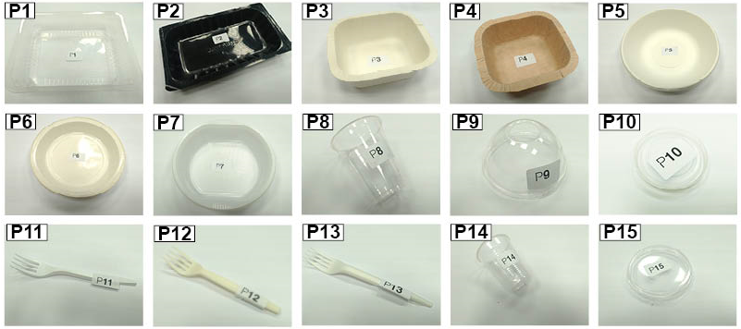
[Figure 1] Commercial Packaging SUPs selected for the user test

[Table 1] Selected Packaging SUPs categorized by type, materials and Right disposal bin
Prod.n. | Type | Material | Right Disposal
P1 | Food containers | Polypropylene | Plastic
P2 | Food containers | Multi layer (12-24)barrier films, Recycled PET | Generic
P3 | Food containers | Biopap: paper with bioplastic coating | Paper (if clean)
P4 | Food containers | Biopap: paper with bioplastic coating | Paper (if clean)
P5 | Plates | Cellulose pulp obtained from sugar and vegetable fibers | Organic
P6 | Plates | Double layer of cellulose pulp with internal coating in PLA | Organic
P7 | Plates | Polystyrene | Plastic
P8 | Glasses | Transparent PLA corn polylactide | Organic
P14 | Glasses | Polystyrene | Plastic
P10 | Cups | Polystyrene | Plastic
P9 | Cups | Transparent PLA corn polylactide | Organic
P15 | Cups | Polystyrene | Plastic
P11 | Cutlery | Polypropylene | Plastic
P12 | Cutlery | Plant origin Plastarch material | Organic
P13 | Cutlery | PLA + hydrous magnesium silicate/talc powder | Organic

The test was performed by 28 non-trained assessors. A panel leader briefly explained the steps of the experiment. The test consists in two steps: in the first, one product (at a time) was presented to the assessor that, through a spontaneous sensorial analysis, was asked to place the product in a specific bin (Figure 2). A data collection app was developed that provides, after the profiling of each user, the registration of different parameters: the time of each analysis, the gestures that the user performed and the reflections that users provided. The user's gestures and their interactions with the product were collected, dividing the possible interactions into 5 macro exploration areas: Technical investigation (pulling, weighing, flexing), tactile (sliding the finger, scratching, compressing), olfactory investigation (sniffing), visual investigation (Looking against the light, searching for the recycle symbol, overturning), auditory investigation (tapping, shaking). After, in step 2 bins have been emptied and each user was asked to perform a survey to predict the correctness of their choices and the aesthetic attribute associations to products thrown in the same bin. At the end of this session, the real destination of the objects was revealed to each user and their reactions were collected.

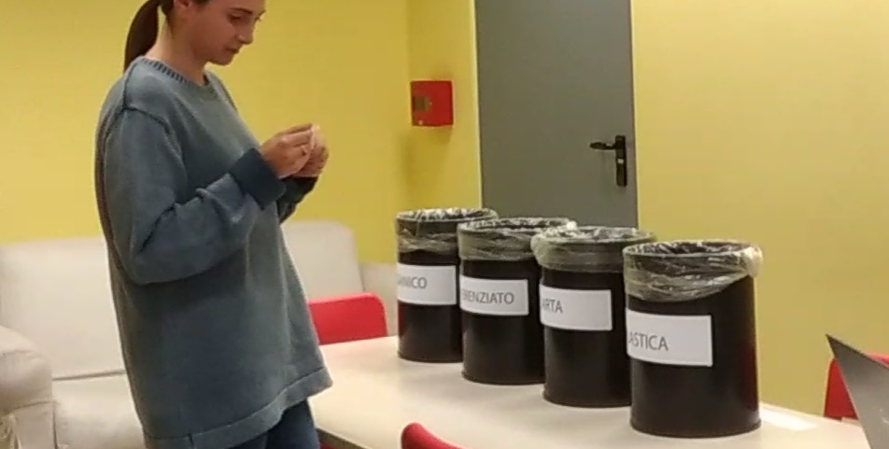
[Figure 2] Set up of the test, the user is exploring the object and must decide where to throw it.

4. RESULTS AND ANALYSIS
In analyzing the results, the first outcome assessed has been how correctly assessors have allocated the products to their waste streams (RQ1). The products destined to the plastic supply chain were the most recognized by the users (96%) followed by those destined to recycling in paper (74%) and finally the single use products destined for compost (24%) as shown in Figure 3 (left side). This result differs from the one evaluated in phase 2 by asking users the percentage of presumed correctness of their choices. In fact, they considered they had conferred the products in the correct way for 67%. Data processing was then conducted to understand in which waste stream have been addressed the remaining 76% of compostable products. Results show that the 51% of the compostable products were disposed with plastic ones and the remaining 25% was disposed with paper products as shown in Figure 3 (right).

[Figure 3] On the left side, how correctly assessors have allocated the products to their waste streams. On the right side, how assessors do dispose compostable SUPs

Analysing the users gestures has been found that the more recognized materials were the less sensorially explored (RQ2), while the less recognized ones were the more sensorially explored. This aspect has considerable relevance if we deduce that the user searches in product interactions to decide where to throw it, sometimes he/she finds it and sometimes he/she does not. The senses most involved in the analysis of compostable products (RQ3) were touch, sight and smell. Among these compostable products, 4 have involved the users in a greater way, they seem ambiguous and hybrid: plates P5, P6 and forks P12, P13. The other two compostable products P8. P9 ie glass and cap made of transparent PLA (Nature Works) were not sensorially investigated in a relevant way and were destined together with plastic materials in 80% of cases. The verbal protocol allowed gathering more detailed opinions and observations. Many users were surprised that among the 4 bins, there was included the one for organic fraction, considering the different packaging analysed. Assessors’ disposal choice was observed to be guided by the presence of the recycling symbols. Although, it was observed that in most of the cases, assessors were misled by symbols: in some compostable products, indeed, the symbol "PLA" was confused with the word "PLAstic".

4. CONCLUSIONS: IMPACT ON SUSTAINABILITY
A compostable product that is disposed in the waste stream of fossil-based plastics or in other one contaminate that recycling chain. So, the circularity of compostable SUPs can be achieved only through a right behaviour of the user in the disposal phase. If the user-product interaction is not appropriate and the user does not take the right behaviour, the disposal phase can significantly influence the environmental impact. It is therefore relevant to note that users behaviour is an active and decisive factor when assessing the environmental impact of a product (Daae & Boks, 2015). This study placed the user at the centre of the system to identify the causes and to highlight the impact that a wrong product design can cause. In this historical moment in which regulations and so the market is changing, the product designer is a key figure in the shift towards compostable SUPs. The new compostable bioplastic products should be designed in an active way, guiding their recognition. For example, transparency, much sought after in food packaging products (Cheng, Mugge, & de Bont, 2018), is actually a misleading factor for compostable products, as well as the current symbolism used in packaging products. Moreover, the compostable products that follow the formal archetype of the fossil-based ones do not lead the user to a sufficient sensorial exploration, since the user refers first to his previous visual knowledge. The colour (sight), texture (touch) and smell can be possible sensory channels to be explored in designing with bioplastics because they are the attributes that do not constitute, at this time, reasons for recognizing the objects of the other material classes. Plastics and paper have a strong connotation and detachment; compostable bioplastics single-use products have a misleading identity, not yet clear and diversified. DfSB therefore plays a fundamental role in the present research considering the human factor within eco-design strategies thanks to the multidisciplinary and user-centred approach.

BIBLIOGRAPHY
Addamo, A. M., Laroche, P., Hanke, G., & Hanke, G. (2017). Top Marine Beach Litter Items in Europe. https://doi.org/10.2760/496717
Bahrudin, F. I., & Aurisicchio, M. (2018). THE APPRAISAL OF SUSTAINABLE MATERIALS. In International Design Conference (DESIGN 2018) (pp. 2575–2584). https://doi.org/10.21278/idc.2018.0455
Bahrudin, F. I., Aurisicchio, M., & Baxter, W. L. (2017). Sustainable materials in design projects. Alive. Active. Adaptive: Proceedings of International Conference on Experiential Knowledge and Emerging Materials (EKSIG 2017), (June), 194–207.
Baxter, W. L., Aurisicchio, M., & Childs, P. R. N. (2016). Tear Here: the Impact of Object Transformations on Proper Disposal. 20th IAPRI World Conference on Packaging, 1–11.
Bergmann, M. (2015). Marine Anthropogenic Litter. (M. Bergmann, L. Gutow, & M. Klages, Eds.). Cham: Springer International Publishing. https://doi.org/10.1007/978-3-319-16510-3
Boks, C., Lilley, D., & Pettersen, I. N. (2017). Sustainability Through Innovation in Product Life Cycle Design,. https://doi.org/10.1007/978-981-10-0471-1
Cheng, P., Mugge, R., & de Bont, C. (2018). Transparency in product design: investigating design intentions and consumers’ interpretations. Journal of Engineering Design, 0(0), 1–30. https://doi.org/10.1080/09544828.2018.1515426
Daae, J., & Boks, C. (2015). Opportunities and challenges for addressing variations in the use phase with LCA and Design for Sustainable Behaviour. International Journal of Sustainable Engineering, 8(3), 148–162. https://doi.org/10.1080/19397038.2015.1010630
Depledge, M. H., Galgani, F., Panti, C., Caliani, I., Casini, S., & Fossi, M. C. (2013). Plastic litter in the sea. Marine Environmental Research, 92, 279–281. https://doi.org/10.1016/j.marenvres.2013.10.002
Derraik, J. G. B. (2002). The pollution of the marine environment by plastic debris : a review. Marine Pollution Bulletin, 44, 842–852. https://doi.org/10.1016/S0025-326X(02)00220-5
European bioplastics. (2017). What are bioplastics? Material types, terminology, and labels – an introduction. Retrieved from http://www.bancodealimentos.es/bancos/aprende/queson
Herbes, C., Beuthner, C., & Ramme, I. (2018). Consumer attitudes towards biobased packaging – A cross-cultural comparative study. Journal of Cleaner Production, 194, 203–218. https://doi.org/10.1016/j.jclepro.2018.05.106
ICF, & Eunomia Research & Consulting. (2018). Assessment of measures to reduce marine litter from single use plastics. https://doi.org/10.2779/500175
Kale, G., Kijchavengkul, T., Auras, R., Rubino, M., Selke, S. E., & Singh, S. P. (2007). Compostability of bioplastic packaging materials: An overview. Macromolecular Bioscience, 7(3), 255–277. https://doi.org/10.1002/mabi.200600168
Karana, E. (2012). Characterization of ‘natural’ and ‘high-quality’ materials to improve perception of bio-plastics. Journal of Cleaner Production, 37, 316–325. https://doi.org/10.1016/j.jclepro.2012.07.034
Klaiman, K., Ortega, D. L., & Garnache, C. (2016). Consumer preferences and demand for packaging material and recyclability. Resources, Conservation and Recycling, 115, 1–8. https://doi.org/10.1016/j.resconrec.2016.08.021
Klöckner, C. A., & Blöbaum, A. (2010). A comprehensive action determination model: Toward a broader understanding of ecological behaviour using the example of travel mode choice. Journal of Environmental Psychology, 30(4), 574–586. https://doi.org/10.1016/j.jenvp.2010.03.001
Labbe, D., Pineau, N., & Martin, N. (2013). Food expected naturalness: Impact of visual, tactile and auditory packaging material properties and role of perceptual interactions. Food Quality and Preference, 27(2), 170–178. https://doi.org/10.1016/j.foodqual.2012.06.009
Lithner, D., Larsson, A., & Dave, G. (2011). Environmental and health hazard ranking and assessment of plastic polymers based on chemical composition. Science of the Total Environment, 409(18), 3309–3324. https://doi.org/10.1016/j.scitotenv.2011.04.038
Lockton, D., Harrison, D., & Stanton, N. A. (2010). The Design with Intent Method: A design tool for influencing user behaviour. Applied Ergonomics, 41(3), 382–392. https://doi.org/10.1016/j.apergo.2009.09.001
Magnier, L., Schoormans, J., & Mugge, R. (2016). Judging a product by its cover: Packaging sustainability and perceptions of quality in food products. Food Quality and Preference, 53, 132–142. https://doi.org/10.1016/j.foodqual.2016.06.006
Piselli, A., Baxter, W., Simonato, M., Del Curto, B., & Aurisicchio, M. (2018). Development and evaluation of a methodology to integrate technical and sensorial properties in materials selection. Materials and Design, 153.
R. Wever, 1, & * L. van Onselen, 1 S. Silvester1 and C. Boks2. (2017). Influence of Packaging Design on Littering and Waste Behaviour. International Journal of Economic Research, 14(16), 165–182. https://doi.org/10.1002/pts
Schifferstein, H. N. J. (2009). The drinking experience: Cup or content? Food Quality and Preference, 20(3), 268–276. https://doi.org/10.1016/j.foodqual.2008.11.003
Simmonds, G., & Spence, C. (2017). Thinking inside the box: How seeing products on, or through, the packaging influences consumer perceptions and purchase behaviour. Food Quality and Preference, 62, 340–351. https://doi.org/10.1016/j.foodqual.2016.11.010
Spence, C., & Wan, X. (2015). Beverage perception and consumption: The influence of the container on the perception of the contents. Food Quality and Preference, 39, 131–140. https://doi.org/10.1016/j.foodqual.2014.07.007
Steenis, N. D., van Herpen, E., van der Lans, I. A., Ligthart, T. N., & van Trijp, H. C. M. (2017). Consumer response to packaging design: The role of packaging materials and graphics in sustainability perceptions and product evaluations. Journal of Cleaner Production, 162, 286–298. https://doi.org/10.1016/j.jclepro.2017.06.036
Thackston, E. (2013). the Effect of Packaging Material Properties on Consumer Food Quality Perception in Quick- Service Restaurants. Clemson University.
Thompson, R. C., Swan, S. H., Moore, C. J., & Vom Saal, F. S. (2009). Our plastic age. Philosophical Transactions of the Royal Society B: Biological Sciences, 364(1526), 1973–1976. https://doi.org/10.1098/rstb.2009.0054
Williams, H., Venkatesh, G., & Wikstr, F. (2016). The influence of packaging attributes on recycling and food waste behaviour An environmental comparison of two packaging alternatives, 137, 895–902. https://doi.org/10.1016/j.jclepro.2016.07.097
Wright, S. L., Thompson, R. C., & Galloway, T. S. (2013). The physical impacts of microplastics on marine organisms: A review. Environmental Pollution, 178, 483–492. https://doi.org/10.1016/j.envpol.2013.02.031
Zafarmand, S. J., Sugiyama, K., Watanabe, M., Wikström, F., Williams, H., Venkatesh, G., … Aydınoğlu, N. Z. (2016). A life cycle perspective on environmental effects of customer focused packaging development. Journal of Cleaner Production, 19(1), 43–48. https://doi.org/10.1016/j.jclepro.2013.10.042

https://www.european-bioplastics.org/
http://www.conai.org/

