Biomechanical response of the human foot when standing in a natural position while exposed to vertical vibration from 10-200Hz
Katie A. Goggins*^{1,2}, Marco Tarabini³, W. Brent Lievers^{1,2}, Tammy R. Eger^{2,4}
¹Bharti School of Engineering, Laurentian University, Sudbury, Canada
²Centre for Research in Occupational Safety and Health, Laurentian University, Sudbury, Canada
³Department of Mechanics, Politecnico di Milano, Lecco, Italy
⁴School of Human Kinetics, Laurentian University, Sudbury, Canada
Corresponding Author: Katie Goggins, Centre for Research in Occupational Safety and Health, 935 Ramsey Lake Road, Sudbury, ON, Canada. Tel.: +1 705 919 5359; E-mail: kx_goggins@laurentian.ca.

This work was supported by a Natural Science and Engineering Research Council of Canada Discovery Grant (RGPIN/4252-2015) and by Regione Lombardia within the project “PORFESR 2014-2020: “Smart Fashion and Design”
Biomechanical response of the human foot when standing in a natural position while exposed to vertical vibration from 10-200Hz
Exposure to foot-transmitted vibration (FTV) can lead to pain and numbness in the toes and feet, increased cold sensitivity, blanching in the toes, and joint pain. Prolonged exposure can result in a clinical diagnosis of vibration-induced white foot (VIWFt). Data on the biomechanical response of the feet to FTV is limited; therefore, this study seeks to identify resonant frequencies for different anatomical locations on the human foot, while standing in a natural position. A laser Doppler vibrometer was used to measure vertical (z-axis) vibration on 21 participants at 24 anatomical locations on the right foot during exposure to a sine sweep from 10-200Hz with a peak vertical velocity of 30 mm/s. The most notable differences in the average peak frequency occur between the toes (range: 99-147Hz), midfoot (range: 51-84Hz), and ankle (range: 16-39Hz).
Practitioner Summary: The biomechanical response of the human foot exposed to foot-transmitted vibration, when standing in a natural position, was measured for 21 participants. The foot does not respond uniformly; the toes, midfoot, and ankle regions need to be considered independently in future development of isolation strategies and protective measures.
Keywords: foot-transmitted vibration; standing; resonant frequency

1. Introduction
Occupational exposure to vibration can be associated with negative health effects. The severity of these health effects can be affected by a number of factors such as the point of contact with the vibration source, vibration amplitude, exposure frequency, and in some cases the worker’s posture (Griffin, 1990; Mansfield, 2004). More specifically, a worker exposed at resonant frequency, which is the point where vibration transmissibility is highest and can result in maximum deformation of tissues in the human body, is at greatest risk (Adamo, Attivissimo, Lanzolla, Saponaro, & Cervellera, 2014; Boileau & Rakheja, 1998). In order to prevent and mitigate injury risk from vibration exposure, it is imperative to understand how vibration is transmitted and resonates through different body segments.
Traditionally, occupational vibration research has focused on whole-body vibration (WBV) and hand-arm vibration (HAV). Vibration transmitted through the buttocks of a seated person, the back of a recumbent person, or the feet of a standing person, is typically classified as WBV (ISO-2631-1, 1997). Exposure to WBV has numerous health risks including back and neck disorders, vascular issues, hearing loss, gastrointestinal disorders, and motion sickness (Bovenzi, 2008; Bovenzi et al., 2006; Pope et al., 2002). Since the consequences of WBV on health can have immediate effects on the lower back, neck, or head, the majority of studies on standing vibration have focused on vibration transmissibility from the platform to these regions (Griffin, 1990; Paddan & Griffin, 1998). Vibration transmitted through the hands, commonly associated with the operation of power tools, is termed HAV. Chronic exposure to HAV places workers at risk for hand-arm vibration syndrome (HAVS), a complex of osteoarticular, neurological, and vascular disorders (Bovenzi, 2005; Griffin, 2008; Hagberg, Burstrom, Lundstrom, & Nilsson, 2008). The vascular symptoms of HAVS can also be referred to as vibration-induced white finger (VIWF) (Shen & House, 2017), where prolonged vibration exposure can result in decreased blood flow and blanching in the fingers (House et al., 2010).
Various prevention/isolation strategies have been developed for WBV and HAV. International standards have been designed specifically to protect workers from vibration exposure (ISO-2631-1, 1997; ISO-5349-1, 2004). Personal protective equipment (PPE) has also been developed specifically for WBV and HAV. Mobile equipment seats are now designed with suspensions to attenuate vibration or impacts (Donati, 2002; Gunaselvam & van Niekerk, 2005; Ji, Eger, & Dickey, 2016) and anti-vibration gloves have been developed in accordance with guidelines in ISO-10819 (2013). Additionally, engineering controls have been implemented to prevent occupational exposure; for example, jumbo drills have replaced hand-held jack-leg drilling in mining in order to minimize HAV exposure (Eger et al., 2014).
An unintended consequence of replacing the jack-leg with a jumbo drill to reduce HAV exposure is that exposure to foot-transmitted vibration (FTV) has increased as the worker is now standing on a vibrating platform (Eger et al., 2014; Thompson, House, Krajnak, & Eger, 2010). The health effects associated with FTV have a similar symptomology to HAVS, including pain and numbness in the toes and feet, increased sensitivity to cold, blanching in the toes, and joint pain (Eger et al., 2014). Tingsgard & Rasmussen (1994), who documented cold-induced blanching in the toes of a farmer who had a 12-year history of FTV exposure, termed the condition vibration-white-toes. The term vibration-induced white foot (VIWFt) was subsequently used to describe the vascular symptoms experienced by a miner with prolonged exposure to FTV (Thompson et al., 2010). The timing of the technological changes and the chronic exposure required suggests that VIWFt is an emergent condition whose incidence is expected to increase over the coming years. In order to prevent FTV injury, the resonant frequencies of different anatomical areas of the foot need to be systematically identified, as has been done with WBV and HAV (Concettoni & Griffin, 2009).
The research measuring the vibration response of the foot has been limited to date. Harazin and Grzesik (1998) investigated the transmission of vertical WBV with a frequency range of 4-250Hz at a amplitude of 4m/s², to six body segments (metatarsus, ankle, knee, hip, shoulder and head) for 10 standing postures. Transmitted vibration was amplified from 4-10Hz and 31.5-125Hz at the metatarsus and 4-10Hz and 25-63Hz at the ankle, implying the formation of a local resonance. Similarly, a laboratory study of FTV conducted on 30 male participants, identified the resonant frequency of the hallux to be 50Hz or higher, and the ankle to be lower than 25Hz (Goggins, Godwin, Lariviere, & Eger, 2016). The major limitation of this study was that only exposure frequencies from 25 to 50Hz were evaluated (at 5Hz intervals). Nevertheless, both of these papers found different transmissibility responses for the forefoot and rearfoot. This observation is consistent with previous HAV work, which has reported differences in the vibration response at the fingers and palm of the hand (Concettoni & Griffin, 2009; R.G. Dong et al., 2004; Morioka & Griffin, 2005). These regional differences suggest that a systematic identification of resonant frequencies for the foot must include more locations to fully capture the foot’s response.
Therefore, the objective for this study was to determine resonant frequencies at 24 anatomical landmarks on the human foot under natural upright standing. Twenty-one volunteers were subjected to a vibration sine sweep from 10-200 Hz. A laser vibrometer was used to determine the vibration at each of the 24 locations, from which the resonant frequencies were identified. This work was intended to contribute to a larger body of ongoing research intended to characterize the vibration response of the foot, ultimately leading to the development of engineering controls, personal protective equipment (PPE), and FTV-specific international standards that set exposure limits to decrease the risk of developing VIWFt.

2. Methodology
This study was performed in accordance with the ethical guidelines of both Politecnico di Milano and Laurentian University.

2.1 Participants
Twenty-one participants (6 females, 15 males) with an average (± standard deviation) age of 24 (±7.8) years, height of 175.6 (± 9.1) cm, mass of 70.1 (± 14.0) kg, and total foot length of 25.8 (± 2.0) cm participated in the study. Participants were excluded from the study if they self-reported having diabetes, a concussion, a current pregnancy, problems with motion sickness, or a lower body musculoskeletal injury in the previous six months.

2.2 Vibration Platform Set-Up
Vertical vibration input was supplied by a 50 x 50cm steel plate mounted to an electromagnetic shaker (LDS V830), with a maximal displacement of ±50 mm and a maximal force close to 10 kN. The upper frequency limit was the one for which the frequency response function (FRF) of the plate itself increased more than 10% at one of the points where the transmissibility was measured; more details about the experimental setup arranged for single-axis are reported elsewhere (Tarabini, Solbiati, Moschioni, Saggin, & Scaccabarozzi, 2014). The vibration platform acceleration was measured using a uni-axial (100mV/g) piezoelectric CCLD accelerometer (Bruel & Kjaer 4508B).

2.3 Vibration Exposure Profile
The stimulus included a peak vertical vibration of 30 mm/s, with a sine sweep from 10-200Hz, lasting 51 seconds. The choice of the constant velocity profile was governed by the necessity of having a constant signal-to-noise ratio (SNR) on the laser, in order to have a constant measurement noise in the presence of constant vibration transmissibility. The large sweep rate was chosen in order to limit the total testing time and participant exposure to vibration. The general set-up of equipment is illustrated in Figure 1.

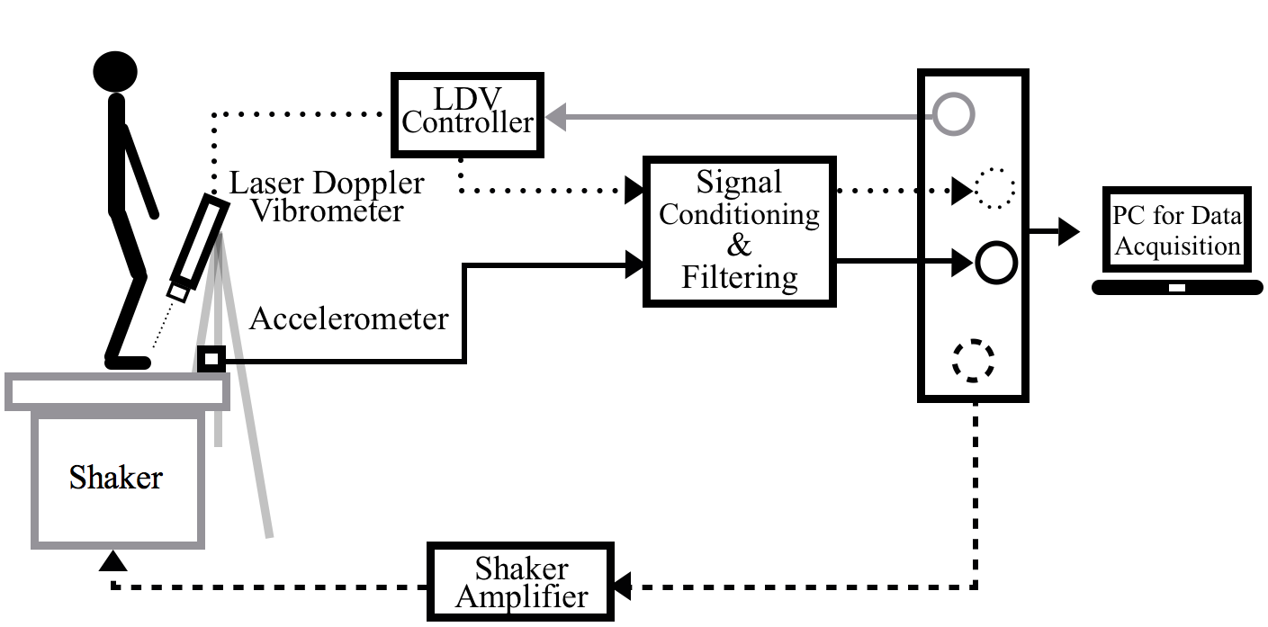
Figure 1. Illustration of experimental set-up and equipment connections.

2.4 Vibration Transmissibility Measurement
Twenty-four small reflective markers (3M retro-reflective tape) were placed on the desired anatomical location on the right foot as follows: three on each toe (15 in total), six on the mid-foot, two on the ankle, and one on the heel (Figure 2). A Polytec Laser Doppler Vibrometer (LDV), with a OFV-505 Sensor Head, was used to measure the velocity at one of 24 anatomical locations on the foot while the participant was standing in their natural upright standing position. After each 51s exposure the participant had a 10 to 20s rest period before the measurements at the next anatomical location were taken. In total, the participant was exposed to vibration for 20 minutes and 24s. Data were acquired at a sampling rate of 2048Hz using a National Instruments 9234, 24-bit data acquisition board.
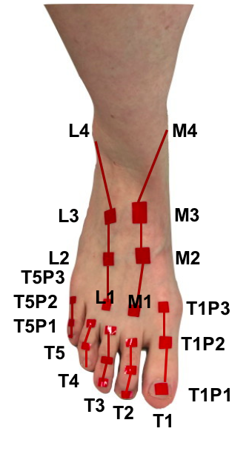 | 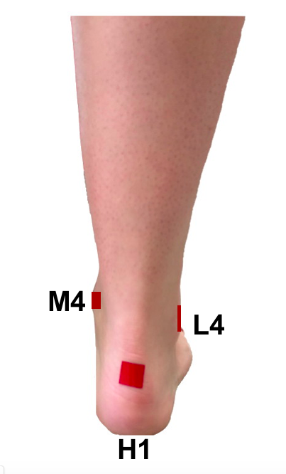 | 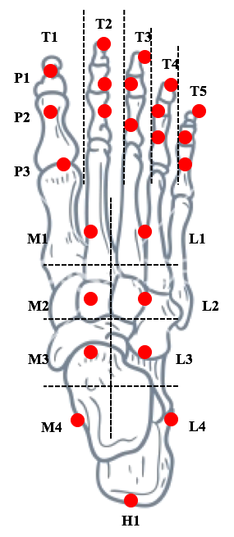
a | b | c

Figure 2. Reflective marker set-up (a) anterior view, (b) posterior view, (c) top view of anatomic representation.

For vertical HAV measurements, the LDV can be positioned directly above the hand to capture vibration transmissibility at the desired anatomical locations (Concettoni & Griffin, 2009). In the current study it was not possible to have the LDV positioned directly above all the measurement points on the foot because the position of the knee and lower leg impeded the laser when participants stood in a natural upright position with both feet on the platform. Therefore, the LDV had to be positioned at an angle to measure vibration transmissibility at all points of interest with the exception of T1P1, T2P1, and T3P1.
In order to enable the calculation of a correction factor, to adjust for the non-vertical position of the LDV, the LDV was moved individually to one of four positions (Figure 3). Using a permanent marker, the location of the LDV beam on the platform was marked and identified as LDV laser points (LP) 1 (LP1), 2 (LP2), 3 (LP3), and 4 (LP4). Pilot testing confirmed the four points were sufficient to enable transmissibility measurements at the 24 anatomical locations for feet ranging from size 6-12 US. The detector of the LDV was positioned 65 cm above the vibration platform (Figure 1). The exact vertical distance from the reflective markers varied with the foot anthropometry of the participant, the anatomic location being measured, and the point on the platform (LP1 to LP4) where the measurement was taken. However, since the maximum stand-off distance for this LDV is 300 m, these small changes in height had no effect on the measurements.
During vibration transmissibility measurement, each participant was asked to position their foot on the platform so that one of the 24 points of interest was located at LP1, LP2, LP3, or LP4. The LDV location at which measurements were taken was recorded for each of the 24 points on the foot (Appendix A).
Previous research has been conducted to quantify noise associated with vibration measures when the LDV beam is on an angle (Drabenstedt, 2007). In order to account for the error associated with the angle of the LDV at LP1-LP4, the FRF was compensated using correction factors determined by measuring the transmissibility of the rigid plate using the tilted LDV. The inverse of the H₁ function (Equations 1-4) were 1.06, 1.16, 1.16, and 1.16 respectively. The values were compatible with the angle arccosine.

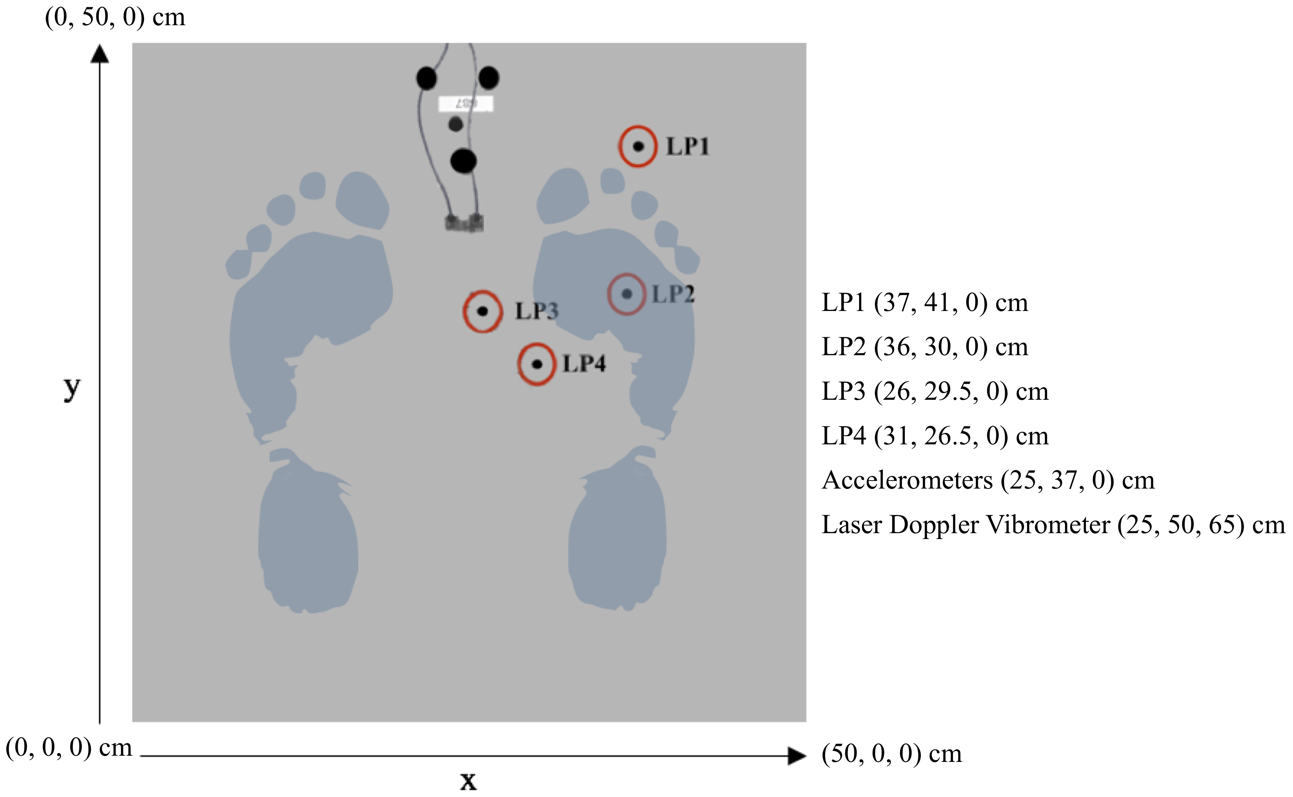
Figure 3. Top view of the four permanently marked laser point locations on the vibration platform, used for the laser Doppler vibrometer (LDV) measurements. The foot was repositioned for each test to ensure the anatomic location being measured was situated over one of these four points. Laser points (LP) from 1 to 4, LP1-LP4, correspond to the four positions on the platform where the LDV beam was directed at the platform. Numbers between the brackets indicate the x, y, and z coordinates (assuming the origin of the axes is the lower-left corner of the platform marked 0,0,0 on the image).

2.5 Data Analysis
All vibration data were processed using LabVIEW (National Instruments, 2015). The vibration time histories of the stimulus (acceleration, hereinafter x) and of the response (velocity, hereinafter y) were split according to the Bartlett method into 26 buffers of 4096 samples lasting 2s without overlap. Complex spectra of x and y ($S_{x}$ and $S_{y}$) were computed on each buffer ($i$) using the rectangular window; the derivative of the velocity was computed in frequency domain by multiplying the signal spectrum times the imaginary unit and angular velocity ($jω$). The cross-spectral averages $({\overline{S}}_{xx}\left(f\right)$ and ${\overline{S}}_{xy}(f))$ and auto-spectral average $({\overline{S}}_{xy}(f))$are:
(1)
(2)
(3)

The FRF was evaluated across the frequency range (10-200Hz) for all 24 locations using the H₁ estimator:
(4)

FRF estimators are typically used with random stimuli, but their usage with a deterministic stimulus removes the non-deterministic components from the FRF (Tarabini et al., 2014); the latter are the ones that, in each specific buffer used for averaging, have a frequency different from that of the stimulus.
The coherence ($γ^{2}\left(f\right)$) was computed for all 24 locations as:
(5)

Coherence is a value between 0 and 1 where a larger number indicates a greater correlation between the two signals being measured (Mansfield, 2004). The coherence function can drop below unity for a number of reasons including contaminating noise on the input or output signals, leakage measurement errors not reduced by windowing, system non-linearities, or because there are non-measured inputs affecting the output (Tarabini et al., 2014). Tests where the average coherence in the range 10-200Hz dropped below 0.5 were redone.
When k is the number of the participant and m the measurement location, the average transmissibility (), phase () and coherence () are defined as:
(6)
(7)
(8)

Of the 504 measurements (24 locations × 21 participants), only five tests were excluded from the analysis due to their inconsistent behaviour (low coherence or obvious artifact).
For each participant, the resonance at each location was identified using the peak amplitude (maximum of ) and the corresponding frequency.

(9)
(10)

These two quantities were averaged to identify the average peak amplitude () and peak frequency () at each location (m):
(11)
(12)
The peak amplitude and frequencies were also computed on the average transmissibility curve () as:
(13)
(14)
These quantities will be referred to as peak amplitude of the average () and peak frequency of the average ().

3. Results
The individual transmissibility responses of each participant at all 24 anatomical locations are presented in Appendix B. The average (± standard deviation) of the entire transmissibility, phase and coherence of 21 participants are plotted for 24 anatomical locations in Appendix C. Two measurements were removed from the analysis due to their low coherence (participant 8 at location H1, and participant 17 at location M4), and an additional three measurements were excluded based on obvious measurement artifact (participant 11 at T2P1, participant 12 at T3P1, and participant 14 at M4). The average coherence was maintained at unity for most points, with the exception of M4, L4, and H1, where the average coherence gradually decreases to 0.6 at frequencies above 130Hz.

3.1 Transmissibility
Vibration transmissibility varied across the 24 measurement points (Figure 4). The most notable differences are observed between three larger areas: the toes (15 locations), midfoot (M1, M2, L1, and L2), and ankle (M3, M4, L3, L4, and H1). As such, these anatomically grouped areas will continue to be referenced throughout the text. Vibration transmissibility was amplified at the toes, midfoot, and ankle at almost all frequencies between 10-200hz, at frequencies between 10-110Hz, and at frequencies between 10-50Hz, respectively (Figure 5).

3.2 Phase
The phase angle had two very distinct categories depending on the anatomical location (see graphs in Appendix C). The average phase angles for the toes and upper portion of the midfoot were initially very close to zero in the range 10-80Hz, but decreased rapidly at higher frequencies. The five points around the ankle (M3, M4, L3, L4, and H1) do not exhibit a similar low frequency-high frequency transition; the phase shift decreases continuously with increasing frequency, reaching angles as high as -497º for M4.

3.3 Resonant Frequency
The average peak amplitude, , and frequency, , of the 21 participants at 24 locations on the foot are reported in Figure 5, together with the peak amplitude of the average, , and peak frequency of the average, . There were notable differences in peak FTV resonance frequency and associated transmissibility amplitude by measurement location (Figure 5). The average peak transmissibility frequency (amplitude) for the toes ranged from 99-147Hz (1.40-2.56), for the midfoot from 51-84Hz (1.42-1.59), and for the ankle from 16-39Hz (1.31-2.10). The maximum average peak transmissibility frequency (147Hz) occurred at T3P2, and the lowest (19Hz) occurred at L4 and H1. The large variability of the transmissibilities, , leads to large differences between and , and between and .
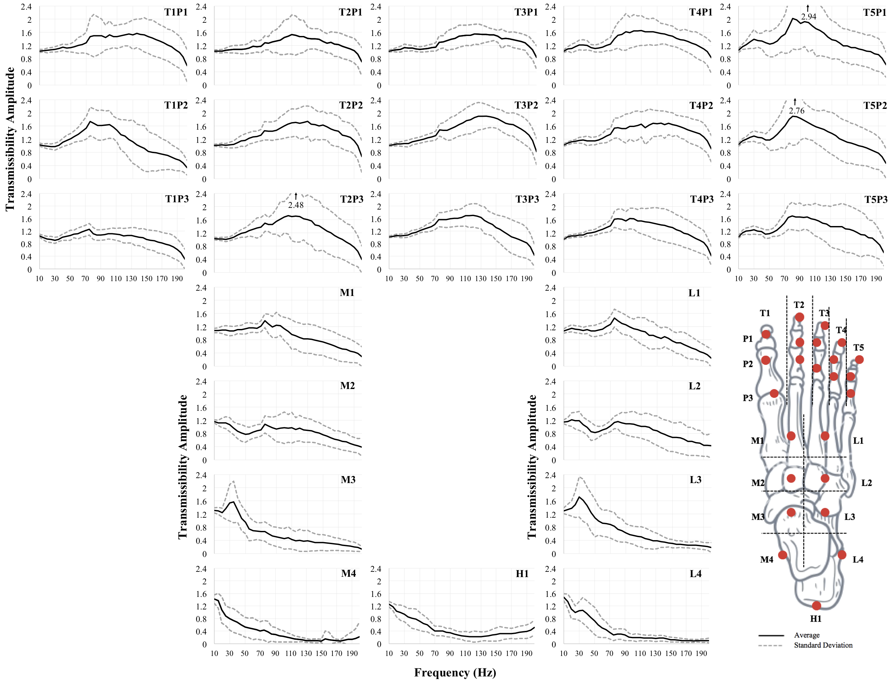
Figure 4. Average (± standard deviation) of the entire FTV transmissibility response of 21 participants plotted for measures taken at 24 anatomical locations across a frequency range of 10-200Hz. Excluded measurements include: one participant at T2P1, T3P1, and H1 and two participants at M4.
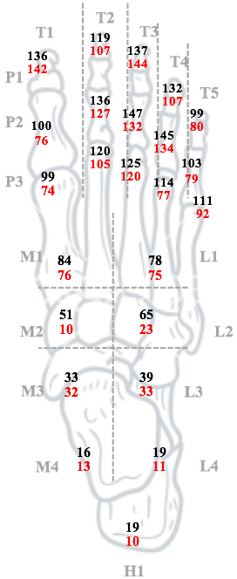 | 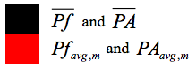  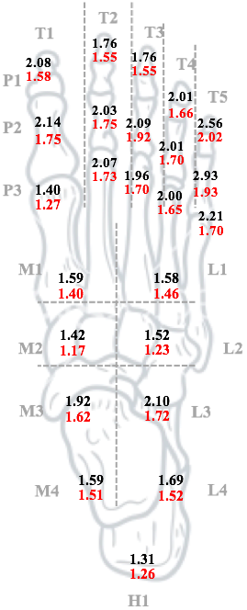
a | b
Figure 5. (a) Average peak frequency, , and peak frequency of the average, , and, (b) average peak amplitude, , and peak amplitude of the average, , measured at 24 locations on the foot.

4. Discussion
The transmissibility response was found to differ for various anatomical locations on the foot, which could be qualitatively divided into three regions: toes, midfoot, and ankle (Figure 4). In general, resonance occurred at higher frequencies at the toes (less mass, soft tissue, and weight bearing) and at lower frequencies at the ankle (increased mass, soft tissue and weight bearing necessities). These results are similar to regional differences observed in HAV exposure measurements, where resonance occurred at higher frequencies at the fingertips than the palm (Concettoni & Griffin, 2009; R.G. Dong et al., 2004; Morioka & Griffin, 2005). The fundamental resonant frequency at each location on the foot-leg system has some similarity to that at the corresponding location on the hand-arm system. Specifically, the resonant frequency range found at the toes (99-147 Hz) is similar to that reported for the fingers (Welcome, Dong, Xu, Warren, & McDowell, 2014). Moreover, the resonant frequency range found at the mid-foot (51-88 Hz) is similar to that reported for the hand dorsum (Welcome et al., 2015) and that found for the ankle (19-39 Hz) is similar to that previously reported at the wrist (Welcome et al., 2015; Xu, Dong, Welcome, Warren, & McDowell, 2015). Evidence that the foot does not respond as a uniform structure is imperative for the development of vibration isolation strategies and protective measures. These regional differences warrant further study.
Comparing the current results with published results is complicated by the limited research specific to FTV. Three previously completed studies reported accelerometer measurements on the metatarsus (Figure 6a), medial malleolus (Figure 6b) and lateral malleolus (Figure 6c). Results from the studies by Goggins et al. (2016) and Wee & Voloshin (2013) were available for direct comparison, whereas the data from the Harazin & Grzesik (1998) study was extracted using a plot digitizer. Two measurement locations in this study (T1P3 and L4) were also used by Goggins et al. (2016) and yielded approximately a 0.3 decrease in transmissibility magnitudes (Figure 6a and Figure 6c). Equipment differences (accelerometers versus LDV) are likely responsible for the magnitude offsets observed.

a | 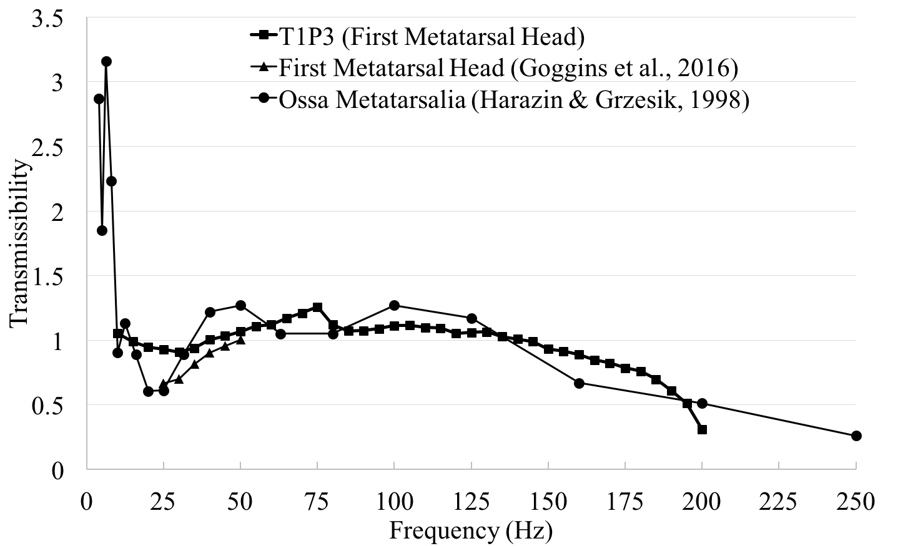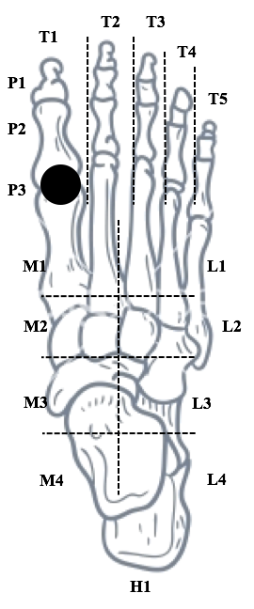
b | 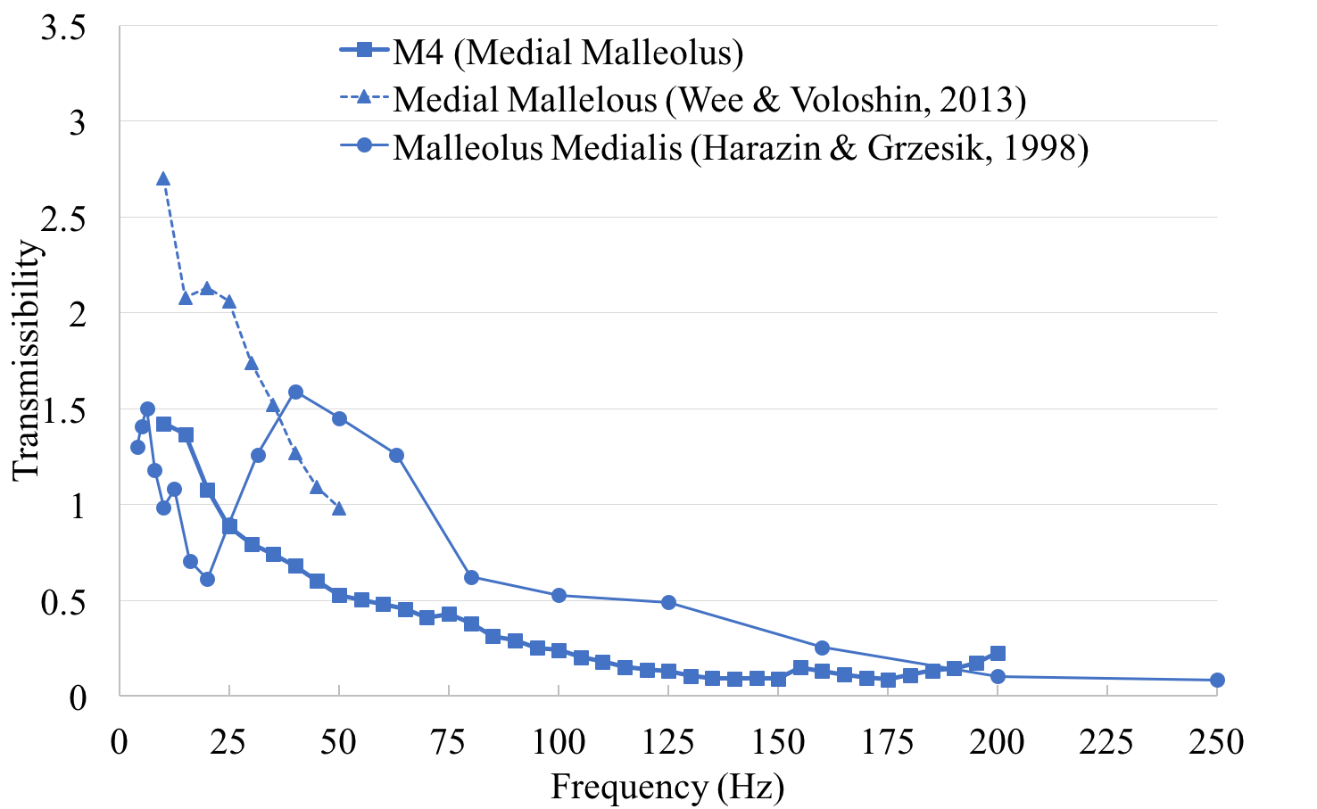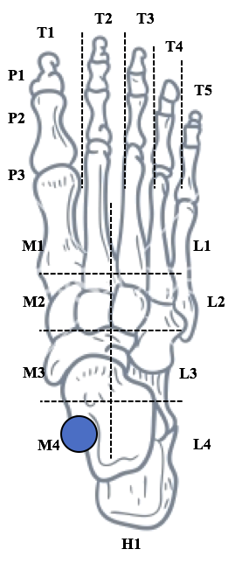
c | 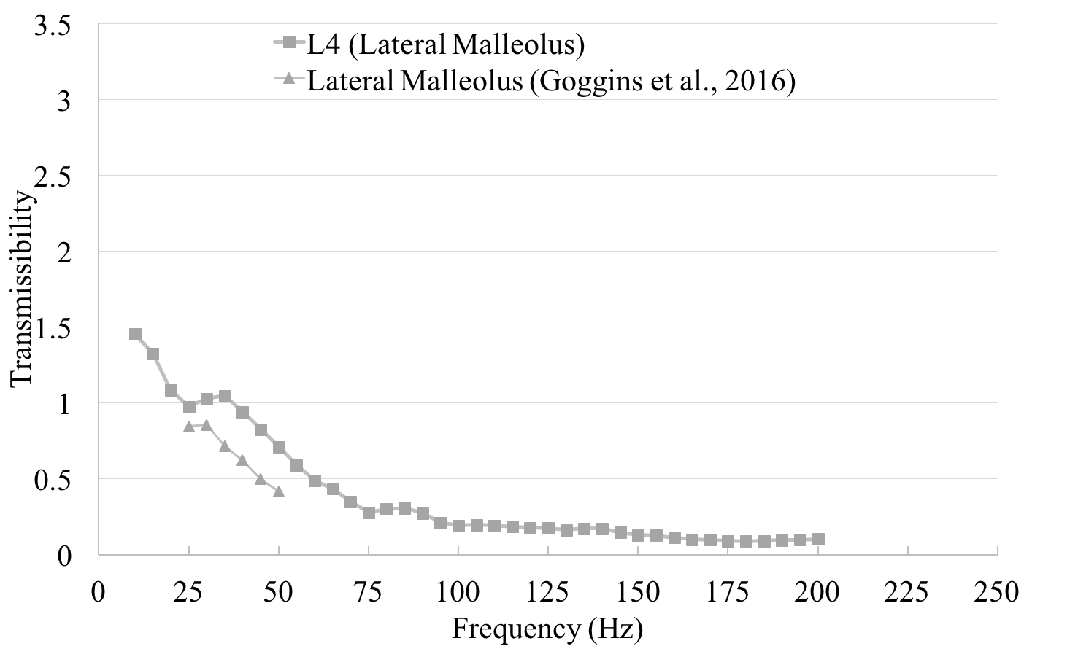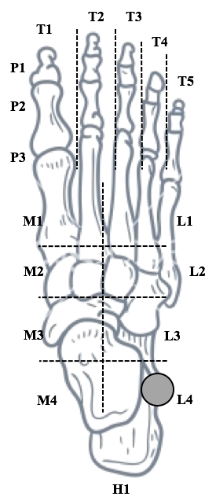
Figure 6: Comparison of transmissibility results at the first metatarsal head (a), medial malleolus (b), and lateral malleolus (c) from three previously completed studies (Goggins et al., 2016; Harazin & Grzesik, 1998; Wee & Voloshin, 2013).

The linear phase response from the toes and the upper portion of the midfoot (Figure 7a) was to be expected because these portions of the feet have a simple transmission path with very little damping from excess tissue. The average phase angle measured at the medial malleolus (M4) is identical to the phase angle measured from 10-50Hz for a seated participant (Wee & Voloshin, 2013). However, the drastic phase changes observed (Figure 7b) at the five locations around the ankle (M3, M4, L3, L4, and H1) have two potential explanations. It is possible that, because the transmissibility magnitudes are below 0.2 between 110 to 200Hz, the large uncertainty on the phase may be due to the poor SNR, as suggested by Smith (1999). The phase change may also result from the greater number of anatomic elements between the vibration input and measurement location compared to the forefoot and midfoot. Vibration can pass through the heel fat pad, talus, calcaneus and one of two leg bones (tibia or fibula), as well as various tendons, ligaments, and muscles. Each of these components introduces structural dampening in the kinematic chain. This more complicated transmission path amounts to multiple mechanical elements in series, which may result in the greater variability observed.

a
b | 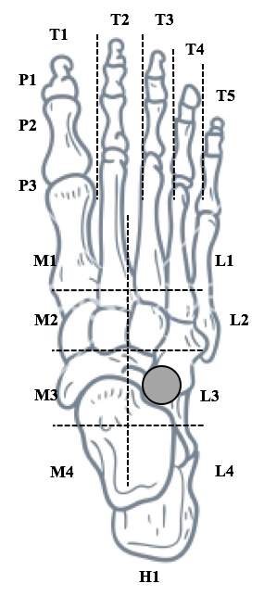
Figure 7: Average phase angle plots for 21 participants at T1P3 (a) and L3 (b).

Results indicated that the average coherence was close to 1 for most points, with the exception of M4, L4, and H1, where the average coherence decreased to 0.6 above 130Hz. Coherence drops from unity for four main reasons: system non-linearity, presence of non-measured inputs, leakage, or noise. The effect of the first three causes is minor for the following reasons:
- the effect of spectral leakage is limited in the presence of high modal damping (Orlando, Peeters, & Coppotelli, 2008);
- the risk of non-measured inputs is small, given that the only input in the frequency range of interest is the vibration provided by the shaker; and,
- the adoption of a non-linear model, which included quadratic and cubic terms described by Tarabini et al. (2014), did not increase the coherence value by more than 10%, the coherence increase was not homogeneous in different tests, and the response at frequencies different from the one of the stimulus was trivial.
Therefore, the low coherence can be reasonably attributed to the presence of measurement noise resulting from the constant velocity imposed by the shaker, which decreases the FRF magnitude, which in turn decreases the SNR at high frequencies. Additionally, recording a vertical measurement of a point within a horizontal plane can cause a reflection artifact which reduces the light measured by the LDV and decreases the SNR.
The human response to vibration is non-linear, with many influencing factors (Matsumoto & Griffin, 2002). Anthropometric differences as well differences in the underlying anatomy, such as muscle mass and the amount of adipose tissue, may have had a significant effect on the person-to-person variability observed in this study. In the case of hand-arm vibration, transmission of vibration occurs primarily through the bones and joints (<20% of the body mass); however, the soft tissues have been identified as being more influential in determining the overall response (Ren G. Dong et al., 2015). Certainly the influence of soft tissue, including the relative motion of the skin and the underlying tissues, becomes an important consideration when vibration transmissibility is measured on the skin. It is reasonable to assume that some of the reported resonances arose solely from relative motion between the skin and the underlying tissues. With the current set-up of this study the authors cannot rule this out. Future studies could consider the use of bone pins with a tri-axial accelerometer to determine transmissibility to the underlying bony structures.
Previous HAV studies have shown an increase in resonant frequency with increases in muscle tension (Adewusi, Rakheja, Marcotte, & Boutin, 2010; Fairley & Griffin, 1989). Although tension was not specifically measured in this study, it is interesting to note that involuntary muscle contraction was observed in some participants on the anterior portion of the ankle (L3, L4, M3, and M4) for frequencies beyond 20 Hz. Since the ability of participants to maintain a natural standing position without losing balance is confounded by individual factors (i.e. muscle control, muscle fatigue, or previous experience on vibration platforms), future research should measure differences in muscle activation and contraction with changes in FTV exposure frequency and magnitude.
Data from the localized transmissibility responses of the foot can contribute to improving the safety of industrial workers. For example, the current data could be used to develop more effective biodynamic models of the foot, as has been done with HTV models of the hand (Adewusi, Rakheja, & Marcotte, 2012). Once an appropriate model has been developed, the initial design and analysis of engineering controls to mitigate FTV exposure could be performed without human exposure testing. Furthermore, the findings from this study suggest that the toe, midfoot and ankle regions of the foot respond differently to the same FTV exposure input. Therefore, development of PPE with a single uniform material, such as anti-vibration insoles, boots, or mats, may be ineffective at mitigating FTV exposure to different areas of the foot.
The main limitations of this study derive from the constraints of the experimental setup. First, the LDV could not be positioned vertically above each measurement point on the foot because the knee and lower-leg blocked the path of the laser when participants stood on the vibration platform. The LDV measures the vibration along the laser axis and, in an ideal set-up, should be located directly above each measurement position and aligned with the vertical stimulus. To compensate for this limitation, correction factors were applied to correct for the off-axis error. However, the resulting compensation is only error-free in the presence of a good SNR (that was verified by the signal quality indicated by the LDV conditioning unit) and if the direction of motion is perpendicular to the LDV laser ray. Given that in the presence of a vertical stimulus the horizontal motion of the foot is expected to be smaller than the vertical one, the error should be small in comparison to inter-and intra- subject variability. Future research could evaluate horizontal foot motion when exposed to a vertical vibration stimulus.
Further limitations include the fact that the vibration stimulus (sweep rate with a constant velocity profile) was chosen in order to have a predictable SNR and to limit the overall test duration. The adoption of different stimuli (stepped sine, noise), of different sweep rates and of different amplitudes, could lead to different FRF estimations in the presence of system non-linearity and should be evaluated in future FTV studies. This study was also limited to the use of barefoot participants in a natural standing position only. Typically, workers exposed to vibration will be wearing socks and footwear, and operating some form of equipment which will take them out of a natural standing position. Future studies should consider the impact of different footwear conditions on FTV and consider the physiological effects. Changes in muscle activation and blood flow during the exposure may be more indicative of the onset for muscle fatigue and vascular damage.
As suggested by Dong and colleagues (2013), an increased knowledge of the foot’s response to vertical vibration may also be used to quantify vibration exposures for risk assessments. Moreover, as researchers learn more about the biomechanical response of the foot and lower leg segment, members of the ISO committee for human health should consider the development of a standard to evaluate health risks associated with occupational exposure to FTV. The current study found the resonant frequencies for the toes, midfoot, and ankle ranged from 99-147Hz, 51-84Hz, and 16-39Hz, respectively. These results may suggest that the current method of evaluating standing WBV exposure (ISO 2631-1, 1997) may not be appropriate for evaluating health/injury risk specifically to the feet, as the weighting curve (W_{k}) decreases the influence of frequencies above 10Hz. The HAV standard (ISO 5349-1, 2004) may be more appropriate for identifying health/injury risk to the feet as it does not apply such a negative weighting (W_{h}) to the higher frequencies where the toes are known to resonate. Nevertheless, future research, including studies examining impedance and apparent mass, will be required before alternative frequency-weighting curves appropriate for determining health effects associated with exposure to FTV can be recommended.

5. Conclusions
This study identified the vibration transmissibility response at 24 anatomical locations on the feet of 21 volunteers when maintaining an upright natural standing position under exposure to FTV from 10 to 200Hz. Overall, the average transmissibility response was found to vary across anatomical locations with different average peak transmissibility frequencies for the toes (range: 99-147Hz), midfoot (range: 51-84Hz), and ankle (range: 16-39Hz). The corresponding average peak transmissibility amplitudes were found to be: toes (1.40-2.56), midfoot (1.42-1.59), and ankle (1.31-2.10).

Acknowledgements

This work was supported by a Natural Science and Engineering Research Council of Canada Discovery Grant (RGPIN/4252-2015) and by Regione Lombardia within the project “PORFESR 2014-2020: “Smart Fashion and Design”. Dr. Lievers is an IAMGOLD Research Fellow and gratefully acknowledges the financial support of the IAMGOLD Corporation.

The authors would also like to acknowledge the instrumental contributions of Francesco Corti (Department of Mechanics, Politecnico di Milano, Lecco, Italy) in assisting with data collection, and for sharing his expertise in mechanical sampling. A sincere thank you as well to all of the willing participants in this study that supported our ability to contribute to the FTV literature.

References
Adamo, F., Attivissimo, F., Lanzolla, A. M. L., Saponaro, F., & Cervellera, V. (2014). Assessment of the uncertainty in human exposure to vibration: An experimental study. IEEE Sensors, 14(2), 474-481. doi:10.1109/JSEN.2013.2284257
Adewusi, S., Rakheja, S., & Marcotte, P. (2012). Biomechanical models of the human hand-arm to simulate distributed biodynamic responses for different postures. International Journal of Industrial Ergonomics, 42(2), 249-260. doi:10.1016/j.ergon.2012.01.005
Adewusi, S., Rakheja, S., Marcotte, P., & Boutin, J. (2010). Vibration transmissibility characteristics of the human hand–arm system under different postures, hand forces and excitation levels. Journal of Sound and Vibration, 329(14), 2953-2971. doi:10.1016/j.jsv.2010.02.001
Boileau, P.-E., & Rakheja, S. (1998). Whole-body vertical biodynamic response characteristics of the seat vehicle driver: Measurement and model development. International Journal of Industrial Ergonomics, 22, 449-472.
Bovenzi, M. (2005). Health effects of mechanical vibration. Giornale Italiano de Medicina del Lavoro ed Ergonomia, 27(1), 58-64.
Bovenzi, M. (2008). A follow up study of vascular disorders in vibration-exposed forestry workers. International Archives Occupational and Environmental Health, 81, 401-408. doi:10.1007/s00420-007-0225-9
Bovenzi, M., Rui, F., Negro, C., D'Agostin, F., Angotzi, G., Bianchi, S., . . . Stacchini, N. (2006). An epidemiological study of low back pain in professional drivers. Journal of Sound and Vibration, 298, 514-539. doi:10.1016/j.jsv.2006.06.001
Concettoni, E., & Griffin, M. (2009). The apparent mass and mechanical impedance of the hand and the transmission of vibration to the fingers, hand, and arm. Journal of Sound and Vibration, 325, 664-678. doi:10.1016/j.jsv.2009.03.033
Donati, P. (2002). Survey of technical preventative measures to reduce whole-body vibration effects when designing mobile machinery. Journal of Sound and Vibration, 253(1), 169-183. doi:10.1006/jsvi.2001.4254
Dong, R. G., Schopper, A. W., McDowell, T. W., Welcome, D. E., Wu, J. Z., Smutz, W. P., . . . Rakheja, S. (2004). Vibration energy absorption (VEA) in human fingers-hand-arm system. Medical Engineering and Physics, 26, 483-492. doi:10.1016/j.medengphy.2004.02.003
Dong, R. G., Sinsel, E. W., Welcome, D. E., Warren, C., Xu, X. S., McDowell, T. W., & Wu, J. Z. (2015). Review and Evaluation of Hand–Arm Coordinate Systems for Measuring Vibration Exposure, Biodynamic Responses, and Hand Forces. Safety and Health at Work, 6(3), 159-173. doi:10.1016/j.shaw.2015.05.003
Dong, R. G., Welcome, D. E., McDowell, T. W., & Wu, J. Z. (2013). Theoretical relationship between vibration transmissibility and driving-point response functions of the human body. Journal of Sound and Vibration, 332(24), 6193-6202. doi:10.1016/j.jsv.2013.07.017
Drabenstedt, A. (2007). Quantification of displacement and velocity noise in vibrometer measurements on transversely moving or rotating surfaces. Proceedings of SPIE - The International Society for Optical Engineering, 6616. doi:10.1117/12.726115
Eger, T., Thompson, A., Leduc, M., Krajnak, K., Goggins, K., Godwin, A., & House, R. (2014). Vibration induced white-feet: Overview and field study of vibration exposure and reported symptoms in workers. Work, 47(1), 101-110. doi:10.3233/WOR-131692
Fairley, T. E., & Griffin, M. J. (1989). The apparent mass of the seated human body: Vertical vibration. Journal of Biomechanics, 22(2), 81-94. doi:10.1016/0021-9290(89)90031-6
Goggins, K., Godwin, A., Lariviere, C., & Eger, T. (2016). Study of the biodynamic response of the foot to vibration exposure. Occupational Ergonomics, 13, 53-66. doi:10.3233/OER-160236
Griffin, M. J. (1990). Handbook of Human Vibration (1st ed.). London: Academic Press.
Griffin, M. J. (2008). Measurement, evaluation, and assessment of peripheral neurological disorders caused by hand-transmitted vibration. International Archives of Occupational and Environmental Health, 81(5), 559-573. doi:10.1007/s00420-007-0253-5
Gunaselvam, J., & van Niekerk, J. L. (2005). Seat selection guidelines to reduce whole-body vibration exposure levels in the SA mining industry. The Journal of The South African Institute of Mining and Metallurgy, 105, 675-686.
Hagberg, M., Burstrom, L., Lundstrom, R., & Nilsson, T. (2008). Incidence of Raynaud's phenomenon in relation to hand-arm vibration exposure among male workers at an engineering plant a cohort study. Journal of Occupational Medicine and Toxicology, 3(13), 1-6. doi:10.1186/1745-6673-3-13
Harazin, B., & Grzesik, J. (1998). The transmission of vertical whole-body vibration to the body segments of standing subjects. Journal of Sound and Vibration, 215(4), 775-787.
House, R., Jiang, D., Thompson, A., Eger, T., Krajnak, K., Sauve, J., & Schweigert, M. (2010). Vasospasm in the feet in workers assessed for HAVS. Occupational Medicine, 1-6. doi:10.1093/occmed/kqq191
International Organization for Standardization. (1997). Mechanical vibration and shock – Evaluation of human exposure to whole-body vibration – whole-body vibration – Part 1: General Requirements. ISO-2631-1. International Organization for Standardization, Geneva, Switzerland.
International Organization for Standardization. (2004). Mechanical vibration and shock – Guidelines for the measurement and the assessment of human exposure to hand-transmitted vibration. ISO-5349-1. International Organization for Standardization, Geneva, Switzerland.
International Organization for Standardization. (2013). Mechanical vibration and shock – Hand-arm Vibration – Measurement and evaluation of the vibration transmissibility of gloves at the palm of the hand. ISO-10819. International Organization for Standardization, Geneva, Switzerland.
Ji, X., Eger, T. E., & Dickey, J. P. (2016). Optimizing seat selection for LHDs in the underground mining environment. The Journal of the Southern African Institute of Mining and Metallurgy, 116, 785-792. doi:10.17159/2411-9717/2016/v116n8a11
Mansfield, N. J. (2004). Human Response to Vibration. London: CRC Press.
Matsumoto, Y., & Griffin, M. J. (2002). Non-linear characteristics in the dynamic responses of seated subjects exposed to vertical whole-body vibration. Journal of Biomechanical Engineering, 124, 627-532.
Morioka, M., & Griffin, M. J. (2005). Thresholds for the perception of hand-transmitted vibration: Dependence on contact area and contact location. Somatosensory and Motor Research, 22(4), 281-297. doi:10.1080/08990220500420400
Orlando, S., Peeters, B., & Coppotelli, G. (2008). Improved FRF estimators for MIMO sine sweep data. Paper presented at the International Conference on Noise and Vibration Engineering, Leuven, Belgium.
Paddan, G. S., & Griffin, M. J. (1998). A review of the transmission of translational seat vibration to the head. Journal of Sound and Vibration, 215(4), 863-882.
Pope, M., Magnusson, M., Lundstrom, R., Hulshof, C., Verbeek, J., & Bovenzi, M. (2002). Guidelines for whole-body vibration health surveillance. Journal of Sound and Vibration, 253(1), 131-167. doi:10.1006/jsvi.2001.4253
Shen, S. C., & House, R. A. (2017). Clinical Review: Hand-arm vibration syndrome - What family physicians should know. Canadian Family Physician, 63, 206-210.
Smith, S. W. (1999). The Scientist and Engineer's Guide to Digital Signal Processing (Second ed.). San Diego, California: California Technical Publishing.
Tarabini, M., Solbiati, S., Moschioni, G., Saggin, B., & Scaccabarozzi, D. (2014). Analysis of non-linear response of the human body to vertical whole-body vibration. Ergonomics, 57(11), 1711-1723. doi:10.1080/00140139.2014.945494
Thompson, A. M. S., House, R., Krajnak, K., & Eger, T. (2010). Vibration-white foot: a case report. Occupational Medicine, 60, 572-574. doi:10.1093/occmed/kqq107
Tingsgard, I., & Rasmussen, K. (1994). Vibration-induced white toes. Ugeskr Laeger, 156(34), 4836-4838.
Wee, H., & Voloshin, A. (2013). Transmission of vertical vibration to the human foot and ankle. Annals of Biomedical Engineering, 41(6), 1172-1180. doi:10.1007/s10439-013-0760-3
Welcome, D. E., Dong, R. G., Xu, X. S., Warren, C., & McDowell, T. W. (2014). The effects of vibration-reducing gloves on finger vibration. International Journal of Industrial Ergonomics, 44, 45-59. doi:10.1016/j/ergon.2013.10.003
Welcome, D. E., Dong, R. G., Xu, X. S., Warren, C., McDowell, T. W., & Wu, J. Z. (2015). An examination of the vibration transmissibility of the hand-arm system in three orthogonal directions. International Journal of Industrial Ergonomics, 45, 21-34. doi:10.1016/j.ergon.2014.11.001
Xu, X. S., Dong, R. G., Welcome, D. E., Warren, C., & McDowell, T. W. (2015). An examination of an adapter method for measuring the vibration transmitted to the human arms. Measurement, 73, 318-334. doi:10.1016/j.measurement.2015.05.039

Appendix A: Laser point (LP) locations (1-4) for 21 participants at 24 anatomical locations.
 |  | Participant #
Anatomical Location |  | 1 | 2 | 3 | 4 | 5 | 6 | 7 | 8 | 9 | 10 | 11 | 12 | 13 | 14 | 15 | 16 | 17 | 18 | 19 | 20 | 21
Anatomical Location | T1P1 | 1 | 1 | 1 | 2 | 2 | 2 | 1 | 1 | 1 | 1 | 1 | 1 | 1 | 1 | 1 | 1 | 1 | 1 | 1 | 1 | 1
Anatomical Location | T2P1 | 1 | 1 | 1 | 2 | 2 | 2 | 1 | 1 | 1 | 1 | 1 | 1 | 1 | 1 | 1 | 1 | 1 | 1 | 1 | 1 | 1
Anatomical Location | T3P1 | 1 | 1 | 1 | 2 | 2 | 2 | 1 | 1 | 1 | 1 | 1 | 1 | 1 | 1 | 1 | 1 | 1 | 1 | 1 | 1 | 1
Anatomical Location | T4P1 | 1 | 1 | 1 | 2 | 2 | 2 | 1 | 1 | 1 | 1 | 1 | 1 | 1 | 1 | 1 | 1 | 1 | 1 | 1 | 1 | 1
Anatomical Location | T5P1 | 1 | 1 | 1 | 2 | 2 | 2 | 1 | 1 | 1 | 1 | 1 | 1 | 1 | 1 | 1 | 1 | 1 | 1 | 1 | 1 | 1
Anatomical Location | T1P2 | 1 | 1 | 1 | 2 | 2 | 2 | 1 | 1 | 1 | 1 | 1 | 1 | 1 | 1 | 1 | 1 | 1 | 1 | 1 | 1 | 1
Anatomical Location | T2P2 | 1 | 1 | 1 | 2 | 2 | 2 | 1 | 1 | 1 | 1 | 1 | 1 | 1 | 1 | 1 | 1 | 1 | 1 | 1 | 1 | 1
Anatomical Location | T3P2 | 1 | 1 | 1 | 2 | 2 | 2 | 1 | 1 | 1 | 1 | 1 | 1 | 1 | 1 | 1 | 1 | 1 | 1 | 1 | 1 | 1
Anatomical Location | T4P2 | 1 | 1 | 1 | 2 | 2 | 2 | 1 | 1 | 1 | 1 | 1 | 1 | 1 | 1 | 1 | 1 | 1 | 1 | 1 | 1 | 1
Anatomical Location | T5P2 | 1 | 1 | 1 | 2 | 2 | 2 | 1 | 1 | 1 | 1 | 1 | 1 | 1 | 1 | 1 | 1 | 1 | 1 | 1 | 1 | 1
Anatomical Location | T1P3 | 1 | 1 | 1 | 2 | 2 | 2 | 1 | 1 | 1 | 1 | 1 | 1 | 1 | 1 | 1 | 1 | 1 | 1 | 1 | 1 | 1
Anatomical Location | T2P3 | 1 | 1 | 1 | 2 | 2 | 2 | 1 | 1 | 1 | 1 | 1 | 1 | 1 | 1 | 1 | 1 | 1 | 1 | 1 | 1 | 1
Anatomical Location | T3P3 | 1 | 1 | 1 | 2 | 2 | 2 | 1 | 1 | 1 | 1 | 1 | 1 | 1 | 1 | 1 | 1 | 1 | 1 | 1 | 1 | 1
Anatomical Location | T4P3 | 1 | 1 | 1 | 2 | 2 | 2 | 1 | 1 | 1 | 1 | 1 | 1 | 1 | 1 | 1 | 1 | 1 | 1 | 1 | 1 | 1
Anatomical Location | T5P3 | 1 | 1 | 1 | 2 | 2 | 2 | 1 | 1 | 1 | 1 | 1 | 1 | 1 | 1 | 1 | 1 | 1 | 1 | 1 | 1 | 1
Anatomical Location | M1 | 2 | 2 | 1 | 2 | 2 | 2 | 1 | 1 | 2 | 2 | 2 | 1 | 2 | 1 | 1 | 1 | 1 | 1 | 2 | 2 | 2
Anatomical Location | M2 | 2 | 2 | 2 | 2 | 2 | 2 | 2 | 4 | 2 | 2 | 2 | 2 | 2 | 2 | 2 | 2 | 2 | 2 | 2 | 2 | 2
Anatomical Location | M3 | 2 | 2 | 2 | 2 | 2 | 4 | 2 | 4 | 2 | 2 | 2 | 2 | 2 | 2 | 2 | 2 | 2 | 2 | 2 | 3 | 2
Anatomical Location | M4 | 4 | 4 | 4 | 4 | 4 | 4 | 4 | 4 | 4 | 3 | 4 | 4 | 4 | 4 | 4 | 4 | 4 | 4 | 4 | 3 | 3
Anatomical Location | L1 | 2 | 2 | 1 | 2 | 2 | 2 | 1 | 1 | 2 | 2 | 2 | 2 | 2 | 1 | 1 | 1 | 2 | 2 | 1 | 2 | 1
Anatomical Location | L2 | 2 | 2 | 2 | 2 | 2 | 2 | 2 | 4 | 2 | 2 | 4 | 2 | 2 | 2 | 2 | 2 | 2 | 2 | 2 | 2 | 2
Anatomical Location | L3 | 2 | 2 | 2 | 4 | 2 | 3 | 2 | 4 | 2 | 2 | 4 | 2 | 2 | 2 | 2 | 2 | 2 | 2 | 2 | 2 | 2
Anatomical Location | L4 | 2 | 2 | 2 | 2 | 4 | 2 | 2 | 4 | 4 | 3 | 4 | 3 | 2 | 4 | 3 | 2 | 2 | 3 | 4 | 2 | 3
Anatomical Location | H1 | 3 | 3 | 3 | 3 | 3 | 3 | 3 | 4 | 4 | 3 | 4 | 3 | 3 | 4 | 3 | 2 | 3 | 3 | 4 | 4 | 3

Appendix B: The individual transmissibility responses of 21 participants at 24 anatomical locations. Excluded measurements include: one participant at T2P1, T3P1, and H1 and two participants at M4.
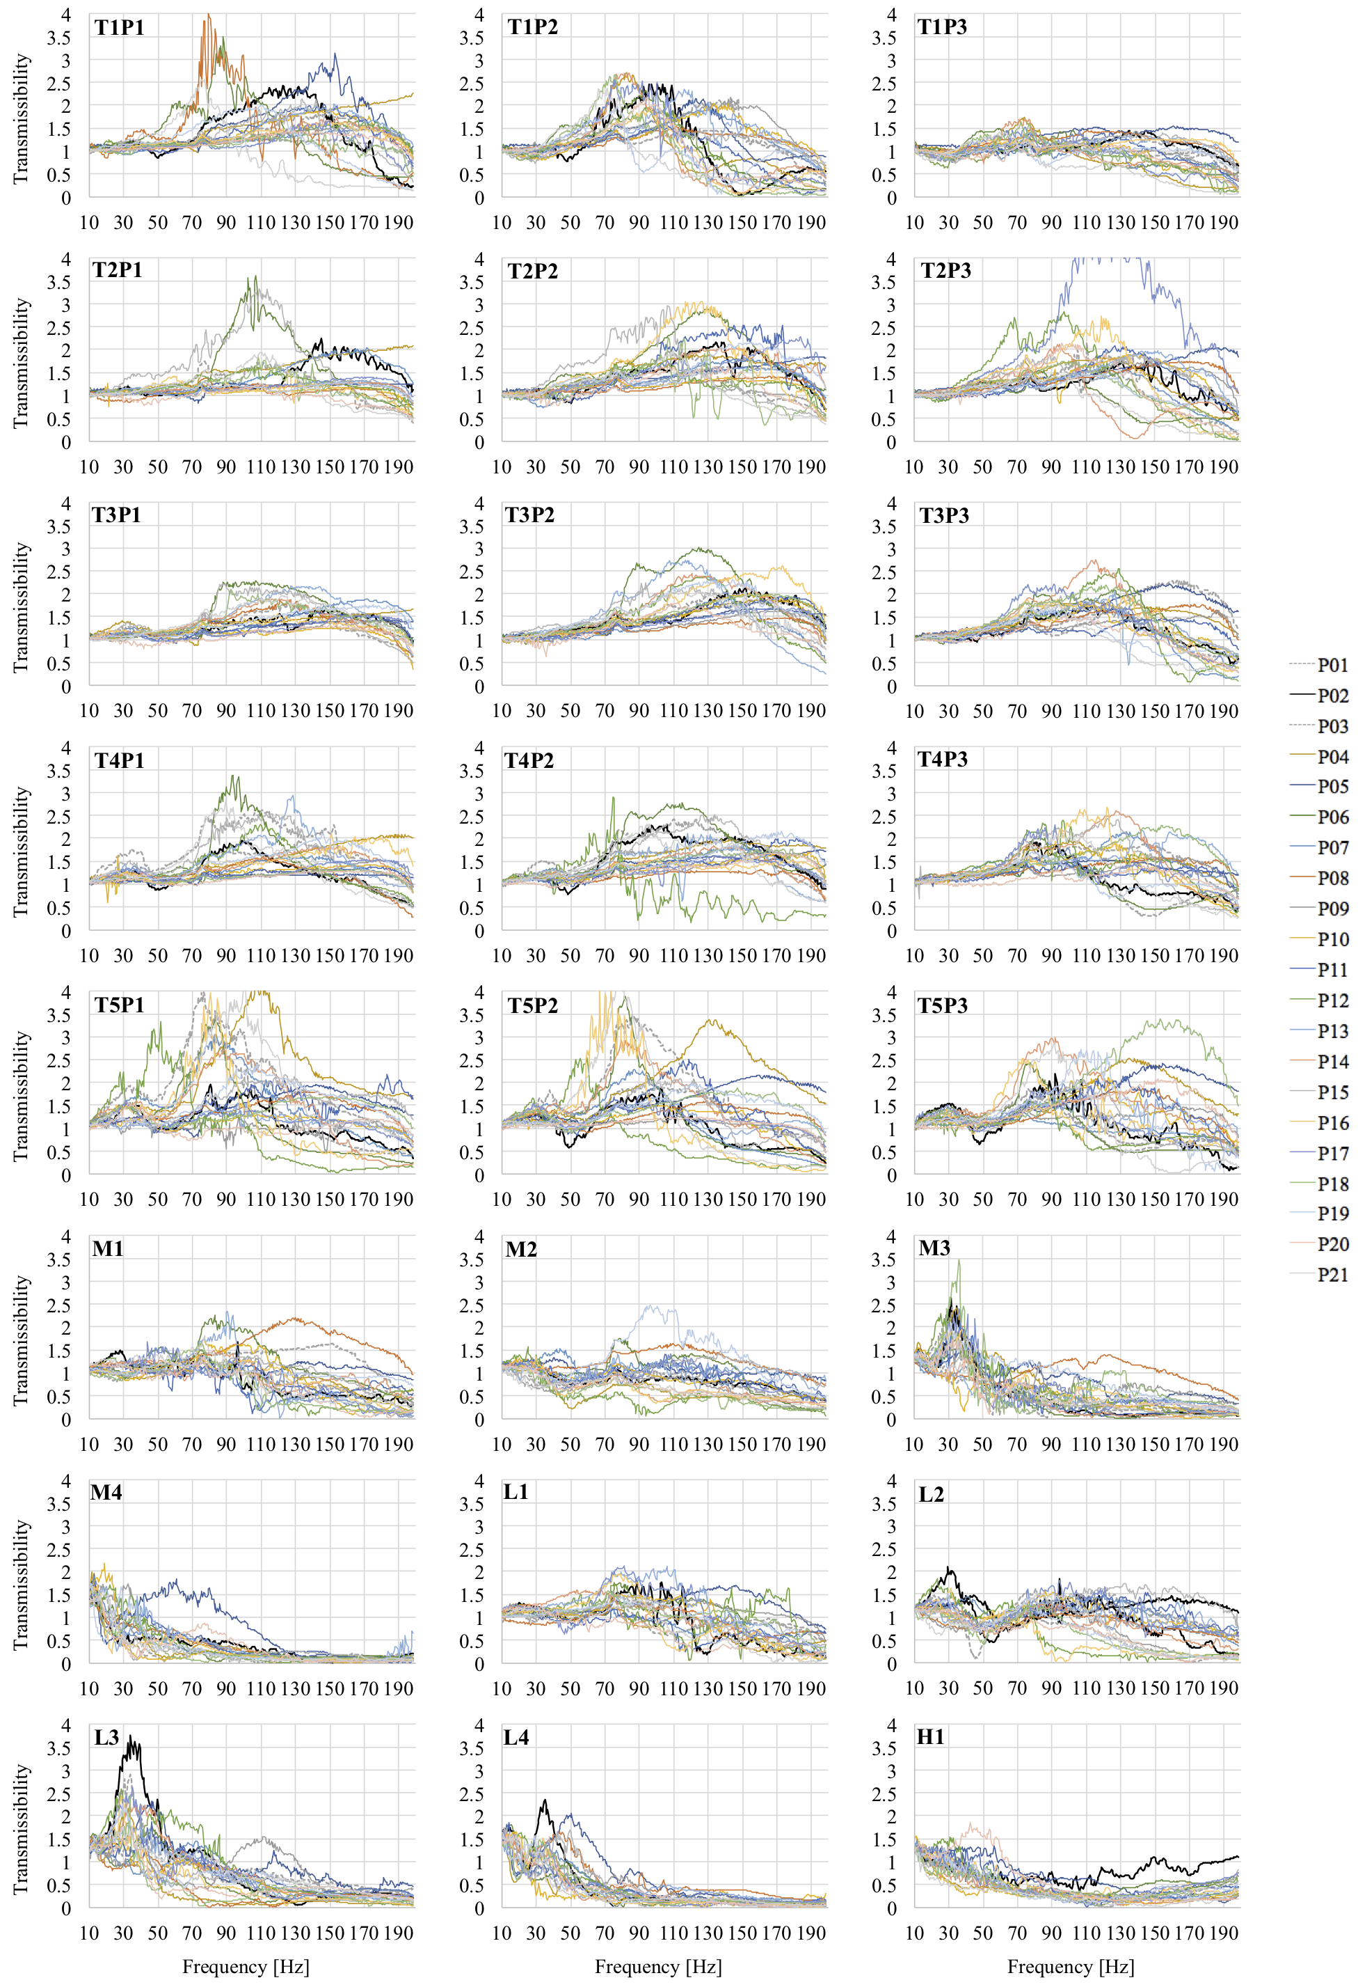
Appendix C: The average (black line) ± standard deviation (grey dotted line) of the entire transmissibility, phase and coherence responses of 21 participants for 24 anatomical locations. Coherence plot only shows negative standard deviation, as measure above unity are not possible. Excluded measurements include: one participant at T2P1, T3P1, and H1 and two participants at M4.
