THE INTERPOLATION METHOD FOR THE DETECTION OF LOCALIZED STIFFNESS LOSSES
M.P. Limongelli, M. Domaneschi, L. Martinelli, M. Dilena, A. Morassi, A. Zambrano, A. Gecchelin

Abstract
In this paper is presented an approach to the detection of localized stiffness losses basing on Operational Deformed Shapes (ODS). The method uses as a damage feature the so called ‘Interpolation Error’ related to the use of a smooth cubic spline function in interpolating the operational deformed shapes of the structure. A localized reduction of smoothness in the operational deformed shapes detected between two consecutive inspections, points out a localized loss of stiffness. The ODS can be recovered from Frequency Response Functions calculated basing on responses measured at selected locations of the structure in terms of acceleration. In order to avoid false or missing indications of damage related to random variations of the damage feature, their effect should be properly taken into account. To this aim a threshold value of the damage feature is defined in terms of the values chosen for the tolerable probability of false alarm. This allows distinguish variations of the interpolation error due to damage from those due to random sources.
The IDDM has been successfully applied to bridges, multistorey buildings and, in its 2D formulation to plates. In this paper after a brief description of the method some examples of its application to different types of structures are reported.

INTRODUCTION
Existing methods for damage identification can be divided into those relying on the calibration and updating a finite element model of the structure, and feature-based methods, which perform damage identification checking the possible changes of a damage sensitive parameter. The last do not need a numerical model and rely on a procedure to extract the damage feature from the sole responses to vibrations recorded on the real structure. Due to the scarce human interaction they require, they are attractive for adoption within an automated monitoring system. Both modal parameters and non-modal parameters (e.g. Frequency Response Functions, Operational Deformed Shapes or their derivatives, Interpolation Errors) have been proposed in the literature as damage sensitive feature. The recently proposed Interpolation Damage Detecting method (IDDM) relies on a damage index defined in terms of the operational deformed shapes of the structure. The damage feature is the interpolation error related to the use of a spline function in modeling the operational deformed shapes: statistically significant variations of the interpolation error between two successive inspections of the structure indicate the onset of damage. The significance of the variation is defined in statistical terms on the base of exceedance of a certain threshold value defined in terms of the accepted probability of false alarm. In the following a brief outline of the method is reported together with some applications.

The INTERPOLATION damage DETECTION method (iddm)
In the Interpolation Damage Detecting method the damage feature is the interpolation error related to the use of a spline function in modeling the Operational Deformed Shapes (ODSs) of the structure: statistically significant variations of the interpolation error between two successive inspections of the structure indicate the onset of damage. Specifically, at a given location of a structure the interpolation accuracy is defined as the difference between the measured ODS and the ODS calculated by interpolating the measured ODSs at all the other locations equipped with a sensor. An increase of the interpolation error in the inspection phase (after a potentially damaging event) with respect to the baseline phase, is an indication of the existence of damage at the location where the change has been recorded. The IDDM has been successfully applied for damage localization of multistory buildings [1], [2], supported bridges [3], [4], models of suspension and cable-stayed bridges [6] and recently extended to the case of two-dimensional structures [7]. Thanks to its formulation based on the detection of reduction stiffness through the detection of reduction of smoothness in the Operational Deformed Shapes (ODS), the IDDM can be applied to any type of structure provided the ODSs can be estimated accurately in the original and in the damaged configurations and a proper continuous function is used to interpolate the ODS in order to detect possible reductions of smoothness.

The damage feature for beam-like structures
The basic idea of the IDDM for beam-like structures can be described with reference to Figure 1.
Figure 1: The interpolation error
The ODS can be determined through the Frequency Response Functions (FRFs) if the excitation giving rise to the available responses is known otherwise Power Spectra of the response can be used to this aim. In this latter case a normalization of the damage feature is required in order to remove the dependence from the amplitude of the external excitation. Let z₁,…z_{n}, be instrumented location of the structure where responses in terms of acceleration have been recorded. At each frequency value, the set of frequency response functions H_{R}(z) measured at the instrumented locations, give the operational deformed shape (ODS) at that frequency (red dots in Figure 1). At the l-th location z_{l} the ODS can be calculated through the spline interpolation using the following relationship:
(1)
where the coefficients (c_{0l}, c_{1l} c_{2l} c_{3l}) are calculated from the values of the transfer functions “recorded” at the other locations:
(2)
The explicit expressions of the coefficient of the spline function c_{j,l} in terms of the ODS’s are determined imposing continuity of the spline function and of its first and second derivative in the knots (that is at the ends of each subinterval). More details on the spline interpolation procedure to calculate acceleration responses can be found in reference [8]. In terms of ODS’s the interpolation error at location z (in the following the index l will be dropped for clarity of notation) at the i-th frequency value f_{i}, is defined as the difference between the magnitudes of recorded and interpolated frequency response functions:
(3)
If the structure is subjected to a known input recorded, for example, during forced vibration tests or under a low seismic excitation the estimation of the ODS is quite straightforward basing on the well-known relationship between the auto and cross power spectra allowing the estimation of the Frequency Response Functions. If the input is not available, the ODS can be recovered from the power spectra of the responses but, being not scaled to the input, cannot be directly employed to estimate the interpolation error since its value is influenced by the magnitude of the ODS which is strictly dependent on the input if they are not scaled: in this case a normalization of the damage feature is required.
The interpolation error in this case can be defined as:
(4)
being z_{rif} a reference sensor location arbitrarily chosen.
In order to characterize each location z with a single error parameter, the norm of the error on the significant frequency range (that is the frequency range with a signal to noise ratio sufficiently high to allow a correct definition of the ODS) is calculated:
(5)
The significant frequency range is selected limiting the summation in equation (5) to the frequency range of the fundamental modes of the structure. This frequency range can be tuned basing on vibration tests carried out on the undamaged structure. If a reduction of stiffness (damage) occurs at a certain location, the operational shapes change in the region close to that location and specifically their smoothness decreases due to the discontinuity of curvature induced by damage. If the estimation of the error function through Eq. (5) is repeated in the baseline (undamaged) and in the inspection (possibly damaged) configuration, the difference between the two values, denoted respectively by E₀(z) and E_{d}(z), can provide an indication about the existence of degradation at location z. An increase () of the interpolation error between the reference configuration and the current configuration at a station z, i.e., highlights a localized reduction of smoothness and therefore, it is assumed to be a symptom of a local decrease of stiffness at location z associated with the occurrence of damage. Basing on this assumption the following conditions will be assumed to define the damage index IDI(z):
(6)

Extension to plate-like structures
In this case a bi-cubic spline interpolation is used to interpolate the ODSs. Assuming that sensors lye on a rectangular grid n_{l+1} x n_{p+1}, (see Figure 3) for each value of frequency f_{i}, the actual value of the ODS at a given location , and its spline interpolation must be known in order to calculate the value of the interpolation error at that location: , as shown in Figure 2. To this aim the spline interpolation is calculated basing on the ODSs at all the instrumented locations except .
at frequency f_{i}
Figure 2. The interpolation error E(x,y)
At each instrumented location (x_{l}, y_{p}) and for each frequency value f_{i}, two values of the interpolation error E_{x} and E_{y} can be calculated basing on the difference between recorded and interpolated ODSs:
(7)
(8)
The total interpolation error at the given location can be calculated as the sum of the two latter values:
(9)
In order to characterize each location P(x, y) (in the following the suffix p and l will be dropped for clarity of notation) with a single error parameter, the norm of the error on the significant frequency range (that is the frequency range with a signal to noise ratio sufficiently high to allow a correct definition of the FRF) is calculated:
(10)
After the evaluation of the interpolation error in equation (10), which is the 2D version of equation (3), the calculation of the damage index for 2D structures follows the same procedures outlined for 1D structures.

Figure 3. Regular grids for the evaluation of the interpolation error

Accounting for uncertainties
Several sources, such as temperature, nonlinear behavior, soil structure interaction and noise in recorded data, can induce variations of the interpolation error even if no damage occurs. To take into account their effect the statistical variability of the interpolation error at each instrumented location z_{i} should be investigated. If enough samples of the damage feature are available both in the undamaged and in the inspection configurations the relevant probability distributions and can be estimated and compared. This is the case for structures permanently monitored and statistical methods are available for the comparison of the two distributions. A different situation occurs when a prompt alert is required, for example in the aftermath of an earthquake: the estimation of the damage feature should rely on a very small sample of values of E_{d}, possibly just one. In these cases the detection of possible damages should be carried out by comparing the value of E_{d} to the distribution in order to check if its value is ‘likely to occur’ in the undamaged configuration In this cases the definition of a threshold corresponding to an ‘accepted probability of false alarm’ is required.
The last situation is the very common one of structures that are periodically or occasionally inspected to check their ‘health state’: in this case the distribution of the damage feature is available neither in the inspection nor in the reference configurations hence the selection of the possibly damaged locations should be carried out basing on a very limited sample of data. In this case, the lack of experimental data requires some simplifying assumptions. For some of the applications reported in the following it was assumed that the sources of random variations equally affect all the instrumented locations the potentially damaged locations are identified among all the instrumented locations as the ones where the variation of the damage feature is ‘significantly higher’ with respect to the others. In order to select ‘significantly higher’ values of E, a threshold value must is introduced in terms of its statistical parameters:
(11)
being μ and σ respectively mean and standard deviation of the statistical distribution of ΔE and ν the value of the standard normal distribution corresponding to the threshold probability. More details will be given in the applications of the IDDM reported in the following.

applications

The Factor Building under seismic excitation
The UCLA Factor building (see Figure 4) is a 17-story moment-resisting steel frame structure consisting of two stories below grade and 15 above grade. The building houses laboratories, faculty offices, administrative offices, the School of Nursing, School of Medicine, auditoriums, and classrooms. More details on this application of the IDDM can be found in reference [2].
Figure 4: The Factor Building (a) East face; (b) Sensors location
The building is permanently instrumented with an embedded 72-channel accelerometer array recording both ambient vibrations of the building and motions from local earthquakes. The network of sensors deployed on the Factor building records responses in two directions as showed in Figure 4b.
(a) | (b) | (c)
(d) | (e) | (f)
Figure 5: Results for damage scenarios in y-direction.
Several damage scenarios have been modeled assuming damage to two column belonging to one frame in the x (or in the y) direction at one, two, three or four storeys. In order to study the influence of the quality of the available data on the reliability of the method, different levels of noise have been randomly added to the responses calculated by the numerical model.
Noise has been modelled as a Gaussian zero mean white noise vector: several different simulations were carried out considering values of noise increasing from 1% to 20%. The percentage represents the ratio between the root mean square of added noise and the root mean square of the amplitude of the absolute acceleration. Results show that the reliability of the method depends on the relationship between the severity of damage, on the intensity of noise and the value chosen for the threshold. Figure 5 reports results for different intensity of noise and for damage of increasing severity (3, 5 or 7 damaged columns)
A rough estimate of the reduction of stiffness per storey is given by the number of damaged columns with respect to the total number of columns at the storey (38 columns): one damaged column corresponds approximately to a reduction of stiffness of 2.5%, 7 damaged columns corresponds to about 18% storey stiffness reduction. At the increase of damage, the value of the IDI increases thus making easier the localization of the damaged storey also for high levels of noise. In the case of 7 damaged columns for both one damaged location (Figure 5c) and 3 damaged locations (Figure 5f) the identification of the damaged location is very clear. For damage of lower severity (3 damage columns, Figure 5a) the correct localization of damage is hampered by a number of false alarms that arise when the noise to signal ratio reaches values higher than 5%.
At the increase of the severity of damage that is at the increase in the number of the damaged elements per storey, also the damage index IDI(z) increases. In Figure 6 the values of the damage index are reported for several scenarios corresponding to an increasing number of damaged columns in one frame along y, at the 7th story. At the moment a relationship between the amount of damage and the value of the Interpolation Damage Index has not yet been established hence it is not possible to recover the amount of damage from the value of the IDI.
P_{f}=2%
nsr=0.1%
Figure 6: Increase of damage index with the severity of damage

The cable-stayed Bill Emerson Memorial Bridge under wind excitation
This bridge at the base of this study is a fan-type cable stayed bridge (Figure 7) which crosses the Mississippi River near Cape Girardeau (USA) with a composite concrete-steel deck stiffened by two longitudinal steel girders. For a more detailed description the reader is referred to reference [6]. In this case it has been assumed that a limited sample of responses is recorded both in the reference and in the inspection configurations hence the distributions of the interpolation error have been assumed unknown. This situation may occur if responses are recorded for a very limited period of time by a network of sensors temporarily installed on the structure. Damage to cables has been simulated by reducing the transversal section of 3 adjacent stays of 10%, 25% and 50% of the original section. Two different damage locations have been considered (see Figure 7b). The values of the damage parameters ΔE, calculated basing on ODS recovered from transversal responses are reported Figure 8a,b. The ODS have been estimated using the transmissibility functions of the responses at the nodes with respect to the response measured at the reference node assumed at location corresponding to Pier2. In the figures a blue vertical bar indicates the actual location of damage assumed at the node joining the deck with the damaged stay. The red dotted bar represents the threshold corresponding to the 98% percentile of the damage parameter distribution in equation (11). In all cases, even if damage is very low (10% reduction of transversal section) the damaged section is correctly identified.

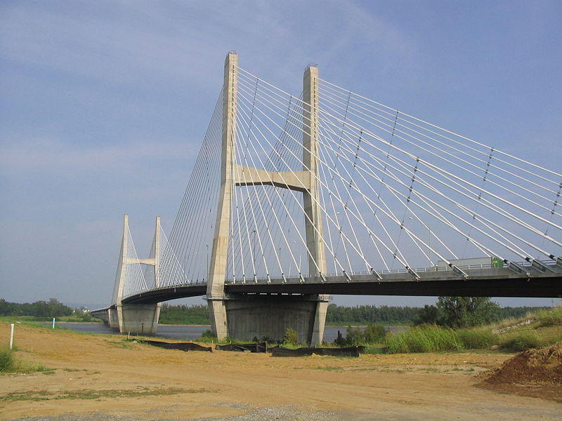
(a) | (b)
Figure 7: a) The Bill Emerson Memorial Bridge (Framerotblues, 2007; with permission); b) Damage scenarios
Of course the method is not able to indicate if the damage is located in the deck or in the cables, since only responses on the deck were considered in the procedure, but the damaged portion of the structure is correctly identified. The highest variation is found for the most severe scenario (C1_2_50) corresponding to a reduction of 50% of the stiffness in 6 cables of the bridge. In this case the maximum variation of modal frequencies was of 0.61% for the frequency of the 10th mode. Hence very low variations that would hardly allow the detection of damage, not to consider that in a real case noise would affect the estimation of modal parameters thus completely hampering the identification of damage through the estimated values of modal frequencies.
a) | (b)
Figure 8: Damage parameter and threshold for the two damage scenarios a) B2: damage in the deck-beam at location 2; b) C1_2_10: damage in the cables at locations 1 and 2.

The Dogna Bridge under forced vibrations for inspection
Dogna Bridge is the four-span, one-lane reinforced concrete bridge shown in Figure 9. The bridge deck is formed by a reinforced concrete (RC) slab 0.18 m in thickness, supported by three longitudinal RC beams of rectangular cross-section 0.35×1.20 m. Beams are simply supported at the ends and are connected at the supports, at mid-span and at span-quarters by transverse RC diaphragms. Dynamic tests were performed from April 2 to April 11, 2008, and during the experiments the tested span was made independent of the adjacent span by removing the deck-joint in correspondence of the pier. Harmonically forced vibration tests were performed on the bridge in its original undamaged condition and in seven damaged configurations D1-D7, see The first six damage states were obtained by cutting the downstream lateral beam (see Figure 9right). Notches were produced by using a hydraulic saw fitted with a diamond disc. The seventh level of damage was obtained by removing the concrete near the mid-span cross-section of the same beam by means of a jackhammer. The vertical motions of the deck structure were produced by means of a vibration generator and deck’s inertance of the bridge was measured by means of zoom analyses within narrow neighborhoods (approximately 3-5 Hz in size) of the natural frequencies. The above procedure has been applied for the characterization of all the damaged configurations D1-D7. Herein a very brief presentation of the main results is given; we refer to reference [4] for a more detailed description of this application of the IDDM.

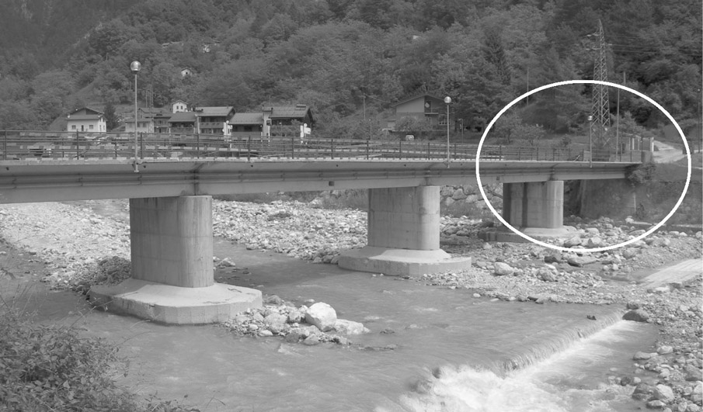 | 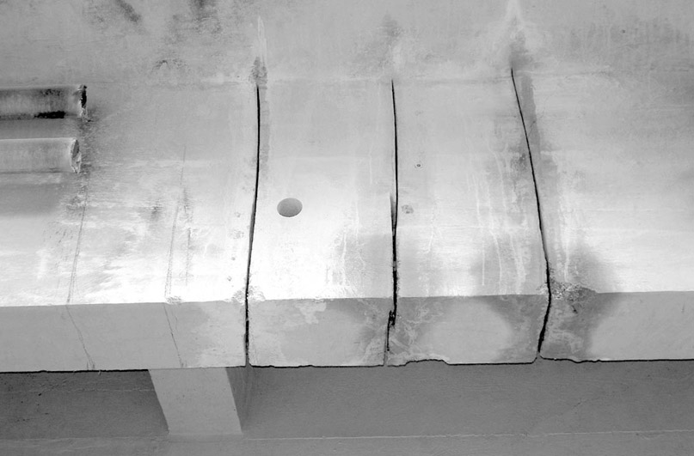
Figure 9: General view of Dogna Bridge (left, tested span circled) and detail of damages D1-D6 (right).
The ODS in this case were easily calculated form the FRF recorded during the tests even if an interpolation of this functions was required in order to complete the experimental data, recorded only around small frequency ranges around the modal ones, with values calculated over the entire frequency range [4]. In almost all cases the values of the damage index, reported in Figure 10, exhibit the highest values at locations close to the actual position of damage. In order to check the capability of the IDDM to localize a new damage starting from a configuration already damaged (i.e., D6), the IDDM was applied to identify configuration D7 assuming configuration D6 as the reference one. Results show that the correct damaged section is always detected.
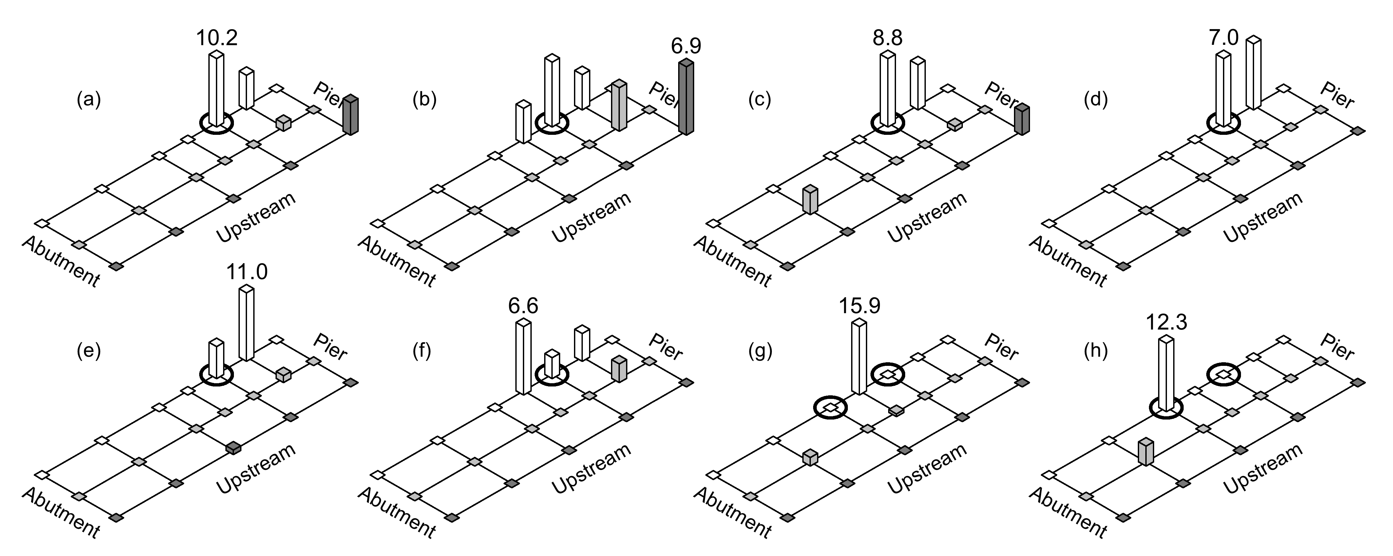
Figure 10. Damage index D calculated in the interval 8-50 Hz (first five vibrating modes) from the reference configuration (U) to actual damage configuration: (a) D1; (b) D2; (c) D3; (d) D4; (e) D5; (f) D6; (g) D7; (h) from D6 to D7. Threshold ν=1. Circles denote the actual damage locations.

The façade of the St Egidio church in old Bussana
The application of the 2D extension of the IDDM to plate like structures, has been successfully carried out for steel and composite plates [7] and [8]. Currently its application for damage localization in masonry structures is under investigation with reference to the case of the façade of the St Egidio Church in old Bussana (Italy) [9]. In the application is it assumed that the façade is permanently instrumented with a network of instruments arranged according the layout reported in the Figure 11. Numerical data recovered from a non linear time history seismic analysis will be used to check the capability of the method to give a prompt alarm allowing to detect almost in real time the location of possible damages to the façade, basing on the responses recorded from a quite dense network of the sensors permanently deployed on the structure Advances in sensors technology and miniaturized signal processing platforms allow exploring the possibility of using a large number of sensors widely distributed over the structure. This application is currently under development and the use of both accelerations, displacements and strains for the estimation of the interpolation error will be investigated.
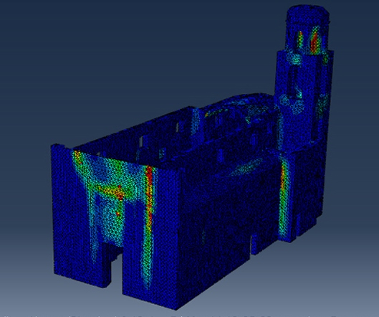 | 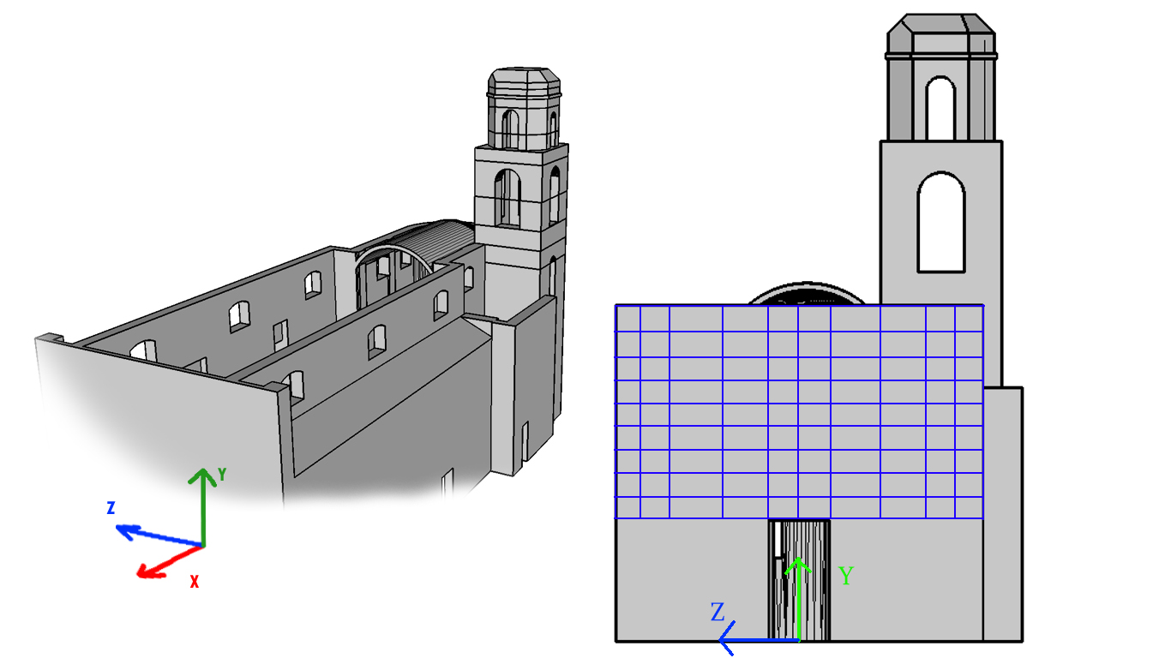
Figure 11. a) Damage pattern from numerical analysis; b) Locations of sensors

CONCLUSIONS AND FUTURE DEVELOPMENTS
The results obtained so far by applying the IDDM in its 1D and 2D formulations are encouraging and several further developments are envisaged. First of all a correlation between the value of the damage index and the effective damage intensity would allow to quantify the severity of damage thus improving the knowledge about the structural condition. A second aspect which is worth investigations is the possible use of tri-cubic splines as interpolating shape functions for the ODS would allow to extend the method to 3D objects for particularly complex structures. Further investigations are also needed in order to define a ‘reasonable’ value for the threshold corresponding to the accepted probability of false alarm in the definition of the damage index. This should be carried out basing on an analysis cost-benefit carried out for the single monitored structure taking into account, together with the costs of a possible false alarm, the advantages related to a prompt intervention. These include both the direct cost savings deriving from a prompt remedial action that can reduce the costs of the interventions, both the increase the safety level and, in the case of historical structures and of structures hosting historically or culturally valuable objects (e.g. museums), the reduction of the risk related to the loss of invaluable objects.

References
- Limongelli, M.P., (2011). The interpolation damage detection method for frames under seismic excitation. Journal of Sound and Vibration, 330. 5474–5489.
- Limongelli, M.P., (2014). Seismic health monitoring of an instrumented multistorey building using the Interpolation Method. Earthquake Engng. Struct. Dyn. doi: 10.1002/eqe.2411.
- Limongelli M.P. (2010). “Frequency response function interpolation for damage detection under changing environment”. Mechanical Systems and Signal Processing doi:10.1016/j.ymssp.2010.03.004
- Dilena M., Limongelli M.P. Morassi A. (2014). “Damage localization in bridges via FRF interpolation method”. Mechanical Systems and Signal Processing, 52-53, pp 162-180.
- M. Domaneschi, M.P. Limongelli, L. Martinelli (2013), “Vibration Based Damage Localization Using MEMS on a Suspension Bridge”, Smart Structures and Systems, 12(6), 679-694.
- Domaneschi M., Limongelli M.P., Martinelli L. (2014). Damage Identification in a Benchmark Cable-Stayed Bridge Using the Interpolation Method. Le Cam, Vincent and Mevel, Laurent and Schoefs, Franck. EWSHM - 7th EuropeanWorkshop on Structural Health Monitoring, Jul 2014, Nantes, France. <hal-01022077>
- Limongelli M.P., (2013). “Two dimensional damage localization using the interpolation method”. 10th International conference on damage assessment of structures. DAMAS 2013. Dublin Ireland. July 8-10 2013.Key Engineering Materials. Vol. 569-570, 860-867.
- Limongelli M.P., (2003),"Optimal location of sensors for reconstruction of seismic responses through spline function interpolation". Earthquake Engineering and Structural Dynamics, 32, pp. 1055-1074.
- Limongelli M.P., Carvelli V. (2015). “Damage localization in a glass fiber reinforced composite plate via the surface interpolation method”. 11th International conference on damage assessment of structures. DAMAS 2015. Ghent Belgium, 24-26 August 2015. Submitted
- A. Gecchelin. (2014) Master thesis. ‘Il tempo non si è fermato a... Bussana Vecchia. Valutazione della vulnerabilità sismica della Chiesa di Sant'Egidio’. Politecnico di Milano. Scuola di Architettura.

