The effect of local scour of a single pier on the vibration parameters of a multi-span bridge under seismic excitation
A. Anžlin
National Building and Civil Engineering Institute, Dimičeva ulica 12, 1000 Ljubljana, Slovenia
L.J. Prendergast & K. Gavin
Faculty of Civil Engineering and Geosciences, Delft University of Technology, Netherlands
M.P. Limongelli
Politecnico di Milano, Department of Architecture, Piazza Leonardo da Vinci 32, 20133 Milano, Italy

ABSTRACT: Some preliminary results of a numerical investigation carried out on the finite element model of a bridge under flood and seismic actions are reported in this paper. The numerical model of a multi-span bridge is subjected to a seismic base input considering several defined scour conditions. Scour has been modelled as the incremental increase in length of one of the piers and the effect of scour on the seismic response is investigated. The studies showed, that the effect of scour is to increase the peak displacement of the pier (at deck level), with a corresponding increase in the peak acceleration at the same level. The shear force at the base of the scoured column drastically decreases with scour; however this results in a redistributed higher shear being experienced by adjacent columns.

1 INTRODUCTION

Several regions in Europe are prone to both seismic and scour hazards thus bridges can suffer from the joint actions of these two phenomena. The two types of hazards are actually independent as to the generation process but the loss of surrounding soil due to scour may significantly modify the dynamic parameters of the structure thus changing its response to a subsequent earthquake.
Permanent monitoring through vibration-based methods can be an effective support in bridge assessment procedures providing updated information about the structural state and performance. Information from the monitoring system allow both the prompt detection of a possible damage state after an extreme event and also support for long term assessment of the structural conditions.
For bridges under multiple hazard the possibility of using the same network of sensors for different hazards can increase the benefit/cost ratio related to the use of a monitoring system.
The first part of the paper reports a brief description of the main damage scenarios connected to scour and to seismic actions. The second part of the paper reports the results of non-linear dynamic analyses of a scoured bridge under seismic input.

  - Bridge scour

Bridge scour is the term used to describe the removal of soil from around bridge foundations caused by adverse hydraulic action (Hamill 1999). There are three main forms of scour: general, contraction and local scour. General scour occurs naturally in river channels and is a fundamental behavior of evolving rivers. It involves the natural erosion and deposition behavior of a river channel that occurs due to changes in the hydraulic parameters governing channel form, for example flow rate or sediment supply (Forde et al. 1999; Federico et al. 2003). Contraction scour occurs due to the sudden increase in flow velocity at the location of a bridge caused by a narrowing of the river channel, as water is channeled between the sub-structural elements of a bridge (piers or abutments). The increased velocity has an associated increase in the shear stresses imposed on the streambed sediment. Once the threshold shear stress of a given bed material is surpassed, sediments are mobilized (Briaud et al. 1999). Finally, local scour occurs around individual piers or abutments due to their disruption of the local water-flow characteristics. The flow is channeled downward once it meets the obstruction, which can cause scour holes to develop on the upstream end of a pier due to the generation of horseshoe vortices. Furthermore, the flow separating at the sides of the pier causes wake vortices to form which can expand the scour hole around the pier (Heidarpour et al. 2010). Figure 1 shows a schematic of the scour process around a cylindrical pier-type object.
Scour is one of the leading causes of bridge failure worldwide (Briaud et al. 2001; Briaud et al. 2005; Melville & Coleman 2000; Wardhana & Hadipriono 2003). In the United States, bridge failure inventories claim that scour is either the leading factor or a major contributory factor to sudden bridge failure. For example, one study of 500 bridge failures that occurred between 1989 and 2000 in the United States claimed that 53% of the failures were attributed to flood-related mechanisms including scour (Wardhana & Hadipriono 2003). Another similar study from an earlier period specified scour as the primary cause of failure in 600 documented bridge failures (Shirole & Holt 1991). Scour represents a significant cost burden on infrastructure managers between preventative measures, inspections and associated repairs.
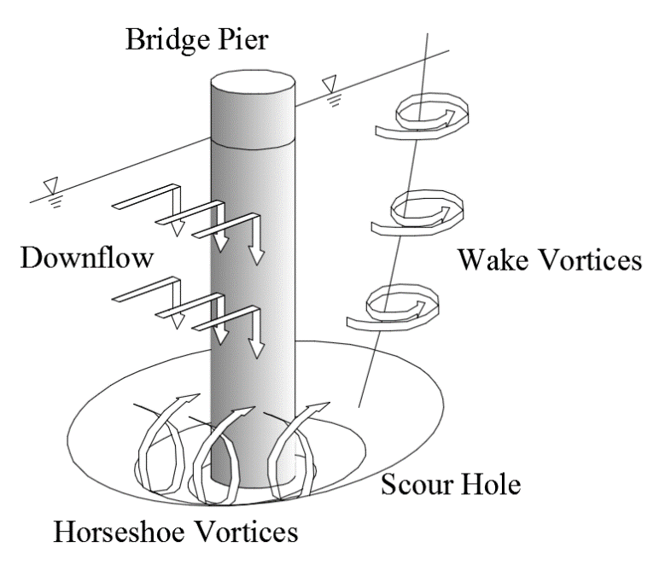
Figure 1: Schematic of local scour - modified from Prendergast & Gavin (2014)

Scour failures tend to occur quite suddenly and generally without much warning. For example, in North Dublin, Ireland in August 2009, a railway bridge on the main Dublin to Belfast rail line partially collapsed as a train passed overhead (Maddison 2012). Fortunately, there were no causalities in this particular incident, however the rail line was out of service for some time afterwards.

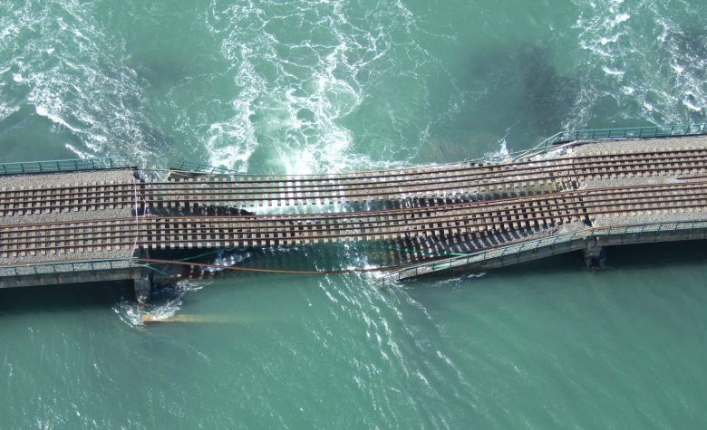

Figure 2: Collapsed Malahide Viaduct on Dublin-Belfast rail line (Maddison 2012)

Figure 2 shows a photo of the bridge after collapse. The bridge is located in a tidal estuary, and tidal scour was deemed to be the cause of collapse.
Monitoring of scour has become a topic of significant importance for asset managers. Scour monitoring was traditionally undertaken by visual means, whereby a diver would inspect the condition of a foundation at discrete periods. The main drawback of these methods is the subjectivity of the condition ratings, as well as the dangers of inspecting for scour during floods. For example, the primary focus of these inspections were to visually assess the magnitude of a scour hole, in terms of its depth, proximity to a foundation as well as any auxiliary impacts present (cracking or other evident damage). Moreover, scour holes tend to refill with sediment as flood waters subside making their detection by discrete visual means quite challenging. In response to the need for more reliable methods, several mechanical and electrical instruments have been developed to remotely monitor scour (Prendergast & Gavin 2014; Fisher et al. 2013). These instruments typically measure the depth of a scour hole near a foundation element with varying degrees of accuracy. A variety of methods exist that use physical sensors placed on or near the ground that move with changing bed level elevation (Hunt 2009; Briaud et al. 2011), or they rely on electromagnetic or sonic methods (Forde et al. 1999; Yu 2009; Nassif et al. 2002). One common drawback of the majority of these types of instruments is that they are typically incapable of assessing the distress experienced by the bridge due to the presence of scour at the foundations.
The need for more information on the condition of the structure due to scour has led to the evolution of the vibration-based scour monitoring field. Several authors have investigated how the dynamic response of bridges or specific bridge elements varies under scour, see (Briaud et al. 2011; Prendergast et al. 2016; Prendergast et al. 2017; Prendergast et al. 2013; Chen et al. 2014; Bao et al. 2017; Elsaid & Seracino 2014; Foti & Sabia 2011) among others. For example, Ju (2013) studied how the natural frequency of a bridge varied with scour incorporating fluid-structure interaction. Chen et al. (2014) present a case study of a vibration-based bridge scour detection scheme applied to a cable-stay bridge based on measuring ambient velocity changes. Prendergast et al. (2013) investigated how the natural frequency of a single pile varied as it was scoured, on a both a laboratory and field scale. Moreover, they put forward a numerical model capable of tracking the frequency change using site specific soil parameters. Prendergast et al. (2016; 2017) build on this method and investigate if scour can be detected and located using frequency measurements of an integral-type bridge structure.
The majority of these studies agree that the loss in stiffness due to scour can be traced using vibration measurements, whereby the stiffness loss manifests itself as a change in modal properties (Doebling et al. 1996). This topic is receiving an increasing amount of interest in the literature in recent years.

  - Seismic actions on bridge performance

Collapse of bridges due to seismic actions may be the result of the application of old design codes that did not consider at all seismic design or did not apply capacity design principles. According to the capacity design principles, the design of the structures (or the upgrading for existing ones) has to be performed so as to enhance the energy dissipation capacity. This can be achieved avoiding brittle failures and allowing controlled energy dissipation.
The first goal is achieved designing the structure with a resistance with respect to brittle collapse mechanisms higher with respect to the resistance to ductile mechanisms. For example the resistance to shear failure has to be higher with respect to the resistance to bending failure and the resistance of the superstructure should be lower with respect to the resistance of the foundations. The second goal of controlled energy dissipation is pursued by allowing the formation of flexural plastic hinges in predefined (controlled) locations. This enables the development of stable collapse mechanisms and thus the dissipation a large amount of energy. For example in the case of a bridge this means that the structure is designed to allow the formation of flexural plastic hinges in as many piers as possible. On the other hand, such deformations are not allowed to occur in the deck and the foundations, which are designed assuming the maximum anticipated actions at the base of the piers.
The capacity design principles can be applied through proper detailing of critical regions (e.g. reduced spacing of the transversal steel bars in reinforced concrete structures, or reduced transversal sections in steel structures) and through design of the structural elements carried out based on the resistance with respect to brittle mechanisms and not based on the actions.
If capacity design is not applied, as is the case of most bridges built according to old design codes, brittle collapse mechanisms with very limited energy dissipation capacity are likely to occur.
Bridge piers usually represent one of the weak elements under seismic actions due to inadequate detailing (Anzlin et al. 2015) that limit their capacity to deform in the non-elastic range.
Another common bridge collapse mechanism is due to the collapse of the deck girders due to large relative displacements between pier columns. Collapse may occur at expansion joints due to compression or tension failures or – in case of simple supported girders - to the unseating of deck due to insufficient seat width (see Figure 5).
In simply supported span bridges the unseating of the bridge deck could be dually affected by scour due to the increased flexibility that increases the maximum potential displacement of the deck induced by seismic actions. In this paper, the effect of scour local to one of the piers on a multi-span bridge is investigated in terms of how it changes the seismic response of the bridge. This is investigated using numerical modelling, as discussed in the following section.

1.3. Seismic behavior of scoured bridges

The seismic response of a bridge depends on its dynamic characteristics that are strongly related to the stiffness of the piers. As remarked in section 1.1, scour causes a stiffness loss of the scoured pier due to the increase of clear length and this may sensibly affect the modal characteristics of the bridge. The increased flexibility in general, for bridges in stiff-medium soils – has a beneficial effect on the severity of the seismic action but at the same time leads to an increase of relative displacement that has a detrimental effect on other collapse mechanism linked for example to the unseating of the deck girders.
Furthermore the variation of the relative stiffness between piers induced by a single pier scouring induces a redistribution of the actions in the piers thus to a possible increase of the shear forces in non-scoured piers.

1.4. Monitoring of bridges under scour and seismic hazards

To date a number of bridges under seismic threat are monitored with permanent network of sensors. Despite the importance of the topic and the large number of bridges that may be under the combined hazard of scour and seismic actions, a limited number of studies have been devoted to this topic. The aim of this paper is to provide an insight to the behavior of a scoured bridge under seismic actions and to check the feasibility of simple vibration-based damage detection algorithms to detect damage induced by the joint hazard of scour and seismic action. Several data driven vibration-based algorithms of damage localization have been proposed in literature and can be used for the case of bridges under seismic excitation (Doebling et al. 1996, Limongelli 2010, 2011, 2014, Kim et al. 2002, Pandey et al. 1991, Ratcliffe 2000, Zhang et al 1998, among many others). In this preliminary study only the modal period and the peak acceleration have been used as indicators of a scouring condition in one of the bridge piers.In this paper, using numerical modelling the effect of scour local to one of the piers on a multi-span bridge is investigated in terms of how it changes the seismic response of the bridge. The use of the variation of modal frequencies and of peak deck accelerations at the pier locations as indicators of scour in one pier is investigated with reference to several scenarios corresponding to increasing scour magnitudes.
- FINITE-ELEMENT MODELLING
The effect of scour on the seismic response of a multi-span bridge is investigated numerically using OpenSees, an open source dynamic modeling software (MacKenna et al. 2016). Section 2.1 present the model used in this study, section 2.2 discusses how scour is modelled and section 2.3 presents how seismic motions are incorporated.

  - Multi-span bridge model in OpenSees

A six-span bridge supported by five I-shaped bridge columns (the cross-section is presented in Figure 3 and 4) was considered in this study. The deck of the structure was modelled as an elastic beam column with the geometrical characteristics representing a cross-section displayed in Figure 4. The abutments of the bridge were simplified into roller supports enabling the longitudinal movements of the bridge. The elastomeric bearings in the first and the last column were modelled with elastic springs whose stiffness was proportional to the shear modulus and the geometrical characteristic of the bearings.
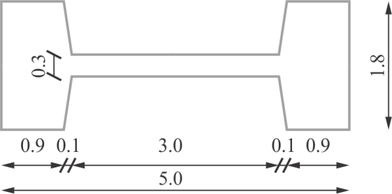
Figure 3: The cross-section of an I-shaped column

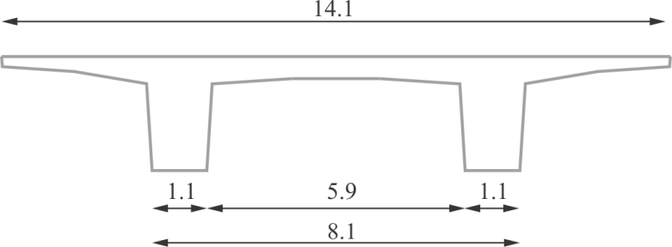Figure 4: The cross-section of a bridge deck

  - Scour modeling

Local scour of one of the piers is modelled as an increase in the effective length. In total, 10m of scour is considered and only one pier is affected, pier 4 (see Figure 5). The scour depth is incremented in 2m increments and the seismic loading is applied for each scour condition in the perpendicular direction of the traffic (longitudinal direction).

  - Seismic modelling

OpenSees program platform (MacKenna et al. 2016) has been used for the modal and non-linear dynamic analysis of the bridge. The lumped plasticity model (Giberson 1969) was used for the modelling of a non-linear response of bridge columns. The characteristics of the non-linear spring located at the bottom of each column (see Figure 5) are based on the tri-linear idealization of the full moment-curvature analysis of a column cross-section. The material characteristic of discretized fibres of steel, unconfined and confined concrete are based on the recommendations of Eurocodes 8/2 (CEN 2005a) and 8/3 (CEN 2005b). The behavior of the non-linear spring was defined using Takeda hysteretic rules (Takeda et al. 1970) assuming the unloading stiffness factor to have a value of 0.5. The damping matrix was defined as a linear combination of the mass and initial stiffness matrices using a Rayleigh approach (Clough & Penzien 1993).
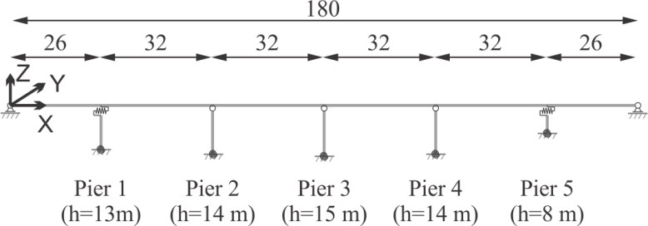
Figure 5: The non-linear numerical model of a multi-span bridge with springs located at the bottom of each pier.
- ANALYSIS & RESULTS
In this section, the results of the analysis are presented. The model presented in the previous section is used to perform a modal study (section 3.1) and a seismic response analysis (section 3.2).

  - Modal analysis

The first two modal shapes obtained from the numerical model in OpenSees (by obtaining a solution of the Eigenproblem) (Clough & Penzien 1993) are shown in Figure 6 and 7 for both the no scour and full (10m) scour scenarios.
Mode 1 is a longitudinal mode (in the traffic direction) and mode 2 is a lateral bridge mode (perpendicular to the traffic direction). As expected, scour increases the global flexibility of the bridge, particularly in the transversal direction. The first two modal shape results due to a scour depth of 10m for the fourth pier (pier 4 in the numerical model) are shown in Figure 7. The comparison with the corresponding modal shapes relevant to the scenario without scouring points out the effect of the latter on these parameters. The asymmetry in the structure’s stiffness before and after scour has shifted the modal displacement in the lateral direction towards the scoured pier. This is sensible as if we consider the increased flexibility of the scoured pier, this should experience larger movements under a dynamic motion.

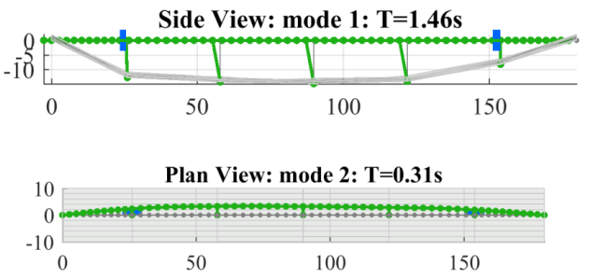
Figure 6: The 1st and 2nd mode shape of the bridge with no scouring

.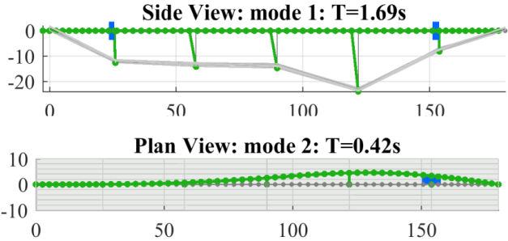

Figure 7: The 1st and 2nd mode shape of the bridge with 10 m scouring

The effect of different scouring depths (scour depth S between 0m and 10m) on the natural periods (first T₁ and second T₂) of the bridge is evident from the values reported in Table 1.

Table 1: 1st and 2nd modal periods (T₁ and T₂) of the bridge with different levels of scouring

Scour S [m] | 0 | 2 | 4 | 6 | 8 | 10
T₁ [s] | 1.46 | 1.54 | 1.6 | 1.64 | 1.67 | 1.69
T₂ [s] | 0.31 | 0.34 | 0.37 | 0.39 | 0.41 | 0.42

Table 2: Variation of the 1st and 2nd modal periods of the bridge with different levels of scouring

Scour S [m] | 0 | 2 | 4 | 6 | 8 | 10
ΔT₁/ T₁ [%] | 0.0 | 5.5 | 9.6 | 12.3 | 14.4 | 15.8
ΔT₂/ T₂ [%] | 0.0 | 9.7 | 19.4 | 25.8 | 32.3 | 35.5

As expected, both modal periods increase with the flexibility of the scoured pier. Scouring has a stronger effect on the second mode as shown in Table 2 by the percentage variations of the two modal periods with respect to the initial values: the percentage variation of the second mode is around twice or higher than the corresponding variation of the first one. This means that the effect of scouring on the dynamic response of this type of bridges is likely to be much higher in the transversal direction than in the direction of the traffic. For this reason in the following sections are reported the results of a dynamic analyses of the scoured bridge under a seismic input acting in the transversal direction - perpendicular to the traffic.

  - Seismic response under progressive scour of single pier

The response of the bridge under an applied seismic input is investigated for the range of scour depths presented in Table 1. A seismic motion with duration of approximately 40 seconds and scaled to peak ground acceleration (PGA) of approximately 1 m/s² is considered for the seismic analyses of the bridge. Figure 8 shows the time history of the scaled earthquake ground motion (Athens 1999 earthquake) used in this study and its response spectrum. The seismic excitation is applied in the lateral direction to the bridge (to excite mode 2), perpendicular to the traffic direction.
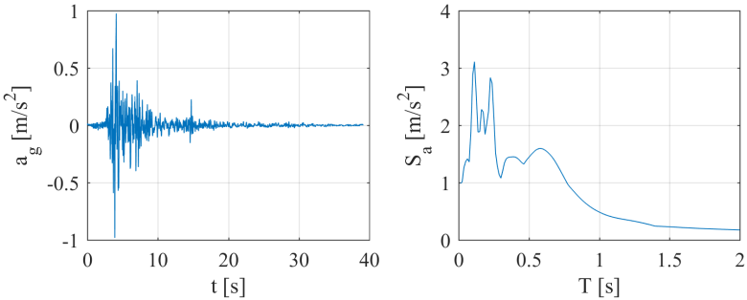
Figure 8: The earthquake ground motion record with peak ground acceleration of 1.0 m/s² considered for the lateral excitation of the bridge and the response spectra of the ground motion.

Responses to the applied ground motion in terms of absolute accelerations a, displacements u, and shear force F in the piers are shown in subsequent plots.

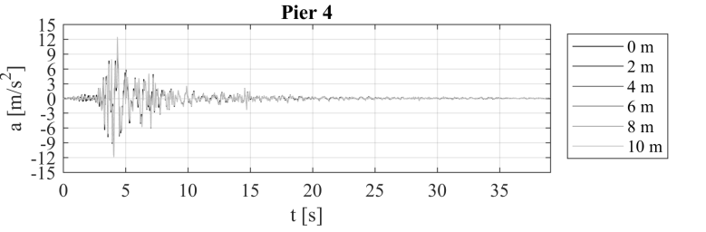
Figure 9: The time domain signal of the absolute acceleration a at the deck level of the Pier 4 for the bridge with no scour (S=0) and investigated levels of scouring (S=2, 4, 6, 8 and 10 m).

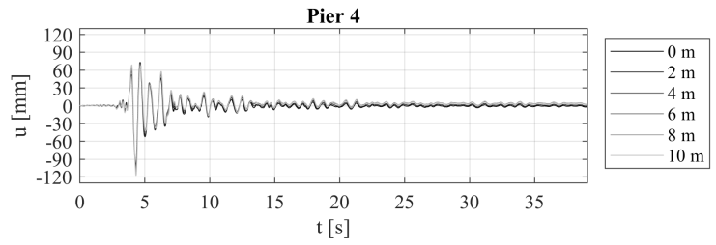
Figure 10: The time domain of the displacement u at the deck level of the pier 4 between the bridge with no sour (S=0) and investigated levels of scouring (S=2, 4, 6, 8 and 10 m).

Figure 9 shows the absolute acceleration measured at the deck level of the scoured column (Pier 4) for scour depths ranging from 0m to 10m. The maximum (peak) acceleration increased under scour from 11.6 m/s² for 0m of scour to 12.4m/s² under 10m scour.

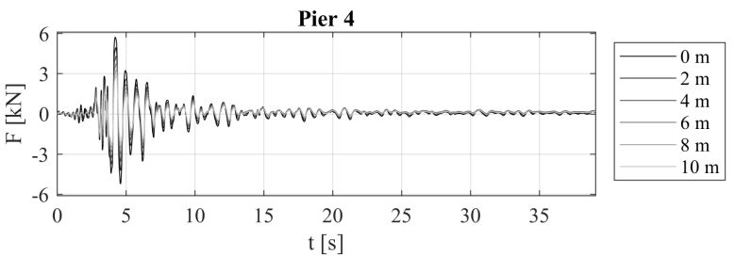 Figure 11: The time domain of the shear force F at the base level of the pier 4 between the bridge with no scour (s=0) and investigated levels of scouring (s=2, 4, 6, 8 and 10 m).

Figure 10 shows the displacement measured at the deck level above the scoured pier 4 for scour depths ranging from 0m to 10m under the applied seismic load (Figure 8). Figure 10 shows that some non-linear plasticity is evident in the responses, particularly for larger scour depths.
The peak displacement observed at the deck level of the scoured pier 4 due to the applied seismic load increases from 0.1 m at the deck level for 0m of scour to 0.12 m for a scour depth of 10m affecting the pier. This is sensible as the increased flexibility of the scoured pier enables it to translate further under the applied excitation.
Finally, Figure 11 shows the absolute shear force calculated at the base of the scoured pier 4 due to the applied seismic load in Figure 8. The shear force is presented in kN. Scour depths are varied from 0m to 10m at pier 4 and the peak shear force calculated at the base of the pier decreases under scour from 5.72kN for the case where there is 0m scour to 2.92kN for the case where there is 10m scour at the pier.

Table 3: Maxima value of the shear in the piers Vp for different levels of scouring and maxima value of the total shear in the piers.

 | Scour S [m] | 0 | 2 | 4 | 6 | 8 | 10
F  [kN] | Pier 1 | 1.56 | 1.56 | 1.52 | 1.52 | 1.52 | 1.52
F  [kN] | Pier 2 | 5.63 | 5.65 | 5.75 | 5.81 | 5.85 | 5.90
F  [kN] | Pier 3 | 5.76 | 5.77 | 5.89 | 5.90 | 5.91 | 5.90
F  [kN] | Pier 4 | 5.72 | 4.94 | 4.32 | 3.77 | 3.30 | 2.92
F  [kN] | Pier 5 | 1.01 | 1.03 | 1.02 | 1.03 | 1.04 | 1.04
F_{T}  [kN] |  | 19.7 | 18.9 | 18.5 | 18.0 | 17.6 | 17.3

Table 3 reports the absolute value of the maximum shear in each piers F and the total shear F_{T} in the piers. At the increase of the scour depth from S=2m to S=10m, the shear F decreases in Pier 4 (the scoured one) by almost 50% with respect to the initial value (un-scoured condition) and increases by values between 2% and 5% in the other piers. The scour is thus beneficial for the scoured pier but of course not for the other resisting elements where the effect of the increased flexibility of the bridge, leading to a reduction of the total shear in the piers F_{T}, is canceled by the redistribution of the internal actions induced by the change of stiffness ratios between piers.
As shown in Figure 12, with the increase of the scour depth, the normalized shear F/F_{T} (ratio between the shear force in the pier and sum of the forces in the piers) sensibly decreases in Pier 4 and increases (with a lower rate) in all the other piers. For example at the increase of the scour from S=2m to S=10m, the normalized shear F/F_{T} for pier 4 decreases from 29% to 17% and increases from about 29% to 34% for piers 2 and 3. The variation of shear forces in piers 1 and 2 due to scouring is much smaller due to the presence of the elastomeric bearings (the connection of the deck and the piers in the direction of seismic loading is not rigid) on the tops of these piers.

Figure 12: Maxima shear forces in the piers normalized to the total shear in the piers as a function or the scour depth

Figure 13: Variation of the maxima absolute acceleration normalized to the reference value a₀ as a function of scour depth

The percentage variation of the maximum absolute accelerations on the deck at the location of the piers are consistent with the variation of the second modal shape. At the increase of the scour depth, the acceleration increases in the scoured pier (pier 4) and in the pier nearby (pier 3) and decreases in the other piers as shown in Figure 13.
- Conclusion
The effects of uncorrelated hazards, in the present case, scour occurrence and earthquakes is becoming a topic of increased interest. Though independent in their generation, the effect of an earthquake will vary depending on the scoured condition of the foundations. In this paper, the effect of local scour on the seismic response of a bridge was investigated briefly. A multi-span bridge was programmed using OpenSees and one of the piers was subjected to scour. Scour was modelled as the increase in the effective length of one of the piers with the remaining piers remaining unscoured. In total, 10m of scour was examined in increments of 2m. A seismic motion was applied to the bridge in the transverse direction (perpendicular to traffic) based on a modal study undertaken.
The effect of scour is to increase the peak displacement of the pier (at deck level), with a corresponding increase in the peak acceleration at the same level. The shear force at the base of the scoured column drastically decreases with scour, however this results in a redistributed higher shear being experienced by adjacent columns.
The increased flexibility of the bridge can be detected monitoring the increase of the modal period in the transversal direction, perpendicular to the traffic.
The variations of the peak accelerations on the deck in the transversal direction show higher values at locations close to the scoured pier.
This paper presents preliminary results. Future research will investigate a more exhaustive set of parameters including multiple seismic records, various applied directions, variations in bridge properties and multiple scoured locations.

ACKNOWLEDGEMENTS
The authors wish to acknowledge COST Action TU1406 ‘Quality Inspection for Roadway Bridges – Standardization at a European Level’ for enabling this collaboration.

References
Anzlin, A., Fischinger, M. & Isakovic, T., 2015. Cyclic response of I-shaped bridge columns with substandard transverse reinforcement. Engineering Structures, 99, pp.642–652.
Bao, T. et al., 2017. Critical insights for advanced bridge scour detection using the natural frequency. Journal of Sound and Vibration, 386, pp.116–133.
Briaud, J.L., et al., 1999. SRICOS: Prediction of Scour Rate in Cohesive Soils at Bridge Piers. Journal of Geotechnical and Geoenvironmental Engineering, (April), pp.237–246.

Briaud, J.L. et al., 2001. Erosion Function Apparatus for Scour Rate Predictions. Journal of Geotechnical and Geoenvironmental Engineering, pp.105–113.
Briaud, J.L. et al., 2011. Realtime monitoring of bridge scour using remote monitoring technology, Austin, TX. Available at: http://tti.tamu.edu/documents/0-6060-1.pdf.
Briaud, J.L. et al., 2005. SRICOS-EFA Method for Contraction Scour in Fine-Grained Soils. Journal of Geotechnical and Geoenvironmental Engineering, 131(10), pp.1283–1295.

CEN, 2005a. EN:1998-2:2005 - Eurocode 8: Design of structures for earthquake resistance - Part 2: Bridges.
CEN, 2005b. EN:1998-3:2005 - Eurocode 8: Design of structures for earthquake resistance - Part 3: Assessment and retrofit of buildings.
Chen, C.-C. et al., 2014. Scour evaluation for foundation of a cable-stayed bridge based on ambient vibration measurements of superstructure. NDT & E International, 66, pp.16–27.
Clough, R.W. & Penzien, J., 1993. Dynamics of structures.
Doebling, S. et al., 1996. Damage identification and health monitoring of structural and mechanical systems from changes in their vibration characteristics: a literature review, Los Alamos, New Mexico. Available at: http://www.osti.gov/energycitations/product.biblio.jsp?osti_id=249299 [Accessed May 8, 2012].
Elsaid, A. & Seracino, R., 2014. Rapid assessment of foundation scour using the dynamic features of bridge superstructure. Construction and Building Materials, 50, pp.42–49.
Federico, F., Silvagni, G. & Volpi, F., 2003. Scour Vulnerability of River Bridge Piers. Journal of Geotechnical and Geoenvironmental Engineering, 129(10), pp.890–900.
Fisher, M. et al., 2013. An evaluation of scour measurement devices. Flow Measurement and Instrumentation, 33, pp.55–67.
Forde, M.C. et al., 1999. Radar measurement of bridge scour. NDT&E International, 32, pp.481–492.
Foti, S. & Sabia, D., 2011. Influence of Foundation Scour on the Dynamic Response of an Existing Bridge. Journal Of Bridge Engineering, 16(2), pp.295–304.
Giberson, M., 1969. Two nonlinear beams with definitions of ductility. Journal of the structural division. Available at: https://trid.trb.org/view.aspx?id=105529 [Accessed December 6, 2017].
Hamill, L., 1999. Bridge Hydraulics, London: E.& F.N. Spon.
Heidarpour, M., Afzalimehr, H. & Izadinia, E., 2010. Reduction of local scour around bridge pier groups using collars. International Journal of Sediment Research, 25(4), pp.411–422.
Hunt, B.E., 2009. NCHRP synthesis 396: Monitoring Scour Critical Bridges - A Synthesis of Highway Practice, Washington, DC.
Ju, S.H., 2013. Determination of scoured bridge natural frequencies with soil–structure interaction. Soil Dynamics and Earthquake Engineering, 55, pp.247–254.
Kim J.T., Stubbs N. (2002). “Improved damage identification method based on modal information” Journal of Sound and Vibration, 252 (2002), pp. 223-238.
Limongelli, M.P., (2010). Frequency Response Function Interpolation for Damage Detection under Changing Environment. Mechanical Systems and Signal Processing, 24(8), 2898-2913.
Limongelli, M.P., (2011). The interpolation damage detection method for frames under seismic excitation. Journal of Sound and Vibration, 330. 5474–5489.
Limongelli, M.P., (2014). Seismic health monitoring of an instrumented multistorey building using the Interpolation Method. Earthquake Engng. Struct. Dyn. doi: 10.1002/eqe.2411
MacKenna, F., Fenves, G.L. & Scott, M.H., 2016. Open System for Earthquake Engineering Simulation. Available at: http://opensees.berkely.edu.
Maddison, B., 2012. Scour failure of bridges. Proceedings of the ICE - Forensic Engineering, 165(FE1), pp.39–52.
Melville, B.W. & Coleman, S.E., 2000. Bridge scour, Highlands Ranch, CO: Water Resources Publications.
Nassif, H., Ertekin, A.O. & Davis, J., 2002. Evaluation of Bridge Scour Monitoring Methods, Trenton, NJ.
Pandey A.K., Biswas M., Samman M.M. (1991). “Damage detection from change in curvature mode shapes”. Journal of Sound and Vibration, 145 (1991), pp. 321–332.
Prendergast, L.J. et al., 2013. An investigation of the changes in the natural frequency of a pile affected by scour. Journal of Sound and Vibration, 332(25), pp.6685–6702.
Prendergast, L.J. & Gavin, K., 2014. A review of bridge scour monitoring techniques. Journal of Rock Mechanics and Geotechnical Engineering, 6(2), pp.138–149.
Prendergast, L.J., Gavin, K. & Hester, D., 2017. Isolating the location of scour-induced stiffness loss in bridges using local modal behaviour. Journal of Civil Structural Health Monitoring.
Prendergast, L.J., Hester, D. & Gavin, K., 2016. Determining the presence of scour around bridge foundations using vehicle-induced vibrations. Journal Of Bridge Engineering, 21(10).
Ratcliffe C.P., (2000). A frequency and curvature based experimental method for locating damage in structures. Transactions of the American Society of Mechanical Engineers. Journal of Vibration and Acoustics, 122: 324–329.
Shirole, A.M. & Holt, R.C., 1991. Planning for a comprehensive bridge safety assurance program. In Transport Research Record. Washington, DC: Transport Research Board, pp. 39–50.
Takeda, T., Sozen, M. & Mielsen, N., 1970. Reinforced concrete response to simulated earthquakes. Journal of the structural division.
Wardhana, K. & Hadipriono, F.C., 2003. Analysis of Recent Bridge Failures in the United States. Journal of Performance of Constructed Facilities, 17(3), pp.144–151.
Yu, X., 2009. Time Domain Reflectometry Automatic Bridge Scour Measurement System: Principles and Potentials. Structural Health Monitoring, 8(6), pp.463–476.
Zhang, Z., Aktan, A.E. ( 1998). Application of modal flexibility and its derivatives in structural identification. Research in Nondestructive Evaluation, 10, 43-61.

