The Interpolation Method for vibration based damage localization: influence of feature uncertainties

M.P. Limongelli
Politecnico di Milano, Department of Architecture, Piazza Leonardo da Vinci 32, 20133 Milano, Italy
Amin Fathi
Amirkabir University of Technology, 424 Hafez Ave, Tehran, Iran

ABSTRACT: Vibration-based methods for damage localizations often rely on a damage feature defined in terms of changes of modal or operational shapes. These methods allow detecting variations of the damage feature that can be ascribed to damage. Many of these methods are based on the detection of irregularities in the deformed shape of the structure. The accuracy of the methods proposed in literature is often verified on numerical models that, by their nature, cannot reproduce all the sources of uncertainties - environmental, operational, and experimental - that affect responses recorded of the structure. The availability of data recorded on real structures provides precious material for the verification of the real capabilities of the proposed damage identification algorithms. Due to several sources of uncertainty the values of the damage feature may undergo changes even in absence of any damage. This variability has to be properly accounted for in order to reduce the number of false or missing indications of damage. In this paper is investigated the influence of the uncertainties on the results provided by the Interpolation Method for damage localization. Specifically several different probabilistic models of the marginal probability of the damage feature are compared in order to verify select the one able to provide the highest accuracy in damage localization. The investigation is carried out with reference to the real case study of a prestressed concrete road bridge, the S101 Bridge in Austria. The bridge, built in the early 1960, is a typical example of a European highway bridge. Responses to ambient vibration have been recorded both in the undamaged and in several different damage scenarios artificially inflicted to the bridge. Damage was introduced by lowering one of the bridge piers and by cutting prestressing tendons of one beam of the bridge deck.

InTroduction
The cost of maintaining bridge is a major part of the construction budget usually. Moreover if the inspection and monitoring system are not reliable, additional costs due to traffic delay will be added to the cost. Structural Health Monitoring (SHM) methods are one of the best tools for maintenance and inspection of structures that provide possibility of continuous inspection of the structure for damage detection in structural components. The general purpose of SHM is the rapid damage diagnosis of structure in order to ensure a proper safety level minimizing at the same time the maintenance costs. To achieve this goal the response of the structure has to be accurately recorded and robust algorithms for damage identification must be used to extract information from recorded data.
Non-destructive methods such as magnetic field methods, radiography, eddy-current methods, thermal field methods and acoustic or ultrasonic method are frequently used to inspect bridges. The main disadvantage of these techniques is that the location of damage must be known, why they are called a priori techniques. In the past few decades advances in sensors technology have significantly fostered the development of SHM methods and algorithms based on responses recorded by networks of sensors installed on the structure.
Vibration based methods are among the most effective tools for damage identification allowing to assess, at different levels of refinement, the structural health of structures equipped with a network of sensors. In reference Limongelli 2011 is presented the vibration-based Interpolation Method (IM) based on the detection of localized increases of curvature related to a reduction of stiffness.
This method has been extensively applied to the case of numerical models of bridges (Domaneschi et al, 2013 - Domaneschi et al, 2015) or using responses recorded on a real bridge during a short monitoring carried out by impact tests (Limogelli et al 2014). An extended version of the IM has been proposed in reference (Limogelli et al 2017) based on a statistical modeling of the damage feature in the damaged configurations of the structure. The method was applied to the case of the prestressed bridge S101, artificially damaged with increasing levels of damage for research purposes (VCE, 2009; Sirigoringo et al., 2013). In reference (Limongelli et al, 2017) data recorded on the bridge in the several damaged configurations were used to check the capability of the proposed algorithm to localize damage.
Based on a previous applications of the IM on a multistory building (Limogelli et al 2014) a Log-normal probability distribution was assumed in (Limongelli et al, 2017) to model the damage feature in both the undamaged and the damaged configurations.
The validity of this assumption was not checked. Furthermore the statistical uncertainty connected with the limited amount of data available for a number of damaged configurations was not acknowledged. The damage localization algorithm was applied assuming as damage feature the Probability of Detection computed based on the conditional probability distribution. The latter, based on the available limited set of data data, was modelled as a lognormal distributions at all the instrumented locations.
In this paper, this statistical uncertainty will be accounted for by defining the damage feature as a function of the marginal probability distributions.
In the following of the paper the extended version of the Interpolation Method will be briefly outlined and the case study of the bridge S101 described. The second part of the paper reports the comparison of results related to different assumptions about the probability distribution of the damage feature.
The results provided by the IM depend on the choice of the threshold defined to select ‘meaningful variations’ of the damage feature. This threshold is defined in terms of the accepted probability of the false alarm. An investigation on the sensitivity of results to this latter probability, for the different possible assumptions on the probability distributions of the damage feature is reported in the last part of the paper.

DAMAGE IDENTIFICATION

The Interpolation Error for damage localization
The Interpolation Method (IM) is based on the assumption of a beam-like behavior of the monitored structure and on the interpolation of the Operational Displacement Shapes (ODS) via a Cubic Spline function (Limongelli, 2011). Due to the so-called ‘Gibbs phenomenon for splines’ a localized discontinuity of curvature in the deformed shape of the structure causes strong oscillation of a cubic spline interpolating function at the location of the discontinuity. By defining the damage feature in terms of the interpolation error, an increase of this latter gives an indication of a variation of curvature therefore of a reduction of stiffness.
The method has been successfully applied for damage localization of bridges under seismic excitation or subjected to impact tests. In these cases the ODS can be computed form the Frequency Response Functions since the input is usually measured.
More details about these applications can be found in references (Limongelli, 2011; Domaneschi et al., 2014). When ambient vibrations or wind are used as a source of excitation, the input is unknown. In this case the Operational Deformed Shapes could still be estimated using on the Power Spectral Densities of the responses, assuming that the input is a white noise.
This assumption is widely applied in output only system identification (e.g. Brincker 2001, Peeters et al., 2001) and, even if it is not strictly verified over the entire frequency range, the PSDs give a good approximation of the deformed shape at different frequencies.
Under ambient vibrations the interpolation error can thus be defined as:
(1)
being P_{R}(z,f_{i}) and P_{S}(z,f_{i}) the power spectral densities of the recorded (R) and interpolated (S) accelerations at location z and frequency . ‘Interpolated’ means that are calculated from a cubic spline interpolation of the PDSs recorded at all the other instrumented locations.
In equation (1), the interpolation error depends on the considered ODS that is on the considered value of frequency. In order to characterize each location with a single error parameter, the norm of the error on the whole range of frequencies is considered:
E(z)=$\sqrt{\sum_{1}^{N}{{E(z,f_{i})}^{2}}}$ | (2)
The difference between the values of the interpolation error at a given location in two different configurations of the structure (reference and potentially damaged) or at two different moments of its life (beginning of monitoring and some-time afterward) should provide an indication about the existence of degradation at that location. Specifically an increase of the interpolation error should indicate the existence of an increase of curvature (decrease of stiffness) at the location where this variation occurs.
Due to several environmental (e.g. temperature or humidity) or operational (e.g. noise in recorded sensors, non-linear behavior of the structure, round off in signal processing) sources the values of the damage feature may change even if there is no damage. In order to account for this, the statistical variability of the interpolation error E has to be assessed. This issue will be addresses in the next section. Herein is reported the description of how the method is applied assuming known the statistical distributions of the damage feature in the undamaged and in the damaged configurations.
Herein we refer to damage as a stiffness loss at one section of the deck.

Figure 1. Distributions in the undamaged (J E,0) and in the inspection (J E,I) configurations

In Figure 1 the probability distribution of the interpolation error at one location z in the undamaged configuration is compared to the distribution in the inspection state assuming that the structure is damaged at z: damage induces a shift of the distribution toward a higher mean value of E.
In order to check the health of the structure, the distribution at each instrumented location z in the undamaged configuration has to be compared to the distribution at the same location, calculated in the ‘inspection phase’.
In order to compare the distributions pertaining to two different configurations, and also to select the locations where the highest variation of the damage feature occurs, will be utilized the Probability of Detection (PoD).
The PoD is the probability of damage being correctly denounced at location z, that is the probability that damage is denounced at z given the structure is damaged at z. The higher the PoD at location z, the higher the probability that location z is actually damaged.
In order to define this probability a threshold value has to be defined.
This PoD is given by the area under the probability distribution in the inspection (possibly damaged) phase, at the right of the threshold. For a given value of the threshold, the PoD at a given location increases with the severity of damage. Therefore the increase of the PoD at a given location will be assumed as an index of the increase of the severity of damage at that location.
Among all locations, the one corresponding to the highest value of the PoD will be assumed herein as the damaged one. The threshold is defined herein in terms of the accepted probability of false alarm (PF) that is the probability that damage is denounced, given the structure is undamaged. This probability is given by the area under the probability distribution in the reference configuration, at the right of the threshold.
The area under the distribution , at the left of the threshold is the Probability of Missing alarm (PM) that is the probability that damage is not denounced, given damage exist at z.
The higher the threshold, the higher PM and the lower PF hence the choice of the threshold is always a tradeoff between the accepted probability of false and missing alarm.
In order avoid false alarms, a condition is imposed on the PoD based on the location of the mode of the damaged distribution with respect to the reference one. The mode of the distribution is the value corresponding to (one of) the maximum of the probability distribution
It is assumed that if the mode in the damaged configuration is higher with respect to the mode in the undamaged one, the location will be considered as ‘damaged’ and the corresponding PoD will be estimated as an index of the damage severity. If the mode is lower with respect to that in the undamaged configuration the location will be considered undamaged and the PoD will be assumed equal to zero.

Probabilistic model of the performance parameter
As described in the previous section, in order to account for the statistical variability of the damage feature its probability distribution has to be computed. This can be done using data recorded on the structure or using a numerical model. For the undamaged configuration the availability of recorded data is not an issue if a permanent monitoring system is installed on the structure.
For the damaged configurations of course this is not possible unless the structure is damaged and of course it would be never possible to dispose of responses corresponding to all the possible damage scenarios. The alternative could be a) the numerical modeling of the structure and of the possible damage scenarios or b) the probabilistic model of the damage feature.
The numerical modeling requires the model of the nonlinear behavior of the structure – for some type of structures this could be quite uncertain due to the many unknown involved in the problem – and of the environmental conditions – e.g. the temperature variation – that may alter the values of the damage feature irrespective of the damage state.
In some cases the numerical modeling could be not straightforward. The alternative probabilistic modeling presents other challenges but can possibly exploit the knowledge of the structural behavior in the undamaged configuration.
The availability of data recorded on the S101 bridge provides an opportunity to check the modeling assumptions that could be made for a real case.
Specifically herein is reported an investigation relevant to the type of probability distribution that can be assumed for the damage feature in the damaged configurations. The aim is to verify the possibility to use the same distribution as in the undamaged configuration, just changing its parameters with the severity of damage.
In the next sections of the paper several different assumptions about the probability distribution of the Interpolation Error will be compared using data recorded on the S101 bridge to check the consistency of the assumption and the accuracy of results obtained.

THE CASE STUDY

3.1.The bridge S101
The S101 (see Figure 2) was a post-tensioned flyover of three spans for a total length of 56 m. In 2008 the bridge was demolished due to insufficient loading capacity and to allow the enlargement of underneath A1 Westautobahn. The bridge was supported on two couples of rectangular piers with a central span and the two side spans built in at the abutments. The structural cross section was a double webbed T-beams sustaining a slab with cross section of variable height with a minimum value of 20 centimeters at mid-span.
During the four days before its demolition, the Austrian bridge operator ASFINAG, owner of the bridge, allowed the execution of an experimental campaign of ambient vibration tests on artificially simulated damage scenarios. Ambient vibration tests were carried out between 10 and 13 December 2008. Progressive damage scenarios were artificially induced, simulating the settlement of a support by lowering one of the bridge piers and the loss of tension in the cables by progressively cutting a number of tendons.
A monitoring system, recording responses to ambient vibrations at several locations along the bridge deck in terms of accelerations, was installed by the Austrian company VCE, in order to provide a useful database for research purposes (VCE, 2009).
Responses of the bridge under the traffic in the underneath Westautobahn A1 were recorded by the network of three directional accelerometers throughout the three days of test.

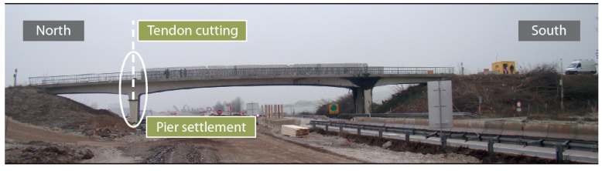
Figure 2. The bridge S101: up) view; down) dimensions. From reference (VCE, 2009).

Simulated damage scenarios and network of sensors
The experimental campaign on the bridge can be divided into three phases corresponding to three different scenarios: 1) the initial (reference) configuration, 2) a support settlement, simulated through the cut of the north-western pier; 3) a loss of tension simulated by the cut of a number of tendons. In Table 1 is reported a summary of the sequence of tests on the several configurations of the bridge. More details of the tests sequence can be found in reference (VCE, 2009). In Phase 1 ambient vibrations were recorded in the undamaged configuration of the bridge.
In Phase 2, the pier was previously unloaded by applying a force on the bottom of the bridge slab with a hydraulic jack.

Table 1. Induced Damage scenarios
____________________________________________
Scenario Description of the scenario
U Undamaged structure
A Cut of the north-western column
B First lowering the column (1cm)
C Second lowering the column (2cm)
D Third lowering the column (3cm)
E Insertion of compensating plates
A_T Column returned in original position
B_T First tendon intersected
C_T Second tendon intersected
D_T Third tendon intersected
E_T Fourth tendon partially intersected
Afterward the pier was cut at the base, near the foundation, and a slice of 10cm thickness was removed.
After the last reduction of pressure the pier underwent a total final settlement of 2.7cm. The lowering of the pier was carried out reducing the pressure in the jack in 3 steps. To simulate the repair of the pier, the initial configuration was restored by lifting the slab 6mm above the original level and inserting some compensating plates at the bottom of the pier. After the lifting, the closure of the cracks on the near pier was observed.
In Phase 3 the loss of tension in the cables was simulated by cutting an increasing number of tendons (see Table 1), in the same section of the deck corresponding to the pier previously cut (see Figure 2). During all the phases of test the bridge was instrumented with a dense network of sensors among which 15 tri-directional accelerometers along the bridge deck.
Due to the symmetry of the bridge, 14 sensors were deployed on the West side of the bridge to accurately capture its modal shapes and only one sensors (15) on the East side in order to differentiate torsional modes from flexural ones. The 15 sensors measured acceleration in the longitudinal, transversal and vertical directions, for a total of 45 signals for each test. In this paper only the results obtained by the analysis of the accelerations recorded in the vertical direction by the 14 sensors on the west side of the deck are reported. Accelerations were continuously sampled at 500 Hz during the three days of testing (10-13 December 2008). Data from each one of the damage scenarios (listed in Table1) were divided in several partial measurements corresponding to 5.5 minutes each.

DAMAGE identification
The Interpolation Method outlined in section 2 has been applied to localize the several levels and types of induce damage based on the responses recorded by the network of 14 accelerometers installed on the west side of the bridge deck. For each response of 5.5 minutes duration (corresponding to 165.000 points at 500Hz sampling) the Power Spectral Density has been computed and used for the computation of the Interpolation Error according to equation (1). The entire set of data recorded throughout the three days of tests has been considered without any previous treatment or removal of portions of data.

Treatment of statistical uncertainties
Registration of responses of the bridge in the undamaged configuration was carried out for about 19 hours in the undamaged configuration (U) and for shorter times (between 1 and 5 hours) in the damaged configurations (A to E_T). Therefore, much more data are available for the reference configuration with respect to the damaged ones. Specifically, for the reference configuration, 152 samples of responses with duration 5.5 minutes are available while for the damaged configuration the total number of samples varies between 10 (for configuration E) to 85 (for configuration C_T). The distributions of the interpolation error obtained based on this sets of data are conditional to the particular considered sample that is to its mean and standard deviation:. In reference (Limongelli et al., 2017) computations have been carried out with reference to the conditional probabilities .
Herein the statistical uncertainty related to the limited number of samples will be taken into account by computing the marginal probability distribution of the damage feature E through equation (3):
(3)
where and are the parameters of the probability distribution.
In order to retrieve the distributions and , a Monte Carlo simulation has been carried out assuming a normal shape of both distributions and generating a total number of 500 samples for each of the two distributions. Under these assumptions the integral in equation (3) has been numerically solved (Shampine, 2008) and a set of 150 samples of has been generated.
Figure 3 reports the marginal distributions (based on log-normal distribution) of the undamaged and damaged scenarios U, E and D_T. computed from equation (3) assuming a lognormal distribution for the conditional probability.
In order to choose the appropriate probability density function for the marginal probability, several assumptions have been tested: gamma, lognormal and normal distributions.
The Kolmogorov-Smirnov has been carried out for the distributions relevant to all locations in order to check their accuracy. The test is based on a statistic (Stat) defined as the largest difference between the theoretical and the empirical cumulative distribution function. The critical value (Δ) depends on the size of the sample and on the level of significance of the test (Faber, 2012).
Based on these results the localization of damage has been performed assuming a lognormal model for the marginal probability. The Probability of Detection has been computed under this assumption and fixing the threshold in terms of a value of 1% for the accepted Probability of False alarm (PF).
Results (R) relevant to locations 11 and 12 are reported in Table 2 and show that for the modelling of the log-normal and the gamma distributions have the highest accuracy with respect to all the others. Similar results are obtained for the other sensors locations.

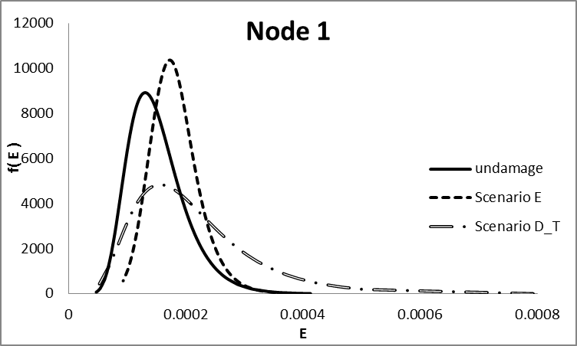

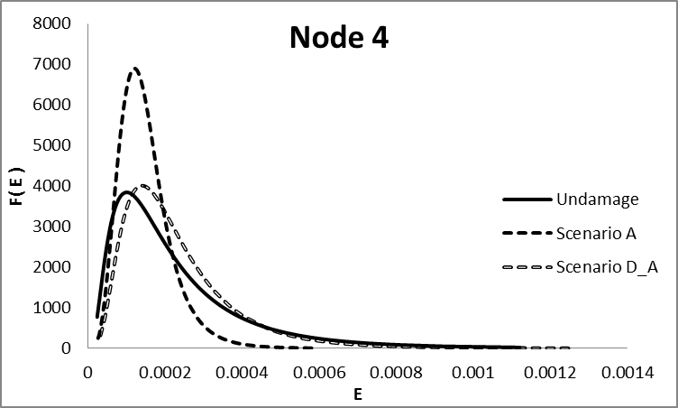

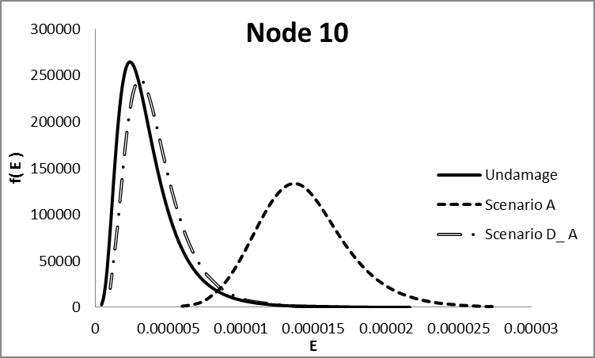

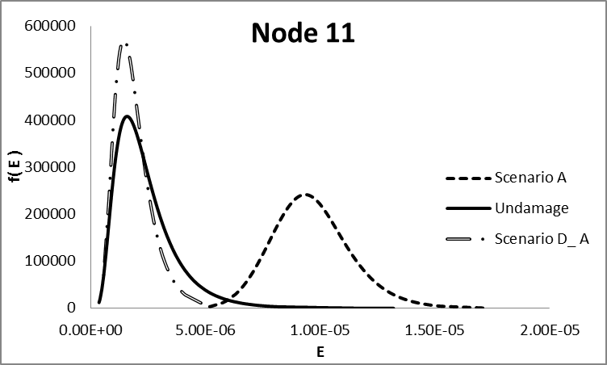
Figure 3. Histogram of the interpolation error for several location based on lognormal distribution
Table 2. Result of Kolmogorov-Smirnov test for nodes 11 and 12
 |  | Log-normal |  | Gamma |  | Normal
N | Δ | Stat | R | Stat | R | Stat | Res
11 | 0.072 | 0.025 | OK | 0.043 | OK | 0.092 | NO
13 | 0.072 | 0.038 | OK | 0.058 | OK | 0.072 | NO

Localization of damage
The location of the sensor number 11, is the closest to the lowered pier and to the beam section where the tendons were cut. This location is thus considered, for all scenarios, the damaged lone.
Figure 4 reports the values of the PoD at all the sensors locations (1 to 14) for scenarios A to E – corresponding to the lowering and following lifting of the pier.

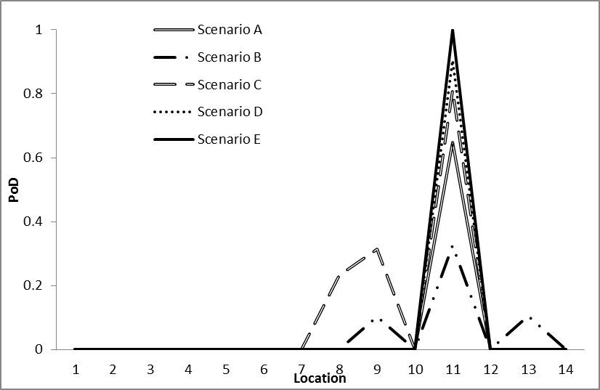
Figure 4. Probability of Detection based on the Log-normal distribution for f(E) for damage scenarios A to E:
For all the scenarios related to the settlement of the pier (A to D) location 11 is correctly detected even if for the scenarios with the lowest amount of damage – A to C – some false alarms are present (see locations 8, 9, and 13). In scenario E the deck was lifted 6 cm over its original level. This certainly caused a variation of curvature even higher with respect to the one induced in scenario D by the lowering of the pier of 3cm. This is correctly detected by the method that finds the highest value of the PoD for scenario E.
The second damage scenario was induced by cutting a progressively increasing number of tendons at the top of one of the deck beams. This type of damage is not supposed to modify the stiffness of the structure thus no changes of the Operational Shapes were expected. This was actually confirmed by the results since no damage is detected for scenarios A_T to E_T.

influence of the probabilistic model
In this section will be investigated the influence
on the accuracy of damage localization, of the probabilistic model of the marginal probability.
Results similar to those reported in Figure 4 are obtained if the Gamma distribution is used to model the marginal probability f(E).
In this second case the number of false alarms is slightly higher which is consistent with the lower quality of the fit indicated by the Kolmogorov-Smirnov test reported in section 4 (see Figure 5) .
The comparison of results obtained using different models for the marginal probability are reported Figure 6 for all the damage scenarios in terms of the PoD at location 11, the damaged one.

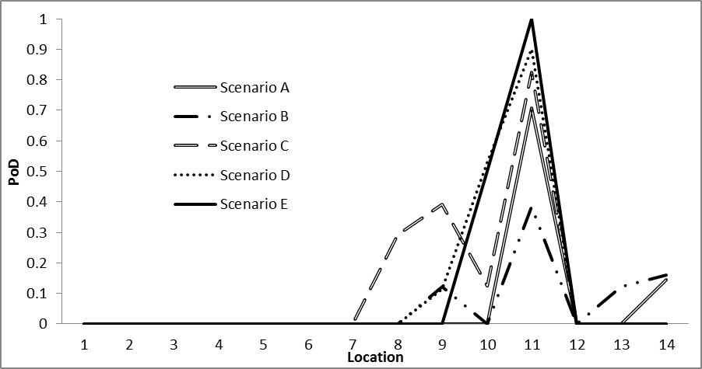
Figure 5. Probability of Detection based on the Gamma distribution for f(E) for damage scenarios A to E:

At this location all the 3 models give reliable results indicating that the damage (represented by the PoD) increases starting from scenario B (1cm lowering of the pier) up to scenario E corresponding to the insertion of the compensating plates (lifting of 6cm over the original deck level).
As previously remarked the lifting of 6 cm over the original level certainly caused a variation of curvature even higher with respect to the one induced in scenario D by the lowering of the pier of 3cm. This is correctly detected by the method that finds the highest value of the PoD for scenario E. Starting from scenario A_T (the column is returned in its original position) and up to scenario E_T (the fourth tendon is partially cut) the PoD is always equal to zero, consistently with the expected behavior.
If other locations are considered the inaccuracy of the normal distribution with respect to the other two (lognormal and gamma) become more evident.
In Figure 7 are reported the values of the PoD at all the sensors locations for damage scenario E considering the three different probabilistic models. False alarms are found at locations 9 and 10 if the Normal distribution is used and a flase alarm is found at location 10 if the Gamma distribution is used. The most accurate results correspond the Lognormal model consistently with the results of the Kolmogorv-Smirnov test.

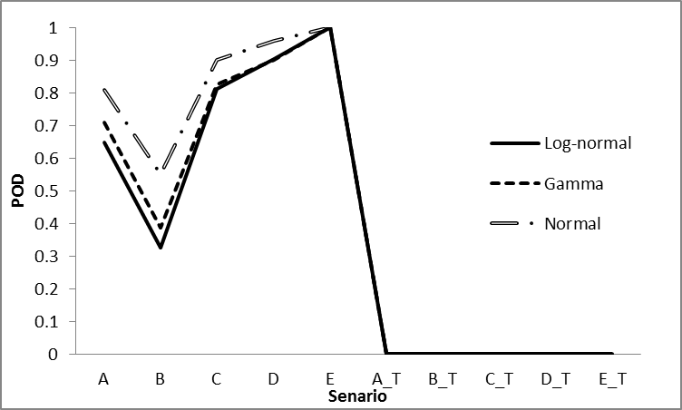
Figure 6. Probability of Detection at the damaged location for all the damage scenarios for location 11

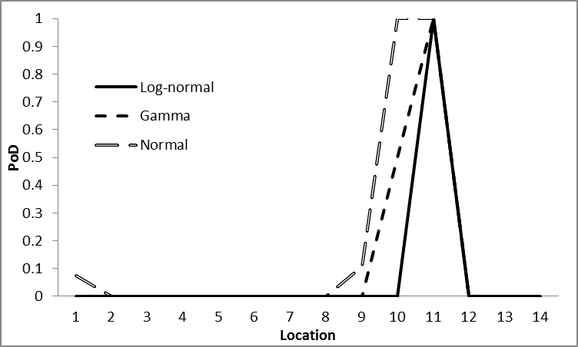
Figure 7. Comparison between the three probabilistic models for damage scenario E.

CONCLUSIONS
In this paper is investigated the influence of the probabilistic model of the marginal distribution of the Interpolation Error on the accuracy of damage localization.
Three distributions, Lognormal, Gamma and Normal have been considered and results compared in terms of the Probability of Detection. The latter is assumed as the damage feature.
The investigation has been carried out with reference to the case study of the S101m bridge for which data recorded in several damaged scenarios are available. The bridge was artificially damaged with several levels of severity and types of damage. The settlement of one pier and the loss of tension in the prestressing cables have been simulated by cutting respectively one of the piers and a number of tendons. Results show that the method is sensitive to the distribution chosen for the marginal probability. The Lognormal distribution - corresponding to the best-fit distribution according to Kolmogorov-Smirnov test – provides the most accurate results with the lowest number of false alarms with respect to the other tested distributions. The lognormal distribution corresponds to the best-fit both in the undamaged and in all the damaged distributions. This result is encouraging in the sense that, if confirmed for other types of damage scenarios and structures, could enable to compute the distributions of the damage feature in the damaged configurations using the same probabilistic model of the undamaged configuration and changing the parameters based on the damage severity. As remarked, more investigations are needed to generalize this results and will be the object of further investigations together with the analyses of the sensitivity of results to the threshold value that is to the accepted probability of false alarm.

AKNOWLEDGEMENTS
The authors would like to thank the Vienna Consulting Engineers (VCE) company for providing the experimental data recorded during the tests on the S101 Bridge. The support of the Iranian ministry of science, research and technology (MSRT) to the stay of Amin Fathi at Politecnico di Milano is gratefully acknowledged.

REFERENCES
Brincker, R., Zhang, L., & Andersen, P. 2001. Modal identification of output-only systems using frequency domain decomposition. Smart materials and structures, 10(3), 441
Dilena, M., Limongelli, M. P., & Morassi, A. 2015. Damage localization in bridges via the FRF interpolation method. Mechanical Systems and Signal Processing, 52, 162-180.
Domaneschi, M., Limongelli, MP, & Martinelli, L. 2015. Damage detection and localization on a benchmark cable-stayed bridge. Earthquake and Structures , 8 , 1113-1126.
Domaneschi, M., Limongelli, M. P., & Martinelli, L. 2013. Multi-site damage localization in a suspension bridge via aftershock monitoring. Ingegneria Sismica, 3, 56-65.
Domaneschi, M., Limongelli, M. P., & Martinelli, L. 2013. Vibration based damage localization using MEMS on a suspension bridge model. Smart Structures and Systems, 12(6), 679-694.‏
Faber M.H. 2012. Statistics and Probability Theory. Springer Publishing Company, ISBN: 978-9400740556
Limongelli, M. P. 2014. Seismic health monitoring of an instrumented multistory building using the interpolation method. Earthquake Engineering & Structural Dynamics, 43(11), 1581-1602.‏
Limongelli, M. P., Tirone, M., & Surace, C. 2017,. Non-destructive monitoring of a prestressed bridge with a data-driven method. In Health Monitoring of Structural and Biological Systems 2017 (Vol. 10170, p. 1017033). International Society for Optics and Photonics.‏
Limongelli, M.P., 2011. The interpolation damage detection method for frames under seismic excitation. Journal of Sound and Vibration, 330. 5474–5489.
Peeters, B., & De Roeck, G. 2001. Stochastic system identification for operational modal analysis: a review. Journal of Dynamic Systems, Measurement, and Control, 123(4), 659-667.‏
Shampine, L. F. 2008. Matlab program for quadrature in 2D. Applied Mathematics and Computation, 202(1), 266-274.‏
Siringoringo, D. M., Fujino, Y., & Nagayama, T. 2011. Dynamic characteristics of an overpass bridge in a full-scale destructive test. Journal of Engineering Mechanics, 139(6), 691-701.‏
VCE. (2009). Vienna Consulting Engineers. “Progressive damage test S101. Flyover Reibersdorf”. Report nr. 08/2308.

