GRAPHITE NANOPLATELETS AND GRAPHENE OXIDE INFLUENCE ON C-S-H FORMATION. I.

P. Gronchi, S. Bianchi, L. Brambilla, M. Goisis

Biography:

Paolo Gronchi is an assistant Professor at Politecnico di Milano, Chemistry, Materials and Engineering Chemistry “G. Natta” Dept, Italy. He obtained the Master Degree in Industrial Chemistry, at the University of Pisa, Italy) in 1974. Materials science and Industrial chemistry are the objects of the teaching and research activity.

Stefania Bianchi graduated in Materials and Nanotechnology Engineering, Master Degree at Politecnico di Milano, Italy. Currently working as a post-degree researcher at Politecnico di Milano, Chemistry, Materials and Engineering Chemistry “G. Natta” Dept., Italy.

Luigi Brambilla is a PhD student in Materials Engineering at Politecnico di Milano, Chemistry, Materials and Engineering Chemistry “G. Natta” Dept., Italy. Master degree in Physics, Physics Dept., Università Statale di Milano, Italy.

Marco Goisis graduated in Chemical Engineering at Politecnico di Milano, Materials and Engineering Chemistry “G. Natta” Dept, Italy. With Italcementi Group for 30 years in R&D and Innovation Depts, now working at Global Product Innovation Dept, HeidelbergCement, i.lab Km rosso, Bergamo, Italy. Current interest addressed at graphene related materials. Leader of a research team inside the Graphene Flagship.

Abstract
Graphene, graphite nanoplatelets and graphene oxide are emerging nanomaterials for future technologies. Despite the conservative nature of the building industry, nanomaterials are already making their way into some construction applications and nanotechnologies have the potential to open a new season in this field. Recent studies reported mechanical improvements in cement-graphene oxide composites. The interaction between the carbon nanoadditives and C-S-H is not clear yet. In this paper, we investigate whether and how graphite nanoplatelets and graphene oxide affect morphology and kinetics of C-S-H formation, studying the simple reaction between calcium oxide and silica. Influence on hydration by two different types of silica having different specific surfaces was considered. Instrumental analyses of the products were performed through Infrared and Raman spectroscopy, TG and SEM analysis up to four weeks. Results indicate that GO interacts with C-S-H phase and hinders its formation while GNPs remain only dispersed in the matrix.
Keywords: Cement; graphene; graphene oxide; silica; dispersion; pozzolanic reaction; C-S-H.

INTRODUCTION
Carbon nanomaterials have proven to be very promising tools for the improvement of composite materials in various industrial and academic fields. For what concerns the construction industry, several studies have been reported about the possibility of introducing carbon micro and nanofillers in cement thus increasing its resistance, in particular its flexural strength¹. Li et al.² found that carbon nanotubes functionalized with carboxylic groups interact strongly with the cement matrix. Improvements of compressive and flexural strength by up to 19% and 25% with respect to the control were found. A carbon nanomaterial with excellent mechanical properties is graphene. In simple terms, graphene is a single layer of graphite that is a two-dimensional atomic crystal made up of carbon atoms arranged in a hexagonal lattice. Graphene oxide (GO) is the product of the strong oxidation of graphite through Hummer’s method³ and it is made of a layer of graphene with epoxy and hydroxyl groups attached on its surface and carboxyl groups attached on the edges. These moieties make GO polar and dispersible in water. The patent WO2013096990 A1, published in 2013 by the Monash University⁴ is related to the addition of GO in cement mortar. The patent claims that small amounts of GO are able to produce remarkable improvement of mechanical properties of the composite. Lv et al.^{5, 6} found a compressive/flexural strength increase of more than 45/60% respectively at 28 days with the addition of 0.03% GO bwc. The authors related these results to the effect of GO on the microstructure of the cementitious matrix, which appeared denser and modified with respect to the control. Moreover, they suggested that GO can have a template effect and that GO promotes the assembly of flower-like and polyhedral structures from rod-like crystals, with the ultimate formation of a dense structure.

Pan et al.⁷ found that the addition of GO increases the compressive/flexural strength by 15-33/41-59% respectively. This is ascribed to two reasons: the high load transfer efficiency of the strong covalent bonds between GO (thanks to its functionalities) and the products of hydration and the capacity of GO sheets to deflect cracks and change the fracture behaviour. It was found that the addition of GO produced an increase of the amount of small and medium pores (1-45 nm/3,937e-8-1,7717e-6 in) with the surface area rising from 27.3 m²/g (8330.6 ft²/oz) to 64.9 m²/g (19804.4 ft²/oz). The reasons were attributed to the high degree of hydration promoted by GO.

Probably the main issue of the use of graphene-related material (GRM) is the good dispersion of the nanoparticles in the cementitious matrix. Babak et al.⁸ used a polycarboxylate superplasticizer and an ultrasonication process in order to disperse adequately GO in water. Moreover, Li et al.⁹ found that, in presence of Ca²⁺ ions, the aggregation of GO platelets is facilitated and that the addition of a proper amount of silica fume (SF) is able to tackle it.
In this paper, we investigate the effects of graphite nanoplatelets (GNPs) and GO addition on C-S-H formation. It is the main product of the hydration of Portland cement and is primarily responsible for the strength in cement-based materials¹⁰. C–S–H makes up about 50% of the hardened paste volume and plays an essential role in controlling its engineering behaviour.

In this study, we adopt a simple model by exploiting the pozzolanic reaction between calcium oxide and silica to produce the C-S-H phase and by using a high water-to-solid ratio, according to the fundamental studies on the subject^{12, 13}. We also investigate the effects of two different kinds of silica, silica fume and pyrogenic silica, characterized by two very different specific surface areas. Previous preliminary studies performed in Politecnico di Milano, CMIC laboratory¹⁴, have attained the optimisation of instrumental analysis on cement–GO composites by Raman and SEM methods. The relevance of particle dimensions was there underlined.

RESEARCH SIGNIFICANCE

This paper studies the influence of graphene-related nanomaterials like GNPs and GO on C-S-H, the main phase of hydrated cement. By confining the investigation to the simple CaO/SiO₂/H₂O system, we intend to get results on the interaction of C-S-H with GRM, for both kinetics and morphology. The capability of controlling the cement core is considered a fundamental key to produce improved binders and superior concrete¹⁰. Fundamental understanding at the nanoscale of the hydration process and cementitious matrix structure and its interaction with other constituents is still limited and C-S-H is not yet completely resolved. The goal of making nanotechnology on the hydrated products is even farther¹¹.

EXPERIMENTAL PROCEDURE

Materials

CaO was prepared through decarbonation of CaCO₃ (VWR International, Lutterworth, Leicestershire UK; reagent grade) at 950°C (1742°F) for 3 hours and maintained under anhydrous dried atmosphere. Two different types of SiO₂ have been used: commercial silica fume (Globe Metallurgical, Inc., Selma, Alabama, USA) and Aerosil©200 by Evonik (Evonik Industries, Essen, Germany). Differences in dimension and morphology are shown in Table 1 and Figs. 1-2.

The infrared spectra are similar and present the two characteristic peaks of silica at 1105 cm⁻¹ (strong, large) and 814 cm⁻¹ (weak).

The graphite nanoplatelets (GNPs) were supplied by Nanesa Srl (Nanesa Srl, Arezzo, Italy) with the commercial name of G2Nan. It is a water-based paste with a GNPs concentration of 5%. The exfoliated graphene oxide (GO) was supplied by Graphenea S.A. (Graphenea S.A., Donostia-San Sebastian, Spain) at a concentration of 4 mg/ml (0.53 oz/gal (US)) in aqueous dispersion. The reported carbon content is 49–56% on dry base; the oxygen content is 41-50%.

Further information is available in Tables 2-3 and Fig. 3.

A very small amount of polycarboxylate-based dispersant (PCP) was added to water to facilitate the dispersion of GO and GNPs. The PCP is a comb-polymer polyethylene oxide (PEO) branched polyacrylic acid synthesized in our laboratories having about 70% of free carboxylic functionalities on the backbone, with the remaining part substituted by PEO 1000 methoxy-terminated. The molecular weight is approximately 30000 g/mol (66.139 lb/mol).

Preparation of specimens

An aqueous dispersion of CaO and SiO₂ was stirred up to 4 weeks to synthesize C-S-H. We followed the procedure by Haas and Nonat¹². The Ca/Si ratio was 3:1 to resemble the stoichiometric proportion of un-hydrated C₃S and the water/solid ratio was 50:1 to dilute the heat produced by CaO hydration. The percentages of addition for both the GO and the GNP were 0.05%, 0.10% and 0.20% by weight of solid part, while the dispersant was added at 0.008% by weight of water. The samples are listed in Table 4.

The GO and the GNPs were added to the water together with the dispersant and the mixture was sonicated for 30 minutes to improve the dispersion. Then, the CaO and the SiO₂ were added to the aqueous bath and kept under mechanical stirring in a closed reactor for 4 weeks. The samples were also kept under thermostatic control at 23°C (73.4°F).

After taking samples from the mixtures, we centrifuged them, in order to remove most of the water, then we added methanol and acetone to stop the reaction and eliminate the remaining water and finally we let them dry under mild vacuum at room temperature.

Analytical investigation

Infrared and Raman analyses
IR spectra were recorded in transmission mode using a Nexus Nicolet FT-IR spectrometer (Nicolet Instrument. Inc., Madison, WI 53711, USA) coupled with an infrared microscope Continuμm Thermo Electron Corporation (GMI, Inc, Ramsey, Minnesota, USA). Spectra were acquired in a diamond anvil cell (DAC) (resolution, 4 cm⁻¹ (10.2 in⁻¹); scans 128). Raman analyses were performed with a Horiba Jobin Yvon Labram HR800 (HORIBA Jobin Yvon IBH Ltd., Glasgow, UK) dispersive Raman spectrometer equipped with Olympus BX41 microscope and a 50X objective (resolution, 2 cm⁻¹ (5.1 in⁻¹); acquisition time, 30 s; 4 accumulations). We used the 785 nm (3.0906e-5 in) excitation laser line with a power of 0.4 mW in order to prevent possible photo-induced thermal degradation of the samples.

TGA analysis

The instrument is a Seiko Exstar 6000 TG/DTA 6300 thermal analyser (Seiko Instruments Inc., Chiba, Japan). We performed the analysis in air from room temperature to 800°C (1472°F) with a constant heating rate of 10°C/min (18°F/min).

SEM analysis

We performed SEM analysis through two scanning electron microscopes: i. Zeiss Evo 50 EP instrumentation (Carl Zeiss AG, Oberkochen, Germany) equipped with a lanthanum hexaboride (LaB6) thermionic source, at 20 kV; ii. Zeiss Evo MA15 instrumentation (Carl Zeiss AG, Oberkochen, Germany), equipped with an Oxford X-Max EDX.

EXPERIMENTAL RESULTS AND DISCUSSION

Raman spectroscopy
Figs. 4 and 5 report the Raman spectra of GNP and GO respectively, when dispersed on C-S-H matrix obtained by the CaO/SiO₂/H₂O reaction.
The following peaks have been identified^{15, 16}:
- D peak (≈1320 cm⁻¹ (3350 in⁻¹)), associated to breathing ring vibrations of sp² carbon atoms that can be observed in Raman scattering in the presence of either chemical/structural disorder or confinement (e.g., by the edges) of the graphitic layers;

- G peak (≈1580 cm⁻¹ (4013 in⁻¹)), associated to the collective C=C stretching vibration of the graphitic layers;

- 2D peak (≈2640 cm⁻¹ (6706 in⁻¹)), due to second order vibrations of the D peak observed only in the presence of extended sp² carbons domains.

The peaks of G_0.20 in the spectrum in the middle in Fig. 4, were detected pointing the laser on a GNP flake. When we moved the laser randomly, away from any flakes (see upper spectrum in Fig. 4), we did not observe any G and D features associated with GNPs anymore. The broad and low features observed in this spectrum are due to trace of carbonaceous structures observed in the silica fume sample.

On the contrary, in the Raman spectra of samples containing GO, we always saw the very strong and broad peaks in the G and D regions associated with GO, independently from the analysed area (see Fig. 5).

FTIR spectroscopy

The spectra obtained by reacting CaO with: i. SiO₂ fume, without any carbon additives, after 1 and 4 weeks and ii. with Aerosil after 1 week are characterised by several peaks whose interpretation is given in the Table 5^{17, 18}.

The evolution of SiO₂ to C-S-H is well evident from the two peaks related to the Si-O stretching (1105 and 905 cm⁻¹ / 2806 and 2299 in⁻¹).

After 1 week (Fig. 6), the peak at 960 cm⁻¹ / 2438 in⁻¹ of the SF control sample is very low compared to the peak at 1105 cm⁻¹ / 2806 in⁻¹. After 4 weeks the peak at 960 cm⁻¹ / 2438 in⁻¹ becomes much higher, while the one at 1105 cm⁻¹ / 2806 in⁻¹, characteristic of the un-hydrated silica, strongly reduces. After 1 week, the pozzolanic reaction in the samples with the pyrogenic silica is already in an advanced state, as shown by the strong intensity of the peak at 960 cm⁻¹ / 2438 in⁻¹ and the disappearance of the peak at 1105 cm⁻¹ / 2806 in⁻¹.

To follow more precisely the effect of GNPs and GO on C-S-H formation the investigation was later addressed to the reaction with silica fume to take advantage of the slower kinetics.

PCP was always used to improve dispersion of GNPs and GO, while it was not used in the Control_A and Control_B. The very low amount of PCP added to the water, 0.008%, did not affect the kinetics of the reaction as shown by the FTIR spectrum of Control_C.

In Fig. 7 the relative intensity ratio between peaks at 960 cm⁻¹ / 2438 in⁻¹ and 1105 cm⁻¹ / 2806 in⁻¹ shows that GNPs slightly reduces the C-S-H formation with respect to the control case.

In Fig. 8, the effect of GO in the C-S-H formation is reported. After 4 weeks of hydration, in presence of GO, the absorption peak at 1105 cm⁻¹ / 2806 in⁻¹ still remains as the dominant feature in the spectra, while the peak at 960 cm⁻¹ / 2438 in⁻¹ is present as a minor feature.

Thermal analysis (TG)

TG analyses of the C-S-H obtained from CaO/SiO₂/H₂O are shown in Fig. 9. The observed phenomena occur in definite temperature ranges according to the following list¹⁹:

- from room temperature to 150°C (302°F): loss of free water;

- from 150°C (302°F) to 390°C (734°F): loss of water from C-S-H pores;

- from 390°C (734°F) to 500°C (932°F): loss of crystallization water from calcium hydroxide;

- above 500°C (932°F): decarbonation of various calcium carbonate forms^{20, 21}.

In Fig. 10, we make a comparison of TG curves of specimen with GNP and GO, both prepared with SF. All the samples were pre-heated at the same temperatures.

The amount of water entrapped in the pores is different for the different samples, as shown in Fig. 10. The samples with GO lost less water from pores among the specimens and, at the opposite site, the Control sample lost the greatest amount. The samples with GNP lost an intermediate amount.

SEM

At first, in Fig. 11, we show the hydration products obtained from CaO and SF (left) and Aerosil© (right) named Control_A and Control_B (see Table 4) after 4 weeks of hydration: the former appears organized in needle-like structures of the order of 0.5 µm / 2e-5 in⁻¹ of length; in the latter, the microstructure has a lower aspect ratio and it’s more regular, more compact.

By limiting our observation to the reaction between CaO and Aerosil©, we observe that the GNP nanoplatelets, remained quite separated also after sonication and stirring for 4 weeks. The nanoplatelets are highlighted in the circles in Fig. 12, where they look like coarse flakes not embodied into any hydrated product.

The C-S-H phase was found very early in the solid mixture obtained from hydration: it appeared after 2 weeks and seems more assembled in the sample with GNP (0.20%), as shown in Fig. 13. The C-S-H has a leaf-like shape with nano-thick sheets, well textured with the solid particles. This morphology, is sharply evidenced in Fig. 14, after 4 weeks.

In the same image, a GNP nanoplatelet is visible in the matrix.

As regards the samples containing GO, Fig. 15 clearly shows solid spheres of not yet hydrated SF, dispersed among the reacted particles. They maintain the original shape previously illustrated in Fig. 2, thus confirming the results from FTIR, of the lower kinetics of the samples prepared with SF in presence of GO.

Discussion

Dispersion
The study was initially addressed at the dispersion of the GNPs in water as GNPs have non-polar and hydrophobic properties and prefer to aggregate. Generally, research into G dispersion is combined with graphite exfoliation: while exfoliation and dispersion are distinct scientific phenomena. Studies on these topics have shown that to exfoliate the sheets of graphite into individual G flakes, the material must be submitted to ball milling²², strong sonication²³, and high-shear mixing²⁴. Several solvents have been identified as being particularly good at dispersing graphene as NMP, DMSO and DMF²⁵.
Graphene aggregation can be tackled through modifications of graphene typically divided into non-covalent interactions, involving the adsorption of molecules onto the graphene surface, or covalent ones, involving chemical reactions with the graphene carbon atoms. Surfactants are perhaps the most promising class of modifiers as there are a wide variety available commercially. In this study, we added a polycarboxylate dispersing polymer to water to boost the effect of stirring and so reducing GNPs agglomeration. The added amount was at low concentration in order to avoid affecting the hydration reaction, as the prepared control samples confirmed. Moreover, it is important to underline that the GNPs used in the study were supplied as embedded in aqueous paste, at 5% concentration. As regards GO, it is widely believed that there are a range of epoxide, ether, aldehyde, ketone, alcohol, and carboxylic acid groups present on the sheets, the last on the corners mainly, which facilitate interaction with water molecules and the other components of the dispersion as well²⁵⁻²⁷.
Previously shown Raman spectra allow to get some understanding on the dispersion degree of the two carbon fillers. In the case of the GNP dispersions, the characteristic peak doesn’t appear when the laser was pointed on the matrix, far from the flakes. The opposite occurred in the samples with GO: wherever the laser was pointed at, the peaks of GO were observed in the spectrum. In our opinion, this means that in these samples a very good dispersion of the GO (required condition to establish interactions with the rest of the material), whereas the GNPs did not. SEM analysis confirm the remark: the GNPs are visibly standing out from the matrix. Probably some physical interaction is present between the two materials, but in overall, the GNPs tend to stay together and even re-aggregate. On the contrary in the samples containing GO, the carbon material does not appear with some clear feature in the photographs.

Kinetics of C-S-H formation

We used two different types of silica with very different surface areas, Aerosil© and SF. FTIR analysis was powerful to investigate into the transformation of SiO₂ into C-S-H. The Control_A sample, prepared with SF, took about four weeks to complete hydration, whereas the Control_B, prepared with Aerosil©, hydrated in about one week. Of course the kinetics of the reactions with Aerosil© were expected to be faster than those with SF due to the higher surface area of Aerosil© (ten times more than that of SF, as indicated in Table 1). In the latter case, many active sites on silica surface are available for the pozzolanic reaction and the synthesis of C-S-H, made the rate faster.

All the products prepared with Aerosil©, added with GNPs or GO, appeared already hydrated after one week, so it was not possible to notice any difference in the hydration rate. On the contrary, the samples with SF showed considerable differences in the kinetics at four weeks of hydration. While the GNPs samples were only partially hydrated, the samples with GO produced a negligible amount of C-S-H. The results were observed mainly by FTIR and they were confirmed by TGA and SEM. Therefore, it is clear that GO interacts with calcium and silica, namely they tend to slow down the formation of C-S-H. This phenomenon can be clearly seen, provided that the reaction kinetic is slow enough as it occurs in presence of SF. The exam of the chemical functions of the materials and the structural aspect of the products suggest some bonding between the GO particles and the reactants. In the simplified system that we investigated, this resulted in the hindering of the C-S-H formation.

Horszczaruk²⁸ put in evidence changes in the D and G Raman absorption bands during the reaction of GO in cement, thus confirming the involvement of GO. The exact nature of this interaction is still under investigation^{9, 26, 29}. Probably the type of oxygen-containing groups laced to GO have influence on the mechanism as well as the silica dimension, which affects hydration and reactivity and plays a role in the formation of the bonds. The GNPs do not seem to bind with the other substances. Anyway, it cannot be excluded that the preparation of cement-based mixtures with GNPs under high-shear mixing can improve their mechanical properties in hardened state³⁰.

Thermal analysis

The weight losses associated with the temperature increase, confirm that GO slows down the C-S-H formation rate. Up to 400°C (752°F), the mass loss can be associated with the water in the C-S-H pores¹⁹. The range we are particularly interested in and which we focused on, is the one from 150°C (302°F) to 390°C (734°F). Under this temperature range, the weight loss is associated to the free water. The results are collected in Fig. 16. The data show that water loss from C-S-H pores is much lower in the case of the samples containing GO, e.g. in the case of GO_0.20 less than half with respect to G_0.20.

General discussion
The investigation presented in this work is addressed at the understanding interactions between graphene-related materials, and especially GO, and the calcium silicate hydrates responsible for most of the engineering properties of cement paste^{18, 31}. Papers appeared in the last years, reported that GO reduces fluidity⁷, creates a more compact microstructure⁶ and consequently reduces porosity, whilst the effect on hydration is not very clear as contradicting results were obtained^{6, 32, 33}. This indicates that further research is required to shed light on the complex interactions occurring during the hydration of cement. Among them, there are, e.g., the interactions that occur during nucleation³⁴, particle growth and aggregation³⁵, formation of supramolecular arrangements, etc... Unfortunately, the hydration of Portland cement depends on lots of different factors, such as cement mineralogical composition, particle size distribution, water/cement ratio, mixing parameters and curing conditions, so it is difficult to discriminate between fundamental and casual results.
To simplify the experimental system, we decided to address the investigation through a system composed only of CaO and SiO₂ in a 3:1 ratio (the same of C₃S), suspended in a huge amount of water (w/s=50:1), thus making the hydration independent from the water/solid ratio and, at the same time, decreasing the thermal effects of CaO hydration.

To face the difficulties in dispersing the hydrophobic carbon additives into water, a very reduced amount of a polycarboxylate dispersant, whose effects on C-S-H hydration was proved not significant with blank tests, was added to the aqueous system, together with sonication and a very long stirring time (4 weeks) at 80 rpm, at nearly constant temperature. According to Raman spectroscopy and SEM analyses, the GO dispersion was satisfactory.

With the aim of identifying and analysing the C-S-H evolution steps, SF was considered more suitable for the prosecution of the study rather than the other silica previously selected, Aerosil©200, characterized by a specific surface area one order of magnitude higher than SF, and reacting too fast. In the FTIR analysis, two strong and broad (1105 cm⁻¹ / 2806 in⁻¹ and 960 cm⁻¹ / 2438 in⁻¹), but well resolved, signals were attributed to the absorption of SiO₂ and its hydrated products, respectively, and monitored at different times. It resulted that in our simplified system, GO effectively hindered the SF hydration to C-S-H. On the contrary, no considerable hindering was observed with GNPs. SEM microphotographs confirmed the more homogeneous dispersion of GO with respect to the larger and aggregated GNP particles.

Moreover, they suggested that a different morphology of the C-S-H had developed, resembling more sheet-like when C-S-H is obtained from Aerosil© and rod-like when SF is used.

Conclusions
The aim of this experimental work was to investigate the microscopic interactions of graphene related materials, and specifically GO, leading to the improvements of mechanical performance of cement-based mixtures. GNPs and GO have been added to a CaO/SiO₂ (3:1) water suspension (50:1, water/solid ratio) at 0.05%, 0.10% and 0.20% dosage by weight of solid. The formation of C-S-H was analysed by FTIR, TGA and SEM analyses. Long stirring times (until 4 weeks) after sonication dispersed well the GO additive, while the hydrophobic nature of GNP platelets hindered their dispersion in water. The very simple ceramic-like system enabled to the in-depth study the hydration kinetics. The use of a silica with low surface area as silica fume (SF) enabled a better monitoring of the evolution of the system. The experiments showed that GO hinders the C-S-H formation while GNPs do not influence the reaction to the same extent. As regards the morphology of the gel produced, it appears affected by GO and structured differently.
The paper is a contribution to the comprehension of the effects of graphene-related materials on C-S-H growth and complement the literature appeared in recent years on the subject and the relevant theories on the interaction between GRM and cement.
The preliminary investigation described in this paper is continuing towards the optimization of the reaction system, with the aim of elaborating a more precise model able to describe the C-S-H kinetics and the interaction between GRM and C-S-H.

References
- S. Chuah, Z. Pan, J. G. Sanjayan, C. M. Wang, W. H. Duan. Nano Reinforced cement and concrete composites and new perspective from graphene oxide. Construction and Building Materials, 73:113-124, 2014.
- Li, G. Y., Wang, P. M., Zhao, X. (2005). Mechanical behavior and microstructure of cement composites incorporating surface-treated multi-walled carbon nanotubes. Carbon, 43(6), 1239-1245. doi: https://doi.org/10.1016/j.carbon.2004.12.017
- Hummers, W. S., Jr., & Offeman, R. E. (1958). Preparation of graphitic oxide. Journal of the American Chemical Society, 80(6), 1339.
- Z. Pan, W. Duan, D. Li, F. Collins. 2013. Graphene oxide reinforced cement and concrete. Patent WO 2013096990 A1, 4 July 2013.
- Lv, S., Ma, Y., Qiu, C., Sun, T., Liu, J., & Zhou, Q. (2013). Effect of graphene oxide nanosheets of microstructure and mechanical properties of cement composites. Construction and Building Materials, 49, 121-127.
- Lv, S., Ting, S., Liu, J., & Zhou, Q. (2014). Use of graphene oxide nanosheets to regulate the microstructure of hardened cement paste to increase its strength and toughness. Crystengcomm, 16(36), 8508-8516.
- Pan, Z., He, L., Qiu, L., Korayem, A. H., Li, G., Zhu, J. W., et al. (2015). Mechanical properties and microstructure of a graphene oxide–cement composite doi:https://doi.org/10.1016/j.cemconcomp.2015.02.001
- F. Babak, H. Abolfazl, R. Alimorad, and G. Parviz. Preparation and mechanical properties of graphene oxide: cement nanocomposites. The Scientific World Journal, 2014.
- Li, X., Korayem, A. H., Li, C., Liu, Y., He, H., Sanjayan, J. G., et al. (2016). Incorporation of graphene oxide and silica fume into cement paste: A study of dispersion and compressive strength doi:https://doi.org/10.1016/j.conbuildmat.2016.07.022
- H. F. W. Taylor (1997) Cement Chemistry. Telford. 459pp.
- Raki, L., Beaudoin, J., Alizadeh, R., Makar, J., & Sato, T. (2010). Cement and concrete nanoscience and nanotechnology. Materials, 3(2), 918-942.
- Haas, J., Nonat, A., From C–S–H to C–A–S–H: Experimental study and thermodynamic modelling. Cem. Concr. Res. 2015, 68 124-138.
- He, Y., Lu, L., Struble, L. J., Rapp, J. L., Mondal, P., & Hu, S. (2014). Effect of Calcium-Silicon ratio on microstructure and nanostructure of calcium silicate hydrate synthesized by reaction of fumed silica and calcium oxide at room temperature
- Romani A. (2015). Graphene oxide as a cement reinforcing additive. Preliminary study (Master’s thesis). doi: http://hdl.handle.net/10589/111981
- Ferrari, A. C. (2007) Raman spectroscopy of graphene and graphite: Disorder, electron–phonon coupling, doping and non-adiabatic effects. Solid State Communications, 143(1–2), 47-57, ISSN 0038-1098.
- Zhu Y., Murali S., Cai W., Li X., Suk J. W., Potts, J. R. and Ruoff R. S. (2010), Graphene and Graphene Oxide: Synthesis, Properties, and Applications. Advanced Materials, 22: 3906–3924.
- Trezza, M. A. (2007). Hydration study of ordinary portland cement in the presence of zinc ions. Materials Research-Ibero-American Journal of Materials - Mater Res-Ibero-Am J Mater, 10(4). doi http://dx.doi.org/10.1590/S1516-14392007000400002
- Bianchi, S. (2017). Study on graphite and graphene oxide as additives in cement: Influence on C-S-H formation. (Materials and Nanotechnology Engineering, Politecnico di Milano).
- St John, D. A., Poole, A. B., & Sims, I. (1998). Concrete petrography: A handbook of investigative techniques. London: Arnold.
- Villain, G., Thiery, M., & Platret, G. (2007). Measurement methods of carbonation profiles in concrete: Thermogravimetry, chemical analysis and gammadensimetry doi:https://doi.org/10.1016/j.cemconres.2007.04.015
- R. Gabrovšeka, T. Vukb, V. Kaučiča (2006). Evaluation of the Hydration of Portland Cement Containing Various Carbonates by Means of Thermal Analysis. Acta Chim. Slov., 53, 159–165.
- Zhao, W., Fang, M., Wu, F., Wu, H., Wang, L., & Chen, G. (2010). Preparation of graphene by exfoliation of graphite using wet ball milling. Journal of Materials Chemistry, 20(28), 5817-5819.
- Meng, W., & Khayat, K. H. (2016). Mechanical properties of ultra-high-performance concrete enhanced with graphite nanoplatelets and carbon nanofibers doi:https://doi.org/10.1016/j.compositesb.2016.09.069
- Paton, K., Varrla, E., Backes, C., Smith, J, Ronan, Khan, U., O Neill, Arlene, et al. (2014). Scalable production of large quantities, defect-free few-layer graphene by shear exfoliation in liquids.
- Johnson, D. W., Dobson, B. P., & Coleman, K. S. (2015). A manufacturing perspective on graphene dispersions. Current Opinion in Colloid & Interface Science. 20 (5–6): 367-382. doi:https://doi.org/10.1016/j.cocis.2015.11.00
- Wang, M., Wang, R., Yao, H., Farhan, S., Zheng, S., & Du, C. (2016). Study on the three dimensional mechanism of graphene oxide nanosheets modified cement.126, 730-739
- Sanchez, F., & Ince, C. (2009). Microstructure and macroscopic properties of hybrid carbon nanofiber/silica fume cement composites doi:https://doi.org/10.1016/j.compscitech.2009.03.006
- Horszczaruk, E., Mijowska, E., Kalenczuk, R. J., Aleksandrzak, M., & Mijowska, S. (2015). Nanocomposite of cement/graphene oxide – impact on hydration kinetics and Young’s modulus doi:https://doi.org/10.1016/j.conbuildmat.2014.12.009
- Lu, Z., Li, X., Hanif, A., Chen, B., Parthasarathy, P., Yu, J., et al. (2017). Early-age interaction mechanism between the graphene oxide and cement hydrates doi:https://doi.org/10.1016/j.conbuildmat.2017.06.176.
- Molfetta, M. (2016). An investigation into graphene-incorporated cement-based materials. Università Telematica Internazionale Uninettuno).
- Devasena, M., & Karthikeyan, J. (2015). Investigation on strength properties of graphene oxide concrete. International Journal of Engineering Science Invention Research & Development, 1(8):307-310.
- Kai, G., Zhu, P., Korayem, A. H., Ling, Q., Dan, L., Frank, C., et al. (2015). Reinforcing effects of graphene oxide on portland cement paste. Journal of Materials in Civil Engineering, 27(2), A4014010. doi:10.1061/(ASCE)MT.1943-5533.0001125
- Li, W., Li, X., Chen, S. J., Liu, Y. M., Duan, W. H., & Shah, S. P. (2017). Effects of graphene oxide on early-age hydration and electrical resistivity of portland cement paste doi:https://doi.org/10.1016/j.conbuildmat.2017.01.066
- Garrault-Gauffinet, S., & Nonat, A. (1999). Experimental investigation of calcium silicate hydrate (C-S-H) nucleation doi:https://doi.org/10.1016/S0022-0248(99)00051-2
- Garrault, S., Finot, E., Lesniewska, E., & Nonat, A. (2005). Study of C-S-H growth on C3S surface during its early hydration. Materials and Structures, 38(4), 435-442.

tables and figures

List of Tables:
Table 1–Raw materials. Characteristics of silica
Table 2–G2Nan features (after Nanesa technical documentation)
Table 3–GO features (after Graphenea S.A.)
Table 4–Synoptic Table of prepared specimens
Table 5–Peaks attribution

List of Figures:
Fig. 1- SEM image of Aerosil© 200 at 25000x
Fig. 2-SEM image of silica fume at 25000x
Fig. 3–SEM images of GNPs (left) and GO (right) at 500x, 3000x and 7500x from the top.
Fig. 4–Raman spectra of: G_0.20 dispersion inorganic matrix (upper), GNP flake in G_0.20 (middle), and bare GNP (lower).
Fig. 5–Raman spectra of GO_0.20 dispersion recorded in two different positions of the laser beam, GO_0.20 A (middle) and GO_0.20 B (upper) compared with the spectrum of bare GO (lower).
Fig. 6–FTIR spectra of samples after different times of reaction: samples with silica fume (SF) Control_A SF after one (upper) and four (middle) weeks, compared with samples containing Aerosil© Control_B Aerosil after one week (lower).
Fig. 7–FT-IR spectra of samples prepared with SF and GNPs equal to: 0% Control_C (upper), 0.10% G_0.10 (middle), and 0.20% G_0.20 (lower) hydrated for 4 weeks.
Fig. 8–FT-IR spectra of samples prepared with SF and GO equal to (from top to bottom): 0% Control_C,
0.05% GO_0.05, 0.10% G_0.10 and 0.20% G_0.20. All samples were hydrated for 4 weeks.
Fig. 9–Temperature ranges considered in our TG analysis. Taken from the Control_A sample with SF.
Fig. 10–TG analyses. All the samples were prepared with SF and analysed after 4 weeks of hydration.
Fig. 11–SEM images after 4 weeks, 25 KX, of SF + Ca(OH)2 specimen (left) and of Aerosil© + Ca(OH)2 (right).
Fig. 12–Large SEM image. GNP are evidenced into the circles.
Fig. 13–On the right, C-S-H at 2 weeks of hydration with GNP addition (0.20%). On the left, the control sample without GNP.
Fig. 14–On the right, C-S-H at 4 weeks of hydration with GNP addition (0.20%). On the left, the control sample without GNP.
Fig. 15–GO addition (0.20%). Product of reaction between CaO and SF after 4 weeks of hydration time.
Fig. 16–C-S-H pore water as obtained by thermogravimetric analysis (from 150°C (302°F) to 390°C (734°F)).
Table 1–Raw materials. Characteristics of silica.
 | Silica fume | Aerosil© 200  (pyrogenic silica)
specific surface area | 15-30 m²/g (4577- 9155 ft²/oz) | 200 m²/g (61030 ft²/oz)
average particle diameter | 150 nm (5.9e-6 in) | 12 nm (4.7e-7 in)

Table 2–G2Nan features (after Nanesa technical documentation)
Parameter | G2nan
Concentration | 5% graphite GNPs in water
Colour | Black
Appearance | Powder
Carbon content | > 98%
Average flake thickness | ~ 10 nm / 3.9e-7 in (30 layers)
Average Particle (lateral) size | 5 – 50 μm (2.0e-4 – 2.0e-3 in)
Bulk density | 0.042 – 0.020 g/cm³ (56.08 – 26.71 oz/gal)
Residual acid content | < 1%
Specific surface area | > 30 m²/g (9155 ft²/oz)

Table 3–GO features (after Graphenea S.A.)
Parameter | Graphene Oxide
Concentration | 4 mg/ml (0.53 oz/gal)
Colour | Black
Appearance | Liquid
Odour | Odourless
Dispersibility | Polar solvents
Solvent | Water
pH | 2.2-2.5
Monolayer content (0.05 wt%) | >95%
Carbon content | 49-56% on dry base
Oxygen content | 41-50%
Hydrogen content | 0-1%
Nitrogen content | 0-1%
Sulphur content | 0-2%

Table 4–Synoptic Table of prepared specimens
Sample name | CaO g (oz) | SiO2 g (oz) | GNP g (oz) | GO g (oz)
Control_A | 2.0 (0.07) | 0.714 (0.0252) Silica fume | 0 | 0
Control_B | 2.0 (0.07) | 0.714 (0.0252) Aerosil© 200 | 0 | 0
Control_C* | 2.0 (0.07) | 0.714 (0.0252) Silica fume | 0 | 0
G_0.05_A | 2.0 (0.07) | 0.714 (0.0252) Silica fume | 0.027 (0.00095) | 0
G_0.05_B | 2.0 (0.07) | 0.714 (0.0252) Aerosil© 200 | 0.027 (0.00095) | 0
G_0.10 | 2.0 (0.07) | 0.714 (0.0252) Silica fume | 0.054 (0.00190) | 0
G_0.20 | 2.0 (0.07) | 0.714 (0.0252) Silica fume | 0.108 (0.00381) | 0
GO_0.05_A | 2.0 (0.07) | 0.714 (0.0252) Silica fume | 0 | 0.371 (0.0131)
GO_0.05_B | 4.0 (0.14) | 0.714 (0.0252) Aerosil© 200 | 0 | 0.371 (0.0131)
GO_0.10_A | 2.0 (0.07) | 0.714 (0.0252) Aerosil© 200 | 0 | 0.743 (0.0262)
GO_0.10_B | 2.0 (0.07) | 0.714 (0.0252) Silica fume | 0 | 0.743 (0.0262)
GO_0.20_A | 2.0 (0.07) | 0.714 (0.0252) Silica fume | 0 | 1.485 (0.0524)
GO_0.20_B | 2.0 (0.07) | 0.714 (0.0252) Aerosil© 200 | 0 | 1.485 (0.0524)

*With PCP

Table 5–Peaks attribution
Position | Attribution
3640 cm⁻¹ / 9246 in⁻¹ (sharp) | isolated O-H stretching in Portlandite (Ca(OH)₂)
3650-2500 cm⁻¹ / 9271-6350 in⁻¹ (weak and very broad) | O-H stretchings of hydrogen bonded H₂O in C-S-H;
1640 cm⁻¹ / 4166 in⁻¹ (weak) | O-H bending of H₂O in C-S-H;
1470 cm⁻¹ / 3734 in⁻¹ (strong and broad) | CO stretching of CaCO₃
1420 cm⁻¹ / 3607 in⁻¹ (strong and broad) | CO stretching of CaCO₃
1105 cm⁻¹ / 2806 in⁻¹ (medium for unreacted sample) | Si-O stretching of the un-polymerized silica
960 cm⁻¹ / 2438 in⁻¹ (strong and broad for reacted samples) | Si-O stretching of polymerized silica in C-S-H.
870 cm⁻¹ /2210 in⁻¹ (narrow and weak) | CO₃ bending of CaCO₃

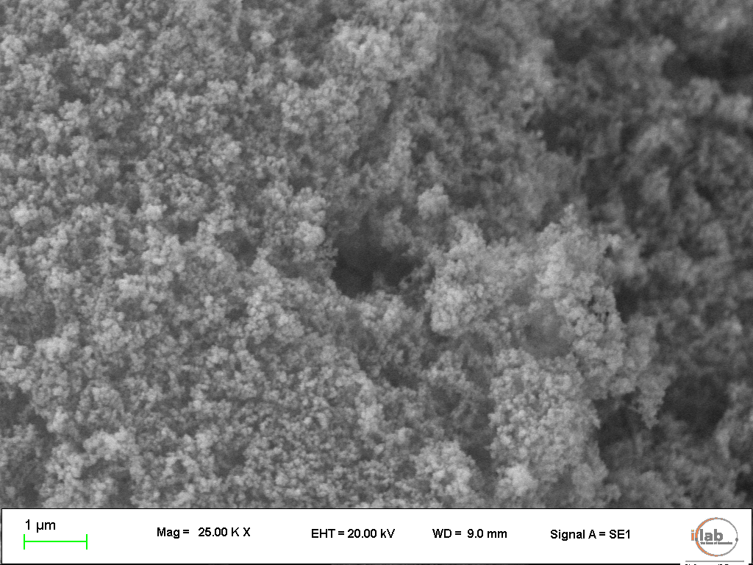  Fig.1–SEM image of Aerosil© 200 at 25000x | 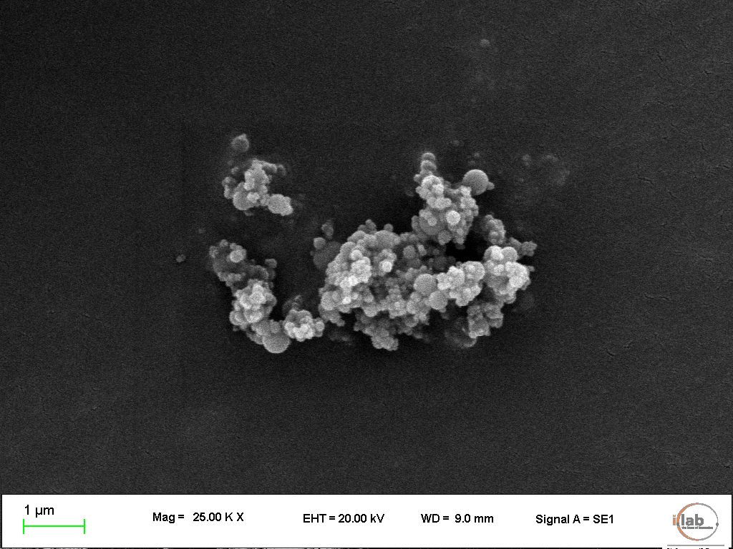  Fig. 2–SEM image of silica fume at 25000x

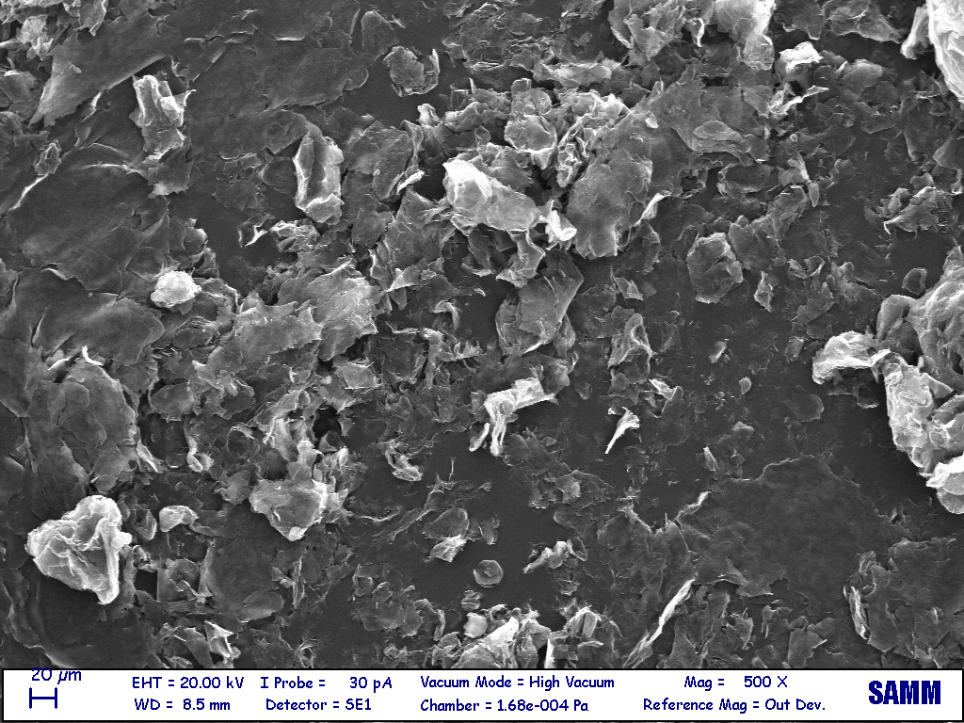 | 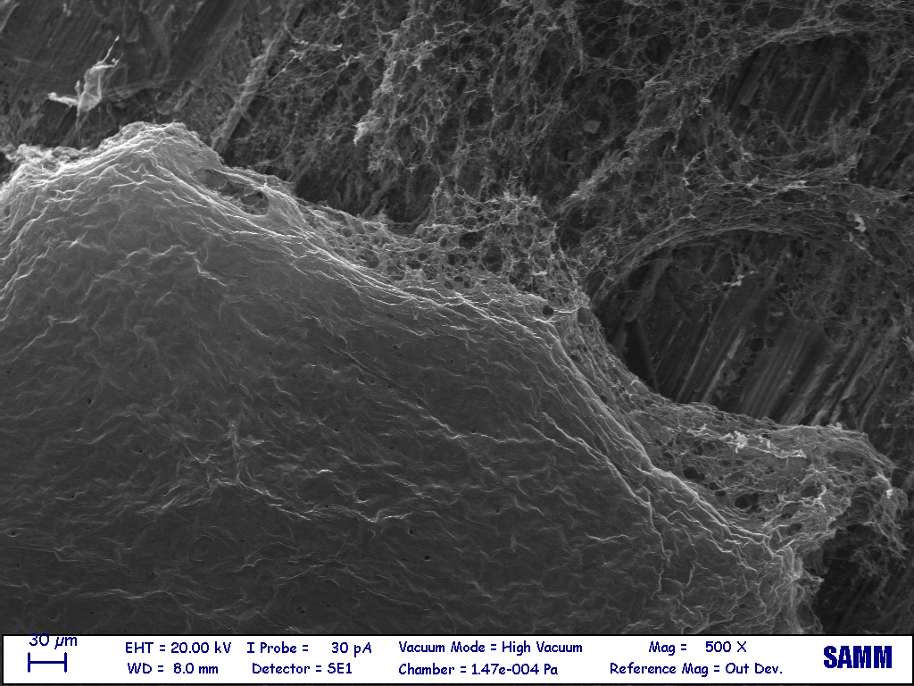

Fig. 3a), b)–SEM images of GNPs (left) and GO (right) at 500x;

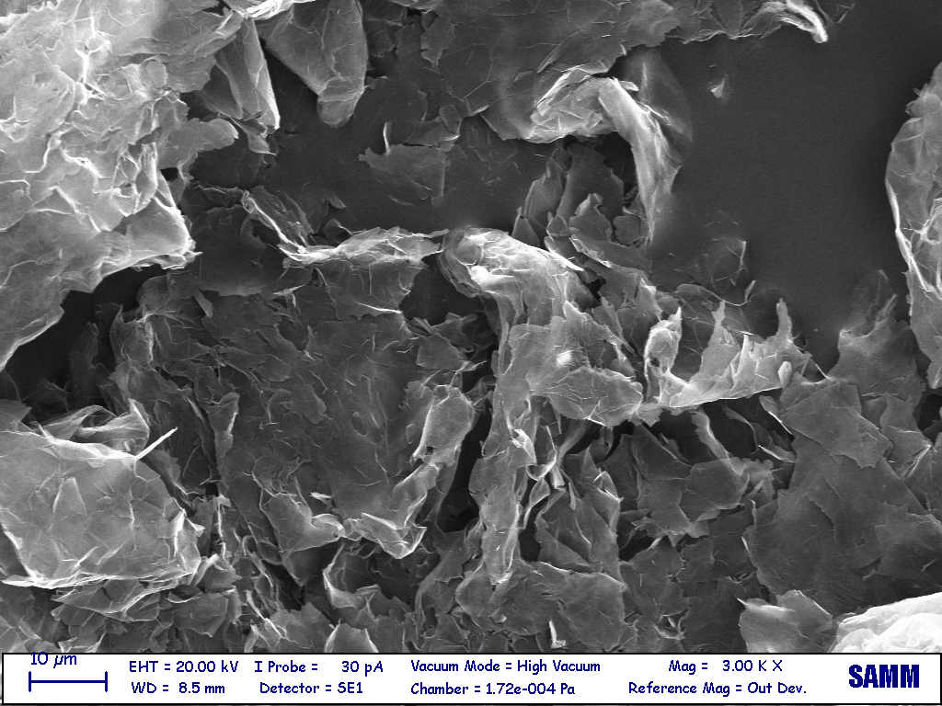 | 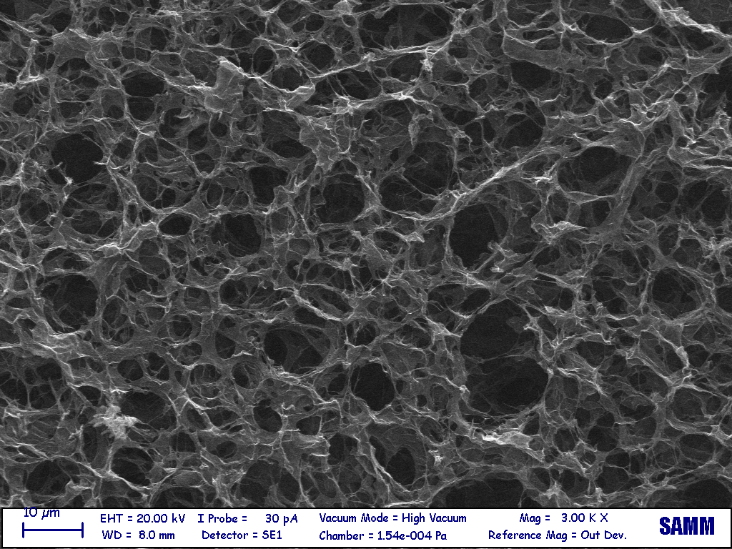

Fig. 3c), d)–SEM images of GNPs (left) and GO (right) at 3000x;

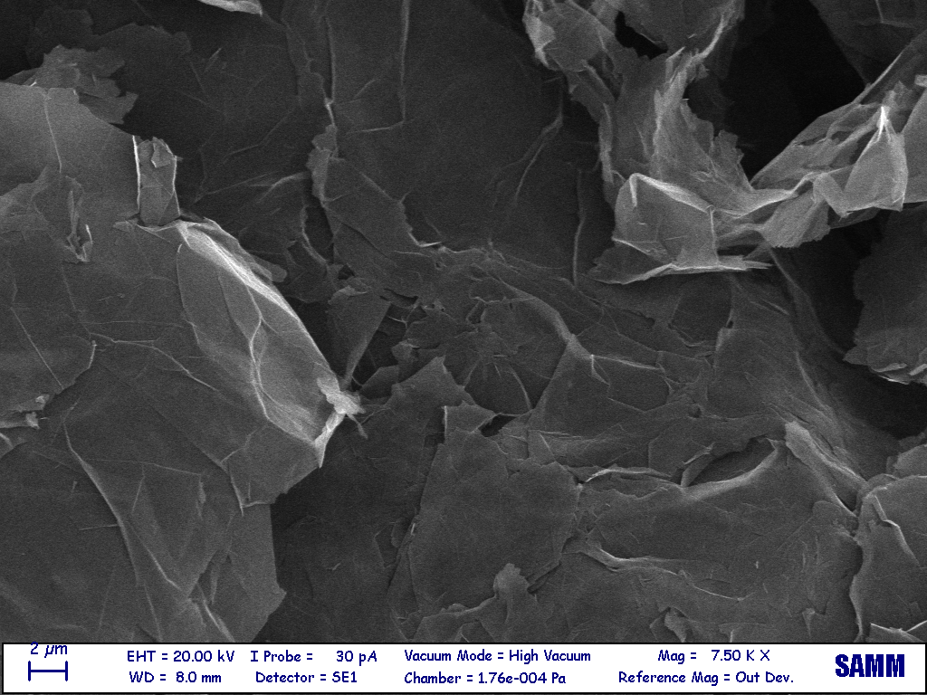 | 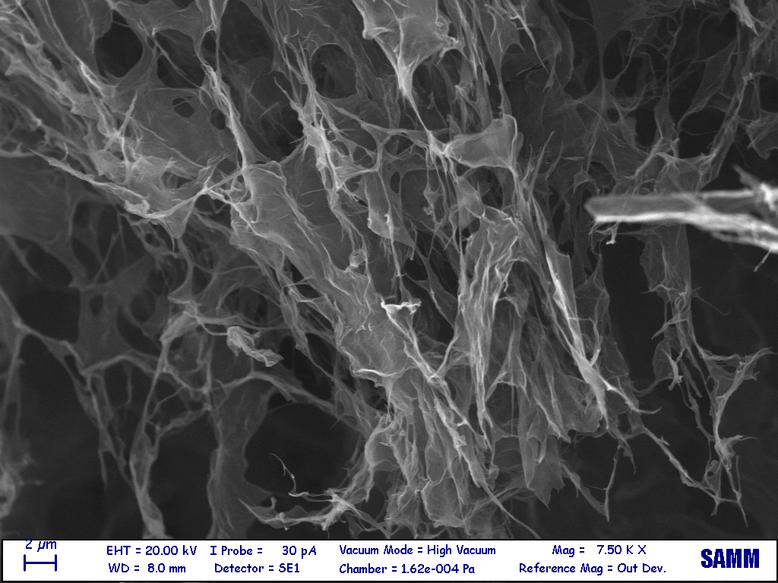

Fig. 3e), f) –SEM images of GNPs (left) and GO (right) at 7500x.

Fig. 4–Raman spectra: G_0.20 dispersion inorganic matrix (up), GNP flake in G_0.20 (middle), bare GNP (down). | Fig. 5–Raman spectra of GO_0.20 dispersion recorded in two different positions of the laser beam, GO_0.20 A (middle) and GO_0.20 B (upper) compared with the spectrum of bare GO (lower).
Fig. 6–FTIR spectra of samples after different times of reaction: samples with silica fume (SF) Control_A SF after one (upper) and four (middle) weeks, compared with samples containing Aerosil© Control_B Aerosil after one week (lower).

Fig. 7–FT-IR spectra of samples prepared with SF and GNPs equal to (from top to bottom): 0%, 0.10% and 0.20%. All samples hydrated for 4 weeks. | Fig. 8–FT-IR spectra of samples prepared with SF and GO equal to (from top to bottom): 0%, 0.05%, 0.10% and 0.20%. All samples hydrated for 4 weeks.

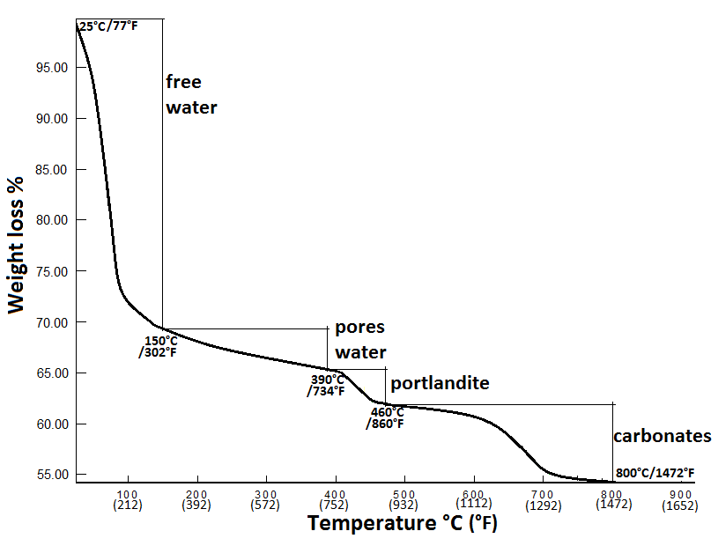
Fig. 9–Temperature ranges considered in our TG analysis. Taken from the Control_A sample with SF.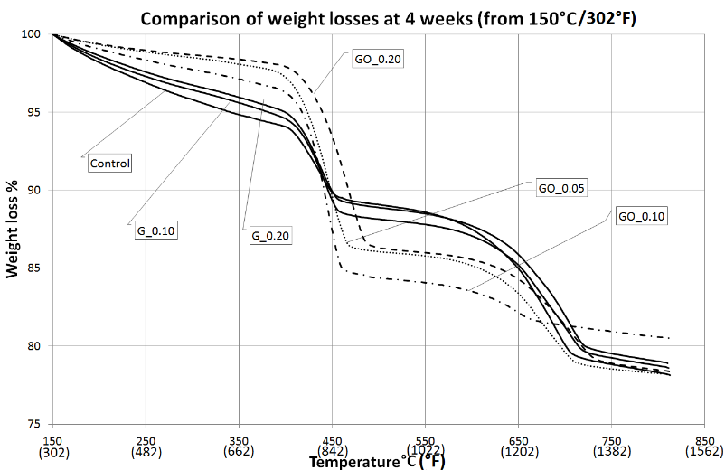
Fig. 10–TG analyses. All the samples were prepared with SF and analysed after 4 weeks of hydration.
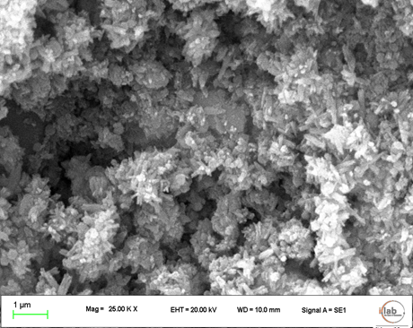 | 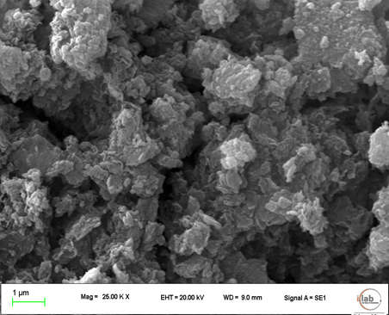
Fig. 11–SEM images after 4 weeks, 25 KX, of SF + Ca(OH)2 specimen (left) and of Aerosil© + Ca(OH)2 (right).
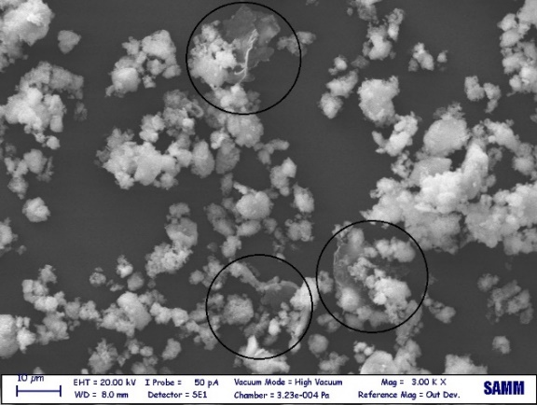
Fig. 12–Large SEM image. GNP are evidenced into the circles.
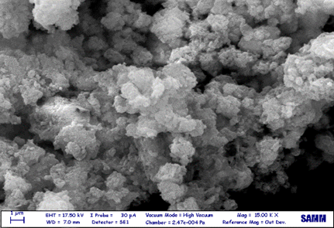 | 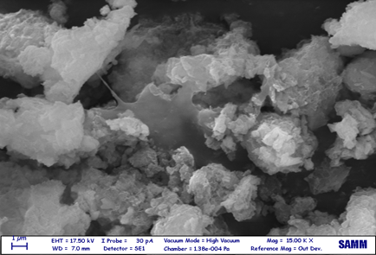
Fig. 13–On the right, C-S-H at 2 weeks of hydration with GNP addition (0.20%). On the left, the control sample without GNP.
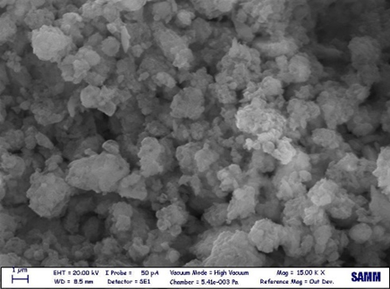 | 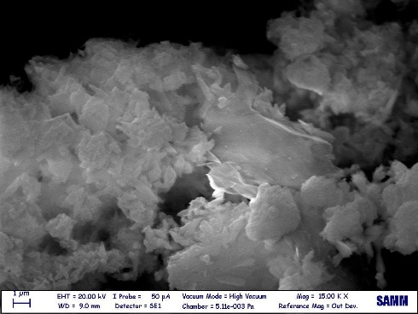
Fig. 14–On the right, C-S-H at 4 weeks of hydration with GNP addition (0.20%). On the left, the control sample without GNP.

Fig. 15–GO addition (0.20%). Product of reaction between CaO and SF after 4 weeks of hydration.

Fig. 16–C-S-H pore water as obtained by thermogravimetric analysis (from 150°C/302°F to 390°C/734°F).

