Experimental Investigation of the Cyclic Response of Double Curved Surface Sliders Subjected to Radial and Bidirectional Sliding Motions
Marco Furinghetti ^{a,c}, Alberto Pavese ª, Virginio Quaglini ^{b}, Paolo Dubini ^{b}
ª University of Pavia, Pavia, Italy, a.pavese@unipv.it
^{b} Politecnico di Milano, Milano, Italy, virginio.quaglini@polimi.it, paolo.dubini@polimi.it
^{c} EUCENTRE, Pavia, Italy, marco.furinghetti@eucentre.it

ABSTRACT
In the present work the experimental response of the Curved Surface Slider (CSS) is investigated through an experimental campaign, carried out on a full-scale prototype subjected to both unidirectional and bidirectional tests. The aim of the study is to assess the effect of vertical load, speed and sustained motion on the frictional response of the device and to compare results returned by different displacement trajectories. In order to perform a quantitative evaluation, a mathematical expression to model the decay of the coefficient of friction as a function of energy dissipation is proposed and calibrated upon experimental data.
Though at low vertical load non-negligible discrepancies between unidirectional and bidirectional orbits were noticed, the CSS device shows consistent behaviour as the applied load, and consequently the dissipated energy, are increased. The results allow to draw some guidance for the estimation of the design variation range of the friction coefficient of Curved Surface Slider devices used to perform bound analyses.
KEYWORDS
Bidirectional motion, Friction coefficient, cyclic effect, Concave Surface Slider, Cloverleaf orbit

acknowledgments
Part of the current work has been carried out under the financial support of the Italian Civil Protection, within the frameworks of the Executive Project 2014–2016 (Project S2.0 – Seismic isolation and supplemental damping systems: evaluation of the seismic response of devices and structures) and the national Research Project DPC – ReLUIS (National Network of Laboratories of Seismic Engineering) 2014–2018, Line 6 – Isolation and Dissipation.

INTRODUction
Curved Surface Sliders (CSSs), also known in their North American version as Friction Pendulum Systems (Zayas et al. [1987], [1990]), represent a viable solution for base-isolation of buildings and structures (Martelli et al. [2014]; Castaldo et al. [2015]; Castaldo et al. [2018]). In such devices, the curvature of the sliding surfaces, in combination with the vertical load, provides a certain recentering capability (Constantinou et al. [1990]; Zayas et al [1987] ; Zayas et al. [1990]), whereas energy dissipation is provided by the friction force developed during the accommodated sliding motion. Since the horizontal stiffness of CSSs is proportional to the acting vertical load, an optimal response with minimal torsional effects can be obtained by use of these isolators, even in presence of irregular plan shapes and setbacks in elevation (Mazza [2017]; Mazza and Mazza [2017]). Research studies and experimental assessments carried out in the past yielded a comprehensive characterization of the lateral response of CSS devices (Lomiento et al. [2013a]; Furinghetti and Pavese, [2017a]; Mosqueda et al. [2004] ; Barone et al. [2017] ; Kumar et al. [2015]) and a better understanding of their overall behaviour. Moreover, these studies showed that the coefficient of friction of current sliding materials used in CSS devices vary with vertical load, velocity of sliding and temperature. One of the main factors that affect the frictional response of CSS devices is indeed the temperature at the sliding surfaces (Dolce et al. [2005]; Gandelli et al. [2013] and Quaglini et al. [2015]). Dolce et al. [2005] highlighted that the friction coefficient of thermoplastic sliding materials decreases as the environmental temperature rises according to a second-order polynomial law, and that the rate of decrease is greater when low-to-moderate temperature transitions are considered rather than moderate-to-high temperatures. However, in addition to ambient temperature, the temperature at the sliding surfaces is influenced by a self-heating mechanism associated to the dissipation of energy occurring at high speeds [Constantinou et al., 2007]. The friction coefficient has been experimentally shown to decrease when the device is subjected to a number of cycles [Mosqueda et al., 2004] due to the heating effect, and such phenomenon can be very important when motion occurs at high frequencies, whereas it is almost negligible at low velocities.
Gandelli et al. [2013] and Quaglini et al. [2015, 2017] provided numerical studies on the cyclic response of CSS devices, accounting for the temperature rise at the sliding interfaces and its effect on the coefficient of friction. In such works the influence of the displacement path on the frictional heat flux developed at the sliding surfaces was investigated and the relevant effect on the force–displacement and damping characteristics of the isolation unit outlined. Different bidirectional orbits, namely circular, elliptical, and “8-shaped” orbits, were compared to unidirectional motion, starting from either undeformed or offset initial conditions. Friction decay is eventually expected to influence the overall response of a structural system isolated by means of CSS devices, by inducing a decrease in reaction forces at the supports, but an increase in the maximum displacement.
A dedicated testing campaign carried out on a Double Curved Surface Slider (DCSS) device by Pavese and co-workers (Pavese et al. [2018]) demonstrated that the friction decay caused by repeated cycling has a decreasing exponential dependence on the dissipated energy, regardless of the trajectory which the device is subjected to. A number of different trajectories were considered in the study, including the bidirectional cloverleaf orbit recommended by the European standard on antiseismic device EN15129:2009 (CEN [2009]), and the decay of the coefficient of friction was compared to a regression curve obtained from unidirectional tests. The fluctuations of the friction coefficient observed along bidirectional trajectories and missing along unidirectional trajectories were ascribed to the effects of the rotation of the slider about the vertical direction induced by the uneven distribution of the pressure, and therefore of the coefficient of friction, on its surface. Larger degradation of the coefficient of friction appeared to affect unidirectional than bidirectional trajectories.
In this regard, it is noted that, though it is generally acknowledged that bidirectional trajectories are more demanding, current North American (AASHTO [2014]; ASCE [2017]) and European (CEN [2009]) standards specify unidirectional tests under assigned displacement time histories for assessing the performance of CSS isolators, because such tests are simple and easy to perform in most of the laboratories worldwide, whereas only a few facilities capable of performing bidirectional tests are today available (Marioni and Dalpedri, [2015]). The European standard EN 15129 prescribes a bidirectional test on CSS devices according to the cloverleaf orbit, which results from the simultaneous application of sinusoidal displacement input waveforms in two perpendicular directions; such a path is considered as the most complete harmonic bidirectional trajectory, since all directions are covered during the motion and the general behaviour of the tested device is properly captured. However, if the testing equipment is unable to perform bidirectional orbits, the standard allows to replace the bidirectional test by a sequence of two unidirectional tests with sinusoidal waveform along two radial directions of the bearing, where the second test is performed after a rotation of 90 degrees of the device, in order to involve a displacement path perpendicular to the one verified in the first test. Thus, according to the standard, response verification of CSS isolators is permitted to rely on unidirectional tests only.
The available research on the degradation of the friction coefficient of CSS devices under sustained motion has pointed to a complex and highly non-linear behavior which needs to be investigated, both experimentally and by means of numerical analyses (Lomiento et al. [2013a]; Lomiento et al. [2013b]; Quaglini et al. [2015] ; De Domenico et al. [2018] ; Gandelli et al. [2018]). Furthermore, a clear understanding of the influence of the trajectory of motion along either unidirectional or bidirectional orbits is still missing, even though a recent work has argued that a direct correlation between the response of base-isolated structural systems under bidirectional and radial motions is likely to exist (Furinghetti and Pavese [2017b]).
The paper addresses the study of the decay of the friction coefficient of CSS devices during sustained motion. A novel formulation accounting for the degradation of friction as a function of the dissipated energy is proposed; the mathematical model is calibrated upon experimental data collected from unidirectional and bidirectional tests performed by the Authors and the relevant parameters are used to evaluate the influence of the trajectory on the friction decay. As a practical application, the formulation is eventually employed to assess the radial (unidirectional) and the cloverleaf orbits in order to evaluate the equivalence of the two orbits for purpose of prototype testing assumed in EN 15129 (CEN [2009]).

TESTING METHODS

Full scale device
A real scale isolator was custom manufactured for the experimental campaign (Furinghetti and Pavese [2017a]). The prototype was designed as a Double Curved Surface Slider (DCSS) device (Fenz and Constantinou [2006]), with two concave spherical surfaces and one non-articulated slider (Figure 1 and Figure 2). The slider houses two circular sliding pads, each one having a diameter equal to 260mm. The concave plates are lined with stainless steel sheets, polished to mirror finish (average surface roughness Ra = 0.2μm), and are designed to accommodate bidirectional movements up to a maximum radial displacement of 250mm.
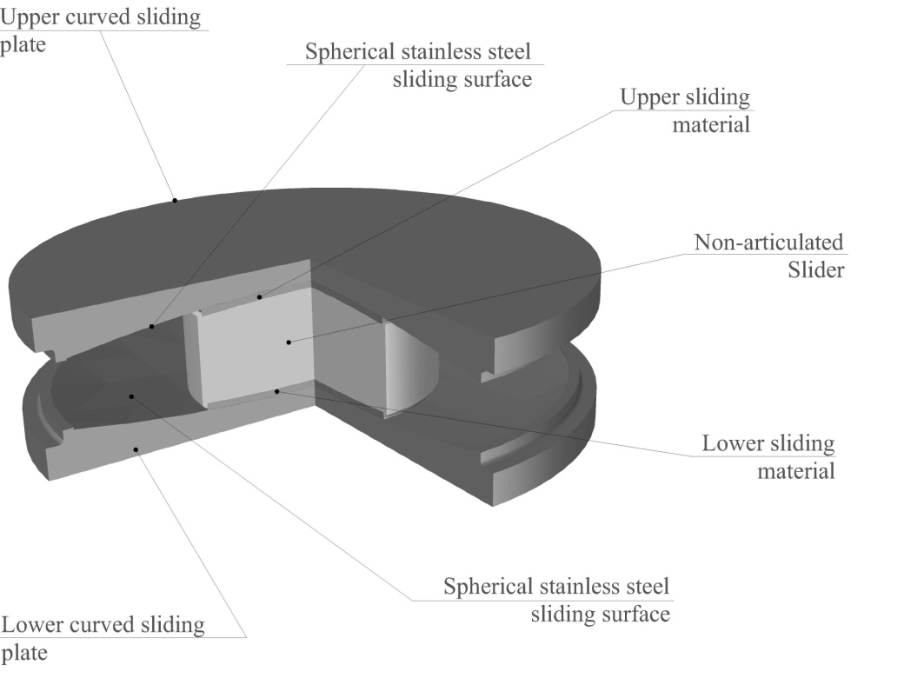
Figure 1. Double Concave Surface Slider (DCSS) device: mechanical components and their nomenclature.
The upper and lower sliding surfaces have the same radius of curvature R = 1600mm and the height of the non-articulated slider is h = 120mm, providing an equivalent radius of curvature of 3080mm. Since the upper and the lower spherical surfaces feature the same radius, it is assumed that identical sliding conditions (i.e. same sliding velocities and travelled distances) occur at either interface.
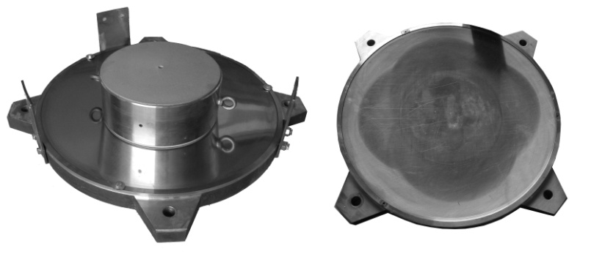
Figure 2. Double Concave Surface Slider (DCSS) device: realized device.
Sliding pads of two different sliding materials were assessed. Both materials are PTFE compounds and will be designed hereinafter as Material A and Material B in order to avoid any reference to commercial products.

Testing protocol
Unidirectional and bidirectional trajectories (Mokha et al. [1990]; Mokha et al. [1993]) were performed on the custom device using the EUCENTRE experimental facility in Pavia (Peloso et al. [2012]). In Figure 3 an external view of the test setup, implemented into the Bearing Tester System of the laboratory, is shown. The set-up consists of a rigid bench equipped with two orthogonal sliding plates driven by horizontal servo-hydraulic actuators, which can apply longitudinal and transverse displacement histories to the tested device.
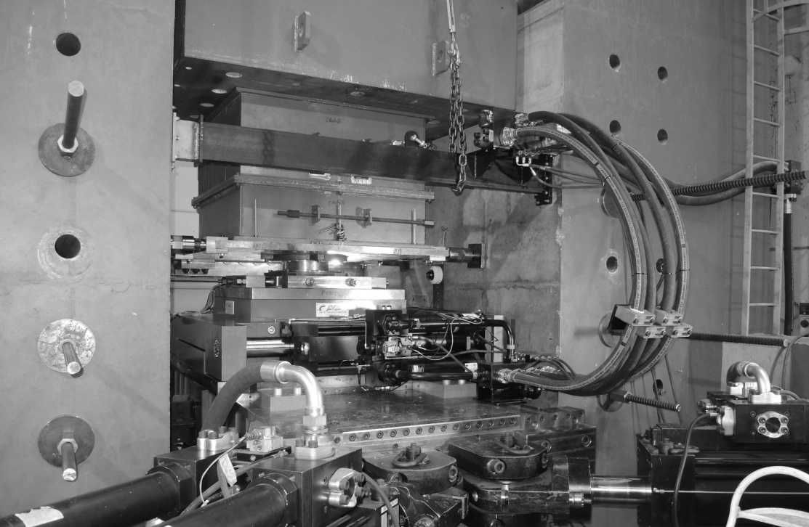
Figure 3. View of the testing setup
Concerning unidirectional motion, a sinusoidal displacement input waveform of the type
d(t) = D_{max} ⋅ sin (2π⋅f_{o}⋅t) was applied along the radial direction of the DCSS device, where D_{max} is the maximum displacement in the considered direction and f_{o} is the frequency; the maximum velocity is V_{max} = 2π⋅f_{o}⋅D_{max} and the average velocity over a cycle is V_{av} = 4⋅f_{o}⋅D_{max}; the total length of the path travelled by the DCSS isolator in half a cycle is 2 D_{max}. In Table 1 the radial testing protocol is outlined, by listing for each test of the sequence the main parameters, namely the maximum displacement D_{max}, the vertical load W applied to the DCSS device and the corresponding average contact pressure P at the sliding interfaces, the peak and the average velocity V_{max} and V_{av}, and the number of cycles performed. In particular, three values of vertical load were assumed, corresponding to as many level of contact pressure P, namely 15 MPa, 33 MPa and 45 MPa, which cover the typical range of application (25 to 45 MPa) of PTFE and PTFE-based sliding material used in this technology.
Table 1. Testing protocol – radial motion
Test [#] | D_{max} [mm] | W [kN] | P [MPa] | V_{max} [mm/s] | V_{av} [mm/s] | cycles [#]
1 | 200 | 796 | 15 | 10.0 | 6.4 | 3
2 | 200 | 796 | 15 | 40.0 | 25.5 | 3
3 | 200 | 796 | 15 | 100.0 | 63.7 | 3
4 | 200 | 796 | 15 | 200.0 | 127.4 | 3
5 | 200 | 796 | 15 | 400.0 | 254.8 | 3
6 | 200 | 1751 | 33 | 10.0 | 6.4 | 3
7 | 200 | 1751 | 33 | 40.0 | 25.5 | 3
8 | 200 | 1751 | 33 | 100.0 | 63.7 | 3
9 | 200 | 1751 | 33 | 200.0 | 127.4 | 3
10 | 200 | 1751 | 33 | 400.0 | 254.8 | 3
11 | 200 | 2388 | 45 | 10.0 | 6.4 | 3
12 | 200 | 2388 | 45 | 40.0 | 25.5 | 3
13 | 200 | 2388 | 45 | 100.0 | 63.7 | 3
14 | 200 | 2388 | 45 | 200.0 | 127.4 | 3
15 | 200 | 2388 | 45 | 400.0 | 254.8 | 3

The bidirectional testing protocol was defined by assuming the cloverleaf orbit (Figure 4). The same peak displacement D_{max} was applied in both x and y directions, so that a symmetric trajectory was obtained; consequently, the displacement accumulated along one lobe of the cloverleaf path is 2.422 D_{max}, i.e. 21.1% larger than the distance travelled along half cycle of radial motion to the same D_{max}. Several tests were carried out by varying the axial load and the peak velocity, and for each test, two repetitions of a full cloverleaf orbit were performed. In Table 2 the bidirectional testing protocol is summarized, where V_{max} and V_{av} stand for the maximum and the average values of the modulus of the bidirectional velocity vector V.
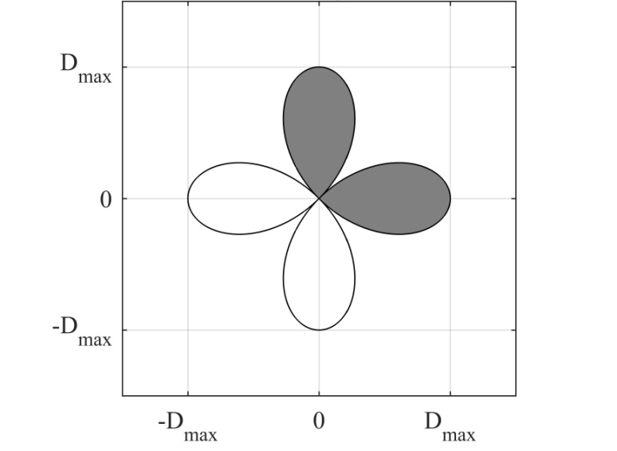
Figure 4. Cloverleaf orbit: total cumulative displacement (cumulated displacement along two lobes D_{C,TOT} = 4.844 D_{max}).

Table 2. Testing protocol – bidirectional motion
Test [#] | D_{max} [mm] | W [kN] | P [MPa] | V_{max} [mm/s] | V_{av} [mm/s] | Rep. [#]
1 | 200 | 796 | 15 | 20 | 20 | 2
2 | 200 | 796 | 15 | 80 | 80 | 2
3 | 200 | 796 | 15 | 300 | 300 | 2
4 | 200 | 1751 | 33 | 20 | 20 | 2
5 | 200 | 1751 | 33 | 80 | 80 | 2
6 | 200 | 1751 | 33 | 200 | 200 | 2
7 | 200 | 1751 | 33 | 300 | 300 | 2
8 | 200 | 2388 | 45 | 20 | 20 | 2
9 | 200 | 2388 | 45 | 80 | 80 | 2
10 | 200 | 2388 | 45 | 300 | 300 | 2

For the cloverleaf orbit, a special resampling procedure (Pavese et al., [2018]) was applied to the displacement input, in order to produce a constant value of the velocity during the whole test (V_{max} = V_{av}) and suppress the effect of velocity changes on the force response

Friction coefficient
As prescribed in (CEN [2009]), for unidirectional motion in the radial direction the average friction coefficient over a single cycle is calculated on the energy dissipated per cycle (EDC) according to the following expression:
(1)
where W and D_{max} had been previously defined. The above expression is valid when a full symmetric cycle is considered, so that the contribution of the restoring force can be neglected, since all paths are covered twice in opposite directions, and the energy dissipated per cycle is identified by the area of the rectangular hysteretic loop associated to the frictional response of the device, as shown in Figure 5.
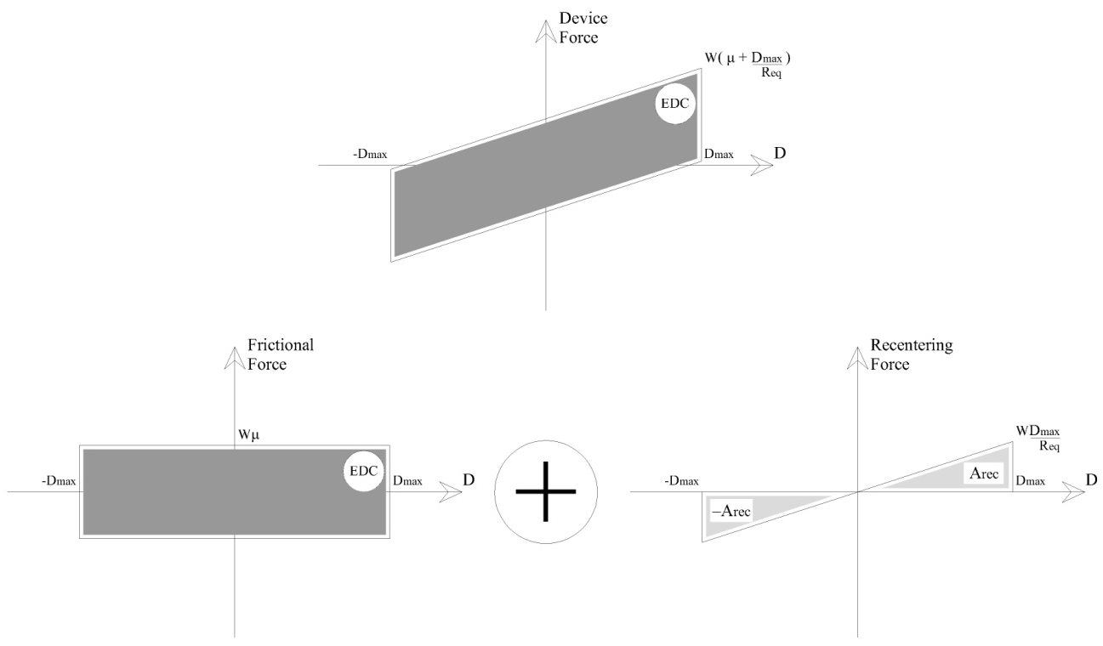
Figure 5. Dissipated energy per cycle in unidirectional motion.
Being the total cumulated displacement per cycle D_{C,TOT} = 4 D_{max}, the average friction coefficient per cycle can be also expressed as :
(2)
The above expression can be used to calculate the average coefficient of friction over bidirectional trajectories as well. The energy dissipated per cycle EDC is expressed by the time integral of the vectorial force-displacement relationship of the device, while for the cloverleaf orbit the total cumulated displacement per cycle counts D_{C,TOT} = 9.688 D_{max}, i.e. more than two times larger than along the radial motion. In order to have similar displacement paths for comparing the changes of the coefficient of friction , and to increase the number of experimental data points, for the bidirectional trajectory the average friction coefficient was hence calculated for each half of the orbit, corresponding to an accumulated displacement D_{C,TOT} = 4.844 D_{max} (Figure 4).

CONTACT PRESSURE DISTRIBUTION
Though an average contact pressure acting on the sliding pad is generally assumed for the evaluation of the dependency of the friction coefficient on the vertical load, the actual pressure distribution on the contact area of the pad is noted to be non-uniform, even for the unidirectional motion [Quaglini et al., 2015]. In the present study the distribution of the contact pressure on the sliding pads of the DCSS device was investigated by means of a pressure-sensitive film [Fuji Prescale], placed between the sliding pad and the mating stainless steel concave surface. Precisely, the Medium Pressure Range film (MS) was used, which measures contact pressure values in the range between 10 and 50 MPa, with an accuracy of ±10%. Figure 6, Figure 7 and Figure 8 illustrate the full field distribution of the contact pressure produced by the application of vertical load to the DCSS device in its centered configuration, i.e. at zero displacement, for all the load levels of the testing protocol.
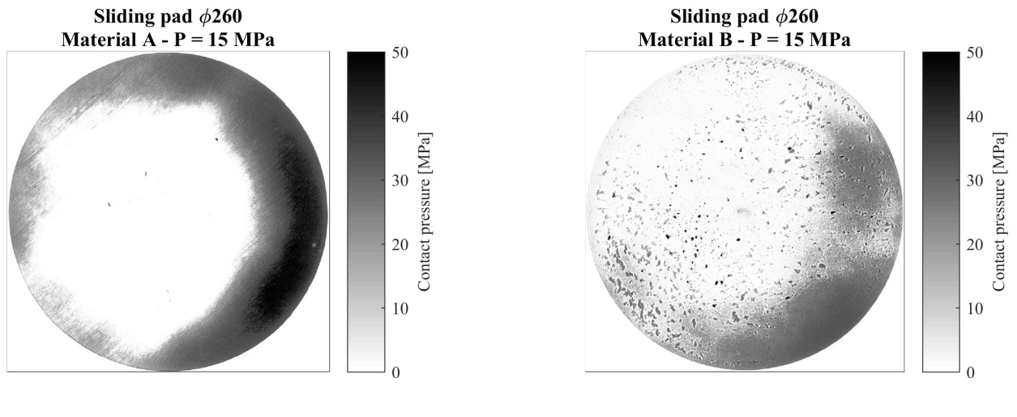
Figure 6. Contact pressure distribution – W = 796kN.
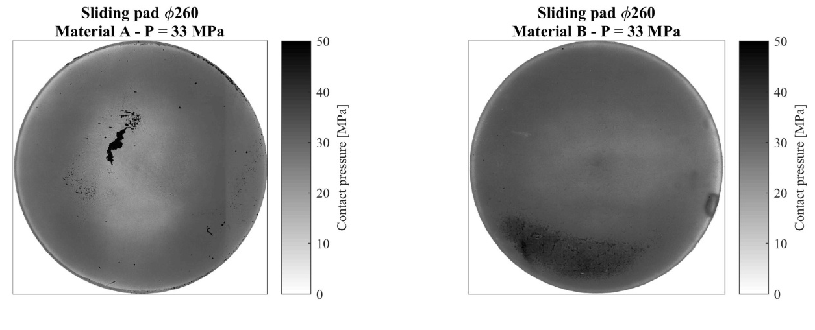
Figure 7. Contact pressure distribution – W = 1751kN.
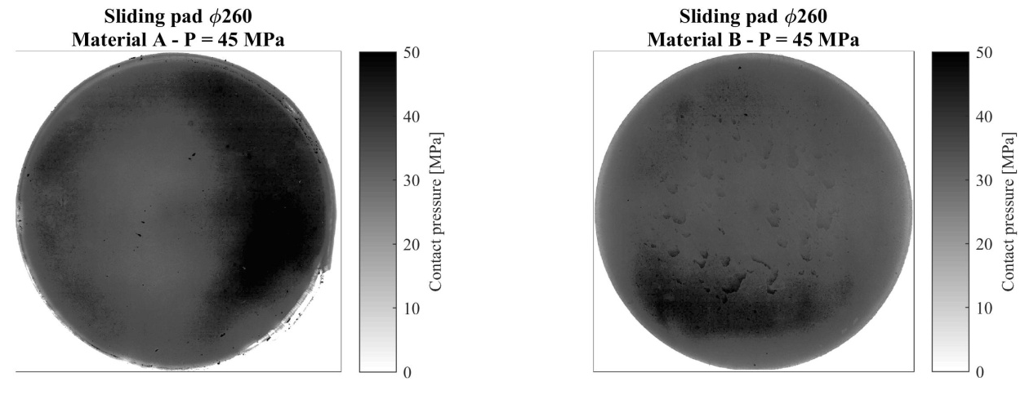
Figure 8. Contact pressure distribution – W = 2388kN.

As it can be noted, at W = 796kN, corresponding to an average pressure P = 15MPa, for either material A and B the pressure distribution is not uniform: the pressure is minimal at the center of the pad, and increases radially so that the largest values are achieved near the edge. By ignoring the asymmetries in pressure distribution which are ascribed to small eccentricities affecting the application of the vertical load, the observed pressure profiles are consistent with the numerical predictions provided for a PTFE based compound by Quaglini et al. [2015]. At W = 1751kN, corresponding to P = 33MPa, the pressure distribution is almost uniform for either material, though a less loaded area still seems to exist at the center of the pad of material A. It is argued that the even profile of the contact stress is consequent to the plasticization of the sliding material induced by the increased load.
Under the highest load W = 2388kN, corresponding to P = 45 MPa, for material A saturation of the pressure-sensitive sheet is achieved over a large portion of the pad surface, denoting that at this area the pressure is close to the capacity of the film (50MPa); also for material B a loaded area with pressure close to 50 MPa is noticed, though slightly smaller than the similar area for material A.
It is therefore concluded that whereas at the lowest load level the sliding materials behave elastically, which explains the uneven pressure profile detected by the pressure-sensitive film, increasing the vertical load promotes the yielding of the material and a homogenization of the surface contact stresses. At the highest load level, for either material the pressure distribution is almost uniform over the whole surface, with only a small less loaded area close to the centre of the pad. However it must be noted that the pressure distribution on the pad surface observed in resting conditions substantially changes during the motion along a unidirectional trajectory (Quaglini et al. [2015]), and even more during the bidirectional motion (Gandelli et al. [2013]; Quaglini et al. [2017]), due to the effects of the geometrical eccentricity of the vertical load and the additional eccentricity introduced by the frictional shear force.

Hysteresis loops analysis
The experimental behaviour of the prototype described in section 2 was investigated considering sliding pads made of either A or B material. In the next paragraphs the results of the tests are presented.
In Figure 9 and Figure 10 hysteresis loops are shown, for radial and bidirectional motions respectively, at high sliding velocity. Precisely, results among all the applied contact pressure values are compared for both materials, in order to notice the dependency of the frictional properties on the applied vertical load.
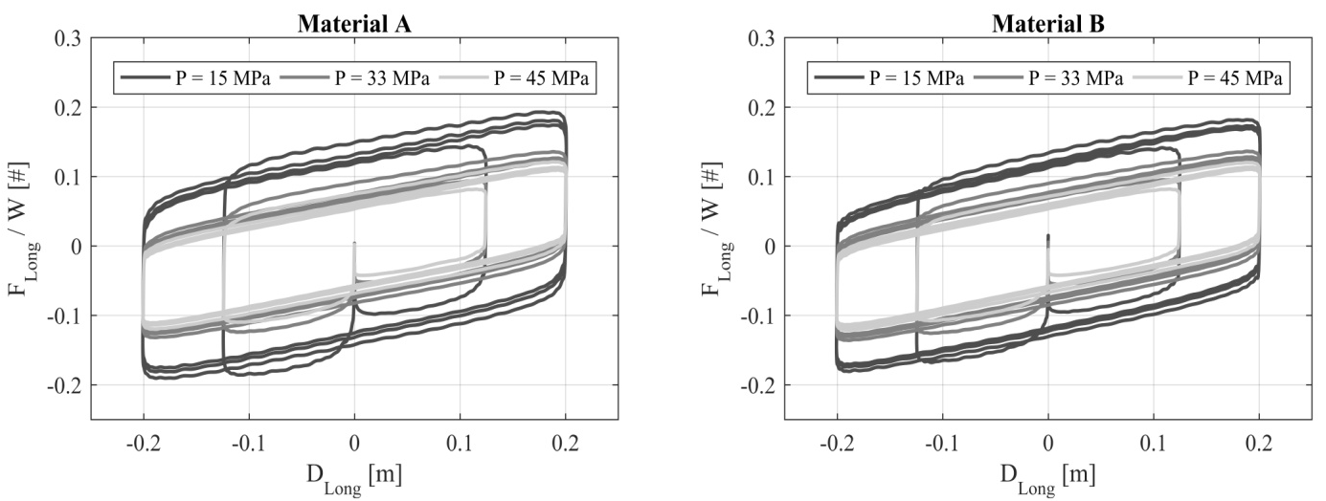
Figure 9. Hysteresis loops of radial motions for material A (left) and B (right) (V_{max} = 300mm/s)
Ordinary response of Curved Surface Slider devices can be found under radial motions. An approximately bi-linear constitutive law can be recognized, according to the friction coefficient value and the restoring stiffness (ratio between the applied vertical load and the equivalent radius of curvature). The normalized longitudinal force decreases if the applied vertical contact pressure at the sliding interfaces increases, as expected, given the common vertical load effect on the frictional properties of sliding devices. In addition, it is possible to note that the longitudinal force decreases as cycles are repeated: the cyclic effect leads to decreasing values of friction coefficient due to heating phenomena at the sliding interfaces, resulting into a continuously reducing dissipated energy per cycle.
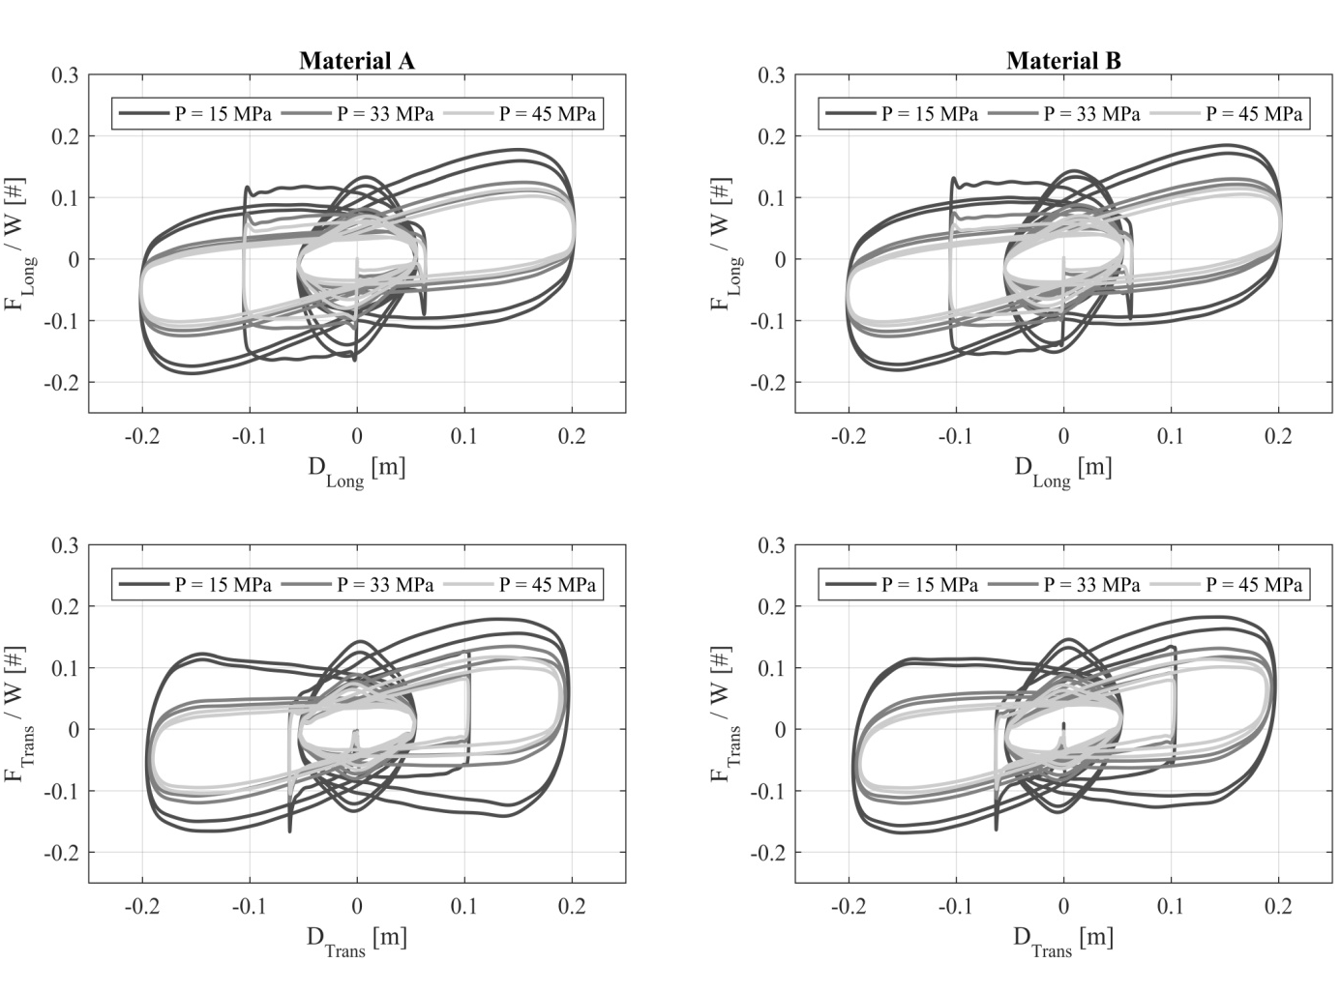
Figure 10. Hysteresis loops of bidirectional motions along Longitudinal (top) and Transverse (bottom) directions for material A (left) and B (right) (V_{max} = 200mm/s)
In the bidirectional case the overall response becomes highly non-linear along the main directions of motion for both materials, and a simplified constitutive law can not be immediately defined. The same effects of the dependency of the frictional properties on the applied vertical load can be noticed, as in the radial case. Moreover, even repetition of the cloverleaf path induces a continuous reduction of both the longitudinal and the transverse forces, which results into a reduction of the dissipated energy.

Friction decay model
In this section special attention is put on the direct comparison of the cyclic response of either unidirectional (radial) or bidirectional (cloverleaf) cyclic motion for several combinations of sliding velocity and vertical load. Furthermore, discrepancies between unidirectional and bidirectional responses for common dependencies of the friction coefficient on sliding velocity and vertical load, as well as cyclic decay trends are studied.

Decay parameters calibration
In this work, the instantaneous value of the friction coefficient of the Curved Surface Slider device observed during a test is expressed as the product of two terms:
(3)
(4)

where for simplicity it is assumed that the vertical load W and the sliding velocity V remain constant during the test. The first term μ_{vW} represents the dynamic friction coefficient as a function of the vertical load and sliding velocity before energy dissipation (and therefore heating) occurs, and hereinafter it will be denoted as the initial friction coefficient. The dependency of this term on the vertical load and the sliding velocity is well noted and a number of analytical model have been proposed in the past (Constantinou et al., [1990]), and therefore will not be investigated in the study.
The second term k_{E}(E(t)) is the multiplication factor which accounts for the decay of the friction coefficient during the motion induced by the dissipation of energy, and is modelled according to an exponential decay function (Lomiento et al. [2013b]). For this term the following expression is proposed:
(5)

where p_{E} stands for an asymptotic decay value, and ε_{r} is a parameter which governs the rate of decrease of the friction coefficient as a function of the dissipated energy (the higher ε_{r}, the faster the decay, as shown in Figure 11); parameter E(t) represents the total cumulated energy dissipated from the beginning of the motion to time t, computed as the integral of the scalar product between the force and the differential displacement vectors. It must be noted that the in the exponential term the variable E(t)/W expresses the ratio between the total Dissipated Energy and the vertical load and has the dimensions of a length, i.e. is proportional to the accumulated slide path.
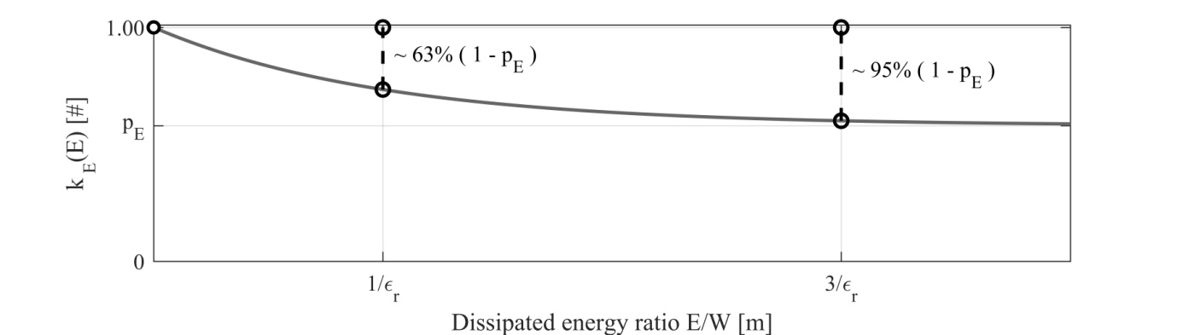
Figure 11. General trend of the friction decay formulation
Parameters of the aforementioned Equation (4), which are expected to depend on the sliding velocity and the vertical load, were calibrated for the prototype of DCSS device considered in the study by means of a non-linear least square error procedure based on all the tests performed, including both unidirectional and bidirectional trajectories. Precisely, Equation (3) was firstly used to fit the average coefficient of friction calculated for each cycle of radial motion, or each half cycle of the cloverleaf orbit, and then Equation (4) was applied to the decay term k_{E}.
In Table 3 and Table 4 results of model calibration for radial and bidirectional motion respectively are reported.
Table 3. Decay model calibration – unidirectional motion
Test [#] | W [kN] | V [m/s] | Material A |  |  |  | Material B
Test [#] | W [kN] | V [m/s] | µ_{VW} [%] | ε_{r} [#] | p_{E} [%] | R² [%] | µ_{VW} [%] | ε_{r} [#] | p_{E} [%] | R² [%]
1 | 796.0 | 0.010 | 8.64 | 0.00 | 100.0 | - | 8.75 | 0.00 | 100.0 | -
2 | 796.0 | 0.040 | 12.35 | 0.89 | 71.2 | 79.8 | 11.70 | 6.25 | 91.8 | 88.5
3 | 796.0 | 0.100 | 14.48 | 4.38 | 78.3 | 97.0 | 13.34 | 7.37 | 82.1 | 97.4
4 | 796.0 | 0.200 | 15.25 | 5.10 | 72.9 | 98.6 | 13.86 | 7.03 | 77.5 | 99.2
5 | 796.0 | 0.400 | 15.20 | 3.55 | 61.2 | 97.8 | 13.92 | 3.78 | 66.2 | 99.0
6 | 1751.2 | 0.010 | 6.85 | 0.00 | 100.0 | - | 7.17 | 0.00 | 100.0 | -
7 | 1751.2 | 0.040 | 9.14 | 9.31 | 73.7 | 99.2 | 9.00 | 9.35 | 77.2 | 99.4
8 | 1751.2 | 0.100 | 9.29 | 10.69 | 72.1 | 99.1 | 9.23 | 10.22 | 74.0 | 99.5
9 | 1751.2 | 0.200 | 9.66 | 11.32 | 65.1 | 99.7 | 9.46 | 10.12 | 69.5 | 99.7
10 | 1751.2 | 0.400 | 9.51 | 7.47 | 55.2 | 98.2 | 9.37 | 5.55 | 57.5 | 98.8
11 | 2388.0 | 0.010 | 5.45 | 0.00 | 100.0 | - | 5.28 | 0.00 | 100.0 | -
12 | 2388.0 | 0.040 | 7.28 | 10.57 | 75.7 | 99.8 | 7.00 | 14.24 | 78.8 | 99.1
13 | 2388.0 | 0.100 | 7.80 | 12.12 | 69.2 | 99.5 | 7.30 | 11.80 | 72.9 | 99.1
14 | 2388.0 | 0.200 | 8.05 | 12.12 | 62.2 | 99.8 | 7.61 | 12.42 | 67.9 | 99.4
15 | 2388.0 | 0.400 | 7.86 | 8.72 | 52.9 | 98.8 | 7.38 | 7.70 | 55.3 | 98.8

Materials A and B show similar values of the model parameters for every combination of sliding velocity and vertical load, and owing to the same PTFE matrix the different filler composition seems not to substantially affect the frictional response.
By comparing the identified parameter values, discrepancies between the frictional response of the DCSS device along either the unidirectional or the bidirectional trajectories can be quantitatively evaluated.
Table 4. Decay model calibration – bidirectional motion
Test [#] | W [kN] | V [m/s] | Material A |  |  |  | Material B
Test [#] | W [kN] | V [m/s] | µ_{VW} [%] | ε_{r} [#] | p_{E} [%] | R² [%] | µ_{VW} [%] | ε_{r} [#] | p_{E} [%] | R² [%]
1 | 796 | 0.020 | 12.25 | 0.00 | 100.0 | - | 12.74 | 0 | 100 | -
2 | 796 | 0.080 | 15.17 | 3.28 | 78.8 | 90.2 | 14.92 | 3.33 | 81.6 | 89.0
3 | 796 | 0.300 | 16.78 | 4.37 | 66.3 | 97.2 | 15.90 | 4.11 | 72.6 | 98.1
4 | 1751 | 0.020 | 9.69 | 10.98 | 79.9 | 85.3 | 9.86 | 2.16 | 69.9 | 89.4
5 | 1751 | 0.080 | 10.12 | 7.92 | 70.5 | 93.9 | 9.98 | 7.16 | 75.3 | 94.4
6 | 1751 | 0.200 | 10.49 | 9.07 | 62.6 | 97.8 | 10.16 | 7.45 | 67.0 | 97.9
7 | 1751 | 0.300 | 10.58 | 8.55 | 59.7 | 99.4 | 9.44 | 4.51 | 66.0 | 98.5
8 | 2388 | 0.020 | 7.05 | 13.29 | 88.4 | 80.3 | 7.29 | 15.03 | 84.9 | 81.2
9 | 2388 | 0.080 | 8.34 | 9.46 | 72.3 | 98.2 | 8.13 | 11.16 | 72.4 | 95.5
10 | 2388 | 0.300 | 8.50 | 9.10 | 60.0 | 99.4 | 7.89 | 8.29 | 63.7 | 99.7

Asymptotic friction decay
In Figure 12 the values of the asymptotic decay parameter p_{E} are reported as a function of the peak sliding velocity V_{max}. In order to compare the average trends observed in unidirectional and bidirectional tests, least square regression curves of the observed data were further calculated according to the proposed expression:
(6)
Since the experimental data showed that the asymptotic decay parameter has a continuous decrease with increasing velocity, the regression equation has been formulated by combining an exponentially decreasing function accounting for a steeper decay for small increase in the sliding rate and a linear function of velocity. The coefficients of the regression curve are listed in Table 5 for both materials and test protocols. The good accuracy of the regression outlined by the R² score demonstrates that the parameter p_{E} can be at a first approximation assumed as a function of the sliding velocity only, whereas the influence of the vertical load is sufficiently small to be disregarded for practical purposes.

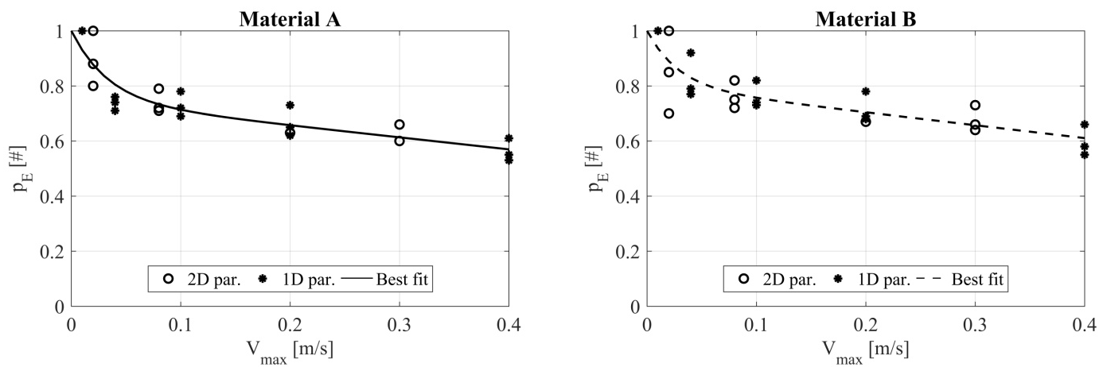
Figure 12. Asymptotic friction decay parameter p_{E} : observed data and regression analysis

Table 5. Asymptotic friction decay parameter p_{E} : coefficients of regression curve
 | Material A |  |  |  | Material B
 | a [#] | b [s/m] | c [s/m] | R² | a [#] | b [s/m] | c [s/m] | R²
 | 0.744 | 29.606 | 0.436 | 0.847 | 0.798 | 34.655 | 0.468 | 0.740

When the device is subjected to fast movements, the minimum friction coefficient achieved after a sustained cyclic excitation is lower than during slow motions, as already known from the practice. In particular, increasing the velocity from 10mm/s to 400mm/s induces a decrease in p_{E} from about 0.90 to about 0.55-0.6 independently of the applied pressure. Moreover Table 5 seems to point out that for large velocities (for which the exponential terms is negligible) no significant difference in terms of the asymptotic decay of the friction coefficient exists between the radial and cloverleaf motions: the friction coefficient approaches the same steady value at the end of a sustained motion at a given velocity, regardless the shape of the orbit.

Decay rate
The parameter ε_{r} represents the rate of decay of the friction coefficient with the dissipated energy. Considering first either unidirectional or bidirectional tests only, when the vertical load doubles, passing from W = 796kN to W = 1751kN, the value of ε_{r} has on average a two-folds increase, i.e. the friction decreases more fast. However no substantial change occurs at a further increase of load from W = 1751kN to W = 2388kN: at high loads the rate of friction decay seems to be almost steady, with a non negligible decrease only at very high speeds. This is probably linked to the tendency of friction to increase at high speeds due to the viscous behavior of thermoplastic sliding materials, which partially balances the effect of heating.
When unidirectional and bidirectional trajectories are compared, ε_{r} is found to be moderately lower (on average, 25 to 30% less) for the bidirectional case. Consistent results are found for both materials assessed in the study.

Initial friction coefficient
In Figure 13 the observed values of the initial friction coefficient are shown, as a function of the maximum sliding velocity, and accounting for different levels of vertical load.
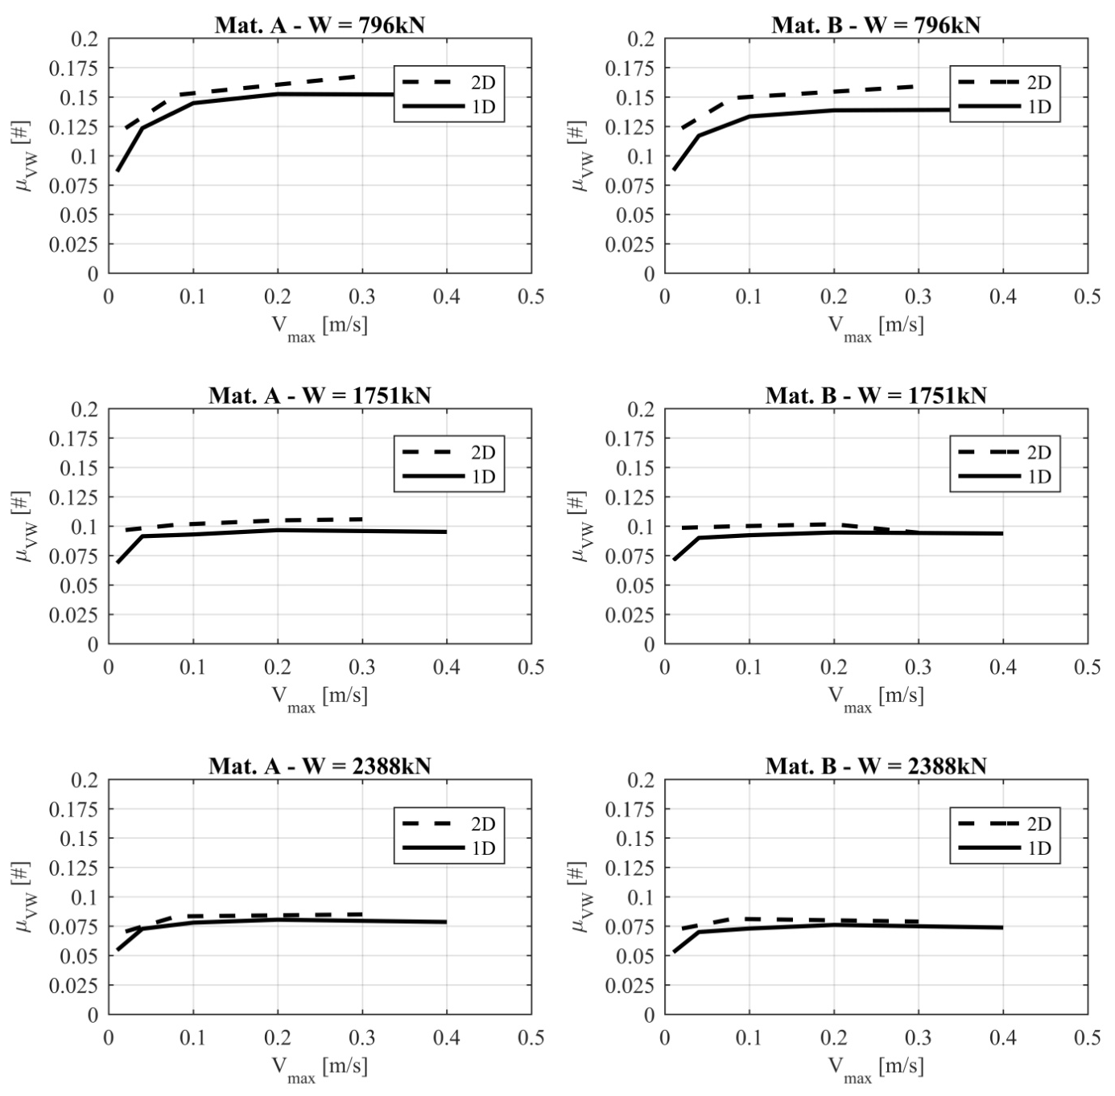
Figure 13. Initial friction coefficient: dependencies on sliding velocity and contact pressure
As expected, the initial friction coefficient increases with increasing of the sliding velocity and decreasing of the vertical load acting on the device. By comparing unidirectional and bidirectional tests, the relevant values of the friction coefficient are quite different when the vertical load is low, while the gap reduces as the vertical load increases. The bidirectional motion tends to produce higher frictional forces in comparison to the unidirectional case, but this effect is less important at high loads inducing contact pressures on the sliding pad higher than 30MPa, which correspond to the plasticization of the sliding materials, as shown by the pressure distribution evaluated in section 3 of this paper. Similar results were observed for either material A or B in the study. Moreover, as the average pressure increases, the heat flux produced by energy dissipation increases as well, and consequently the sliding pad approaches the melting temperature of the thermoplastic sliding material, regardless the type of motion. Thus, in order to reduce uncertainties in predicting the response of sliding devices under a general seismic input, a design contact pressure at the sliding interfaces higher than the yielding pressure of the sliding material is likely to yield better agreement between bidirectional and radial responses.

Instantaneous friction coefficient: cyclic effect
Finally, the cyclic behaviour has been investigated by analysing the change of the coefficient of friction with the dissipated energy for the various combinations of sliding velocity and vertical load, and distinguishing between unidirectional and bidirectional motion. The results are shown in Figure 14, Figure 15 and Figure 16, where the curves represent the friction model defined by Equation (3) and Equation (4): since different sliding velocities were applied in either motion, results are shown by referring to the velocities of the bidirectional testing protocol, whereas the model parameters of decay curves for the unidirectional case were obtained by linear interpolation: precisely, for every parameter, the proper parameter value for the considered velocity is calculated by considering a stepwise linear trend between each couple of velocity-to-parameter points, related to radial motions. It is here recalled one again that the ratio E/W between the dissipated energy and the vertical load assumed as the independent variable has the dimension of a length and is proportional, through the friction coefficient, to the accumulated slide path (see Equation (2)).
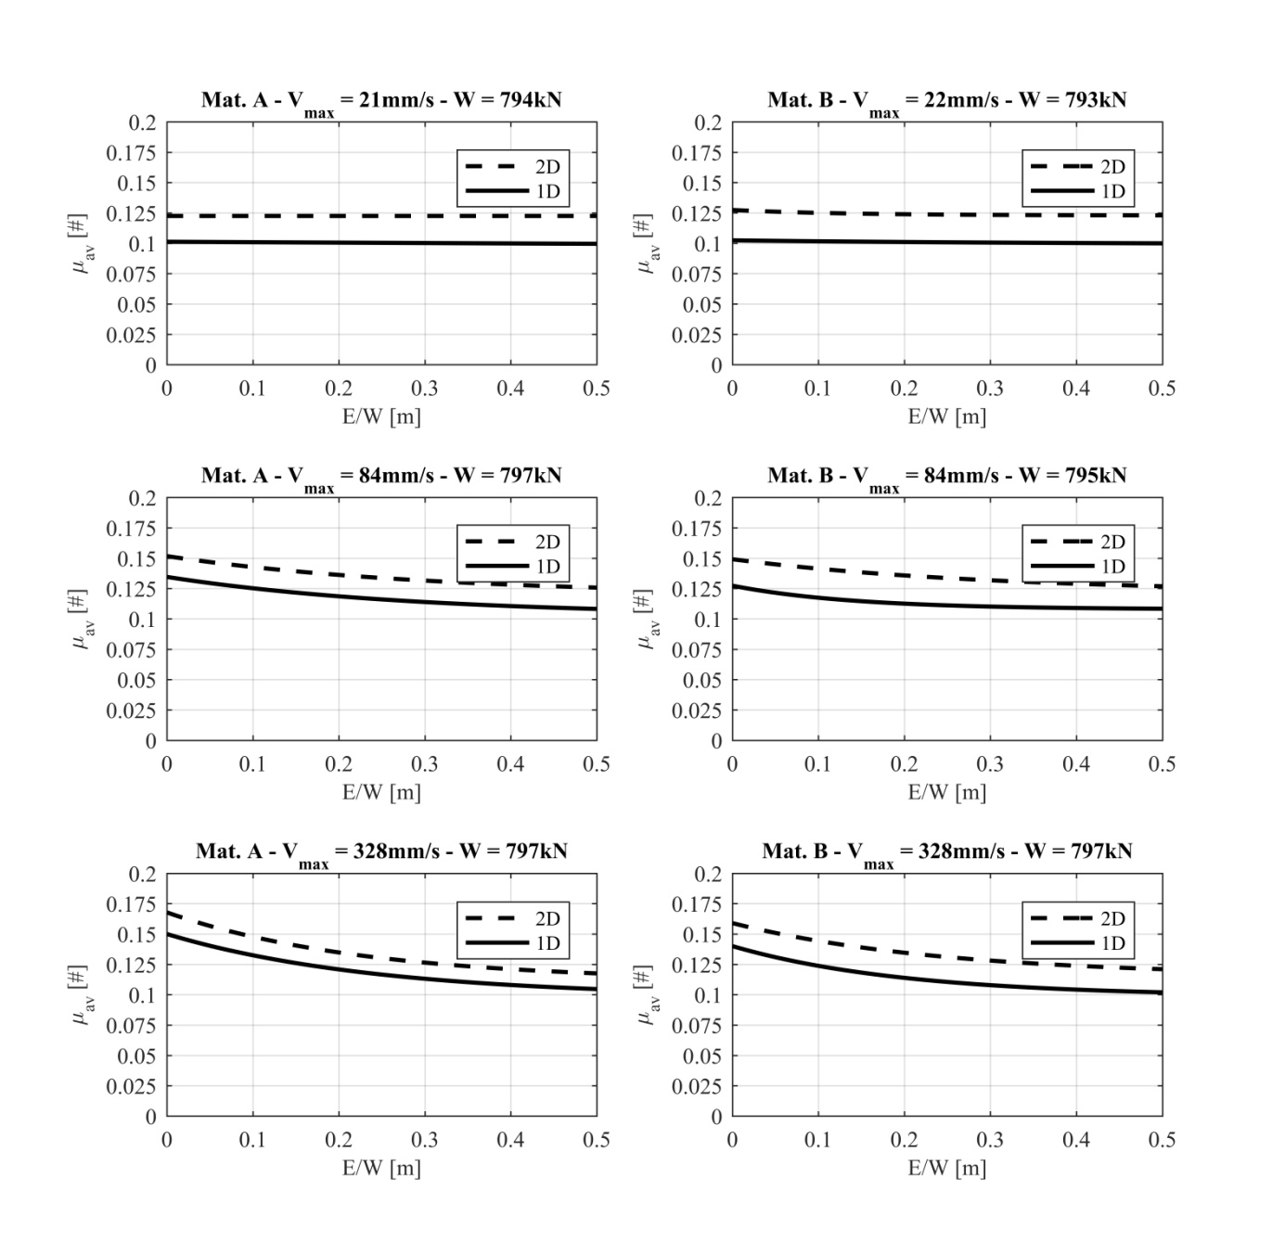
Figure 14. Cyclic decay – Contact pressure on sliding pad: 15 MPa
At the lowest vertical load, the bidirectional motion consistently provides higher coefficient of friction (maximum variation: +25%) at every velocity. It is worth noting that at low velocity there is no appreciable decay of friction with increasing of the accumulated slide path, and the friction coefficient can be assumed as constant; however, when velocity is increased, the frictional decay is no longer negligible. The unidirectional motion shows the same decay trend of the bidirectional case, and therefore the cyclic factor seems to induce comparable effects, regardless of the trajectory of the device.
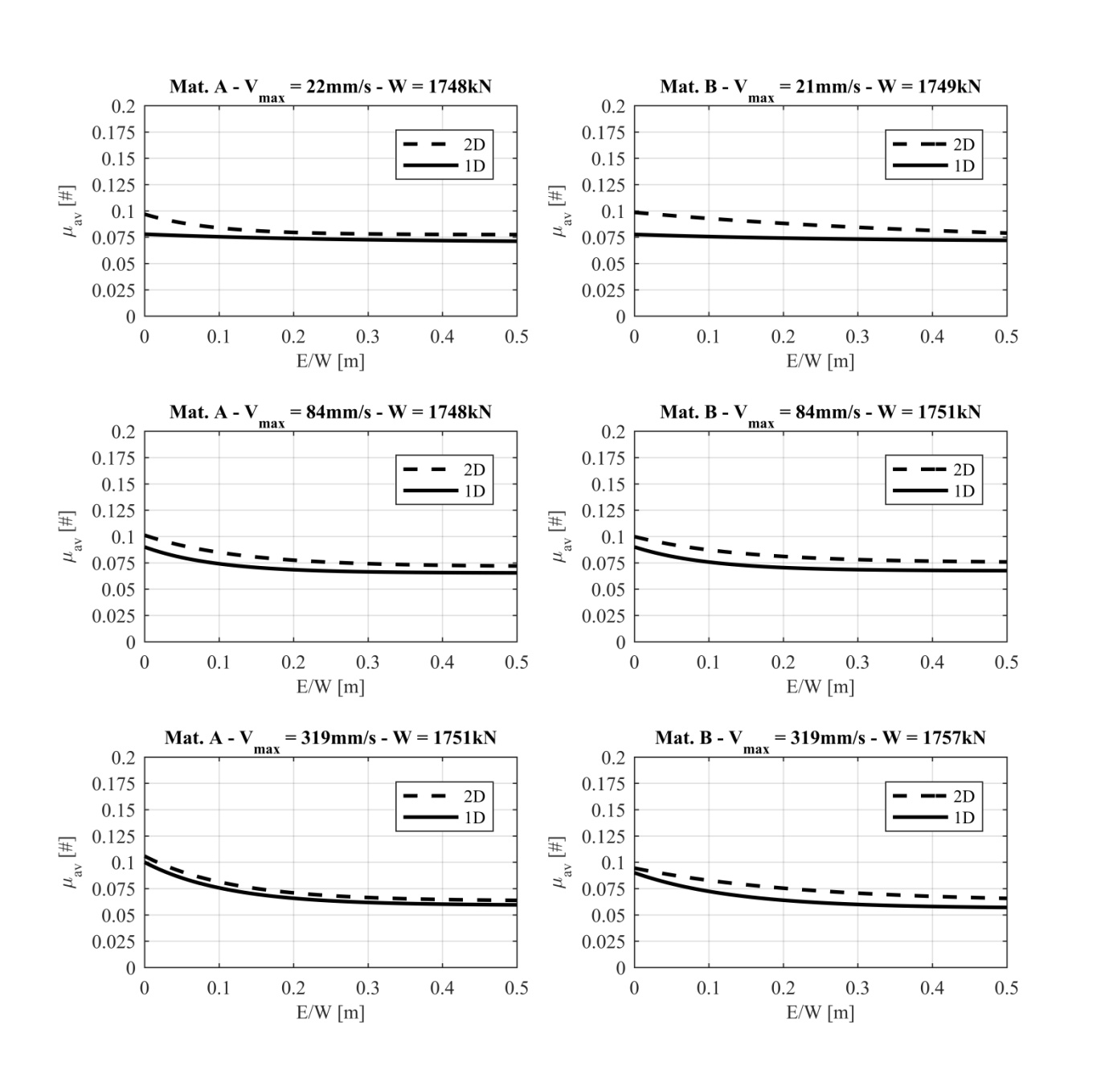
Figure 15.Cyclic decay – Contact pressure on sliding pad: 33 MPa
When the vertical load is increased to W = 1751kN, unidirectional and bidirectional decay curves become closer and eventually tend to overlap, especially at high velocities, as already observed for the initial friction coefficient. The difference between the plots is not negligible only at low velocity, where the bidirectional case returns exponentially decreasing curves, instead of a steady friction response. Nonetheless, at velocities of at least 80mm/s unidirectional and bidirectional tests provide a similar response for both materials A and B.
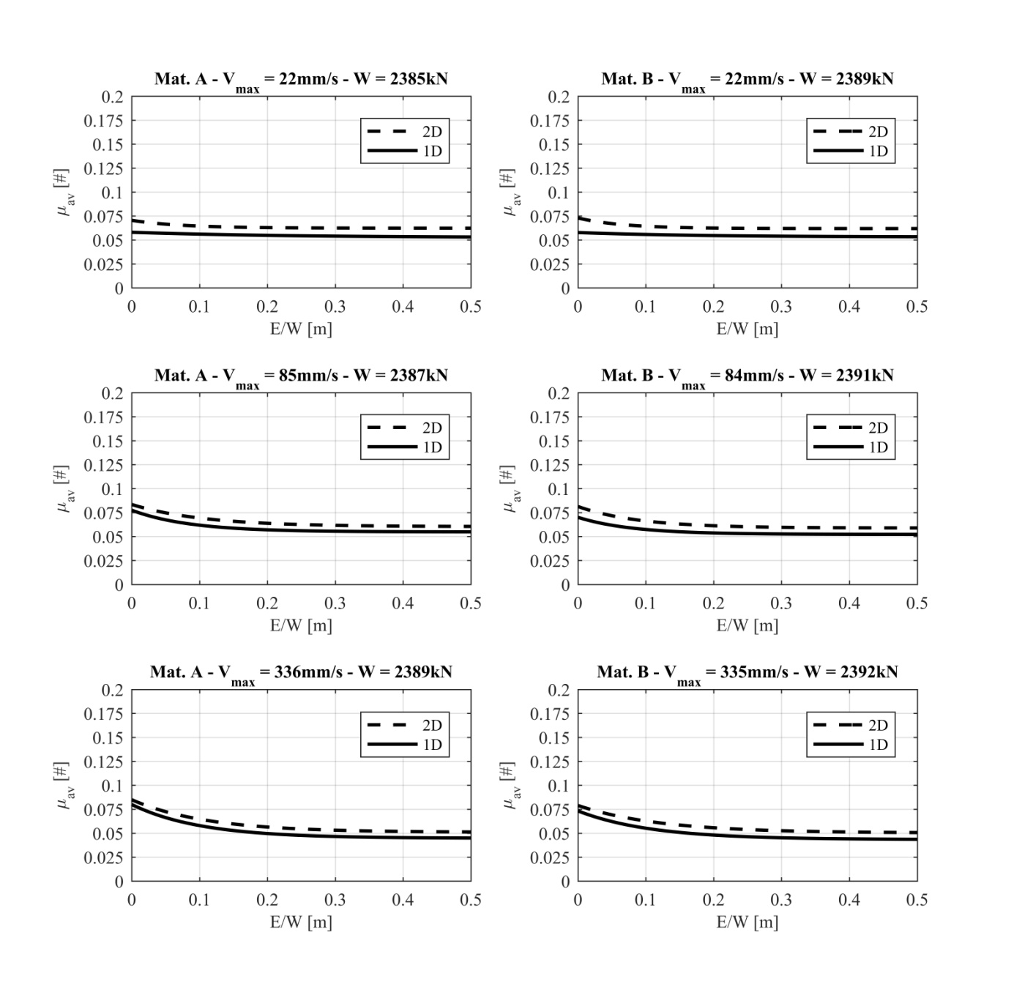
Figure 16. Cyclic decay – Contact pressure on sliding pad: 45 MPa
Eventually, at the highest level of vertical load W = 2388kN, the cyclic effect induces the same decay of coefficient of friction for both unidirectional and bidirectional motions at all velocities, without any practical differences.

discussioN
In current practice, design values of the coefficient of friction required to perform bound analyses in order to assess the seismic response of a base-isolated structural system are derived from laboratory tests: namely, the maximum friction coefficient is determined at the early onset of motion, i.e. at zero dissipated energy, whereas the minimum friction coefficient is achieved by subjecting the device to a sustained excitation, at the design velocity and the maximum vertical load. In accordance with current standards, unidirectional tests in one radial direction of the CSS device are typically performed.
The study is aimed at providing a better understanding of the experimental variation of the coefficient of friction of Curved Surface Slider devices. A first outcome of the study is that under certain conditions unidirectional tests return lower values of the coefficient of friction than observed during bidirectional motions which typically occur during real earthquakes. Therefore, whereas the unidirectional test provides a precautionary estimation of the lower bound friction value used in the analyses to calculate displacements, it is not conservative in respect to the maximum bound value used to calculate forces. In the study, a comparison was performed between unidirectional tests performed in radial direction and bidirectional tests according to the cloverleaf orbit recommended by the European standard on anti-seismic devices (CEN [2009]). As already mentioned, though the bidirectional test is preferred, the standard allows to carry out unidirectional tests in two perpendicular directions in case the testing equipment is unable to perform the former. The results of the investigation show that the difference in term of coefficient of friction is important only at low vertical loads (maximum deviation +25%), but tends to quickly reduce as the vertical load is increased. At low levels of vertical load unidirectional tests provide conservative estimates when the focus is on the lower bound value used to calculate the displacements, but are not conservative with respect to the maximum bound value. However, at high vertical load the difference between radial and bidirectional tests in terms of the coefficient of friction tends to disappear, and practical differences no longer exist. It is worth noting that equivalence of the friction coefficients along unidirectional and cloverleaf orbits for the DCSS prototype and the two PTFE-based sliding materials considered in the study, is observed for vertical loads producing contact pressure between 33 and 45MPa, i.e. in the range of practical interest for most of base isolation applications. Thus, for a conservative evaluation of displacement demands at the isolation level, the minimum coefficient of friction shall be used, which corresponds to a long-cyclic excitation at a high contact pressure. On the other hand, additional checks should be performed, in order to ensure that the superstructure experiences an equivalent linear-elastic response, when the maximum friction coefficient is modelled: in that case, frictional properties shall be defined at the early onset of motion (i.e at the breakaway).
A second outcome of the study is that the decay of the coefficient of friction during sustained motion can be modelled as an exponential decreasing function of the dissipated energy, as shown by Equation (5). Moreover, as the amount of dissipated energy increases, the coefficient of friction approaches a steady minimum value, and the ratio p_{E} between this steady value and the initial value of the coefficient of friction is dependent in practice on the sliding velocity only, whereas the effect of the vertical load can be considered negligible with sufficient accuracy. Graphical decay results (Figure 14, Figure 15 and Figure 16) show that the asymptotic decay value p_{E} is achieved for values of the ratio E/W of at least 0.3m, 0.25m and 0.2m at pressures of 15MPa, 33MPa and 45MPa respectively. Similarly to Equation (2), in an unidirectional test the coefficient of friction evaluated for a full number of cycles n_{c} at the maximum displacement D_{max} can be expressed as:
(7)
Therefore, considering n_{c} = 3 cycles, for a ratio E/W = 0.3m Equation (5) returns a coefficient of friction μ = 0.125, which matches the asymptotic value observed at P = 15 MPa; similarly, for E/W = 0.25m and E/W = 0.2m the calculated friction coefficients (μ = 0.105 and μ = 0.083, respectively) are in line with the asymptotic values at either P = 33MPa or P = 45MPa. Thus, for the tested devices, three cycles of radial movement (or three half-cycles of bidirectional movement) seem enough for achieving a reliable estimate of the p_{E} coefficient at the relevant design velocity.
A similar trend is exhibited by the rate of decay of the friction coefficient with the dissipated energy, represented by the parameter ε_{r}. At high vertical loads (corresponding for the studied DCSS device to a pressure on the pad surface P ≥ 33MPa), the rate seems to (moderately) depend on velocity only, whereas it halves when the response under low vertical load (corresponding to P = 15MPa) is considered. A lower decay rate (on average, 20% to 30% less) is observed for bidirectional rather than unidirectional motion. The cyclic effect of Curved Surface Slider devices implies significant changes in the friction coefficient value during a general seismic motion. All the presented issues are supposed to cause increased displacement demand of a seismically base-isolated system, and isolation devices may be subjected to displacements higher than the design values.
According to the approach proposed in the study through Equation (5), the decay of the coefficient of friction has been expressed as an exponentially decreasing function of the dissipated energy E, instead of a function of the temperature at the sliding surface, as proposed e.g. by (Kumar et al. [2015]). For completeness, it must be recalled that a similar formulation to model the cyclic effect was already presented in other studies (Lomiento et al. [2013b] ; Gandelli et al. [2018]). Since it is well noted that direct measurement of the temperature at the sliding interface of CSS devices during experimental tests is not practical and may lead to substantial errors (Gandelli et al. [2013] ; Quaglini et al. [2015]), by replacing the dependence of the coefficient of friction on temperature by its dependence on the dissipated energy, which can be easily calculated from force and displacement records, the present approach is indeed more practical for purpose of experimental characterization of the friction properties of sliding isolators. The reason for the consistent friction behaviour between the radial and the bidirectional motions observed at high load levels has not been investigated in detail. However, a possible explanation is provided hereinafter. Energy is dissipated by friction at the interface between the pad of sliding material and the mating stainless steel surface; therefore the heat generation can be assumed as produced by a moving source coinciding with the surface of the sliding pad. Owing to the very low thermal conductivity of thermoplastic materials, the generated heat is removed from the sliding interface by thermal conduction through the steel plate only. As a consequence, different orbits which involve more or less frequent passage of the sliding pad on heated areas of the stainless steel sliding surface affect the amount removed heat and eventually the temperature increase on the sliding material surface. This explains why at low vertical load, especially when combined with low speeds, the coefficient of friction is significantly affected by the path travelled during the motion, with appreciable differences between the unidirectional and the bidirectional trajectory. On the contrary at high vertical loads and high speeds, a huge amount of energy is dissipated at the interface, which induces an almost uniform warming of the stainless steel sliding surface; consequently, the effect of the trajectory of the specific orbit tends to become less important.
Consistent results were obtained between two commercial sliding materials considered in the study. However, it must be noted that both of them consist of PTFE compounds, though differing by filler nature and content. In order to prove the general validity of the conclusions drawn in this work, the investigation needs to be extended to other current sliding materials used by manufacturer of CSS devices, including Ultra High Molecular Weight (UHMWPE) (Cardone et al. 2015), and Polyamide (PA) (Barone et al. [2017]). This will be pursued in a future development of the research.

conclusions
The results of an experimental study performed on a prototype of Double Curved Surface Slider, considering two different PTFE-based sliding materials and unidirectional (radial) and bidirectional (cloverleaf) trajectories, are used to evaluate the effect of vertical load, speed and sustained motion on the frictional response of the device and to compare results returned by the different loading protocols. In particular, the unidirectional trajectory along the radial direction of the bearing typically performed for characterizing the coefficient of friction of sliding isolators, and the bidirectional cloverleaf trajectory recommended by the European standard (CEN [2009]) are assessed.
The main findings of the study are summarized in the next points:
- A formulation of the friction coefficient accounting for cyclic degradation due to heating of the sliding surfaces is proposed and calibrated using unidirectional and bidirectional tests;
- The decay of the friction coefficient is mainly dependent on the sliding speed, whereas the vertical load has a minor effect which can be neglected at high load levels, e.g. for the materials considered in the study, at levels producing contact pressures higher than 30 MPa);
- For combinations of vertical load and sliding velocity of practical interest for seismic isolation applications, the influence of the loading trajectory appears to be negligible. Therefore the assumption of the standard (CEN [2009]) which allows to replace the bidirectional test by radial tests in two perpendicular directions seems to be substantiated;
- Some general guidance for the experimental estimation of the design variation range of the friction coefficient of Curved Surface Slider devices to be used to perform bound analyses is drawn.

Funding
This study was funded by Italian Civil Protection (Convenzione DPC-EUCENTRE 2014-2016 - ReLUIS project 2014-2018).

Conflict of Interest
Declarations of interest: none.

references

AASHTO [2014] Guide Specifications for Seismic Isolation Design, American Association of State Highway and Transportation Officials, Washington, DC.

ASCE [2017], ASCE/SEI 7-16. Minimum Design Loads for Buildings and Other Structures, American Society of Civil Engineers ASCE, Reston, VA.

Barone, S., Calvi G.M., Pavese, A., [2017] “Experimental dynamic response of spherical friction-based isolation devices, Journal of Earthquake Engineering,” DOI: 10.1080/13632469.2017.1387201.

Cardone, D., Gesualdi, G. and Brancato, P. [2015] “Restoring capability of friction pendulum seismic isolation systems,” Bulletin of Earthquake Engineering 13(8), 2449–2480. DOI:10.1007/s10518-014-9719-5.

Castaldo, P., Palazzo, B., Della Vecchia, P., [2015] “Seismic reliability of base-isolated structures with fiction pendulum bearings,” Engineering Structures, 95:80-93.

Castaldo, P., Mancini, G., Palazzo, B. [2018] “Seismic reliability-based robustness assessment of three-dimensional reinforced concrete systems equipped with single-concave sliding devices,” Engineering Structures, 163:373-387.

CEN [2009], Comité Européen de Normalisation TC 340, European Code UNI EN 15129:2009 Anti-seismic devices, European Committee for Standardization, Brussels, Belgium.

Constantinou, M.C., Mokha, A., Reinhorn, A.M. [1990] Teflon bearings in base isolation II: Modeling, Journal of Structural Engineering, Vol. 116, No. 2, pp. 455-474.

De Domenico, D., Ricciardi, G., Benzoni, G., [2018] “Analytical and finite element investigation on the thermo-mechanical coupled response of friction isolators under bidirectional excitation,” Soil Dynamics and Earthquake Engineering, 106:131-147.

Dolce, M., Cardone, D., and Croatto, F. [2005] “Frictional behavior of steel-PTFE interfaces for seismic isolation,” Bulletin of Earthquake Engineering, Vol. 3, pp. 75–99.

Fenz, D., Constantinou, M.C. [2006] “Behaviour of the double concave friction pendulum bearing,” Earthquake Engineering and Structural Dynamics, Vol. 35, pp. 1403–1424.

Furinghetti, M., Pavese, A. [2017a] “Investigation of the Lateral Response of Friction-Based Isolators under Multi-Cyclic Excitations,” 16th WCEE, World Conference on Earthquake Engineering, Santiago, Chile.

Furinghetti, M., Pavese, A. [2017b] “Equivalent Uniaxial Accelerogram for CSS-Based Isolation Systems Assessment under Two-Components Seismic Events”, Mechanics Based Design of Structures and Machines, DOI: 10.1080/15397734.2017.1281145.

Fuji Prescale: http://www.fujifil.com/products/prescale/prescalefilm

Gandelli, E., Quaglini, V., Dubini, P., Bocciarelli, M., Poggi, C. [2013] “Frictional heating in sliding seismic isolators,” ANIDIS 2013 L’ingegneria sismica in Italia, Padova, Italy.

Gandelli, E., Penati, M., Quaglini, V., Lomiento, G., Miglio, E., Benzoni, G.M. [2018] “A novel OpenSees element for single curved surface sliding isolators,” Soil Dynamics and Earthquake Engineering, DOI: 10.1016/j.soildyn.2018.01.044.

Kumar, M., Whittaker, A. S., Constantinou, M. C. [2015] “Characterizing friction in sliding isolation bearings,” Earthquake Engineering and Structural Dynamics, 44:1409–1425.

Lomiento G, Bonessio N, Benzoni G [2013a] “Concave sliding isolator’s performance under multi-directional excitation,” Ingegneria Sismica, 30(3):17-32.

Lomiento, G., Bonessio, N., and Benzoni, G. [2013b] “Friction model for sliding bearings under seismic excitation”, Journal of Earthquake Engineering 17(8), 1162–1191, doi:10.1080/13632469.2013.814611.

Marioni, A, Dalpedri, R. [2015] “HITEEQ - The HIRUN test equipment”, 14th WCSI World Conference on Seismic Isolation, Energy Dissipation and Active Vibration Control of Structures, San Diego, Ca USA

Martelli A, Clemente P, De Stefano A, Forni M, Salvatori A. “Recent development and application of seismic isolation and energy dissipation and conditions for their correct use.” In: Ansal A, editor. Perspectives on European earthquake engineering and seismology, volume 1. New York: Springer; 2014. p. 449–88.

Mazza, F [2017] “Lateral-torsional response of base-isolated buildings with curved surface sliding system subjected to near-fault earthquakes”, Mechanical Systems and Signal Processing, 92, 64-85.

Mazza, F, Mazza, M [2017] “Sensitivity to modelling and design of curved surface sliding bearings in the nonlinear seismic analysis of base-isolated r.c. framed buildings”, Soil Dynamics and Earthquake Engineering, 79, 951-970.

Mokha, A., Constantinou, M.C., and Reinhorn, A. [1990] “Teflon Bearings in Base Isolation I: Testing”, Journal of Structural Engineering ASCE 116(2), 438-454, doi:10.1061/(ASCE)0733-9445.

Mokha, A., Constantinou, M.C., and Reinhorn, A.M. [1993] “Verification of Friction Model of Teflon Bearings under Triaxial Load”, Journal of Structural Engineering ASCE 119(1), 240-261, doi:10.1061/(ASCE)0733-9445(1993)119:1(240).

Mosqueda, G., Whittaker, A.S., and Fenves, G.L. [2004] “Characterization and modeling of friction pendulum bearings subjected to multiple components of excitation”, Journal of Structural Engineering ASCE 130(3),433–442.

Pavese, A., Furinghetti, M., Casarotti, C. [2018] “Experimental Assessment of the Cyclic Response of Friction-Based Isolators under Bidirectional Motions,” Soil Dynamics and Earthquake Engineering, DOI: 10.1016/j.soildyn.2018.06.031.

Peloso, S., Pavese, A., Casarotti, C. [2012] “Eucentre trees lab: Laboratory for training and research in earthquake engineering and seismology,” Geotechnical, Geological and Earthquake Engineering, Vol. 20, pp. 65-81.

Quaglini, V., Bocciarelli, M., Gandelli, E, Dubini, P. [2015] “Numerical Assessment of Frictional Heating in Sliding Bearings for Seismic Isolation,” Journal of Earthquake Engineering, Vol. 18, No. 8, pp. 1198-1216.

Quaglini, V., Gandelli, E., Dubini, P. [2017], “Response of Curved Surface Sliders under bidirectional displacement orbits” In: “XVII Convegno ANIDIS”, Pistoia, pp. 1 – 10, Article id. 2719.

Zayas, V.A., Low, S.S., and Mahin, S.A. [1987] “The FPS earthquake protection system”, Report No. 87-01, Earthquake Engineering Research Center, Berkeley.

Zayas, V.A., Low, S.S., and Mahin, S.A. [1990], “A simple pendulum technique for achieving seismic isolation”, Earthquake Spectra, V. 6, No. 2, pp. 317-333.

