Rammed Earth incorporating Recycled Concrete Aggregate: a sustainable, resistant and breathable construction solution

Alessandro Arrigoni ª, Christopher T. S. Beckett ^{b}, Daniela Ciancio ^{c}, Renato Pelosato ª, Giovanni Dotelli ª, Anne-Cécile Grillet ^{d}
ª Dipartimento di Chimica, Materiali e Ingegneria Chimica “G. Natta”, Politecnico di Milano, Piazza Leonardo da Vinci 32, Milano, 20133, Italy
^{b} Institute for Infrastructure and Environment, School of Engineering, The University of Edinburgh, Edinburgh, EH93JL, United Kingdom
^{c} School of Civil & Resource Engineering, The University of Western Australia, Perth, WA 6009, Australia
^{d} LOCIE, CNRS-UMR 5271, Université Savoie Mont Blanc, Campus Scientifique Savoie Technolac, Le Bourget du Lac 73376, France

CORRESPONDING AUTHOR:
Alessandro Arrigoni, Dipartimento di Chimica, Materiali e Ingegneria Chimica "G. Natta", Politecnico di Milano, piazza Leonardo da Vinci 32, 20133 Milano, Italy
E-mail address: alessandro.arrigoni@polimi.it

ABSTRACT
Construction and demolition debris, mainly concrete and masonry rubble, represent a significant share of municipal waste. Recycling crushed concrete aggregates and using them as substitutes for natural ones might therefore be determinant in reducing landfilling and mineral resource depletion. An innovative way to give new value to Recycled Concrete Aggregates (RCAs) is to ram them in layers to form load-bearing walls for stabilised Rammed Earth (RE) applications. However, the success of those few existing RE projects using RCA is mainly due to the knowledge and experience of the contractors rather than official standards or guidelines or scientific literature. The objective of this study was to further the knowledge of this building technique by determining the effect of different RCA replacements on the material’s mechanical resistance, sustainability and hygroscopic properties: indicative of the structure’s structural, environmental and hygrothermal performance. Mechanical resistance was assessed by means of the Unconfined Compressive Strength (UCS, commonly used for rammed earth-like materials), hygroscopic properties via Moisture Buffer Value (MBV) and sorption isotherms while the sustainability was assessed via consequential Life Cycle Assessment (LCA). Microstructural investigations via mercury intrusion porosimetry, nitrogen adsorption-desorption isotherms, scanning electron microscopy and X-ray diffraction were performed to understand and explain material mechanical and hygroscopic behaviour. The building technique, already proven to be durable, was demonstrated to be resistant (from 4 to 12 MPa at 28 days depending on the RCA replacement and cement content), sustainable (down to 25 kg CO₂-eq. of embodied carbon per square meter of load-bearing wall) and to have good moisture buffering abilities (0.88 g/(m2 %RH) for mixtures containing only RCA). Strength appeared to be more related to the particle size distribution of the mix rather than to the percentage of RCA added. The amount and type of stabiliser added to the mix and the distance covered by the RCA during its lifetime strongly affected the environmental sustainability of the mixture; to maximise the potential of this building technique, reducing the amount of cement in the mixture by using alternative stabilisers should be the main priority.

KEYWORDS
Rammed Earth; Recycled Concrete Aggregate; Life Cycle Assessment; Moisture Buffer Value; Unconfined Compressive Strength; Microstructure

ABBREVIATIONS
BET Brunauer, Emmett and Teller
BJH Barrett, Joyner and Halenda
CDW Construction and Demolition Waste
CEM Cement
CL Crushed Limestone
ES Engineered Soil
FA Fly Ash
GHG Greenhouse Gas
LCA Life Cycle Assessment
LL Liquid Limit
MBV Moisture Buffer Value
MDD Maximum Dry Density
MIP Mercury Intrusion Porosimetry
OWC Optimum Water Content
PL Plastic Limit
PSD Particle Size Distribution
RCA Recycled Concrete Aggregate
RE Rammed Earth
RH Relative Humidity
RRCA Rammed Recycled Concrete Aggregate
SRE Stabilised Rammed Earth
UCS Unconfined Compressive Strength
XRD X-Ray Diffraction

INTRODUCTION
Maximising reuse and recycling of waste materials is one of the main paradigms of a circular economy. To boost the transition towards more sustainable economic growth, different governments are adopting strategies to reduce the amount of waste landfilled and to increase recycling rates. The European Commission, for instance, adopted a Circular Economy Package, which includes legislative proposals such as targets for recycling 65% of municipal waste and to reduce its landfilling to a maximum of 10% by 2030 (European Commission, 2015): as it currently stands, only 35% of the non-compostable fraction of municipal waste is recycled and almost 30% is still committed to landfill (Eurostat, 2018).
A significant share of municipal waste is occupied by construction and demolition debris (approximately 35% in Europe (Eurostat, 2014)), which in turn mainly comprise concrete and masonry rubble. In Europe, it is estimated that roughly 1,350 Mt of concrete is produced annually (approximately 2.7 tonnes per inhabitant) and about 350 Mt of concrete debris are generated (European Commission and BIO Intelligence Service, 2011). Global figures are even more astonishing: worldwide concrete production was estimated to be 10 billion m³ in 2012 (i.e. approximately 1.4 m³ per person), with Asia and particularly China being the primary consumers (Miller et al., 2016). Data concerning global concrete waste generation and recycling is harder to obtain. Several developed countries already reuse or recycle most of the waste originating from demolished structures: in the Netherlands, for example, more than 95% of the Construction and Demolition Waste (CDW), mainly composed of concrete aggregates, is recycled (BIO Intelligence Service, 2015). However, the same cannot be said for many other countries in Europe, where only between 30% (Johnson, 2014) and 60% (European Commission and BIO Intelligence Service, 2011) of concrete is in fact estimated to be recycled. Figures for CDW recycling have a wide geographical variation in the rest of the world too: in Taiwan, for instance, the recovery rate is higher than 90% (Cement Sustainability Initiative, 2009), while in Australia more than 30% is still disposed of by landfill (Randell et al., 2014) and in China only about 5% of total CDW is reused or recycled (Duan and Li, 2016).
Concrete can be either re-used in its original form or, most commonly, it can be reprocessed into coarse or fine aggregates. Once sorted and processed, coarse Recycled Concrete Aggregates (RCAs) can be used for road works as base or sub-base (Paranavithana and Mohajerani, 2006), reintroduced into the manufacturing of concrete as a substitute for natural aggregates (Fraile-Garcia et al., 2017) or used as backfilling material in quarries, foundations, etc. (Vieira and Pereira, 2015). Incorporating RCAs in new concrete structures may reduce the latter’s enormous environmental impact (Hossain et al., 2016); more than 4% of total greenhouse gas (GHG) emissions over the past decade were in fact related to concrete manufacturing (IPCC, 2014). Although using RCA may not make significant CO₂ emission savings, substituting natural aggregates with recycled ones might be determinant in terms of curbing waste production and natural mineral resource depletion (Kleijer et al., 2017). Moreover, recovering the demolished concrete leads to considerable cost advantages to the contractor by eliminating charges for waste disposal (Mah et al., 2018). The environmental and cost benefits of employing RCAs might be particularly true for cases where the supply of gravel is constrained (Ioannidou et al., 2017).
An innovative way to reuse demolished concrete is to ram it into layers to form load-bearing walls for stabilised rammed earth (SRE) applications (Hall and Swaney, 2005). Rammed earth is an ancient construction procedure where walls are built by compacting an earthen mixture between formwork. SRE is a modern form of rammed earth that involves the addition of a (usually cementitious) binder to the earth mix to improve the material’s mechanical resistance (Walker et al., 2005). Right now, the most used stabiliser is cement but alternative, more environmentally friendly binders such as by-products (e.g. fly ash (da Rocha et al., 2014), calcium carbide residue (Arrigoni et al., 2017c)) or natural polymers (e.g. (Achenza and Fenu, 2006; Eires, 2012)) are being explored. RCA can partially or entirely substitute the sub-soil typically used for earthen construction. However, the success of those RE projects that have used RCA is due to the knowledge and experience of the contractors involved in the projects (for example the design of the deep elevated beam shown in Figure 1), rather than the presence of any official or rigorous standards or guidelines on this topic. In contrast to concrete, where the use of RCA has been extensively investigated (Behera et al., 2014), the research currently available in literature on the use of RCA for SRE applications is almost non-existent. The first attempt to populate the scientific database with information was done by Taghiloha, who explored the effect on the mechanical properties of SRE caused by a partial replacement of the larger particles (i.e. gravel and sand) with RCA (Taghiloha, 2013). SRE mixes incorporating RCA proved to have an acceptable (but lower) compressive strength than the counterpart with natural aggregates. Advancing on the same topic, Jayasinghe et al. tested the compressive and flexural strength of SRE incorporating building demolition waste in order to find an optimum proportion. Results indicated a mix proportion of 1:5:5 of cement:soil:demolition waste (by mass or volume was not specified) as the best combination to form a new building material with satisfactory load bearing properties (Jayasinghe et al., 2016).
Building on these works, the mechanical behaviour of SRE samples with different RCA replacement percentages was investigated here with the goal of understanding whether a diffusion of this innovative technique might be desirable. Additionally, durability and environmental sustainability results, which were first examined in a previous study (Arrigoni et al., 2017a), were integrated with new information covering the hygroscopic and microstructural properties of the material to create a full characterization of the construction technique.

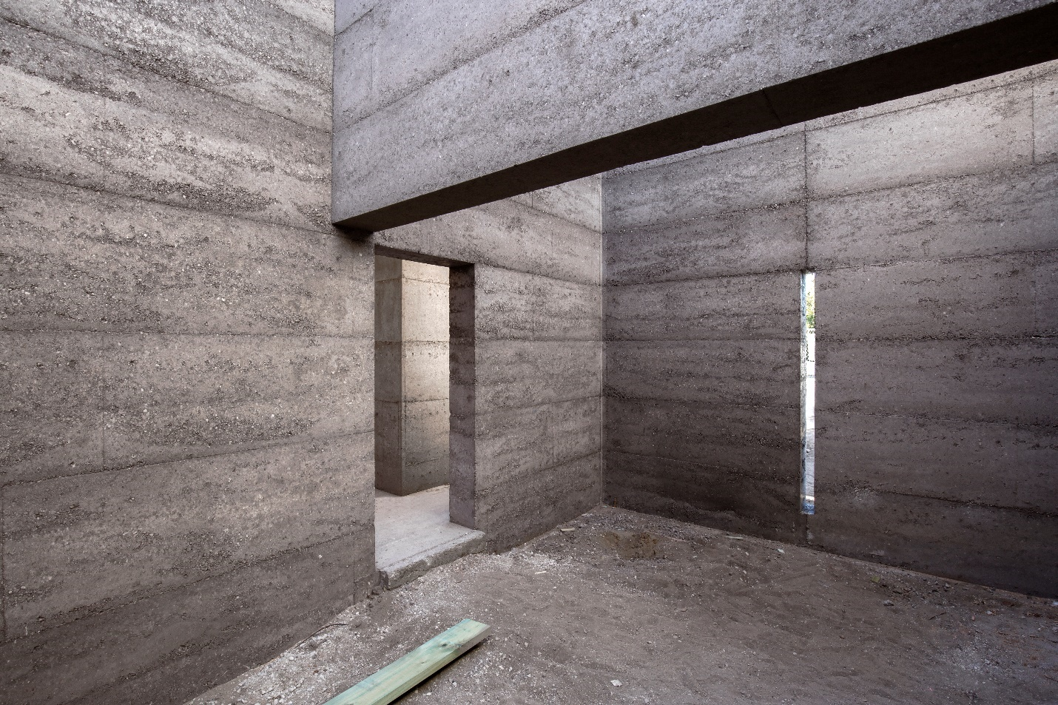
Figure 1. Example of a Rammed Earth house manufactured exclusively from RCA (with cement and oxides added for strength and colour respectively) in Perth, Australia (credit: Hera Engineering (Hera Engineering Pty Ltd.))

MATERIALS AND METHODS

Materials

Recycled Concrete Aggregate
RCA was obtained from demolished structures in the metropolitan area of Perth, Western Australia. Aggregate sizes were predominantly between 0.6 and 19mm (i.e. sand and gravel grains). Specimens tested either comprised solely RCA and stabiliser or a mixture of RCA, “artificial” soil (described in the following sections) and stabilisers. The entire grading was used when RCA was the only constituent; when RCA was paired with soil, RCA size fraction smaller than 6 mm and greater than 19 mm were discarded for a better control of the final granulometry. X-Ray Diffraction (XRD) analyses on RCA samples (Figure 2) revealed the presence of Quartz (SiO₂), Calcite (CaCO₃), Anorthite (CaAl₂Si₂O₈), and traces of Larnite (C₂S, Ca₂SiO₄) phase. The latter indicates the presence of residual un-hydrated cement in the RCA, while the presence of Anorthite could be attributed to the presence of bricks or other ceramic contaminants (Ahmad and Iqbal, 2016).

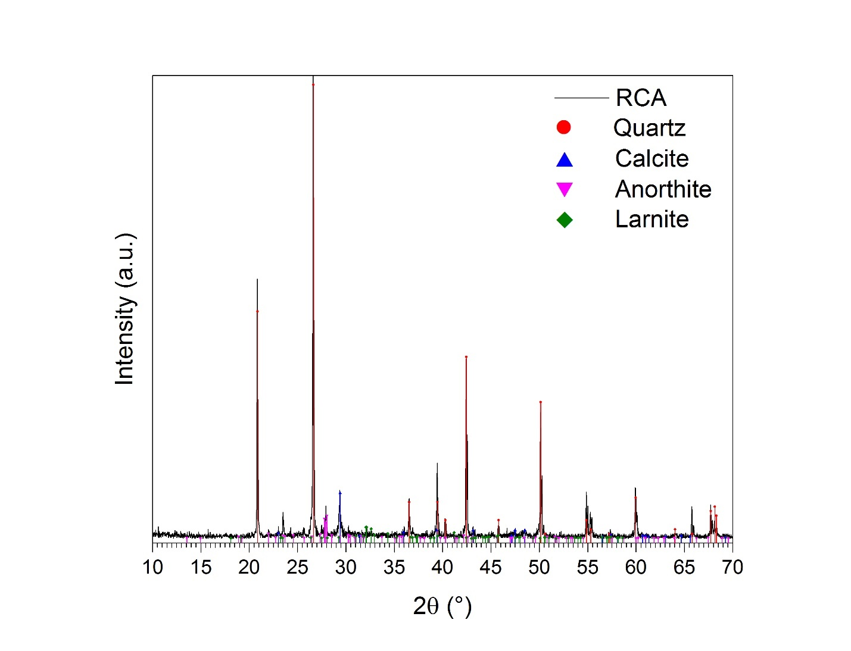
Figure 2. X-Ray Diffraction pattern of recycled concrete aggregates.

Mixtures
The primary constituent of traditional RE is inorganic sub-soil taken from deposits found beneath organic topsoil. As soil characteristics are site specific and highly variable, for this study it was decided to create artificial earth mixes to allow for repeatable results. To determine the effect of RCA substitution on RE compressive strength two testing groups, each comprising one artificial soil and varying amounts of RCA, were established, as shown in Table 1. Each group consisted of a benchmark mix (0% RCA replacement) and 3 mixes with respectively 25, 50 and 75% by mass of RCA substitution. Furthermore, batches made only of RCA were tested. A summary of all the mixtures prepared is also presented in Table 1. The first benchmark was a Crushed Limestone (CL) typically used in Western Australia in RE projects, owing to its ready availability. The second benchmark mix was an “engineered” soil created using Kaolin clay (10%, PL=27%, LL=61% (Cocjin et al., 2014)), silica flour (to simulate silt particles, 20%), clean sand (50%) and 10-mm blue aggregate (20%) and will be referred to as Engineered Soil (ES). The Particle Size Distribution (PSD) curves of the benchmark mixes are reported in Figure 3. Portland cement (CEM, 7% by dry mass) was added to all materials to improve the mechanical resistance of the mixtures. For the batches comprising only RCA, additional mixtures comprising a different amount of cement (i.e. 10%) or by partial replacement of cement with fly ash (i.e. 5% cement + 5% fly ash) were also investigated. Fly Ash (FA) is the residue from coal power plants and its addition to the mixture was here considered due to its good performance as cement replacement and its environmental friendliness (Xu and Shi, 2018). FA used in this study was classified as class F according to its calcium content (ASTM, 2015). The chemical analysis showed that the material comprised 58.7% SiO₂, 27.4% Al₂O₃, 8.1% Fe₂O₃, 1.6% TiO₂ and 0.9% CaO. Mixture labels in Table 1 list that mix’s constituent parts: for example, “100RCA + 5CEM 5FA” indicates a 100% RCA substrate with an additional 5% Portland cement and 5% fly ash by mass.

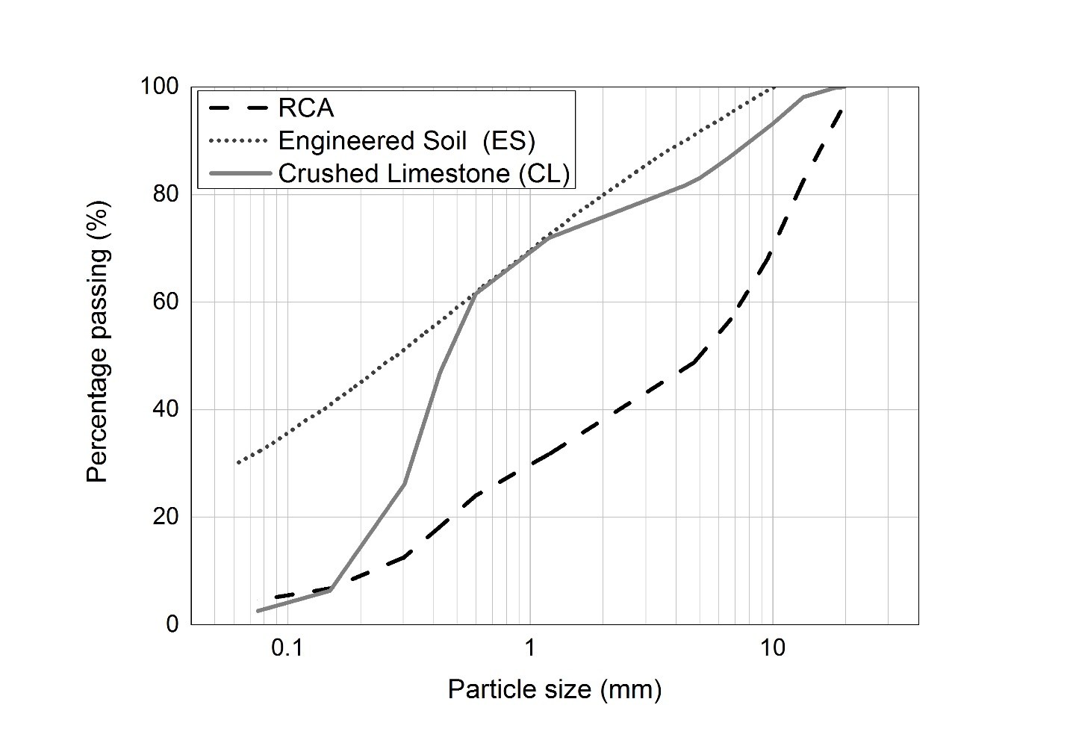
Figure 3. Particle size distribution of RCA, Engineered Soil (ES) and Crushed Limestone (CL)

Table 1. Overview on the different mixtures analysed. wt. % indicates the weight percentage of dry substrate.
GROUP | MIXTURE | SUBSTRATE |  |  | ADDITIVES |  | Optimum Water Content (OWC) | Maximum Dry Density  (MDD) | Coefficient of uniformity | Coefficient of curvature
GROUP | MIXTURE | RCA  (Sieved (S)/Non-Sieved (NS)) | Engineered Soil (ES) | Crushed Limestone  (CL) | Cement  (CEM) | Fly Ash  (FA)
GROUP | MIXTURE | [wt. %] | [wt. %] | [wt. %] | [wt. %] | [wt. %] | [%] | [g/cm³]
1 | 100CL + 7CEM | - | - | 100 | 7 | - | 8.2 | 1.97 | 3.4 | 1.1
1 | 75CL + 7CEM | 25 (S) | - | 75 | 7 | - | 11.7 | 1.93 | 17 | 0.2
1 | 50CL + 7CEM | 50 (S) | - | 50 | 7 | - | 12.4 | 1.93 | 30 | 0.2
1 | 25CL + 7CEM | 75 (S) | - | 25 | 7 | - | 14.7 | 1.79 | 22 | 9.9
2 | 100ES + 7CEM | - | 100 | - | 7 | - | 6.8 | 2.21 | 9.0 | 0.1
2 | 75ES + 7CEM | 25 (S) | 75 | - | 7 | - | 9.6 | 2.06 | 29 | 0.1
2 | 50ES + 7CEM | 50 (S) | 50 | - | 7 | - | 10.3 | 2.00 | 89 | 0.6
2 | 25ES + 7CEM | 75 (S) | 25 | - | 7 | - | 11.9 | 1.89 | 62 | 28
3 | 100RCA + 7CEM | 100 (S) | - | - | 7 | - | 16.0 | 1.79 | 1.4 | 0.8
3 | 100RCA + 10CEM | 100 (NS) | - | - | 10 | - | 12.7 | 1.98 | 34 | 0.6
3 | 100RCA + 5CEM 5FA | 100 (NS) | - | - | 5 | 5 | 12.7 | 1.99 | 34 | 0.6

Methods

Mechanical resistance
Mechanical performance of concrete (Verian et al., 2018) and mortars (Raeis Samiei et al., 2015) containing RCAs is highly dependent on the quality of the aggregates; nevertheless, strength generally decreases with increasing RCA content (Fraj and Idir, 2017). The suitability and durability of rammed earth materials are qualified via their unconfined compressive strengths (UCSs). The effect of RCA replacement on UCS was therefore examined in this work to contrast results to those available in the literature for traditional cement-stabilised RE materials. Cylinders of 100-mm diameter and 200-mm height comprising five layers of equal mass and volume were manufactured following techniques described in previous works (Beckett and Ciancio, 2014). Specimens were manufactured at their Maximum Dry Density (MDD) obtained via the modified Proctor Test (Standards Australia, 2003). The MDDs and the Optimum Water Contents (OWCs) resulting from the modified Proctor test are reported in Table 1. Once manufactured, cylinders were placed in a curing room for 28 days at constant humidity (RH: 96 ± 2%) and temperature (21 ± 1 °C). After curing, the cylinder UCS was tested using a soft-board sheet as contact material between the specimen and the machine platens to ensure a uniform application of the load; this was necessary as specimen ends could not be polished for fear of damage (Ciancio and Gibbings, 2012). At least 3 specimens for each mix were manufactured and the compression was performed at 0.3 mm/min displacement rate until failure (Ciancio and Gibbings, 2012). Specimen dry density and water content at the time of testing was calculated by measuring their weight and volume before testing and by transferring part of the crushed sample to an oven at 105 °C and drying for 24 h.

Environmental impact assessment
The environmental benefits of using RCA as a substrate for RE structures in comparison with traditional and innovative earthen mixtures was presented by the authors in a previous work (Arrigoni et al., 2017a). Although the environmental sustainability of the analysed SRE mixtures was shown to be strictly related to the amount and type of stabiliser, attributional Life Cycle Assessment results confirmed the environmental benefits of using a waste material in comparison to quarried products. In the present work, the analysis is enriched with the assessment, from a consequential point of view, of the environmental benefits of partially replacing the substrate of traditional RE mixture with RCA. The consequential approach, in opposition to the attributional, aims to capture the environmental consequences due to a change in the system under study (Weidema, 2003). Moreover, it bypasses the discussion on the best way to allocate the impacts to “by-products” or “wastes” (Chen et al., 2010). In fact, when a by-product is used as an input to the system, which methodological approach to adopt depends on the constraints of the by-product market (Ekvall and Weidema, 2004). When part of the material is disposed, until an increase in the demand can be satisfied without affecting other consumers, the by-product can be classified as waste and be available burden free. Conversely, when the market is constrained and an additional demand for the material cannot be satisfied without affecting other consumers (e.g. more fly ash would not be produced even though there was a larger demand), its use should be modelled as if the unconstrained alternative on the market was used (in the case of fly ash this could be another cementitious product, such as cement (Crossin, 2015)) (Consequential-LCA, 2015). Since both the by-products considered in this research (i.e. RCA and fly ash) are still party landfilled in Western Australia (Arrigoni et al., 2017a) and RE building still occupies a niche of the construction sector market (Ciancio and Boulter, 2012), the by-products were modelled as waste, for which the credits from avoided landfilling were also accounted.
Together with global warming, new indicators (i.e. land use and water consumption) from the recently updated ReCiPe2016 method were used to assess the environmental impacts of the different RRCA mixtures (Huijbregts et al., 2016). The approach of the study was “from cradle to gate” (i.e. limited to the production stage of the mixtures (ISO, 2006)).
The reference scenario for the assessment was the most typical mixture used in Western Australia for RE applications: crushed limestone as substrate and Portland cement as stabiliser (i.e. 100CL + 7CEM). Two different functional units were considered in the analysis: i) 1 kg of SRE mixture and ii) 1 m² of finished 300-mm thick load-bearing wall. Different units were investigated considering that, even though one mixture may be more sustainable by mass, the finished walls may differ in density and require different amounts of base constituents. Since the impacts due to transportation depend on the location of the building site with respect to the source of the base components, the same distance (equal to 50 km) was considered to be covered by any good transported to the site. For comparison purposes, the base constituents used for the engineered soil mixtures were assumed to be taken from site-excavated soil. Although the comparison is interesting to understand the transportation role in the final environment cost of the earthen structure, it is unlikely that the in situ soil, especially in Western Australia, would be suitable for RE construction without needing additional components to improve its natural grading (Ciancio et al., 2013).

Hygroscopicity
Hygroscopic performance of walls, closely related to their humidity buffering potential, is a key contributing factor to indoor perceived comfort and a key asset used to promote earthen construction (McGregor et al., 2016). Hence, hygroscopic performance, via Moisture Buffer Value (MBV) and moisture adsorption-desorption isotherms, was examined here to determine any detrimental or advantageous effects of RCA replacement on likely internal comfort. The mix tested, chosen as representative for RRCA, was 100RCA + 10CEM (i.e. RCA as the only substrate material, stabilised with 10% cement).
Moisture buffering ability was tested according to the Nordtest standard (Rode, 2005) by alternatively exposing the surface of a specimen to a 75% and 33% Relative Humidity (RH) environment. Specimens used for the test were 20mm high cylinders with a 100mm diameter. Details on the climatic chambers used for the test can be found in (Arrigoni et al., 2017b).
ISO 12571 was used as reference standard to determine the sorption and desorption isotherms (ISO, 2013). Two samples with a mass of approximately 50 g were used and, to avoid particle loss, they were wrapped in a permeable and hydrophobic nonwoven fabric. Samples were first oven-dried to constant mass and then placed consecutively in a series of environments at constant temperature (25 °C) and increasing RH levels: 9%, 22%, 33%, 58%, 75%, 84% and 97%. The targeted humidity level was obtained via saturated salt solutions and constantly monitored with HygroPuces sensors (accuracy ±3% (Waranet Solutions SAS)). When the samples reached a constant mass (i.e. the mass variation for three consecutive days was lower than 0.1% of the sample weight), they were moved to the next environment in the sequence. Once in the environment with a RH level of 97%, the reverse process was performed to obtain the desorption curve.

Microstructural characterisation
To understand and explain the hygroscopic and mechanical behaviour of RRCA, the microstructure of crushed samples was investigated by means of porosimetry and microscopy.
Pore size distribution and surface area were investigated via mercury intrusion porosimetry (MIP) and nitrogen adsorption-desorption isotherms using an AutoPore IV 9500 Hg porosimeter and a TriStar 3000 analyser respectively (Micromeritics Instrument Corporation). The Barrett, Joyner and Halenda (BJH) and the Brunauer, Emmett and Teller (BET) methods were used to derive respectively the pore size distribution and the surface area from the nitrogen isotherm. The pore diameter range investigated with the mercury intrusion technique was from 60,000 to 6 nm, while that investigated by the BJH method spanned from 300 to 1.7 nm. The techniques were chosen to cover most of the porosity belonging to the system investigated. Moreover, according to the conjoined Kelvin-Laplace equation, results could partially justify the behaviour of the different mixtures during the MBV test (Atkins and De Paula, 2006). In fact, although the pores that likely remained filled even at the lowest humidities (i.e. pores with a radius below 10 Å) could not be identified, the techniques allowed the larger pores that were gradually filled in the high humidity chamber to be detected (Arrigoni, 2017). In a typical experiment, about 0.2-0.5 g of material was tested. Before testing, samples were adequately deaerated.
A Cambridge Stereoscan 360 Scanning Electron Microscope was employed to investigate the morphology of the samples. Fractured surfaces and polished samples (after being incorporated in an organic resin) were observed. The samples were gold coated before the analysis to prevent charging effects.

RESULTS

Mechanical resistance

RCA
UCS results of the different mixes investigated here with respect to their RCA content are presented in Figure 4. Although all mixes complied with the minimum 2.0 MPa compressive strength requirement for stabilised earthen structures (indicated by the red line in Figure 4) according to the Australian Earth Building Handbook (Walker and Standards Australia, 2001), it is evident that RCA replacement detrimentally affected the UCS values of both mixes. Whilst the addition of RCA caused a decrease in strength in the CL group compared with the specimens made without recycled aggregates (i.e. 100CL + 7CEM), the decrease was not linearly proportional to the addition of RCA; conversely, a clear trend was not evident for the ES group. Certainly, other factors above RCA replacement percentage, for instance the particle size distribution, should be taken into account to understand this mechanical behaviour. Although the increase in strength with the addition of RCA in some soil mixes seemed to suggest that some optimal PSD may exist, coefficients of uniformity and curvature for the different mixes (Table 1, describing the shape of the PSD) did not exhibit a clear correlation with the compressive strengths. The same could be said for the initial dry densities, depicted as rhombuses in Figure 4, which, while tending to decrease with the increase in RCA content, did not present a clear correlation with strength. Rather, results agreed with previous studies, which highlighted that dry densities cannot be a standalone proxy for strength when more than one material and/or a binder are used (Beckett and Ciancio, 2014).
Mechanical properties of RRCA (i.e. rammed mixtures that had RCA as the only substrate) varied when a different binding agent was used. When the amount of cement was increased to 10%, unconfined compressive strength at 28 days went from 4.2 MPa to 8.4 MPa. More interestingly, a net increase was noticed also when cement content was reduced to 5% and an additional supplementary cementitious material was applied (i.e. 5% fly ash): after 28 days specimens exhibited an average UCS of 6.7 MPa. Nevertheless, it must be noted that the mixtures with different binders, presented by the authors in previous research (Arrigoni et al., 2017a), were tested starting from a different non-sieved RCA batch.

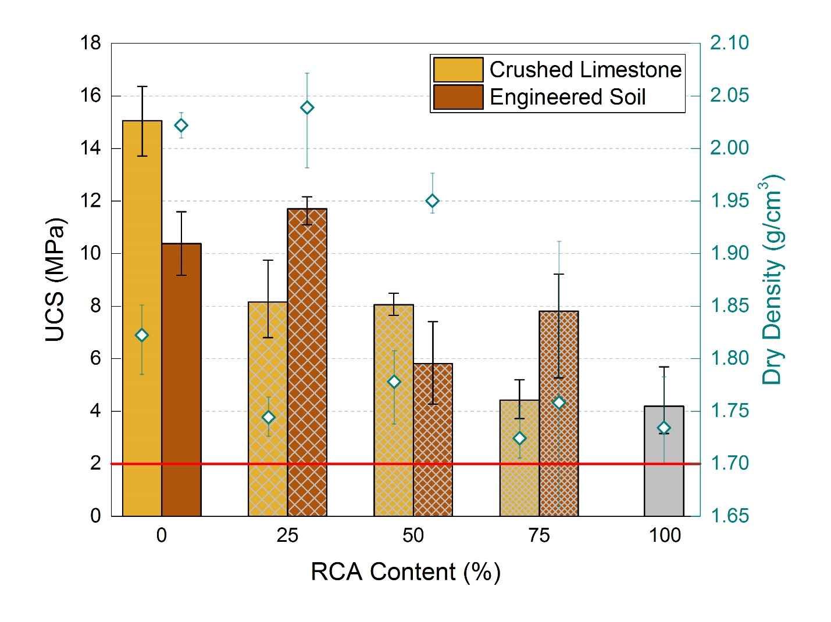
Figure 4. Unconfined Compressive Strength (UCS) and dry densities (white-filled rhombuses) of cement stabilised rammed earth mixture vs. RCA content. Error bars indicate the minimum and maximum measured for each mix.

Environmental impact assessment
Results for the consequential LCA of the different mixtures are presented in Figure 5. Impacts referring to one kilogram of mixture are depicted using coloured columns while the impacts attributed to one square meter of finished wall are superimposed as a hatched pattern.
Global warming results were closely related to the amount of cement in the different mixtures: the worse mixture incorporated the highest percentage of cement (i.e. 100RCA + 10CEM) and the best one the least (only 5%). The cause of this close relationship was the massive CO₂ emissions associated with cement manufacturing (Barcelo et al., 2013). When the same amount of cement was employed, the advantage of using a waste material available on site (i.e. in situ excavated soil) emerged; the zero emissions for transportation made the 100ES + 7CEM mix the best solution. Next, the mix incorporating RCA performed slightly better than the reference case considering that RCA was available burden-free while quarry operations were needed to obtain the crushed limestone. The ranking changed when the square meter was considered as functional unit, due to the higher density of 100ES + 7CEM compared to the other mixtures. In this case, 100RCA + 7CEM emitted the least greenhouse gases (GHGs) during its life cycle.
Land use results, which account for species losses caused by a specific use of land compared to a natural reference situation (de Baan et al., 2012), showed a similar trend to the one of global warming: the mix with higher contents of cement were the most impacting and, among the mixtures with the same amount of cement per unit mass, the mixture based solely on engineered soil was the most sustainable. Most of the cement impacts related to land use came from the occupation of soil by the trees that were logged to produce both the paper for packaging and the wood for heating. The additional soil occupation of the quarry made the mixture containing crushed limestone the worse in terms of land use.
Finally, the water consumption results are reported in the last group of columns in Figure 5. Although cement played an important role for this impact as well, a critical share of the final water footprint was due to the water consumed for blending the components on-site, directly related to the optimum water content of the different mixtures. Given its high water absorption capacity, the mixtures containing RCA were those with the highest water consumptions. However, the mixture using alternative stabilisers (i.e. 100RCA + 5CEM 5FA) performed better than the reference scenario (100CL + 7CEM) for all the impact categories considered, showing that reducing the amount of cement and using waste materials could substantially reduce the environmental impacts and the water footprint of the mixture.
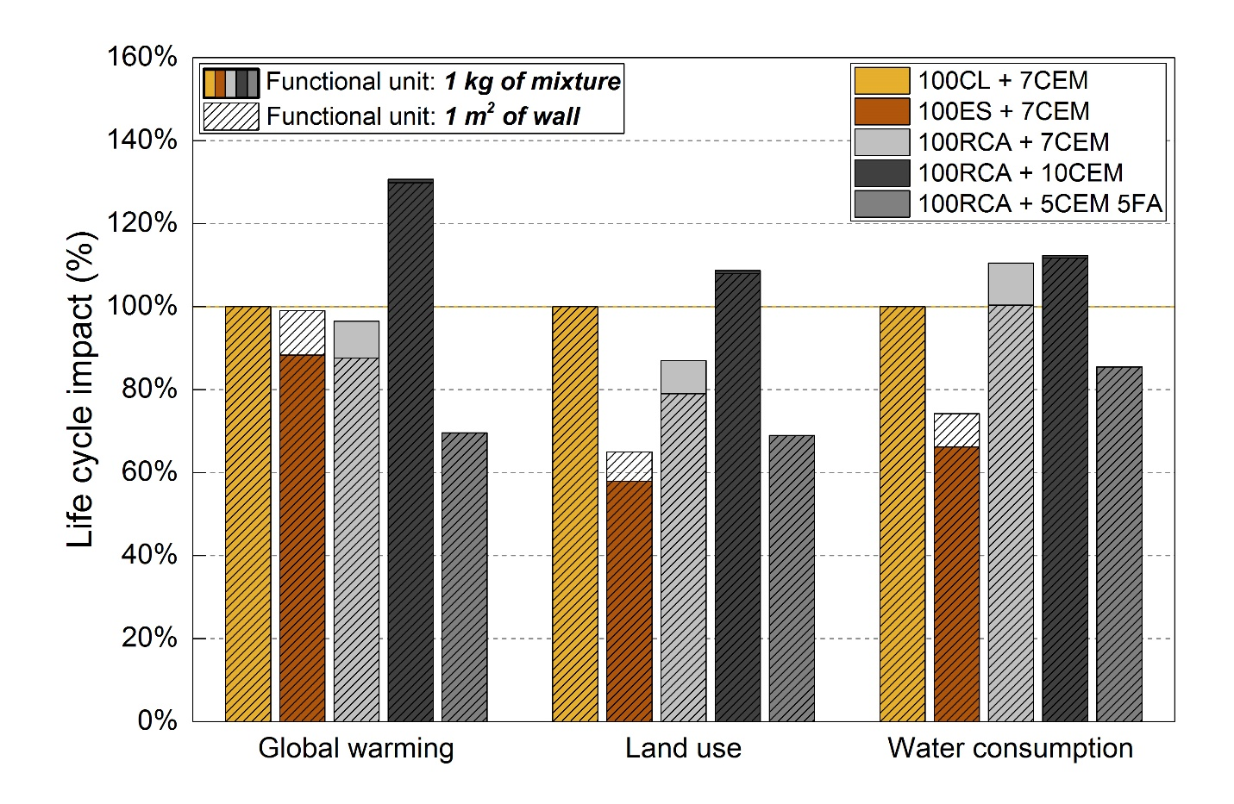
Figure 5. Consequential LCA results for RRCA mixtures (100RCA + 7CEM, 100RCA + 10CEM and 100RCA + 5CEM 5FA) in comparison with traditional rammed earth mixtures (100CL + 7CEM and 100ES + 7CEM). The impacts generated by the crushed limestone mixture (i.e. 100CL + 7CEM) were considered as the base case scenario and the impacts of the other mixtures were normalised (%) to the base case.

GHG savings or expenditures by substituting part of the reference substrates (i.e. CL and ES) with RCA are presented in Figure 6a and Figure 6b respectively, together with the variation in compressive strength of the relative mixtures. For a constant amount of cement, substituting RCA produced a gradual saving in GHG emissions but a corresponding strength reduction. Notably, the two pairs 75CL – 50CL and 25 CL – RCA had very similar GHG emission and UCS results. These similarities highlighted the close dependence of the mixtures’ sustainability and resistance performances on the amount of cement used per unit volume. In fact, cement was administered on a weight basis and the pairs mentioned had very similar dry densities. Considering the pure RRCA mixtures, the higher environmental cost paid by increasing the amount of cement from 7 to 10% was not compensated by a strength gain; on the contrary, strength reduced compared to the base case but GHG emissions dramatically increased. Conversely, reducing the amount of cement by using alternative stabilisers led to a substantial reduction of GHG emissions (more than 15 kg of CO₂ equivalent per square meter of wall with respect to the ES base case) and to a compressive strength lower than the reference cases but very close to those mixtures with only a partial substitution of the substrate.
For the sake of comparison, if unreinforced concrete was used the cradle-to-gate emissions would be far higher; considering an average 35 MPa concrete (Wernet et al., 2016), the wall could only be 60-mm thick to equal the GHG emissions of the reference 300-mm thick SRE wall and 40-mm thick to have the same life cycle impact of the most sustainable RRCA solution (i.e. 100RCA + 5CEM 5FA). Even if the very thin concrete wall could support the imposed load, it is obvious that the wall would perform very differently in terms of thermal regulation. A different functional unit must therefore be adopted for a fair LCA comparison, which would likely lead to completely different results (Panesar et al., 2017). Contrastingly, although outside of the scope of the present research, structural elements with the same functions could be compared. For instance, if an SRE and a concrete beam were compared, considering a linear proportionality between thickness of the beam and compressive strength and considering the same width for the two beams due to reinforcement requirements, a beam made with traditional SRE mixture would allow a saving of more than 40 kg of CO₂-eq. per linear metre. On the other hand, the 100RCA + 5CEM 5FA mix would guarantee a lower saving (i.e. 10 kg CO₂-eq/linear meter) due to its lower mechanical resistance.

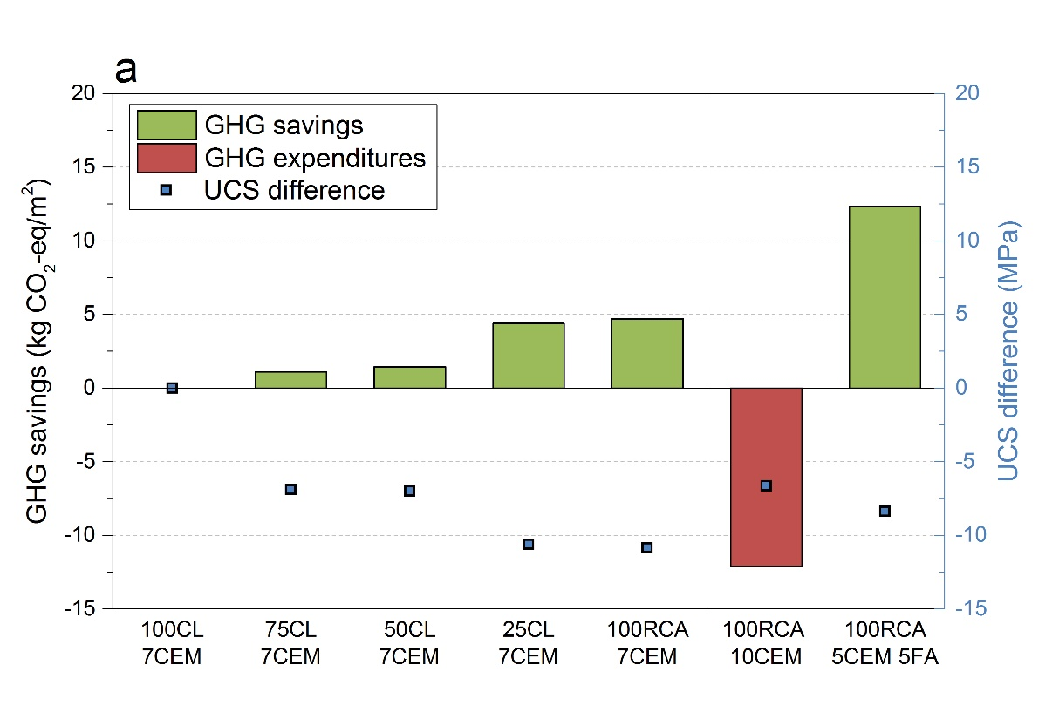
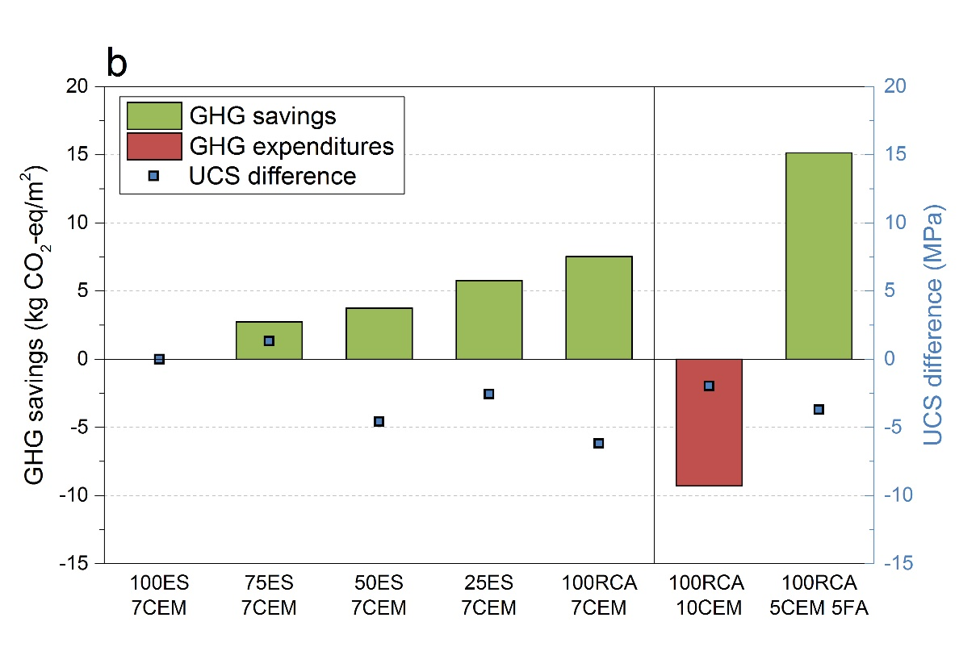
Figure 6. Greenhouse gases (GHG) savings and expenditures and Unconfined Compressive Strength (UCS) resistance of the different mixtures in comparison to: a) 100CL + 7CEM and b) 100ES + 7CEM

Hygroscopicity

Moisture Buffer Value
Average MBV results for the RRCA samples tested (i.e. 100RCA + 10CEM) are presented in Figure 7. The material achieved a “moderate” to “good” moisture buffering ability according to the categories set by the Nordtest, with an average MBV of 0.88 g/(m² %RH). RRCA showed a lower buffering capacity than literature values for unstabilised earth (McGregor et al., 2014) but it performed better than most of the traditional materials tested in the Nordtest project, such as concrete, brick and gypsum boards (Rode, 2005). Results for RRCA are in line with literature values for stabilised rammed earth (Allinson and Hall, 2012) and performed slightly better than the SRE specimens made from engineered soil tested under the same operating conditions (with average MBVs ranging from 0.82 to 0.88 g/(m² %RH) (Arrigoni et al., 2017b)).
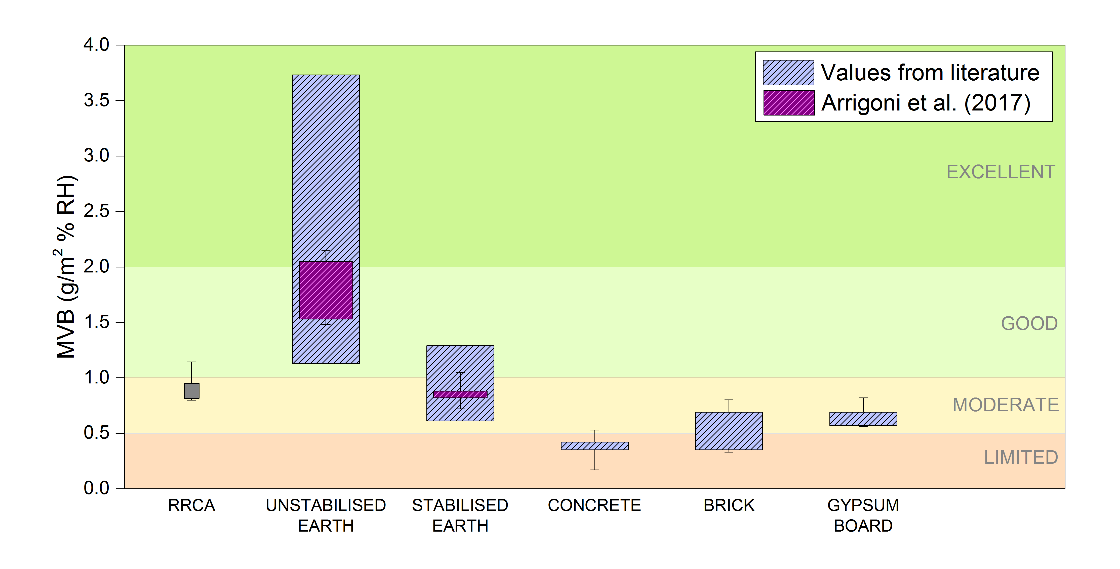
Figure 7. Moisture Buffer Value results for RRCA specimen in comparison with traditional earthen mixtures and building materials. The categories in which the results are subdivided and the values for the traditional building materials are taken from the Nordtest project (Rode, 2005). Values for unstabilised and stabilised earth are from literature (Allinson and Hall, 2012; Arrigoni et al., 2017b; McGregor et al., 2014). Error bars indicate the minimum and the maximum registered for the different materials.

Sorption isotherm
The average sorption isotherm for RRCA is shown in Figure 8 together with the isotherms of more traditional RE mixtures presented in Arrigoni et al. (2017b). The lower part of the isotherms (distinguished by filled symbols) and the upper parts (distinguished by empty symbols) represent, respectively, the absorption and desorption results. RRCA showed an absorption curve similar to the one of the unstabilised RE, absorbing much more moisture than the stabilised RE sample throughout the test. The reference unstabilised RE represents a traditional soil used for pisé (an alternative term for rammed earth) structures in the south of France composed mainly of silt and Illitic clay with a dry density of approximately 1.83 g cm⁻³ (El-Nabouch et al., 2018), while stabilised RE is an engineered soil (60% sand, 30% Kaolin clay and 10% gravel) stabilised with 5% cement and 5% fly ash (dry density: 1.98 g cm⁻³). RRCA showed a much larger hysteresis loop compared to traditional RE mixes. Hysteresis is generally associated with pore interconnectivity; therefore, an extensive microstructural characterisation was performed.
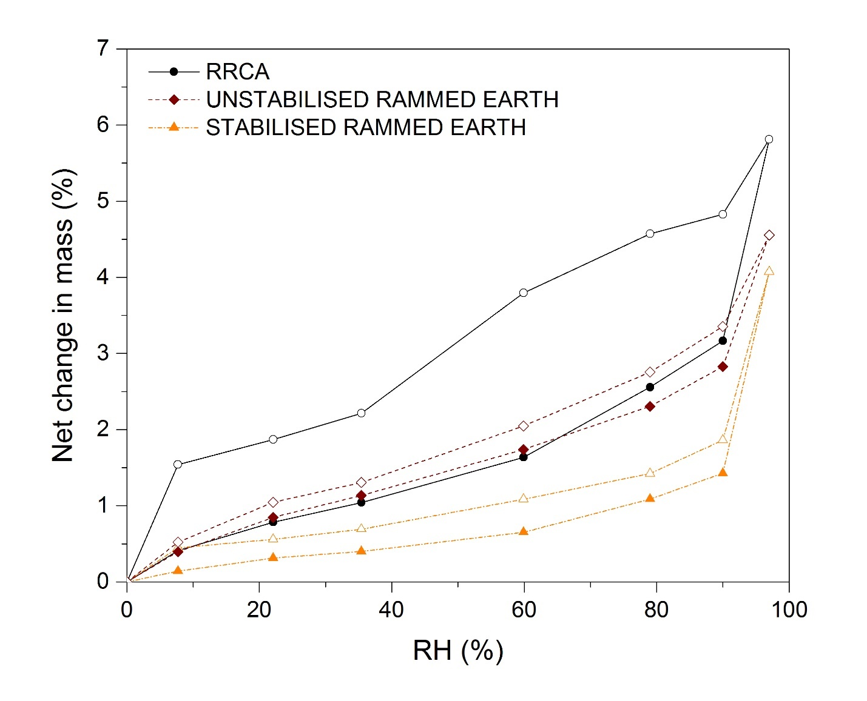
Figure 8. Sorption isotherm result for RRCA compared to traditional RE mixes.

Microstructural analysis

Porosimetry
Porosimetry results for RRCA samples are presented in Figure 9 and in Table 2, together with the results obtained for traditional RE mixtures. Before drawing any conclusions on RRCA, it must be borne in mind that the specimens had a high heterogeneity due to the different origin and typology of the recycled aggregates in the mixture. Results may therefore be only partially representative of the whole system. Moreover, the porosity investigated may originate both from the old system of concrete aggregates and from the new RRCA system. Nevertheless, different samples from the same mixture were analysed and the results reported are indicative of the recurring trends.
When analysed via MIP, RRCA showed a more uniform pore distribution than traditional mixes (i.e. a strong modal pore size was not evident, Figure 9a), most likely due to its aforementioned heterogeneity. Moreover, RRCA exhibited a large total pore area compared, in particular, to the stabilised RE mixture. The higher total pore area may be attributed to the high amount of cementitious gel, belonging to both the old and the new system, with intrinsic narrow (i.e. <100 Å) porosity.
Nitrogen adsorption-desorption isotherms results are reported in Table 2 in terms of surface area calculated with the BET method and of average pore diameters obtained with the BJH method from desorption isotherms. Considering the existence of hysteresis between adsorption and desorption isotherms, desorption calculations were used to analyse the distribution of mesopore diameters (Barrett et al., 1951). RRCA demonstrated an intermediate surface area and average pore diameter when compared to typical unstabilised and stabilised earthen mixtures. RRCA samples also exhibited a large adsorption-desorption hysteresis loop, which could be attributed to the ink-bottle effect caused by an irregular distribution of the pores (Arrigoni et al., 2017b). The sharp step between 30 and 50 Å on the desorption isotherm was considered to be a sign of the pores’ interconnection (Figure 9b). The ink-bottle effect is typical in hardened cementitious paste, where capillary pores (>100 Å) can be interconnected through finer connections (i.e. gel pores). These nanometre-sized pores represent the intrinsic porosity of hydrated products such as CSH gel (Kaufmann et al., 2009). Cementitious paste, belonging to the original crushed concrete or newly formed, was abundant in RRCA. Conversely, cementitious paste was limited or absent in stabilised and unstabilised earthen samples respectively, due to the low (or null) amount of cement in the mixtures. Although not containing any cementitious particle, the unstabilised mixture exhibited the highest surface area, the lowest average pore diameter and an important hysteresis in the adsorption-desorption isotherm, which could be attributed to the clayey-silt matrix with a high specific surface area and an intrinsic narrow porosity interconnecting larger pores.

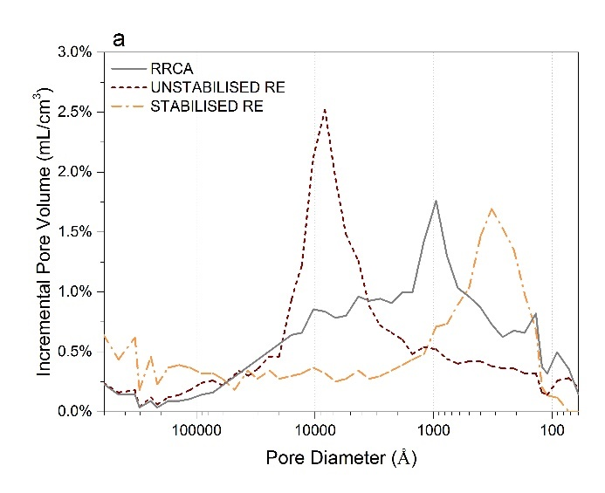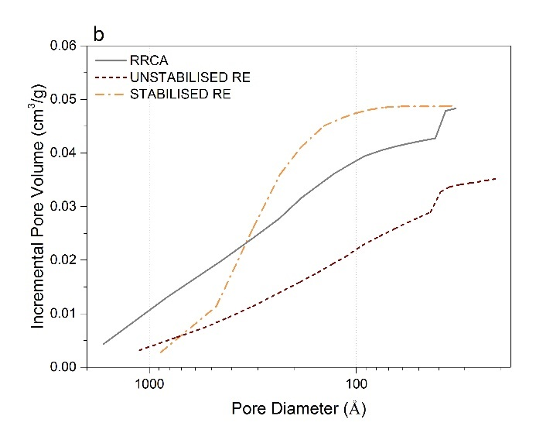
Figure 9. Porosimetry results for RRCA compared to traditional rammed earth mixtures: a) incremental intrusion percentage volume measured via mercury intrusion porosimetry; b) BJH desorption cumulative pore volume.

Table 2. Porosimetry analyses results for RRCA compared to traditional rammed earth (RE) mixtures.
Mix | Dry density | MIP bulk porosity | MIP average pore diameter | MIP total pore area | BET surface area | BJH average pore diameter
 | [g cm⁻³] | [%] | [Å] | [m²g⁻¹] | [m²g⁻¹] | [Å]
RRCA | 1.91 | 24.4 | 589 | 10.0 | 11.4 | 137
UNSTABILISED RE | 1.83 | 24.2 | 1012 | 5.09 | 15.0 | 90.8
STABILISED RE | 1.98 | 21.9 | 649 | 6.73 | 7.37 | 235

Scanning Electron Microscopy
Figure 10a and b show SEM images of the aggregate/binder interfaces of two different RRCA samples (i.e. 100RCA + 10CEM and 100RCA + 5CEM 5FA). The binding matrix of 100RCA + 10CEM resulted in rich hydration cementitious products (labelled “2” in the figure), identifiable in dendrites and needle-like phases that could be attributed to CSH gel and ettringite. The same phases were present, to a lower extent, in the 100RCA + 5CEM 5FA binding matrix. The minor concentration of these phases could be explained by the lower cement content in the mixture. On the other hand, in the 100RCA + 5CEM 5FA matrix, fly ash particles embedded in the matrix could be spotted (labelled “3” in the figure). The fly ash particle highlighted in Figure 10b had a smooth surface, suggesting that the particle did not react during the curing period. However, the presence of unreacted fly ash particles seemed to be minimal: as highlighted in Figure 10c, other fly ash particles seemed to be completely reacted and embedded in the matrix. Completely reacted fly ash particles are recognisable by the crystalline residues concentrated in a rounded shape area (Figure 10d), which represents the area previously occupied by the particle. The crystals could be attributed to the unreacted residues of the fly ash particle (i.e. quartz and mullite). In Figure 10c the interface between the original cementitious matrix (i.e. mortar) that surrounded the aggregates (labelled “4” in the figure) and the newly formed matrix (labelled “5”) is also evident.
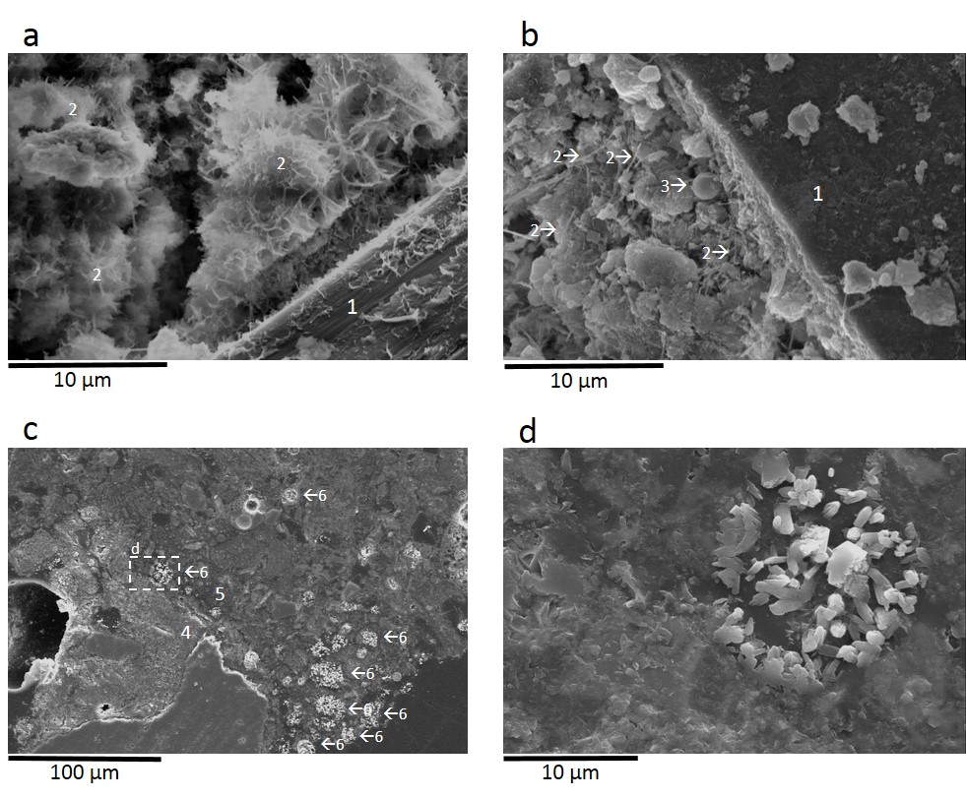
Figure 10. SEM images of RRCA samples (100RCA + 10CEM (a) and 100RCA + 5CEM FA (b, c and d)): a-b) aggregate/binder interface; c) original and new matrix at low magnification; d) detail of a reacted fly ash particle. In the figures “1” designates aggregate particles, “2” cementitious products (CSH gel and ettringite needles), “3” fly ash particles, “4” the original RCA (recognisable from a lighter colour in the figure), “5” the newly formed matrix (recognisable from the darker colour) and “6” reacted fly ash particles. The marked region in c) highlights one reacted fly ash and indicate the position of the zoomed image (d).

DISCUSSION
In our previous studies, stabilised rammed earth mixtures incorporating RCA have already been shown to be highly durable even when they were stabilised with a minimal amount of cement (e.g. 5%) (Arrigoni et al., 2017a); when subjected to simulated extreme weathering conditions (i.e. prolonged high-pressure water jet and cyclic water-submersion and drying), samples, if properly compacted, lost little mass or strength. The experimental campaign presented here aimed at deepening the knowledge of these material in terms of mechanical resistance, hygroscopic properties and sustainability.
Unconfined compressive test results indicated that the presence of RCA in a rammed earth mix detrimentally affected the strength of the material. Nevertheless, the addition of RCA did not automatically translate into a decrease in characteristic UCS; most likely, the strength of the material is more closely related to the grading of the mix and the presence of contaminants rather than the percentage of RCA added alone (for example, X-ray diffraction analyses indicated the presence of bricks and ceramics in the recycled “concrete” aggregates as well as unhydrated cement). In order to avoid the creation of weak points leading to possible localised failure in the rammed earth, it might be convenient to remove these contaminants first. Given the significant effect that the quality and the characteristics of the material (which will vary from site to site) ostensibly had on the final behaviour, strength testing should be performed on the material prior to construction to ensure the required standards are met. Results found here were in line with the accessible works on SRE incorporating RCA: Taghiloha (2013) obtained a compressive strength at 28 days (on 177-mm high cylinders with a 152-mm diameter) between 6.7 and 8.2 MPa with mixtures containing recycled aggregates and 8.7% cement (on substrate dry mass), whereas the resistance of the cubes stabilised with 10% cement tested by Jayasinghe et al. (2016) ranged between 3.0 and 6.3 MPa. In both cases, the maximum RCA substitution tested was approximately 60%. In the present research, such strengths could be obtained using only recycled material and a lower cement content (e.g. 6.7 MPa at 28 days for 100RCA + 5CEM 5FA), highlighting the wide range of performance expected of these materials. Even so, all batches tested here showed strengths exceeding 2 MPa and could therefore be used in rammed earth construction according to the existing Australasian standards (e.g. Standards New Zealand (1998); Walker and Standards Australia (2001)).
Incorporating RCA improved the sustainability of all tested mixes, save for that solely comprising soil sourced on site. RCA performed better than quarried products in terms of both GHG emissions and land occupation. Nevertheless, different distances between the building site, the natural quarry and the site where RCA is sourced may affect the sustainability ranking (Fraj and Idir, 2017); for example, if RCA were sourced 80 km farther than the natural quarry, it would be better to use the quarried material in terms of GHG emissions rather than RCA. The gap reduced when land use was considered: the recycling site should not be 35 km more distant than the quarry. Finally, in order to have a RRCA structure with a lower water footprint than the base Western Australia case, the site where RCA is sourced should be at least 7 km closer than the quarry. Overall, however, it was the amount of cement used in the mixture that was the primary parameter affecting environmental impact.
Tests performed to evaluate the hygroscopicity of RRCA highlighted the relevant moisture absorption capacity of the material. RRCA performed better than most of traditional construction elements in terms of moisture buffering ability, so guaranteeing an improved indoor air quality (Fang et al., 1998) and reduced energy consumption (Zhang et al., 2017). The good absorption capacity of tested RRCA was probably due to the large surface area of the pores, comparable to that of unstabilised RE, which is typical for cementitious matrices. However, the large hysteresis loop suggested an abundance of pores where moisture was trapped because of restricted entrances (Issaadi et al., 2015). That the typical unstabilised earthen mixture considered here performed better than RRCA could be attributed to the lack of clay particles in the RRCA matrix, well-known for their optimal physico-chemical affinity with water (McGregor et al., 2014).

CONCLUSIONS
This study highlighted the benefits (numerous) and drawbacks (few) of incorporating RCA into stabilised rammed earth materials. The examination of the strength, sustainability and hygroscopicity of RRCA complemented a durability analysis presented in a previous paper (Arrigoni et al., 2017a).
Cement stabilised RRCA exhibited acceptable compressive resistance according to available standards on stabilised rammed earth. For the most part, RCA addition caused a decrease in unconfined compressive strength compared to the traditional rammed earth mixes, although such substitution did not affect durability. Decrease in strength was not linearly related to the amount of substitution. Rather, changes to the mix particle size distributions and the quality of the recycled aggregates themselves appeared to affect the strength of the final material more than the percentage of RCA added. Regardless, no mix achieved a higher strength than the parent material alone.
Substituting part of the natural aggregates in the mixture with RCA slightly reduced the environmental impact, but the need for each mix to contain cement largely offset any benefit. Using alternative stabilisers alleviated this issue: including fly ash in the mixture and reducing the cement content to 5% led to a net reduction of the life cycle greenhouse gas emissions of up to 15 kg CO₂-eq/m² without compromising mechanical resistance or durability. SEM images of crushed RRCA samples showed how most of the fly ash reacted to form new cementitious products that were perfectly incorporated in the new matrix. RRCA exhibited “moderate” moisture buffering abilities: less than unstabilised earth mixtures but similar to those of stabilised earth mixtures previously tested by the authors and better than many traditional building materials (e.g. concrete and bricks).
Reusing demolished concrete aggregates definitely guarantees environmental benefits in terms of landfill occupation and raw materials exploitation; both of these impacts, however, are difficult to capture with the currently available LCA impact assessment methods. However, the environmental benefits of using waste materials could be jeopardized by the surrounding conditions; if RCA had to cover longer distances before reaching the new building site, it may be more sustainable for some impact categories (e.g. global warming) to use natural aggregates.
To conclude, although the idealistic mixture made only from excavated in situ soil remains the optimal rammed earth solution in terms of sustainability and moisture buffering ability, when the soil available on site is not suitable for earthen structures or greater resistances are required, RRCA may represent a worthwhile solution.

ACKNOWLEDGMENTS
The authors thankfully acknowledge MORQ architecture (www.morq.it) and Hera Engineering (www.hera.net.au) for their support throughout the research. Moreover, the authors would like to thank Chiara Parolini (www.linkedin.com/in/chiaraparolini) for her help in the design of the graphical abstract.

REFERENCES
Achenza, M., Fenu, L., 2006. On Earth Stabilization with Natural Polymers for Earth Masonry Construction. Mater. Struct. 39(1), 21-27.

Ahmad, S., Iqbal, Y., 2016. Phase evolution and microstructure-property relationship in red clay bricks. J. Ceram. Process. Res. 17(4), 373-379.

Allinson, D., Hall, M., 2012. Humidity buffering using stabilised rammed earth materials. Proc. ICE - Constr. Mater. 165(6), 335-344.

Arrigoni, A., 2017. How sustainable are natural construction materials? Stabilised rammed earth, hempcrete and other strategies to reduce the life cycle environmental impact of buildings, Dipartimento di Chimica, Materiali e Ingegneria Chimica “G. Natta”. Politecnico di Milano, Milano, Italy.

Arrigoni, A., Beckett, C., Ciancio, D., Dotelli, G., 2017a. Life cycle analysis of environmental impact vs. durability of stabilised rammed earth. Constr. Build. Mater. 142, 128-136.

Arrigoni, A., Grillet, A.-C., Pelosato, R., Dotelli, G., Beckett, C.T.S., Woloszyn, M., Ciancio, D., 2017b. Reduction of rammed earth's hygroscopic performance under stabilisation: an experimental investigation. Build. Environ. 115, 358-367.

Arrigoni, A., Pelosato, R., Dotelli, G., Beckett, C.T.S., Ciancio, D., 2017c. Weathering’s beneficial effect on waste-stabilised rammed earth: a chemical and microstructural investigation. Constr. Build. Mater. 140, 157-166.

ASTM, 2015. C618-15 Standard Specification for Coal Fly Ash and Raw or Calcined Natural Pozzolan for Use in Concrete. ASTM International, West Conshohocken, Pennsylvania, USA.

Atkins, P., De Paula, J., 2006. Atkins’ physical chemistry, 8th ed. Oxford University Press, New York, New York, USA.

Barcelo, L., Kline, J., Walenta, G., Gartner, E., 2013. Cement and carbon emissions. Mater. Struct. 47(6), 1055-1065.

Barrett, E.P., Joyner, L.G., Halenda, P.P., 1951. The determination of pore volume and area distributions in porous substances. I. Computations from nitrogen isotherms. J. Am. Chem. Soc. 73(1), 373-380.

Beckett, C., Ciancio, D., 2014. Effect of compaction water content on the strength of cement-stabilized rammed earth materials. Can. Geotech. J. 51(5), 583-590.

Behera, M., Bhattacharyya, S.K., Minocha, A.K., Deoliya, R., Maiti, S., 2014. Recycled aggregate from C&D waste & its use in concrete – A breakthrough towards sustainability in construction sector: A review. Constr. Build. Mater. 68, 501-516.

BIO Intelligence Service, 2015. Screening template for Construction and Demolition Waste management in The Netherlands V2. Paris, France.

Cement Sustainability Initiative, 2009. Recycling concrete. World Business Council for Sustainable Development (WBCSD), Conches-Geneva, Switzerland.

Chen, C., Habert, G., Bouzidi, Y., Jullien, A., Ventura, A., 2010. LCA allocation procedure used as an incitative method for waste recycling: An application to mineral additions in concrete. Resour. Conserv. Recy. 54(12), 1231-1240.

Ciancio, D., Boulter, M., 2012. Stabilised rammed earth: a case study in Western Australia. Proceedings of the Institution of Civil Engineers - Engineering Sustainability 165(2), 141-154.

Ciancio, D., Gibbings, J., 2012. Experimental investigation on the compressive strength of cored and molded cement-stabilized rammed earth samples. Constr. Build. Mater. 28(1), 294-304.

Ciancio, D., Jaquin, P., Walker, P., 2013. Advances on the assessment of soil suitability for rammed earth. Constr. Build. Mater. 42, 40-47.

Cocjin, M.L., Gourvenec, S.M., White, D.J., Randolph, M.F., 2014. Tolerably mobile subsea foundations – observations of performance. Géotechnique 64(11), 895-909.

Consequential-LCA, 2015. Byproducts, recycling and waste. www.consequential-lca.org. (Accessed 18 April 2018).

Crossin, E., 2015. The greenhouse gas implications of using ground granulated blast furnace slag as a cement substitute. J. Clean. Prod. 95, 101-108.

da Rocha, C.G., Consoli, N.C., Dalla Rosa Johann, A., 2014. Greening stabilized rammed earth: devising more sustainable dosages based on strength controlling equations. J. Clean. Prod. 66, 19-26.

de Baan, L., Alkemade, R., Koellner, T., 2012. Land use impacts on biodiversity in LCA: a global approach. Int. J. Life Cycle Assess. 18(6), 1216-1230.

Duan, H., Li, J., 2016. Construction and demolition waste management: China’s lessons. Waste Manag. Res. 34(5), 397-398.

Eires, R., 2012. Building with earth: improved performance with biopolymers incorporation (Construção em Terra: Desempenho melhorado com incorporação de biopolímeros) (in Portuguese). University of Minho, Guimarães, Portugal.

Ekvall, T., Weidema, B.P., 2004. System boundaries and input data in consequential life cycle inventory analysis. Int. J. Life Cycle Assess. 9(3), 161-171.

El-Nabouch, R., Bui, Q.B., Plé, O., Perrotin, P., 2018. Characterizing the shear parameters of rammed earth material by using a full-scale direct shear box. Constr. Build. Mater. 171, 414-420.

European Commission, 2015. Proposal for a DIRECTIVE OF THE EUROPEAN PARLIAMENT AND OF THE COUNCIL amending Directive 2008/98/EC on waste, in: European Union (Ed.) COM/2015/0595 final - 2015/0275 (COD). Brussels, Belgium.

European Commission, BIO Intelligence Service, 2011. Service Contract on Management of Construction and Demolition Waste - SR1. Final Report Task 2. Paris, France.

Eurostat, 2014. Waste generation by economic activities and households, EU-28.

Eurostat, 2018. Municipal waste landfilled, incinerated, recycled and composted in the EU-28, 1995 to 2016.

Fang, L., Clausen, G., Fanger, P.O., 1998. Impact of Temperature and Humidity on the Perception of Indoor Air Quality. Indoor Air 8(2), 80-90.

Fraile-Garcia, E., Ferreiro-Cabello, J., Lopez-Ochoa, L.M., Lopez-Gonzalez, L.M., 2017. Study of the Technical Feasibility of Increasing the Amount of Recycled Concrete Waste Used in Ready-Mix Concrete Production. Materials (Basel) 10(7).

Fraj, A.B., Idir, R., 2017. Concrete based on recycled aggregates – Recycling and environmental analysis: A case study of paris’ region. Constr. Build. Mater. 157, 952-964.

Hall, M., Swaney, B., 2005. Stabilised rammed earth (SRE) wall construction - Now available in the UK. Build. Eng. 80(9), 12-15.

Hera Engineering Pty Ltd., 426 Cambridge Street - Rammed Earth house. http://hera.net.au/projects/426-cambridge-street-rammed-earth-house/. (Accessed 28 February 2018).

Hossain, M.U., Poon, C.S., Lo, I.M.C., Cheng, J.C.P., 2016. Comparative environmental evaluation of aggregate production from recycled waste materials and virgin sources by LCA. Resour. Conserv. Recy. 109, 67-77.

Huijbregts, M.A.J., Steinmann, Z.J.N., Elshout, P.M.F., Stam, G., Verones, F., Vieira, M., Zijp, M., Hollander, A., van Zelm, R., 2016. ReCiPe2016: a harmonised life cycle impact assessment method at midpoint and endpoint level. Int. J. Life Cycle Assess. 22(2), 138-147.

Ioannidou, D., Meylan, G., Sonnemann, G., Habert, G., 2017. Is gravel becoming scarce? Evaluating the local criticality of construction aggregates. Resour. Conserv. Recy. 126, 25-33.

IPCC, 2014. Climate Change 2014: Mitigation of Climate Change. Contribution of Working Group III to the Fifth Assessment Report of the Intergovernmental Panel on Climate Change (IPCC). New York, USA.

ISO, 2006. ISO 14040:2006 Environmental management — Life cycle assessment — Principles and framework.

ISO, 2013. ISO 12571:2013 Hygrothermal performance of building materials and products — Determination of hygroscopic sorption properties.

Issaadi, N., Nouviaire, A., Belarbi, R., Aït-Mokhtar, A., 2015. Moisture characterization of cementitious material properties: Assessment of water vapor sorption isotherm and permeability variation with ages. Constr. Build. Mater. 83, 237-247.

Jayasinghe, C., Fonseka, W.M.C.D.J., Abeygunawardhene, Y.M., 2016. Load bearing properties of composite masonry constructed with recycled building demolition waste and cement stabilized rammed earth. Constr. Build. Mater. 102, 471-477.

Johnson, J., 2014. Recycling construction & demolition waste. https://www.theconcreteinitiative.eu/newsroom/events/71-recycling-construction-demolition-waste. (Accessed 20 September 2017).

Kaufmann, J., Loser, R., Leemann, A., 2009. Analysis of cement-bonded materials by multi-cycle mercury intrusion and nitrogen sorption. J. Colloid Interface Sci. 336(2), 730-737.

Kleijer, A.L., Lasvaux, S., Citherlet, S., Viviani, M., 2017. Product-specific Life Cycle Assessment of ready mix concrete: Comparison between a recycled and an ordinary concrete. Resour. Conserv. Recy. 122, 210-218.

Mah, C.M., Fujiwara, T., Ho, C.S., 2018. Life cycle assessment and life cycle costing toward eco-efficiency concrete waste management in Malaysia. J. Clean. Prod. 172, 3415-3427.

McGregor, F., Heath, A., Maskell, D., Fabbri, A., Morel, J.-C., 2016. A review on the buffering capacity of earth building materials. Proc. ICE - Constr. Mater., 1-11.

McGregor, F., Heath, A., Shea, A., Lawrence, M., 2014. The moisture buffering capacity of unfired clay masonry. Build. Environ. 82, 599-607.

Micromeritics Instrument Corporation, Product showcase. www.micromeritics.com/Product-Showcase.aspx. (Accessed 10 December 2016).

Miller, S.A., Horvath, A., Monteiro, P.J.M., 2016. Readily implementable techniques can cut annual CO2emissions from the production of concrete by over 20%. Environmental Research Letters 11(7).

Panesar, D.K., Seto, K.E., Churchill, C.J., 2017. Impact of the selection of functional unit on the life cycle assessment of green concrete. Int. J. Life Cycle Assess. 22(12), 1969-1986.

Paranavithana, S., Mohajerani, A., 2006. Effects of recycled concrete aggregates on properties of asphalt concrete. Resour. Conserv. Recy. 48(1), 1-12.

Raeis Samiei, R., Daniotti, B., Pelosato, R., Dotelli, G., 2015. Properties of cement–lime mortars vs. cement mortars containing recycled concrete aggregates. Constr. Build. Mater. 84, 84-94.

Randell, P., Pickin, J., Grant, B., 2014. Waste generation and resource recovery in Australia. Reporting period 2010/11. Final report version 2.6. Blue Environment Pty Ltd, Docklands, Victoria, Australia.

Rode, C., 2005. Moisture Buffering of Building Materials. Technical University of Denmark, Kongens Lyngby, Denmark.

Standards Australia, 2003. AS 1289.5.2.1-2003 Soil compaction and density tests, Determination of the dry density or moisture content relation of a soil using modified compactive effort. Standards Australia, Sydney, Australia.

Standards New Zealand, 1998. NZS 4298: 1998 Materials and workmanship for earth buildings. Wellington, New Zealand.

Taghiloha, L., 2013. Using rammed earth mixed with recycled aggregate as a construction material, Escuela Técnica Superior de Ingenieros de Caminos, Canales y Puertos de Barcelona. Universitat Politècnica de Catalunya, Barcelona, Spain.

Verian, K.P., Ashraf, W., Cao, Y., 2018. Properties of recycled concrete aggregate and their influence in new concrete production. Resour. Conserv. Recy. 133, 30-49.

Vieira, C.S., Pereira, P.M., 2015. Use of recycled construction and demolition materials in geotechnical applications: A review. Resour. Conserv. Recy. 103, 192-204.

Walker, P., Keable, R., Martin, J., Maniatidis, V., 2005. Rammed Earth: Design and Construction Guidelines, BRE Bookshop, Watford, UK.

Walker, P., Standards Australia, 2001. HB 195: The Australian earth building handbook. Standards Australia, Sydney, Australia.

Waranet Solutions SAS, Thermopuces and hygropuces. www.waranet-solutions.com/en/traceability/thermopuces-and-hygropuces. (Accessed 15 November 2016).

Weidema, B.P., 2003. Market Information in Life Cycle Assessment. Danish Environmental Protection Agency, Copenhagen, Denmark.

Wernet, G., Bauer, C., Steubing, B., Reinhard, J., Moreno-Ruiz, E., Weidema, B., 2016. The ecoinvent database version 3 (part I): overview and methodology. Int. J. Life Cycle Assess. 21(9), 1218-1230.

Xu, G., Shi, X., 2018. Characteristics and applications of fly ash as a sustainable construction material: A state-of-the-art review. Resour. Conserv. Recy. 136, 95-109.

Zhang, M., Qin, M., Rode, C., Chen, Z., 2017. Moisture buffering phenomenon and its impact on building energy consumption. Appl. Therm. Eng. 124, 337-345.

