Article type: Article

Enhancement of pure titanium localized corrosion resistance by anodic oxidation

D. Prando, A. Brenna, M. Pedeferri, M. Ormellese*
Davide Prando
Department of Chemistry, Materials, Chemical Engineering “G. Natta”, Politecnico di Milano
Via Mancinelli 7, 20131 Milano (Italy)

Andrea Brenna
Department of Chemistry, Materials, Chemical Engineering “G. Natta”, Politecnico di Milano
Via Mancinelli 7, 20131 Milano (Italy)

MariaPia Pedeferri
Department of Chemistry, Materials, Chemical Engineering “G. Natta”, Politecnico di Milano
Via Mancinelli 7, 20131 Milano (Italy)

Marco Ormellese
Department of Chemistry, Materials, Chemical Engineering “G. Natta”, Politecnico di Milano
Via Mancinelli 7, 20131 Milano (Italy)
marco.ormellese@polimi.it

The corrosion behavior of commercially pure titanium (UNS R50400, ASTM grade 2) was investigated in presence of aggressive, bromides containing, species, reported to cause severer localized corrosion compared to chlorides. To enhance localized corrosion resistance of the metal, several surface treatments were performed. Samples anodized at potentials between 10 V and 200 V were characterized in term of oxide thickness and morphology and tested with potentiodynamic analyses in ammonium bromide solution. Base metal was prepared both with etching and mechanical polishing pre-treatment, to enlighten the effect of pre-treatment sample preparation on post-treatment corrosion resistance.

Keywords: Titanium, anodizing, PEO, ASD, surface treatment

1 Introduction
Titanium has outstanding corrosion resistance due to a thin, amorphous, non-stoichiometric TiO₂ protective layer (max 10 nm thick [1]) that is formed spontaneously on the surface when exposed to aerated environment. This protective layer is very stable and allows the use of titanium in severe working conditions, such as offshore, acid environment, aerospace [2, 3], automotive, high temperature applications, chemical and food industry [4–6], marine hydrometallurgical application and nuclear fuel wastes containment [7–10], where no other metal can be used.
Nevertheless, commercially pure titanium may suffer different forms of corrosion in very severe environments. Generalized corrosion is caused by small quantity of fluorides ions (more than 0.002 M [11]) that combining with titanium forming TiF₄, destroying passivity film. Hydrogen embrittlement happens prevalently on α- and α-β titanium due to their low hydrogen solubility in α-Ti, [12] stress corrosion cracking can also happen in very specific environments, such as anhydrous methanol, nitrogen tetroxide, red-fuming nitric acid or solid cadmium. [13] However, the most critical forms of corrosion of titanium are due to localized breaking of passive layer and this is favored by the presence of concentrated halides, such hot salty water (above 200°C) or bromide containing species. [14, 15]
To overcome this weakness, corrosion resistance enhancing treatments can be performed or proper alloying element may be added; the latter is the case of inclusion of elements that promote cathodic reaction, raising cathodic polarization curve above the critical active anodic curve at higher potentials in the passive region, such as palladium, [16]. A well know treatment is nitration, that consist in introducing nitrogen in the first µm of the surface to promote the formation of TiN and increase corrosion resistance. [17, 18] These methods, acting on titanium composition, are effective but complicated to perform and expensive as well other surface coating techniques, such as vacuum plasma spray coating, plasma spraying and chemical vapor deposition. [19]
For this reason, treatments that act on the naturally formed passive layer are preferred. The easiest and cheapest treatment to tune oxide layer is anodic oxidation, that consists in applying an anodic polarization of several tens of volts to the metal, promoting the growth of the natural oxide layer with thicknesses from about 40 nm with anodizing potential 10 V, to about 250 nm at 100 V. [20–22] At potentials higher than 100 V the anodizing begins to cause the instauration of microarcs in the insulating oxide layer; in this regime, called “anodic spark deposition (ASD)” or “plasma electrolytic oxidation (PEO)”, the oxide grows much more, reaching the thickness of several micrometers but switching from a compact to a porous structure. [23]
Due to promising results in increasing corrosion resistance obtained with anodizing treatments, in this work the effect of the anodizing potential has been investigated, ranging from 10 V to 200 V, to define a treatment procedure able to delay or prevent localized corrosion in very severe environments.
Surface treatment are greatly influenced by the condition of the as received surface, in term of roughness and chemical composition. Prior to any anodizing treatment, the surface has to be degreased, clean and any adsorbed chemicals must be removed; for this reason, pre-treatments like etching and mechanical polishing are required. Moreover, by controlling the condition of these pre-treatments it is possible to obtain similar surface roughness on all the titanium samples prior oxidation. However, to perform chemical etching on titanium, a hydrofluoric acid containing solution have to be used and this is reported to cause fluoride surface enrichment. [24, 25] To investigate the effect of the presence of brimides on anodized titanium corrosion resistance, the same treatments, in term of final potential, anodizing solution, anodizing current density was performed on sample prepared with the two different pre-treatment and then tested for corrosion resistance.
2 Experimental procedure
2.1 Materials
Square samples 19 × 19 × 1.6 mm were cut from a commercial pure titanium plate, chemical composition according to UNS R50400, ASTM grade 2. To remove working grease and dust, samples were ultrasonically degreased in ethanol for 4 minutes, then rinsed in distilled water. Then, to remove possible contamination and adsorbed species from metal surface and to ensure the same surface finishing, samples were etched or mechanically polished. Etching was performed in hydrofluoric acid 5% + nitric acid 35% solution for 2 minutes, solution volume was at least 400 mL for each sample and samples were kept vertical while etching process was taking place. Mechanical polishing was performed with 100 and 320 grit SiC papers. Both the procedures were followed by ethanol ultrasonic bath and distilled water rinsing.
2.2 Anodic Oxidation
After surface polishing, anodization treatments were conducted in two different regimes: fixed current density, for samples anodized up to 120 V, and constant voltage ramp, for samples anodized from 120 V to 200 V. In the first case the current was supplied by an AimTTi PLH120 DC power supply, able to operate up to 120 V and 0.75 A; in the second case a custom pre-industrial implant with three rectifiers of 150 V each and a current limit of 10 A was used. All the anodization treatments were conducted in sulfuric acid 0.5 M electrolyte at ambient temperature because of previous knowledge on the behaviour of this electrolyte. [26] However, the possibility to carry out anodization treatment in similar but less aggressive electrolytes, such as sodium sulphate, was already demonstrated by past work. [26]
During galvanostatic anodization the current was kept at 20 mA cm⁻² until the achievement of 10 V – 20 V – 40 V – 60 V – 80 V – 120 V. For sample anodized at constant potential ramp, the ramp was set to reach 120 V – 150 V – 200 V in two minutes. To investigate the effect of a longer ramp, the anodization at 200 V was repeated with 10 minutes ramp.
Both the samples batches (etched and mechanical polished) were subject to low potential anodization, up to 80 V. Only mechanical polished samples were anodized at high potential (between 120 V and 200 V) due to the better behaviour of these samples compared to etched ones.
2.3 Testing procedure
Prior to surface treatment, pre-treated specimens were characterized with laser UBM Microfocus profilometer, and average roughness (R_{a}), root mean square (R_{q}), Skewness (R_{sk}) and Kurtosis (R_{ku}) were measure for samples in the as-received surface condition, after etching and after mechanical polishing with 320 grit paper.
After surface treatment, each sample was rinsed with distilled water in ultrasonic bath for 4 minutes to remove possible deposits from the surface. Oxides film thicknesses then measured with indirect spectrophotometric technique. [20] For sample exceeding the technique thickness range, sacrificial samples were produced, cut, and gold sputtered to observe their cross section with scanning electron microscope SEM StereoScan 360.
The presence of crystalline structure in the oxides was detected using XRD technique with a diffractometer model Phillips PW 1830, able to generate a Cu-Kα radiation with a wavelength of 0.154 nm. This technique does not allow the measurement of absolute crystalline fraction, but it is able to determine if anatase or rutile crystalline phases are present in more than 2% fraction and, through Spurr-Meyer equation, the relative amount of each crystalline phase. [27]
Furthermore, samples corrosion resistance to bromides containing solution were characterized with potentiodynamic tests performed with MetroOhm Autolab potentiostat M204. Open circuit potential (OCP) was recorded after 1 h of sample exposition to the testing solution with a potassium chloride saturated Silver / Silver Chloride reference electrode (SSC). Then potential was scanned from 100 mV below the OCP up to 9 V SSC at 20 mV min⁻¹. Anodic current and potential difference between metal and reference electrode were registered with Nova® 2.1.1 software. Tests were performed in 1 L cell, filled with ammonium bromide 0.5 M, that is reported to cause localized breakdown of titanium passive layer [28]; as the duration did not exceed 8 hours, no sealing was necessary and neither chemical (ΔpH ≈ 0.05) nor physical (ΔT ≈ 2°C) deviations were detected. In order to ensure repeatability, at least three measurements were made for each treatment procedure.
3 Results
3.1 Surface profile
Surface profile was characterized in term of average roughness (R_{a}), root mean square (R_{q}), Skewness (R_{sk}) and Kurtosis (R_{ku}). The average results of at least three different measures for samples in as received condition, after etching or after mechanical polishing are visible in Table 1.
<< Table 1 >>

The chemical etching slightly reduced the average roughness, from 0.35 µm to 0.326 µm, while the mechanical polishing favored a 30% reduction of roughness. The Skewness of the etched sample is close to zero, indicating the height distribution (peaks and pits) is symmetrical around the mean plane. The as received sample as well as the mechanical polished one have a positive R_{sk} (close to 0.3) suggesting the height distribution is skewed below the mean plane. Concerning the Kurtosis parameter, the etching promotes the spikes corrosion, than the height distribution is normal. R_{ku} greater than 3 suggest a spiked height distribution, such as in the case of the as-received titanium and after polishing.

3.2 Oxide thickness and morphology
The oxides thicknesses of anodized samples, obtained with indirect spectrophotometric measurements or direct SEM observation, are reported in Table 2 together with anatase fraction over the total crystalline phase.

<< Table 2>>

Up to 60 V the oxide is completely amorphous. From 80 V crystallinity appears. At 80 V the crystalline oxide is 100% anatase phase; increasing anodizing potential up to 200 V leads to a progressive reduction of the anatase into the crystalline phase, which transforms into rutile phase. At 200 V the amount of anatase in the crystalline fraction is between 7% and 10%, depending on the potential ramp imposed for oxide formation.
It is also important to notice that oxide thickness increases of two order of magnitude passing from 10 V anodizing potential to 200 V. Up to 120 V the oxide thickness (expressed in µm) is about two times the applied anodizing voltage. For voltages greater than 120 V, due to PEO condition and microarcs formation, a sharp increase of the oxide thickness was observed. The maximum thickness (4 mm) was achieved at 200 V anodizing potential with an anodizing ramp of 10 minutes.
Direct SEM surface observation showed the evolution of surface morphology with anodizing potential, as visible in Figure 1. The morphology deeply changes increasing anodizing potential. Up to 80 V the surface is flat and the only morphology detectable is due to polishing. At 120 V some nanopores start to appear. At 150 V the surface is fully covered with nanopores and going further with anodizing potential induce a morphology transformation passing from nanoporous to nanogrooved.

<< Figure 1 >>
3.3 Corrosion tests
Pre-treatment showed to have a great influence on the final corrosion resistance, both on non-treated and on anodized titanium. Figure 2, Figure 3 and Figure 4 report potentiodynamic curves obtained in ammonium bromide 0.5 M on not-treated titanium, and on titanium anodized at 10 V, 20 V, 40 V, 60 V and 80 V. Breakdown potentials are clearly visible, corresponding to the potential at which a sharp increase of anodic current density is noticed. All anodized titanium samples show an evident breakdown potential improvement, indicating a better corrosion behaviour respect the not-treated titanium. Best corrosion resistance was achieved on the mechanical polished samples at all the tested anodizing voltages.

<< Figure 2 >>
<< Figure 3 >>
<< Figure 4 >>

Because of the evident practical advantages of mechanical polishing pre-treatment over the etching, the second bench of tests, high potential anodization (from 120 V to 200 V), was carried out only on polished titanium. Potentiodynamic curves are shown in Figure 5. Results show that at 120 V the effect of the changed anodizing regime starts to appear and the localized breakdown potential raise over 5.5 V SSC. At voltages higher than 120 V no localized corrosion occurs in the testing environment up to 9.5 V SSC polarization. A further increase in anodizing potential leads to similar results with slightly lower corrosion current density, especially at low potential. The effect of potential ramp duration is visible keeping a final potential of 200 V, reached in 2 minutes and 10 minutes; in the latter case a much lower corrosion resistant sample was produced, as confirmed by the anodic current density value, more than one order of magnitude higher with respect to the samples anodized at 200 V in 2 minutes.
<< Figure 5 >>
4 Discussion
4.1 Surface characterization
Comparing the two proposed pre-treatment (etching and polishing), the etched samples maintain an average roughness very similar to the as-received sample. However, a more detailed comparison reveals that a rough polishing up to 320 grit can reproduce much better R_{q}, skewness and kurtosis value of the as-received titanium. The mechanical polished surface is less symmetry, with a sharp picks and a distribution skewed below the mean plane.
Morphologic results, summarized in Table 2, show not only the expected increase in oxide thickness and crystallinity with anodizing potential, but also an increase in rutile fraction by changing ramp time from 2 minutes to 10 minutes. This is explained from the longer time given to the oxide to rearrange and transform anatase phase into rutile phase, moreover the higher total current used in the process justify the higher thickness of the oxide anodized for more time.
Pre-treatment have great influence on corrosion resistance of both, anodized and non-anodized samples. Figures 2, 3 and 4 show that for each treatment condition localized oxide breakdown occurs at lower potential on etched samples compared to polished ones. Furthermore, anodic current density of polished sample is lower for all the tested conditions. This behavior is a consequence of the fluoride enrichment of the surface after etching pre-treatment. The initial hypothesis that the etched surface profile enhance corrosion by higher electric field due to tip effect, suggested by Figure 6, is proved wrong by profilometric measurement. In fact, the kurtosis value, close to 3, of etched surface suggests the presence of less sharp surface tips compared to as-received sample (R_{ku} higher than 3).
<< Figure 6 >>

4.2 Corrosion resistance
After pre-treatment characterization, samples in both the polished and etched conditions were anodized up to 80 V. Anodizing at higher voltages was performed only of polished samples.
Corrosion resistance of anodized titanium up to 200 V is visible in Figure 7, where free corrosion potentials (E_{corr}) and oxide breakdown potentials are reported. Error bars referred to at least three different measurement per condition.

<< Figure 7 >>

As expected free corrosion potential does not show substantial changes from non-treated to anodized sample, since it is mainly influenced by the cathodic process with is almost the same in all the tested conditions.
The oxide breakdown potential of the not-anodized titanium is the range 1 V SSC to 2.3 V SSC. Samples anodized at 10 V up to 120 V show an increase of the breakdown potential of about 2 V. The best behavior was achieved with titanium anodized at 80 V.
Samples anodized in ASD condition (anodizing voltage higher than 120 V) show a much higher localized corrosion resistance with a breakdown potential of about 5 V at 120 V, and the total absence of localized corrosion up to 9 V SSC for titanium anodized at 150 V and 200 V.
Although ASD samples show porous surface, literature reports the existence of an inner compact barrier layer below the outer porous layer [29, 30], for this reason the corrosion resistance of these samples were expected to be at least as high as the one of samples anodized below 120 V.
To compare different potentiodynamic curves, anodic current densities at fixed potential 1 V SCC and 2 V SSC were plotted (Figure 8).

<< Figure 8 >>

All the anodized samples perform better than the not-treated ones, with a lower anodic current density. Titanium anodized at 80 and 120 V perform slightly better. Anodic current density of samples anodized in ASD regime is comparable to the one of samples anodized in galvanostatic condition.
Moreover, the comparison between sample anodized at 200 V with 2 minutes and 10 minutes ramp, respectively, shows higher anodic current density in the latter condition. This is in agreement with the higher crystallinity developed in the sample anodized for a longer period; in fact, crystalline domains has higher conductivity and, even if they do not affect localized corrosion potential, they increase the anodic current density below that potential.

5 Conclusion
Anodization treatment can be used to improve the corrosion behavior of commercially pure titanium. All the anodization processes tested enhanced corrosion resistance of titanium in bromide containing solution, increasing oxide breakdown potential by at least 2 V over the one observed on non-anodized titanium. Since the higher difference in corrosion resistance is observed between non-treated sample and anodized sample, and a negligible difference is registered between sample anodized in galvanostatic condition below 120 V, an anodizing voltage of 20 V is suggested for a possible industrial application. This treatment produces an oxide thick enough to resist minor wear and requires just a small amount of current. When higher corrosion resistance is needed it is possible to anodize in ASD regime, in this case a potential of 200 V reached in a small time is suggested, not only to increase oxide breaking potential, but also to keep the corrosion current density low.
Etching pre-treatment, compared to mechanical polishing one, was found to be deleterious to corrosion resistance. The reason is probably the presence of fluorine contamination in metal surface after etching. For this reason, mechanical polishing up to paper grit 320 was preferred to obtain surface finish similar to as-received samples.

6. References
- Z. Liu, G.E. Thompson, J Mater Eng Perform 2014, 24, 59.
- S.Y., Chang, H.K. Lin, L.C. Tsao, Corros Eng Sci Technol, 2014, 49, 17.
- R.R. Boyer Mater Sci Eng , 1996, A 213, 103.
- T-L. Yau, Mater Corros, 1992, 43, 358.
- S. Virtanen, Corros Rev, 2008, 26, 147.
- F.H. Froes, D. Eylon, H.B. Bomberger, Titanium technology: present status and future trends, Titanium Development Association, 1985.
- I.V. Gorynin IV, Mater Sci Eng, 1999, A263, 112.
- J. Liu, A. Alfantazi, E. Asselin, Corrosion, 2014, 70, 29.
- D.W. Shoesmith, D. Hardie, B.M. Ikeda, J.J. Noel, Hydrogen absorption and the lifetime performance of titanium nuclear waste containers in Atomic Energy (Canada), 1997.
- J.C. Griess, Corrosion, 1996, 24, 96.
- Z.B. Wang, H.X. Hu, C.B. Liu, Y.G. Zheng, Electroch. Acta 2014, 135, 526.
- Z.B. Wang, H.X. Hu, C.B. Liu, Y.G. Zheng, Corros Sci, 2016, 103, 50.
- M. Kouřil, E. Christensen, S. Eriksen and B. Gillesber, Mater Corros, 2012, 63, 310.
- D. K. Peacock, J.S. Grauman, Mater Corros, 1998, 49, 61.
- T.R. Beck, J Electrochem Soc, 1973, 120, 1317.
- P. Handzlik, K. Fitzner, Trans Nonferrous Met Soc China, 2013, 23, 866.
- S. Sathish, M. Geetha, N.D. Pandey Mater Sci Eng C, 2010, 30, 376.
- G.C.L.B Neto, M.A.M. da Silva, J. Alves, Surf Eng 2009, 25, 146.
- M.V. Diamanti, M. Pedeferri, Corros Sci, 2007, 49, 939.
- M.V. Diamanti, M. Ormellese, M. Pedeferri, Corros Sci, 2010, 52, 1824.
- Q. Mohsen, S.A. Fadl-Allah, Mater Corros, 2011, 62, 310.
- M.V. Diamanti, M. Ormellese, M. Pedeferri, J Exp Nanosci, 2015, 10, 1285.
- O.A. Galvis, D. Quintero, J.G. Castaño, Surf Coat Technol, 2015, 269, 238.
- J. Guo, R.J. Padilla, W. Ambrose, Biomaterials, 2007, 28, 5418.
- S.F. Lamolle, M. Monjo, M. Rubert M, Biomaterials, 2009, 30, 736.
- D. Prando, A. Brenna A, F.M. Bolzoni, M.V. Diamanti, M. Pedeferri, M. Ormellese, J Appl Biomater Funct Mater. 2017, 15, e19.
- R.A. Spurr, H. Myers, Anal Chem, 1957, 29, 760.
- R. Ittah, E. Amsellem, D. Itzhak, Int J Electrochem Sci, 2014, 9, 633.
- M.R.G Jazi, M.A. Golozar, K. Raeissi, M. Fazel, J Mater Eng Perform, 2014, 23, 1270.
- D. Krupa, J. Baszkiewicz, J. Zdunek J, J Biomed Mater Res B Appl Biomater, 2012, 100B, 2156.

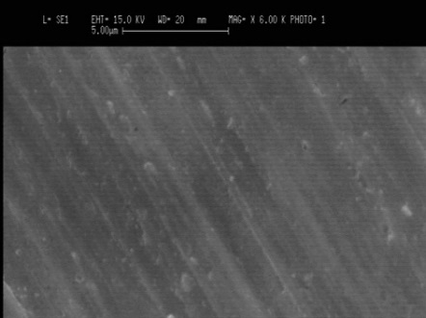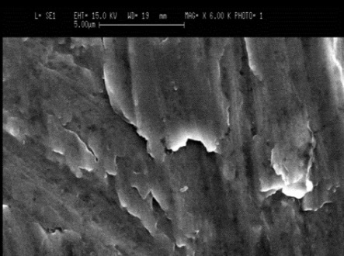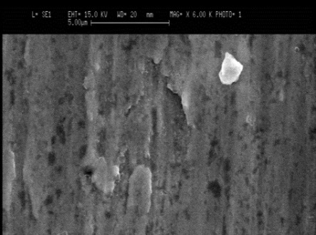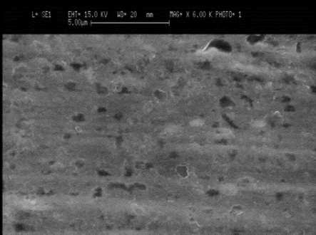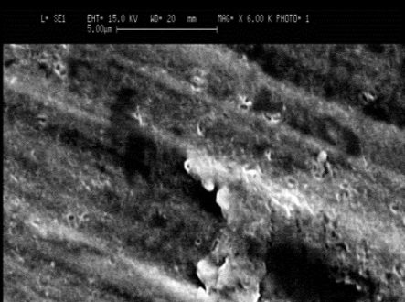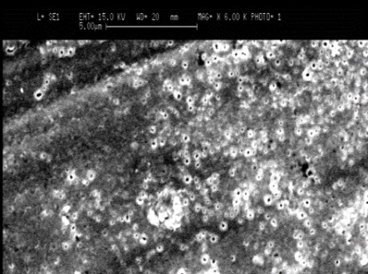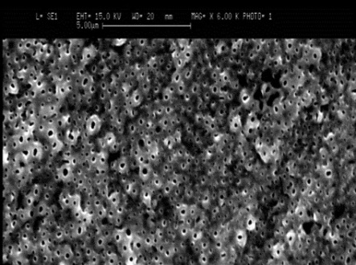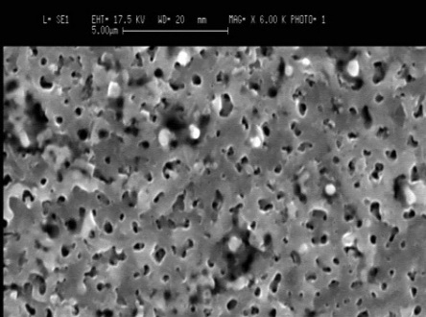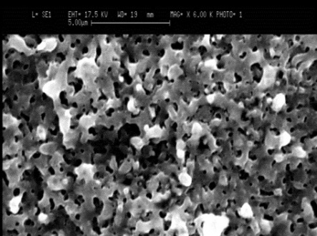
10 V
20 V
40 V
60 V
80 V
120 V
150 V
200 V _{2 min}
200 V _{10 min}
Figure 1. Surface morphology of anodized samples.

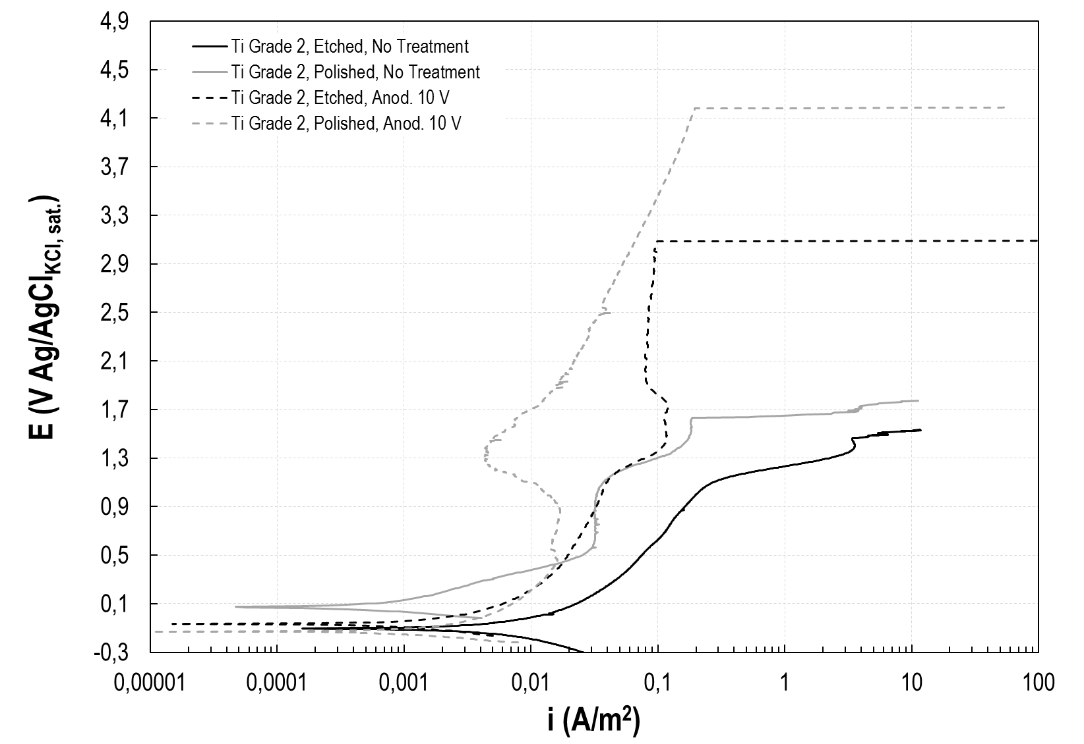
Figure 2. Pre-treatment effect on not-treated and 10 V anodized samples.

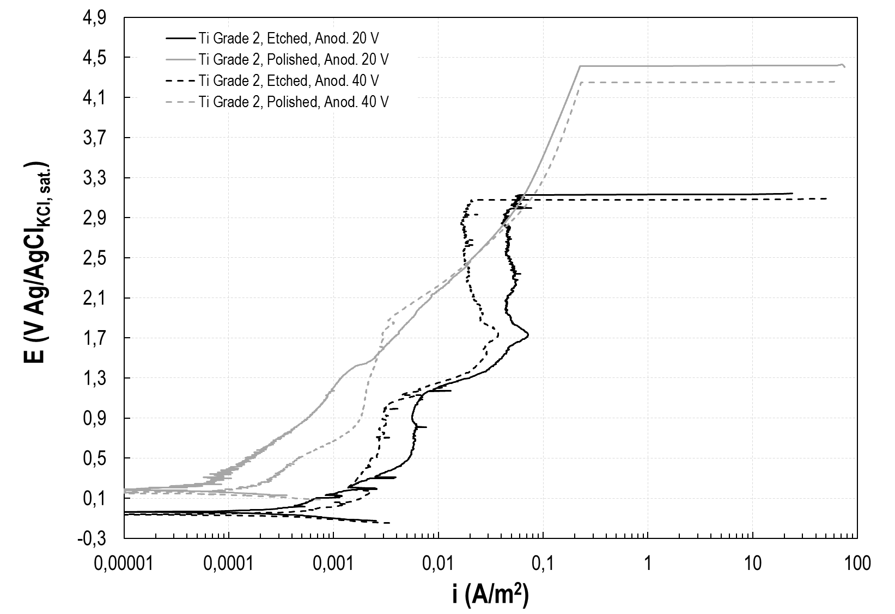
Figure 3. Pre-treatment effect on 20 V and 40 V anodized samples.
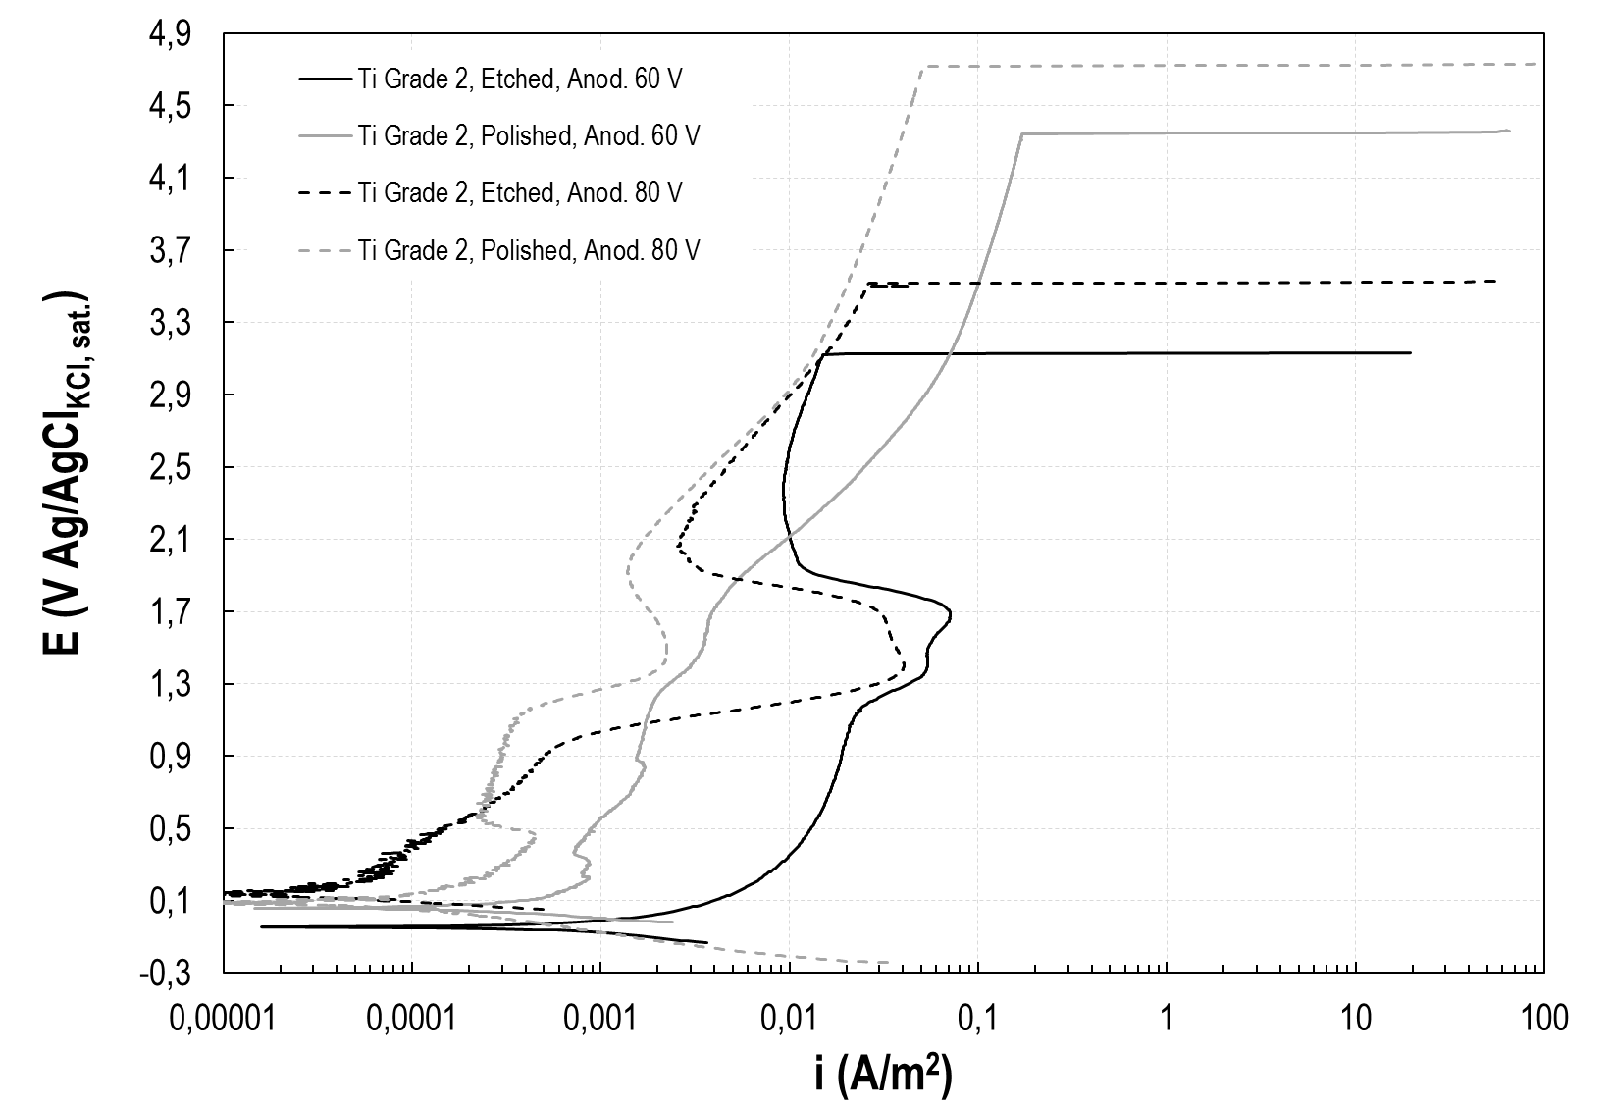
Figure 4. Pre-treatment effect on 60 V and 80 V anodized samples.

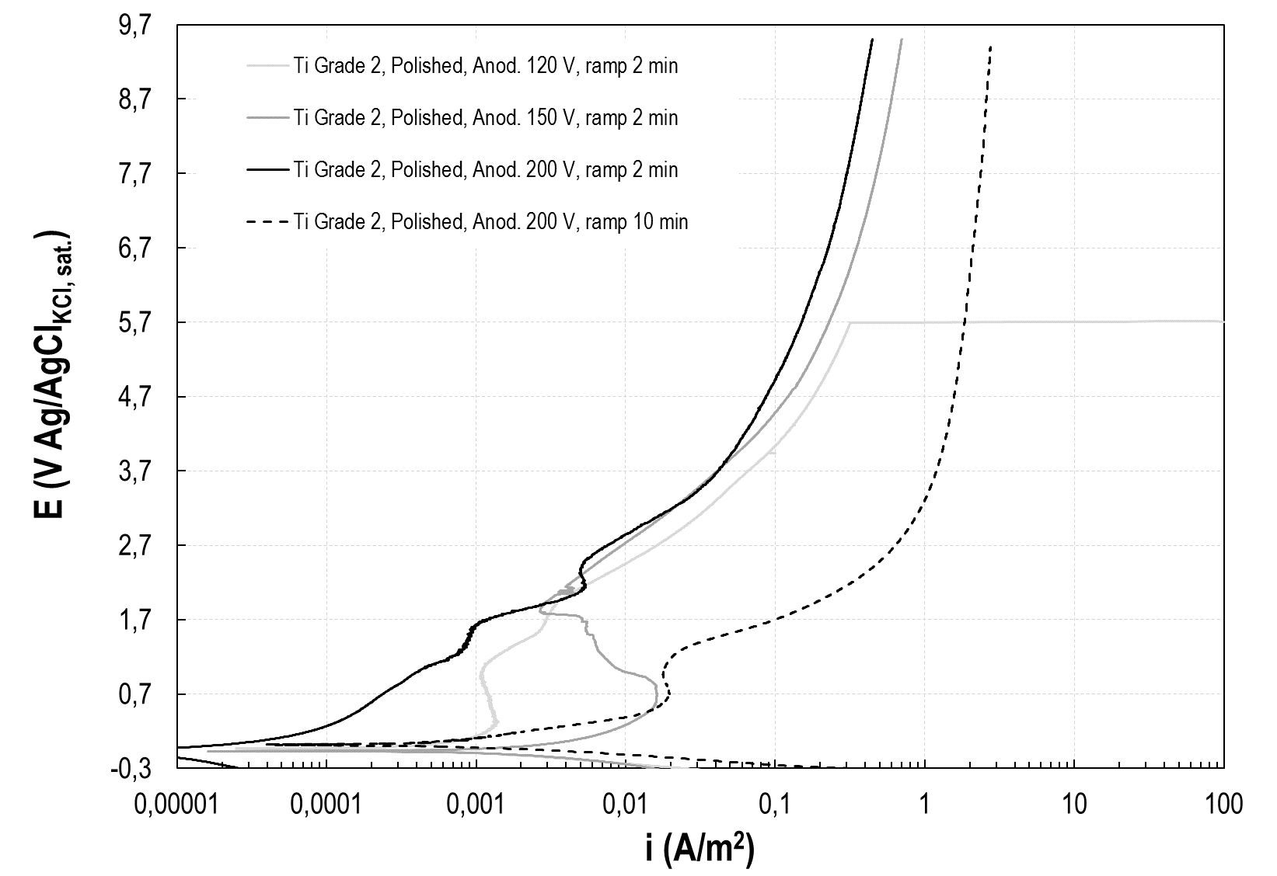
Figure 5. Corrosion resistance of titanium anodized in anodic spark deposition regime.

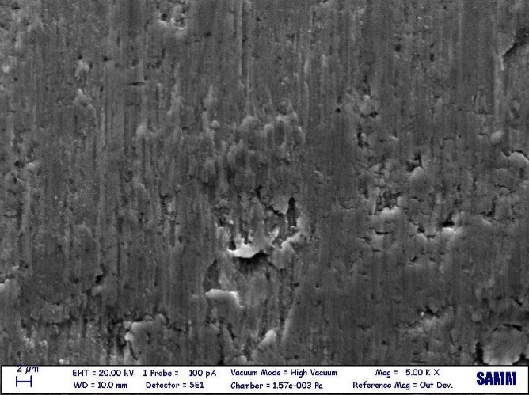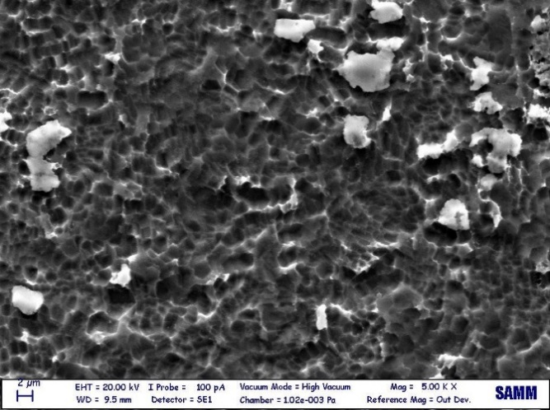
a) b)
Figure 6. SEM micrography of sample surfaces: a) as received; b) after etching.

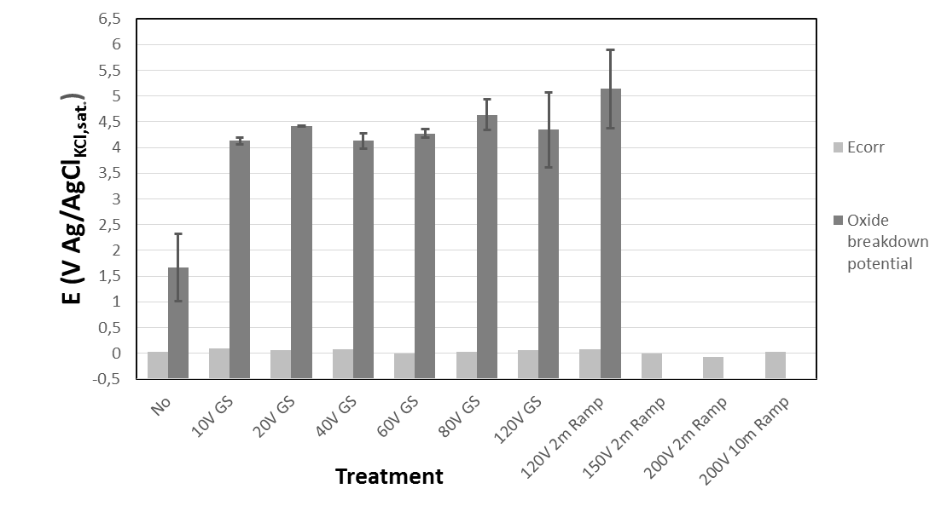
Figure 7. Free corrosion potential and oxide breakdown potential of anodized samples in galvanostatic (GS) and constant ramp condition.

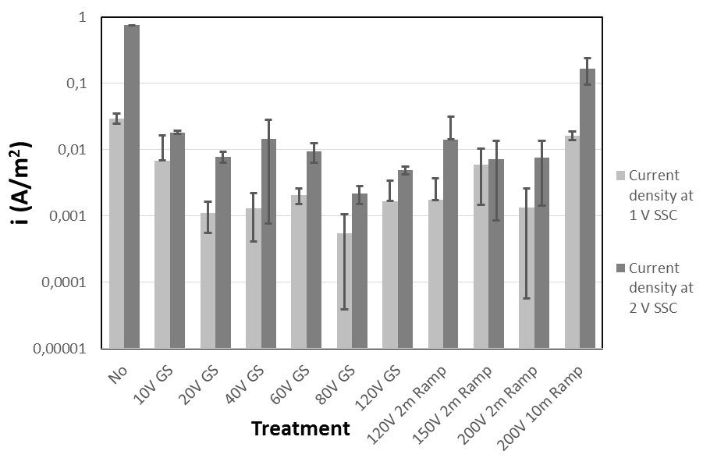
Figure 8. Anodic current density at 1 V SSC and 2 V SCC of anodized samples tested in NH₄Br 0.5 M.

Table 1. Surface profile parameters of pre-treated samples
Sample | Ra [μm] | Rq [μm] | Rsk | Rku
As received | 0.350 | 0.322 | 0.301 | 4.369
Etched | 0.326 | 0.413 | 0.016 | 3.106
Polished | 0.266 | 0.346 | 0.298 | 4.006

Table 2. Anodized sample oxide thickness and anatase fraction
Anodizing conditions |  | Oxide Thickness | Anatase fraction x_{a}
10 V | 20 mA cm⁻² | 40 nm | Amorphous oxide
20 V | 20 mA cm⁻² | 60 nm | Amorphous oxide
40 V | 20 mA cm⁻² | 80 nm | Amorphous oxide
60 V | 20 mA cm⁻² | 120 nm | Amorphous oxide
80 V | 20 mA cm⁻² | 160 nm | 1.00
120 V | 20 mA cm⁻² | 220 nm | 0.93
150 V | 2 min ramp | 600 nm | 0.59
200 V | 2 min ramp | 1500 nm | 0.10
200 V | 10 min ramp | 4000 nm | 0.07

