Transport fuel demand responses to fuel price and income projections: Comparison of Integrated Assessment Models
O.Y. Edelenbosch^{a,b}, D.P. van Vuuren^{a,b}, C. Bertram^{c}, S. Carrara^{d}, J. Emmerling^{d} H. Daly^{e}, A. Kitous^{f}, D.L. McCollum^{g}, N. Saadi Failali^{e}

ª PBL Netherlands Environmental Assessment Agency, Bezuidenhoutseweg 30, 2594 AV Den Haag, The Netherlands (E: Oreane.Edelenbosch@pbl.nl, Detlef.vanvuuren@pbl.nl);
^{b} Copernicus Institute of Sustainable Development, Utrecht University, Heidelberglaan 2, 3584 CS Utrecht, The Netherlands;
^{c} Potsdam Institute for Climate Impact Research, Telegrafenberg, 14473 Potsdam, Germany;
^{d} Fondazione Eni Enrico Mattei (FEEM) and Centro Euro-Mediterraneo sui Cambiamenti Climatici (CMCC), Corso Magenta 63 ,20123 Milan;
^{e} UCL Energy Institute, University College London, Upper Woburn Place, London WC1H 0NN, United Kingdom;
^{f} European Commission, JRC IPTS, Edificio Expo; C/ Inca Garcilaso, 3, E-41092 Sevilla, SPAIN; Disclaimer: The views expressed are purely those of the writer and may not in any circumstances be regarded as stating an official position of the European Commission.
^{g} International Institute for Applied Systems Analysis (IIASA), Schlossplatz 1, 2361 Laxenburg, Austria

Acknowledgements
The research leading to these results has received funding from the European Union’s Seventh Framework Programme FP7/2007-2013, under grant agreement no. 308329 (ADVANCE).

Abstract
Income and fuel price pathways are key determinants in projections of the energy system in integrated assessment models. In recent years, more details have been added to the transport sector representation in integrated assessment models. To better understand the dynamics within these more complex models, this manuscript analyses transport fuel demand elasticities to projected income and fuel price levels. In order to isolate price effects on energy demand and create a transparent environment to compare fuel demand response, fuel price shocks were simulated under various scenarios. Interestingly, the models show very comparable oil price elasticity values for the first 10 to 20 years that are also close to the range described in the empirical literature. When looking at the very long term (30−40 years), demand elasticity values widely vary between models, between 0.4 and -1.9, showing either continuous demand or increased demand responses over time. The latter can be the result of long response time to fuel price shocks, availability of new technologies, and feedback effects on fuel prices. The elasticity calculation method proved to be a suitable method to evaluate model behaviour and its application is also recommended for other models as well as other sectors represented in integrated assessment models.

Key words: Transportation, energy modelling, model evaluation, price elasticity, income elasticity

Introduction
Integrated Assessment Models (IAMs) have been developed to model the evolution of the global energy and land-use systems for the coming century. They have extensively been used to project greenhouse gas emissions and to identify cost-effective mitigation strategies [1, 2]. In the past, IAMs tended to represent energy demand sectors in a rather stylised manner, while presenting energy supply in more detail. Energy demand sectors are complex, both in terms of the many sub-sectors with numerous technologies and in the heterogeneity of consumers that use the services requiring energy. These sectors are therefore more difficult to represent in quantitative models.
Energy demand reduction can, however, have important contribution to emission reduction [1, 3, 4]. In recent years, more details of the energy demand side have been incorporated in IAMs, in order to better understand demand dynamics and the role of efficiency in mitigation strategies. This is especially the case for the transport sector, where infrastructure, behaviour and technology considerations have been addressed, as described in several articles in the Transport Research Part D special issue on transport modelling in IAMs [5-9].
The models have various representations of the transport system, some with more technology detail, and others providing a more aggregated demand formulation. Several studies compare IAM transport sector outcomes [10-12], and show a variation in projected growth of transport service demand, fuel switching and efficiency change [11]. Intermodal comparison studies are informative, as they provide a range of plausible pathways. However, as the models have become more complex, it becomes less easy to understand why model results differ [3]. Kriegler et al. (2015) indicate that, besides intermodal comparisons, diagnostic analysis which characterise model dynamics, are very relevant to explain model differences. This type of analysis is not aimed to explore realistic policy scenarios, but to identify typical model responses to a single policy signal [13]. So far, a detailed diagnostic analysis of transport model responses to key drivers in IAMs has not been performed.
Income and fuel price levels are key model drivers. Income relates to the money available to spend on transport activities and fuel price affects the benefits of energy efficiency of technologies used and of switching to alternative fuels. Moreover, the implementation of a carbon tax, which is the commonly used mitigation policy instrument in IAMs, will impact fuel prices. Elasticities of transport fuel demand are used as measure for how sensitive demand is to changes in –in this case- either income or prices. In this study, the transport models’ implicit fuel demand elasticities are explored, by comparing demand responses to various fuel price and income trajectories. The aim is twofold; first to better understand model dynamics through a diagnostic experiment, and second comparing the model dynamics to empirical data as a validation test. A large number of empirical studies have analysed the sensitivity of transport demand to changes in fuel price and income [14, 15], expressed in elasticities, to inform transport planners and policymakers [16]. Moreover, quantifying the model response to elasticity values provides the opportunity to translate model dynamics of models that consider details of transport modes and technologies into relatively aggregate models. A comparable exercise has been performed for demand models by Hogan and Sweeney [17]. They conclude that the implicit elasticity calculation method is appropriate for comparing demand model dynamics, and they recommend modellers to make this a standard component of their documentation to better understand the model dynamics.
An overview of the various models and methods used to calculate elasticities and scenarios that were run by the models are discussed in Section 2. The models’ transport consumption response to varying fuel prices and income scenarios compared to the empirical data is presented and discussed in Section 3. Underlying changes, such as efficiency effects and changes in the kilometres travelled, are addressed separately. Section 4 provides tentative conclusions about the variations between models and discusses the implications of the projections of energy transitions and the role of climate policy.

Method
With everything else remaining constant, fuel demand elasticities measure the percentage change in demand due to a 1% increase in price or income. A set of scenarios was designed to estimate price and income elasticities for transport demand in six global integrated assessment models. Elasticities of fuel consumption, but also, for those models in this study containing sufficient detail, service demand and efficiency responses for specific transport modes. This section provides an overview of the models, fuel and income scenarios, and the elasticity calculation method.
2.1 Models and baseline scenario
The IAMs included in this study are IMAGE, MESSAGE, POLES, REMIND, TIAM-UCL and WITCH. These form a set of well-known IAM models that contributed to key assessments and also cover a wide range of different methods (see Table 1 and Supplementary Information).
Table 1 Overview of key characteristics of the transport models
Name | Model type | Solution methods | Service Demand driver per transport mode | End use technology representation
IMAGE | PE | Recursive dynamic simulation | GDP, population, fuel price, travel time, mode characteristics | All modes
POLES | PE | Recursive dynamic simulation | GDP/income, population, fuel prices | All modes
MESSAGE | GE | Intertemporal optimisation | GDP, population, fuel price | All modes (aggregated together)
REMIND | GE | Intertemporal optimisation with perfect forecast | GDP growth, fuel prices, elasticity of substitution in CES function | LDV
TIAM-UCL | PE | Intertemporal optimisation | Linear relation to GDP and population | All modes
WITCH | GE | Intertemporal optimisation with perfect forecast | GDP, population, elasticity of substitution in CES function | LDV and road freight

Of the six IAMs, POLES, IMAGE and TIAM-UCL have a more technology-rich representation of transport demand. The projected kilometres travelled, which are related to population and GDP, are distributed over the transport modes either based on exogenous assumptions (TIAM-UCL and POLES) or endogenously on their price and speed (IMAGE). Per transport mode, different technologies are considered that compete on the basis of exogenous technology cost and endogenous fuel cost. POLES and IMAGE are both recursive dynamic simulation models and TIAM-UCL is a linear optimisation model.
In REMIND, the mobility demand for all modes of transport are input to a nested CES production function that ultimately produces GDP. REMIND differentiates between four other transport modes besides light duty vehicles (LDVs). The representation of transport in the version of MESSAGE used in this study captures only fuel switching and price-induced demand responses [18]. Importantly, the entire sector is modelled as one; all motorised transport modes are aggregated together into a single demand category.
Finally, in WITCH, road transport kilometre demand (LDVs and freight) is derived based on GDP and population growth. This demand can be met by different vehicles (traditional, hybrid, plug-in hybrid, battery electric vehicles) and fuel types, which compete based on cost. The investment costs of batteries endogenously decrease, following a global learning rate via dedicated R&D investments. The remaining part of the transport sector is modelled in a top-down fashion and included in the aggregated non-electric vehicle sector in the CES structure.

All models are run on the basis of a medium baseline, using the assumptions from the SSP2 scenario for population, income and other parameters (unless otherwise indicated).

2.2 Fuel price elasticity scenarios
In line with previous studies that tested demand elasticities inherent in models, scenarios with fuel prices shocks are compared to the original price pathway in the models’ baseline scenario [17, 19]. The shocks are applied to 1) oil & natural gas, 2) biofuels and 3) electricity from 2020 to 2070, changing the price with respect to a reference price trajectory, by -50%, +50% and +100% (see Table 2). Based on experience with model demand responses to carbon prices the expectation was that fuel price shocks of 50% to 100% would be needed before there would be a significant demand response. The fuel price is increased at the final energy level for all demand sectors; however, the focus of our analysis is only on the transport demand response.
Table 2: Scenario design to calculate price demand and income demand elasticities. Descriptions of Scenarios 2 to 10 indicate the price jumps relative to the baseline scenario, for the three fuel types considered. Ref indicates the unaltered reference fuel price trajectory in the baseline of each model. Scenario descriptions of Scenarios 11 and 12 indicate the varying income pathways.
Scenario |  | Price change per fuel type
 |  | Oil & Natural gas | Electricity | Biofuel
1 |  | Ref | Ref | Ref
2 |  | -50% | Ref | Ref
3 |  | Ref | -50% | Ref
4 |  | Ref | Ref | -50%
5 |  | +50% | Ref | Ref
6 |  | Ref | +50% | Ref
7 |  | Ref | Ref | +50%
8 |  | +100% | Ref | Ref
9 |  | Ref | +100% | Ref
10 |  | Ref | Ref | +100%
Scenario | Income change
11 | SSP1 GDP assumptions
12 | SSP3 GDP assumptions

Figure 1 shows the baseline transport oil price used in each model (at the end-use level; global average) (panel a), as well as the fuel price change, relative to the baseline, in the -50% scenario and +100% scenario (panel b). The WITCH and TIAM-UCL scenarios do not include end-use taxes in their prices, implying that these models use a lower price pathway. All models project oil prices to increase as a result of resource depletion in baseline, but the extent of this effect varies. The variations in oil price development between models ultimately resulted in different fuel shocks, in absolute terms. Price jumps are implemented as exogenous shocks. In two models (IMAGE, POLES), this is implemented by replacing the endogenous prices by an exogenous input. In the other models (TIAM-UCL, MESSAGE, REMIND and WITCH), where this would interfere with the model solution, price increases/decreases were added to the endogenously calculated final energy prices – thus mimicking additional taxes or subsidies. Here, dynamic model responses and feedback effects could clearly be observed.
The most important model response is that, due to higher fuel prices, the demand for this particular fuel (and its primary resource, crude oil) is reduced (allowing to calculate the elasticities – see further). As a result, however, as a feedback final energy prices tend to move away from the price shock pathway towards the original price pathway, in the long run. This effect is the largest in MESSAGE, but can also be seen in the TIAM-UCL and REMIND projections. In REMIND, the perfect foresight feature leads to a reduction in the price change effect already by 2020 (when the shock is introduced). The reduction in demand due to the exogenous price increase, in this case, has led to a relaxation of the scarcity and thus to a reduction in the endogenous price component. Yet, despite the variance in fuel price pathways, since price demand elasticities are calculated relative to price changes (and not to price levels), even with smaller price changes it is still possible to compare elasticities between models.
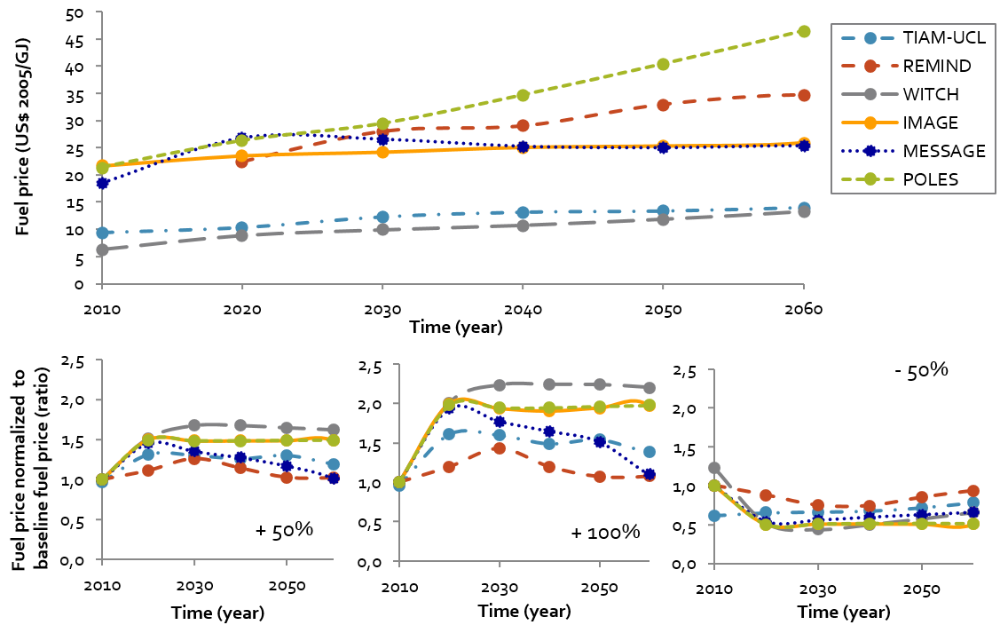
Figure 1: Global average price of transport oil in the baseline scenario (Scenario 1) (top) and the relative increase in oil price compared to this baseline (bottom), for the price shock scenarios of +50% (Scenario 5), +100% (Scenario 8) and -50% (Scenario 2).
2.3 Income elasticity scenarios
Two extra scenarios with different income pathways are run to analyse income elasticities (see Table 2, Scenarios 11 and 12 and Figure 2). In the baseline scenario, the models have implemented the Shared Socio-Economic Pathway (SSP) 2 assumptions on GDP and population growth. The SSPs are a scenario framework that defines pathways of the evolution of society and ecosystems in the next century. Within this framework SSP2 is the middle of the road scenario. The alternative GDP pathways are based on SSP1 and SSP3 which assume respectively low and high challenges for mitigation and adaptation. Within that narrative SSP1 follows higher and SSP3 follows lower economic development than SSP2 [20].
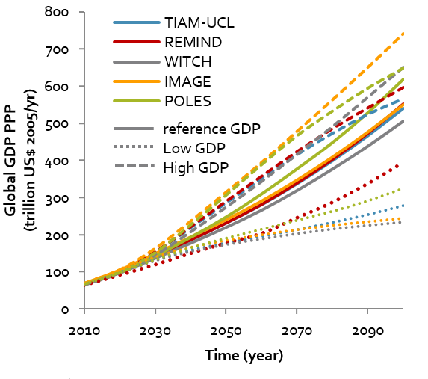
Figure 2: GDP pathways implemented in the models. The solid line is the SSP2 baseline (Scenario 1), the dashed line is the higher GDP pathway (Scenario 11) and the dotted line represents the lower GDP pathway (Scenario 12).
2.4 Price and Income elasticity calculation method
The scenarios described above allow to calculate elasticities. In the case of calculating elasticities on the basis of model runs, the various fuel quantities and prices can be compared at the same point in time and for the same region. This allows to compute the elasticities without having to correct for other covariates or confounding factors (which can obviously not be done for empirically derived elasticities). Based on two different scenarios (1 and 2), $Q_{i1}$ and $Q_{i2}$ denote the quantity consumed, which can be - service demand (kilometres travelled) , final energy use, or energy efficiency (energy use per kilometre travelled) of category or fuel $i$. Similarly, $P_{i1}$ and $P_{i2}$ denote the price of fuel $i$ in both scenarios. Given these four values, the arc price elasticity can be calculated through a logarithmic function:
$$η_{Q,i}=\frac{logQ_{i2}-logQ_{i1}}{logP_{i2}-logP_{i1}}$$
where $η_{Q,i}$ measures the price elasticity of quantity Q with respect to the price of fuel $i.$
In this case, various price projections for a given future year are compared, and there is no beginning or end point between those points. The arc elasticity can therefore be approximated by a mid-point formulation on the basis of the average value of the independent variables [14]:

$$η_{Q,i} =\left(\frac{∆Q_{i}}{0.5 (Q_{i1}+Q_{i2)}}\right)/\left(\frac{∆P_{i}}{0.5 (P_{i1}+P_{i2})}\right)$$

where the percentage change between Scenarios 1 and 2 is calculated relative to the average value between the two.
The elasticities are calculated for the years 2030 and 2060. Some models work with 10-year time steps, which would make 2030 the first year for which price change effects can be analysed and 2060 the last. In the literature, there is a differentiation between short-term and long-term elasticities, as the full impact of a price change can take several years to wear out. Short term is often considered less than two years, while long term refers to more than 10 years. It has been found that long-term elasticities are higher (and can be up to three times as high [21]) than short-term elasticities. Compared to the literature, all those calculated in this study are long-term elasticities, in line with the models’ long-term perspective, mostly with an end-of-the-century time horizon. Both the long term (10 years) and the very long term (40 years) are compared to the long-term transport elasticity values described in the empirical literature.
2.5. Cross-price market share semi-elasticities
To examine fuel consumption responses to price changes in other fuels, typically standard cross-price elasticities are used (e.g., [22]). However, this approach does not always yield meaningful results: if market shares of alternative fuels are small, such as currently is the case for biofuel and electricitythis result in difficult-to-compare high elasticity responses to a slight change in demand. Therefore, market share elasticities are computed (as introduced in [23]). The market shares of different fuels i are defined as:

$${MS}_{i}=\frac{Q_{i}}{\sum_{j=1}^{I}{Q_{j}}}$$
Based on these market shares, the changes in absolute values of the market shares ${MS}_{i}$ are computed for the different fuel types i due to changes in the price of fuel $j$, resulting in cross-price market share semi-elasticities, which we define as:

$$η_{MSi,j}≡\frac{{MS}_{i,1}-{MS}_{i,2}}{\frac{∆P_{j}}{0.5 (P_{j,1}+P_{j,2)}}}$$
These market share elasticities can be interpreted as changes in the market share of each fuel $i$ due to a 1% increase in the price of fuel $j$ (or by multiplying them by 100, they represent the (approximate) market share change in percentage points due to a doubling of the price of fuel $j$). These elasticities sum to zero, $\sum_{i=1}^{I}{η_{MSi,j}}=0$, since market shares always add to one. Therefore, these cross-price elasticities isolate the fuel switching effect due to price changes as a result of efficiency improvements and demand changes discussed above.

3. Models’ inherent demand elasticity results
3.1 Oil and alternative fuel responses
The absolute change in energy demand, compared to the baseline in 2030 and 2060, of transport oil and alternative fuel (AF) in response to the oil and natural gas price shocks (Scenarios 2, 5 and 8) are shown in Figure 3. In 2030 (i.e., 10 years after the applied shock) all models show a decrease in oil demand and an increase in alternative fuel under higher oil and natural gas prices, and vice versa. Most models show a stronger response to the price shocks in 2060 than those in 2030, with higher demand-price slopes (right side vs left side of graph 3). The POLES model is the only one to project the absolute change in oil demand to be less while the fuel price jump becomes larger over time. WITCH shows a relatively mild response to the changing fuel price as well, while IMAGE, REMIND, MESSAGE and TIAM UCL show significant responses. In MESSAGE, oil demand ranges from 35 to 290 EJ/year in 2060. between the higher and lower price scenario, implying that the transport system has completely changed in response to 40 years of widely diverging price trajectories. As MESSAGE, TIAM-UCL and REMIND show strong feedback effects on the price trajectory, moving back to the original fuel price pathway, here very high price elasticities can be expected.
In all models, the decrease in oil is greater than the increase in alternative fuel demand, indicating that increased fuel prices also lead to efficiency improvements. However, there is clear variation in the size of energy reduction, on the one hand, and fuel substitution effects, on the other, across the models. MESSAGE, REMIND and WITCH show higher substitution rates (48%−83% of the oil change), while this is less the case in the more technology-rich models POLES, IMAGE and TIAM-UCL (2%−34%).
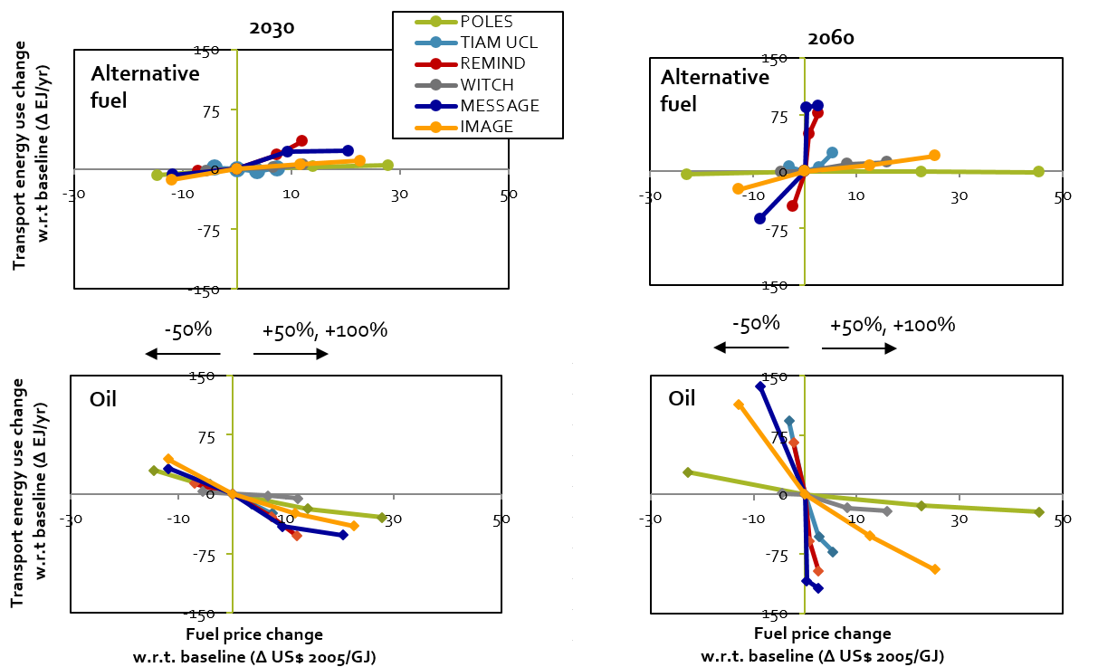
Figure 3: The oil (bottom) and alternative fuel (AF) (top) energy demand response to oil and gas price shocks – Scenarios 2, 5 and 8 - in 2030 (left) and 2060 (right). Alternative fuel is defined as any fuel other than oil.
3.2 Service demand and fuel consumption elasticities
For the models that include details on passenger transport modes (IMAGE, POLES and TIAM-UCL), Table 3 shows the mean and standard deviation in modal service demand (expressed in passenger kilometres (pkm) or tonne kilometres (tkm)) and energy efficiency elasticities of the three oil & natural gas price shock scenarios. This method gives insight into the underlying sectoral changes, for example changes in the kilometres travelled or in the fuel efficiency of each transport mode, which contribute to sectors’ change in energy demand. At the same time, it provides the opportunity to compare model elasticities to empirical data, which are often reported at modal level. For the REMIND, WITCH and MESSAGE projections, the contribution of service demand and efficiency to energy demand elasticities have been specified for total transport, freight and passenger elasticities, as shown in Table 3.
Table 3 Mean service demand (pkm or tkm), fuel efficiency (MJ/pkm or MJ/tkm) and fuel consumption (MJ) elasticities to oil price per mode of transport and aggregated for freight, passenger and total transport. Calculated by comparing the oil & natural gas fuel-price shock Scenarios 2, 5 and 8 to the baseline. The standard deviation in the elasticity values of these three scenarios are indicated between brackets. In bold are the elasticities that are elastic (>1).
 |  |  |  |  |  | IMAGE |  |  | POLES |  |  |  |  |  |  | TIAM-UCL
 |  |  |  |  |  | 2030 | 2060 |  | 2030 |  |  |  |  | 2060 |  |  |  |  | 2030 |  |  |  | 2060
LDV |  |  |  | Pkm |  | -0.2 (0.1) | -0.1 (0.0) |  | -0.2 (0.0) |  |  |  |  | -0.1 (0.0) |  |  |  |  | 0.0 (0.0) |  |  |  | -0.1 (0.0)
 |  |  |  | Efficiency |  | -0.3 (0.2) | -0.7 (0.6) |  | -0.3 (0.1) |  |  |  |  | -0.3 (0.0) |  |  |  |  | -0.2 (0.0) |  |  |  | -2.0 (0.7)
 |  |  |  | Energy |  | -0.5 (0.2) | -0.8 (0.6) |  | -0.4 (0.2) |  |  |  |  | -0.4 (0.0) |  |  |  |  | -0.2 (0.0) |  |  |  | -2.1 (0.7)
Public transport |  |  |  | Pkm |  | -0.2 (0.0) | -0.2 (0.1) |  | -0.2 (0.0) |  |  |  |  | -0.1 (0.0) |  |  |  |  | -0.1 (0.0) |  |  |  | -0.1 (0.0)
 |  |  |  | Efficiency |  | -0.1 (0.2) | -0.4 (0.5) |  | -0.3 (0.0) |  |  |  |  | -0.2 (0.0) |  |  |  |  | 0.0 (0.0) |  |  |  | -0.4 (0.2)
 |  |  |  | Energy |  | -0.4 (0.2) | -0.6 (0.4) |  | -0.5 (0.0) |  |  |  |  | -0.4 (0.1) |  |  |  |  | 0.0 (0.0) |  |  |  | -0.4 (0.2)
Aviation |  |  |  | Pkm |  | -0.7 (0.1) | -0.6 (0.1) |  | 0.1 (0.0) |  |  |  |  | 0.0 (0.0) |  |  |  |  | -0.3 (0.0) |  |  |  | -0.4 (0.1)
 |  |  |  | Efficiency |  | -0.1 (0.1) | -0.6 (0.2) |  | -0.2 (0.1) |  |  |  |  | -0.2 (0.1) |  |  |  |  | 0.0 (0.0) |  |  |  | 0.0 (0.0)
 |  |  |  | Energy |  | -0.8 (0.1) | -1.2 (0.1) |  | -0.1 (0.1) |  |  |  |  | -0.1 (0.1) |  |  |  |  | -0.3 (0.0) |  |  |  | -0.5 (0.1)
Walking & Cycling |  |  |  | Pkm |  | 0.1 (0.0) | 0.2 (0.0)
Total Passenger |  |  |  | Pkm |  | -0.2 (0.0) | -0.2 (0.0) |  | -0.2 (0.0) |  |  |  |  | -0.1 (0.0) |  |  |  |  | -0.2 (0.0) |  |  |  | -0.3 (0.0)
 |  |  |  | Efficiency |  | -0.3 (0.1) | -0.7 (0.4) |  | -0.2 (0.1) |  |  |  |  | -0.2 (0.0) |  |  |  |  | 0.0 (0.0) |  |  |  | -1.0 (0.6)
 |  |  |  | Energy |  | -0.5 (0.2) | -0.9 (0.4) |  | -0.4 (0.1) |  |  |  |  | -0.3 (0.0) |  |  |  |  | -0.2 (0.0) |  |  |  | -1.3 (0.5)
Total Freight |  |  |  | Tkm |  | -0.2 (0.1) | -0.1 (0.1) |  |  |  |  |  |  |  |  |  |  |  | -0.1 (0.0) |  |  |  | -0.1 (0.0)
 |  |  |  | Efficiency |  | -0.1 (0.2) | -0.3 (0.3) |  | -0.2 (0.0) |  |  |  |  | -0.1 (0.0) |  |  |  |  | -0.3 (0.3) |  |  |  | -2.0 (1.9)
 |  |  |  | Energy |  | -0.3 (0.1) | -0.4 (0.2) |  | -0.2 (0.0) |  |  |  |  | -0.1 (0.0) |  |  |  |  | -0.4 (0.3) |  |  |  | -2.1 (1.9)
Total Transport |  |  |  | Energy |  | -0.4 (0.1) | -0.7 (0.1) |  | -0.3 (0.1) |  |  |  |  | -0.2 (0.0) |  |  |  |  | -0.3 (0.1) |  |  |  | -1.5 (0.7)
 |  |  |  |  | REMIND |  |  |  |  |  | WITCH |  |  |  |  |  |  | MESSAGE
 |  |  |  |  | 2030 |  | 2060 |  |  | 2030 |  |  | 2060 |  |  |  | 2030 |  |  |  | 2060
Total Passenger |  |  | Pkm |  | -0.3 (0.1) |  | -0.5 (0.2)
 |  |  | Efficiency |  | 0.0 (0.0) |  | -1.7 (0.7) |  |  | 0.0 (0.0) |  |  | -0.1 (0.2)
 |  |  | Energy |  | -0.3 (0.1) |  | -2.3 (0.9) |  |  | 0.0 (0.0) |  |  | -0.1 (0.2)
Total Freight |  |  | Tkm |  | -0.5 (0.1) |  | -1.3 (0.5)
 |  |  | Efficiency |  | 0.0 (0.0) |  | 0.1 (0.1) |  |  | 0.0 (0.0) |  |  | 0.0 (0.0)
 |  |  | Energy |  | -0.5 (0.1) |  | -1.2 (0.5) |  |  | 0.0 (0.0) |  |  | 0.0 (0.0)
Total Transport |  |  | Energy |  | -0.3 (0.1) |  | -1.9 (0.7) |  |  | 0.0 (0.0) |  |  | -0.1 (0.1) |  |  |  | -0.4 (0.1) |  |  |  | 0.4 (3.8)

The passenger service demand elasticity — the elasticity of the travelled passenger kilometres — in 2030, varies between -0.2 and -0.3 across all models and, in 2060, between -0.1 and -0.5. Freight service demand ranges from -0.1 to -0.5 in 2030 and from -0.1 to -1.3 in 2060. In the REMIND model, where there is no alternative for liquid fuel in freight transport, fuel-price shocks have a larger impact on transport prices than in passenger transport, resulting in higher elasticity values. In all models, but REMIND the transport service demand is not elastic to fuel prices (i.e. <1). WITCH service demand and POLES freight service demand projections are not related to energy prices, but are driven only by GDP and population, and changes in energy prices are reflected only in the choice of technology. Not capturing service demand price elasticity could lead to relatively downward bias for the overall energy demand elasticity. Indeed, of the six models, POLES and WITCH energy demand elasticity are on the low side of the spectrum. MESSAGE does not differentiate between passenger and freight transport demand, but relates total transport (useful) energy demand directly to economic and demographic drivers.
Fouquet has analysed the income and price elasticities of passenger transport demand between 1850 and 2010 in the United Kingdom, and shows that both elasticities have declined over time [24], from 3.1 and -1.5 to 0.8 and -0.6, respectively. Price elasticities depend on income effects as well as substitution effects. When incomes rise, the share of fuel expenditure in total expenditure declines, leading to lower price sensitivity. Moreover, with higher incomes, travel time is valued more, and fuel costs take up a relatively smaller share of the generalised cost of travel (in which money and time are accounted for) [16]. Fouquet compares service demand to the price of service demand, instead of to the price of fuel [24]. Therefore, the results in Table 3 cannot be compared directly to Fouquet’s results. The described trends of service demand’s reduced sensitivity to prices, over time, can be seen for some modes of transport, but others show the opposite trend.
Most models show a response in efficiency change that is stronger for 2060 — ranging from -0.1 to -1.7 for passenger transport and -0.0 to -2.0 for freight transport — than for 2030. As a result, in all models except POLES, the long-term (2060) energy demand elasticity is higher than that in the medium term (2030), as is also noted in Section 3.1. This is especially pronounced in TIAM-UCL’s projections. This is because 1) models have a much longer time period to respond to higher/lower prices, and 2) new vehicle technology developments have led to cheaper alternatives, which, for example in the case of electric vehicle deployment, would lead to higher efficiency. Also, long-term feedback effects on fuel prices, as seen in REMIND, MESSAGE and TIAM-UCL projections, could further enhance this effect.
A large share of the empirical research on transport price elasticity has focused on road transport elasticities to the petrol price under different circumstances, and a few review studies have summarised these results in ‘generic values’. Johansson and Shipper (1997) [25] study 12 OECD countries, for the period from 1973 to 1992, and find long term elasticities to fuel prices of car service demand to range between -0.05 and -0.55, and of car fuel economy to range between -0.45 and -0.35. These figures are comparable to those in reviews by Graham and Glaister (2002) [26], Goodwin et al. (2004) [27] and Espey (1998) [28]. Interestingly, the models’ LDV service demand elasticities range from -0.1 to -0.2, which is within that range. The models respond very similarly; not covering the full uncertainty found empirically. For 2030, the efficiency response of the models (-0.3 in all models) is very comparable to the empirically found data; leading to an overall comparable LDV energy consumption elasticity in 2030. For 2060 however, both IMAGE and TIAM-UCL project a stronger efficiency response, resulting in an elastic (< -1) response that is beyond the range summarised in the reviews of empirically found elasticities. The availability of more fuel-efficient alternative types of vehicles increases the substitution effect on the price elasticity projected for the second half of the century.
The differences between price elasticities per transport mode, in the model projections, not necessarily imply modal shifts, because the elasticity is defined as a relative decrease in pkm to the transport mode’s total pkm, and the transport modes differ in overall volume. Moreover, the various transport modes do not contribute equally to the overall transport volume (some, such as bicycles, have a smaller share). A change in fuel price can be expected to have a larger effect on the transport modes that are relatively high in energy consumption, such as LDVs and aviation. Fouquet argues that air transport is a ‘luxury’ form of transport and service demand would be more sensitive to fuel prices than would other modes of transport [24]. IMAGE and TIAM-UCL indeed show higher service demand responses in aviation than in other modes of transport, and all three models show the largest efficiency response in the light duty vehicles (LDV).
3.3 Market share elasticities of fuel
The transport sector is currently being dominated by oil products, but Integrated Assessment models show that fuel switching is an effective way to mitigate the greenhouse gas emissions from the transport sector, in order to achieve a stringent climate target [11]. The scenarios with oil, biofuel and electricity shocks of +100% (Scenarios 6, 7 and 8) and -50% (Scenarios 2, 3 and 4) are used to analyse how responsive fuel market shares are to fuel price changes for various carriers. Following the equations in section 2.5, Figure 5 shows the cross-price elasticities per fuel type. The interpretation, for instance for IMAGE, shows that a doubling of oil prices will lead to a 50 percentage points decrease in the market share of oil in transportation by 2050, whereas the share of biofuels and electricity will increase by respectively 18 and 21 percentage points.
Fuel market shares are considerably more responsive to oil and biofuel price changes than to electricity price changes. For many modes of transport, switching to electricity means switching to an alternative type of propulsion. The lower sensitivity could be explained by the fact that technology cost, availability and consumer behaviour are larger hurdles than the costs of electricity in relation to this transition. The fuel market is the most sensitive to changing oil prices and decreasing biofuel prices, which both lead to oil substitution. Elasticities of all fuel types, in all models, increase over time, with the exception of the IMAGE biofuel response in the +100% scenario. POLES and WITCH show la low response, compared to the other models, projecting the sector to remain dependent on oil irrespective of fuel price changes, in line with the low responses to oil price changes as shown in Sections 3.1 and 3.2. MESSAGE and REMIND show a high response, which again partially can be explained by the feedback effects on prices, but also higher fuel switching flexibility due to less technology constraints.
Oil price increases are projected to lead to a switch from oil to biofuel in 2030 and, in some models, to fossil synfuel, while, in 2050, electricity also becomes an attractive alternative. Increasing electricity and biofuel prices lead to a reduction in the use of both fuel types, from which can be concluded that, under the baseline scenario, electricity and biofuel have a certain share in transport fuel use. In REMIND, intertemporal foresight and interactions with other fuel-consuming sectors may lead to the opposite effect; for example, with increasing oil shares under higher oil prices in 2030. Lowering fuel prices leads to strong early consumption, both in the transport sector and in others, which implies that long-term scarcities become more pronounced, in turn leading to increased long-term reliance on alternative fuels.
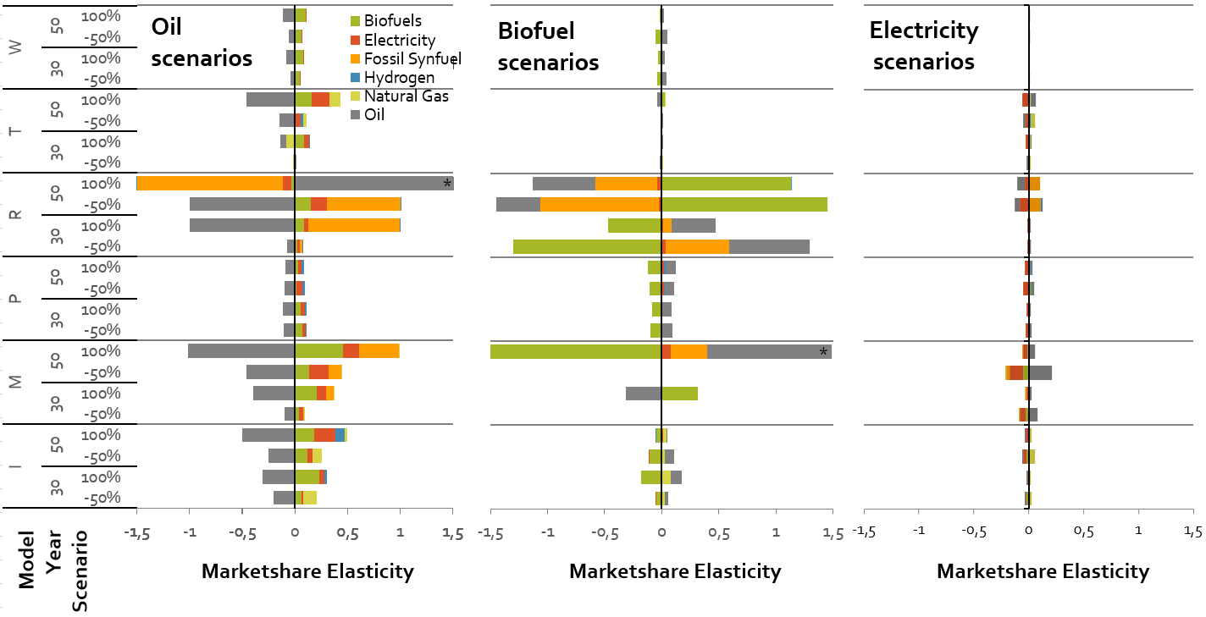
Figure 4: Market share elasticities in response to changes in oil, biofuel and electricity prices from +100% to -50%. Elasticities indicate the shift in market shares, for all the different fuel types for which the sum of the elasticities is 0. Negative elasticities in the -50% scenario imply an increase in use, as the elasticity is relative to the price signal. The models are indicated by their first letter (R=REMIND, I=IMAGE, T=TIAM-UCL, M=MESSAGE, P=POLES and W=WITCH). * In two scenarios (marked with *) the market elasticity was larger than 1.5 - due to very high price feedbacks- the results were normalised to 1.5.
3.4 Income elasticities
To assess the sensitivity of demand to income level, an approach similar to that described in Section 3.1 was used, distinguishing the effects of changes in efficiency and service demand. The results are presented in Table 4. There have been suggestions that at higher income the per capita kilometres travelled would saturate and that we are reaching peak travel [29, 30]. The theory is that transport was originally perceived as a ‘luxury’ product which is sensitive to income changes. As incomes continue to rise, saturation effects will reduce income elasticity. This theory is supported by the already mentioned reduced travel demand to income elasticity between 1850−2010, in Fouquet [24]. This trend is not clearly reflected in all the model results, neither over time nor with increased income. The elasticity values for high and low incomes are rather comparable, although IMAGE, REMIND and WITCH do show lower service demand elasticities to higher income scenarios.
The energy efficiency response in IMAGE increases, due to a shift to higher intensity transport modes with higher income. In the other models, efficiency decreases, which could reflect the concept of a larger budget leading to an increase in technology use, which, in turn, leads to efficiency learning. Johansson and Shipper (1997) find that the long-term elasticity of vehicle fuel consumption (related to what here is called efficiency) with respect to income is between 0.05 to 1.6 [25], and Glaister and Graham (2002) report this to be between 1.1 and 1.3 [26]. These two studies were conducted at LDV level, and, therefore, are not easy to compare to the model projections used in this study, as the effects of structural changes (shifting transport modes) are not included, but it can be concluded that this positive relationship is not necessarily reflected in the models. Both studies also analyse long-term elasticity of service demand with respect to income; Johansson and Shipper (1997) find a range of 0.65 to 1.25 [25], while Glaister and Graham (2002) report this to be between 1.1 to 1.8 [26]. For the United Kingdom, Fouquet reports a reduction in transport service demand to income elasticity of 3.1 to 1.0 (including air travel) between 1850 and 2010. Compared to these figures, the IAM service demand elasticity values are on the low side, with the exception of the WITCH model. Income elasticities of transport energy demand are reported to be greater than price elasticities provided in the literature [27]. The models show service demand to income elasticities are indeed larger (especially in WITCH) but negative energy efficiency may lead to income energy demand elasticities (ranging from 0.31 to 1.44) that are comparable to price elasticities.

Table 4 Service demand (pkm or tkm), fuel efficiency (MJ/pkm or MJ/tkm) and fuel consumption (MJ) elasticities with respect to income changes (Scenarios 11 and 12) for freight, passenger and total transport.
 | IMAGE |  | POLES |  | REMIND |  | WITCH |  | TIAM-UCL
 | low | high | low | high | low | high | low | High | low | high
Passenger transport in 2030
Pkm  Efficiency  Energy | 0.50 | 0.38 | 0.49 | 0.65 | 0.45 | 0.32 | 1.19 | 0.91
Pkm  Efficiency  Energy | 0.11 | 0.20 | -0.13 | -0.17 | -0.01 | -0.02 | -0.03 | -0.10
Pkm  Efficiency  Energy | 0.61 | 0.58 | 0.36 | 0.47 | 0.44 | 0.31 | 1.15 | 0.81
Freight transport in 2030
Tkm  Efficiency  Energy | 0.87 | 0.35 | 0.43 | 0.83 | 0.42 | 0.30 | 1.17 | 0.93
Tkm  Efficiency  Energy | -0.26 | 0.18 | -0.01 | -0.42 | -0.06 | 0.00 | -0.03 | 0.04
Tkm  Efficiency  Energy | 0.61 | 0.54 | 0.42 | 0.41 | 0.36 | 0.31 | 1.14 | 0.97
Total | 0.61 | 0.56 | 0.39 | 0.44 | 0.41 | 0.31 | 1.15 | 0.87 | 0.65 | 0.99
Passenger transport in 2060
Pkm  Efficiency  Energy | 0.51 | 0.53 | 0.62 | 0.40 | 0.37 | 0.31 | 0.96 | 0.75
Pkm  Efficiency  Energy | 0.16 | 0.38 | -0.09 | -0.18 | 0.08 | 0.04 | -0.06 | -0.30
Pkm  Efficiency  Energy | 0.67 | 0.90 | 0.52 | 0.22 | 0.45 | 0.34 | 0.91 | 0.46
Freight transport in 2060
Tkm  Efficiency  Energy | 0.78 | 0.50 | 0.53 | 0.59 | 0.41 | 0.25 | 0.99 | 0.79
Tkm  Efficiency  Energy | -0.08 | 0.03 | -0.14 | -0.15 | -0.02 | 0.00 | 0.02 | 0.04
Tkm  Efficiency  Energy | 0.70 | 0.52 | 0.40 | 0.44 | 0.39 | 0.25 | 1.01 | 0.83
Total | 0.68 | 0.77 | 0.47 | 0.32 | 0.43 | 0.31 | 0.95 | 0.62 | 0.53 | 1.44

- Discussion and conclusions
In this paper, we introduced fuel price shocks in models in order to determine the implicit demand elasticities. This can help to describe and understand model behaviour and projected results. In the experiments in the paper, ideally, the fuel price shocks would follow the exact same fuel price pathways in all models. However, the fuel price trajectories in the baseline already varies across models. Moreover, due to interference with some of the models solution methods, fuel prices could not follow a predefined pathway in all models. In those models price increases/decreases were added to endogenously calculated fuel prices to mimic the fuel price shocks. In some models, this method resulted in fuel prices moving away from the set pathway over time, as a result of lower fuel use. In REMIND, fuel prices also moved away but already in the early decades, due to intertemporal forecasts. Because of the relative nature of elasticities, different fuel price pathways not necessarily have an impact on results, but we did find the demand response to be both pathway- and time-dependent. This is most clearly demonstrated by the results from the MESSAGE and REMIND models, projecting large demand differences, while fuel price differences became very small (in some cases, even negative) by 2060. Remaining as close as possible to the intended fuel price pathway would therefore improve the comparability of results between models. However the scenarios do show how the different solution methods affect the model dynamics. It can be expected that the implementation of a carbon tax could result in similar model responses.

On the basis of the results, the following conclusions can be derived:
The proposed method in this paper to derive price and income elasticities as diagnostic indicators provides a transparent environment to test model dynamics. The approach provides insights into model responsiveness, both for the medium and long term. It enables us to evaluate model behaviour and to distinguish a model’s fingerprint. At the same time, it could be used to understand the effect of model development on model behaviour, through a before-and-after comparison. Modelling individual transport modes explicitly does not lead to major differences in energy demand responses (compared to models that only represent transport modes in a more aggregated way), and the detailed and less detailed models show similar elasticity values.

Efficiency and service demand elasticities to fuel price are within the range of values found empirically, and very close to each other in the medium term. Comparing model elasticities at modal level, and specifying between service demand and efficiency changes, shows that in 2030 energy demand elasticities are very comparable between models and close to the range reported in the literature. This shows that in terms of historical validation in the medium term the model perform well. LDV energy demand elasticities to oil and gas prices are projected to range from -0.2 to -0.5 in 2030. Total transport energy elasticity values, projected to range between 0.0 and -0.4 in 2030, are also comparable (although on the low side) to the values reported by Hogan and Sweeney [17] that ranged between (-0.1 to -0.6) in the short term. For 2060, the models show more diverging behaviour, and elasticities cover a broader range as a result of fuel substitution, increased efficiency, service demand reduction and feedback effects on prices. Assuming service demand pathways exogenously, as is done in WITCH and POLES, on the other hand leads to a weaker demand response.

A division can be made between the models that become more responsive in the long term (2060) than in the medium term (2030). Some models clearly show higher fuel switching and energy demand reduction responses in the long term, while service demand response remains comparable. The projected elasticity of total energy demand in transport to oil and natural gas prices in 2060 range from 0.4 to -1.9, and for LDV energy consumption from -0.4 to -2.1. There are however different effects that can have caused this increased response. In IMAGE, REMIND, MESSAGE and TIAM-UCL, alternative technologies become more attractive (cheaper) in the long term, and therefore oil price changes can lead to a stronger response. In REMIND’s freight sector, the opposite is visible, since no alternatives are available, therefore travelling becomes more expensive and, thus, leads to higher price effects on service demand. MESSAGE, REMIND and TIAM-UCL also show large feedback effects on fuel price pathways in the long term, while demand does not immediately follow. This also shows that near term price policies could have long term effects.

Market share distribution responds more strongly to oil and biofuel price changes than to electricity prices. Oil will be substituted as the dominant fuel when oil prices increase. Biofuel price change sees in some models a strong effect but electricity price changes hardly have an impact on the projected shares. The models show that, in 2030, mainly biofuel is used as a substitute, and some models use fossil synfuel, while electricity shares increase as a result of higher oil prices in the long term. Furthermore, the models show a stronger response to biofuel price reductions than to reductions in the oil price. The models are not responsive to electricity price changes, indicating that other factors such as technology costs and behaviour might be more important in this transition. The models’ response to price jump of 50% compared to a price jump of 100% is not clearly different. Elasticity values for most models are comparable per model under both these scenarios, implying a linear demand response. Again, here a clear difference can be seen between models that show a high response (REMIND, MESSAGE), medium response (IMAGE, TIAM-UCL) and a low response (WITCH and POLES).

Service demand projections are more responsive to income level than to fuel prices, which corresponds to findings in the literature. Saturation effects over time or with increasing income are not clearly visible. The model results are responsive to income projections and elasticity values range between 0.31 and 1.44. This is within the range reported in the literature. Even so, this range has a large impact on the projected transport demand, and could explain the varying transport sector service demand growth projections which have been seen in previous model comparison studies [11]. Reduced income elasticities over time, or in response to higher income shocks indicating saturation, cannot clearly be retraced in the model results. A better understanding of the uncertainty of income effects on service demand by exploring different income pathways as well as different service demand to income elasticities, is very relevant — as is having a better understanding of the role of saturation. The efficiency response to income change differs across models. In some models efficiency increases as a result of technology learning, while in others it decreases due to a shift to more energy-intensive transport modes.

References

1. Luderer, G., et al., The economics of decarbonizing the energy system—results and insights from the RECIPE model intercomparison. Climatic Change, 2012. 114(1): p. 9-37.
2. Clarke, L., et al., International climate policy architectures: Overview of the EMF 22 International Scenarios. Energy Economics, 2009. 31, Supplement 2: p. S64-S81.
3. Sugiyama, M., et al., Energy efficiency potentials for global climate change mitigation. Climatic Change, 2014. 123(3-4): p. 397-411.
4. Riahi, K., et al., Chapter 17 - Energy Pathways for Sustainable Development, in Global Energy Assessment - Toward a Sustainable Future2012: Cambridge University Press, Cambridge, UK and New York, NY, USA and the International Institute for Applied Systems Analysis, Laxenburg, Austria. p. 1203-1306.
5. McCollum, D.L., et al., Improving the behavioral realism of global integrated assessment models: an application to consumers’ vehicle choices. Transportation Research Part D: Transport and Environment, 2016.
6. Ó Broin, E. and C. Guivarch, Transport Infrastructure costs in low-carbon Pathways. Transportation Research Part D: Transport and Environment 2016 (forthcoming).
7. Dai, H., Key factors influencing the global passenger transport dynamics using the AIM/Transport model. Transportation Research Part D: Transport and Environment, 2016 (forthcoming).
8. Karkatsoulis, P., et al., Simulating deep CO2 emission reduction in transport in a general equilibrium framework: the GEM-E3T model. Transportation Research Part D: Transport and Environment, 2016 (forthcoming).
9. Carrara, S. and T. Longden, Freight Futures: The Potential Impact of Road Freight on Climate Policy. Transport Research Part D: Transport and Environment, 2016 (forthcoming).
10. Girod, B., et al., Climate impact of transportation A model comparison. Climatic Change, 2013. 118(3-4): p. 595-608.
11. Edelenbosch, O., et al., Decomposing passenger transport futures: Comparing results of global integrated assessment models. Transportation Research Part D: Transport and Environment, 2016.
12. Pietzcker, R.C., et al., Long-term transport energy demand and climate policy: Alternative visions on transport decarbonization in energy-economy models. Energy, 2014. 64: p. 95-108.
13. Kriegler, E., et al., Diagnostic indicators for integrated assessment models of climate policy. Technological Forecasting and Social Change, 2015. 90: p. 45-61.
14. Litman, T., Understanding transport demands and elasticities. How prices and other factors affect travel behavior.(Victoria Transport Policy Institute: Litman) Available at http://www. vtpi. org/elasticities. pdf [Verified 22 November 2013], 2013.
15. McCollom, B.E. and R.H. Pratt, TRAVELER RESPONSE TO TRANSPORTATION SYSTEM CHANGES. CHAPTER 12-TRANSIT PRICING AND FARES2004.
16. Small, K.A. and K. Van Dender, Long run trends in transport demand, fuel price elasticities and implications of the oil outlook for transport policy. 2007.
17. Hogan, W. and J. Sweeney, Aggregate elasticity of energy demand. The Energy Journal, 1981. 2(2): p. 37-75.
18. McCollum, D., et al., Transport electrification: A key element for energy system transformation and climate stabilization. Climatic Change, 2014. 123(3-4): p. 651-664.
19. Jaccard, M. and A. Beylin-Stern, Hybrid Simulation Modeling to Estimate U.S. Energy Elasticity of Substitution, 2014, Simon Fraser University.
20. O’Neill, B.C., et al., A new scenario framework for climate change research: the concept of shared socioeconomic pathways. Climatic Change, 2014. 122(3): p. 387-400.
21. Dargay, J. and D. Gately, The demand for transportation fuels: Imperfect price-reversibility? Transportation Research Part B: Methodological, 1997. 31(1): p. 71-82.
22. Ziemba, W.T., and S. L. Schwartz., Energy Policy Modeling: United States and Canadian Experiences. Vol. Volume I Specialized Energy Policy Models. 2012: Springer Science & Business Media.
23. Bucklin, R.E., G.J. Russell, and V. Srinivasan, A relationship between market share elasticities and brand switching probabilities. Journal of Marketing Research, 1998: p. 99-113.
24. Fouquet, R., Trends in income and price elasticities of transport demand (1850–2010). Energy policy, 2012. 50: p. 62-71.
25. Johansson, O. and L. Schipper, Measuring the long-run fuel demand of cars: separate estimations of vehicle stock, mean fuel intensity, and mean annual driving distance. Journal of Transport Economics and policy, 1997: p. 277-292.
26. Graham, D.J. and S. Glaister, The demand for automobile fuel: a survey of elasticities. Journal of Transport Economics and policy, 2002: p. 1-25.
27. Goodwin, P., J. Dargay, and M. Hanly, Elasticities of Road Traffic and Fuel Consumption with Respect to Price and Income: A Review. Transport Reviews, 2004. 24(3): p. 275-292.
28. Espey, M., Gasoline demand revisited: an international meta-analysis of elasticities. Energy Economics, 1998. 20(3): p. 273-295.
29. Millard‐Ball, A. and L. Schipper, Are We Reaching Peak Travel? Trends in Passenger Transport in Eight Industrialized Countries. Transport Reviews, 2011. 31(3): p. 357-378.
30. Dargay, J., D. Gately, and M. Sommer, Vehicle ownership and income growth, worldwide: 1960-2030. The Energy Journal, 2007: p. 143-170.
31. Luderer, G., et al., Description of the Remind Model (Version 1.6). 2015.
32. E. Stehfest, D.P.v.V., T. Kram, L. Bouwman, Integrated Assessment of Global Environmental Change with IMAGE 3.0: model description and policy application, 2014, PBL Netehrlands Environmental Assessment Agency: The Hague, the Netherlands.
33. Girod, B., D.P. van Vuuren, and S. Deetman, Global travel within the 2 C climate target. Energy Policy, 2012. 45: p. 152-166.
34. Plotkin, S. and M. Singh, Multi-path transportation futures study: vehicle characterization and scenario analyses., 2009, Argonne National Laboratory (ANL).
35. McCollum, D.L., et al., Improving the behavioral realism of global integrated assessment models: An application to consumers’ vehicle choices. Transportation Research Part D: Transport and Environment, 2016.
36. Riahi, K., A. Grübler, and N. Nakicenovic, Scenarios of long-term socio-economic and environmental development under climate stabilization. Technological Forecasting and Social Change, 2007. 74(7): p. 887-935.
37. Messner, S. and L. Schrattenholzer, MESSAGE-MACRO: linking an energy supply model with a macroeconomic module and solving it iteratively. Energy, 2000. 25(3): p. 267-282.
38. Messner, S. and M. Strubegger, User's guide for MESSAGE III, Working Paper WP-95-069, 1995, International Institute for Applied Systems Analysis (IIASA): Laxenburg, Austria. p. 164.
39. Rao, S., I. Keppo, and K. Riahi, Importance of technological change and spillovers in long-term climate policy. The Energy Journal, Special Issue: Endogenous Technological Change and the Economics of Atmospheric Stabilisation, 2006. 27.
40. Riahi, K., E.S. Rubin, and L. Schrattenholzer, Prospects for carbon capture and sequestration technologies assuming their technological learning. Energy, 2004. 29(9-10): p. 1309-1318.
41. Roehrl, R.A. and K. Riahi, Technology Dynamics and Greenhouse Gas Emissions Mitigation: A Cost Assessment. Technological Forecasting and Social Change, 2000. 63(2-3): p. 231-261.
42. Bosetti, V. and T. Longden, Light duty vehicle transportation and global climate policy: The importance of electric drive vehicles. Energy policy, 2013. 58: p. 209-219.
43. Longden, T., Travel intensity and climate policy: The influence of different mobility futures on the diffusion of battery integrated vehicles. Energy policy, 2014. 72: p. 219-234.

Supplementary Material of

Transport fuel demand responses to fuel price and income projections: Comparison of Integrated Assessment Models
O.Y. Edelenbosch^{a,b}, D.P. van Vuuren^{a,b}, C. Bertram^{c}, S. Carrara^{d}, J. Emmerling^{d} H. Daly^{e}, A. Kitous^{f}, D.L. McCollum^{g}, N. Saadi Failali^{e}

ª PBL Netherlands Environmental Assessment Agency, Bezuidenhoutseweg 30, 2594 AV Den Haag, The Netherlands (E: Oreane.Edelenbosch@pbl.nl, Detlef.vanvuuren@pbl.nl);
^{b} Copernicus Institute of Sustainable Development, Utrecht University, Heidelberglaan 2, 3584 CS Utrecht, The Netherlands;
^{c} Potsdam Institute for Climate Impact Research, Telegrafenberg, 14473 Potsdam, Germany;
^{d} Fondazione Eni Enrico Mattei (FEEM) and Centro Euro-Mediterraneo sui Cambiamenti Climatici (CMCC), Corso Magenta 63 ,20123 Milan;
^{e} UCL Energy Institute, University College London, Upper Woburn Place, London WC1H 0NN, United Kingdom;
^{f} European Commission, JRC IPTS, Edificio Expo; C/ Inca Garcilaso, 3, E-41092 Sevilla, SPAIN; Disclaimer: The views expressed are purely those of the writer and may not in any circumstances be regarded as stating an official position of the European Commission.
^{g} International Institute for Applied Systems Analysis (IIASA), Schlossplatz 1, 2361 Laxenburg, Austria

- Transport model descriptions of participating Integrated Assessment Models
REMIND transport
REMIND models the transport sector by using a hybrid approach combining top-down and bottom-up elements. Mobility demands for the four modeled transport sub-sectors (passenger-light duty vehicles (LDV), freight, electric rail, passenger-aviation and buses) are derived in a top-down fashion, since they are input to a nested CES production function that ultimately produces GDP. For the LDV mode, three different technology options (internal combustion engine, battery electric vehicle, and fuel cell vehicle) compete against each other in a linear bottom-up technology model.
The transport sector requires input of final energy in different forms (liquids, electricity and hydrogen) and requires investments and operation and maintenance payments into the distribution infrastructure (infrastructure capacity grows linearly with distributed final energy) as well as into the vehicle stock.
The main drivers/determinants of transport demand are GDP growth, the autonomous efficiency improvements (efficiency parameters of CES production function), and the elasticities of substitution between capital and energy and between stationary and transport energy forms. Furthermore, inside a model run, different final energy prices (due to climate policy, different resource assumptions, etc.) can lead to substitution of different transport modes inside the CES function, or a total reduction in travel demand.
The distribution of vehicles inside the LDV mode follows cost optimisation (perfect linear substitutability), although with different non-linear constraints (learning curve, upper limits of 70% on share of battery-electric vehicles and 90% on Fuel Cell vehicles) that in most realisations lead to a technology mix. Further information on the transport sector modeling in REMIND can be found in Luderer, Leimbach [31]and Pietzcker, Longden [12]

IMAGE travel model
The Integrated Model to Assess the Greenhouse Effect (IMAGE)is developed by PBL Netherlands Environment Assessment Agency, to assess environmental consequences of human activities in industry, transport, buildings, agriculture and forestry affecting energy use and land use at a global level [32]. The transportation module IMAGE/Travel model is described in detail by [33]. In this study the GDP and population drivers are updated to SSP2 scenarios that can be accessed at https://secure.iiasa.ac.at/web-apps/ene/SspDb .
In IMAGE/Travel travelling costs form the basis of the modeling both in determining modal shares, as well as vehicle shares per transport mode, based on a multi nominal logit (MNL) model. The model represents 7 passenger transport modes and 6 freight transport modes. Modal costs depend on real cost per pkm, non-monetary preferences, and a time weight that captures the importance of time compared to monetary costs. Non-monetary preferences are used to calibrate the model to historical observations and account for factors that go beyond cost (e.g. driving a car is more expensive than other modes, but a popular travel choice). The concepts of the travel money budget (TMB) and travel time budget (TTB) are used to relate travel demand to income. Increasing income leads to increasing travel demand per capita which results in more time spent travelling. Through the concept of travel time budget (TTB), time gets more weight and faster modes are values more, as a result. This dynamic relation results in the empirically observed shift to higher speed modes when income increases [33].
All transport-specific model mechanics and data are documented in the main text and appendix of [33], with the exception of the following updates. The costs per vehicle type, which determines vehicle choice, depend on energy cost, technology cost, non-energy cost (related to maintenance and vehicle purchase), and the load factor, which is regionally dependent. Energy efficiency in the model is captured in three ways: 1) Price induced efficiency improvement: in response to higher fuel price more efficient vehicles become cost competitive, 2) Autonomous efficiency improvement: technology costs of efficient technologies decline over time as a result of technological learning, 3) Modal shift: increasing fuel prices can also result in a shift toward more efficient modes [33] [34]. Reduction in transport GHG emissions are achieved through a carbon tax resulting, on the one the hand, in reduced competitiveness of technologies and modes with high dependency on fossil fuels, and, on the other hand, the increased price of travelling leads to less travel demand implemented through the concept of travel monetary budget (TMB).
Since Girod (2012) the LDV projected vehicle costs and efficiency have been revised to incorporate the most recent projections of LDV vehicle technology development, following the in depth study performed by the Argonne National Laboratory [34].
MESSAGE Stylised Transport Sector Representation

The version of MESSAGE employed in this study (‘MESSAGE V.5a’) includes a quite stylised representation of the transport sector, which essentially captures only fuel switching and price-elastic demands as mechanisms to respond to climate and energy policies. Importantly, the entire sector is modeled as one: all motorised transport modes, including light-duty vehicles, buses, trains, heavy-duty trucks, ships, and airplanes, are aggregated together into a single demand category. (Other MESSAGE model versions, in contrast, have a highly-detailed technological and socio-behavioral representation of the various modes, including a mechanism for switching transport modes; [35] for more information on the model version ‘MESSAGE-Transport V.5’.) The following brief description elaborates the main characteristics of the transport module employed here.

The model chooses between different final energy forms to provide useful energy for transportation. This decision is based primarily on the energy service costs by fuel, taking into account fuel prices at the final energy level and the respective final-to-useful energy conversion efficiencies. In addition, cost mark-ups are applied to non-liquid fuels, in order to capture increased vehicle investment costs and market adoption hurdles, or ‘behavioral barriers’, which this stylised transport formulation is otherwise not well equipped to handle. The portion of the mark-ups capturing behavioral barriers are referred to as ‘inconvenience’ or ‘disutility’ costs. They represent, for instance, range anxiety, extent of refueling/recharging infrastructure, and risk aversion. The conversion efficiencies vary by energy carrier. Useful energy demands (for the aggregate transportation sector of each region) are first specified in terms of internal combustion engine (ICE)-equivalent, which therefore by definition have a conversion efficiency of final to useful energy of 1. Relative to that, the conversion efficiency of alternative fuels is higher, for example electricity in 2010 has a factor of ~3x higher final-to-useful efficiency than the regular oil-product-based ICE. The assumed efficiency improvements of the ICE vehicles in the transportation sector, as well as switching transport modes and other lifestyle changes, are implicitly embedded in the baseline demand specifications (i.e., the scenario storyline). These come from the MESSAGE scenario generator (see Riahi et al. [36] for more information). Finally, the demand for international shipping is modeled in a very simple way with a number of different energy carrier options (light and heavy fuel oil, biofuels, natural gas, and hydrogen). Demand is coupled to global GDP development with an income elasticity.

Additional demand reduction in response to price increases (e.g., in policy scenarios) then occurs via two mechanisms: (i) the fuel switching option (due to the fuel-specific relative efficiencies), and (ii) the linkage with the macro-economic model MACRO. Figure 6 graphically illustrates the main components of the stylised transport sector representation in MESSAGE.

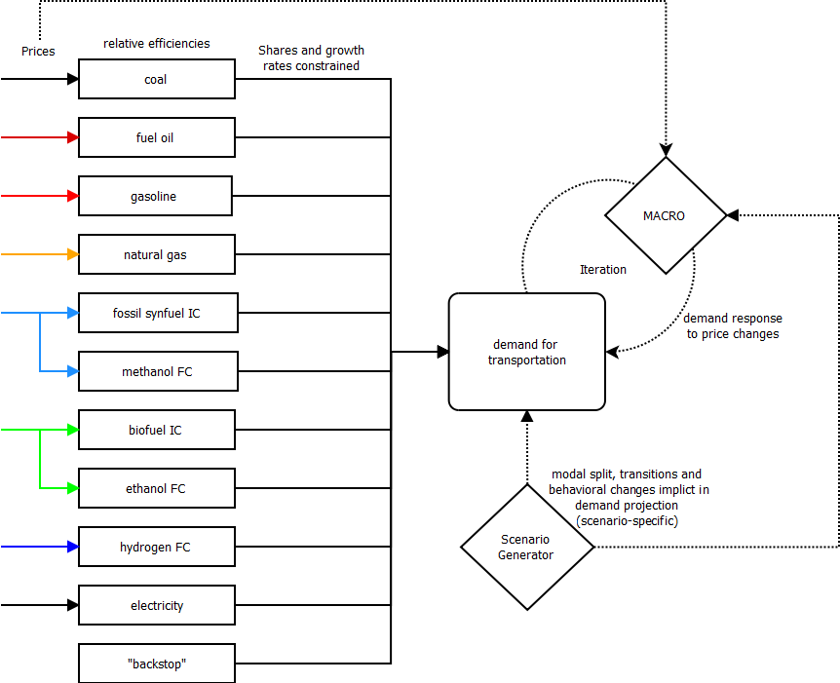
Figure 6. Schematic diagram of the stylised transport sector representation in MESSAGE

To reflect limitations of switching to alternative fuels, for example as a result of limited infrastructure availability (e.g., rail network) or some energy carriers being largely unsuitable for certain transport modes (e.g., electrification of aviation), cost mark-ups and share constraints are imposed on certain energy carriers (e.g., electricity) and energy carrier groups (e.g., liquid fuels) of the transport sector. In addition, the diffusion speed of alternative fuels is limited to mimic known bottlenecks in the supply chain, particularly those not explicitly represented in MESSAGE (e.g., non-energy related infrastructure). Both the share and diffusion constraints are typically parameterised based on transport sector studies that analyse such developments and their feasibility in much greater detail.

In the overall MESSAGE framework, price-induced demand responses for energy carriers at the final energy level result from a combination of three different factors: (i) adopting more efficient technologies, (ii) fuel switching and the resulting relative efficiency changes (e.g., differences between solids, gases and electricity), and (iii) demand response at the useful energy level. The latter changes in useful energy demand are modeled in MESSAGE via an iterative link to MACRO, an aggregated macro-economic model of the global economy[37]. Through an iterative solution process, MESSAGE and MACRO exchange information on energy prices, energy demands, and energy system costs until the demand responses are such (for each of the six end-use demand categories in the model: electric and thermal heat demands in the industrial and residential/commercial sectors (1-4), non-energy feedstock demands for industrial applications (5), and mobility demands in the transportation sector (6)) that the two models have reached equilibrium. This process is parameterised off of a baseline scenario (which assumes some autonomous rate of energy efficiency improvement, AEEI) and is conducted for all eleven MESSAGE regions simultaneously. Therefore, the demand responses motivated by MACRO are meant to represent the additional (compared to the baseline) energy efficiency improvements and conservation that would occur in each region as a result of higher prices for energy services. The macro-economic response captures both technological and behavioral measures (at a high level of aggregation), while considering the substitutability of capital, labor, and energy as inputs to the production function at the macro level.

Further, more detailed information on the MESSAGE modeling framework is available, including documentation of model set-up and mathematical formulation[4, 38] and the models’ representation of technological change and learning[39-41].

TIAM-UCL transport model

TIAM-UCL is a whole energy system model covering from energy resources to conversion to infrastructure to end-use sectors. This is a linear programming model that minimises total discounted energy system cost in the standard version and maximises societal welfare (total surplus) in the elastic demand version to compute a partial equilibrium.

The transportation sector is characterised by 14 energy-services plus one non-energy use demand segment (Table 1). Six of the energy-services are considered as generic demands: international and domestic aviation (TAI, TAD), freight and passenger rail transportation (TTF, TTP), domestic and international navigation (TWD, TWI). All other energy-services are for road transport.

Table 1: Energy-service demands in transport sector
Code  TAD | Energy-service demand  Domestic Aviation | Unit  PJ
TAI | International Aviation | PJ
TRB | Road Bus Demand | Bv-km
TRC | Road Commercial Trucks Demand | Bv-km
TRE | Road Three Wheels Demand | Bv-km
TRH | Road Heavy Trucks Demand | Bv-km
TRL | Road Light Vehicle Demand | Bv-km
TRM | Road Medium Trucks Demand | Bv-km
TRT | Road Auto Demand | Bv-km
TRW | Road Two Wheels Demand | Bv-km
TTF | Rail-Freight | PJ
TTP | Rail-Passengers | PJ
TWD | Domestic Internal Navigation | PJ
TWI | International Navigation | PJ

Demand for road transport energy-services is expressed in b-vkm and others are in PJ. Base-year energy-service demands are exogenous and are projected for the future using drivers such as GDP, population, household, sector output etc. Base-year transport sector final energy consumption is calibrated to IEA extended energy balance data for each region.

WITCH transport model
The WITCH transport model is documented in detail as part of this Special Issue by Carrara and Longden [9] as far as road freight is concerned, while the passenger transport modelling is described in Bosetti and Longden [42] and Longden [43].

POLES transport model
A more detailed description of the POLES transport model can be found in Girod, van Vuuren [10]

References

1. Luderer, G., et al., Description of the Remind Model (Version 1.6). 2015.
2. Pietzcker, R.C., et al., Long-term transport energy demand and climate policy: Alternative visions on transport decarbonization in energy-economy models. Energy, 2014. 64: p. 95-108.
3. E. Stehfest, D.P.v.V., T. Kram, L. Bouwman, Integrated Assessment of Global Environmental Change with IMAGE 3.0: model description and policy application, 2014, PBL Netehrlands Environmental Assessment Agency: The Hague, the Netherlands.
4. Girod, B., D.P. van Vuuren, and S. Deetman, Global travel within the 2 C climate target. Energy Policy, 2012. 45: p. 152-166.
5. Plotkin, S. and M. Singh, Multi-path transportation futures study: vehicle characterization and scenario analyses., 2009, Argonne National Laboratory (ANL).
6. McCollum, D.L., et al., Improving the behavioral realism of global integrated assessment models: An application to consumers’ vehicle choices. Transportation Research Part D: Transport and Environment, 2016.
7. Riahi, K., A. Grübler, and N. Nakicenovic, Scenarios of long-term socio-economic and environmental development under climate stabilization. Technological Forecasting and Social Change, 2007. 74(7): p. 887-935.
8. Messner, S. and L. Schrattenholzer, MESSAGE-MACRO: linking an energy supply model with a macroeconomic module and solving it iteratively. Energy, 2000. 25(3): p. 267-282.
9. Messner, S. and M. Strubegger, User's guide for MESSAGE III, Working Paper WP-95-069, 1995, International Institute for Applied Systems Analysis (IIASA): Laxenburg, Austria. p. 164.
10. Riahi, K., et al., Chapter 17 - Energy Pathways for Sustainable Development, in Global Energy Assessment - Toward a Sustainable Future2012: Cambridge University Press, Cambridge, UK and New York, NY, USA and the International Institute for Applied Systems Analysis, Laxenburg, Austria. p. 1203-1306.
11. Rao, S., I. Keppo, and K. Riahi, Importance of technological change and spillovers in long-term climate policy. The Energy Journal, Special Issue: Endogenous Technological Change and the Economics of Atmospheric Stabilisation, 2006. 27.
12. Riahi, K., E.S. Rubin, and L. Schrattenholzer, Prospects for carbon capture and sequestration technologies assuming their technological learning. Energy, 2004. 29(9-10): p. 1309-1318.
13. Roehrl, R.A. and K. Riahi, Technology Dynamics and Greenhouse Gas Emissions Mitigation: A Cost Assessment. Technological Forecasting and Social Change, 2000. 63(2-3): p. 231-261.
14. Carrara, S. and T. Longden, Freight Futures: The Potential Impact of Road Freight on Climate Policy. Transport Research Part D: Transport and Environment, 2016 (forthcoming).
15. Bosetti, V. and T. Longden, Light duty vehicle transportation and global climate policy: The importance of electric drive vehicles. Energy policy, 2013. 58: p. 209-219.
16. Longden, T., Travel intensity and climate policy: The influence of different mobility futures on the diffusion of battery integrated vehicles. Energy policy, 2014. 72: p. 219-234.
17. Girod, B., et al., Climate impact of transportation A model comparison. Climatic Change, 2013. 118(3-4): p. 595-608.

The MESSAGE transport module used in this study is a simpler version than the one used in other papers (e.g.. McCollum et al., 2016) of the special issue “Transport in IAMs”, that this paper is part of. Other models employed might also not exactly match those versions employed in other papers of the special issue.
Note that in the figure the average global prices are shown. The moving away effect at the global level can be larger than at the regional level as the average fuel prices also can be affected by regions, with lower or higher than average fuel prices, accumulating a larger share of the global transport final energy use.
The SSP1, SSP2 and SSP3 GDP pathway assumptions are published on https://secure.iiasa.ac.at/web-apps/ene/SspDb
Note that the same arc elasticity approach is used as before. Moreover, the definition of the semi elasticity here uses the absolute change in a value due to a percentage change in the price.
In the following, cross-price market share semi-elasticities are referred to simply as cross-price elasticities for brevity.
If the total quantity $\sum_{j=1}^{I}{Q_{j}}$does not change, the standard cross price elasticity $η_{i,j}$ can be obtained from this elasticity as $η_{i,j}=η_{MSi,j}/\overline{{MS}_{i}}$ where $\overline{{MS}_{i}}$ represents the average market share of fuel I in both scenarios.
Alternative fuel is defined as all fuels other than oil.
Note that the IAM values are expressed in passenger kilometers (pkm) and thus car sharing effects and load factor change are accounted for in energy intensity change, which could explain the somewhat low values.
Scenarios (8−10) were precisely designed to implement a doubling of fuel prices, compared to those in the baseline. In the cross elasticity calculation, the price increase is calculated relative to the average price shock and the baseline scenario(∆P_{j})/(0.5 (P_{(j,1)+}P_{(j,2)}). Therefore, the relative price increase is + 2/3.
Energy service demands are provided exogenously to MESSAGE; they are then adjusted endogenously based on energy prices thanks to the linkage with MACRO. There are seven demands in the stylized end-use version of the model, one of which is transport. These demands are generated using an R-based model called the scenario generator. This model uses country-level historical data of GDP per capita (PPP) and final energy use, as well as projections of GDP|PPP and population, to extrapolate the seven energy service demands into the future. The sources for the historical and projected datasets come from, for example, the World Bank, UN, OECD, and IEA. Using the historical datasets, the scenario generator conducts regressions that describe the historical relationship between the independent variable (GDP|PPP per capita) and several dependent variables, including total final energy intensity (MJ/2005USD) and the shares of final energy in several energy sectors (%).The historical data are also used in quantile regressions to develop global trend lines that represent each percentile of the cumulative distribution function (CDF) of each regressed variable. Given the regional regressions and global trend lines, final energy intensity and sectoral shares can be extrapolated forward in time based on projected GDP per capita. Several user-defined inputs allow the user to tailor the extrapolations to individual socio-economic scenarios. The total final energy in each region is then calculated by multiplying the extrapolated final energy intensity by the projected GDP|PPP in each time period. Next, the extrapolated shares are multiplied by the total final energy to identify final energy demand for each of the seven energy service demand categories. Finally, final energy is converted to useful energy in each region by using the average final-to-useful energy efficiencies reported by the IEA for each country.

