Evaluation by MOIT of organic coating oxidation degree and degradation activity through thermogravimetry (TG).
M. Pinali¹, P. Gronchi¹ and F. Bulian²
¹Chemistry, Material and Chemical Engineering Dept., “G. Natta”, Politecnico di Milano, P.za Leonardo da Vinci, 32 20133 Milano, Italy; paolo.gronchi@polimi.it
²Catas spa, San Giovanni al Natisone (UD) via Antica 24/3; bulian@catas.com

Abstract
The work relates to the study of the chemical and chemical-physical properties of artificially aged organic films, compared with those of the materials naturally aged (atmosphere exposure). The first objective of this study is the selection and validation of the most suitable instrumental methods to highlight the consequences of the degradative action due to photo-oxidation and/or weathering agents on protective coatings applied on wood substrates. With the MOIT term we indicated the Modified Oxidation Induction Time parameter that results from the instrumental analysis we used. It appears very sensible to property of materials and may be useful for the ageing assessment.
The technique involves a double weight loss analysis (TG) instead of the calorimetric analysis (as recommended in the standard method) on a sample of the film: the first being carried out in a nitrogen atmosphere and the second in an air atmosphere. In both cases the analysis is carried out under the same conditions, i.e. with a thermal profile which provides a heating ramp. At fixed time and temperature, the sample weights, determined under a nitrogen atmosphere, were subtracted from the sample weights homolog in air. The values obtained allow the determination of the "Δ", parameters and its evolution with temperature/time, from which it is possible to determine both the oxidation entity and the oxidation induction time. In this paper the authors illustrate the method referring to one acrylic resin used for coating

Introduction
The UV rays, the temperature, the atmospheric oxygen, the atmospheric components, the chemical compounds and the biological organisms, are all responsible of the ageing of organic coatings, strongly influencing the physical properties and creating macroscopic defects.
For thermoplastic polymers, the temperature considered by the normative is at the polymer melting but this procedure is not applicable to thermosetting resins films. The analysis involves the use of a method that derives from the standard method prescribed in ASTM D3895 and ISO 11357-6 standards but it was appropriately adapted to film tests. The term MOIT indicate the result of the used analytical procedure for the ageing assessment.
In the charts below they are shown the various steps that lead to the determination of MOIT taking as an example the sample of film 23 constituted by the more complete coating (resin and additives).
The expected impacts of the aging are listed below:
• Degradation of the polymer chains (cross-linking, breakage of chains, groups loss side, formation of peroxides, radicals, etc.);
• Evaporation of molecular fragments;
• Exudation and leaching of low molecular weight groups such as fragments of chain additives;
• Cracking or exfoliation of the polymeric coating;
• Yellowing of the polymeric protective layer for oxidative chemical reactions;
• Loss of mechanical characteristics.
Usually additives are added to counter the degradation phenomena listed. The always asked question is how much these additives are effective that is a technical question and one economic question due to the complexity of their molecular structure. The study tries to provide useful answers on the thermoxidative aspects.

Materials and methods

Materials
Samples of coating were prepared by CATAS. The sample ageing is obtained using an accelerated stability apparatus. All materials were used as received.

Instrument
Thermogravimetric and Differential Thermal Analyses (TG-DTA) were performed by SII Seiko Instruments Exstar 6000 TG-DTA 6300.

Methods
The technique involves a double thermal analysis (TG) of a material of the film (Fig. 1): the first being carried out in a nitrogen atmosphere and the second in an air. Both the analyses were carried out under the same conditions, with a thermal profile which provides a heating ramp from room temperature (25 °C) to 260°C with a heating rate of 10°C/minute and then maintaining of the sample at 260°C (isotherm) for 60 minutes.
The temperature of 260 ° C was determined after tests conducted in a temperature range 220 - 275°C with the intent to determine the best temperature for the isotherm analysis (Fig. 1). The temperature must be below the degradation temperature of the polymer (which is over 300°C) and, moreover, so elevated to allow a significant oxidation and in reasonable time. The film sample has a weight of about 10μg. All the processed weights are referred to their initial weight in order to have comparable data. The weight of the sample values is obtained as a function of time and temperature. The values obtained were defined as "Δ values" of the sample and they are reported as a function of temperature and the time. The evaluation of the MOIT was made geometrically determining the intersection between the “Δ” curve and the time axis or the time after which the sample oxidation begins (see after). To simplify the MOIT calculation we assumed that before the intersection between the “Δ” curve and the horizontal axis the curve has a linear trend and it is coincident with the axis itself.
Fig. 1. Weight loss (TG) curves in Air (dotted line) and in N₂ (continuous line) and, superimposed the curve of ∆ value with the isotherm at 260°C (sample 23 not-aged).
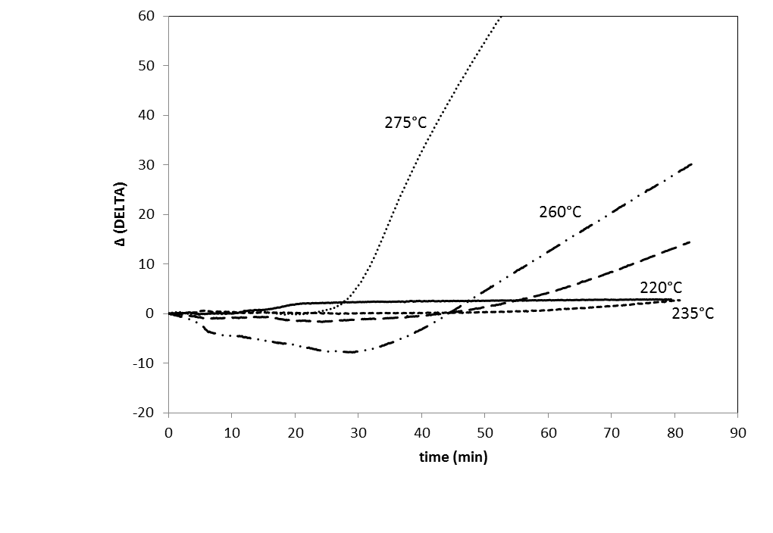
Fig. 2. Determination of the optimal temperature to be used in the isothermal part of TG analysis, through the Δ (delta) values. The 260°C curve gives more information. Different phenomena influence the shapes.

Results and Discussion

Analysis of the curve and interpretation of data.
The ∆ data determine the oxidative degree: as higher, it is, as greater is the oxidative advancement. Conversely, the stability of a sample increase with the lowering of the ∆ values. The ∆ curve normally rises very rapidly after an induction time were the values are around “zero”. This is as to consider that in that time interval, from the analysis start (time zero) to the curve rise point, the sample is resistant to the oxidation.
However, this is not always true. In fact, by analyzing, e.g., the trend of the curve shown in fig. 2, we observe that the calculated value Δ assumes negative values. The area of the negative Δ values, underlying the horizontal axis, relates to the weight increase due to adsorption of O₂. In these cases, we are in the presence of oxidation reactions in which the reacting oxygen is adsorbed on the sample (fig. 3), and then we observe a weight increase the instead of the decrease. The phenomena continue until all the oxygenated gasified by forming more light oxygenated groups or, at the end, degrading to CO and CO₂.
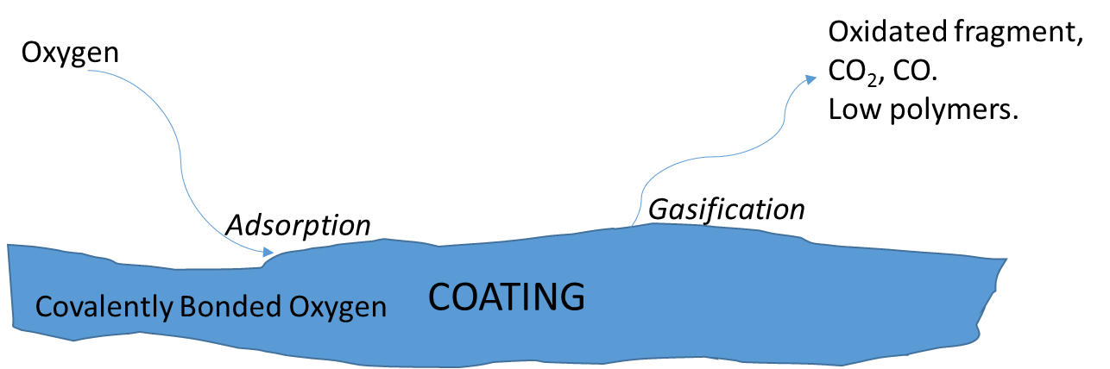
Fig. 3. Weight loss phenomena at surface.

With regard to the point where the ∆ values become greater than zero, it is necessary to take into account that the depolymerization phenomenon due to a pure thermal effect, it is eliminated from the comparison, and can be ignored, since the thermal analysis in nitrogen excludes the oxidation but does not exclude the thermal depolymerization. The value of Δ therefore refers uniquely to oxidative degradation.
The "Δ" curves in fig. 4 belong to one analysis taken as an example.
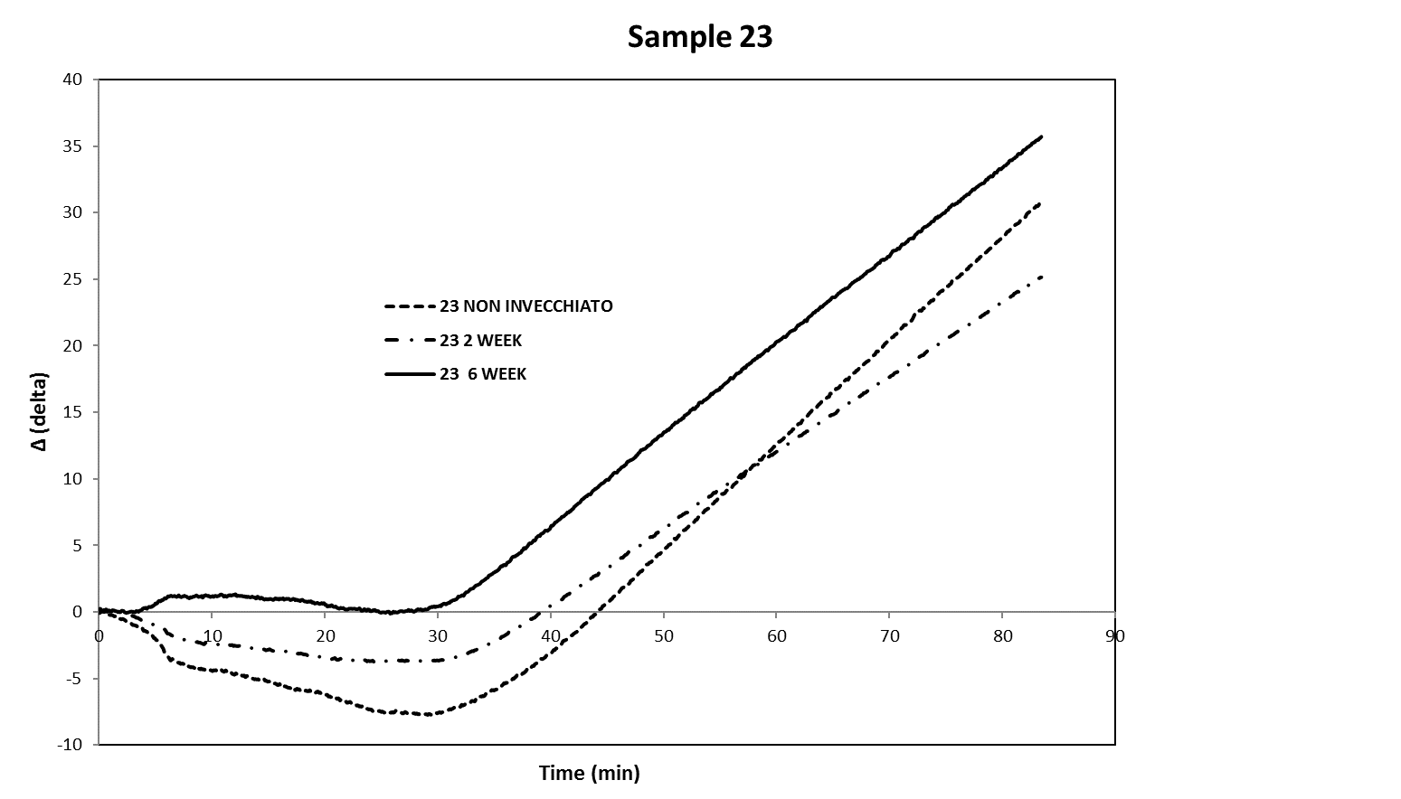
Fig. 4. Comparison of the ∆ values for sample with different ageing (sample 23).

The 3 curves relate to not-aged sample, aged for 2 weeks, aged for 6 weeks. The curve belonging to the 6 week aged sample is completely over the 0 Δ line. It can be deduced that the sample aged for longer (6 weeks) does not sequester O₂ in the same reason of the other samples aged for less time. It is reasonable to think that, in the experimental conditions, the oxidation degree, at the surface or deeper, until to a not defined depth, reached an equilibrium of the O₂ concentration.

Fig. 5. MOIT at different ageing for the sample 23.
The area of the curve is an index of the oxidation reactivity of the sample. Shortly aged materials have more active sites on which the oxygen can physically bond (and then reacts) and the subtended area is greater than that of a mature sample or long aged where the sites have already been oxidized, and therefore unable to absorb more oxygen.
It is useful to note that each MOIT point is a dynamic phenomenon whose quantity is a balance between the weight increase-in and the weight losses.
We cannot exclude that, at longer treatment times, the cracking reactions of depolymerized parts could start, maybe in the inner areas of the coating. Around the kinetic aspect, with unchanged test conditions, it is assumed that the kinetics of oxidation is fast up to the minimum point of the curve (negative Δ curve), and from that point it decreases linearly and then exponentially. A further study would be necessary on this aspect for a deep understanding of the phenomenon (e.g., with good probability, the derivative of the value Δ with respect to time of the curve could indicate the minimum point).

Conclusion
The ageing of plastic materials and specifically of composite materials used for coating, was analyzed using a thermal method. The work has led to the definition of a parameter that we named MOIT (Modified Oxidation Induction Time), similar but conceptually and analytically different from the already standardized OIT parameter for plastics. The analysis is relatively fast but very simple and uses a known instrumentation widespread distributed in chemical laboratories. The analysis highlights many features of the phenomenon of aging/oxidation of the polymer samples and allows to obtain a comparison data between the various materials that can be used on a predictive basis.
The intersection point of Δ curve with the horizontal axis (MOIT) slide progressively towards higher time values with aging, indicating a sensible change in the oxidation degree. The results are related essentially to two phenomena:
- a greater oxidation degree of the aged samples than the not-aged ones;
- a less availability towards the oxidation of the aged samples.
The first results is relevant to determine the age of a sample, the second is to correlate to the oxidation kinetic.
The comparison between the performance of MOIT curves for samples artificially aged and those aged naturally highlights:
- substantial agreement between trends with a slight upward trend MOIT to aging proceed;
- higher MOIT values for the artificially aged samples compared to those naturally aged;
- a full agreement with the experimental evidences that indicate a greater degrading effect of the UV lamps with respect to sunlight.
Further study are in advance, aiming a more specific interpretation of the phenomenological degradation of polymeric organic films.

Bibliography
ASTM International, Standard Test Method for Oxidative-Induction Time of Polyolefins by Differential Scanning Calorimetry, ASTM D 3895 – 07, 1-6, (2007).
Blaine, R. L., Harris, M. B., A Proposed Reference Material For Oxidative Induction Time By Differential Scanning Calorimetry, Oxidative Behavior of Materials by Thermal Analytical Techniques, ASTM STP 1326, ed. Riga, A. T. and Patterson, G. H., Eds., American Society for Testing and Materials, TA -233, 1-12, (1997).
Braithwaite, G.J.C., Heuer, E.G., Miller, B.L., Thomas, B., Spiegelberg, S.H.S., Ranking Antioxidant Activity by Oxidation Induction Time, 56th Annual Meeting of the Orthopaedic Research Society, Poster No. 2294, (2010).
Dobkowski, Z., Lifetime prediction for polymer materials using OIT measurements by the DSC method, Polymery, 50 (3), 213-215 (2005).
Duce, C., Bernazzani, L., Bramanti, E., Spepi, A., Colombini, M.P., Tiné, M.R., Alkyd artists’ paints: Do pigments affect the stability of the resin? A TG and DSC study on fast-drying oil colours, Polymer Degradation and Stability, 105, 48-58, (2014).
Feller, R.L., Accelerated aging: photochemical and thermal aspects, Research in conservation, 4, 1-280, (1994).
Fortunati, E., Luzi, F., Puglia, D., Dominici, F., Santulli, C., Kenny, J.M., Torre, L., Investigation of thermo-mechanical, chemical and degradative properties of PLA-limonene films reinforced with cellulose nanocrystals extracted from Phormium tenax leaves, European Polymer Journal, 56, 77-91, (2014).
Hitachi High-Tech Science Corporation, Oxidation Induction Time Measurements by DSC, TA No. 49, 1-3, (1988).
Ilie, S., Senetscu, R., Polymeric Materials Review on Oxidation, Stabilization and Evaluation using CL and DSC Methods, TE – VSC, TE Technical Note, 1-62
Jacoby, P.,The Effect of Hindered Phenol Stabilizers on Oxygen Induction Time (OIT) Measurements, and The Use of OIT Measurements to Predict Long Term Thermal Stability, Mayzo Corporation
Marcus, S. M., Blaine, R. L., Estimation Of Bias In The Oxidative Induction Time Measurement By Pressure DSC, TA Instruments -Thermal Analysis & Rheology, TA.228
Parparita, E., Nistor, M.T.,. Popescu, M.C, Vasile, C., TG/FTIR/MS study on thermal decomposition of polypropylene/biomass composites, Polymer Degradation and Stability, 109, 13-20, (2014)
Santonja-Blasco, L., Moriana, R., Badía, J.D., Ribes-Greus, A., Thermal analysis applied to the characterization of degradation in soil of polylactide: I. Calorimetric and viscoelastic analyses, Polymer Degradation and Stability, 95, 2185-2191, (2010).
Tadano, T., Zhu, R., Suzuki, S., Hoshi, T., Sasaki, D. Hagiwara, T., Sawaguchi, T., Thermal degradation of transparent poly(methyl methacrylate)/silica nanoparticle hybrid films, Polymer Degradation and Stability, 109, 7-12, (2014).
Tochácek, J., Vrátnícková, Z., Polymer life-time prediction: The role of temperature in UV accelerated ageing of polypropylene and its copolymers, Polymer Testing, 36, 82-87, (2014)
Woo, L., Khare, A.R, Sandford, C.L., Ling, M.T.K., Ding, S.Y., Relevance of High Temperature Oxidative Stability Testing to Long Term Polymer Durability, Journal of Thermal Analysis and Calorimetry, 64, 539-548, (2001).
Ye, P., Tan, B.C., How to Optimize OIT Tests?, PerkinElmer, Application Note, (2012).

