Effect of wear from cleaning operations on sintered ceramic surfaces: correlation of surface properties data with touch perception and digital image processing

Agnese Piselli^{a,b} , Margherita Basso^{b,c,}*, Michele Simonato^{b}, Riccardo Furlanetto^{b}, Alberto Cigada^{c}, Luigi De Nardo^{c}, Barbara Del Curto^{c}

ª Politecnico di Milano, Department of Design, Via Durando 38/A, Milan, Italy
^{b} The Research Hub by Electrolux Professional, Viale Treviso 15, Pordenone, Italy
^{c} Politecnico di Milano, Department of Chemistry, Materials and Chemical Engineering “G. Natta”, Via Mancinelli 7, Milan, Italy

* Corresponding author.
E-mail addresses: agnese.piselli@polimi.it (A. Piselli), margherita.basso@polimi.it (M. Basso), michele.simonato@electrolux.it (M. Simonato), riccardo.furlanetto@electrolux.it (R. Furlanetto), alberto.cigada@polimi.it (A. Cigada), luigi.denardo@polimi.it (L. De Nardo), barbara.delcurto@polimi.it (B. Del Curto)
ABSTRACT

In the professional kitchen environment, frequent and harsh cleaning processes are one of the main causes of surface wearing. This experimental study evaluates the effects of abrasive wear on different ceramic surfaces, aiming at selecting the most reliable and durable material in terms of performances and aesthetics.
Accelerated wear testing was applied on two ceramic finishes to simulate manual cleaning on commercial kitchen working tops.
Roughness changes on aged ceramic samples were analysed by quantitative and qualitative techniques. Surface properties were investigated using non-contact profilometry, and then correlated with digital image processing. Paired-comparison test was used to explore users’ tactile responses to surface roughness modifications.
Results showed that the aging process had a limited but significant effect on the sintered ceramic roughness change. Quantitative and qualitative analysis revealed that abrasive aging affected the two finishes in a different way, probably due to their different chemical composition. Paired-comparison test confirmed the findings based on the tactile user perception, and demonstrated to be a reliable qualitative tool for finishes selection, even when physical differences among the material samples are negligible.

Keywords:
Surface topography
Two-body abrasion
Traditional (clay-based) ceramics
Electron microscopy
Profilometry
Wear testing

INTRODUCTION
Materials selection for professional food processing appliances focuses on the analysis of several properties: technical, manufacturing and economic requirements, food contact compliance, durability at specific service conditions, environmental properties, sensorial properties, user-interaction aspects, and intangible meanings [1–4]. Durability and sensorial properties, in particular, are one of the most important aspects to be evaluated while selecting materials and finishes for aesthetic components, the part of the product, which the user interacts the most with. Consumers interact with products through materials at first [1,5] Therefore, it is becoming increasingly important to analyse the user perception during interaction with aged materials, as changes in their properties may strongly affect the overall perception about a product [6,7]. This aspect, known in literature as “cosmetic obsolescence”, relates to the physical changes that occur on a product or a material over time and use. It alters the perceived look and feel of materials, contributing to associate a shortened product lifespan [8].
In a professional kitchen environment, stainless steel represents one of the most widely employed materials for kitchen tops as it shows an excellent durability to food chemicals and detergent compounds, abrasive materials and impacting utensils, meeting also the aesthetic and hygienic needs of the market [9–11]. Following recent material trends, sintered ceramic surfaces represent an alternative to stainless steel for kitchen working tops. Ceramics, indeed, are considered chemically inert materials [12]. However, different features as the material composition and microstructure, its chemical resistance, and the exposure time to the chemical solutions, may influence the durability of sintered ceramics [13]. As sintered ceramic surfaces, applied on kitchen tops, could be cyclically exposed at variable temperatures, due to the presence of heat sources, to food fouling deposits and consequent cleaning processes, their wear resistance in terms of durability has to be evaluated [14,15]. Moreover, wear caused by these cleaning processes could affect aesthetic changes on the material surface [16]. The integration of qualitative evaluations, as material sensorial properties analysis tests [17] [18] [19], from the first phases of materials selection could help in designing the material experience with the product [5]. In detail, these tests aim to evaluate the impact of wear action due to cleaning processes on material surface properties, and assess if their change would be detected by the user. As such changes usually contribute in lowering the perception of quality of the entire product [7], through sensorial analysis tests it would be possible to select which material and finishing may be perceived as the one which has changed the least over time.
During their lifetime, aesthetic components in professional food processing appliances face specific compliance problems related to daily contact with food, chemicals and to user-product interactions (frequent use, cleaning cycles, misuse practices, etc.) [19,20]. Among them, wear effects have been studied also for other applications, as to assess the slip-resistance of a surface [21,22] or to follow changes in cleanability of materials surfaces [13,23]. For this reason, accelerated ageing test methods based on the chemical and mechanical wear experienced by the materials and finishing during cleaning processes, have been used [7]. Preliminary manual cleaning tests were performed in order to depict the factors that could have more influence on materials degradation processes in the kitchen environment (i.e., type of chemicals, abrasive sponge use, cleaning cycles, etc.) [19].
Commercial appliances’ testing is typically focused on safety and labelling certifications, food equipment sanitation, international regulation compliance, and electromagnetic compatibility assessment. There is no evidence in literature of methods or standards for accelerated wear testing for this type of products used to evaluate their gradual wear and longevity. Therefore, we developed test methods for accelerated ageing of aesthetical surfaces applied on professional appliances based on the types of wear experienced in use [19].
To simulate the daily manual cleaning process in the kitchen environment, a specific testing appliance has been designed to get a functional tuning of different testing parameters. The need for a specific testing apparatus came out of the peculiar application, as it has been done for other cases where wear take place [23–26], being manual cleaning represents an unstable and non-static process. The testing set up has been developed and inspired from some standards that simulate specific tribosystems [27–31], following the guidelines and considering the need of a more realistic simulation for the studied application [ASTM G190-06] compared to the more common Taber abraser used in [ASTM C501-84(2015)]. The aim of the using a full-scale accelerated wear testing is not to explore all the possible effects of the factors that might influence wear (e.g., surface roughness, backing type, humidity, etc.), but to rapidly assess a general pattern of wear behaviour from which performance trends could be predicted [32].
The present study reflects on different methods for the analysis of sintered ceramic surfaces after accelerated wear testing conducted to simulate the cleaning procedures in wet and dry conditions during the lifetime of professional kitchen worktops. Surface roughness measurements and image processing have been used to characterize the aged samples basing roughness. The sensorial analysis technique of paired-comparison test [18] has been used to verify if through tactile perception the user was able to assess samples roughness changes.
The first aim of the paper is to select the material finishing that the user perceives as the one that has changed the least over time, according to the material replacement of a professional kitchen worktop. This was achieved by evaluating the level of concordance between image processing and sensory analysis results with physical parameters measurements [33–35]. Linked to this, another objective of the study is to assess the reliability of image processing and sensory test as qualitative instruments for the analysis of accelerated life-tests results and materials aging.

MATERIALS AND METHODS

Specimens preparation and aging set up
Six ceramic tiles (150 mm x 130 mm x 7 mm), made by high-pressure sintered particle manufacturing process, have been used. The tiles composition is based on Aluminium, Silicon and Calcium oxides. Two different finishes were selected to cover a range of possible available colours: cream (E) and dark brown (K) colour samples. The sample E is characterized by a slate-like textured finishing, while the sample K has a smooth-mate texture. The apparent density of both ceramic specimens is 2.50-2.52 g cm⁻³, while their open porosity is assessed around 0.2 %. One specimen per finishing has been aged by “dry cleaning” (samples ED and KD) and by “wet cleaning” (samples EW and KW) accelerated test, while one per colour remained in pristine condition, to be used as a reference. Further details on the differences between the two cleaning procedures will be provided below.
The testing appliance is characterized by these main components: a rotating disc (15,1 cm; 26 rpm rotating speed) with tilted rotation axis, which represents the support to stitch different abrasive sandpaper discs, weights over the rotating disc support (for a total of 5 kg), and detergent pumps (Fig.1). Rotating disc is provided of some holes in order to ease the flow of liquid detergent solution towards the sample surface.
The weight of 5 kg has been chosen in line with the average lateral pinch reported in [36]. Pressure is used as a valid parameter to evaluate mechanical action in cleaning operations, as pressure and its drop have been widely studied especially for cleaning-in-place [37,38]. However, as in this case study manual cleaning pressure is not easily measurable, due to its abrupt and quick changes, the strength of the hand is reported using kilograms, as done in other studies [38–40].
In order to compare different backings, the use of a thin sponge (3 mm thickness) between the rotating disc and the sandpaper disc was evaluated, but the final result showed that the tilted axis effect was almost neutralized by the deformation of the sponge itself. In the end, it was observed that the use of the rotating disc made of rigid expanded PU was the best choice to tune the abrasive conditions and exploit the tilted rotation axis. The abrasive path over the tested surface describes then a circle with diameter slightly smaller than the backing disc, with different contact pressures (in the range 0 – 4 kPa) in the contact area depending on the rotational position of the disc itself.
The sample is placed under the rotating disc and supported by a perforated stainless steel sheet in order to drain the liquid solution in excess during the test.
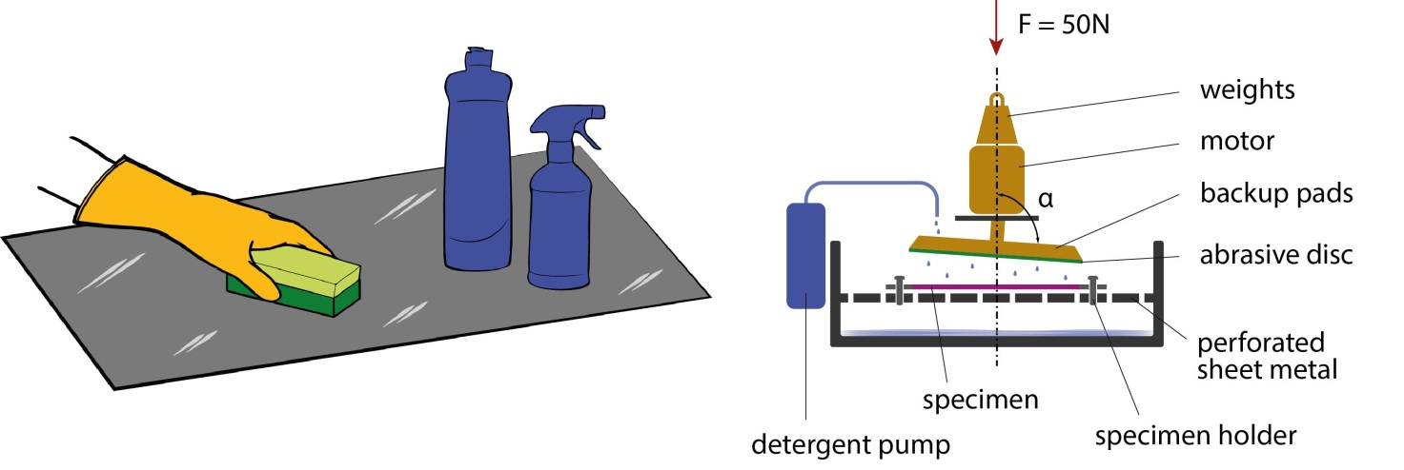
Fig.1 – Illustration of manual cleaning on kitchen worktops and schematic diagram of the designed testing apparatus
We divided the wide spectrum of possible degradation phenomena into two processes. Both tests simulated the abrasion due to 3 years of use, with 3 daily cleaning cycles made by hand by customers, each of about 20 seconds, using a commercial abrasive sponge.
In order to simulate aging effect comparable to the real use by costumers, parameters for aging conditions have been detected comparing the aging of real manual cleaning with one commercial abrasive sponge on transparent polycarbonate sheets with the same aging generated using the testing appliances with different weights of sandpaper discs (600, 800 and 1200 grit). When field test records are not available as terms of comparison for the accelerated life testing, it becomes necessary to create a reference from experimental data. Transparent polymeric material has been chosen in order to easily compare the effect of wear aging through the change in optical properties of the material.
From this comparison, optimal parameters for two different aging conditions were studied, namely:
(i) Dry cleaning – simulates the manual surface dirt removal by metallic sponges. To accelerate this form of wear, 800 grit sandpaper abrasive discs were used. The disc has been substituted after 1642 seconds of working cycle to maintain its abrasive properties. This trial represents a more severe wear condition compared to the “wet cleaning” process.
(ii) Wet cleaning – simulates the manual cleaning process using abrasive sponges and surface detergents. As in the previous trial, 800 grit sandpaper abrasive discs were used and periodically substituted. A commercial surface cleaner solution commonly used in professional kitchen environment (Suma Multi D2, Johnson Diversey) [42] has been used with recirculation during the whole test.

Surface roughness analysis
The sample surface roughness was measured using a laser profilometer (UBM Microfocus, 5600), with a measurement length of 12.50 mm, with a point density of 150 points mm⁻¹, cut off wavelength of 2.50 mm and a 75% damping. Five profile measures were conducted on different areas of each sample.
Surface morphology and composition studies were conducted by scanning electron microscopy (SEM) (EVO 50 SEM, Carl Zeiss), coupled with an Energy Dispersion x-ray Spectroscope (EDS, Oxford INCA 200) for surface microanalysis. The characterization of the sintered ceramic material by SEM-EDS provides both morphological and chemical analysis, useful to monitor surface morphology changes due to wet and dry abrasion in aged material samples.

Image processing analysis
Every sample was analysed using a stereo-microscope (Leica M165 C). Stereomicroscopic examinations took place on five random areas of the samples, paying attention to analyse surface areas representative of the overall effects of the testing conditions. The same pictures have then been used for digital image processing and analysis with ImageJ licence-free software [43]. The five repetitions were chosen in order to introduce statistical random sampling also in visual and image processing analysis. For each picture three parameters of grey scale histogram (with 0-value correspondent to white and 255 to black), generated with the above-mentioned software, were considered for further descriptive statistical analysis: mean (µ), standard deviation (σ) and mode (m). To compare the grey scale histograms analysis with other procedures freely available online to calculate surface roughness parameters through image processing, two free plugins have been used: roughness calculation and SurfCharJ 1q [10]. These plugins have been both applied on pictures taken with stereomicroscopy. From this analysis emerged that the first one better matched the real surface roughness measurements both in terms of absolute values and in terms of the relative among the samples.
For 3D surface plot reconstruction, a dedicated plug-in freely available with ImageJ licence-free software has been adopted. 3D surface plot reconstructions were created using the interactive 3D surface plot plugin available with ImageJ license-free software. All 3D surface plots have a grid size of 256, perspective 0.0, lighting 1.0, z-scale 0.61, scale 1.0, max 100%, min 0%, smoothing 10.5 and isolines, or filled pattern, with spectrum Look-Up Table (LUT) colour scale or grey scale [44]. These views have been compared to perceive the surface roughness differences and compare them with measured surface roughness parameters.
The colour stimuli variations of the samples were measured using a spectrophotometer (Konica Minolta CM-2600d). Negligible colour changes have been observed. Moreover, no significant colour change has been highlighted from the panel observations.

Paired-comparison analysis
Paired-comparison test was run to evaluate if users could perceive the surfaces roughness modification after the material exposure to wear testing [45–47]. The exploration of user tactile responses aims at simulating if in real context the user could be able to detect possible surface changes due to the material aging in time. This aspect is particularly important to be investigated in the professional appliances field, where an early aging of the material could be associated to a lower perceived quality of the overall product.
The paired-comparison test was guided by a panel leader and performed by 12 participants (6 M and 6 F). The non-trained assessors, with an experience on the industrial context object of the study, had a mean age of 30.2 years old (S.D. 5.6). 11 participants were native Italians, while 1 was Swedish. The 6 different specimens, obtained after accelerated aging tests, was used in the experiment.
The panel leader presented simultaneously two different coded samples to each assessor that seated in front of a table enlighten by a lamp (2 neon lamps, 9W). The samples were presented on a stand at 45°, to guarantee the same incident lighting angle on the material’s surface (Fig. 2).
Between the two specimens, the participants were asked to choose by touch the material perceived as rougher, after an exploration of the two surfaces by all fingers. The test has been conducted blinded in singular modality (by touch) because the surface colour or shininess could have an influence on the “roughness” evaluation. The blinded panellists were asked “Which samples do you feel as rougher? The one on the left or the one on the right?”. As the test was performed in Italian, the question was: “Quale campione percepisci come più ruvido? Quello a sinistra o quello a destra?”.
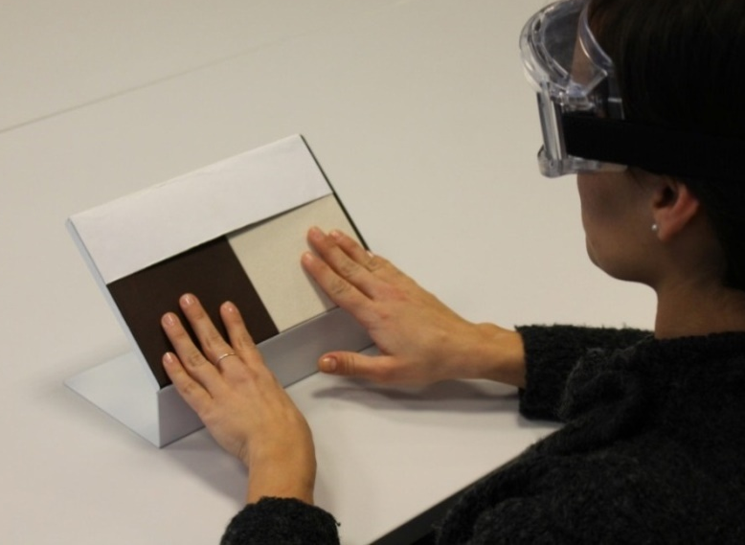
Fig. 2. Sensorial analysis test setting. (single column)
As the material set gave 30 possible pairs combinations, each participant was asked to evaluate 15 sample pairs, in randomized order across the panellists. To minimize the assessor’s fatigue, these repetitions were kept deliberately low compared to similar literature studies [48–50].

Data analysis
The experimental data from the image processing and the surface roughness measurements were analysed using standard statistical techniques: ANOVA and Tukey for image processing results, ANOVA and Fisher-LSD for surface roughness parameters. Tukey’s test has been used as most conservative statistical comparison among means, after verification of equal standard deviations and normal distribution of data and standardized residuals. Significance levels (p-values) of 0.05 were used to judge the degree of variance for all the statistical techniques. All p-values reported are 2-tailed.
In order to evaluate the consistency of the participants’ responses, a one-tailed binominal table from the ISO 5495:2005 (Annex A) [18], together with the Pearson's chi-squared test has been used in the paired-comparison test. Sensorial responses were examined as they relate back to the hypotheses as small groups to gain insights in relation to the finishes typologies (E or K).
All the statistical analyses have been conducted with Minitab® ver. 17 (Minitab, State College, PA).

RESULTS

Surface roughness
Surface roughness parameters were taken into account to verify the quantitative differences among the starting state and the surface conditions of aged samples. The most common standardized roughness parameters were considered in this analysis: roughness average (Ra), RMS roughness (Rq), third maximum peak-to-valley height (R3z), ten-point height of irregularities (RzISO), maximum roughness depth (Rmax) and skewness (Sk). From ANOVA and Fisher-LSD method statistical analyses to compare means values, cream (E) samples did not show significant differences between roughness parameters before and after aging, for all the analysed values (all p > 0.05). Dark brown (K) samples showed the opposite trend, with significant differences among reference sample, dry and wet aged ones. For this second group Ra decreased significantly for wet aged samples, with a stronger decrease for dry aged ones (p=0.000, F = 20.63): the flattening action of aging is then higher in absence of aqueous cleaning solutions. The same effect was observed for R3z (p=0.001, F = 12.65) and Rq (p=0.000, F = 20.58), confirming the reduction of peak-to-valley heights. RzISO (p=0.001, F = 13.27) and Sk (p=0.003, F = 10.18) showed significant differences between aged samples and the reference one, but with no significant difference between wet and dry aged ones. This demonstrates that wear aging mainly contributed with the smoothing of surface roughness peaks.

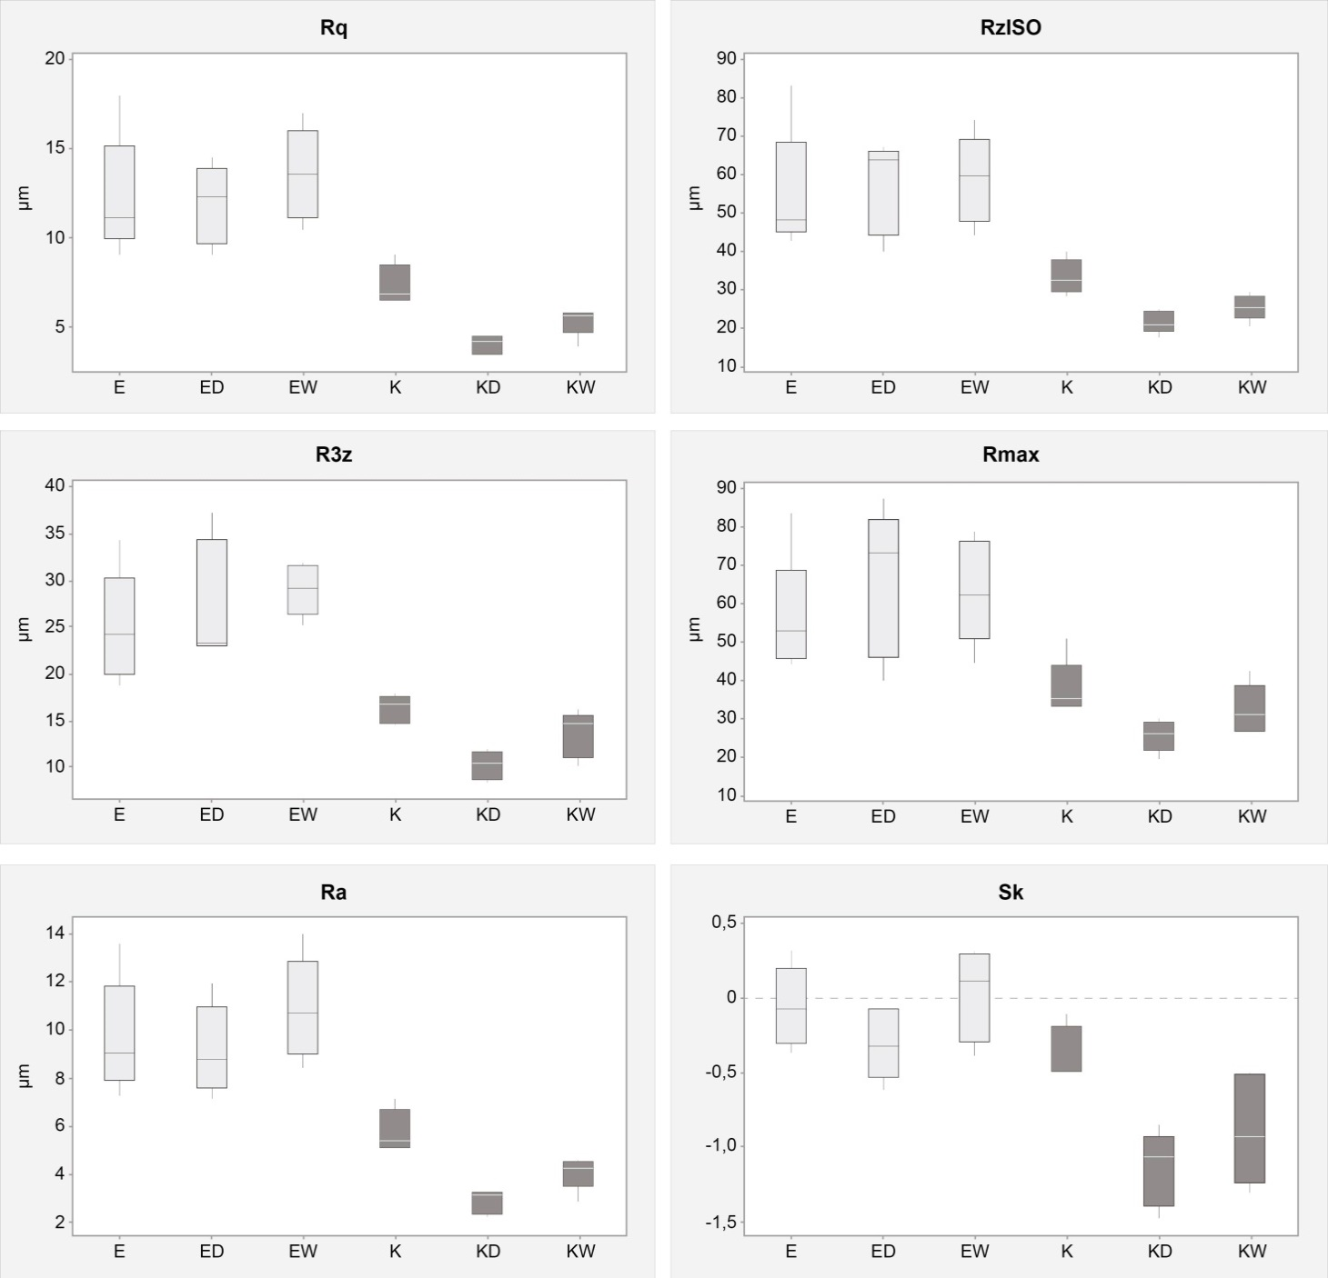
Fig. 3. Box-plots for surface roughness parameters measurements with laser profilometry. (2- column)

Figure 3 reports different trends visible for E and K samples. Dark brown (K) samples showed a coherent decrease in all surface roughness parameters, with a stronger decrease for samples abraded under dry conditions. This effect can be easily explained observing that presence of liquid media in general reduce abrasion effect, acting in some way as lubricant. In this case, liquid media is given by the presence of detergent solution, which could give an additional chemical attack during abrasive action. Moreover, the general trend of parameters decrease indicates a flattening effect of surfaces.
Cream (E) samples demonstrated a small increase in almost all surface parameters. Wet abrasive conditions revealed a stronger increase in surface roughness parameters when exposed to detergent solutions (+12 ± 3 % R_{a} and R_{max} , +16 ± 4 % R_{3z}, +7 ± 2 % R_{zISO}). This could be caused by the different mineral composition of this surface finishing, indicating a stronger influence of chemical action. In this second case, detergent solution probably did not have lubricating action, but on the contrary, it chemically attacks samples surfaces on selected areas, increasing surface roughness. As a second hypothesis, the same detergent solution could have aided in the selective detachment of mineral fillers, promoting a third body abrasive mechanism. Further analyses about mineral composition of the samples through SEM micrographs highlights several morphological and compositional differences in both material finishes (Fig. 4-5). Cream colour samples show the higher influence of abrasive action on surface morphology: the presence of detergent solution decreased the effect of abrasion action, with consequent more extended areas of uniform abrasion (Fig.4c). On the opposite, dry abrasion generated craters and a visible increase in surface roughness (Fig.4b), with higher penetration in terms of abraded layer of material. This is supported also by EDS spectra: reference sample (E) shows the presence of calcium Ca and barium Ba in the composition of the surface layer (Fig.4g), which decrease on the wet abraded sample (Fig.4i) and are almost absent in the dry abraded one (Fig.4h). EDS spectra (Fig. 4g-i) highlighted also that Si, O and Al are the most present elements; Na is in the same way present but to a minor extent. This phenomenon agrees with the high pressure sintering production process, which induces the formation of glass phases among the particles, and for this Ca and Ba should act as secondary oxides in the glassy surface layer.

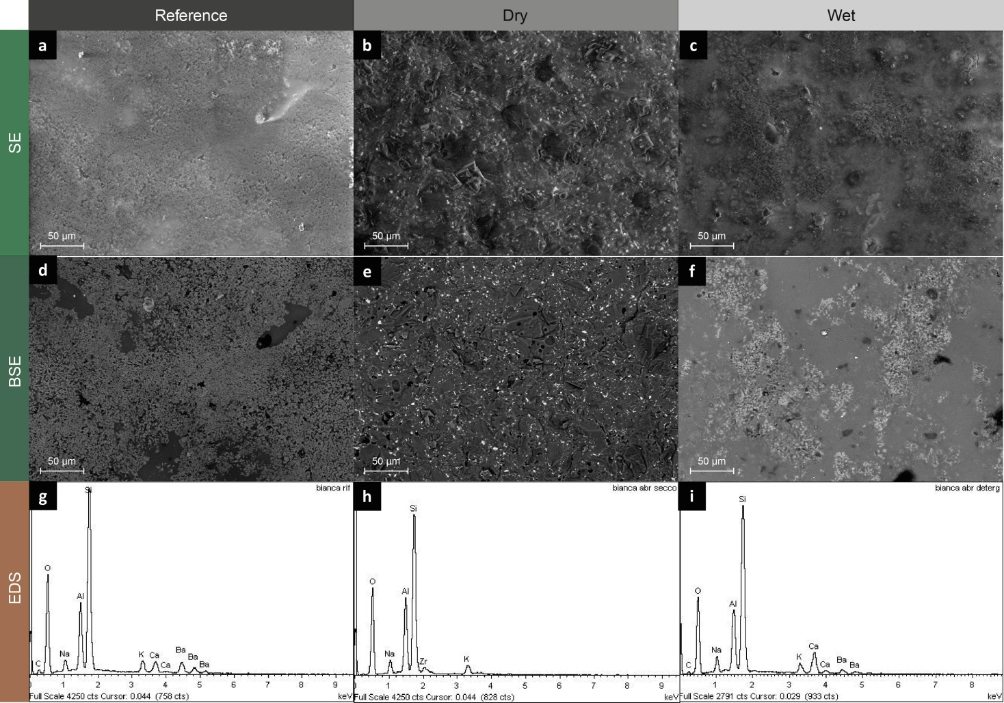
Fig. 4. SEM images of cream colour samples (E): Secondary Electrons (SE) (a, b, c); Back Scattered Electrons (BSE) (d, e, f). EDS spectra of overhead images on the overall surface (g, h, i). (2-column)

The same SEM images have been taken for dark brown samples (K) to evaluate their resistance to abrasive action together with EDS spectra for chemical composition (Fig.5). In this second finishing, the surface glass layer exhibits higher resistance to abrasion, due to the presence of barium and calcium on both EDS spectrum of dry and wet abraded samples (Fig.5h-i), and confirmed by the slightly perceptible change of surface morphology between reference sample and tested ones (Fig.5a-f).

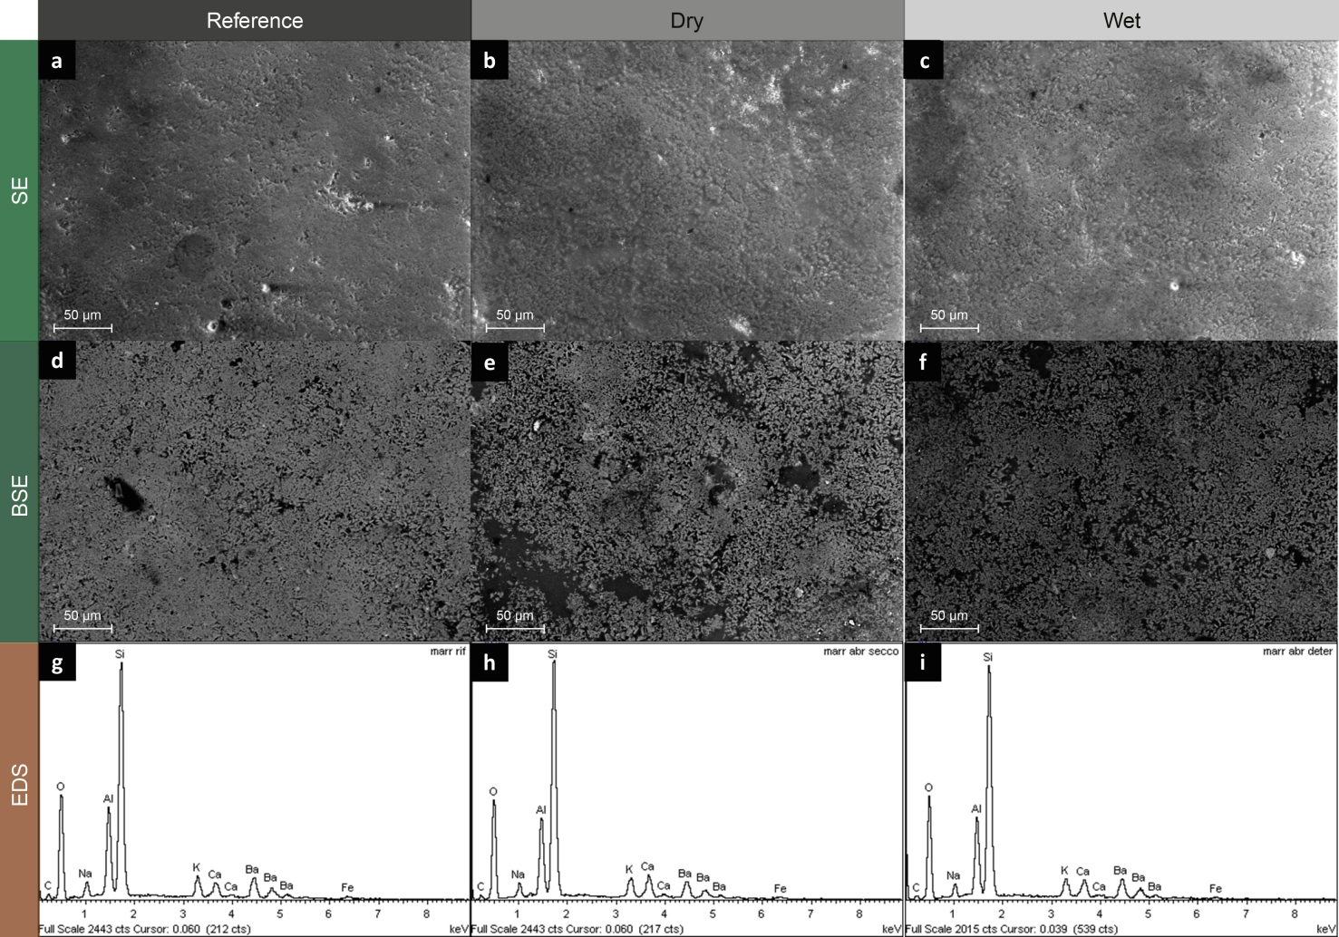
Fig. 5. SEM images of brown colour samples (K): Secondary Electrons (SE) (a, b, c); Back Scattered Electrons (BSE) (d, e, f). EDS spectra of overhead images on the overall surface (g, h, i). (2-column)

Image processing
The statistical analysis of grey scale histogram parameters on the pictures taken through stereomicroscope (Fig. 6) of cream (E) samples confirmed the absence of significant differences between aged and non-aged samples (all p-values>0.05), in this case probably due to the light colour of surface finishing. The high reflectivity of the surface decreases the details perceived in stereomicroscopic analysis, with less control of morphology changes of surface roughness. ANOVA and Tukey method for means comparison have been used with significance level of 0.05. Dark brown (K) samples showed on the contrary significant differences in terms of standard deviation (σ) of grey scale histograms (p < 0.05, F = 34.56). Wet aged samples showed an increase in σ, while dry aged samples showed a decrease if compared to non-aged samples.
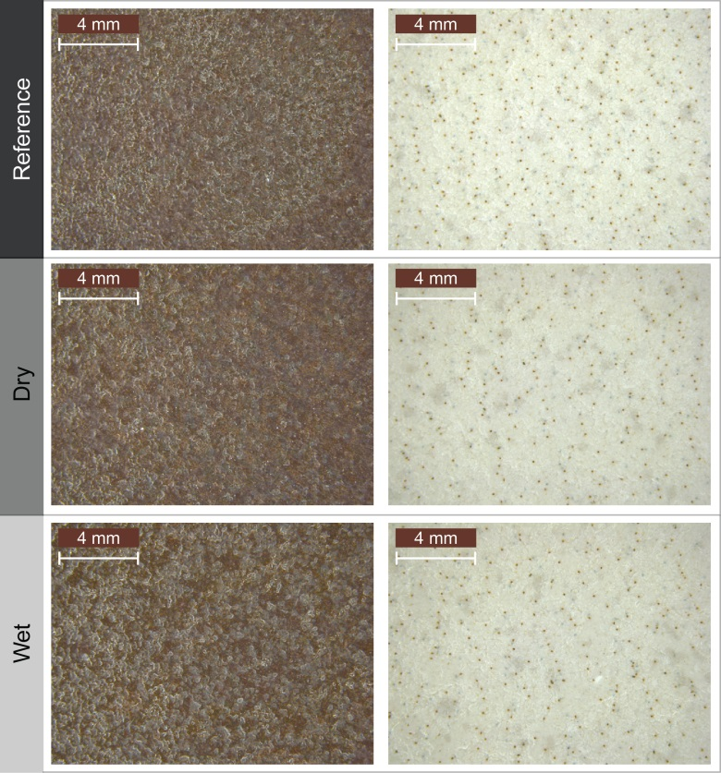
Fig. 6. Low magnification stereomicroscopic images of K samples (left) and E samples (right), before and after dry and wet tests. (single column)

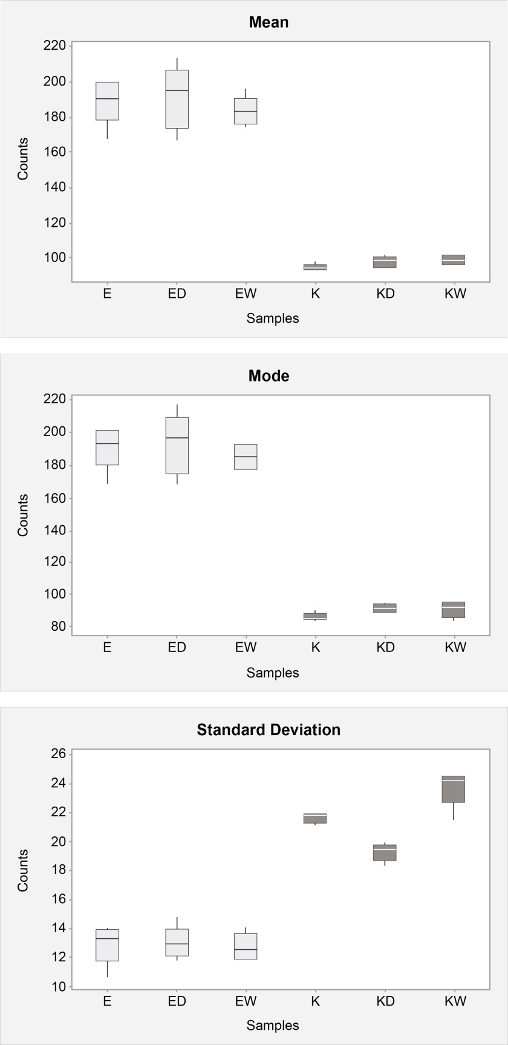
Fig. 7. Box-plots of grey scale histograms parameters analysed through image processing (ImageJ software) for all the samples. (single column)

To further compare surface roughness measurements and image processing results, 3D surface plots reconstruction has been generated using 3D surface plot plugin available with ImageJ license free software [51]. Figure 8 shows 3D surface plots of cream E samples before (Reference) and after dry and wet abrasion. The representation is considered in terms of filled 3D pattern (Fig. 8a,c,e) and contours (Fig. 8b,d,f), i.e. lines resulting from the intersection of planes parallel to the surface of the sample, at different values of heights (z-axis), where the mean plane of sample surface correspond to z = 180 (Fig.8). Contours generated by the intersection of other two parallel planes at z = 170 and z = 200 have different grey tones and they can be used as indications of different surface topographies. In fact, the density of latter contours can be qualitatively correlated to the surface roughness of samples. Reference sample (Fig. 8a-b) showed most of contours at z values of 180 and 170, with almost no presence of contours at z = 200; dry abraded sample (Fig.8c-d) exhibited a strong decrease in contours at 170, with increased presence of z = 200 contours, which is coherent with the strong removal of surface material. Wet abraded sample (Fig.8e-f) demonstrated a halfway behaviour with decreased number of contours at 170 compared to reference sample, but higher than their presence in dry abraded sample. Ra, Rq and R3z trends coming from profilometry are then confirmed from the above-mentioned change in filled 3D pattern.

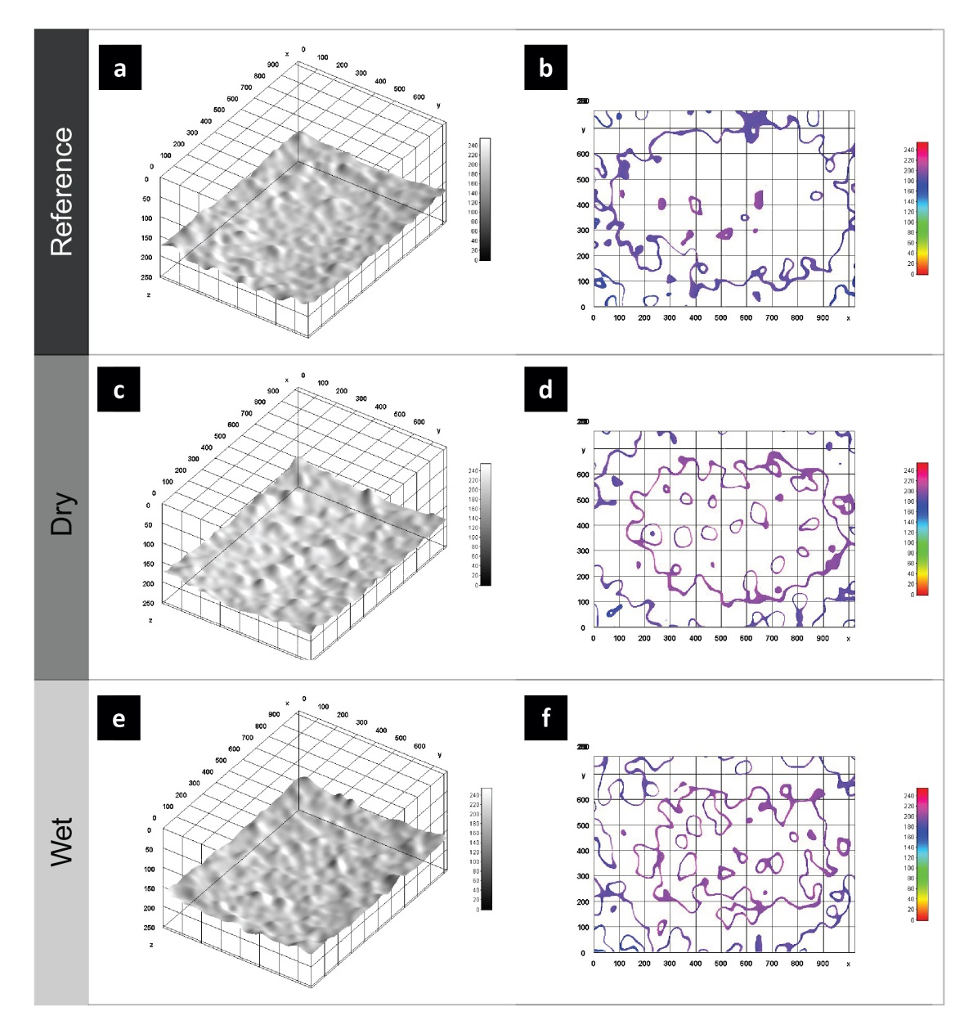
Fig. 8. 3D surface plots reconstruction on cream samples (E). Frontal view (left) and lateral view (right). X and Y axes are coordinates of the image measured in pixels, while Z-axis scale is the height of the surface, reported with grey scale or spectrum LUT scale on the right side of every image. (1.5-column)

The same plots have been generated based on K samples stereomicroscopic pictures (Fig.9), revealing that 3D reconstruction enhanced the differences among surface morphologies of tested samples even if with high reflective colours. In this second type of samples, the mean plane of surface is placed at z = 90, while the other contours are taken as intersection at z = 80, z = 110 and z = 120 planes. Dry and wet abraded samples showed a total decrease in contours at 120, while contours at 110 and 80 increased, even if there is not strong qualitative differences among dry (Fig.9c-d) and wet (Fig.9e-f) abraded samples. A good extension of this method can be made by further quantitative elaboration of 3D surface plots, taking into considerations that the Look-Up Table (LUT) scale [44] is based on RGB values of images, and for this it can be intrinsically limited by analysed pictures and optical characteristics of analysed surfaces.
In addition, the results of measurement of Ra using the SurfCharJ 1q plugin on 3D reconstructed surfaces showed concordance with the experimental measurements trend of the same parameters. The higher values were reference samples ones (69.8 ± 2.0 µm for K, 59.1 ± 2.0 µm for E), while the lower values correspond to the dry abraded samples (60.8 ± 2.0 µm for KD, 52.0 ± 2.0 µm for ED). Wet abraded samples show intermediate values between reference and dry abraded ones (66.0 ± 2.0 µm for KW, 54.1 ± 2.0 µm for EW).

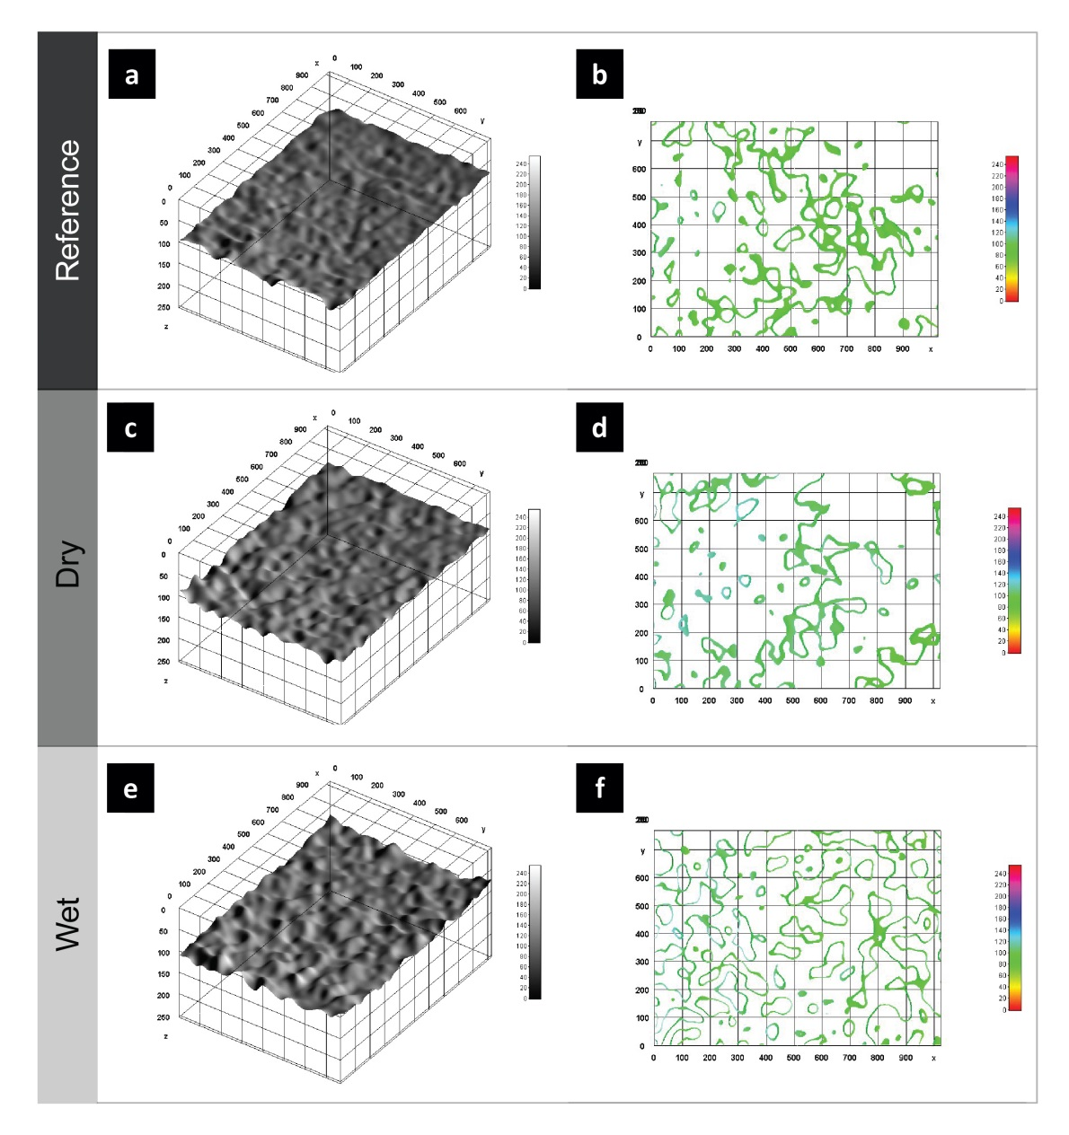
Fig. 9. 3D surface plots reconstruction on dark brown (K) samples. Frontal view (left) and lateral view (right). X and Y axes are coordinates of the image measured in pixels, while Z-axis scale is the height of the surface, reported with grey scale or spectrum LUT scale on the right side of every image. (1.5-column)

Paired-comparison test
180 observations on samples roughness perception were gathered from the paired-comparison test [18], which lasted 14 minutes on average for each participant. A frequency histogram (Fig. 10) synthetizes the assessments from the panel and examines the relationships between categorical variables. Specifically, the column sums the number of users who affirmed that the specimen in object is rougher than the sample in the buckets. For instance, looking at KW column, one assessor thought that KW was rougher than K and ED, while eight panellists judged KW rougher than KD. As specified in the standard paired-comparison test (ISO/IEC IS 5495:2005 - Annex A) [18], the number of responses inferior to 8 are considered not significant for this study.
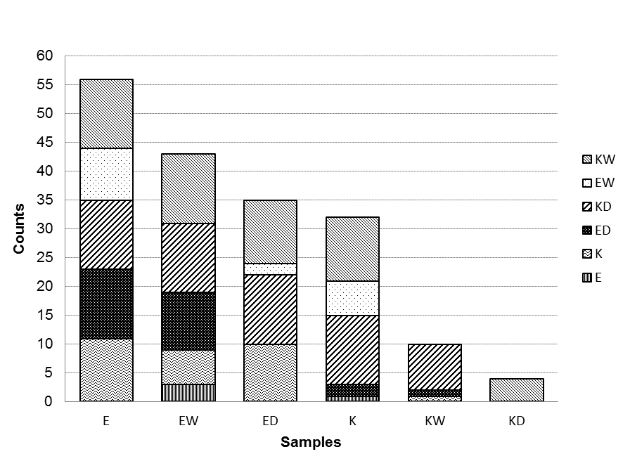
Fig. 10. Frequency histogram: the buckets count the number of users who affirmed that the sample in the column is rougher than the one in the legend. (single column)

Significance levels (p-value) of <0.05 and <0.001 were used to judge the degree of variance across the set. P values <0.05 level indicate a reasonable correlation, while <0.001 level indicate a strong correlation. From a general observation, all the answers were consensual with a reasonable level of correlation (p<0.05). The significance of the test is confirmed by the analysis of the contingency table by Pearson's chi-squared test (χ² = 80,210; DF = 25; P <0.001).
Blindfolded (tactile) responses evidence that users perceived the non-aged cream colour sample (E) as the roughest between all the specimens, while the dry aged dark brown one (KD) as the smoother. In detail, taking into consideration roughness perception, emerged that:
$$E>EW>ED>K>KW>KD$$
Sensorial analysis observations indicated that cream colour ceramic surfaces, both in case of non-aged and aged samples (E, ED, EW), are perceived as rougher than their equivalent in dark brown colour (K, KD, KW). The significant correlation between the reference samples (E-K) (χ² = 7.123; p = 0.008), the dry-aged (ED-KD) (χ² = 9.000; p = 0.003) and the wet-aged specimens (EW-KW) (χ² = 9.000; p = 0.003), confirm the data analysed by surface roughness measurement.
In the following, analysis of the categories that we expected would be particularly significant for the study is reported. The reference for each finishing has been compared with the dry-aged sample (E-ED, K-KD) and with the wet-aged one (E-EW, K-KW); then, between the same finishing colour, the dry and the wet-aged samples have been compared (ED-EW, KD-KW).
Dry abrasion significantly impacts on lowering roughness perception (χ² = 9.000; P = 0.003), both in the case of cream colour (E), or dark brown (K) samples. The effect became less significant when considering the wet-aged specimens: the correlation for cream colour ceramic surfaces (E-EW), even if at reasonable level (χ² = 4.967; P = 0.026), is lower if compared to the dark brown samples (K-KW) (χ² = 7.123; P = 0.008). Good correlation is evident also in the comparison of dry and wet-aged samples. According to the observations, wet abrasion had a significant effect if compared to dry aging both in the case of light coloured samples (ED-EW) (χ² = 5.835; p = 0.016), and in that for the dark ones (KD-KW) (χ² = 4.410; P = 0.036).

DISCUSSION
The main purpose of this study is to select the material finishing that the user perceives as the one that has changed the least over time, according to the material replacement of a professional kitchen worktop. In doing so, quantitative and qualitative evaluations have been performed: physical parameters measurements and analysis, image processing and sensory analysis tests.
The results provided by roughness measurements showed that simulated cleaning operations on the two analysed finishes significantly affect surface parameters, even if in different ways, as assessed in other studies from different industrial fields [52–56]. The major differences detected were between the aged samples and the reference one, but no significant difference in roughness could be measured between wet and dry aged ones in the case of cream (E) finishing. This is coherent with the possible role of surface texture in the determination of wetting properties and acting as a lubricant reservoir in the case of lubricated contacts [52].
SEM images (Fig.5) supported this decrease in roughness parameters, highlighting the slight difference among reference and abraded samples, without big differences in terms of chemical composition (Fig. 5g-i) and surface morphology. No presence of etching signs [53] were detected after wet cleaning simulation on both surface finishes. As regards cream (E) samples, the slight increase in surface roughness (Fig. 3) can be better explained considering SEM images (Fig. 4a-f), where the abrasion of the glassy surface layer brings to an evident change in surface morphology . This is also supported by the decrease in Ca and Ba peaks in EDS spectra (Fig.4g-i).
The second objective of this work was to assess the reliability of qualitative evaluations as rapid instruments for the analysis of the results of accelerated life-tests and aging on materials.
Image processing have been used to quickly assess the previously measured surface roughness parameters: this method confirmed to have a good sensitivity to surface morphology [57], even if the results could be affected by the surface colour. The analysis of the grayscale parameters on cream samples (E), showed the absence of significant differences between aged and non-aged samples, while dark brown (K) samples demonstrated to have significant differences (Fig. 7) in terms of standard deviation (σ). Roughness measurements obtained by image processing have reduced information content, if only colour analysis is considered through grey scale evaluation. To complete the analysis, further investigations would be necessary to demonstrate the analytical correlation between roughness data measurements and image processing parameters. 3D surface plots reconstruction partially overcame the limits on sample colour, even if they are not giving quantitative results (Fig. 8 and 9), and further elaboration would be required to translate in quantitative scale based on contours density. Although, their correlation with the panel qualitative evaluations allows to improve the consistency of the results. Compared to other proposed methods involving image processing and complex data analysis [57–59], the use of a quicker and simpler process allowed to obtain well correlated results with experimental surface measurements.
Sensory analysis by paired-comparison test focused on the analysis of the user perception of damages and changes on materials’ surfaces over time. Similarly to other user perception case studies [50,60–65], where the correlation between different materials’ perceived roughness and physical surface parameters was proved, the qualitative results proved to be consistent, and in total accordance with the physical roughness measurements and the SEM analysis, even if in presence of reduced roughness differences. From this research emerged that the arithmetic average of the roughness profile (Ra), even if it represents the material surface roughness in a simplistic way, could be correlated with the tactile perception of roughness [1,47,50,65]. The tactile assessment demonstrated that dark coloured samples have higher evident aging effects compared to light coloured ones. For this reason, in case of application in professional kitchen environment, it would be preferable to use light coloured ceramic surfaces that would hide, as confirmed by perception analysis, the aesthetical damages due to use and cleaning better. However, some limits linked to the use of sensorial analysis tests are evidenced in order to be explored in further investigations. In a real application, users evaluate the overall quality perception based also on visual analysis and on the experience with the product. Further exploration of the influence of the sense of sight, through multimodal sensorial evaluation, could be useful to validate the study.

CONCLUSIONS
One of the aims of this study was the evaluation of changes in surface roughness of sintered ceramics after accelerated wear testing. As there are no standard test procedures to simulate the material ageing process for the considered application, a specific testing appliance was designed to simulate the abrasion due to use and cleaning in the professional industry environment. Quantitative (physical property analysis) and qualitative (digital image processing and sensory analysis test) methodologies have been used to analyse the aged samples.
As a result of this work, the following points illustrate the main findings:
- A new testing set up has been developed to assess the impact of manual cleaning operations on materials;
- The aging process had a limited but significant effect on the roughness modification of the analysed sintered ceramic surfaces, based on their surface finishing and colour;
- Image processing revealed that standard deviation of grey scale histograms can be considered as an indicator of aging process only for dark brown samples (K);
- Tactile assessment of the materials through sensorial tests confirmed the slight modifications measured by the physical sample analysis;
- Paired-comparison method showed good reliability in the analysis of surface roughness perception, confirming the same results obtained with surface roughness measurements and digital image processing.
The qualitative tools used in this experiment have been assessed as low cost reliable techniques to be applied in the product development process in the analysed industrial context. As a result, they can be implemented both in the quick qualitative analysis of accelerated life-test results and in the material selection process, in order to integrate user perception about aesthetic obsolescence and wear aging due to cleaning operations.

Acknowledgments
We would like to thank Electrolux Professional Spa for founding AP and MB PhD scholarships. We gratefully acknowledge all members of The Research Hub by Electrolux Professional for their help with this work, and Prof. Maria Francesca Brunella, Mattia Ronchi and Dario Picenoni (Department of Chemistry, Materials and Chemical Engineering “G. Natta”) for the technical support with roughness measurements and surface morphology and composition analysis.

Authors Contributions
Conceived and designed the experiments: AP MB LDN BDC. Performed the experiments: AP MB. Analysed the data: AP MB LDN. Contributed reagents/materials/analysis tools: MS RF AC LDN BDC. Wrote the paper: AP and MB equally contributed to the manuscript.

REFERENCES

[1] M. Ashby, K. Johnson, Materials and design: the art and science of material selection in product design, Oxford, 2002.
[2] E. Karana, P. Hekkert, P. Kandachar, Material Considerations in Product Design: A Survey on Crucial Material Aspects Used by Product Designers, (n.d.).
[3] A. Piselli, M. Simonato, B. Del Curto, Holistic approach to materials selection in professional appliances industry, in: S. Marjanović, D.; Štorga, M.; Pavković, N.; Bojčetić, N.; Škec (Ed.), Proc. 14th Int. Des. Conf. Des., The Design Society, Cavtat, Dubrovnik, 2016: pp. 865–874.
[4] I.E.H. Van Kesteren, P.J. Stappers, J.C.M. de Bruijn, Materials in Products Selection: Tools for including user-interaction in materials selection, Int. J. Des. (2007).
[5] E. Karana, O. Pedgley, V. Rognoli, Materials experience, fundamentals of materials and design, 2013. doi:10.1017/CBO9781107415324.004.
[6] W.L. Baxter, M. Aurisicchio, P.R.N. Childs, Materials, use and contaminated interaction, Mater. Des. (2014). doi:10.1016/j.matdes.2015.04.019.
[7] D. Lilley, G. Smalley, B. Bridgens, G.T. Wilson, K. Balasundaram, Cosmetic obsolescence? User perceptions of new and artificially aged materials, Mater. Des. (2016). doi:10.1016/j.matdes.2016.04.012.
[8] A.H.G. Manley, D. Lilley, K. Hurn, Cosmetic wear and affective responses in digital products: towards and understanding of what types of cosmetic wear cause what types of attitudinal responses from smartphone users, in: T. Cooper (Ed.), Prod. Lifetimes Environ., 2015.
[9] L. Boulané‐Petermann, Processes of bioadhesion on stainless steel surfaces and cleanability: A review with special reference to the food industry, Biofouling. 10 (1996) 275–300.
[10] G. Chinga, P.O. Johnssen, R. Dougherty, E. Lunden-Berli, J. Walter, Quantification of the 3-D micro-structure of SC surfaces, J. Microsc. 227 (2007) 254–265.
[11] R.C. Newman, Materials science: Beyond the kitchen sink, Nature. 415 (2002) 743–744.
[12] C.B. Carter, M. Grant Norton, Ceramic materials: science and engineering, Springer Science & Business Media, 2007.
[13] R. Kuisma, H.-R. Kymäläinen, A.-M. Sjöberg, Determination of cleanability and wearing of plastic flooring surfaces in field and laboratory conditions, Constr. Build. Mater. 23 (2009) 1093–1101. doi:10.1016/j.conbuildmat.2008.05.020.
[14] W. Liu, P.J. Fryer, Z. Zhang, Q. Zhao, Y. Liu, Identification of cohesive and adhesive effects in the cleaning of food fouling deposits, Innov. Food Sci. Emerg. Technol. 7 (2006) 263–269. doi:10.1016/j.ifset.2006.02.006.
[15] S.G. Sapate, A. Selokar, N. Garg, Experimental investigation of hardfaced martensitic steel under slurry abrasion conditions, Mater. Des. 31 (2010) 4001–4006. doi:10.1016/j.matdes.2010.03.009.
[16] A. Zorcolo, R. Lewis, R.S. Dwyer-Joyce, Particle/applicator interactions in household surface cleaning, Wear. 271 (2011) 2579–2587. doi:10.1016/j.wear.2010.12.079.
[17] J. Faucheu, A. Caroli, B. Del Curto, D. Delafosse, Experimental Setup for Visual and Tactile Evaluation of Materials and Products Through Napping ® Procedure, Proc. 20th Int. Conf. Eng. Des. (ICED 15), Vol. 1 Des. Life. (2015) 1–10.
[18] International Organization for Standardization, ISO/IEC IS 5495:2005: Sensory analysis — Methodology — Paired comparison test, Geneva, Switzerland, 2005. www.iso.org/iso/catalogue_detail.htm?csnumber=31621.
[19] A. Piselli, M. Basso, B. Del Curto, L. De Nardo, Integration of durability and sensorial properties in the materials selection for professional appliances, J Appl Biomater Funct Mater. 14 (2016) 314–393.
[20] M.V. Diamanti, P. Pozzi, F. Randone, B. Del Curto, M. Pedeferri, Robust anodic colouring of titanium: Effect of electrolyte and colour durability, Mater. Des. 90 (2016) 1085–1091. doi:10.1016/j.matdes.2015.11.063.
[21] S. Derler, R. Huber, F. Kausch, V.R. Meyer, Effectiveness, durability and wear of anti-slip treatments for resilient floor coverings, Saf. Sci. 76 (2015) 12–20. doi:10.1016/j.ssci.2015.02.002.
[22] I.J. Kim, A study on wear development of floor surfaces: Impact on pedestrian walkway slip-resistance performance, Tribol. Int. 95 (2016) 316–323. doi:10.1016/j.triboint.2015.11.039.
[23] J. Määttä, M. Hellstedt, R. Kuisma, H.R. Kymäläinen, R. Mahlberg, A.M. Sjöberg, Effects of chemical and mechanical wearing on the cleanability and surface properties of traditional and new surface materials in cattle barns - a laboratory study, Biosyst. Eng. 103 (2009) 464–473. doi:10.1016/j.biosystemseng.2009.02.003.
[24] Z. Mané, J.-L. Loubet, C. Guerret, L. Guy, O. Sanseau, L. Odoni, L. Vanel, D.R. Long, P. Sotta, A new rotary tribometer to study the wear of reinforced rubber materials, Wear. 306 (2013) 149–160. doi:10.1016/j.wear.2013.07.012.
[25] Z. Karaca, N. Günes Yılmaz, R.M. Goktan, Abrasion wear characterization of some selected stone flooring materials with respect to contact load, Constr. Build. Mater. 36 (2012) 520–526. doi:10.1016/j.conbuildmat.2012.06.004.
[26] Y. Huang, D. Guo, X. Lu, J. Luo, Modeling of particle removal processes in brush scrubber cleaning, Wear. 273 (2011) 105–110. doi:10.1016/j.wear.2011.06.022.
[27] ASTM International, ASTM G190-15, Standard Guide for Developing and Selecting Wear Tests, 2015.
[28] ASTM International, ASTM D3702-94(2014), Standard Test Method for Wear Rate and Coefficient of Friction of Materials in Self-Lubricated Rubbing Contact Using a Thrust Washer Testing Machine, 2014.
[29] ASTM International, ASTM G75-15, Standard Test Method for Determination of Slurry Abrasivity (Miller Number) and Slurry Abrasion Response of Materials (SAR Number), 2015.
[30] British Standards Institution, BS EN 1071-12:2010, Advanced technical ceramics. Methods of test for ceramic coatings. Reciprocating wear test., 2010.
[31] ASTM International, ASTM C501-84(2015), Standard Test Method for Relative Resistance to Wear of Unglazed Ceramic Tile by the Taber Abraser, 2015.
[32] J.K. Lancaster, Accelerated wear testing as an aid to failure diagnosis and materials selection, Tribol. Int. 15 (1982) 323–329. doi:10.1016/0301-679X(82)90141-4.
[33] C.J. Barnes, T.H.C. Childs, B. Henson, C.H. Southee, Surface finish and touch—a case study in a new human factors tribology, Wear. 257 (2004) 740–750. doi:10.1016/j.wear.2004.03.018.
[34] W.M.B. Tiest, A.M.L. Kappers, Haptic and visual perception of roughness, (n.d.).
[35] J. van Kuilenburg, M.A. Masen, M.N.W. Groenendijk, V. Bana, E. van der Heide, An experimental study on the relation between surface texture and tactile friction, Tribol. Int. 48 (2012) 15–21. doi:10.1016/j.triboint.2011.06.003.
[36] A.B. Swanson, I.B. Matev, G. de Groot, The strength of the hand, Bull. Prosthet. Res. (1970) 145–153.
[37] K.J. et al. Valentas, Handbook of Food Engineering Practice, CRC press, New York, 1997.
[38] P.J. Fryer, K. Asteriadou, A prototype cleaning map: A classification of industrial cleaning processes, Trends Food Sci. Technol. 20 (2009) 255–262. doi:10.1016/j.tifs.2009.03.005.
[39] N.M. Massy-Westropp, T.K. Gill, A.W. Taylor, R.W. Bohannon, C.L. Hill, Hand Grip Strength: age and gender stratified normative data in a population-based study, BMC Res Notes. 4 (2011) 127–132.
[40] O. Karakoc, C. Taskın, S. Yüksek, M. Özçöven, Examining hand grip strength in different sports, Int. J. Sport Stud. 5 (2015) 1132–1136.
[41] H.C. Roberts, H.J. Denison, H.J. Martin, H.P. Patel, H. Syddall, C. Cooper, A.A. Sayer, A review of the measurement of grip strength in clinical and epidemiological studies: towards a standardised approach, Age Ageing. 40 (2011) 423–429. doi:10.1093/ageing/afr051.
[42] M. Basso, M. Simonato, R. Furlanetto, L. De Nardo, Study of chemical environments for washing and descaling of food processing appliances: An insight in commercial cleaning products, J. Ind. Eng. Chem. 53 (2017) 23–36. doi:10.1016/j.jiec.2017.03.041.
[43] S.R. Gallagher, Digital image processing and analysis with ImageJ, John Wiley & Sons, Ltd., 2010.
[44] A. Van Hurkman, Color Correction Handbook: Professional Techniques for Video and Cinema, Peachpit Press, 2014.
[45] E. Parizet, E. Guyader, V. Nosulenko, Analysis of car door closing sound quality, Appl. Acoust. (2008). doi:10.1016/j.apacoust.2006.09.004.
[46] C. Velasco, C. Michel, A.T. Woods, C. Spence, On the importance of balance to aesthetic plating, Int. J. Gastron. Food Sci. 5-6 (2016) 10–16. doi:10.1016/j.ijgfs.2016.08.001.
[47] H. Yanagisawa, K. Takatsuji, Effects of visual expectation on perceived tactile perception: An evaluation method of surface texture with expectation effect, Int. J. Des. (2015).
[48] P.D. Howes, S. Wongsriruksa, Z. Laughlin, H.J. Witchel, M. Miodownik, The perception of materials through oral sensation, PLoS One. (2014). doi:10.1371/journal.pone.0105035.
[49] H.N.J. Schifferstein, From salad to bowl: The role of sensory analysis in product experience research, Food Qual. Prefer. 21 (2010) 1059–1067. doi:10.1016/j.foodqual.2010.07.007.
[50] S. Wongsriruksa, P. Howes, M. Conreen, M. Miodownik, The use of physical property data to predict the touch perception of materials, Mater. Des. (2012). doi:10.1016/j.matdes.2012.05.054.
[51] K. Uwe Barthel, Interactive 3D Surface Plot, Int. Medien. Berlin, Ger. (n.d.). https://imagej.nih.gov/ij/plugins/surface-plot-3d.html.
[52] K.J. Kubiak, T.G. Mathia, M.C.T. Wilson, Methodology for metrology of wettability versus roughness of engineering surfaces, in: Proc. 14th Congrès Int. Métrologie, Paris, 2009.
[53] E. Rambaldi, B. Mazzanti, Anti-slip Treatment on Glazed Ceramic Tiles: Microstructural and Topographic Modifications, 2014.
[54] I.-J. Kim, A study on wear development of floor surfaces: Impact on pedestrian walkway slip-resistance performance, Tribol. Int. 95 (2016).
[55] B.A. Behrens, G. Bräuer, S. Hübner, M. Weber, E. Lorenz, S. Zimbelmann, M. Jalanesh, Development and validation of a new method for accelerated and economic wear testing of tool materials for deep drawing applications, Wear. 376–377, P (2017) 1814–1821.
[56] R. Kuisma, I. Redsven, E. Pesonen-Leinonen, A.M. Sjöberg, M. Hautala, A practical testing procedure for durability studies of resilient floor coverings, Wear. 258 (2005) 826–834. doi:10.1016/j.wear.2004.09.068.
[57] T. Jeyapoovan, M. Murugan, Surface roughness classification using image processing, Measurement. 46 (2013) 2065–2072. doi:10.1016/j.measurement.2013.03.014.
[58] G. Samtaş, Measurement and Evaluation of Surface Roughness Based on Optic System Using Image Processing and Artificial Neural Network, Int. J. Adv. Manuf. Technol. 73 (2014) 353–364. doi:10.1007/s00170-014-5828-1.
[59] Y.C. Taşan, M.B. de Rooij, D.J. Schipper, Measurement of wear on asperity level using image-processing techniques, Wear. 258 (2005) 83–91. doi:https://doi.org/10.1016/j.wear.2004.05.018.
[60] X. Chen, F. Shao, C. Barnes, T. Childs, B. Henson, Exploring relationships between touch perception and surface physical properties, Int. J. Des. 3 (2009) 67–76. doi:citeulike-article-id:8499855.
[61] W.M. Bergmann Tiest, Tactual perception of material properties, Vision Res. 50 (2010) 2775–2782.
[62] R. Ackerley, K. Saar, F. Mcglone, H.B. Wasling, Quantifying the sensory and emotional perception of touch: differences between glabrous and hairy skin, Front. Behav. Neurosci. 8 (2014) 1–12. doi:10.3389/fnbeh.2014.00034.
[63] I.C. de Morais, A.F. Pereira, Perceived Sensory Characteristics of Wood by Consumers and Trained Evaluators, J. Sens. Stud. 30 (2015) 472–483. doi:10.1111/joss.12181.
[64] L. Bacci, F. Camilli, S. Drago, M. Magli, E. Vagnoni, A. Mauro, S. Predieri, Sensory evaluation and instrumental measurements to determine tactile properties of wool fabrics, (2012). doi:10.1177/0040517512438125.
[65] K.E. Overvliet, S. Soto-Faraco, I can’t believe this isn't wood! An investigation in the perception of naturalness, Acta Psychol. (Amst). 136 (2011) 95–111. doi:10.1016/j.actpsy.2010.10.007.

