PRE-PRINT

Solar prototype for Shell-Eco Marathon race
A Galmarini, G., Dell'Agostino, S., Gobbi, M., and Mastinu, G.
Affiliation: POLITECNICO DI MILANO

Abstract
Apollo is the name of a solar prototype vehicle of Politecnico di Milano (Technical University of Milan) that has been conceived and employed for the Shell Eco-marathon® Europe competition (SEM). The paper introduces the concept design, the detailed design, the construction, the indoor tests, the successful employment at SEM and the end-of-life of the prototype. Apollo is a three-wheeler with a single driving and steering wheel at the rear. A wing with solar cells provides part of the electric energy required for running. The conceptual design started from the accommodation of the driver inside the vehicle. A number of iterations focusing on CFD (computation fluid dynamics) and wind-tunnel tests allowed to refine the total drag to less than 2N at 35 km/h. The tyre characteristic was measured on a drum. The camber of front wheels was set to 4 deg which provided the least rolling resistance. The powertrain, with an extremely simple engagement of the reduction gear, was designed to fit into the rear wheel, properly designed. A Maxon® electric motor is adopted. The CFRP (carbon fiber reinforced plastic) body has been designed by FEM (finite element model) and the body weight is just 8.9 kg. Wheels have been optimized for weight saving. Apollo, in 2011 at Lausitz ring during SEM Europe, was able to run an equivalent distance of 1108 km with 1 kWh only, establishing the best performance ever attained for such kind of prototype vehicles at SEM. Such a performance is two or three orders of magnitude better than the one of current electric production road licensed vehicles and sets an unsurpassed limit for such kind of applications.
Keywords: vehicle design, energy consumption, sensitivity analysis, aerodynamics, drive by wire

Introduction
The design of an electric powered prototype vehicle, with solar cell power supply, is presented in this paper. The prototype has been designed for the Shell Eco-marathon® Europe competition. The vehicle design must follow the competition rules guideline [1] that gives constraints, mainly about vehicle safety issues. The main goal of this competition is to realize a vehicle able to achieve the highest possible energy efficiency. During the competition, each vehicle has to cover a fixed number of track laps at an average speed of 25 km/h. It is difficult to find in the literature proper information on scientific and technical issues on this particular type of vehicles. Only in [2] a general description of the vehicle design process is given.
The paper presents the activities undertaken at the Politecnico di Milano within the Shell Eco Marathon project [6,7].
The paper is organized as follows. At first a sensitivity analysis is performed to define the design goals, then the assessment of tyre characteristic is performed. The vehicle body design is introduced with reference to aerodynamic and structural performance. The electric propulsion system, the powertrain and the steering system are described. Finally the employment and the end of life of the Apollo prototype are presented.
1.Sensitivity analysis
The concept design of an energy efficient vehicle starts with a sensitivity analysis to study the effect of different vehicle design parameters on vehicle energy efficiency.
A simulation tool able to predict the race energy consumption has been implemented with Matlab® Simulink®. The race circuit (Figure 2) has been simulated through discrete coordinates in order to evaluate the effect of circuit corners and hills. The driver behaviour has been neglected, considering the vehicle following the track center line of the race circuit and a fixed racing strategy.
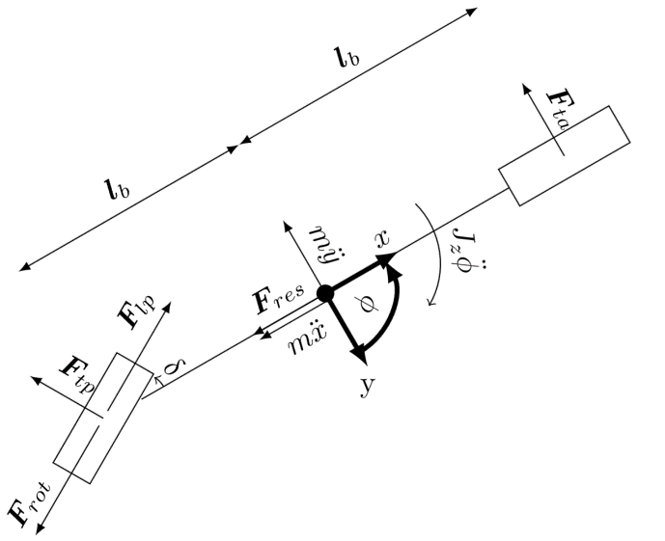
Figure 1 - Single track vehicle model. Rear wheel steering
The racing strategy consists on switching on the motor when the speed is more than 2 km/h lower than the requested average speed and switching off the motor when the speed is 8 km/h higher than the requested average speed. Moreover, during cornering, the motor is switched off. The single track model of the vehicle shown in Figure 1 has been introduced in the simulation in order to evaluate dynamic parameters such as vehicle longitudinal acceleration and speed, yaw angle and cornering forces. The tyre characteristics used for this model are obtained with experimental testing described in the next section.
The vehicle model is completed with the electric motor model. The effect of the dynamics of the motor has been neglected, however, the efficiency of the motor has been estimated through the evaluation of the armature resistance variation with the operating temperature. This phenomenon has been modelled with the variation law of the resistances that is:
$R=R_{0}\left[1+α_{Cu}\left(T°-298\right)\right]$ (1)
Where R₀ is the resistance at 25°C and T° is the motor temperature expressed in Kelvin degrees. The coefficient α_{Cu} is the temperature coefficient of the winding of the electric motor. The winding temperature has been evaluated, during the simulation, by using the thermal resistances reported in Table 6. The thermal capacitance of the housing and of the windings have been taken into account by introducing a delay in the temperature increase. In particular, the thermal equations used are described in [3] where only the heat generated by joule effect is considered. In Table 6 all the motor data are listed. The numerical integration of the ODE of the model has been made with the 1st grade Euler method with a fixed integration step.
The energy consumption of the vehicle has been modelled as a function of the total resistance force given by
$R=R_{r}+R_{h}{+R}_{a}+R_{c}$ (2)

Where R_{r} is the rolling resistance, R_{h} is the grade resistance, R_{c} is the rolling resistance during cornering and R_{a} is the aerodynamic resistance.
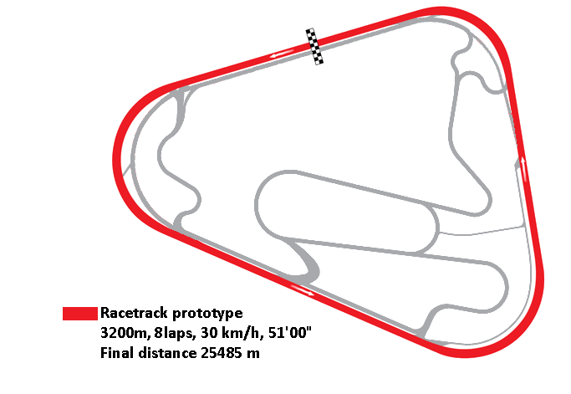
Figure 2- Lausitz ring, SEM 2011 race circuit
A simple model in equation (3) gives the rolling resistance
${R_{r}=F_{z}(f}_{0}+ f_{1}*v+f_{2}*v^{2})$ (3)

Where F_{z} is the load on wheels normal to the ground plane. The correlation between rolling resistance and vehicle speed is represented by f₀, f₁, f₂, experimental coefficients obtained through the tests described in the next section.
When there is a slope on the vehicle track, an additional grade resistance R_{h} is given by the weight of the vehicle as
$R_{h}=mg sin⁡(β)$ (4)

where m is the vehicle mass and β is the slope angle. During cornering the resistance force increases as a function of slip angle. Considering a simple single-track vehicle model (Figure 1) the drag force due to centripetal acceleration is
$R_{c}=\frac{m*v^{2}}{r*l}*\left(L_{a}*α_{1}+L_{b}*α_{2}\right)$ (5)

Where v is the vehicle speed, r is the turning radius, l= L_{a} + L_{b} is the vehicle wheelbase. L_{a} and L_{b} are respectively the distance between the vehicle COG and the front and rear axle. $α_{1}$ and $α_{2}$ are the sideslip angles at front and rear axle, respectively.
The aerodynamic drag resistance R_{a} is
$R_{a}=\frac{1}{2}ρ C_{x} S v^{2}$ (6)

Where ρ is the air density at 25°C, S is the cross section of the vehicle and C_{x} is the drag coefficient.
The model output is the energy consumption of the vehicle, running for a fixed number of laps on the given circuit. The consumption is calculated from the motor variables (speed, current, voltage, ec) of the motor model plus a fixed power consumption of 1 W given by the motor controller. The consumption is computed at the motor poles and is given at each integration step. It is split into four components related to four resistance forces in equation (2) respectively. The contribution of each part to the total energy consumption is shown in Table 1. The slope resistance consumption is considered only for the uphill part and not for the downhill part. The major impact on energy consumption is given by the aerodynamic drag and by the rolling resistance. They give together the 86.9% of the total energy consumption. The energy loss due to circuit slope is only 9.7% of the total energy loss because the vehicle mass in the simulation is only 85kg (vehicle plus driver).
Table 1- Simulation results
Laps | 8 | #
Elapsed time | 49’49’’
Total covered distance | 25.528 | [km]
Average speed | 30.75 | [km/h]
Max power | 62.7 | [W]
Average power | 25 | [W]
Average motor efficiency | 87.9 | [W]
Rolling resistance consumption | 45.7 | [%]
Cornering resistance consumption | 3.4 | [%]
Slope resistance consumption | 9.7 | [%]
Aerodynamic force consumption | 41.2 | [%]
Total consumption | 117.1 | [kJ]

2.Tyre testing
An experimental analysis of the prototype tyres characteristics was performed, with the objective to minimize the rolling resistance. Tyres 45/75 R16 Michelin® were tested, such tyres are produced on purpose for the SEM competition. Tests have been performed on the tyre-testing drum of Politecnico di Milano. In Figure 3, the testing set-up is shown.
Different speeds, different toe angles, different camber angles and different tyre pressures have been tested in order to minimize the rolling resistance. The vertical load on the tyre is two third of the estimated vehicle weight. The longitudinal force has been measured with a load cell with a full scale of 100N and a resolution of 0.02 N. Figure 4 shows the value of normalized rolling resistance at different speeds. The polynomial interpolation of this data give the experimental values of coefficients f₀, f₁ and f₂ that have been used in the sensitivity analysis. As the f₀ value depends also on the roughness of the track asphalt, the experimental value obtained on a smooth surface has been increased by 50%. As expected, zero toe angle is the best choice.
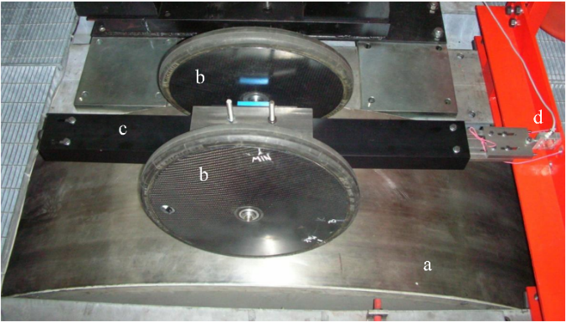
Figure 3 - Tyre testing rig: a) drum; b) two wheels with tyres under test; c) trailing arm; d) load cell

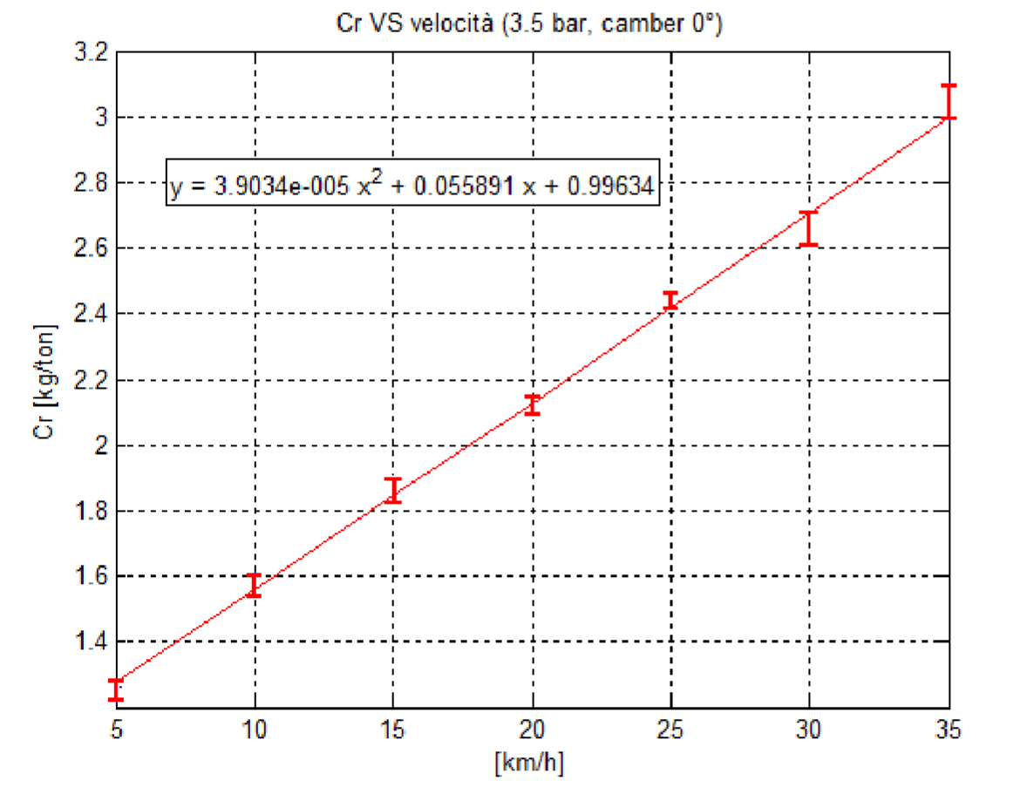
Figure 4 - Normalized Rolling resistance coefficient as function of speed at 0° camber angle, tyre pressure 3.5 bar
Figure 5 shows the rolling resistance value with respect to camber angle and tyre pressure. A change in the tyre pressure of 1 bar have a maximum influence on the rolling resistance of 20%. The lower value of rolling resistance coefficient is achieved with a 4° camber angle with a tyre pressure of 5 bar and zero toe angle.. Therefore, the vehicle was designed with a 4 degrees camber angle at front axle wheels. This, as explained later, has a great influence for reducing the frontal area and thus reducing aerodynamic drag. The rear steering was chosen to keep the frontal area (and thus the cross section area) as much small as possible.
3. Vehicle body design
The constraints for the design phase are the competition rules and the driver size. The driver is the main volume to be fitted into the vehicle. An Italian 50th percentile 23 years old woman [4] has been chosen as an envisaged driver dummy, corresponding to a slim university student (Figure 6). The volume for mandatory equipment as fire extinguisher, wheels and batteries has been fitted easily into the vehicle. The vehicle shape has been defined in order to minimize the frontal area and the whole vehicle size, as function of the mentioned volumes and the competition dimensional rules reported in Table 2.
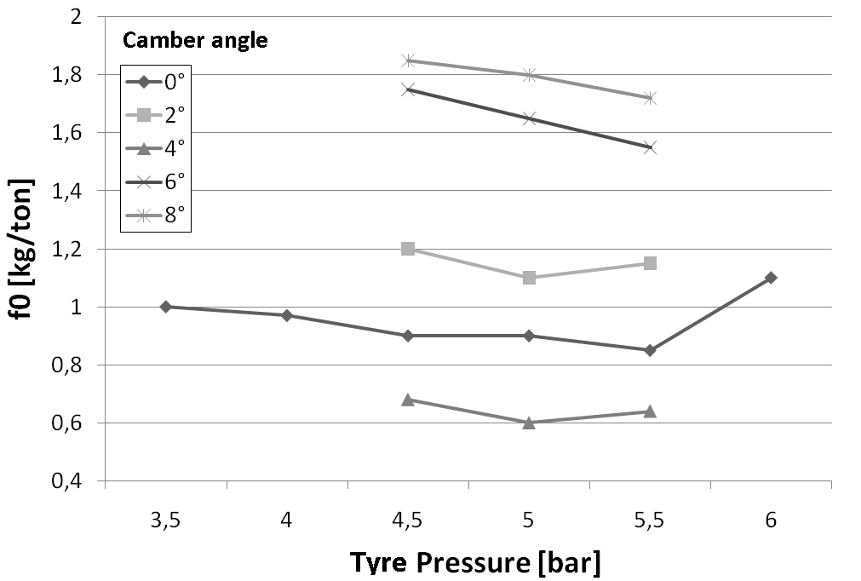
Figure 5- Rolling resistance coefficient f₀ as function of tyre pressure at different camber angles. Values refer to steel drum in Fig.3.
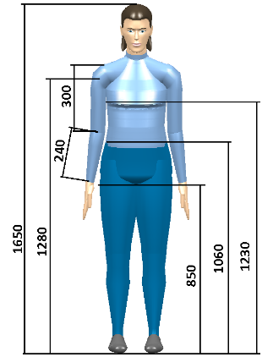
Figure 6 - Virtual dummy
Table 2. Shell Eco marathon regulation: dimensional constraints (SEM constraints)
Constraint | Value
Minimum track width | 500 mm
Maximum width | 1300 mm
Minimum wheelbase | 1000 mm
Maximum height | 1.25 track
Minimum gap between driver helmet and roll-bar | 50 mm

Figure 7 shows the preliminary result of vehicle design process. A simple vehicle shape is taken which fulfils the SEM constraints and fits the driver. The simple vehicle shape is a symmetric shape based on aerodynamics bi-dimensional profiles combined in a 3D surface. To obtain the actual vehicle, additional aerofoils have been added in order to cover the wheels and minimize the wheels ventilation effect. The final vehicle shape in shown in Figure 8. Such a shape has been obtained after further analysis regarding the aerodynamic performance and rolling resistance. In Figure 8a, the frontal area is substantially reduced thanks to cambered wheels.
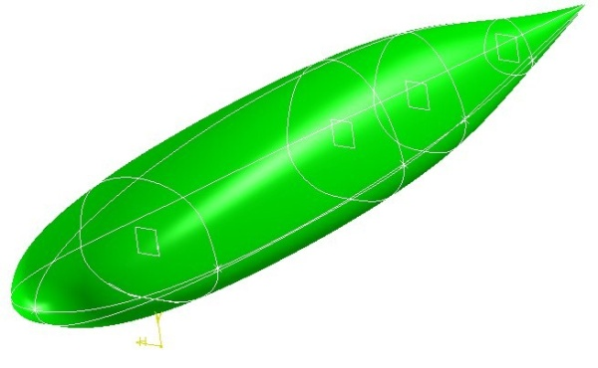
Figure 7 - Elementary shape used for vehicle design
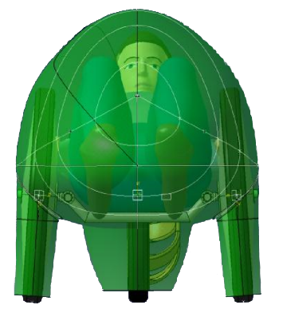
a)
b)
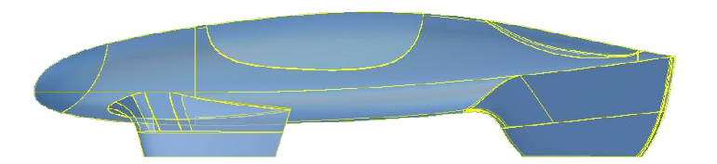
Figure 8 - a) Front view and b) side view of the final vehicle shape
The front part and the top part of the vehicle (Figure 8) were made with transparent polycarbonate (Lexan®) to provide the mandatory front and side view to the driver. According to the SEM rules, the driver must have a range of visual of ± 90° in the longitudinal direction and he/she must be able to see 60 cm tall pins positioned on a 5 m radius circumference arch [1].
In the rear part of the vehicle, a wing has been added in order to provide a flat surface for the solar panel. The top surface of the wing has an area equal to the maximum solar panel area allowed by competition rules, which is 0.5 m². The early configuration was a simple flat panel which provided sometimes lift forces, sometimes down forces. The lift forces were extremely dangerous for the active stability of the vehicle, actually the steering wheel is located at the rear, under the solar panel. The final configuration is an aerofoil which provides a steady downforce.

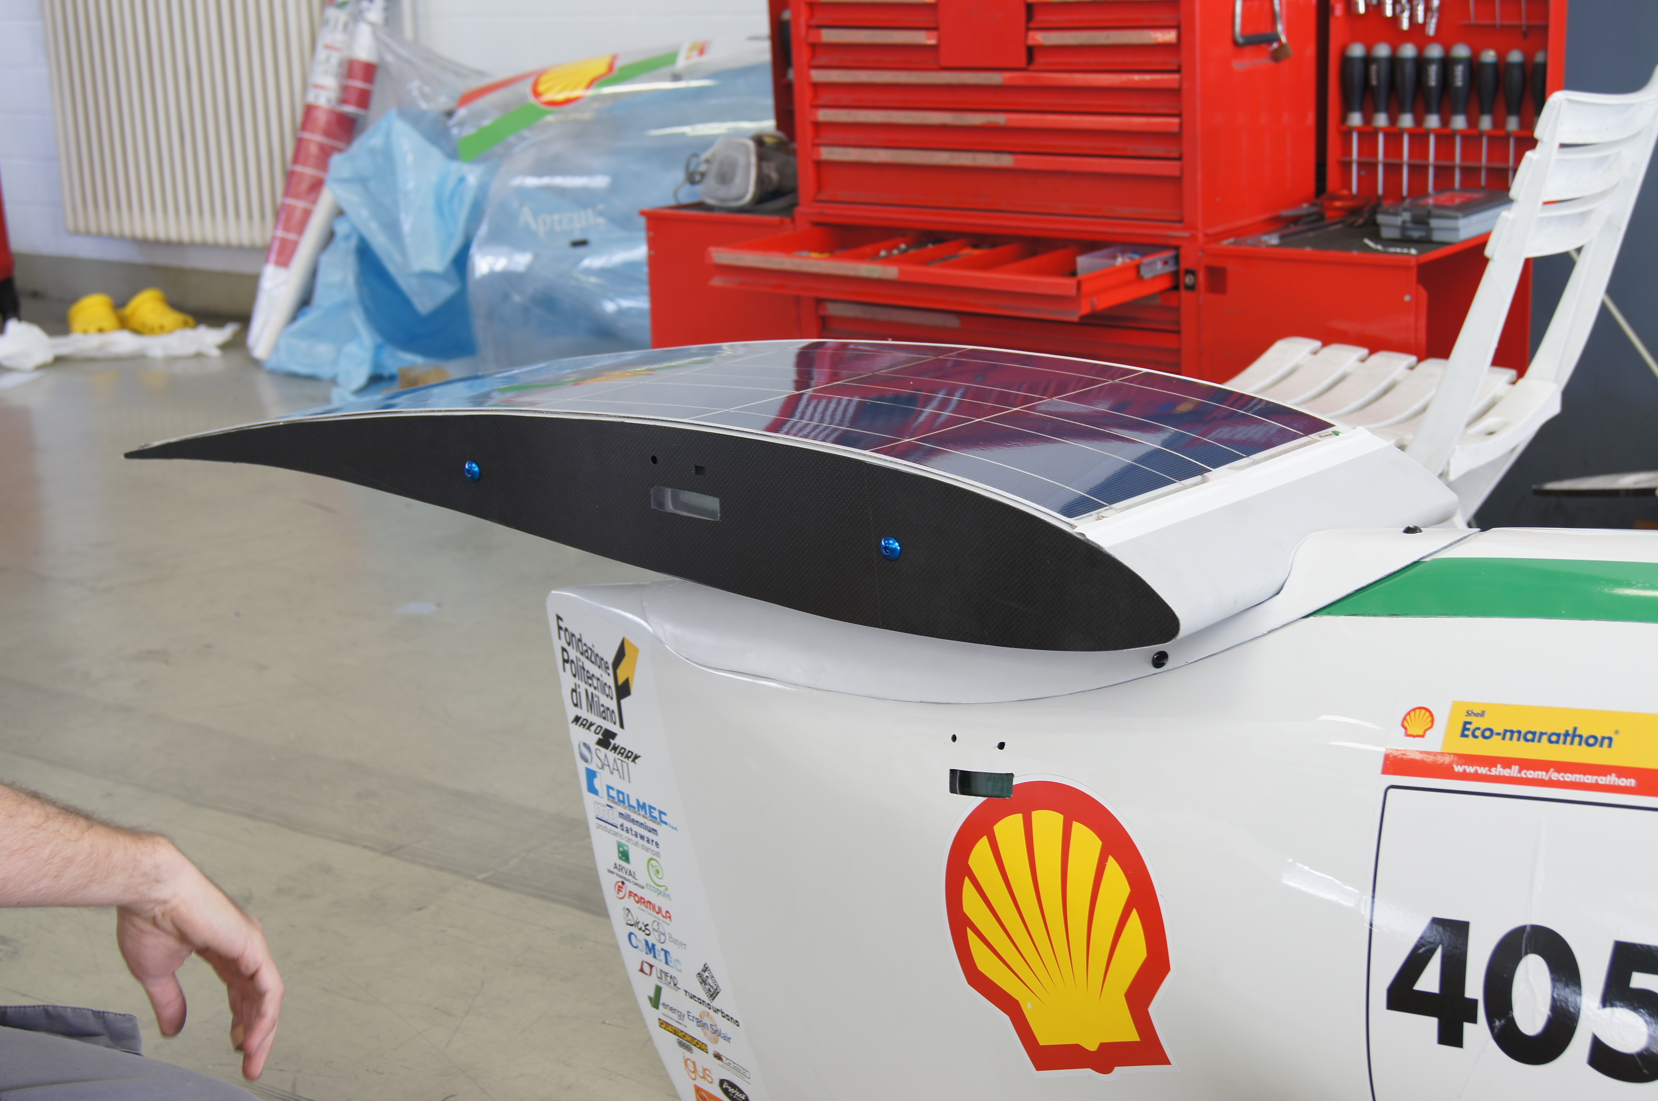
Figure 9 - Rear wing with solar panel. The wing provides a light downforce.

4. Aerodynamic analysis
In order to verify the aerodynamic performance of the designed vehicle shape, numerical analysis and experimental tests have been performed.
Numerical analysis
A CFD model of the vehicle has been derived to simulate the straight driving of the vehicle at the average speed required by competition rules. Only the left half of the vehicle has been considered in the simulation due to the symmetry of the problem, in order to reduce the computational effort. The turbulence model employed is a k-ε model, characterized by two differential equations that model the evolution of turbulence; wall effects have been defined by means of non-equilibrium wall functions [5].
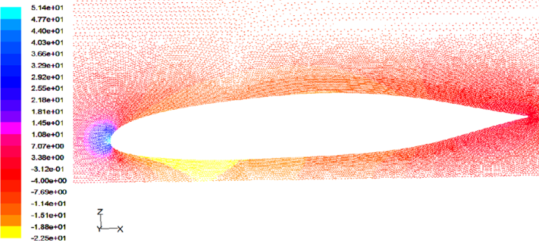
Figure 10 - Pressure field on a longitudinal section of the vehicle body [MPa]

The boundary condition imposed is an 8.33 m/s speed to the inlet surface and to the ground surface.
Figure 10 and Figure 11 show the simulation results. In Figure 10 it is shown the pressure field on a vehicle section. A pressure peak is located in the front part of the vehicle body while no turbulence existing through the entire vehicle shape. Obviously the absence of turbulence is a result that is to be carefully assumed.
Figure 11 shows the pressure field on the front fairing area. It is possible to notice that the connections between the front fairings and the central body cause a pressure loss.
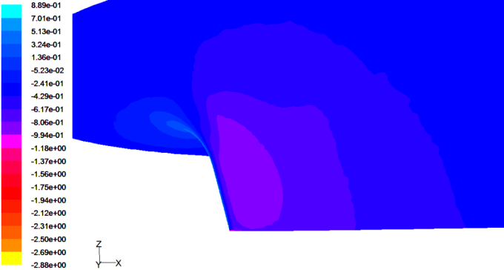
Figure 11 - Pressure field on the front fairing [MPa]
Experimental tests
Tests on the vehicle in a wind tunnel have been performed to evaluate the aerodynamic coefficients, particularly the drag coefficient as well as the location of transition between laminar and turbulent flow. The resistance force has been directly measured in order to calculate the drag coefficient. Moreover, the CFD pressure field has been compared with the experimental value using a pressure sensor. Figure 13 show the detail of the pressure sensor fixed on the vehicle.

Test results are presented in the following table as the product of vehicle frontal area S and drag coefficient Cx.

Table 3 - Test results
Type | S·Cx
Experimental | 0.0399 m²
Numerical | 0.0366 m²
Variation | 8.2 %

Preliminary numerical simulations have been performed by introducing in the model the experimental determined line of transition (from laminar to turbulent flow) in order to increase the simulation accuracy. The major difference between the experimental and numerical result is due to the actual vehicle shape errors. The pressure loss of Figure 11 identified through the CFD simulation has been detected also with pressure sensor in the same area (Figure 10).

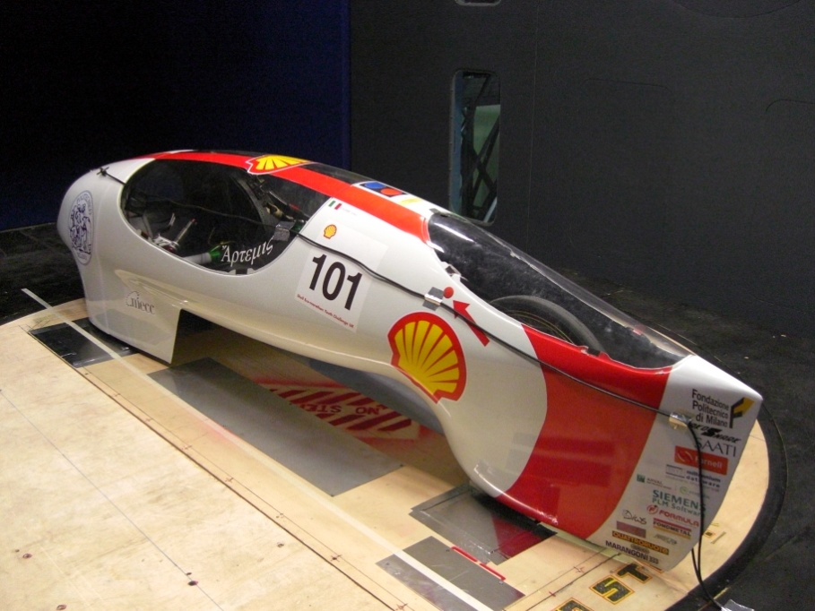
Figure 12 - Vehicle in thewind tunnel at Politecnico di Milano

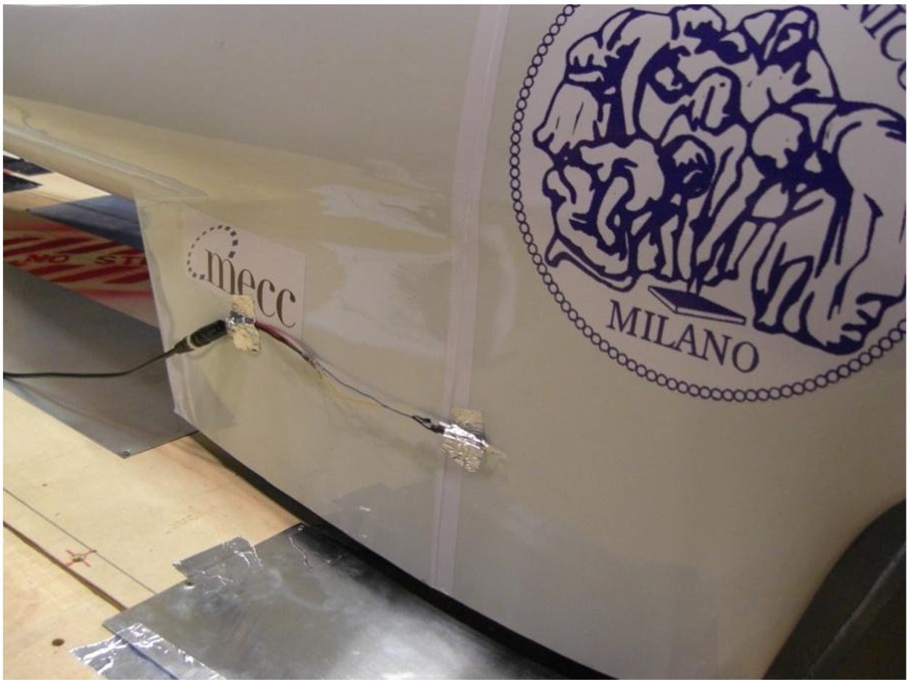

Figure 13 - Pressure sensor installed on the fairing area during testing
5. Structural analysis
The vehicle here presented has two structural parts. The first is the body main frame and the second is the front wheel axis frame shown in Figure 16. The structural analysis of those two parts is presented in this section.
The layup of the CFRP structure of the vehicle body has been designed with the aid of FEM models. The structure is a sandwich structure made of CFRP and Nomex® honeycomb. In particular bi-directional fabric with a weight of 200 g/m² (CC202) and a unidirectional tape with a weight of 300 g/m² (HS300) both impregnated with epoxy resin (ET443) have been selected. The variables used in the mass reduction process are the fabric layup and the honeycomb thickness.
Functional subdivision of the vehicle body has been considered. The front part of the vehicle has been separated from the main body to access the front wheels. The same for the rear hood with solar panel. Wheel covers (aerofoils) are non structural parts and the minimum number of CFRP plies have been displayed in this area, according to manufacturing constraints.
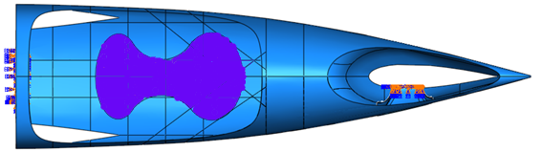
Figure 14 – Area affected by driver load in the FEM model
Two load cases have been considered. The first is due to the driver weight. This load has been modelled as a pressure pushing on an area shaped as two ellipses (one corresponding to the buttocks and the other to the shoulder zone) as it is shown in Figure 14. The driver mass has been set to 55 kg.
The second load case is given by the competition rules. According to SEM rules the roll bar, or the monocoque, “must be capable of withstanding a static load of 700 N (~ 70 kg) applied in a vertical, horizontal or perpendicular direction” [1].
The constrains for the FEM model have been placed where the wheels reaction forces are positioned. The surface linking the rear wheel to its support has been connected by a pin constraint to the ground. The reaction force due to the front wheels has been applied to the chassis where an aluminium alloy plate enclosed in the CFRP sandwich is located.
Table 4 and Figure 15 show the FEM results for the final composite layup.
Table 4 - FEM results
Field | Value | @ node
Max Displacement | 0.697 mm | 18745
Max Tsai-Wu CFRP | 0.121 | 40311 (ply 2)
Max Tsai-Wu Honeycomb | 0.452 | 40372

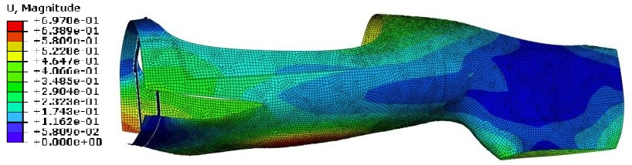
Figure 15 - Vehicle body displacement field
Different layup with the same stiffness has been compared in terms of vehicle mass. In Table 5 the iteration steps are shown. The composite layup B has been obtained observing the stress results at the first iteration (layup A). The layup C has been obtained from layup B, in particular adding a 7mm honeycomb instead of a 5 mm honeycomb and reducing the number of CFRP plies.
Table 5 - Composite layup mass
Layup | Mass (kg) | Mass reduction
A | 10.2
B | 9.5 | -7.3%
C | 8.9 | -6.7%

The connection between the front wheels and the vehicle body is obtained through the frame shown in Figure 16. A CFRP rod with 2 mm thickness connect the left and right hub carrier of the front axis in a single frame. Since the geometrical dimensions are extremely important for the correct positioning of the wheels with respect to the ground, a number of check points are defined in the body to allow the proper mounting of different assemblies.

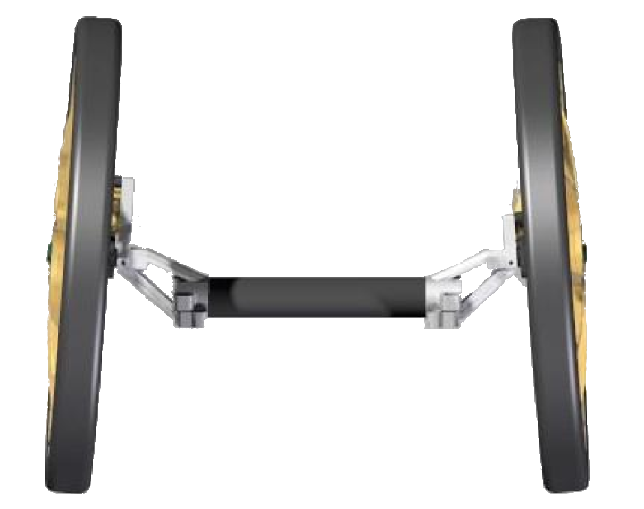
Figure 16 - CAD model of the front axis frame assembly

A FEM model has been used to optimize the hub carrier structure in order to reduce the vehicle mass. With respect to the wheel nominal camber angle of 4 degrees, a maximum variation of 0.1 degrees is allowed. Therefore, a maximum displacement constraint of 0.2 mm is imposed to the hub carrier.
Figure 17 shows the displacement of different hub carrier confi-gurations. The best configuration in terms of mass and stiffness is shown in Figure 18. The minimum mass is 135g for the hub carrier, with a total mass of the front axis frame of 480g. In Figure 19 the front axis frame assembled on the vehicle is shown.
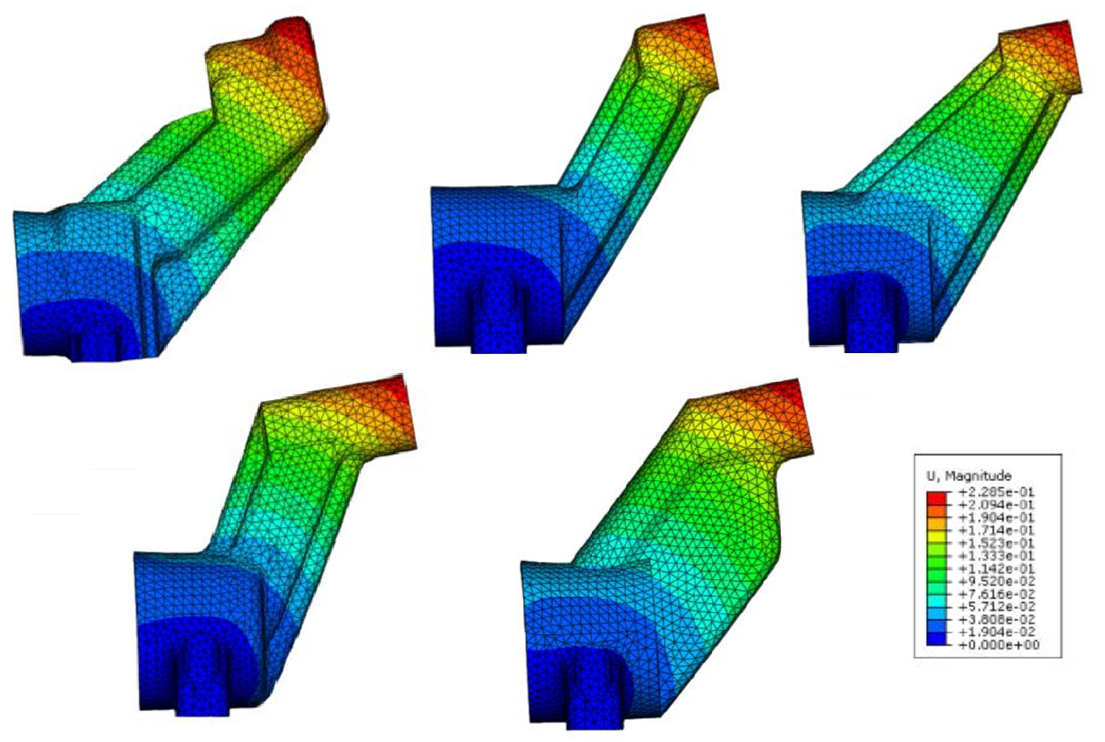
Figure 17 – Displacement magnitude [mm] of different hub carrier shapes
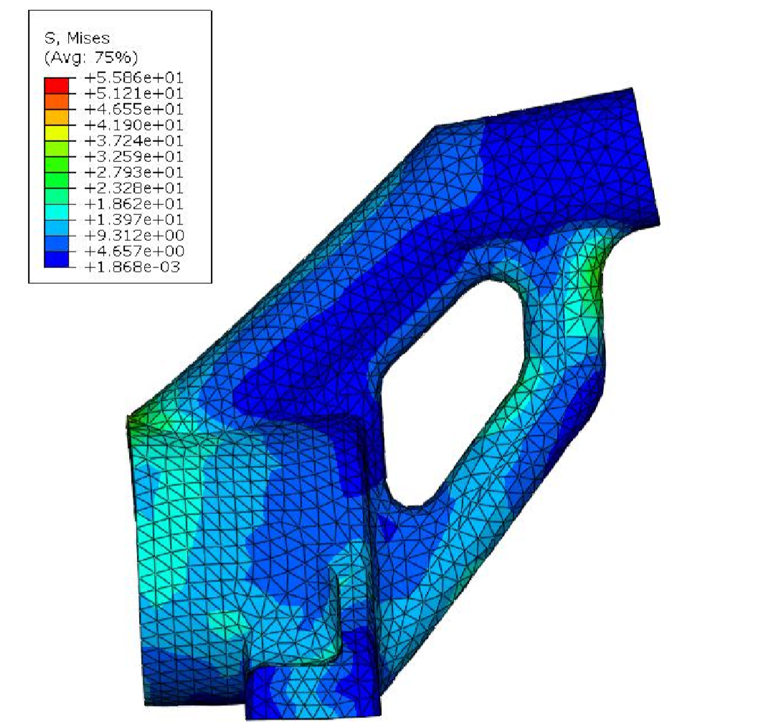
Figure 18 - Final hub carrier shape: Von Mises stresses [MPa]
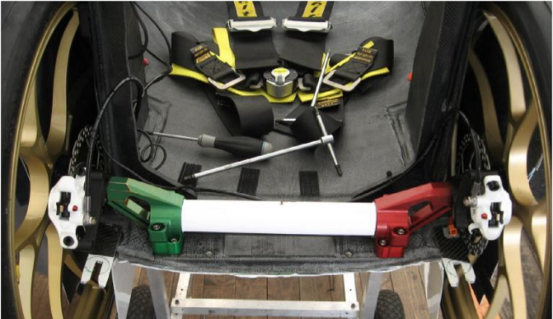
Figure 19 - Front axis frame with the optimized hub carrier indicated by arrows
6. Electric propulsion system
A scheme of the electric system of the vehicle is shown in Figure 20.

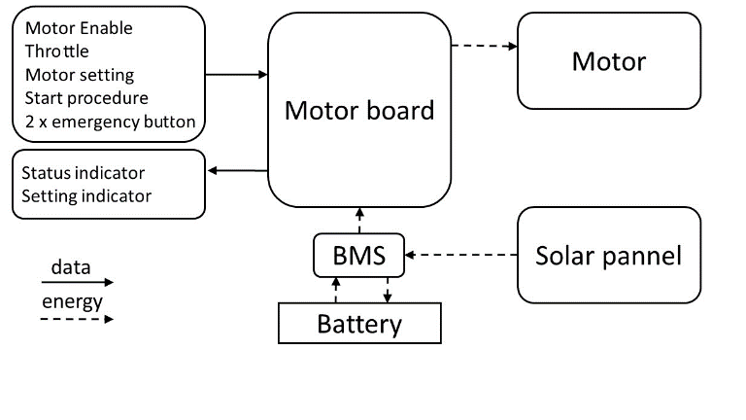
Figure 20 - Vehicle Electric system scheme
An electric DC brush motor is adopted for the propulsion of the vehicle. In particular, a Maxon® RE 40 Motor has been used with the main properties reported in Table 6.

Table 6 - DC motor data
Rated Power | 150 | [W]
Rated Voltage | 24 | [V]
Max speed (no load) | 7580 | [rpm]
Speed/Torque | 3.32 | [rpm/mNm]
Torque constant | 30.2 | [mNm/A]
Tot. resistance at 25°C | 317 | [mΩ]
Speed constant | 317 | [rpm/V]
Rotor inertia | 134 | [gcm^2]
Thermal resistance housing- air | 4.7 | [K/W]
Thermal resistance rotor-housing | 1.9 | [K/W]
Thermal time constant of rotor housing | 1120 | [s]
Thermal time constant of rotor windings | 41.6 | [s]
Thermal coefficient of windings | 3.92 | [mΩ/K]

This motor has been chosen off-the-shelf among motors with very high efficiency in the required power range. The manufacturer data for this motor gives a maximum efficiency of 91% at 2960 rpm.
A motor converter is needed to drive the motor with the maximum efficiency. For a DC brushed motor an efficient way is to use one static switch. With this layout the power consumption of the motor board is approximately 1W. Besides the motor control, the motor board has as input simple signals (Motor Enable,Throttle, Motor setting, Start procedure, emergency button) and gives as output analogic signal for the LED indicators on the driver interface.
The 48V, 12cells, LiPo battery is connected to a BMS board able to manage the charging/discharging process of the battery. In particular the BMS takes the electric power at approximately 500 mV from the solar panel and convert it to the battery voltage. The charging/discharging process is controlled by the BMS through the monitoring of temperature, voltage and overcurrent of each battery cell.
The whole system is integrated with a safety circuit connected to the BMS that disconnect the battery from the electric system when an emergency button is pushed or the BMS gives malfunctioning error. The detailed description of the safety parameters of the electric system is given in the SEM regulation [1]
The selected solar panels are made from polycrystalline silicon solar cells. The single cell data and the complete panel data, made with 15 cells are reported in Table 7.
Solar cells with efficiency up to 20% are available on the market, but only the selected polycrystalline cells, with efficiency equal to 15%, had the possibility to be integrated into a flexible solar panel and to be adapted to the vehicle shape. Furthermore, the mass of a solar panel with 15 cells is only 100g.
During the race, the BMS connected to the solar panel perform a MPPT control logic in order to obtain the maximum power in each weather condition.

Table 7 - Solar panel data
Efficiency | 15 | [%]
Max. Power | 2.3 | [W]
Max. Power Voltge | 505 | [mV]
Max. Power Current | 4.6 | [A]
Open Circuit Voltage | 605 | [mV]
Short-circuit current | 5.1 | [A]
Number of cells | 15
Panel width | 193 | [mm]
Panel length | 390 | [mm]
Panel thickness | 2.2 | [mm]

7.Powertrain
The powertrain must have the maximum energy efficiency. Nevertheless, the powertrain components must be as light as possible and fit inside the vehicle space. The required performance is obtained with a single stage spur gear transmission.
The gear ratio is calculated in order to have the maximum efficiency speed of the motor when the vehicle speed is equal to the average required speed of the race. So, except for the race start, the motor will work in a speed range close to the maximum efficiency. The gear ratio value is
$τ= \frac{V}{πdS_{m}}≅0.05$ ( 7)

where V is the average speed of the vehicle required by competition rules, d is the rolling radius, and S_{m} is the maximum efficiency speed of the motor. The efficiency of the gear transmission is correlated with the number of gear teeth as described in [3]. Therefore a 0.8 modulus have been used in order to increase the number of teeth with the given gear ratio.
The pinion is connected directly to the motor shaft while the drive gear is connected to the wheel hub through a freewheel, in order to reduce the resistances during coasting. With this configuration, the entire powertrain can be accommodated inside the rear wheel and its configuration requires a minimum number of components, with a total mass of 480g.
In Figure 21 the powertrain assembly is shown. The motor is shown in the upper part of the picture mounted on its carrier. On the wheel centre it is shown the drive gear and the brake disk. In the foreground, the two servomotors of the steering system are shown.
A hardware in the loop test rig has been used in order to measure the motor and driveline losses. Figure 21 shows the test rig composed by an alluminium frame where the motor and the powertrain are mounted.
The powertrain is connected to a braking motor equipped with an encoder and controlled through a computer with the dSPACE® software environment. This software includes the Matlab® Simulink® model describing the motion of the vehicle. The longitudinal force at the driving wheel is computed during the simulated running along the track. The dSPACE® software takes such a force and instruct the braking motor to apply to the powertrain the resistance torque. Alternatively an efficiency map can be derived.
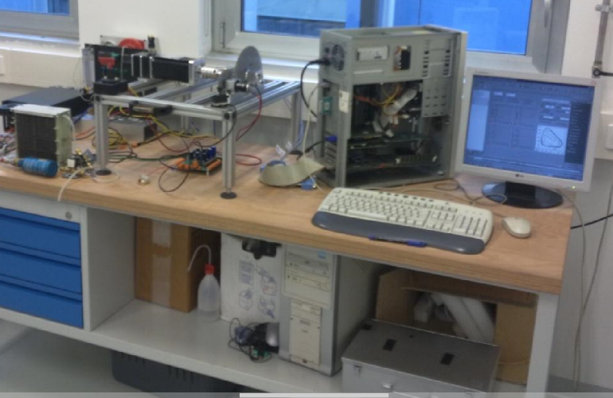
Figure 21- Test bench for assessing powertrain efficiency
The vehicle motor is powered with an exact copy of the vehicle electronic system (battery and motor board) and the motor voltage and current are measured with the dSPACE® software.
In this way, the efficiency of the entire powertrain, from the battery to the wheel, has been measured.
Considering the nominal speed of the Maxon® RE50 motor, the wheel diameter, the race average speed and the racing strategy, the gear ratio has been optimized. With a gear ratio of 13.8 the motor efficiency during a simulated race will be between 92% with a vehicle speed of 24 km/h and 94% with a vehicle speed of 30 km/h. The hardware in the loop simulation of the race on the Lausitz circuit with 8 laps, give a total efficiency of 91% (motor + powertrain).

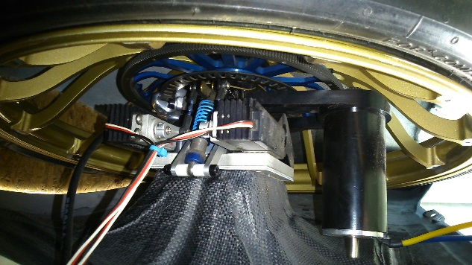
Figure 22 - Rear wheel assembly with powertrain and steering system

8. Steering system
As introduced in the first paragraph, the vehicle steering system is a drive by wire system acting on the rear wheel. This configuration allows us to reduce the vehicle cross section area and thus improving the aerodynamic performance. The Shell Eco-marathon® competition do not have any rules referring to the use of electric assisted steering but it is not forbidden. The rear wheel hub carrier, is connected to the vehicle with two pins along a vertical axis, that is the steering axis. The steering axis intersect the ground plane in the centre of the tyre-road contact patch, in order to decrease the steering forces.
The steering system components are the driver interface, a control electronic board and two servomotors with two steering arms acting simultaneously.
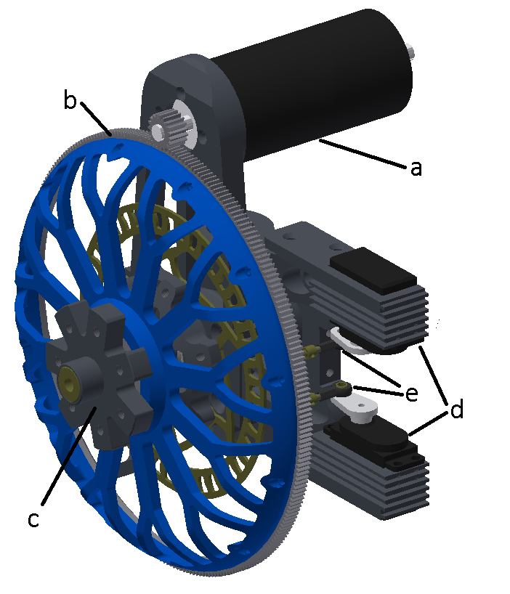
Figure 23 - Powertrain and steering system: a) motor; b)drive gear; c) wheel hub; d) servomotor; e) steering arms;
.
The driver interface is shown in Figure 22. Through the rotation of a handle the driver changes the position of a potentiometer that gives the position reference signal to the motor through a motor control board. The driver handle is maintained in the neutral position by a spring. The two servomotors are controlled through a feedforward logic, with the wheel position proportional to the reference signal given by the driver interface. The two motors give the steering force and they are mounted on the vehicle as in Figure 22. The servomotors are made by Ko-Propo® and their main properties are reported in Table 8.
The choice of this motor is based on the calculation of the steering torque that is 12Nm with zero camber angle and zero caster angle. The steering arm introduce a force multiplication of 4.5, so, the required final torque at the servomotor shaft is 2.7Nm. A single servomotor can apply this torque but two servomotor are used in order to increase the reliability of the steering system.
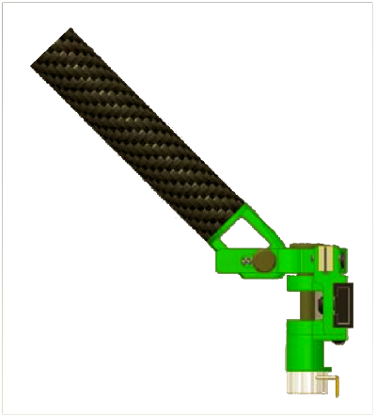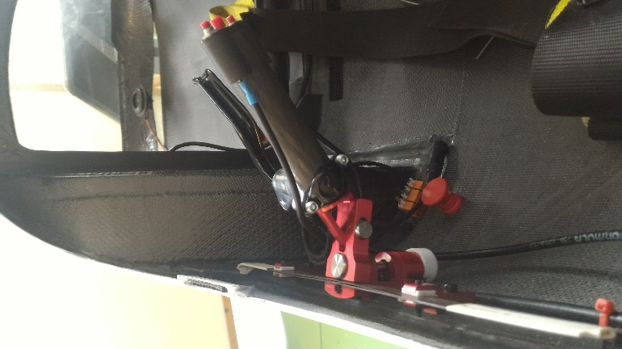
Figure 24- Driver steering handle a) CAD image b) actual components

Table 8 - Servomotor Data for steer-by-wire
Voltage | 7.4 | [V]
Max torque | 3.1 | [Nm]
Speed | 545÷461 | [deg/s]

Two springs and two dampers are connected between the vehicle body and the rotating hub carrier of each wheel respectively, in order to maintain the straight driving wheel attitude in case of a failure of the electric system (Figure 23). Nevertheless, the two dampers contribute to the vehicle stability by filtering the high frequency vibration due to road surface irregularities.
9.Employment
The vehicle was employed at the 2011 Shell Eco-Marathon Europe at Lausitzring in Germany. The Politecnico di Milano team MECC-SUN placed 1th in the overall ranking with an equivalent traveled distance of 1180 km/kWh. Considering that the energy content of one litre of Shell FuelSafe® Unleaded 95 is 32010 kJ at 15° Celsius, the distance that would be traversed by Apollo with one litre of gasoline is 9750 kilometres. This result has been obtained by running eight laps on the circuit at the average speed of 30 km/h. The energy consumption was measured with the joulemeter provided by the organization and referred to the race distance. The race marshals, through a transponder installed inside the vehicle, controlled the speed on the track. The race was organized with three session of 3 hours each, with four possible attempt to obtain a positive result. The first attempt was used to evaluate the track characteristic. The driver evaluated the optimal trajectory and the minimum power required to reach the average speed, using the different motor settings. With those settings, we run three attempts according to weather condition in order to have the maximum solar power from the solar panel.
The team was composed by fifteen members, with one team manager, two drivers, six master degree students and six bachelor degree students from Politecnico di Milano. The vast majority of the members are students from the Mechanical Engineering Department.

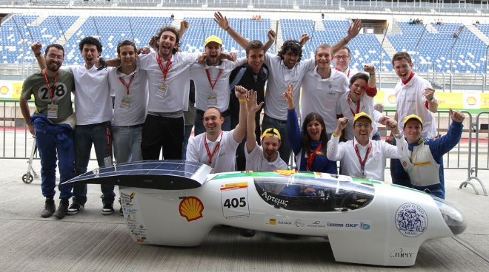
Figure 25 - Solar prototype Apollo at SEM 2011 in Lausitz.
10. End of life
The vehicle was exhibited at the Shanghai Expo Area as one of the Italian (European) most relevant achievements in vehicle engineering academic research.
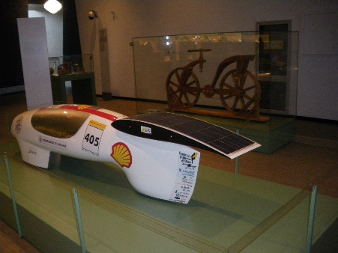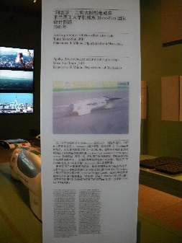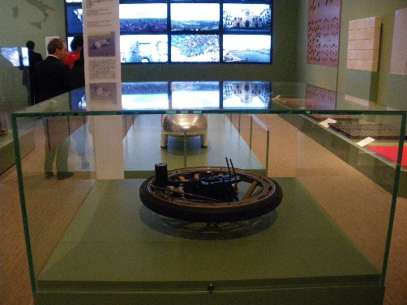
Figure 26 - Solar prototype Apollo at the Shanghai Expo area, 2012.

11.Conclusions
This paper presents the design and the manufacturing of an electric prototype vehicle powered with a solar panel for the Shell Eco-Marathon competition.
A preliminary step was a sensitivity analysis to understand the effects on energy efficiency of different vehicle design parameters. With a vehicle mass of 35kg the energy consumption of a vehicle are mainly correlated to rolling resistance and aerodynamic drag, even if the speed is lower than 38 km/h. Tyre testing have been performed, obtaining a linear characteristics of rolling resistance with respect to speed. Moreover, the effect of toe and camber angle on rolling resistance has been investigated obtaining the optimal configuration with 0° toe and 4° of camber angle.
All the vehicle parts and subsystems have been optimized in order to reduce the vehicle mass. In particular, it has been obtained a vehicle body made with CFRP with a global weight of 8.9 kg and the total weight of the vehicle is 35 kg. The aerodynamic shape and the global vehicle size reduction through the driver position optimization, give a drag force of only 2N at 35 km/h. The drive by wire steering system has improved the vehicle stability during cornering and on the straight ahead driving.
The design process that has been developed can be used for the development of lightweight vehicles, especially for the analysis of the interaction vehicle layout and aerodynamic performance.
The relevance of vehicle design and production process has been confirmed by the results obtained in the 2011 Shell Eco-marathon competition. An equivalent distance of 1180 km was traversed with only one kWh.
References
[1] | Royal Dutch Shell plc, Shell Eco-marathon Official rules, 2011.
[2] | J. J. Santin, C. H. Onder, J. Bernard, D. Isler, F. Kolb, N. Wiedmann e L. Guzzella, The world’s most fuel efficient vehicle, Zurich: vdf Hochschulverlag AG, 2007.
[3] | G. Galmarini, «Costruzione ed impiego di un veicolo per la competizione Shell Eco-marathon®,» Politecnico di milano, Milano, Doctoral thesis, 2010.
[4] | F. Tosi, «Progettazione ergonomica,» Il sole 24 ore, 2001.
[5] | A. C. Kermode, Flight without formulae, Longman, 1989.
[6] | G. Galmarini, G. Mastinu, M. Gobbi and M. Mauri, Design of an Hydrogen Powered Electrical Race Vehicle, ASME 2011 International Design Engineering Technical Conferences and Computers and Information in Engineering Conference, Volume 8: 11th International Power Transmission and Gearing Conference; 13th International Conference on Advanced Vehicle and Tire Technologies, Washington, DC, USA, August 28–31, 2011
[7] | G. Galmarini, M. Gobbi and G. Mastinu, Design, Construction and Employment of a Sustainable “Urban Concept” Race Vehicle, ASME 2012 International Design Engineering Technical Conferences and Computers and Information in Engineering Conference Volume 6: 1st Biennial International Conference on Dynamics for Design; 14th International Conference on Advanced Vehicle Technologies Chicago, Illinois, USA, August 12–15, 2012

Definitions/Abbreviations
CFD | Computational Fluid Dynamics
CFRP | Carbon Fiber Reinforced Plastic
Cx | Drag Coefficient
DC | Direct Current
FEM | Finite Element Method
g | Gravity acceleration
MPPT | Maximum Power Point Tracker
NACA | National Advisory Committee for Aeronautics
PETG | Polyethylene Terephthalate Glycol
SEM | Shell Eco-Marathon®

Contact Information
Prof. Dr-Ing Giampiero Mastinu, mastinu@mecc.polimi.it

