Uncertainty evaluation in air quality planning decisions: a case study for Northern Italy
C. Carnevale (University of Brescia, IT), J. Douros (AUTH, GR), G. Finzi (University of Brescia, IT), A. Graff (UBA, DE), G. Guariso (Politecnico di Milano, IT), Z. Nahorski (SRI, PL), E. Pisoni (EC-JRC, EU), J-L. Ponche (University of Strasburg, FR), E. REAL (INERIS, FR), E. Turrini (University of Brescia, IT), Ch. Vlachokostas (AUTH, GR).

Abstract
In recent years, evaluating the robustness of environmental models results has become essential in order to effectively support decision makers to define suitable emission control strategies. This evaluation is performed in literature through uncertainty and sensitivity analyses. Therefore, the application of such methodologies to air quality Integrated Assessment Models (IAMs) is extremely challenging. In fact, in this case uncertainty and sensitivity analyses should be assessed not only for each single component of the system, but also for the overall IAM. In the paper, an attempt is made to extend and systematize the information available on uncertainty/sensitivity analysis, at first considering environmental models in general, and then focusing on air quality IAMs. The study aims to offer a tentative framework addressed to modelers and decision makers in the implementation of IAM and evaluation of its results. The framework has been tested on Lombardy region (Northern Italy). The results show how the uncertainty on Drivers of emissions propagates on the whole modelling chain characterizing an integrated assessment study.

Introduction
In recent years, environmental models are becoming more and more important as intermediary between policy and science, supporting decision makers in management and planning/strategic choices. These applications are very challenging for the complexity of the involved phenomena and (perhaps, mainly) for the socio-economic impacts of the policy decisions. So, as models are becoming more and more important in the policy arena, the complexity of the relationship between their output and the consequent decisions together with the limited evaluation of their robustness can cause a lack of confidence, and a possible growing mistrust on the capability of systems to support important strategic choices.
A rigorous robustness analysis approach may be the answer to overcome this problem. The US Environmental Protection Agency indeed recommends that both model developers and users perform such an analysis to help determining when a model can be used to take reliable decisions (EPA, 2009). Similarly, in Europe, the FAIRMODE (Forum for Air Quality Modelling) initiative is dealing with guidelines on “fitness for purpose” to assess if an air quality model reaches the minimum level of quality to be used in the science-to-policy interface (Thunis et al., 2015).
In the case of Integrated Assessment Models (IAMs), the analysis becomes even more complex, since it does not consider a single model, but a set of interlinked specific models. It means that the robustness analysis should assess the uncertainty and sensitivity not only for each single component of the system, but also for the system in its entirety (Amann et al. 2011).
To be more specific, let’s consider the case of Integrated Assessment Modelling (IAM) in the air quality field. In this context, the analyst should answer questions such as:
- Does the preferable decision change, if it is assessed that the results of the model of the (physical, economic, social) system are inaccurate?
- How much risk affects the implementation of a certain decision, given that there is no certainty about the model result?
The results of an air quality IAM may be inaccurate for a number of different reasons that are common to any modelling exercise, going from the too simplistic formulation to the impossibility of measuring the necessary inputs. In addition, uncertainty might derive from various sources, that are peculiar to this context. The space of feasible actions (options/alternatives/decisions) is normally very limited and, more precisely, the granularity of the decision is much coarser than the granularity of the model results (e.g. the concentration at many receptors can be computed at many different times, but then we can just decide to stop or not the traffic in the entire centre of a city).
This implies that all the information derived from the integrated models of the (physical/environmental, economic, social) system(s) needs to be “squeezed” into very few and simply countable variables (e.g. the yearly number of exceedances of a given concentration threshold somewhere in the domain) thus strongly filtering out much of the temporal and spatial variations.
The models are used in this perspective to compute values that are different, by definition, from those experienced in the past. Thus, there is no way to test if they will closely represent the possible outcomes of our decision or not. This is also true for the other boundary conditions which are supposed to represent future (new) scenarios, consequent to other decisions or to other uncertain factors (e.g. climate change). This is particularly important when (practically always) the domain in which decisions are implemented (often defined by some administrative boundary) differs from the physical domain and thus the outcomes of the decisions of one administrative entity will (possibly, strongly) depend on the decision of others.
In this paper, the authors aim to extend and systematize the information available on uncertainty analysis/sensitivity analysis (UA/SA), at first considering environmental models in general, and then focusing on air quality IAM. The study is one of the first to focus on the overall IAM and not only on a single component and would offer a tentative framework for both modelers and decision makers in the implementation of IAM and evaluation of its results and weakness. The paper is organized in two parts, the first related to the framework and the second concerning the application of the defined framework to a case study, showing how the uncertainty on Drivers of emissions propagates along the whole modelling chain that characterizes an integrated assessment study.

Uncertainty & Sensitivity analysis framework
Uncertainty and sensitivity analysis are key issues in the definition and evaluation of IAMs. The main goal of uncertainty analysis is to quantitatively assess the impact of the input (measured, estimated or assumed) uncertainties on the computed output results. It is worth to take note that in the literature, the term “uncertainty” has been mostly associated with the process of model validation, as suggested by the current EU legislative framework.
Sensitivity analysis is, on the other hand is defined as the study of how model output variation can be apportioned, qualitatively or quantitatively, to different sources.
The two approaches have to be used together and integrated, usually starting by the uncertainty analysis.
One of the most important issues to be addressed at the beginning of both the analyses is the definition of what can be considered as input. In this context, each factor that may lead to a variation in the in the model output is considered an input. Consequently, not only the traditional “model input” i.e. the physical causes determining the output, but also the model parameterizations and the numerical algorithms may be characterized as input.
In the next sections a review of the main techniques, both analytical and numerical, that can be used to perform uncertainty and sensitivity analysis will be briefly presented and the application impact of these analysis will be investigated in the IAM framework introduced in Volta et al., in press.

Analytical methods
When dealing with linear or relatively “simple” nonlinear systems, analytical methods for statistical error propagation can be used for uncertainty analysis. Variance propagation is the analytical approach most frequently used for simple equations (Martz and Waller, 1982; Morgan and Henrion, 1990).
As for the sensitivity analysis, the partial derivative study (Vlachokostas et al., 2009) is the only analytical technique used. Indeed, the derivative ∂Y/∂ U_{i} of an output Y versus an input U_{i} can be thought as a mathematical definition of the sensitivity of Y versus U_{i}. Unfortunately, often the analytical computation of the partial derivatives may be very difficult due to the complexity of the involved relationships (e.g. constraints, strong nonlinearity).

Numerical methods
To overcome problems related to analytical methods, a series of numerical methods has been presented in literature.
In general, all the procedures develop the following steps:
- definition of the bound/probability distribution of each source of uncertainty taken into account;
- definition of the output variable to be analysed;
- Design of Experiments (DoEs), closely related to the selected method, with the purpose of propagating the source uncertainty through the model;
- computation of the model output for the scenarios defined in (3);
- computation of the uncertainty/sensitivity measures of interest.
According to literature, the most commonly techniques used for uncertainty analysis are:
- Monte Carlo simulation (Rubinstein, 1981), where a relatively large set of sampling values from the input space are used to drive the model (or a statistically simplified version of the model) and the variance of the results is estimated (Downing et al., 1985). The sampling is usually performed using either the Simple Random Sampling or the Latin Hypercube Sampling (Morgan and Henrion, 1990).
- Differential uncertainty analysis (Cacuci, 1981; Worley, 1987), in which the numerical value of the partial derivatives of the model response with respect to the input are used to estimate uncertainty.
- First-order analysis using Taylor series expansions (Scavia et al., 1981), or polynomial chaos expansions (Cheng and Sandu, 2009) where a numerical approximation of the analytical variance propagation equation is computed.
A large number of approaches exist in the literature to perform a sensitivity analysis (Saltelli et al., 2000).
In general, the numerical sensitivity methods can be grouped in four different families:
- Numerical implementation of partial derivative methods. Various software implementations of models include routines for the efficient computation of system derivatives (Rabitz, 1989; Turanyi, 1990; Varma et al., 1999; Saltelli et al., 2000). This approach is usually very efficient in terms of computational time. Unfortunately, derivatives are meaningful only at the point where they are computed and do not provide information about the remaining part of the space of the input factors, so an analysis covering the full parameter space is challenging..
- Regression analysis, which implies fitting a mathematical relationship to the model response and using standardized regression coefficients as direct measures of sensitivity. Literature has indicated that this method is most suitable when the model response may be assumed as linear with respect to the considered input. As an example, in Vlachokostas et al., 2013, the stepwise regression analysis shows reliable results when dependent and independent variables have the same origin and the linearity assumption is confirmed by a high value of the determination coefficient. Regression analysis is a flexible process with low computational costs. Otherwise, if the relationship is significantly nonlinear, the fitted regression is considerably different from the model under study (Saltelli et al., 2000).
- The elementary effect method is a screening method allowing to highlight a limited number of important input factors among the many contributing to the output of the system (Morris, 1991; Campolongo et al., 2007). The elementary effect is computed for a subset of input values obtained by randomly sampling the input space to obtain a distribution function F_{i} for each of the input factors. The two sensitivity indexes used in this context are the mean and the standard deviation for each distribution.
- Variance-based methods, aim to the estimate of the contribution of single (or group of) input variance to the output variance. Usually, these methods are computationally very expensive due to the variance estimation process. That is why recent research aims to find efficient numerical algorithms for the DoEs. The most detailed methods are based on the work of the Russian mathematician I. M. Sobol, and involve the computation/estimation of the following effects on the variance of the output (Sobol, 1993, Homma and Saltelli, 1996):
  - First order sensitivity index: it represents the pure effect of each input factor.
  - Second order sensitivity index: it represents the effect of the interaction between two factors.
  - Total effect: it represents the overall effect of the input (considering also all the interaction between the other terms).
These computations of the indexes are usually evaluated from the output of the model in a subset of points of the input space, selected by mean of a Monte-Carlo/Quasi Monte-Carlo method (Morokoff and Caflish, 1995).

Uncertainty & Sensitivity analysis in IAM
Due to the high socio-economical impact of decisions related to air quality control, the study of how and how much the results of IAMs may be affected by small variability /uncertainty in both input data and implemented models is a key issue. For this reason, it is very important to associate a consistent sensitivity/uncertainty analysis to any IAM result.
In the literature, very few works concerning the application of uncertainty/sensitivity analysis to IAMs considered as a whole system in the context of air quality control are presented. The most complete works in this frame are due to (1) Oxley and ApSimon (2007), presenting a review of the issues and focusing on space/ time resolution and on the problem of uncertainty propagation in integrated systems, and (2) Uusitalo et al (2015), presenting a quite complete methodological review concerning possible applications.
In general, the analysis is a very complex task due to the fact that IAMs are implemented by a set of integrated models, the input of which are usually uncertain and whose outputs can become the input of the following stages. This fact makes the analytical and partial derivative methods for both uncertainty and sensitivity analysis quite impossible to be used on the overall system, and sometimes also for a portion of it. For instance, even if the computation of the uncertainty propagated from an emission factor to an emission value is quite simple to be computed analytically, it is not clear how to compute later the uncertainty on the output of a CTM model (STATE block) due to the uncertainty of such emissions. The strong integration and links among IAM components and the complexity of some of them make the numerical methods more suitable to approach the problem.
Table 1 presents, for each single DPSIR block (Volta et al., in press), the available literature.
In any case, for both uncertainty and sensitivity analysis, the first step of the procedure is the identification of the uncertainty sources. For this reason, the next section presents the main uncertainty cause of the different DPSIR blocks.

Uncertainty Methodology | - Kouridis et al., 2010 (N)  - Kioutsioukis et al., 2004 (N)  - Crosetto and Tarantola, 2001 (N) | - Kouridis et al., 2010 (N)  - IPCC, 2000 (N) | - Freeman et al., 1986 (A)  - Zabkar et al., 2013(N)  - Boynard et al., 2011 (N)  - Cheng and Sandu, 2009 (N)  - Hanna et al., 2001 (N)  - Isukapall et al., 1998 (N)  - Tatang et al., 1997 (N)  - Uliasz, 1988 (N)  - Gao et al., 1996 (N)  - Irwin et al., 1987 (N) | - Fuentes, 2009 (N)  - Chart-asa and Mac Donald Gibson, 2015 (N) | - Baroni et al., 2013 (N)  - Pisoni et al., 2010 (N)  \
Sensitivity Methodology | - Kouridis et al., 2010 (N)  - Kioutsioukis et al., 2004 (N)  - Crosetto and Tarantola, 2001 (N) | - Kouridis et al., 2010 (N) | - Vlachokostas et al., 2009 (A)  - Martien et al, 2006 (N)  - Hakami 2004(N)  - Hakami 2003 (N)  - Menut et al., 2000 (N)  - Yang et al., 1997  - Carmichael et al., 1997  - Seigneur et al., 1981  - Cukier et al., 1973 | - Vlachokostas et al., 2009 (A)  - Chart-asa and Gibson, 2015 (N) | - Vlachokostas et al., 2009 (A)  - Butler et al., 2014 (N)  - Baroni et al. 2013 (N)  - Pisoni et al., 2010. (N)  - Ravalico et al., 2009 (N)  - Rios Insua and French, 1991
DPSIR BLOCK | Drivers | Pressures | States | Impacts | Responses
Table 1: Methodologies applied in the literature for uncertainty and sensitivity analysis in each DPSIR block. (N) identifies numerical methods while (A) identifies analytical methods.

Uncertainty sources in IAM systems
For each DPSIR scheme block and according to the outcome of APPRAISAL project (www.appraisal-fp7.eu), Table 2 resumes the most important uncertainty sources considered as (1) direct, if the connection among uncertainty sources and output is related to the same block, and (2) indirect, if the uncertainty in the source has effect on the block through the output of a connected block. For instance, the uncertainty on emission factors directly affects the output of the Pressure block, which is connected to the State one. For this reason, the impact of this uncertainty source on the State block is indirect.

Uncertainty Sources | Drivers | Pressure | State | Impact | Response
Road Traffic – Non exhaust emission parameters | direct | indirect | indirect | indirect | indirect
Heating - wood burning | direct | indirect | indirect | indirect | indirect
Industrial emissions | direct | indirect | indirect | indirect | indirect
Gridding procedure | direct | direct | direct | direct | direct
Emission factors | - | direct | indirect | indirect | indirect
Scale adaptation | - | direct | direct | direct | direct
Temporal adaptation | - | - | direct | direct | direct
Chemical Mechanism | - | direct | direct | indirect | indirect
Modelling Formalization | - | direct | direct | direct | direct
Meteorology | - | direct | direct | indirect | indirect
Meteorology modelling | - | direct | direct | indirect | indirect
Source-Receptor modelling | - | - | direct | indirect | indirect
Dose-response formalization | - | - | - | direct | indirect
Concentration-response formalization | - | - | - | direct | indirect
Table 2: Different uncertainty sources with their impact (direct/indirect) in each block of the DPSIR scheme.
Moreover, according to Table 2, the uncertainty sources can affect only one DPSIR block or be general (affecting more than one block). The second category includes methodological issues as the temporal/spatial scale, the chemical details used and the formalization/parameterization selection virtually performed in each block.
In the next subsections a brief discussion about the specific uncertainty sources for each DPSIR block is presented.

DRIVERS
- Considering the DRIVERS, represented by the level of activities (traffic, industries, etc…) the most important uncertainty sources are related to Road traffic sector, in particular to the lack of reliable non-exhaust emission data (road surface type and condition). For Non-road traffic and machinery. Even if for some non-road activities, as sea vessels, trains and airplanes, activities and spatial patterns are often relatively well known, for other form of machinery, as construction and maintenance machinery, information from national level might suffer from a lack of appropriate weighting surrogates. Residential wood combustion activities and technology information are often uncertain because a lot of the wood/coal fuel is used from private stock directly, and house-hold level heating system stock is poorly known. Furthermore, spatial assessment (e.g. gridding) of residential combustion activities is often uncertain because of the lack of building registers for residential heating appliances. Large energy production and industrial plants, activity and technology information can be sometimes attained even at individual plant or process level. For a large number of smaller plants, it might be practical to use more general information which can generate uncertainties on activities and spatial distribution. In agriculture, the relative high uncertainty in both activity levels and emission factors could be very important, since agriculture is a major source of ammonia emissions and can be important in PM formation and accumulation.

PRESSURES
The functionality of the PRESSURES block aims at estimating emission data or/and reliable emission projections.
The main uncertainties related to this block are indirect, due to the output of the DRIVERS block (activity levels) and direct, related to the data on emission factors, to the spatial and temporal distributions (gridding) procedures and the proxies used (Ponche, 2002, François et al., 2005).

STATES
The functionality of the STATES block is to produce air quality (AQ) state, i.e. pollutant concentrations or deposition, starting from emissions. Generally, AQ state is simulated through the use of a numerical model, but AQ state can also be described through measurements together with a geo-statistical interpolation method and source-receptor models to link emissions and concentrations at a specific location.
When the AQ state is evaluated through measurements only, uncertainties are related to the measurements themselves (generally well known), to the geo-statistical methods used to interpolate point measurements and to uncertainties related to source apportionment technique used to link emissions to the AQ state.
In Hanna (2001) the total uncertainty related to a model simulation can be computed as the sum of both linguistic (model formulation and inherent variability due to the stochastic nature of atmospheric processes) and epistemic (input data) uncertainty.

IMPACTS
Health Impact Assessment (HIA) aims to the quantification of the expected health burden induced by atmospheric pollution in the target population, most commonly expressed in terms of years of life lost attributable to the exposure to the atmospheric pollutant(s) under study (Krzyzanowski et al., 2002). Beside the indirect effects from the STATE block output, the IMPACT block is strongly affected by indirect uncertainty sources related to the computation of exposure levels. Moreover, there is uncertainty related to the relationship between exposure level and impact (Martuzzi et al., 2003, Fuentes, 2009). Lack of accuracy in the parameter of dose-response function could directly affect the output of this block. In particular, mortality data may be considered generally accurate, while frequency measures of morbidity and data on health-care systems are more uncertain (Künzli et al., 2000). Furthermore, in contrast to directly countable events listed in national health statistics (e.g., deaths or injuries due to traffic accidents), it is not possible to directly identify the victims of mixtures of cumulative toxicity, such as smoking or air pollutants. Also, the health outcomes may not be specifically linked to air pollution due to additive or synergistic effects with other factors.

RESPONSES
Responses in the context of IAMs are all about defining long-term, efficient air pollution control strategies. This requires a complex and multi-disciplinary process involving a wide range of scientists with different expertise and interests. It requires, among others- mainly the knowledge of: (i) the costs and externalities associated with the rates of each measure’s applications and the total strategy implementation, (ii) the emission reductions to be achieved, (iii) the concentration variations that represent acceptable air quality levels in the area examined and (iv) societal consensus on specific alternatives included in the control strategy. On this basis, all the uncertainties of the previous items (DRIVERS, PRESSURE, STATE, IMPACTS) will have an effect on the decision taken.
What is usually done in this context at international level (see e.g. UNECE (2002), is to focus on robust strategies, that is to say on “policies that do not significantly change due to changes in the uncertain model elements”. This issue is linked to the need of defining a set of indexes and a methodology to measure the sensitivity of the decision problem solutions. In particular, , since an absolute “optimal” policy is not known in IAM applications and most times does not even exist.

Case Study
A numerical assessment of uncertainty and sensitivity of the results of an IAM will be presented in this section, applying Monte-Carlo analysis to a test case concerning the use of RIAT+ (Carnevale et al., 2014, Carnevale et al., 2012). RIAT+ (Regional Integrated Assessment Tool) is a Decision Support System covering the whole DPSIR chain that has been used in the APPRAISAL project as an example of IAM implementation. The present study has been performed over Lombardy region in Northern Italy (Figure 1), a densely populated and industrialized area that is often affected by high PM₁₀ concentrations. The domain (23860 km²) has been divided into 1166 square cells, each with a size of 6x6 km².
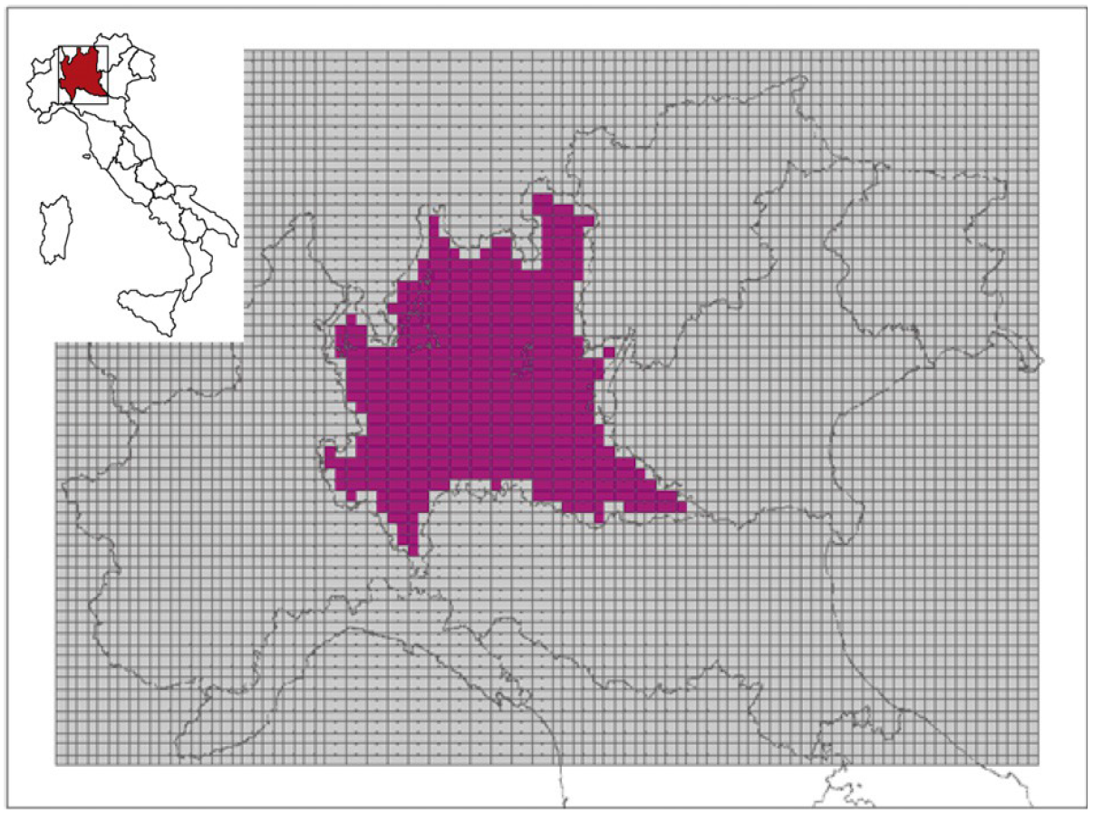
Figure 1: Application domain (Lombardy Region highlighted).

PM₁₀ precursor emissions E_{p} in each cell of the domain may be expressed as the product of several factors: a measure of the activity a (A_{ia}) in each emission sector i, times the emission factor for the precursor p from the activity a; this could represent a virtual uncontrolled emission to which the emissions removed by the application of a technology must be subtracted. These removed emissions are computed by multiplying the unabated emissions times the sum over all the set of technologies T_{a}, applicable to the activity a, of the application rate of a certain abatement technology (r_{t}), times the removal efficiency (eff_{pt}) of the technology t for the precursor p. Thus,
E_{p} = Σ_{ia}A_{ia}ef_{p,ia}(1-Σ_{Ta}r_{t}eff_{p,t})
The rate r_{t} of application of the technology t to a certain pollutant and emission activity is a decision (RESPONSE) while, in principle, all the other factors in the formula should be known data.
The analysis has been focused on the impact of uncertainty on the values of activities in the best alternatives to obtain a PM₁₀ reduction. A total of 50 perturbations were created by varying the activity levels between 95% and 105% of nominal ones (representing the actual values in 2011). Then an optimization has been performed (i.e. the determination of the best abatement technologies) for each of these 50 conditions.
The optimization procedure applied in this case study is based on a Cost-Effectiveness approach (CEA). This means that a figure of merit representing an Air Quality Index (AQI) (yearly average PM₁₀ concentration over the domain, in the present case) is minimized, with the constraint that the total implementation cost of the abatement measures is below an available budget. Three different cases have been analysed:
- Base-case: is the starting point for the comparison. It represents the adoption of technologies foreseen by Current LEgislation (CLE) for year 2020 (no optimization);
- 200M€: is the efficient solution that can be obtained with an overall implementation cost of 200M€/year;
- 400M€: is the efficient solution with a cost of 400M€/year.

Uncertainty analysis
Figure 2 shows the variations in the state (described by the AQI) due to activity level uncertainty. Central lines represent the mean values over the 50 scenarios of the AQI, the extremes of the surrounding rectangles identify twenty-fifth and seventy-fifth percentile, the two blacks whiskers extend from the 2nd to 98th, and the red crosses represent the value outside this range (outliers). The nominal case (the one with no perturbation of activity levels) is represented by green circles.
The effectiveness of the two efficient abatement strategies comes out evident. In both cases the extreme inferior whisker of CLE boxplot and the superior one of the optimized cases do not overlap at all. We can assume that the average yearly PM10 concentration over the domain is significantly decreased thanks to the selection of the most efficient abatement technologies, even if we take into account the uncertainty confidence intervals.
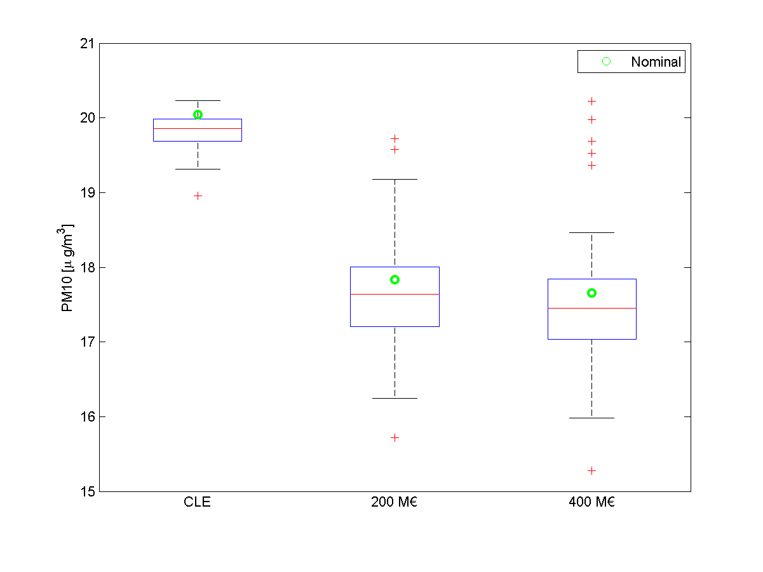
Figure 2. Uncertainty of average yearly PM10 concentrations for the Basecase and for two different Cost-Effectiveness optimizations (200 M€ and 400 M€) due to the variation of the activity levels.

Figure 3 presents the variations of abatement costs allocated to the different CORINAIR emission macro-sectors in the two performed optimization. The analysis shows how the increase in the allowable budget leads to an increasing of the spread (dimension of the blue boxes) related to its allocation, in particular in macro-sectors 1, 2, 6 and 10 (energy production, domestic heating, solvent use, agriculture).
Figures 2 and 3 indicate that the increasing of the available abatement cost provides a marginal improvement of air quality in terms of lower PM₁₀ concentration, but also increases the impact of uncertainty in the optimal cost allocation.

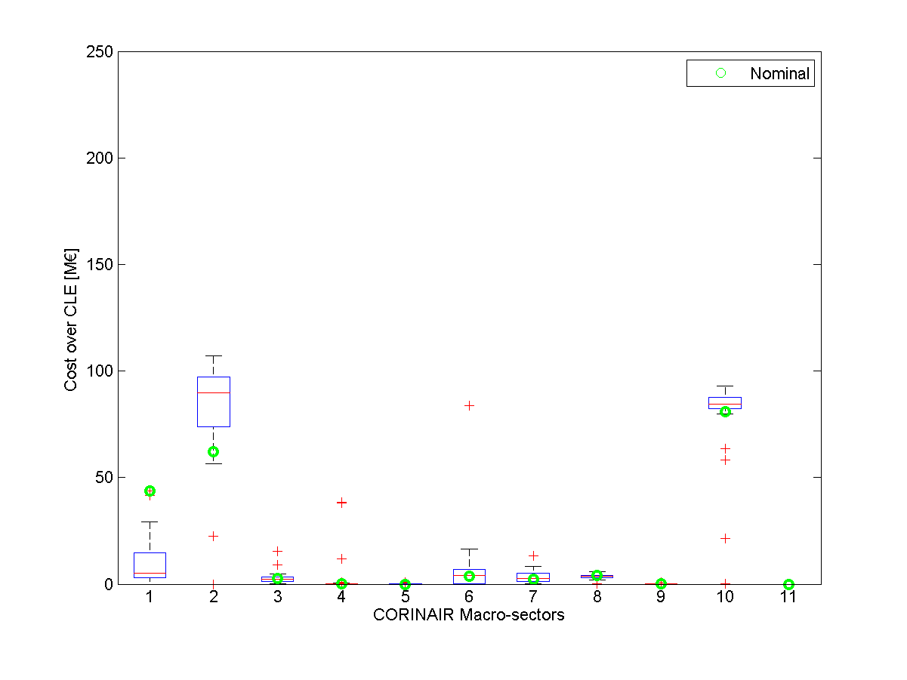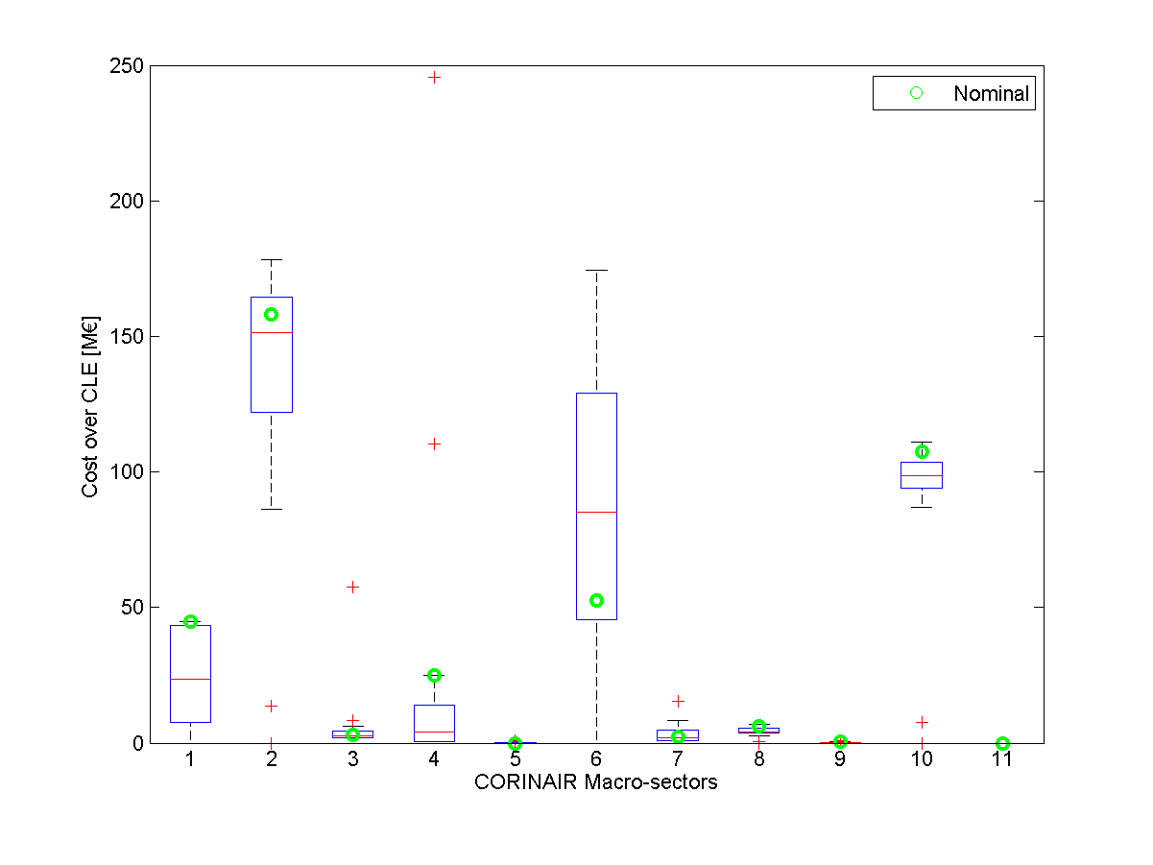
(b)
(a)
Figure 3. Boxplots showing the variation of the investment in the different CORINAIR Macro-sectors. Figure (a) is relative to a cost-effectiveness optimization with a 200M€/year cost, while Figure (b) is relative to 400M€/year,

Finally, Figure 4 analyses the application rates of the measures belonging to the CORINAIR macro-sectors for the optimization solutions (200 M€ and 400 M€ per year). For each measure, the difference of application rates between the maximum application over the 50 perturbations and the minimum has been computed, these differences have been clustered for the macro-sectors to which the measures belong.
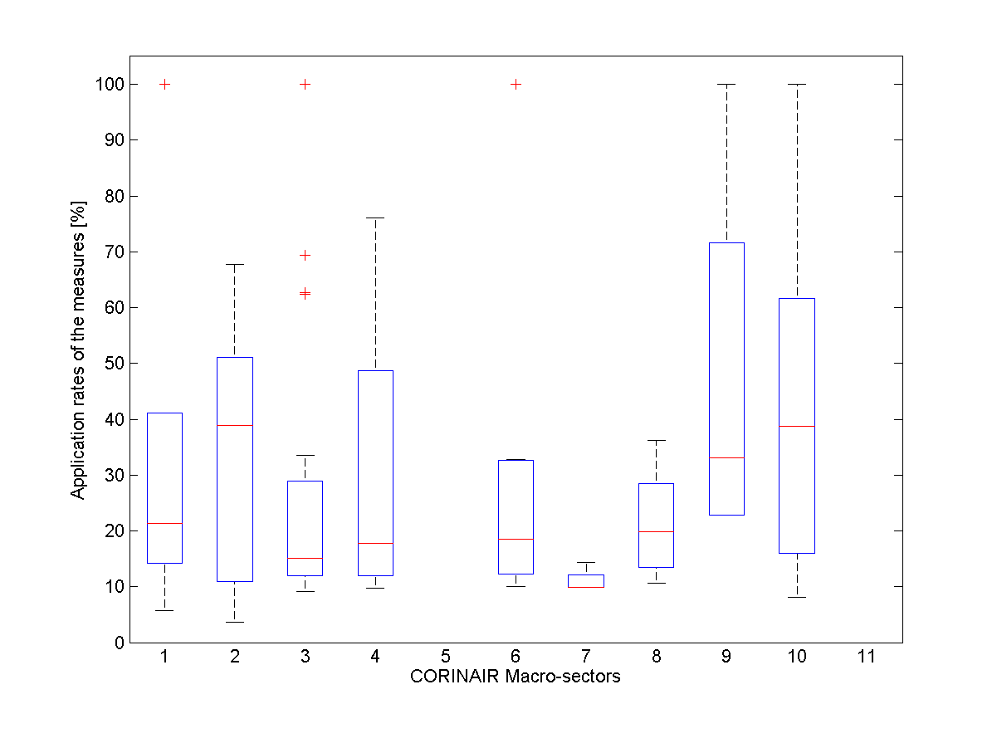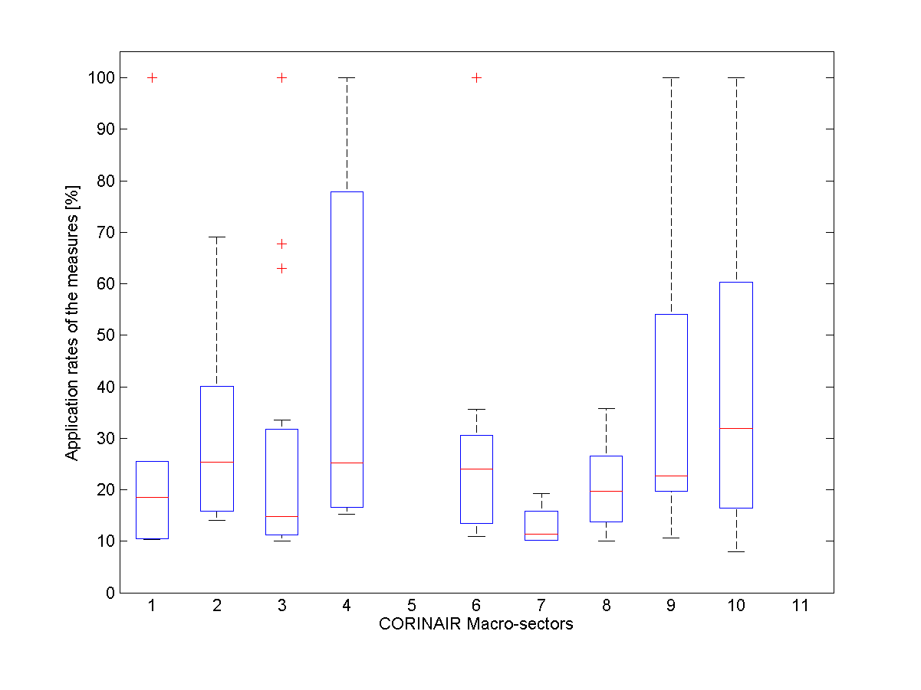
(a)
(b)
Figure 4. Differences between maximum and minimum application rate of the measures for each macro-sector in the solutions with annual cost 200 M€ (a) and 400 M€ (b).

Sensitivity analysis
The question the sensitivity analysis would now try to answer is which inputs are the main responsible for the decision variation.
In particular, in this study, the following Total Sensitivity Index is computed:
$$S_{T_{j}}=\frac{E(V(Y/H_{\sim j}))}{V(Y)}$$
Given all the possible input values H_{j}, the total index S_{Tj} is the average of the variance of the output Y when this is conditioned by all the possible input values with the exception of H_{j} . It accounts for the total contribution to the output variation due to factor H_{j} , i.e., its first-order effect plus all higher order effects due to interactions. A value of S_{Tj} close to 0 means that the variable H_{j} does not affect the output Y neither directly nor indirectly.
Due to the computational time by the analysis and the limited differences in terms of air quality for the two cases (Figure 2), the sensitivity analysis has been performed only for the 200M€/year case, comparing its results with that of CLE.
In particular, Figure 5 shows the S_{T} indexes for the impact of activity level variations in the different macro-sectors on PM10 yearly mean for CLE scenario and the Cost-effectiveness solutions with 200 M€ total cost. It is clear that variations on macro-sectors 5 (fossil fuels/geothermal energy) and 11 (natural emissions) do not affect the PM10 concentrations on the domain and that the PM10 concentration is much more sensitive to the input variation in the 200 M€ solution than in the evaluation of CLE scenario concentrations. This can be explained by the fact that, in the CLE case, the emission values are fixed by law, while in the CEA one both the emission scenario and the allocation of abatement rates over the sectors are the result of the optimization procedure.
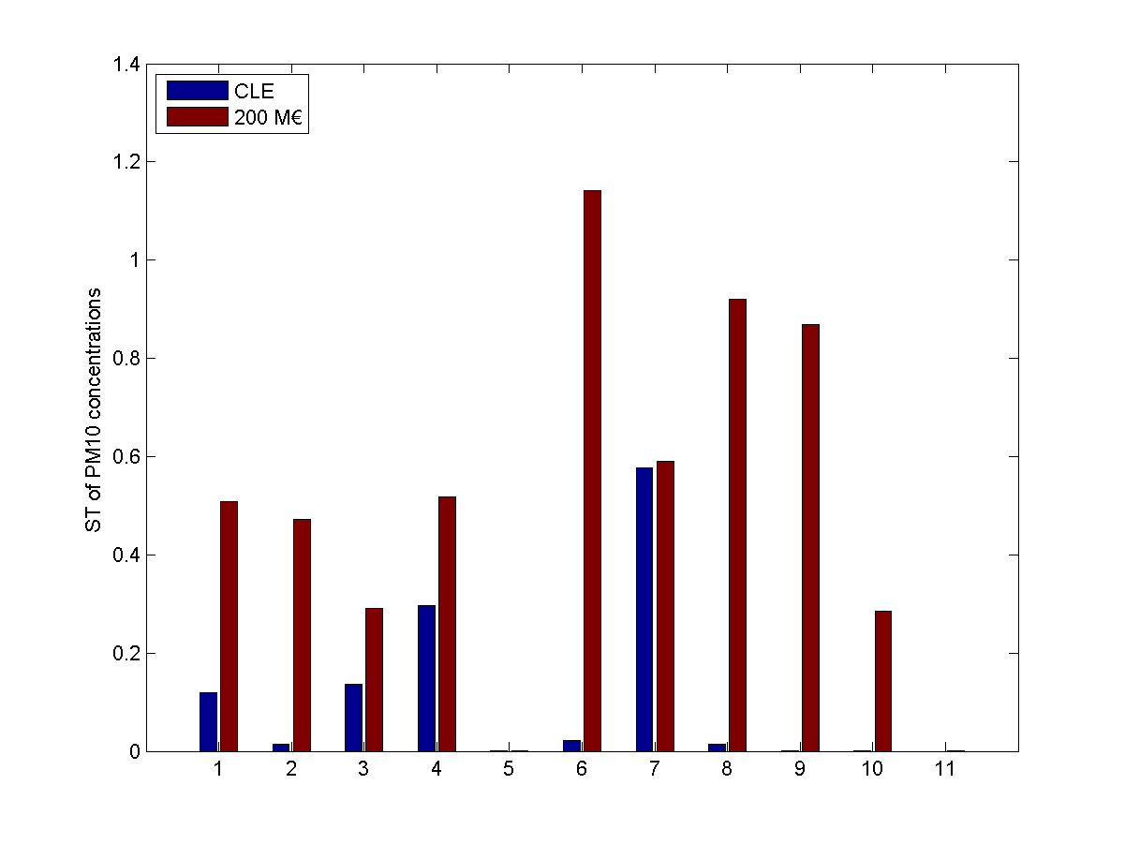
Figure 5: S_{T} indexes for the impact of Activity level variations in the different macro-sectors on PM10 yearly mean for CLE scenario and the Cost-effectiveness solution with 200 M€/year cost.

Conclusions
Talking about robustness in IAMs requires new tools with respect to the traditional ones extensively discussed in scientific literature. The output of IAMs are plans for air quality improvement that (hopefully) will materialize in different conditions (e.g. in a changed climate or in different energy use scenarios) and will involve emission scenarios that are, by definition, different from those experienced in the past on which air pollution models have been developed and tested.
This makes mandatory the development of a new framework to perform and evaluate uncertainty and sensitivity analyses that we tried to outline in this paper by summarizing some of the key aspects of the problem and how they have been dealt with in the current literature.
The analysis of a real-world case shows indeed that the propagation of uncertainty through various blocks of an integrated model may increase the variance of the most efficient actions, and thus suggests the way future studies have to follow in order for IAMs to become a reliable tool in policy-making.

References
- Amann M. et al. (2011). Cost-effective control of air quality and greenhouse gases in Europe: Modeling and policy applications, Environmental Modelling & Software, 26, 1489-150.
- Baroni G., Carnevale C., Finzi G., Pisoni E., Turrini E. Volta M. (2013). Uncertainty analysis in air quality control systems. Proceeding of the Conference in Decision and Control 2013, 6792-6797.
- Boynard, A., Beekman, M., Foret, G., Ung, A., Szopa, S., Schmechtig, C., Coman, A. (2011). An ensemble assessment of regional ozone model uncertainty with an explicit error representation. Atmospheric Environment, 45:784-793.
- Butler, M.P., Reed P.M., Fisher-Vanden, K., Keller, K., Wagener, T. (2014). Identifying parametric controls and dependencies in integrated assessment model using global sensitivity analysis. Environmental Modelling and Software, 59:10-29.
- Cacuci, D. G. (1981). Sensitivity Theory for Nonlinear Systems. Part I and II. J. Math. Physics 22:2794.
- Campolongo, F., J. Cariboni, A. Saltelli (2007). An effective screening design for sensitivity analysis of large models. Environmental Modelling and Software 22:1509-1518.
- Carmichael G.R., Sandu A., Potra F. (1997). Sensitivity analysis for atmospheric chemistry models via automatic differentiation. Atmospheric Environment, 31:475-489.
- Carnevale, C., Finzi, G., Pisoni, E., Volta, M., Guariso, G., Gianfreda, R., Triacchini, G. (2012). An integrated assessment tool to define effective air quality policies at regional scale. Environmental Modelling and Software, 38:306–315.
- Carnevale, C., Finzi, G., Pederzoli, A., Turrini, E., Volta, M., Guariso, G., Perron, G. (2014). Exploring trade-offs between air pollutants through an Integrated Assessment Model. The Science of the Total Environment, 481:7–16.
- Chart-asa C., MacDonald Gibson J. (2015). Health impact assessment of traffic related air pollution at the urban project scale: influence of variability and uncertainty. Science of the Total Environment, 506, 409-421.
- Cheng H., Sandu A. (2009) Uncertainty quantification and apportionment in air quality models using the polynomial chaos methods. Environmental Modelling and Software, 24, 917-925.
- Crosetto M., Tarantola S. (2001) Uncertainty and sensitivity analysis: tools for GIS-based model implementation. International Geographic Information, 15, 415-437.
- Cukier R.I., Fortuin C.M. Shler K.E., Petschek A.G., Schibly J.H. (1973). Study of the sensitivity of coupled reaction systems to uncertainties in rate coefficients. Journal of Chemistry Physics, 59, 3873-3878.
- Downing, D. J., Gardner R.H., Hoffman F.O. (1985). An Examination of Response-Surface Methodologies for Uncertainty Analysis in Assessment Models. Technometrics 27, 151-163.
- EPA (2009). Guidance on the development, evaluation, and application of environmental models. Technical report, Office of the Science Advisor, Council for Regulatory Environmental Modeling, March 2009.
- François, S. , Grondin, E., Fayet, S. and Ponche, J.-L. (2005), The establishment of the atmospheric emission inventories of the ESCOMPTE program, Atmos Res 74, 5-35.
- Freeman, D.L., Egami, R.T., Robinson, N.F., Watson, J.G. (1986), A Method for Propagating Measurement Uncertainties through Dispersion Models, J. Air Poll. Cont. Assoc. 36, 246–253.
- Fuentes M. (2009). Statistical issues in health impact assessment at the state and local levels, Air Qual Atmos Health, 2(1): 47–55.
- Gao D., Stockwell W.R., Milford J.B. (1996). Global uncertainty analysis of a regional-scale gas-phase chemistry mechanism. Journal of Geophysical Research, 101, 9107-9119.
- Hakami A., Odman M.T., Russel A.G. (2003). High-order, direct sensitivity analysis of multidimensional air quality models. Environ Sci Technol, 37, 2442–2452.
- Hakami A., Odman M.T., Russell A.G. (2004). Nonlinearity in atmospheric response: a direct sensitivity analysis approach. J Geophys Res, 109.
- Hanna S.R., Lu Z., Frey H.C., Vukovich N.W.J., Arunachalam S., Fernau M., et al. (2001). Uncertainties in predicted ozone concentrations due to input uncertainties for the UAM-V photochemical grid model applied to the July 1995 OTAG domain, Atmos Environ, 35, 891–903
- Homma, T., Saltelli A. (1996). Importance measures in global sensitivity analysis of nonlinear models. Reliability Engineering and System Safety 52, 1–17.
- IPCC (2000). Good practice guidance and uncertainty management in National Greenhouse Gas Inventories, http://www.ipcc-nggip.iges.or.jp/public/gp/gpgaum.htm
- Irwin J.S., Rao S.T., Petersen W.B., Turner D.B. (1987). Relating Error Bounds for Maximum Concentration Estimates to Diffusion Meteorology Uncertainty, Atmos. Environ., 21, 1927–1937.
- Isukapalli S.S., Roy A., Georgeopoulos, P.G. (1998). Stochastic Response Surface Methods (SRSMs) for Uncertainty Characterization and Propagation: Application to Environmental and Biological Systems, Risk Analysis, 18, 351–363.
- Kioutsioukis, I. Tarantola, S:, Saltelli, A. (2004) Uncertainty and global sensitivity analysis of road transport emission estimates. Atmospheric Environment 38:6609-6620.
- Kouridis, C., Gkatzoflias D., Kioutsioukis I., Ntziachristos L., Pastorello C., Dilara P. (2010). Uncertainty Estimates and Guidance for Road Transport Emission Calculations, JRC Scientific and Technical Reports, EUR 24296 EN.
- Krzyzanowski M., Cohen A., Anderson R. and the WHO Working Group (2002). Quantification of health effects of exposure to air pollution, Occupational & Environmental Medicine, 59:791-793.
- Künzli N., Kaiser R., Medina S., Studnicka M., Chanel O., Filliger P., Herry M., Horak Jr F., Puybonnieux-Texier V., Quénel P., Schneider J., Seethaler R., Vergnaud J.-C., Sommer H. (2000). Public-health impact of outdoor and traffic-related air pollution: a European assessment, THE LANCET, 356:795-801.
- Martien P., Harley R., Cacuci D. (2006). Adjoint sensitivity analysis for a threedimensional photochemical model: implementation and method comparison. Environ Sci Technol, 40:2663–70.
- Martuzzi M., Krzyzanowski M. and Bertollini R. (2003). Health impact assessment of air pollution: providing further evidence for public health action, European Respiratory Journal, 21: 86–91.
- Menut L., Vautard R., Beekmann M., Honoré C. (2000). Sensitivity of photochemical pollution using the adjoint of a simpli_ed chemistry-transport model. Journal of Geophysical Research, 105,15379-15402.
- Martz, H. F., Waller R.A. (1982). Bayesian Reliability Analysis. John Wiley & Sons, New York.
- Morgan, M. G., Henrion M. (1990). Uncertainty, A Guide to Dealing with Uncertainty in Quantitative Risk and Policy Analysis. Cambridge University Press, New York.
- Morokoff W.J., Caflisch R.E. (1996). Quasi-Monte Carlo integration, J. Comput. Phys. 122, 218--230.
- Morris, M. D. (1991). Factorial sampling plans for preliminary computational experiments. Technometrics, 33, 161–174.
- O’Hagan A., Buck C.E., Daneshkhah A., Eiser J.R., Garthwaite P.H., Jenkinson D.J., Oakley J.E., Rakow T. (2006). Uncertain Judgements: Eliciting Experts' Probabilities. Wiley.
- Oxley, T., ApSimon, H.M. (2007). Space, time and nesting Integrated Assessment Models. Environmental Modelling and Software, 22:1732-1749.
- Pisoni, E., Carnevale, C., Volta, M. (2010) Sensitivity to spatial resolution of modelling systems designing air quality control policies. Environmental Modelling and Software, 25:66-73.
- Ponche J.-L. (2002). The spatialized emission inventories: a tool for the Air Quality Management French IGPB-WCRP News Letters (in French).
- Rabitz, H. (1989). System analysis at molecular scale. Science, 246, 221–226.
- Ravalico, J.K., Maier, H.R., Dandy, G.C. (2009) Sensitivity analysis for decision-making using the MORE method – A Pareto approach. Reliability Engineering and System Safety, 94:1229-1237.
- Rios-Insua D., French S. (1991). A framework for sensitivity analysis in discrete multi-objective decision-making. European Journal of Operational Research, 54,176-190.
- Rubinstein, R. Y. (1981). Simulation and the Monte Carlo Method. Wiley, New York.
- Saltelli, A., Chan K. and M. Scott M. (2000). Sensitivity Analysis. Wiley Series in Probability and Statistics. New York: John Wiley & Sons, Ltd.
- Saltelli A. (2002), “Making best use of model evaluations to compute sensitivity indices.” Computer Physics Communications, vol. 145, pp. 280– 297.
- Scavia, D., Powers W.F., Canale R.P., Moody J.L. (1981). Comparison of First-Order Error Analysis and Monte Carlo Simulation in Time-Dependent Lake Eutrophication Models. Water Resources Research 17, 1051-1059.
- Seigneur C., Tesche T.W., Roth P.M., Reid L.E. (1981). Sensitivity of a complex urban air quality model to input data. Journal of Applied Meteorology, 20, 1020-1040.
- Sobol I. M. (1993). Sensitivity analysis for non-linear mathematical models. Mathematical Modelling and Computational Experiment 1, 407–414. English translation of Russian original paper Sobol’ (1990).
- Sobol I. M. (2001), “Global sensitivity indices for nonlinear mathematical models and their Monte Carlo estimates,” Mathematics and Computers in Simulation, vol. 55, no. 1-3, pp. 271 – 280.
- Tatang M.A., Pan W., Prinn R.G., McRae G.J., 1997. An efficient method for parametric uncertainty analysis of numerical geophysical models. Journal of Geophysical Research, 102, 21925-21932.
- Thunis P. et al., (2012). A tool to evaluate air quality model performances in regulatory applications, Environmental Modelling & Software, 38, 220–230.
- Thunis et al. (2015). Dynamic evaluation of air quality models over European regions, Atmospheric Environment, 111, 185-194
- Turanyi, T. (1990). Sensitivity analysis of complex kinetic systems. Tools and applications. Journal of Mathematical Chemistry, 5, 203–248.
- Uliasz M. (1988). Application of the FAST Method to Analyze the Sensitivity–Uncertainty of a Lagrangian Model of Sulphur Transport in Europe, Water, Air and Soil Pollution, 40, 33–49.
- UNECE (2002). Progress Report Prepared by the Chairman of the Task Force on Integrated Assessment Modelling, United Nations Economic Commission for Europe, Geneva, Switzerland.
- Uusitalo L., Lehikoinen A., Helle I., Myrberg K. (2015). An overview of methods to evaluate uncertainty of deterministic model in decision support, Environmental Modelling and Software, 63, 24-31.
- Varma, A., M. Morbidelli M., and H. Wu H. (1999). Parametric Sensitivity in Chemical Systems. Cambridge University Press.

- Vlachokostas, Ch., Achillas, Ch., Moussiopoulos, ., Hourdakis, E., Tsilingiridis, G., Ntziachristos, L., Banias, G., Stavrakakis, N., Sidiropoulos, C. (2009). Decision support system for the evaluation of urban air pollution control options: Application for particulate pollution in Thessaloniki, Greece. Science of the Total Environment, 407 (23), pp. 5937-5948.
- Vlachokostas, Ch., Michailidou, A.V., Spyridi, D., Moussiopoulos, N. (2013). Bridging the gap between traffic generated health stressors in urban areas: Predicting xylene levels in EU cities. Environmental Pollution, 180, pp. 251-258.
- Volta, M., Guariso, G., Maione, M. (submitted). A decision framework for Integrated Assessment Modelling at regional and local scale. Environmental Science & Policy.
- Worley, B. A. (1987). Deterministic Uncertainty Analysis. ORNL-6428. Oak Ridge National Laboratory, Oak Ridge, Tennessee.
- Yang Y-J., Wilkinson J.G., Russell A.G. (1997). Fast, direct analysis of multidimensional photochemical models. Environmental Science and Technology, 31, 2859-2868.
- Zabkar R., Koracin D., Rakovec J. (2013). A WRF/Chem sensitivity study using ensemble modelling for a high ozone episode in Slovenia and the Northern Adriatic area. Atmospheric Environment 77:990-1004.

