A Decision framework for Integrated Assessment Modelling of air quality at regional and local scale
G. Guariso (Politecnico di Milano, IT), M. Maione (University of Urbino, IT), M. Volta (DIMI, University of Brescia, IT)

ABSTRACT
Decision making in the field of air quality and greenhouses gases reductions can nowadays be supported by a clear overall framework and by computer tools that integrate the most relevant aspects of the problem. This approach is particularly important at local scale since new general rules on emission abatement at European level can only marginally modify the most critical hotspots and may be very costly. This paper adapts the general Drivers, Pressures, State, Impacts, Responses (DPSIR) scheme proposed by the European Environment Agency to the specific case of local air quality policies and shows how the most recent scientific developments in impacts evaluation and social acceptance can be integrated. The proposed decision framework represents a general methodology to design Integrated Assessment Modelling (IAM) systems aimed at the implementation of effective Air Quality Plans (AQP). An extensive survey in several European countries shows the current degree of adoption of these approaches.

KEYWORDS: air quality planning; policy design; cost-benefit integration; European IAM database

INTRODUCTION
Recent studies on compliance with the Ambient Air Quality Directive 2008/50/EC (EU, 2008) suggest that, despite a general improvement expected for the next decade, some urban areas and some regions will still struggle with severe air quality (AQ) problems and related health effects in the next two decades (e.g. Amann, 2014; EC, 2013). These areas are often characterized by specific environmental and anthropogenic factors and will require ad hoc additional local actions to complement medium and long term national and EU-wide strategies to reach EU air quality objectives. At the same time, these urban areas are among the territories where most energy is consumed and most greenhouse gases (GHGs) are emitted. Recent reports on the review of the Thematic Strategy on Air Pollution (Amann et al., 2013; Keiswetter et al., 2013) show the evolution trend of compliance from the base year 2010 to 2025 (assuming current legislation only), the improvement for the optimised A5 so-called ‘Central Policy Scenario’ by 2025 and the further compliance achieved in 2030, by implementing all technical measures (Maximum Technically Feasible Reductions, MTFR). The assessment of compliance of the daily PM10 exceedances limit value with respect to the current Ambient Air Quality Directive is shown in Figure 1.

Some important observations can be derived from these figures:
- Comparing the 2010 map with the 2025 CLE case, it clearly appears the move away from a general picture of non-compliance (2010) to few limited remaining areas of non-compliance. European wide measures (already mandated) will determine a significant improvement in compliance especially in the EU-15 Member States. What is also clear by comparing the 2025 CLE with the 2025 A5 (defined as ‘central policy scenario’) is the limited potential of further EU-wide measures to improve compliance; this is further underlined by comparing the 2025 A5 scenario with the 2030 MTFR scenario.
- Introducing tougher European-wide measures to address residual non-compliance confined to 10% of the urban zones in Europe (the extent of NO₂ non-compliance according to IIASA in the 2025 CLE scenario) would likely be significantly more costly than directly addressing the non-compliance areas with specifically designed measures based on bottom-up Integrated Assessment (IA) using regional/local data. This has significant implications for the role of regional/local ‘bottom-up’ approaches to develop effective and efficient Air Quality Management Plans.
- In this regard, regional IA tools such as RIAT (Carnevale et al., 2012), LEAQ (Zachary et al., 2011), etc. with their ability to identify cost-optimised local strategies are already available to quantify the cost-effective split between further European wide measures and regional/local measures. They will inevitably find wider application and play an increasing role in these emerging ‘discrete islands of non-compliance’.
- A further observation comes from comparing the 2025 CLE case with the 2025 A5 scenario. A5 is a highly ambitious scenario (delivering 75% of the further health benefits of MTFR for the EU as a whole). At this high level, a number of Member States are already forced to deploy all available pollution abatement measures (i.e. MTFR). Yet, from an AQ compliance perspective, this does not substantially change the picture from 2025 CLE. This points again to the key role of local targeted technical and non-technical measures in order to achieve compliance. As already noted, such measures (low emission zones, special fuels for captive fleets, captive fleet retrofitting etc.) can only be appropriately designed using ‘bottom-up’ tools.

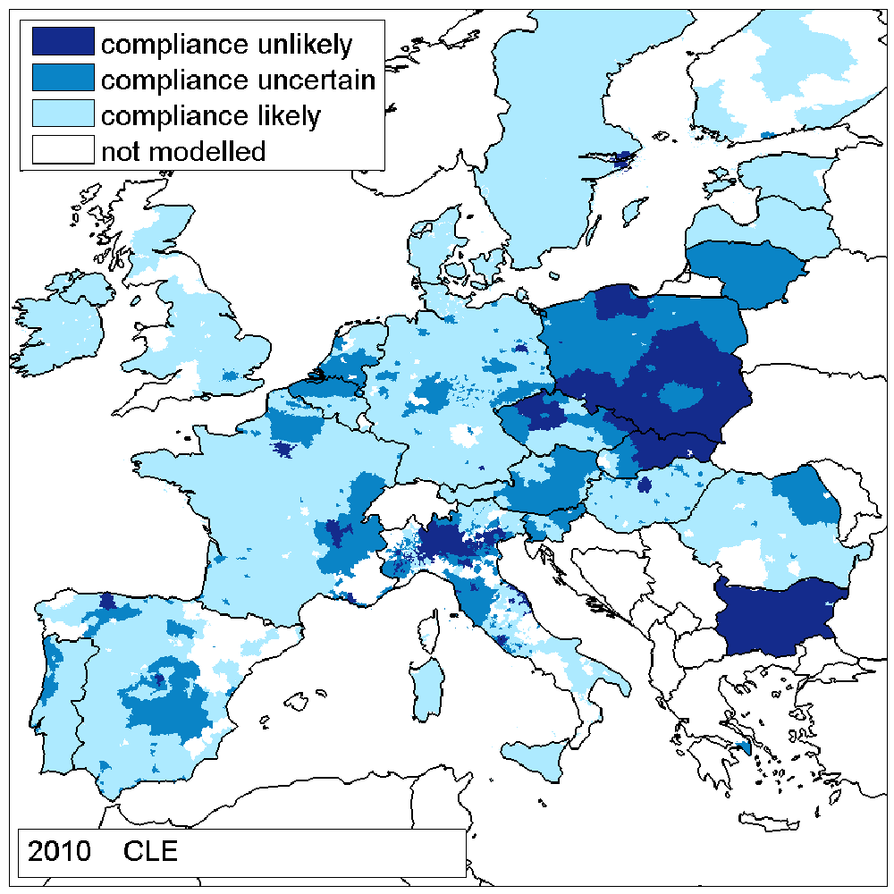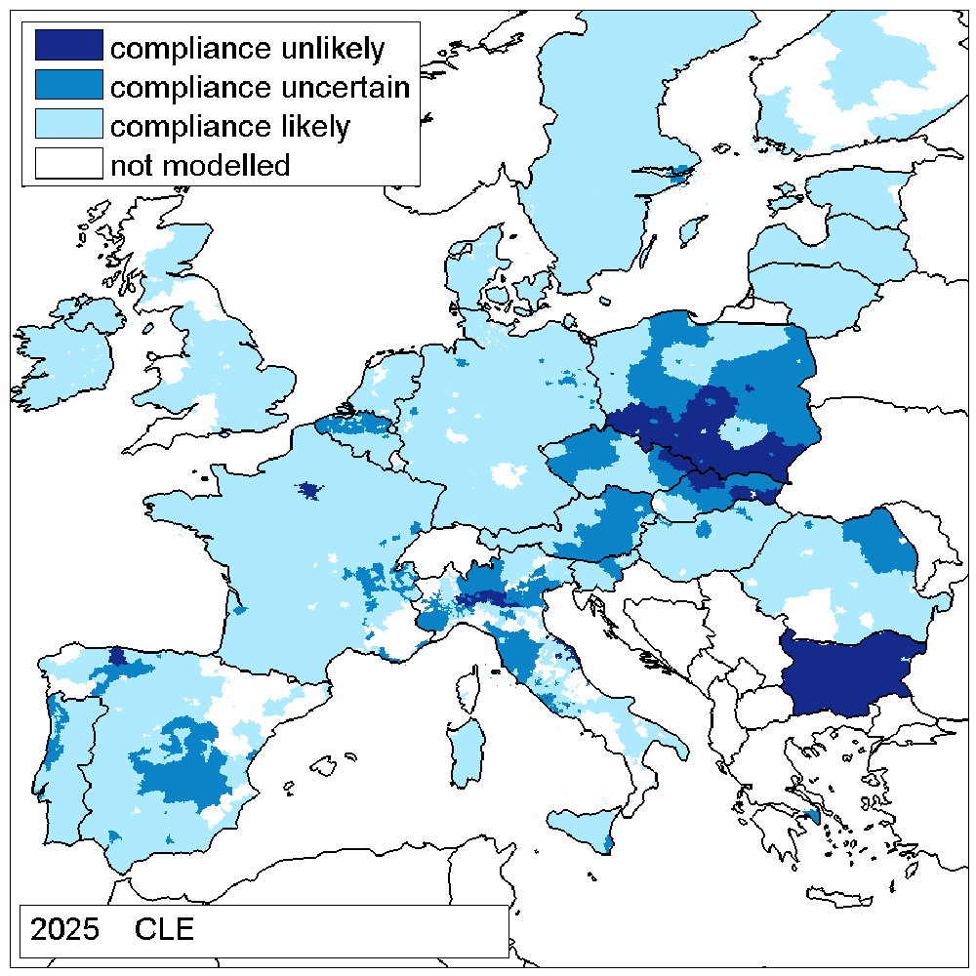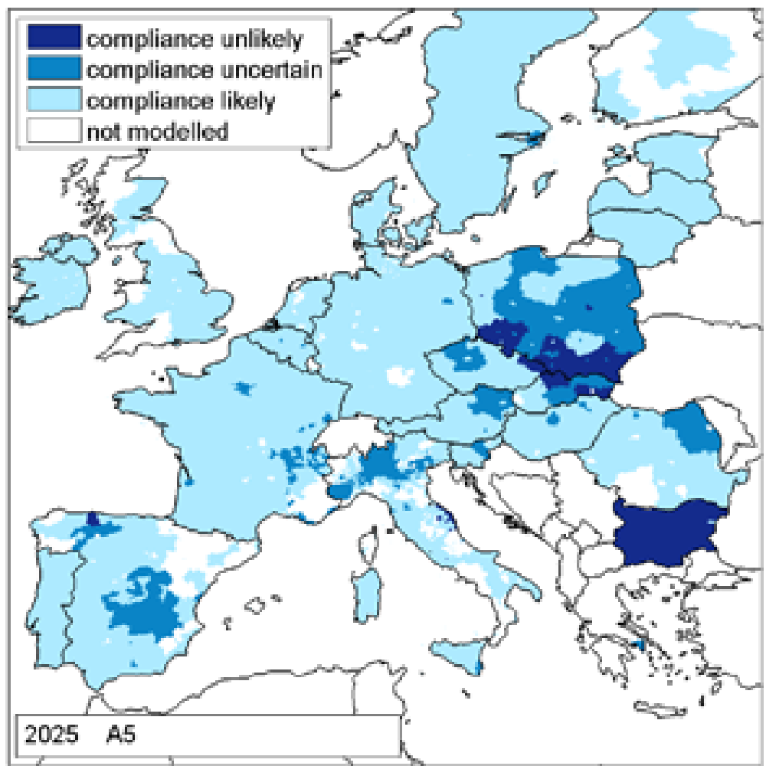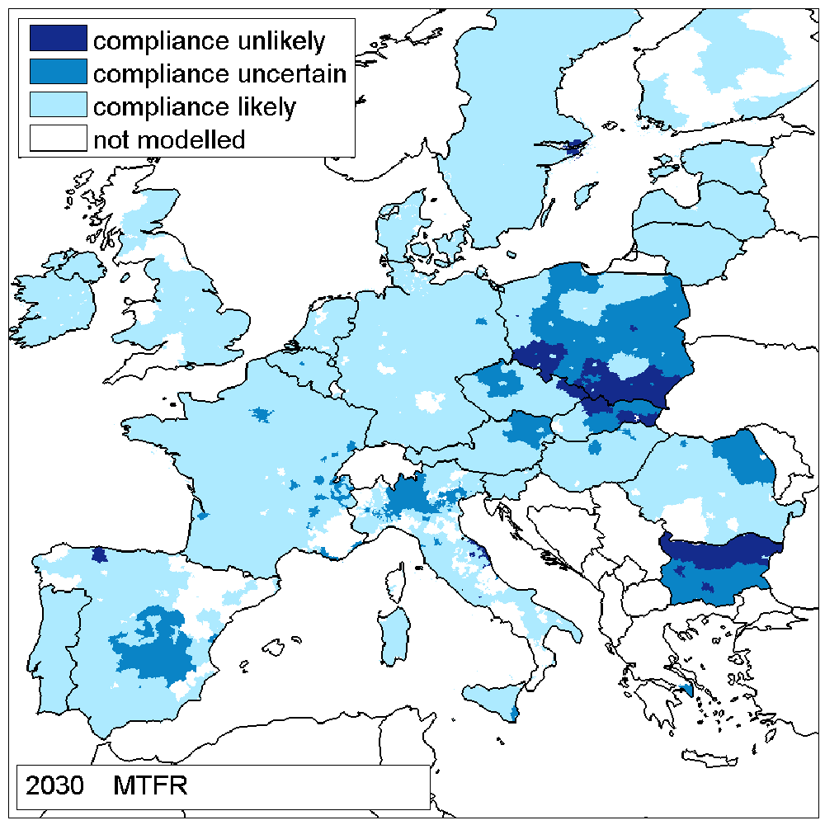
Figure 1. PM10 compliance assessment via GAINS 2013 (Source: Amann, 2014).
These observations motivate the growing interest in IA models and tools for local and regional scale.
Indeed, since the preparatory work of the 2008 EU Air Quality Directive (AQD), new emphasis has been placed on the use of numerical models to evaluate and forecast air quality conditions (e.g. Marécal et al, 2015; Cuvelier et al., 2007; Monteiro et al., 2007; Vautard et al., 2007). Many different models have thus been developed at European, regional and local scales and are already in use. They cover different aspects of air quality control, like emission estimates, short-term air pollution forecast, measurement network assessment and the simulation of the effects of alternative emission reduction scenarios. They often use different databases and assumptions so that it is sometimes difficult to compare and integrate their results. The AQD requires that Member States design comprehensive air quality plans for areas which do not comply with limit values and that they assess possible emission reduction measures to improve concentration levels (Kiesewetter et al., 2015; Vlachokostas et al., 2011) taking into account also the National Emission Ceiling Directive (NECD) (Coll et al., 2009). The necessary emission reductions need to be distributed in a cost effective way throughout the territory and the different sectors of activity (e.g. transport, industry, energy, agriculture) (e.g. Carnevale et al., 2014 for a European case; Fann et al., 2013, for a U.S. study). This has boosted the development of integrated models where air quality and carbon emissions are evaluated in conjunction with the costs of implementing emission abatement measures as well as external costs related to human health (e.g. Lefebvre et al., 2013; Carnevale et al., 2012).
Finally, the development and the successful application of such integrated models rely more and more on considerations about the development of local energy production and use, to which both the emissions of traditional air pollutants and of GHGs are strongly related. Bollen and Brink (2014) have recently demonstrated that the achievement of EU air pollution targets for the year 2020 will depend on classical end-of-pipe measures for at most two thirds. Thus, at least one additional third of the required emission reduction should come from changes in the use of energy through efficiency improvements, fuel switching and other structural and behavioural changes, and in the longer term, if 2050 goals for GHGs are to be achieved, even more fundamental changes will be required.
The latest generation of integrated air quality models comprises an evaluation of GHG emissions, even if more detailed feedbacks between aerosols and climatic effects and possible joint reduction strategies are not yet fully considered. As shown by Shindell et al. (2012), the emissions reductions of short lived climate pollutants such as methane and black carbon would have important “win-win” benefits for near-term climate, human health and agriculture.
In the following, we will show how these recent advances in integrated assessment modelling (IAM) can be seen as part of a general decision making approach to environmental problems and we will concentrate on the structures and functionalities needed for policy formulation. Section 3 will illustrate how such decisions can nowadays be supported by accessible tools embedding current scientific findings in air quality evaluation, while section 4 will present a method to classify the degree of detail used by current IAM studies, and will adopt such a classification to analyse an extensive survey throughout EU member states .

2. THE FRAMEWORK STRUCTURE
The need to provide both a methodological support for the implementation of AQPs at regional/local scale, and a systematic framework for the analysis and evaluation of current European plans and projects, requires to define the IAM as a holistic scheme (Laniak et al., 2013), that should:
- Be structured in a modular way, with data flows connecting each framework building block;
- Be interconnected to higher decision levels (i.e. national and European scales);
- Consider the approaches available to evaluate IAM variability (taking into account both the concept of “uncertainty”, that is related to “variables/model results” that can be compared with real data, and the concept of “indefiniteness”, related to the impacts of future policy decisions)
- Be sufficiently general to include the current experiences/approaches, and,
- Show, for each module of the framework, different “levels of implementation detail”.

The last two points are quite important. The idea is that one should be able to grasp in which “direction” to move to improve the quality of his own IAM implementation. This should translate into the possibility to assess the pros and cons for enhancing the level of detail of the description of each block in a given IAM implementation, and thus compare possible improvement with the related effort. The final idea is to be able to classify existing European plans and projects, with the aim not to provide an assessment value of the plans themselves, but to show possible “directions” of improvement, for each building block of each plan.

The APPRAISAL project (www.appraisal-fp7.eu) proposes to map the key elements of an IAM approach in the general DPSIR scheme adopted by the European Environment Agency (EEA, 2012). This choice represents a link between the scientific knowledge and methods and the need of decision makers to report to EEA the air quality state and the plans they are going to implement.
The DPSIR analytical concept (Figure 2) is the causal framework for describing the interactions between society and environment. As underlined by Hamilton et al. (2015), this is only a portion, even if possibly the most relevant, of the overall IA approach. An initial scoping phase, and a final one of outcome communication are also important and may critically impact the results of a study. The building blocks of the DPSIR scheme are:
- DRIVERS,
- PRESSURES,
- STATE,
- IMPACTS,
- RESPONSES,
and represent an extension of the PSR model originally developed by the Organisation for Economic Co-operation and Development (OECD) (definitions from EEA glossary, available at http://glossary.eea.europa.eu).
The DPSIR scheme helps “to structure thinking about the interplay between the environment and socioeconomic activities”, and “support in designing assessments, identifying indicators, and communicating results” (EEA, 1999). It does not focus on a specific modelling approach, that must be selected looking at the specific features of the assessment being performed (Kelly et al., 2013). Conversely, EEA proposed a set of indicators, that helps to reduce efforts for collecting data and information by focusing on a few elements, and to make data comparable between institutions and countries.
In particular, addressing air quality problems, the meaning of each block may be specified as follows (quotes are again from EEA glossary):
- DRIVERS: this block describes the “actions resulting from or influenced by human/natural activities or interventions” mainly intended to meet the social and individual needs. Here we refer to variables (often called “activity levels”) describing, for instance, traffic, industries, residential heating and food production. Natural phenomena like a changing solar radiation or the diffusion of volcanic dust may also be thought as part of this block.
- PRESSURES (Emissions): this block describes the “discharge of pollutants into the atmosphere from stationary sources such as smokestacks, and from surface areas of commercial or industrial facilities and mobile sources, for example, motor vehicles, locomotives and aircrafts.” PRESSURES depend on DRIVERS, and are computed as function of the activity levels and the quantity of pollutant emitted per activity unit.
- STATE (Air quality): this block describes the “condition of different environmental compartments and systems“. Here, we refer to STATE as the concentrations of air pollutants resulting from the PRESSURES defined in the previous block. In IAM implementations, STATE can sometimes be directly measured, but more often it is computed using some kind of air quality model.
- IMPACTS: this block describes “any alteration of environmental conditions or creation of a new set of environmental conditions, adverse or beneficial, caused or induced by an action or set of actions under consideration”. In the proposed framework, we refer to IMPACTS on human health, vegetation, ecosystem, derived by a modification of the STATE. Again the calculation of the IMPACTS may be based on some measure, but normally requires a set of models.

There is however a substantial difference among the blocks composing the scheme. Besides the RESPONSES block related to decisions aimed at improving air quality and decreasing the carbon footprint, the DRIVERS and STATE blocks (as suggested by the last name) represent dynamical systems, even if evolving at quite different speed. The DRIVERS block represents the (slow) evolution of the society and of the economic system under new regulations, high level agreements, citizens involvement and learning ($u_{d}\left(t\right)$) as well as external conditions like climate changes or fossil fuel prices $\left(v_{d}\left(t\right)\right)$. The STATE block represents instead the evolution of the atmospheric system influenced by anthropogenic emissions $\left(E\left(t\right)\right)$ and by natural factors such as meteorology or natural emissions. The PRESSURES and IMPACTS blocks, on the contrary, are non-dynamical. They are simply a transformation of their inputs, activities $\left(A\left(t\right)\right)$ and concentrations $\left(x\left(t\right)\right)$, respectively) into outputs that can be subsequently used further down the scheme. Indeed, the emissions are simply a product of the activities by their respective emission factors, while the overall impacts are described by static functions of the concentration (e.g. a dose-response function for the impact on human health). This does not mean that decisions cannot influence them. Decisions on the adoption of certain (cleaner) technologies can in fact modify the emission factor of a given activity $\left(u_{p}\left(t\right)\right)$, with the effect of reducing the PRESSURES without modifying the DRIVERS. In quite the same way, all decision aimed at modifying, for instance, the exposition of the human population to bad air quality air, may modify the IMPACTS without changing the STATE$\left(u_{i}\left(t\right)\right)$. All decisions improving the adaptation to climate changes or the resilience to extreme events are also in this category.

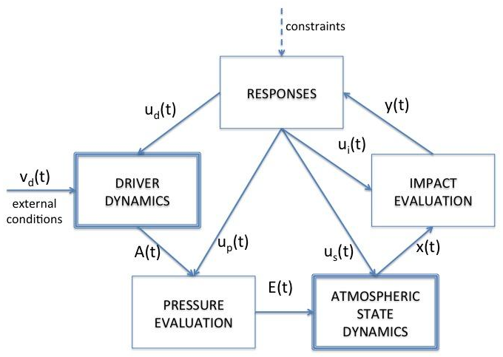
Figure 2. A view of the links and structures of the blocks in the DPSIR scheme

Given these characteristics of the DPSIR blocks, one can immediately realize that decisions (RESPONSES) aimed at modifying the drivers require a long time before having some measurable effects, while decisions on PRESSURES, STATE, and IMPACTS may be considered also in a short or medium-term perspective. At the same time, if one decides to concentrate on rapid deployment, activities (i.e. the output of the driver block) can be mostly considered as fixed, while the possibility of direct intervention $\left(u_{s}\left(t\right)\right)$ on the concentration (e.g. absorbing paintings or coatings) are extremely limited. This explains why most of the recent scientific literature and most actual air quality and low carbon plans are devoted to the implementation of technical measures (pressures changes) in the hope to devise actions that may provide perceivable reductions of the impacts in the short run (few years).

2.1 Modelling the policy response
The RESPONSES block deserves a deeper analysis since it represents the core of the decision process, that is to say the set of techniques/approaches used to take decisions on activity changes, on emission reduction measures, on direct concentration reductions, or on impact attenuation.
First, one has to clarify the type and limits of the possible actions. These include all the measures that can be applied by the regional/local Authority on a specific territory. They can be constituted by:
Efficiency measures $\left(u_{d}\left(t\right)\right)$, (often called “non-technical measures”) that change activity (DRIVERS) levels, (e.g. acting on people's behaviour, impose changes of buildings to improve efficiency, moving good transport to rail, etc...). Also localization decisions (e.g. moving activities to different areas) can be considered part of these efficiency measures.
End-of-pipe measures $\left(u_{p}\left(t\right)\right)$ applied to reduce emissions at the “pipe” of an emitting activity, i.e. modifying the PRESSURE values without changing the correspondent activity. Such measures include also primary and/or fugitive pollutants control measures.
Direct pollution reduction measures $\left(u_{s}\left(t\right)\right)$. These act directly on STATE to reduce the pollution already in the environment. Planting some species of PM absorbing trees in urban environments or using coatings photocatalytically decomposing nitrogen oxides belong to these types of measures.
Mitigation and compensation measures (u_{i}(t)) aimed at reducing the IMPACTS (e.g. air pollution warning systems) without changing the pollution concentration.

It must be noted that all these measures that can be taken by a governing agency may be implemented in a geographical area (a “policy domain” normally defined by some administrative boundary,) quite different from the physical domain determining the environmental conditions (e.g. decision taken by a regional authority on a portion of an air basin).
As stated in UNECE (2002), it is important that any decision approach focuses on robust strategies, that is to say on “policies that do not significantly change due to changes in the uncertain model elements”. This issue is linked to the need of defining a set of indexes and a methodology to measure the sensitivity of the decision problem solutions. It is in fact worth underlining that, while for air quality models the sensitivity can be measured by referring in one way or the other to field data (Thunis et al., 2012), for IAMs this is not possible, since an absolute “optimal” policy is not known and most of the times does not even exist. The traditional concept of model accuracy must thus be replaced by notions such as risk of a certain decision or regret of choosing one policy instead of another.
Two other relevant characteristics of the RESPONSES block require a further discussion. The first is the information on the basis of which decisions are taken. Though certainly such decisions are motivated by the perception of some negative impacts, from the implementation viewpoint the relevant information can be derived by any of the other blocks. A regional agency may decide to act simply on the base of high measured traffic (and this produces emission that determine high concentrations with detrimental impacts, even if not directly measured); or based on too high monitored (or calculated) emissions from industrial plants; or based on the fact that measured concentrations exceed a safety threshold; or, finally, based on the increasing number of hospital admissions for respiratory problems. Each of these pieces of information has a different cost to be measured and may be interpreted in a specific way in determining the consequent actions. It is also obvious, that all these (and other) items could be measured at the same time (with a higher cost), and reach together the decision-maker, but the efficient exploitation of such information would require a (possibly very complex) system to process them.
Sometimes the information requirements of air quality plans are left undetermined, assuming that the required information will be available and could be effectively processed at (almost) no cost. This is definitely not the case in practice and, if EU has standardized and made mandatory some reporting about air quality state, there is no codified way of e.g. computing emissions, so that complete inventories are missing in some areas and are almost always incompatible across different regions and times.
The other relevant feature of the RESPONSES block is that it requires a formal definition of the objectives, that a Decision Maker would like to improve/optimize. “Improving air quality” cannot in fact be considered an objective from a formal point of view. A precise (quantitative, mathematical) representation of such objectives is needed. The EEA suggests a number of indicators that can be easily applied to a single measuring station (e.g. number of days in a year in which the daily average PM10 concentration exceeds a given threshold), but how these indicators can be extended to a region is still a matter of debate. For instance, one may tend to give more importance to areas where people leave with respect to open country. And most decision maker would say they are more interested in how much a certain action may cost to the society and what would be its (monetary) outcome, particularly because they have a limited budget (or they assume a limited burden can be borne by their community) but many conflicting objectives (e.g. related to various pollutants) to improve.
A common approach is thus to summarize all (or at least the most important) concerns into one Air Quality Index (AQI), formally defined, to be optimized. For instance, the original decision-maker’s problem could be translated into reaching a given level of an AQI at minimum cost, or to use a predefined budget to minimize an AQI.

2.2 The definition of the policy constraints
Regional and local authorities are also constrained by “higher levels” decisions, i.e. coming from national or EU scale. In practical terms, this means that regional scale policies need to consider the national/EU Current Legislation (CLE) as a starting point for their choices in the effort to “go beyond CLE”. This issue has to be considered for both Air Quality and Climate Change fields. In both cases, in fact, there are a lot of agreement/protocols that are in force, and that represent a minimum requirement for the regional actions. Other constraints are obviously due to budget availability and to the type of technologies or actions that can be implemented on the specific territory.
Altogether the number of alternative decisions to compose an air quality plan is extremely high and thus their selection can be supported by different approaches. It is interesting to note that, from the technical point of view, the overall problem can be solved only within an integrated assessment approach, namely by explicitly taking into account the (industrial and external) costs of the foreseen measures. Emissions are in fact always computed as the product of two factors: a measure of the activity level (DRIVERS) times an emission factor, i.e. the amount of pollutant emitted per unit activity. The activity level may be measured for instance, by the energy used in a certain industry or by the kilometres travelled by a certain car. The emission factor (e.g. grams of NOx emitted per kilometre) may or may not take into account the presence of specific end-of-pipe technology to reduce the emission (unabated or abated emission factor). Whatever the case, there are infinite combinations of activity levels and abatement technologies that give the same result in term of emission.
The costs of reducing a certain activity and those of adopting a certain technology are thus a first way to distinguish between different measures. However, in many cases, they are not sufficient to disentangle the ambiguity and another important criterion that can be applied in selecting a given measure is to assess to what extent it can be accepted by lay-citizens. Acceptability, defined as the way in which potential users will react and act if a certain measure is implemented (Vlassenroot et al., 2010), is a key element that can guarantee the success of a policy. So far, the fields in which the acceptability of policy instruments has been more extensively explored are the transport sector, where road pricing schemes has been assessed (Di Ciommo et al., 2013), and the energy sector, where the introduction of pollution-free power generation systems was evaluated (Soerensen et al., 2003).
Acceptability is crucial in the case of air quality policies, where behavioural-based measures are likely to play an increasingly important role. The SEFIRA FP7 project (www.sefira-project.eu), on the socio economic implication of individual responses to air pollution policies in EU, is, among others, aimed at assessing the acceptability of a set of air quality measures implying behavioural changes. To this purpose, it evaluated the potentiality of Discrete Choice Models (DCMs), a statistical techniques already used to model the way people choose between a set of alternatives (Bristow et al., 2010; Marcucci et al., 2012; Zhang et al., 2011).. DCMs help researchers in analysing and predicting how choices are influenced by personal characteristics and by available alternatives. The alternatives could be referred to different products, services, policies etc. Each alternative is described by a set of specific features, called attributes, which in turn are described by attributes-levels (Ben-Akiva and Lerman, 1985).However, so far they have never been applied in the field of air quality policies. In this case, determining individuals’ trade-offs between the various attributes-levels, the decision maker can elicit individual preferences for potential new policies, analysing their ex ante acceptability. In SEFIRA, an unlabelled alternative approach has been chosen, including in the choice experiments the description of a generic air quality policy with reference to the specific sectors of transport and food habits, being vehicular traffic and the agro-food sector among the main drivers of air quality degradation. Over a traditional questionnaire approach, DCMs present the advantages of stressing the trade-offs among different choice alternatives. In this way, the impacts of regional policies on local socio-economical systems is assessed as well as to what extent such impact is accepted by individuals. In addition, socio-economic data of respondents have been used to perform a segmentation analysis and highlighting socio-economic differences in the air quality acceptability across the various countries and according to the socio economic structure of the population. Thus, different environmental measures having the same impacts can be implemented according to an acceptability ranking and outputs. from DCMs may be used to build decision support systems (Hensher et al., 2005). Examples of smart user-friendly package created with Excel software are reported by Valeri (2013).

2.3 Integrating atmospheric science into the decision process
The design of policies for effectively reducing the impacts of degraded air quality on human health and ecosystems requires to be based on robust scientific findings, distilled in clear and incisive messages in which the uncertainty must be quantified so that the levels of confidence of further policy actions can be assessed. For this purpose, in the past few years the European research community has been involved in a thoughtful and comprehensive exercise of revision of the most recent literature on air quality and climate with a view to provide support to the European air quality policy making process (Maione and Fuzzi, 2013). In this process a leading role was taken by the EU FP7 coordination and support action ACCENT-Plus (Atmospheric Composition Change: the European Network. Policy Support and Science, www.accent-network.org), whose goal was answering the overarching question on how can Europe control the composition of its atmosphere under a changing climate. The messages provided by the science community, though not policy prescriptive by nature, are broad and consider effects on human health, ecosystems and climate. An emphasis has been given to the need of integrating air quality and climate issues, an integration that so far has not been fully adopted in the policy context. Ozone (Monks et al., 2015), particulate matter (Fuzzi et al., 2015) and the nitrogen cycle (Fowler et al., 2015) have been identified as the main topic of interest in this context, notably being involved in both air quality and climate.
To allow the integration of all these items in a usable and handy system, one of the key aspects of modern IAMs is that they allow the utilization of the results of a complex chemical and transport pollution model (CTMs) in a fast and simple way. The idea has evolved from the earlier approach developed for the RAINS (Schöpp et al., 1998) to the more modern one like RIAT+ (Carnevale et al., 2012). It is based on the substitution of the CTM with a simplified surrogate model that can reasonably replicate CTM results under limited spatial and temporal circumstances.
More in detail, this approach is represented in Figure 3, and requires, on the one side, the definition of a simple, but flexible mathematical structure for the surrogate model; on the other, a small number of runs of the complete model that may represent the consequences of the actions one is willing to test on a specific geographic domain.
Using the results of these runs and computing some suitable indicators of the local air quality (AQI), one can calibrate the parameters of the surrogate model in such a way that it approximates the known CTM results.
This procedure allows to effectively embed into the decision process of (an approximation of) the most accurate and up-to-date air quality modelling tools even if they are difficult to handle and heavily time-consuming.
Additionally, modern software packages implementing this approach, can support the decision makers by offering a full set of views on the problem, starting from suggested emissions in each domain cell, to allocation of cost to different measures and sector, to the external costs due to impacts on the population health and on ecosystems. This significantly changes the standard approach to decision support: till few years ago, to define an air quality plan, an environmental agency adds to devise very few reasonable scenarios and test them with a considerable time and budget effort. If the tested scenarios were, for some reason, not satisfactory, they had to go on with additional tests in search of an acceptable solution, without being able to answer questions like “how much do we have to invest to reach a given quality standard?” or “In which sector will our investments be more effective”? Now, the whole optimization problem can be implemented and solved on a standard pc in a limited time and so we can definitely say that the level of support provided to the decision maker by these systems has had a definite step forward. Indeed, despite execution speed and interactivity has been recognised since long ago as a key enabling feature of IAMs (van der Sluijs, 2002), only recently the increased computer power, on one side, and the availability of surrogate models, on the other, have made this possible. Applying for instance the RIAT+ package to draw the Pareto curve showing the efficient trade-offs between abatement costs and some aggregated air quality indicator over a region (Carnevale et al. 2014) takes few minutes on a standard pc. This means one can immediately get an idea of the optimal degree of adoption of different measures, of the geographical distribution of costs, impacts, and emissions corresponding to each assumed level of air quality. This, on the other side, means that the majority of time and effort goes into the activities on the left side of figure 3, i.e. the collection of local data and the development of correspondent surrogate models.

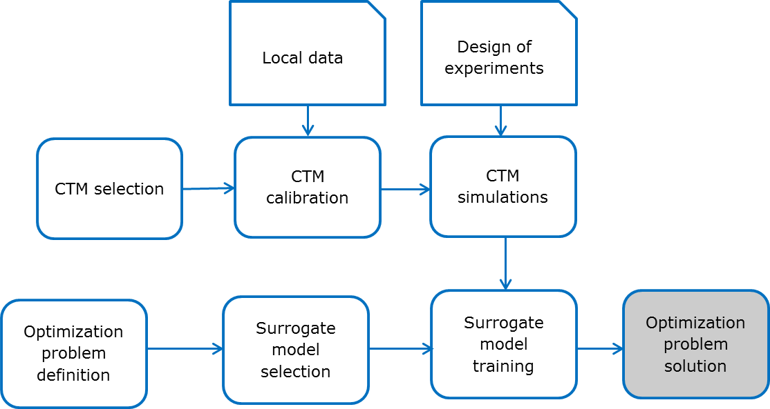
Figure 3. The procedure of surrogate model definition.

3. CLASSIFYING THE AQ PLANS in EUROPE

To understand the level of detail with which the components of the DPSIR scheme are dealt with in the current European practice, the EU APPRAISAL project collected information on the different methodologies used by the European Member States to define emission abatement policy options and measures (Thunis et al., 2016) . To collect these information in a common format, the analysis of the current practices was broken down into five topics which determined the structure of an on-line database: (i) synergies among national, regional and local approaches, including emission abatement policies; (ii) air quality assessment, including modelling and measurements; (iii) health impact assessment approaches; (iv) source apportionment; and (v) uncertainty and robustness, including Quality Assurance/Quality Control. Air quality experts and regional/local environmental agencies were invited to fill on-line the corresponding questionnaire, detailing the methodologies they use to build their AQP or research project. At the moment 59 questionnaires were completed, accurately checked and finally stored in the database. In particular, almost 60% were AQPs, 30% were research projects and 10% were others. Almost 60% concern the selection of abatement measures, more than 20% concern the assessment of air quality state and only 8% deal with health assessment. About the number of questionnaire completed in each country: only Germany exceeds 10, 9 questionnaires are from Portugal and UK, 8 for Belgium and all the other countries are below this value.
The questionnaire responses have been classified trying to evaluate the level of detail at which each block of the DPSIR scheme has been treated. Though this classification is qualitative and partially subjective, it may serve a double purpose: within each plan, it highlights where more work has been invested and where, on the contrary, less attention was given; in comparison with other plans, it may indicate how a certain aspect has been dealt with in similar cases.
Dealing with an aspect with a higher level of detail does not necessarily mean that the plan is more accurate or efficient in that field. Though the two things are hopefully correlated, there may be cases in which a more detailed approach was not supported by corresponding data or was not balanced with the corresponding costs or benefits. A further analysis would thus be necessary in the future to understand and estimate the actual outcome of the plans and not just how they approached the problem.

We may classify the definitions of the RESPONSES by three levels of detail:
1: Expert judgment and Scenario analysis: In this case the selection of measures to be adopted is based on expert opinion, with/without modelling support to test the consequences of a predefined emission reduction scenario. In this context, the costs of the emission reduction actions can be evaluated as an output of the procedure (even if in many cases they are not considered).
2: Source Apportionment and Scenario analysis: In this case, the most significant sources of emissions are derived through a formal approach; this then allows to select the measures that should be applied. Again, emission reduction costs, if any, are usually evaluated as a model output.
3: Optimization: In this case the whole decision framework is described through a mathematical approach (Carlson et al., 2004), and costs are usually taken into account. Different approaches (both in discrete and continuous setting) are available, as:
- Cost-benefit analysis: all costs (from emission reduction technologies to efficiency measures) and benefits (improvements of health or environmental quality conditions) associated to an emission scenario are evaluated in monetary terms and an algorithm searches for solutions that maximize the difference between benefits and costs among different scenarios.
- Cost-effectiveness analysis: due to the fact that quantifying benefits of nonmaterial issues is strongly affected by subjective evaluations, the cost-effectiveness approach is used to search for the best solutions considering non-monetizable issues (typically, health related matters) as constraints of a mathematical problem, the objective of which is simply the sum of (relevant) costs (Amann et al., 2011).
- Multi-objective analysis: it selects the efficient solutions, considering all the objectives of the problem explicitly in a vector objective function (e.g, one AQI and costs), thus determining the trade-offs and the possible conflicts among them (Guariso et al., 2004; Pisoni et al., 2009).

Following a similar definition, also the other blocks of the DPSIR scheme can be examined and classified according to the detail used for their description (see Table 1).

Table 1. Different levels of detail for the different DPSIR blocks.
DPSIR blocks | Levels of detail
DPSIR blocks | Low | Medium | High
DRIVERS and PRESSURES | Activity levels and emissions are estimated for the 11 macro-sectors (SNAP1 classification) at a low spatial resolution (e.g. national level), using by default a top-down methodology. Due to the limited detail in the sector contributions and spatial resolution, this level does not allow for detailed scenarios at a local scale. | Combination of bottom-up and top-down methodology is used (SNAP2 or SNAP3 classification).  Emission factors and activity data representative for the study area are used when available. | Emissions and activities are calculated with the finest space and time resolution required for the purpose of the IAM application, with a bottom-up approach and finest level classification at least for the significant emission sources for the area of interest.  Emission factors and activity data have to correspond to the specific activities (SNAP3 classifications) and fuels of the area under study. The processes have to be detailed attributing the most representative emissions. In case data are lacking, a top-down approach can be used but with the help of complementary data to take into account regional specificities.
STATE | The simplest way to characterize the AQ state is to use measurements taken routinely or during a measurement campaign and to interpolate them to a grid with a geo-statistic interpolation method to obtain a map of concentrations over the area of interest. Such an assessment of STATE does not require any input on emissions and activities. For IAM application, the difficulty is therefore to link these concentrations to emissions; that is, to estimate the contribution from identified sources to observed concentrations (source apportionment). | It is based on a characterization of the AQ state using one single deterministic model adapted to the studied spatial scale. This model should be validated over the studied area and should use emission input data adapted to this scale. | The AQ state is characterized using a chain of AQ and meteorological models, from large scale (Europe for example) to regional (country or regions) and urban/local scale (city) and street scale. The use of a downscaling model chain allows for taking into account the interactions between the various scales, such as the transport of pollutants at a large scale or interactions between mesoscale wind flows and local dynamics.  An operational model validation with observations is required.
IMPACTS  (Health) | It requires a coarse “exposure” estimate provided either by measurement or modelling (e.g. average mean annual exposure for a city), a dose-response function or concentration-response function and a simple population description. This results in a single number to roughly indicate the ‘average’ exposure for the considered territory (for example, a city or a country). | Similar to level 1, but with spatial detail in the STATE description, such that the variation in space of the AQ is taken into consideration. | It requires a detailed “exposure” estimate based on detailed, temporal and spatial, concentration and population information and allows deriving health impact information taking into account aspects such as distance to a road, spatial distribution and vulnerable groups.
RESPONSES | Expert judgment and Scenario analysis: the selection of measures to be adopted is based on expert opinion, with/without modelling support. | Source Apportionment and Scenario analysis: the most relevant emission sources are derived through a mathematical model, and measures to applied to them are tested. | Optimization: the whole decision framework is formalized as a mathematical model, including some evaluation of abatement costs.

The analysis of individual AQPs has been summarized using radar charts. This chart graphically represents the level of detail for each of the DPSIR blocks based on the answers to the questionnaire. For each of the five blocks, five levels of detail have been defined: N/A – impossible to assign level based on input from questionnaire (the topic is not even mentioned), Level 0 – the block is considered in the AQP, but not investigated, Level 1 – low level of detail in the implementation, Level 2 – medium level of detail, and Level 3 – high level of detail.

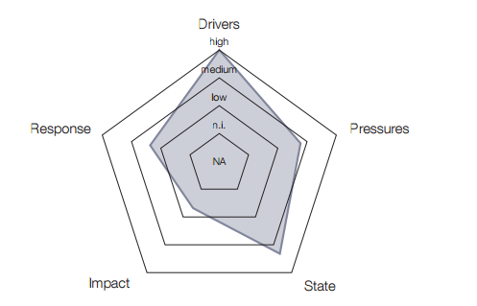
Figure 4. “Average graph” computed considering all air quality plans available in the APPRAISAL database.

The radar chart in Figure 4 represents the “average graph” computed considering all the plans available in the database. Some main observations can be derived. Most effort was put into quantifying the DRIVERS and the STATE (concentration) in all the studies that were considered. The degree of detail used to evaluate emissions (PRESSURES) or to determine the consequent actions (RESPONSES) has been generally lower. Indeed, only rarely, actual plans and studies try to reach a quantification of the impacts on human health and ecosystems. More than half of the activities examined did not dealt with the quantification of impacts at all, while about one fourth did some estimation based on rough national population data (level 1).
‘Scenario analysis’ was the most frequently used approach, about twice as common as IAM approaches based on cost-benefit, cost-effectiveness or on multi-objective (i.e. optimization), which however are those mainly adopted by research projects. It is also interesting to note that only about one third of the scenario analyses were later completed with an estimation of the costs involved.

4. CONCLUSIONS
Recent studies of compliance with the Ambient Air Quality Directive (2008/50/EC) suggest that some urban areas and some regions in Europe will still struggle with severe air quality problems and related health effects for the years to come. This has fostered the development of plans and projects to improve air quality throughout EU member states. A relatively large sample of these activities has been collected in the APPRAISAL online database and analysed in the DPSIR framework adopted by the EEA.
The results show that in the majority of cases, regional and cities authorities rely on the simplest decision scheme (scenario approach, where possible abatement measures are selected by experts), while research projects tend to use some more formal approach. Only rarely anyway, some quantification of the external costs is attempted.
Despite, in most cases, there is insufficient experience to understand how these issues have impacted the actual environmental situations, a number of critical points requiring at least some additional studies have emerged. Among them, the reduced availability of standardized data and procedures, the low diffusion of handy and fast decision support tools, and the difficulties in understanding and communicating the embedded uncertainties certainly play a major role.
Furthermore, it clearly emerged that a widespread application of classical end-of-pipe measures, such as various types of filters and catalysts, may provide only a moderate improvement to the air quality in these areas and will not reduce their GHG emissions. It is therefore essential to introduce different types of measures, which improve energy efficiency and air quality at the same time. These energy reduction measures cover a very wide spectrum, but often imply a relevant shift in citizens’ behaviour as well as changes in buildings and urban plans. Facilitating civil society towards such an important structural evolution requires the involvement of a wide range of actors, with the citizen as a key stakeholder. Acceptability of structural and non-structural measures by involved people is another key issue that has been formally dealt with only in specific projects, like SEFIRA, but needs to become part of set of political tools needed to adapt air quality planning to the (fast) evolution of the current society.
The awareness of the complexity of this task has triggered the development of the Transition Management concept (Loorbach, 2007). In order to influence the direction and speed of the transition to a cleaner air/low carbon society in the best way, decision makers can be supported by a systematic framework like that presented in the paper that can be adapted to the specific circumstances of different regions and cities and by a working set of tools that helps at different stages of the transition.
Future projects will need to co-design both a general guidance to Transition Management and an integrated toolbox suitable for each city/region to provide the decision makers with a continuous and progressive support in the conception, design, implementation and monitoring of Air Quality and Low Carbon policies.

Acknowledgements
This paper is based on the activities carried out within the European Union’s Seventh Framework Programme for research, technological development and demonstration under grant agreements APPRAISAL (308395), SEFIRA (603941), ACCENT-Plus (265119).

References
Amann M. (ed)., Policy scenarios for the revision of the thematic strategy on air pollution, 2013. TSAP Report #10, IIASA, Laxenburg, Austria.
Amann M. (ed)., The final policy scenarios of the EU Clean Air Policy Package, 2014. TSAP Report #11, IIASA, Laxenburg, Austria.
Ben-Akiva M., Lerman S.R., Discrete choice analysis: theory and application to travel demand, MIT Press, Cambridge, Massachusetts, 1985, 412 pp. ISBN: 9780262022170
Bollen J., Brink C., Air pollution policy in Europe: Quantifying the interaction with greenhouse gases and climate change policies. Energy Economics, 2014, 46, 202-215. doi:10.1016/j.eneco.2014.08.028
Bristow, A. L., Wardman, M., Zanni, A. M., and Chintakayala, P. K.: Public acceptability of personal carbon trading and carbon tax. Ecological Economics, 2010, 69(9), 1824-1837. doi: http://dx.doi.org/10.1016/j.ecolecon.2010.04.021.
Carnevale C., Finzi C., Pisoni E., Volta M., Guariso G., et al., An integrated assessment tool to define effective air quality policies at regional scale, Environmental Modelling and Software, 2012, 38, 306–315. doi:10.1016/j.envsoft.2012.07.004
Carnevale C., Finzi C., Pederzoli A., Turrini E., Volta M., et al., Exploring trade-offs between air pollutants through an Integrated Assessment Model. Science of The Total Environment, 2014, 481, 7-16.doi:10.1016/j.scitotenv.2014.02.016
Coll I., Lasry F., Fayet S., Armengaud A., Vautard R.,, Simulation and evaluation of 2010 emission control scenarios in a Mediterranean area, Atmospheric Environment, 2009, 43, 4194-4204. doi:10.1016/j.atmosenv.2009.05.034
Cuvelier C., Thunis P., Vautard R., Amann M., Bessagnet B., et al. CityDelta: A model intercomparison study to explore the impact of emission reductions in European cities in 2010, Atmospheric Environment 2007, 41, 189–207. doi:10.1016/j.atmosenv.2009.05.034
Di Ciommo, F., Monzón, A., and Fernandez-Heredia, A.: Improving the analysis of road pricing acceptability surveys by using hybrid models. Transportation Research Part A: Policy and Practice, 2013, 49(C), 302-316.
EC, A Clean Air Programme for Europe, COM/2013/0918 final,, 2013. (Available at http://http://eur-lex.europa.eu/ last accessed March 2016)
EEA, Environmental indicators: Typology and overview, Technical report No 25/1999, 1999. (Available at http://www.eea.europa.eu/publications/TEC25 last accessed March 2016)
EU, Directive 2008/50/EC of the European Parliament and of the Council, Official journal of the European Union, L152/1-44, 11.6.2008.
Fann N., Fulcher C.M., Baker K., The Recent and Future Health Burden of Air Pollution Apportioned Across U.S. Sectors, Environmental Science & Technology, 2013, 47, 3580-3589. doi: 10.1021/es304831q
Fowler, D., Steadman C. E., Stevenson D., Coyle M., Rees R. M. et al. (2015), Effects of global change during the 21st century on the nitrogen cycle, Atmospheric Chemistry and Physics, 2015, 15, 13849-13893, doi:10.5194/acp-15-13849-2015.
Fuzzi, S., Baltensperger U., Carslaw K., Decesari S., Denier van der Gon H., et al., Particulate matter, air quality and climate: lessons learned and future needs, Atmospheric Chemistry and Physics, 2015, 15, 8217-8299. doi:10.5194/acp-15-8217-2015.
Guariso G., Pirovano G., Volta M., Multi-objective analysis of ground-level ozone concentration control, Journal of Environmental Management, 2004, 71, 25-33. doi:10.1016/j.jenvman.2003.12.015
Hamilton S. H., ElSawah S., Guillaume J.H.A., Jakeman A.J., Pierce S.A., Integrated assessment and modelling: Overview and synthesis of salient dimensions, Environmental Modelling & Software, 2015, 64, 215-229.
Hensher, D. A., Rose, J. M. and Greene, W. H.:Applied Choice Analysis: A Primer. Cambridge University Press, Cambridge U.K. , 2005.ISBN: 9780511114038
Kieswetter G., Borken-Kleefeld J., Schöpp W., Heyes C., Bertok I., et al., Modelling compliance with NO2 and PM10 air quality limit values in the GAINS model,TSAP Report #9, IIASA, Laxenburg, Austria, 2013.
Kiesewetter G., Borken-Kleefeld J., Schöpp W., Heyes C., Thunis P., et al., Modelling street level PM10 concentrations across Europe: source apportionment and possible futures, Atmospheric Chemistry & Physics, 2015, 15, 1539–1553. doi:10.5194/acp-15-1539-2015
Kelly R. A., Jakeman A.J., Barreteau O., Borsuk M.E., ElSawah S., et al., Selecting among five common modelling approaches for integrated environmental assessment and management, Environmental modelling & software, 2013, 47, 159-181,
Laniak G.F., Olchin G., Goodall J., Voinov A., Hille M., et al., Integrated environmental modeling: A vision and roadmap for the future, Environmental Modelling & Software, 2013, 39, 3-23.
Lefebvre B., Degrawe B., Beckx C., Vanhulsel M., Kochan B., et al., Presentation and evaluation of an integrated model chain to respond to traffic- and health-related policy questions, Environmental Modelling & Software, 2013, 40, 160-170. doi:10.1016/j.envsoft.2012.09.003
Loorbach D.A., Transition Management: new mode of governance for sustainable development, International Books, Utrecht, the Netherlands. 328 pp .,2007.
Maione M., and Fuzzi S. (eds), Research findings in support of the EU Air Quality Review, European Commission, Directorate-General for Research and Innovation, Brussels, 2013.
Marcucci, E., Stathopoulos, A., Gatta, V., and Valeri, E.: A Stated Ranking Experiment to Study Policy Acceptance: The Case of Freight Operators in Rome’s LTZ. Italian Journal of Regional Science, 201211(3), 11-30.
Marécal V., Peuch V.-H., Andersson C., Andersson S., Arteta J., et al., A regional air quality forecasting system over Europe: the MACC-II daily ensemble production, Geoscientific Model Development 2015, 8, 2739-2806. doi:10.5194/gmd-8-2777-2015
Monks P. S., Archibald A. T., Colette A., Cooper O., Coyle M., et al., Tropospheric ozone and its precursors from the urban to the global scale from air quality to short-lived climate forcer, Atmospheric Chemistry and Physics, 2015, 15, 8889-8973, doi:10.5194/acp-15-8889-2015
Monteiro A., Miranda A.I., Borrego C., Vautard R., Air quality assessment for Portugal, Science of the Total Environment, 2007, 373, 22-31. doi:10.1016/j.scitotenv.2006.10.014
Pisoni E., Carnevale C., Volta M., Multi-criteria analysis for PM10 planning, Atmospheric Environment, 2009, 43, 4833-4842. doi:10.1016/j.atmosenv.2008.07.049
Schöpp W., Amann A., Cofala J., Klimont Z., Integrated assessment of European air pollution emission control strategies, Environmental Modelling & Software, 14, 1–9. doi:10.1016/S1364-8152(98)00034-6
Shindell, D., Kuylenstierna J.C.I., Vignati E., van Dingenen R., Amann M., et al., Simultaneously Mitigating Near-Term Climate Change and Improving Human Health and Food Security, Science, 2012, 335, 183-189. doi: 10.1126/science.1210026
Soerensen, H. C., Hansen, L. K., Hansen, R., and Hammarlund, K.: European Thematic Network on Wave Energy: Public acceptability: EMU and Hammarlund Consulting, 2003.
Thunis P., Georgieva E., Pederzoli A., A tool to evaluate air quality model performances in regulatory applications, Environmental Modelling & Software, 2012, 38, 220–230. doi:10.1016/j.envsoft.2012.06.005
Thunis P, Miranda A., Baldasano J.M., Blond N., Douros J., Grafff A., Janssen S., Juda-Rezlerh K., Karvosenojaj N., Maffeis G., Martilli A., Rasoloharimahefa M., Real E., Viaene P., Volta M., White L., Overview of current regional and local scale air quality modelling practices: Assessment and planning tools in the EU, Environmental Science & Policy, 2016 in press, doi:10.1016/j.envsci.2016.03.013
UNECE, Integrated Assessment Modelling, EB.AIR/GE.1/2002/5, 2002. (Available at www.unece.org/fileadmin/DAM/env/documents/2002/eb/ge1/eb.air.ge.1.2002.5.e.pdf last accessed March 2016)
Valeri, E.:. Air and rail transport in the Rome-Milan corridor: competition policy implications based on a discrete choice analysis, PhD thesis, University of Trieste, 2013. http://www.openstarts.units.it/dspace/handle/10077/9507.
van der Sluijs J.P., A way out of the credibility crisis of models used in integrated environmental assessment, Futures, 2002, 34, 133–146.
Vautard R., P.H.J. Builtjes P.H.J., Thunis P., Cuvelier C., Bedogni M., et al., Evaluation and intercomparison of Ozone and PM10 simulations by several chemistry transport models over four European cities within the CityDelta project, Atmospheric Environment, 2007, 4, 173-188. doi:10.1016/j.atmosenv.2006.07.039
Vlachokostas Ch., Achillas Ch., Moussiopoulos N., Banias G., et al., Multicriteria methodological approach to manage urban air pollution, Atmospheric Environment, 2011, 45, 4160-4169. doi:10.1016/j.atmosenv.2011.05.020
Vlassenroot, S., Brookhuis, K., Marchau, V., and Witlox, F.: Towards defining a unified concept for the acceptability of Intelligent Transport Systems (ITS): A conceptual analysis based on the case of Intelligent Speed Adaptation (ISA). Transportation Research Part F: Traffic Psychology and Behaviour, 2010, 13(3), 164-178. doi: http://dx.doi.org/10.1016/j.trf.2010.02.001
Zachary D.S., Drouet L., Leopold U., Aleluia Reis L., Trade-offs between energy cost and health impact in a regional coupled energy–air quality model: the LEAQ model, Environmental Research Letters, 2011, 6, 1–9. doi: 10.1088/1748-9326/6/2/024021
Zhang, Y., Yu, Y., and Zou, B.: Analyzing public awareness and acceptance of alternative fuel vehicles in China: The case of EV. Energy Policy, 2011, 39(11), 7015-7024. doi: http://dx.doi.org/10.1016/j.enpol.2011.07.055

